# **Pandas challenge – School district analysis**

This report provides insight into the School District statistics. The objective is to uncover trends or actual status that may help to articulate strategies for results improvement.

No executive summary has been written as the report itself is short.

**MAIN CONCLUSIONS :**

1. **Math AND Reading skills percentage is low; a plan for improvement is due**
2. Charter schools perform much better than District schools
3. Smaller schools (budget wise) perform better than larger schools
4. Smaller schools ( size wise) perform better than larger schools

**PRELIMINARY ANALYSIS**

To obtain insight into the data a DESCRIBE procedure was run on the merged file. The results were the following:

1. The analysis covers 15 schools with 39,170 students.
2. There is a relevant repetition of *“student_name”* :
   1. only 83.5% are unique.
   2. one is repeated 26 times !
   3. using the middle name in the student’s name should be analyzed.
3. *math_score* results are slightly lower than *reading_score.*
4. *Statistical values do no show excessive deviations, students are relatively homogenous.*

**DISTRICT ANALYSIS**

The following table shows the basic District Data:

Next table illustrates about the student’s performance:

Math and Reading skills are fundamental now and will be more critical in the future.

Therefore, the passing math and reading percentage is not acceptable.

A plan should be developed to improve this figure.

The next three tables show the schools performance based on a factor calculated on how much the mean of the schools is better than 70. All schools perform better in average, but some of them are very close to the passing limit.

The table above shows the District Data and students results, by school name.

The next two tables show a significant result: **Charter perform better than District.**

The next three tables show the average scores by grade.

There is no significant difference in performance by grade.

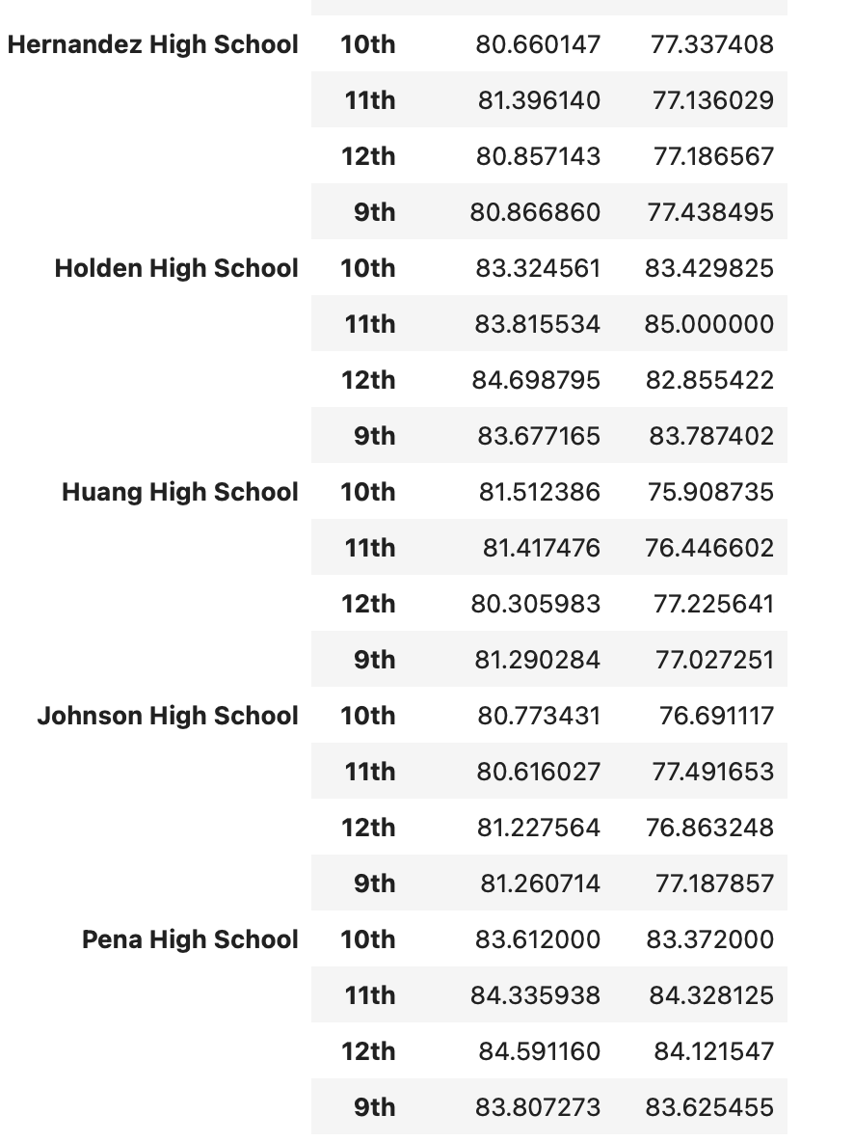

**SCHOOL ANALYSIS**

The following table is the basis for the Scores by School Spending analysis.

Above table shows the budget per school sizes and all performance parameters.

Below table is the spending summary.

The obvious conclusion is that smaller schools ( with less budget ! ) perform better than large schools.

Above report shows the complete performance of the schools, sorted by the Math and Read passing factor. Below is the same table showing only the sorting factor and school data.

Again, small and medium Charter schools perform better than bigger District schools.

