**#1: Install Helm 3 on Kubernetes Cluster**

Install helm3 on Kubernetes Cluster on Kubernetes Cluster using below command

curl -fsSL -o get_helm.sh https://raw.githubusercontent.com/helm/helm/master/scripts/get-helm-3

chmod 700 get_helm.sh

./get_helm.sh

To check helm3 version

helm version

**#2: Install Prometheus and Grafana on Kubernetes using Helm 3**

Add the latest helm repository in Kubernetes

helm repo add stable https://charts.helm.sh/stable

Add the Prometheus community helm chart in Kubernetes

helm repo add prometheus-community https://prometheus-community.github.io/helm-charts

once added search Prometheus community helm chart to install

helm search repo prometheus-community

You will see available Prometheus and grafana helm chart to install

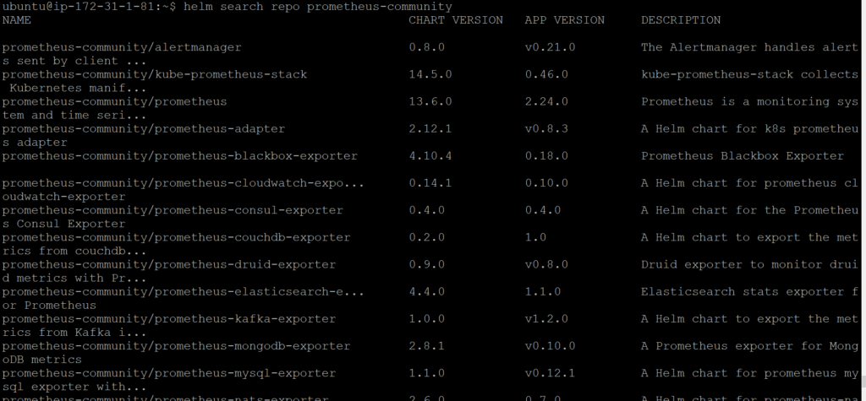

Prometheus and grafana helm chart moved to kube prometheus stack

Below is helm command to install kube-prometheus-stack

helm install [RELEASE_NAME] prometheus-community/kube-prometheus-stack

Lets install stable prometheus-community/kube-prometheus-stack

helm install stable prometheus-community/kube-prometheus-stack

once installed, you will see below output

**Output:**

helm install stable prometheus-community/kube-prometheus-stack

NAME: stable

LAST DEPLOYED: Fri Apr 9 11:53:08 2021

NAMESPACE: default

STATUS: deployed

REVISION: 1

NOTES:

kube-prometheus-stack has been installed. Check its status by running:

kubectl --namespace default get pods -l "release=stable"

Visit https://github.com/prometheus-operator/kube-prometheus for instructions on how to create & configure Alertmanager and Prometheus instances using the Operator.

Lets check prometheus and grafana pods

kubectl get pods

**Output:**

NAME READY STATUS RESTARTS AGE

alertmanager-stable-kube-prometheus-sta-alertmanager-0 2/2 Running 0 4m3s

prometheus-stable-kube-prometheus-sta-prometheus-0 2/2 Running 1 4m3s

stable-grafana-6fdd68bd8c-m8s59 2/2 Running 0 4m34s

stable-kube-prometheus-sta-operator-7d89c8b9d8-6rpt5 1/1 Running 0 4m34s

stable-kube-state-metrics-5fd847bcbd-xdl4g 1/1 Running 0 4m34s

stable-prometheus-node-exporter-479lc 1/1 Running 0 4m34s

stable-prometheus-node-exporter-nzx5h 1/1 Running 0 4m34s

Lets check prometheus and grafana services

kubectl get svc

**Output:**

NAME TYPE CLUSTER-IP EXTERNAL-IP PORT(S) AGE

alertmanager-operated ClusterIP None <none> 9093/TCP,9094/TCP,9094/UDP 4m13s

kubernetes ClusterIP 100.64.0.1 <none> 443/TCP 10m

prometheus-operated ClusterIP None <none> 9090/TCP 4m13s

stable-grafana ClusterIP 100.65.58.48 <none> 80/TCP 4m44s

stable-kube-prometheus-sta-alertmanager ClusterIP 100.68.38.188 <none> 9093/TCP 4m44s

stable-kube-prometheus-sta-operator ClusterIP 100.67.54.161 <none> 443/TCP 4m44s

stable-kube-prometheus-sta-prometheus ClusterIP 100.67.172.242 <none> 9090/TCP 4m44s

stable-kube-state-metrics ClusterIP 100.69.46.211 <none> 8080/TCP 4m44s

stable-prometheus-node-exporter ClusterIP 100.66.152.213 <none> 9100/TCP 4m44s

We have covered Install Prometheus and Grafana on Kubernetes using Helm 3.

**#3: Edit Prometheus Service**

By default prometheus and grafana service is available within the cluster using ClusterIP, to access it outside lets change it either NodePort or Loadbalancer.

kubectl edit svc stable-kube-prometheus-sta-prometheus

Here we are changing from **ClusterIP** to **LoadBalancer/NodePort**

# Please edit the object below. Lines beginning with a '#' will be ignored,

# and an empty file will abort the edit. If an error occurs while saving this file will be

# reopened with the relevant failures.

#

apiVersion: v1

kind: Service

metadata:

annotations:

meta.helm.sh/release-name: stable

meta.helm.sh/release-namespace: default

creationTimestamp: "2021-04-09T11:53:24Z"

finalizers:

- service.kubernetes.io/load-balancer-cleanup

labels:

app: kube-prometheus-stack-prometheus

app.kubernetes.io/managed-by: Helm

chart: kube-prometheus-stack-14.5.0

heritage: Helm

release: stable

self-monitor: "true"

name: stable-kube-prometheus-sta-prometheus

namespace: default

resourceVersion: "7902"

selfLink: /api/v1/namespaces/default/services/stable-kube-prometheus-sta-prometheus

uid: 9042a504-d25f-4122-b6aa-52ed5e53b576

spec:

clusterIP: 100.67.172.242

externalTrafficPolicy: Cluster

ports:

- name: web

nodePort: 31942

port: 9090

protocol: TCP

targetPort: 9090

selector:

app: prometheus

prometheus: stable-kube-prometheus-sta-prometheus

sessionAffinity: None

type: **LoadBalancer**

**#4: Edit Grafana Service**

Now edit the grafana service

kubectl edit svc stable-grafana

Change from **ClusterIP** to **LoadBalancer/NodePort**

# Please edit the object below. Lines beginning with a '#' will be ignored,

# and an empty file will abort the edit. If an error occurs while saving this file will be

# reopened with the relevant failures.

#

apiVersion: v1

kind: Service

metadata:

annotations:

meta.helm.sh/release-name: stable

meta.helm.sh/release-namespace: default

creationTimestamp: "2021-04-09T11:53:24Z"

finalizers:

- service.kubernetes.io/load-balancer-cleanup

labels:

app.kubernetes.io/instance: stable

app.kubernetes.io/managed-by: Helm

app.kubernetes.io/name: grafana

app.kubernetes.io/version: 7.4.5

helm.sh/chart: grafana-6.6.4

name: stable-grafana

namespace: default

resourceVersion: "8222"

selfLink: /api/v1/namespaces/default/services/stable-grafana

uid: 7ebeb0da-858f-4232-8904-560e7ce83c5b

spec:

clusterIP: 100.65.58.48

externalTrafficPolicy: Cluster

ports:

- name: service

nodePort: 31258

port: 80

protocol: TCP

targetPort: 3000

selector:

app.kubernetes.io/instance: stable

app.kubernetes.io/name: grafana

sessionAffinity: None

type: **LoadBalancer**

Verify the service if changed to **LoadBalancer**

kubectl get svc

**Output:**

NAME TYPE CLUSTER-IP EXTERNAL-IP PORT(S) AGE

alertmanager-operated ClusterIP None <none> 9093/TCP,9094/TCP,9094/UDP 46m

kubernetes ClusterIP 100.64.0.1 <none> 443/TCP 52m

prometheus-operated ClusterIP None <none> 9090/TCP 46m

stable-grafana LoadBalancer 100.65.58.48 a7ebeb0da858f42328904560e7ce83c5-996403152.ap-south-1.elb.amazonaws.com 80:31258/TCP 46m

stable-kube-prometheus-sta-alertmanager ClusterIP 100.68.38.188 <none> 9093/TCP 46m

stable-kube-prometheus-sta-operator ClusterIP 100.67.54.161 <none> 443/TCP 46m

stable-kube-prometheus-sta-prometheus LoadBalancer 100.67.172.242 a9042a504d25f4122b6aa52ed5e53b57-356305290.ap-south-1.elb.amazonaws.com 9090:31942/TCP 46m

stable-kube-state-metrics ClusterIP 100.69.46.211 <none> 8080/TCP 46m

stable-prometheus-node-exporter ClusterIP 100.66.152.213 <none> 9100/TCP

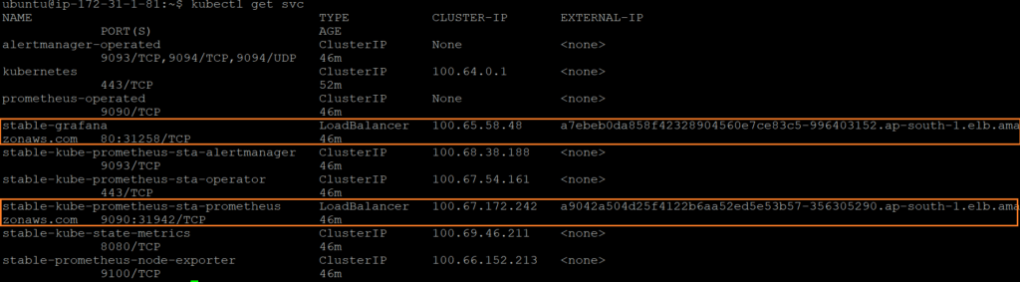

**#5: Access Prometheus and Grafana WEB Interface**

To access Prometheus web interface copy Loadbalancer URL and port number 9090

http://a9042a504d25f4122b6aa52ed5e53b57-356305290.ap-south-1.elb.amazonaws.com:9090

**Output:**

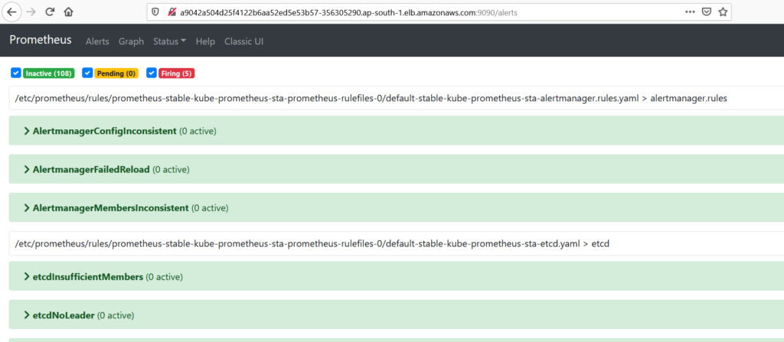

To access Grafana web interface copy Loadbalancer URL and port number 80

http://a7ebeb0da858f42328904560e7ce83c5-996403152.ap-south-1.elb.amazonaws.com

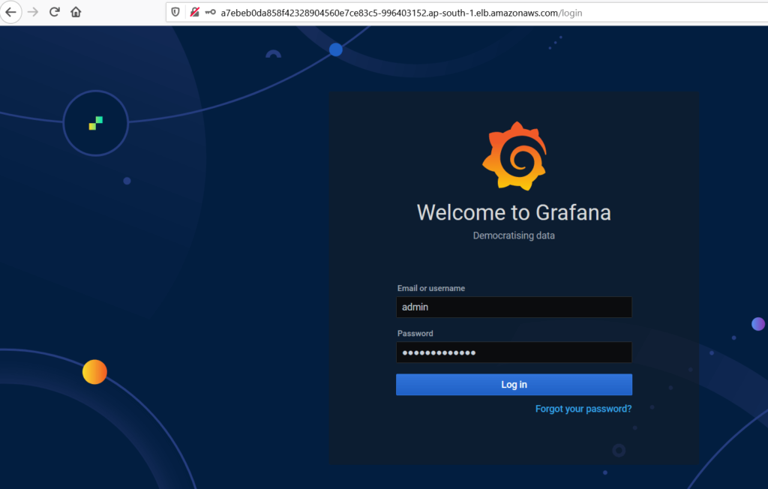

you will redirected to Grafana dashboard, it will prompt for username and Password, below are default credentials for Grafana

UserName: admin

Password: prom-operator

after successfully logged in Grafana dashboard, click on Manage to see Kubernetes cluster

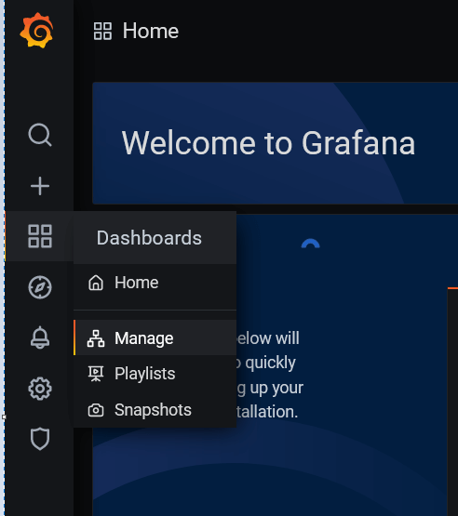

once clicked on manage, you will see Kubernetes cluster

