前面已经讲了get流程的内容，那么下面开始讲解一下关于search流程的东西，这里因为两种做法是不一样的，因此分开讲解.

读取search基本流程

全文数据索引建立

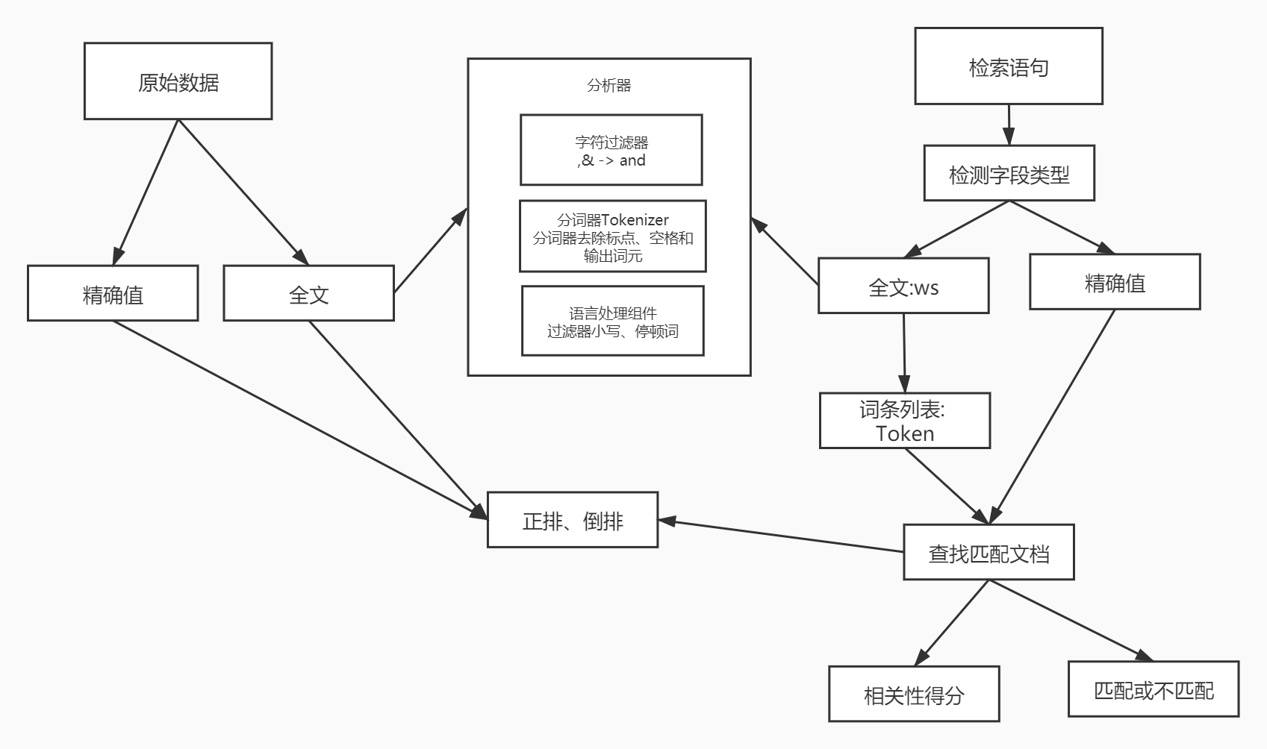

这里首先说明一下关于search流程里面的这些数据建立索引的原理图. 这里全文数据其实是指一段字符串，或者一条日志这样的数据,那么这些全文数据，需要对文本进行分析,当然现在es当中设置mapping的时候，string被keyword和text替代了,这里可以选择不分词,那么查询的时候就是全匹配了，不会进行分析器分析进行倒排索引进行处理了.

那么这里分析器的实现如下功能:
- 字符过滤器，主要是对字符串进行处理，例如去掉HTML,将&转换为and等;
- 分词器(Tokenizer),将字符串分割为单个词条，例如根据空格和标点符号分割,输出的词条称为词元(Token)
- Token过滤器,根据停止词(Stop word)删除词元,例如,and、the等无用词,或者根据同义词表增加词条,例如,jump和leap.
- 语言处理,对上一步得到的Token做一些和语言相关的处理，例如大小写转换、以及将单词转换为词根的形式.语言处理组件输出的结果称为词(Term).

这里处理完毕之后，将分析器输出的词(Term)传递给索引组件,生成倒排索引和正排索引,再存储到文件系统中.

这里在执行search搜索的时候，调用Lucene完成，大概步骤如下所示:
- 对检索字段使用建立索引时相同的分析器进行分析,产生Token列表;
- 根据查询语句的语法规则转换成一棵语法树
- 查找符合语法树的文档;
- 对匹配到的文档列表进行相关新评分,评分策略一般使用TF-IDF;
- 根据评分结果进行排序

搜索过程
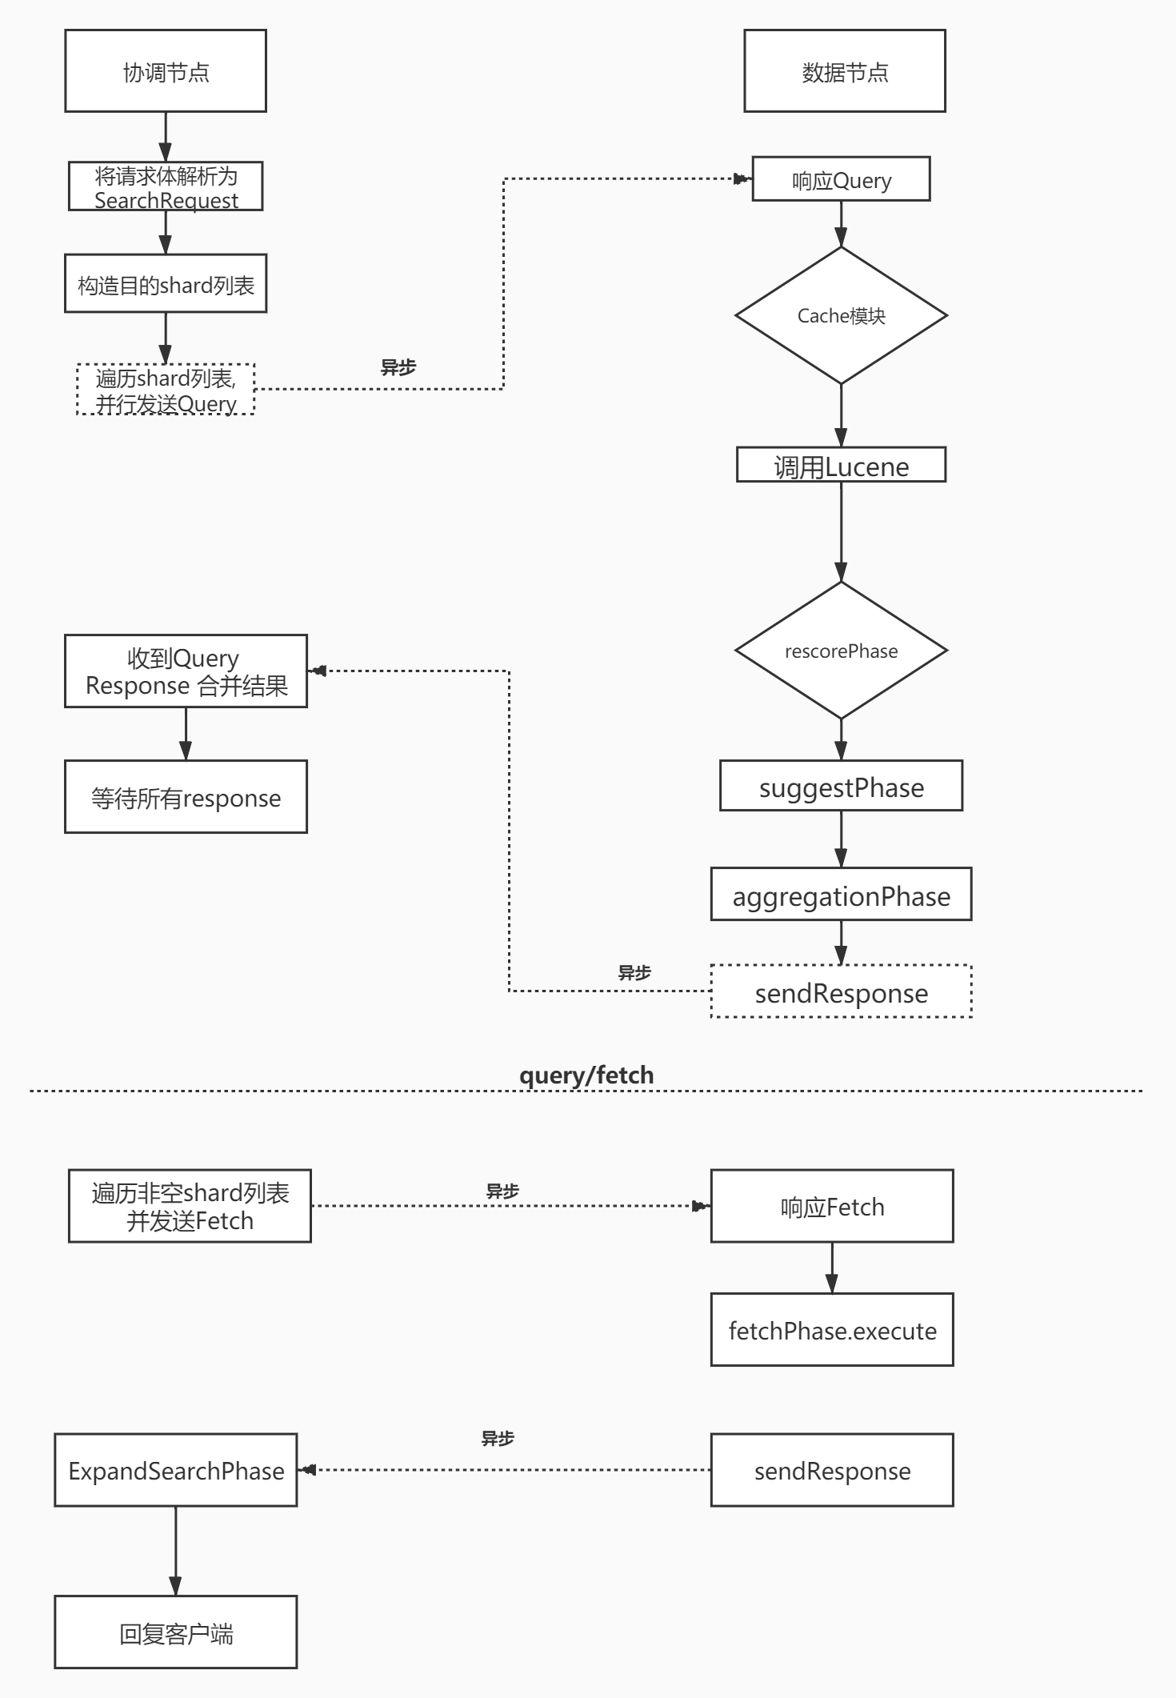

从上图可以知道，默认这里search搜索类型是QUERY_THEN_FETCH,这里先发送请求到达协调节点,然后发送请求到数据节点，其中这里可能发送给shard的主分片或副分片中的一个,找到符合条件的doc的ID和分数，返回到协调节点进行汇总,然后再根据ID去分片中获取数据.

两阶段相应的实现位置:
查询(Query)阶段----- search.InitialSearchPhase
取回(Fetch)阶段----search.FetchSearchPhase

Query阶段

请求解析
•
@Override
• public RestChannelConsumer prepareRequest(final RestRequest request, final NodeClient client) throws IOException {
• SearchRequest searchRequest = new SearchRequest();
• IntConsumer setSize = size -> searchRequest.source().size(size);
• request.withContentOrSourceParamParserOrNull(parser ->
• parseSearchRequest(searchRequest, request, parser, setSize));
•
• return channel -> client.search(searchRequest, new RestStatusToXContentListener<>(channel));
• }

这里是RestSearchAction下的方法，这里将请求解析为SearchRequest数据结构.
那么这里parseSearchRequest方法就是对请求进行处理和判断的，这里具体的情况见如下所示:

- public static void parseSearchRequest(SearchRequest searchRequest, RestRequest request,
- XContentParser requestContentParser,
- IntConsumer setSize) throws IOException {

- if (searchRequest.source() == null) {
- searchRequest.source(new SearchSourceBuilder());
- }
- searchRequest.indices(Strings.splitStringByCommaToArray(request.param("index")));
- if (requestContentParser != null) {
- searchRequest.source().parseXContent(requestContentParser);
- }

- final int batchedReduceSize = request.paramAsInt("batched_reduce_size", searchRequest.getBatchedReduceSize());
- searchRequest.setBatchedReduceSize(batchedReduceSize);
- searchRequest.setPreFilterShardSize(request.paramAsInt("pre_filter_shard_size", searchRequest.getPreFilterShardSize()));

- if (request.hasParam("max_concurrent_shard_requests")) {
- // only set if we have the parameter since we auto adjust the max concurrency on the coordinator
- // based on the number of nodes in the cluster
- final int maxConcurrentShardRequests = request.paramAsInt("max_concurrent_shard_requests",
- searchRequest.getMaxConcurrentShardRequests());
- searchRequest.setMaxConcurrentShardRequests(maxConcurrentShardRequests);
- }

- // do not allow 'query_and_fetch' or 'dfs_query_and_fetch' search types
- // from the REST layer. these modes are an internal optimization and should
- // not be specified explicitly by the user.
- String searchType = request.param("search_type");
- if ("query_and_fetch".equals(searchType) ||
- "dfs_query_and_fetch".equals(searchType)) {
- throw new IllegalArgumentException("Unsupported search type [" + searchType + "]");
- } else {
- searchRequest.searchType(searchType);
- }
- parseSearchSource(searchRequest.source(), request, setSize);
- searchRequest.requestCache(request.paramAsBoolean("request_cache", null));

- String scroll = request.param("scroll");
- if (scroll != null) {
- searchRequest.scroll(new Scroll(parseTimeValue(scroll, null, "scroll")));
- }

- searchRequest.types(Strings.splitStringByCommaToArray(request.param("type")));
- searchRequest.routing(request.param("routing"));
- searchRequest.preference(request.param("preference"));
- searchRequest.indicesOptions(IndicesOptions.fromRequest(request, searchRequest.indicesOptions()));
- }

这里可以看到，如
String scroll = request.param("scroll");
这样的语句，其实就是判断是否有scroll，这个是游标，关于这部分的原理后面再具体详细研究一下.

执行完上面的方法之后，这里就跳转到下面的handleRequests
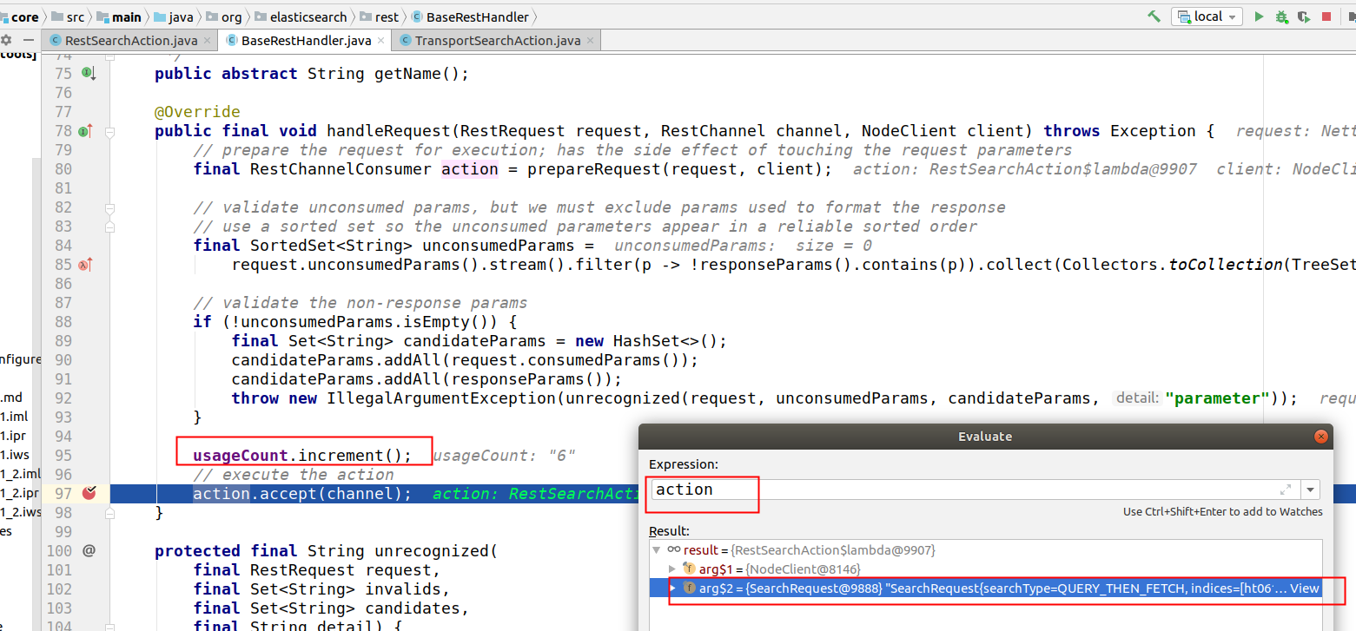
这里是跳转之前的action内容，这里如果把arg$2的内容复制出来，可以看到如下所示:

SearchRequest{searchType=QUERY_THEN_FETCH, indices=[ht0610], indicesOptions=IndicesOptions[id=38, ignore_unavailable=false, allow_no_indices=true, expand_wildcards_open=true, expand_wildcards_closed=false, allow_aliases_to_multiple_indices=true, forbid_closed_indices=true, ignore_aliases=false], types=[], routing='null', preference='null', requestCache=null, scroll=null, maxConcurrentShardRequests=0, batchedReduceSize=512, preFilterShardSize=128, source={}}

这里核心的就是对一些参数做了设置.

处理请求
这里处理请求进入到了TransportSearchAction里面的方法,具体代码如下所示:

- @Override
- protected void doExecute(Task task, SearchRequest searchRequest, ActionListener<SearchResponse> listener) {
- final long absoluteStartMillis = System.currentTimeMillis();
- final long relativeStartNanos = System.nanoTime();
- final SearchTimeProvider timeProvider =
- new SearchTimeProvider(absoluteStartMillis, relativeStartNanos, System::nanoTime);
- ActionListener<SearchSourceBuilder> rewriteListener = ActionListener.wrap(source -> {
- if (source != searchRequest.source()) {
- // only set it if it changed - we don't allow null values to be set but it might be already null be we want to catch
- // situations when it possible due to a bug changes to null
- searchRequest.source(source);
- }
- final ClusterState clusterState = clusterService.state();
- final Map<String, OriginalIndices> remoteClusterIndices = remoteClusterService.groupIndices(searchRequest.indicesOptions(),
- searchRequest.indices(), idx -> indexNameExpressionResolver.hasIndexOrAlias(idx, clusterState));
- OriginalIndices localIndices = remoteClusterIndices.remove(RemoteClusterAware.LOCAL_CLUSTER_GROUP_KEY);
- if (remoteClusterIndices.isEmpty()) {
- //进入到具体的方法里面去处理请求,计算shard列表等.
- executeSearch((SearchTask)task, timeProvider, searchRequest, localIndices, remoteClusterIndices, Collections.emptyList(),
- (clusterName, nodeId) -> null, clusterState, Collections.emptyMap(), listener, clusterState.getNodes()
- .getDataNodes().size(), SearchResponse.Clusters.EMPTY);
- } else {
- remoteClusterService.collectSearchShards(searchRequest.indicesOptions(), searchRequest.preference(),
- searchRequest.routing(), remoteClusterIndices, ActionListener.wrap((searchShardsResponses) -> {
- List<SearchShardIterator> remoteShardIterators = new ArrayList<>();
- Map<String, AliasFilter> remoteAliasFilters = new HashMap<>();
- BiFunction<String, String, DiscoveryNode> clusterNodeLookup = processRemoteShards(searchShardsResponses,
- remoteClusterIndices, remoteShardIterators, remoteAliasFilters);
- int numNodesInvolved = searchShardsResponses.values().stream().mapToInt(r -> r.getNodes().length).sum()
- + clusterState.getNodes().getDataNodes().size();
- SearchResponse.Clusters clusters = buildClusters(localIndices, remoteClusterIndices, searchShardsResponses);
- executeSearch((SearchTask) task, timeProvider, searchRequest, localIndices, remoteClusterIndices,
- remoteShardIterators, clusterNodeLookup, clusterState, remoteAliasFilters, listener, numNodesInvolved,
- clusters);
- }, listener::onFailure));
- }
- }, listener::onFailure);
- if (searchRequest.source() == null) {
- rewriteListener.onResponse(searchRequest.source());
- } else {
- Rewriteable.rewriteAndFetch(searchRequest.source(), searchService.getRewriteContext(timeProvider::getAbsoluteStartMillis),
- rewriteListener);
- }
- }
然后这里的关键就是进入到executeSearch方法里面.
•
private void executeSearch(SearchTask task, SearchTimeProvider timeProvider, SearchRequest searchRequest, OriginalIndices localIndices,
• Map<String, OriginalIndices> remoteClusterIndices, List<SearchShardIterator> remoteShardIterators,
• BiFunction<String, String, DiscoveryNode> remoteConnections, ClusterState clusterState,
• Map<String, AliasFilter> remoteAliasMap, ActionListener<SearchResponse> listener, int nodeCount,
• SearchResponse.Clusters clusters) {
•
• clusterState.blocks().globalBlockedRaiseException(ClusterBlockLevel.READ);
• ....
• Map<String, Long> nodeSearchCounts = searchTransportService.getPendingSearchRequests();
• //这里将请求涉及的本集群的shard列表和远程集群的shard列表合并
• GroupShardsIterator<ShardIterator> localShardsIterator = clusterService.operationRouting().searchShards(clusterState,
• concreteIndices, routingMap, searchRequest.preference(), searchService.getResponseCollectorService(), nodeSearchCounts);
• GroupShardsIterator<SearchShardIterator> shardIterators = mergeShardsIterators(localShardsIterator, localIndices,
• remoteShardIterators);
•
• failIfOverShardCountLimit(clusterService, shardIterators.size());
•
• Map<String, Float> concreteIndexBoosts = resolveIndexBoosts(searchRequest, clusterState);
•
• ....
• boolean preFilterSearchShards = shouldPreFilterSearchShards(searchRequest, shardIterators);
• //下面的方法就是发起线程遍历shard发送请求.
• searchAsyncAction(task, searchRequest, shardIterators, timeProvider, connectionLookup, clusterState.version(),
• Collections.unmodifiableMap(aliasFilter), concreteIndexBoosts, listener, preFilterSearchShards, clusters).start();
• }

然后下面可以看到计算的shardIterators 的结果.
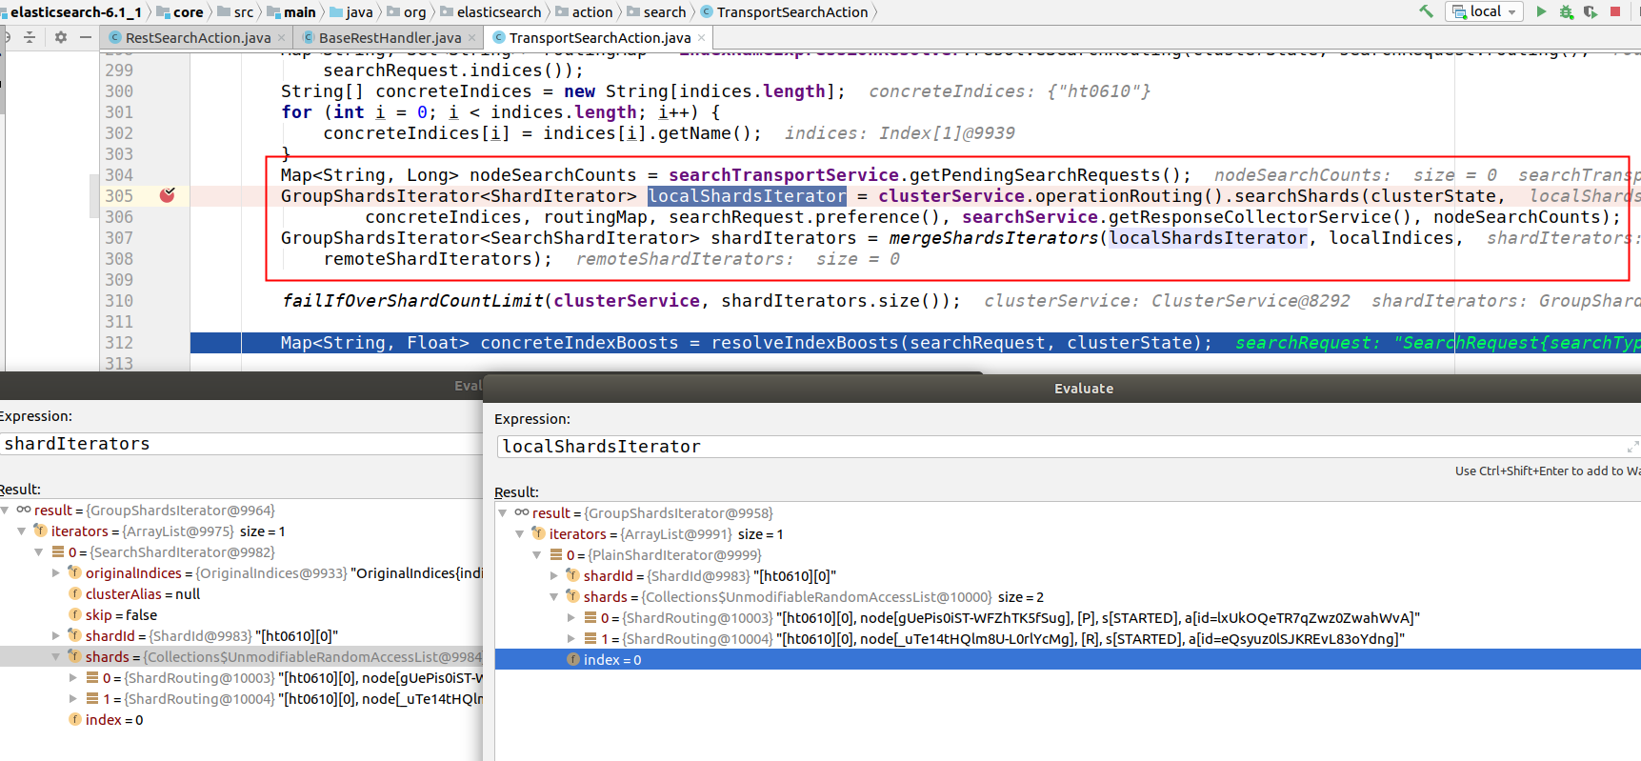

遍历shard分发请求
下面就会进入到InitialSearchPhase当中.
- @Override
- public final void run() throws IOException {
- for (final SearchShardIterator iterator : toSkipShardsIts) {
- assert iterator.skip();
- skipShard(iterator);
- }
- if (shardsIts.size() > 0) {
- //最大分片请求数.
- int maxConcurrentShardRequests = Math.min(this.maxConcurrentShardRequests, shardsIts.size());
- final boolean success = shardExecutionIndex.compareAndSet(0, maxConcurrentShardRequests);
- assert success;
- for (int index = 0; index < maxConcurrentShardRequests; index++) {
- final SearchShardIterator shardRoutings = shardsIts.get(index);
- assert shardRoutings.skip() == false;
- //执行shard级请求.
- performPhaseOnShard(index, shardRoutings, shardRoutings.nextOrNull());
- }
- }
- }
然后下面就是真正的转发请求了.注意这里从for循环中可以看到，这里是根据shard来转发请求的，但是这里并没有考虑到如果多个shard就在本地，那么可以合并请求.

- private void performPhaseOnShard(final int shardIndex, final SearchShardIterator shardIt, final ShardRouting shard) {

- final Thread thread = Thread.currentThread();
- if (shard == null) {
- fork(() -> onShardFailure(shardIndex, null, null, shardIt, new NoShardAvailableActionException(shardIt.shardId())));
- } else {
- try {
- executePhaseOnShard(shardIt, shard, new SearchActionListener<FirstResult>(new SearchShardTarget(shard.currentNodeId(),
- shardIt.shardId(), shardIt.getClusterAlias(), shardIt.getOriginalIndices()), shardIndex) {
- @Override
- public void innerOnResponse(FirstResult result) {
- maybeFork(thread, () -> onShardResult(result, shardIt));
- }

- @Override
- public void onFailure(Exception t) {
- maybeFork(thread, () -> onShardFailure(shardIndex, shard, shard.currentNodeId(), shardIt, t));
- }
- });
- } catch (final Exception e) {
- /*
- * It is possible to run into connection exceptions here because we are getting the connection early and might run in to
- * nodes that are not connected. In this case, on shard failure will move us to the next shard copy.
- */
- fork(() -> onShardFailure(shardIndex, shard, shard.currentNodeId(), shardIt, e));
- }
- }
- }
这里是转发请求的代码，然后这里onShardResult就是响应成功之后的处理，见如下所示

请求响应处理
- private void onShardResult(FirstResult result, SearchShardIterator shardIt) {
- assert result.getShardIndex() != -1 : "shard index is not set";
- assert result.getSearchShardTarget() != null : "search shard target must not be null";
- onShardSuccess(result);
- //这里进行统计响应成功的shard请求.
- successfulShardExecution(shardIt);
- }
那么这里统计的方法如下所示:
- private void successfulShardExecution(SearchShardIterator shardsIt) {
- final int remainingOpsOnIterator;
- if (shardsIt.skip()) {
- remainingOpsOnIterator = shardsIt.remaining();
- } else {
- remainingOpsOnIterator = shardsIt.remaining() + 1;
- }
- final int xTotalOps = totalOps.addAndGet(remainingOpsOnIterator);
- if (xTotalOps == expectedTotalOps) {
- //统计成功之后，这里就会执行取回阶段,也就是Fetch阶段.
- onPhaseDone();
- } else if (xTotalOps > expectedTotalOps) {
- throw new AssertionError("unexpected higher total ops [" + xTotalOps + "] compared to expected ["
- + expectedTotalOps + "]");
- } else if (shardsIt.skip() == false) {
- maybeExecuteNext();
- }
- }
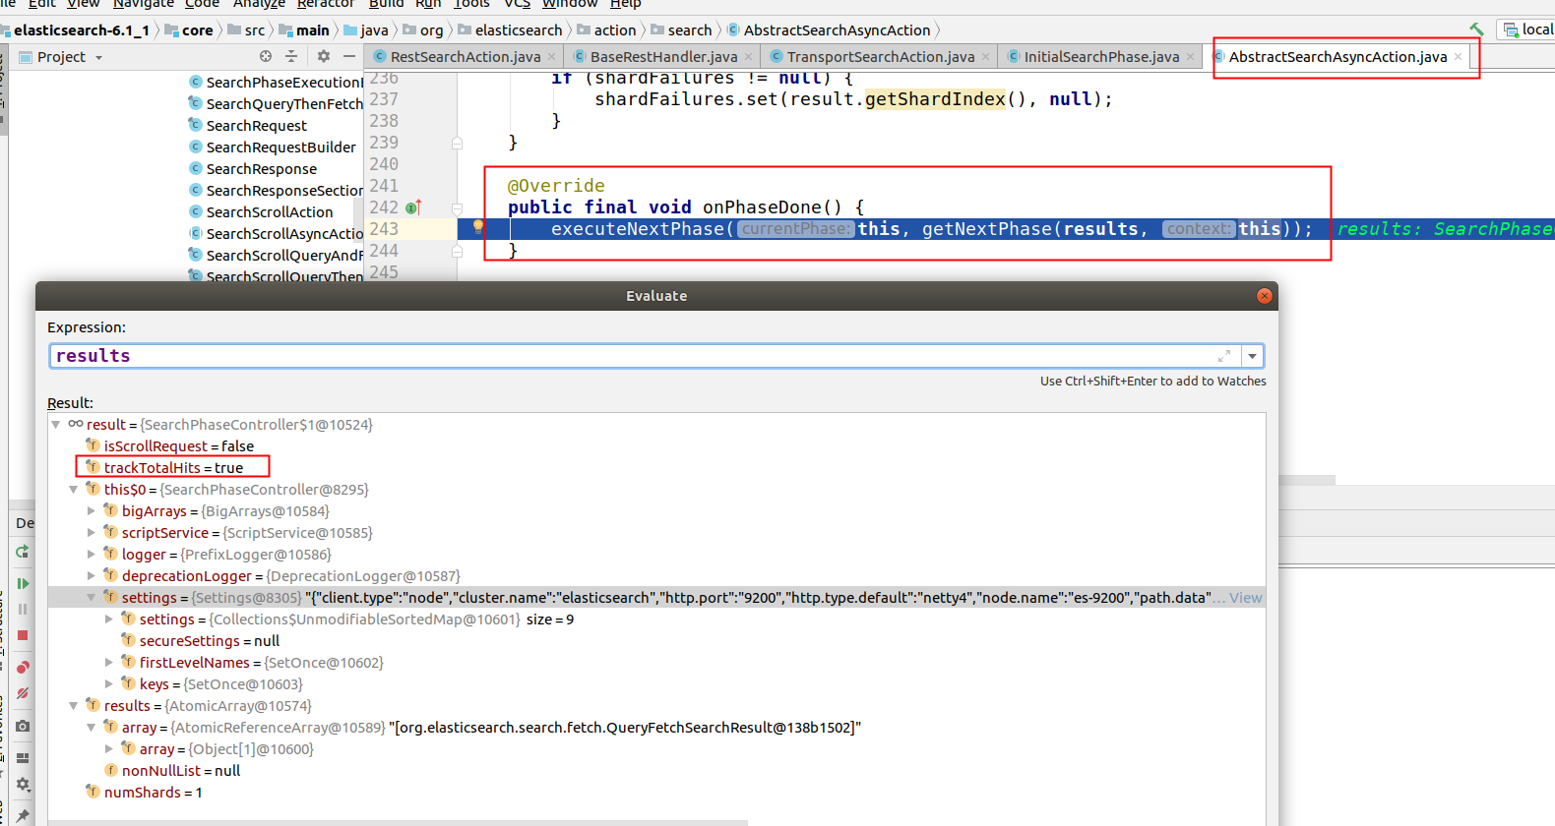

这里是所有的query的结果.然后下面的resutls内容具体如下所示:

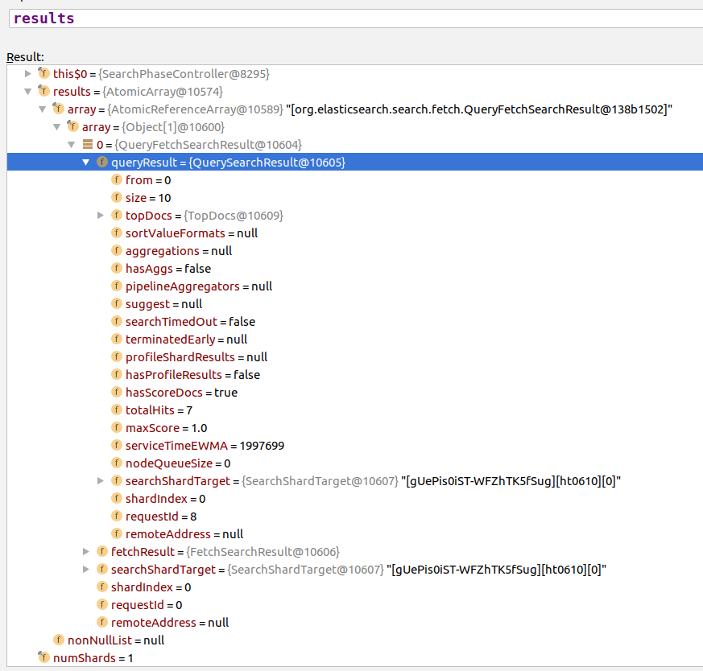
这里还可以继续看下topDocs里面的内容
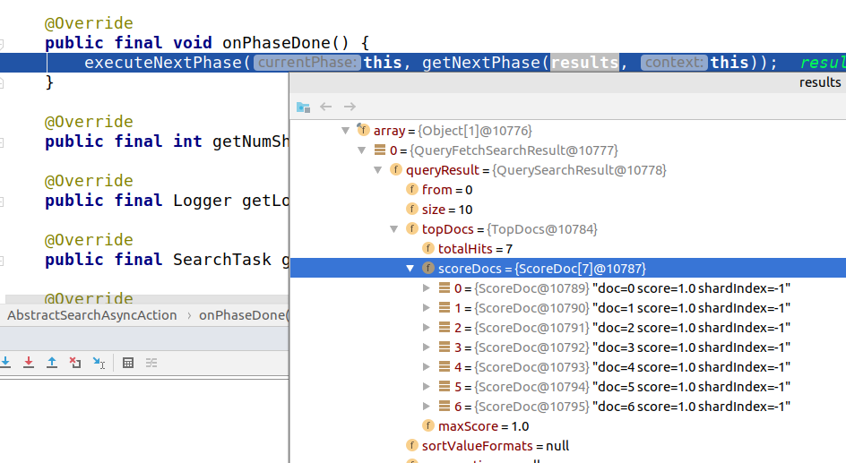

Fetch阶段

发送Fetch请求
这里的Fetch阶段开始是在FetchSearchPhase中的innerRun方法中,这里是怎么找到的呢？
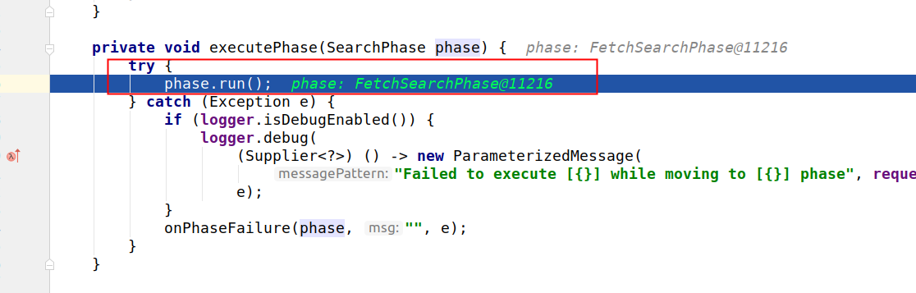
从前面的方法进入以后就能看到了.
这个方法的代码如下所示:
- private void innerRun() throws IOException {
- final int numShards = context.getNumShards();
- final boolean isScrollSearch = context.getRequest().scroll() != null;
- List<SearchPhaseResult> phaseResults = queryResults.asList();
- String scrollId = isScrollSearch ? TransportSearchHelper.buildScrollId(queryResults) : null;
- final SearchPhaseController.ReducedQueryPhase reducedQueryPhase = resultConsumer.reduce();
- final boolean queryAndFetchOptimization = queryResults.length() == 1;
- final Runnable finishPhase = ()
- -> moveToNextPhase(searchPhaseController, scrollId, reducedQueryPhase, queryAndFetchOptimization ?
- queryResults : fetchResults);
- //这里如果是只有一个index索引请求，那么就走这个方法
- if (queryAndFetchOptimization) {
- assert phaseResults.isEmpty() || phaseResults.get(0).fetchResult() != null : "phaseResults empty [" + phaseResults.isEmpty()
- + "], single result: " + phaseResults.get(0).fetchResult();
- // query AND fetch optimization
- //这个方法就是执行前面的 moveToNextPhase
- finishPhase.run();
- } else {
- final IntArrayList[] docIdsToLoad = searchPhaseController.fillDocIdsToLoad(numShards, reducedQueryPhase.scoreDocs);
- if (reducedQueryPhase.scoreDocs.length == 0) { // no docs to fetch -- sidestep everything and return
- phaseResults.stream()
- .map(SearchPhaseResult::queryResult)
- .forEach(this::releaseIrrelevantSearchContext); // we have to release contexts here to free up resources
- finishPhase.run();
- } else {
- final ScoreDoc[] lastEmittedDocPerShard = isScrollSearch ?
- searchPhaseController.getLastEmittedDocPerShard(reducedQueryPhase, numShards)
- : null;
- final CountedCollector<FetchSearchResult> counter = new CountedCollector<>(r -> fetchResults.set(r.getShardIndex(), r),
- docIdsToLoad.length, // we count down every shard in the result no matter if we got any results or not
- finishPhase, context);
- for (int i = 0; i < docIdsToLoad.length; i++) {
- IntArrayList entry = docIdsToLoad[i];
- SearchPhaseResult queryResult = queryResults.get(i);
- if (entry == null) { // no results for this shard ID
- if (queryResult != null) {
- // if we got some hits from this shard we have to release the context there
- // we do this as we go since it will free up resources and passing on the request on the
- // transport layer is cheap.
- releaseIrrelevantSearchContext(queryResult.queryResult());
- }
- // in any case we count down this result since we don't talk to this shard anymore
- counter.countDown();
- } else {
- SearchShardTarget searchShardTarget = queryResult.getSearchShardTarget();
- Transport.Connection connection = context.getConnection(searchShardTarget.getClusterAlias(),
- searchShardTarget.getNodeId());
- ShardFetchSearchRequest fetchSearchRequest = createFetchRequest(queryResult.queryResult().getRequestId(), i, entry,
- lastEmittedDocPerShard, searchShardTarget.getOriginalIndices());
- //这里发送请求
- executeFetch(i, searchShardTarget, counter, fetchSearchRequest, queryResult.queryResult(),
- connection);
- }
- }
- }
- }
- }
这里可以看到如果是要查询多个索引的情况下，查看一下executeFetch的代码

- private void executeFetch(final int shardIndex, final SearchShardTarget shardTarget,
- final CountedCollector<FetchSearchResult> counter,
- final ShardFetchSearchRequest fetchSearchRequest, final QuerySearchResult querySearchResult,
- final Transport.Connection connection) {
- context.getSearchTransport().sendExecuteFetch(connection, fetchSearchRequest, context.getTask(),
- new SearchActionListener<FetchSearchResult>(shardTarget, shardIndex) {
- @Override
- public void innerOnResponse(FetchSearchResult result) {
- counter.onResult(result);
- }

- @Override
- public void onFailure(Exception e) {
- try {
- if (logger.isDebugEnabled()) {
- logger.debug((Supplier<?>) () -> new ParameterizedMessage("[{}] Failed to execute fetch phase",
- fetchSearchRequest.id()), e);
- }
- counter.onFailure(shardIndex, shardTarget, e);
- } finally {
- // the search context might not be cleared on the node where the fetch was executed for example
- // because the action was rejected by the thread pool. in this case we need to send a dedicated
- // request to clear the search context.
- releaseIrrelevantSearchContext(querySearchResult);
- }
- }
- });
- }
这里如果请求响应成功了，那么执行的是
counter.onResult(result);
这里counter其实就是CountedCollector这个类里面.

- void onResult(R result) {
- try {
- resultConsumer.accept(result);
- } finally {
- countDown();
- }
- }
这里是把result保存到数组中，然后执行countDown,那么这里之后执行什么呢？
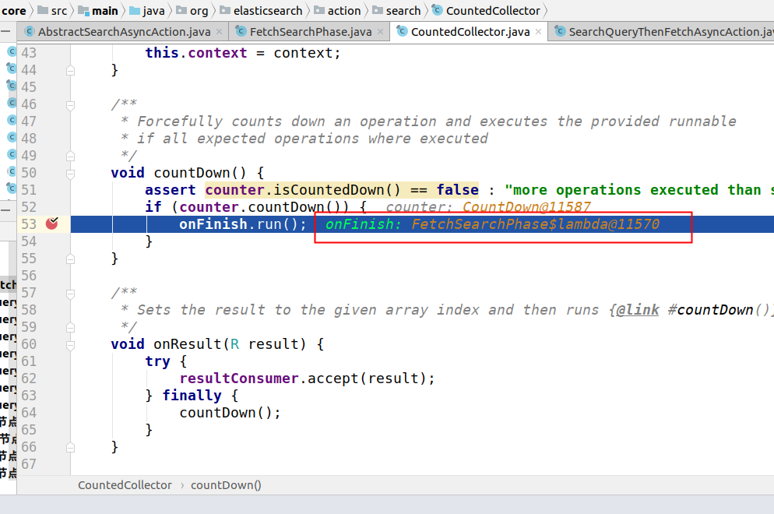
那么这里就会执行FetchSearchPhase中的方法了，这里其实就是前面innerRun中的代码
finishPhase.run(); 然后执行这个对象的moveToNextPhase方法，其实就是在innerRun代码中的如下这句内容:

- final Runnable finishPhase = ()
- -> moveToNextPhase(searchPhaseController, scrollId, reducedQueryPhase, queryAndFetchOptimization ?
- queryResults : fetchResults);

收集结果
那么这里这个方法的内容如下所示:

- private void moveToNextPhase(SearchPhaseController searchPhaseController,
- String scrollId, SearchPhaseController.ReducedQueryPhase reducedQueryPhase,
- AtomicArray<? extends SearchPhaseResult> fetchResultsArr) {
- final InternalSearchResponse internalResponse = searchPhaseController.merge(context.getRequest().scroll() != null,
- reducedQueryPhase, fetchResultsArr.asList(), fetchResultsArr::get);
- context.executeNextPhase(this, nextPhaseFactory.apply(internalResponse, scrollId));
- }

那么这里执行的是这个构造方法里面的东西.

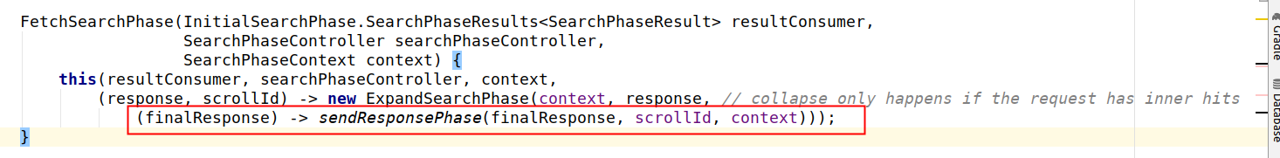
也就是这里的内容.那么这里ExpandSearchPhase触发的是run方法的内容.具体的可以详细自行查阅代码.

最后回复客户端的代码如下所示:

•
private static SearchPhase sendResponsePhase(InternalSearchResponse response, String scrollId, SearchPhaseContext context) {
• return new SearchPhase("response") {
• @Override
• public void run() throws IOException {
• context.onResponse(context.buildSearchResponse(response, scrollId));
• }
• };
• }

数据节点执行搜索

响应Query请求
前面的Query阶段是把请求发送到了数据节点上面进行搜索，但是这里到底怎么处理的，需要具体了解一下.那么这里的入口是在SearchTransportService#registerRequestHandler
下面是截取了这个方法的部分代码,如下所示:

- transportService.registerRequestHandler(QUERY_ACTION_NAME, ShardSearchTransportRequest::new, ThreadPool.Names.SAME,
- new TaskAwareTransportRequestHandler<ShardSearchTransportRequest>() {
- @Override
- //收到Query请求入口.
- public void messageReceived(ShardSearchTransportRequest request, TransportChannel channel, Task task) throws Exception {
- //这里是查询实现入口
- searchService.executeQueryPhase(request, (SearchTask) task, new ActionListener<SearchPhaseResult>() {
- @Override
- public void onResponse(SearchPhaseResult searchPhaseResult) {
- try {
- channel.sendResponse(searchPhaseResult);
- } catch (IOException e) {
- throw new UncheckedIOException(e);
- }
- }
- //查询失败处理
- @Override
- public void onFailure(Exception e) {
- try {
- channel.sendResponse(e);
- } catch (IOException e1) {
- throw new UncheckedIOException(e1);
- }
- }
- });
- }
- });
从上面代码可以知道这里的查询实现入口是在searchService.executeQueryPhase
•
public void executeQueryPhase(ShardSearchRequest request, SearchTask task, ActionListener<SearchPhaseResult> listener) {
• rewriteShardRequest(request, new ActionListener<ShardSearchRequest>() {
• @Override
• public void onResponse(ShardSearchRequest request) {
• try {
• listener.onResponse(executeQueryPhase(request, task));
• } catch (Exception e) {
• onFailure(e);
• }
• }
•
• @Override
• public void onFailure(Exception e) {
• listener.onFailure(e);
• }
• });
• }

那么在这里可以opResponse中会添加listener,这里会调用executeQueryPhase

查询是否使用Cache
•
SearchPhaseResult executeQueryPhase(ShardSearchRequest request, SearchTask task) throws IOException {
• final SearchContext context = createAndPutContext(request);
• final SearchOperationListener operationListener = context.indexShard().getSearchOperationListener();
• context.incRef();
• boolean queryPhaseSuccess = false;
• try {
• context.setTask(task);
• operationListener.onPreQueryPhase(context);
• long time = System.nanoTime();
• contextProcessing(context);
• //这里判断是否使用cache进行查询
• loadOrExecuteQueryPhase(request, context);
•
• if (context.queryResult().hasSearchContext() == false && context.scrollContext() == null) {
• freeContext(context.id());
• } else {
• contextProcessedSuccessfully(context);
• }
• final long afterQueryTime = System.nanoTime();
• queryPhaseSuccess = true;
• operationListener.onQueryPhase(context, afterQueryTime - time);
• if (request.numberOfShards() == 1) {
• return executeFetchPhase(context, operationListener, afterQueryTime);
• }
• return context.queryResult();
• } catch (Exception e) {
• // execution exception can happen while loading the cache, strip it
• if (e instanceof ExecutionException) {
• e = (e.getCause() == null || e.getCause() instanceof Exception) ?
• (Exception) e.getCause() : new ElasticsearchException(e.getCause());
• }
• if (!queryPhaseSuccess) {
• operationListener.onFailedQueryPhase(context);
• }
• logger.trace("Query phase failed", e);
• processFailure(context, e);
• throw ExceptionsHelper.convertToRuntime(e);
• } finally {
• cleanContext(context);
• }
• }

那么这里loadOrExecuteQueryPhase是判断是否使用cache进行查询，具体代码如下所示:
- private void loadOrExecuteQueryPhase(final ShardSearchRequest request, final SearchContext context) throws Exception {
- final boolean canCache = indicesService.canCache(request, context);
- context.getQueryShardContext().freezeContext();
- if (canCache) {
- indicesService.loadIntoContext(request, context, queryPhase);
- } else {
- queryPhase.execute(context);
- }
- }
关于这部分内容，后面可以自行查看代码.

数据节点查询数据
- @Override
- public void execute(SearchContext searchContext) throws QueryPhaseExecutionException {
- if (searchContext.hasOnlySuggest()) {
- suggestPhase.execute(searchContext);
- // TODO: fix this once we can fetch docs for suggestions
- searchContext.queryResult().topDocs(
- new TopDocs(0, Lucene.EMPTY_SCORE_DOCS, 0),
- new DocValueFormat[0]);
- return;
- }
- // Pre-process aggregations as late as possible. In the case of a DFS_Q_T_F
- // request, preProcess is called on the DFS phase phase, this is why we pre-process them
- // here to make sure it happens during the QUERY phase
- aggregationPhase.preProcess(searchContext);
- Sort indexSort = searchContext.mapperService().getIndexSettings().getIndexSortConfig()
- .buildIndexSort(searchContext.mapperService()::fullName, searchContext::getForField);
- final ContextIndexSearcher searcher = searchContext.searcher();
- //调用Lucene、searcher.search()实现搜索
- boolean rescore = execute(searchContext, searchContext.searcher(), searcher::setCheckCancelled, indexSort);

- if (rescore) { // only if we do a regular search
- //全文检索并且需要打分
- rescorePhase.execute(searchContext);
- }
- //自动补全及纠错
- suggestPhase.execute(searchContext);
- //实现聚合
- aggregationPhase.execute(searchContext);

- if (searchContext.getProfilers() != null) {
- ProfileShardResult shardResults = SearchProfileShardResults
- .buildShardResults(searchContext.getProfilers());
- searchContext.queryResult().profileResults(shardResults);
- }
- }
但是这里方法的返回是void，具体到底是怎么实现返回数据的，这里还需要有待研究.

总结
- 聚合是在ES中实现的,而非Lucene
- Query和Fetch请求之间是无状态的，除非是scroll方式
- 分页搜索不会单独cache,cache和分页没有关系
- 每次分页的请求都是一次重新搜索的过程,而不是从第一次搜索的结果中获取

附录:

https://zhuanlan.zhihu.com/p/34680841
关于Lucene的数据模型参考文献

https://zhuanlan.zhihu.com/p/35469104
关于Lucene的基本概念

