读取GET基本流程

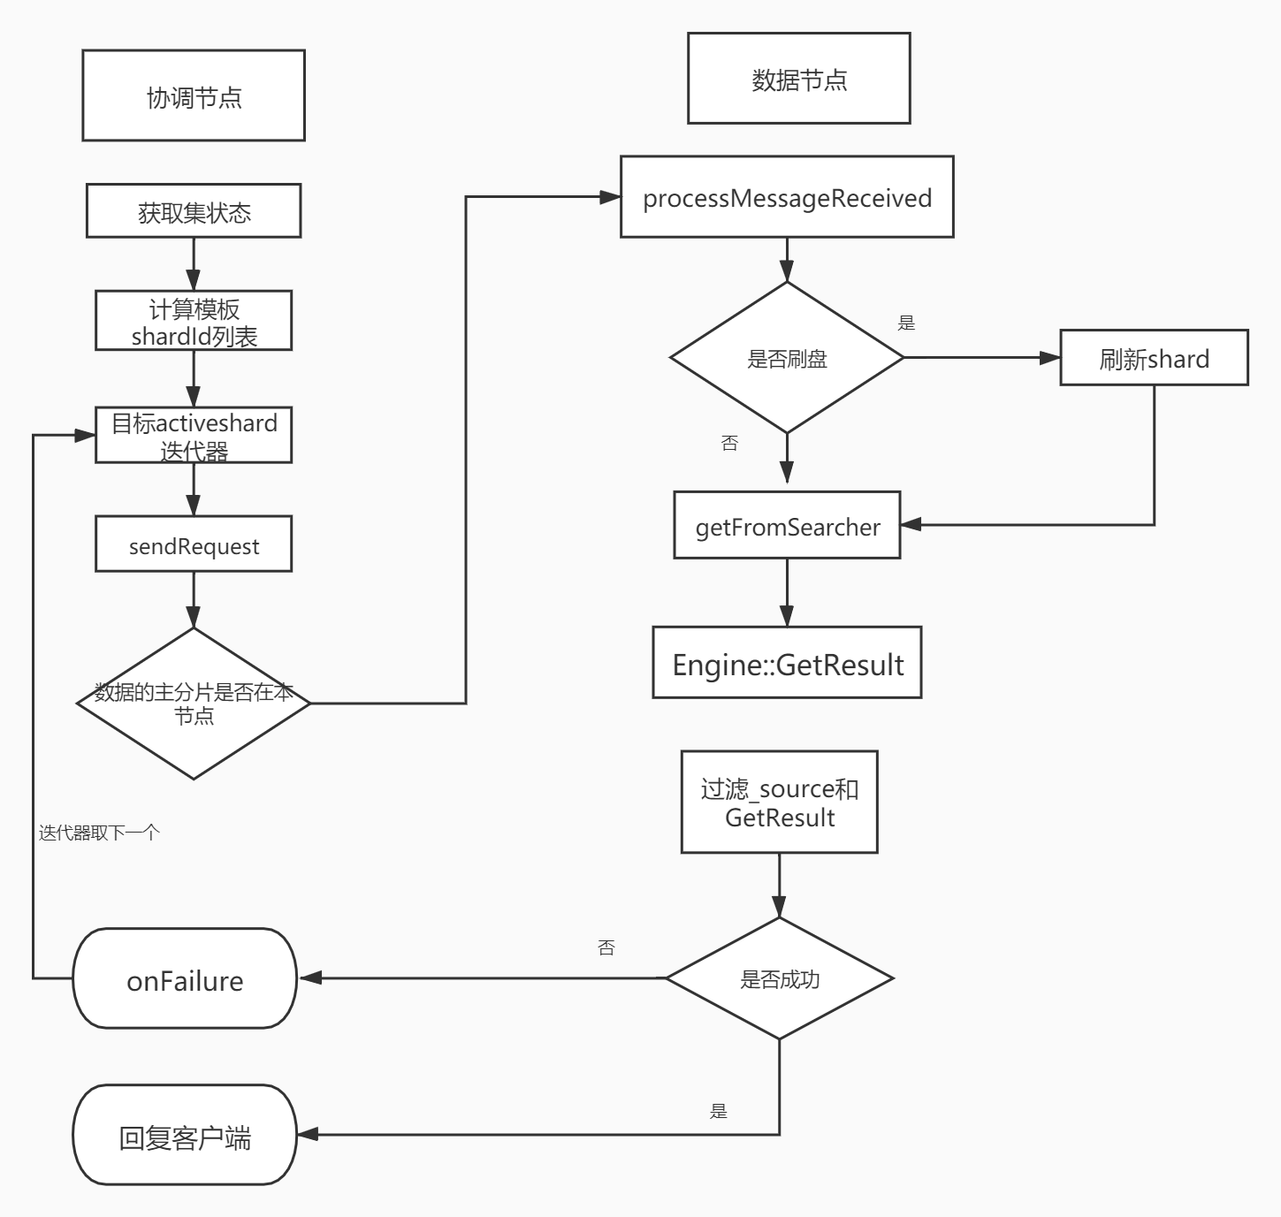

这里因为查询是有两类的，一种是GET,一个是search查询，两种的方式不太一样.这里先讲讲GET查询.下面对各个节点的处理过程进行详细分析.

协调节点.
这里首先会进入到TransportSingleShardAction#doExecute方法当中.
•
protected void doExecute(Request request, ActionListener<Response> listener) {
• new AsyncSingleAction(request, listener).start();
• }

这里一开始先执行AsyncSingleAction方法，然后执行start

2.1) 处理请求索引
- private AsyncSingleAction(Request request, ActionListener<Response> listener) {
- this.listener = listener;
- //获取集群信息
- ClusterState clusterState = clusterService.state();
- if (logger.isTraceEnabled()) {
- logger.trace("executing [{}] based on cluster state version [{}]", request, clusterState.version());
- }
- //获取node信息
- nodes = clusterState.nodes();

- ClusterBlockException blockException = checkGlobalBlock(clusterState);
- if (blockException != null) {
- throw blockException;
- }

- String concreteSingleIndex;
- if (resolveIndex(request)) {
- //获取请求的索引名称
- concreteSingleIndex = indexNameExpressionResolver.concreteSingleIndex(clusterState, request).getName();
- } else {
- concreteSingleIndex = request.index();
- }
- this.internalRequest = new InternalRequest(request, concreteSingleIndex);
- //处理请求，防止一些别名等影响.
- resolveRequest(clusterState, internalRequest);

- blockException = checkRequestBlock(clusterState, internalRequest);
- if (blockException != null) {
- throw blockException;
- }
- //计算shardId,和写流程类似.
- this.shardIt = shards(clusterState, internalRequest);
- }
这里处理完成之后，那么就会进入到start的方法里面.

这里其中resolveRequest代码如下所示:
•
protected void resolveRequest(ClusterState state, InternalRequest request) {
• IndexMetaData indexMeta = state.getMetaData().index(request.concreteIndex());
• // update the routing (request#index here is possibly an alias)
• request.request().routing(state.metaData().resolveIndexRouting(request.request().parent(), request.request().routing(), request.request().index()));
• // Fail fast on the node that received the request.
• if (request.request().routing() == null && state.getMetaData().routingRequired(request.concreteIndex(), request.request().type())) {
• throw new RoutingMissingException(request.concreteIndex(), request.request().type(), request.request().id());
• }
• }

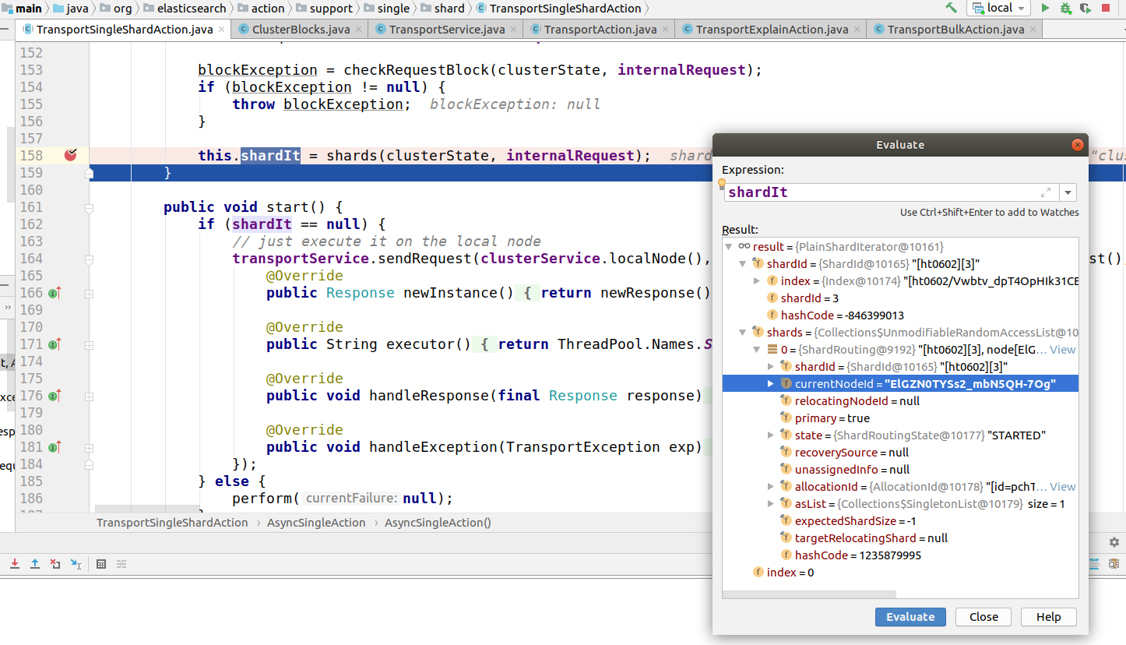
这里是上面start方法执行前，计算shardId结果.

2.2) 请求转发

- public void start() {
- if (shardIt == null) {
- // just execute it on the local node
- transportService.sendRequest(clusterService.localNode(), transportShardAction, internalRequest.request(), new TransportResponseHandler<Response>() {
- @Override
- public Response newInstance() {
- return newResponse();
- }

- @Override
- public String executor() {
- return ThreadPool.Names.SAME;
- }

- @Override
- public void handleResponse(final Response response) {
- listener.onResponse(response);
- }

- @Override
- public void handleException(TransportException exp) {
- listener.onFailure(exp);
- }
- });
- } else {
- perform(null);
- }
- }
这里perform就是里面的转发代码,下面具体查看一下

- private void perform(@Nullable final Exception currentFailure) {
- Exception lastFailure = this.lastFailure;
- if (lastFailure == null || TransportActions.isReadOverrideException(currentFailure)) {
- lastFailure = currentFailure;
- this.lastFailure = currentFailure;
- }
- final ShardRouting shardRouting = shardIt.nextOrNull();
- if (shardRouting == null) {
- Exception failure = lastFailure;
- if (failure == null || isShardNotAvailableException(failure)) {
- failure = new NoShardAvailableActionException(null, LoggerMessageFormat.format("No shard available for [{}]", internalRequest.request()), failure);
- } else {
- if (logger.isDebugEnabled()) {
- logger.debug(
- (org.apache.logging.log4j.util.Supplier<?>)
- () -> new ParameterizedMessage("{}: failed to execute [{}]", null, internalRequest.request()), failure);
- }
- }
- listener.onFailure(failure);
- return;
- }
- DiscoveryNode node = nodes.get(shardRouting.currentNodeId());
- if (node == null) {
- onFailure(shardRouting, new NoShardAvailableActionException(shardRouting.shardId()));
- } else {
- internalRequest.request().internalShardId = shardRouting.shardId();
- if (logger.isTraceEnabled()) {
- logger.trace(
- "sending request [{}] to shard [{}] on node [{}]",
- internalRequest.request(),
- internalRequest.request().internalShardId,
- node
- );
- }
- transportService.sendRequest(node, transportShardAction, internalRequest.request(), new TransportResponseHandler<Response>() {

- @Override
- public Response newInstance() {
- return newResponse();
- }

- @Override
- public String executor() {
- return ThreadPool.Names.SAME;
- }

- @Override
- public void handleResponse(final Response response) {
- listener.onResponse(response);
- }

- @Override
- public void handleException(TransportException exp) {
- onFailure(shardRouting, exp);
- }
- });
- }
- }
- }
关于这部分代码，暂时不做深入了解,和前面写流程其实原理类似的.

数据节点

3.1) 读取及过滤
这里首先代码会进入到TransportSingleShardAction下的方法.

- private class ShardTransportHandler implements TransportRequestHandler<Request> {

- @Override
- public void messageReceived(final Request request, final TransportChannel channel) throws Exception {
- if (logger.isTraceEnabled()) {
- logger.trace("executing [{}] on shard [{}]", request, request.internalShardId);
- }
- Response response = shardOperation(request, request.internalShardId);
- channel.sendResponse(response);
- }
- }
这里主要先进入到shardOperation方法里面，下面详细看下.

•
@Override
• protected GetResponse shardOperation(GetRequest request, ShardId shardId) {
• IndexService indexService = indicesService.indexServiceSafe(shardId.getIndex());
• IndexShard indexShard = indexService.getShard(shardId.id());
•
• if (request.refresh() && !request.realtime()) {
• indexShard.refresh("refresh_flag_get");
• }
•
• GetResult result = indexShard.getService().get(request.type(), request.id(), request.storedFields(),
• request.realtime(), request.version(), request.versionType(), request.fetchSourceContext());
• return new GetResponse(result);
• }

这里首先通过indicesService.indexServiceSafe返回一个索引对象，这里有一个有意思的代码.

•
public IndexService indexServiceSafe(Index index) {
• IndexService indexService = indices.get(index.getUUID());
• if (indexService == null) {
• throw new IndexNotFoundException(index);
• }
• //断言
• assert indexService.indexUUID().equals(index.getUUID()) : "uuid mismatch local: " + indexService.indexUUID() + " incoming: " + index.getUUID();
• return indexService;
• }

这里使用到了断言，也就是如果uuid不一致的话，那么就抛出异常了.关于这块感兴趣的可以自行查询资料.

然后返回对象以后就进入到indexShard.getService().get
- public GetResult get(String type, String id, String[] gFields, boolean realtime, long version, VersionType versionType, FetchSourceContext fetchSourceContext) {
- currentMetric.inc();
- try {
- long now = System.nanoTime();
- //核心代码.
- GetResult getResult = innerGet(type, id, gFields, realtime, version, versionType, fetchSourceContext);

- if (getResult.isExists()) {
- existsMetric.inc(System.nanoTime() - now);
- } else {
- missingMetric.inc(System.nanoTime() - now);
- }
- return getResult;
- } finally {
- currentMetric.dec();
- }
- }
然后这里就是进入到ShardGetService#innerGet函数中.

3.2) 通过Engine读取数据
•
private GetResult innerGet(String type, String id, String[] gFields, boolean realtime, long version, VersionType versionType, FetchSourceContext fetchSourceContext) {
• fetchSourceContext = normalizeFetchSourceContent(fetchSourceContext, gFields);
• final Collection<String> types;
//处理_all选项
• if (type == null || type.equals("_all")) {
• types = mapperService.types();
• } else {
• types = Collections.singleton(type);
• }
•
• Engine.GetResult get = null;
• for (String typeX : types) {
• Term uidTerm = mapperService.createUidTerm(typeX, id);
• if (uidTerm != null) {
//调用engine读取数据.
• get = indexShard.get(new Engine.Get(realtime, typeX, id, uidTerm)
• .version(version).versionType(versionType));
• if (get.exists()) {
• type = typeX;
• break;
• } else {
• get.release();
• }
• }
• }
•
• if (get == null || get.exists() == false) {
• return new GetResult(shardId.getIndexName(), type, id, -1, false, null, null);
• }
•
• try {
• // break between having loaded it from translog (so we only have _source), and having a document to load
• return innerGetLoadFromStoredFields(type, id, gFields, fetchSourceContext, get, mapperService);
• } finally {
• get.release();
• }
• }

这里下面主要就是indexShard.get和innerGetLoadFromStoredFields方法
那么这里get方法当中，如果进入到里面，可以找到如下代码，这段代码在InternalEngine中.
- @Override
- public GetResult get(Get get, BiFunction<String, SearcherScope, Searcher> searcherFactory) throws EngineException {
- assert Objects.equals(get.uid().field(), uidField) : get.uid().field();
- try (ReleasableLock ignored = readLock.acquire()) {
- ensureOpen();
- SearcherScope scope;
- if (get.realtime()) {
- VersionValue versionValue = versionMap.getUnderLock(get.uid().bytes());
- if (versionValue != null) {
- if (versionValue.isDelete()) {
- return GetResult.NOT_EXISTS;
- }
- if (get.versionType().isVersionConflictForReads(versionValue.version, get.version())) {
- throw new VersionConflictEngineException(shardId, get.type(), get.id(),
- get.versionType().explainConflictForReads(versionValue.version, get.version()));
- }
- //刷盘操作
- refresh("realtime_get", SearcherScope.INTERNAL);
- }
- scope = SearcherScope.INTERNAL;
- } else {
- // we expose what has been externally expose in a point in time snapshot via an explicit refresh
- scope = SearcherScope.EXTERNAL;
- }

- // no version, get the version from the index, we know that we refresh on flush
- return getFromSearcher(get, searcherFactory, scope);
- }
- }

这里get.realtime()的参数，其实就是先判断是否有数据可以刷盘，然后调用Searcher进行读取.
https://elasticsearch.cn/question/6881
关于realtime的作用，可以参考中文社区的内容.

https://blog.csdn.net/HuoqilinHeiqiji/article/details/88015560
refresh的参考资料.

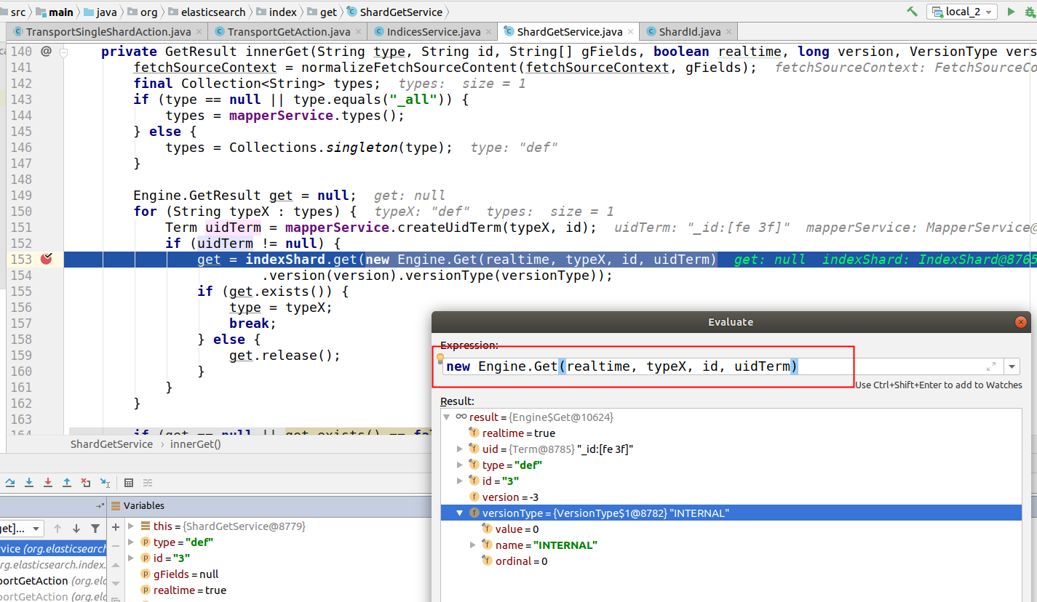

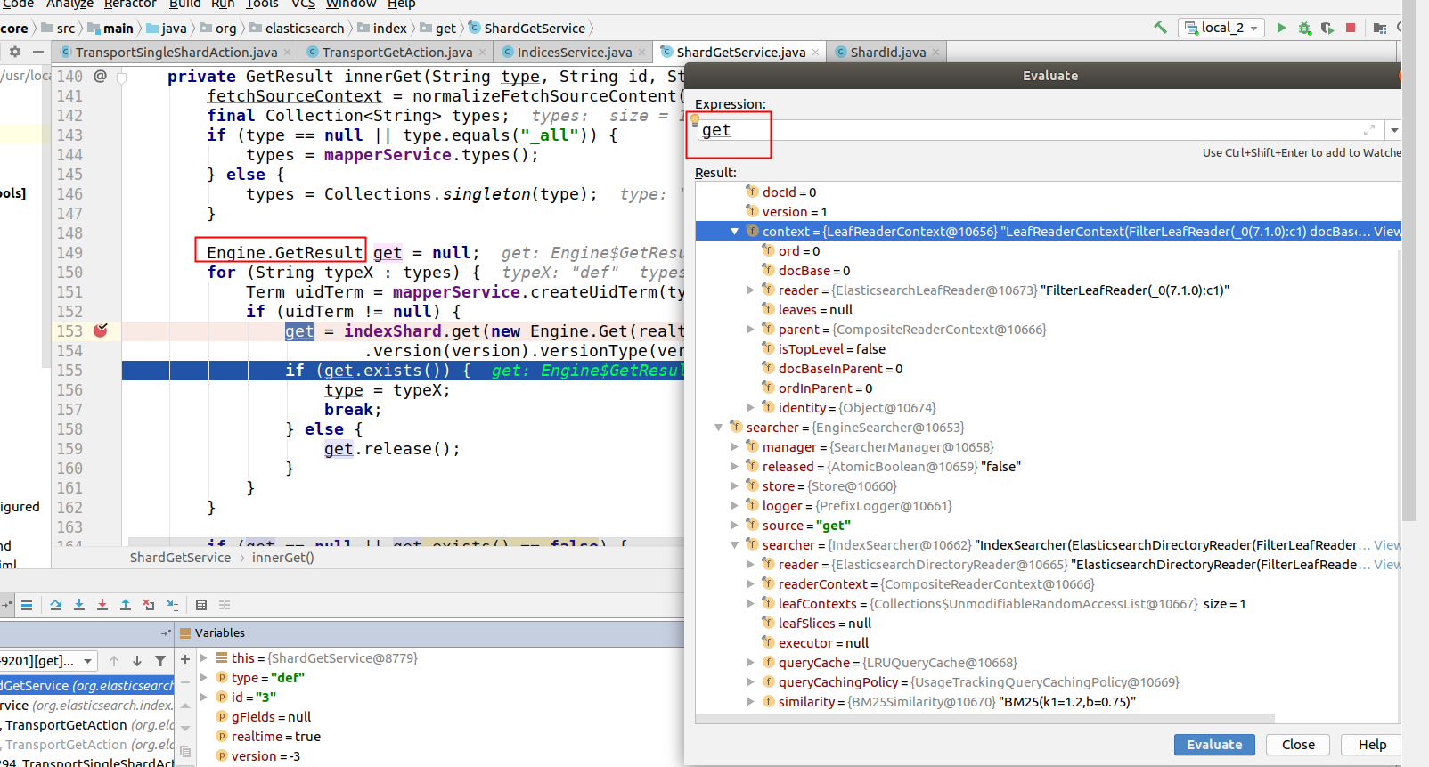
上面这两张图片就是get得到的结果

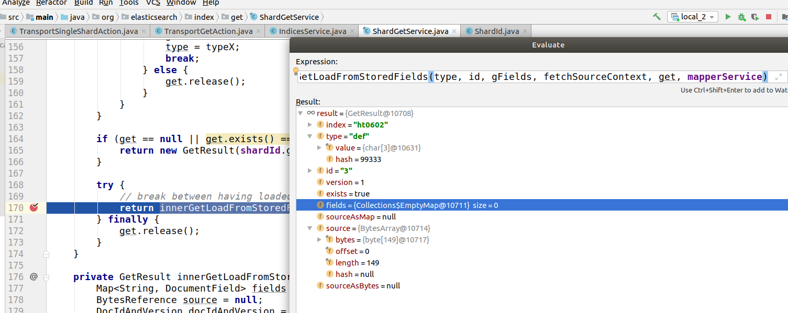
然后这里最终就是得到结果了,其中source字段里面就是查询结果.

Q&A:

关于update与realtime的联系
因此在这里也可以引出一个update的问题: update操作需要先GET再写，为了保证一致性,update调用GET时将realtime选项设置为true，并且不可配置.因此update操作可能会导致refresh生成新的Lucene分段.

