前面讲到了es的写流程，提到了全局检查点这些，那么这些内容涉及到es的数据模型pacifiA算法.

算法术语
- Replica Group: 每个索引都有主副分片，而互为副本的数据集合称为副本组.也就是每个index的primary shard和对应的replica shard为副本组.
- Configuration: 配置中心描述了一个副本组有哪些副本,primary和replica信息，包括这些分片位于哪个节点等.
- Configuration Version: 配置信息的版本号，每次发生变更时递增.
- Serial Number: 代表每个写操作的顺序，每次写操作时递增,简称SN.每个副本组维护自己的SN.
- Prepared List: 写操作的准备序列.
- Committed List: 写操作的提交序列.

算法假设与前提:
- 节点可以失效,对消息延迟的上限不做假设.
- 消息可以丢失、乱序，但是不考虑被篡改，即不存在拜占庭问题
- 网络分区可以发生，系统时钟可以不同步，但是漂移有限度.

整个系统框架主要由两部分组成: 存储管理和配置管理.

数据副本策略
这里数据写入的流程如下所示:
1) 写请求进入到primary shard节点,节点为该操作分配seq num,使用该seq num创建UpdateRequest结构，然后该UpdateRequest插入自己的prepare list.
2) 主分片节点将携带seq num的UpdateRequest发往副分片节点，从节点收到后同样插入prepare list,完成后给主分片节点回复一个ACK.
3) 一旦primary shard节点接收到从replicas shard节点的响应,确定该数据已经被正确写入所有的副分片节点，那么此时就认为可以提交了,将此UpdateRequest放入commited list中，该List向前移动.
4) 主分片节点回复客户端更新成功完成.对于没有一个prepare消息,primary shard节点向replica shard节点发送一个commit通知，告知自己的committed point位置，从replicas shard节点收到通知后根据指示移动committed point到相同到位置.

注意这里产生的seq num和checkpoint不是一个概念，虽然都是数字，但是seq num是每次写/更新操作的时候都会进行更新该数字，而checkpoint是数据刷盘的时候提交的数字，因此两者不是一个概念，而每次flush刷盘的时候,本地checkpoint就会改变了.

错误检测
分布式系统经常存在网络分区、节点离线等异常.当数据同步存在问题的时候，那么必须处理旧的主副本和新的主副本之间的问题，这里通过租约(lease)机制来解决这个问题.

主副本定期向其他从副本获取租约,这个过程中可能会产生两种情况:
- 如果主副本节点在一定时间内(lease period)未收到从副本节点的租约回复,则主副本认为从副本所在节点异常，向配置管理器汇报,将该异常从副本组中移除，同时也将自己降级，不再作为主副本节点.
- 如果从副本节点在一定时间内(grace period)未收到主副本节点的租约请求,则认为主副本异常，向配置管理器汇报，将主副本从副本组中移除，同时将自己提升为新的主.如果存在多个从副本,则哪个从副本先执行成功,哪个从副本就提升为新主.

注意这里是pacificA算法的内容，对应到ES当中.这里就是有点不一样,下面测试一下.
目的: 删除其中一个replicas shard,模拟从副本失效，查看primary shard情况.

注意这里先设置一下分片数量，主要就是为了方便，设置3个primary和2个replica.另外这里是三个节点，以端口号进行区分，分别是9200,9201和9202
这里通过GET _nodes/stats 结合配置项得到下面的节点信息.

nodeId | es-name | http.port | path.data
cLhIlS13TX2TzA6L5AswIQ | es-9200 | 9200 | /es_data
8OX6L9mhQd6bTQebnA5IkQ | es-9201 | 9201 | /es_data_2
95FDq9WsTrOSRPxwZoX9PA | es-9202 | 9202 | /es_data_3

3.1) 模拟replicas shard损坏测试
那么这里修改分片内容的请求如下所示:

- PUT _template/template_http_request_record
- {
- "index_patterns": ["*"],
- "settings": {
- "number_of_shards": 3,
- "number_of_replicas": 2
- }
- }

这里修改之后，对于已经存在的索引不会修改，需要删除索引之后再创建.

- PUT /ht052701/def/1
- {
- "name": "gaolujie yagao",
- "desc": "gaoxiao meibai",
- "price": 30,
- "producer": "gaolujie producer",
- "tags": ["meibai","fangzhu"]

- }

- =====================

- {
- "_index": "ht052701",
- "_type": "def",
- "_id": "1",
- "_version": 1,
- "result": "created",
- "_shards": {
- "total": 2,
- "successful": 2,
- "failed": 0
- },
- "_seq_no": 0,
- "_primary_term": 1
- }
这里点击多次PUT，然后可以看到，每次进行操作的时候，那么seq_no就会递增,但是只要主分片没有改变，那么这里就不会修改.

- GET /ht052701/_search_shards

- =========================
- {
- "nodes": {
- "8OX6L9mhQd6bTQebnA5IkQ": {
- "name": "es-9201",
- "ephemeral_id": "gGrYIq3HTiapPovAlRrfLg",
- "transport_address": "127.0.0.1:9300",
- "attributes": {}
- },
- "cLhIlS13TX2TzA6L5AswIQ": {
- "name": "es-9200",
- "ephemeral_id": "avi_8eY-Tsy5iG8yZ5r3Hw",
- "transport_address": "127.0.0.1:9302",
- "attributes": {}
- },
- "95FDq9WsTrOSRPxwZoX9PA": {
- "name": "es-9202",
- "ephemeral_id": "Mj9ZuRnKRB-gBxRYddRcTw",
- "transport_address": "127.0.0.1:9301",
- "attributes": {}
- }
- },
- "indices": {
- "ht052701": {}
- },
- "shards": [
- [
- {
- "state": "STARTED",
- "primary": false,
- "node": "95FDq9WsTrOSRPxwZoX9PA",
- "relocating_node": null,
- "shard": 0,
- "index": "ht052701",
- "allocation_id": {
- "id": "C2z7LX0wRkSWVJhIJm5ggg"
- }
- },
- {
- "state": "STARTED",
- "primary": true,
- "node": "8OX6L9mhQd6bTQebnA5IkQ",
- "relocating_node": null,
- "shard": 0,
- "index": "ht052701",
- "allocation_id": {
- "id": "LzvP9ElHSy-MKrFz9rztpQ"
- }
- },
- {
- "state": "STARTED",
- "primary": false,
- "node": "cLhIlS13TX2TzA6L5AswIQ",
- "relocating_node": null,
- "shard": 0,
- "index": "ht052701",
- "allocation_id": {
- "id": "P53vyVQPRXG5iCrF5wBgog"
- }
- }
- ],
- [
- {
- "state": "STARTED",
- "primary": false,
- "node": "95FDq9WsTrOSRPxwZoX9PA",
- "relocating_node": null,
- "shard": 1,
- "index": "ht052701",
- "allocation_id": {
- "id": "6vBgWWzgSzCepJLTQP_PUw"
- }
- },
- {
- "state": "STARTED",
- "primary": false,
- "node": "8OX6L9mhQd6bTQebnA5IkQ",
- "relocating_node": null,
- "shard": 1,
- "index": "ht052701",
- "allocation_id": {
- "id": "LnrVmmgtTOefqB6kDR5YFQ"
- }
- },
- {
- "state": "STARTED",
- "primary": true,
- "node": "cLhIlS13TX2TzA6L5AswIQ",
- "relocating_node": null,
- "shard": 1,
- "index": "ht052701",
- "allocation_id": {
- "id": "uIdLy1pdQJehr53He_QtOw"
- }
- }
- ],
- [
- {
- "state": "STARTED",
- "primary": true,
- "node": "95FDq9WsTrOSRPxwZoX9PA",
- "relocating_node": null,
- "shard": 2,
- "index": "ht052701",
- "allocation_id": {
- "id": "6y1Jc1psQX6K2d4x8JCeTw"
- }
- },
- {
- "state": "STARTED",
- "primary": false,
- "node": "8OX6L9mhQd6bTQebnA5IkQ",
- "relocating_node": null,
- "shard": 2,
- "index": "ht052701",
- "allocation_id": {
- "id": "OyadGo19T1OBZtj2ngkvcQ"
- }
- },
- {
- "state": "STARTED",
- "primary": false,
- "node": "cLhIlS13TX2TzA6L5AswIQ",
- "relocating_node": null,
- "shard": 2,
- "index": "ht052701",
- "allocation_id": {
- "id": "P_cbJG8ZQu275SoojRDRBA"
- }
- }
- ]
- ]
- }

那么这里找一个primary为false的shard进行删除，这里找最后一个.
可以看到这里的node是uWjTZp6pTJiB8M0j7qdgvA,同时这里的shardId为2

- GET _cat/indices?v

- ========================

- health status index uuid pri rep docs.count docs.deleted store.size pri.store.size
- green open ht052701 gsAXK186SI6B4kWo00ssAg 3 2 1 0 18.2kb 6kb

这里如果有多个索引的话，还需要知道当前的索引所对应的uuid.
那么这里默认只有一个索引,因此直接查看.

那么这里如果要删除id为P_cbJG8ZQu275SoojRDRBA的数据，那么这里
那么从表格可以知道，只要删除掉2目录，那么就是对应的replicas shard内容了.

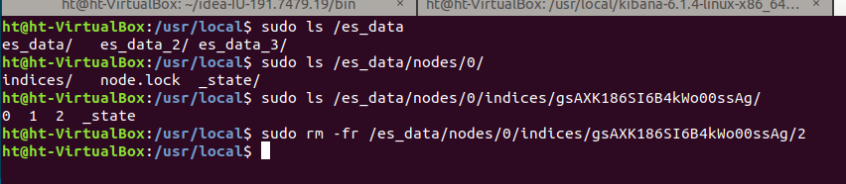
另外这里再执行一下前面的PUT数据操作,这里也就是/ht052701/def/1

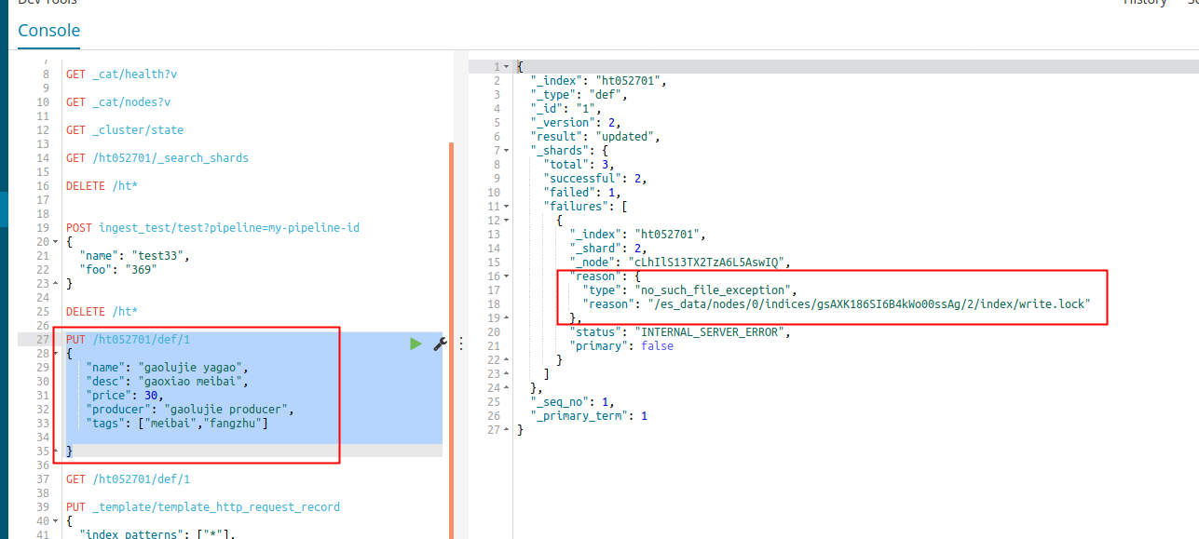
然后这里执行的时候，因为恰好id为1的数据根据前面的写流程可以知道这里的shardId为2,那么这里再次执行的时候，第一次会报错.

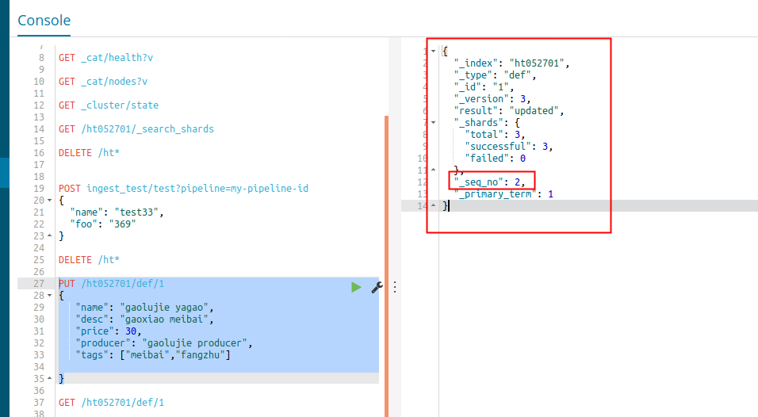

然后这里再次执行就好了.
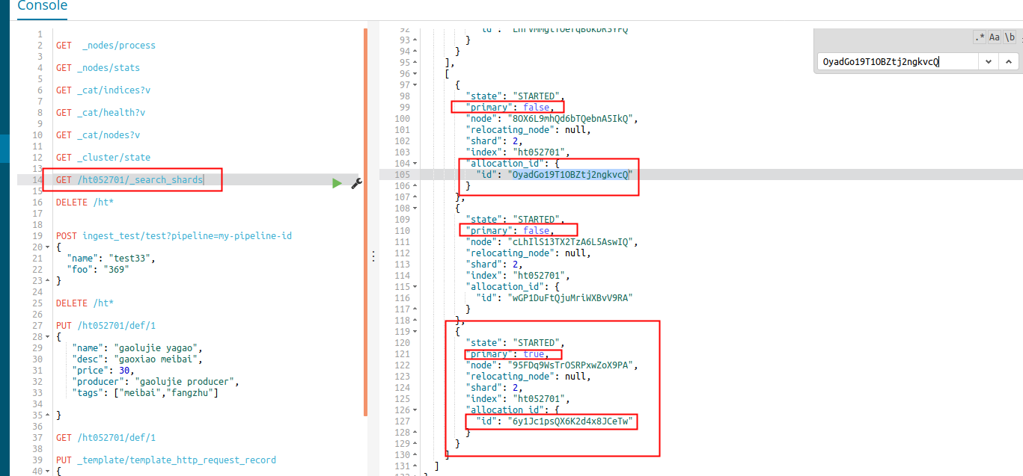

那么这里可以看到最后一组的副本情况，可以看到primary shard的id并没有变,同时另外一个replicas shard也没有变.

3.2) 模拟primary shard损坏测试
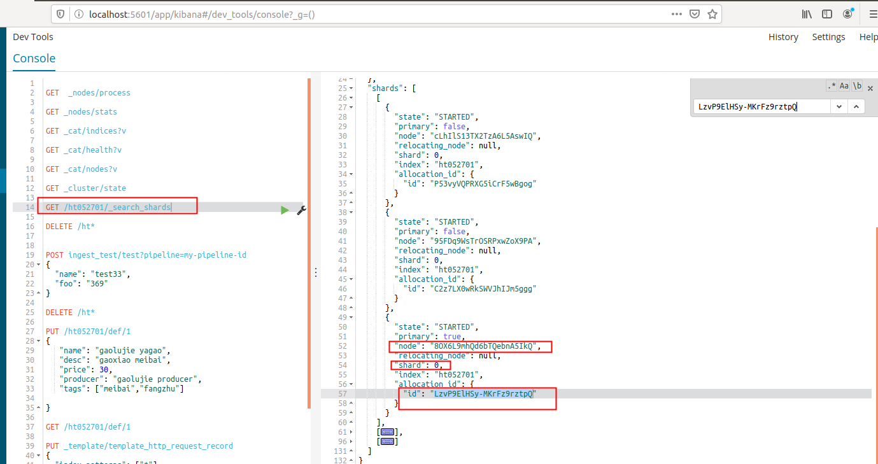

然后这里考虑干掉这个primary shard分片的内容.

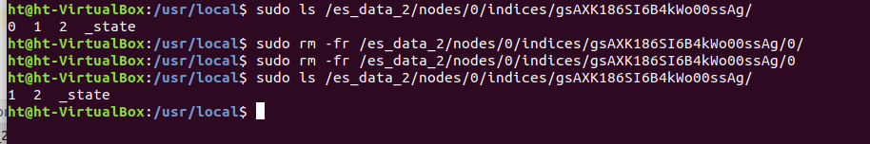
然后接下来写入一个数据PUT /ht052701/def/2,这里根据shardId的规则可以知道会分到0分片里面的.
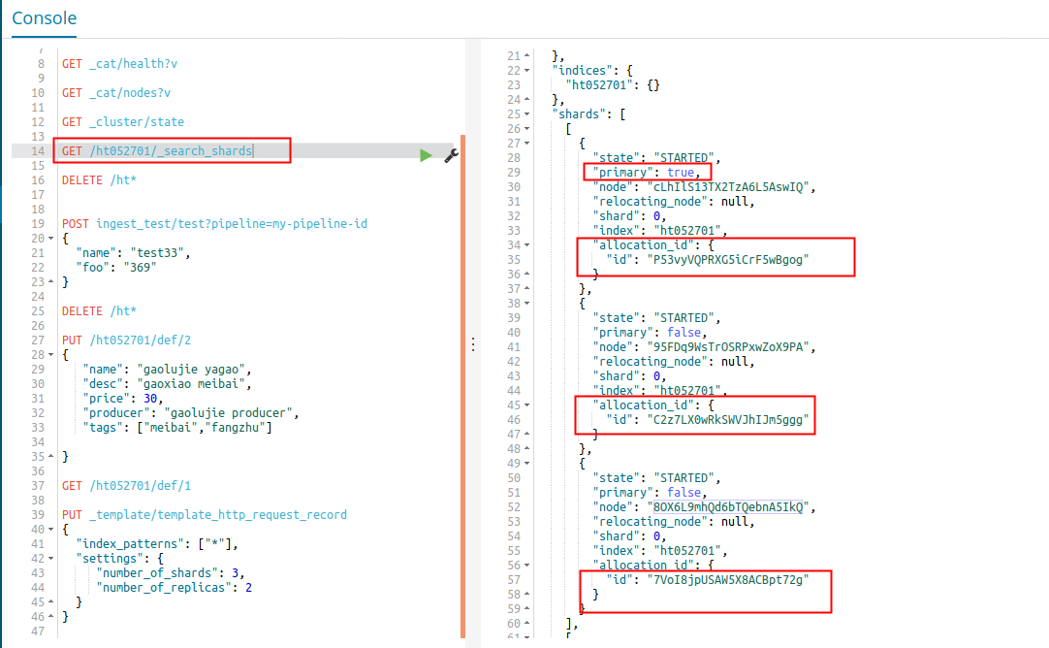

这里可以看到就是把其中一个副本提升为primary shard了.

注意这里关于主副分片的分配问题，属于Allocation模块的内容，这里放到后面来讲解.
也就是关于分片分配到哪里，给哪个节点分配的问题.

Allocation IDs机制
ES从5.x版本开始引入了这个机制的概念，用于主分片选举策略.每个分片有自己唯一的Allocation IDs,同时集群元信息中有一个列表,记录了哪些分片拥有最新数据.

在更早期版本当中,选举主分片的时候，是从已知的分片当中选择版本数最高的分片作为主分片，但是这样带来的一个问题就是，当只有一个分片活跃的时候，那么一定会被选为主分片，也就是例如在极端情况下，当所有节点重启的时候，如果当前恰好在选举分片时，其他节点都没有启动，那么这时候就会选举该节点的分片了.

Allocation IDs由主节点在分片分配时指定,并由数据节点存储在磁盘中.Master节点负责追踪包含最新数据副本的子集,这些副本集合称为同步分片标识(in-syncallocation IDs),存储于集群状态中.

也就是说,Allocation IDs存储在shard级元数据信息中,每个shard都有自己唯一的Allocation IDs,同时集群级元信息中记录了一个被认为是最新shard的Allocation ID集合.
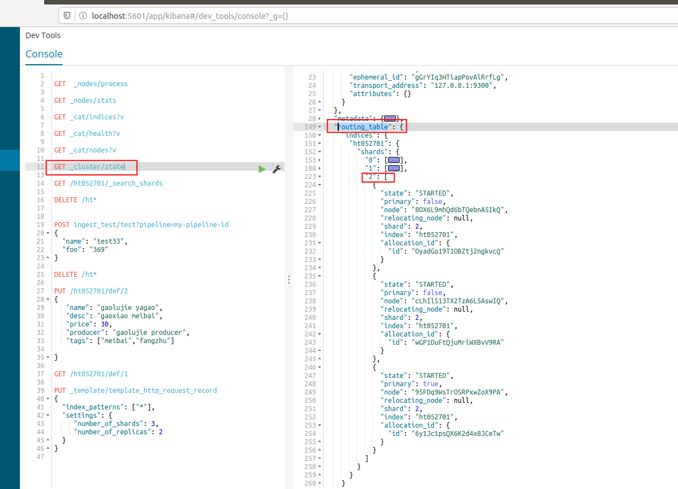

如果当写入数据的时候，主分片本地执行完写操作，然后转发到副分片时，操作有未成功的，那么这时候有两种解决办法:

- 让写请求失败,已经写的做回滚处理.
- 确保差异的分片不再被视为同步.

ES在这里的处理(默认失败的副分片没有达到半数以上)选择写入可用性: 主分片所在节点命令主节点将差异分片的Allocation IDs从同步集合(in-sync set)中删除.然后,主分片所在节点等待主节点删除成功的确认消息,这个确认消息意味着集群一致层已更新成功,之后才向客户端确认写请求,这样确保了只有包含所有已确认写入的分片副本才会被主节点选为主分片.

- GET _cluster/state?filter_path=metadata.indices.ht052701.in_sync_allocations.*

- ======================

- {
- "metadata": {
- "indices": {
- "ht052701": {
- "in_sync_allocations": {
- "0": [
- "7VoI8jpUSAW5X8ACBpt72g",
- "C2z7LX0wRkSWVJhIJm5ggg",
- "P53vyVQPRXG5iCrF5wBgog"
- ],
- "1": [
- "LnrVmmgtTOefqB6kDR5YFQ",
- "uIdLy1pdQJehr53He_QtOw",
- "6vBgWWzgSzCepJLTQP_PUw"
- ],
- "2": [
- "OyadGo19T1OBZtj2ngkvcQ",
- "wGP1DuFtQjuMriWXBvV9RA",
- "6y1Jc1psQX6K2d4x8JCeTw"
- ]
- }
- }
- }
- }
- }

如果想看更加具体的信息，可以在请求后面添加一些内容.
GET _cluster/state?filter_path=metadata.indices.ht052701.in_sync_allocations.*,routing_table.indices.ht052701.*

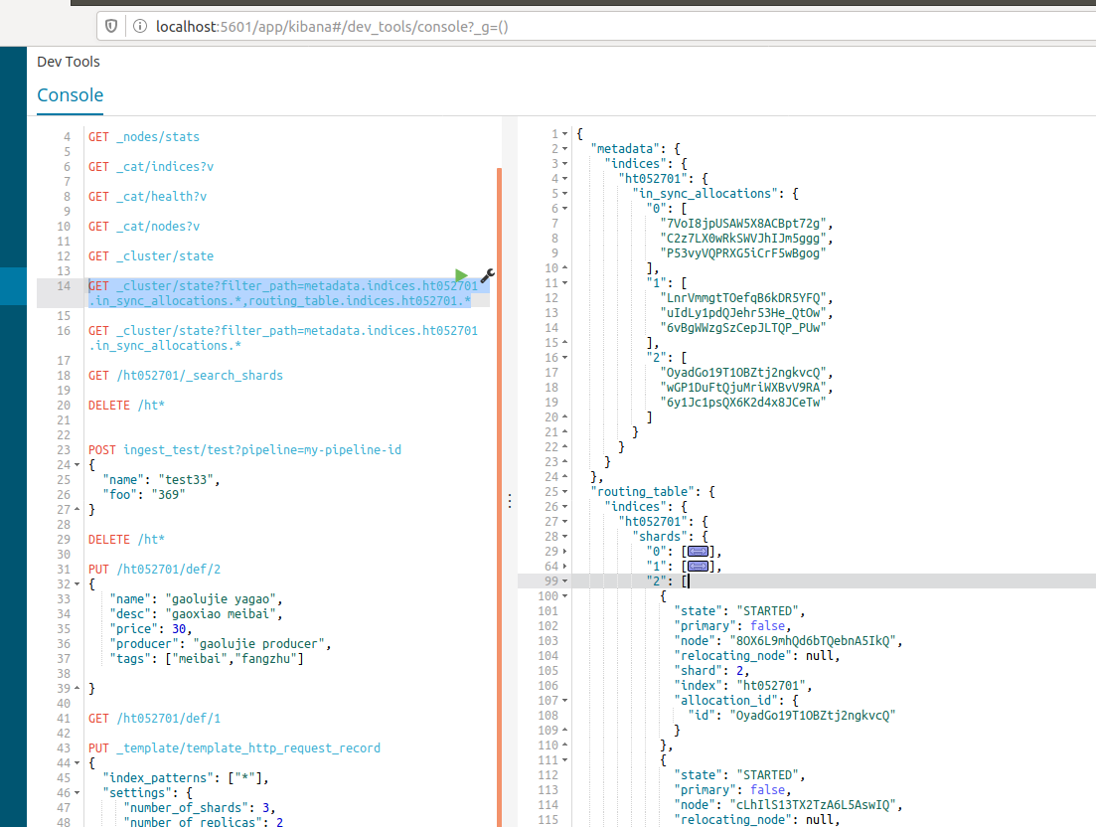

这个命令会添加上分片路由表信息内容.

4.1) 模拟主节点宕机恢复情况.

- PUT /ht052701/def/1
- {
- "name": "gaolujie yagao",
- "desc": "gaoxiao meibai",
- "price": 30,
- "producer": "gaolujie producer",
- "tags": ["meibai","fangzhu"]

- }

- =========================

- {
- "_index": "ht052701",
- "_type": "def",
- "_id": "1",
- "_version": 4,
- "result": "updated",
- "_shards": {
- "total": 3,
- "successful": 3,
- "failed": 0
- },
- "_seq_no": 3,
- "_primary_term": 1
- }

这里先插入一条数据，保证先记录好_seq_no和primary_term,关于这两个数值的作用，后面会用到.

- GET _cat/nodes?v

- ip heap.percent ram.percent cpu load_1m load_5m load_15m node.role master name
- 127.0.0.1 16 57 1 0.14 0.09 0.11 mdi - es-9202
- 127.0.0.1 16 57 1 0.14 0.09 0.11 mdi - es-9200
- 127.0.0.1 8 57 1 0.14 0.09 0.11 mdi * es-9201

然后使用命令查看一下当前哪个节点是master节点.

- GET _cluster/state?filter_path=metadata.indices.ht052701.in_sync_allocations.*,routing_table.indices.ht052701.*

- ===================================================

- {
- "metadata": {
- "indices": {
- "ht052701": {
- "in_sync_allocations": {
- "0": [
- "7VoI8jpUSAW5X8ACBpt72g",
- "C2z7LX0wRkSWVJhIJm5ggg",
- "P53vyVQPRXG5iCrF5wBgog"
- ],
- "1": [
- "LnrVmmgtTOefqB6kDR5YFQ",
- "uIdLy1pdQJehr53He_QtOw",
- "6vBgWWzgSzCepJLTQP_PUw"
- ],
- "2": [
- "OyadGo19T1OBZtj2ngkvcQ",
- "wGP1DuFtQjuMriWXBvV9RA",
- "6y1Jc1psQX6K2d4x8JCeTw"
- ]
- }
- }
- }
- },
- "routing_table": {
- "indices": {
- "ht052701": {
- "shards": {
- "0": [
- {
- "state": "STARTED",
- "primary": false,
- "node": "8OX6L9mhQd6bTQebnA5IkQ",
- "relocating_node": null,
- "shard": 0,
- "index": "ht052701",
- "allocation_id": {
- "id": "7VoI8jpUSAW5X8ACBpt72g"
- }
- },
- {
- "state": "STARTED",
- "primary": true,
- "node": "cLhIlS13TX2TzA6L5AswIQ",
- "relocating_node": null,
- "shard": 0,
- "index": "ht052701",
- "allocation_id": {
- "id": "P53vyVQPRXG5iCrF5wBgog"
- }
- },
- {
- "state": "STARTED",
- "primary": false,
- "node": "95FDq9WsTrOSRPxwZoX9PA",
- "relocating_node": null,
- "shard": 0,
- "index": "ht052701",
- "allocation_id": {
- "id": "C2z7LX0wRkSWVJhIJm5ggg"
- }
- }
- ],
- "1": [
- {
- "state": "STARTED",
- "primary": false,
- "node": "8OX6L9mhQd6bTQebnA5IkQ",
- "relocating_node": null,
- "shard": 1,
- "index": "ht052701",
- "allocation_id": {
- "id": "LnrVmmgtTOefqB6kDR5YFQ"
- }
- },
- {
- "state": "STARTED",
- "primary": true,
- "node": "cLhIlS13TX2TzA6L5AswIQ",
- "relocating_node": null,
- "shard": 1,
- "index": "ht052701",
- "allocation_id": {
- "id": "uIdLy1pdQJehr53He_QtOw"
- }
- },
- {
- "state": "STARTED",
- "primary": false,
- "node": "95FDq9WsTrOSRPxwZoX9PA",
- "relocating_node": null,
- "shard": 1,
- "index": "ht052701",
- "allocation_id": {
- "id": "6vBgWWzgSzCepJLTQP_PUw"
- }
- }
- ],
- "2": [
- {
- "state": "STARTED",
- "primary": false,
- "node": "8OX6L9mhQd6bTQebnA5IkQ",
- "relocating_node": null,
- "shard": 2,
- "index": "ht052701",
- "allocation_id": {
- "id": "OyadGo19T1OBZtj2ngkvcQ"
- }
- },
- {
- "state": "STARTED",
- "primary": false,
- "node": "cLhIlS13TX2TzA6L5AswIQ",
- "relocating_node": null,
- "shard": 2,
- "index": "ht052701",
- "allocation_id": {
- "id": "wGP1DuFtQjuMriWXBvV9RA"
- }
- },
- {
- "state": "STARTED",
- "primary": true,
- "node": "95FDq9WsTrOSRPxwZoX9PA",
- "relocating_node": null,
- "shard": 2,
- "index": "ht052701",
- "allocation_id": {
- "id": "6y1Jc1psQX6K2d4x8JCeTw"
- }
- }
- ]
- }
- }
- }
- }
- }
同时这里结合GET _nodes/stats结果可以知道,master节点所在的nodeId为
8OX6L9mhQd6bTQebnA5IkQ

那么下面就断掉master节点的程序.

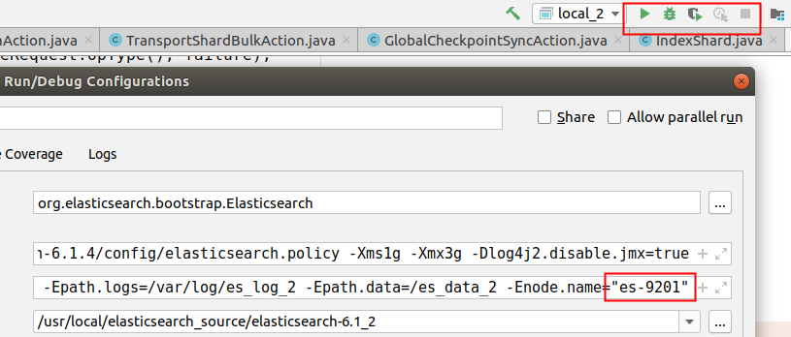

那么这时候再去查看一下情况.

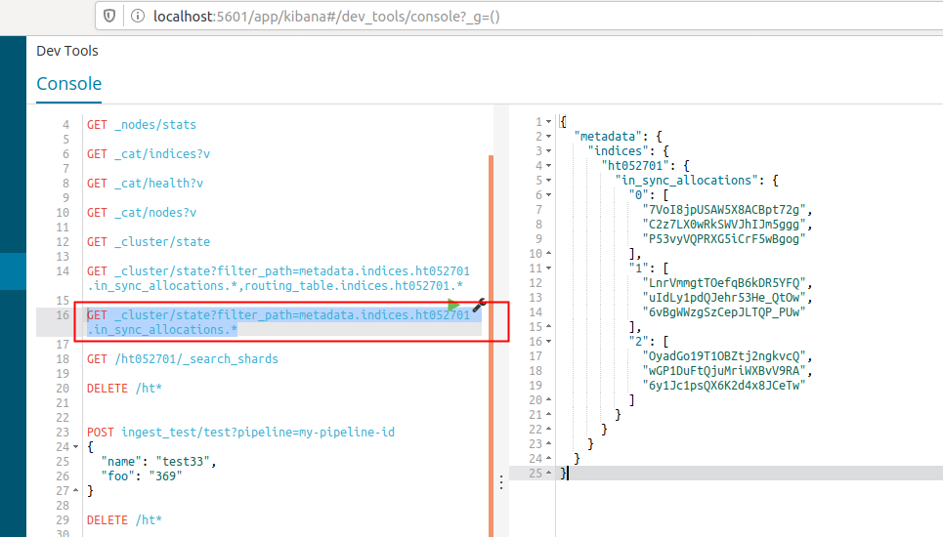
如果这时候没有插入数据,那么可以看到这里的情况还是没变的.

- PUT /ht052701/def/1
- {
- "name": "gaolujie yagao",
- "desc": "gaoxiao meibai",
- "price": 30,
- "producer": "gaolujie producer",
- "tags": ["meibai","fangzhu"]

- }

- ==============

- {
- "_index": "ht052701",
- "_type": "def",
- "_id": "1",
- "_version": 5,
- "result": "updated",
- "_shards": {
- "total": 3,
- "successful": 2,
- "failed": 0
- },
- "_seq_no": 4,
- "_primary_term": 1
- }

这里插入更新数据，会发现_primary_term是没有变化的，但是如果这里换一个id,变成一个之前没有生成过的数据,如id为4的，那么这里得到的结果如下所示:
- PUT /ht052701/def/4
- {
- "name": "gaolujie yagao",
- "desc": "gaoxiao meibai",
- "price": 30,
- "producer": "gaolujie producer",
- "tags": ["meibai","fangzhu"]

- }

- =========================

- {
- "_index": "ht052701",
- "_type": "def",
- "_id": "4",
- "_version": 1,
- "result": "created",
- "_shards": {
- "total": 3,
- "successful": 2,
- "failed": 0
- },
- "_seq_no": 2,
- "_primary_term": 2
- }

可以看到这里的数据_primary_term已经变为2了，这说明现在主分片已经切换了.
- GET _cluster/state?filter_path=metadata.indices.ht052701.in_sync_allocations.*

- {
- "metadata": {
- "indices": {
- "ht052701": {
- "in_sync_allocations": {
- "0": [
- "C2z7LX0wRkSWVJhIJm5ggg",
- "P53vyVQPRXG5iCrF5wBgog"
- ],
- "1": [
- "LnrVmmgtTOefqB6kDR5YFQ",
- "uIdLy1pdQJehr53He_QtOw",
- "6vBgWWzgSzCepJLTQP_PUw"
- ],
- "2": [
- "wGP1DuFtQjuMriWXBvV9RA",
- "6y1Jc1psQX6K2d4x8JCeTw"
- ]
- }
- }
- }
- }
- }

这里可以看到allocations已经改变了.这里注意是只有部分id的会改变.
关于这部分原因还有待验证.

这里还做了第二次试验，具体内容可以见文档.

4.2) 模拟单主分片实验.

因为上面的实验，master节点中也有数据,因此为了减少干扰，下面做一个更加简单的实验,就是一个master,两个data.
这里规范一下.

nodeId | es-name | http.port | path.data | 属性
5zCedNTxR3-pm4YN81w-sg | es-9200 | 9200 | /es_data | master
tB-kRxzWQvq7l0pkywT1lw | es-9201 | 9201 | /es_data_2 | data
P5IjmjsQQkmUj91tjQM4UA | es-9202 | 9202 | /es_data_3 | data

注意,这里master的话要添加设置
node.master:true
node.data: false
而data节点则相反.

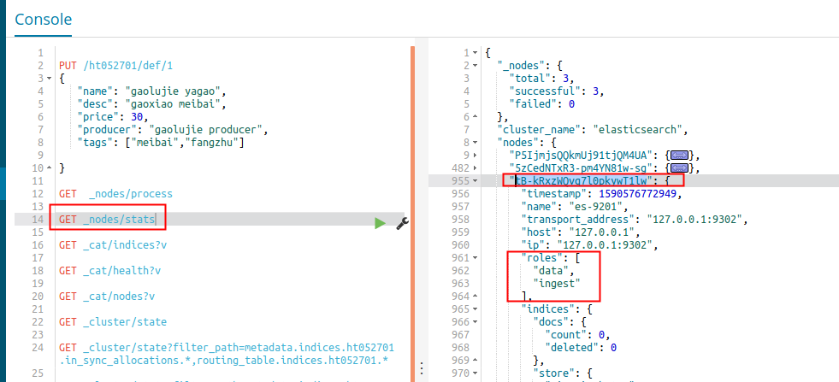
这里可以看到节点的属性,没有了master属性.

- PUT _template/template_http_request_record
- {
- "index_patterns": ["*"],
- "settings": {
- "number_of_shards": 1,
- "number_of_replicas": 1
- }
- }

这里因为只有两个data节点，因此这里主副分片都设置为1.

- PUT /ht052701/def/1
- {
- "name": "gaolujie yagao",
- "desc": "gaoxiao meibai",
- "price": 30,
- "producer": "gaolujie producer",
- "tags": ["meibai","fangzhu"]

- }

- ==================

- {
- "_index": "ht052701",
- "_type": "def",
- "_id": "1",
- "_version": 1,
- "result": "created",
- "_shards": {
- "total": 2,
- "successful": 1,
- "failed": 0
- },
- "_seq_no": 0,
- "_primary_term": 1
- }

然后下面查看一下分片的情况
- GET /ht052701/_search_shards

- ======================
- {
- "nodes": {
- "P5IjmjsQQkmUj91tjQM4UA": {
- "name": "es-9202",
- "ephemeral_id": "PUV9W57XQmabV95IWUKrdQ",
- "transport_address": "127.0.0.1:9300",
- "attributes": {}
- },
- "tB-kRxzWQvq7l0pkywT1lw": {
- "name": "es-9201",
- "ephemeral_id": "8izxwATeRuqFpaBDTLz72w",
- "transport_address": "127.0.0.1:9302",
- "attributes": {}
- }
- },
- "indices": {
- "ht052701": {}
- },
- "shards": [
- [
- {
- "state": "STARTED",
- "primary": true,
- "node": "P5IjmjsQQkmUj91tjQM4UA",
- "relocating_node": null,
- "shard": 0,
- "index": "ht052701",
- "allocation_id": {
- "id": "B4gSWsJwRFiuIRYUocgwkQ"
- }
- },
- {
- "state": "STARTED",
- "primary": false,
- "node": "tB-kRxzWQvq7l0pkywT1lw",
- "relocating_node": null,
- "shard": 0,
- "index": "ht052701",
- "allocation_id": {
- "id": "40iizsK-QfCf-uuotspyiQ"
- }
- }
- ]
- ]
- }
然后这里停掉priamry shard所在的节点.这里也就是es-9202
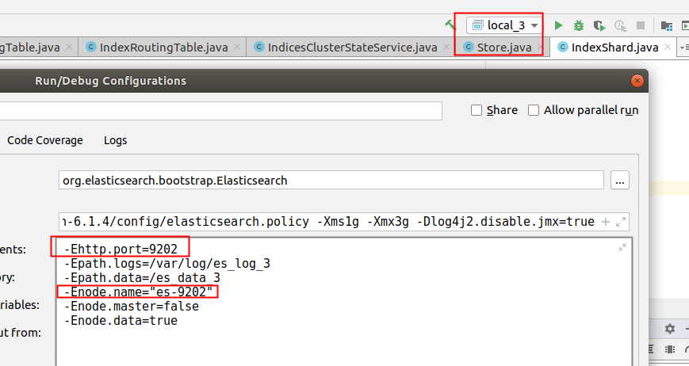

然后这时候再次查看一下索引分片情况.
这里查询的语法如下所示:
GET _cluster/state?filter_path=metadata.indices.ht052701.in_sync_allocations.*,routing_table.indices.ht052701.*

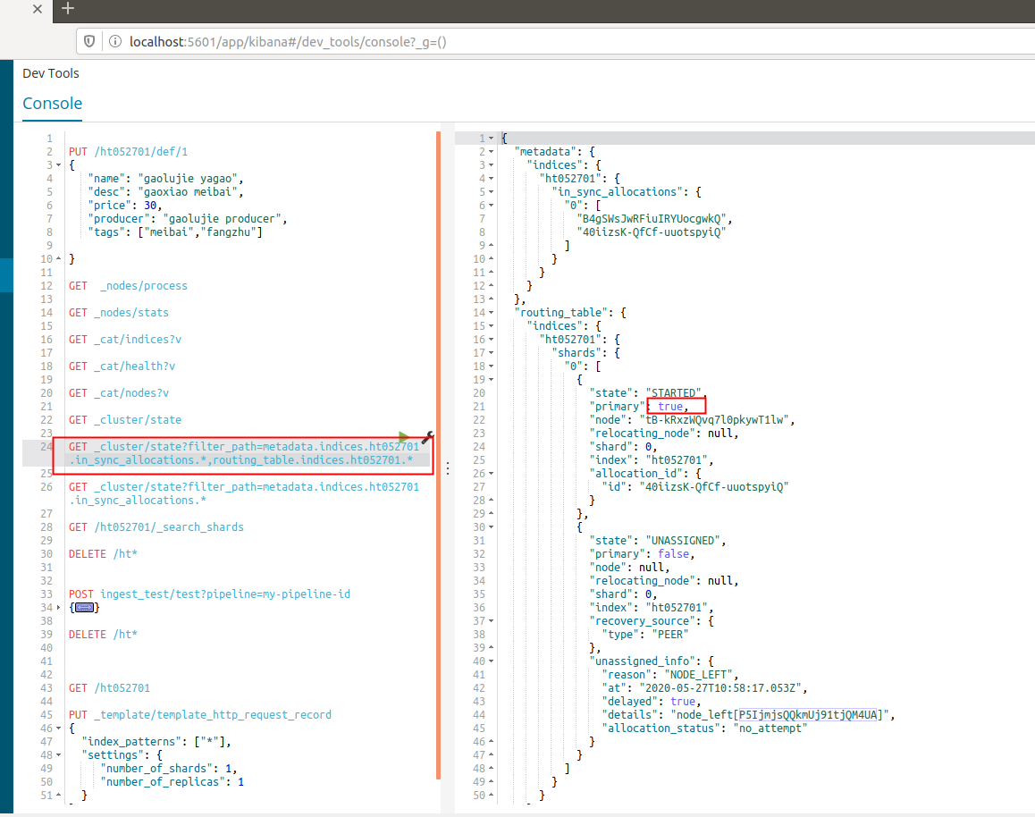

因为这里只有一个数据节点，因此这里副分片并没有分配,也就是有unassigned_info信息.
但是这里还是可以看到in_sync_allocations里面还是有两个数据，因为这里并没有新的数据插入.

- PUT /ht052701/def/1
- {
- "name": "gaolujie yagao",
- "desc": "gaoxiao meibai",
- "price": 31,
- "producer": "gaolujie producer",
- "tags": ["meibai","fangzhu"]

- }

- =========================================

- {
- "_index": "ht052701",
- "_type": "def",
- "_id": "1",
- "_version": 2,
- "result": "updated",
- "_shards": {
- "total": 2,
- "successful": 1,
- "failed": 0
- },
- "_seq_no": 1,
- "_primary_term": 2
- }

然后这里就可以明显看到_primary_term改变了.这里是更新了数据.

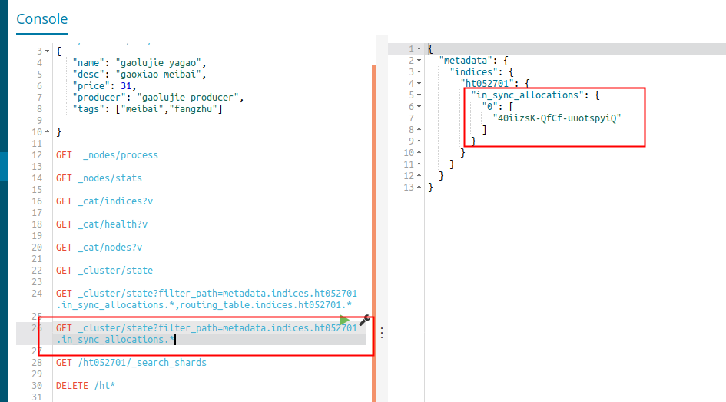

可以看到这里就只剩下一个allocations ids了.而routings数据则和之前的没有变化.

然后这时候，就先关闭掉唯一的数据节点，然后启动之前关闭的数据节点.

- GET _cat/health?v

- =========================

- epoch timestamp cluster status node.total node.data shards pri relo init unassign pending_tasks max_task_wait_time active_shards_percent
- 1590577903 19:11:43 elasticsearch red 2 1 0 0 0 0 2 0 - 0.0%

然后这里就可以看到节点一直是red状态了.

•
GET /_cluster/allocation/explain
•
• {
• "index": "ht052701",
• "shard": 0,
• "primary": true,
• "current_state": "unassigned",
• "unassigned_info": {
• "reason": "CLUSTER_RECOVERED",
• "at": "2020-05-27T11:11:07.764Z",
• "last_allocation_status": "no_valid_shard_copy"
• },
• "can_allocate": "no_valid_shard_copy",
• "allocate_explanation": "cannot allocate because all found copies of the shard are either stale or corrupt",
• "node_allocation_decisions": [
• {
• "node_id": "P5IjmjsQQkmUj91tjQM4UA",
• "node_name": "es-9202",
• "transport_address": "127.0.0.1:9300",
• "node_decision": "no",
• "store": {
• "in_sync": false,
• "allocation_id": "B4gSWsJwRFiuIRYUocgwkQ"
• }
• }
• ]
• }

这里可以看到无法分配的原因是因为副本的数据很久了.

- POST /_cluster/reroute
- {
- "commands" : [ {
- "allocate_stale_primary" :
- {
- "index" : "ht052701",
- "shard" : 0,
- "node" : "es-9202",
- "accept_data_loss" : true
- }
- }
- ]
- }

- ========================

- {
- "acknowledged": true,
- "state": {
- "version": 3,
- "state_uuid": "Pll_24CfStyQshCWdxMfcw",
- "master_node": "5zCedNTxR3-pm4YN81w-sg",
- "blocks": {},
- "nodes": {
- "5zCedNTxR3-pm4YN81w-sg": {
- "name": "es-9200",
- "ephemeral_id": "4fveK-XjRuuggX3ZJwUsnA",
- "transport_address": "127.0.0.1:9301",
- "attributes": {}
- },
- "P5IjmjsQQkmUj91tjQM4UA": {
- "name": "es-9202",
- "ephemeral_id": "LtnUlGxjQA2rS84emSpoAQ",
- "transport_address": "127.0.0.1:9300",
- "attributes": {}
- }
- },
- "routing_table": {
- "indices": {
- "ht052701": {
- "shards": {
- "0": [
- {
- "state": "INITIALIZING",
- "primary": true,
- "node": "P5IjmjsQQkmUj91tjQM4UA",
- "relocating_node": null,
- "shard": 0,
- "index": "ht052701",
- "recovery_source": {
- "type": "EXISTING_STORE"
- },
- "allocation_id": {
- "id": "VN-TqhKuSZ6vJDr_ey86iw"
- },
- "unassigned_info": {
- "reason": "CLUSTER_RECOVERED",
- "at": "2020-05-27T11:11:07.764Z",
- "delayed": false,
- "allocation_status": "no_valid_shard_copy"
- }
- },
- {
- "state": "UNASSIGNED",
- "primary": false,
- "node": null,
- "relocating_node": null,
- "shard": 0,
- "index": "ht052701",
- "recovery_source": {
- "type": "PEER"
- },
- "unassigned_info": {
- "reason": "CLUSTER_RECOVERED",
- "at": "2020-05-27T11:11:07.764Z",
- "delayed": false,
- "allocation_status": "no_attempt"
- }
- }
- ]
- }
- }
- }
- },
- "routing_nodes": {
- "unassigned": [
- {
- "state": "UNASSIGNED",
- "primary": false,
- "node": null,
- "relocating_node": null,
- "shard": 0,
- "index": "ht052701",
- "recovery_source": {
- "type": "PEER"
- },
- "unassigned_info": {
- "reason": "CLUSTER_RECOVERED",
- "at": "2020-05-27T11:11:07.764Z",
- "delayed": false,
- "allocation_status": "no_attempt"
- }
- }
- ],
- "nodes": {
- "P5IjmjsQQkmUj91tjQM4UA": [
- {
- "state": "INITIALIZING",
- "primary": true,
- "node": "P5IjmjsQQkmUj91tjQM4UA",
- "relocating_node": null,
- "shard": 0,
- "index": "ht052701",
- "recovery_source": {
- "type": "EXISTING_STORE"
- },
- "allocation_id": {
- "id": "VN-TqhKuSZ6vJDr_ey86iw"
- },
- "unassigned_info": {
- "reason": "CLUSTER_RECOVERED",
- "at": "2020-05-27T11:11:07.764Z",
- "delayed": false,
- "allocation_status": "no_valid_shard_copy"
- }
- }
- ]
- }
- },
- "snapshots": {
- "snapshots": []
- },
- "snapshot_deletions": {
- "snapshot_deletions": []
- },
- "restore": {
- "snapshots": []
- }
- }
- }

然后这里使用reroute进行强行指定数据.
注意这里shard要和最开始的shardId一致,这个数字不能乱填.否则会报错.

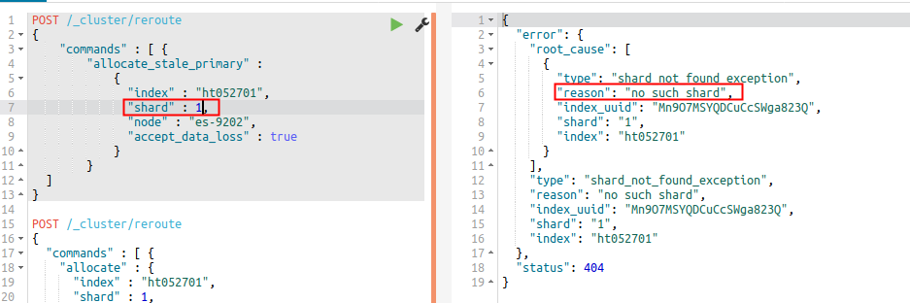

接着这时候才查看一下数据,则只有一条数据了.再使用_cat/health?v查看就是yellow了.
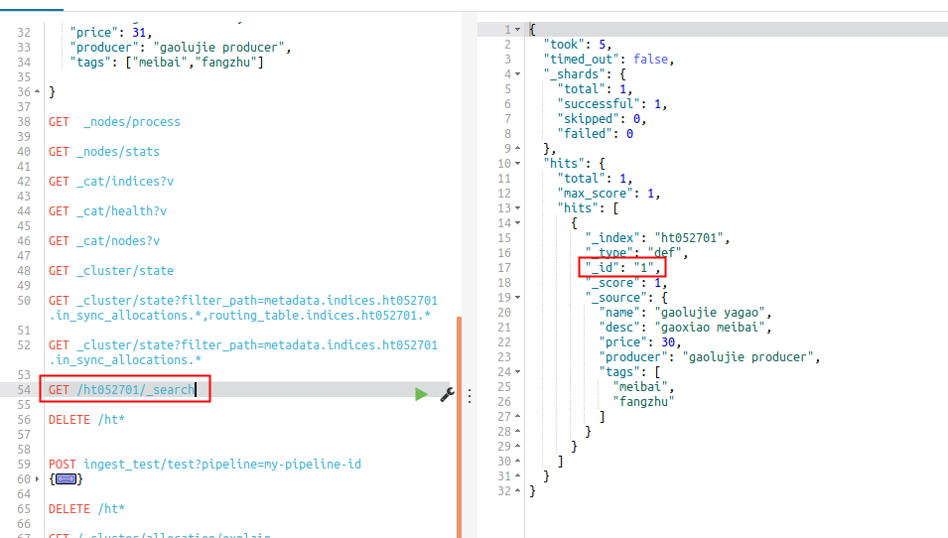

但是如果这时候又重新恢复刚刚关闭的节点，那么就又会重新起来了.但是这里还是只剩下一条数据，也就是刚刚关闭的节点恢复的时候，新PUT进去数据就被丢弃了.

那么如果这里在启动之前，再添加一条数据呢？也是会同步现在的数据.
所以这里就是在强制恢复数据之后，就以当前的primary shard为主，不再管之前的数据情况了.

Q&A:

_version和seq num的区别?
这里_version是用于乐观锁的，这是在给数据读取的时候，防止出现脏读的情况,而seq num这是内部使用的,是用于给数据恢复标识最新分片的时候使用的.

