这里使用三台虚拟机centos7来做配置，主要就是一个master两个node节点.
注意这里服务器之间需要设置免密钥登录和关闭iptables ,selinux这些.

注意这里记得要关闭ipv6,修改/etc/sysconfig/network-scripts/ifcfg-enp0s3文件，把IPV6INIT改为no.
然后编辑/etc/sysconfig/network配置，增加 NETWORKING_IPV6=no
编辑/etc/sysctl.conf配置，增加net.ipv6.conf.all.disable_ipv6=1
使用sysctl -p来生效.并且重启网卡.

1)修改配置Repo文件(所有节点)
注意这里使用阿里云的镜像仓库来进行下载,这里要拿到docker-ce和k8s的镜像repo，那么这里官网访问地址如下所示:
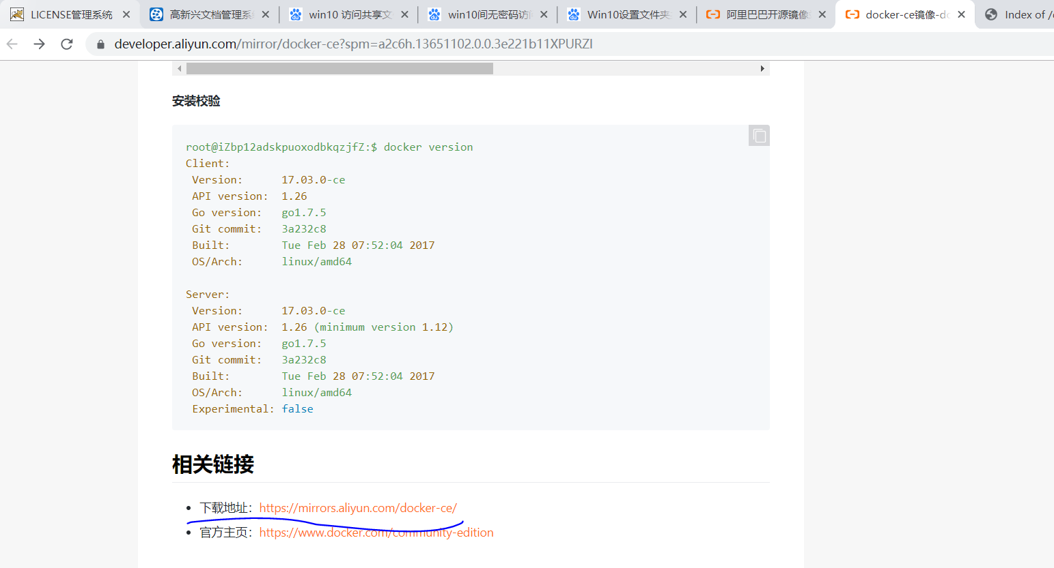
这里可以在下载地址找到下面的地址.

https://mirrors.aliyun.com/docker-ce/linux/centos/

然后这里拿到docker-ce.repo的地址，在/etc/下使用该命令:

- cd /etc/yum.repos.d
- wget https://mirrors.aliyun.com/docker-ce/linux/centos/docker-ce.repo

然后同理找到kubernetes的地址

https://mirrors.aliyun.com/kubernetes/yum/repos/kubernetes-el7-x86_64/

这里需要手动修改一下repo

- [root@docker0 yum.repos.d]# cat kubernetes.repo
- [kubernetes]
- name=Kubernetes Repo
- baseurl=https://mirrors.aliyun.com/kubernetes/yum/repos/kubernetes-el7-x86_64/
- gpgcheck=1
- gpgkey=https://mirrors.aliyun.com/kubernetes/yum/doc/yum-key.gpg
- enable=1

然后这里用yum repolist来更新一下
这里说明一下，gpgcheck这个数值1表示检测，0表示不检测，一般可以不用开启.

这里还可以选择先使用wget 把yum-key.gpg下载下来，然后在使用命令 rpm --import yum-key.gpg 进行导入即可.

- [root@docker0 yum.repos.d]# yum repolist
- Loaded plugins: fastestmirror
- base | 3.6 kB 00:00:00
- ...

下面就复制repo到其他两个节点
- [root@docker0 yum.repos.d]# scp -rp docker-ce.repo kubernetes.repo docker2:/etc/yum.repos.d/
- Warning: the ECDSA host key for 'docker2' differs from the key for the IP address '192.168.100.19'....

Master节点安装部署

2.1) 安装docker和kubelet
下面就可以在master下安装内容了

yum install docker-ce kubelet kubeadm kubectl
使用命令看到对应的版本关系如下图所示:
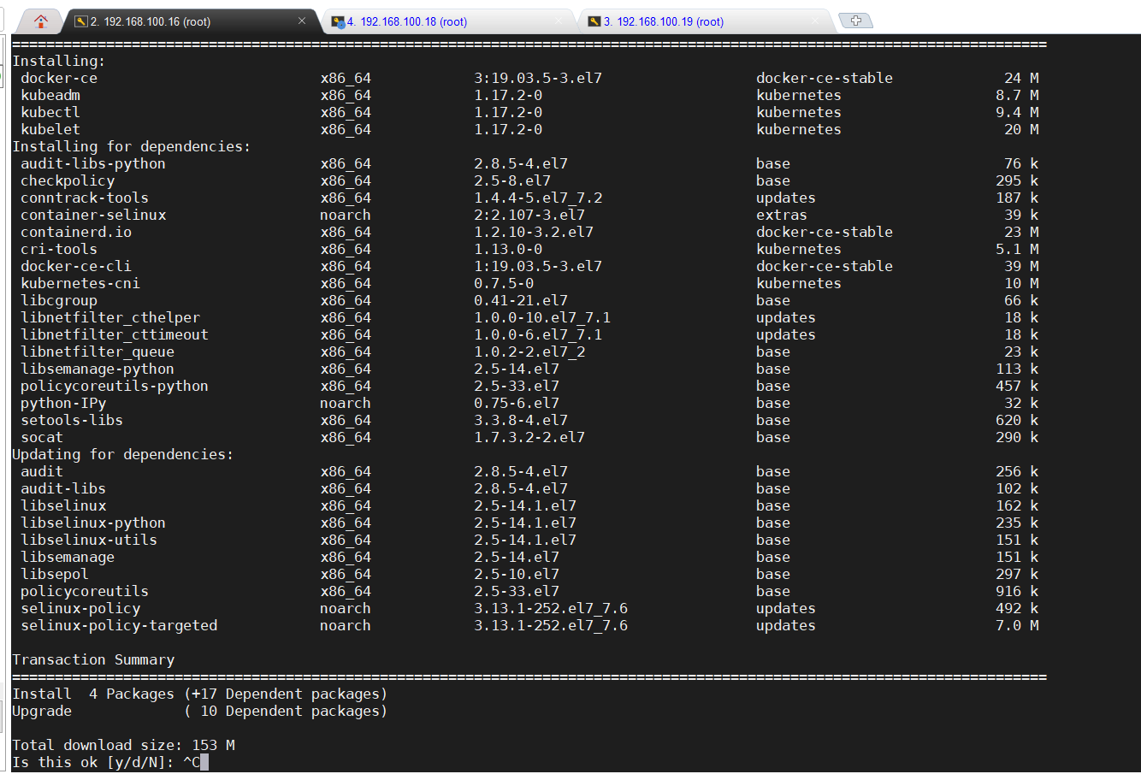

2.2) 修改镜像加速器地址
这里下载了docker之后，那么修改一下docker的代理配置，这是为了下载的时候方便从仓库从拉取镜像.因为网络的限制，默认的国外的镜像站是在国外的，因此这里可以考虑修改
这里国内有阿里云和DaoCloud等加速器可以使用.具体方法可以就是到对应的官网注册一个账号然后有对应的下载镜像

- [root@docker0 ~]# cat /etc/docker/daemon.json
- {
- "registry-mirrors": ["http://xxx.daocloud.io","https://xxx.mirror.aliyuncs.com/","https://docker.mirrors.ustc.edu.cn/"]
- }
这里修改对应的名称，然后systemctl daemon-reload和systemctl restart docker即可.

- [root@docker0 ~]# cat /proc/sys/net/bridge/bridge-nf-call-iptables
- 1
- [root@docker0 ~]# cat /proc/sys/net/bridge/bridge-nf-call-ip6tables
- 1
检查下iptables规则，这里只要数值为1就是正常的

2.3) 启动kubelet

- [root@docker0 ~]# rpm -ql kubelet
- /etc/kubernetes/manifests
- /etc/sysconfig/kubelet
- /usr/bin/kubelet
- /usr/lib/systemd/system/kubelet.service
- [root@docker0 ~]# cat /etc/sysconfig/kubelet
- KUBELET_EXTRA_ARGS=

这里在启动之前先看看kubelet的安装内容.那么这里如果需要禁用Swap，那么可以在该配置中进行修改.

- [root@docker0 ~]# systemctl enable kubelet docker
- Created symlink from /etc/systemd/system/multi-user.target.wants/kubelet.service to /usr/lib/systemd/system/kubelet.service.
- Created symlink from /etc/systemd/system/multi-user.target.wants/docker.service to /usr/lib/systemd/system/docker.service.

另外这里还要启动docker,使用systemctl start docker .
设置开机自启动,这里注意不用启动kubelet的.也就是不用start.
另外这里如果修改了docker的配置，要使用systemctl daemon-reload命令来加载，然后再重启.否则会不生效.

- [root@docker0 ~]# kubeadm init --help
- ...
- Flags:
- --apiserver-advertise-address string The IP address the API Server will advertise it's listening on. If not set the default network interface will be used.
- --apiserver-bind-port int32 Port for the API Server to bind to. (default 6443)
- --apiserver-cert-extra-sans strings Optional extra Subject Alternative Names (SANs) to use for the API Server serving certificate. Can be both IP addresses and DNS names.
- --cert-dir string The path where to save and store the certificates. (default "/etc/kubernetes/pki")
- --certificate-key string Key used to encrypt the control-plane certificates in the kubeadm-certs Secret.
- ...

那么从kubeadm里面可以看到很多配置参数，这里等会启动的时候需要指定一些的.这里其中包括加载证书的配置文件，还有监听的地址和端口.

- [root@docker0 ~]# kubeadm init --pod-network-cidr=10.244.0.0/16 --service-cidr=10.96.0.0/12
- W0203 10:49:23.445858 3013 version.go:101] could not fetch a Kubernetes version from the internet: unable to get URL "https://dl.k8s.io/release/stable-1.txt": Get https://dl.k8s.io/release/stable-1.txt: net/http: request canceled while waiting for connection (Client.Timeout exceeded while awaiting headers)
- W0203 10:49:23.445962 3013 version.go:102] falling back to the local client version: v1.17.2
- W0203 10:49:23.446031 3013 validation.go:28] Cannot validate kube-proxy config - no validator is available
- W0203 10:49:23.446035 3013 validation.go:28] Cannot validate kubelet config - no validator is available
- [init] Using Kubernetes version: v1.17.2
- [preflight] Running pre-flight checks
- [WARNING Firewalld]: firewalld is active, please ensure ports [6443 10250] are open or your cluster may not function correctly
- [WARNING IsDockerSystemdCheck]: detected "cgroupfs" as the Docker cgroup driver. The recommended driver is "systemd". Please follow the guide at https://kubernetes.io/docs/setup/cri/
- error execution phase preflight: [preflight] Some fatal errors occurred:
- [ERROR NumCPU]: the number of available CPUs 1 is less than the required 2
- [ERROR Swap]: running with swap on is not supported. Please disable swap
- [preflight] If you know what you are doing, you can make a check non-fatal with `--ignore-preflight-errors=...`
- To see the stack trace of this error execute with --v=5 or higher

然后这里就启动，指定服务端的端口，另外这里可以指定版本，但是一般使用默认的，可以看到这里有两个错误，一个是因为虚拟机分配的默认cpu只有1核，因此这里需要关机调整一下重启，然后还有就是设置Swap的问题.

注意:这里如果是多网卡的环境，那么这里需要指定网卡的ip,也就是加多一个参数为:
--apiserver-advertise-address=192.168.56.106
这里的地址为当前的master节点的ip.这样的话，后面join显示的内容才会是该网卡的网络.

注意这里重启之后需要先systemctl stop kubelet，因为启动了也会报错误的.
- [root@docker0 ~]# cat /etc/sysconfig/kubelet
- KUBELET_EXTRA_ARGS="--fail-swap-on=false"
- [root@docker0 ~]# kubeadm init --pod-network-cidr=10.244.0.0/16 --service-cidr=10.96.0.0/12 --ignore-preflight-errors=Swap
- W0203 11:07:13.563914 2373 version.go:101] could not fetch a Kubernetes version from the internet: unable to get URL "https://dl.k8s.io/release/stable-1.txt": Get https://dl.k8s.io/release/stable-1.txt: net/http: request canceled while waiting for connection (Client.Timeout exceeded while awaiting headers)
- W0203 11:07:13.564229 2373 version.go:102] falling back to the local client version: v1.17.2
- W0203 11:07:13.564312 2373 validation.go:28] Cannot validate kube-proxy config - no validator is available
- W0203 11:07:13.564316 2373 validation.go:28] Cannot validate kubelet config - no validator is available
- [init] Using Kubernetes version: v1.17.2
- [preflight] Running pre-flight checks
- [WARNING Firewalld]: firewalld is active, please ensure ports [6443 10250] are open or your cluster may not function correctly
- [WARNING IsDockerSystemdCheck]: detected "cgroupfs" as the Docker cgroup driver. The recommended driver is "systemd". Please follow the guide at https://kubernetes.io/docs/setup/cri/
- [WARNING Swap]: running with swap on is not supported. Please disable swap
- [preflight] Pulling images required for setting up a Kubernetes cluster
- [preflight] This might take a minute or two, depending on the speed of your internet connection
- [preflight] You can also perform this action in beforehand using 'kubeadm config images pull'
- ...

这里主要做了两件事情，第一个就是修改/etc/sysconfig/kubelet，屏蔽掉Swap的内容，然后还有就是kubeadm里面使用提示的参数也屏蔽掉错误.

- [root@docker0 ~]# docker image ls
- REPOSITORY TAG IMAGE ID CREATED SIZE
- ...
另外这里就是因为下载的时候还是会无法连接，这是因为k8s.io是域名的无法使用加速，因此这里需要添加一些参数配置
--image-repository registry.cn-hangzhou.aliyuncs.com/google_containers
这个镜像站属于阿里云里面的半官方的地址.

- [root@docker0 ~]# kubeadm init --pod-network-cidr=10.244.0.0/16 --service-cidr=10.96.0.0/12 --ignore-preflight-errors=Swap
- --image-repository registry.cn-hangzhou.aliyuncs.com/google_containers
- ....
- [bootstrap-token] Using token: rv4bdq.3k7rev457y28em2m
- [bootstrap-token] Configuring bootstrap tokens, cluster-info ConfigMap, RBAC Roles
- [bootstrap-token] configured RBAC rules to allow Node Bootstrap tokens to post CSRs in order for nodes to get long term certificate credentials
- [bootstrap-token] configured RBAC rules to allow the csrapprover controller automatically approve CSRs from a Node Bootstrap Token
- [bootstrap-token] configured RBAC rules to allow certificate rotation for all node client certificates in the cluster
- [bootstrap-token] Creating the "cluster-info" ConfigMap in the "kube-public" namespace
- [kubelet-finalize] Updating "/etc/kubernetes/kubelet.conf" to point to a rotatable kubelet client certificate and key
- [addons] Applied essential addon: CoreDNS
- [addons] Applied essential addon: kube-proxy

- Your Kubernetes control-plane has initialized successfully!

- To start using your cluster, you need to run the following as a regular user:

- mkdir -p $HOME/.kube
- sudo cp -i /etc/kubernetes/admin.conf $HOME/.kube/config
- sudo chown $(id -u):$(id -g) $HOME/.kube/config

- Then you can join any number of worker nodes by running the following on each as root:

- kubeadm join 192.168.100.16:6443 --token rv4bdq.3k7rev457y28em2m \
- --discovery-token-ca-cert-hash sha256:19c640a366e4a1e1d97a91aa0b0486cb681971b8cf0cb67b7a2d50ff2413a78c

注意这里初始化完成之后，最后这一行非常重要，是用于对其他node节点加入到集群使用的一串命令和密钥.
然后这里就可以看到下载的镜像了
- [root@docker0 ~]# docker image ls
- REPOSITORY TAG IMAGE ID CREATED SIZE
- registry.cn-hangzhou.aliyuncs.com/google_containers/kube-proxy v1.17.2 cba2a99699bd 2 weeks ago 116MB
- registry.cn-hangzhou.aliyuncs.com/google_containers/kube-apiserver v1.17.2 41ef50a5f06a 2 weeks ago 171MB
- registry.cn-hangzhou.aliyuncs.com/google_containers/kube-controller-manager v1.17.2 da5fd66c4068 2 weeks ago 161MB
- registry.cn-hangzhou.aliyuncs.com/google_containers/kube-scheduler v1.17.2 f52d4c527ef2 2 weeks ago 94.4MB
- registry.cn-hangzhou.aliyuncs.com/google_containers/coredns 1.6.5 70f311871ae1 3 months ago 41.6MB
- registry.cn-hangzhou.aliyuncs.com/google_containers/etcd 3.4.3-0 303ce5db0e90 3 months ago 288MB
- registry.cn-hangzhou.aliyuncs.com/google_containers/pause

这里说明一下,pause是一个类似副本的镜像，也就是每次kubelet重新启动创建容器的时候，不需要再次重新封装pod，可以直接通过pod来进行复制即可.

- [root@docker0 ~]# mkdir -p $HOME/.kube
- [root@docker0 ~]# cp -i /etc/kubernetes/admin.conf $HOME/.kube/config
- [root@docker0 ~]# kubectl get cs
- NAME STATUS MESSAGE ERROR
- scheduler Healthy ok
- controller-manager Healthy ok
- etcd-0 Healthy {"health":"true"}
- [root@docker0 ~]# kubectl get nodes
- NAME STATUS ROLES AGE VERSION
- docker0 NotReady master 6h22m v1.17.2

最后就是按照提示，创建目录和复制文件，因为这里直接使用root用户操作，因此就不需要更改所属组了.另外这里就可以使用kubectl来查看客户端情况了.这里cs就是查看组件状态情况，这里没有显示api server，这是因为如果不健康，那么就无法显示信息了.

这里get nodes显示节点没有准备好，这是因为没有安装网络插件如Flannel等

2.4) 网络插件flannel安装
https://github.com/coreos/flannel
github上的flannel地址.

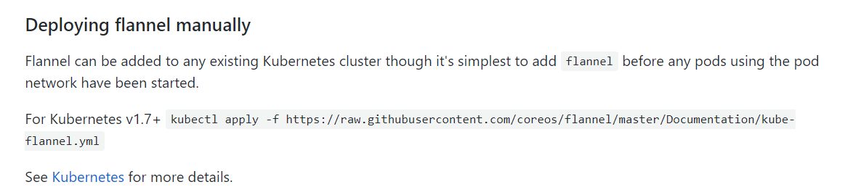
然后这里给出一个在线获取的方式.

- [root@docker0 ~]# kubectl apply -f kube-flannel.yml
- podsecuritypolicy.policy/psp.flannel.unprivileged created
- clusterrole.rbac.authorization.k8s.io/flannel created
- clusterrolebinding.rbac.authorization.k8s.io/flannel created
- serviceaccount/flannel created
- configmap/kube-flannel-cfg created
- daemonset.apps/kube-flannel-ds-amd64 created
- daemonset.apps/kube-flannel-ds-arm64 created
- daemonset.apps/kube-flannel-ds-arm created
- daemonset.apps/kube-flannel-ds-ppc64le created
- daemonset.apps/kube-flannel-ds-s390x created

这里我直接复制下来然后运行，可以看到这里创建了很多文件.
然后这里可以看到docker image ls 下会多了一个镜像

注意这里如果是多网卡的环境，那么需要配置指定网卡.下面命令是在线修改.
kubectl edit daemonset.apps/kube-flannel-ds-amd64 -n kube-system

也可以考虑采用直接修改yaml文件.
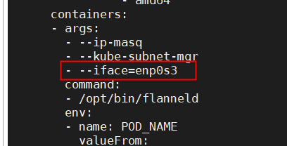
在这里添加多一句，这样的化指定网卡即可.

注意这里如果是修改yaml文件，那么每一个pods定义下都要添加.

- [root@docker0 ~]# docker image ls
- REPOSITORY TAG IMAGE ID CREATED SIZE
- ...
- quay.io/coreos/flannel v0.11.0-amd64 ff281650a721 12 months ago 52.6MB
- ...

这里就可以看到比之前多了一个flannel的镜像.

- [root@docker0 ~]# kubectl get nodes
- NAME STATUS ROLES AGE VERSION
- docker0 Ready master 6h39m v1.17.2
- [root@docker0 ~]# kubectl get pods -n kube-system
- NAME READY STATUS RESTARTS AGE
- coredns-7f9c544f75-8wtc5 0/1 Running 0 6h39m
- coredns-7f9c544f75-zzt5b 0/1 Running 0 6h39m
- etcd-docker0 1/1 Running 0 6h39m
- kube-apiserver-docker0 1/1 Running 0 6h39m
- kube-controller-manager-docker0 1/1 Running 0 6h39m
- kube-flannel-ds-amd64-w6gwp 1/1 Running 0 9m33s
- kube-proxy-xjjfx 1/1 Running 0 6h39m
- kube-scheduler-docker0 1/1 Running 0 6h39m
- [root@docker0 ~]# kubectl get ns
- NAME STATUS AGE
- default Active 6h40m
- kube-node-lease Active 6h40m
- kube-public Active 6h40m
- kube-system Active 6h40m

然后这里可以看到节点是Ready状态了，另外这里可以看到有四个名称空间

Node节点安装部署
这里还是首先要设置repo，这里和master节点类似就不再讲解了，然后还是安装docker和kubelet，注意，这里可以不一定需要安装kubectl,因为不一定需要在node上使用客户端

- [root@docker1 yum.repos.d]# scp -rp docker0:/etc/yum.repos.d/{docker-ce.repo,kubernetes.repo} docker1:/etc/yum.repos.d/
- ...
- [root@docker1 yum.repos.d]# scp -rp docker0:/etc/docker/daemon.json docker1:/etc/docker
- ...
- [root@docker1 yum.repos.d]# scp -rp docker0:/etc/sysconfig/kubelet /etc/sysconfig/
- ..
- [root@docker1 yum.repos.d]# yum repolist
- [root@docker1 yum.repos.d]# yum install docker-ce kubelet kubeadm kubectl -y
- ...
- [root@docker1 yum.repos.d]# systemctl enable docker kubelet
- ...
- [root@docker1 yum.repos.d]# kubeadm join 192.168.100.16:6443 --token rv4bdq.3k7rev457y28em2m --discovery-token-ca-cert-hash sha256:19c640a366e4a1e1d97a91aa0b0486cb681971b8cf0cb67b7a2d50ff2413a78c --ignore-preflight-errors=Swap
- W0204 04:25:35.254046 7813 join.go:346] [preflight] WARNING: JoinControlPane.controlPlane settings will be ignored when control-plane flag is not set.
- [preflight] Running pre-flight checks
- [WARNING IsDockerSystemdCheck]: detected "cgroupfs" as the Docker cgroup driver. The recommended driver is "systemd". Please follow the guide at https://kubernetes.io/docs/setup/cri/
- [WARNING Swap]: running with swap on is not supported. Please disable swap
- [preflight] Reading configuration from the cluster...
- [preflight] FYI: You can look at this config file with 'kubectl -n kube-system get cm kubeadm-config -oyaml'
- [kubelet-start] Downloading configuration for the kubelet from the "kubelet-config-1.17" ConfigMap in the kube-system namespace
- [kubelet-start] Writing kubelet configuration to file "/var/lib/kubelet/config.yaml"
- [kubelet-start] Writing kubelet environment file with flags to file "/var/lib/kubelet/kubeadm-flags.env"
- [kubelet-start] Starting the kubelet
- [kubelet-start] Waiting for the kubelet to perform the TLS Bootstrap...

- This node has joined the cluster:
- * Certificate signing request was sent to apiserver and a response was received.
- * The Kubelet was informed of the new secure connection details.

- Run 'kubectl get nodes' on the control-plane to see this node join the cluster.
注意这里node节点可以不用安装kubectl，这是api server的客户端，只允许访问master节点.

然后就可以在master上面看到显示了
- [root@docker0 yum.repos.d]# kubectl get nodes
- NAME STATUS ROLES AGE VERSION
- docker0 Ready master 7h2m v1.17.2
- docker1 NotReady <none> 78s v1.17.2
- [root@docker0 yum.repos.d]# kubectl get pods -n kube-system -o wide
- NAME READY STATUS RESTARTS AGE IP NODE NOMINATED NODE READINESS GATES
- coredns-7f9c544f75-8wtc5 1/1 Running 0 7h5m 10.244.0.3 docker0 <none> <none>
- coredns-7f9c544f75-zzt5b 1/1 Running 0 7h5m 10.244.0.2 docker0 <none> <none>
- etcd-docker0 1/1 Running 0 7h4m 192.168.100.16 docker0 <none> <none>
- kube-apiserver-docker0 1/1 Running 0 7h4m 192.168.100.16 docker0 <none> <none>
- kube-controller-manager-docker0 1/1 Running 0 7h4m 192.168.100.16 docker0 <none> <none>
- kube-flannel-ds-amd64-t82qx 1/1 Running 0 3m41s 192.168.100.18 docker1 <none> <none>
- kube-flannel-ds-amd64-w6gwp 1/1 Running 0 35m 192.168.100.16 docker0 <none> <none>
- kube-proxy-pz64v 1/1 Running 0 3m41s 192.168.100.18 docker1 <none> <none>
- kube-proxy-xjjfx 1/1 Running 0 7h5m 192.168.100.16 docker0 <none> <none>
- kube-scheduler-docker0 1/1 Running 0 7h4m 192.168.100.16 docker0 <none> <none>

这里可以看到在docker0和docker1上启动的容器了.

3.1) token过期重新生成获取
这里如果时间长了想加入集群的话，那么使用kubeadm join命令会发现不行了，一个原因就是token失效了，这里可以在master节点上使用命令查看token:

- [root@docker0 ~]# kubeadm token create
- W0210 11:03:08.070968 15651 validation.go:28] Cannot validate kube-proxy config - no validator is available
- W0210 11:03:08.071003 15651 validation.go:28] Cannot validate kubelet config - no validator is available
- tg76ng.f6dt6ekgn00z4p62
- [root@docker0 ~]# kubeadm token list
- TOKEN TTL EXPIRES USAGES DESCRIPTION EXTRA GROUPS
- tg76ng.f6dt6ekgn00z4p62 23h 2020-02-11T11:03:08-05:00 authentication,signing <none>

这里首先使用token create 命令重新生成一个，然后再使用list命令去查看一下有效性，然后这里替换掉token即可.但是注意，如果是也丢失了sha256的话，那么就需要其他命令来生成了.

http://www.mamicode.com/info-detail-2917459.html?__cf_chl_jschl_tk__=6f1613e4369e53baadf754a7096f696ae9a4bc71-1581430917-0-AZg_uyrY6D3egYdAzZ62NhB6kmc7zQtH9SLf7dLbfkawHMoCHfdxhX-OlryBVcwcG-YLwSx2H8MGJti9aH3BXwgFlGLC9F-l3eVt1mDM3w5opGN_0l3NwXjlF5iCjpdOSY0fMiJv8p7Jo8_H9tuO8ShHG8K65fjSIM5LPwilwnYCgZ84t5IYzjX7LhRclqxX1Q3OZaDDzBOAkzxPU6n0SANJeaS2mWtQv-P20OJSETef5glM9c9358md2TeK6ZPQ5SwnRRu_qrKmz_F-BfGfL8j1ScNYgEcYxIYcI5LfGFzj
k8s重新生成token参考资料

3.2) Connection refused报错
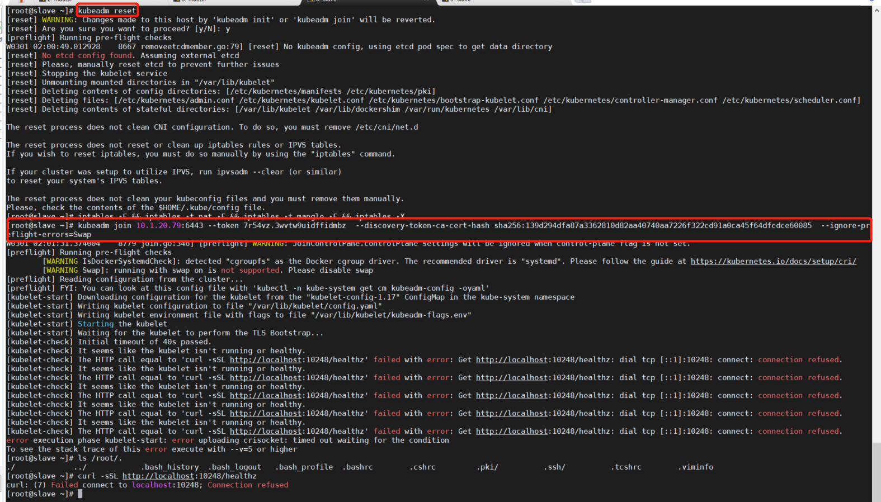
这里有一个报错，提示10248端口不通，那么可以考虑使用swapoff -a命令，然后再次使用kubeadm reset重置一下，再进行join

