前面介绍了一些常用的kubectl的命令,但是通常情况下一般是不会直接使用命令来操作的，大部分情况下都是使用配置清单的方式来实现.

kubectl配置清单:

1.常见的资料清单内容
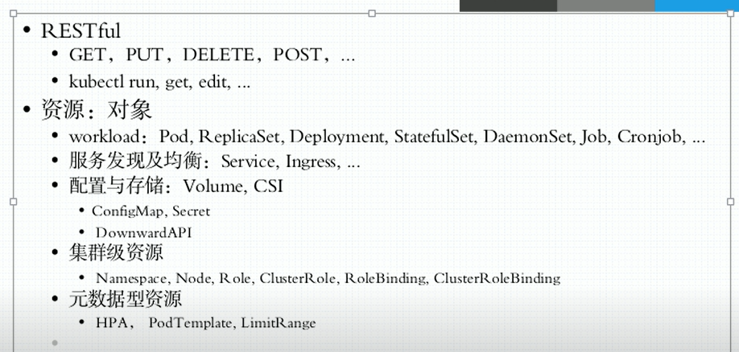

首先k8s中的很多资源都是一个对象，这里根据不同的分类可以有以上常见的一些，当然这里还有很多其他的.

- [root@docker0 ~]# kubectl get pods
- NAME READY STATUS RESTARTS AGE
- myapp-7c468db58f-7sdnr 1/1 Running 0 11h
- ...
- [root@docker0 ~]# kubectl get pod myapp-7c468db58f-7sdnr -o yaml
- apiVersion: v1
- kind: Pod
- metadata:
- creationTimestamp: "2020-02-12T04:08:07Z"
- generateName: myapp-7c468db58f-
- labels:
- pod-template-hash: 7c468db58f
- run: myapp
- name: myapp-7c468db58f-7sdnr
- namespace: default
- ownerReferences:
- - apiVersion: apps/v1
- blockOwnerDeletion: true
- controller: true
- kind: ReplicaSet
- name: myapp-7c468db58f
- uid: 02731a83-e823-48f3-bc5b-86475c6af5cc
- resourceVersion: "883105"
- selfLink: /api/v1/namespaces/default/pods/myapp-7c468db58f-7sdnr
- uid: 7cddcf5b-e76c-4f01-b957-11f90aa602bf
- spec:
- containers:
- - image: ikubernetes/myapp:v1
- imagePullPolicy: IfNotPresent
- name: myapp
- resources: {}
- terminationMessagePath: /dev/termination-log
- terminationMessagePolicy: File
- volumeMounts:
- - mountPath: /var/run/secrets/kubernetes.io/serviceaccount
- name: default-token-8c8gv
- readOnly: true
- dnsPolicy: ClusterFirst
- enableServiceLinks: true
- nodeName: docker2
- priority: 0
- restartPolicy: Always
- schedulerName: default-scheduler
- securityContext: {}
- serviceAccount: default
- serviceAccountName: default
- terminationGracePeriodSeconds: 30
- tolerations:
- - effect: NoExecute
- key: node.kubernetes.io/not-ready
- operator: Exists
- tolerationSeconds: 300
- - effect: NoExecute
- key: node.kubernetes.io/unreachable
- operator: Exists
- tolerationSeconds: 300
- volumes:
- - name: default-token-8c8gv
- secret:
- defaultMode: 420
- secretName: default-token-8c8gv
- status:
- conditions:
- - lastProbeTime: null
- lastTransitionTime: "2020-02-13T02:25:19Z"
- status: "True"
- type: Initialized
- - lastProbeTime: null
- lastTransitionTime: "2020-02-13T02:25:19Z"
- status: "True"
- type: Ready
- - lastProbeTime: null
- lastTransitionTime: "2020-02-13T02:25:19Z"
- status: "True"
- type: ContainersReady
- - lastProbeTime: null
- lastTransitionTime: "2020-02-12T04:08:07Z"
- status: "True"
- type: PodScheduled
- containerStatuses:
- - containerID: docker://f6beda8dd4fc836bba1ba7db7dbed1907e8d398cdfc40a75a226c162bb574204
- image: ikubernetes/myapp:v1
- imageID: docker-pullable://ikubernetes/myapp@sha256:9c3dc30b5219788b2b8a4b065f548b922a34479577befb54b03330999d30d513
- lastState: {}
- name: myapp
- ready: true
- restartCount: 0
- started: true
- state:
- running:
- startedAt: "2020-02-13T02:25:19Z"
- hostIP: 192.168.100.19
- phase: Running
- podIP: 10.244.2.10
- podIPs:
- - ip: 10.244.2.10
- qosClass: BestEffort
- startTime: "2020-02-13T02:25:19Z"

这里第一个是apiVersion，这里是有分类的，一般来说都是用稳定版的，关于这个具体内容，可以使用命令kubectl api-versions查看.

另外这里一级字段中有Kind是类型，status是当前状态，一般是不允许用户自定义修改的，spec是期望状态，如果pods不符合期望的话，那么就会自动进行各种操作.metadata是元数据信息.

其中metadata中name、namespace、labels和annotations都是常见的.

查看和配置资源清单.
这里可以使用命令来查看情况.
- [root@docker0 ~]# kubectl explain pods
- KIND: Pod
- VERSION: v1

- DESCRIPTION:
- Pod is a collection of containers that can run on a host. This resource is
- created by clients and scheduled onto hosts.

- FIELDS:
- apiVersion <string>
- APIVersion defines the versioned schema of this representation of an
- object. Servers should convert recognized schemas to the latest internal
- value, and may reject unrecognized values. More info:

- kind <string>
- Kind is a string value representing the REST resource this object
- represents. Servers may infer this from the endpoint the client submits
- requests to. Cannot be updated. In CamelCase. More info:

- metadata <Object>
- Standard object's metadata. More info:

- spec <Object>
- Specification of the desired behavior of the pod. More info:

- status <Object>
- Most recently observed status of the pod. This data may not be up to date.
- Populated by the system. Read-only. More info:

然后如果这里想查看具体的某个一级字段下面的内容，可以使用命令kubect explain pods.spec 这样来查看.

.配置清单demo
- [root@docker0 mainfast]# cat pod-daemon.yaml
- apiVersion: v1
- kind: Pod
- metadata:
- name: pod-demo
- namespace: default
- labels:
- app: myapp
- tier: frontend
- spec:
- containers:
- - name: myapp
- image: ikubernetes/myapp:v1
- - name: busybox
- image: busybox:latest
- command:
- - "/bin/sh"
- - "-c"
- - "sleep 3600"

这里创建一个yaml文件，然后这里定义一个pod，里面有两个容器myapp和busybox.这里注意，对于带有横杠的，其实可以写成类似command: {“/bin/sh”,”-c”,”sleep 3600”}这样的

- [root@docker0 mainfast]# kubectl create -f pod-daemon.yaml
- pod/pod-demo created
- [root@docker0 mainfast]# kubectl get pods
- NAME READY STATUS RESTARTS AGE
- pod-demo 2/2 Running 0 5s
- ...
然后这里就可以看到结果了.

- [root@docker0 mainfast]# kubectl exec -it pod-demo -c myapp -- /bin/sh
- / # cat /usr/share/nginx/html/index.html
- Hello MyApp | Version: v1 | <a href="hostname.html">Pod Name</a>

这里注意一个问题，就是文件名要和metadata下的name相同，否则可能会出现报错
error: a container name must be specified for pod pod-demo, choose one of: [myapp busybox]

2)查看情况
然后这里还可以进去到里面查看结果.同时这里还可以使用describe命令查看情况.

- [root@docker0 mainfast]# kubectl describe pods pod-demo
- Name: pod-demo
- Namespace: default
- Priority: 0
- Node: docker1/192.168.100.18
- Start Time: Wed, 12 Feb 2020 12:42:49 -0500
- Labels: app=myapp
- tier=frontend
- Annotations: <none>
- Status: Running
- IP: 10.244.1.24
- IPs:
- IP: 10.244.1.24
- Containers:
- myapp:
- Container ID: docker://89c852fe82db6a0d2147dae23658b5333618b706ccac31195a99e0a1f97624bf
- Image: ikubernetes/myapp:v1
- Image ID: docker-pullable://ikubernetes/myapp@sha256:9c3dc30b5219788b2b8a4b065f548b922a34479577befb54b03330999d30d513
- Port: <none>
- Host Port: <none>
- State: Running
- Started: Wed, 12 Feb 2020 12:42:49 -0500
- Ready: True
- Restart Count: 0
- Environment: <none>
- Mounts:
- /var/run/secrets/kubernetes.io/serviceaccount from default-token-8c8gv (ro)
- busybox:
- Container ID: docker://0ee7089f7b34ffcdca57151ba3f17796025a5b0beee6d5b59c2b78a799038e27
- Image: busybox:latest
- Image ID: docker-pullable://busybox@sha256:6915be4043561d64e0ab0f8f098dc2ac48e077fe23f488ac24b665166898115a
- Port: <none>
- Host Port: <none>
- Command:
- /bin/sh
- -c
- sleep 3600
- State: Running
- Started: Wed, 12 Feb 2020 12:42:50 -0500
- Ready: True
- Restart Count: 0
- Environment: <none>
- Mounts:
- /var/run/secrets/kubernetes.io/serviceaccount from default-token-8c8gv (ro)
- Conditions:
- Type Status
- Initialized True
- Ready True
- ContainersReady True
- PodScheduled True
- Volumes:
- default-token-8c8gv:
- Type: Secret (a volume populated by a Secret)
- SecretName: default-token-8c8gv
- Optional: false
- QoS Class: BestEffort
- Node-Selectors: <none>
- Tolerations: node.kubernetes.io/not-ready:NoExecute for 300s
- node.kubernetes.io/unreachable:NoExecute for 300s
- Events:
- Type Reason Age From Message
- ---- ------ ---- ---- -------
- Normal Pulled 7m45s kubelet, docker1 Container image "ikubernetes/myapp:v1" already present on machine
- Normal Created 7m45s kubelet, docker1 Created container myapp
- Normal Started 7m45s kubelet, docker1 Started container myapp
- Normal Pulling 7m45s kubelet, docker1 Pulling image "busybox:latest"
- Normal Pulled 7m44s kubelet, docker1 Successfully pulled image "busybox:latest"
- Normal Created 7m44s kubelet, docker1 Created container busybox
- Normal Started 7m44s kubelet, docker1 Started container busybox
- Normal Scheduled 7m23s default-scheduler Successfully assigned default/pod-demo to docker1

然后这里可以使用curl命令来进行测试.

- [root@docker0 mainfast]# curl 10.244.1.24
- Hello MyApp | Version: v1 | <a href="hostname.html">Pod Name</a>
- [root@docker0 mainfast]# kubectl logs pod-demo myapp
- 10.244.0.0 - - [12/Feb/2020:17:51:56 +0000] "GET / HTTP/1.1" 200 65 "-" "curl/7.29.0" "-"

这里同时也可以使用logs命令来查看到结果了.另外这里如果要删除，可以直接使用kubect delete -f pod-daemon.yaml来删除.

3).配置清单的其他参数使用.

1.镜像下载策略imagePullPolicy
这里主要有三个选项，分别是Alaways、Never和IfnotPresent，其中最后一个的意思是，如果当前本地没有镜像，那么就拉取最新的，但是如果有则不会去更新。一般来说常用的是最后一个选项，而Alaways的策略，一般是适用于更新最新版的镜像，因为本地最新的和仓库最新的不一定是相同的.

- [root@master ~]# kubectl explain pods.spec.containers
- KIND: Pod
- VERSION: v1

- RESOURCE: containers <[]Object>

- ...

- imagePullPolicy <string>
- Image pull policy. One of Always, Never, IfNotPresent. Defaults to Always
- if :latest tag is specified, or IfNotPresent otherwise. Cannot be updated.
- More info:
- https://kubernetes.io/docs/concepts/containers/images#updating-images

- lifecycle <Object>
- Actions that the management system should take in response to container
- lifecycle events. Cannot be updated.

- livenessProbe <Object>
- Periodic probe of container liveness. Container will be restarted if the
- probe fails. Cannot be updated. More info:
- https://kubernetes.io/docs/concepts/workloads/pods/pod-lifecycle#container-probes

- ...

这里可以通过命令参数来看到具体的显示.

2.暴露端口.
- [root@master yaml]# cat pod-demo.yaml
- apiVersion: v1
- kind: Pod
- metadata:
- name: pod-demo
- namespace: default
- labels:
- app: myapp
- tier: frontend
- spec:
- containers:
- - name: myapp
- image: ikubernetes/myapp:v1
- ports:
- - name: http
- containerPort: 80
- - name: https
- containerPort: 443
- - name: busybox
- image: busybox:latest
- imagePullPolicy: IfNotPresent
- command:
- - "/bin/sh"
- - "-c"
- - "sleep 3600"

这里暴露端口其实要注意一个问题，不是说端口不暴露就不能访问的，这里一般情况下，使用这样的定义是为了方便获取信息的.

如果这里的type的NodePort，那么端口是可以全部访问的，只要有监听就可以通信了.

3.命令与参数
https://kubernetes.io/docs/tasks/inject-data-application/define-command-argument-container/#running-a-command-in-a-shell
官网关于command与args的资料

这里关于这个，其实主要就是如下图所示的关系.

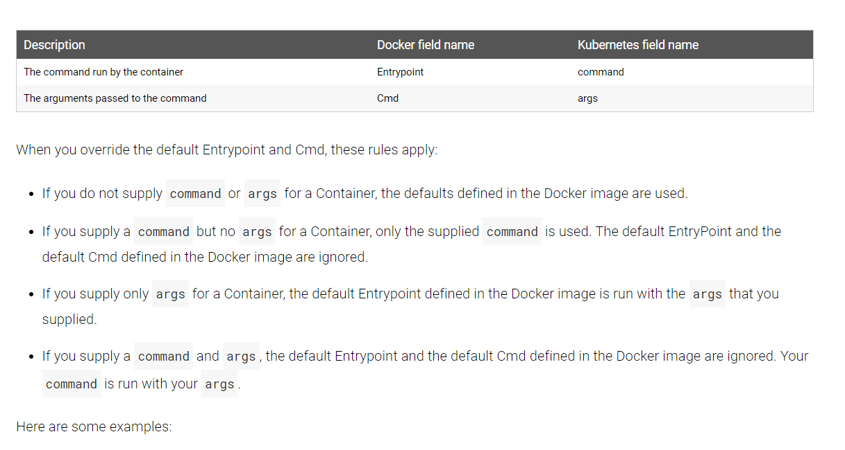

这里如果本身容器内部有命令和参数的话，那么默认是会执行的，但是一旦有参数过来，那么就替换掉，而如果只有自定义命令，那么就单独运行自定义命令了.

3.标签的使用.

1). 给Pods加标签
- [root@master yaml]# kubectl get pods --show-labels
- NAME READY STATUS RESTARTS AGE LABELS
- pod-demo 2/2 Running 1 72m app=myapp,tier=frontend
- [root@master yaml]# kubectl get pods --show-labels -l app
- NAME READY STATUS RESTARTS AGE LABELS
- pod-demo 2/2 Running 1 72m app=myapp,tier=frontend
- [root@master yaml]# kubectl get pods --show-labels -l abc
- No resources found in default namespace.
- [root@master yaml]# kubectl get pods --show-labels -L myapp
- NAME READY STATUS RESTARTS AGE MYAPP LABELS
- pod-demo 2/2 Running 1 72m app=myapp,tier=frontend
- [root@master yaml]# kubectl get pods --show-labels -L t
- NAME READY STATUS RESTARTS AGE T LABELS
- pod-demo 2/2 Running 1 72m app=myapp,tier=frontend

这里容器都是带有标签的，因此可以使用-l 或者-L来进行过滤.

- [root@master yaml]# kubectl label pods pod-demo release=cancary
- pod/pod-demo labeled
- [root@master yaml]# kubectl get pods --show-labels -L cancary
- NAME READY STATUS RESTARTS AGE CANCARY LABELS
- pod-demo 2/2 Running 1 76m app=myapp,release=cancary,tier=frontend
- [root@master yaml]# kubectl label pods pod-demo release=stable --overwrite

这里还可以使用label来对容器进行打标签，当然，这里也可以对节点进行打标签的.
那么在后面创建pods的时候，也可以指定对应的标签的节点进行部署.

另外注意，这里关于标签，还可以使用 -l release=cancary这种方式来操作，这样的话就是一个等值操作，只有标签是这个值的过滤出来.

这里还有一种就是集合关系的，就是使用 -l “release in (canary,beta...)” 这种方式来使用.

. 标签选择器的使用
- [root@master yaml]# kubectl label nodes slave disktype=ssd
- node/slave labeled
- [root@master yaml]# kubectl get nodes --show-labels
- NAME STATUS ROLES AGE VERSION LABELS
- master Ready master 39h v1.17.3 beta.kubernetes.io/arch=amd64,beta.kubernetes.io/os=linux,kubernetes.io/arch=amd64,kubernetes.io/hostname=master,kubernetes.io/os=linux,node-role.kubernetes.io/master=
- slave Ready <none> 38h v1.17.3 beta.kubernetes.io/arch=amd64,beta.kubernetes.io/os=linux,disktype=ssd,kubernetes.io/arch=amd64,kubernetes.io/hostname=slave,kubernetes.io/os=linux

这里首先给slave节点创建了一个标签，然后在yaml中就可以使用标签选择器来指定节点部署了.

- [root@master yaml]# cat pod-demo.yaml
- ...
- spec:
- containers:
- - name: myapp
- image: ikubernetes/myapp:v1
- ports:
- ...
- nodeSelector:
- disktype: ssd
这里省略掉部分无关内容，在和containers同级下使用即可，这样创建出来的pods也会指定节点部署.另外这里还有NodeName这个直接指定节点的.

3). 资源注解的使用
http://docs.kubernetes.org.cn/477.html
国内k8s中文站关于annotattion的用法参考资料

Annotations的目的是存储辅助数据，特别是通过工具和系统扩展操作的数据.一般来说，标签是为了方便安装部署的时候进行设置，而资源注解可以理解为，纯属是一个辅助字段信息.

- [root@master yaml]# cat pod-demo.yaml
- apiVersion: v1
- kind: Pod
- metadata:
- name: pod-demo
- namespace: default
- labels:
- app: myapp
- tier: frontend
- annotations:
- created-by: cluster admin
- ...
- [root@master yaml]# kubectl describe pod pod-demo
- ...
- Start Time: Wed, 19 Feb 2020 21:33:00 -0500
- Labels: app=myapp
- tier=frontend
- Annotations: created-by: cluster admin
- ....

这里就是设置annotations的结果了，然后可以使用describe来查看到具体的信息，另外这里是可以设置多个的.

