前面已经讲了Curator的一些用法，但是对于这个开源工具来说， 还有一些高级用法，主要是根据zk来封装的.下面进行具体讲解一下.

封装的应用方法

另外这里会有多个代码实现方式，那么这里提供了多少工具呢？可以看下这里的代码结构
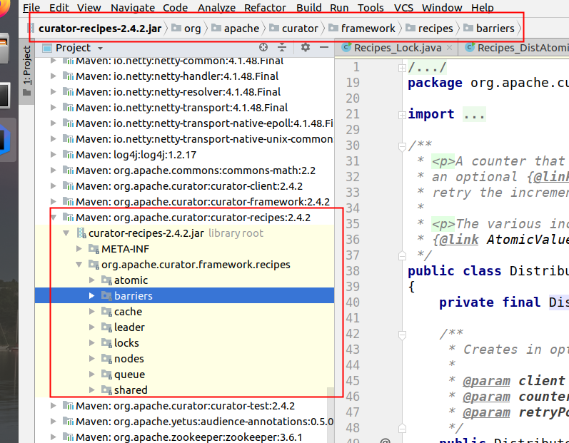
这里的作用见如下所示:

包名 | 功能简介
atomic | 分布式计数器(DistributedAtomicLong)，能在分布式环境下实现原子自增
barriers | 分布式屏障(DistributedBarrier)，使用屏障来阻塞分布式环境中进程的运行，直到满足特定的条件
cache | 监听机制，分为NodeCache(监听节点数据变化)，PathChildrenCache（监听节点的子节点数据变化），TreeCache（既能监听自身节点数据变化也能监听子节点数据变化）
leader | leader选举
locks | 分布式锁
nodes | 提供持久化节点(PersistentNode)服务，即使客户端与zk服务的连接或者会话断开
queue | 分布式队列(包括优先级队列DistributedPriorityQueue，延迟队列DistributedDelayQueue等)
shared | 分布式计数器SharedCount

Master选举
很多大数据工具都会利用zk来实现协调，尤其是选举方面的，那么这里的实现思路也是很简单的,就是选择一个根节点,如/master_select,多台机器同时向该节点创建一个子节点/master_select/lock,利用zookeeper的特性,最终只有一台机器能够成功，成功的那台机器就作为Master.

https://blog.csdn.net/hosaos/article/details/88727817
关于zk curator选举的代码原理参考资料.

LeaderSelector应用

代码实现方式一
- public class Recipes_MasterSelect {

- static String master_path = "/curator_recipes_master_path";

- static CuratorFramework client = CuratorFrameworkFactory.builder()
- .connectString("127.0.0.1:2182")
- .retryPolicy(new ExponentialBackoffRetry(1000, 3)).build();
- public static void main( String[] args ) throws Exception {
- client.start();
- LeaderSelector selector = new LeaderSelector(client,
- master_path,
- new LeaderSelectorListenerAdapter() {
- public void takeLeadership(CuratorFramework client) throws Exception {
- Date date = new Date();
- System.out.println("成为Master角色"+ date.toString());
- Thread.sleep( 3000);
- date = new Date();
- System.out.println( "完成Master操作，释放Master权利" +date.toString());
- }
- });
- selector.autoRequeue();
- selector.start();
- Thread.sleep( Integer.MAX_VALUE );
- }
- }
这里核心的就是LeaderSelector 对象,该实例负责封装所有和Master选举相关的逻辑，包括所有和zk服务器的交互过程。
在创建该实例的时候，还会传入一个监听器: LeaderSelectorListenerAdapter,这个监听器需要实现takeLeadership方法.Curator在竞争到Master后自动调用该方法.另外注意的是，这里一旦执行完takeLeadership方法，Curator就会立即释放Master权利，然后重新开始新的一轮选举.

上面有两个关键的方法:
//开始抢主
void start()
//在抢到leader权限并释放后，自动加入抢主队列，重新抢主
void autoRequeue()

下面的把运行两个应用程序代码后输出的结果:

第一个程序运行结果
成为Master角色Mon Jun 01 10:23:00 CST 2020
• 完成Master操作，释放Master权利Mon Jun 01 10:23:03 CST 2020
• 成为Master角色Mon Jun 01 10:23:06 CST 2020
• 完成Master操作，释放Master权利Mon Jun 01 10:23:09 CST 2020
• 成为Master角色Mon Jun 01 10:23:12 CST 2020
• 完成Master操作，释放Master权利Mon Jun 01 10:23:15 CST 2020
• 成为Master角色Mon Jun 01 10:23:19 CST 2020
• 完成Master操作，释放Master权利Mon Jun 01 10:23:22 CST 2020
• 成为Master角色Mon Jun 01 10:23:25 CST 2020
• 完成Master操作，释放Master权利Mon Jun 01 10:23:28 CST 2020
• 成为Master角色Mon Jun 01 10:23:31 CST 2020
• 完成Master操作，释放Master权利Mon Jun 01 10:23:34 CST 2020

- 第二个程序运行结果
- 成为Master角色Mon Jun 01 10:22:54 CST 2020
- 完成Master操作，释放Master权利Mon Jun 01 10:22:57 CST 2020
- 成为Master角色Mon Jun 01 10:22:57 CST 2020
- 完成Master操作，释放Master权利Mon Jun 01 10:23:00 CST 2020
- 成为Master角色Mon Jun 01 10:23:03 CST 2020
- 完成Master操作，释放Master权利Mon Jun 01 10:23:06 CST 2020
- 成为Master角色Mon Jun 01 10:23:09 CST 2020
- 完成Master操作，释放Master权利Mon Jun 01 10:23:12 CST 2020
- 成为Master角色Mon Jun 01 10:23:15 CST 2020
- 完成Master操作，释放Master权利Mon Jun 01 10:23:18 CST 2020
- 成为Master角色Mon Jun 01 10:23:22 CST 2020
- 完成Master操作，释放Master权利Mon Jun 01 10:23:25 CST 2020
- 成为Master角色Mon Jun 01 10:23:28 CST 2020
- 完成Master操作，释放Master权利Mon Jun 01 10:23:31 CST 2020
- 成为Master角色Mon Jun 01 10:23:34 CST 2020

期间在zk的目录下会产生类似如下的目录:
- [zk: localhost:2181(CONNECTED) 6] ls /curator_recipes_master_path
- [_c_8d0b33d5-d390-4cee-9dc5-57cceb04e3c1-lock-0000000023, _c_c9ca5898-7278-476b-b9b4-d4f0395e1bbf-lock-0000000022]

这里因为停止等待的时间比较短，因此效果不明显，可以延长等待时间进行处理.
另外在等待的过程中,目录下的内容如下所示:

•
[zk: localhost:2181(CONNECTED) 16] get /curator_recipes_master_path/_c_3860968d-e387-4753-a180-8bba839bb787-lock-0000000016
• 127.0.1.1

这里记录的其实就是ip地址了.
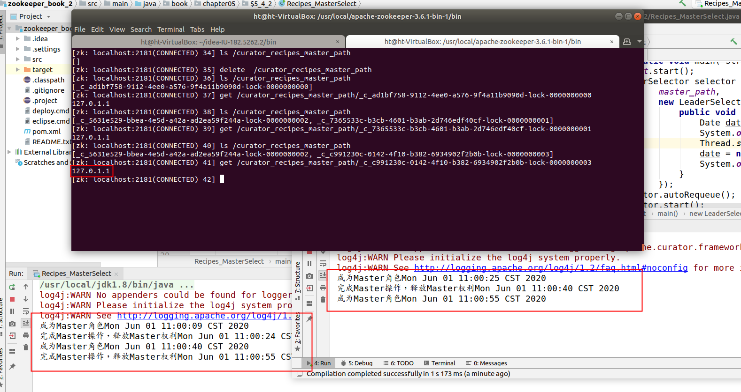
上图就是延长了时间之后得到的内容.

代码实现方式二
除了上面的写法，还可以优化一下,实现方式如下所示:
- public class Recipes_MasterSelect_2 {

- static int CLINET_COUNT = 10;
- static String LOCK_PATH = "/leader_selector";

- public static void main(String[] args) throws Exception {
- List<CuratorFramework> clientsList = Lists.newArrayListWithCapacity(CLINET_COUNT);
- //启动10个zk客户端，每几秒进行一次leader选举
- for (int i = 0; i < CLINET_COUNT; i++) {
- CuratorFramework client = getZkClient();
- clientsList.add(client);
- ExampleClient exampleClient = new ExampleClient(client, LOCK_PATH, "client_" + i);
- exampleClient.start();
- }
- //sleep 以观察抢主过程
- Thread.sleep(Integer.MAX_VALUE);
- }

- static class ExampleClient extends LeaderSelectorListenerAdapter implements Closeable {
- private final String name;
- private final LeaderSelector leaderSelector;
- private final AtomicInteger leaderCount = new AtomicInteger();

- public ExampleClient(CuratorFramework client, String path, String name) {
- this.name = name;

- leaderSelector = new LeaderSelector(client, path, this);

- // 该方法能让客户端在释放leader权限后 重新加入leader权限的争夺中
- leaderSelector.autoRequeue();
- }

- public void start() throws IOException {
- leaderSelector.start();
- }

- @Override
- public void close() throws IOException {
- leaderSelector.close();
- }

- @Override
- public void takeLeadership(CuratorFramework client) throws Exception {
- // 抢到leader权限后sleep一段时间，并释放leader权限
- final int waitSeconds = (int) (5 * Math.random()) + 1;

- System.out.println(name + " is now the leader. Waiting " + waitSeconds + " seconds...");
- System.out.println(name + " has been leader " + leaderCount.getAndIncrement() + " time(s) before.");
- try {
- Thread.sleep(TimeUnit.SECONDS.toMillis(waitSeconds));
- } catch (InterruptedException e) {
- System.err.println(name + " was interrupted.");
- Thread.currentThread().interrupt();
- } finally {
- System.out.println(name + " relinquishing leadership.\n");
- }
- }
- }

- private static CuratorFramework getZkClient() {
- String zkServerAddress = "127.0.0.1:2181,127.0.0.1:2182,127.0.0.1:2183";
- ExponentialBackoffRetry retryPolicy = new ExponentialBackoffRetry(1000, 3, 5000);
- CuratorFramework zkClient = CuratorFrameworkFactory.builder()
- .connectString(zkServerAddress)
- .sessionTimeoutMs(5000)
- .connectionTimeoutMs(5000)
- .retryPolicy(retryPolicy)
- .build();
- zkClient.start();
- return zkClient;
- }

- }
这里和第一种方式不同的是，这里在代码中模拟了10个客户端然后进行选举.

•
client_4 is now the leader. Waiting 3 seconds...
• client_4 has been leader 0 time(s) before.
• client_4 relinquishing leadership.
•
• client_2 is now the leader. Waiting 4 seconds...
• client_2 has been leader 0 time(s) before.
• client_2 relinquishing leadership.
•
• client_8 is now the leader. Waiting 5 seconds...
• client_8 has been leader 0 time(s) before.
• client_8 relinquishing leadership.

LederSelector原理分析
•
public interface LeaderSelectorListener extends ConnectionStateListener
• {
• public void takeLeadership(CuratorFramework client) throws Exception;
• }
•
• ==========================================
•
• public abstract class LeaderSelectorListenerAdapter implements LeaderSelectorListener
• {
• @Override
• public void stateChanged(CuratorFramework client, ConnectionState newState)
• {
• if ( (newState == ConnectionState.SUSPENDED) || (newState == ConnectionState.LOST) )
• {
• throw new CancelLeadershipException();
• }
• }
• }

这里监听器的代码如上所示.

https://blog.csdn.net/hosaos/article/details/88727817
Zk Curator选举参考资料.
那么下面来分析一下具体的原理,这里核心的地方是在start,因此先进入到start方法里面查看一下.

- public void start()
- {
- Preconditions.checkState(state.compareAndSet(State.LATENT, State.STARTED), "Cannot be started more than once");

- Preconditions.checkState(!executorService.isShutdown(), "Already started");
- Preconditions.checkState(!hasLeadership, "Already has leadership");

- client.getConnectionStateListenable().addListener(listener);
- requeue();
- }

这里前面的checkState是检查可以不同关心,然后后面addListener是保存监听器,关键代码是requeue();

- public boolean requeue()
- {
- Preconditions.checkState(state.get() == State.STARTED, "close() has already been called");
- return internalRequeue();
- }

- public synchronized boolean internalRequeue()
- {
- //没有进入抢主并且已经调用过start()方法
- if ( !isQueued && (state.get() == State.STARTED) )
- {
- isQueued = true;
- Future<Void> task = executorService.submit(new Callable<Void>()
- {
- @Override
- public Void call() throws Exception
- {
- try
- {
- doWorkLoop(); //开始抢主
- }
- finally
- {
- clearIsQueued();
- //如果设置了释放权限自动抢主 则重新开始抢主
- if ( autoRequeue.get() )
- {
- internalRequeue();
- }
- }
- return null;
- }
- });
- ourTask.set(task);

- return true;
- }
- return false;
- }
这里核心的方法在doWorkLoop的doWork下，具体内容如下所示:
- void doWork() throws Exception
- {
- hasLeadership = false;
- try
- {
- //利用Curator的分布式锁InterProcessMutex抢锁
- mutex.acquire();

- hasLeadership = true;
- try
- {
- //测试用 可以忽略
- if ( debugLeadershipLatch != null )
- {
- debugLeadershipLatch.countDown();
- }
- if ( debugLeadershipWaitLatch != null )
- {
- debugLeadershipWaitLatch.await();
- }
- //抢锁成功 触发监听器takeLeadership()方法
- listener.takeLeadership(client);
- }
- catch ( InterruptedException e )
- {
- Thread.currentThread().interrupt();
- throw e;
- }
- catch ( Throwable e )
- {
- ThreadUtils.checkInterrupted(e);
- }
- finally
- {
- clearIsQueued();
- }
- }
- catch ( InterruptedException e )
- {
- Thread.currentThread().interrupt();
- throw e;
- }
- finally
- {
- //触发完监听器方法后 释放leader权限 释放分布式锁
- if ( hasLeadership )
- {
- hasLeadership = false;
- try
- {
- mutex.release();
- }
- catch ( Exception e )
- {
- ThreadUtils.checkInterrupted(e);
- log.error("The leader threw an exception", e);
- // ignore errors - this is just a safety
- }
- }
- }
- }
这里是利用了Curator的分布式锁的内容，关于这块的内容见后面分析.

LeaderLatch应用
除了上面的LeaderSelector之外，这里Curator还封装了另外一个方法,下面先试试.

代码实现
- public class LeaderLatchTest {
- static int CLINET_COUNT = 10;
- static String LOCK_PATH = "/leader_latch";

- public static void main(String[] args) throws Exception {
- List<CuratorFramework> clientsList = Lists.newArrayListWithCapacity(CLINET_COUNT);
- List<LeaderLatch> leaderLatchList = Lists.newArrayListWithCapacity(CLINET_COUNT);
- //创建10个zk客户端模拟leader选举
- for (int i = 0; i < CLINET_COUNT; i++) {
- CuratorFramework client = getZkClient();
- clientsList.add(client);
- LeaderLatch leaderLatch = new LeaderLatch(client, LOCK_PATH, "CLIENT_" + i);
- leaderLatchList.add(leaderLatch);
- //必须调用start()方法来进行抢主
- leaderLatch.start();
- }
- //判断当前leader是哪个客户端
- checkLeader(leaderLatchList);

- }

- private static void checkLeader(List<LeaderLatch> leaderLatchList) throws Exception {
- //Leader选举需要时间 等待10秒
- Thread.sleep(10000);
- for (int i = 0; i < leaderLatchList.size(); i++) {
- LeaderLatch leaderLatch = leaderLatchList.get(i);
- //通过hasLeadership()方法判断当前节点是否是leader
- if (leaderLatch.hasLeadership()) {
- System.out.println("当前leader:"+leaderLatch.getId());
- //释放leader权限 重新进行抢主
- leaderLatch.close();
- checkLeader(leaderLatchList);
- }
- }
- }

- private static CuratorFramework getZkClient() {
- String zkServerAddress = "127.0.0.1:2182,127.0.0.1:2183,127.0.0.1:2184";
- ExponentialBackoffRetry retryPolicy = new ExponentialBackoffRetry(1000, 3, 5000);
- CuratorFramework zkClient = CuratorFrameworkFactory.builder()
- .connectString(zkServerAddress)
- .sessionTimeoutMs(5000)
- .connectionTimeoutMs(5000)
- .retryPolicy(retryPolicy)
- .build();
- zkClient.start();
- return zkClient;
- }

- }

这里有几个关键的方法.
- //调用start方法开始抢主
- void start()

- //调用close方法释放leader权限
- void close()

- //await方法阻塞线程，尝试获取leader权限，但不一定成功，超时失败
- boolean await(long, java.util.concurrent.TimeUnit)

- //判断是否拥有leader权限
- boolean hasLeadership()

下面是运行结果:
- 当前leader:CLIENT_2
- 当前leader:CLIENT_3
- 当前leader:CLIENT_4
- 当前leader:CLIENT_5
- 当前leader:CLIENT_6
- ....
注意这里如果不手动调用close,那么是不会重新选举的.

原理
- public void start() throws Exception
- {
- Preconditions.checkState(state.compareAndSet(State.LATENT, State.STARTED), "Cannot be started more than once");

- client.getConnectionStateListenable().addListener(listener);
- reset();
- }
这里前面的还是和LederSelector差不多，主要核心是后面的reset方法.

- @VisibleForTesting
- void reset() throws Exception
- {
- //选举前设置为不是leader
- setLeadership(false);
- setNode(null);

- BackgroundCallback callback = new BackgroundCallback()
- {
- @Override
- public void processResult(CuratorFramework client, CuratorEvent event) throws Exception
- {
- if ( debugResetWaitLatch != null )
- {
- debugResetWaitLatch.await();
- debugResetWaitLatch = null;
- }

- if ( event.getResultCode() == KeeperException.Code.OK.intValue() )
- {
- setNode(event.getName());
- if ( state.get() == State.CLOSED )
- {
- setNode(null);
- }
- else
- {
- getChildren();
- }
- }
- else
- {
- log.error("getChildren() failed. rc = " + event.getResultCode());
- }
- }
- };
- //在latchPath下创建临时有序节点，节点内容为serverId，并设置异步回调
- client.create().creatingParentsIfNeeded().withProtection().withMode(CreateMode.EPHEMERAL_SEQUENTIAL).inBackground(callback).forPath(ZKPaths.makePath(latchPath, LOCK_NAME), LeaderSelector.getIdBytes(id));
- }
注意这里的creatingParentsIfNeeded方法，其实就是当父节点不存在的时候进行创建.

创建完临时有序节点后，会触发到回调BackgroundCallback里的getChildren()方法，代码如下

- private void getChildren() throws Exception
- {
- BackgroundCallback callback = new BackgroundCallback()
- {
- @Override
- public void processResult(CuratorFramework client, CuratorEvent event) throws Exception
- {
- if ( event.getResultCode() == KeeperException.Code.OK.intValue() )
- {
- checkLeadership(event.getChildren());
- }
- }
- };
- //获取latchPath下子节点信息，获取成功后触发异步回调callback
- client.getChildren().inBackground(callback).forPath(latchPath);
- }
最终在获取到latchPath下子节点信息后，进入checkLeadership()方法，该方法是核心

- private void checkLeadership(List<String> children) throws Exception
- {
- final String localOurPath = ourPath.get();
- //按节点编号排序
- List<String> sortedChildren = LockInternals.getSortedChildren(LOCK_NAME, sorter, children);
- int ourIndex = (localOurPath != null) ? sortedChildren.indexOf(ZKPaths.getNodeFromPath(localOurPath)) : -1;
- if ( ourIndex < 0 )
- {
- log.error("Can't find our node. Resetting. Index: " + ourIndex);
- reset();
- }
- else if ( ourIndex == 0 )
- {
- //如果当前节点编号最小 即抢主成功 设当前节点为leader
- setLeadership(true);
- }
- else
- {
- //抢主失败 监听前面一个(节点编号更小的)节点
- String watchPath = sortedChildren.get(ourIndex - 1);
- Watcher watcher = new Watcher()
- {
- @Override
- public void process(WatchedEvent event)
- {
- //监听前一个节点的删除事件，重新进入getChildren方法判断是否抢主成功
- if ( (state.get() == State.STARTED) && (event.getType() == Event.EventType.NodeDeleted) && (localOurPath != null) )
- {
- try
- {
- getChildren();
- }
- catch ( Exception ex )
- {
- log.error("An error occurred checking the leadership.", ex);
- }
- }
- }
- };

- BackgroundCallback callback = new BackgroundCallback()
- {
- @Override
- public void processResult(CuratorFramework client, CuratorEvent event) throws Exception
- {
- if ( event.getResultCode() == KeeperException.Code.NONODE.intValue() )
- {
- // previous node is gone - reset
- reset();
- }
- }
- };
- //设置对前一个节点删除时间的监听器，并在异步回调里重新进行抢主
- client.checkExists().usingWatcher(watcher).inBackground(callback).forPath(ZKPaths.makePath(latchPath, watchPath));
- }
- }
核心流程就是
- zk客户端往同一路径下创建临时节点，创建后回调callBack
- 在回调事件中判断自身节点是否是节点编号最小的一个
- 如果是，则抢主成功，如果不是，设置对前一个节点(编号更小的)的删除事件的监听器，删除事件触发后重新进行抢主

分布式锁
在分布式环境中,为了保证数据的一致性,经常在程序的某个运行点(例如减库存操作或者流水号生成).需要进行同步控制,在用户量很大的情况下，会有并发问题.下面展示一下如何使用Curator进行分布式锁的应用.

代码实现
- public class Recipes_Lock {

- static String lock_path = "/curator_recipes_lock_path";
- static CuratorFramework client = CuratorFrameworkFactory.builder()
- .connectString("127.0.0.1:2181,127.0.0.1:2182,127.0.0.1:2183")
- .retryPolicy(new ExponentialBackoffRetry(1000, 3)).build();
- public static void main(String[] args) throws Exception {
- client.start();
- final InterProcessMutex lock = new InterProcessMutex(client,lock_path);
- final CountDownLatch down = new CountDownLatch(1);
- for(int i = 0; i < 30; i++){
- new Thread(new Runnable() {
- public void run() {
- try {
- down.await();
- //申请加锁
- lock.acquire();
- } catch ( Exception e ) {}
- SimpleDateFormat sdf = new SimpleDateFormat("HH:mm:ss|SSS");
- String orderNo = sdf.format(new Date());
- System.out.println("生成的订单号是 : "+orderNo);
- try {
- //释放锁
- lock.release();
- } catch ( Exception e ) {}
- }
- }).start();
- }
- down.countDown();
- }
- }
这里主要的代码就是通过lock的acquire和release进行处理.

•
生成的订单号是 : 17:12:20|620
• 生成的订单号是 : 17:12:20|659
• 生成的订单号是 : 17:12:20|702
• 生成的订单号是 : 17:12:20|723
• 生成的订单号是 : 17:12:20|745
• 生成的订单号是 : 17:12:20|821
• 生成的订单号是 : 17:12:20|897

这里关于具体的原理，可以参考相应的内容，其实这里还是和前面的类似，采用临顺序节点来判断最小的id，然后进行监控这样的.

原理
InterProcessMutex基于Zookeeper实现了分布式的公平可重入互斥锁，类似于单个JVM进程内的ReentrantLock(fair=true)

锁初始化
- @Override
- public void acquire() throws Exception
- {
- if ( !internalLock(-1, null) )
- {
- throw new IOException("Lost connection while trying to acquire lock: " + basePath);
- }
- }
这里的关键方法是InterProcessMutex 的acquire,然后这里需要进入到internalLock查看一下.

- private boolean internalLock(long time, TimeUnit unit) throws Exception
- {
- /*
- Note on concurrency: a given lockData instance
- can be only acted on by a single thread so locking isn't necessary
- */

- Thread currentThread = Thread.currentThread();

- LockData lockData = threadData.get(currentThread);
- if ( lockData != null )
- {
- // re-entering
- //实现可重入
- //同一线程再次acquire,首先判断当前映射表内(threadData)是否有该线程的锁信息,如果有则原子+1
- lockData.lockCount.incrementAndGet();
- return true;
- }
- //映射表内没有对应的锁信息，尝试通过LockInternals获取锁.
- String lockPath = internals.attemptLock(time, unit, getLockNodeBytes());
- if ( lockPath != null )
- { //成功获取锁,记录信息到映射表
- LockData newLockData = new LockData(currentThread, lockPath);
- threadData.put(currentThread, newLockData);
- return true;
- }

- return false;
- }
那么这里threadData的内容是什么呢？
- private final ConcurrentMap<Thread, LockData> threadData = Maps.newConcurrentMap();

同时这里可以看下LockData的结构.

•
private static class LockData
• {
• final Thread owningThread;
• final String lockPath;
• final AtomicInteger lockCount = new AtomicInteger(1);
•
• private LockData(Thread owningThread, String lockPath)
• {
• this.owningThread = owningThread;
• this.lockPath = lockPath;
• }
• }

尝试申请锁

那么这里关键就是attemptLock这个方法了.
• //尝试获取锁,并返回锁对应的zk临时顺序节点的路径
String attemptLock(long time, TimeUnit unit, byte[] lockNodeBytes) throws Exception
• {
• final long startMillis = System.currentTimeMillis();
//为null的时候无限等待
• final Long millisToWait = (unit != null) ? unit.toMillis(time) : null;
// 创建ZNode节点时的数据内容，无关紧要，这里为null，采用默认值（IP地址）
• final byte[] localLockNodeBytes = (revocable.get() != null) ? new byte[0] : lockNodeBytes;
//重试次数.
• int retryCount = 0;
•
//在zk中创建临时顺序节点的路径,相当于一把待激活的分布式锁.
//激活条件: 同级目录子节点,名称排序最小(排队、公平锁)
• String ourPath = null;
//是否已经持有该分布式锁.
• boolean hasTheLock = false;
• //是否已经完成尝试获取分布式锁的操作.
boolean isDone = false;
• while ( !isDone )
• {
• isDone = true;
•
• try
• { // lockNodeBytes不为null则作为数据节点内容，否则采用默认内容（IP地址）
• if ( localLockNodeBytes != null )
• {
• ourPath = client.create().creatingParentsIfNeeded().withProtection().withMode(CreateMode.EPHEMERAL_SEQUENTIAL).forPath(path, localLockNodeBytes);
• }
• else
• {
• ourPath = client.create().creatingParentsIfNeeded().withProtection().withMode(CreateMode.EPHEMERAL_SEQUENTIAL).forPath(path);
• }
//循环等待来激活分布式锁，实现锁的公平性
• hasTheLock = internalLockLoop(startMillis, millisToWait, ourPath);
• }
• catch ( KeeperException.NoNodeException e )
• {
• // gets thrown by StandardLockInternalsDriver when it can't find the lock node
• // this can happen when the session expires, etc. So, if the retry allows, just try it all again
• if ( client.getZookeeperClient().getRetryPolicy().allowRetry(retryCount++, System.currentTimeMillis() - startMillis, RetryLoop.getDefaultRetrySleeper()) )
• {
• isDone = false;
• }
• else
• {
• throw e;
• }
• }
• }
•
• if ( hasTheLock )
• { //如果成功获取分布式锁，返回临时顺序节点的路径,上层将其封装成锁信息记录在映射表,方便重入
• return ourPath;
• }
•
• //获取分布式锁失败,返回Null.
return null;
• }

那么通过这里的代码其实就很好理解了,zk的分布式锁的内容了,同时这里继续深入查看一下如果当前没有获取到锁，那么到底是如何激活的？也就是internalLockLoop的代码.

激活分布式锁
- private boolean internalLockLoop(long startMillis, Long millisToWait, String ourPath) throws Exception
- { //是否已经持有分布式锁.
- boolean haveTheLock = false;
- //是否需要删除子节点.
- boolean doDelete = false;
- try
- {
- if ( revocable.get() != null )
- {
- client.getData().usingWatcher(revocableWatcher).forPath(ourPath);
- }

- while ( (client.getState() == CuratorFrameworkState.STARTED) && !haveTheLock )
- { //获取排序后的子节点列表
- List<String> children = getSortedChildren();
- //获取前面自己创建的临时顺序子节点的名称.
- String sequenceNodeName = ourPath.substring(basePath.length() + 1); // +1 to include the slash
- //实现锁的公平性核心逻辑
- PredicateResults predicateResults = driver.getsTheLock(client, children, sequenceNodeName, maxLeases);
- if ( predicateResults.getsTheLock() )
- { //获得锁后中断循环返回
- haveTheLock = true;
- }
- else
- { //没有获得锁,监听上一临时顺序节点.
- String previousSequencePath = basePath + "/" + predicateResults.getPathToWatch();

- synchronized(this)
- {
- //这里checkExists判断是否存在,然后使用watcher进行监听.
- Stat stat = client.checkExists().usingWatcher(watcher).forPath(previousSequencePath);
- if ( stat != null )
- {
- if ( millisToWait != null )
- {
- millisToWait -= (System.currentTimeMillis() - startMillis);
- startMillis = System.currentTimeMillis();
- if ( millisToWait <= 0 )
- { //获取锁超时,标记删除之前创建的临时顺序节点.
- doDelete = true; // timed out - delete our node
- break;
- }
- //等待被唤醒,限时等待
- wait(millisToWait);
- }
- else
- { //等待被唤醒,无限等待.
- wait();
- }
- }
- }
- // else it may have been deleted (i.e. lock released). Try to acquire again
- }
- }
- }
- catch ( Exception e )
- {
- doDelete = true;
- throw e;
- }
- finally
- {
- if ( doDelete )
- {
- deleteOurPath(ourPath);
- }
- }
- return haveTheLock;
- }
那么这里如果感兴趣的话，可以进去查看getsTheLock这个方法的代码.
- @Override
- public PredicateResults getsTheLock(CuratorFramework client, List<String> children, String sequenceNodeName, int maxLeases) throws Exception
- { //之前创建的临时顺序节点在排序后的子节点列表中的索引.
- int ourIndex = children.indexOf(sequenceNodeName);
- //校验之前创建的临时顺序节点是否有效
- validateOurIndex(sequenceNodeName, ourIndex);
- //由InterPorcessMutex的构造函数可知,maxLeases为1,即只有ourIndex为0时,线程才能持有锁.
- boolean getsTheLock = ourIndex < maxLeases;
- //因为锁是公平的,因此无需监听除了(ourIndex-1)以外的所有节点,这是为了减少羊群效应.
- String pathToWatch = getsTheLock ? null : children.get(ourIndex - maxLeases);

- return new PredicateResults(pathToWatch, getsTheLock);
- }
注意这个getsTheLock的代码在StandardLockInternalsDriver中.那么这里还要注意一下
validateOurIndex这个方法的作用，代码如下所示:

容错中断尝试
- static void validateOurIndex(String sequenceNodeName, int ourIndex) throws KeeperException
- {
- if ( ourIndex < 0 )
- {
- log.error("Sequential path not found: " + sequenceNodeName);
- throw new KeeperException.NoNodeException("Sequential path not found: " + sequenceNodeName);
- }
- }
这里是一个容错处理.
由于会话过期或连接丢失等原因，该线程创建的临时顺序节点被Zookeeper服务端删除，往外抛出NoNodeException
如果在重试策略允许范围内，则进行重新尝试获取锁，这会重新重新生成临时顺序节点

唤醒等待线程
- private final Watcher watcher = new Watcher()
- {
- @Override
- public void process(WatchedEvent event)
- {
- notifyFromWatcher();
- }
- };
那么最后这里看下到底怎么唤醒的，就是notifyFromWatcher这个方法里面其实使用的是线程的唤醒方法.

释放锁
前面讲到的都是分布式锁获取过程，那么这里还有一个就是关于释放这个锁的代码，也就是
InterProcessMutex的release方法.下面可以具体进入查看一下.

- @Override
- public void release() throws Exception
- {
- /*
- Note on concurrency: a given lockData instance
- can be only acted on by a single thread so locking isn't necessary
- */

- Thread currentThread = Thread.currentThread();
- LockData lockData = threadData.get(currentThread);
- if ( lockData == null )
- { //无法从映射表中获取锁信息,不持有锁
- throw new IllegalMonitorStateException("You do not own the lock: " + basePath);
- }

- int newLockCount = lockData.lockCount.decrementAndGet();
- if ( newLockCount > 0 )
- { //锁是可重入的,初始值为1,原子-1到0,锁才释放.
- return;
- }
- if ( newLockCount < 0 )
- {
- throw new IllegalMonitorStateException("Lock count has gone negative for lock: " + basePath);
- }
- try
- { // lockData!=null & newLockCount ==0 释放锁资源
- internals.releaseLock(lockData.lockPath);
- }
- finally
- { //最后从映射表中移除当前线程的锁信息
- threadData.remove(currentThread);
- }
- }
这里释放锁的方法releaseLock见如下所示

- void releaseLock(String lockPath) throws Exception
- {
- revocable.set(null);
- //删除临时顺序节点,只会触发后一顺序节点去获取锁,理论上不存在竞争,只排队,非抢占,公平锁.
- deleteOurPath(lockPath);
- }
那么这里deleteOurPath就是直接使用client去delete临时顺序目录了.

InterProcessMutex的特性
- 分布式锁（基于Zookeeper）
- 互斥锁
- 公平锁（监听上一临时顺序节点 + wait() / notifyAll()）
- 可重入

分布式计数器

代码实现一
•
// 使用Curator实现分布式计数器
• public class Recipes_DistAtomicInt {
•
• static String distatomicint_path = "/curator_recipes_distatomicint_path";
• static CuratorFramework client = CuratorFrameworkFactory.builder()
• .connectString("127.0.0.1:2181,127.0.0.1:2182,127.0.0.1:2183")
• .retryPolicy(new ExponentialBackoffRetry(1000, 3)).build();
• public static void main( String[] args ) throws Exception {
• client.start();
• DistributedAtomicInteger atomicInteger =
• new DistributedAtomicInteger( client, distatomicint_path,
• new RetryNTimes( 3, 1000 ) );
• AtomicValue<Integer> rc = atomicInteger.add( 8 );
• System.out.println( "Result: " + rc.succeeded() );
• }
• }

这是一个比较简单的写法，那么下面考虑使用多线程来实现一下.

代码实现二
- public class Recipes_DistAtomicInt_2 {

- static CountDownLatch countDownLatch = new CountDownLatch(10);

- public static void main(String[] args) throws Exception {
- CuratorFramework zkClient = getZkClient();
- //指定计数器存放路径 及重试策略
- DistributedAtomicInteger distributedAtomicInteger = new DistributedAtomicInteger(zkClient, "/counter", new ExponentialBackoffRetry(1000, 3));
- //多线程自增10*100次
- for (int i = 0; i < 10; i++) {
- new Thread(() -> {
- for (int j = 0; j < 100; j++) {
- try {
- //调用add方法自增
- AtomicValue<Integer> result = distributedAtomicInteger.add(1);
- } catch (Exception e) {
- e.printStackTrace();
- }
- }
- countDownLatch.countDown();

- }).start();
- }
- try {
- countDownLatch.await();
- } catch (InterruptedException e) {
- e.printStackTrace();
- }
- //查看结果
- System.out.println("多线程自增结果" + distributedAtomicInteger.get().postValue());
- }

- private static CuratorFramework getZkClient() {
- String zkServerAddress = "127.0.0.1:2182,127.0.0.1:2183,127.0.0.1:2184";
- ExponentialBackoffRetry retryPolicy = new ExponentialBackoffRetry(1000, 3, 5000);
- CuratorFramework zkClient = CuratorFrameworkFactory.builder()
- .connectString(zkServerAddress)
- .sessionTimeoutMs(5000)
- .connectionTimeoutMs(5000)
- .retryPolicy(retryPolicy)
- .build();
- zkClient.start();
- return zkClient;
- }

- }
这里和前面的区别其实只是加多了多线程来进行判断，就是判断每个线程是否都自增到1000.

但是这里其中一次执行的结果输出是: 多线程自增结果999

那么这里很明显有点不同，所以需要查看一下具体原理，这里可以查看相关的文档.

原理
具体来说，原理如下所示:

- 先尝试乐观锁形式更新
- 如果计数器zkPath对应节点不存在，新建节点并塞入最新值
- 如果计数器zkPath对应节点存在，则利用stata的dataversion进行乐观锁更新
- 若更新成功，返回
- 若更新失败，判断重试次数是否在重试策略允许范围内，若允许重试，重复2、3两步
- 如果1-5步乐观锁形式更新失败，尝试加锁，再在同步块内进行乐观锁更新
- 若加锁失败，返回失败

- private AtomicValue<Integer> worker(final Integer addAmount) throws Exception
- {
- Preconditions.checkNotNull(addAmount, "addAmount cannot be null");

- MakeValue makeValue = new MakeValue()
- {
- @Override
- public byte[] makeFrom(byte[] previous)
- {
- int previousValue = (previous != null) ? bytesToValue(previous) :
- int newValue = previousValue + addAmount;
- return valueToBytes(newValue);
- }
- };
- //重试方法.
- AtomicValue<byte[]> result = value.trySet(makeValue);
- return new AtomicInteger(result);
- }
这里关键是DistributedAtomicInteger 的add方法，然后进入到代码里面，这里可以找到关键是worker下的trySet方法

- AtomicValue<byte[]> trySet(MakeValue makeValue) throws Exception
- {
- MutableAtomicValue<byte[]> result = new MutableAtomicValue<byte[]>(null, null, false);
- //先尝试乐观锁更新
- tryOptimistic(result, makeValue);
- if ( !result.succeeded() && (mutex != null) )
- {
- //如果乐观锁更新失败，则加分布式锁，再进行更新
- tryWithMutex(result, makeValue);
- }

- return result;
- }
然后这里关键是tryOptimistic和tryWithMutex，下面一个个具体查看一下.

乐观锁更新
- private void tryOptimistic(MutableAtomicValue<byte[]> result, MakeValue makeValue) throws Exception
- {
- long startMs = System.currentTimeMillis();
- //重试次数
- int retryCount = 0;

- boolean done = false;
- while ( !done )
- {
- //增加统计次数
- result.stats.incrementOptimisticTries();
- //如果更新成功，则返回.
- if ( tryOnce(result, makeValue) )
- {
- result.succeeded = true;
- done = true;
- }
- else
- {
- //如果更新不成功，看是否还允许重试(和定义的重试策略有关)
- //如果不允许重试，直接返回
- if ( !retryPolicy.allowRetry(retryCount++, System.currentTimeMillis() - startMs, RetryLoop.getDefaultRetrySleeper()) )
- {
- done = true;
- }
- }
- }

- result.stats.setOptimisticTimeMs(System.currentTimeMillis() - startMs);
- }
这里使用乐观锁来更新的话，关键方法就是tryOnce

- private boolean tryOnce(MutableAtomicValue<byte[]> result, MakeValue makeValue) throws Exception
- {
- Stat stat = new Stat();
- //是否需要创建节点，如果节点存在，返回false，标识不需要创建，并且将节点stat信息存入stat中，如果节点不存在，返回true
- boolean createIt = getCurrentValue(result, stat);

- boolean success = false;
- try
- {
- byte[] newValue = makeValue.makeFrom(result.preValue);
- if ( createIt )
- {
- //节点不存在，则创建.
- client.create().forPath(path, newValue);
- }
- else
- { //节点已经存在的，则根据version来更新.
- client.setData().withVersion(stat.getVersion()).forPath(path, newValue);
- }
- result.postValue = Arrays.copyOf(newValue, newValue.length);
- success = true;
- }
- catch ( KeeperException.NodeExistsException e )
- {
- // do Retry
- }
- catch ( KeeperException.BadVersionException e )
- {
- // do Retry
- }
- catch ( KeeperException.NoNodeException e )
- {
- // do Retry
- }

- return success;
- }

分布式锁更新
那么这里如果使用乐观锁更新失败了，那么就会考虑使用分布式锁来进行操作了.
•
private void tryWithMutex(MutableAtomicValue<byte[]> result, MakeValue makeValue) throws Exception
• {
• long startMs = System.currentTimeMillis();
• int retryCount = 0;
• //抢锁成功.
• if ( mutex.acquire(promotedToLock.getMaxLockTime(), promotedToLock.getMaxLockTimeUnit()) )
• {
• try
• {
• boolean done = false;
• while ( !done )
• { //增加统计次数.
• result.stats.incrementPromotedTries();
//尝试乐观锁进行更新.
• if ( tryOnce(result, makeValue) )
• {
• result.succeeded = true;
• done = true;
• }
• else
• {
• if ( !promotedToLock.getRetryPolicy().allowRetry(retryCount++, System.currentTimeMillis() - startMs, RetryLoop.getDefaultRetrySleeper()) )
• {
• done = true;
• }
• }
• }
• }
• finally
• {
• mutex.release();
• }
• }
•
• result.stats.setPromotedTimeMs(System.currentTimeMillis() - startMs);
• }

可以看到加锁形式，与乐观锁形式的区别就是先使用分布式锁锁住，其余内容一致。

分布式线程同步
Barrier是一种用来控制多线程之间同步的经典方式,在jdk中是通过自带的CyclicBarrier来实现的，下面先简单查看一下.

jvm单机实现
- public class Recipes_CyclicBarrier {

- public static CyclicBarrier barrier = new CyclicBarrier( 3 );
- public static void main( String[] args ) throws IOException, InterruptedException {
- ExecutorService executor = Executors.newFixedThreadPool( 3 );
- executor.submit( new Thread( new Runner( "1号选手" ) ) );
- executor.submit( new Thread( new Runner( "2号选手" ) ) );
- executor.submit( new Thread( new Runner( "3号选手" ) ) );
- executor.shutdown();
- }
- }
- class Runner implements Runnable {
- private String name;
- public Runner( String name ) {
- this.name = name;
- }
- public void run() {
- System.out.println( name + " 准备好了." );
- try {
- Recipes_CyclicBarrier.barrier.await();
- } catch ( Exception e ) {}
- System.out.println( name + " 起跑!" );
- }
- }

这里的代码逻辑比较简单，就是创建了一个线程池，然后开了三个线程放进去.
而在线程的run方法里面,关键是await这个方法.输出结果如下所示:

•
1号选手 准备好了.
• 2号选手 准备好了.
• 3号选手 准备好了.
• 3号选手 起跑!
• 2号选手 起跑!
• 1号选手 起跑!

分布式同步实现
- //使用Curator实现分布式Barrier
- public class Recipes_Barrier {
- static String barrier_path = "/curator_recipes_barrier_path";
- static DistributedBarrier barrier;
- public static void main(String[] args) throws Exception {
- for (int i = 0; i < 5; i++) {
- new Thread(new Runnable() {
- public void run() {
- try {
- CuratorFramework client = CuratorFrameworkFactory.builder()
- .connectString("127.0.0.1:2182,127.0.0.1:2183,127.0.0.1:2184")
- .retryPolicy(new ExponentialBackoffRetry(1000, 3)).build();
- client.start();
- barrier = new DistributedBarrier(client, barrier_path);
- System.out.println(Thread.currentThread().getName() + "号barrier设置" );
- barrier.setBarrier();
- barrier.waitOnBarrier();
- System.err.println("启动...");
- } catch (Exception e) {}
- }
- }).start();
- }
- Thread.sleep( 2000 );
- barrier.removeBarrier();
- }
- }
这里模拟了5个线程,通过调用DistributedBarrier 的setBarrier方法来完成Barrier的设置,然后使用waitOnBarrier方法来等待Barrier的释放,然后在主线程中,通过调用removeBarrier来释放Barrier,同事触发所有等待该Barrier的5个线程的同事进行各自的业务逻辑.

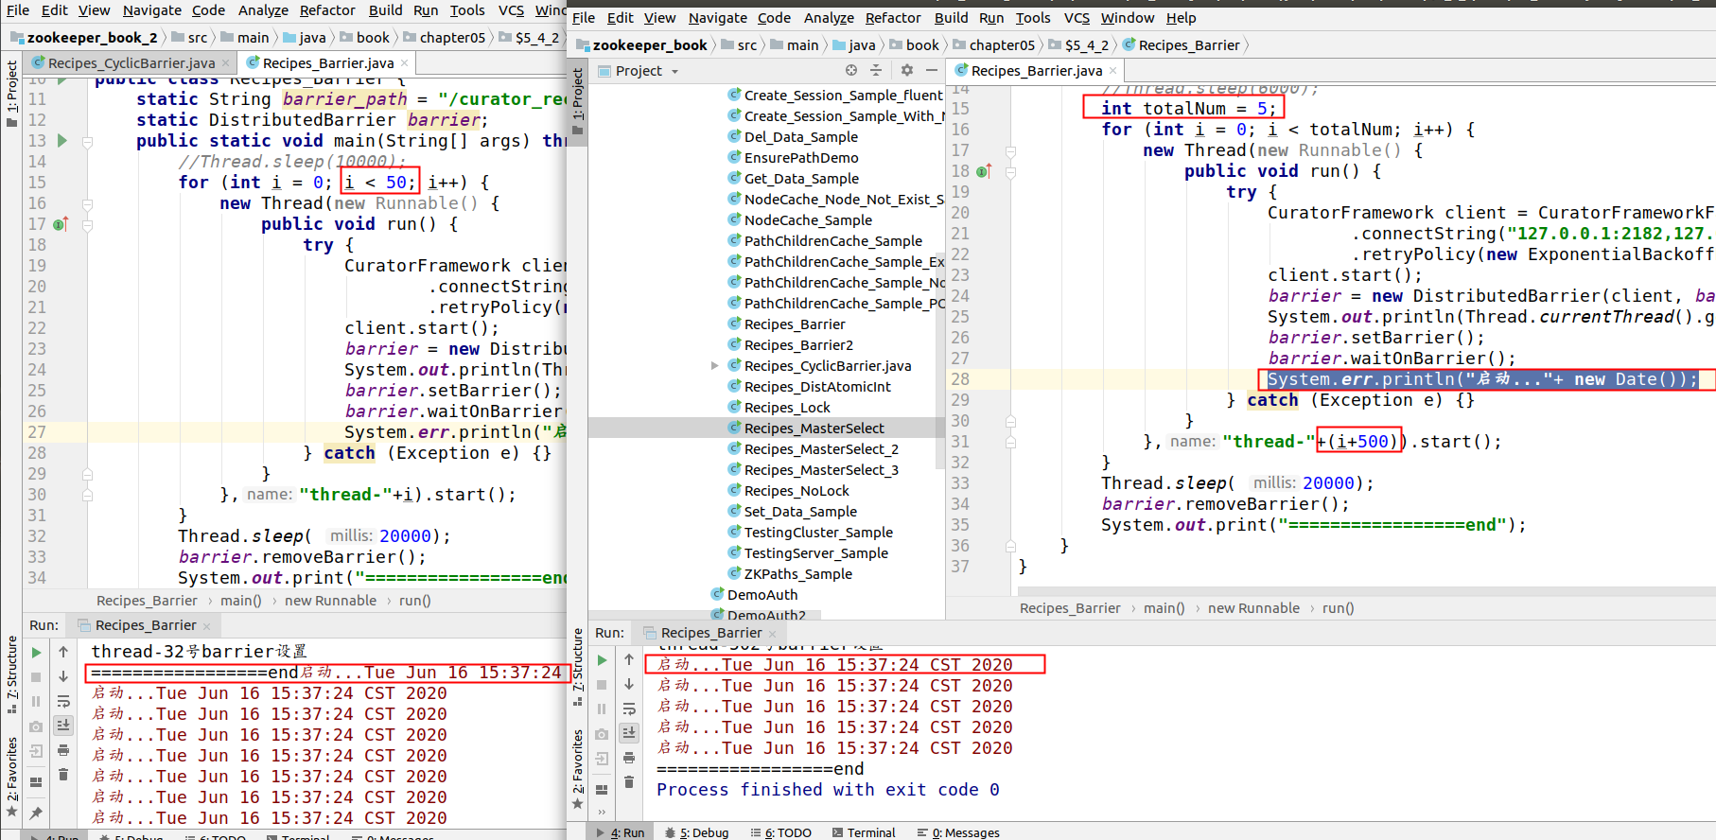
这里做了一个测试，就是为了真正验证在多个程序下，能否实现线程同步，这里的两个程序区别，一个是创建了50个线程，一个是5个线程，然后分别添加了不同的线程名，避免重复.

这时候可以看到，两个程序的启动时间是一致的.

原理
这里的原理核心方法在waitOnBarrier中，见如下所示.
- public synchronized boolean waitOnBarrier(long maxWait, TimeUnit unit) throws Exception
- {
- long startMs = System.currentTimeMillis();
- boolean hasMaxWait = (unit != null);
- long maxWaitMs = hasMaxWait ? TimeUnit.MILLISECONDS.convert(maxWait, unit) : Long.MAX_VALUE;

- boolean result;
- for(;;)
- {
- result = (client.checkExists().usingWatcher(watcher).forPath(barrierPath) == null);
- if ( result )
- {
- break;
- }

- if ( hasMaxWait )
- {
- long elapsed = System.currentTimeMillis() - startMs;
- long thisWaitMs = maxWaitMs - elapsed;
- if ( thisWaitMs <= 0 )
- {
- break;
- }
- wait(thisWaitMs);
- }
- else
- {
- wait();
- }
- }
- return result;
- }
如果这里没有设置同步超时时间，那么就是无限等待.那么激活唤醒是由watche的方法实现的.

- private final Watcher watcher = new Watcher()
- {
- @Override
- public void process(WatchedEvent event)
- {
- notifyFromWatcher();
- }
- };
这里的内容就和前面的类似了.

附录
https://blog.csdn.net/hosaos/article/details/88727817
分布式选举参考文档.

https://blog.csdn.net/hosaos/article/details/88233109
分布式锁的参考文档.

