PROJECT REPORT
ON
YOUTUBE SOCIAL MEDIA ENGAGEMENT
ANALYTICS DASHBOARD
VI SEMESTER
INFORMATION TECHNOLOGY
Submitted by
AMRIT KAUR GAHIR
B.E. Information Technology
Department of Information Technology

ST. VINCENT PALLOTTI COLLEGE OF
ENGINEERING AND TECHNOLOGY
Wardha Road, Gavsi Manapur, Nagpur

CERTIFICATE
This is to certify that the project report entitled “YouTube Social Media Engagement Analytics Dashboard” has been prepared by Amrit Kaur Gahir, student of B.E. Information Technology, VI Semester, as a project study. The report describes the design and implementation of a data collection, storage, analytics, and visualization workflow for publicly available YouTube channel information.
The work presented in this report is based on the project implementation and the records available in its local database at the time of review. Any live data collection requires a valid YouTube Data API v3 key and is subject to API quota and policy requirements.
______________________________ ______________________________
Project Guide / Supervisor Head of Department
Date: ____________________ Place: Nagpur

ACKNOWLEDGEMENT
I express my sincere gratitude to the Department of Information Technology and St. Vincent Pallotti College of Engineering and Technology for providing the academic environment and resources required to undertake this project. I am thankful to the faculty members whose coursework helped me apply software engineering, database, and data-analysis concepts in a practical system.
I also acknowledge the documentation and developer resources published by Google, FastAPI, Pydantic, SQLAlchemy, pandas, and Microsoft. These references informed the implementation and the reporting of API limits, data quality, and Power BI relationships. Finally, I thank my family and peers for their encouragement during the development and documentation of this work.
Amrit Kaur Gahir

ABSTRACT
This project implements a FastAPI-backed analytics dashboard for public YouTube video engagement. The system resolves the MrBeast channel through the official YouTube Data API v3, follows its uploads playlist, retrieves video metadata and public statistics in paginated/batched requests, validates and normalizes records, and persists video metadata with dated metric snapshots in SQLite. Python analytics services calculate engagement rates, rank videos, summarize publication patterns, compare historical observations, and generate evidence-qualified recommendations. Pydantic schemas validate API input and output, while FastAPI exposes interactive Swagger and ReDoc documentation. Stored data can be exported to four CSV datasets and modeled in Microsoft Power BI.
At inspection on 17 October 2026, the local SQLite database contained 200 video records and 400 metric snapshots over two collection times. This count describes the local database; it does not establish that a live API request was made during this report’s verification. The automated suite completed with 10 passing tests and one Starlette/httpx deprecation warning. YouTube calls are mocked in tests. Missing or hidden public statistics remain null, and engagement is calculated only when views, likes, and comments are available. The system does not access private YouTube Studio metrics such as impressions, watch time, retention, or audience demographics.
Keywords: YouTube Data API, FastAPI, Pydantic, SQLite, engagement analytics, Power BI

TABLE OF CONTENTS
CHAPTER 1 INTRODUCTION 1
CHAPTER 2 REVIEW OF TECHNOLOGY AND FEASIBILITY 2
CHAPTER 3 SYSTEM ANALYSIS AND DESIGN 3
CHAPTER 4 IMPLEMENTATION 5
CHAPTER 5 TESTING AND VERIFICATION 7
CHAPTER 6 RESULTS, CONCLUSION AND FUTURE SCOPE 8
CHAPTER 7 REFERENCES 9
STUDENT INFORMATION 10

LIST OF FIGURES
Update field in Microsoft Word

CHAPTER 1
INTRODUCTION

1.1 Project Overview
Social media platforms publish large volumes of content and public interaction counts. This project turns selected public YouTube channel and video records into a reproducible analytics workflow. It focuses on a single public channel, MrBeast, and combines collection, validation, storage, analysis, export, and dashboarding in one locally runnable project.

1.2 Problem Statement
Public video statistics are exposed through API resources, but raw responses are not directly suited to repeatable comparison. A useful workflow must resolve a channel, traverse its uploads, respect request pagination and batching, retain observations at known times, represent unavailable statistics honestly, and make the resulting data accessible to dashboards. A separate challenge is avoiding false Power BI key assumptions when historical tables intentionally contain repeated video IDs.

1.3 Objectives
• Collect public channel and video data through the official YouTube Data API v3.
• Validate requests and response structures with Pydantic and persist records in SQLite.
• Store dated snapshots so growth can be measured across actual observation times.
• Calculate transparent engagement metrics, rankings, publication patterns, and qualified recommendations.
• Expose the workflow through documented FastAPI endpoints and CSV exports for Power BI.

1.4 Scope and Limitations
The system covers public metadata and counts available through the Data API. It excludes private channel-owner analytics. A configured API key, remaining quota, network access, and current Google policies are required for collection. Public statistics can be hidden, delayed, or unavailable. Correlation between publication time and engagement is descriptive and does not prove causality. Non-authorized API data retention must follow YouTube policy, including refresh or deletion within the applicable 30-day period [3].

1.5 Report Organization
Chapter 2 reviews technical foundations and feasibility; Chapter 3 specifies requirements and design; Chapter 4 explains implementation; Chapter 5 records verification; Chapter 6 presents observed outputs, conclusions, limitations, and future scope; Chapter 7 lists references.

CHAPTER 2
REVIEW OF TECHNOLOGY AND FEASIBILITY

2.1 YouTube Data API v3
The project uses public REST resources from YouTube Data API v3. Channel lookup identifies the channel and its uploads playlist; playlist items are paginated to enumerate uploads; videos.list requests retrieve metadata and public statistics for batches of video IDs [1, 2]. This API workflow provides public counts and metadata, not owner-only analytics. Requests consume quota and may fail because of invalid credentials, quota limits, transient service errors, or removed/private videos.

2.2 Application and Data Technologies
Technology | Role in the project
FastAPI | Versioned HTTP endpoints, dependency injection, OpenAPI and interactive API docs.
Pydantic | Request/response models, field constraints, parsing and schema validation.
SQLAlchemy + SQLite | Relational persistence for channel/video metadata and metric observations.
Python + pandas | Normalization, missing-value handling, derived measures and exports.
Power BI | Interactive KPI, ranking, time-pattern and coverage reports sourced from CSV.

2.3 Feasibility

2.3.1 Technical
The tools are compatible with a local Windows/Python workflow. SQLite avoids a separate database server; FastAPI publishes an OpenAPI document and Swagger UI; the collection client isolates the external API from analytics and persistence. Tests use mocked API responses to exercise the flow without a key or quota.

2.3.2 Economic and Operational
The project uses open-source Python libraries and a local SQLite database. Power BI Desktop is used to build and refresh the report; the project includes CSV exports and model guidance. Operational use still depends on API quota, key protection, scheduled refresh/collection, and compliance with YouTube developer policies.

2.4 Data Quality Principles
The system treats a missing statistic as unknown rather than zero, validates request bounds before calling external services, stores collection timestamps, and keeps descriptive calculations tied to available fields. A historical growth value is meaningful only when the same video has distinct retained snapshots. Recommendations are observational hypotheses; they are not claims of causal effects.

CHAPTER 3
SYSTEM ANALYSIS AND DESIGN

3.1 Requirements
Type | Requirement
Functional | Resolve a channel; enumerate uploads; collect video details and statistics; persist metadata and dated observations.
Functional | Provide channel, videos, analytics, collection, health and export endpoints.
Functional | Calculate overview metrics, top videos, publishing patterns, historical growth and qualified recommendations.
Non-functional | Validate inputs; return consistent HTTP errors; avoid logging secrets; keep database access transactional.
Non-functional | Expose OpenAPI, Swagger UI and ReDoc; use portable local SQLite configuration.

3.2 Layered Architecture
The route layer handles HTTP and dependency wiring. Pydantic schemas define validated API contracts. Service modules implement collection, analytics, export, and video workflows. Repositories encapsulate SQLAlchemy reads/writes; ORM models define the relational shape; configuration reads environment values. The YouTube client is the boundary to the external API. This separation keeps route handlers small and supports isolated service tests.
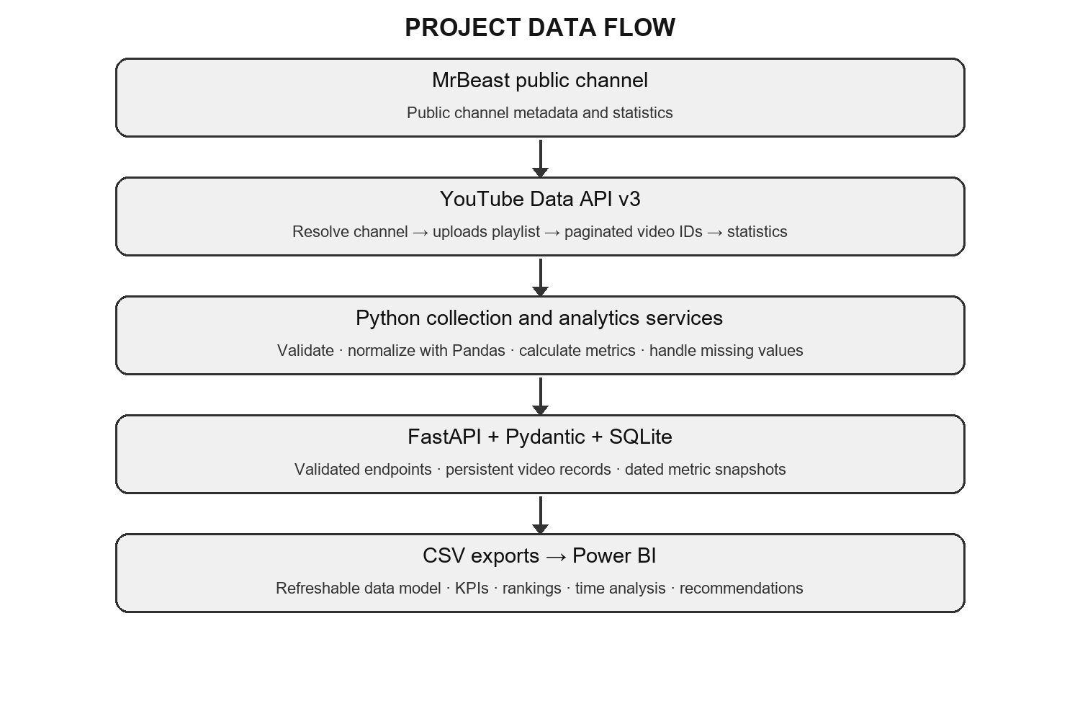
Figure Update field in Microsoft Word. End-to-end data flow and system layers

3.3 Collection Flow
A collection request is validated, the channel is resolved from its handle, and the uploads playlist is traversed page by page. The collector gathers IDs up to the requested limit and fetches video resources in batches. Valid records are normalized and committed with a new timestamped snapshot; hidden counts remain null. The service reports collection outcomes and handles external API and persistence errors. Historical records are subject to the configured retention policy.

3.4 Database Design
Entity | Key and purpose
videos | video_id primary key; one row per video; channel, title, publication time, duration and URL/thumbnail metadata.
video_metric_snapshots | snapshot id primary key; video_id foreign key; collected_at; nullable views, likes and comments.

A video can have multiple metric snapshots over time. The natural relationship is therefore videos 1-to-many snapshots. Snapshot timestamps preserve the observation context; the latest counts represent a current observation rather than lifetime history reconstructed from one export.

3.5 API Design
The API is grouped under /api/v1 and provides health, channel, video listing/detail, overview and detailed analytics, collection, and CSV export routes. FastAPI generates /docs, /redoc, and /openapi.json. Request constraints include a channel-handle pattern and a bounded max_videos integer. Error responses use HTTP status codes and structured detail messages instead of silently returning success for failed collection.

CHAPTER 4
IMPLEMENTATION

4.1 Project Structure
Package | Responsibility
app/api/v1/endpoints | HTTP route definitions and response schemas.
app/schemas | Validated Pydantic request and response data.
app/models and app/db | SQLAlchemy entities, database session and repository operations.
app/services | YouTube client, collection workflow, analytics, video queries and CSV generation.
app/core | Environment-backed settings and application configuration.
tests | API, schema, service, persistence, analytics and export verification.

4.2 Input Validation and Error Handling
Pydantic models describe expected fields and apply type/range/pattern constraints. Invalid inputs are rejected before business logic. Database and external API failures are translated into meaningful HTTP errors at the service or route boundary, while logs avoid exposing the API key. Application configuration is loaded from environment variables, and `.env` is excluded from version control; `.env.example` documents variable names without secrets.

4.3 Metrics
For a video with views V, likes L, and comments C, the engagement rate is defined as 100 × (L + C) / V. It is calculated only where V is greater than zero and both L and C are present. Like rate and comment rate are also percentage-point ratios against views. A rate value of 5 represents 5 percent; when displayed as a Power BI percentage, it must not be multiplied by 100 a second time. These are public-count ratios, not reach-based audience engagement rates.

4.4 Collection and Persistence
The client uses the official API endpoints and follows pagination tokens. Video detail requests are batched, then cleaned into consistent records. Repository operations upsert the unique video metadata and append dated metric snapshots, allowing repeated collection to show changes. The workflow stores data locally in SQLite and can regenerate exports from stored records without making a new API request.

4.5 Power BI Data Preparation
Export | Grain and usage
videos.csv | One record per video; unique dimension key.
video_metrics.csv | One record per video per collection time; repeated video_id is expected.
engagement_analysis.csv | Observation-level metrics and rates; repeated video_id is expected.
channel_summary.csv | Channel aggregate at export time; kept disconnected in the documented model.

In Power BI, Videos[video_id] is the unique 1 side. It relates in a single direction to VideoMetrics[video_id] and EngagementAnalysis[video_id], each on the many side. Fact tables must not be designated as the unique side or joined directly to one another. Repeated IDs in both observation exports are correct and explain the prior refresh error when Power BI inferred an invalid one-side key. The project’s model guide and DAX measures describe this setup.

4.6 Dashboard
The Power BI dashboard uses a dark visual theme inspired by the supplied design. It contains channel/video coverage and engagement KPIs, monthly views, a top-video ranking, an engagement-rate table, a year comparison, and interaction coverage. Visuals should use the latest snapshot where a current value is intended and preserve the date grain for historical comparisons. The supplied screenshot is included below as the implemented report reference.
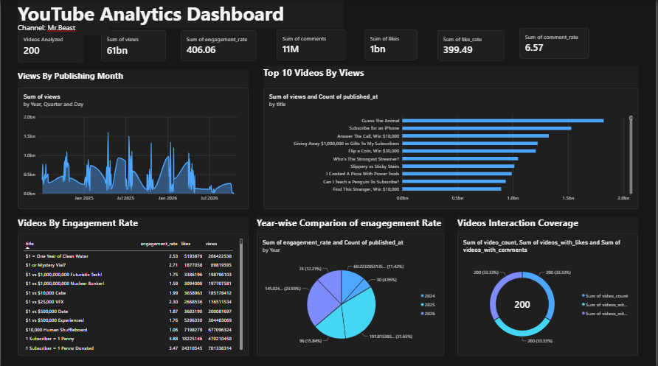
Figure Update field in Microsoft Word. YouTube Analytics Power BI dashboard design supplied for the project

CHAPTER 5
TESTING AND VERIFICATION

5.1 Verification Approach
Automated tests cover Pydantic validation, HTTP routes and error responses, database/repository behavior, mocked collection responses, analytics calculations, and CSV output. The test suite uses simulated YouTube responses so it can run without credentials, network access, or API quota. This verifies code paths against the fixtures but does not certify current live API behavior.

5.2 Test Results
Check | Observed result | Interpretation
Automated test suite | 10 passed; 1 warning | Completed 17 October 2026; warning is Starlette/httpx TestClient deprecation.
Local SQLite | 200 videos; 400 snapshots | Records exist for MrBeast at two distinct collection times.
CSV exports | 4 documented datasets | Export schemas support unique video dimension and repeated observation facts.
External YouTube API | Not verified in this report run | Live collection requires configured key, quota and network/API availability.
Power BI refresh | Model instructions verified; not automated here | Use Videos as the unique 1 side and observation tables as many.

5.3 Error and Edge-Case Coverage
The project test suite includes invalid request and mocked external-service cases. The system design also accounts for missing public counts, videos that are no longer available, zero views, API errors, quota/credential failures, and database errors. An unavailable statistic must remain null in storage and exports; analytics should omit it from a calculation that requires the value instead of treating it as zero.

5.4 Reproduction
From the project root in PowerShell:
.\.venv\Scripts\python.exe -m pytest -q -p no:cacheprovider
.\.venv\Scripts\python.exe -m scripts.init_db
.\.venv\Scripts\python.exe -m uvicorn app.main:app --reload --port 8001
Open http://127.0.0.1:8001/docs for Swagger UI, then use POST /api/v1/collection/run with a configured YOUTUBE_API_KEY to request live collection. Port 8001 is shown because the default port 8000 may be restricted by local Windows networking policy.

CHAPTER 6
RESULTS, CONCLUSION AND FUTURE SCOPE

6.1 Observed Project State
The local database inspected on 17 October 2026 held 200 MrBeast video rows and 400 metric snapshots. The snapshots span two recorded collection timestamps from 06:48:16 to 07:45:14 UTC on that date. These facts establish that records and multiple observation times are present in the local database. They do not establish that the report author performed a fresh live collection or independently verified each record against the API during report generation.

6.2 Conclusion
The project connects public YouTube data collection to a maintainable web API, relational storage, transparent analytics, CSV interchange, and a Power BI dashboard. Its separation into routes, schemas, repositories, and services supports validation and testing. Dated snapshots provide the foundation for historical comparisons, while explicit null handling prevents hidden statistics from becoming misleading zeros. The documented Power BI relationship pattern resolves the duplicate-key problem by treating observation tables as facts and videos as the unique dimension.

6.3 Limitations
• Metrics are public counts only; private Studio measures such as watch time, impressions, retention, and demographics are out of scope.
• Live API collection depends on an API key, quota, network availability, and current API policy.
• Snapshot history is limited by the retention policy applicable to non-authorized API data.
• Recommendations and publishing-time comparisons are descriptive hypotheses and do not establish causality.
• A Power BI Desktop refresh and PBIX integrity check require the user’s local Power BI installation and configured data paths.

6.4 Future Scope
• Schedule compliant collection and monitor quota, API errors, and freshness.
• Add an explicit calendar dimension and latest-snapshot measures for consistent Power BI filtering.
• Expand to additional user-selected public channels with per-channel configuration and isolation.
• Add data-quality reporting for missing fields, stale snapshots, duplicate imports, and export validation.
• Run deployment-level security review and production hosting only after secrets, access controls, retention, and observability are configured.

CHAPTER 7
REFERENCES
[1] Google Developers, YouTube Data API v3: REST API Reference, https://developers.google.com/youtube/data/reference/rest (accessed 17 Oct 2026).
[2] Google Developers, YouTube Data API: Videos and channel uploads implementation guide, https://developers.google.com/youtube/data/guides/implementation/videos (accessed 17 Oct 2026).
[3] Google Developers, YouTube API Services Developer Policies, https://developers.google.com/youtube/terms/developer-policies (accessed 17 Oct 2026).
[4] FastAPI, First Steps and Interactive API Documentation, https://fastapi.tiangolo.com/tutorial/first-steps/ (accessed 17 Oct 2026).
[5] FastAPI, Handling Errors, https://fastapi.tiangolo.com/tutorial/handling-errors/ (accessed 17 Oct 2026).
[6] Pydantic, Models and Data Validation, https://docs.pydantic.dev/latest/concepts/models/ (accessed 17 Oct 2026).
[7] SQLAlchemy, SQLite Dialect, https://docs.sqlalchemy.org/en/20/dialects/sqlite.html (accessed 17 Oct 2026).
[8] pandas, Working with Missing Data, https://pandas.pydata.org/docs/user_guide/missing_data.html (accessed 17 Oct 2026).
[9] Microsoft Learn, Power BI Desktop Data Sources: Text/CSV, https://learn.microsoft.com/power-bi/connect-data/desktop-data-sources (accessed 17 Oct 2026).
[10] Project source and configuration: README.md, docs/architecture.md, docs/methodology.md, docs/data_dictionary.md, docs/limitations.md, powerbi/data_model.md, powerbi/measures.dax, powerbi/dashboard_guide.md, and tests/ (reviewed 17 Oct 2026).

STUDENT INFORMATION
Field | Details
Name | Amrit Kaur Gahir
Programme | B.E. Information Technology
Semester | VI Semester
Project | YouTube Social Media Engagement Analytics Dashboard
Institution | St. Vincent Pallotti College of Engineering and Technology, Nagpur

