
TECHNICAL UNIVERSITY OF MOLDOVA
Faculty of Computers, Informatics and Microelectronics
Department of Software Engineering
REPORT
on laboratory work no. 13
Course: Operating Systems
Topic: Semaphores in Your Own Kernel
Done by: st. gr. FAF-242, Cătălin Bîtca
Checked by: Reițman Patricia
Chișinău, 2026

Purpose of the work
In Labs 11 and 12 I used the semaphores of the C library. In this lab I built them myself, inside the xv6 kernel, as three new system calls: sem_init, sem_down and sem_up (numbers 24, 25 and 26). The goal is to see that a semaphore is only a number, a spinlock that protects it, and the sleep and wakeup of the kernel, and that a process that waits really sleeps and uses no CPU. As the optional task I added a fourth call, sem_trydown (27).

Work environment
I worked in my ~/xv6-riscv tree on the Azure VM, which already has trace (23) from Lab 10. One thing had to be changed first. In Lab 10 I had also added the optional call sysinfo, and I had given it number 24, the next free number at that time. This handout needs 24, 25 and 26 for the semaphores and 27 for the optional call, so I moved sysinfo to 28. It is a one-line change in kernel/syscall.h: the table, the stub and the name all use the constant SYS_sysinfo, not the number, so they follow it automatically.
As in the previous labs, I typed the code of the handout without its comments. The GitHub repository of my xv6 tree checks the formatting with clang-format, so I put the new numbers in their own group after an empty line in syscall.h (otherwise clang-format would realign all 23 lines above them), and I let clang-format realign the table of names of trace in syscall.c.

Part 1. The numbers and the user side
The same recipe as trace in Lab 10, three times: the numbers in kernel/syscall.h, the declarations in user/user.h, the stubs in user/usys.pl, and the two programs in UPROGS (after my programs from Lab 10, with a TAB in front):
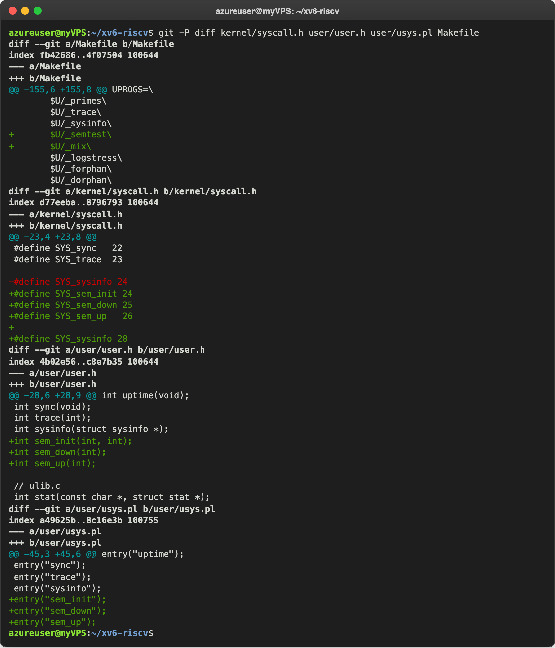
Figure 1.1 – The edits of Part 1, and sysinfo moved from 24 to 28
Then the two programs. semtest checks two things: the child must wait for the parent (semaphore 0 starts at 0), and ping and pong must take turns, with semaphore 1 (ping's turn, starts at 1) and semaphore 2 (pong's turn, starts at 0) passing the turn to each other:
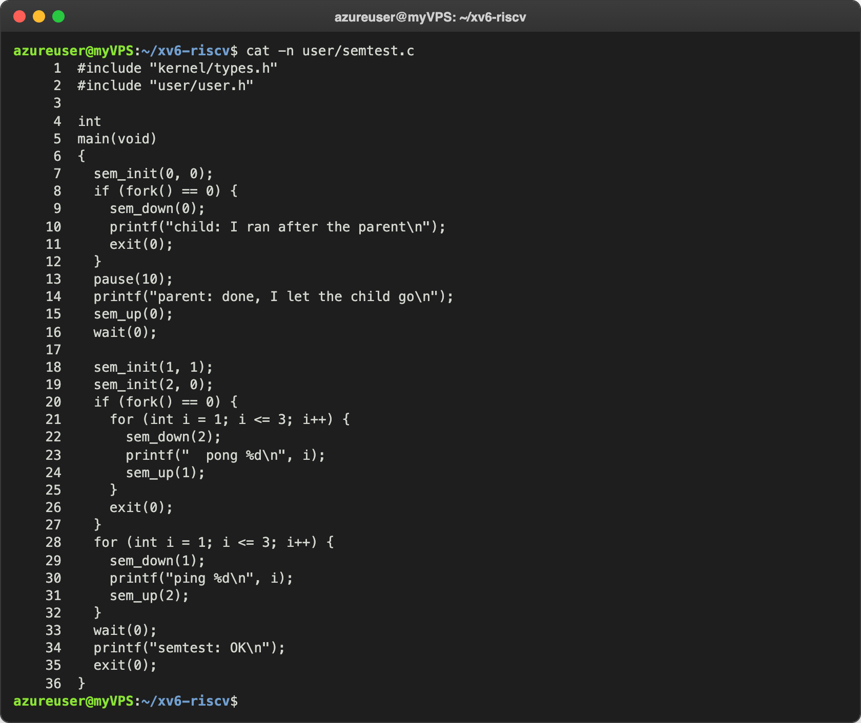
Figure 1.2 – user/semtest.c
mix starts two processes that print five lines each, one letter per write(); with an argument it uses semaphore 3, started at 1, as a lock around each line:
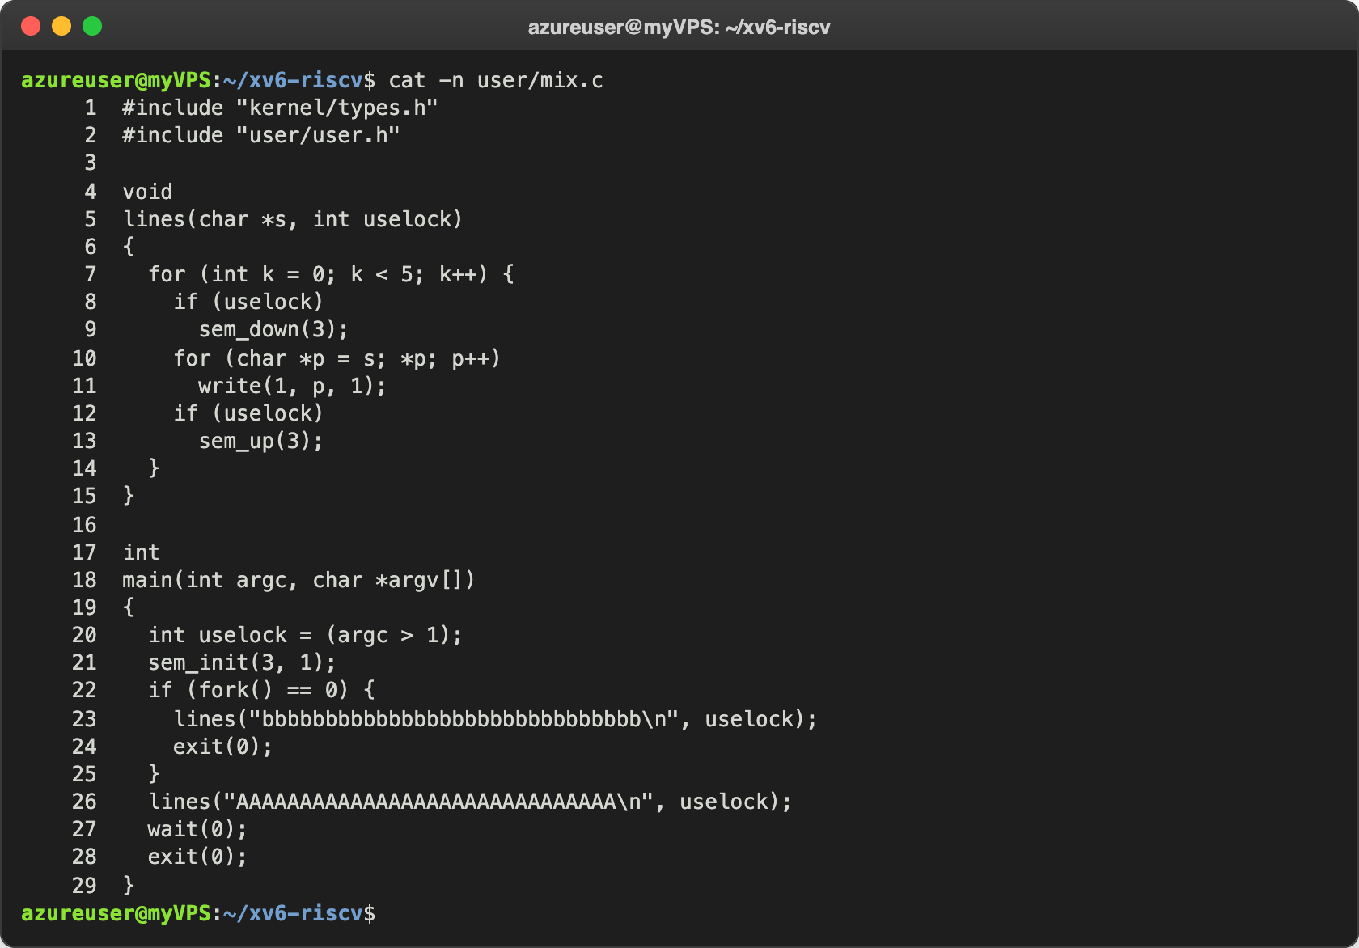
Figure 1.3 – user/mix.c

Check 1: the calls reach the kernel
I started xv6 with make qemu and ran semtest:
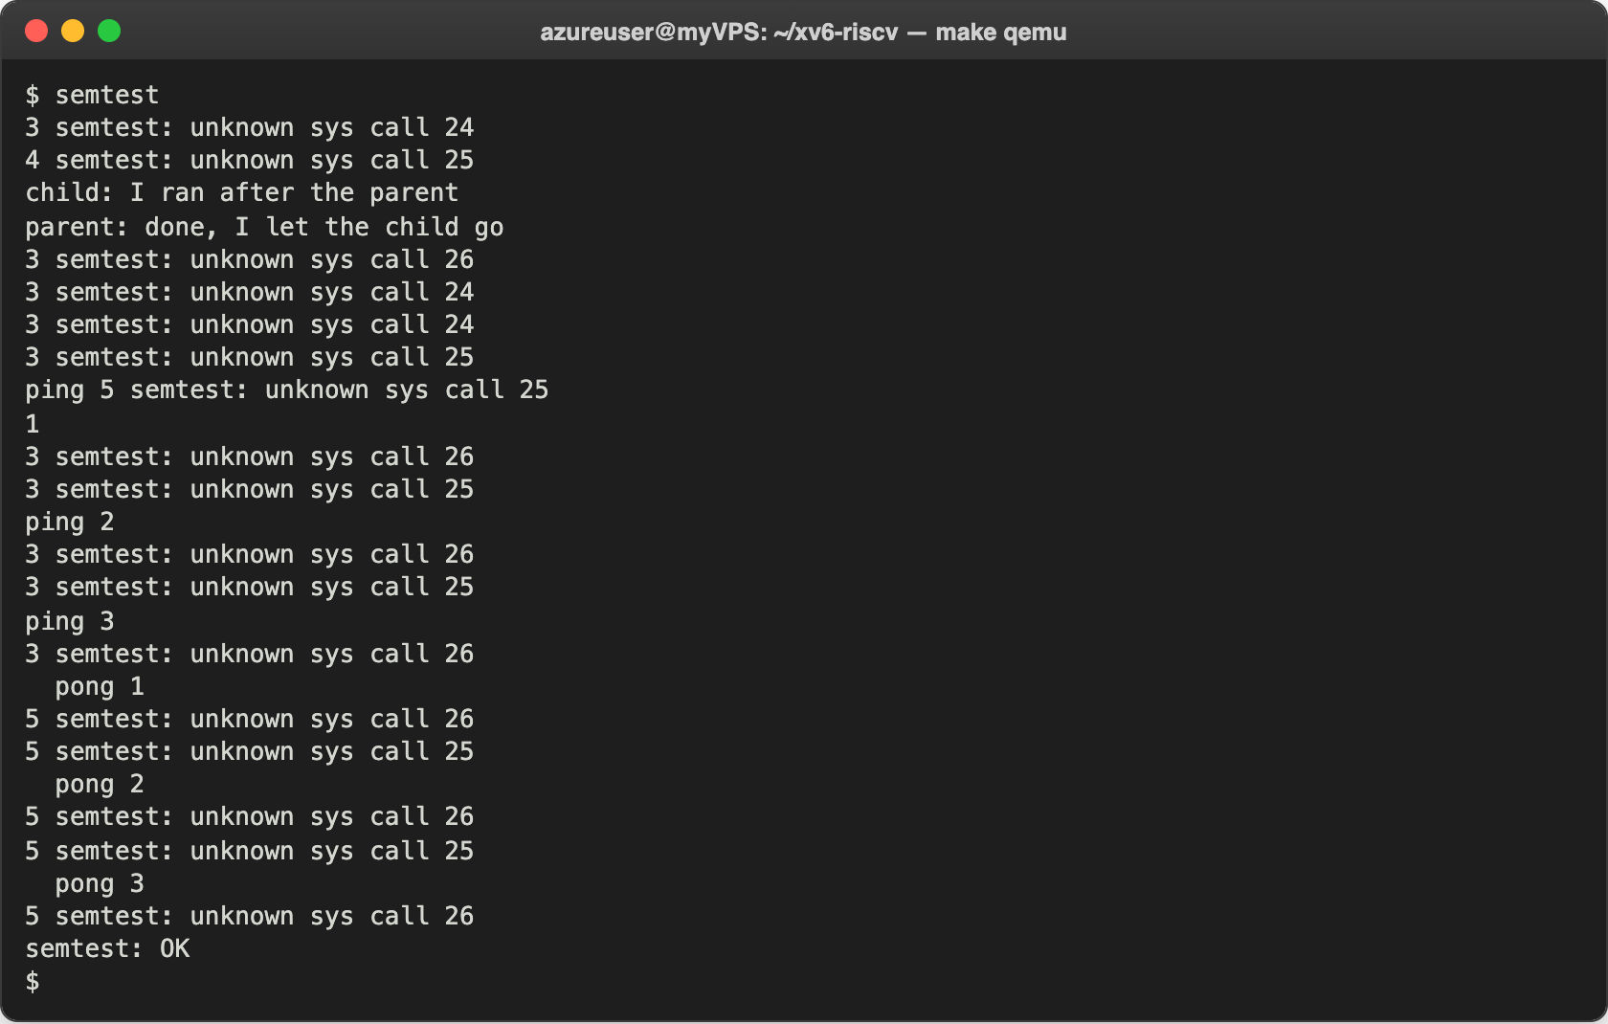
Figure 1.4 – semtest before the kernel side exists
The first four lines are exactly the ones of the handout. sem_init reached the kernel as call 24 and sem_down of the child (PID 4) as call 25, but the table had no function for them, so each call printed "unknown sys call" and returned -1 at once. Because sem_down did not wait, the child printed its line immediately, while the parent was still in pause(10): the child came BEFORE the parent. After that, ping and pong are mixed with the error lines, and the kernel messages even cut a line of the program in two ("ping 5 semtest: ..." and then "1"), because the kernel and the two processes all print to the same console. semtest: OK is still printed at the end, since the program does not look at the return values. This is what Part 2 fixes.

Part 2. The kernel side
The semaphores themselves are in a new file, kernel/sem.c:
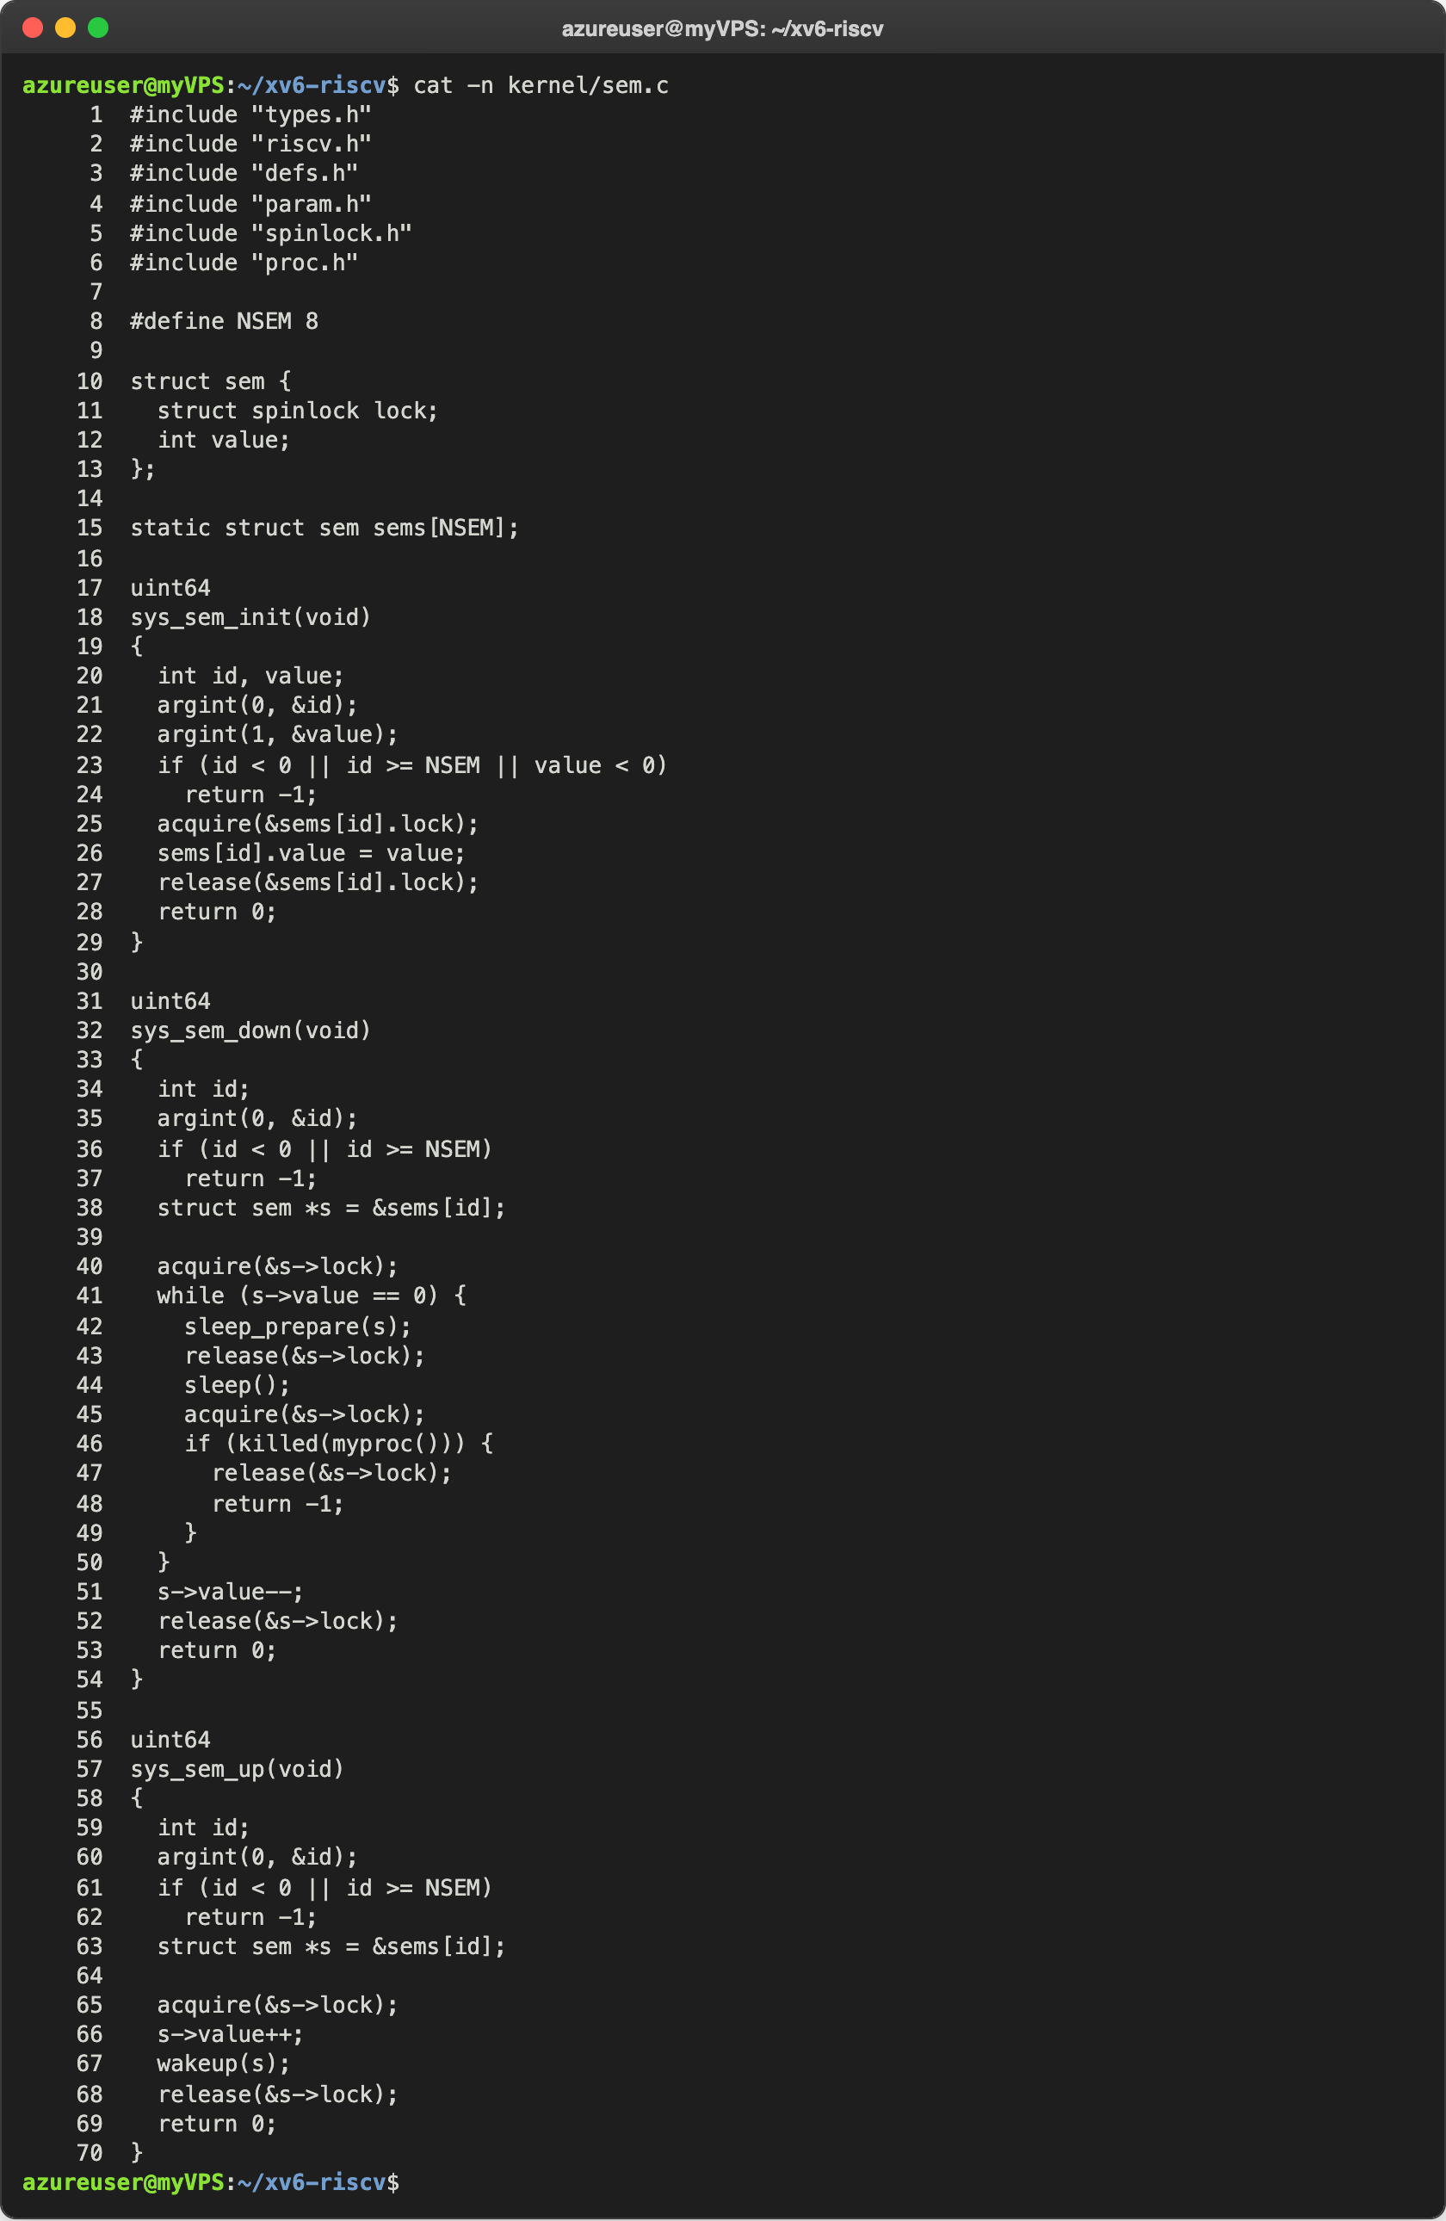
Figure 2.1 – kernel/sem.c
There is a small table of NSEM = 8 semaphores, shared by all processes. Each one is a number (value) and a spinlock that protects it. The table is a static array, so at boot it is all zeros, and a zeroed spinlock is a free spinlock. sys_sem_init reads the two arguments with argint, checks them and sets the value while holding the lock.
sys_sem_down is the heart (lines 32–54). It takes the lock and, while the value is 0, it waits: sleep_prepare(s) registers the address of the semaphore as the "channel" the process waits for (p->chan = s), release lets go of the spinlock, and sleep() puts the process to sleep: its state becomes SLEEPING, and sched() gives the CPU to another process. When it wakes up, it takes the lock again and checks the value again. When the value is not 0, it takes one unit (s->value--) and returns. sys_sem_up takes the lock, adds 1 and calls wakeup(s), which makes every process sleeping on the address s RUNNABLE again.
Our kernel sleeps in two steps for a reason. If sem_up runs on another CPU between release and sleep(), its wakeup finds the process already registered on s and clears p->chan; then sleep() sees that and returns at once, so the wakeup is not lost. Then I added $K/sem.o to OBJS in the Makefile, and the three functions to the table in syscall.c (and their names to the table of trace):
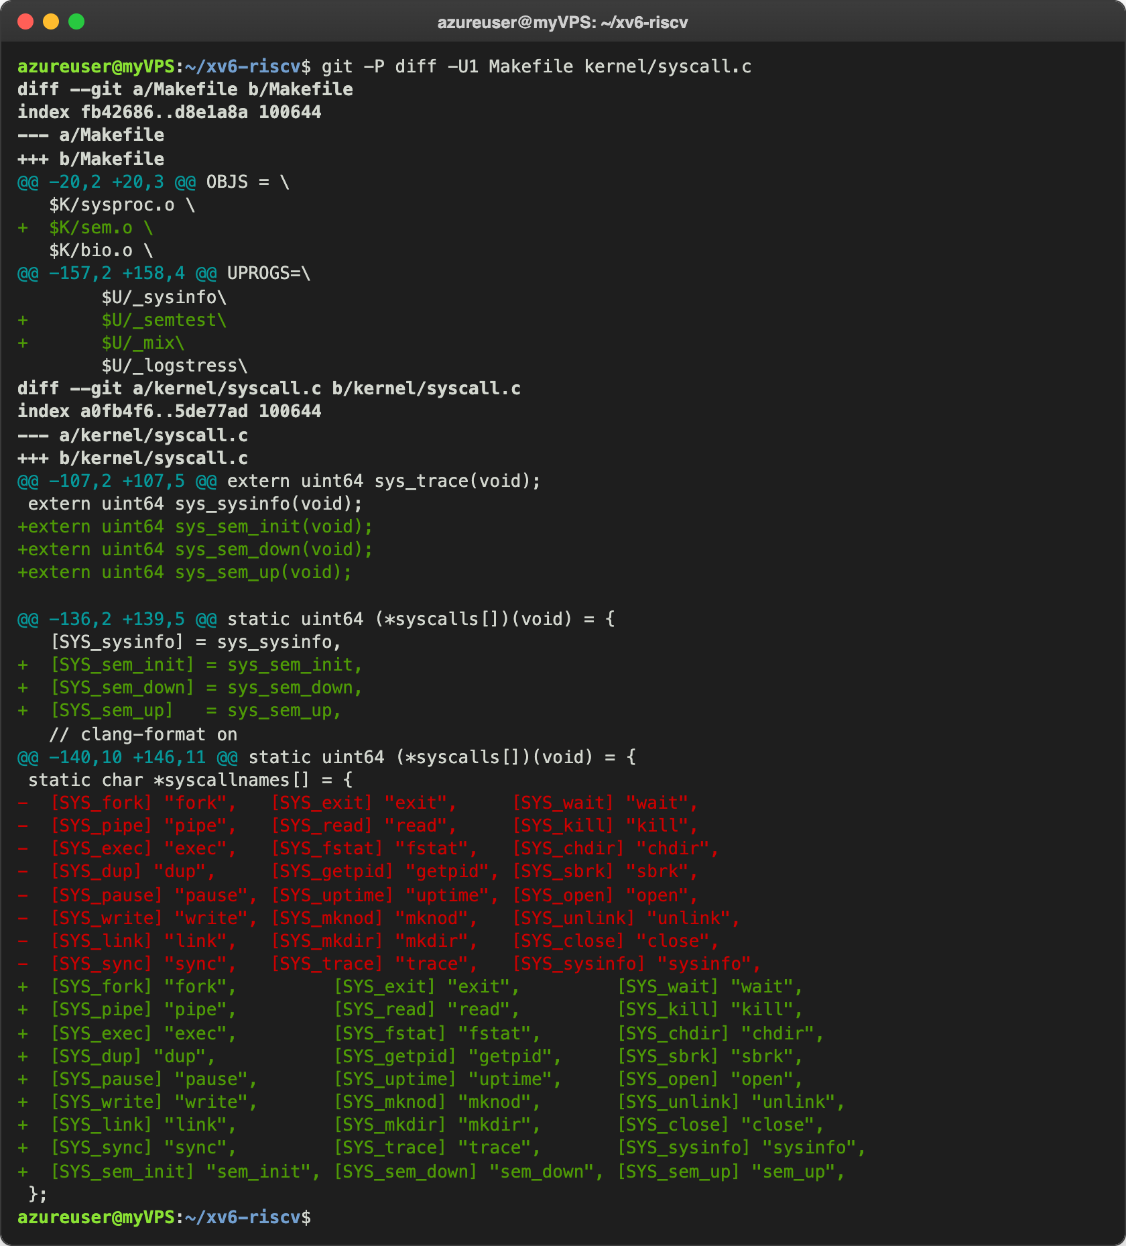
Figure 2.2 – sem.o in OBJS, and the table entries in kernel/syscall.c

Check 2: semtest
Ctrl-A X, make qemu, and semtest again:
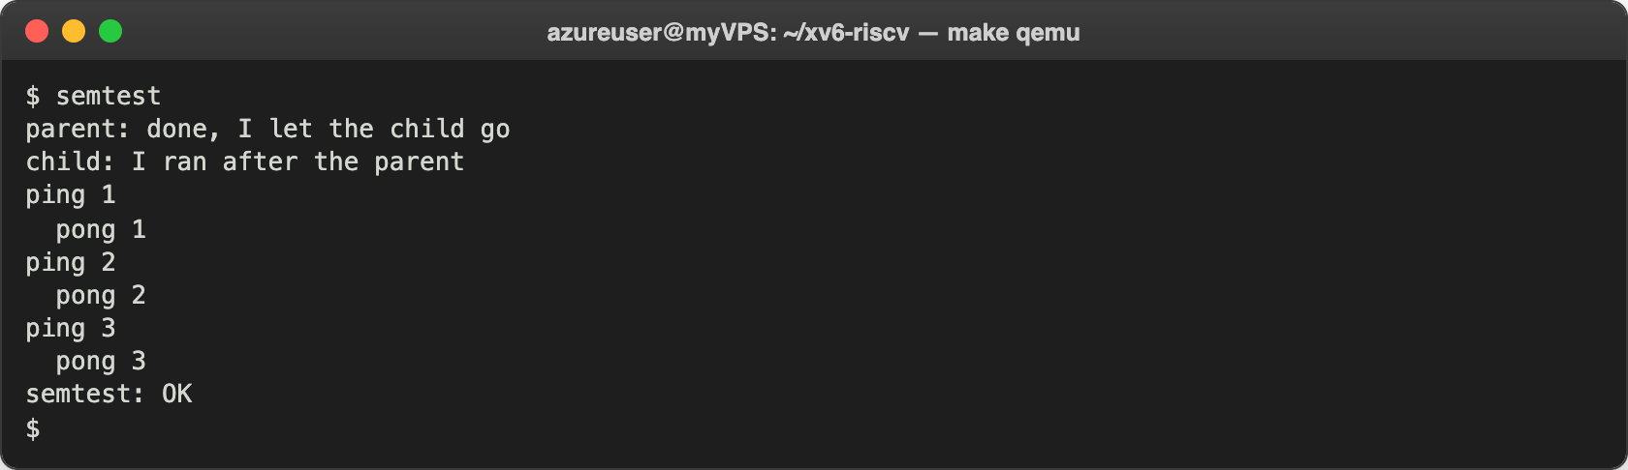
Figure 2.3 – semtest with the kernel semaphores
Exactly the expected output. The parent waited 10 ticks (one second) before it let the child go, and the child still printed second: during that time it was asleep inside sem_down, in the SLEEPING state, so the scheduler did not give it any CPU. Then ping and pong alternated strictly, three times each: ping starts, because semaphore 1 starts at 1, and after each line each side gives the turn to the other one with sem_up.

Part 3. A semaphore as a lock: mix
make qemu starts xv6 with 3 CPUs, so the two processes of mix really run at the same time. I ran it twice without the lock:
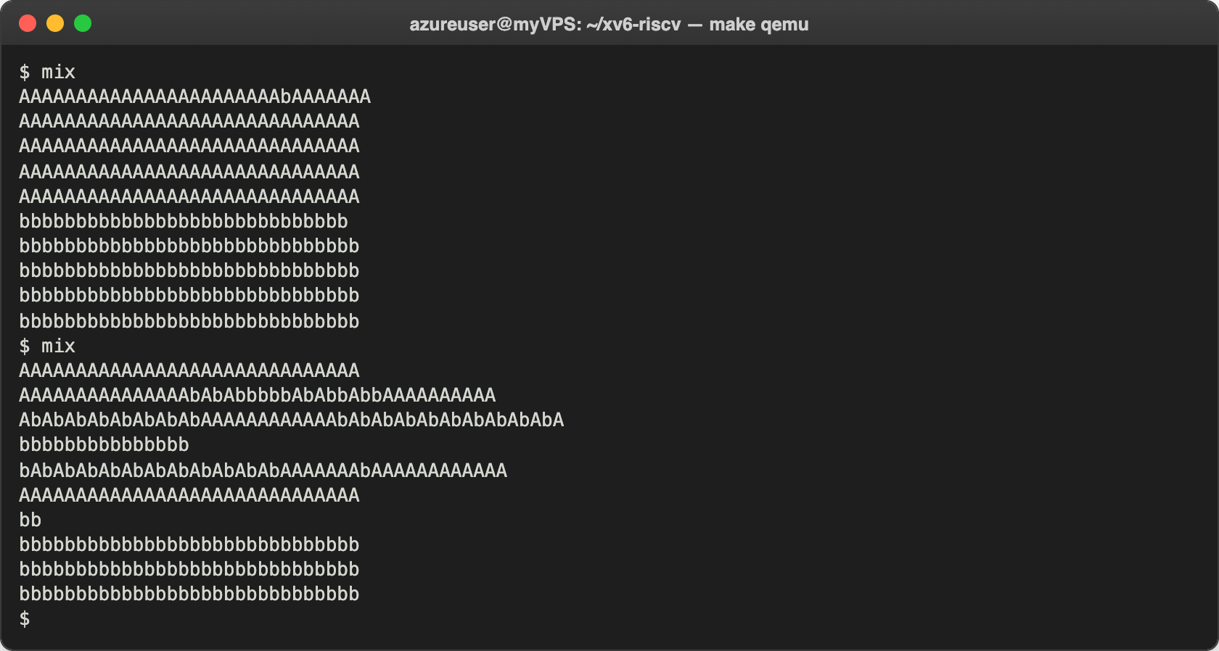
Figure 3.1 – mix without the lock, twice
In the first run only one b got into the first line of A (and the first line of b has one b less): the child started a little later, after fork, and the parent had almost finished. In the second run the letters are mixed in almost every line. Then with the lock:
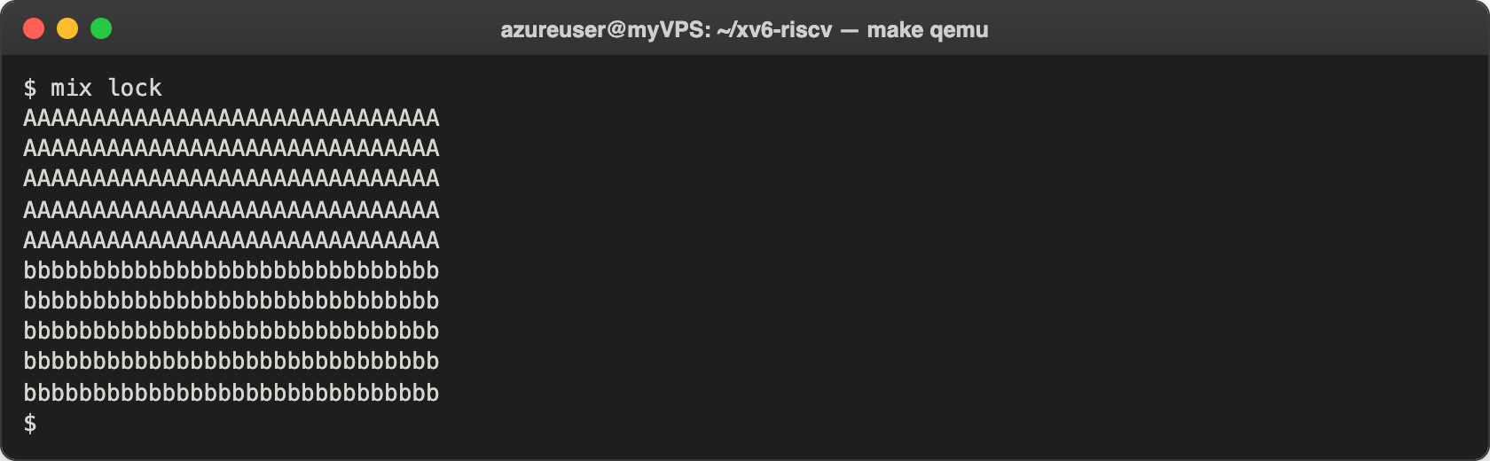
Figure 3.2 – mix lock
Now every line is whole. All the A lines came first: after sem_up(3) the parent immediately calls sem_down(3) for its next line, and it usually gets the unit before the child, which was only made RUNNABLE by the wakeup, has time to run. The semaphore guarantees whole lines, not turns.

Observe
- Without the lock, why do the letters mix? How many system calls does one line cost? One line costs 31 write() system calls: 30 letters and the new line, one byte each. Each write is done whole, but between two write calls of one process the other process, on another CPU, can make its own write calls, and the console receives the bytes in the order the calls happen. So the letters of the two processes mix inside a line.
- With the lock every line is whole. Which two lines of mix.c make one line a critical section? sem_down(3); (line 9, before the loop that writes the letters) and sem_up(3); (line 13, after it). Semaphore 3 starts at 1 (sem_init(3, 1)), so it works as a lock: only one process at a time can be between these two lines, and the 31 write calls of one line cannot be interrupted by the other process.
- In sem_down the test is "while (s->value == 0)", not "if". Why can a process wake up and still find 0? Because wakeup(s) wakes up every process that sleeps on s, but sem_up added only one unit. The first process that takes the lock again takes the unit, and the others find 0 and must go back to sleep. Also, a process that was not sleeping at all can take the unit first: in mix lock the parent called sem_down again right after its sem_up and took the unit before the woken child could run. And a process woken by kill must check again too. With if, all of them would decrease the value below 0, and several processes would be inside the critical section together.
- sem_down calls release(&s->lock) BEFORE sleep(). What would go wrong if it slept holding the spinlock? Then nobody could ever wake it: sem_up must take the same s->lock to add 1 and call wakeup, so on the other CPU it would spin forever in acquire, waiting for a lock held by a sleeping process, and the whole system would stop there. A spinlock also turns off interrupts on its CPU while it is held, and xv6 does not allow it at all: sched() checks that the process holds no lock other than its own p->lock, and panics with "sched locks". The two-step sleep solves the danger of releasing first: the process is registered on s before the lock is released, so a sem_up that comes in between is not lost.

Optional task. sem_trydown
sem_trydown(id) is like sem_down, but when the value is 0 it does not sleep: it returns -1 at once. It got number 27, between the semaphores and sysinfo:
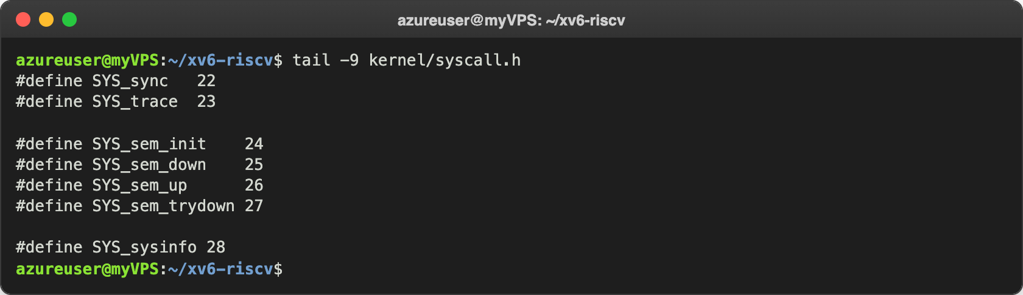
Figure 4.1 – The numbers in kernel/syscall.h
In kernel/sem.c the function takes the lock and takes one unit only if there is one:
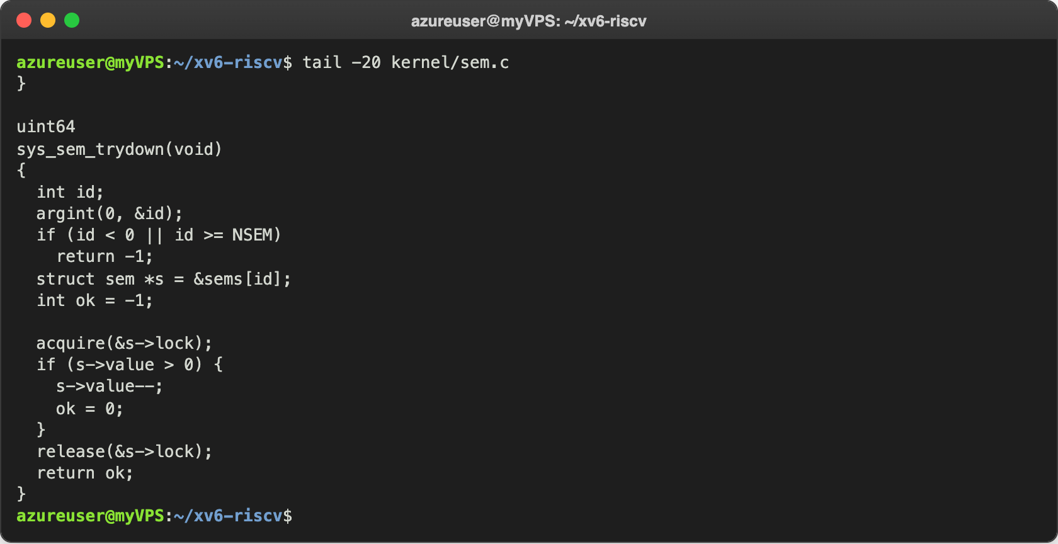
Figure 4.2 – sys_sem_trydown at the end of kernel/sem.c
The rest is the same recipe (the table, the name, user.h, usys.pl, $U/_trydown\ in UPROGS). The small program trydown shows both answers:
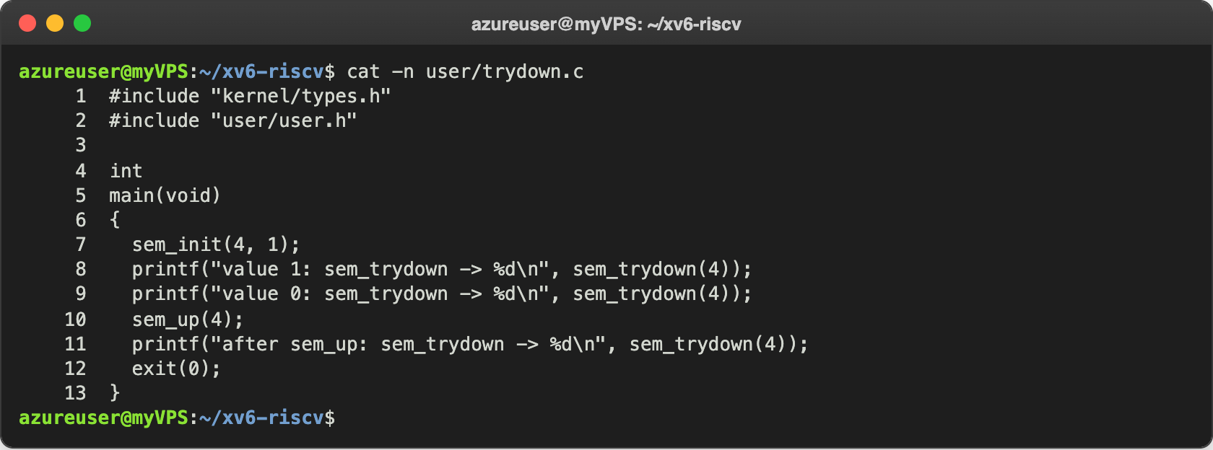
Figure 4.3 – user/trydown.c
Finally I ran trydown, checked that sysinfo still works under its new number (bit 28 of the trace mask, 268435456), and ran semtest under trace with bits 24 to 27 on (2²⁴ + 2²⁵ + 2²⁶ + 2²⁷ = 251658240), to watch the semaphore calls:
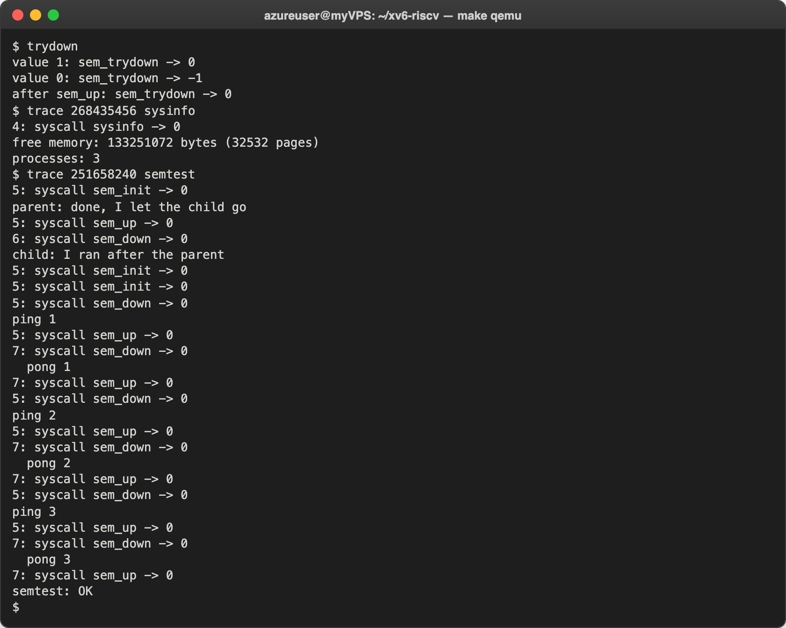
Figure 4.4 – trydown, sysinfo at 28, and semtest seen through trace
sem_trydown returned 0 while the value was 1, -1 when it was 0, and 0 again after a sem_up, without ever sleeping. The trace of semtest shows the sleep of Part 2 directly: the child (PID 6) called sem_down at the start, but its line "6: syscall sem_down -> 0" appears only after the parent's "5: syscall sem_up -> 0", because the call returned only when the parent gave the unit. In the ping-pong part every sem_down of one process returns right after a sem_up of the other one.

Conclusions
In this lab I saw that a semaphore is not magic: in my kernel it is an int and a spinlock in a table of eight, and about seventy lines of C. The spinlock makes the check and the change of the value atomic, and the kernel's sleep and wakeup make a waiting process really sleep, so it uses no CPU until another process calls sem_up. Without the kernel side, semtest ran the child before the parent; with it, the order and the ping-pong were exactly right.
Two details turned out to be the most important ones. The value must be checked again in a while loop after every wakeup, because wakeup wakes everybody and only one unit was added. And the spinlock must be released before sleeping, in the right two-step order, so that sem_up can take it and no wakeup is lost. The same semaphore, started at 1, turned mix into whole lines, which is what the mutex did in Lab 11, now built by me inside the kernel.
Repository: https://github.com/httpcatalin/os-2026-CatalinBitca (folder lab13/, with sem.c, semtest.c, mix.c, trydown.c, the Makefile and kernel.patch). kernel.patch holds the changes of syscall.h, syscall.c, user.h and usys.pl; on a clean xv6 tree, git apply kernel.patch, then copying sem.c into kernel/, the three programs into user/ and the Makefile (with $K/sem.o in OBJS and only my three programs in UPROGS) is enough to build and run everything. The changes are also in my xv6 tree.

