TECHNICAL UNIVERSITY OF MOLDOVA
Faculty of Computers, Informatics and Microelectronics
Department of Software Engineering
REPORT
on laboratory work no. 4
Course: Operating Systems
Topic: The xv6 Shell from the Outside
Done by: st. gr. FAF-242, Cătălin Bîtca
Checked by: ________________
Chișinău, 2026

Purpose of the work
The purpose of this lab is to compare the xv6 shell (user/sh.c, one program of about 500 lines) with bash, and to find out by experiment what a shell really has to do and what bash adds on top. I also wrote a small program that prints its own arguments, to see exactly who expands * and who removes the quotes: the program, the kernel or the shell. Before that I made sure that my sleep program from Lab 2 still builds on the current xv6.

Work environment
Like in Lab 3, I worked on my Ubuntu 24.04 virtual machine in Azure over ssh. The check from the lab passed:
azureuser@myVPS:~/xv6-riscv$ bash ~/Downloads/os2026-setup.sh --check
OS 2026 setup system: Ubuntu 24.04.4 LTS family: debian
==> 2/4 Checking the tools
[ OK ] git
[ OK ] make
[ OK ] gcc
[ OK ] bash
[ OK ] grep
[ OK ] sed
[ OK ] awk
[ OK ] RISC-V compiler: riscv64-linux-gnu-gcc
[ OK ] QEMU 8.2
==> 3/4 xv6 in /home/azureuser/xv6-riscv
[ OK ] already present, left as it is (your work is safe)
==> 4/4 Building xv6 and booting it once
[ OK ] build
[ OK ] xv6 booted and ran ls
All set. Start xv6 with: cd ~/xv6-riscv && make qemu
My ~/xv6-riscv is at the same revision the labs were tested on (06aad25), with my changes from Lab 2 on top.

Part 1. Fix sleep for the current xv6
First I checked which name my tree uses for the system call:
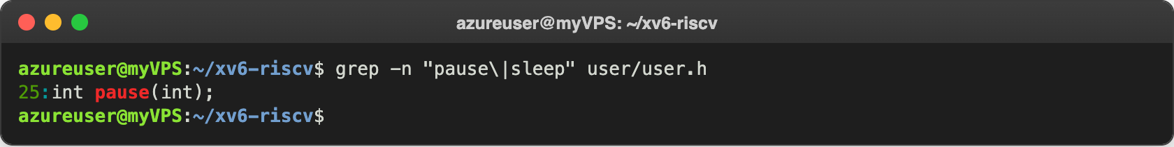
Figure 1.1 – The grep result in user.h
user.h declares only int pause(int); (line 25), there is no sleep. I already ran into this in Lab 2: the sleep.c from that lab failed with implicit declaration of function 'sleep', so my sleep.c already calls pause(). $U/_sleep\ is in UPROGS (line 135 of the Makefile, it starts with a TAB and ends with the backslash).
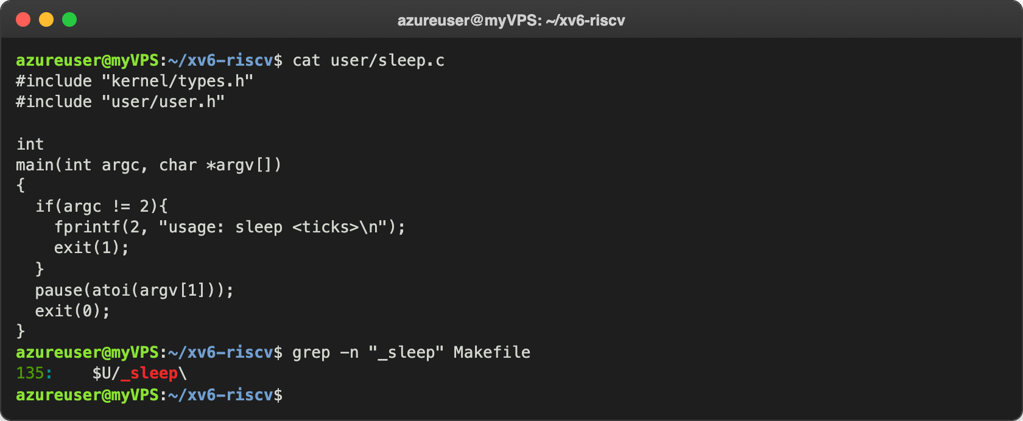
Figure 1.2 – The updated sleep.c
Then I built and booted xv6 with make qemu and tested it. sleep 20 waited about 2 seconds before the prompt came back (one tick is about 0.1 s), and sleep without an argument printed the usage message. I left QEMU with Ctrl-A, X.
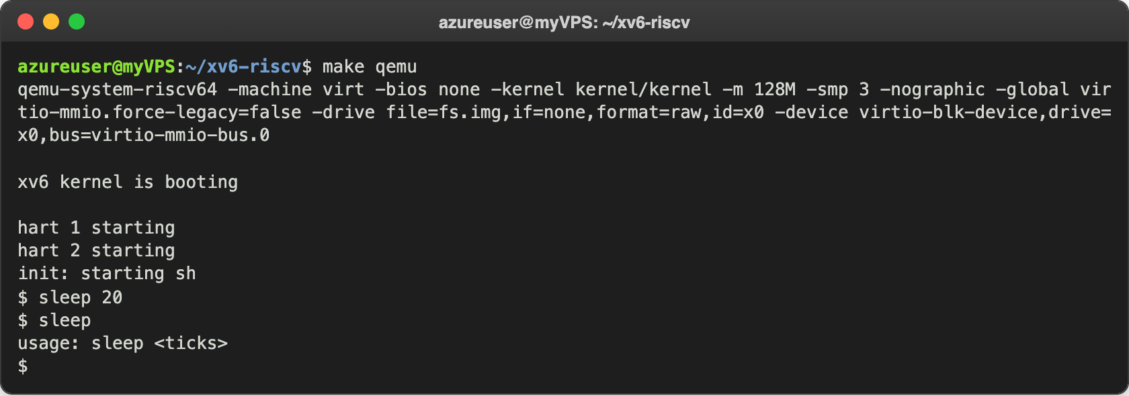
Figure 1.3 – sleep running in xv6, with and without an argument

Part 2. bash versus the xv6 shell
I ran every command twice: once in bash in the empty folder ~/shtest with a file named README, and once at the xv6 $ prompt. The results:
Command | Tests | bash | xv6
echo hello > f ; cat < f | redirection | hello | hello. Both shells know >, < and ;.
ls | grep READ | pipe | README | README 2 2 2441. The pipe works; xv6 ls also prints type, inode and size.
(echo a; echo b) | wc | grouping, list | 2 2 4 | 2 2 4. Parentheses group a list in both.
echo one ; echo two | sequence | one, two | one, two
echo bg & | background | [1] 103298, then bg, and later [1]+ Done echo bg | bg$: runs in background, but the output gets mixed with the next prompt; no job number, no "Done".
ls * | globbing | README f | ls: cannot open *. No globbing, * is passed as it is.
echo $HOME | variables | /home/azureuser | $HOME. No variables.
echo "a b" | quotes | a b | "a b". Quotes are not removed, echo gets "a and b".
mkdir d ; cd d ; ls .. | PATH | README d f | exec cd failed, then ls .. lists /. d is created, but cd works only as a separate line (see Part 4).
arrow up, Tab, Ctrl+R | history, completion | Up brings back the last command, cat ../RE + Tab becomes cat ../README, Ctrl+R "grep" finds ls | grep READ. | Nothing works. Up only echoes the escape code (the cursor jumps up) and Enter gives exec ... failed; Tab just adds a blank; Ctrl+R puts a control character in the line.

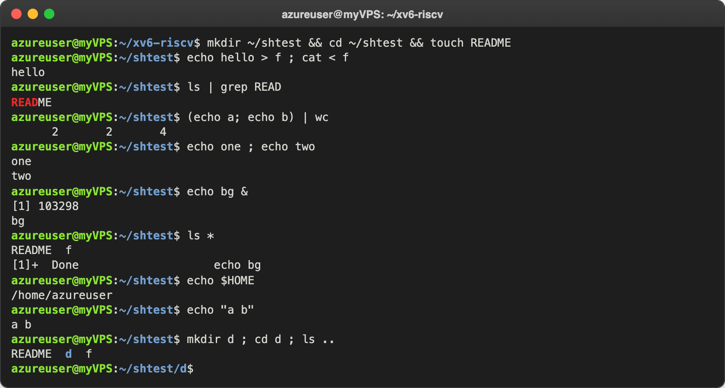
Figure 2.1 – The commands run in bash
For the last row in bash I pressed the keys at the prompt:
azureuser@myVPS:~/shtest/d$ ls ..
README d f
azureuser@myVPS:~/shtest/d$ ls .. <- arrow up
azureuser@myVPS:~/shtest/d$ cat ../README <- "cat ../RE" + Tab
(reverse-i-search)`grep': ls | grep READ <- Ctrl+R, "grep"
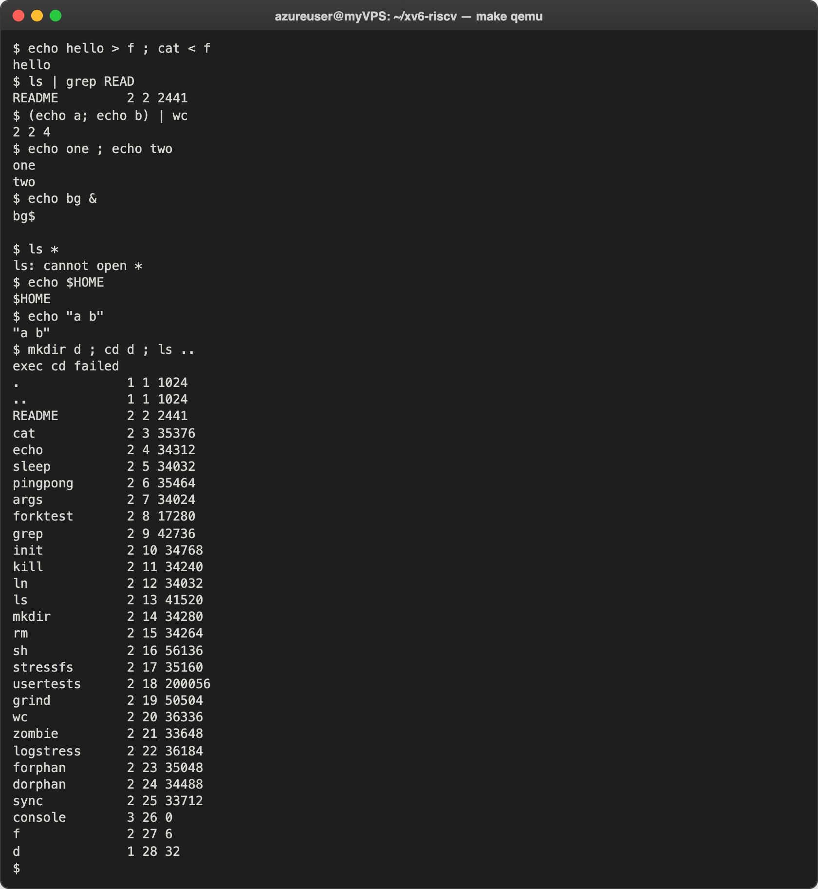
Figure 2.2 – The same commands run in xv6
Then I tested cd d as a separate line in xv6. After that ls does not work any more, but /ls with the full path works:
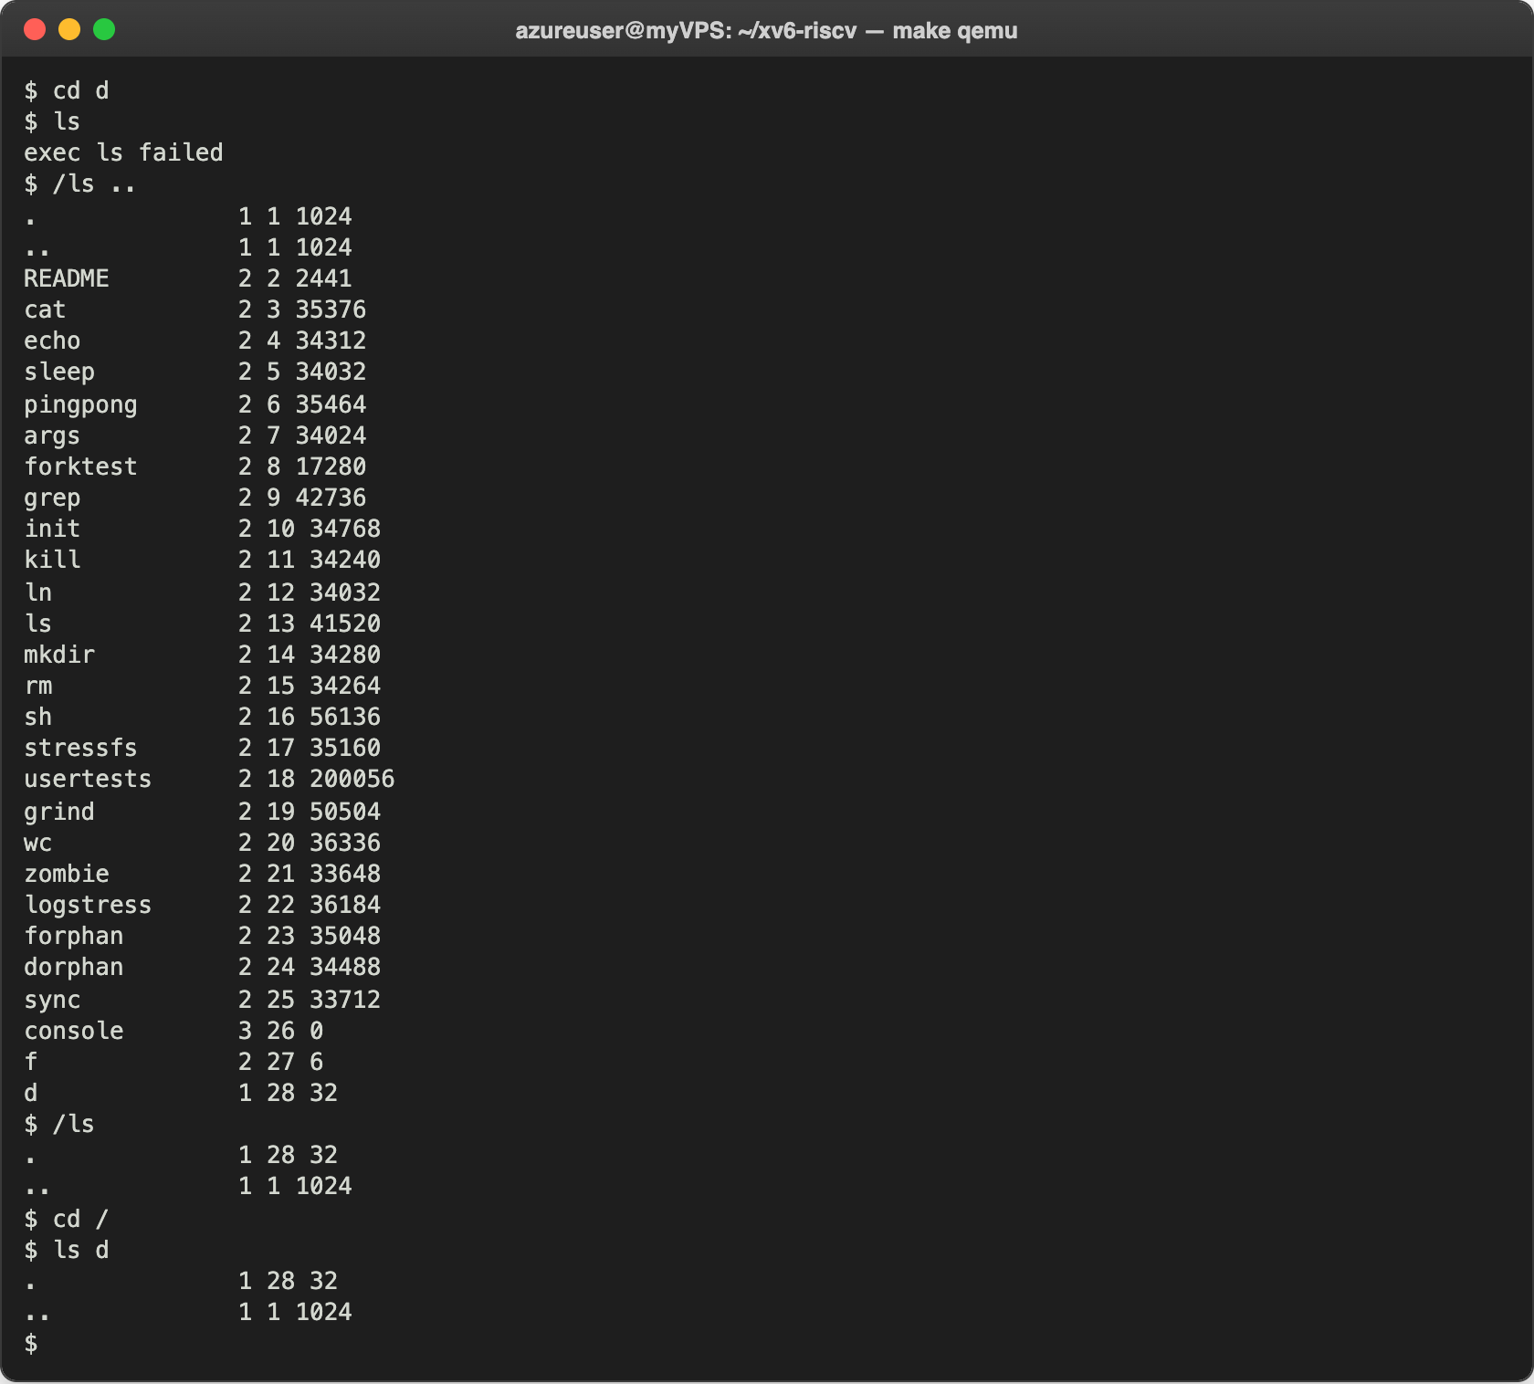
Figure 2.3 – ls failing after cd d, and the working alternative

Observe
- Features both shells have: running a program with arguments, redirection with <, > (and >>), pipes |, lists with ;, grouping with ( ), background with &, and cd. Only bash has: globbing (*, ?, [ ]), variables ($HOME), quotes, searching programs in PATH, history (arrow up, Ctrl+R), Tab completion, job control (jobs, %1, the "Done" message) and cd inside a list.
- Why ls stops working after cd d, and how to run it anyway. All xv6 programs live in the root directory / (I saw them with ls there). The xv6 shell has no PATH, it calls exec("ls") with the name exactly as I typed it, so the kernel looks for a file ls in the current directory /d, where it doesn't exist: exec ls failed. It works if I give the full path, /ls (or ../ls), for example /ls ...
- What I would miss most, and what is easiest to add. I would miss the history with arrow up and Tab completion the most, I use them all the time. The easiest to add is a simple PATH: if exec(argv[0]) fails and the name does not start with /, try again with "/" in front of the name. That is only a few lines in the EXEC case of runcmd() in sh.c.

Part 3. Who expands *? A program that prints its argv
I wrote user/args.c and added $U/_args\ to UPROGS, right after my sleep and pingpong lines:
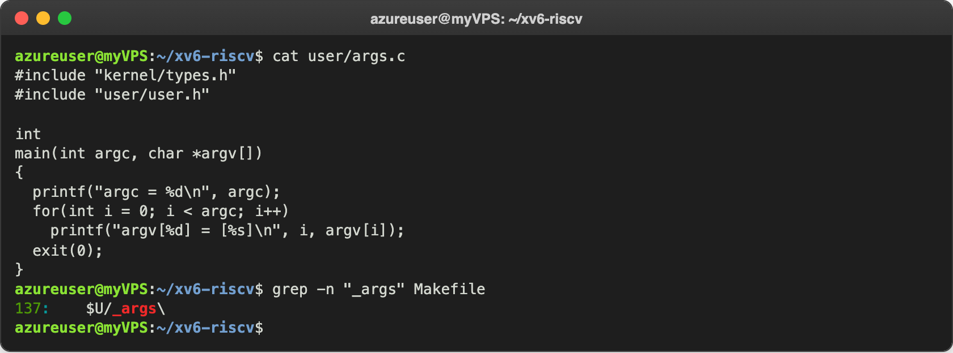
Figure 3.1 – args.c and the UPROGS line
For Linux I wrote the same program as args_linux.c (with <stdio.h> and return 0) in ~/os-lab4 and compiled it with gcc -o args args_linux.c:
#include <stdio.h>

int
main(int argc, char *argv[])
{
printf("argc = %d\n", argc);
for(int i = 0; i < argc; i++)
printf("argv[%d] = [%s]\n", i, argv[i]);
return 0;
}
Then I ran the same lines in both shells:
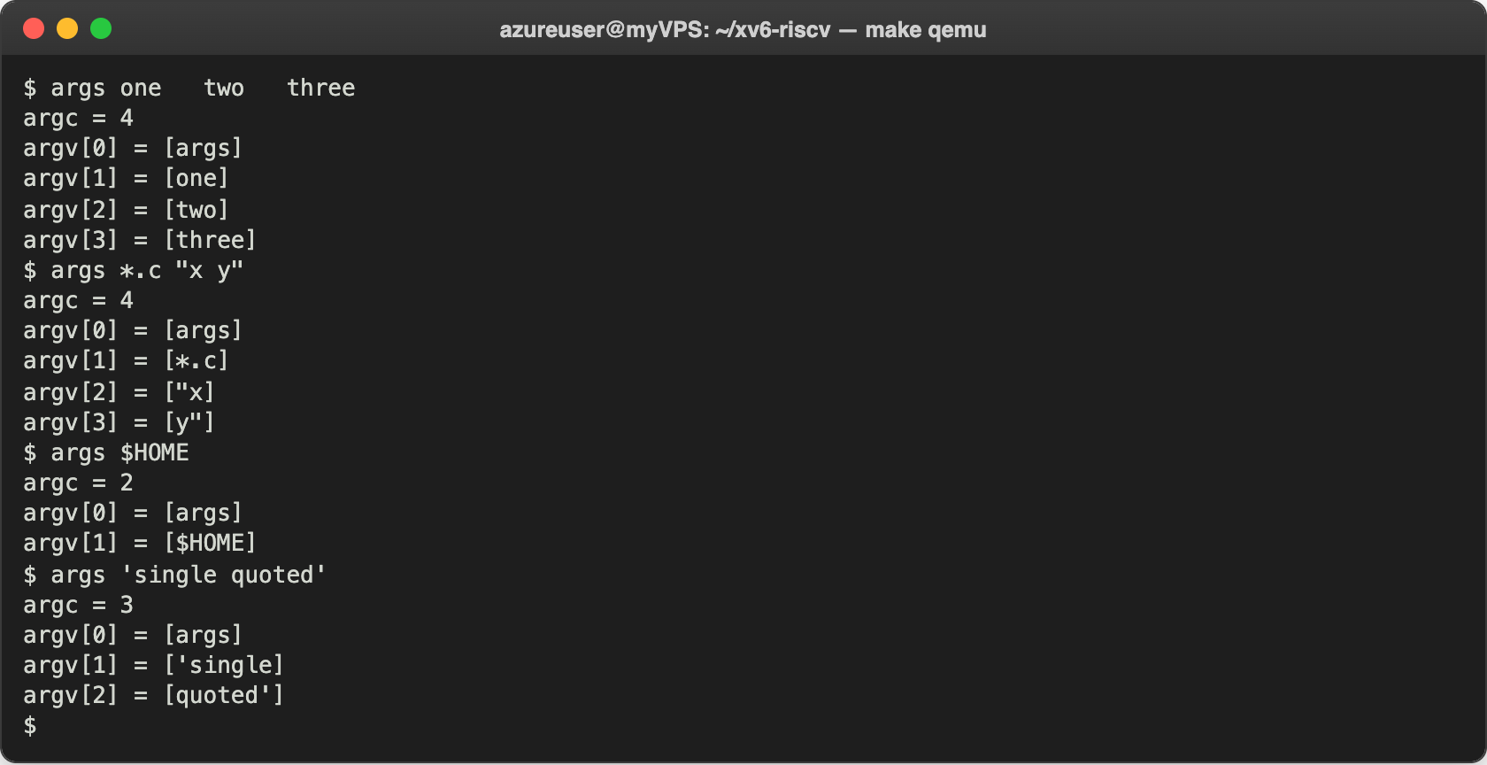
Figure 3.2 – args output in xv6
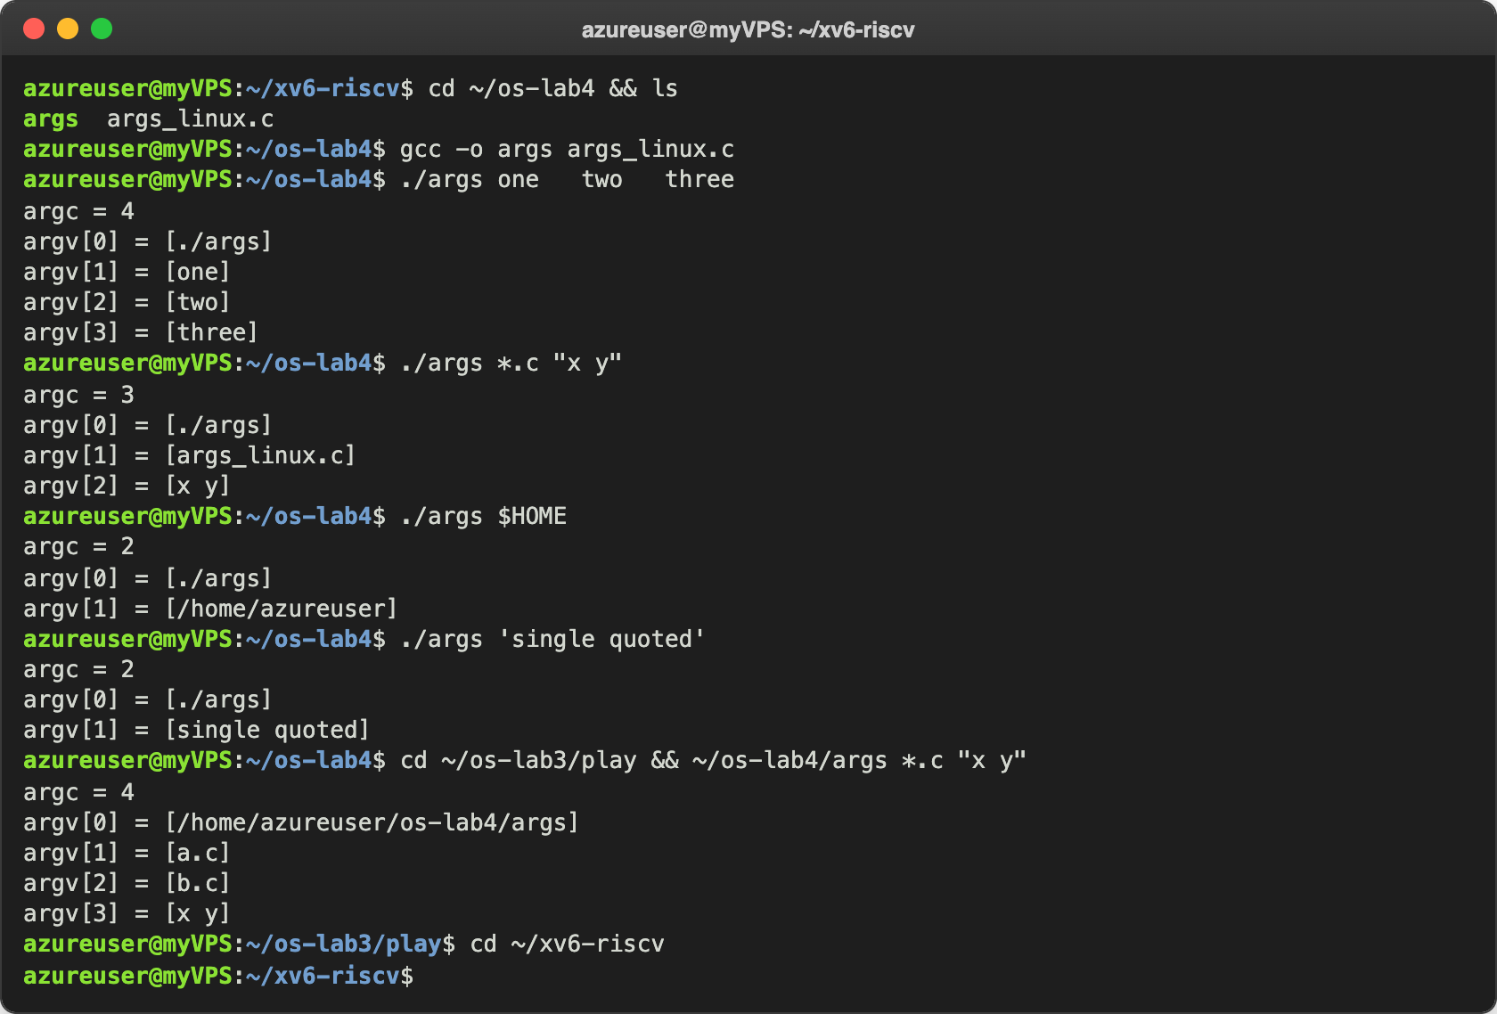
Figure 3.3 – args_linux output in bash

Observe
- Both outputs for args *.c "x y", and how many arguments each program got. In xv6: argc = 4, [args] [*.c] ["x] [y"]. In bash in ~/os-lab4, where the only .c file is args_linux.c: argc = 3, [./args] [args_linux.c] [x y]. I also ran it in ~/os-lab3/play, which has two .c files: argc = 4, [a.c] [b.c] [x y]. The program is the same, only the shell is different, and the arguments are completely different.
- Who turns *.c into file names and removes the quotes? The shell. The kernel only copies the strings it gets in exec to the new program, and the program only prints them. Bash replaced *.c with the file names and removed the quotes before calling exec, the xv6 shell does neither of these, so its program gets the text as it was typed.
- What happened to the extra spaces in one two three? They disappeared in both shells: argc = 4 with [one] [two] [three]. The shell splits the line into words at spaces, and the spaces themselves are never passed to the program. In bash only quotes could keep them.

Part 4. Read the shell
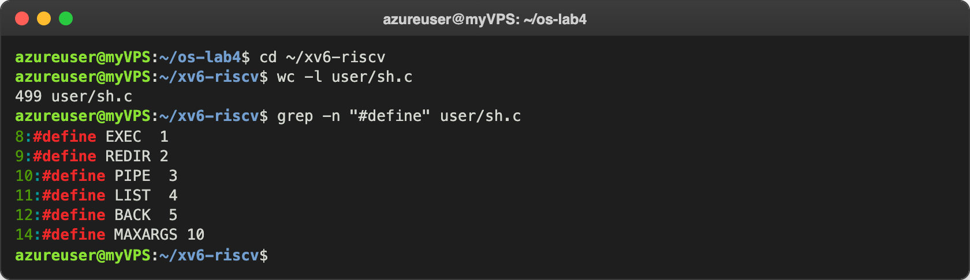
Figure 4.1 – The command kinds defined in sh.c
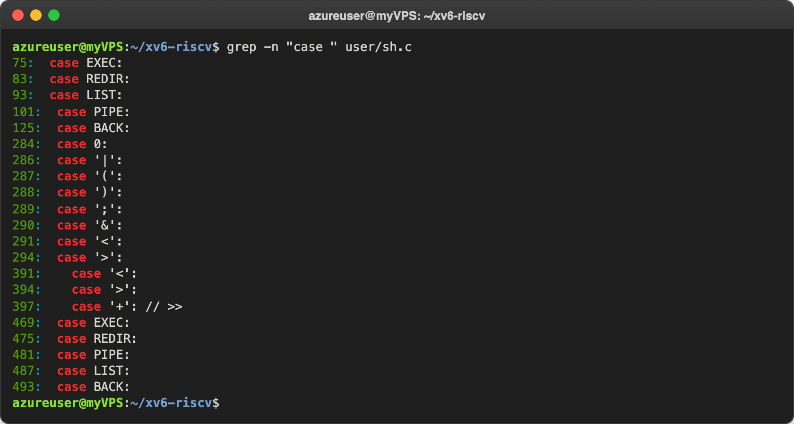
Figure 4.2 – Where each kind is run
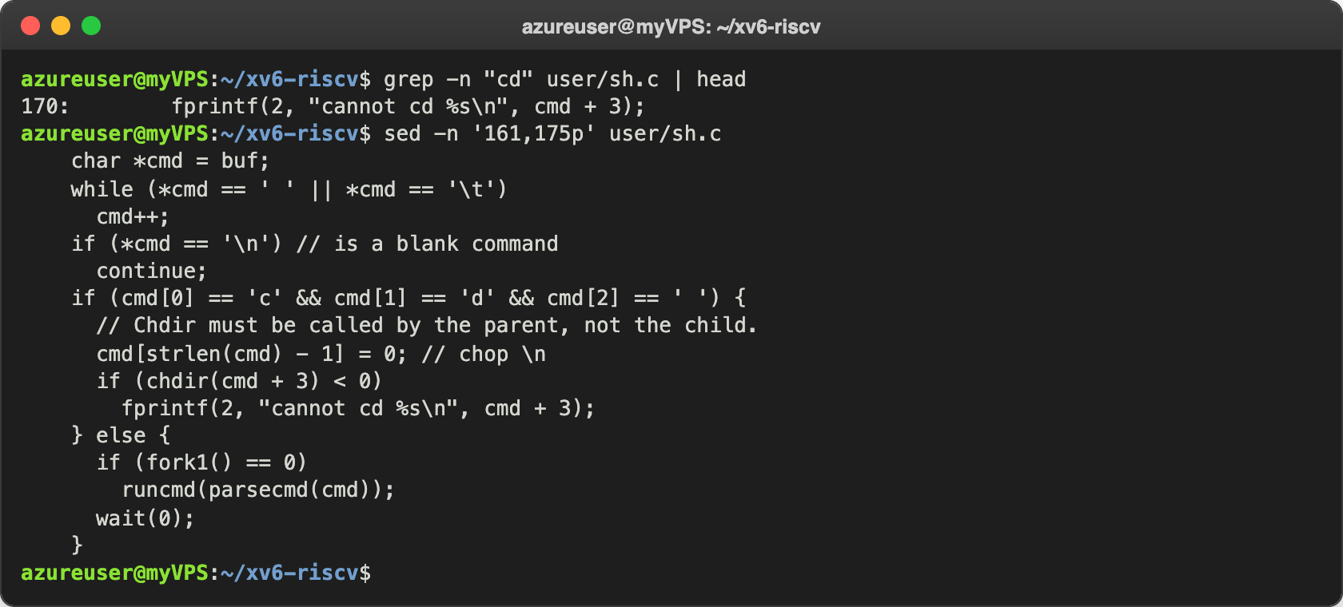
Figure 4.3 – The code that handles cd
I also searched for any code that handles * or $:
azureuser@myVPS:~/xv6-riscv$ grep -n '\$' user/sh.c
137: write(2, "$ ", 2);
azureuser@myVPS:~/xv6-riscv$ grep -n "'\*'" user/sh.c ; echo "matches: $?"
matches: 1
azureuser@myVPS:~/xv6-riscv$ grep -n "whitespace\|symbols" user/sh.c | head -4
268:char whitespace[] = " \t\r\n\v";
269:char symbols[] = "<|>&;()";
278: while (s < es && strchr(whitespace, *s))
303: while (s < es && !strchr(whitespace, *s) && !strchr(symbols, *s))

Observe
- The five kinds of command and the character for each: EXEC (1), a simple command, just words with no special character; REDIR (2), produced by <, > or >>; PIPE (3), produced by |; LIST (4), produced by ;; BACK (5), produced by &. The parentheses ( ) only group commands, they don't have their own kind. Each kind is run in runcmd() (the case lines 75 to 125).
- Where cd is handled and why it is not a separate program. In main(), lines 166 to 170: if the line starts with cd , the shell calls chdir() itself; for anything else it does fork1() and runs the command in the child. The comment says it: "Chdir must be called by the parent, not the child". If cd was run in a child, only the child would change directory and then exit. This also explains Part 2: mkdir d ; cd d ; ls .. does not start with "cd ", so the whole line goes to a child, and cd is looked for as a program: exec cd failed.
- Code that handles * or $. There is none. The only $ in sh.c is the prompt write(2, "$ ", 2), and there is no '*' at all. The parser only knows the whitespace characters and the symbols <|>&;(). Everything else, including *, $ and the quotes, is just part of a word. That explains Part 2: ls *, echo $HOME and echo "a b" pass these characters to the program unchanged.

Conclusions
In this lab I saw that a working shell can be very small. The xv6 shell is under 500 lines and it can still run programs, redirect, build pipes, run lists and background jobs, because these are just combinations of fork, exec, open, close, dup, pipe and wait. Everything comfortable in bash (globbing, variables, quotes, PATH, history, completion, job control) is extra work that bash does in user space before it calls exec.
The args program showed it clearly: the same C code got *.c and "x in xv6, but real file names and x y in bash. So the program and the kernel never see the * or the quotes, it's the shell that decides what the arguments are. I also understood why cd has to be inside the shell: a child process cannot change the directory of its parent. The exec cd failed I got in xv6 for mkdir d ; cd d ; ls .. was a good example of that.
Repository: https://github.com/httpcatalin/os-2026-CatalinBitca (folder lab4/).

