
TECHNICAL UNIVERSITY OF MOLDOVA
Faculty of Computers, Informatics and Microelectronics
Department of Software Engineering
REPORT
on laboratory work no. 6
Course: Operating Systems
Topic: Inside the xv6 File System
Done by: st. gr. FAF-242, Cătălin Bîtca
Checked by: Reițman Patricia
Chișinău, 2026

Purpose of the work
The purpose of this lab is to look inside the file system of xv6. It has the same ideas as ext4 from Lab 5 (inodes, directories as tables of names, hard links, a journal), but in a few hundred lines of code that I can read. I read what xv6 shows with ls, wrote my own stat program called mystat, measured the limits written in kernel/fs.h, and finally wrote find, which walks the directory tree recursively.

Work environment
Like in Lab 4, I worked on my Ubuntu 24.04 virtual machine in Azure over ssh, in my ~/xv6-riscv tree (revision 06aad25 with my programs from Labs 2 and 4 on top). The check passed:
azureuser@myVPS:~/xv6-riscv$ bash ~/Downloads/os2026-setup.sh --check
OS 2026 setup system: Ubuntu 24.04.4 LTS family: debian
==> 2/4 Checking the tools
[ OK ] git
[ OK ] make
[ OK ] gcc
[ OK ] bash
[ OK ] grep
[ OK ] sed
[ OK ] awk
[ OK ] RISC-V compiler: riscv64-linux-gnu-gcc
[ OK ] QEMU 8.2
==> 3/4 xv6 in /home/azureuser/xv6-riscv
[ OK ] already present, left as it is (your work is safe)
==> 4/4 Building xv6 and booting it once
[ OK ] build
[ OK ] xv6 booted and ran ls
All set. Start xv6 with: cd ~/xv6-riscv && make qemu
For this lab I added two programs, user/mystat.c and user/find.c, and two lines to UPROGS in the Makefile, $U/_mystat\ and $U/_find\ (lines 138 and 139, each starting with a TAB). To start from a clean disk I used make clean ; make qemu, because the disk image fs.img keeps all the changes I make inside xv6.

Part 1. Read what xv6 shows you
On a fresh disk I listed the root directory, made a directory a and listed it:
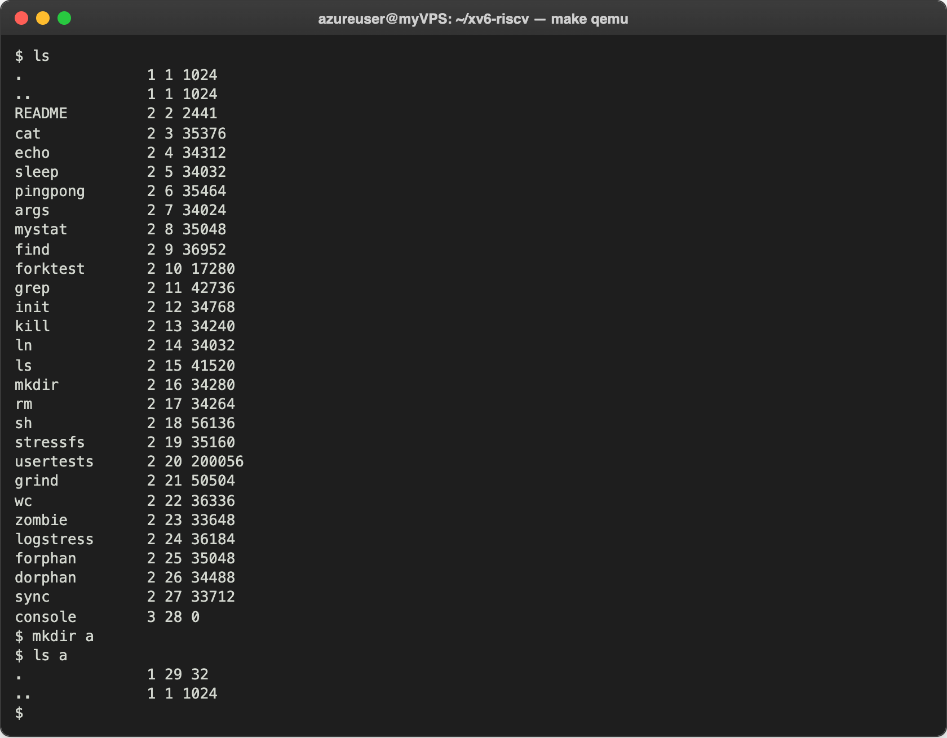
Figure 1.1 – ls in the root directory and in a new empty directory
Each line is: the name, the type, the inode number and the size in bytes. To decode the type I opened kernel/stat.h, and I also looked for the root inode number and the directory entry in kernel/fs.h:
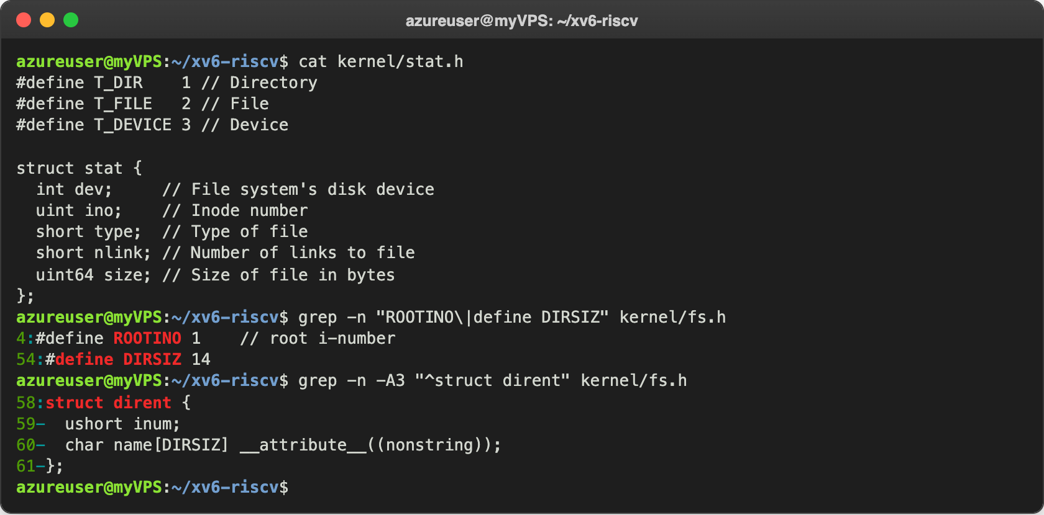
Figure 1.2 – kernel/stat.h, ROOTINO and struct dirent

Observe
- What do types 1, 2 and 3 mean? From kernel/stat.h: 1 is T_DIR, a directory; 2 is T_FILE, a regular file; 3 is T_DEVICE, a device. In the listing ., .. and a are directories, all the programs and README are files, and console is the only device. Its size is 0, because its bytes do not come from disk blocks but from the console driver.
- Which inode does the root directory have, and why are . and .. the same there? The root has inode 1 (#define ROOTINO 1 in kernel/fs.h; inode number 0 is never used, it marks an empty directory entry). . always points to the directory itself, and .. to its parent. The root has no parent, so when mkfs builds the disk it makes .. of the root point to the root too. That is why both are 1 1 1024, and cd .. in / stays in /.
- How big is one directory entry, and which two entries does a contain? One entry is struct dirent: a ushort inum (2 bytes) and char name[DIRSIZ] with DIRSIZ = 14, so 2 + 14 = 16 bytes. The empty directory a has 32 bytes, which is 2 entries: . with inode 29 (a itself) and .. with inode 1 (the root). The root shows 1024 bytes because mkfs rounds its size up to one full block (1024 bytes), although its 30 entries take only 480 bytes.

Part 2. Write mystat
stat() fills a struct stat with the fields dev, ino, type, nlink and size. My mystat prints them in the format from the lab:
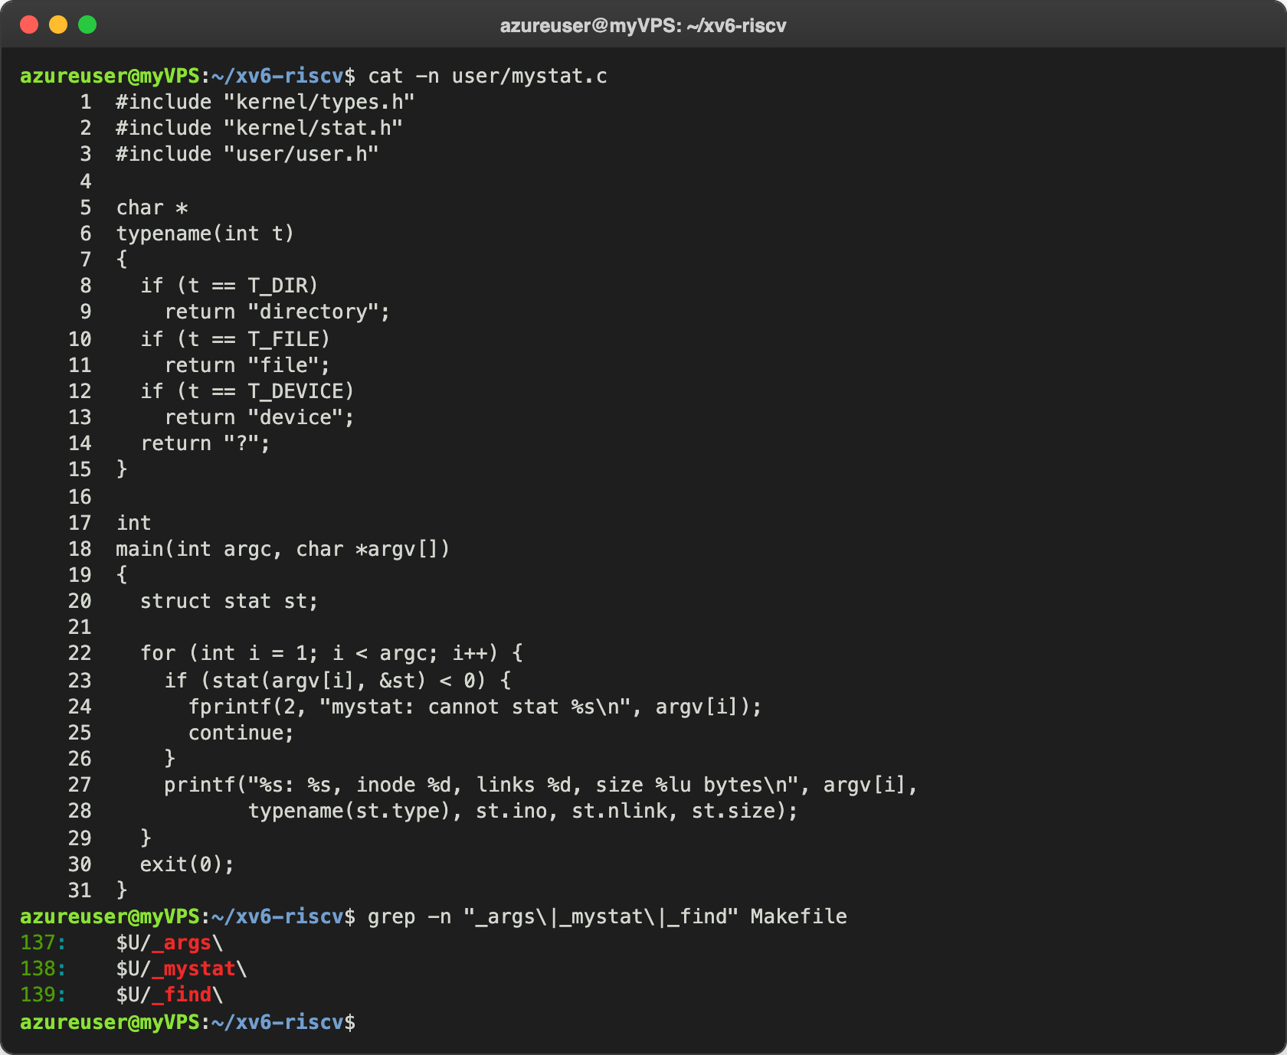
Figure 2.1 – user/mystat.c and the UPROGS lines
typename turns the type number into a word using the constants from kernel/stat.h. For every argument the program calls stat(); on error it prints a message to file descriptor 2 and continues with the next name instead of stopping. size is a uint64, so I print it with %lu, which the xv6 printf supports. Then I used it to watch hard links at work:
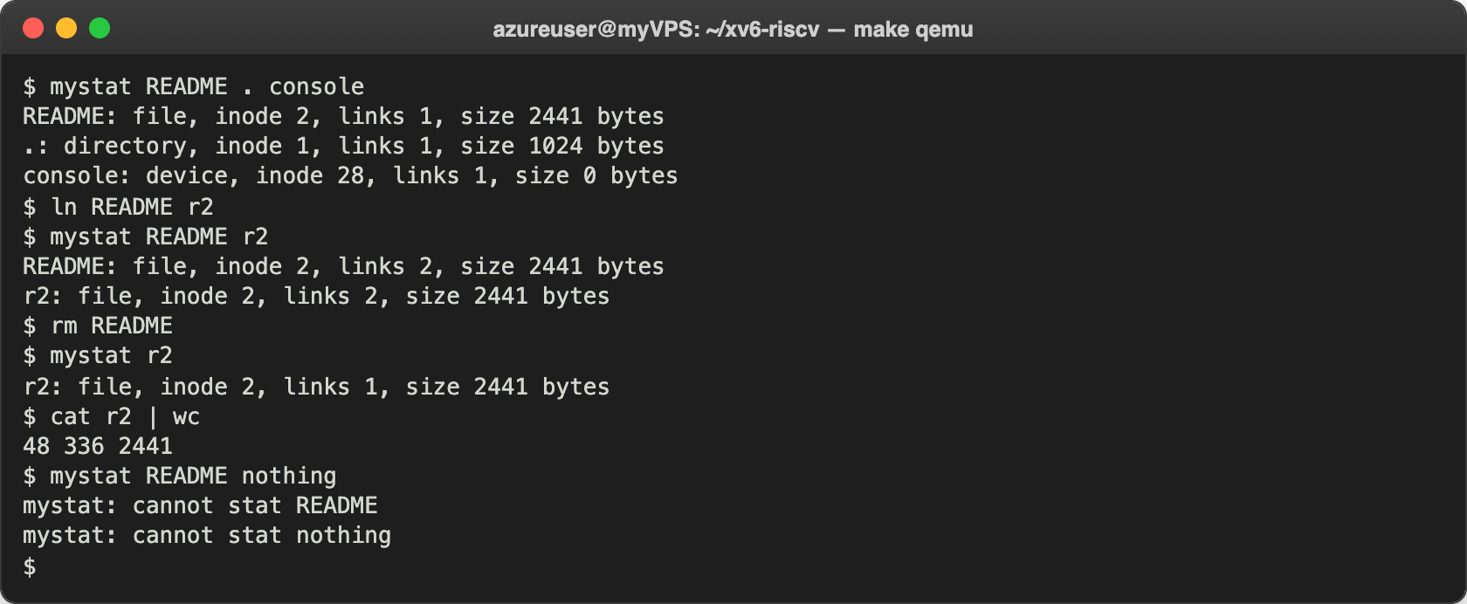
Figure 2.2 – mystat before and after ln and rm
The first line is the same as in the lab, except that console has inode 28 here, because my disk has a few more programs (sleep, pingpong, args, mystat, find) before it. At the end I also tried a name that does not exist: both errors went to the screen and the program did not crash. Then I looked for the code that removes a link:
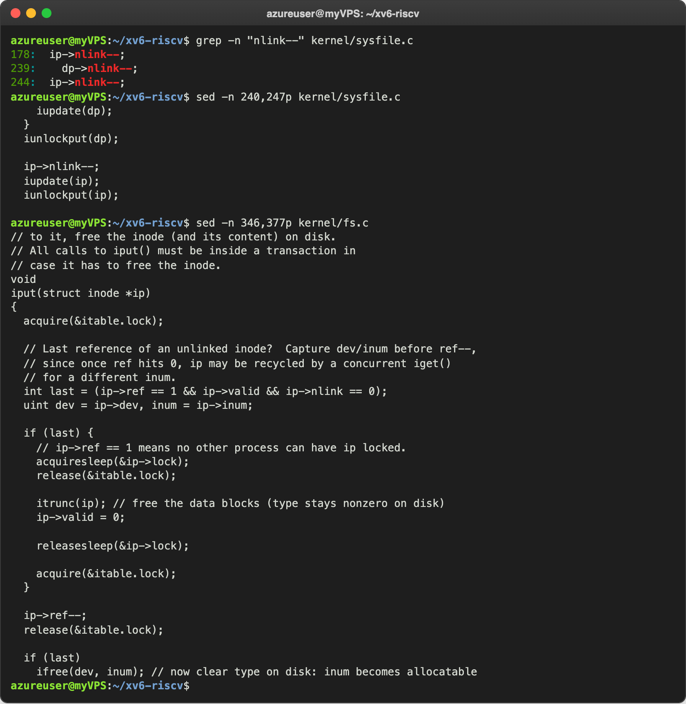
Figure 2.3 – Where sys_unlink decrements the link count, and where iput frees the blocks
And the inode as it is written on the disk:
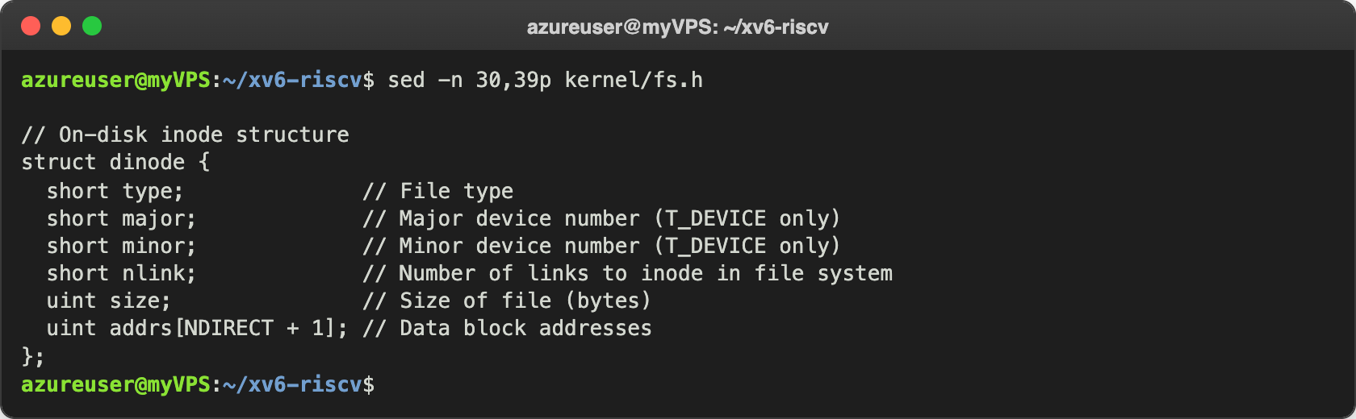
Figure 2.4 – struct dinode in kernel/fs.h

Observe
- The outputs after ln and after rm: what changed and what did not? After ln README r2 both names show inode 2 with 2 links: README: file, inode 2, links 2, size 2441 bytes and r2: file, inode 2, links 2, size 2441 bytes. After rm README only r2: file, inode 2, links 1, size 2441 bytes is left, and cat r2 | wc gives 48 336 2441, the same as wc README in Lab 2. Only the link count and the list of names changed. The inode number, the type, the size and the data did not change, because ln only added a second directory entry for inode 2 and rm only removed one. It is exactly what I saw on Linux in Lab 5, Figure 2.2.
- Which line of sys_unlink decrements the link count, and when are the data blocks freed? Line 244 of kernel/sysfile.c, ip->nlink--;, followed by iupdate(ip) that writes the inode back to the disk. (Line 239, dp->nlink--, is for removing a directory: the parent loses the link from its ... Line 178 is in sys_link and only undoes the increment when linking fails.) sys_unlink itself does not free any data. The blocks are freed in iput() in kernel/fs.c: when the last reference to the inode in memory is dropped (ref == 1) and nlink == 0, it calls itrunc(ip), which frees the data blocks, and then ifree(), which marks the inode as free on the disk. So the data is freed only when the file has no names left and no process has it open, the same rule as in Linux.
- Which fields does an xv6 inode have? struct dinode has only type, major and minor (the device numbers, used only for T_DEVICE), nlink, size, and addrs[NDIRECT + 1], the addresses of 12 direct data blocks plus one indirect block. There is no owner (uid, gid), no permission bits and no times, which is why xv6 has no permissions, and there is no type for a symbolic link. The whole structure is 2 + 2 + 2 + 2 + 4 + 13 × 4 = 64 bytes, so 16 inodes fit in one 1024-byte block.

Part 3. Measure the limits
I found the constants in kernel/fs.h and rebuilt the disk image to see the layout that mkfs prints:
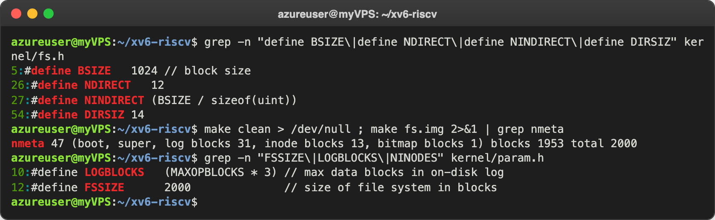
Figure 3.1 – The limits in kernel/fs.h and the disk layout from mkfs
Then I booted xv6 and made a directory with a long name:
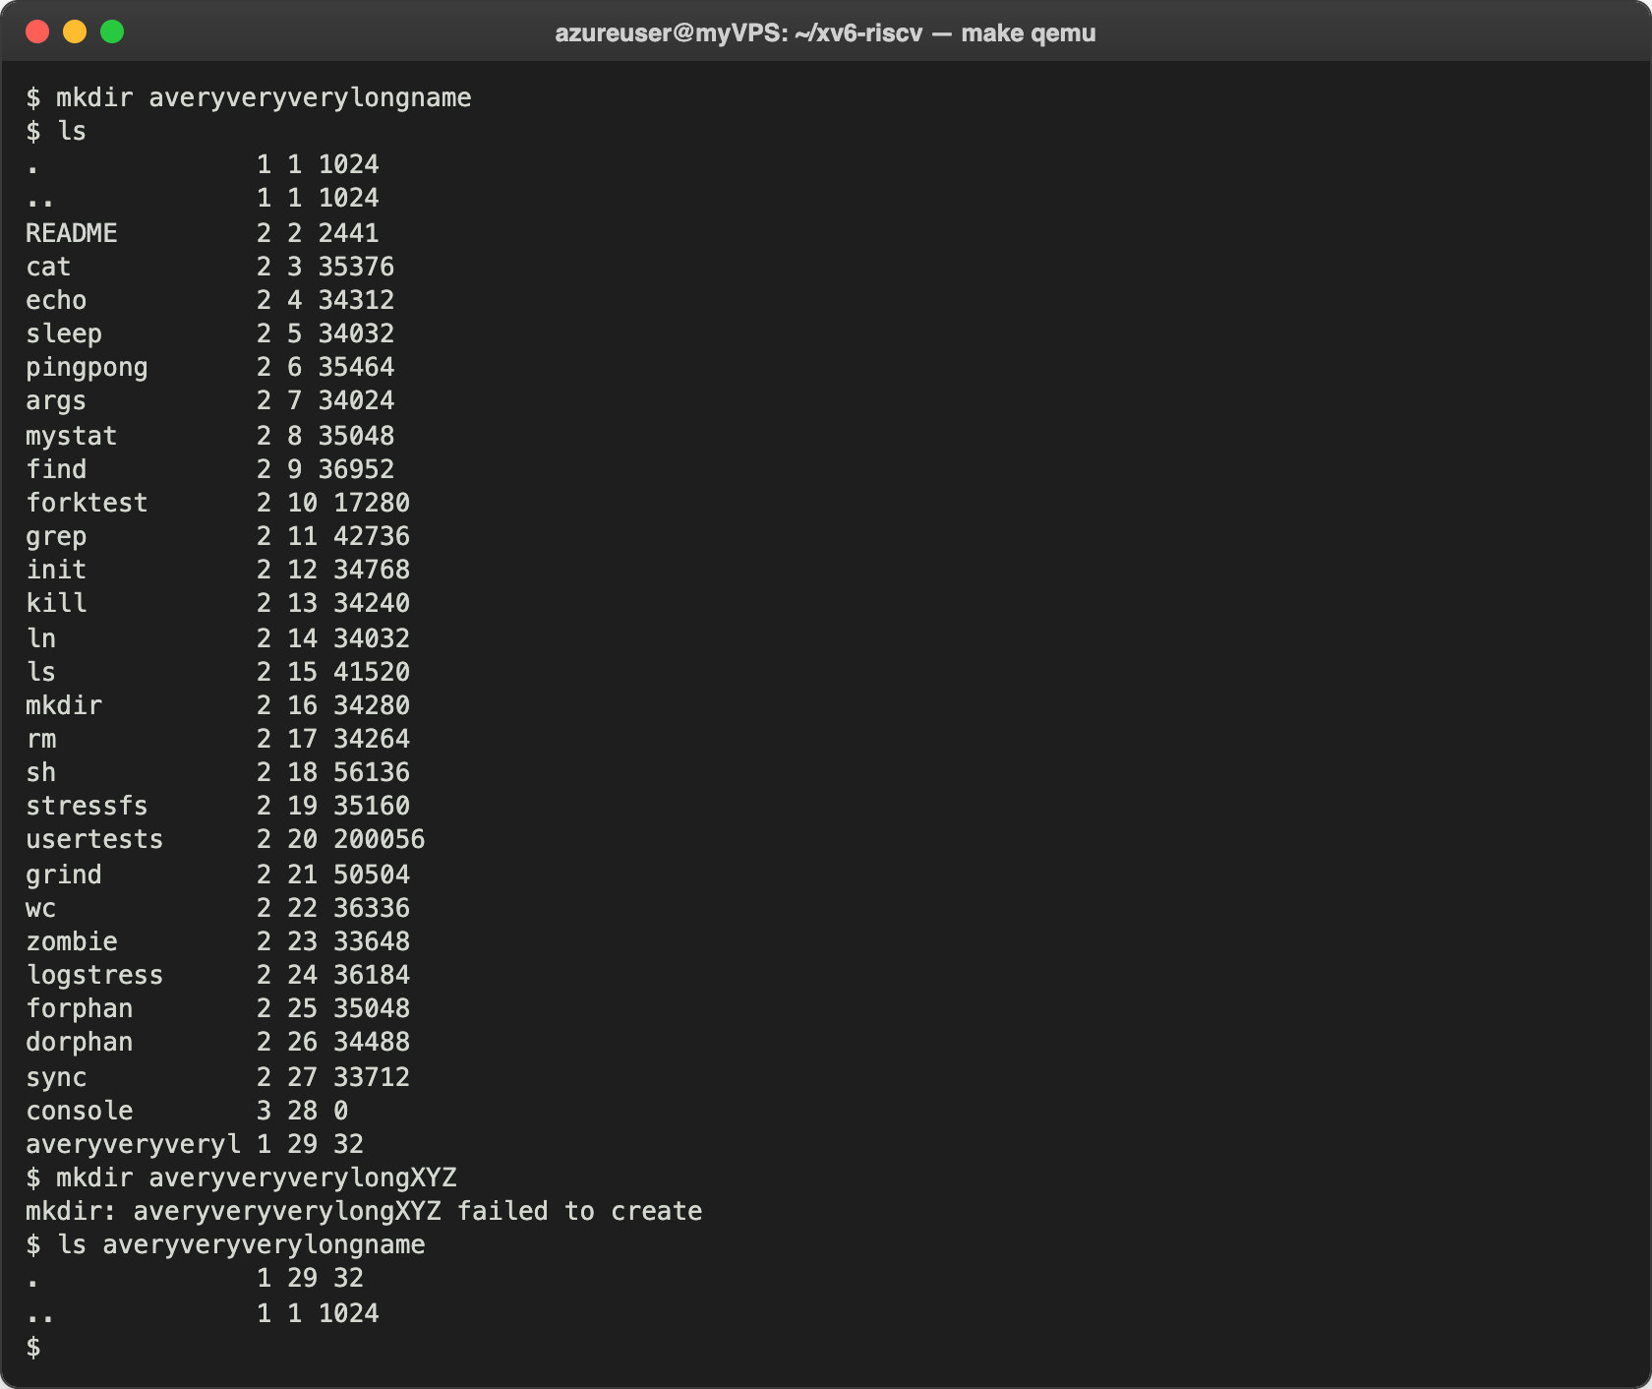
Figure 3.2 – A directory name longer than 14 characters

Observe
- What does ls show for averyveryverylongname, and which constant explains it? It shows averyveryveryl, only the first 14 characters, because of DIRSIZ = 14: the name field in struct dirent has only 14 bytes, and the rest of the name is simply cut off. xv6 also compares names only up to 14 characters (namecmp uses strncmp(s, t, DIRSIZ)), so ls averyveryverylongname still works, while mkdir averyveryverylongXYZ fails, because its first 14 characters are the same as the name that already exists.
- The largest file xv6 can hold. One block has BSIZE = 1024 bytes and a block number is a uint of 4 bytes, so the indirect block holds NINDIRECT = 1024 / 4 = 256 block numbers. A file can have NDIRECT + NINDIRECT = 12 + 256 = 268 blocks (this is MAXFILE), and 268 × 1024 = 274,432 bytes, which is 268 KB. The biggest file on my disk, usertests with 200,056 bytes, still fits.
- How many blocks does the disk have, and how many are for the log, the inodes and the data? The line is nmeta 47 (boot, super, log blocks 31, inode blocks 13, bitmap blocks 1) blocks 1953 total 2000. The disk has 2000 blocks (FSSIZE), so 2000 × 1024 bytes, about 2 MB. 47 of them are metadata: 1 boot block, 1 superblock, 31 log blocks (30 = LOGBLOCKS = MAXOPBLOCKS × 3, plus one header block), 13 inode blocks (200 inodes / 16 per block = 12.5, rounded to 12, plus one) and 1 bitmap block (one block has 8192 bits, enough for 2000 blocks). The remaining 1953 blocks are for data.

Part 4. Write find
find <dir> <name> prints every path under <dir> whose last component is <name>. I started from user/ls.c, which already shows how to open a directory, read the struct dirent entries one by one, build the full path in a buffer and call stat on it. My final version:
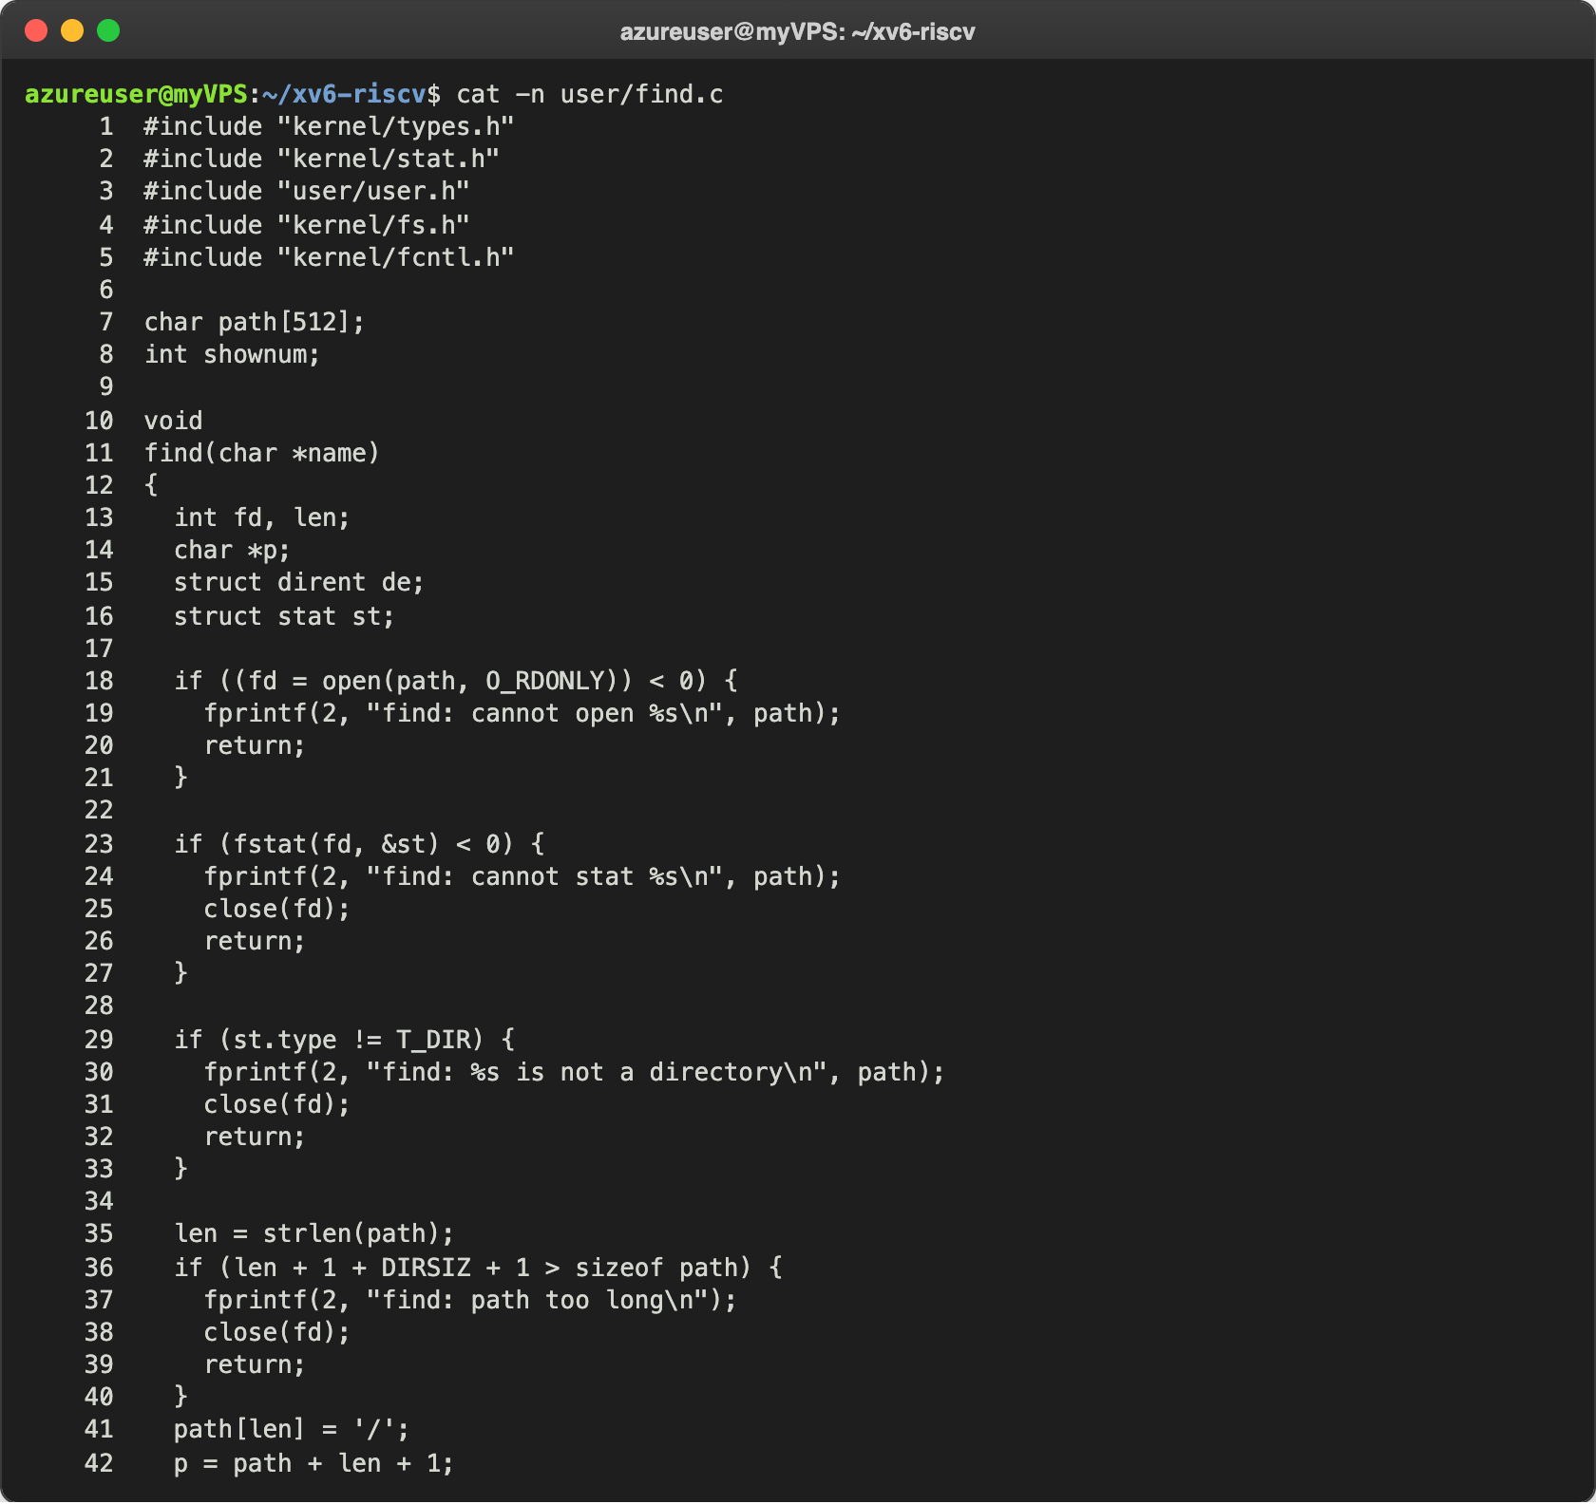
Figure 4.1 – user/find.c, lines 1 to 42
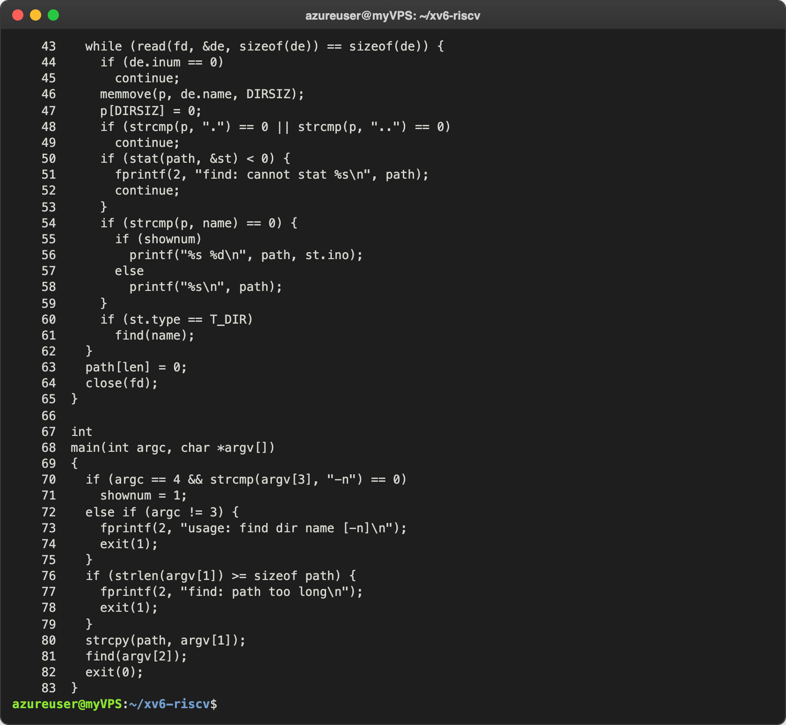
Figure 4.2 – user/find.c, lines 43 to 83
find() opens the current path and checks that it is a directory. Then it adds a / after the path and reads the directory 16 bytes at a time. For each entry it skips the free slots (inum == 0), copies the name after the / and puts a 0 after it, because a name of exactly 14 characters has no 0 at the end on the disk. It skips . and .., because going into them would loop forever. It calls stat on the full path, prints the path if the name is the one we are looking for (comparing with strcmp), and calls itself again if the entry is a directory. At the end it restores the path and closes the directory, so only one directory per level is open at a time.
My first version kept a char buf[512] inside find(), exactly like ls.c. It passed the test below, but on a deeper tree it crashed after 7 levels:
$ find z z
z/z
z/z/z
z/z/z/z
z/z/z/z/z
z/z/z/z/z/z
z/z/z/z/z/z/z
usertrap(): unexpected scause 0xf pid=18
sepc=0x8be stval=0x2e38
scause 0xf is a page fault on a store. In xv6 the user stack is only one page, 4096 bytes (USERSTACK 1 in kernel/param.h), and every level of the recursion put more than 512 bytes on it (buf plus the other local variables), so after about 7 levels the stack ran into the guard page below it and the kernel killed the process. So I moved the path into one global buffer path[512]: each level only adds /name at the end and writes the 0 back when it returns, and a level now uses only 112 bytes of stack (I checked the addi sp,sp,-112 at the start of find with objdump). I tested it on a fresh disk with the commands from the lab:
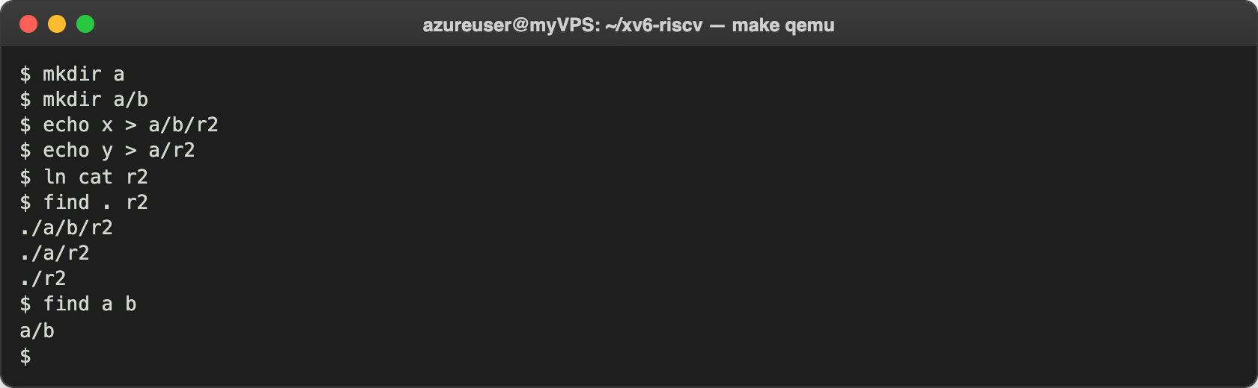
Figure 4.3 – find on a fresh disk
The output is exactly the one expected in the lab: the three r2 files and a/b. Then I repeated the deep test with the new version:
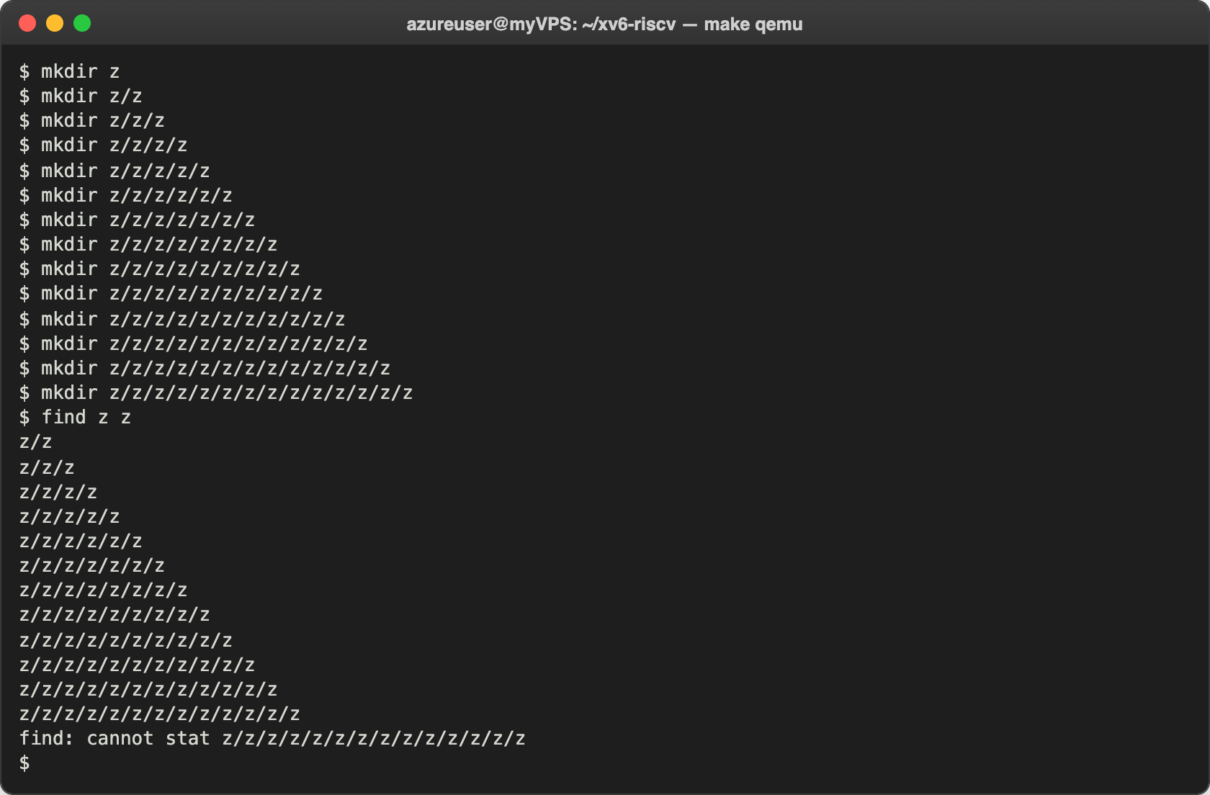
Figure 4.4 – The fixed find on a tree 14 levels deep
Now it goes 12 levels deep and then stops with an error message instead of crashing. The new limit is the number of open files: a process can have only 16 (NOFILE), 3 are used by the standard input, output and error, each level keeps its directory open, and stat() in user/ulib.c also needs one more file descriptor because it opens the file. Paths longer than 128 characters (MAXPATH) would not work either, because the kernel does not accept them.

Stretch. find with -n
I added an optional third argument -n that prints the inode number next to each path (lines 70–71 and 55–58 of find.c):
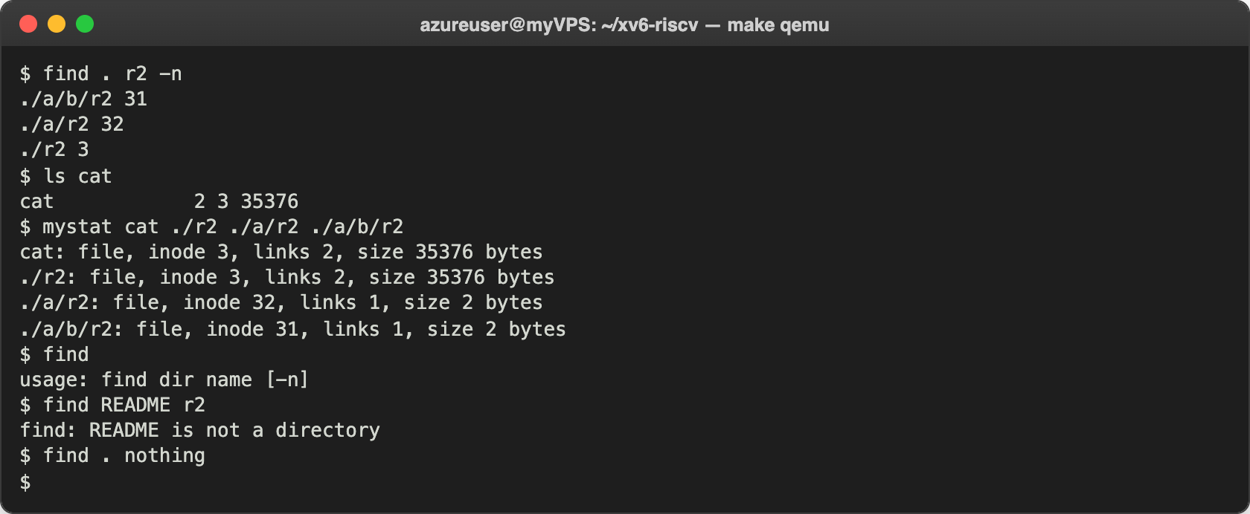
Figure 5.1 – find . r2 -n, and the error cases
./r2 has inode 3, the same as cat, and both have 2 links, so ./r2 is the same file as cat (it was made with ln cat r2). ./a/r2 (inode 32) and ./a/b/r2 (inode 31) are two different small files with 2 bytes each ("y" or "x" and a newline). I also checked the errors: without arguments find prints the usage, on a file it says that it is not a directory, and when nothing matches it prints nothing.

Conclusions
In this lab I saw that the xv6 file system works the same way as ext4 in Lab 5, only much smaller. A directory is just a file with 16-byte entries, a name and an inode number, and the inode keeps everything else. Hard links work the same: ln adds one more entry for the same inode, rm (sys_unlink) only decreases nlink, and the blocks are freed in iput() only when there are no names and no open references left. Because struct dinode has no owner, no permission bits and no symbolic link type, xv6 has none of these features.
The limits are simple numbers in kernel/fs.h: names of at most 14 characters, files of at most 268 KB, and a 2000-block disk with 47 blocks of metadata. Writing find showed me that recursion in a small OS has real limits: my first version, copied from the style of ls.c, ran out of the 4 KB user stack after 7 levels, and the fixed version is limited by the 16 open files per process instead, but it reports an error rather than crashing.
Repository: https://github.com/httpcatalin/os-2026-CatalinBitca (folder lab6/, with mystat.c, find.c and the Makefile).

