
TECHNICAL UNIVERSITY OF MOLDOVA
Faculty of Computers, Informatics and Microelectronics
Department of Software Engineering
REPORT
on laboratory work no. 9
Course: Operating Systems
Topic: Watching System Calls with strace
Done by: st. gr. FAF-242, Cătălin Bîtca
Checked by: Reițman Patricia
Chișinău, 2026

Purpose of the work
In the lecture we saw that a program cannot touch the disk or the screen by itself: it asks the kernel through a system call. The purpose of this lab is to watch that door from the outside with strace, a tool that prints every system call a program makes. I read the calls of a real command (ls -l), wrote a small program that uses open, write, read and close directly, and then counted one kind of call, write, to see how the number of calls depends on where the output goes.

Work environment
Like in the previous labs, I worked on my Ubuntu 24.04 virtual machine in Azure over ssh. strace was already installed:
azureuser@myVPS:~$ strace -V | head -1
strace -- version 6.8
azureuser@myVPS:~$ uname -sr
Linux 6.17.0-1022-azure
strace runs the program under the ptrace system call: the kernel stops the program at every system call and lets strace read the number of the call, its arguments and its result. It prints one line per call on standard error, so the normal output of the program still goes to the screen next to it.

Part 1. The calls of a real command
I ran the command from the handout in my home folder. -f also follows the children of the program (ls has none), and -e trace=openat,read,write,close shows only these four kinds of calls. The output is long, so it is split in two figures:
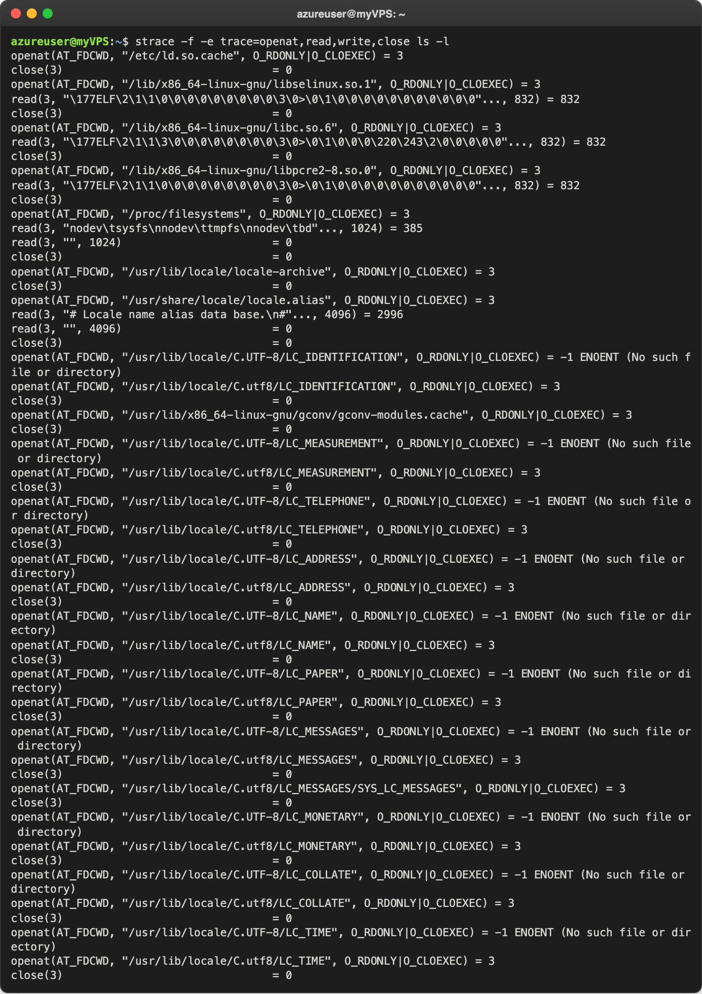
Figure 1.1 – strace of ls -l, the beginning: libraries and locale
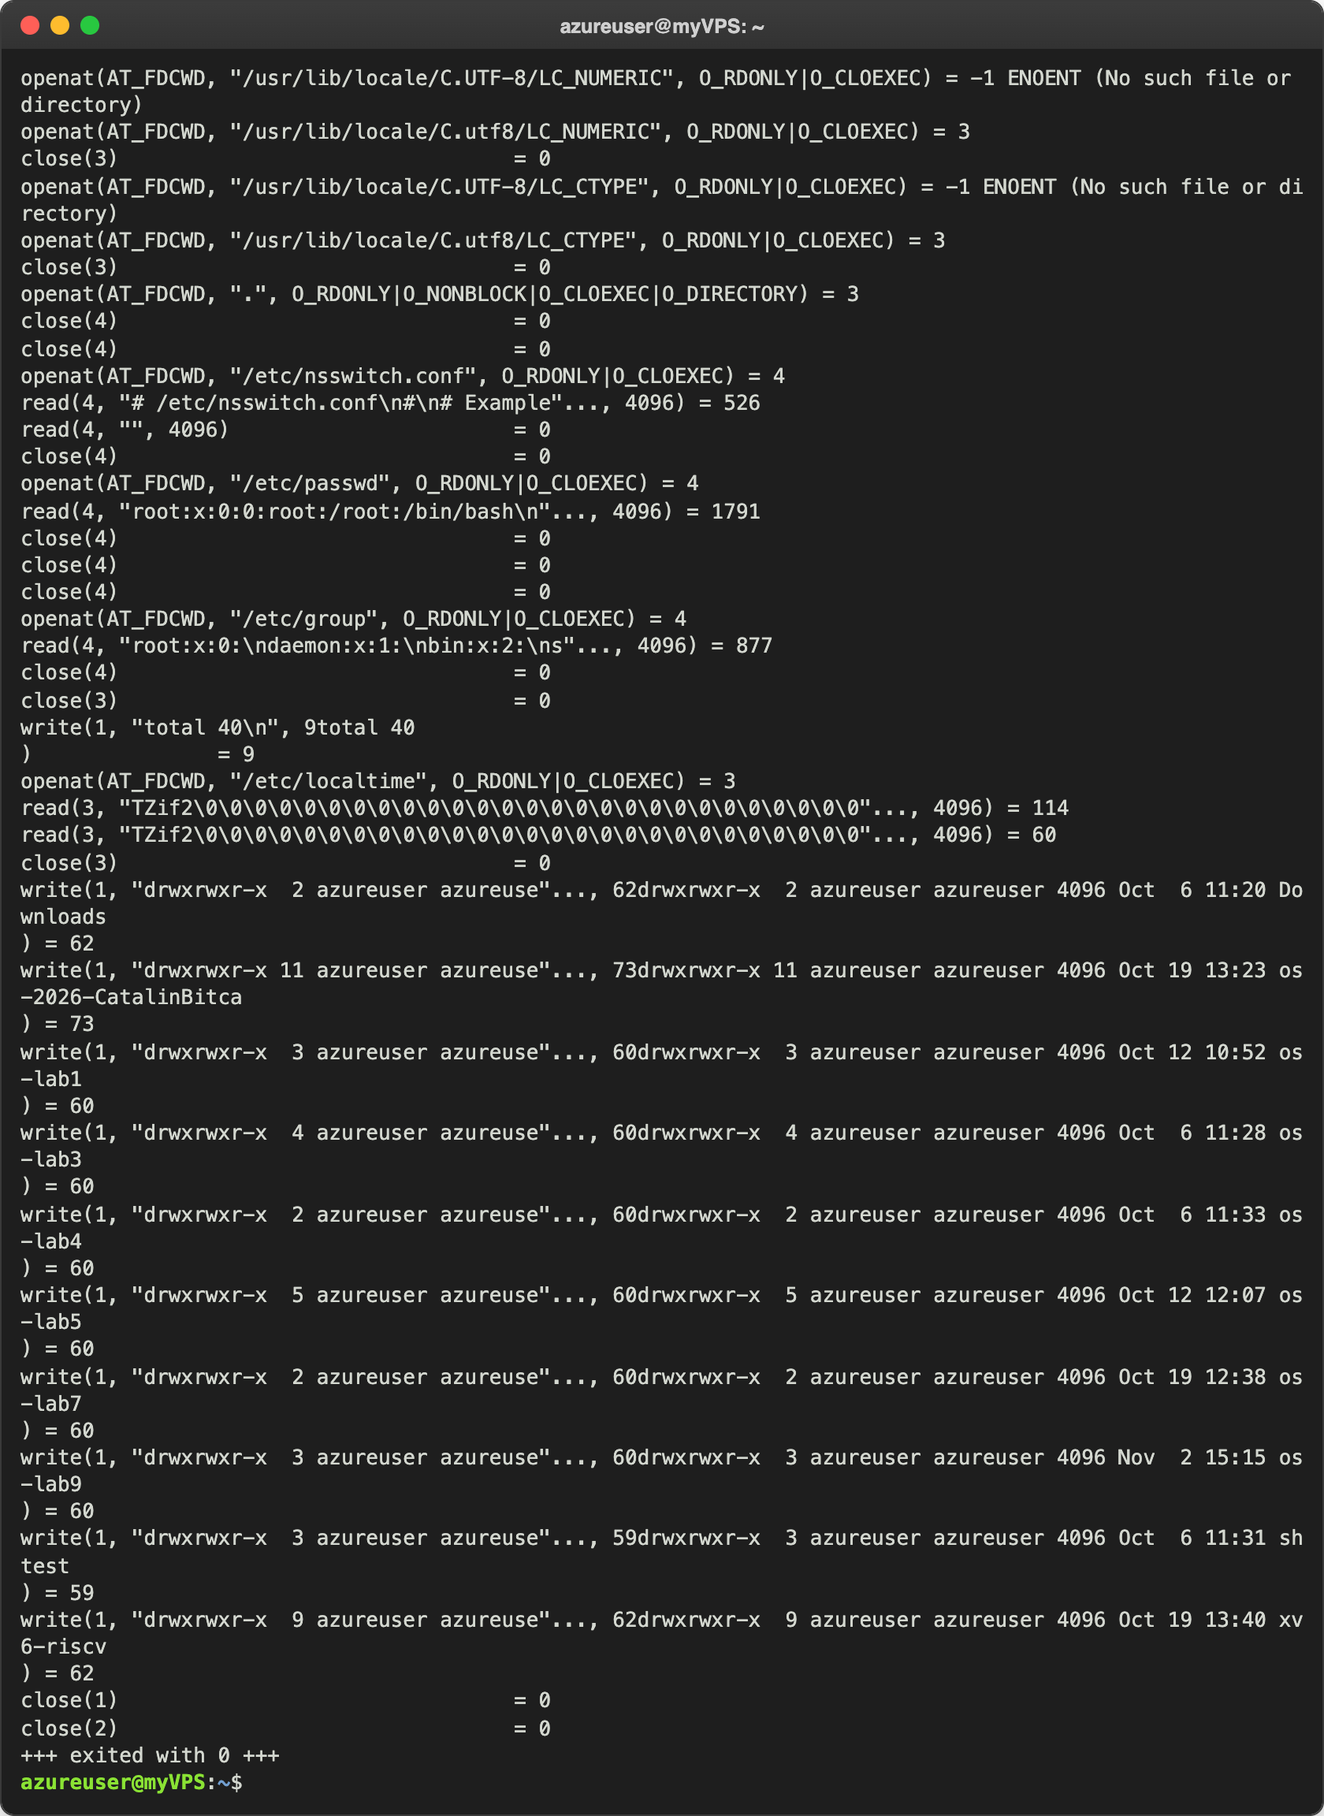
Figure 1.2 – strace of ls -l, the end: the folder, the users and the output
Most of the lines are not the work of ls itself. In Figure 1.1 the dynamic loader opens /etc/ld.so.cache and the libraries libselinux, libc and libpcre2, and reads the first 832 bytes of each (the ELF header, starting with \177ELF). Then the C library reads /proc/filesystems and opens about twenty locale files; half of them do not exist (-1 ENOENT), because it first tries the name C.UTF-8 and then C.utf8.
The real work is in Figure 1.2. ls opens the current folder "." as descriptor 3. To print the names of the owner and of the group instead of numbers, it reads /etc/nsswitch.conf, /etc/passwd and /etc/group (descriptor 4, since 3 is still the folder). The close(4) lines without an openat before them close sockets: the C library first tried to ask the nscd service through a socket, and socket and connect are not in my filter. For the dates it reads /etc/localtime. Only at the end come the write calls: write(1, "total 40\n", 9) and then one write per line of the listing. strace prints the text of the call, the program prints the line itself, and then strace finishes its own line with ) = 62, which is why each listing line appears in the middle of a write line.
To count the calls, I saved the trace into a file with -o (so only the listing stays on the screen) and counted the kinds with awk, sort and uniq -c. Then I used strace -c, which does not print the calls but a table with the number of calls of every kind:
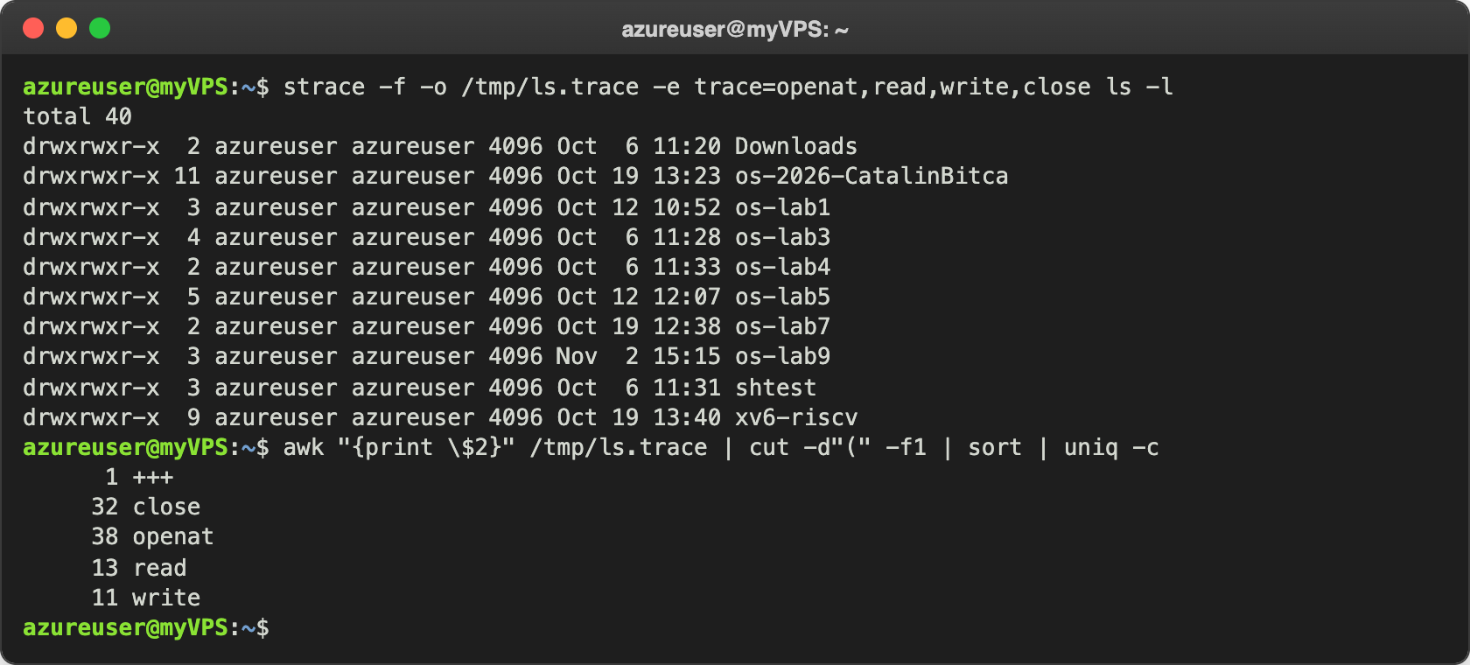
Figure 1.3 – How many calls of each of the four kinds
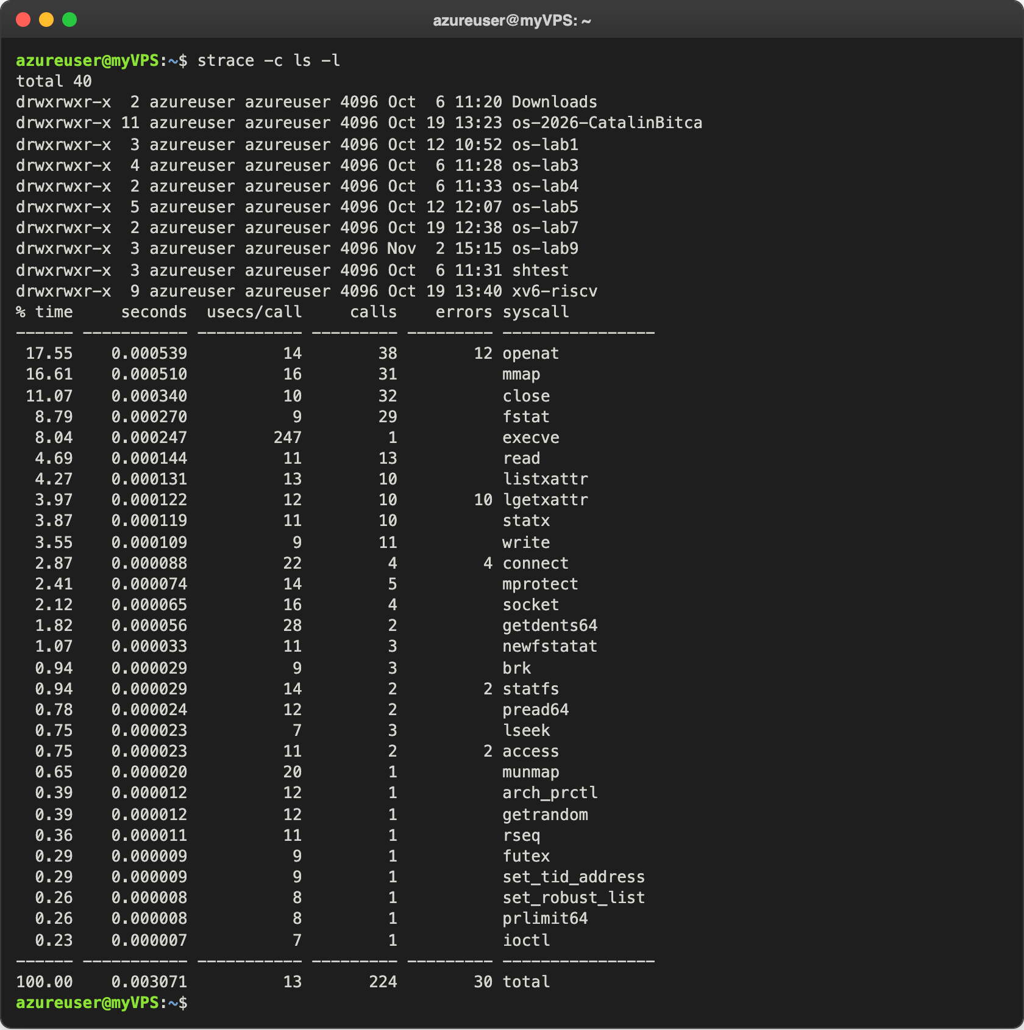
Figure 1.4 – strace -c: all the system calls of ls -l
Of the four kinds, one ls -l made 94 calls: 38 openat, 13 read, 11 write and 32 close. Counting every kind, it made 224 system calls, and 30 of them failed on purpose (missing locale files, lgetxattr and the connect to nscd). The biggest groups after openat and close are mmap (31) and fstat (29), which load the libraries into memory, and statx (10), one for each of the 10 entries of my home folder.

Observe
- Which system call does ls use to print to the screen? To which descriptor does it write? write, to descriptor 1, the standard output: write(1, "total 40\n", 9) = 9 and then one write(1, ...) for each line (Figure 1.2). The return value is the number of bytes the kernel took, for example 62 for the line of Downloads. ls never writes to the terminal device itself; descriptor 1 is just the number that its parent, bash, connected to my terminal.

Part 2. A program that calls the kernel directly
I typed syscalls.c from the handout (without the comments). It opens note.txt for writing, writes one line into it with write, closes it, opens it again for reading and reads the line back with read:
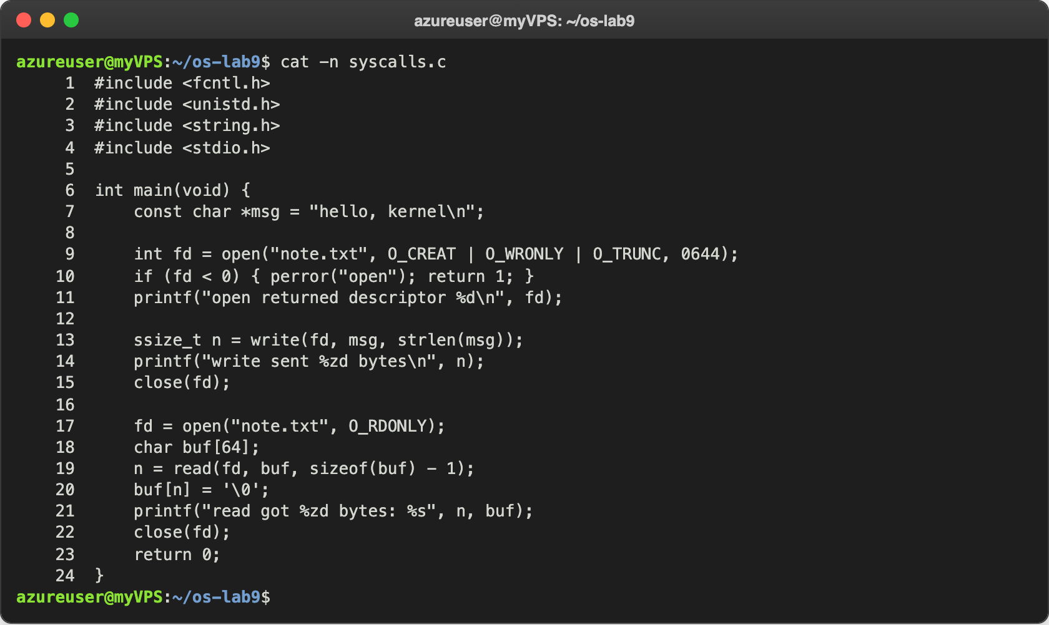
Figure 2.1 – syscalls.c
It compiled with -Wall -Wextra without warnings and printed exactly the expected output:
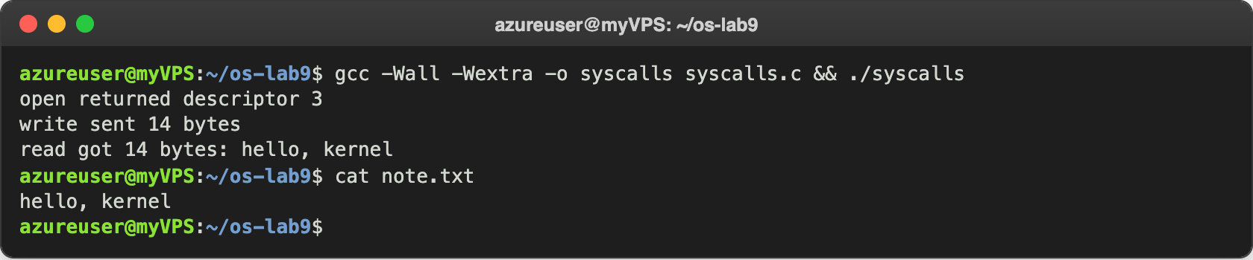
Figure 2.2 – syscalls and the file it created
Then I watched the same program with strace:
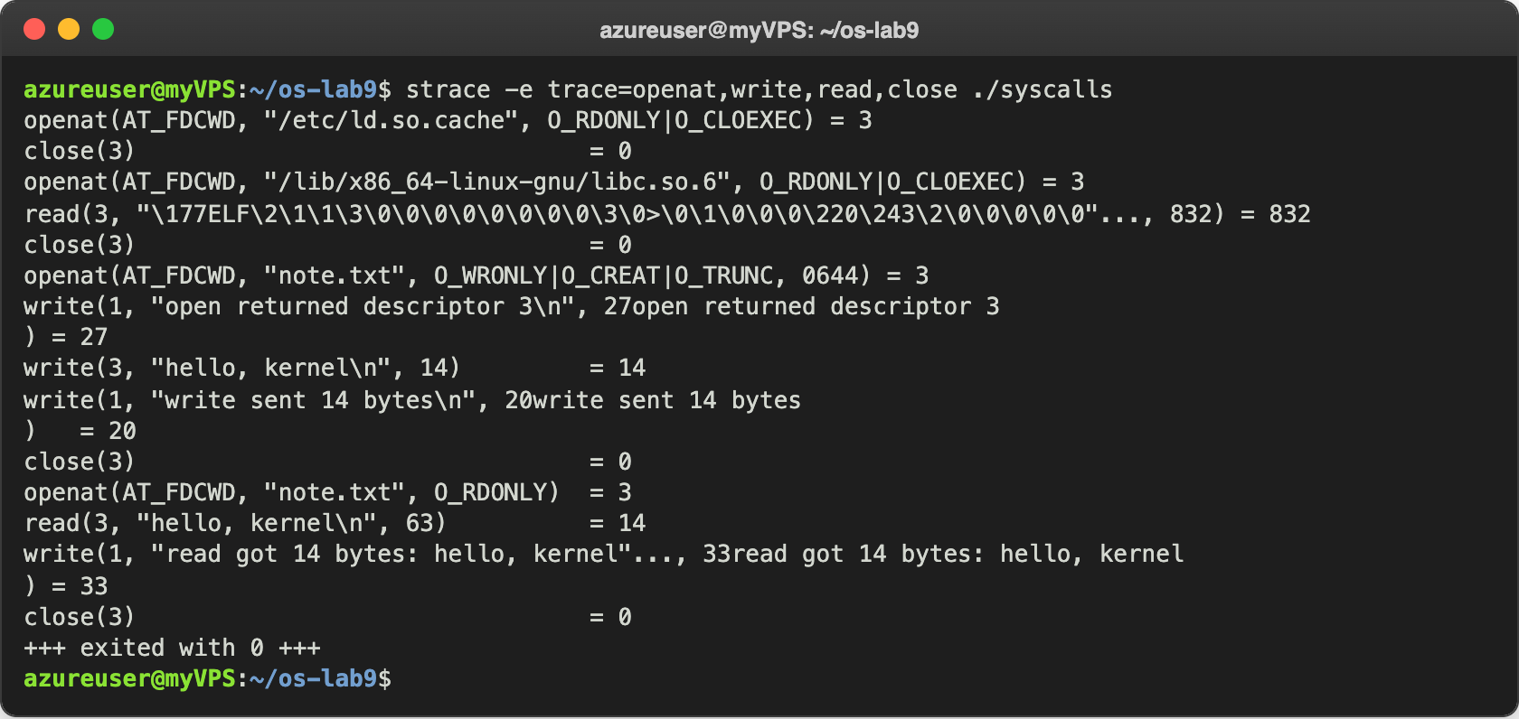
Figure 2.3 – The calls of syscalls
The first five lines are the setup: the loader opens ld.so.cache and libc.so.6. After them come my calls, exactly like in the handout. A few things I noticed. My C call open("note.txt", ...) became the system call openat(AT_FDCWD, "note.txt", ...): the C library uses openat, and AT_FDCWD means that the path is relative to the current folder. read asked for 63 bytes (sizeof(buf) - 1), but got only 14, because the file has only 14 bytes; the return value tells how many bytes really came. And printf is not a system call: each of my three printf lines turned into a write(1, ...), one per line, since the output was the terminal.

Observe
- The descriptor returned by the first openat is 3, not 0, 1 or 2. Why are those three already taken? Because every program starts with three open descriptors: 0 is the standard input, 1 the standard output and 2 the standard error. My program did not open them; it got them from bash. Bash has them open on my terminal, and when it starts a command, fork copies its descriptor table and exec keeps it. open always returns the smallest free number, and the smallest free one is 3. Figure 2.4 shows both sides. ls -l /proc/self/fd lists the open descriptors of ls itself: 0, 1 and 2 all point to my terminal /dev/pts/0 (and 3 is the folder ls was reading). Then I started syscalls with <&-, which tells bash to close descriptor 0 for this command, and open returned 0, the smallest free number.
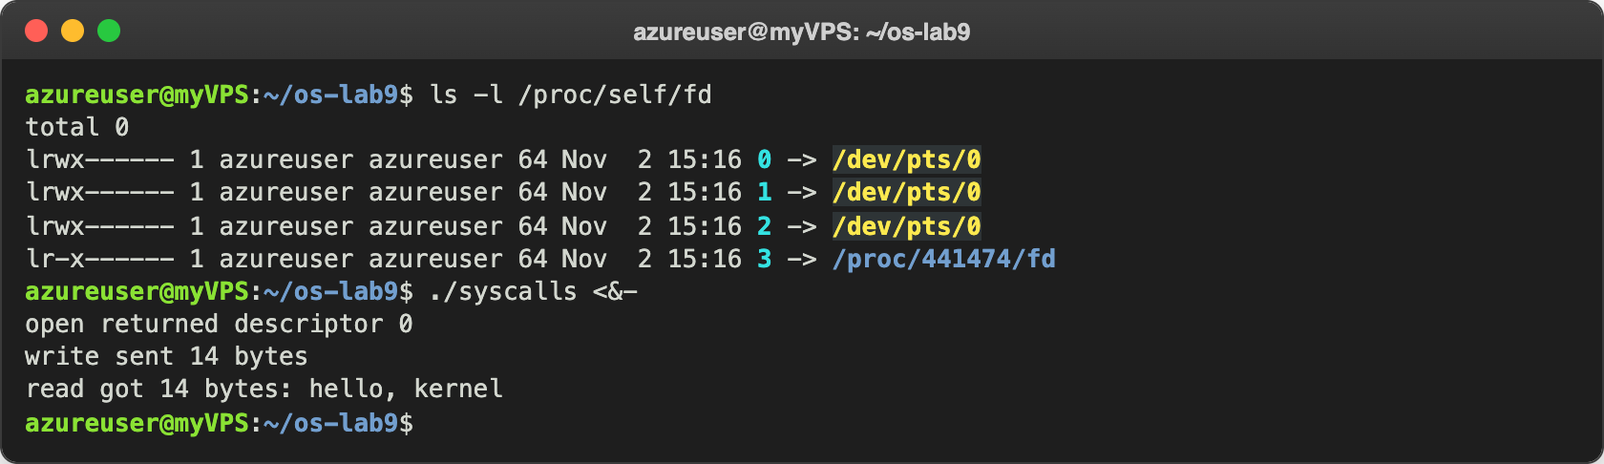
Figure 2.4 – The three inherited descriptors, and open with descriptor 0 closed

Part 3. Count one kind of call
My copy of the handout ends after the Observe box of Part 2, so for this part I followed its title, "Count one kind of call". I counted the write calls with strace -c -e trace=write, for the same program writing to the terminal and to a file. In Part 1 I already noticed that ls -l makes one write per line, and in Figure 1.3 the trace written with -o showed 11 write calls. I wanted to see whether this is always so.
First seq 20, which prints the numbers from 1 to 20, with the output on the terminal:
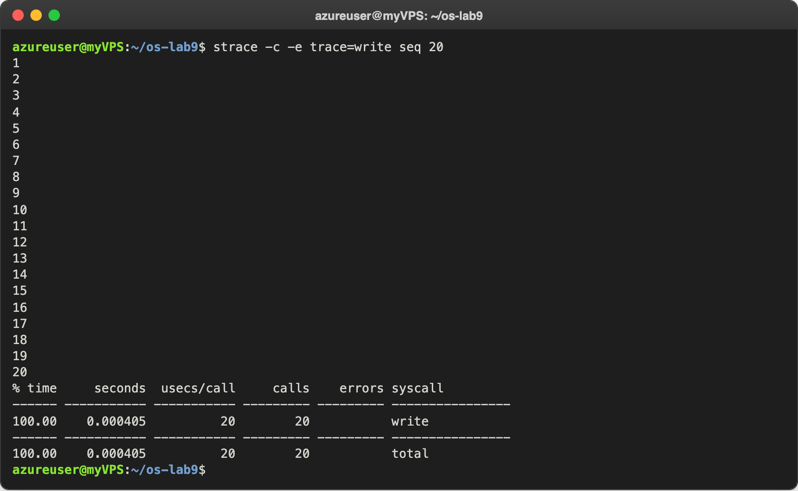
Figure 3.1 – seq 20 on the terminal: 20 lines, 20 write calls
Then the same command with the output redirected into a file, and then a much bigger one, seq 100000:
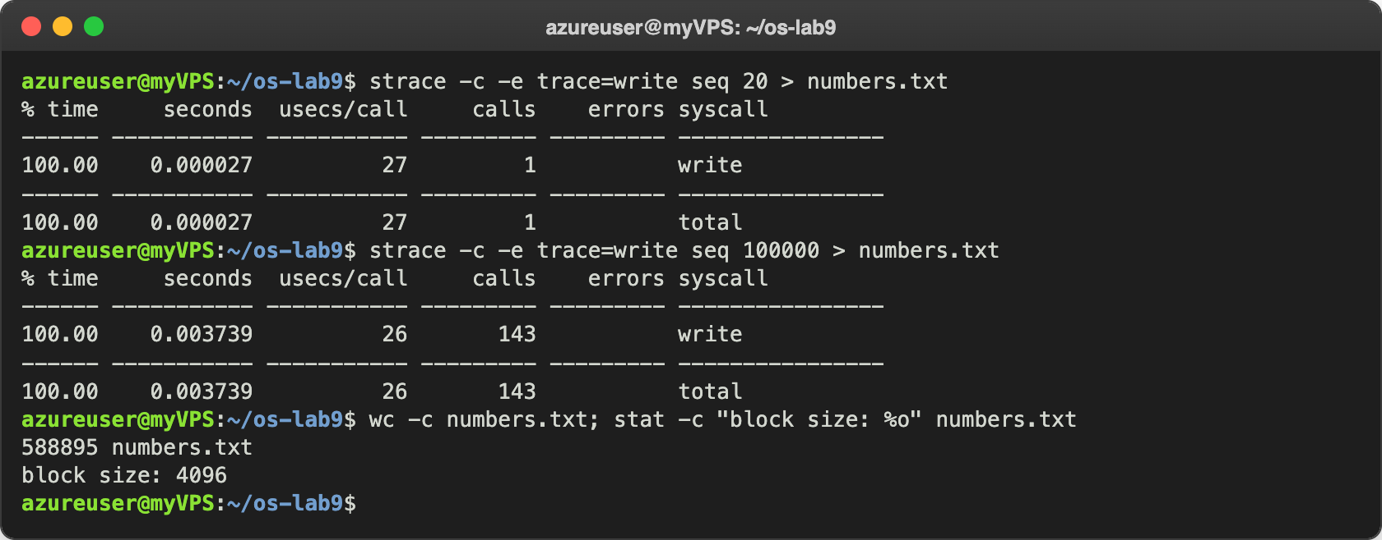
Figure 3.2 – The same output into a file
Into the file, the same 20 lines needed one single write. The 100000 numbers (588895 bytes) needed only 143 calls, not 100000. To see why, I looked at the sizes of these calls. Here strace writes to the pipe (2>&1) and the output of seq goes to the file (> numbers.txt); the order of the redirections matters, like in Lab 3:
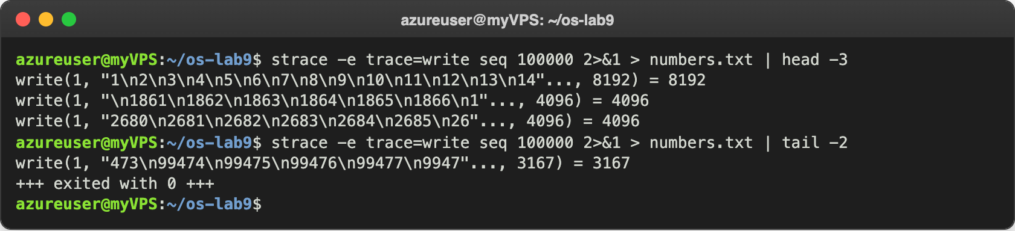
Figure 3.3 – The sizes of the write calls into the file
Almost every call writes exactly 4096 bytes, the block size of the file that stat printed in Figure 3.2. The first one writes 8192 bytes, two blocks at once, and the last one writes what is left, 3167 bytes: 8192 + 141 × 4096 + 3167 = 588895. At the end I checked ls -l again, now into a file:
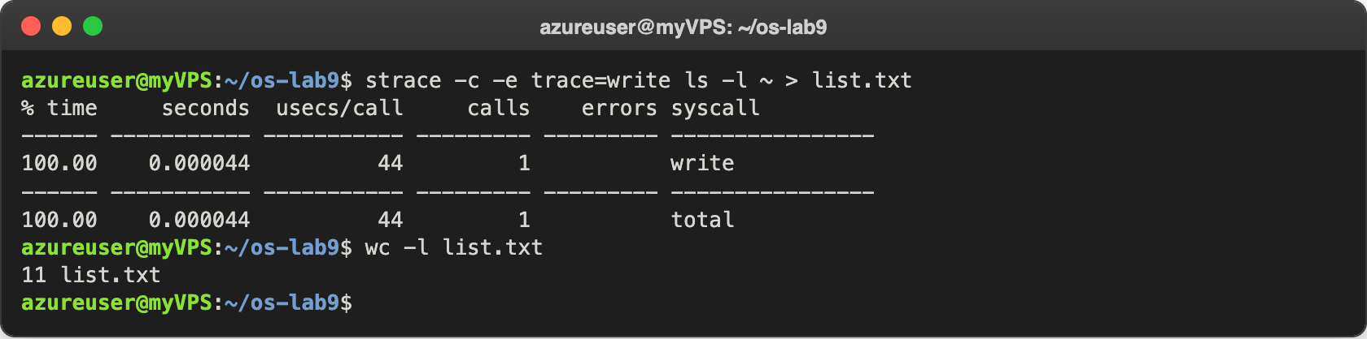
Figure 3.4 – ls -l into a file: one write for 11 lines

Observe
- Why does the same program make 20 write calls on the terminal and only 1 into a file? Because printf (or puts) does not call write by itself; it puts the text into a buffer of the C library, and the library decides when to call write. When descriptor 1 is a terminal, the buffer is line-buffered: it is written at every \n, so that a person sees each line at once. When descriptor 1 is a file or a pipe, the buffer is fully buffered: it is written only when it is full, in blocks of the size the kernel suggests (4096 bytes here), or when the program ends. 20 short lines fit in one block, so one write was enough.
- How many write calls for 588895 bytes, and why? 143, almost all of 4096 bytes. Fewer system calls mean less time spent going in and out of the kernel: in Figure 3.1 one write took about 20 microseconds, so 100000 calls would cost much more than 143.
- What does this have to do with Lab 7? It is the same buffer that made me call fflush(stdout) before fork and exec in run.c. When the output was a file or a pipe, the text of printf stayed in the buffer and was not yet written by any write, so fork copied it and exec lost it. strace shows this directly: the text exists for the kernel only when the write call appears.

Conclusions
In this lab I saw that every real action of a program goes through a system call. Even a simple ls -l made 224 system calls, and most of them were not its own work but the loading of libraries and locale files. My C calls open, write, read and close became system calls almost one to one (open became openat), and printf turned out to be a write on descriptor 1. The first file I open gets descriptor 3, because 0, 1 and 2 are inherited from the shell, and open takes the smallest free number.
Counting the write calls showed that the C library adds its own buffer in front of the kernel: the same output costs one write per line on a terminal, but one write per 4096 bytes in a file. This is why fflush was needed in Lab 7. strace is a very useful tool to understand what a program really asks from the kernel, and in Lab 10 I will build a small version of it inside xv6.
Repository: https://github.com/httpcatalin/os-2026-CatalinBitca (folder lab9/, with syscalls.c).

