
TECHNICAL UNIVERSITY OF MOLDOVA
Faculty of Computers, Informatics and Microelectronics
Department of Software Engineering
REPORT
on laboratory work no. 8
Course: Operating Systems
Topic: The Same Calls, Inside Your Own OS
Done by: st. gr. FAF-242, Cătălin Bîtca
Checked by: Reițman Patricia
Chișinău, 2026

Purpose of the work
In Lab 7 I ran fork, exec and wait on Linux. The purpose of this lab is to run the same program inside xv6, the small OS we build this semester, and to see that the calls are the same. Then I made two processes talk to each other through pipes (pingpong). I also did the optional primes program, a chain of processes connected by pipes.

Work environment
I worked in my ~/xv6-riscv tree on the Azure VM (revision 06aad25 with my programs from the previous labs). For this lab I added user/run.c and user/primes.c and two lines to UPROGS, $U/_run\ and $U/_primes\ (lines 154 and 155, after $U/_zombie\, each starting with a TAB). $U/_pingpong\ is already on line 136, since I wrote pingpong as the optional task of Lab 2; for this lab I rewrote user/pingpong.c following the template from the handout. Like in Lab 7, I typed the code without the comments of the handout.

Part 1. run, inside xv6
user/run.c does the same three steps as run.c from Lab 7, but there is no glibc in xv6, only the system calls of the kernel I compiled. The child becomes echo:
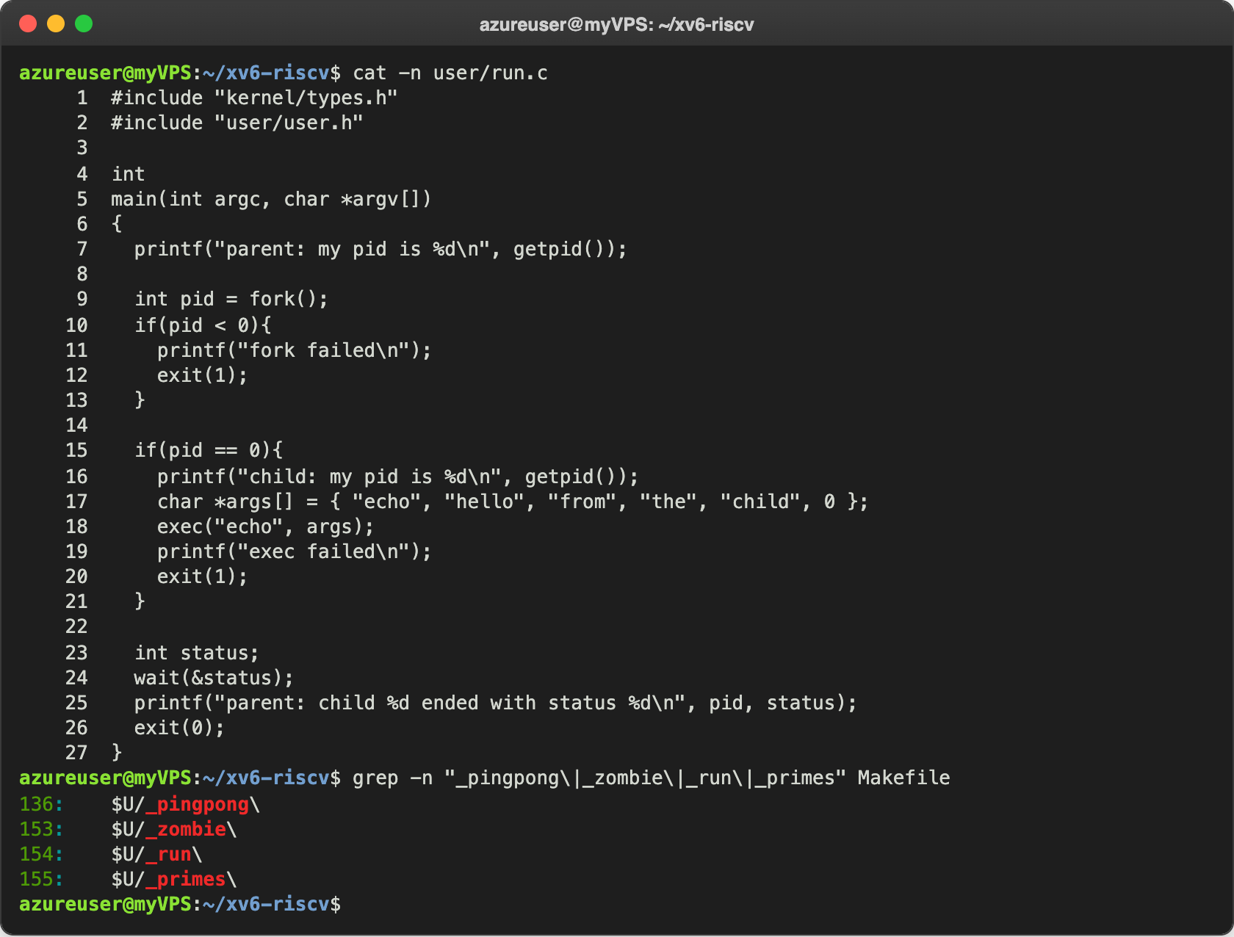
Figure 1.1 – user/run.c and the UPROGS lines
In xv6 exec takes the name of the program and an array of arguments that ends with 0; the first argument is the name of the program itself, like argv[0] on Linux. I started xv6 with make qemu and ran it:
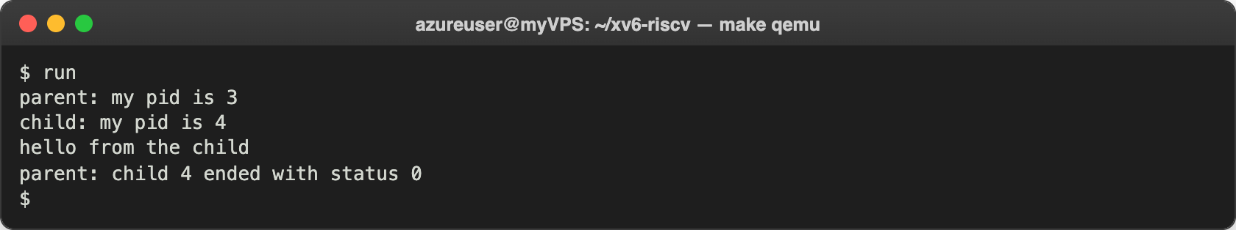
Figure 1.2 – run inside xv6
It is exactly the expected output. After boot the shell is PID 2, so run got PID 3 and its child PID 4. Then I made the child run ls by changing lines 17 and 18 (I left xv6 with Ctrl-A X first and started it again with make qemu, which recompiled run and rebuilt the disk image):
17: char *args[] = { "ls", 0 };
18: exec("ls", args);
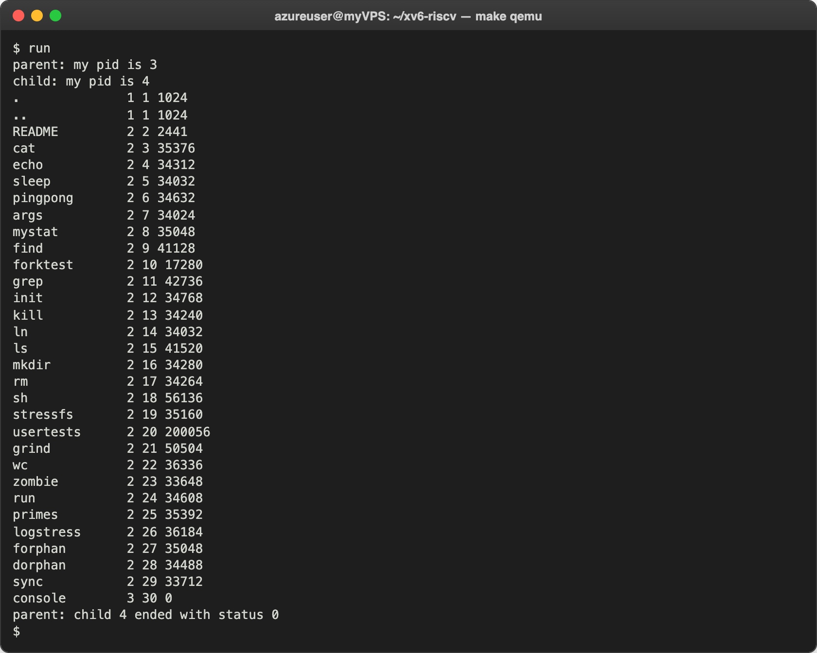
Figure 1.3 – The child becomes ls
The child printed the listing of the root folder; run itself is there with inode 24. At the end I asked for a program that does not exist:
18: exec("nosuchprog", args);
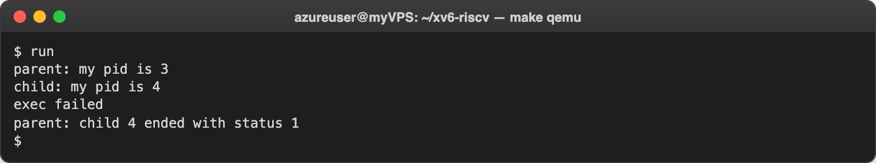
Figure 1.4 – exec of a program that does not exist
After the tests I put back the original run.c with echo; Figure 2.2 starts with it running again.

Observe
- The three calls in xv6 and on Linux. What is the same? In xv6: fork(), exec("echo", args) and wait(&status). On Linux in Lab 7: fork(), execlp("ls", "ls", "-l", NULL) and waitpid(pid, &status, 0). The idea and the order are the same: fork makes a copy and returns 0 in the child and the PID of the child in the parent; exec replaces the program of the child and returns only if it fails; wait blocks the parent until the child ends and gives its exit status. The differences are small: the xv6 exec takes a path and an array of arguments and does not search PATH, wait waits for any child and stores the exit value directly (on Linux I needed WEXITSTATUS), and the xv6 printf calls write for every character, so there is no buffer and no need for fflush.
- Who prints "hello from the child": the code of run, or echo? echo. After exec succeeds, the child no longer runs the code of run; its memory now holds the program echo, and run only gave it the words "hello", "from", "the", "child" as arguments. Figure 1.3 shows it clearly: with the same run code but ls in exec, the child printed a listing instead.
- Why is the status 1 here and 127 on Linux? Because the status is just the number the child passes to exit, and after a failed exec my xv6 run.c calls exit(1), while the Linux run.c calls exit(127). The kernel does not choose the number, wait only hands it to the parent. 127 is the number the Unix shells use for "command not found", but xv6 does not follow that rule.

Part 2. pingpong
I completed the four TODO lines of the template with read(fd, &b, 1) and write(fd, &b, 1):
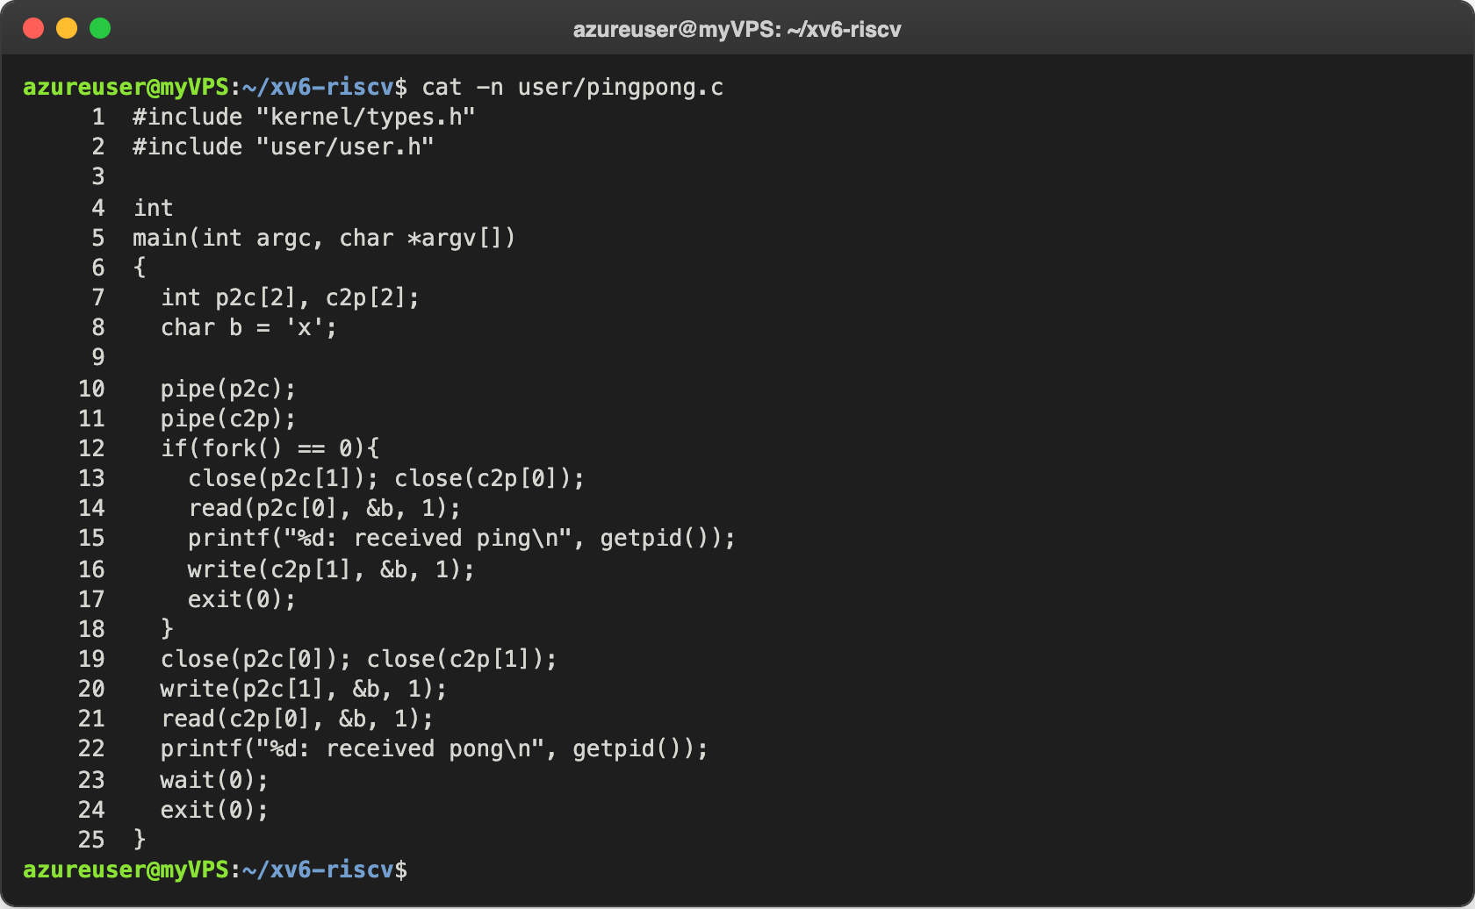
Figure 2.1 – user/pingpong.c
p2c is the pipe from the parent to the child and c2p the pipe back. After fork, each process first closes the two ends it does not use. The child reads one byte from p2c[0], prints "received ping" and writes the byte back into c2p[1]. The parent writes the byte into p2c[1], reads the answer from c2p[0], prints "received pong" and waits for the child. I ran it twice:
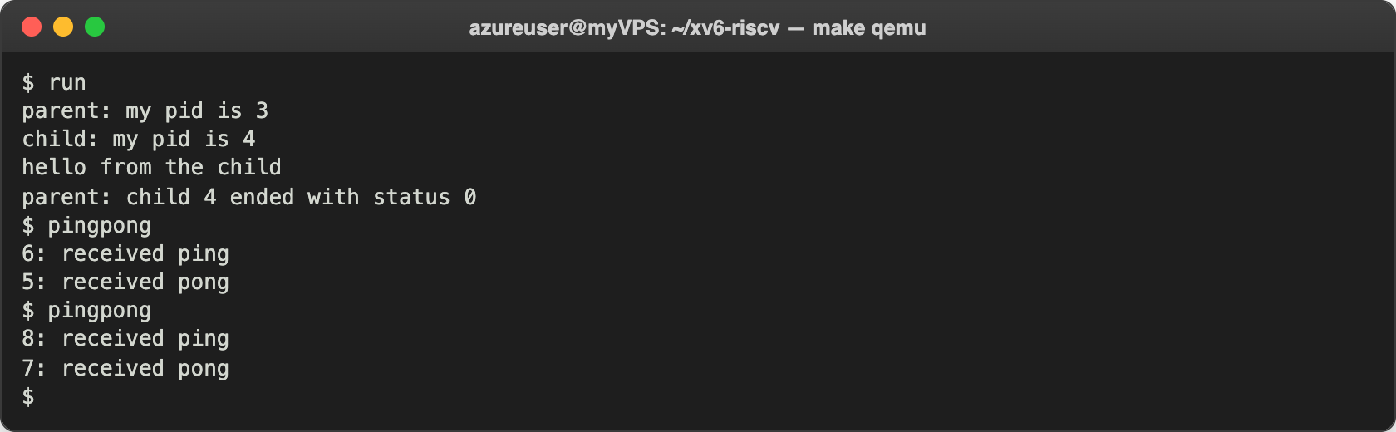
Figure 2.2 – run and pingpong inside xv6
Ping always comes first, from the child. The numbers are PIDs: after run (3) and its child (4), the first pingpong got 5 and its child 6, and the second one 7 and 8.

Observe
- Why TWO pipes, and not one for both directions? A pipe goes in one direction only: what is written into one end comes out of the other end, and it goes to whichever process reads first. With one pipe, after writing "ping" the parent would immediately call read on the same pipe and could take its own byte back before the child gets it; then the child would wait forever for a byte that never comes. With two pipes, each direction has its own channel, and each process reads only what the other one wrote.
- Which call makes the parent wait for the reply? read(c2p[0], &b, 1). When the pipe is empty, read blocks: the kernel puts the parent to sleep until at least one byte arrives. The child writes into c2p only after it printed "received ping", so the parent cannot print "received pong" earlier. The same happens on the other side: the child sleeps in read(p2c[0], ...) until the parent sends the byte.

Optional task. primes
user/primes.c prints the primes from 2 to 35 with a chain of processes. The first process writes the numbers 2 to 35 into a pipe. Each next process (sieve) reads its first number p, which is always a prime, prints "prime p", creates a new pipe and a child, and passes to the child only the numbers that are not divisible by p:
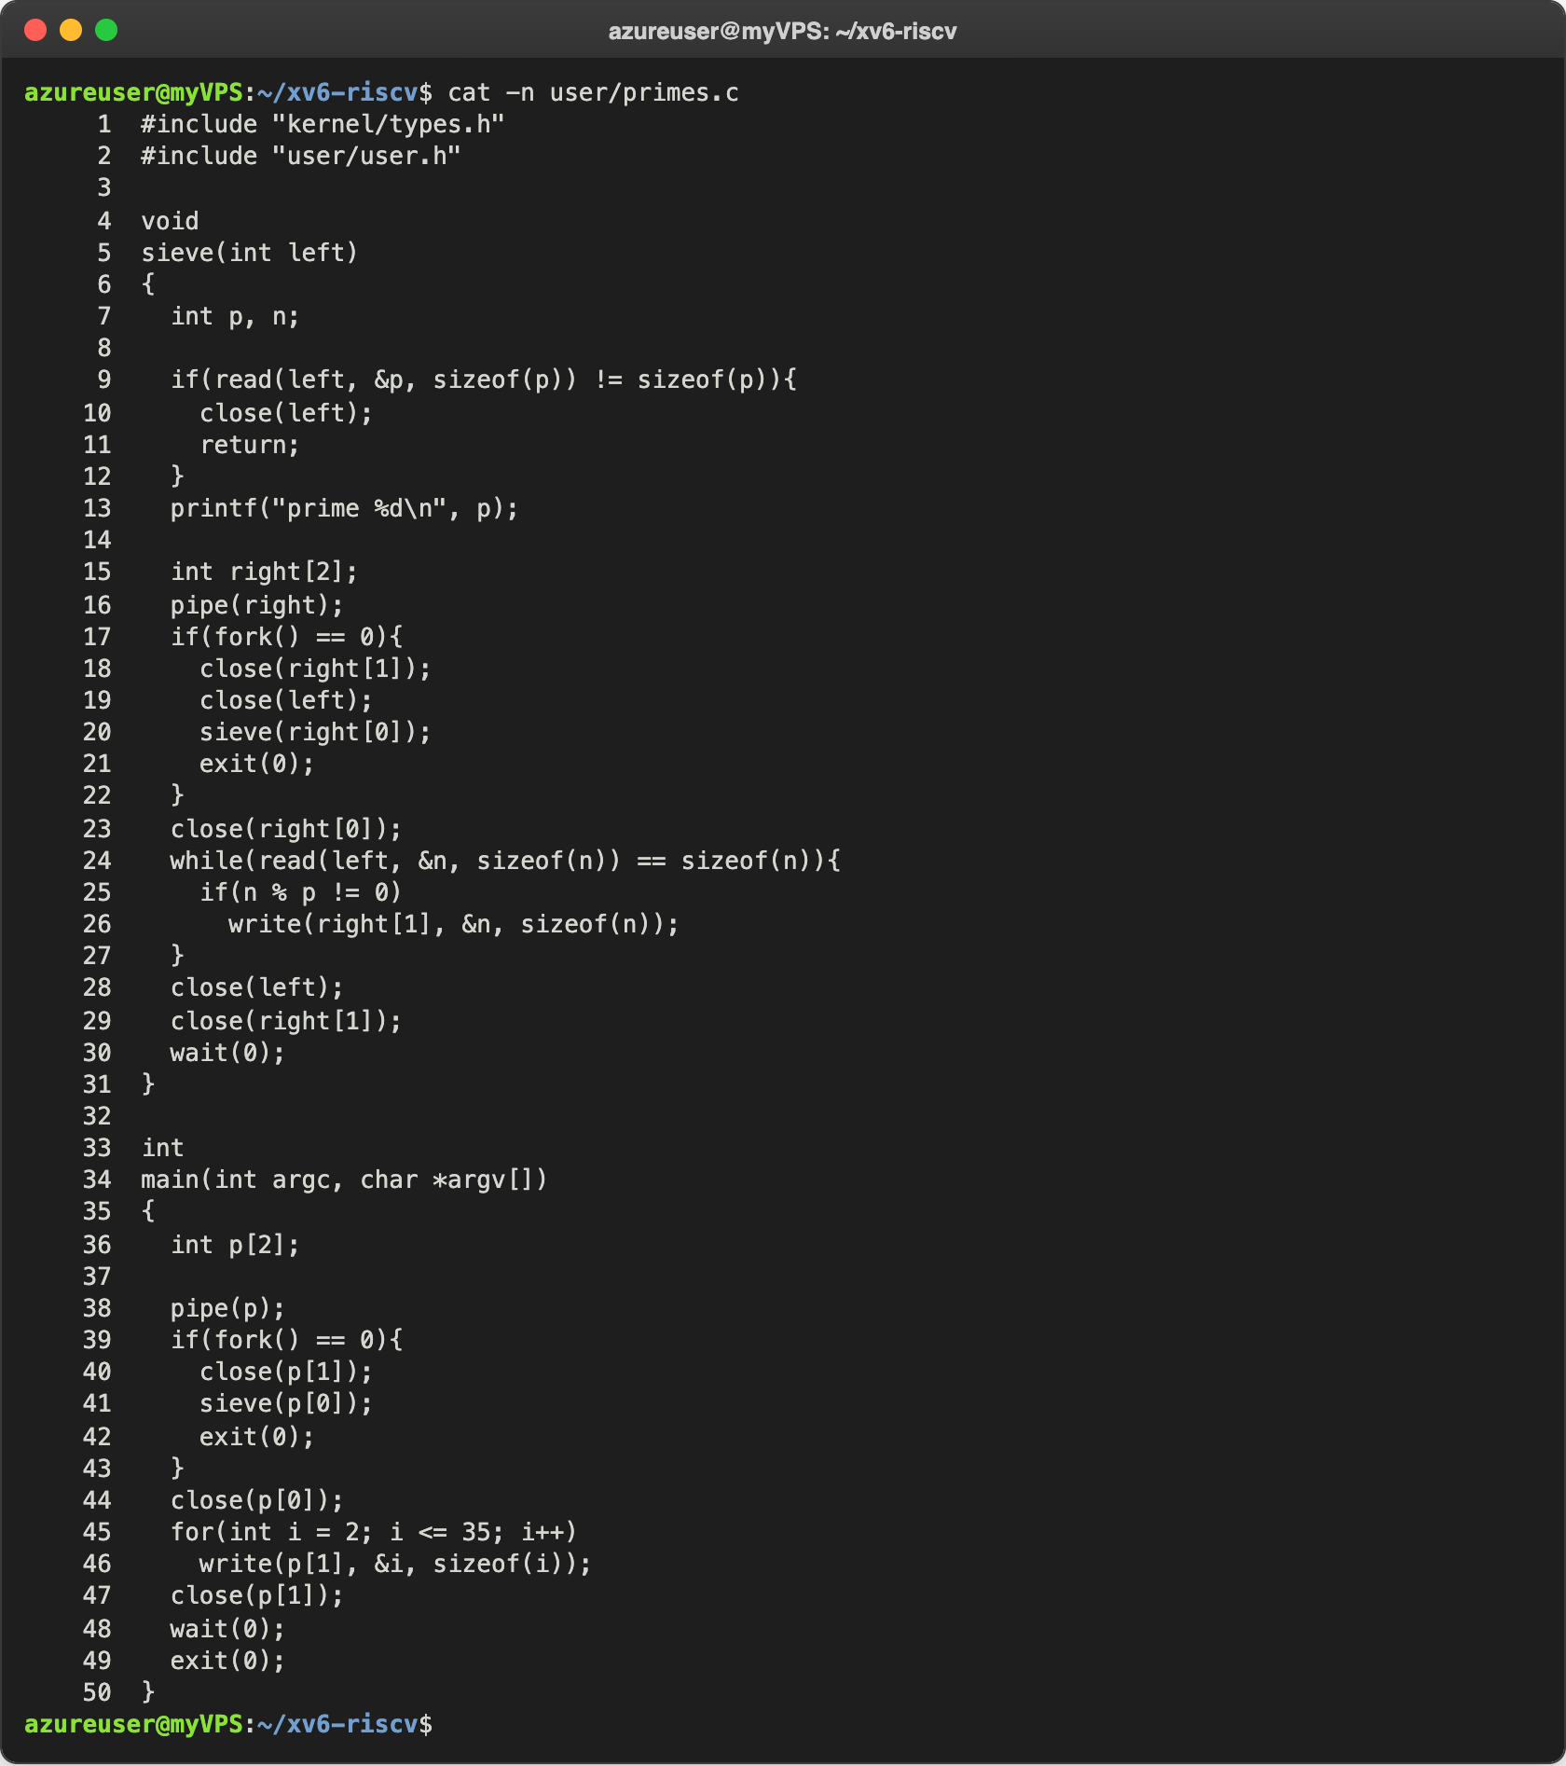
Figure 3.1 – user/primes.c
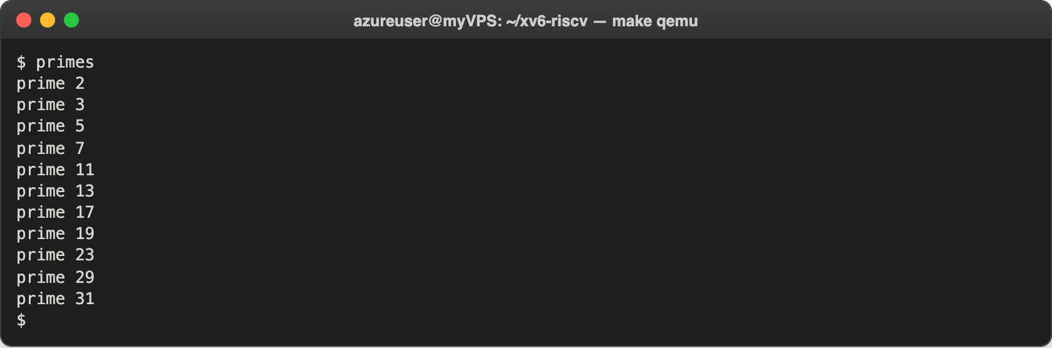
Figure 3.2 – primes inside xv6
All 11 primes up to 35 are there, in order. When the first process closes its write end, the read of the next process returns 0, so it closes its own pipe and waits for its child, and the chain ends from left to right. Every process keeps only the two pipe ends it really uses, so the chain never runs out of descriptors (16 per process). The chain has one process for each prime, plus the first process and a last one that gets no numbers at all and ends right away.
My first version ended sieve with exit(0) on every path, and the xv6 build stopped with error: infinite recursion detected [-Werror=infinite-recursion]: since the function could never return, gcc thought it only calls itself. I changed sieve to return normally and moved the exit(0) to the code that calls it, after which it compiled without warnings.

Conclusions
In this lab I saw that fork, exec and wait are not something special of Linux: my own small xv6 kernel offers the same three calls, and the same program works there almost without changes. The differences are only in the details: exec with a path and an array of arguments, wait with the status directly, printf without a buffer. The exit status is simply the number the child gives to exit.
pingpong showed how two processes can talk through pipes and why one pipe per direction is needed. It also showed that blocking read is what keeps them in order: the parent sleeps in read until the child answers. primes used the same ideas for a whole chain of processes, where closing the unused pipe ends is what lets the chain finish.
Repository: https://github.com/httpcatalin/os-2026-CatalinBitca (folder lab8/, with run.c, pingpong.c, primes.c and the Makefile).

