
TECHNICAL UNIVERSITY OF MOLDOVA
Faculty of Computers, Informatics and Microelectronics
Department of Software Engineering
REPORT
on laboratory work no. 11
Course: Operating Systems
Topic: The Race and the Semaphore
Done by: st. gr. FAF-242, Cătălin Bîtca
Checked by: Reițman Patricia
Chișinău, 2026

Purpose of the work
When two threads change the same variable at the same time, some of the work is lost. The purpose of this lab is to see this race happen, to fix it with a mutex and with a semaphore, and then to use the same semaphore in three different ways: as a lock (start value 1), as a signal (start value 0) and as a counter (start value N). As the optional task I also fixed the counter with an atomic operation, without any lock.

Work environment
Like in the previous Linux labs, I worked on my Ubuntu 24.04 virtual machine in Azure over ssh, in a new folder ~/os-lab11. The machine has two CPUs, so two threads can really run at the same time:
azureuser@myVPS:~/os-lab11$ nproc
2
azureuser@myVPS:~/os-lab11$ gcc --version | head -1
gcc (Ubuntu 13.3.0-6ubuntu2~24.04.1) 13.3.0
I typed every program from the handout without its comments and compiled it with -Wall -pthread, without -O2, as the handout asks. None of them gave a warning.

Part 1. See the race
race.c starts two threads, and each of them adds 1 to the same global counter one million times. The right answer is 2 000 000:
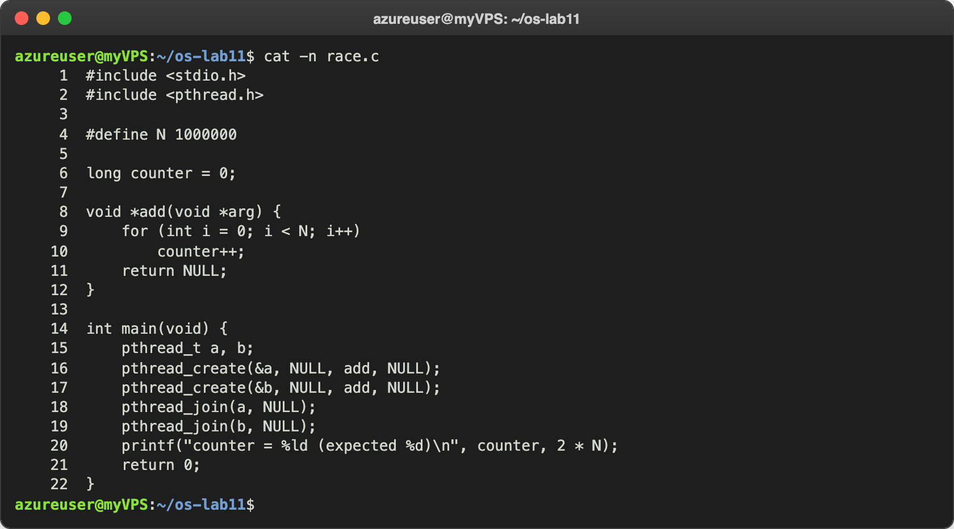
Figure 1.1 – race.c
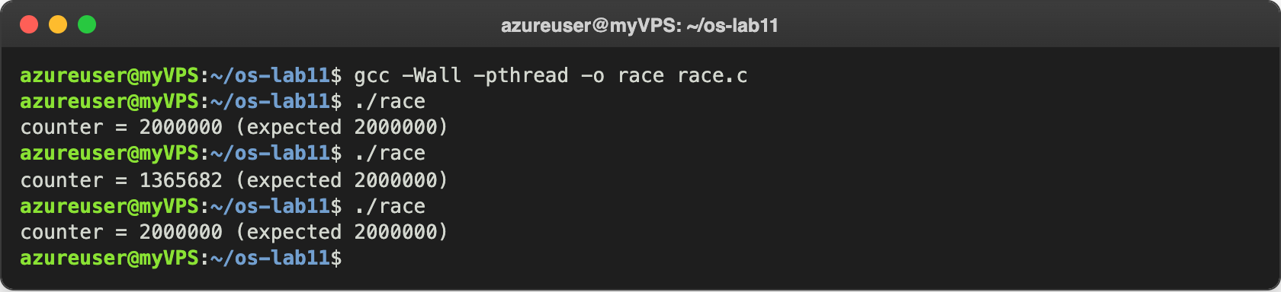
Figure 1.2 – Three runs of race
The second run lost about 634 000 additions, but the first and the third one gave exactly 2 000 000. On my machine one million additions take about one millisecond, and creating a thread also takes some time, so sometimes the first thread finishes its whole loop before the second one even starts, and they never overlap. To see how often the race really happens, I ran it ten times in a row:
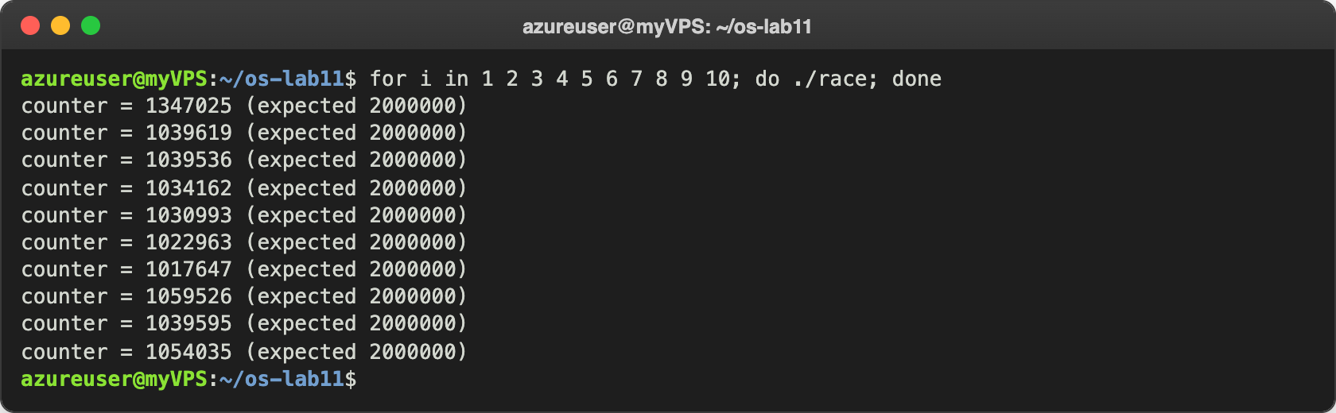
Figure 1.3 – Ten runs of race in a row
This time all ten results were wrong, and almost half of the work was lost every time. To see what counter++ really is, I looked at the machine code of the function add with objdump:
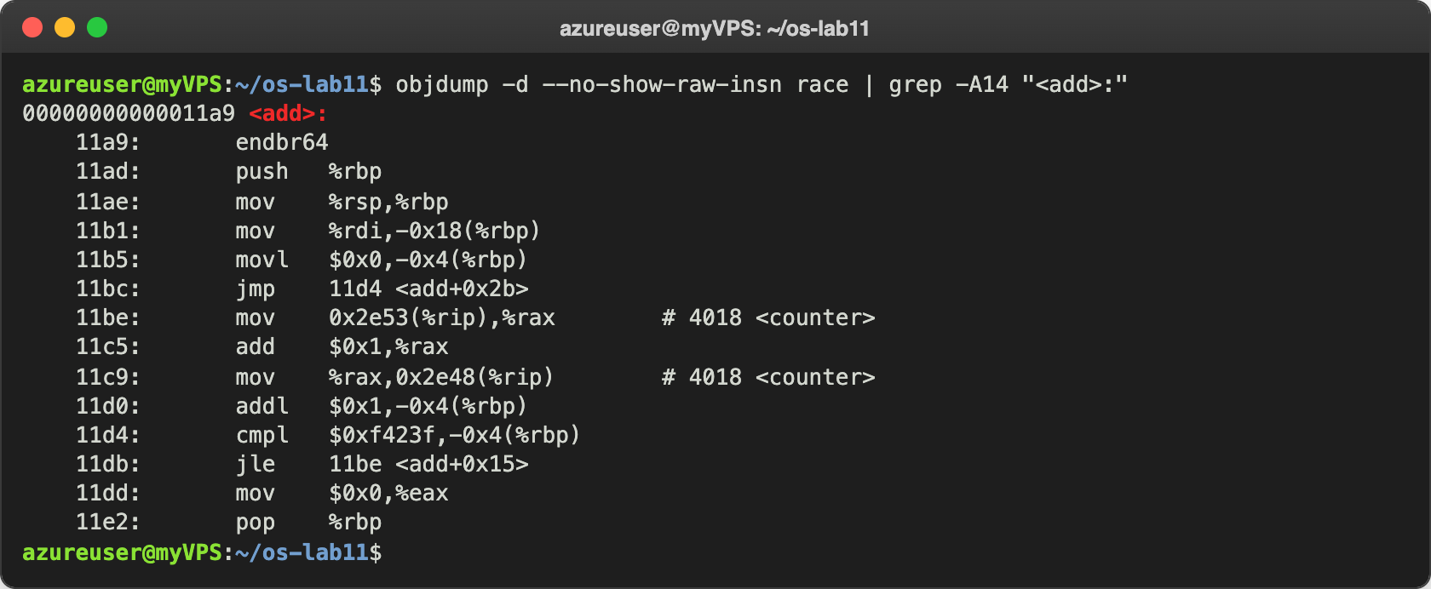
Figure 1.4 – The machine code of add: counter++ is three instructions

Observe
- counter++ looks like one step. Write the three steps the CPU really does. Figure 1.4 shows them at addresses 11be, 11c5 and 11c9: (1) load: mov 0x2e53(%rip),%rax copies counter from memory into the register rax; (2) add: add $0x1,%rax adds 1 to the register; (3) store: mov %rax,0x2e48(%rip) writes the register back into counter. Between these instructions the other thread can do anything.
- Describe, with those steps, how two threads can lose one addition. Say counter is 5. Thread A loads 5 into its register. Before A stores, thread B, on the other CPU, also loads 5. A adds 1 and stores 6; B adds 1 to its own copy and also stores 6. Two additions were done, but counter grew only by 1: the store of B overwrote the result of A. With two CPUs this happens all the time, which is why about half of the additions were lost in Figure 1.3.
- Why is the result different at every run? Because it depends on the exact timing of the two threads, and nobody controls it: when each thread is created, on which CPU and when the scheduler runs it, interrupts, other processes on the machine. Every run the threads overlap in a different way, so a different number of additions is lost. When they did not overlap at all, the result was even right (Figure 1.2), which is the dangerous part: a program with a race can look correct in one run and be wrong in the next.

Part 2. Fix it: mutex, then semaphore
In mutex.c the line counter++ is between pthread_mutex_lock and pthread_mutex_unlock. This is the critical section: only one thread at a time may be inside it.
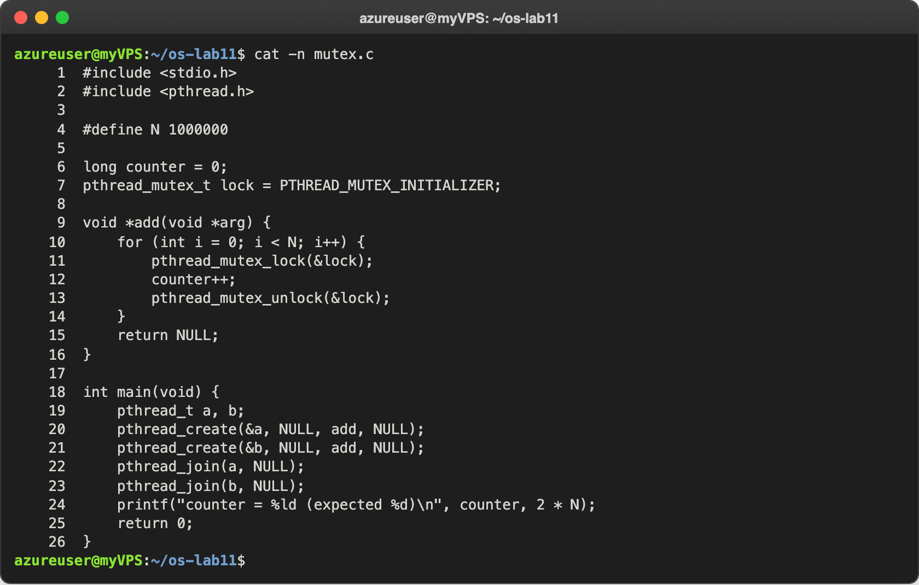
Figure 2.1 – mutex.c
sem.c does the same with a semaphore that starts at 1. sem_wait takes one unit (1 → 0) or waits if the value is 0, and sem_post gives it back (0 → 1):
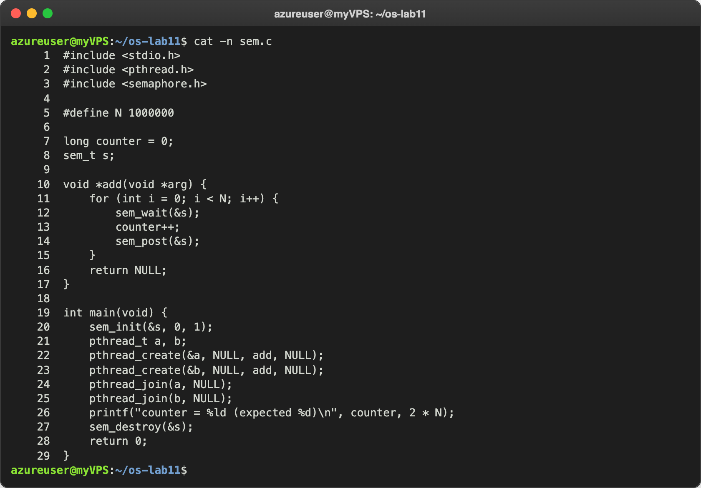
Figure 2.2 – sem.c
I ran each of them three times:
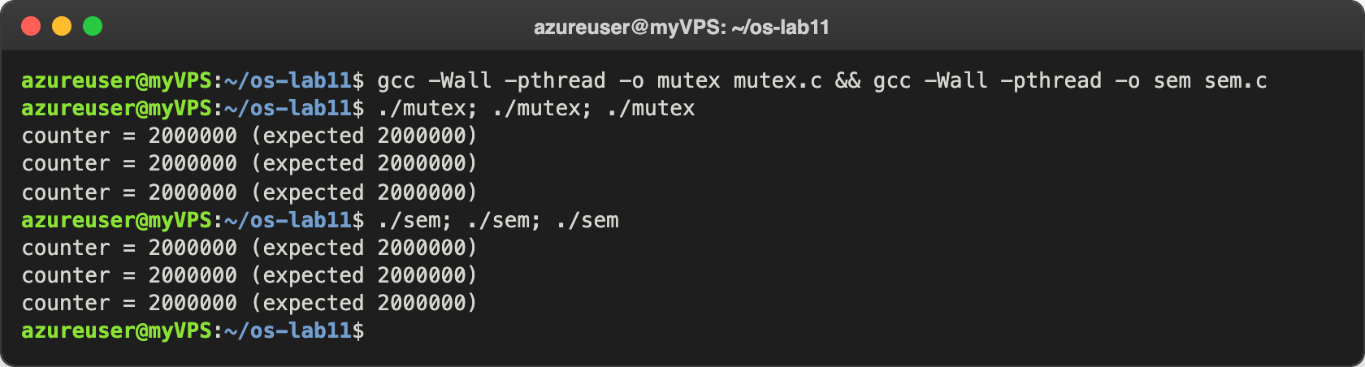
Figure 2.3 – mutex and sem, three runs each
Then I measured the three programs with time:
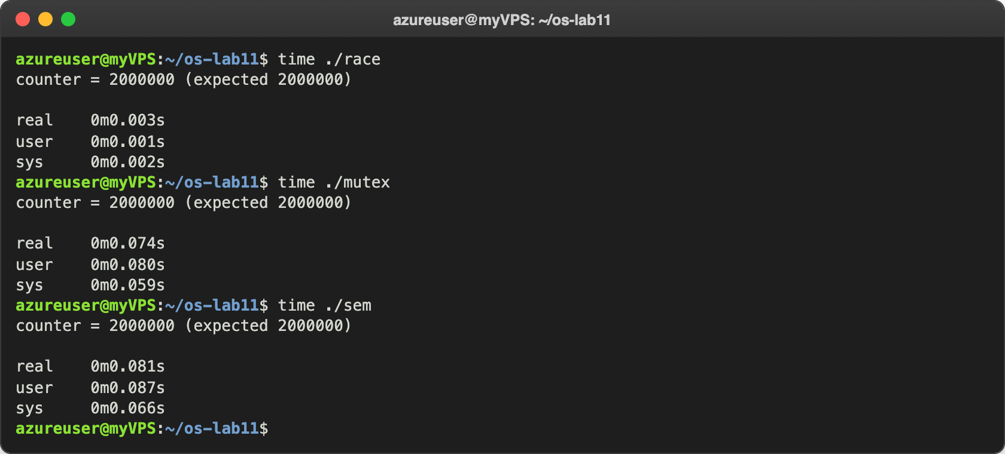
Figure 2.4 – The price of the lock
race needed 0.003 s (and this time it was even lucky: the two threads did not overlap), mutex 0.074 s and sem 0.081 s: the same order as on the reference machine.

Observe
- Run mutex and sem three times each. Is the answer always 2 000 000? Yes, all six runs in Figure 2.3 printed exactly 2 000 000, and so did the runs in Figure 2.4. The three steps of counter++ are now inside a critical section, so the load-add-store of one thread can never be cut by the other one.
- What would happen in sem.c with sem_init(&s, 0, 2)? Try it and explain. I changed the start value to 2 and ran it five times (Figure 2.5): the result was wrong again, about 10 000 additions were lost each time. With 2 units, both threads can pass sem_wait at the same moment (2 → 1 → 0), so both are inside the critical section together, and the race of Part 1 comes back. Fewer additions were lost than in race, because now most of the time of each loop is spent inside sem_wait and sem_post, and the two threads are less often exactly at the three instructions of counter++ at the same time. After this I put the value back to 1.
- Why is the locked version slower? Because each of the 2 000 000 additions now also costs a lock and an unlock, which are atomic instructions on a shared variable, more expensive than the addition itself. And when one thread holds the lock, the other one cannot work: it has to wait, and if it waits longer, it goes to sleep in the kernel (the futex system call) and has to be woken up again. The sys time of about 0.06 s in Figure 2.4 is this time spent in the kernel. With the lock the two threads take turns, so the second CPU does not help any more.
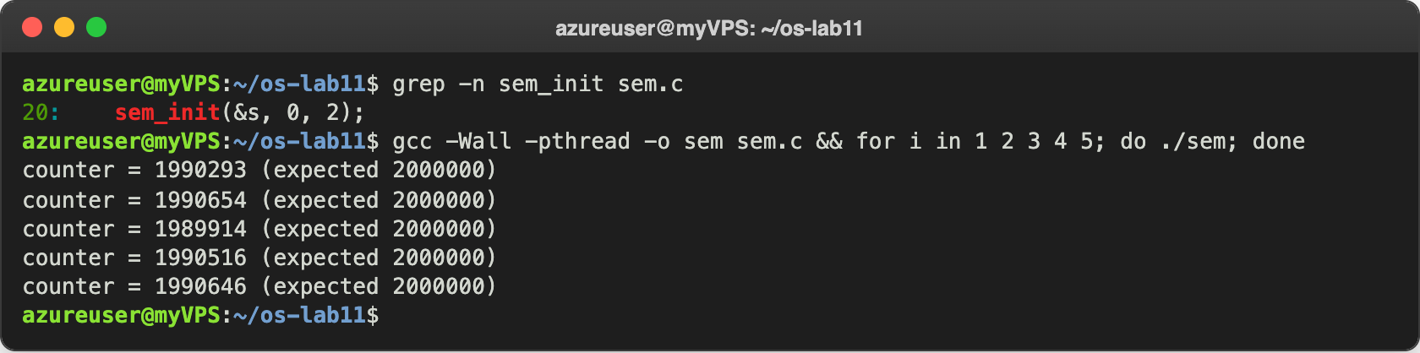
Figure 2.5 – sem.c with the start value 2

Part 3. A semaphore as a signal
Here the problem is not that two threads run at once, but the order: thread B must read the message only after thread A has written it. The semaphore ready starts at 0, a closed door. B is created first, on purpose, and waits in sem_wait; A sleeps one second, writes the message and calls sem_post:
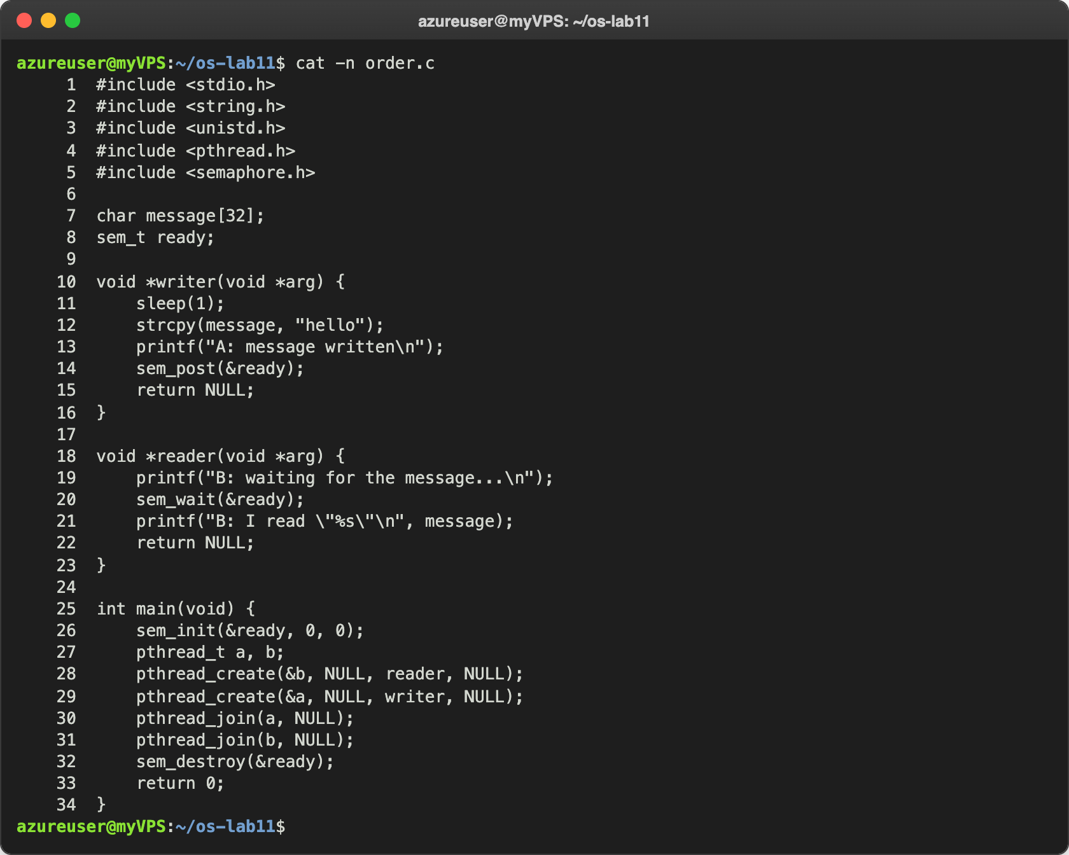
Figure 3.1 – order.c
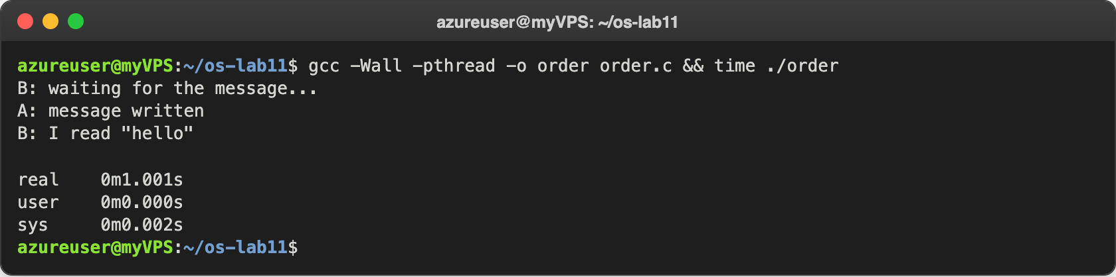
Figure 3.2 – order: B waits for A
B printed its first line at once, then nothing happened for one second (the whole run took 1.001 s), and then A and B finished, exactly as in the handout. Then I changed the start value to 1:
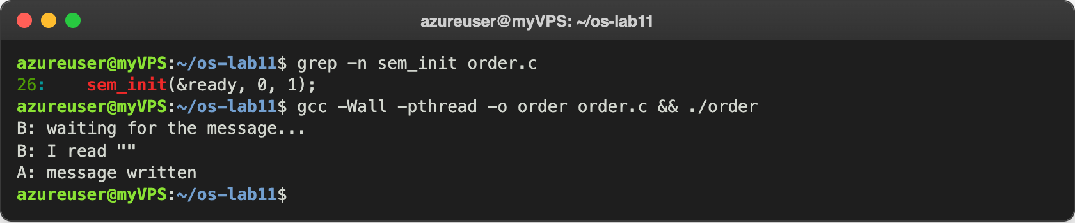
Figure 3.3 – order.c with the start value 1
And at the end I put it back to 0, and the right order came back:
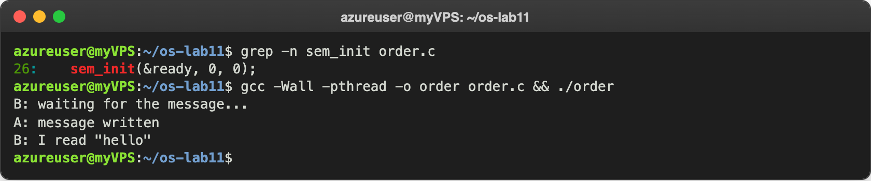
Figure 3.4 – order.c back with the start value 0

Observe
- Change the start value to 1, compile, run. What does B read now, and why? B reads an empty string: B: I read "", and only after that A writes the message (Figure 3.3). With the value 1, sem_wait of B finds one unit, takes it and does not wait at all, so B reads message immediately, while A is still sleeping. message is a global array, so it is all zeros, an empty string.
- Put it back to 0. In one sentence: what does a semaphore that starts at 0 mean? It means "the event has not happened yet": whoever calls sem_wait sleeps until another thread announces the event with sem_post.

Part 4. A semaphore as a counter: the parking lot
Six cars and three places. The semaphore places starts at 3 and counts the free places: every car takes one with sem_wait and gives it back with sem_post when it leaves. The mutex only keeps the variable inside and its printf together:
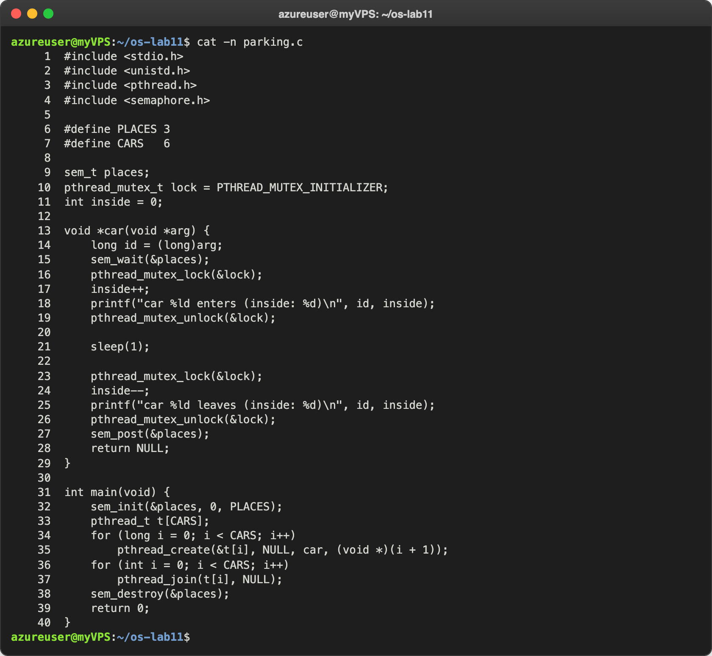
Figure 4.1 – parking.c
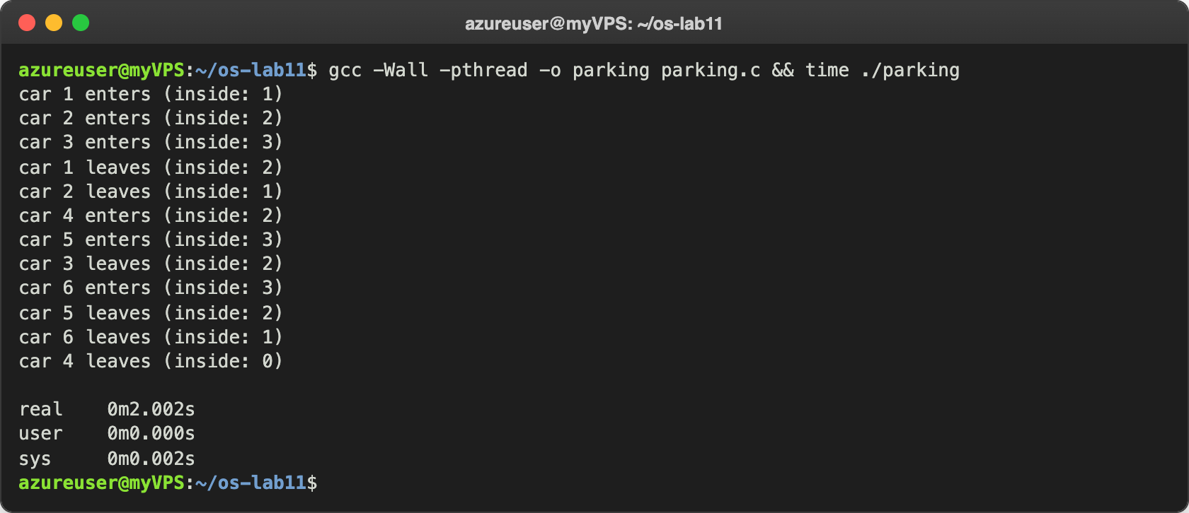
Figure 4.2 – parking with 3 places
Cars 1, 2 and 3 entered at once; car 4 could enter only after two cars had left. The whole run took 2 seconds: two rounds of one second for six cars. Then I set PLACES to 1:
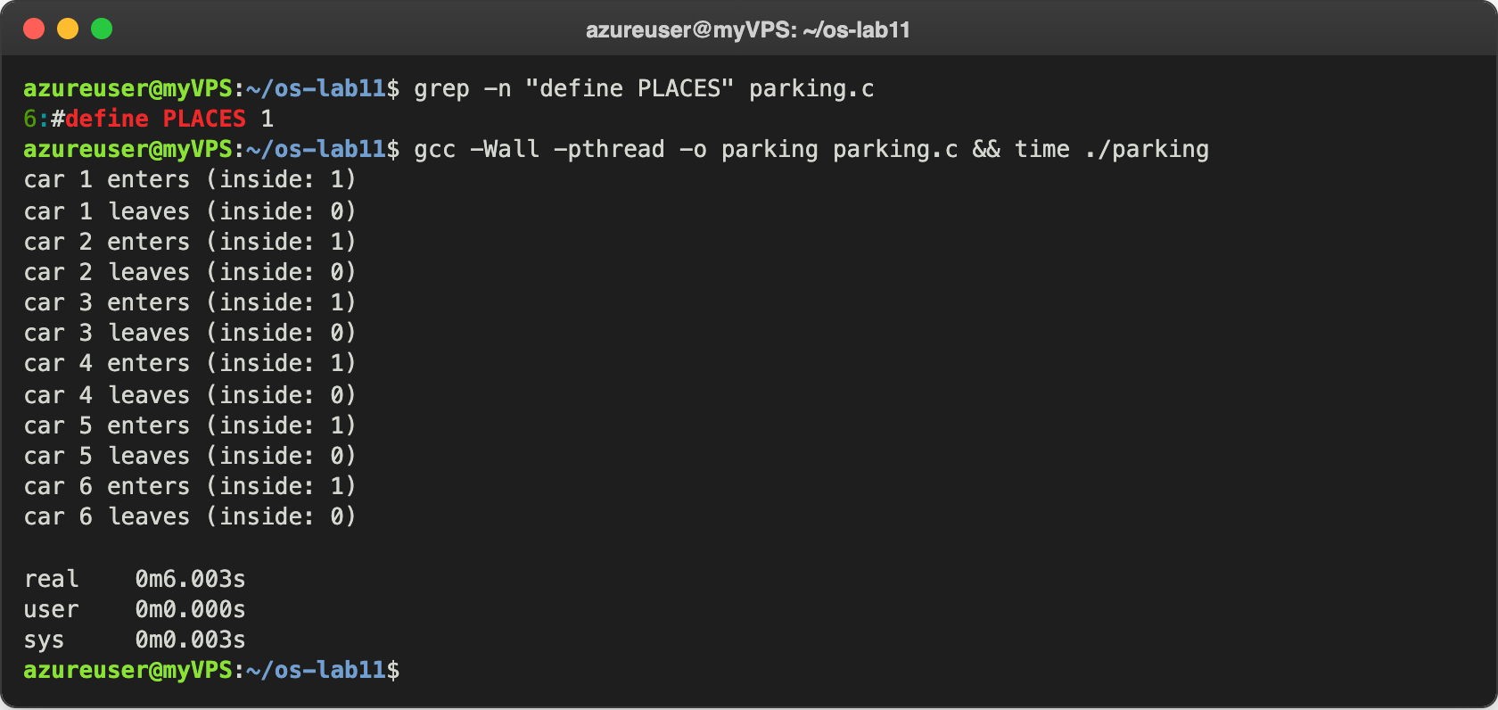
Figure 4.3 – parking with 1 place

Observe
- What is the largest value of "inside" you see? Which line of code guarantees it? 3, never more (Figure 4.2). The line sem_wait(&places); at the start of car() guarantees it, together with sem_init(&places, 0, PLACES): there are only 3 units, so after three cars have entered the value is 0, and the fourth car sleeps in sem_wait until a car leaves and calls sem_post(&places).
- Set PLACES to 1. What does the semaphore become? A semaphore that can be only 0 or 1, a binary semaphore, which is the same as a mutex (a lock): only one car can be inside at a time. In Figure 4.3 the cars enter and leave strictly one by one, and the run took 6 seconds instead of 2. This is the same semaphore as in Part 2, where the start value 1 made it a lock. After this I put PLACES back to 3.

Optional task. No lock at all: atomic
For one counter there is also a third way: an atomic operation. atomic_fetch_add does the load, the add and the store as one indivisible instruction of the CPU, so the other thread cannot cut in between:
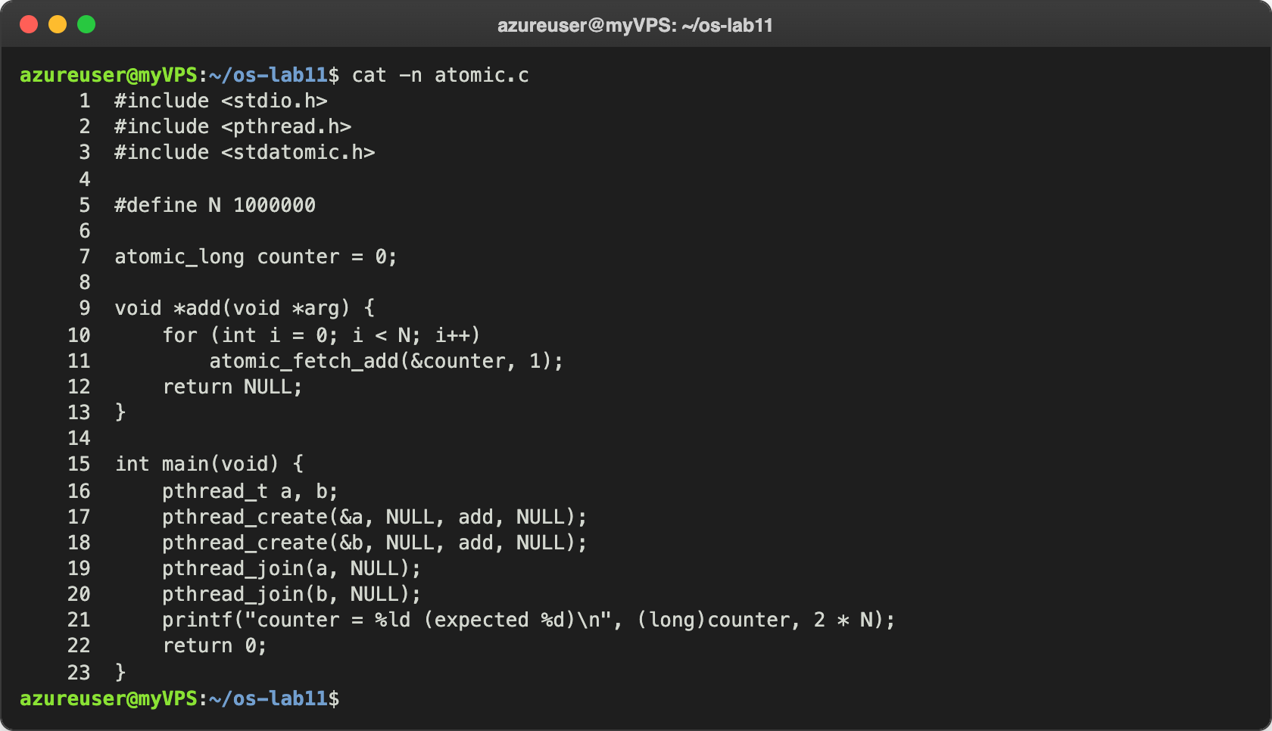
Figure 5.1 – atomic.c
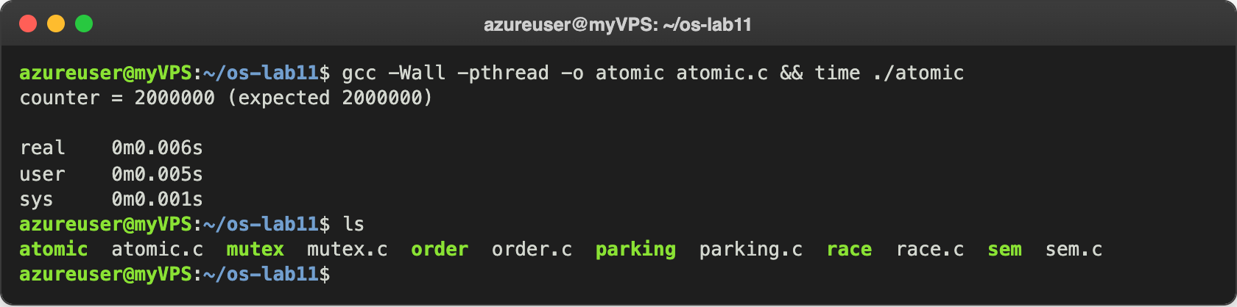
Figure 5.2 – atomic: right, and without a lock
The result is right, and the program needed only 0.006 s, much less than the 0.074 s of the mutex: there is no lock to take, no waiting and no system call, only one special instruction per addition. I checked which instruction it is:
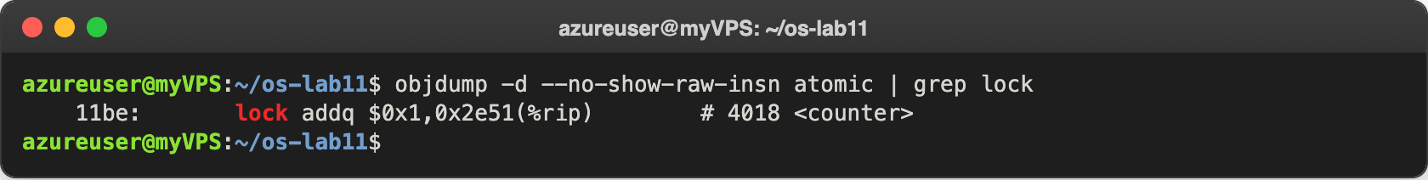
Figure 5.3 – The atomic addition in the machine code of atomic
Instead of the three instructions of Figure 1.4 there is one: lock addq $0x1,counter. The lock prefix tells the CPU to do the whole read-add-write on that memory address without letting the other CPU touch it in between.

Conclusions
In this lab I saw that counter++ is not one step but three (load, add, store), and that two threads on two CPUs lose almost half of the additions when they do them at the same time. The result changed at every run, and sometimes it was even right, which shows why races are dangerous: they depend on timing and can hide.
A mutex or a semaphore that starts at 1 makes counter++ a critical section and gives the right answer, at the price of being about 25 times slower. The same semaphore did three different jobs, only by its start value: 1 is a lock, 0 is a signal that makes one thread wait for another, and 3 is a counter that lets at most three threads in. When the start value is wrong (2 for the lock, 1 for the signal), the program compiles and runs, but the protection is gone. For a single counter, an atomic instruction is the cheapest correct solution.
Repository: https://github.com/httpcatalin/os-2026-CatalinBitca (folder lab11/, with race.c, mutex.c, sem.c, order.c, parking.c and atomic.c).

