
TECHNICAL UNIVERSITY OF MOLDOVA
Faculty of Computers, Informatics and Microelectronics
Department of Software Engineering
REPORT
on laboratory work no. 12
Course: Operating Systems
Topic: Producer, Consumer and the Other Tools
Done by: st. gr. FAF-242, Cătălin Bîtca
Checked by: Reițman Patricia
Chișinău, 2026

Purpose of the work
In Lab 11 I used one semaphore at a time: as a lock, as a signal and as a counter. The purpose of this lab is to make the tools work together on the two classic problems of synchronization, producer and consumer, and readers and writers, to meet the condition variable, and to build a deadlock on purpose, see why it happens and remove it.

Work environment
The same Ubuntu 24.04 virtual machine in Azure with two CPUs and gcc 13.3, in a new folder ~/os-lab12. As before, I typed the programs from the handout without their comments and compiled each of them with -Wall -pthread; none of them gave a warning.

Part 1. Producer and consumer
A fast producer puts 8 items into a buffer of 4 slots, and a slow consumer (300 ms per item) takes them out. Three tools work together: the semaphore empty counts the free slots (it starts at 4), the semaphore full counts the filled slots (it starts at 0), and the mutex lock protects the buffer itself and the indexes in and out:
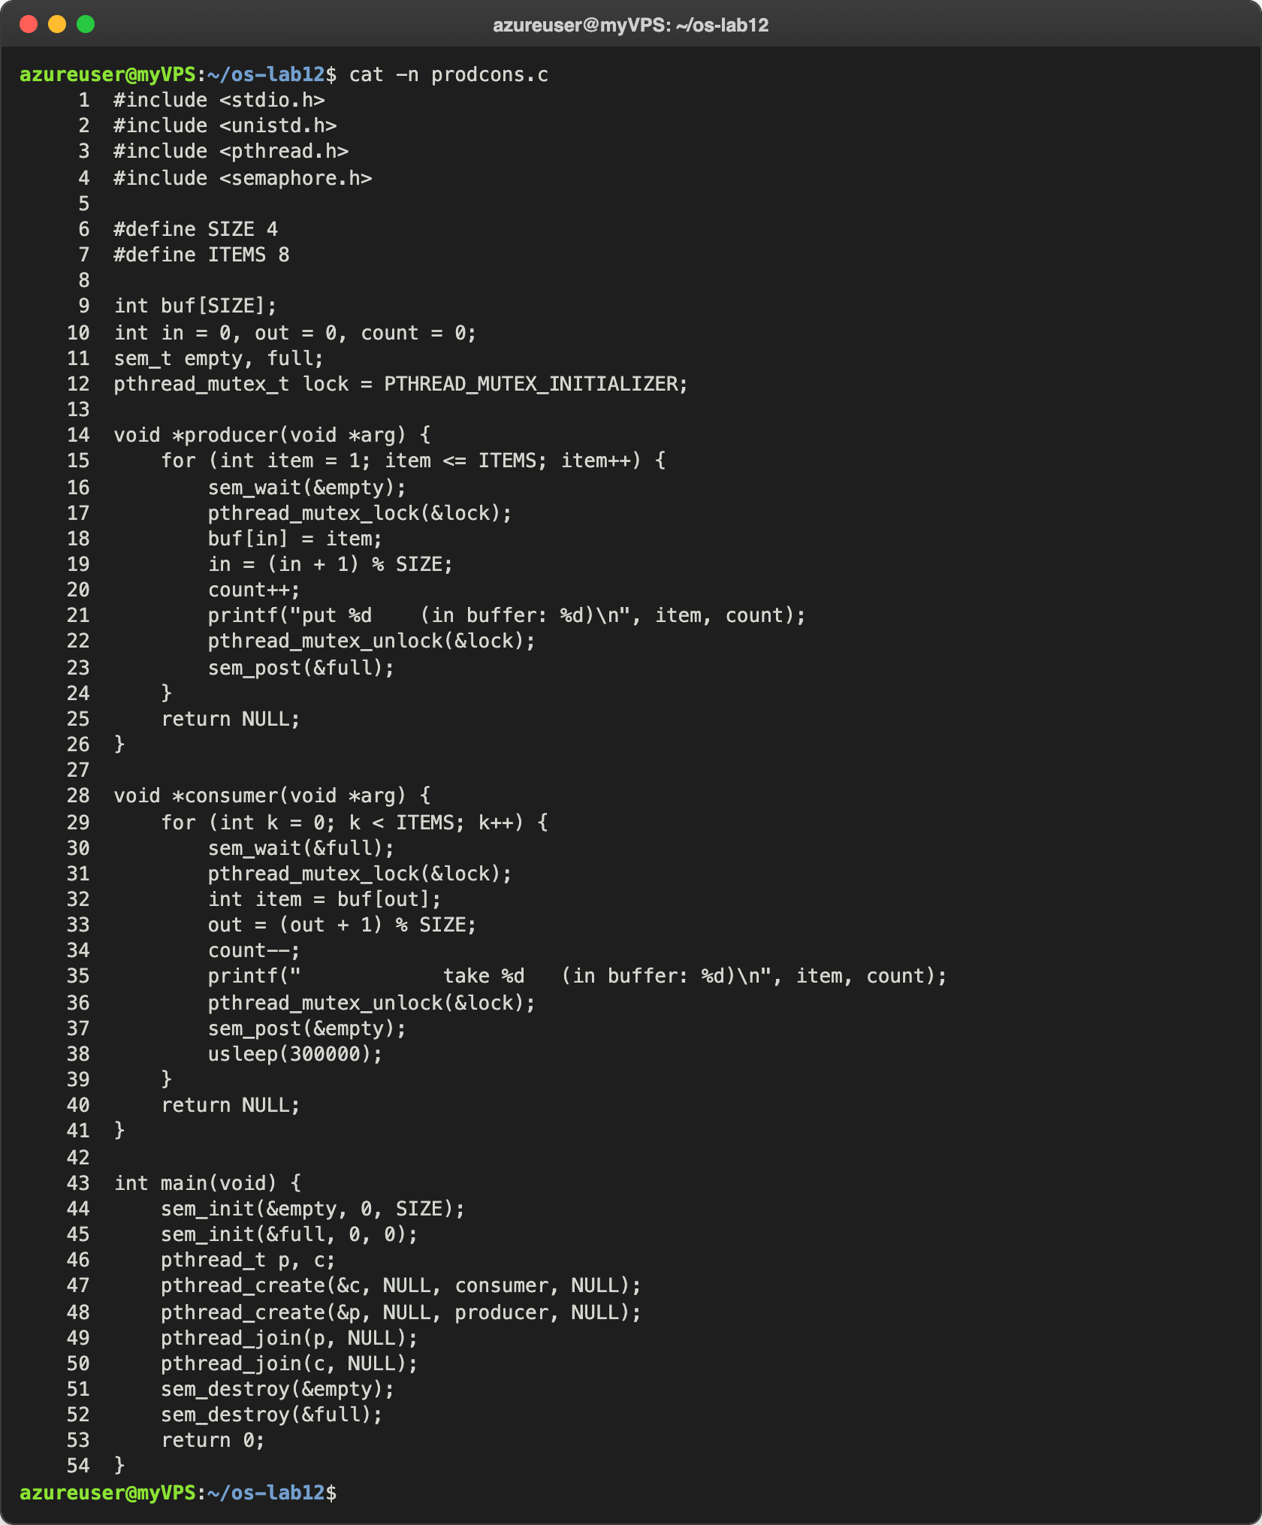
Figure 1.1 – prodcons.c
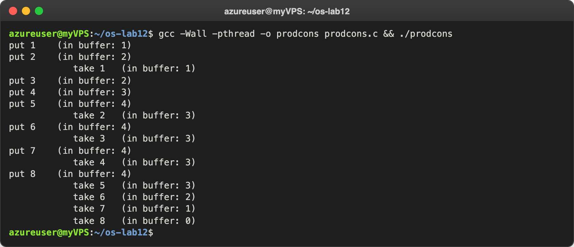
Figure 1.2 – prodcons
My run differs a little from the handout in the first lines: the consumer took item 1 already after put 2, because it was woken up as soon as the first item was in the buffer. From put 5 on, the pattern is the same as in the handout: the buffer is full (4), the producer can put a new item only after the consumer takes one, and at the end the consumer empties the buffer alone.
Then I did the experiment of question 3: in producer() I swapped the first two lines, so that the mutex is locked before sem_wait(&empty):
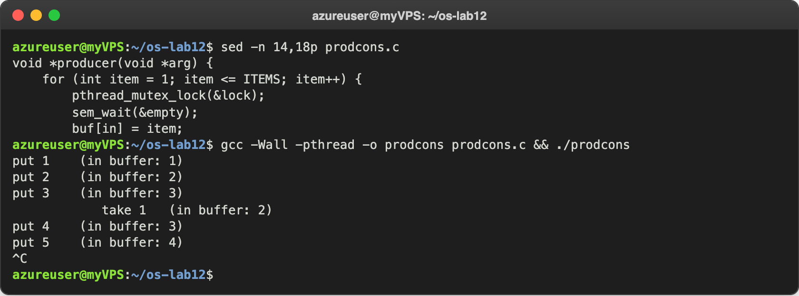
Figure 1.3 – The producer locks the mutex before waiting for a free slot
After put 5 the buffer was full and the program stopped forever: nothing more was printed, and I stopped it with Ctrl-C. Then I put the two lines back.

Observe
- The producer is fast, yet "in buffer" never goes above 4. Which call stops it? sem_wait(&empty). empty starts at 4, the number of free slots, and every put takes one unit. When the buffer is full, empty is 0 and the producer sleeps in sem_wait(&empty) until the consumer takes an item and calls sem_post(&empty). That is why in Figure 1.2 after the buffer is full every put comes only after a take.
- Who waits at the start: the consumer or the producer? Which call makes it wait? The consumer. It is created first, and its first call is sem_wait(&full); full starts at 0, because the buffer is empty, so the consumer sleeps until the producer puts the first item and calls sem_post(&full). Later the roles change: when the buffer is full, it is the producer that waits, in sem_wait(&empty).
- Swap the first two lines of producer(): what happens when the buffer is full, and why? The program hangs (Figure 1.3): a deadlock. The producer takes the mutex and then sleeps in sem_wait(&empty), because the buffer is full, still holding the mutex. The consumer wakes up from its usleep, passes sem_wait(&full), and then blocks in pthread_mutex_lock(&lock), because the producer holds it. So the producer waits for the consumer to free a slot, and the consumer waits for the producer to release the mutex; neither can go on. The rule: never sleep on a semaphore while holding the lock that the other side needs to wake you.

Part 2. The condition variable
This is the problem of order.c from Lab 11, B must read only after A has written, solved another way. The state is a normal variable ready, protected by the mutex lock. The condition variable changed is only the place where B sleeps until A says that something changed. pthread_cond_wait releases the mutex, sleeps, and takes the mutex again before it returns:
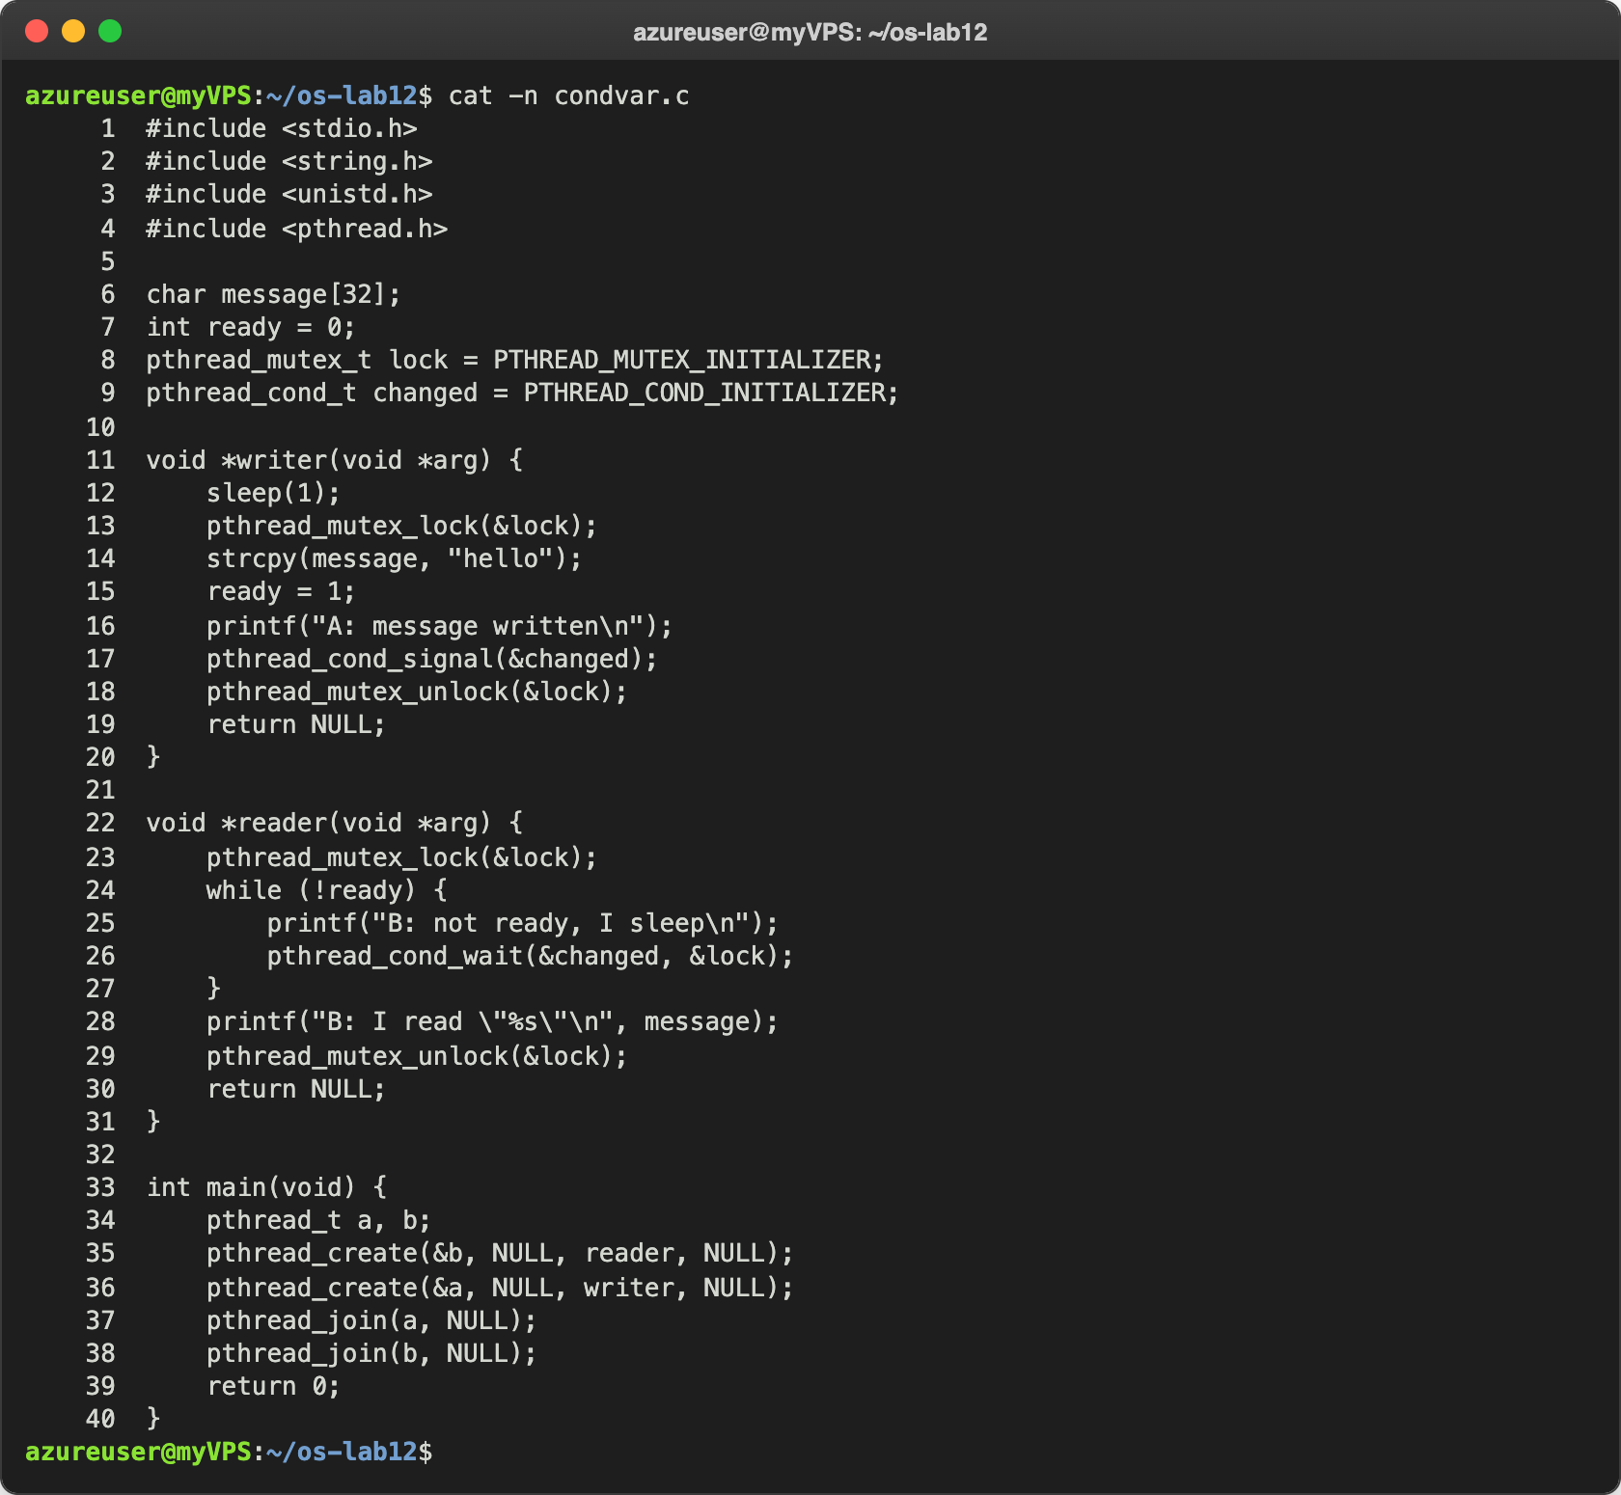
Figure 2.1 – condvar.c
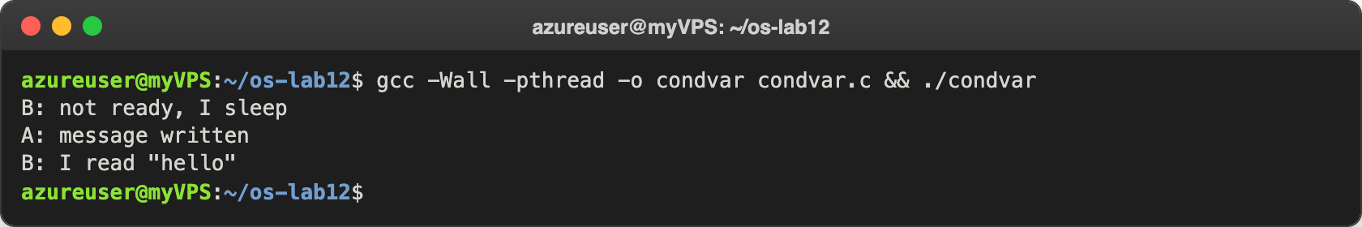
Figure 2.2 – condvar
Then I replaced while (!ready) with if (!ready) (line 24), compiled and ran it again:
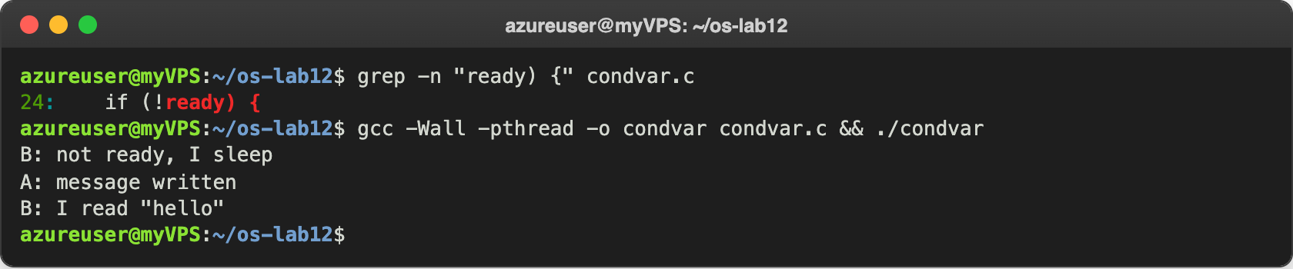
Figure 2.3 – condvar with if instead of while
The output is the same. After this I put while back.

Observe
- In order.c the semaphore itself remembered that the message was ready. Here, which variable remembers it? The variable ready. A condition variable has no memory and no value: pthread_cond_signal only wakes a thread that is sleeping at that moment, and if nobody is sleeping, the signal is simply lost. That is why the state must live in a normal variable, protected by the mutex, and B checks it before it sleeps.
- Replace "while (!ready)" with "if (!ready)", compile, run. Does it still work here? Yes (Figure 2.3). Here there is only one reader and one writer, and A calls pthread_cond_signal only after it set ready = 1, so when B wakes up, ready is always 1 and checking it only once is enough.
- Then why do we write while? Give one reason why a thread can wake up and still find ready == 0. Because waking up does not guarantee that the condition is true. First, POSIX allows spurious wakeups: pthread_cond_wait may return even if nobody called signal. Second, between the signal and the moment the woken thread takes the mutex again, another thread can take the mutex first and change the state; for example, with two readers and pthread_cond_broadcast, the first reader could use the message and set ready back to 0. With while the thread checks again and goes back to sleep; with if it would read a message that is not there.

Part 3. Readers and writers
Many readers may read at the same time, but a writer must be alone. Two semaphores do this: room (1 = the room is free for a writer) and rlock, a lock around the counter readers. The first reader in locks the room for all readers, and the last one out unlocks it:
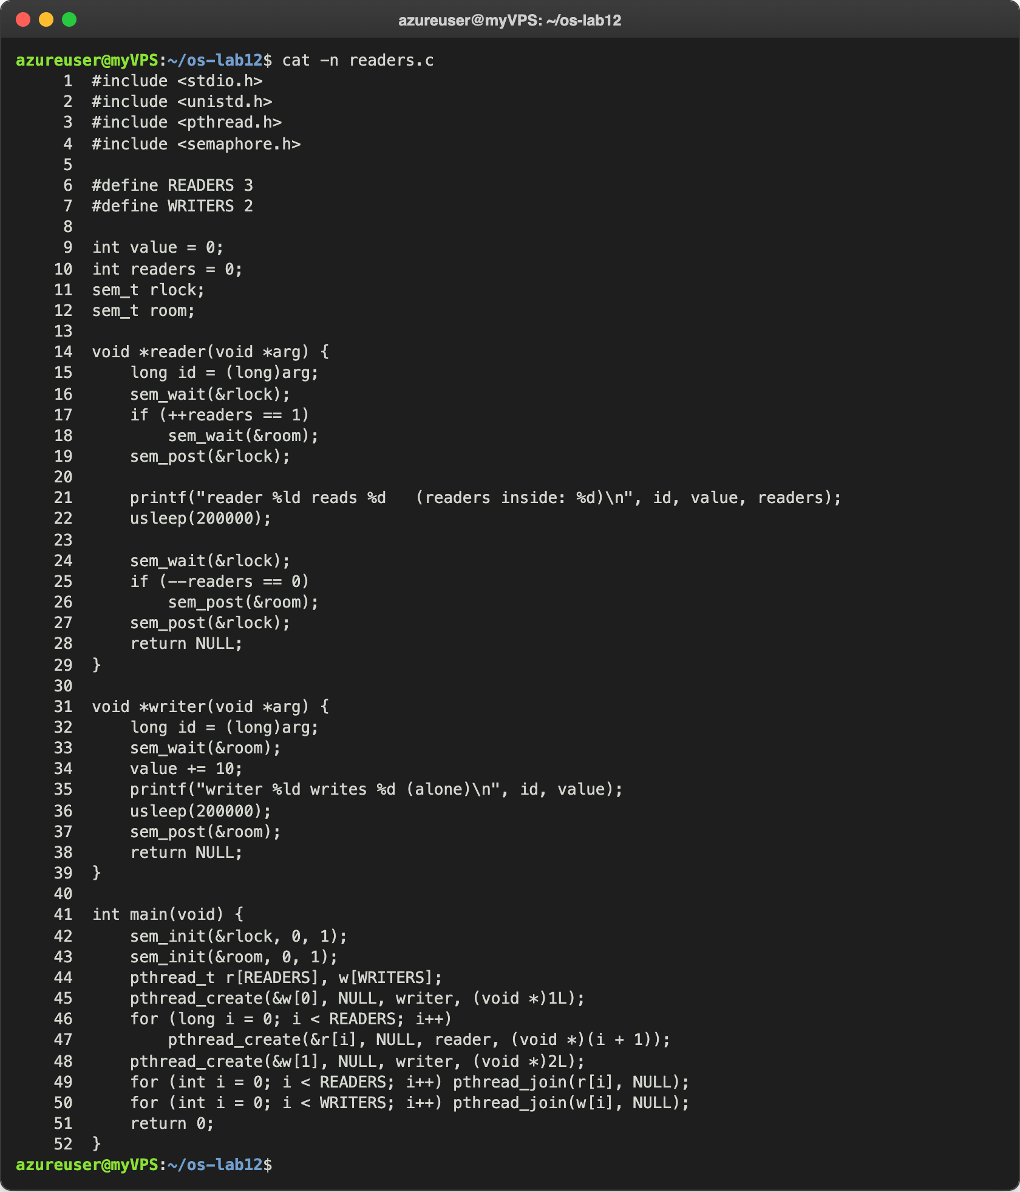
Figure 3.1 – readers.c
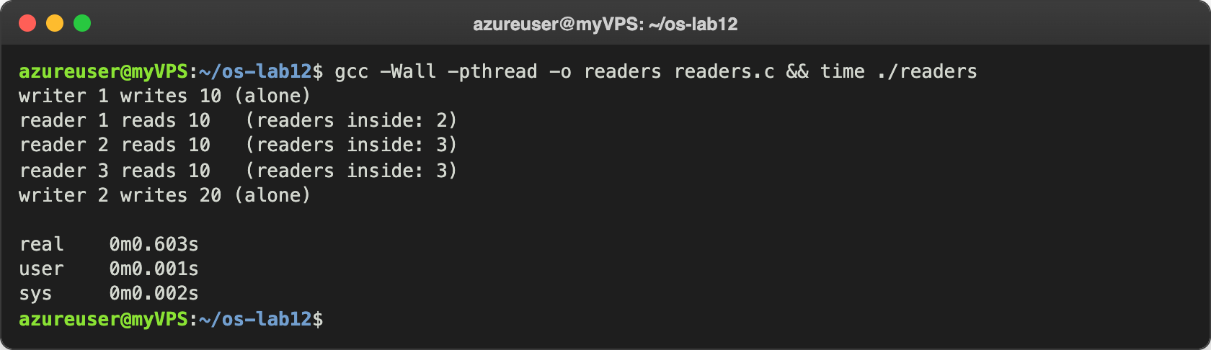
Figure 3.2 – readers
Writer 1 wrote alone, then the three readers read together, then writer 2 wrote alone. The whole run took 0.603 s: three steps of 0.2 s (writer 1, the three readers together, writer 2). If the readers had read one after another, it would have taken 1.0 s. My numbers in "readers inside" differ from the handout (2, 3, 3 instead of 1, 2, 3), because printf reads readers after sem_post(&rlock), outside the lock: when reader 1 printed, reader 2 had already come in. This only confirms that the three readers were inside together.

Observe
- Three readers are inside at the same time, but a writer is always alone. Which two lines of reader() make that possible? if (++readers == 1) sem_wait(&room); and if (--readers == 0) sem_post(&room);. Only the first reader that comes in takes the room, and it takes it for all the readers: the next readers see readers greater than 1 and do not touch room at all, so they come in freely. Only the last reader that leaves gives the room back. A writer always does sem_wait(&room), so it can enter only when there is no reader inside and no other writer.
- Why does the counter readers need its own lock (rlock)? What could go wrong without it? Because ++readers and --readers are read-modify-write operations, exactly like counter++ in Lab 11, and the decision "am I the first one?" must be taken together with the change. Without rlock, two readers that arrive together could both read 0 and both write 1: both think they are the first, both call sem_wait(&room), and the second one blocks forever, because the first already took the room. Or an update could be lost, and then readers never comes back to 0, the last reader never calls sem_post(&room), and the writers wait forever.
- Imagine readers that keep arriving without a pause. What happens to writer 2? It waits forever. The room is released only when readers falls to 0. If a new reader always comes in before the last one leaves, the counter never reaches 0, sem_post(&room) is never called, and writer 2 never gets in, although nothing is broken and the program keeps working. This is starvation: a thread waits without end because the others always go before it.

Part 4. Build a deadlock, then remove it
Two threads and two mutexes, taken in opposite order: one() takes A and then B, two() takes B and then A. The sleep(1) between the two locks makes sure that each thread has its first mutex before it asks for the second one:
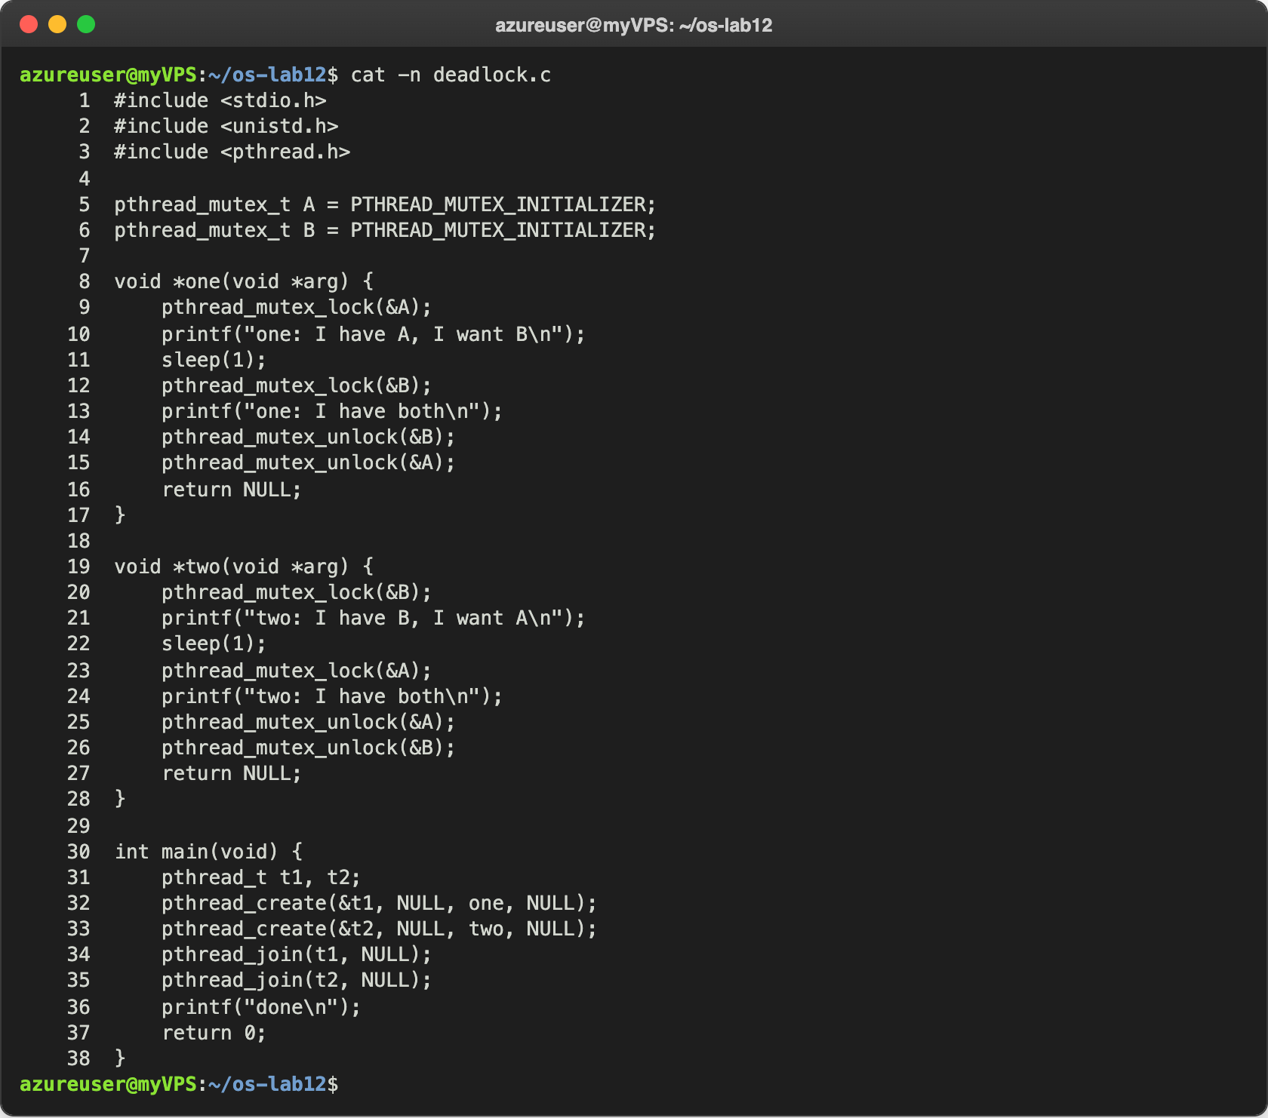
Figure 4.1 – deadlock.c, the original version
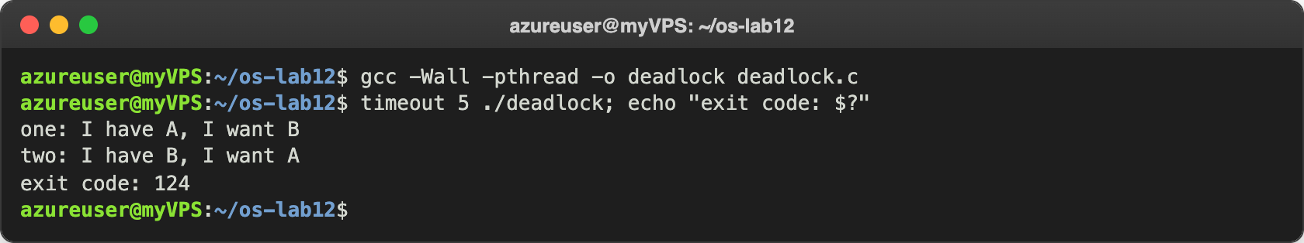
Figure 4.2 – The deadlock: timeout kills the program after 5 seconds
Both threads printed their first line, then nothing happened for 5 seconds, and timeout had to kill the program: exit code 124. For question 2, I removed both sleep(1) lines from the original version and ran it ten times, and then one hundred times, with a timeout of 1 second, counting the runs that hung:
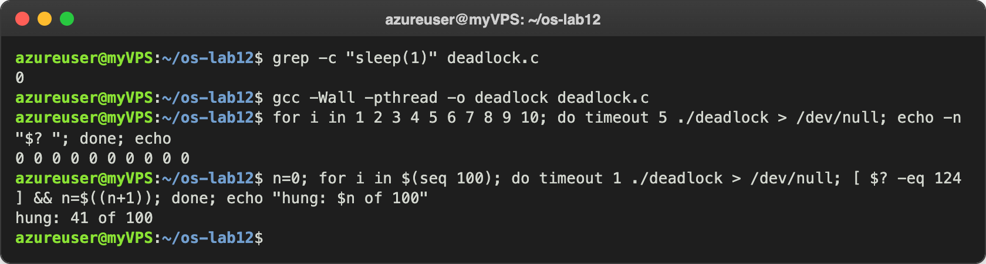
Figure 4.3 – The original version without sleep(1)
All ten runs finished (exit code 0), but out of one hundred runs, 41 hung. Then I made the fix: in two() I swapped the two pthread_mutex_lock lines and the two pthread_mutex_unlock lines, so that two() also takes A first and B second. I put back the original version with the sleep(1) lines before the fix, so that the fix is checked in the worst case. I left the text of the printf as in the handout:
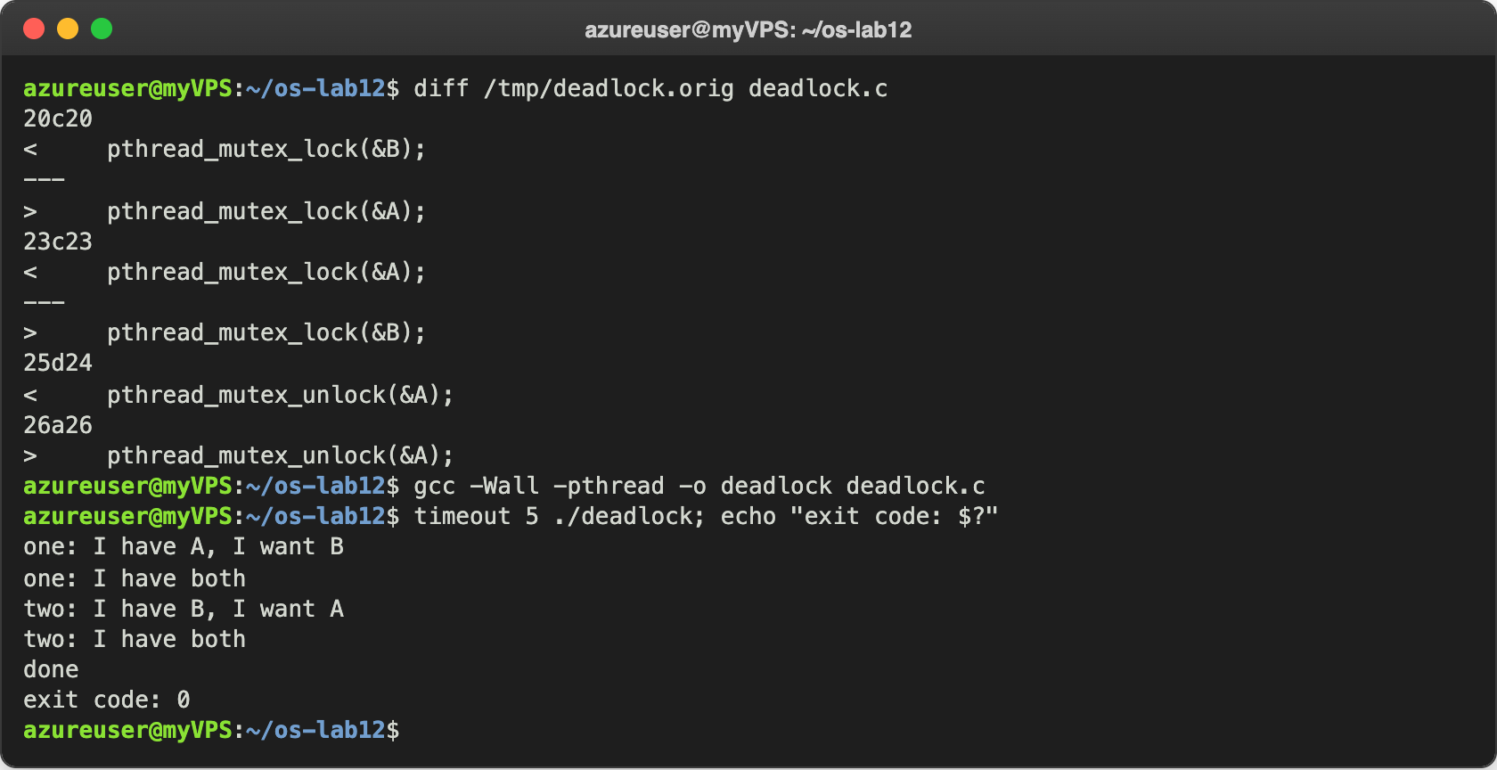
Figure 4.4 – The fix: the same lock order in both threads
Now the output is exactly the expected one, and the exit code is 0. This fixed version is the deadlock.c in my repository.

Observe
- In the stuck run, which thread holds which mutex, and which one is each thread waiting for? Draw the circle. Thread one holds A and waits for B; thread two holds B and waits for A. Each waits for the mutex the other one holds, so the waiting closes into a circle:
holds wants
one ---------> [A] <---------- two
| |
| wants holds |
+-----------> [B] <------------+

one waits for B, held by two; two waits for A, held by one.
- Remove both sleep(1) lines from the original version and run it ten times. Does it still always hang? Why is that worse, not better? No: in my ten runs it never hung, but in one hundred runs it hung 41 times (Figure 4.3). Without the sleep, the first thread often takes both mutexes before the second one even starts, and then there is no deadlock. It is worse, because the bug is still there, but now it hides: the program passes when you try it a few times, and then hangs at random later, at a user, and it is very hard to reproduce and find. With the sleep(1) the deadlock happened every time, so it was impossible to miss.
- In one sentence: why can taking the locks in the same order never deadlock? Because a thread can only wait for a lock that comes later in the order than every lock it already holds, so the thread holding the "highest" lock never waits for anybody, and a circle of waiting threads can never close.

Conclusions
In this lab the tools worked together. In the producer and consumer problem two counting semaphores (empty and full) make the threads wait for each other, and a mutex protects the buffer; the order matters, because waiting on a semaphore while holding the mutex produced a deadlock. The condition variable showed another way to wait for an event: the state is kept in a normal variable under a mutex, and the condition is checked in a while loop, because waking up does not mean that the condition is true.
The readers and writers solution let three readers in together and kept each writer alone, but it can starve the writers if readers never stop coming. The last part showed the most dangerous problem: two locks taken in opposite order make a circle of waiting threads. Without the sleep the deadlock happened only in some runs, which makes it worse, not better. Taking the locks always in the same order removes the circle and the deadlock with it.
Repository: https://github.com/httpcatalin/os-2026-CatalinBitca (folder lab12/, with prodcons.c, condvar.c, readers.c and deadlock.c, the fixed version).

