
TECHNICAL UNIVERSITY OF MOLDOVA
Faculty of Computers, Informatics and Microelectronics
Department of Software Engineering
REPORT
on laboratory work no. 5
Course: Operating Systems
Topic: The File System with Your Own Hands
Done by: st. gr. FAF-242, Cătălin Bîtca
Checked by: Reițman Patricia
Chișinău, 2026

Purpose of the work
The purpose of this lab is to check on a real Linux system the ideas from the lecture about file systems: the tree and the file types, the inodes that stay behind the names, hard and symbolic links, permissions, and the disks underneath. There was no programming, only commands, careful observation and short explanations of what I saw.

Work environment
Like in the previous labs, I worked on my Ubuntu 24.04 virtual machine in Azure over ssh. I did everything as my normal user, not as root, because root ignores most permission checks and the experiments in Part 3 would not show anything:
azureuser@myVPS:~$ whoami
azureuser
azureuser@myVPS:~$ mkdir -p ~/os-lab5 && cd ~/os-lab5
azureuser@myVPS:~/os-lab5$

Part 1. The tree and the file types
First I listed the root of the tree and looked at five paths with ls -ld (-d shows the directory itself, not what is inside it):
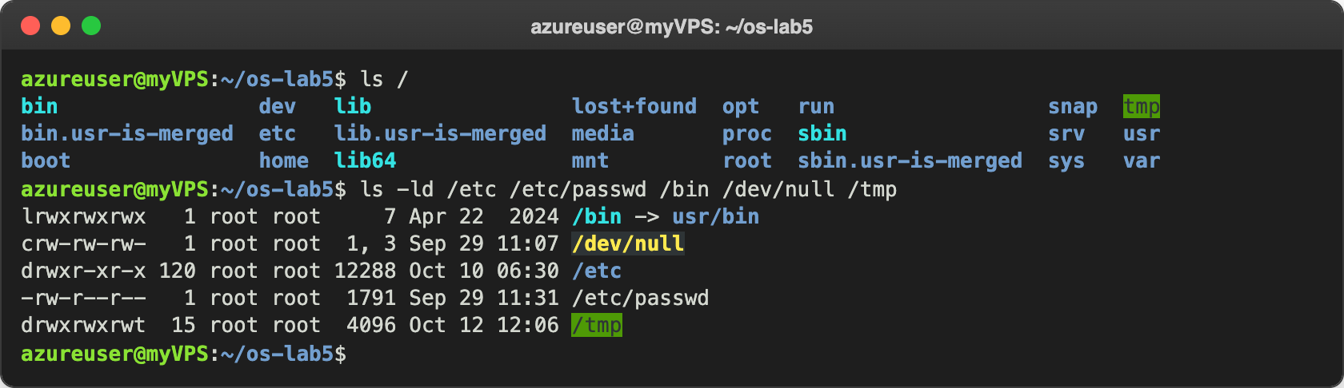
Figure 1.1 – The root directory and the types of five paths
Besides the usual folders, ls / shows bin.usr-is-merged, lib.usr-is-merged and sbin.usr-is-merged. They are left over from the "usr merge" in Ubuntu, after which /bin, /lib and /sbin became links into /usr. Then I looked at the device files and asked file what three paths really are:
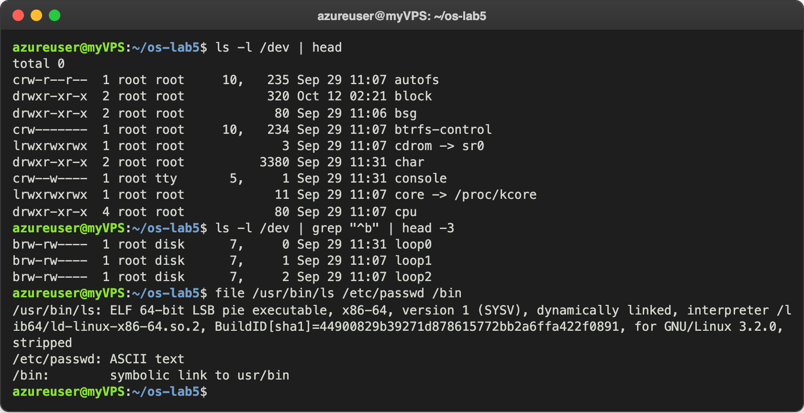
Figure 1.2 – Device files in /dev and the file command
For device files ls -l shows two numbers instead of the size, the major and the minor number (for example 1, 3 for /dev/null): the major number tells the kernel which driver handles the device, the minor tells which device of that driver. The first lines of /dev had only character devices, folders and links, so I used grep "^b" to find block devices. file does not look at the name, it reads the content: ls is an ELF 64-bit program for x86-64, /etc/passwd is plain text and /bin is a symbolic link. Last, the size of two folders:
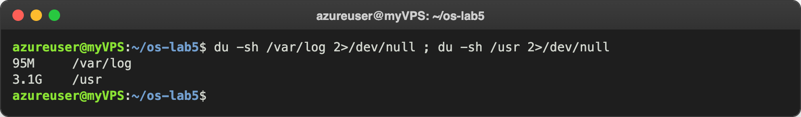
Figure 1.3 – The disk usage of /var/log and /usr

Observe
- The type of each path, from the first letter. /etc is d, a directory; /etc/passwd is -, a regular file; /bin is l, a symbolic link; /dev/null is c, a character device; /tmp is d, a directory (the t at the end of its permissions is explained in Part 3).
- What is /bin? On my system /bin is not a directory but a symbolic link: /bin -> usr/bin. file /bin says the same, symbolic link to usr/bin. So /bin/ls and /usr/bin/ls are the same file.
- One character device and one block device. Character device: /dev/null (crw-rw-rw-, numbers 1, 3), and also /dev/console (5, 1). Block device: /dev/loop0 (brw-rw----, numbers 7, 0). The real disk /dev/sda is also a block device, with numbers 8:0 in lsblk (Part 4).
- Which is bigger, /var/log or /usr? /usr has 3.1G and /var/log 95M, so /usr is about 33 times bigger (3.1 GB is about 3170 MB, and 3170 / 95 is about 33). /usr holds all the installed programs and libraries, while /var/log holds only the log files. The 2>/dev/null hides the errors for folders I cannot read; I also ran sudo du -sh /var/log and it gave the same 95M, so nothing was hidden here.

Part 2. Inodes and links
I created a small file and looked at its inode with stat:
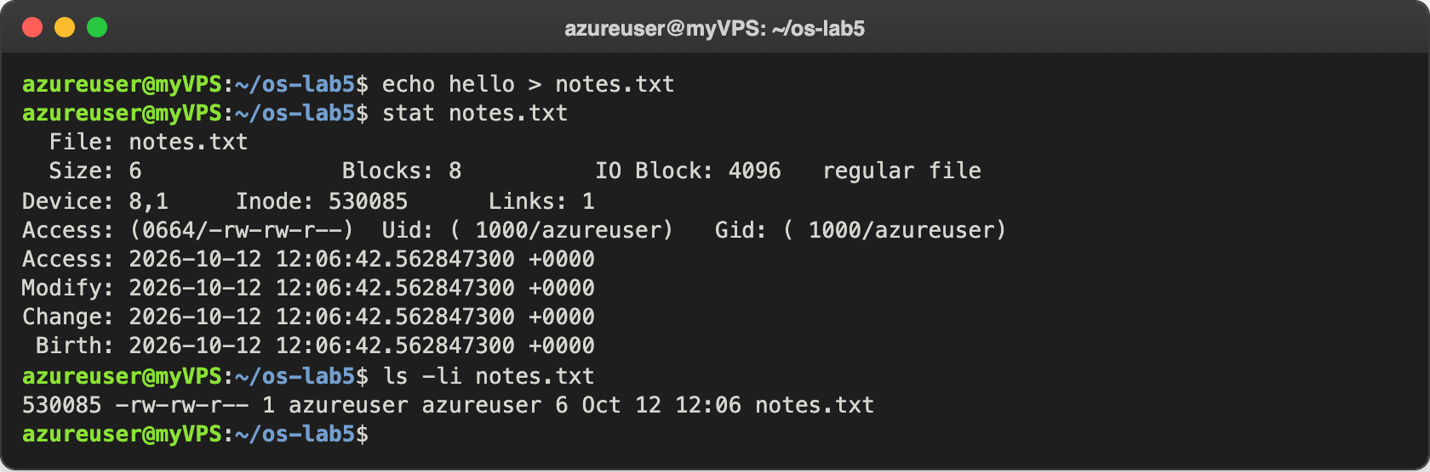
Figure 2.1 – The inode of notes.txt
The file has 6 bytes ("hello" and the newline) but takes 8 blocks. Device: 8,1 is the partition sda1. The inode keeps the size, the owner, the permissions, the times and where the data is, but not the name: the name "notes.txt" is written in the directory ~/os-lab5, next to the inode number 530085. Then I made a hard link and removed the "original":
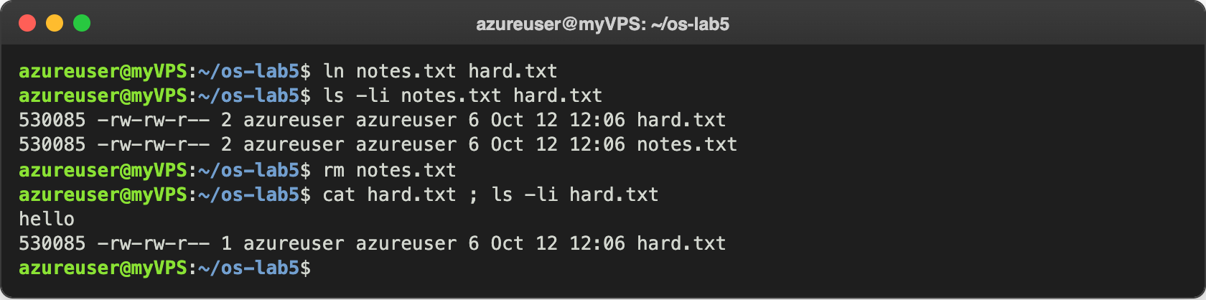
Figure 2.2 – A hard link survives the removal of the original name
Both names show the same inode 530085 and the link count 2, so they are two names for one file, there is no "original" and "copy". After rm notes.txt the link count went back to 1 and hard.txt still printed "hello". Then a symbolic link:
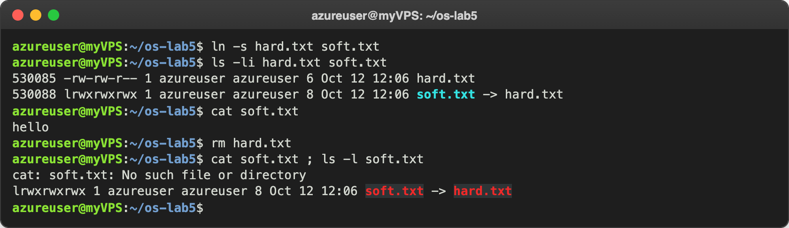
Figure 2.3 – A symbolic link breaks when its target is removed
soft.txt has its own inode (530088) and its own type, l. It worked while hard.txt existed, but after rm hard.txt the cat failed, although ls -l still shows soft.txt -> hard.txt. Before the next step I predicted that a new directory has 2 links and that two subdirectories add 2 more:
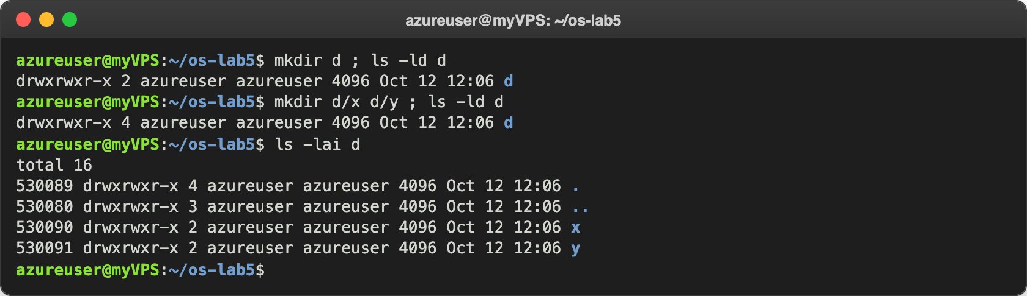
Figure 2.4 – The link count of a directory
The prediction was right: 2, then 4. ls -lai d shows where the links come from: . inside d has the same inode as d (530089), and .. is the inode of os-lab5 (530080). Last, size against space:
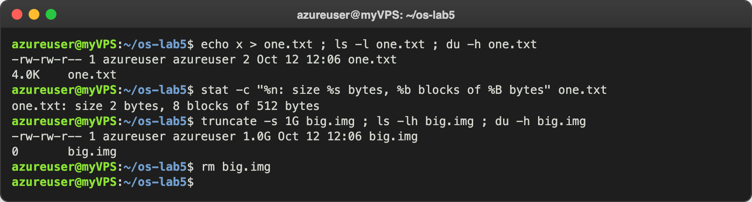
Figure 2.5 – The size of a file is not the space it uses

Observe
- Which number is the inode and which is the number of names? Inode: 530085 is the inode number, and Links: 1 is the link count, the number of names (directory entries) that point to this inode. In ls -li the first column is the inode and the number right after the permissions is the link count.
- Why could I still read hard.txt after rm notes.txt? What does rm remove? Because notes.txt and hard.txt were two names of the same inode, and the data belongs to the inode, not to a name. rm only removes one name from the directory (it calls the unlink system call) and decreases the link count from 2 to 1. The inode and its data are freed only when the link count reaches 0 and no process has the file open anymore.
- Why did cat soft.txt fail, and why is soft.txt 8 bytes? A symbolic link does not point to an inode, it only stores a path as text, here "hard.txt". When I removed hard.txt, there was no file with that name anymore, so opening soft.txt fails with "No such file or directory", even though the link itself still exists (a "dangling" link). Its size is 8 bytes because "hard.txt" has exactly 8 characters; the link stores only those characters, without a newline or a 0 at the end.
- Where do the links of a directory come from? A new directory d has 2 links: its name d in os-lab5, and the entry . inside d itself. Each subdirectory has an entry .. that points back to its parent, so x and y add one link each: 2 + 2 = 4. In general a directory has 2 links plus one per subdirectory; this is why os-lab5 shows 3 links (its name in my home, its own ., and .. of d).
- Why does a 2-byte file use 4.0K, and a 1 GB file use 0? The file system gives space in whole blocks, and a block here is 4 KB (IO Block: 4096 in stat). So even 2 bytes ("x" and the newline) take one full block: stat shows 8 blocks of 512 bytes, which is 4096 bytes. truncate -s 1G only writes the size 1 GB in the inode and allocates no blocks at all, because nothing was written: this is a sparse file, and reading it returns zeros. ls shows the size from the inode, while du counts the blocks really used, so it shows 0.

Part 3. Permissions
First the permissions of a file, and the umask:
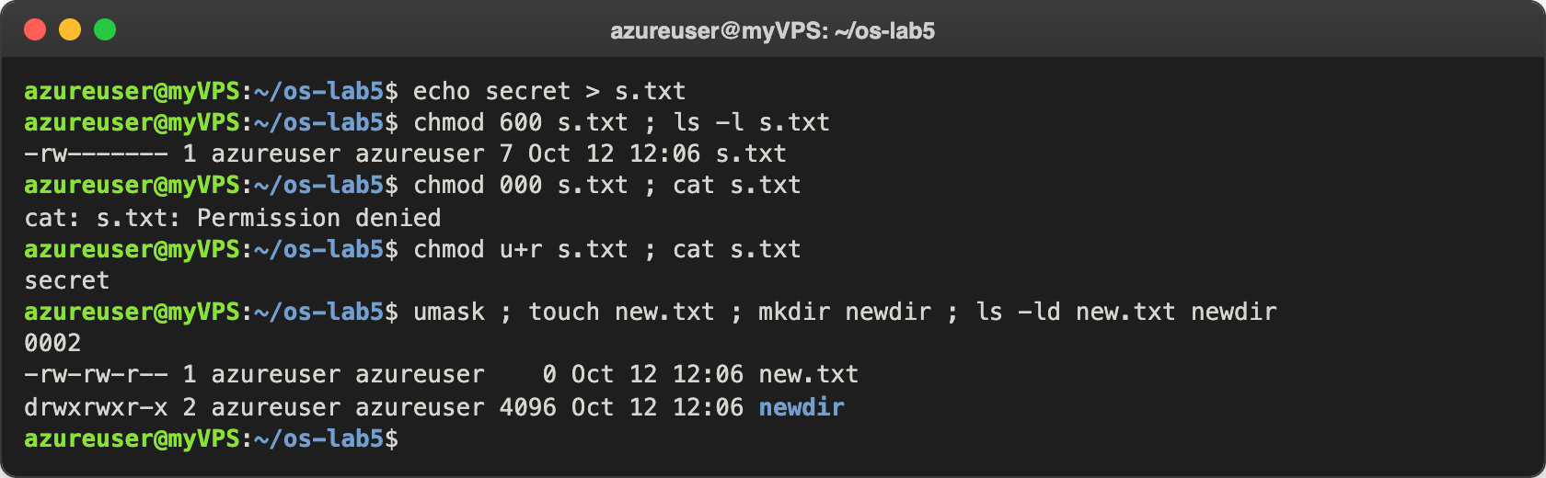
Figure 3.1 – chmod on a file I own, and the umask
Then the same bits on a directory. Before running the commands I predicted that with only r I would see the names but not open the file, and with only x the opposite:
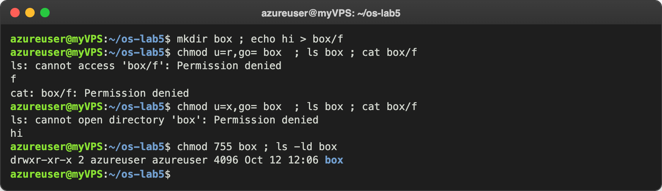
Figure 3.2 – A directory with only r, then only x
Last, the special bits and a file that belongs to someone else:
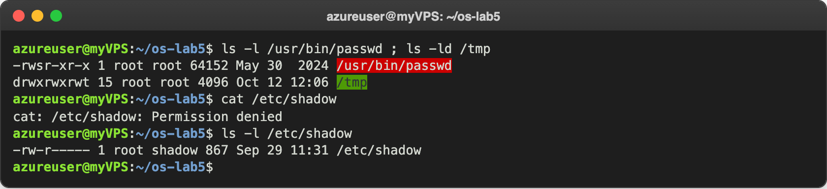
Figure 3.3 – The setuid bit on passwd, the sticky bit on /tmp, and /etc/shadow

Observe
1. 600, 644, 755 and 700 as rwx strings, with one real use for each:
Number | String | Who can do what | Real use
600 | rw------- | only the owner reads and writes | a private ssh key ~/.ssh/id_ed25519; ssh refuses a key that others can read
644 | rw-r--r-- | owner writes, everybody reads | normal files that everyone may read, like /etc/passwd
755 | rwxr-xr-x | owner changes it, everybody reads and runs (or enters, for a folder) | programs like /usr/bin/ls, and public folders like box at the end of Figure 3.2
700 | rwx------ | only the owner can do anything | a private folder like ~/.ssh, or a script only I should run

- With chmod 000 I own the file but cannot read it. Why does ownership not help? The kernel picks only one class of bits: if I am the owner, it checks only the owner bits, and they were ---. Being the owner does not give access by itself. What ownership gives is the right to change the permissions, and that is why chmod u+r s.txt worked without root and after it cat printed "secret". Only root skips these checks.
- What is my umask and how does it explain new.txt and newdir? My umask is 0002, which means "take away the write permission for others". A new file starts from 666 (rw-rw-rw-, files never get x by default) and becomes 664, -rw-rw-r--; a new directory starts from 777 and becomes 775, drwxrwxr-x. This is exactly what ls -ld showed. On Ubuntu the group may write too, because every user has a private group with the same name.
- What do r and x allow on a directory? A directory is a list of names and inode numbers. r allows reading that list: ls box printed the name f, but it could not look at the file itself ("cannot access 'box/f'"; ls tries to do that to color the name), and cat box/f failed. x allows going through the directory to reach a file whose name I already know: ls box failed with "cannot open directory", but cat box/f printed "hi". So r is "see the names", and x is "use the directory in a path".
- What do the s in /usr/bin/passwd and the t in /tmp mean? The s in -rwsr-xr-x is the setuid bit: the program runs with the rights of its owner, root, not with the rights of the user who started it. passwd needs it because it must write my new password hash into /etc/shadow, which is -rw-r----- root shadow, and as a normal user I cannot even read it (cat /etc/shadow gave "Permission denied"). With setuid, passwd can change the file, and the program itself makes sure I change only my own password. The t in drwxrwxrwt is the sticky bit: everybody can create files in /tmp, but a user can delete or rename only their own files, not the files of other users.

Part 4. Disks and the kernel as files
I looked at the disks, how full they are, and where / comes from:
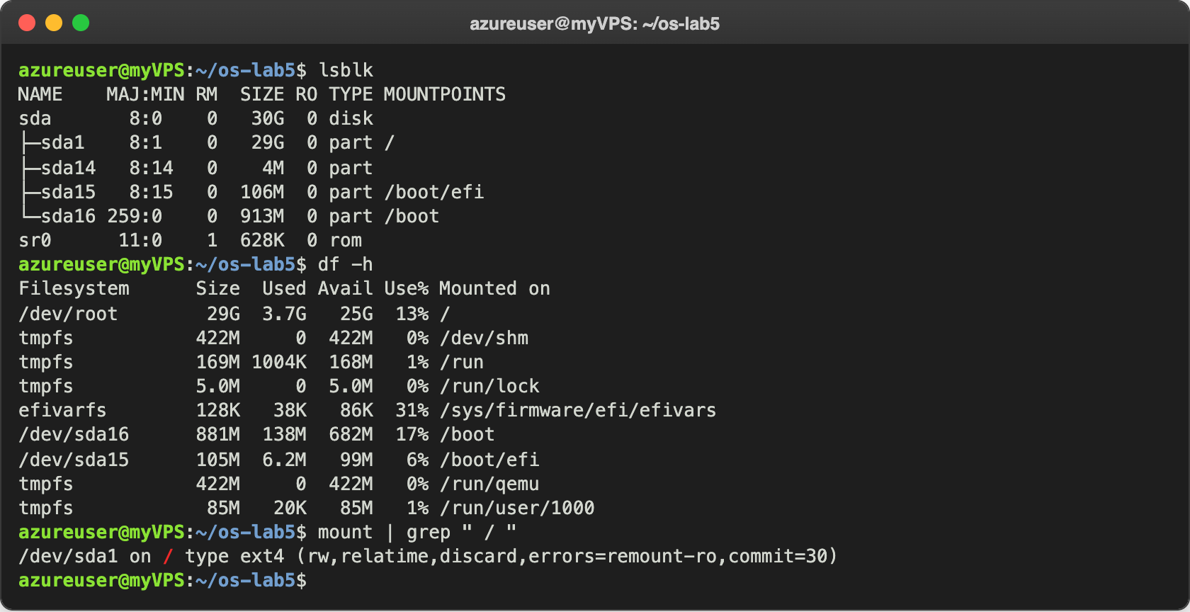
Figure 4.1 – The block devices, the mounted file systems and the root mount
Then I asked the kernel about the hardware and about a process, through /proc:
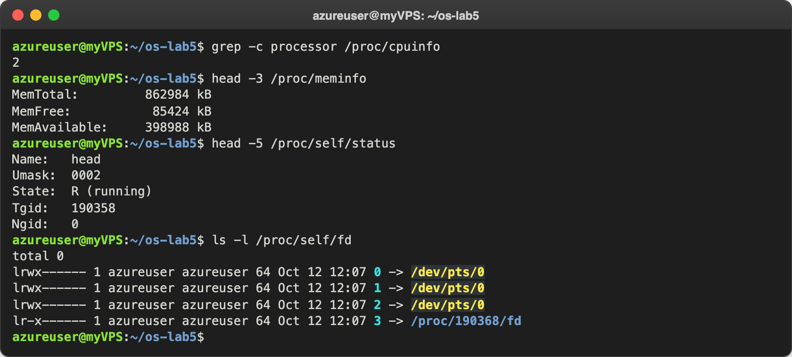
Figure 4.2 – CPU, memory and a process as files in /proc

Observe
1. My disk. From lsblk and the file system types (I checked them with lsblk -f):
sda 30 GB disk (8:0)
|-- sda1 29 GB ext4 mounted at / <- root, /dev/root in df
|-- sda14 4 MB (none) BIOS boot partition, not mounted
|-- sda15 106 MB vfat mounted at /boot/efi <- EFI system partition
`-- sda16 913 MB ext4 mounted at /boot
sr0 628 KB a small virtual CD-ROM attached by Azure
/ is on /dev/sda1 with the type ext4 (mount | grep " / "). df calls it /dev/root.
- How full is the root file system? 3.7G used of 29G, that is 13% (Use%), with 25G still available.
- How many CPU cores and how much RAM, according to /proc? grep -c processor /proc/cpuinfo printed 2, so 2 cores. MemTotal: 862984 kB, which is about 843 MB (842 MiB), the same as free showed in Lab 1.
- /proc/self/status showed the name of which program, and why? It showed Name: head. /proc/self is a special link that always points to the folder of the process that opens it. The process that read /proc/self/status was head itself, so it saw its own status (PID 190358). The same with ls -l /proc/self/fd: those are the files of ls, its 0, 1 and 2 go to my terminal /dev/pts/0, and 3 is the /proc/190368/fd folder that ls itself had open to read it.

Stretch tasks
I did three of the four stretch tasks: (a), (c) and (d).

(a) Magic numbers
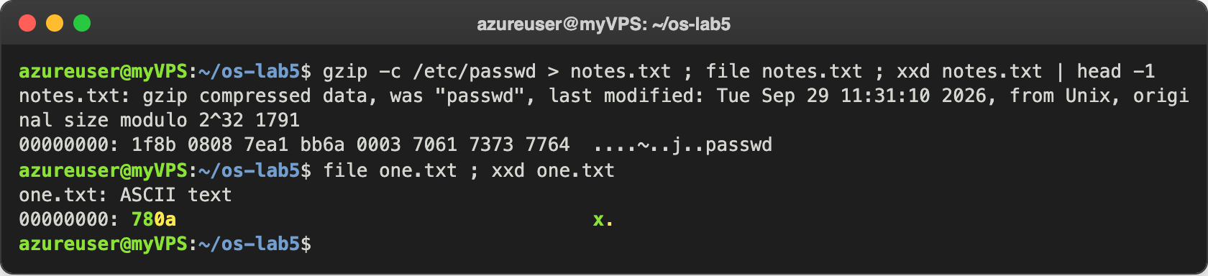
Figure 5.1 – file recognizes gzip data by its first bytes
The file is called notes.txt, but file says it is gzip data, because it reads the content and does not care about the name. The first two bytes, 1f 8b, are the gzip magic number, and the next byte, 08, is the compression method (deflate). You can also see the original name "passwd" stored inside. A plain text file like one.txt has no magic number at all (just 78 0a, "x" and a newline), so file decides that it is text because all its bytes are printable characters.

(c) Deleting a file that is still open
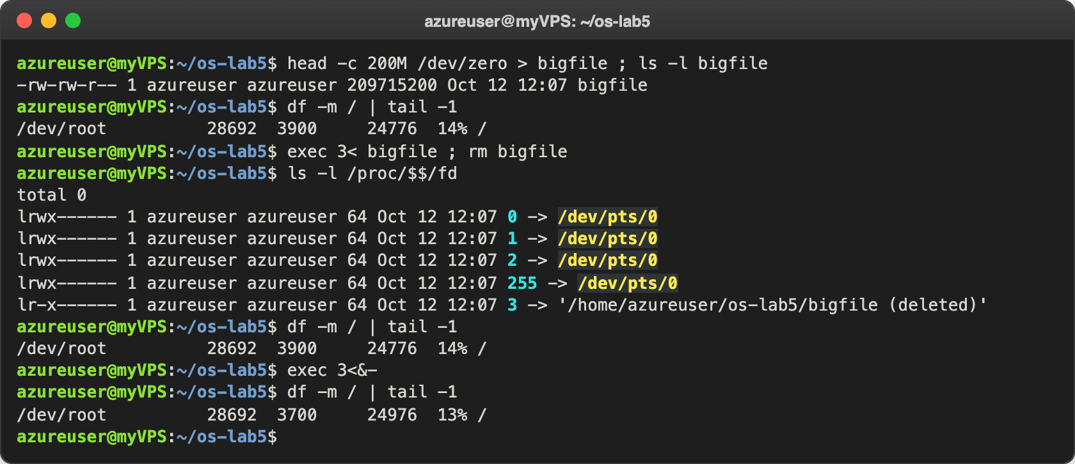
Figure 5.2 – A deleted file keeps its space until the last descriptor is closed
I made a 200 MB file, opened it in my shell as file descriptor 3 and then deleted it. The link in /proc/$$/fd says '/home/azureuser/os-lab5/bigfile (deleted)': the name is gone, but the inode is still in use. The used space stayed at 3900 MB after rm, and dropped to 3700 MB only after I closed the descriptor with exec 3<&-. So the space is really freed when both the link count is 0 and no process has the file open, the same rule as in Part 2.

(d) A file system inside a file
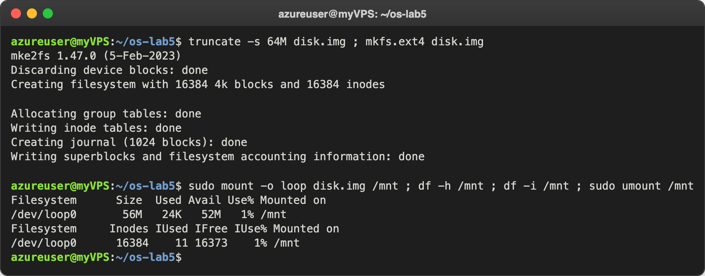
Figure 5.3 – A 64 MB ext4 file system made in a file and mounted with a loop device
mkfs.ext4 created 16384 inodes, one for every 4 KB of the 64 MB, and df -i confirms it: 16384 inodes, of which 11 are already used (the inodes reserved by ext4 and lost+found). This means the file system can never hold more than 16384 files, even if they are all empty. df -h shows only 56M of space and 52M available, because the journal (1024 blocks, 4 MB) and the inode tables take space, and ext4 keeps 5% of the blocks reserved for root.

Conclusions
In this lab I saw that a file is really two things: an inode with the data and the information about it, and one or more names in directories that point to it. Hard links are just more names for the same inode, rm only removes a name, and the space comes back only when no name and no open descriptor are left. A symbolic link is a different kind of file that only stores a path, so it can point to something that no longer exists. Even the link count of a directory is explained by the . and .. entries.
I also learned that the size of a file and the space it uses are different numbers, because space is given in 4 KB blocks and a sparse file can have a size without any blocks. For permissions, the most useful experiment was the box: on a directory r means "list the names" and x means "pass through it". Finally, /proc/self and /dev showed again that in Linux the kernel shows processes and devices as files, which I could read with the same commands.
Repository: https://github.com/httpcatalin/os-2026-CatalinBitca (folder lab5/).

