
TECHNICAL UNIVERSITY OF MOLDOVA
Faculty of Computers, Informatics and Microelectronics
Department of Software Engineering
REPORT
on laboratory work no. 10
Course: Operating Systems
Topic: Add Your Own System Call: trace
Done by: st. gr. FAF-242, Cătălin Bîtca
Checked by: Reițman Patricia
Chișinău, 2026

Purpose of the work
In Lab 9 strace showed me the system calls of a Linux program. In this lab I changed the xv6 kernel itself for the first time: I added a new system call, trace, which makes a process print every system call it makes, together with its return value. Doing this, I followed one number, 23, from a user program, through the ecall instruction, down to a function inside the kernel. As the optional task I added a second system call, sysinfo.

Work environment
I worked in my ~/xv6-riscv tree on the Azure VM (revision 06aad25 with my programs from the previous labs). Before starting I checked that it builds and boots with make qemu. As the handout warns, our xv6 is newer than the MIT page: number 22 is already sync, so trace gets 23, and the kernel print function is printk. In our tree the kernel functions also have a k in front: fork() from the handout is kfork() in kernel/proc.c.
I typed the code from the handout without its // new comments. One more detail: the GitHub repository of my xv6 tree checks the formatting with make fmt (clang-format) on every push, so I split the long printk line in syscall.c the way clang-format wants it; the code is the same. Each part was committed separately in the xv6 git tree: "Lab 10: add trace system call" and "Lab 10: add sysinfo system call".

Part 1. The number and the user side
First the call gets a number, then the user side learns to ask for it. I made the four small edits: SYS_trace 23 in kernel/syscall.h, the declaration int trace(int); in user/user.h, entry("trace"); in user/usys.pl, and $U/_trace\ in UPROGS (line 156, after $U/_zombie\ and my two programs from Lab 8, with a TAB in front). git diff shows exactly these lines:
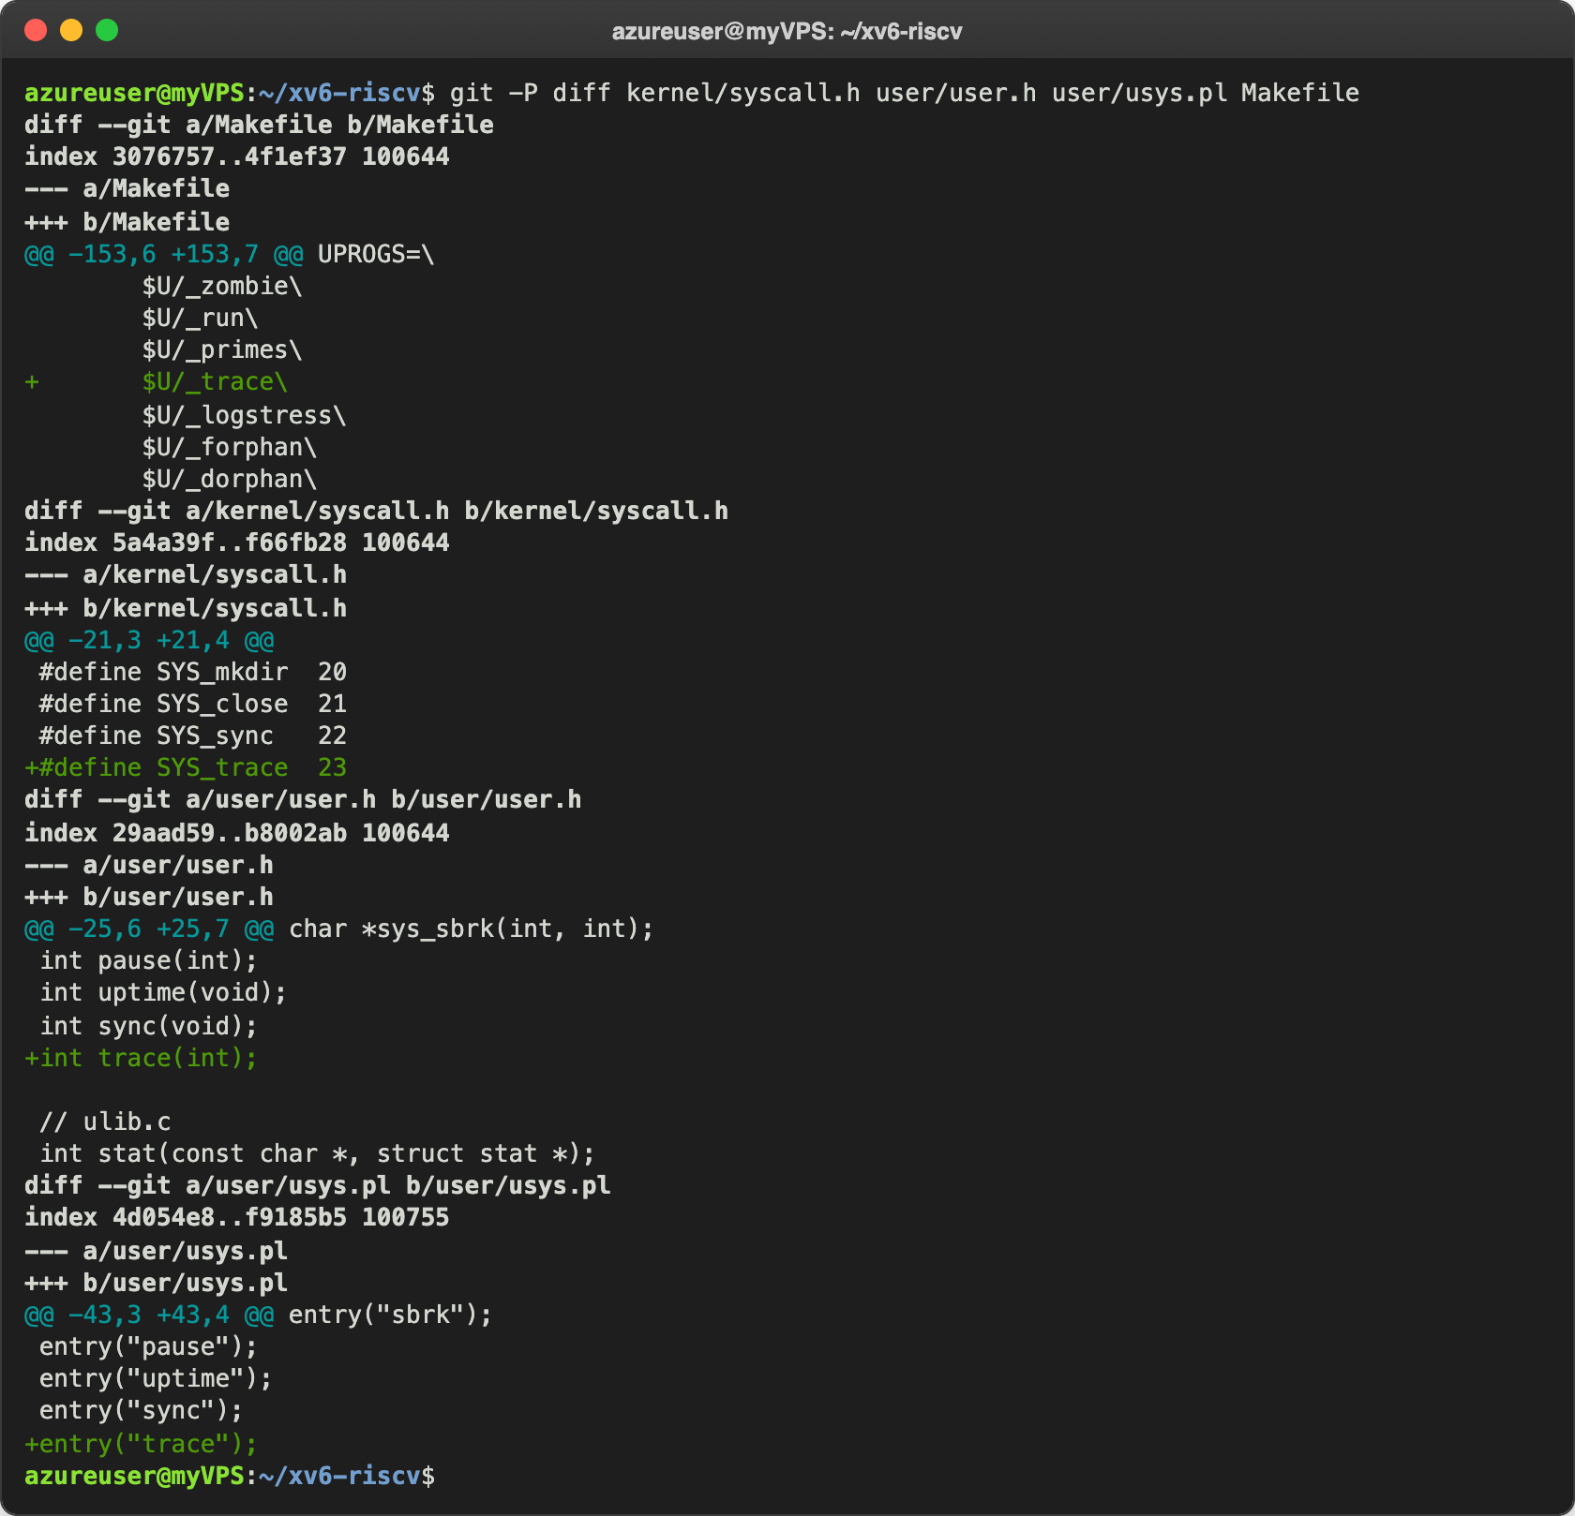
Figure 1.1 – The edits of Part 1
Then I created user/trace.c:
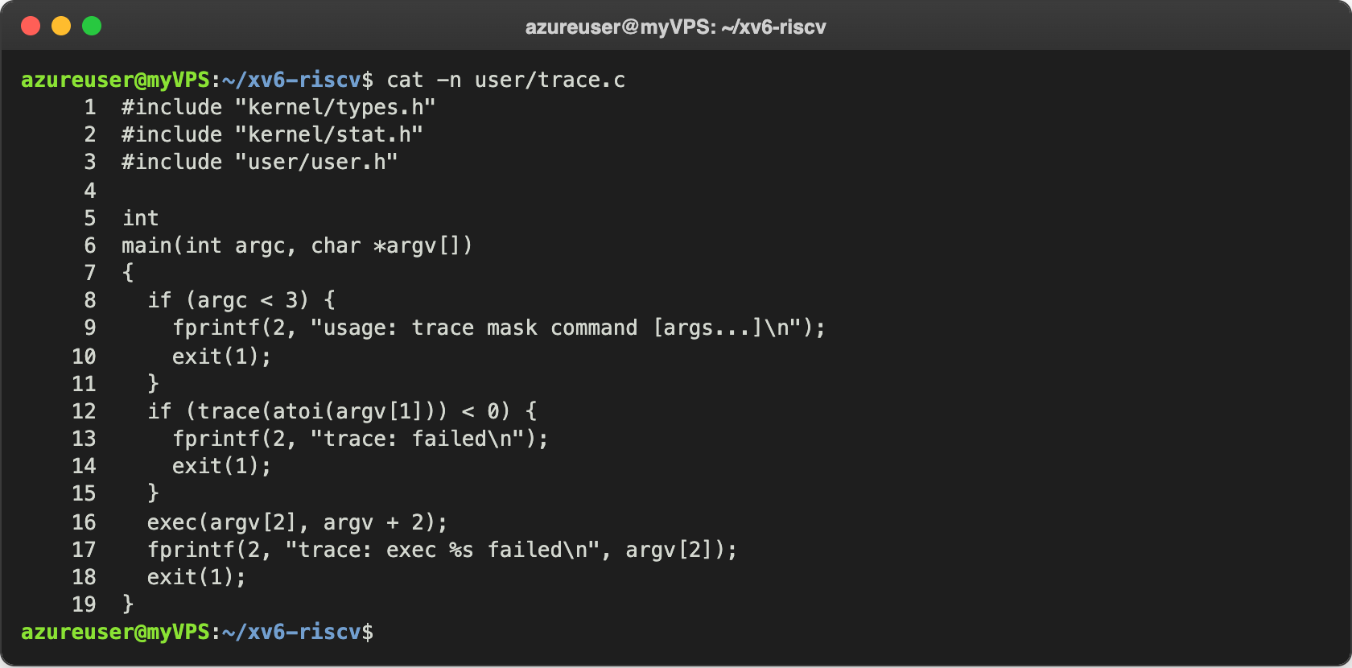
Figure 1.2 – user/trace.c
trace first calls the new system call with the mask from argv[1] (atoi turns the text "32" into the number 32), so the mask is set on its own process. Then it calls exec(argv[2], argv + 2): argv + 2 is the same argument array, starting from the name of the command, and it still ends with 0. After exec the process runs grep instead of trace, but it is the same process, with the same struct proc, so the mask stays.

Check 1: the number reaches the kernel
I started xv6 with make qemu and ran the command from the handout:
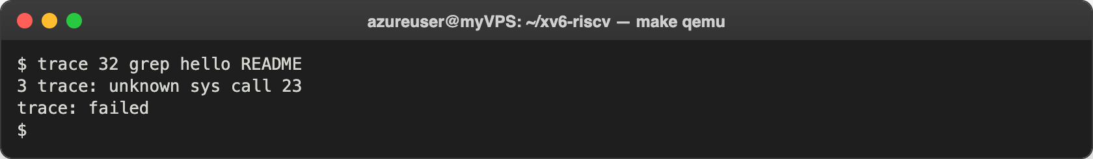
Figure 1.3 – The kernel receives call 23, but has no function for it yet
This is exactly the expected message. To see the way the number travels, I looked at the stub that usys.pl generated at build time in user/usys.S (after leaving xv6 with Ctrl-A X):
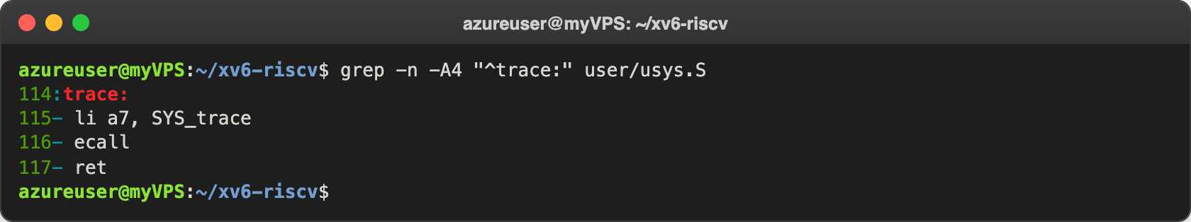
Figure 1.4 – The stub of trace in user/usys.S
So trace(32) in C is these three instructions. The argument 32 is already in register a0, li a7, SYS_trace puts the number 23 into register a7, and ecall jumps into the kernel. There usertrap() in kernel/trap.c sees that the cause is a system call and calls syscall(), which reads num = p->trapframe->a7. The table syscalls[] had only 23 places (0 to 22), so 23 was outside it: the kernel printed "3 trace: unknown sys call 23" (PID 3, process name trace) and returned -1 in a0. Back in user space trace() returned -1, and my program printed "trace: failed".

Part 2. The kernel side
Now the kernel side. In kernel/proc.h every process gets a field trace_mask, in kernel/sysproc.c I added the handler sys_trace, and in kfork() in kernel/proc.c the child copies the mask of its parent:
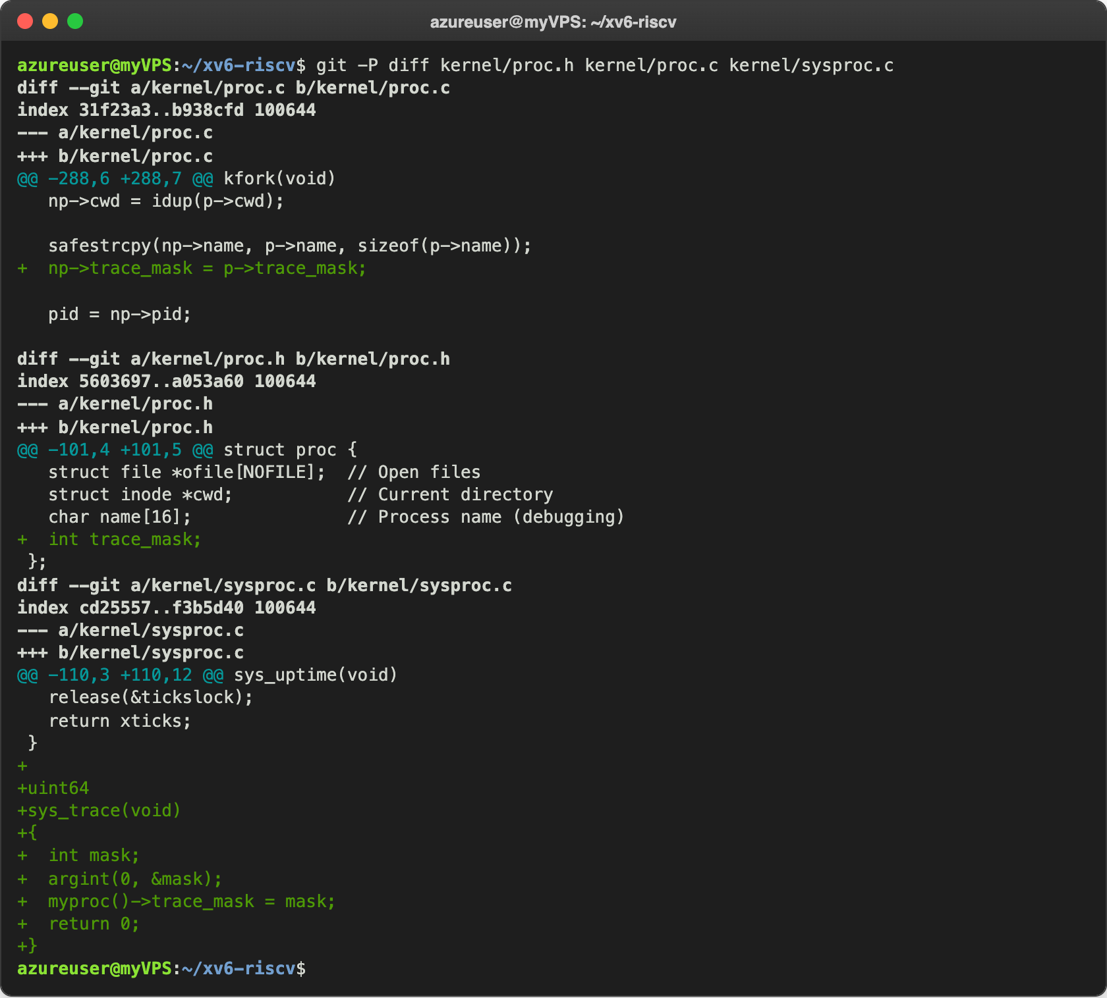
Figure 2.1 – The mask in struct proc, the handler and the copy in kfork
sys_trace takes no C parameters: the kernel cannot see the user stack directly, so argint(0, &mask) reads argument 0 from the saved user registers, p->trapframe->a0. It stores the mask in the struct proc of the calling process (myproc()) and returns 0. The rest is in kernel/syscall.c:
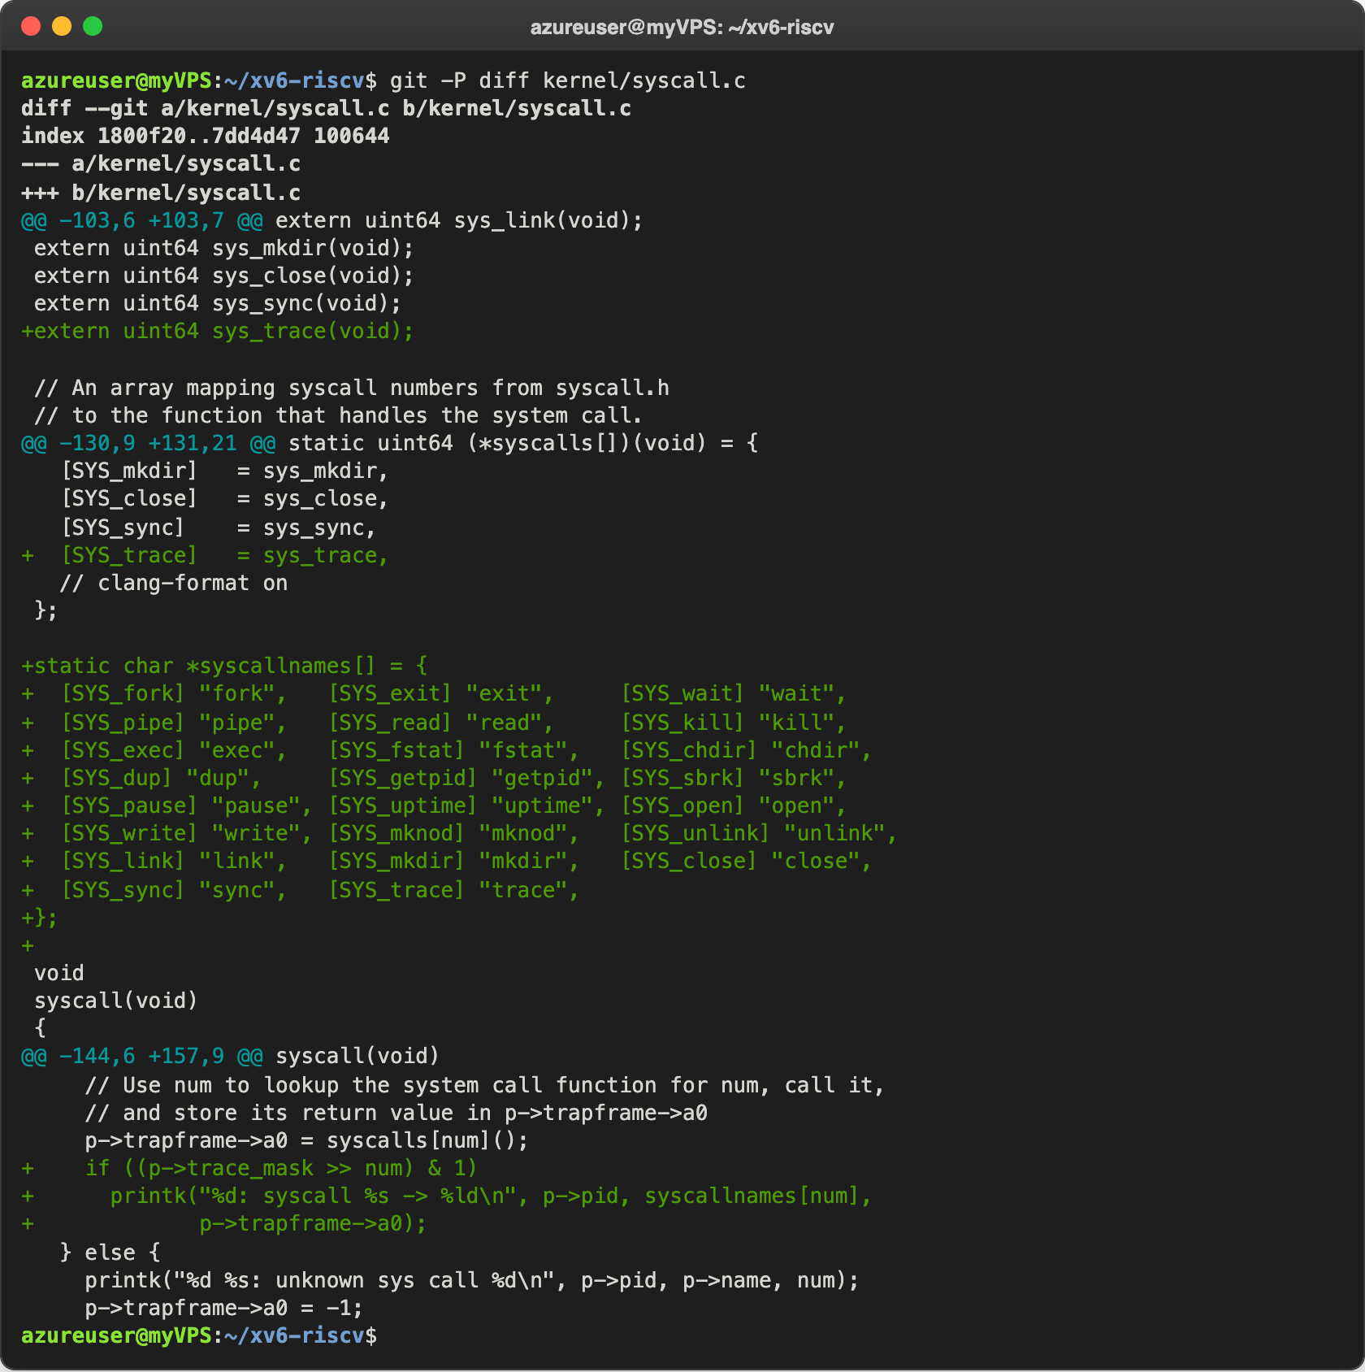
Figure 2.2 – The table entry, the names and the print in kernel/syscall.c
The extern line and [SYS_trace] = sys_trace put my function into place 23 of the table, so syscall() can now call it. The kernel knows only numbers, so syscallnames[] gives each number a name, in the same order. The two new lines are placed after p->trapframe->a0 = syscalls[num]();, so the return value is already in a0 when it is printed. (p->trace_mask >> num) & 1 moves bit number num of the mask to the right end and keeps only that bit: it is 1 when this call must be printed.

Check 2: trace works
Ctrl-A X, make qemu (which recompiled the kernel), and the same command:
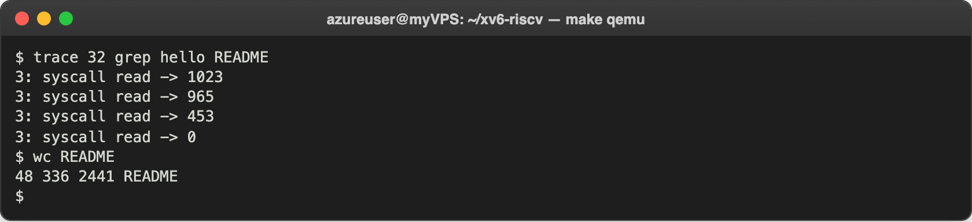
Figure 2.3 – trace 32 grep hello README
The numbers are exactly the ones from the handout, and wc confirms them: 1023 + 965 + 453 = 2441 bytes, the size of README, then 0 for the end of the file. The pieces are different because of the way grep reads: its buffer has 1024 bytes and it asks for sizeof(buf) - m - 1 bytes, where m is the unfinished last line it kept from the previous read. The first read asks for 1023 bytes, the second only for 965, because 58 bytes of an unfinished line were moved to the beginning of the buffer, and the third gets the last 453 bytes of the file.

Part 3. Play with the mask
The mask is read in binary: bit N on means "print call number N". 32 = 2⁵, and 5 is SYS_read. I restarted xv6 and ran the commands of the handout in order. First all the calls, with all 31 low bits on (2147483647 = 2³¹ − 1):
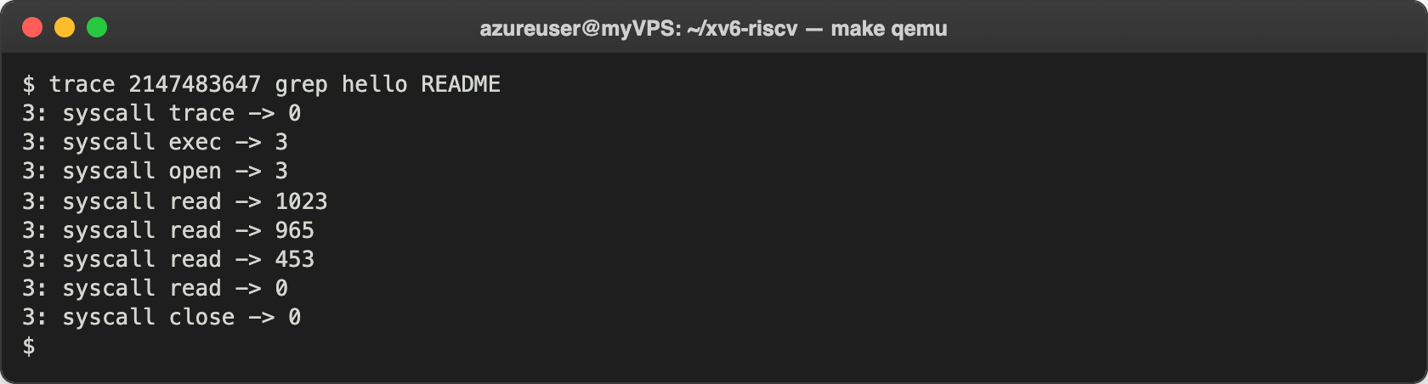
Figure 3.1 – trace with all the bits on
Now I see the whole life of grep. The first line is the call trace itself: the mask was set during this call, and the check comes after the call, so it is already printed. exec -> 3 is not a descriptor: exec returns argc (3: "grep", "hello", "README"), which becomes the first argument of main. Then open returns 3, for the same reason as in Lab 9: 0, 1 and 2 are already the console. Then the four read calls and close.
Then only fork (bit 1, mask 2) on the test that forks until the process table is full:
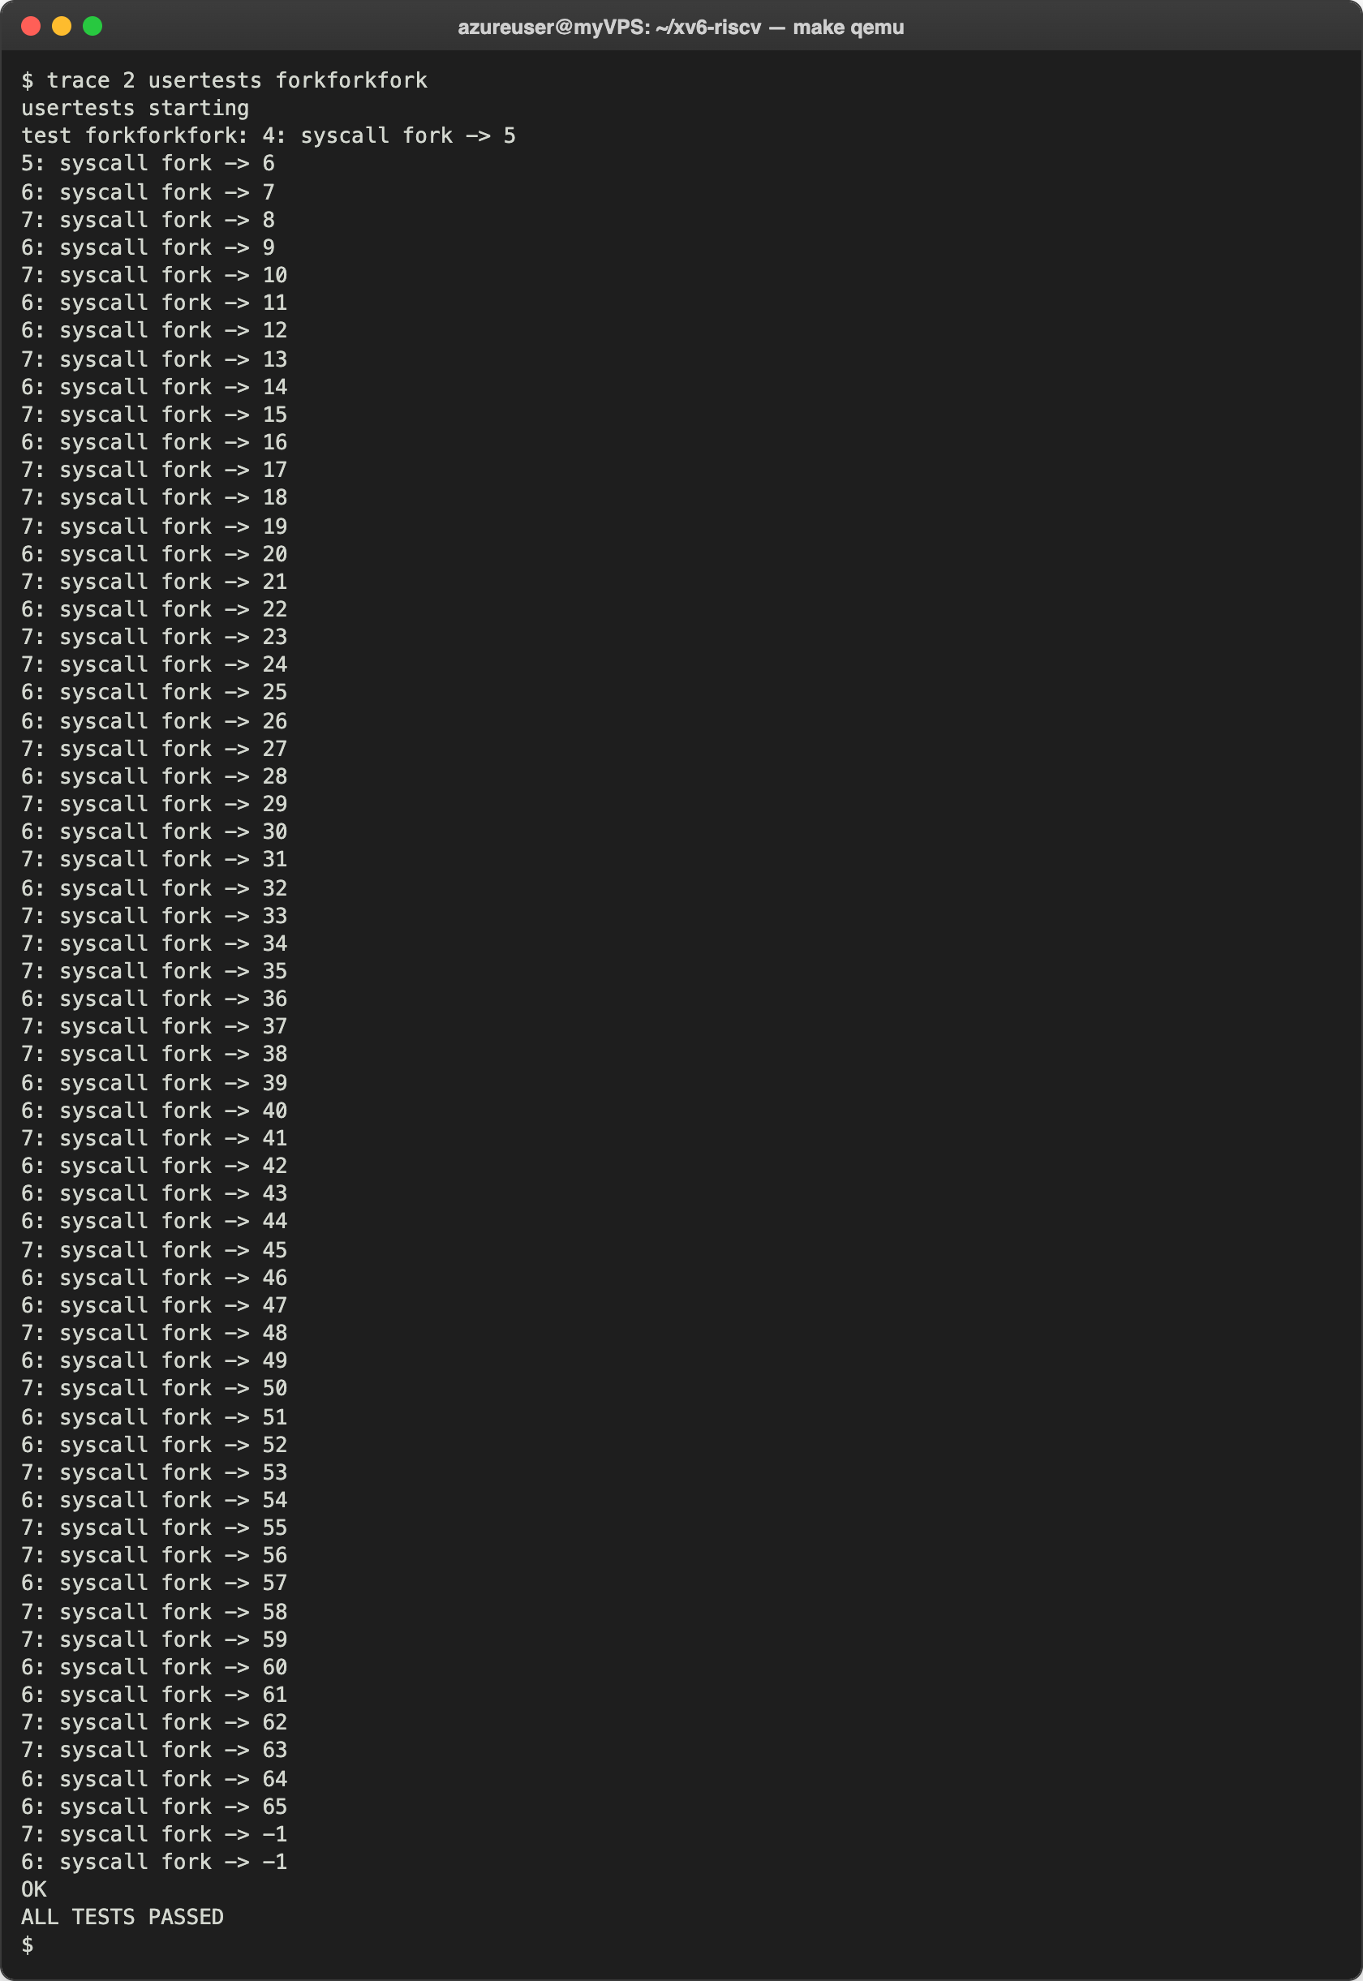
Figure 3.2 – trace 2 usertests forkforkfork
trace became usertests (PID 4), which forked the test process 5. Process 5 forked 6, and then processes 6 and 7 kept forking, each in its own loop, until the last successful fork returned 65 and the next ones returned -1: the table of 64 processes was full (NPROC is 64). A child that got -1 created the file stopforking, all the children saw it and exited, and the test printed OK.
Then only write (bit 16, mask 65536):
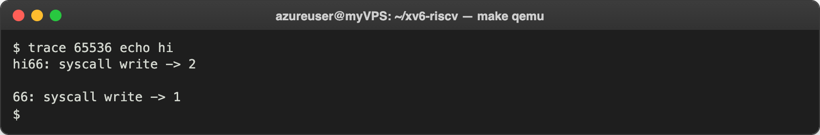
Figure 3.3 – trace 65536 echo hi
At the end I checked my answer to question 4 below with the mask 2129920:
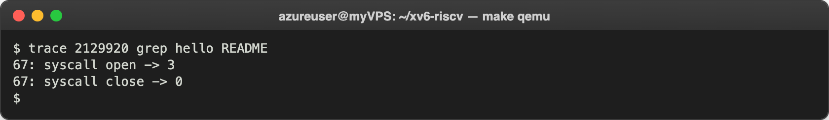
Figure 3.4 – Only open and close

Observe
- In trace 32 grep hello README, why do you see only read, and not open or close? Because the mask 32 is 100000 in binary: only bit 5 is on, and 5 is SYS_read. open is call 15 and close is call 21; bits 15 and 21 of 32 are 0, so (p->trace_mask >> num) & 1 is 0 for them, and the kernel runs these calls but does not print them. Figure 3.1 shows that they really happen when all the bits are on.
- In forkforkfork, several different pids print lines. Which line of code from Part 2 makes that possible? The line in kfork() in kernel/proc.c: np->trace_mask = p->trace_mask;. Only trace itself called trace(2); all the other processes are its descendants, created by fork, and each new process copies the mask of its parent at that line. In my run PIDs 4, 5, 6 and 7 printed lines. Without that line the children would not get the mask, and only PID 4 would print.
- In trace 65536 echo hi the trace line is printed between "hi" and the new line. Why? How many times does echo call write? Twice. echo writes each argument with one write and then, after the last one, the new line with a separate write(1, "\n", 1). The first write puts "hi" on the console and returns 2; right after it returns, the kernel prints "66: syscall write -> 2" on the same line, and only then does echo make its second write, the "\n", which returns 1 and is also printed. That is why "hi" and the trace line are glued together and an empty line follows.
- Which mask traces both open (15) and close (21), and nothing else? The mask with only bits 15 and 21 on: 2¹⁵ + 2²¹ = 32768 + 2097152 = 2129920 (in C: (1 << 15) | (1 << 21)). Figure 3.4 confirms it: only open -> 3 and close -> 0 are printed.

Optional task. A second system call: sysinfo
With the same recipe I added sysinfo (number 24), which returns the number of free bytes of memory and the number of processes in use. It needs a structure that the kernel and the user program share, so I put it in a new header, kernel/sysinfo.h:
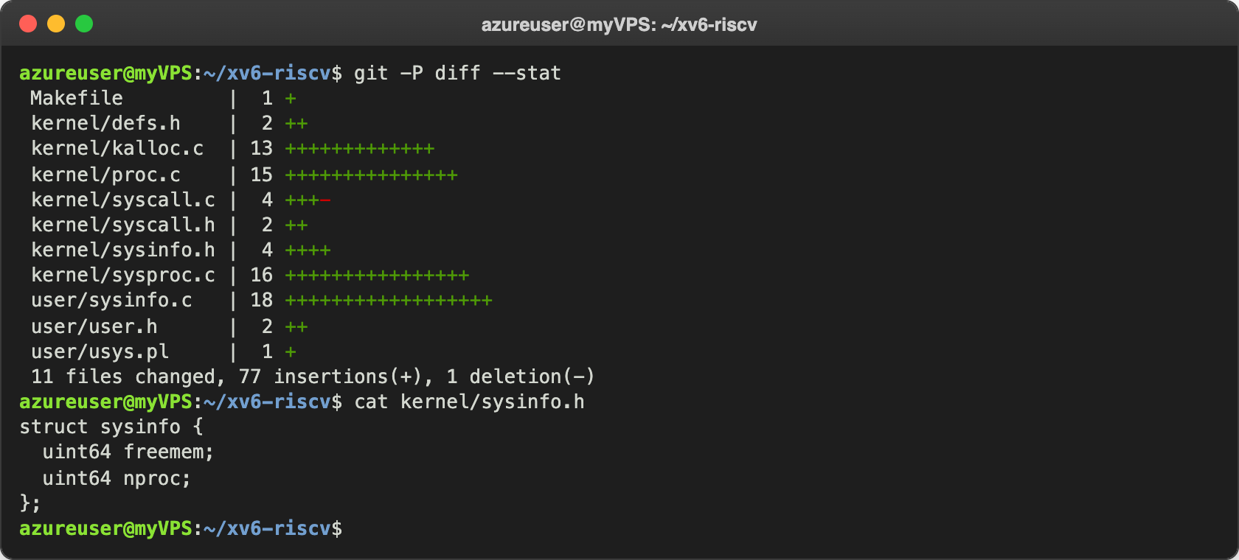
Figure 4.1 – All the files of sysinfo, and kernel/sysinfo.h
I added two helpers, one in kernel/kalloc.c and one in kernel/proc.c, and declared both in kernel/defs.h:
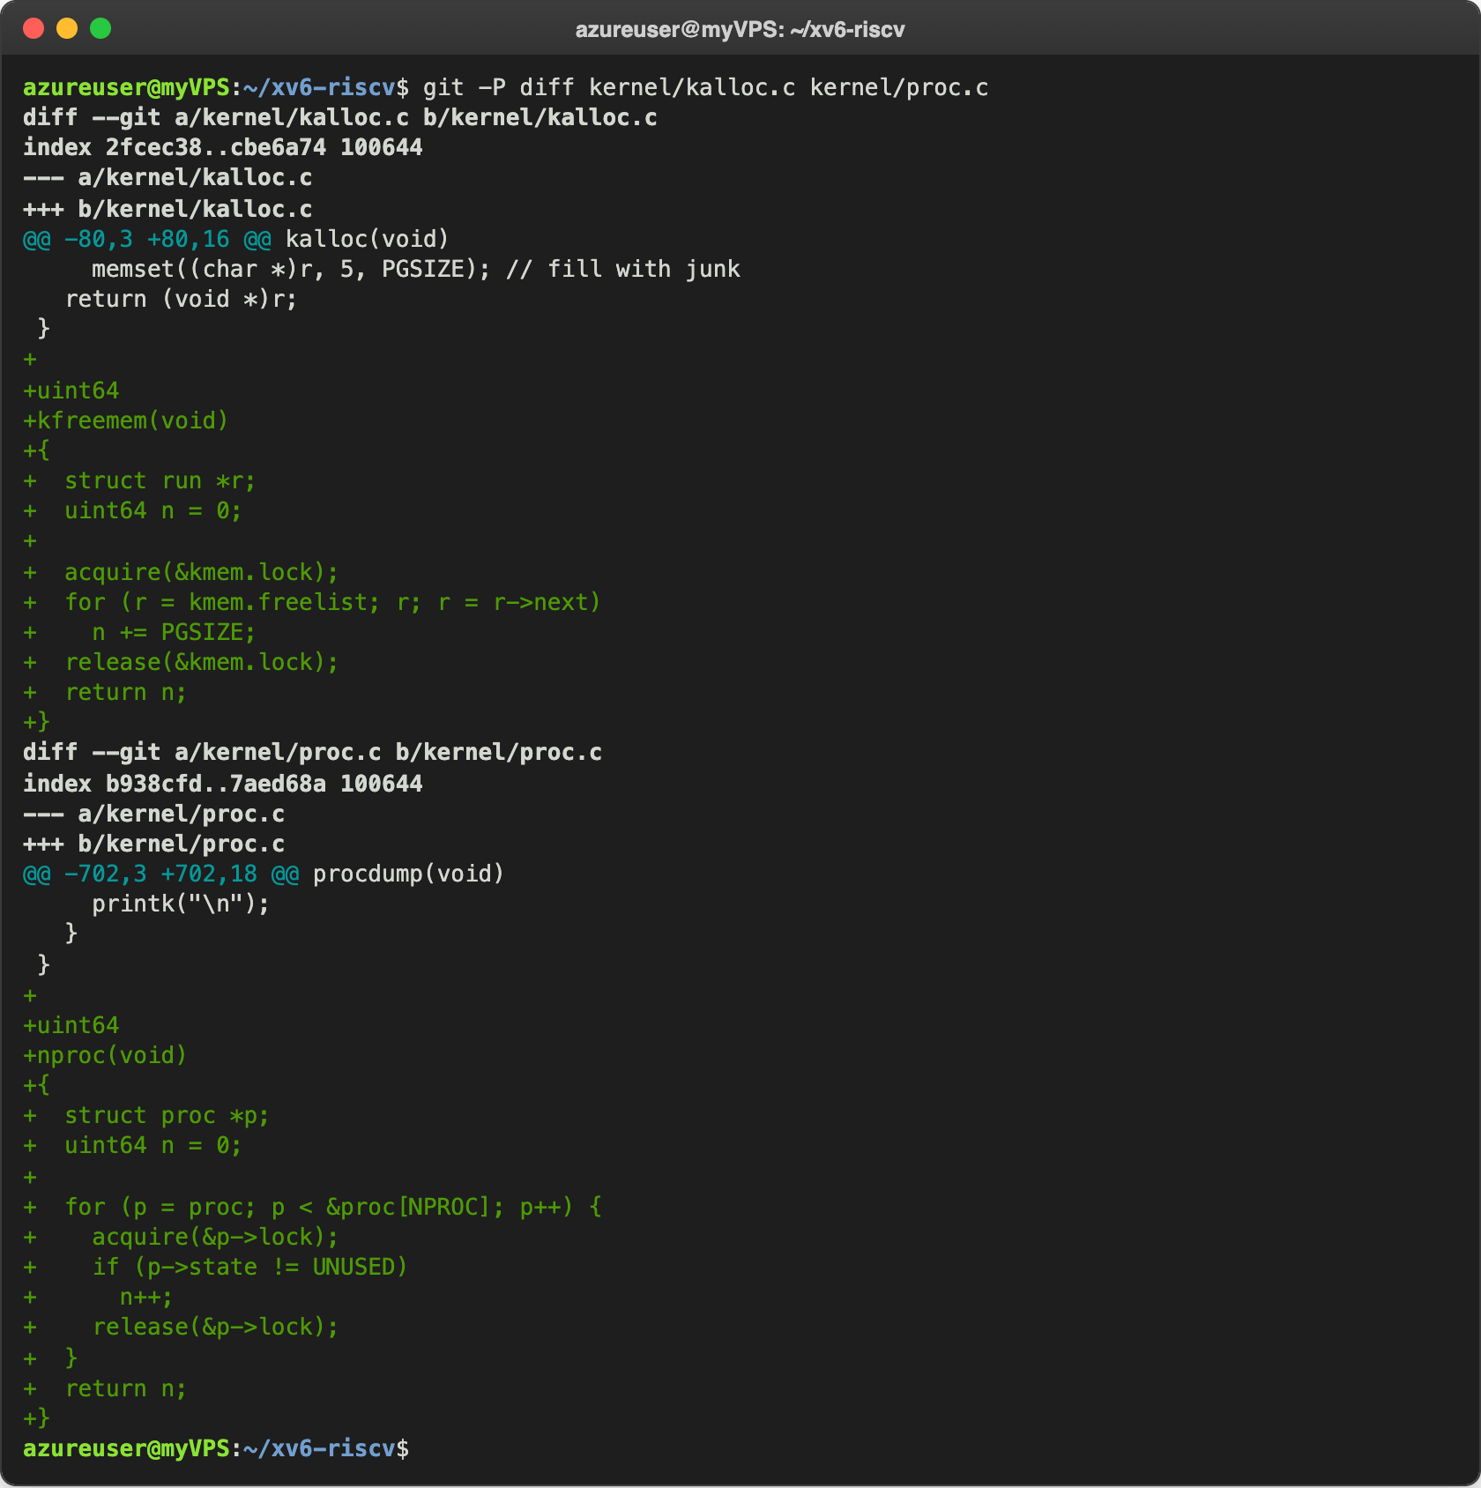
Figure 4.2 – kfreemem in kalloc.c and nproc in proc.c
kfreemem() walks the list of free pages of the kernel allocator and adds 4096 bytes (PGSIZE) for each page; it holds kmem.lock, so that no other CPU changes the list meanwhile. nproc() counts the slots of the process table whose state is not UNUSED, holding the lock of each process while it reads its state. Then the handler, the table entries, the name and the number:
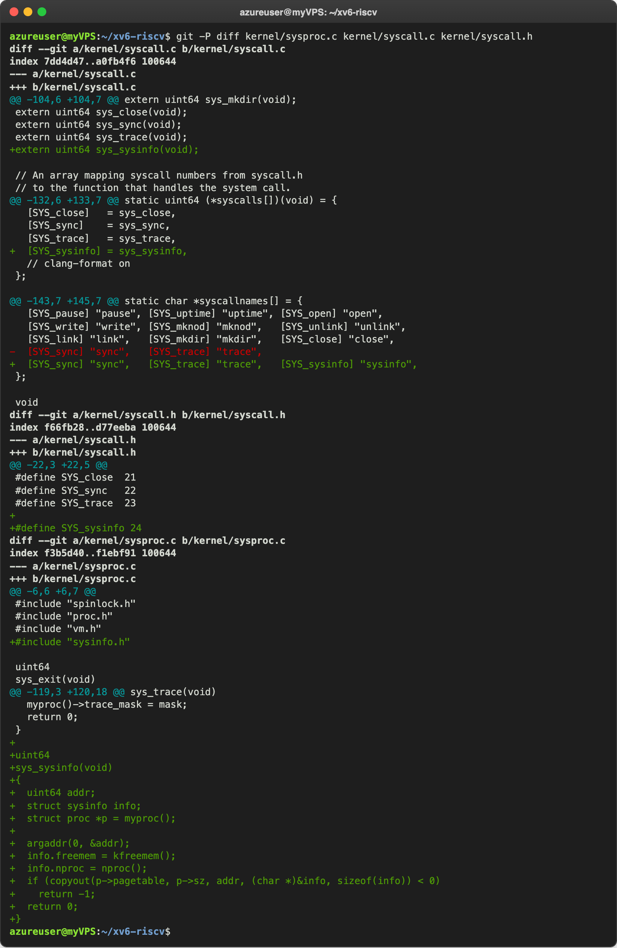
Figure 4.3 – sys_sysinfo, the table and the number 24
This time the argument is a pointer: argaddr(0, &addr) reads the address of the user structure, and copyout() copies the kernel structure into the memory of the process. The kernel cannot simply write through a user pointer, because the user memory is mapped by the page table of the process, not of the kernel; copyout translates the address through that page table and returns -1 if the address does not belong to the process. I put SYS_sysinfo after an empty line in syscall.h, because clang-format aligns consecutive #define lines, and the longer name would have moved all the other numbers. On the user side I added struct sysinfo; and int sysinfo(struct sysinfo *); to user.h, entry("sysinfo"); to usys.pl, $U/_sysinfo\ to UPROGS, and a small program:
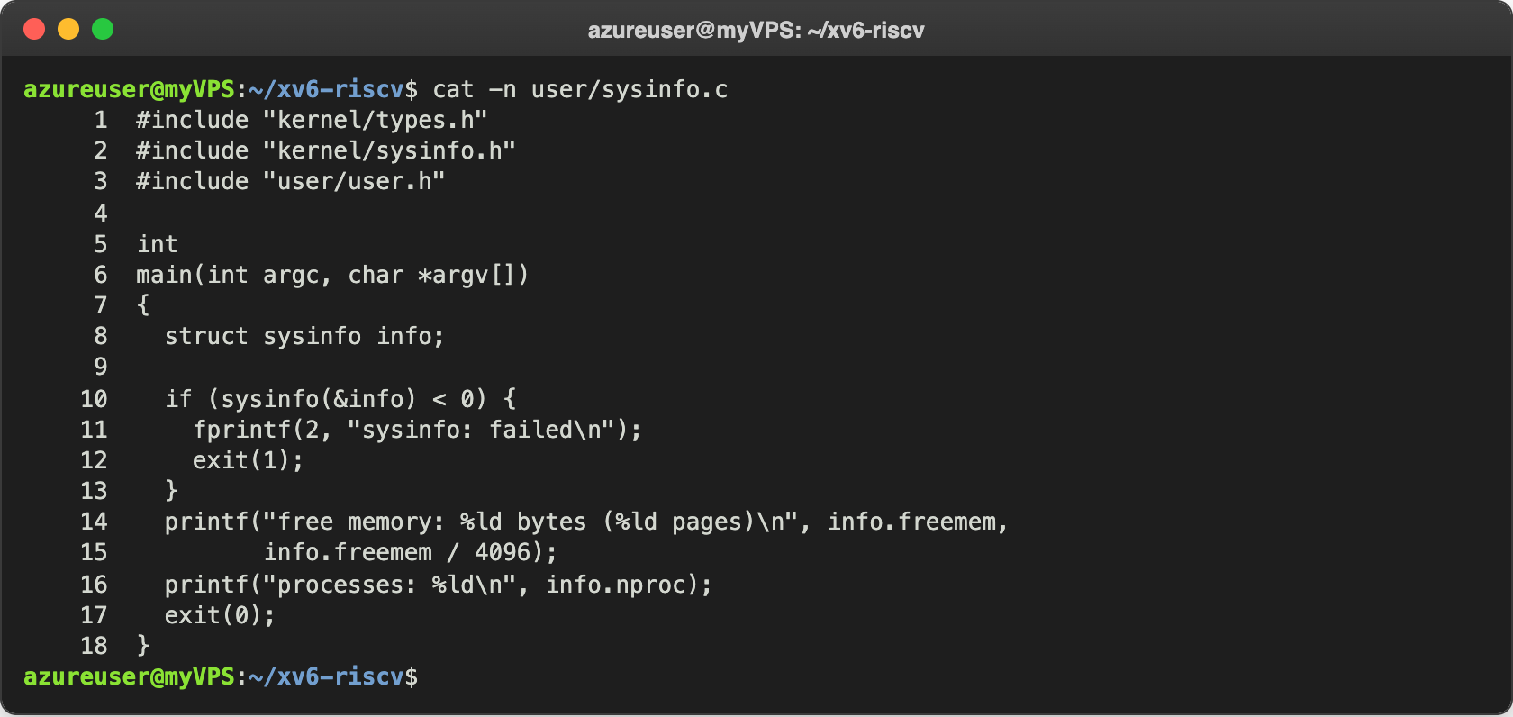
Figure 4.4 – user/sysinfo.c
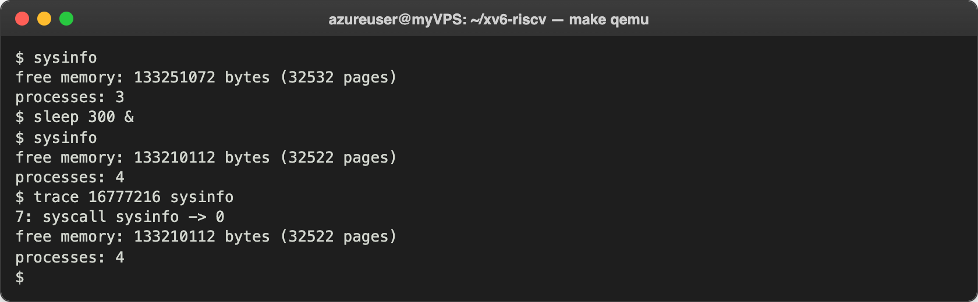
Figure 4.5 – sysinfo inside xv6
Right after boot there are 3 processes: init, sh and sysinfo itself, and 32532 free pages of the 128 MB of QEMU. After I started sleep 300 & in the background (my sleep from Lab 2, 30 seconds), there were 4 processes, and 10 pages (40960 bytes) less free memory: the code, the stack, the trapframe and the page table of the new process. The last command combines both of my system calls: bit 24 (16777216 = 2²⁴) traces only sysinfo, and the kernel printed "7: syscall sysinfo -> 0".
After all the changes I also ran the whole xv6 test suite (./test-xv6.py usertests), and it still passed.

Conclusions
In this lab I followed a system call from the beginning to the end. In user space, trace() is only a stub of three instructions: it puts the number of the call into a7 and runs ecall. In the kernel, syscall() takes the number from the saved a7, finds the function in the table syscalls[], and puts its return value back into a0. To add a call I had to touch every step: the number, the declaration, the stub, the table and the handler. Without the table entry, the kernel only said "unknown sys call 23".
The mask is just a field of struct proc. Because exec keeps the process, the command started by trace is traced, and because fork copies the field, its children are traced too. Reading the mask in binary, every bit chooses one call. With sysinfo I saw that the kernel needs copyout to give data to a user program through a pointer. This is a small version of strace from Lab 9: there the kernel stopped the program for another process, here the kernel prints the calls itself.
Repository: https://github.com/httpcatalin/os-2026-CatalinBitca (folder lab10/, with trace.c, sysinfo.c, the Makefile and kernel.patch). kernel.patch holds the kernel side of both calls and the changes of user.h and usys.pl; on a clean xv6 tree, git apply kernel.patch, then copying trace.c and sysinfo.c into user/ and the Makefile (which lists only $U/_trace\ and $U/_sysinfo\ in UPROGS, lines 149 and 150) is enough to build and run both programs.

