
TECHNICAL UNIVERSITY OF MOLDOVA
Faculty of Computers, Informatics and Microelectronics
Department of Software Engineering
REPORT
on laboratory work no. 1
Course: Operating Systems
Topic: The OS as a Resource Manager
Done by: st. gr. FAF-242, Cătălin Bîtca
Checked by: Reițman Patricia
Chișinău, 2026

Purpose of the work
The purpose of this lab is to see the operating system at work as the manager that stands between the programs and the hardware. I looked at the four main jobs of any OS, managing files, processes, memory and devices, live in the terminal of a Linux machine, and I wrote down what I observed, not only which commands I typed.

Work environment
Instead of the provided VM I did the lab on my own Linux virtual machine in Azure (Ubuntu 24.04.4 LTS, 2 vCPUs, about 842 MiB of RAM), connected to it with ssh. First I created the working folder and checked who I am to the OS, which kernel manages the machine and how long it has been running:
azureuser@myVPS:~$ mkdir -p ~/os-lab1 && cd ~/os-lab1
azureuser@myVPS:~/os-lab1$ whoami
azureuser
azureuser@myVPS:~/os-lab1$ uname -a
Linux myVPS 6.17.0-1022-azure #22-Ubuntu SMP Mon Jul 27 17:24:03 UTC 2026 x86_64 x86_64 x86_64 GNU/Linux
azureuser@myVPS:~/os-lab1$ uptime
10:52:45 up 12 days, 23:45, 3 users, load average: 0.00, 0.00, 0.00
So I am the user azureuser, the kernel is Linux 6.17 (a version built for Azure) on a 64-bit x86 machine, and the system had been running for almost 13 days without a reboot.

Part 1. Files and directories
The OS turns the raw disk into a tree of named files that have owners and permissions. First I looked at where I am and at the root of the whole tree:
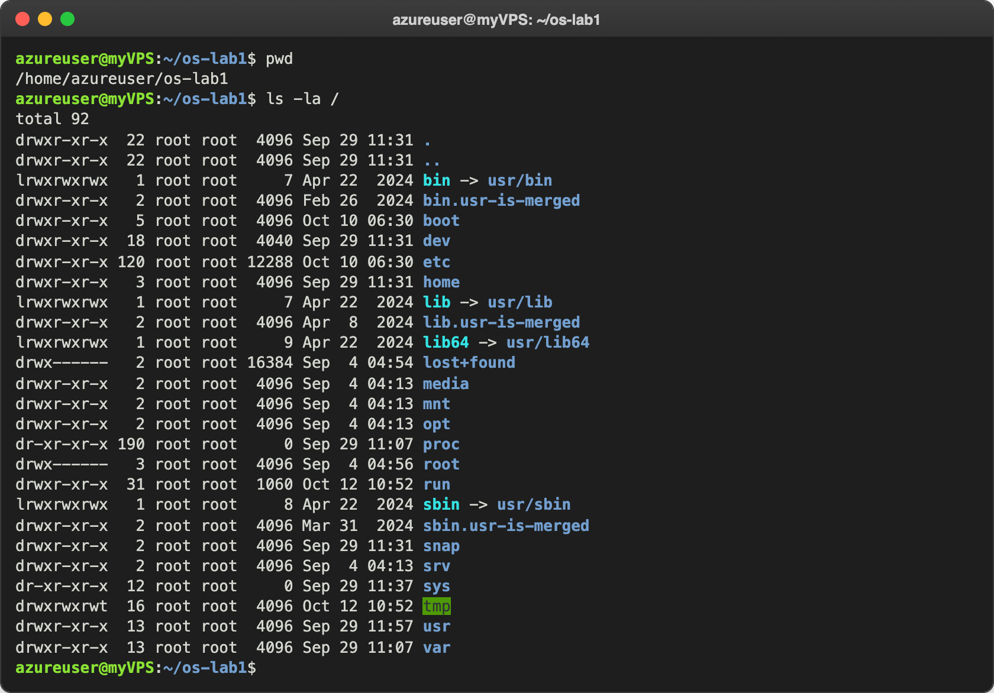
Figure 1.1 – The current directory and the root of the tree
Two things surprised me here. /bin is not a real folder on this Ubuntu, it is only a link to usr/bin (the same for lib and sbin). And /proc and /sys have size 0, because they are not on the disk at all: the kernel creates them in memory.
Then I looked at my home directory and at the first entries of /etc:
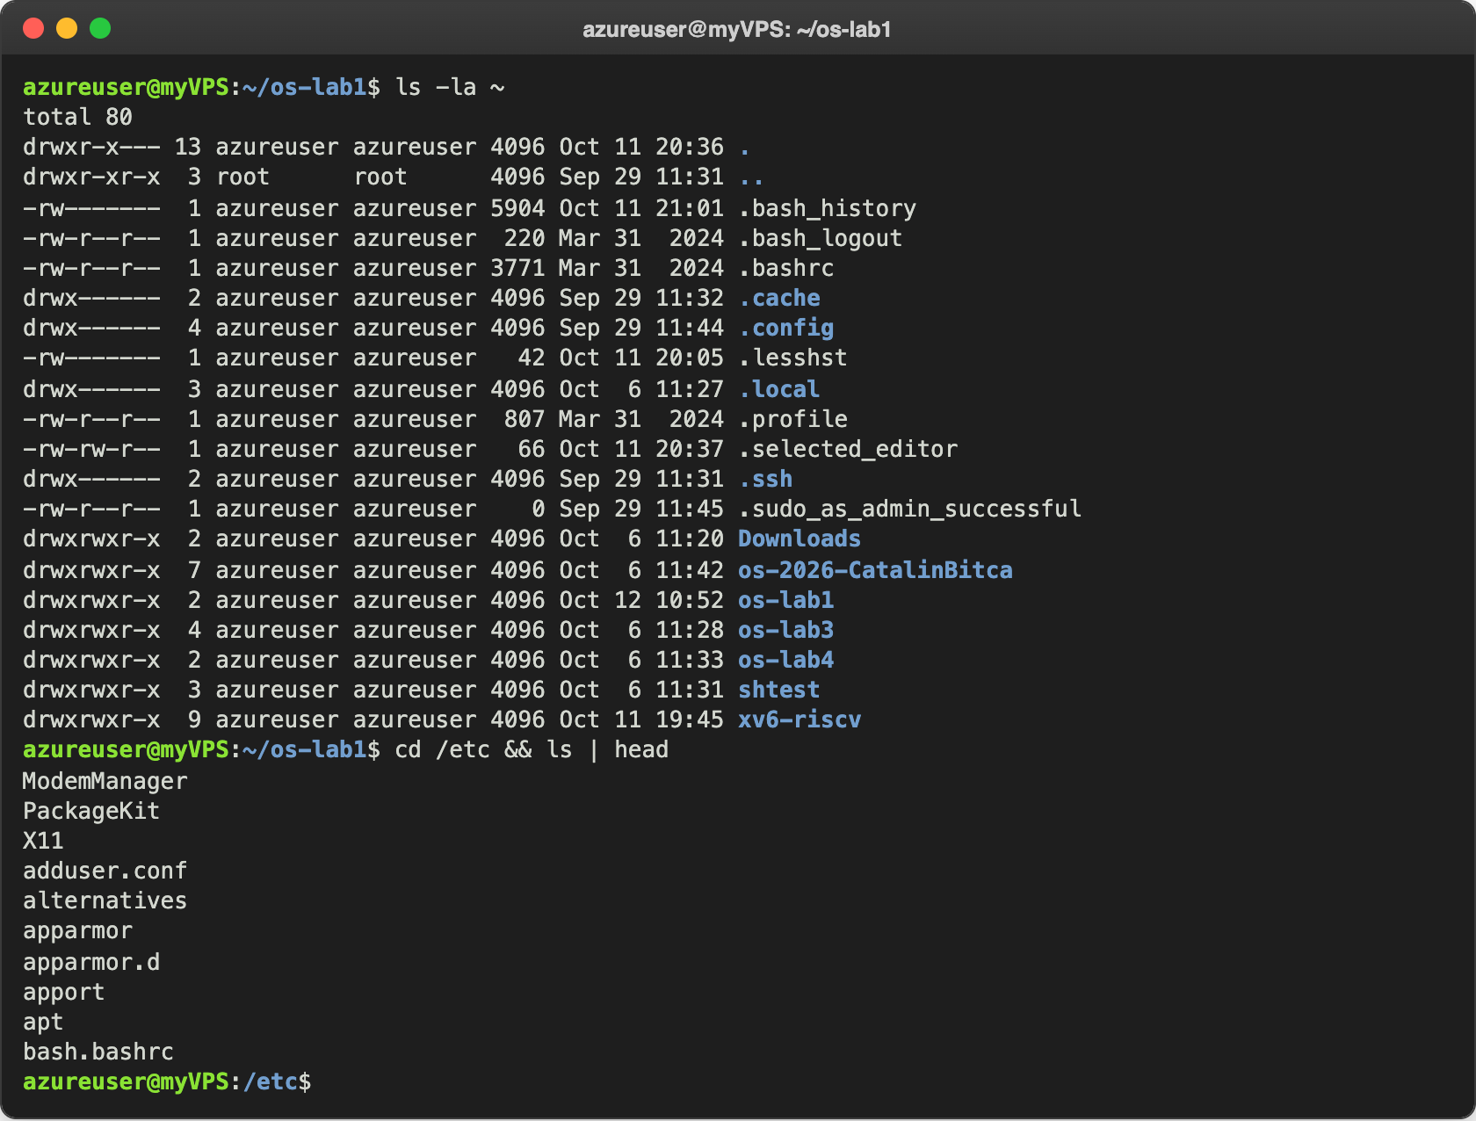
Figure 1.2 – My home directory and the first files in /etc
After that I created a folder and a file, copied the file, renamed the copy and removed it, and checked the tree with ls -l after each change:
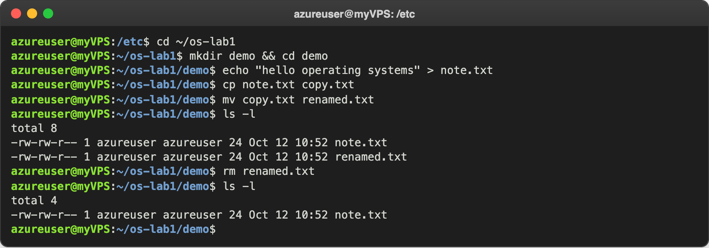
Figure 1.3 – Creating, copying, renaming and removing a file
note.txt has 24 bytes: "hello operating systems" is 23 characters, plus the newline that echo adds at the end. At the end only note.txt was left, because mv renamed copy.txt and rm deleted it.
Finally I changed the permissions of note.txt:
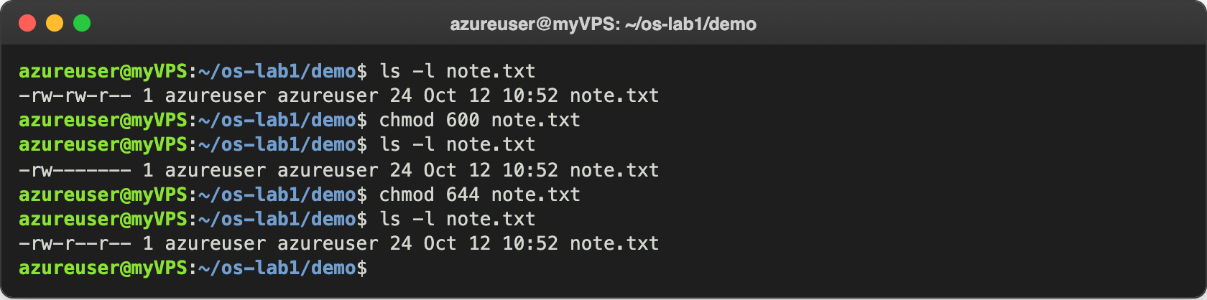
Figure 1.4 – Permissions before and after chmod 600 and chmod 644

Observe
- Who owns the files and which group? The owner is me, azureuser, and the group is also azureuser. On Ubuntu every user gets a private group with the same name.
- What the ten characters mean after chmod 600. It was -rw-------. The first - means a normal file (a folder would have d). Then come three groups of three: rw- for the owner (I can read and write), --- for the group and --- for everybody else (they can do nothing). So after chmod 600 only I can read or change the file. The numbers are r = 4, w = 2, x = 1 added up: 6 = rw-, 0 = ---. With chmod 644 it became -rw-r--r--, everybody can read but only I can write.
- Two directories under /. /etc holds the configuration files of the system, for example adduser.conf, apt and bash.bashrc in Figure 1.2. /home holds the home folders of the users; on my VM there is only azureuser.

Part 2. Processes
Every running program is a process that the OS created and schedules. First I listed them:
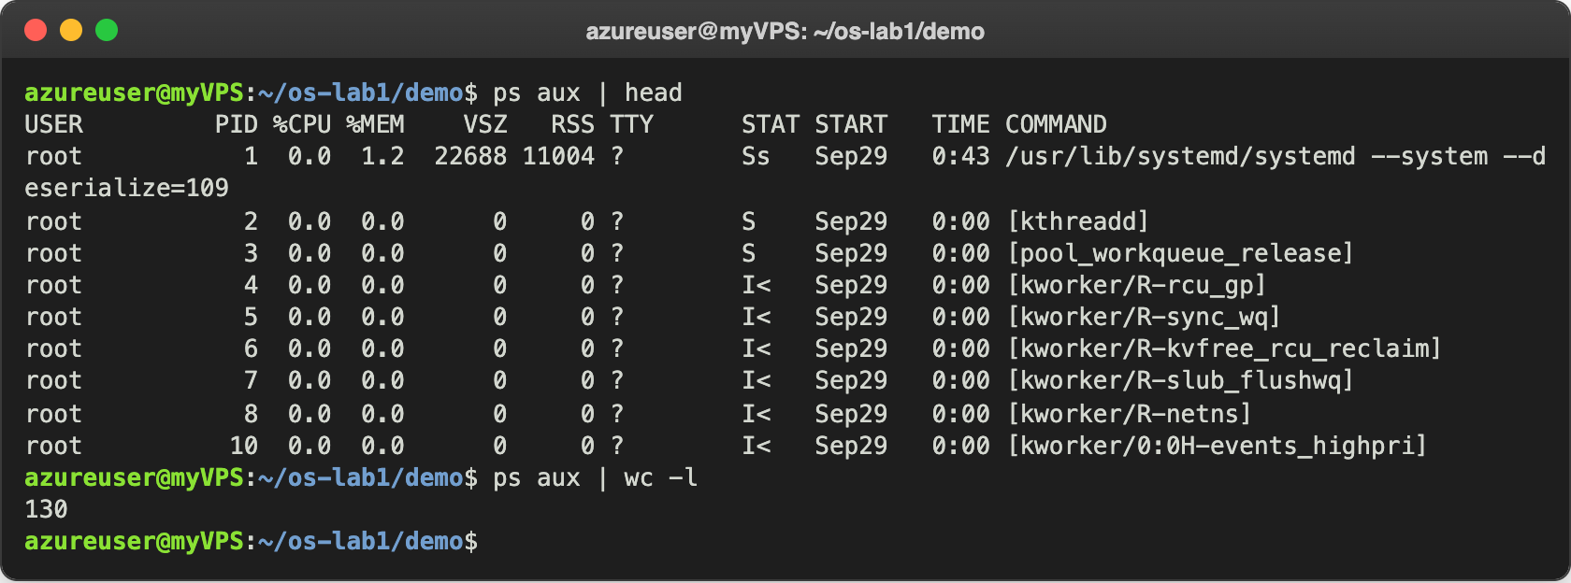
Figure 2.1 – The first processes and how many there are
ps aux | wc -l printed 130, so there were 129 processes (the first line is the header). Most of them are kernel threads, the ones in square brackets like [kthreadd] and [kworker/...]. Then I opened top, the live view:
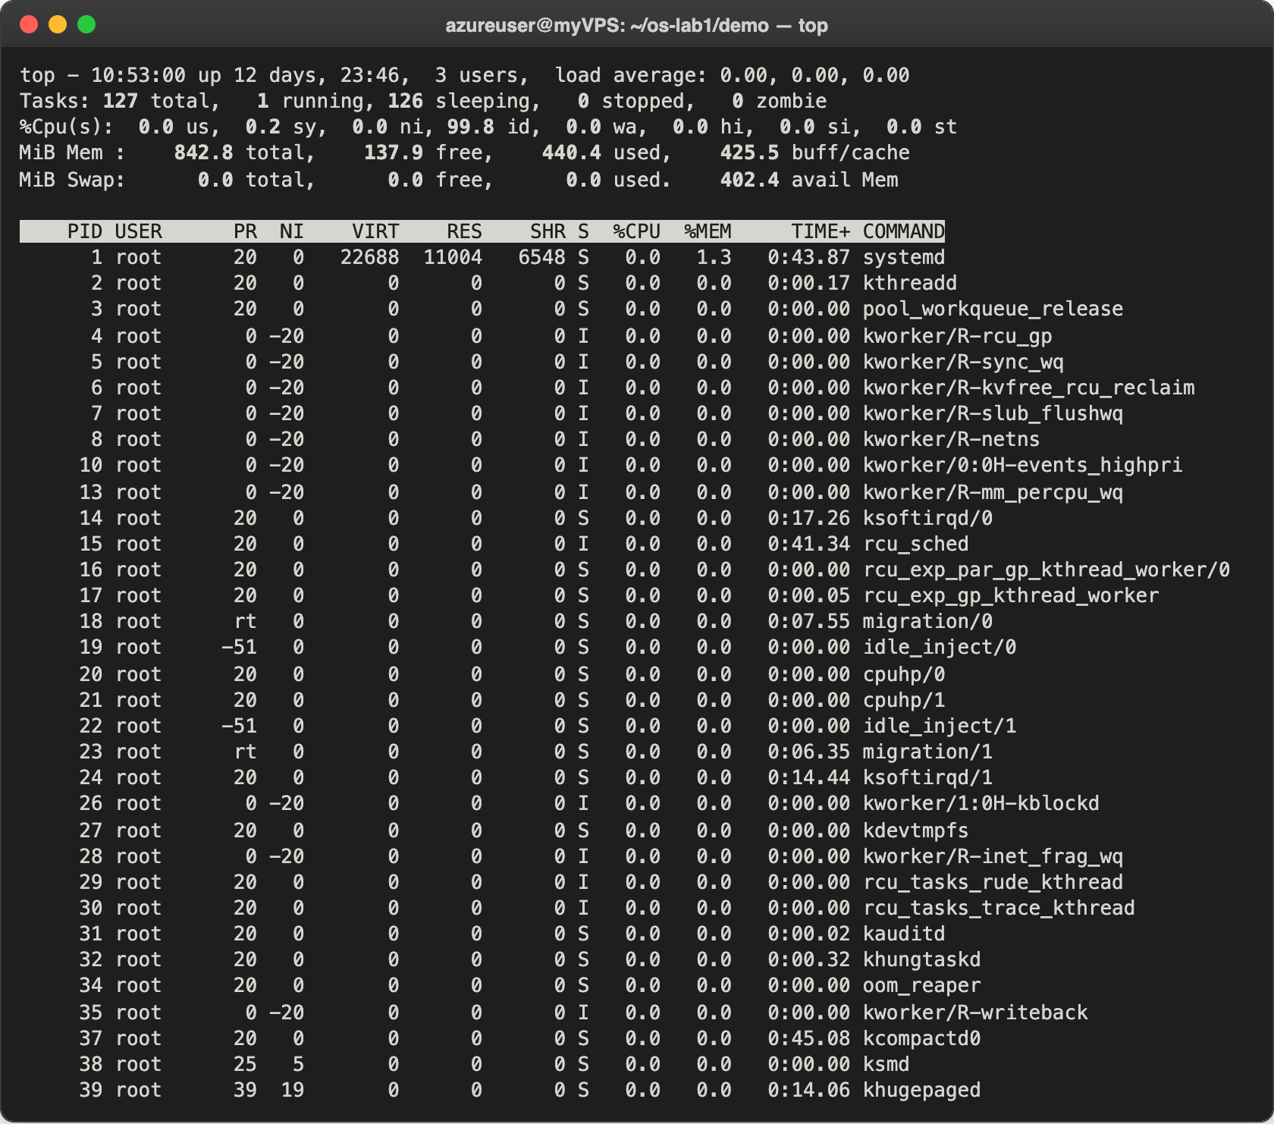
Figure 2.2 – The live view in top
top says Tasks: 127 total, 1 running, 126 sleeping. Almost everything was sleeping, waiting for something to happen; the only one running was top itself. I quit it with q.
Then I started a process in the background, found it and stopped it:
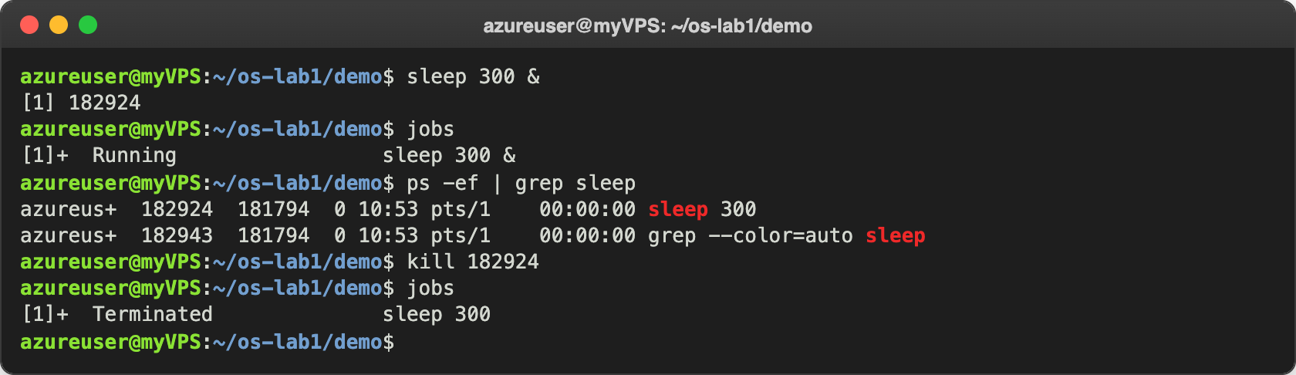
Figure 2.3 – A background sleep, found with ps and stopped with kill
The & started sleep 300 in the background and the shell printed the job number [1] and the PID 182924. jobs showed it as Running, ps -ef | grep sleep found it among all processes (the second line is grep itself, because its own command line also contains "sleep"), and kill 182924 asked the OS to terminate it. After that jobs showed it as Terminated.
The kernel also shows everything about a process as files in /proc/<PID>/:
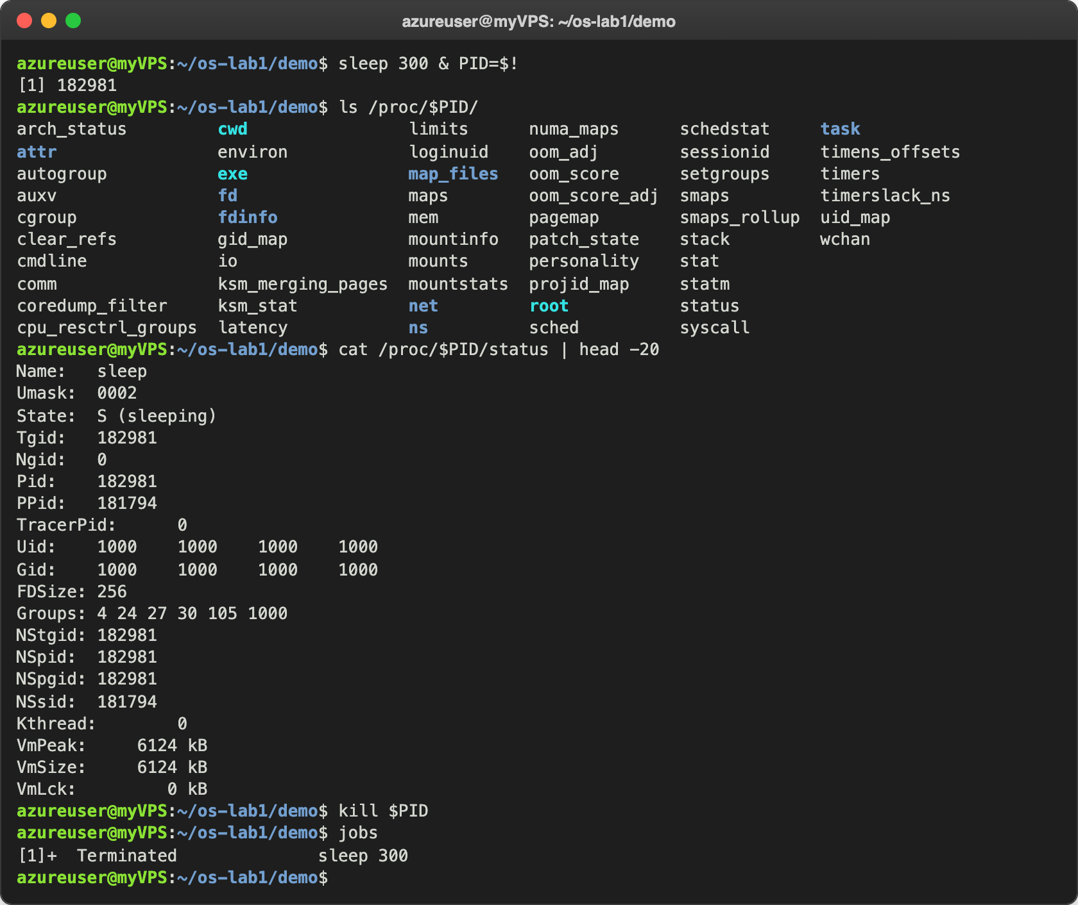
Figure 2.4 – The /proc folder of a sleeping process and its status
Last, I checked what process number 1 is:
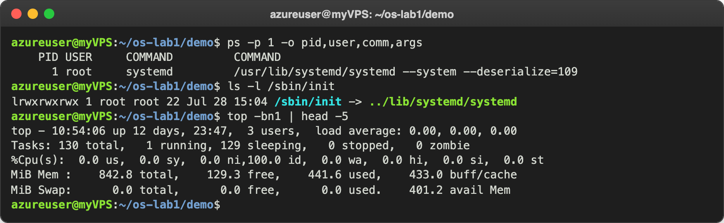
Figure 2.5 – Process number 1 and the task count

Observe
- What is PID 1? It is systemd. In older systems it shows as /sbin/init, and on my VM /sbin/init is just a link to ../lib/systemd/systemd. It is the first process the kernel starts when the machine boots, and then it starts all the other services (ssh, cron, logging and so on). If PID 1 dies, the whole system stops.
- How many processes on the idle VM? About 130: ps aux | wc -l gave 130 lines (129 processes), top showed 127 tasks and top -bn1 showed 130. The numbers move a little because ps, top and the shell are processes too. I expected far fewer on an empty VM, but most of them are kernel threads.
- The State line of the sleeping process. It says State: S (sleeping). The process is only waiting for the 300 seconds to pass, so it does not use the CPU at all. PPid is the PID of my bash, because bash created it.

Part 3. Memory
The OS gives each process its own view of memory and shares the physical RAM between them. First I looked at the totals:
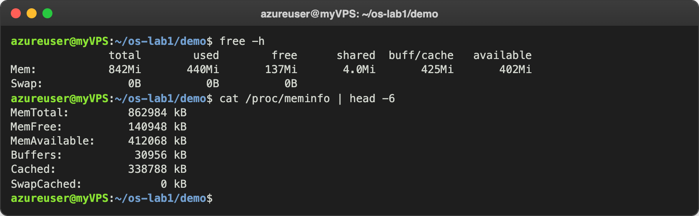
Figure 3.1 – free -h and the first lines of /proc/meminfo
Then I started a sleep again and looked at how much real RAM it uses:
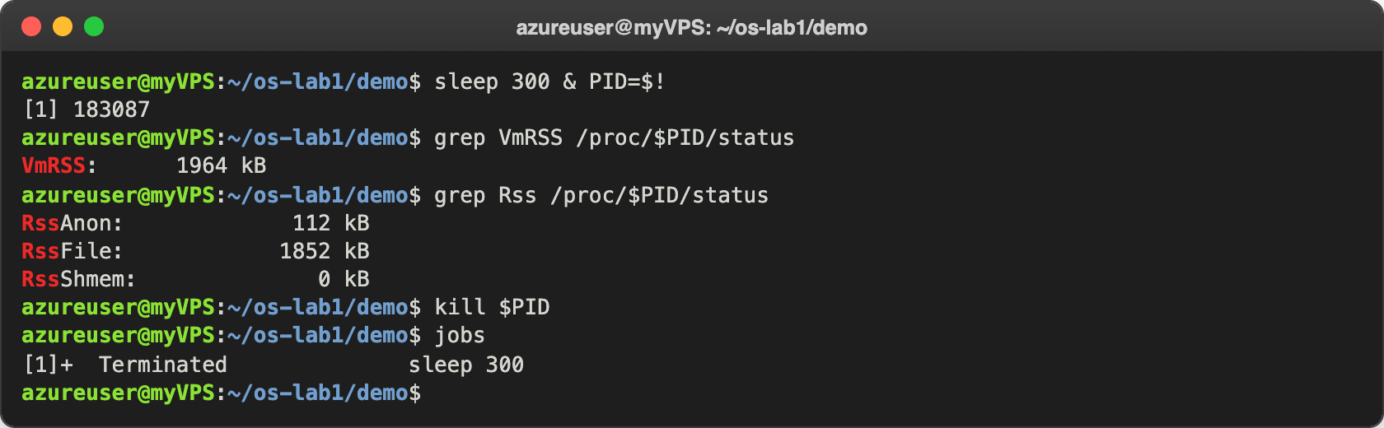
Figure 3.2 – The resident memory of a bare sleep process

Observe
- How much RAM, and how much is free? The VM has 842 MiB in total (MemTotal: 862984 kB). Only 137 MiB is "free", but 402 MiB is "available". The difference is the buff/cache (425 MiB): Linux uses the RAM that nobody needs as a cache for files, and gives it back as soon as a program asks for memory. So "available" is the real number.
- What is swap, and how much is configured? Swap is space on the disk that the OS uses as extra RAM when the real RAM is full. It is much slower than RAM. On my VM it is 0B, so there is no swap at all.
- VmRSS of sleep, and does it surprise me? VmRSS: 1964 kB, so about 2 MB for a program that does nothing. It surprised me a little, but grep Rss explains it: only RssAnon: 112 kB is memory that belongs to this process alone. The other RssFile: 1852 kB are pages of files, mostly the C library and the loader, which are shared with every other program that uses them.

Part 4. Devices and storage
The OS hides every disk and device behind the same file-like interface. I looked at the mounted file systems, at the disks themselves and at the size of my folder:
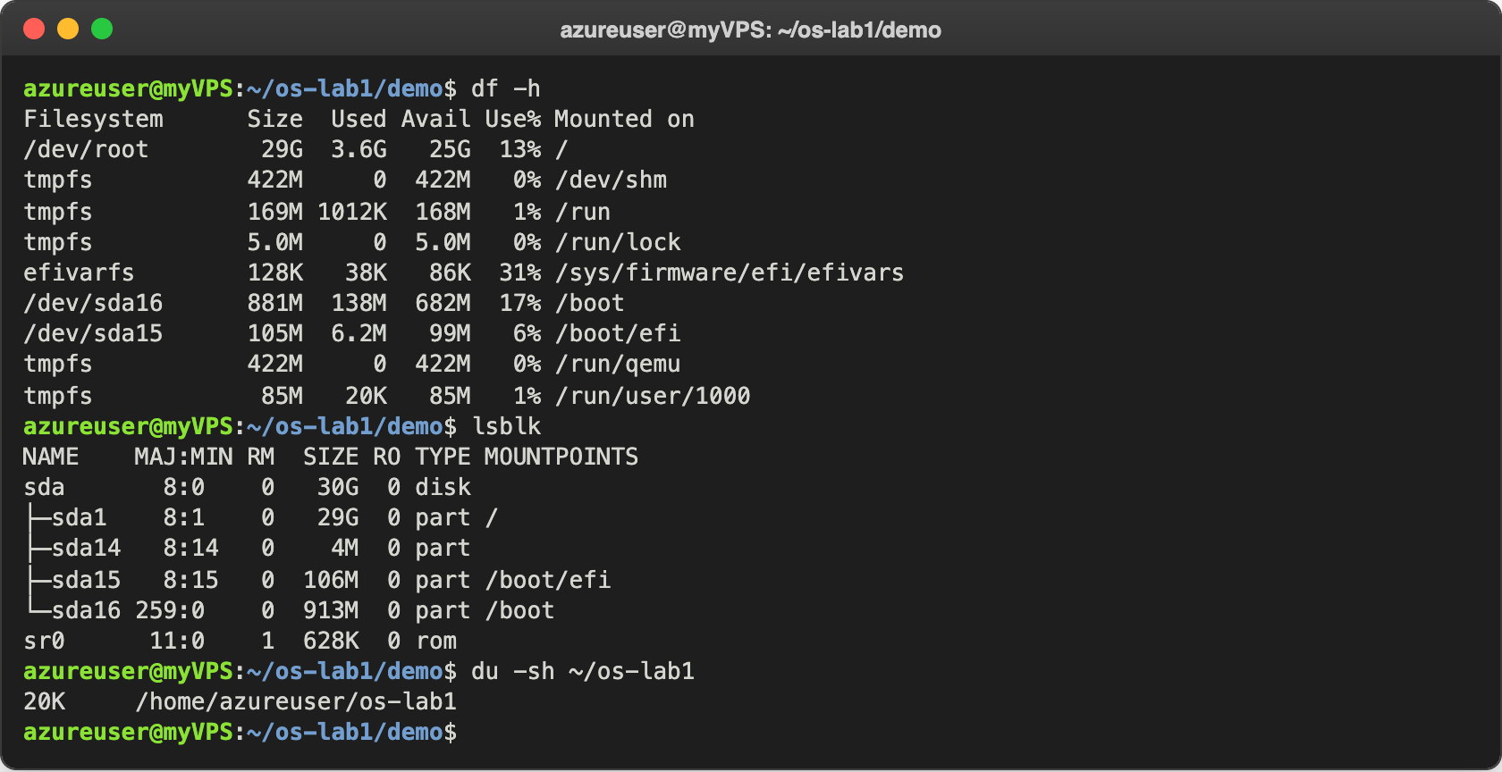
Figure 4.1 – Mounted file systems, block devices and the size of my folder
Then I listed the first entries of /dev and the first mounts:
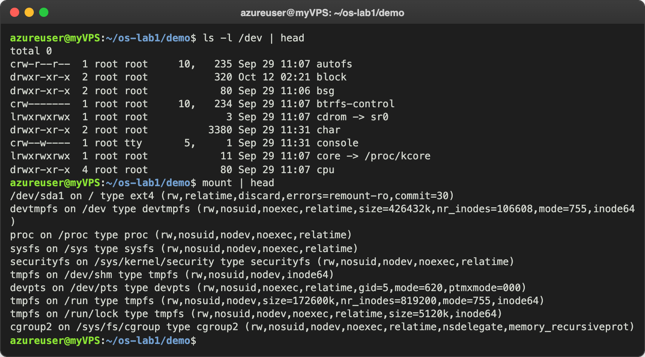
Figure 4.2 – Devices presented as files, and the mounted file systems
Finally I looked at three device files in detail and checked where / is mounted:
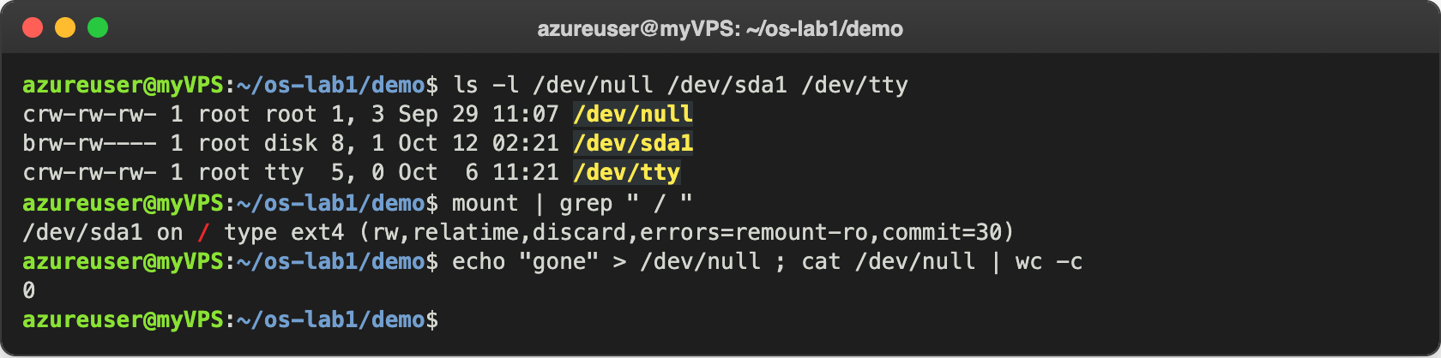
Figure 4.3 – Three device files and the root file system

Observe
- Which device is / mounted on? On /dev/sda1. In df it shows as /dev/root, but mount | grep " / " shows the real name: /dev/sda1 on / type ext4. It is the 29 GB partition of the 30 GB disk sda, formatted with ext4.
- One entry from /dev. /dev/null is a character device (c, numbers 1, 3) that throws away everything written to it: I wrote "gone" into it and reading it back gave 0 bytes. Another one is /dev/sda1, a block device (b, numbers 8, 1) that stands for the first partition of my real disk.
- What "everything is a file" means. In Linux, disks, terminals and even the information about processes (in /proc) show up as files, so the same commands and system calls (ls, cat, open, read, write) work on all of them.

Extra. htop and strace
I finished early, so I also tried htop. It shows the same information as top, but with colored bars for each CPU and for the memory, which are much easier to read:
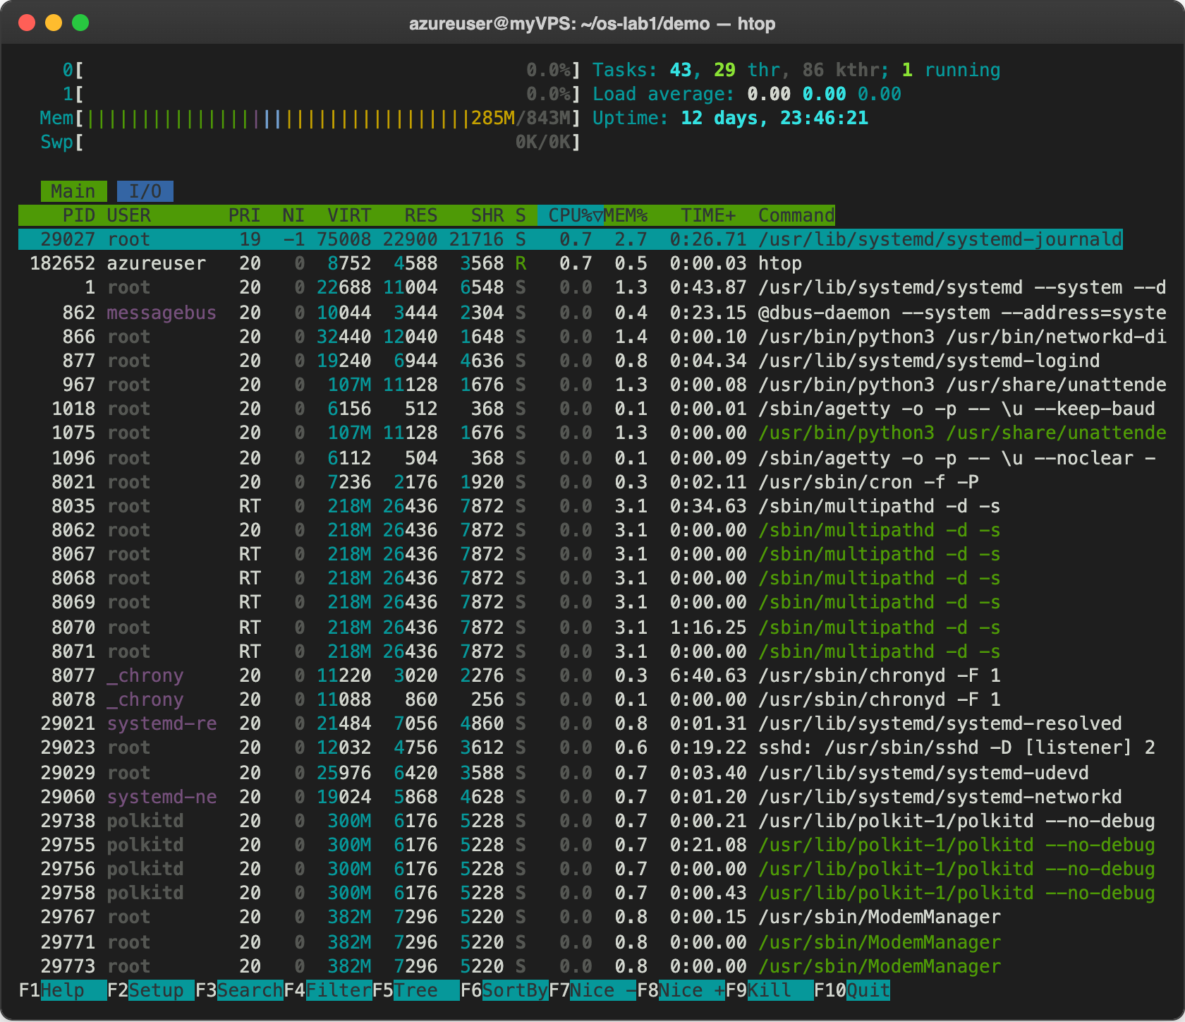
Figure 5.1 – The live view in htop
Then I ran strace -c ls to see which system calls ls makes, sending the normal output of ls to /dev/null so only the table is left:
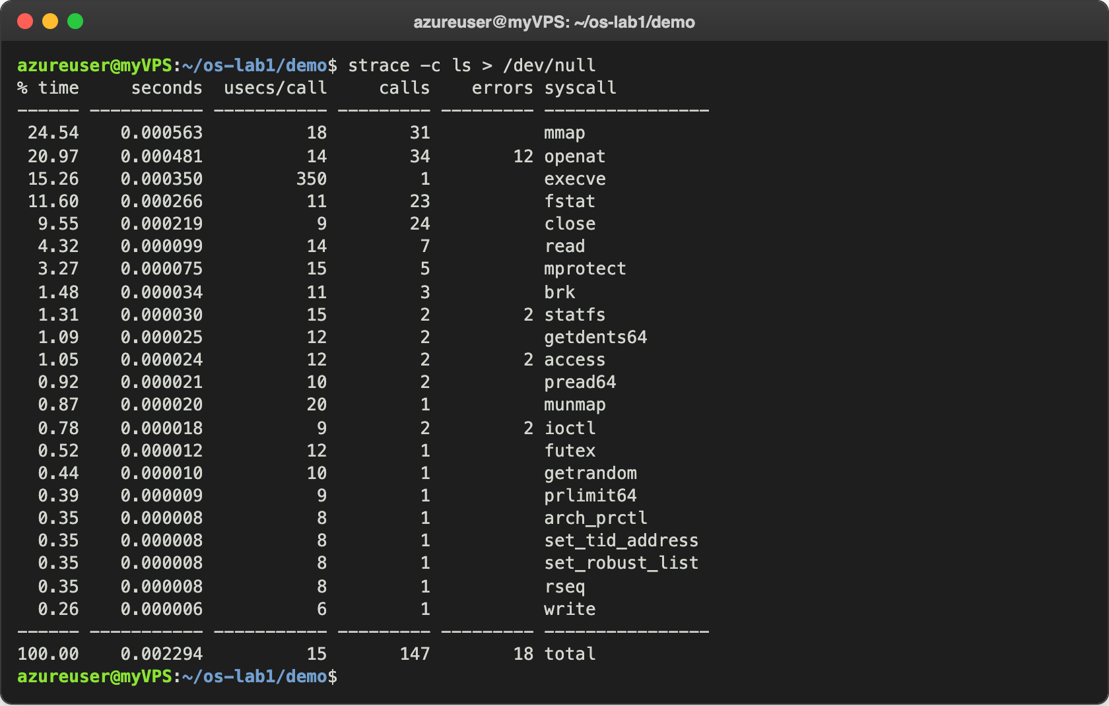
Figure 5.2 – The system calls made by ls
Just listing a small folder took 147 system calls. Most of them are mmap and openat for loading the libraries, and only one write was needed to print the result. Every one of these calls is a request from the program to the OS.

Conclusions
In this lab I saw that the OS manages four resources. For files I used ls -l, which showed the tree, the owners and the permissions. For processes I used ps aux, which showed about 130 processes, almost all of them sleeping. For memory I used free -h, which showed 842 MiB of RAM and no swap. For devices I used lsblk, which showed the disk sda and the partition sda1 where / lives.
The thing I liked most was that a lot of what the kernel knows is visible as ordinary files, in /proc and /dev, so I could read it with cat and ls. strace showed the other side: even a simple command like ls is really a long list of requests to the kernel.
Repository: https://github.com/httpcatalin/os-2026-CatalinBitca (folder lab1/).

