
TECHNICAL UNIVERSITY OF MOLDOVA
Faculty of Computers, Informatics and Microelectronics
Department of Software Engineering
REPORT
on laboratory work no. 2
Course: Operating Systems
Topic: Meet the OS You Will Build (xv6)
Done by: st. gr. FAF-242, Cătălin Bîtca
Checked by: Reițman Patricia
Chișinău, 2026

Purpose of the work
The purpose of this lab is to meet xv6, the small teaching Unix we will grow during the semester: about 9,000 lines of C that run on a RISC-V machine emulated by QEMU. I built it from source, booted it, used it like a normal Unix, read some of its code on both sides (the programs in user/ and the kernel in kernel/), and wrote my first program that runs inside it, sleep. I also did the optional pingpong program.

Work environment
I worked on my Ubuntu 24.04 virtual machine in Azure over ssh. The RISC-V toolchain was not installed there, so first I installed it and cloned xv6:
sudo apt update && sudo apt install -y git build-essential gdb-multiarch qemu-system-misc \
gcc-riscv64-linux-gnu binutils-riscv64-linux-gnu
git clone https://github.com/mit-pdos/xv6-riscv ~/xv6-riscv
cd ~/xv6-riscv
After that the tree and the tools looked like this:
azureuser@myVPS:~/xv6-riscv$ ls
LICENSE Makefile README kernel lab1 lab2 mkfs test-xv6.py user
azureuser@myVPS:~/xv6-riscv$ riscv64-linux-gnu-gcc --version | head -1
riscv64-linux-gnu-gcc (Ubuntu 13.3.0-6ubuntu2~24.04.1) 13.3.0
azureuser@myVPS:~/xv6-riscv$ qemu-system-riscv64 --version | head -1
QEMU emulator version 8.2.2 (Debian 1:8.2.2+ds-0ubuntu1.18)
The xv6 revision I cloned is 06aad25, the same one the labs were tested on. lab1/ and lab2/ are folders I added for my reports.

Part 1. Build it and boot it
make qemu compiles the kernel and all the user programs with the RISC-V cross-compiler, builds the disk image fs.img, and starts QEMU with the kernel. The start of the build:
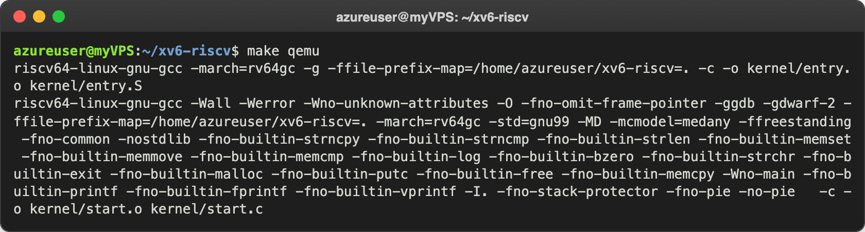
Figure 1.1 – The start of make qemu: compiling the kernel
And the end of it, after all the programs were compiled:
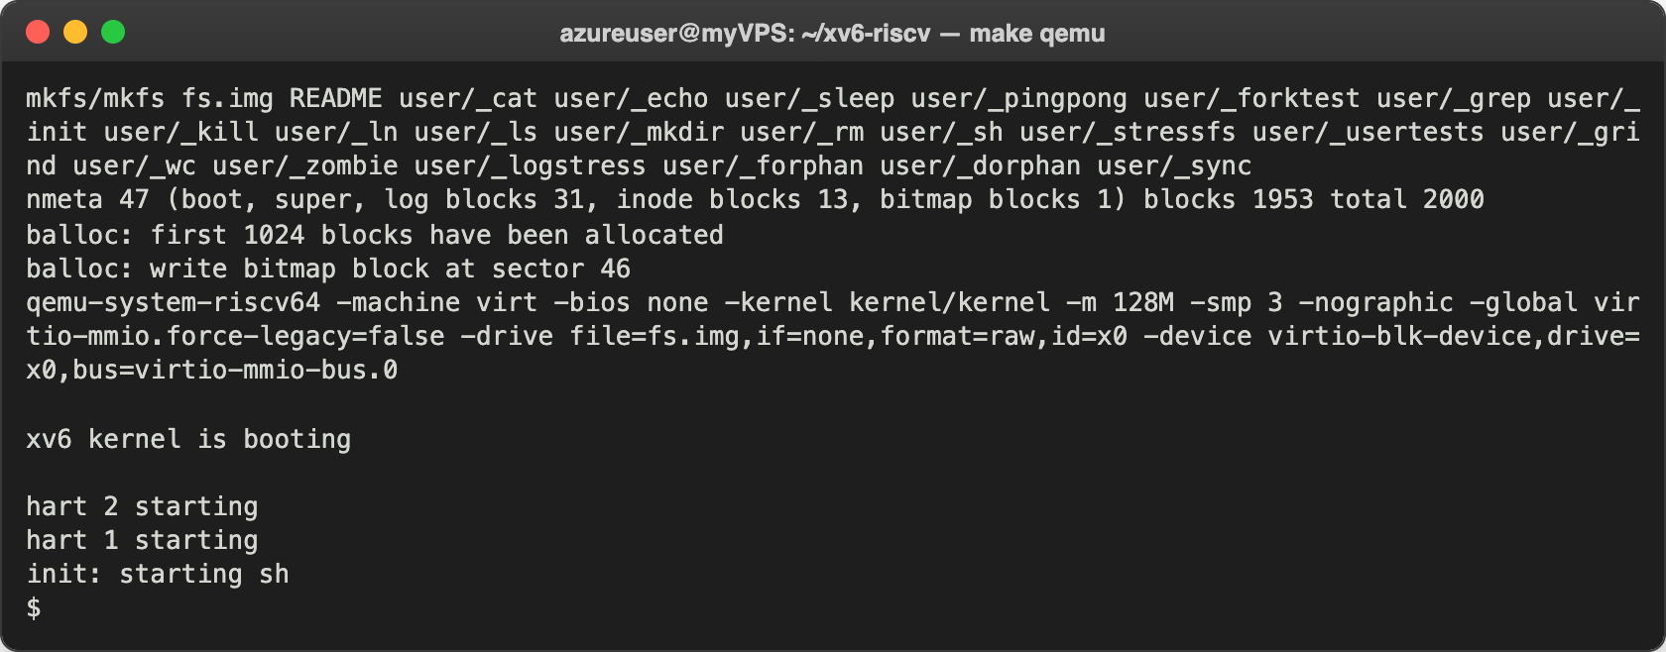
Figure 1.2 – The end of make qemu: mkfs builds the disk and xv6 boots
mkfs puts README and all the user/_* programs on the disk image. Then QEMU starts a virt machine with 128 MB of RAM (-m 128M) and 3 CPUs (-smp 3); in RISC-V a CPU core is called a "hart", which is why it prints hart 2 starting and hart 1 starting. The kernel starts init, init starts the shell sh, and I got the $ prompt after a few seconds. To leave xv6 I pressed Ctrl-A, released, then X: that is the QEMU exit, not a shortcut inside xv6.

Part 2. Use xv6 as the Unix it is
At the xv6 prompt I first listed the files:
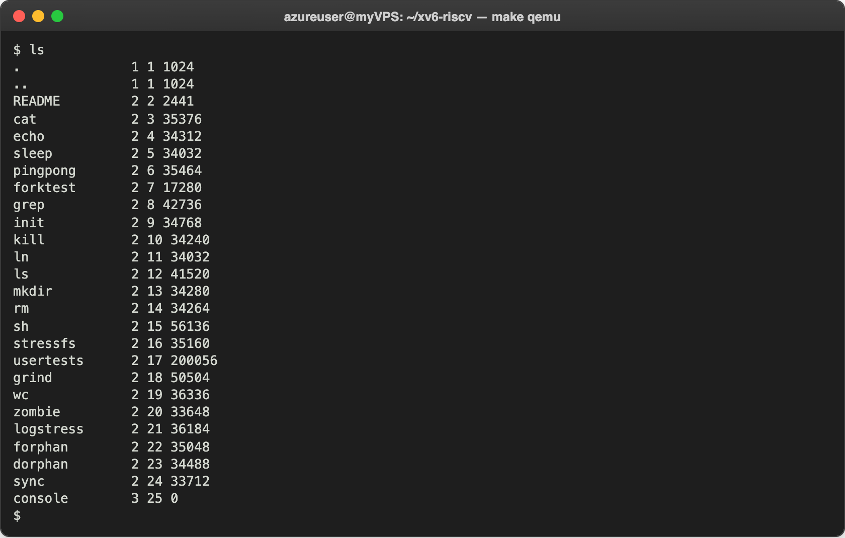
Figure 2.1 – ls inside xv6
xv6 ls prints four columns: the name, the type (1 is a directory, 2 a file, 3 a device), the inode number and the size in bytes. All the programs are in the root directory /, and console is a device, not a normal file. Then I read the README:
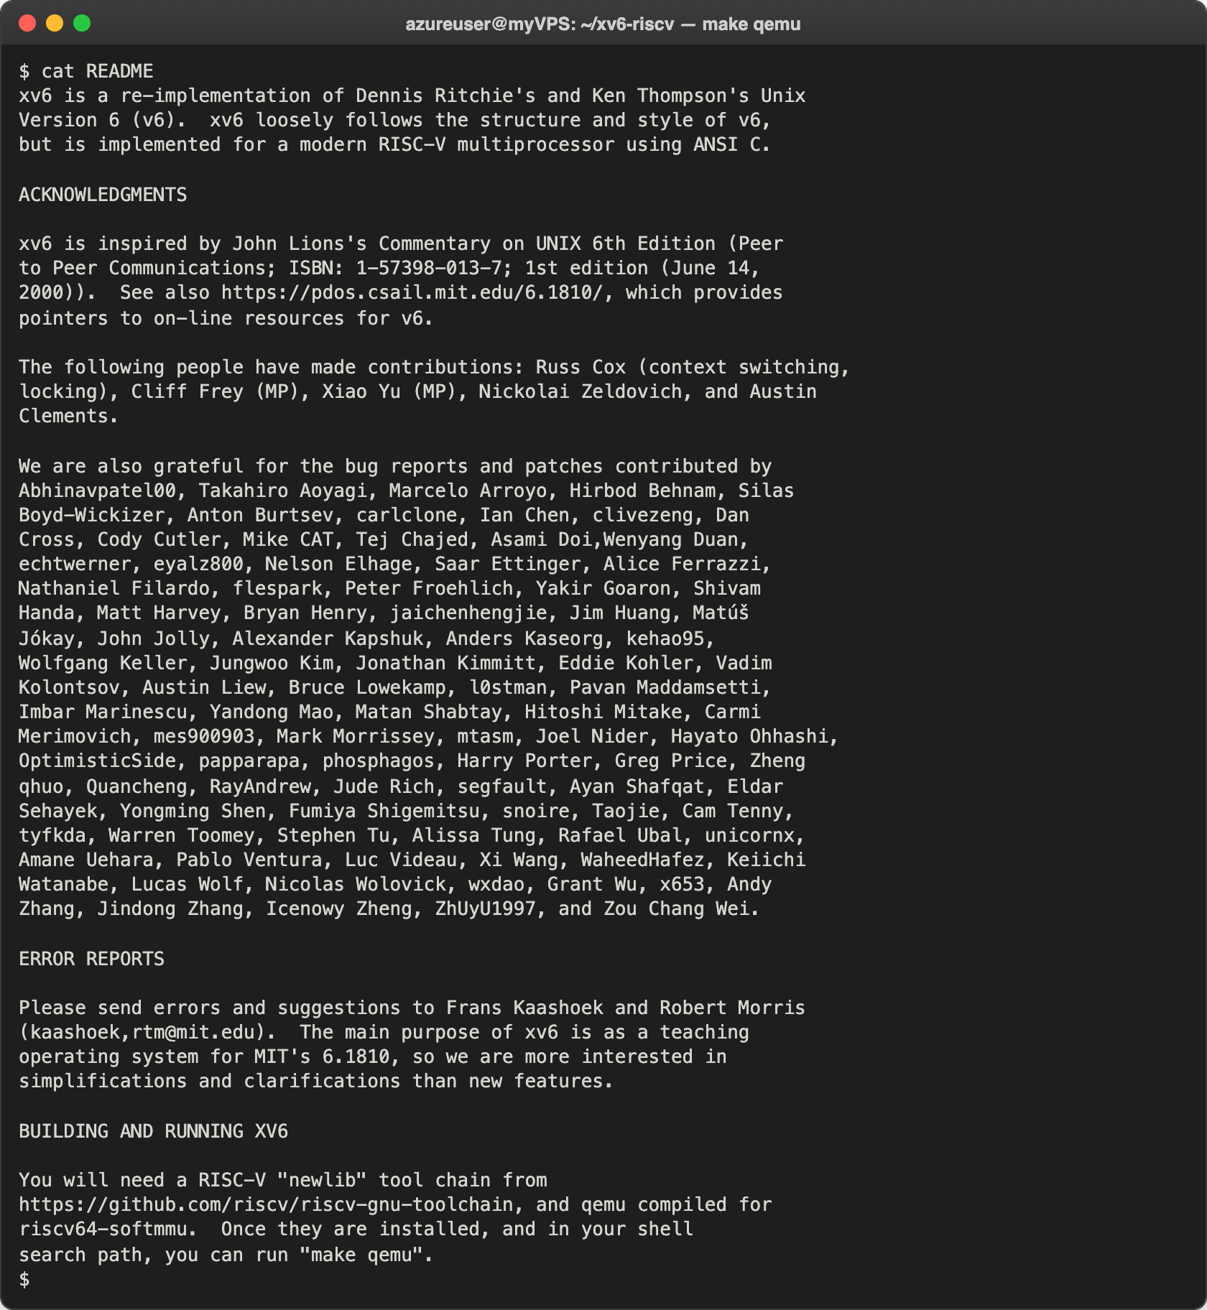
Figure 2.2 – cat README inside xv6
Then echo, a pipe and wc:
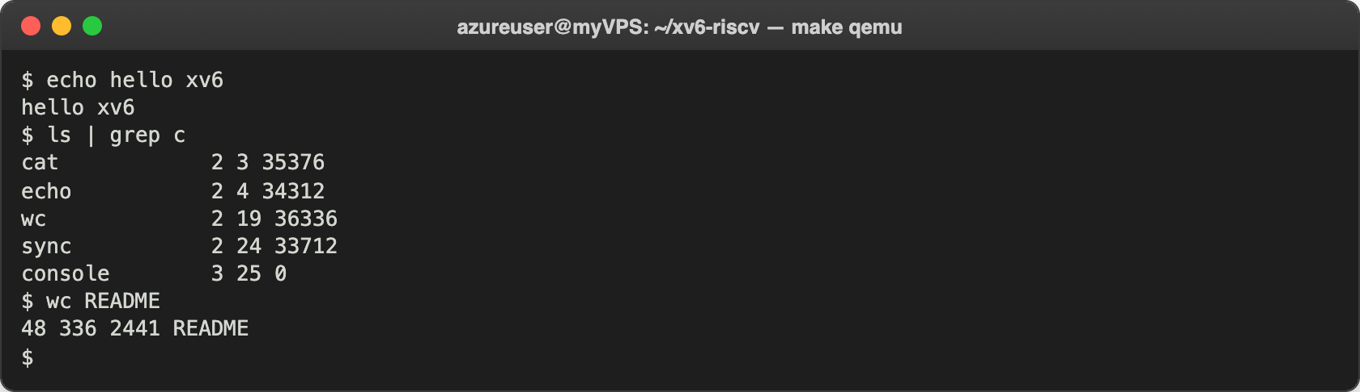
Figure 2.3 – echo, a pipe into grep and wc inside xv6
ls | grep c kept only the lines that contain the letter c, exactly like on Linux, and wc README printed 48 lines, 336 words and 2441 bytes, the same size that ls shows for README. At the end I ran the kernel test suite, usertests -q. It took about 2 minutes:
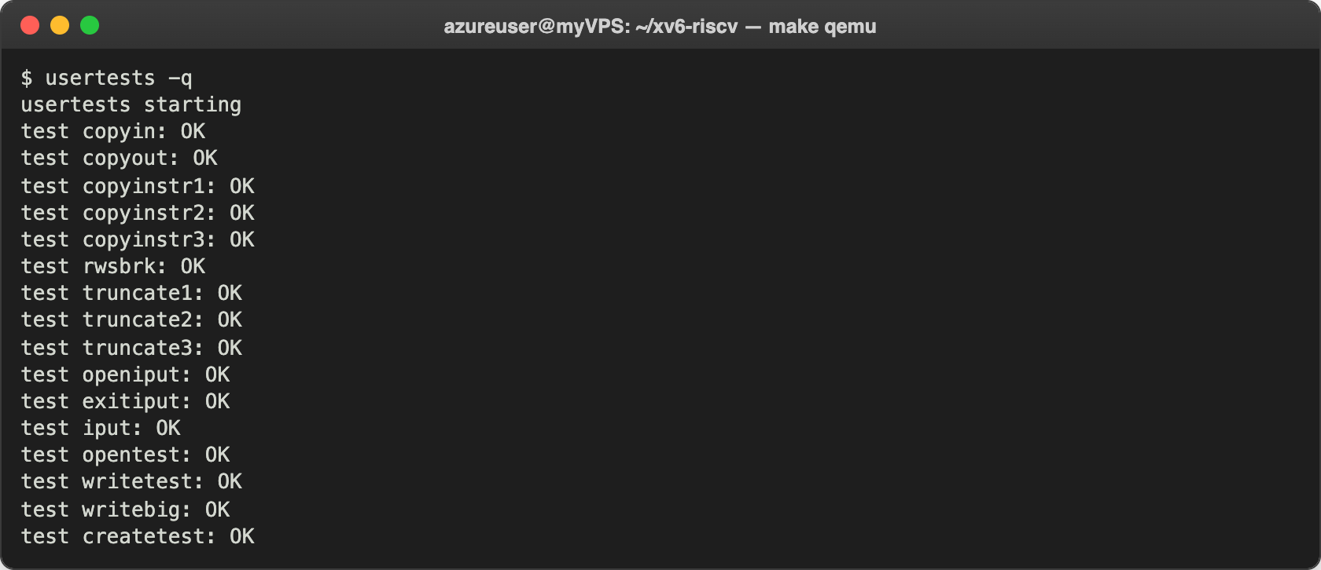
Figure 2.4 – The start of usertests -q
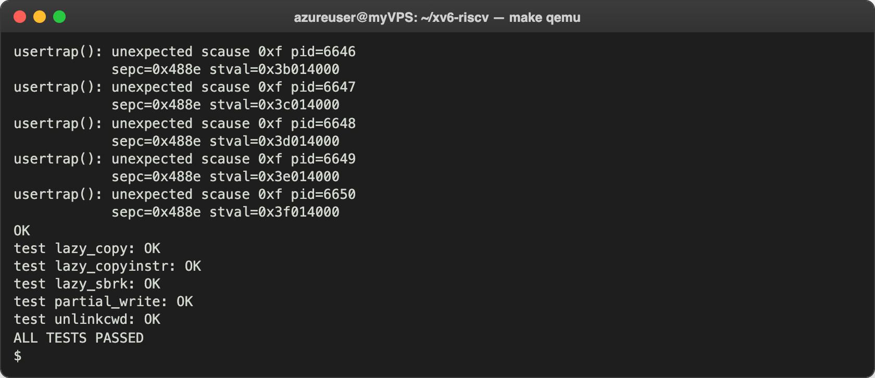
Figure 2.5 – The end of usertests -q: ALL TESTS PASSED
All 68 tests passed. The usertrap(): unexpected scause 0xf lines are not errors: the lazy_unmap test touches memory that it has unmapped on purpose, the kernel kills that child process, and the test checks that this really happens.

Observe
- Three programs xv6 ships with. ls, cat and echo. There are more, for example grep, wc, sh, kill, mkdir, rm and usertests (Figure 2.1).
- Which two OS features must exist for a pipe to work? First, processes: the shell must create two processes with fork and exec, one for ls and one for grep, and they run at the same time. Second, communication between processes: the pipe() system call, which gives a buffer inside the kernel with a write end and a read end (two file descriptors). The output of ls goes into the write end, and grep reads its input from the read end.
- xv6 shell compared to the Linux shell. The basic things work the same (running programs with arguments, |, >, <), but the xv6 shell is much simpler: it has no history with the arrow keys, no Tab completion, no variables, and its ls shows only the name, type, inode number and size instead of permissions, owners and dates.

Part 3. Read the source
I quit QEMU and looked at the code. The tree splits into kernel/, the operating system itself, and user/, the normal programs that run on top of it. First a user program, ls:
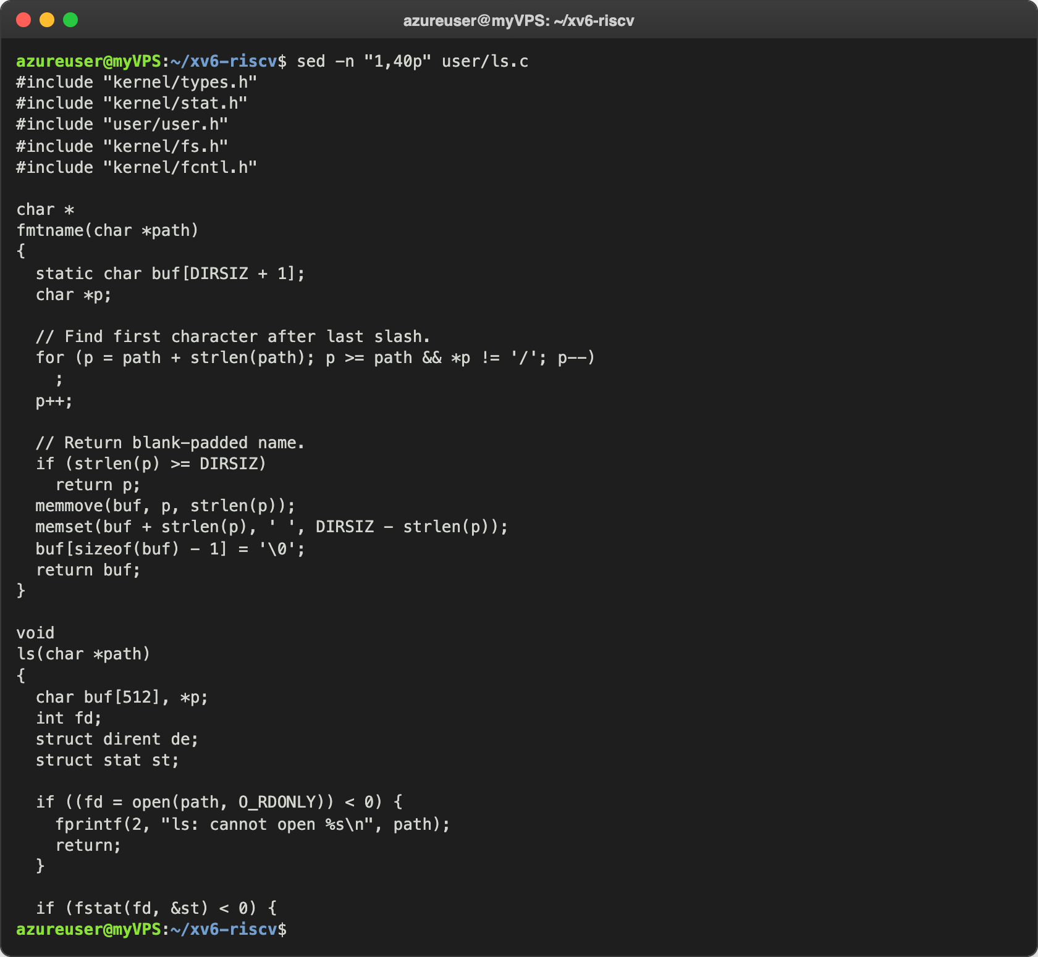
Figure 3.1 – The first 40 lines of user/ls.c
It looks like a normal C program from my C labs, but it includes user/user.h instead of <stdio.h>, and to read a directory it calls open() and fstat(), which are requests to the kernel. Then cat:
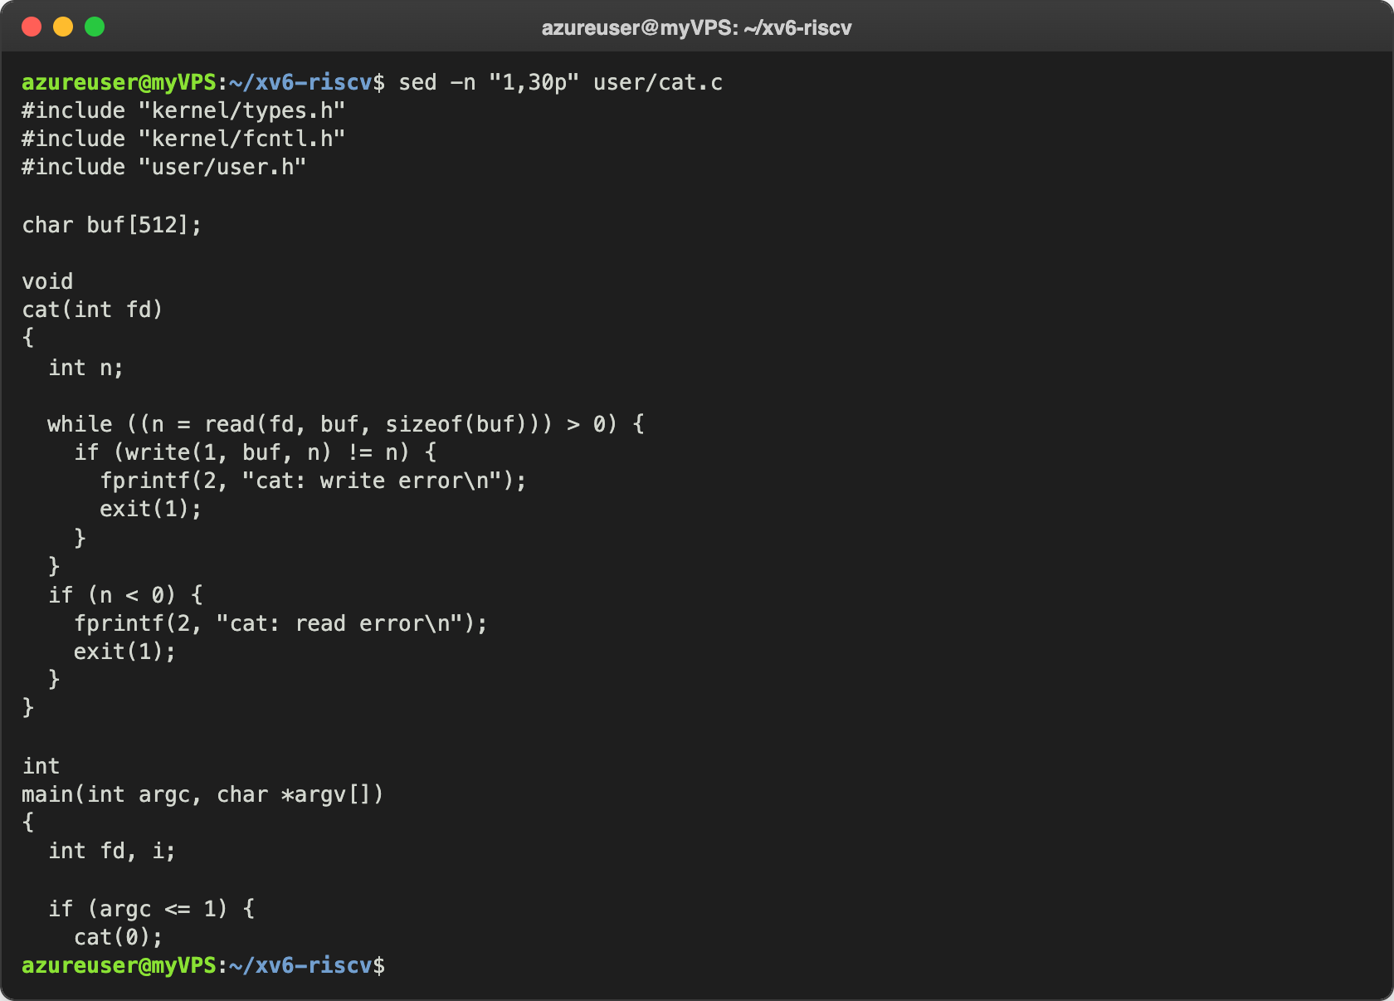
Figure 3.2 – The first 30 lines of user/cat.c
The whole work of cat is one loop: read() up to 512 bytes into buf, then write() them to file descriptor 1, until read() returns 0. To see which functions are system calls I looked at user/user.h:
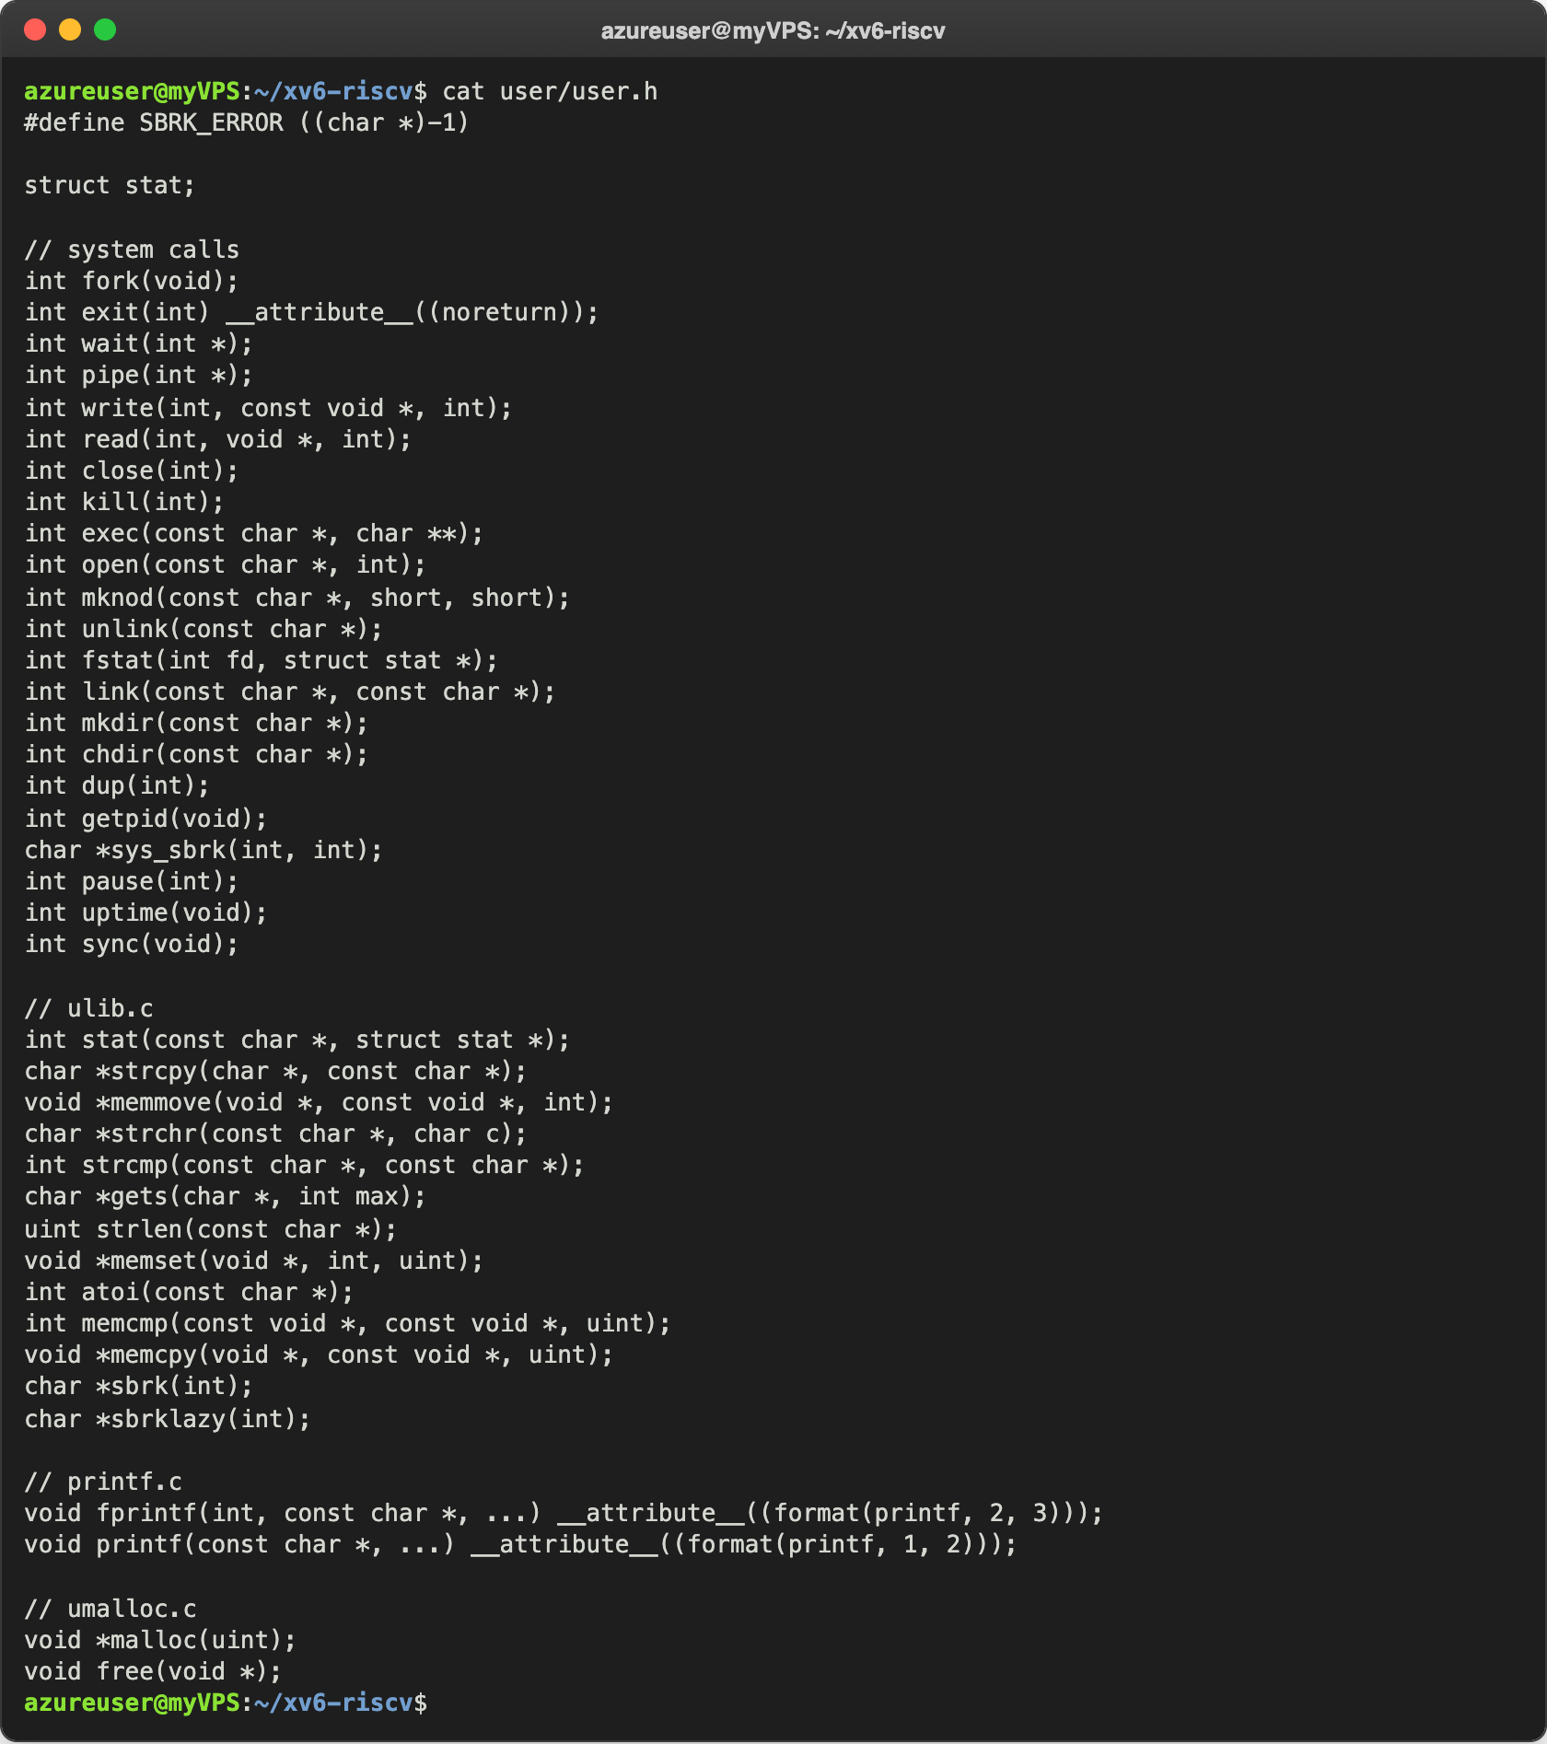
Figure 3.3 – user/user.h, the list of system calls available to programs
Everything under // system calls is a request into the kernel; the functions under // ulib.c and // printf.c are normal library code that runs in user space. Then I found where the kernel side is:
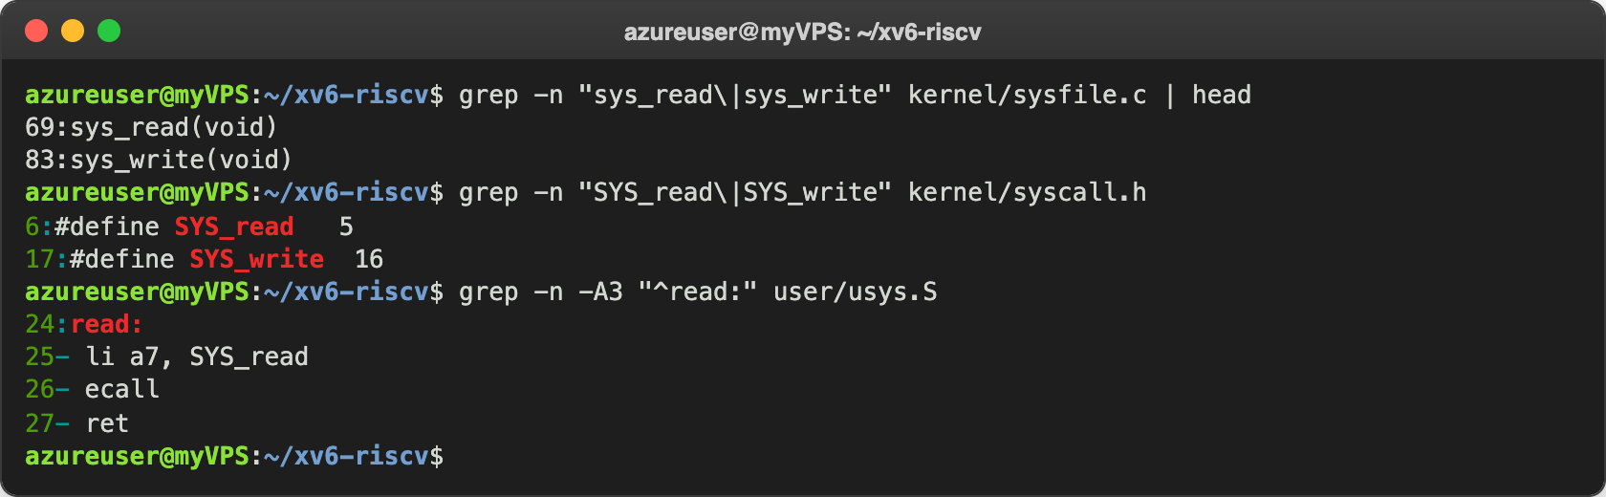
Figure 3.4 – Where sys_read is implemented and how read() enters the kernel
read() in a user program is only three instructions in user/usys.S: it puts the number SYS_read (5, from kernel/syscall.h) in register a7 and executes ecall. ecall switches the CPU into supervisor mode and jumps into the kernel, which looks up number 5 in its table of system calls and runs sys_read() in kernel/sysfile.c.

Observe
- Which system calls does user/cat.c use, and what does each one ask? open(path, O_RDONLY) asks the kernel to open a file and give back a file descriptor; read(fd, buf, 512) asks it to copy up to 512 bytes from that file into buf; write(1, buf, n) asks it to write n bytes to file descriptor 1, the console; close(fd) says we are done with the file descriptor; exit(0) or exit(1) ends the process and gives the status to the parent. fprintf(2, ...) for the error messages also ends in a write, on file descriptor 2.
- Where is sys_read implemented? In kernel/sysfile.c, on line 69 (and sys_write on line 83). It takes the arguments (the file descriptor, the address of the buffer and n) and calls fileread().
- The difference between kernel/ and user/. The code in kernel/ is the OS itself and runs in privileged (supervisor) mode with access to all the memory and hardware, while the code in user/ are normal programs that run in user mode and can only ask the kernel for things through system calls.

Part 4. Write your first xv6 program
I created user/sleep.c exactly as in the lab and added $U/_sleep\ to UPROGS in the Makefile, but the build failed:
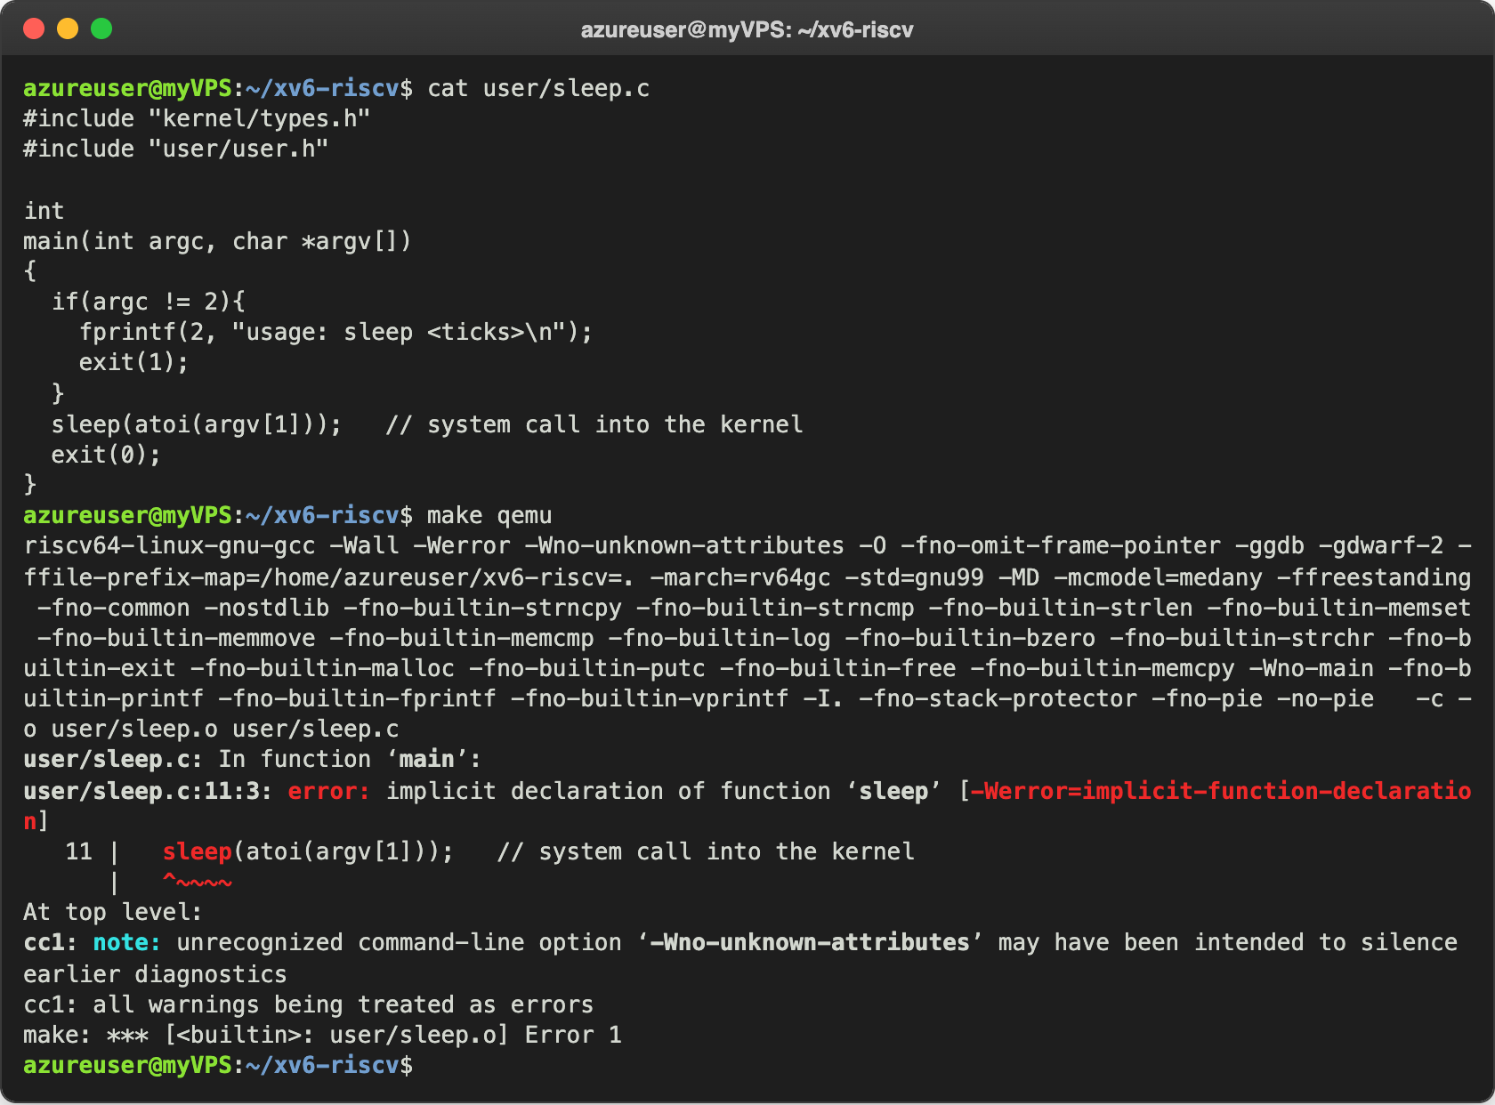
Figure 4.1 – The sleep.c from the lab does not compile
The compiler says implicit declaration of function 'sleep', so sleep() is not declared anywhere. I searched user/user.h and the git history:
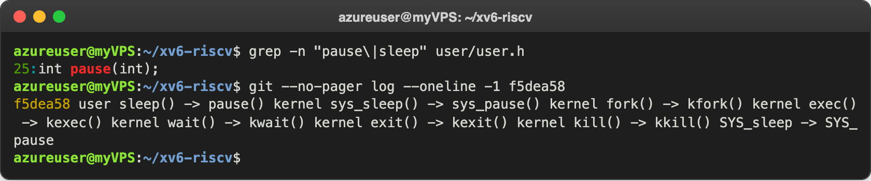
Figure 4.2 – user.h only has pause(), and the commit that renamed it
In the current xv6 the system call is not called sleep any more. Commit f5dea58 (August 2025) renamed it to pause (SYS_sleep became SYS_pause and sys_sleep() became sys_pause()). The same commit also renamed kernel functions like fork() to kfork() and exec() to kexec(); I think the reason is that the kernel has its own internal sleep() and the names were getting mixed up. It is the same system call, only the name is different, so in my program I call pause():
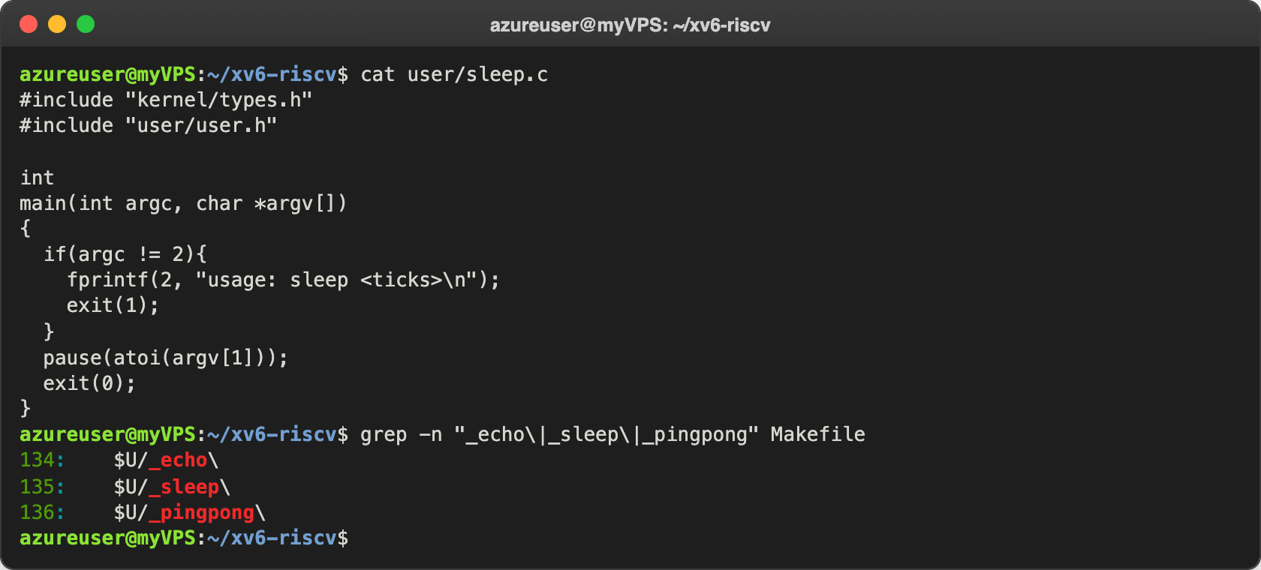
Figure 4.3 – My sleep.c and the UPROGS lines in the Makefile
$U/_sleep\ is on line 135 of the Makefile, right after $U/_echo\. The line starts with a TAB and ends with the backslash. After that make qemu compiled without errors and I tested the program inside xv6:
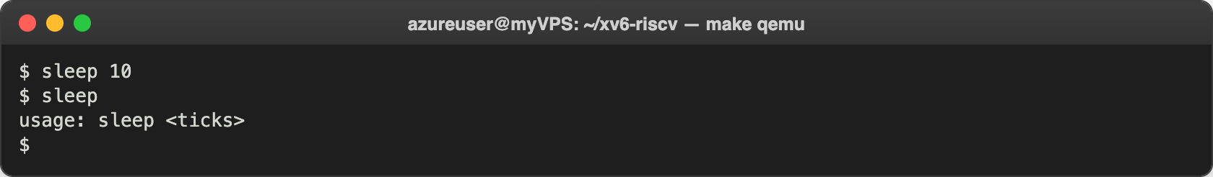
Figure 4.4 – sleep inside xv6, with and without an argument
sleep 10 waited about one second before the prompt came back, and sleep without an argument printed my usage message. I also measured it from outside: sleep 10 took 1.02 s, sleep 50 took 5.07 s and sleep 100 took 10.13 s, so one tick is about 0.1 s. That matches the comment in kernel/trap.c, where the timer interrupt is set to 1000000 cycles, "about a tenth of a second". On the kernel side, sys_pause() in kernel/sysproc.c waits in a loop until the global ticks counter has grown by n.

Optional task. pingpong
I also wrote user/pingpong.c and added $U/_pingpong\ to UPROGS (line 136):
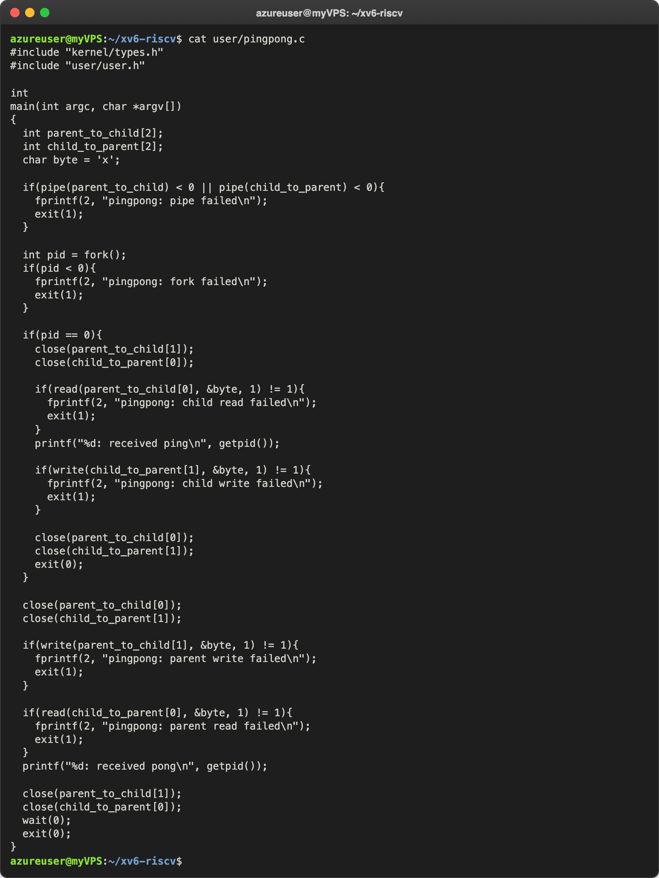
Figure 5.1 – user/pingpong.c
It makes two pipes, one from the parent to the child and one from the child to the parent, because a pipe only works in one direction. Then it calls fork(). The parent writes one byte into the first pipe; the child reads it, prints received ping and writes the byte back into the second pipe; then the parent reads it and prints received pong, and waits for the child to finish. Each side closes the pipe ends it does not use.
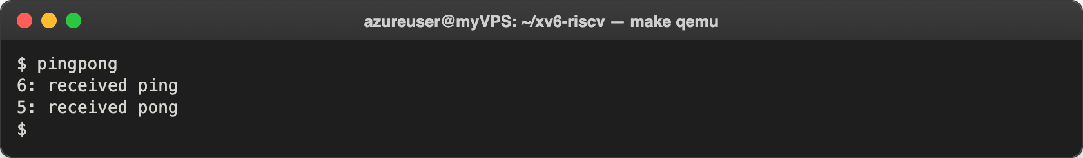
Figure 5.2 – pingpong running inside xv6
The numbers are PIDs. After the boot the shell is PID 2, and every command I typed got the next PID: sleep 10 was 3, sleep was 4, so pingpong was 5 and its child got 6. The order is always ping first, because the parent is blocked in read() until the child sends the byte back.

Conclusions
In this lab I built and booted a whole operating system from source in a few seconds, and saw that it already behaves like a real Unix: it has files, a shell, pipes and a test suite that passed completely. On Linux in Lab 1 I could only look at the OS from the outside; in xv6 I can read both sides, the program that asks (user/cat.c) and the kernel code that answers (sys_read in kernel/sysfile.c), and follow a system call from ecall into the kernel.
Writing sleep showed me how a new program is added: a C file in user/ and one line in UPROGS. I also learned that the lab text and the code can get out of sync: the build error made me look in user.h and in the git history, where I found that sleep() had been renamed to pause(). pingpong was a good small example of fork(), pipes and how a blocking read() keeps two processes in order.
Repository: https://github.com/httpcatalin/os-2026-CatalinBitca (folder lab2/).

