
TECHNICAL UNIVERSITY OF MOLDOVA
Faculty of Computers, Informatics and Microelectronics
Department of Software Engineering
REPORT
on laboratory work no. 3
Course: Operating Systems
Topic: The Command Line: Shell, Pipes and Text Filters
Done by: st. gr. FAF-242, Cătălin Bîtca
Checked by: Reițman Patricia
Chișinău, 2026

Purpose of the work
The purpose of this lab is to learn to work fast in bash and to understand what the shell does with a command line before the program even starts (globbing, quotes, variables, command substitution). I also practiced redirecting the output and the errors where I want them, joining small filters with pipes to answer questions about a log file, and at the end I wrote my first bash script and ran it with cron.

Work environment
I don't have Linux installed directly on my laptop, so I did the lab on my Linux virtual machine in Azure (Ubuntu 24.04.4 LTS, GNU bash 5.2.21), connected to it with ssh. First I ran the course script bash os2026-setup.sh. It installed the packages that were missing (man-db, cron, bc), checked the RISC-V compiler and QEMU, and booted xv6 once. The last line was All set.
Then I generated the data set for Part 4 exactly as given in the lab:
azureuser@myVPS:~$ mkdir -p ~/os-lab3 && cd ~/os-lab3
azureuser@myVPS:~/os-lab3$ for i in $(seq 1 500); do
> echo "2026-10-05 10:$(printf %02d $((i % 60))) user$((i % 7)) $([ $((i % 5)) -eq 0 ] && echo FAIL || echo OK) /page$((i % 4))"
> done > access.log
azureuser@myVPS:~/os-lab3$ head -3 access.log ; wc -l access.log
2026-10-05 10:01 user1 OK /page1
2026-10-05 10:02 user2 OK /page2
2026-10-05 10:03 user3 OK /page3
500 access.log
The check prints 500 access.log, so the file is correct.

Part 1. Move fast, find help

Tab completion
I typed ls /usr/sh and pressed Tab. Bash completed it right away to ls /usr/share/, because share is the only name in /usr that starts with "sh". The second Tab did nothing (just a beep), because inside /usr/share/ there are many names and bash did not know which one I want. Only after one more Tab it asked Display all 152 possibilities? (y or n). I answered n. Then I typed cd /et and pressed Tab once: it became cd /etc/ immediately, since /etc is the only match, and after Enter I was in /etc.
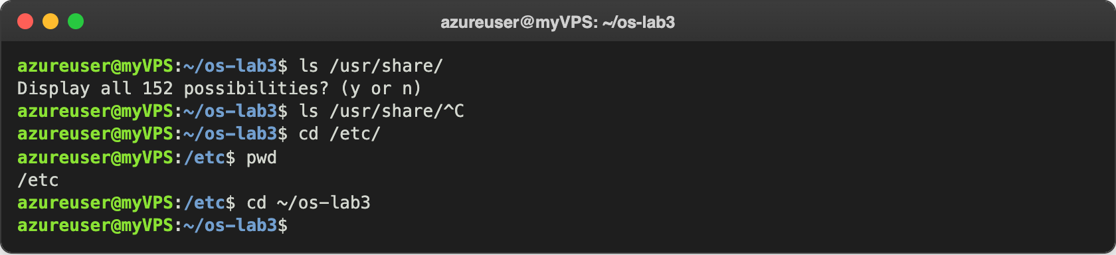
Figure 1.1 – Tab completion

History search with Ctrl+R
I ran three commands (date, uname -r, whoami), then pressed Ctrl+R and typed "dat". Bash searched backwards in the history and showed the last command that contains "dat". When I pressed Enter it ran date again, so I didn't have to type it.
azureuser@myVPS:~/os-lab3$ date
Tue Oct 6 11:24:25 UTC 2026
azureuser@myVPS:~/os-lab3$ uname -r
6.17.0-1022-azure
azureuser@myVPS:~/os-lab3$ whoami
azureuser
(reverse-i-search)`dat': date
--- after Enter ---
azureuser@myVPS:~/os-lab3$ date
Tue Oct 6 11:24:28 UTC 2026

Built-in or external, and where the shell looks
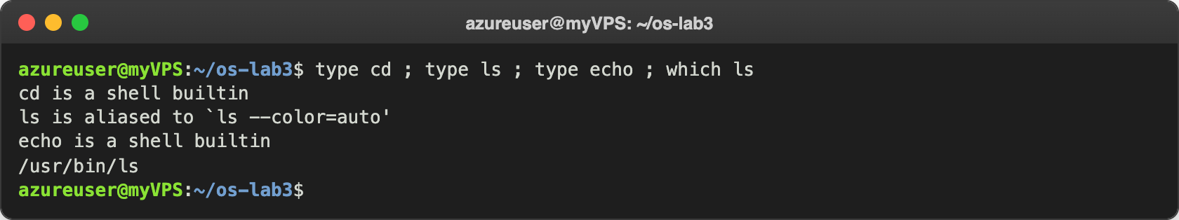
Figure 1.2 – Output of type and which
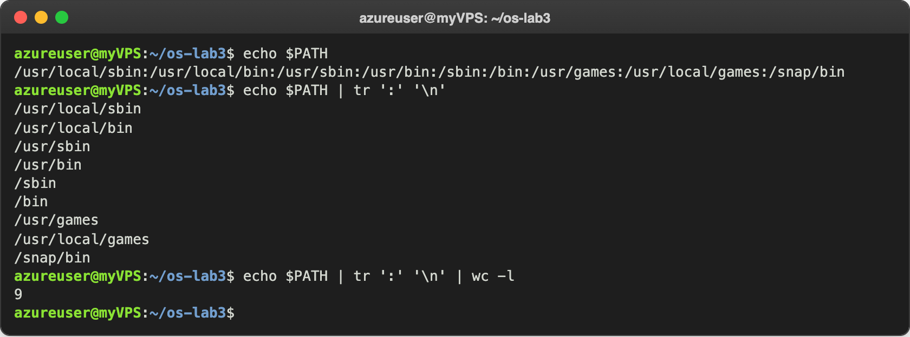
Figure 1.3 – The directories in PATH
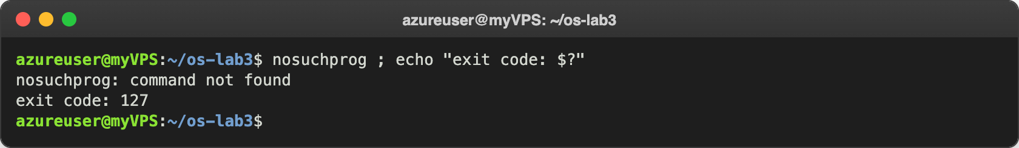
Figure 1.4 – Exit code of a missing command

Help without a browser
In man ls I searched with /sort and pressed n a few times until I got to the option that sorts by time. ls --help | head shows the short help, man -k "list directory" searches all the manual page descriptions, and help cd gives the help for a built-in command (built-ins don't have their own man page).
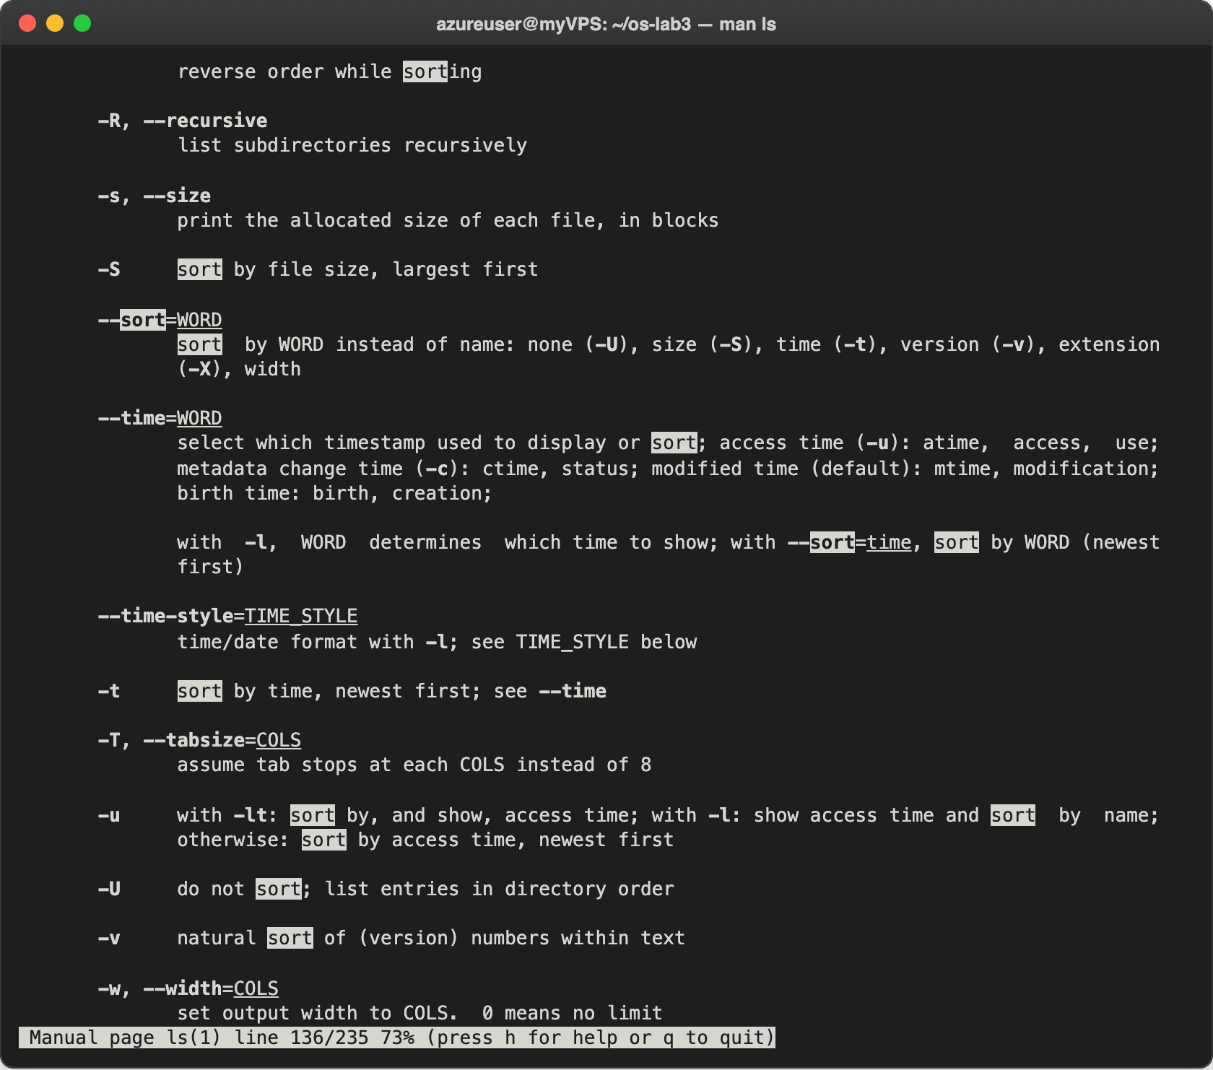
Figure 1.5 – Searching for "sort" inside man ls
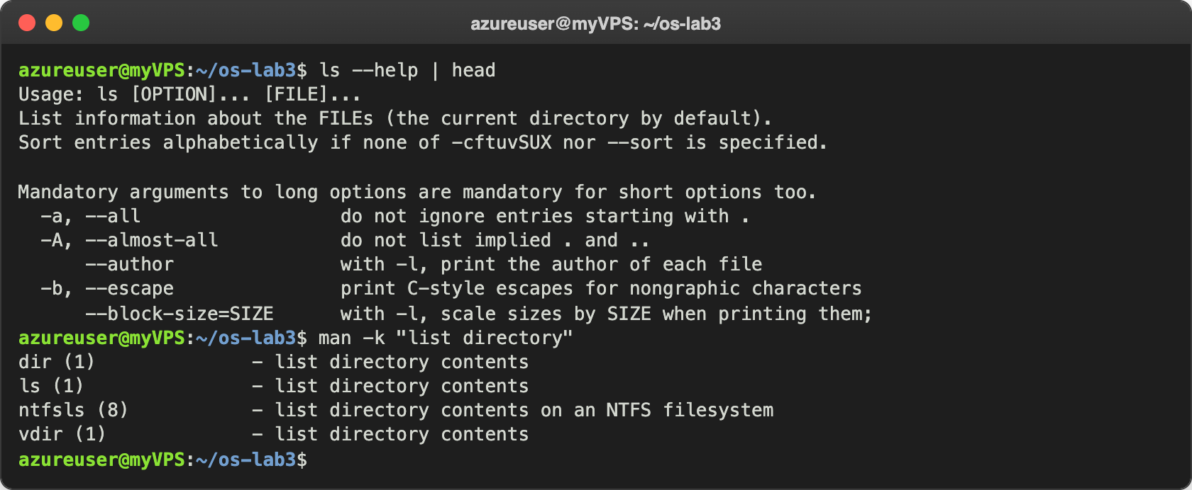
Figure 1.6 – ls --help and man -k "list directory"
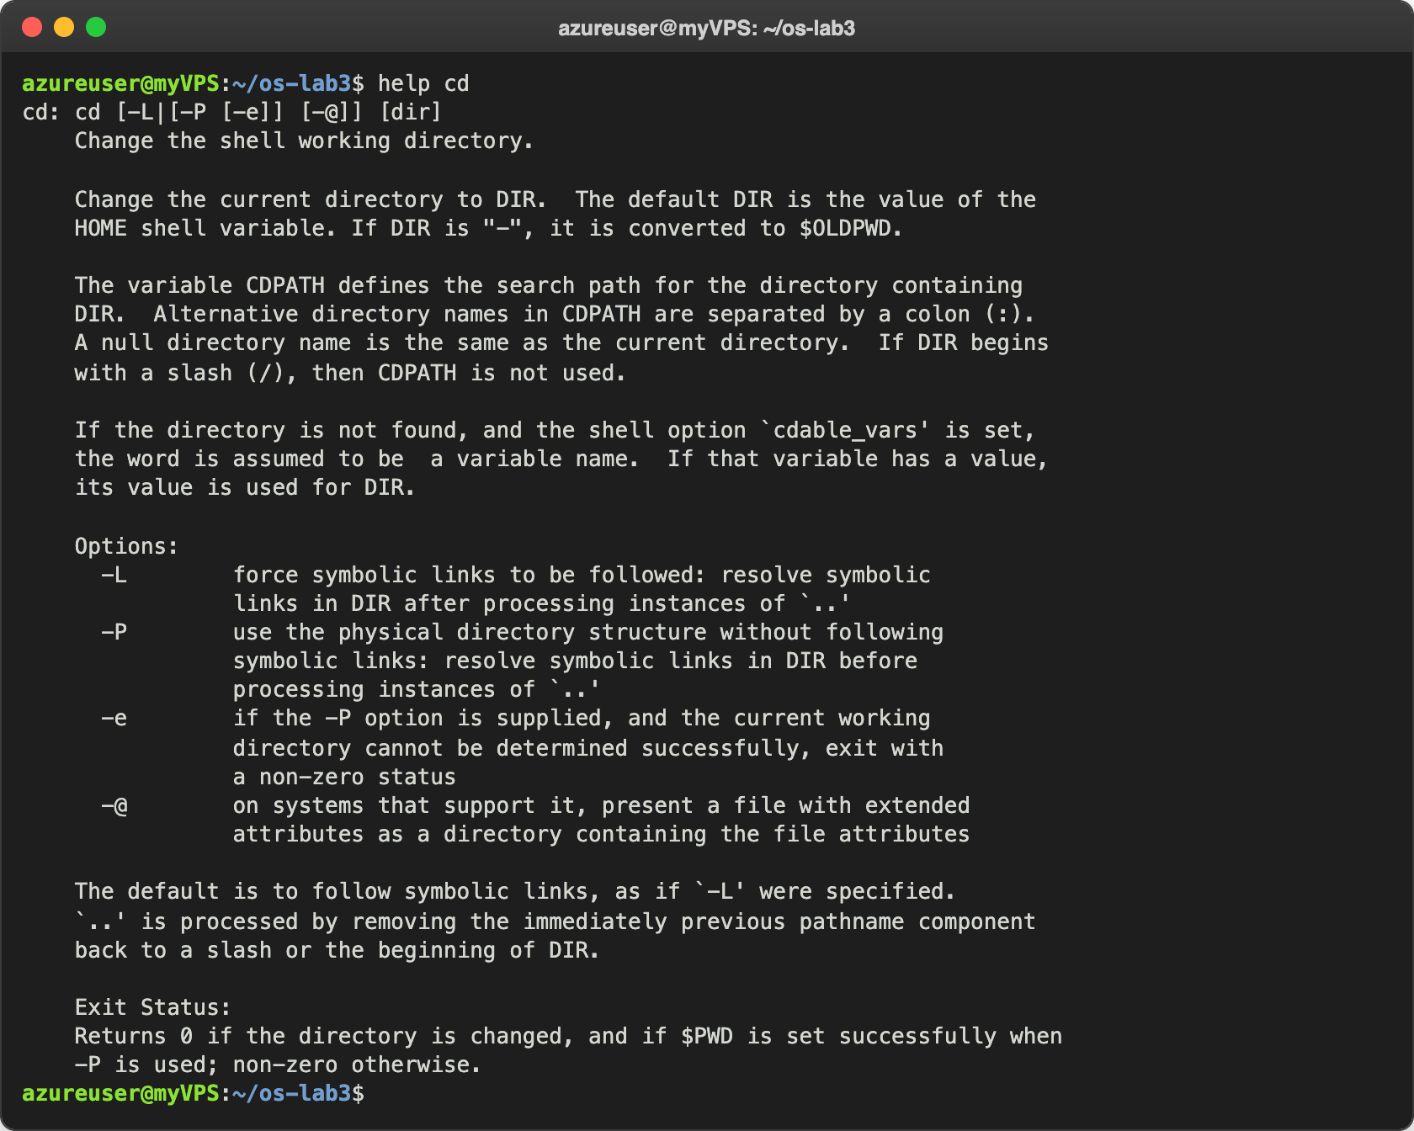
Figure 1.7 – help cd

Observe
- Which of cd, ls, echo are built-ins, and why must cd be one? cd and echo are shell built-ins (type says "is a shell builtin"). ls is not: type ls shows it is an alias for ls --color=auto, and which ls shows the real program is /usr/bin/ls. cd must be a built-in because the current directory belongs to each process. If cd was a separate program, bash would start it as a child process, the child would change its own directory and then exit, and my shell would stay where it was.
- How many directories are in PATH, and where is ls? There are 9 directories (echo $PATH | tr ':' '\n' | wc -l prints 9). ls is in /usr/bin.
- Exit code of a command that is not found: 127 (nosuchprog: command not found, exit code: 127).
- Which option of ls sorts by modification time? -t, "sort by time, newest first" (the long form is --sort=time; by default the time used is the modification time, mtime).

Part 2. What the shell does to your line
I created the test folder with the files from the lab:
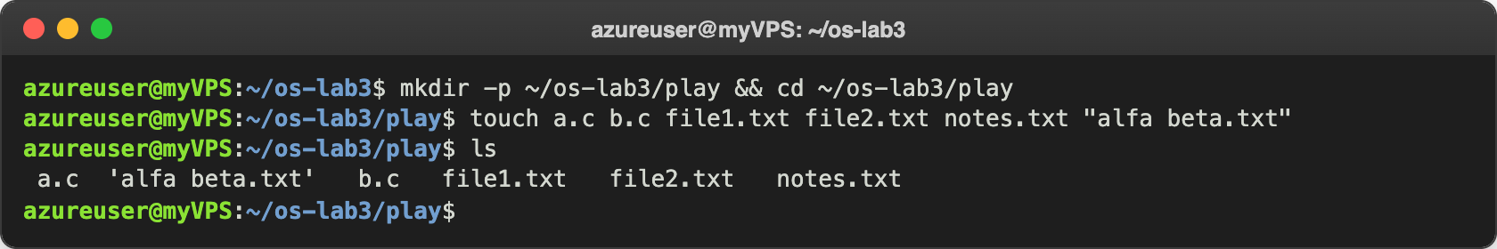
Figure 2.1 – Files created in the play directory
Before running each line I wrote my prediction first. The table shows my prediction, the real output and an explanation when they were different.
Command | My prediction | Real output | Explanation (if different)
echo *.c | a.c b.c | a.c b.c | –
echo file?.txt | file1.txt file2.txt | file1.txt file2.txt | –
echo [a-b]* | a.c b.c | a.c alfa beta.txt b.c | I forgot that "alfa beta.txt" also starts with "a". The space is part of the name, it is still one file.
echo *.xyz | an empty line | *.xyz | When nothing matches, bash leaves the pattern as it is and gives it to echo.
ls alfa beta.txt | 'alfa beta.txt' | two errors: cannot access 'alfa' and 'beta.txt' | Without quotes the space splits the name into 2 arguments.
ls "alfa beta.txt" | 'alfa beta.txt' | 'alfa beta.txt' | –
echo '$HOME' "$HOME" \$HOME | $HOME /home/azureuser /home/azureuser | $HOME /home/azureuser $HOME | The backslash escapes the $, so the third one is not expanded either.
echo {1..5} ; echo $((7 * 6)) | 1 2 3 4 5 and 42 | 1 2 3 4 5 and 42 | –
echo "today is $(date +%A), I am $(whoami)" | today is Tuesday, I am azureuser | today is Tuesday, I am azureuser | –
touch log{1..3}.txt && ls log* | log1.txt log2.txt log3.txt | log1.txt log2.txt log3.txt | –

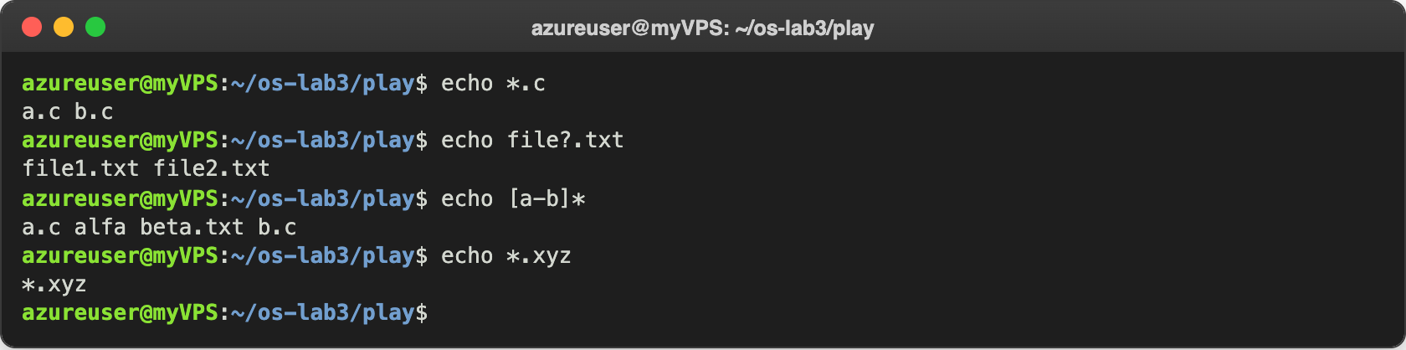
Figure 2.2 – Globbing results
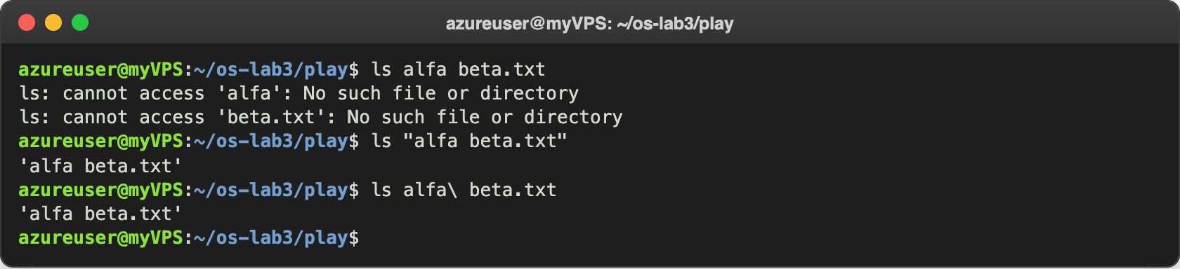
Figure 2.3 – The ls error on a name with a space, and the fix
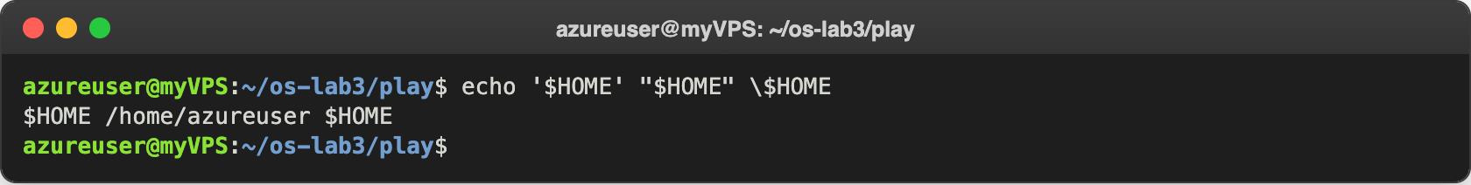
Figure 2.4 – Single quotes, double quotes and backslash
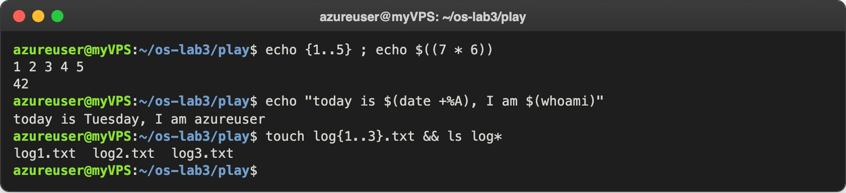
Figure 2.5 – Brace expansion, arithmetic and command substitution

Observe
- Prediction vs real output: see the table above. I got 3 wrong: echo [a-b]*, echo *.xyz and the backslash in \$HOME.
- echo knows nothing about files, so who produced the names? The shell. Bash expands *.c into the matching file names (globbing) before it starts echo, so echo just receives a.c and b.c as normal arguments and prints them.
- Why did ls alfa beta.txt fail, and two ways to fix it. Bash splits the line into words on spaces, so ls got two arguments, alfa and beta.txt, and neither file exists. Fix 1: put the name in quotes, ls "alfa beta.txt" (or single quotes). Fix 2: escape the space with a backslash, ls alfa\ beta.txt (this is also what Tab completion writes).
- Single vs double quotes: inside single quotes everything is literal, nothing is expanded ('$HOME' stays $HOME). Double quotes also keep the text as one argument with the spaces, but $VAR, $(command) and $((...)) are still expanded inside them.
Why ls shows 'alfa beta.txt' in quotes: when the output goes to a terminal, GNU ls puts quotes around names with special characters like spaces, so I can copy the name and paste it back as a correct argument. It's only for display: ls | cat prints the name without quotes.

Part 3. Redirection, chaining and jobs
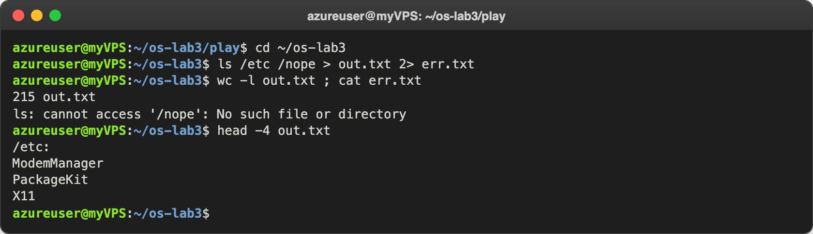
Figure 3.1 – stdout and stderr in separate files
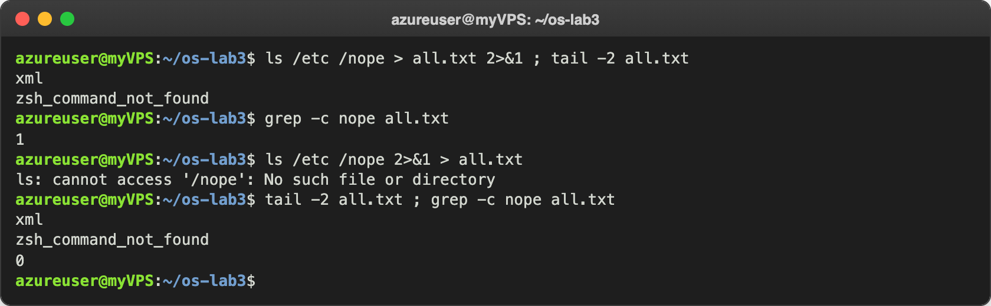
Figure 3.2 – Comparing the order of redirections
The next commands were appending to a file and giving a file as standard input:
azureuser@myVPS:~/os-lab3$ echo first > notes.md ; echo second >> notes.md ; cat notes.md
first
second
azureuser@myVPS:~/os-lab3$ wc -l < access.log
500
azureuser@myVPS:~/os-lab3$ wc -l access.log
500 access.log
> creates or overwrites the file, >> adds to the end, so notes.md has both lines.
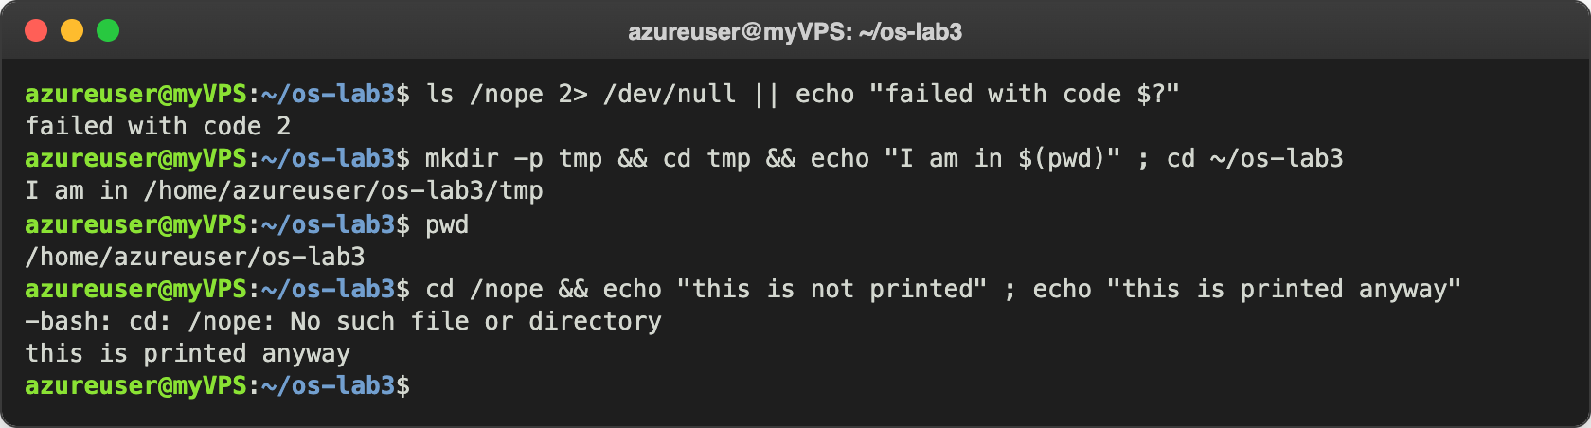
Figure 3.3 – The ; && || operators
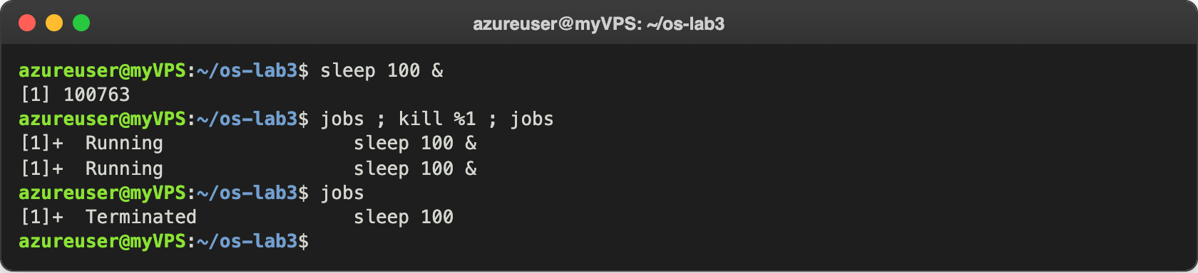
Figure 3.4 – Running a background job and stopping it
In Figure 3.4 the jobs right after kill %1 still showed Running, because the signal is delivered and the job status is updated a moment later. When I ran jobs again it showed Terminated.

Observe
- Which file got the error and which got the listing? err.txt got the error ls: cannot access '/nope': No such file or directory (stderr, fd 2). out.txt got the listing of /etc (stdout, fd 1): 215 lines, the header line /etc: (ls adds it because I gave it two arguments) plus 214 names.
- > all.txt 2>&1 vs 2>&1 > all.txt. Redirections are done from left to right. In > all.txt 2>&1 stdout first goes to the file and then stderr is pointed to the same place as stdout, so both go in the file (grep -c nope all.txt gives 1). In 2>&1 > all.txt, at the moment of 2>&1 stdout is still the terminal, so stderr is copied to the terminal; only after that stdout is moved to the file. That's why the error appeared on the screen and the file had only the listing (grep -c gives 0). 2>&1 copies where fd 1 points right now, it is not a permanent link.
- Why wc -l < access.log prints only a number. With < the shell opens the file and gives it to wc as its standard input, so wc just reads data and doesn't know any file name. With wc -l access.log it is wc itself that opens the file, so it knows the name and prints it.
- The operators: ; runs the next command always, no matter what happened before. && runs the next command only if the previous one succeeded (exit code 0). || runs the next command only if the previous one failed (exit code not 0), for example failed with code 2 from ls /nope.

Part 4. Answer questions with one-liners
Each line of access.log is: date, time, user, result (OK or FAIL) and page, separated by one space, so I used cut -d' ' with the field number: 2 = time, 3 = user, 4 = result, 5 = page.

Q1. How many requests failed?
grep -c FAIL access.log
100 requests failed. grep -c counts the matching lines instead of printing them.
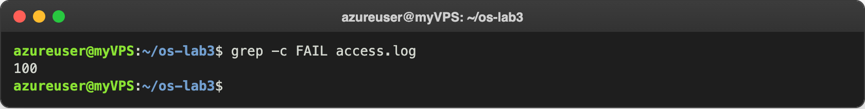
Figure 4.1 – Number of failed requests

Q2. How many different pages were requested, and which?
cut -d' ' -f5 access.log | sort -u ; cut -d' ' -f5 access.log | sort -u | wc -l
4 pages: /page0, /page1, /page2, /page3. sort -u sorts and keeps every value only once.
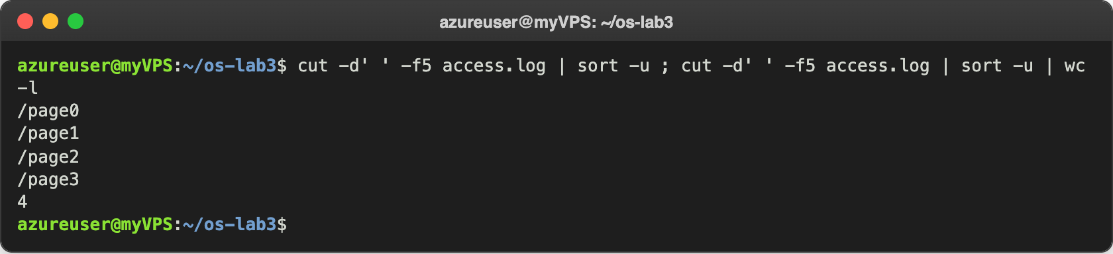
Figure 4.2 – Different pages requested

Q3. How many requests did each page get?
cut -d' ' -f5 access.log | sort | uniq -c
Every page got 125 requests. uniq -c counts equal lines that are next to each other, that's why I sort first. Check: 4 × 125 = 500, the same as the number of lines in the log.
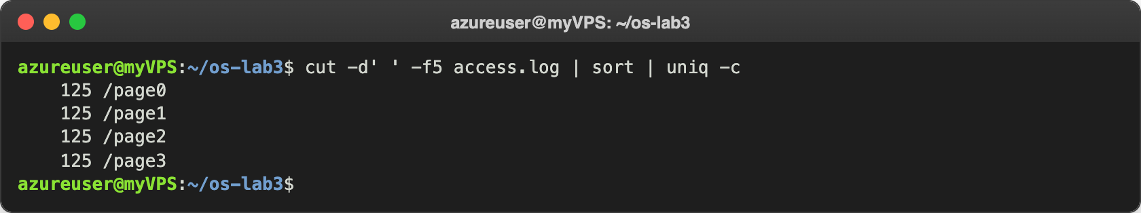
Figure 4.3 – Requests per page

Q4. Which user or users have the most failed requests, and how many?
grep FAIL access.log | cut -d' ' -f3 | sort | uniq -c | sort -rn
grep FAIL access.log | cut -d' ' -f3 | sort | uniq -c | sort -rn | grep "^ *$(grep FAIL access.log | cut -d' ' -f3 | sort | uniq -c | sort -rn | head -1 | tr -s ' ' | cut -d' ' -f2) "
user3 and user5, with 15 failed requests each (all the others have 14). The first line is the pattern from the lab and shows the full ranking. Because there is a tie, head -1 would show only one of them, so in oneliners.sh I used the second line: the inner $( ) takes the biggest count (15) from the first line of the ranking, and the outer grep keeps all the users with that count. Check: 15 + 15 + 5 × 14 = 100, the same as Q1.
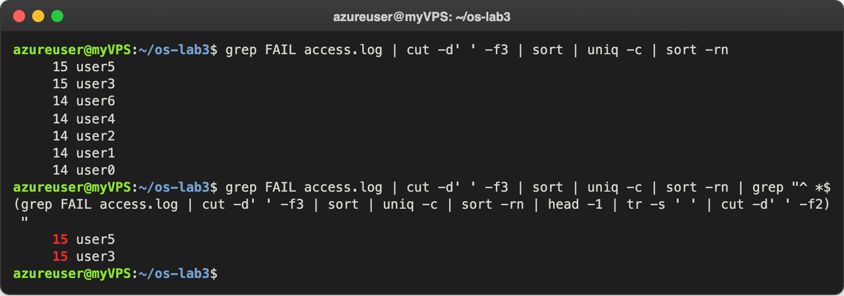
Figure 4.4 – Users with the most failed requests

Q5. How many requests did user3 make, and how many of them failed?
echo "user3: $(grep -cw user3 access.log) requests, $(grep -w user3 access.log | grep -c FAIL) failed"
user3 made 72 requests and 15 of them failed. I used -w so it matches only the whole word "user3".
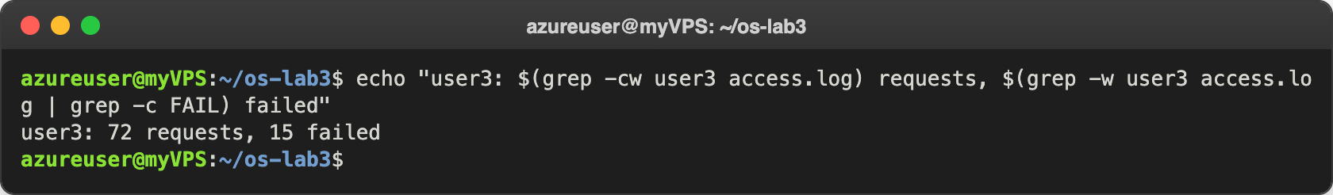
Figure 4.5 – Requests and failures of user3

Q6. Print the last 3 failed requests, showing only time and user.
grep FAIL access.log | tail -3 | cut -d' ' -f2,3
10:10 user0, 10:15 user5, 10:20 user3.
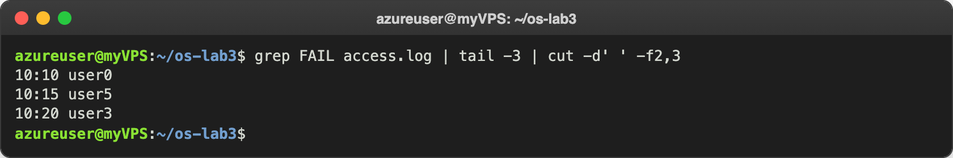
Figure 4.6 – The last 3 failed requests

Q7. Which login shells appear in /etc/passwd, and how many accounts use each?
cut -d: -f7 /etc/passwd | sort | uniq -c | sort -rn
/usr/sbin/nologin 28 accounts, /bin/false 3, /bin/bash 2 (root and azureuser), /bin/sync 1. Most accounts are system accounts that are not supposed to log in, that's why they have nologin or false.
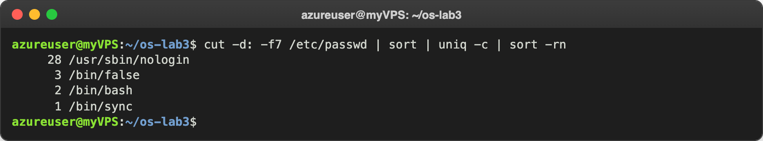
Figure 4.7 – Login shells in /etc/passwd

Q8. Why do ls /etc | wc -l and ls -l /etc | wc -l differ by exactly one?
ls /etc | wc -l ; ls -l /etc | wc -l ; ls -l /etc | head -1
My prediction: ls -l prints one extra line at the top. Real output: 214 and 215, and the extra line is total 1008. ls -l starts with a "total" line (the disk blocks used by the files listed), and after that it prints one line per file, same as ls (when the output goes into a pipe, plain ls also prints one name per line). So the difference is exactly that one line.
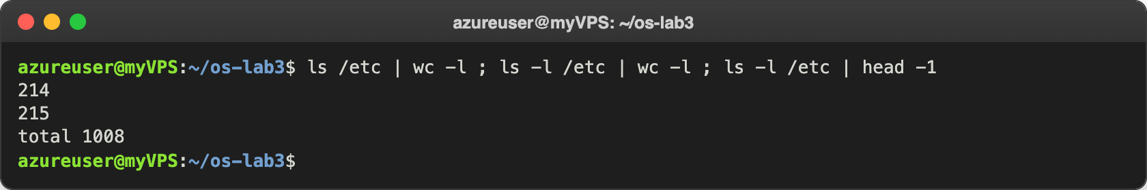
Figure 4.8 – ls vs ls -l line count

The file oneliners.sh and the full run
# Q1. How many requests failed?
grep -c FAIL access.log

# Q2. How many different pages were requested, and which?
cut -d' ' -f5 access.log | sort -u ; cut -d' ' -f5 access.log | sort -u | wc -l

# Q3. How many requests did each page get?
cut -d' ' -f5 access.log | sort | uniq -c

# Q4. Which user or users have the most failed requests, and how many?
grep FAIL access.log | cut -d' ' -f3 | sort | uniq -c | sort -rn | grep "^ *$(grep FAIL access.log | cut -d' ' -f3 | sort | uniq -c | sort -rn | head -1 | tr -s ' ' | cut -d' ' -f2) "

# Q5. How many requests did user3 make, and how many of them failed?
echo "user3: $(grep -cw user3 access.log) requests, $(grep -w user3 access.log | grep -c FAIL) failed"

# Q6. Print the last 3 failed requests, showing only time and user.
grep FAIL access.log | tail -3 | cut -d' ' -f2,3

# Q7. Which login shells appear in /etc/passwd, and how many accounts use each?
cut -d: -f7 /etc/passwd | sort | uniq -c | sort -rn

# Q8. Why do ls /etc | wc -l and ls -l /etc | wc -l differ by exactly one?
ls /etc | wc -l ; ls -l /etc | wc -l ; ls -l /etc | head -1

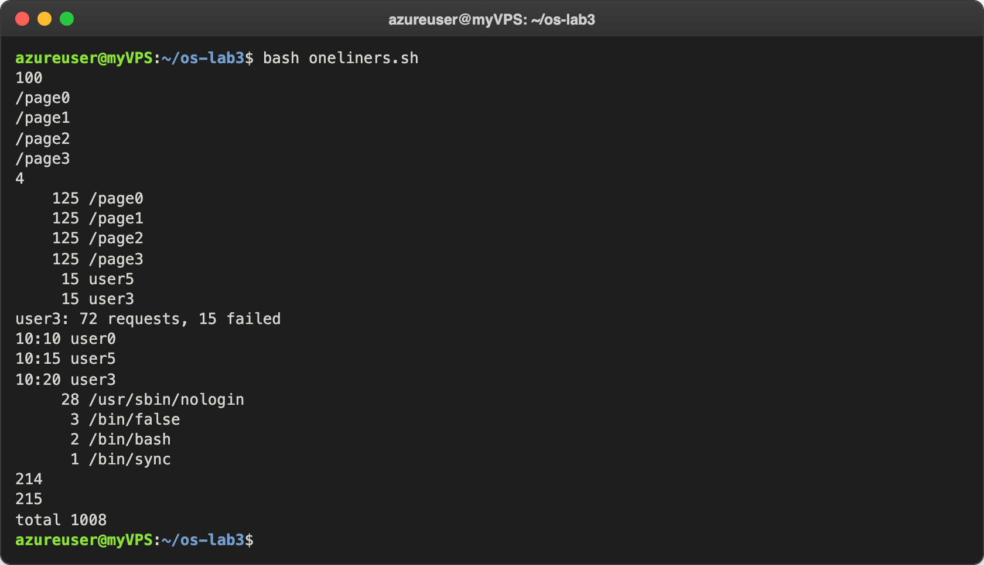
Figure 4.9 – Full run of oneliners.sh

Bonus: minute ends in 0 and the request failed
grep -E ' 10:[0-5]0 user[0-6] FAIL ' access.log
grep -cE ' 10:[0-5]0 user[0-6] FAIL ' access.log
There are 50 such lines. [0-5]0 matches the minutes 00, 10, 20, 30, 40, 50. It also makes sense from how the file is generated: the minute ends in 0 when i is a multiple of 10, and every multiple of 10 is also a multiple of 5, so all of these requests are FAIL, 500 / 10 = 50.
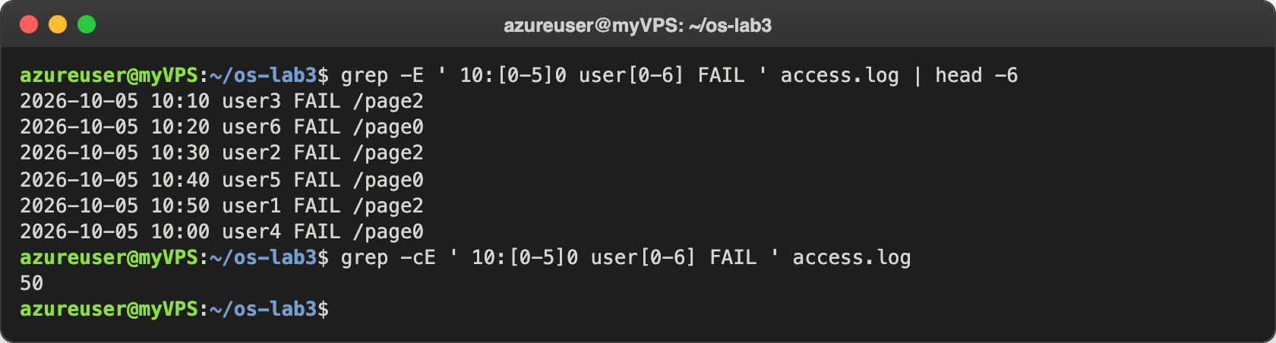
Figure 4.10 – Bonus: failed requests in minutes that end in 0

Part 5. Your first script
I created report.sh with the content from the lab and completed the TODO with a loop over the 7 users:
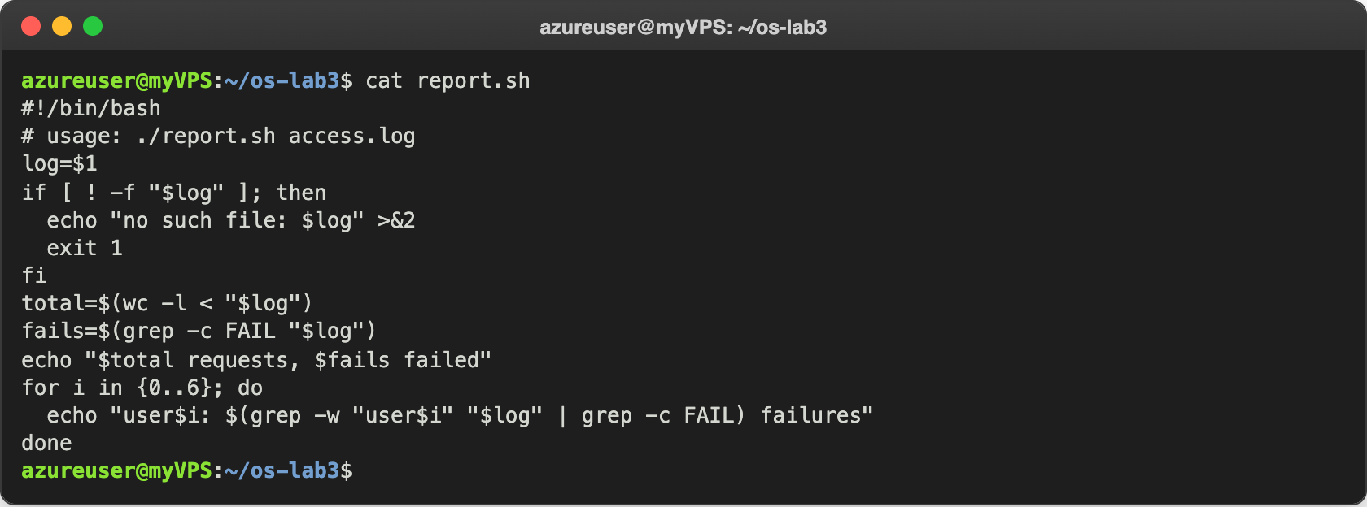
Figure 5.1 – Contents of report.sh
The first time I ran it without chmod +x and got Permission denied. After chmod +x report.sh it worked:
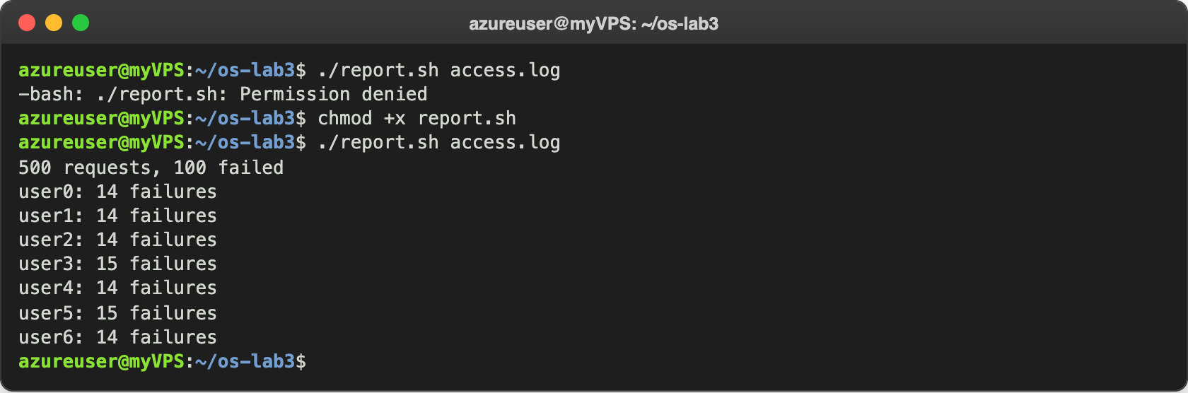
Figure 5.2 – Running the script on access.log
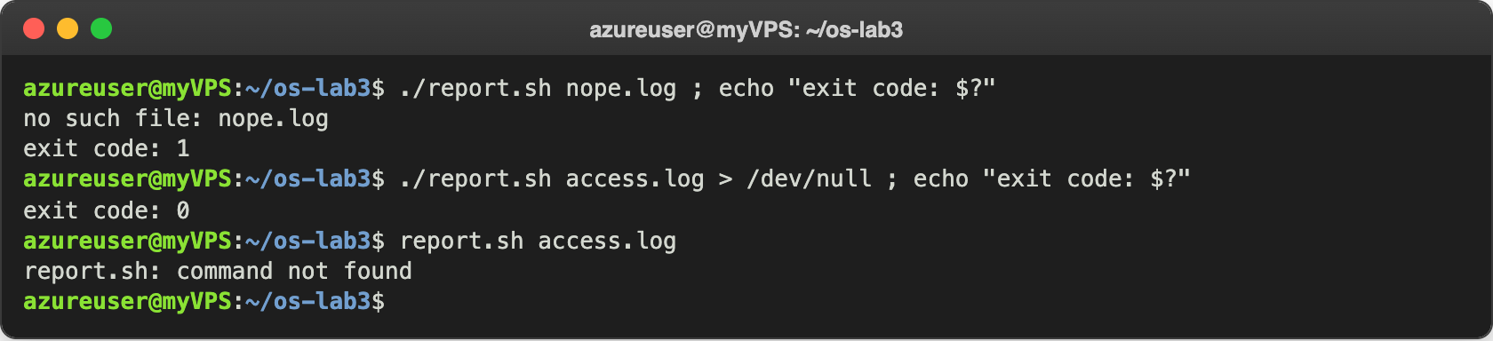
Figure 5.3 – Error handling for a missing file

Observe
- What does #!/bin/bash do, and what happens before chmod +x? It is the "shebang": when I run the file directly, the kernel reads the first line and starts /bin/bash to execute the script. Before chmod +x the file is only rw-r--r--, it has no execute permission, so I got -bash: ./report.sh: Permission denied.
- Why ./report.sh and not report.sh? The current directory is not in PATH (none of the 9 directories is .), so for report.sh bash searches only PATH and says command not found (Figure 5.3). ./ gives the exact path to the file, so no search is needed. It is also safer like this, otherwise a file with a fake name like ls in some folder could be run by mistake.
- Why >&2 and exit 1? >&2 sends the error message to stderr, so it doesn't mix with the normal output: if somebody redirects or pipes the output of the script, the error still shows on the screen and doesn't end up as data. exit 1 gives a non-zero exit code, which means "failed", so $?, &&, ||, other scripts or cron can see that something went wrong (exit code: 1, while a normal run gives exit code: 0).

Bonus: running it with cron
I opened the crontab with crontab -e (nano as editor) and added this line at the end:
* * * * * (date; /home/azureuser/os-lab3/report.sh /home/azureuser/os-lab3/access.log) >> /home/azureuser/os-lab3/report.log 2>&1
The five stars mean every minute of every hour, every day. I used full paths because cron runs the job from my home directory with a very short PATH, so ./report.sh or access.log alone would not be found. >> appends to report.log and 2>&1 puts the errors there too. I also added date so I can see when each run happened.
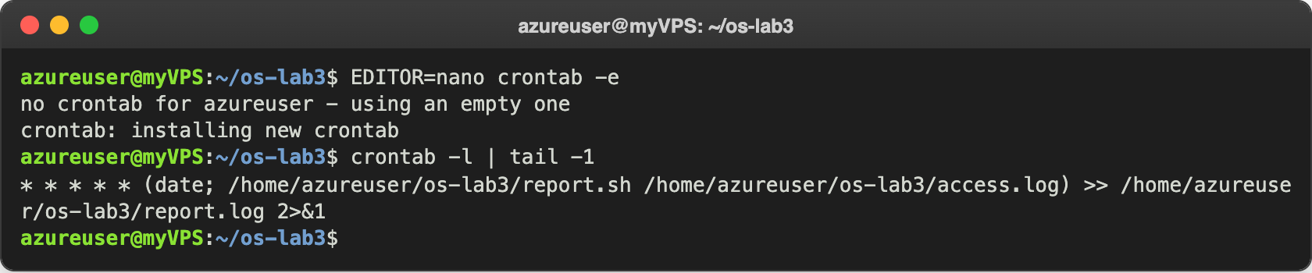
Figure 5.4 – The crontab line
After two minutes the log had two runs, at 11:28:01 and 11:29:01. Then I removed the crontab with crontab -r:
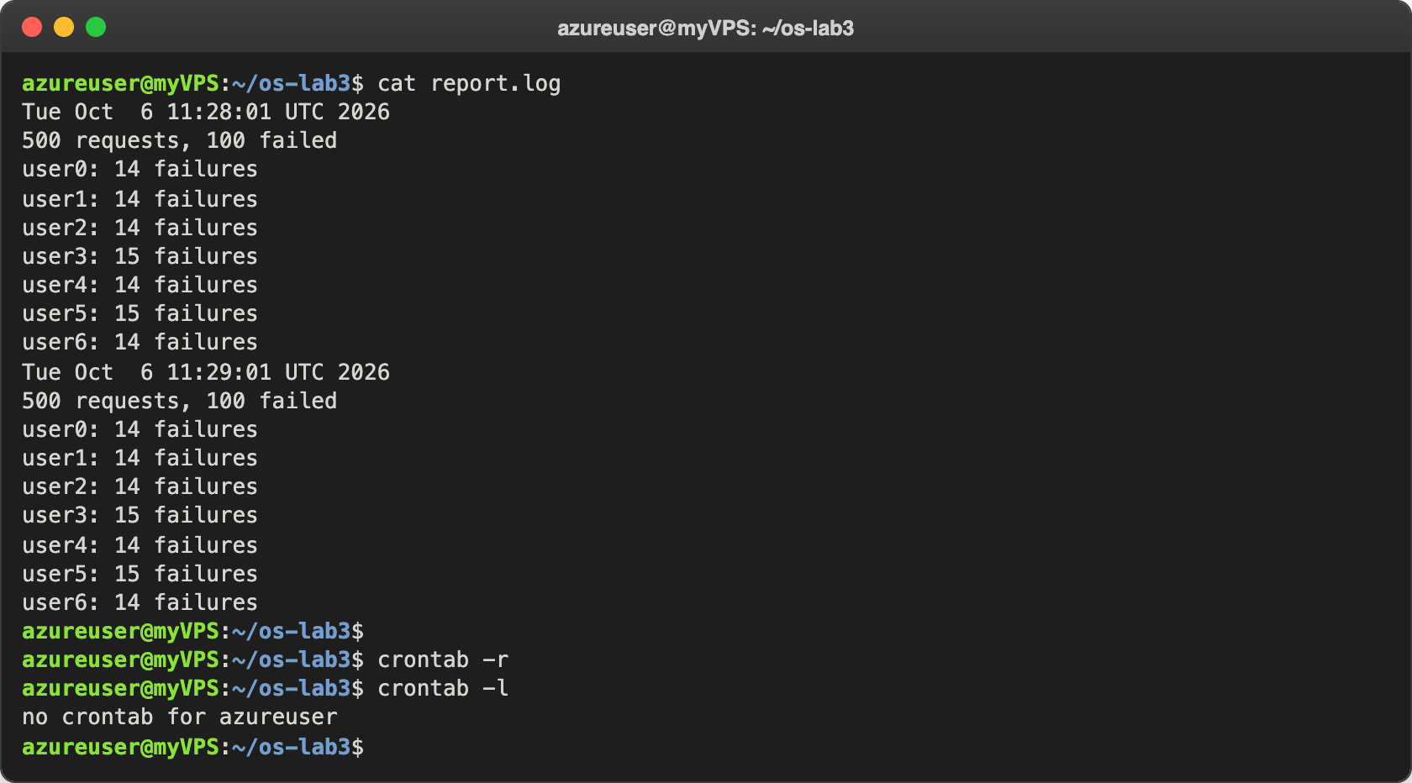
Figure 5.5 – report.log after two minutes, and removing the crontab

Conclusions
In this lab I understood that a lot of the work happens in the shell before the program even starts. The shell expands * and ? into file names, replaces $HOME and $(...), removes the quotes and splits the line into arguments. The program only gets the final list. That's why echo *.c prints file names even though echo knows nothing about files, and why a file name with a space breaks without quotes.
I also learned that every process has separate stdout and stderr, and that the order of redirections matters (2>&1 copies where stdout points at that moment). With ;, && and || and the exit code I can control what runs next. The most useful part for me was Part 4: with grep, cut, sort, uniq -c and wc joined by pipes I answered every question in one line, and the check (125 × 4 = 500 and the per-user failures adding up to 100) showed that my filters were correct. Finally I turned the one-liners into a real script with error handling and a proper exit code, and ran it automatically every minute with cron.
Repository: https://github.com/httpcatalin/os-2026-CatalinBitca (folder lab3/).

