
TECHNICAL UNIVERSITY OF MOLDOVA
Faculty of Computers, Informatics and Microelectronics
Department of Software Engineering
REPORT
on laboratory work no. 7
Course: Operating Systems
Topic: Three Small Programs: Processes, Redirection, a Pipe
Done by: st. gr. FAF-242, Cătălin Bîtca
Checked by: Reițman Patricia
Chișinău, 2026

Purpose of the work
The lecture asked three questions: how is a process born, where does printf write, and how does ls | wc -l work. In this lab I answered them by running three short C programs from the handout: run.c (fork, exec and wait), redirect.c (ls -l > out.txt) and pipeline.c (ls /etc | wc -l). I compiled each one, ran it, changed one line and looked at what happened. I also made a zombie on purpose and did the optional three-stage pipeline.

Work environment
Like in the previous labs, I worked on my Ubuntu 24.04 virtual machine in Azure over ssh, with gcc 13.3:
azureuser@myVPS:~$ mkdir -p ~/os-lab7 && cd ~/os-lab7
azureuser@myVPS:~/os-lab7$ gcc --version | head -1
gcc (Ubuntu 13.3.0-6ubuntu2~24.04.1) 13.3.0
I typed the programs from the handout without the comments; the code itself is the same line by line. All of them compiled with -Wall -Wextra without a single warning.

Part 1. fork + exec + wait
run.c does the three steps that the shell does for the command ls -l:
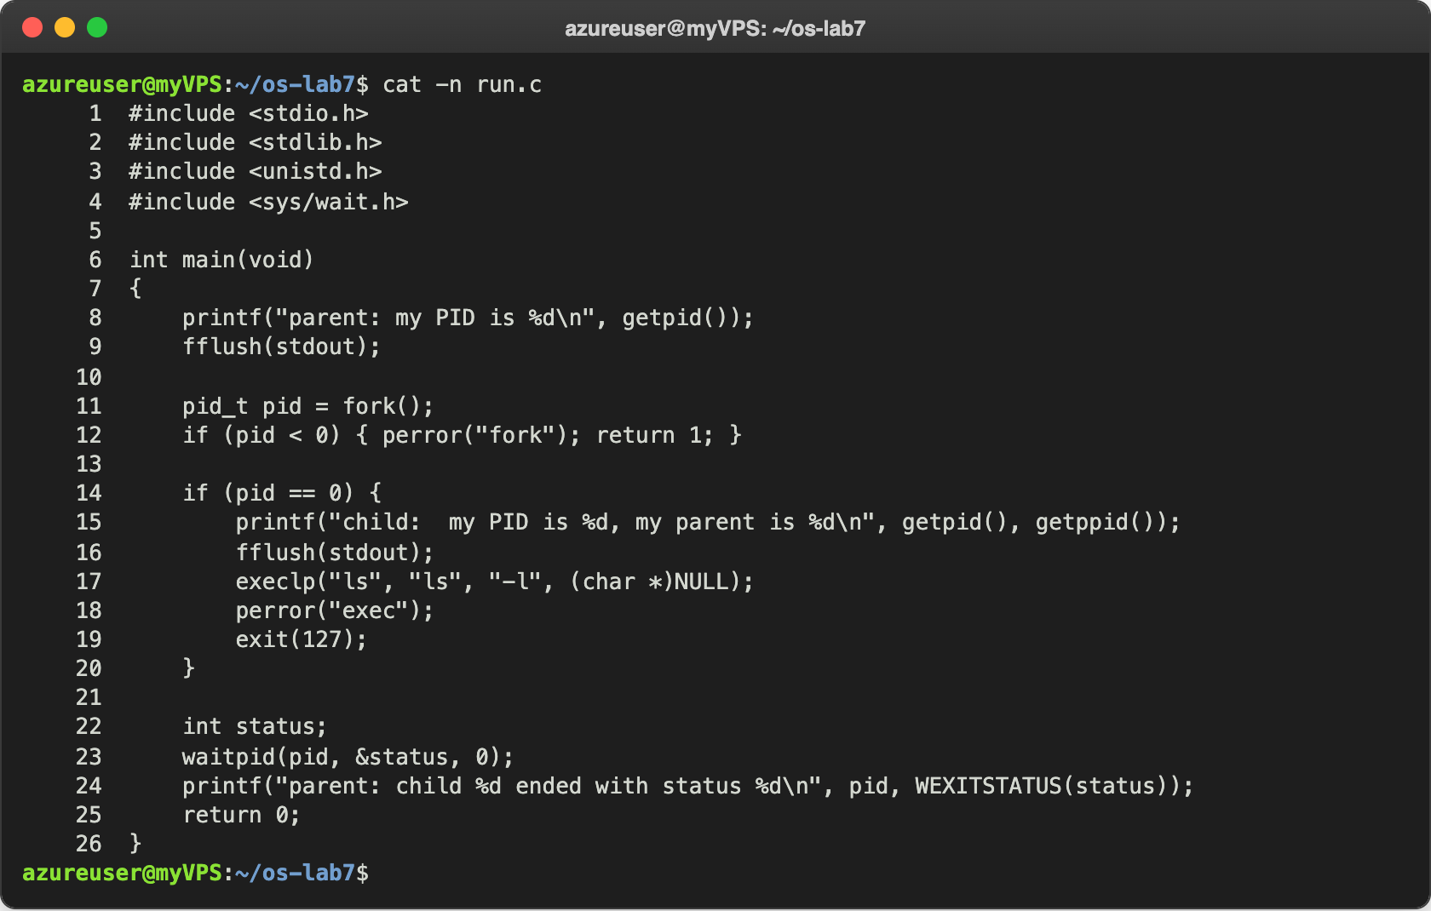
Figure 1.1 – run.c
fork() makes a copy of the process. Both copies continue from the same line, and the only difference is the value fork() returns: 0 in the child and the PID of the child in the parent. The child calls execlp, which replaces its program with ls. The parent calls waitpid, which blocks until the child ends and gives back its exit status. The fflush(stdout) calls are important. When the output goes to a file or a pipe, printf keeps the text in a buffer: without the flush before fork() the child would get a copy of the unwritten "parent:" line and print it a second time, and without the flush before execlp the "child:" line would be lost, because exec throws away the memory of the old program, buffer included.
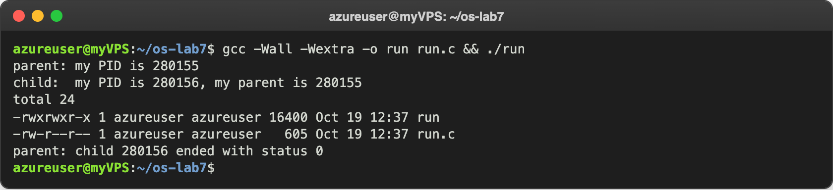
Figure 1.2 – run.c with ls -l
The order of the lines is the one from the handout: the parent, then the child, then the listing printed by ls (which shows run and run.c), and the last line of the parent only after ls ended. Then I changed the execlp line to run date:
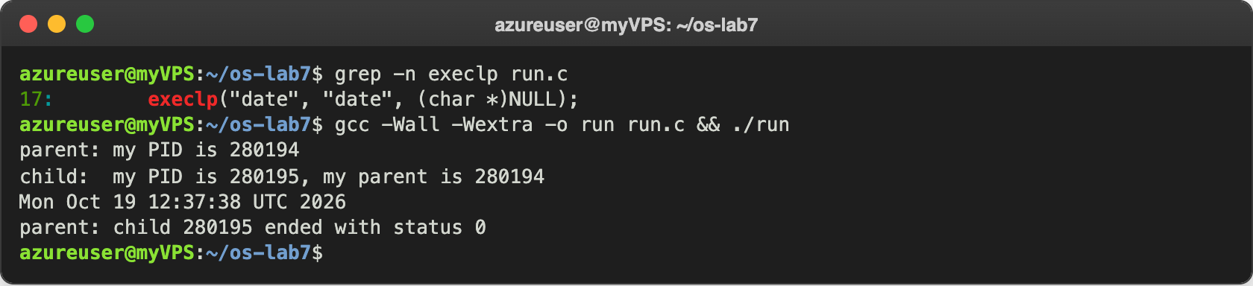
Figure 1.3 – The child becomes date
And then a program that does not exist:
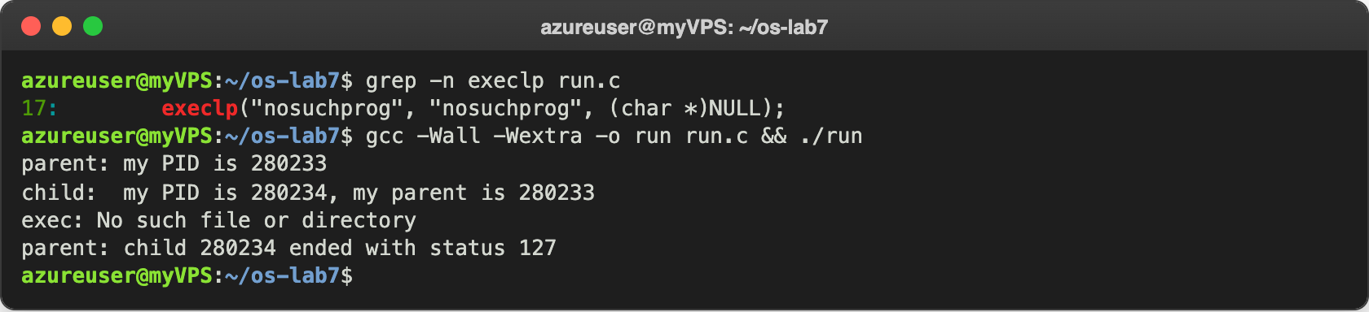
Figure 1.4 – The child tries to become nosuchprog

Observe
- Why is perror("exec") printed only with nosuchprog? When execlp succeeds, the program of the child is replaced completely by ls or date, so the lines after execlp do not exist anymore in that process and are never reached; execlp does not return at all. With nosuchprog, execlp cannot find the program in PATH, so it fails and returns -1. Only then does the child continue with the next line, perror("exec"), which prints "exec: No such file or directory", and then exit(127).
- Which number does the child print as "my parent", and whose PID is it? In Figure 1.2 the child prints "my parent is 280155". That is the PID of the parent, the run process itself: the first line says "parent: my PID is 280155". getppid() returns the PID of the process that called fork().
- What status does the parent see with ls, and with nosuchprog? With ls (and with date) the status is 0, which means success. With nosuchprog it is 127, the number the child passed to exit(127) after the failed exec. WEXITSTATUS(status) takes this number out of the status that waitpid returns. 127 is also the code the shell uses for "command not found".

Part 2. A zombie, on purpose
zombie.c is run.c with one more line, sleep(20);, just before waitpid. I started it in the background with its output thrown away and looked at the processes of my terminal while the parent was sleeping:
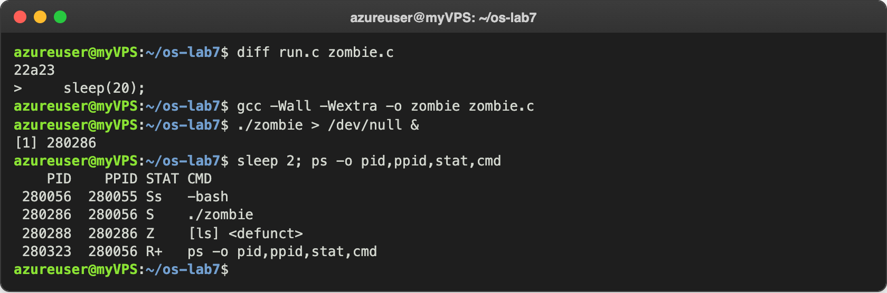
Figure 2.1 – zombie.c and the process table while the parent sleeps
ls finished almost immediately, but its parent ./zombie (PID 280286) was still in sleep(20) and had not called waitpid yet. Then I waited 20 seconds and looked again:
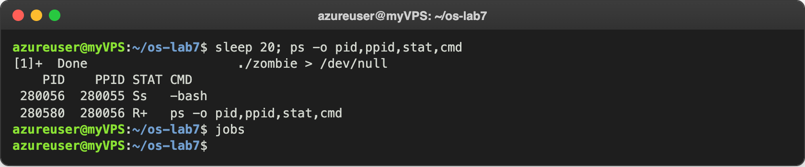
Figure 2.2 – The process table after 20 seconds

Observe
- Which letter does ls have in the STAT column, and what does it mean? Z, and ps shows it as [ls] <defunct>. It means zombie: the process has ended and freed its memory, but the kernel keeps its entry in the process table (the PID and the exit status) until the parent asks for the status with wait. The parent ./zombie has S, sleeping.
- After 20 seconds, is the [ls] <defunct> line still there? Which line made it disappear? No. Only bash and ps are left, and bash printed [1]+ Done ./zombie > /dev/null. The line that removed the zombie is waitpid(pid, &status, 0);, the one right after sleep(20);. It collected the exit status of ls, and after that the kernel deleted its entry. Then ./zombie itself ended, and bash, its parent, waited for it, so it did not stay a zombie either.

Part 3. Redirection: ls -l > out.txt
redirect.c does in the child what the shell does for ls -l > out.txt: it closes descriptor 1, opens the file, and runs ls:
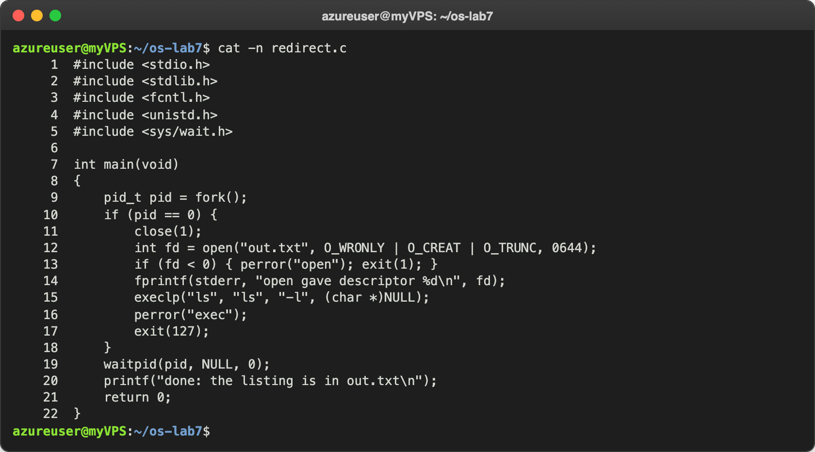
Figure 3.1 – redirect.c
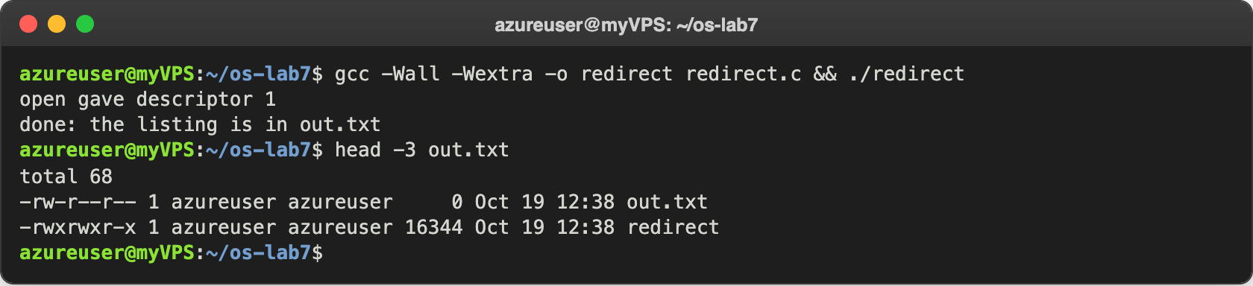
Figure 3.2 – redirect and the beginning of out.txt
The line "open gave descriptor 1" still appears on the screen, because the child prints it with fprintf(stderr, ...), to descriptor 2, which was not touched. "done: ..." is printed by the parent, whose descriptor 1 is still the terminal. The listing of ls is not on the screen, it is in out.txt.

Observe
- Which number did open give, and why exactly that one? It gave 1. open always returns the smallest free descriptor number. 0 (standard input) was still open, and 1 had just been closed with close(1), so 1 was the smallest free number.
- ls was not changed at all. Why does its listing not appear on the screen? Because ls simply writes to descriptor 1, as always; it does not know what is behind that number. Open descriptors are kept by exec, so in the child descriptor 1 was already out.txt when it became ls, and the listing went into the file. In the listing out.txt itself has size 0, because O_TRUNC emptied it and ls looked at the folder before writing anything into it.
- To redirect the errors instead (2> err.txt), which descriptor would you close? Descriptor 2, standard error. Then open would return 2 and everything the program writes to its errors would go into err.txt.

Part 4. A pipe: ls /etc | wc -l
pipeline.c builds the pipeline by hand, with one pipe and two forks:
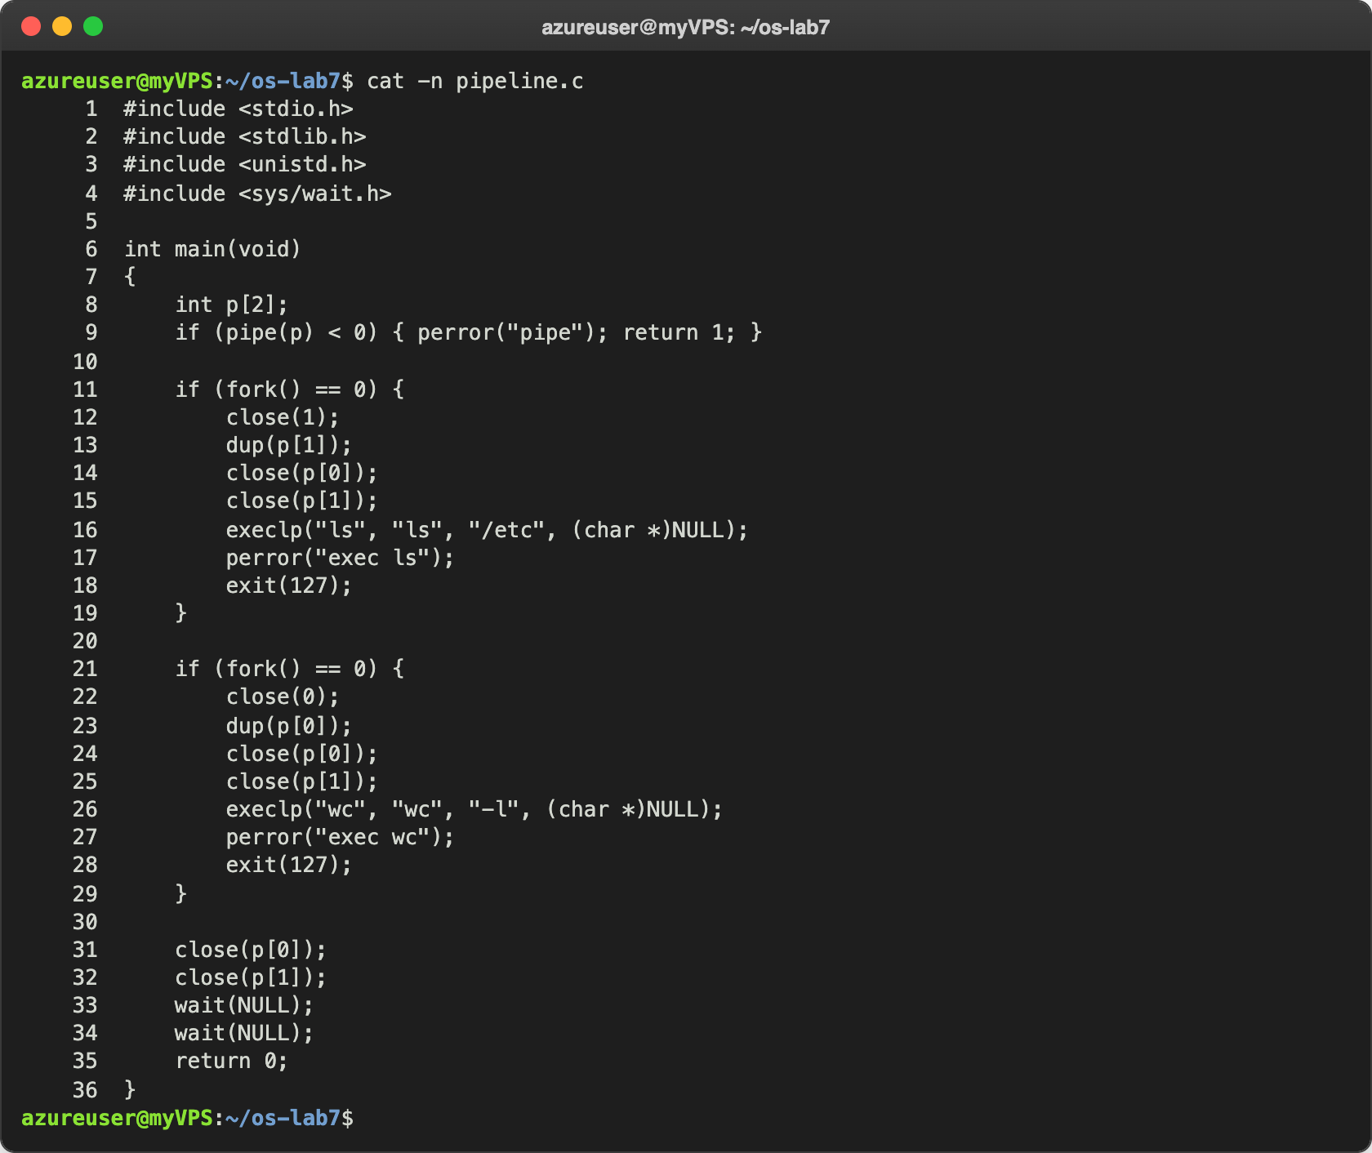
Figure 4.1 – pipeline.c
pipe(p) gives two descriptors: p[0] to read and p[1] to write. In the first child, close(1) and dup(p[1]) make descriptor 1 the writing end of the pipe (dup copies a descriptor into the smallest free number, exactly like open), and then ls writes into the pipe. In the second child, descriptor 0 becomes the reading end, so wc reads from the pipe. After dup, each child closes both original ends, and the parent closes both too, because it uses neither of them.
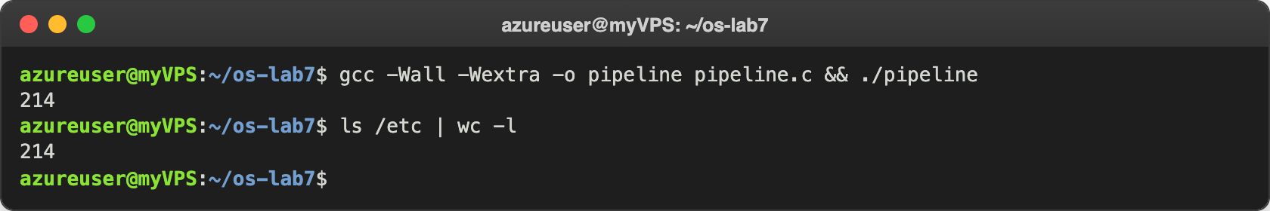
Figure 4.2 – pipeline compared with the real shell
Then I broke it on purpose: I removed the close(p[1]); of the parent (the handout says to turn it into a comment, which has the same effect). In Figure 4.3, grep shows that the parent now closes only p[0] (line 31). The program printed nothing and did not end, so I stopped it with Ctrl-C:
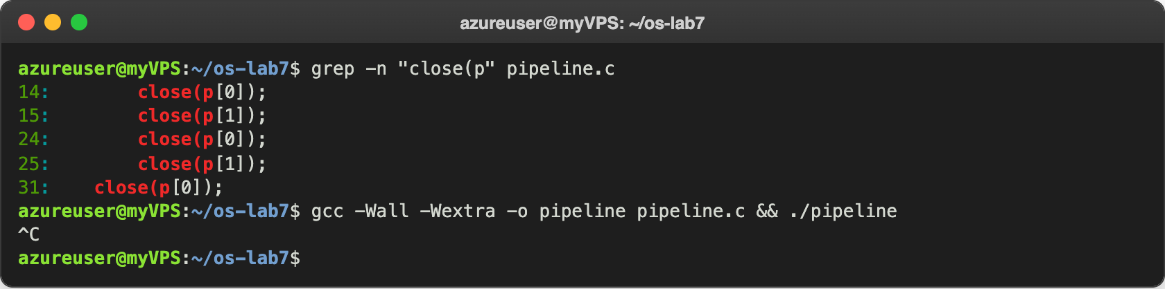
Figure 4.3 – pipeline without the close(p[1]) of the parent never ends
To see which child was stuck, I started the broken program in the background and looked at the processes, then killed only the parent ($! is the PID of the last background process):
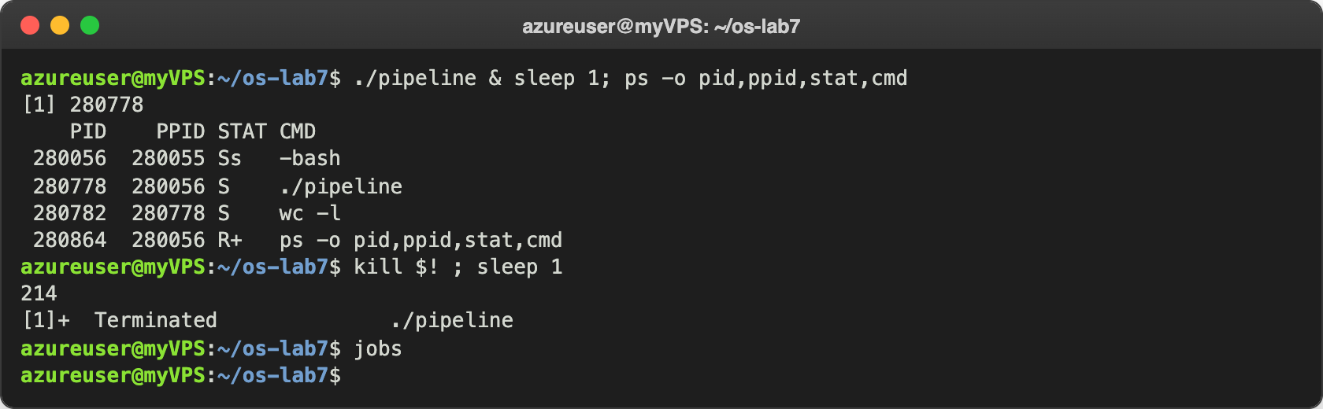
Figure 4.4 – Who is waiting, and what happens when the parent dies

Observe
- Did ./pipeline and ls /etc | wc -l give the same number? Yes, both printed 214.
- After the change, which child never ends, ls or wc? wc. In Figure 4.4 only ./pipeline and wc -l are still there, both sleeping (S). ls is gone: it wrote its 214 lines and ended, and the first wait(NULL) of the parent collected it. The parent is stuck in the second wait(NULL), waiting for wc.
- What is wc waiting for? wc waits for the end of the input (end-of-file), and a pipe gives end-of-file only when every write end of it is closed, but the parent still had p[1] open. This is shown in Figure 4.4: when I killed only the parent, its p[1] was closed by the kernel, and wc immediately printed 214 and ended.
Ctrl-C in Figure 4.3 stopped both the parent and wc, because the terminal sends the signal to every process of the foreground job. That is why nothing was printed there.

Optional task. Three stages
I also wrote pipeline3.c for ls /usr/bin | grep x | wc -l: two pipes and three children. grep is in the middle, so it gets both a new 0 (from the first pipe) and a new 1 (to the second pipe). Every child closes all four pipe ends after its dup, and so does the parent; I put the four close calls in a small function, close_all:
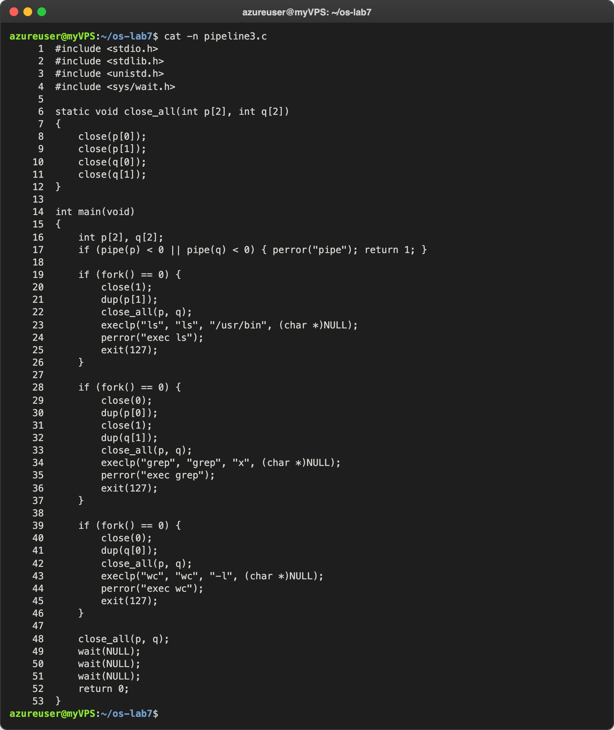
Figure 5.1 – pipeline3.c
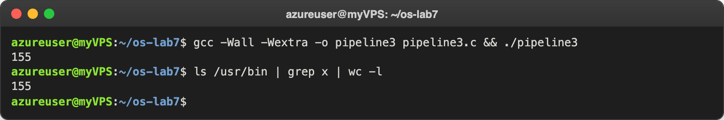
Figure 5.2 – pipeline3 compared with the real shell
Both print 155. Closing all the ends really matters here: if any process kept a write end open, grep or wc would wait for end-of-file forever, exactly like in Figure 4.3.

Conclusions
In this lab I saw that the shell builds every command from a few system calls. fork makes a copy of the process, exec replaces the program of that copy and returns only if it fails, and wait lets the parent wait for the child and read its exit status. A child that ended but was not waited for stays in the process table as a zombie until its parent calls wait.
Redirection and pipes are both the same trick with descriptors: close 0 or 1, then open or dup fills the smallest free number, and exec keeps it. The programs ls and wc were not changed at all; they write to 1 and read from 0 as usual. The broken pipeline showed the most important rule of pipes: the reader gets end-of-file only when every write end is closed, so every process must close the ends it does not use.
Repository: https://github.com/httpcatalin/os-2026-CatalinBitca (folder lab7/, with run.c, zombie.c, redirect.c, pipeline.c and pipeline3.c).

