**th:text**

**#{...}** s yntax 显示message(properties)

Properties文件如下：

properties_key=从properties文件中读取数据

html：

<p th:text="#{properties_key}">default message</p>

显示如下：



**th:utext** (for “unes caped text”): 不转义

Properties文件如下：

text_key=Welcome to our <b>fantastic</b>

html5:

<p th:text=*"'使用text:'+#{text_key}"*></p>

<p th:utext=*"'使用utext:'+#{text_key}"*></p>

页面显示：



显示变量**Using and displaying variables**

**${...} OGNL**

Thy表达式：

Simple expres s ions :

Variable Expres s ions : ${...}

Selection Variable Expres s ions : *{...}

Mes s ag e Expres s ions : #{...}

Link URL Expres s ions : @{...}

Literals

Text literals : 'one text' , 'Another one!' ,…

Number literals : 0 , 34 , 3.0 , 12.3 ,…

Boolean literals : true , false

Null literal: null

Literal tokens : one , sometext , main ,…

Text operations :

String concatenation: +

Literal s ubs titutions : |The name is ${name}|

Arithmetic operations :

Binary operators : + , - , * , / , %

Minus s ig n (unary operator): -

Boolean operations :

Binary operators : and , or

Boolean neg ation (unary operator): ! , not

Comparis ons and equality:

Comparators : > , < , >= , <= ( gt , lt , ge , le )

Equality operators : == , != ( eq , ne )

Conditional operators :

If-then: (if) ? (then)

If-then-els e: (if) ? (then) : (else)

Default: (value) ?: (defaultvalue)

Message:

**#{...} 表达式用来获取文本信息.**

**.properties配置文件如下:**

properties_key=从properties文件中读取数据

<p th:text="#{properties_key}">default message</p>

页面显示:



已**java.text.MessageFormat风格动态显示message内容:**

**Properties配置如下：**

**text_key2=变量1为{0},变量2为{1}**

**h5如下：**

**<p th:utext="#{text_key2(v1,v2)}">**

**页面显示如下：**



**Variables**

**${...} OGNl表达式显示变量值**

**Java 代码：**

WebContext ctx = **new** WebContext(request, response, servletContext, request.getLocale());

ctx.setVariable("today", Calendar.*getInstance*());

**<p>Today is: <span th:text="${today}">13 february 2011</span>.</p>**

等价于：

ctx.getVariables().get("today");

But OGNL allows us to create quite more powerful expres s ions , and that’s how this :

<p th:utext="#{home.welcome(${session.user.name})}">

Welcome to our grocery store, Sebastian Pepper!

</p>

…does in fact obtain the us er name by executing :

((User) ctx.getVariables().get("session").get("user")).getName();

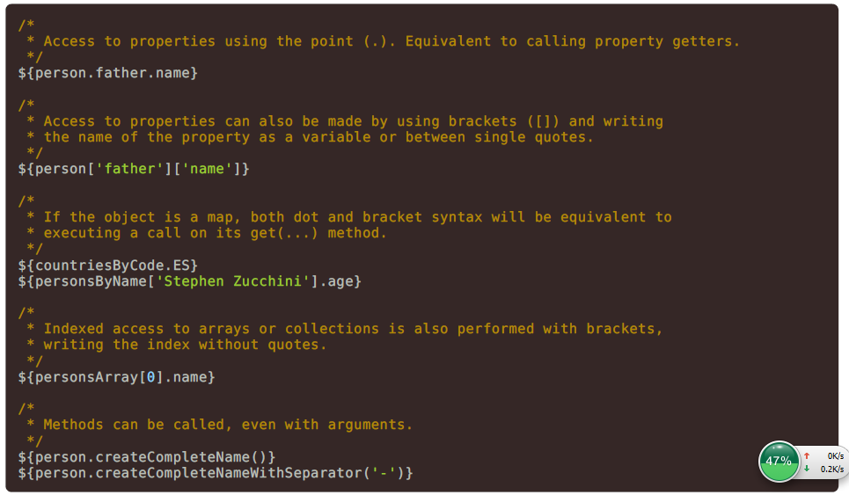

OGNL内置变量：

注意已#开头

**#ctx** : the context object.

**#vars:** the context variables .

**#locale** : the context locale.

**#httpServletRequest** : (only in Web Contexts ) the **HttpServletRequest** object.

**#httpSession** : (only in Web Contexts ) the **HttpSession** object

内置方法：

**#dates** : utility methods for **java.util.Date** objects : formatting , component extraction, etc.

**#calendars** : analog ous to **#dates** , but for **java.util.Calendar** objects .

**#numbers** : utility methods for formatting numeric objects .

**#strings** : utility methods for **String** objects : contains , s tartsWith, prepending /appending , etc.

**#objects** : utility methods for objects in g eneral.

**#bools** : utility methods for boolean evaluation.

**#arrays** : utility methods for arrays .

**#lists** : utility methods for lis ts .

**#sets** : utility methods for s ets .

Page 17 of 76

**#maps** : utility methods for maps .

**#aggregates** : utility methods for creating ag g reg ates on arrays or collections .

**#messages** : utility methods for obtaining externalized mes s ag es ins ide variables expres s ions , in the s ame

way as they would be obtained us ing #{…} s yntax.

**#ids** : utility methods for dealing with id attributes that mig ht be repeated (for example, as a res ult of an

iteration).

变量表达式另外的一种方式：

**\*{...} ：**针对选定的对象赋值.

There is an important difference, thoug h: the as teris k s yntax evaluates expres s ions on s elected objects rather than on

the whole context variables map. This is : as long as there is no s elected object, the dollar and the as teris k s yntaxes

do exactly the s ame.

And what is that object s election thing ? A **th:object** attribute. Let’s us e it in our us er profile ( **userprofile.html** )

pag e:

URL:

Literals: 文本