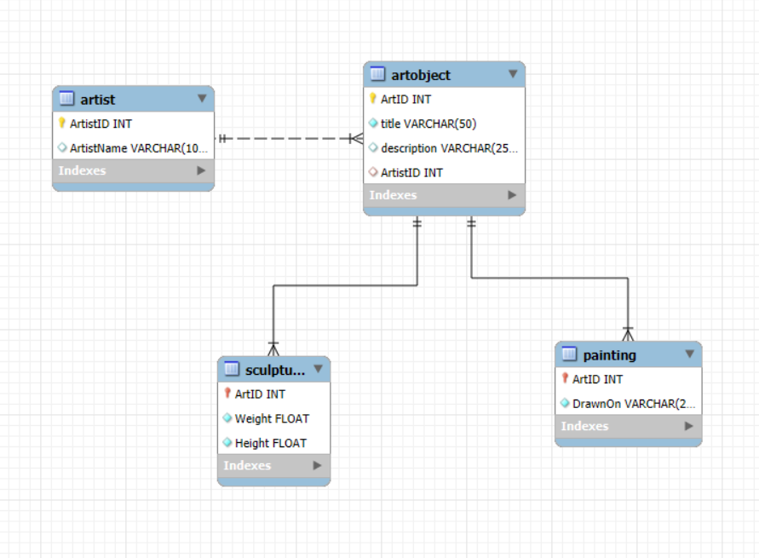

1. Create stored procedures for the following:
2. CRUD for Artist
3. CRUD for Art Object
4. CRUD for Painting
5. CRUD for Sculpture

*Try to test the stored procedures you created using these sample data.

ARTIST

|  |  |
| --- | --- |
| **ArtistID** | **ArtistName** |
| 111 | Juan Luna |
| 222 | Vicente Manansala |
| 333 | Guillermo Tolentino |
|  |  |

ARTOBJECT

|  |  |  |  |  |  |  |
| --- | --- | --- | --- | --- | --- | --- |
| **ArtID** | **Title** | **Description** | **ArtistID** | **DrawnOn** | **Height** | **Weight** |
| 1 | Spoliarium | The picture recreates a despoiling scene in a Roman circus where dead gladiators are stripped of weapons and garments. | Juan Luna | Canvas | null | null |
| 2 | Madonna of the Slums | He painted an innovative mother and child, which reflected the poverty in postwar Manila. | Vicente Manansala | Masonite Board | null | null |
| 3 | Bonifacio Monument | A group sculpture composed of numerous figures massed around a central obelisk. | Guillermo Tolentino | null | 13.7 | Null |
| 4 | The Ruins | An architectural site of the remains of an ancestral Italian-styled home. | null | null | null | null |

1. Create a view that creates a masterlist of Art objects which includes all information such as Art Id, title, description, artist name, and additional information such as height, weight for sculptures and drawn on for painting.
2. Create the following functions:
3. a function that displays if an Art Object is a Painting, Sculpture or Others

|  |  |
| --- | --- |
| **Input** | **Output** |
| The Ruins | Others |
| Bonifacio Monument | Sculpture |
| Spoliarium | Painting |
| Madonna of the Slums | Painting |

1. a function that displays the percentage composition of painting or sculpture or others among the art objects

|  |  |
| --- | --- |
| **Input** | **Output** |
| Painting | 50% |
| Sculpture | 25% |
| Others | 25% |

1. Use the ArtObject masterlist view and incorporate added information produced by the 1st function.