Two-Tier File Upload & Display with EC2, S3, and IAM Roles
Joel Campos
Screenshot 1: Local lab03/uploader-app/ and lab03/viewer-app/ folders showing app.js and package.json in each.
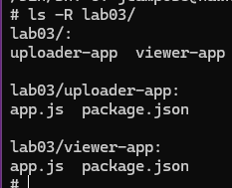
Screenshot 2: Uploader page and a successful upload confirmation.
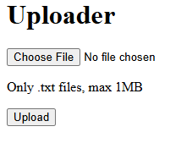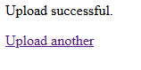
Screenshot 3: Attempting to upload a .txt file larger than 1MB (showing the "file exceeds the 1MB limit" error).
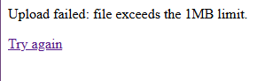
Screenshot 4: Attempting to upload a non-.txt file (showing the "only .txt files are allowed" error).
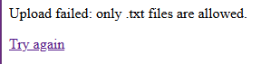
Screenshot 5: Viewer page displaying the uploaded file's content.
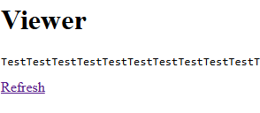
Screenshot 6: Viewer page after uploading a second, different file and clicking Refresh (showing updated content).
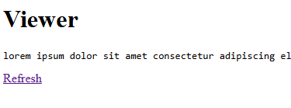
Screenshot 7: CLI output: aws ec2 describe-launch-templates showing both templates.
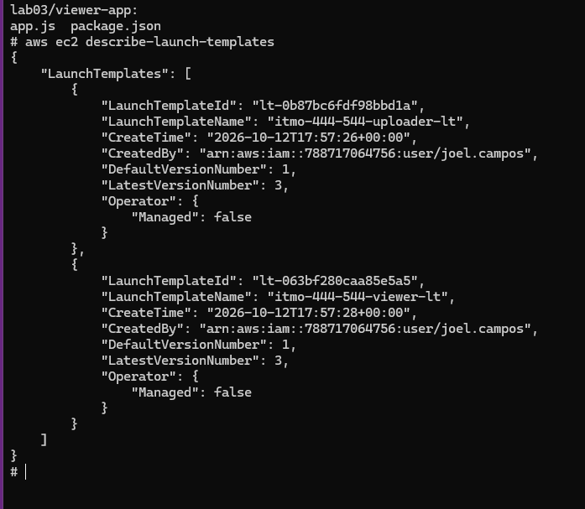
Screenshot 8: CLI output: aws ec2 describe-launch-template-versions for the uploader template showing more than one version.
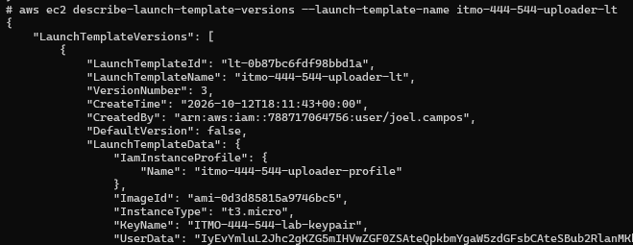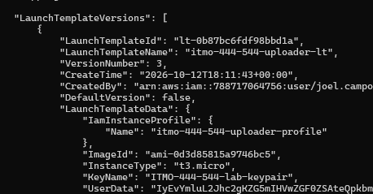
Screenshot 9: CLI output: aws iam get-role-policy output for both roles showing exactly one intended action.
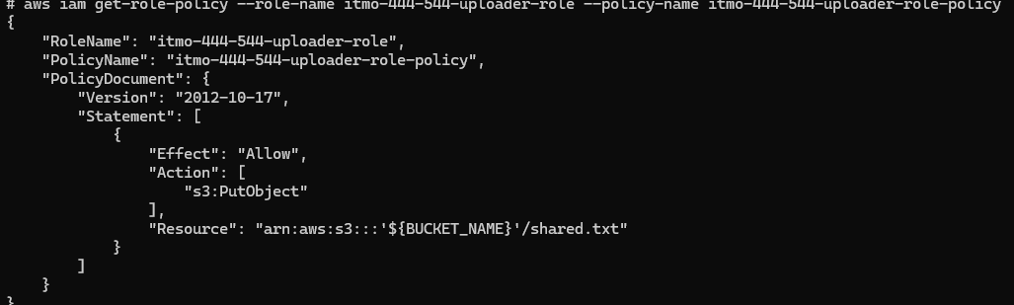 Screenshot 10: CLI output: create_app_stack.sh output showing both instances running with public IPs.
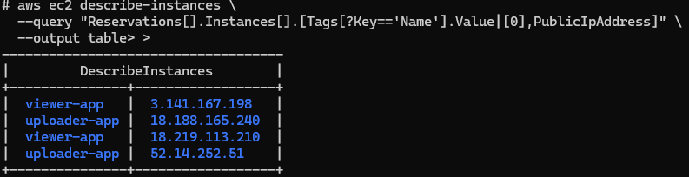 Screenshot 11: CLI output: delete_app_stack.sh completing with no errors.
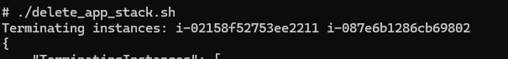 Part 2: Short Answer
Question 1 Explain why the uploader and viewer use separate IAM roles instead of one shared role with both permissions:
Any system or application should utilize the principle of least privilege because the user only needs to view files it should only have read permissions. Likewise, a user that only needs to upload files should only have those permissions. Any instance where a user’s permissions are greater than what they need it increases the attack surface and can cause issues for security.
Question 2 Explain why embedding code directly into user-data means the instance never needs a Git or S3 credential just to fetch its own code:
because the code is embedded into the instance when it boots it does not have to authenticate against external services like a private repository or a s3 bucket to download files It instead already has the files it needs.

