Step01_AWS_Account_Setup_MFA
Screenshot Of the IAM dashboard after setting up MFA authentication
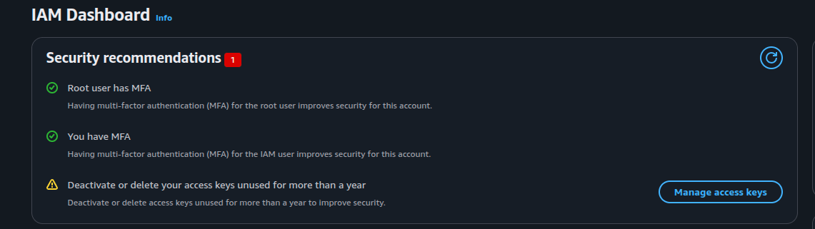
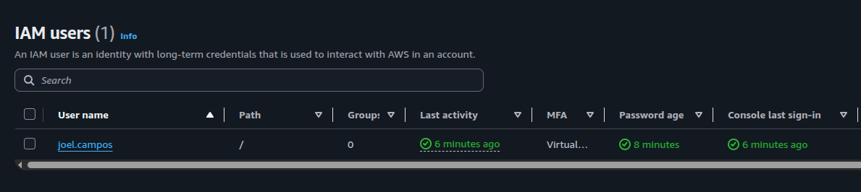
Screenshot of IAM Users
This screenshot also contains the proof of MFA enabled on the IAM user
Access Key was successfully generated Active – AKIA***********NF03
Using MFA and Least privilege are both principles that are part of two key concepts in the AAA framework. Authentication is handled by using MFA access to prove you are who you say you are. And the principles of least privilege is part of authorization. This means the user has only the authority to do what they are meant to do. Least privilege is a way of ensuring that the threat is minimized if their account were to be compromised.

Step02_Docker_Linux_Container_Setup.pdf

Docker Version Output:
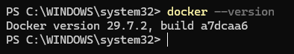

Docker hello-world container output:
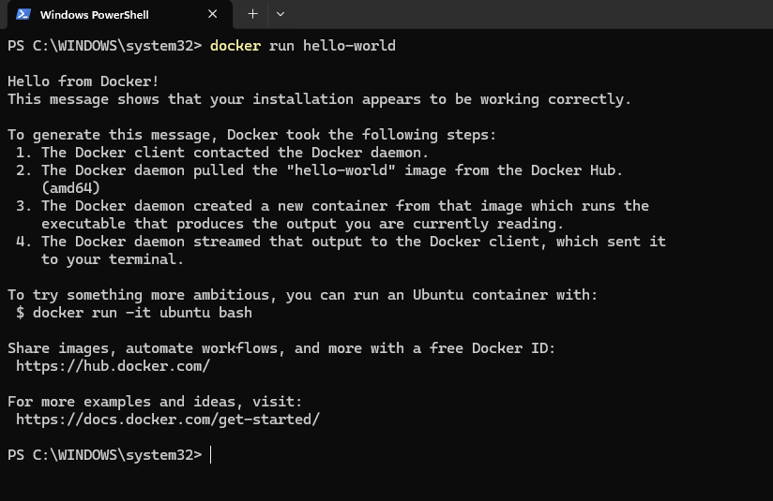
Ubuntu Docker release output:
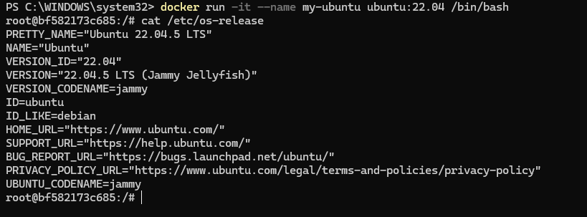

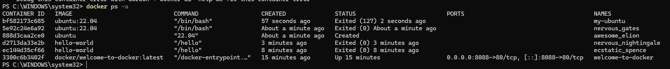
Docker processes output before and after cleanup tasks:

Question: What is the difference between a docker container and a docker image
A docker image is a read only program that is used within a docker environment. This image cannot be eddied and is used similarly to a blueprint for a docker container.
A docker container is the live program that a user can interact with this is a containerized instance of a program using the docker platform

Step03_AWS_CLI_GitHub_Container_Setup.pdf
AWS Version output:
AWS Caller Identity output:
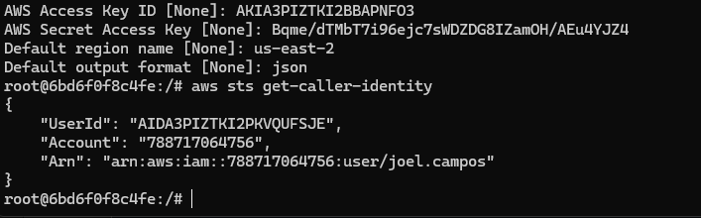
GIT config output:
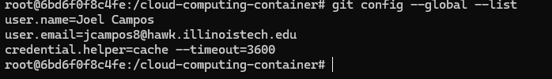
Github repo push output:
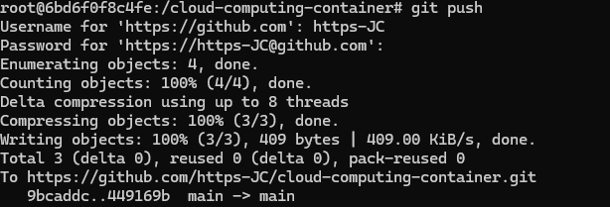
Assignment Question: Why you should never push private tokes to a repository, even a private one.
Doing this is a huge security risk. If any of the information gets exposed to the outside or an insider is able to gain access to this information the security of the token is compromised. This can cause unwanted charges and data loss.

