**Infrastructure Administration**

**Recommended Topography**

CyFy recommends the organizations infrastructure include a VPN Server, Firewall, Client workstations, and a Network Attached Storage (NAS) device (figure below).

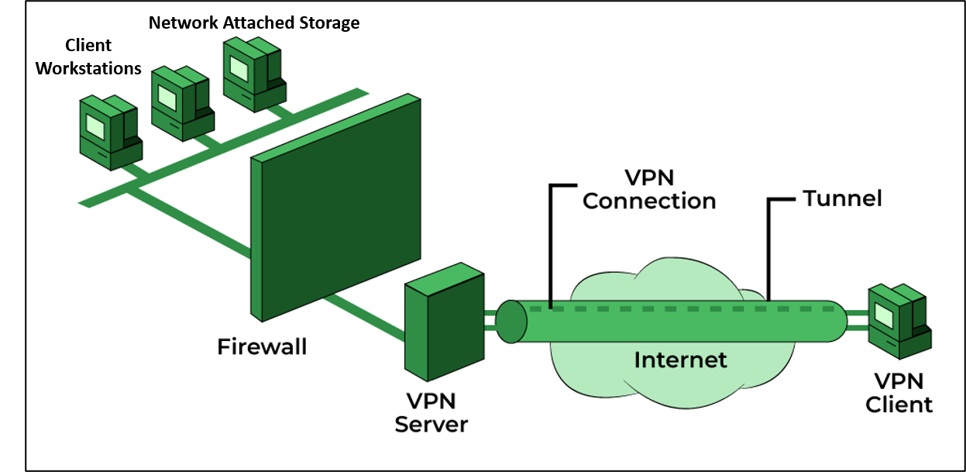

**VPN Server**

CyFy will implement a self-hosted enterprise grade “[OpenVPN Access Server](https://openvpn.net/wp-content/uploads/access-server-datasheet.pdf).)” provided by OpenVPN. Cost to utilize OpenVPN’s “Standard” infrastructure is only seven dollars a month and supports 2000 concurrent client workstations.

The organizations OpenVPN Access Server will be installed on a refurbished desktop computer purchased by CyFy. Specifications will include a minimum 12 core 1 GHz Intel Xeon processor and no less than 128MB of RAM. Ubuntu 22.04 LTS will be utilized as a compatible OS.

[OpenVPN Access Server system requirements](https://openvpn.net/vpn-server-resources/openvpn-access-server-system-requirements/)

**Firewall**

CyFy will purchase a refurbished [Netgate 6100 Base PFSense+ Security Gateway](https://shop.netgate.com/products/6100-base-pfsense) to support firewall capability. Supports high-throughput firewall, routing, and VPN applications. This will enable administrators to filter traffic and content coming to and from the organizations internal network. Firewall configuration will be further discussed in network security settings portion of this document.

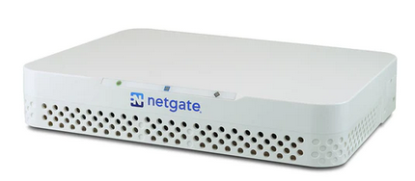

**Network Attached Storage**

CyFy will establish a Network Attached Storage server to support sharing files, endpoint backup services, and recovery procedures. CyFy will purchase a refurbished  [DiskStation DS923+ NAS device](https://www.synology.com/en-my/products/DS923+) ([Amazon $600](https://www.amazon.com/Synology-4-Bay-DiskStation-DS923-Diskless/dp/B0BM7KDN6R)) and two ten TB SSD hard drives. One hard drive will be used for sharing, while the other will be used for backup support & recovery.

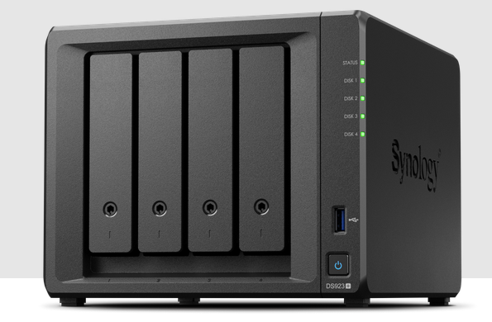

[DiskStation DS923+ Hardware Data Sheet](https://global.synologydownload.com/download/Document/Hardware/DataSheet/DiskStation/23-year/DS923%2B/enu/Synology_DS923%2B_Data_Sheet_enu.pdf)

The following Desktop utilities will be installed on CyFy Administrator workstations to provide easy access to DS923+ connectivity, configuration, and back up services.

* **Synology Drive** – file sharing, remote access, on-demand file restoration, and backup
* **Synology Office** – collaborate on docs, spreadsheets, and presentations in real time
* **Synology Hyper Backup** – browse, decrypt, extract, and backup data

[Synology Knowledge Center](https://kb.synology.com/en-my)

[Synology Drive Admin Console process to configure DS923+ to sync & share files](https://kb.synology.com/en-my/DSM/tutorial/How_to_sync_files_between_Synology_NAS_and_your_computer_using_Drive_desktop)

[Synology Drive Client process to backup & recover DS923+ data](https://kb.synology.com/en-eu/DSM/tutorial/How_to_back_up_data_on_my_computer_using_Drive)

**Client Workstations**

CyFy will provide laptops donated by larger organizations for use as client workstations. These client workstations will be capable of hybrid connectivity, allowing them to connect in office as well as remotely when out of office. CyFy personnel will ensure remote desktop services are enabled prior to issuing out computers. Further information on client workstations is provided in the user profile section of this document.

**Laptop Sanitization**

CyFy will be utilizing [Blancco Drive Eraser for ITAD](https://www.blancco.com/products/drive-eraser/?_gl=1*aj2oyd*_up*MQ..*_ga*MzE2MzY4NTY5LjE2Nzc2MjcwOTA.*_ga_C071SRQ59E*MTY3NzYyNzA4OS4xLjAuMTY3NzYyNzA4OS4wLjAuMA..) software to ensure all previous data on donated laptops is safely removed. This same process will be implemented on any laptop or workstation that will no longer be used by the organization.

[Blancco Drive Eraser for ITAD Technical Specifications](https://www.blancco.com/wp-content/uploads/2022/12/blancco_drive-eraser-ITAD.pdf?_gl=1*y4byvy*_up*MQ..*_ga*MTkyNjMzMDE2OS4xNjc3NjI3ODg2*_ga_C071SRQ59E*MTY3NzYyNzg4NS4xLjAuMTY3NzYyNzg4NS4wLjAuMA..)

[Blancco Drive Eraser Knowledge Base](https://support.blancco.com/display/KB/Knowledge+Base)

Below are some of the primary features of Blancco Drive Eraser software:

* Locally or remotely controlled data erasure via Blancco Management Console
* High-speed, simultaneous erasure of multiple drives
* Tamper proof audit trail with digitally signed Certificate of Erasure
* Deployable via Pre-boot Execution Environment (PXE)

**Secure Remote Management**

CyFy will utilize the Remote Desktop Protocol (RDP) to manage & troubleshoot client workstations. RDP has known vulnerabilities so we will take the steps listed below to provide [RDP connectivity security](https://delinea.com/blog/rdp-security).

* We will utilize self-signed certificates to control user & location RDP access
* Our pfSense firewall will act as a jump host filtering traffic
* RDP connections will only be conducted via OpenVPN connections

**Technology purchase request**

Technology purchase requests must be initially submitted in writing to executive management. If deemed appropriate, CyFy personnel will meet with management and the individual who submitted the request to discuss potential solutions and cost.

CyFy fully understands the need to keep costs down, so will focus on the purchase of refurbished equipment from reputable vendors we have established a working relationship with.

CyFy Equipment Vendors:

* [CXtec](https://www.cxtec.com/)
* [NewEgg Business - Refurbished](https://www.neweggbusiness.com/t/refurbished)
* [2nd Gear - Refurbished](https://www.2ndgear.com/refurbished/)