

July 18, 2025

ATTY. ALAN FELIX MACARAYA
OIC-NTC Region VII
Cor. M. Logarta & Lopez Jaena Sts.,
Subangdaku, Mandaue City, Cebu

Dear Sir:

Good day!

This is in reference to our vessel M/TUG “POLLUX 3” Ship Station License that will expire on July 25, 2025.

With this, we would like to apply for renewal of the said document with license number 7MS-1225-24R.

Attached is the Radio Operation License and Certification.

We are hoping for your consideration.

Thank you.

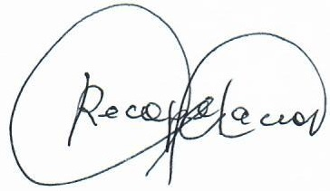
Respectfully yours,

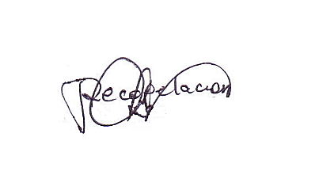
ROGELIO RECOPELACION JR.
Liaison Officer

CSI Compound, Canduman,
Mandaue City, Cebu
Tel Nos: 344-8081, 422-1831
Telefax: 344-8081 local 116

CERTIFICATION

This is to certify that ALFEREZ, DARRENEL JOHN DUGENIO, has been employed by CONCRETE SOLUTIONS, INC., as CHIEF MATE of M/TUG “POLLUX 3” from March 12, 2020 up to present.

This certification is issued for the purpose of renewal of Ship Station License as per required by the National Telecommunication Commission.

Done this 18th day of July 2025, at Purok Bougainvilla, Sitio Manggahan, Canduman, Mandaue City, Cebu Philippines.

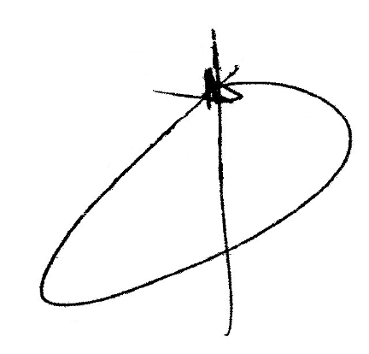

Engr. Alvin G. Basal
General Manager
C Solutions, Inc.

July 17, 2025

ATTY. ALAN FELIX MACARAYA
OIC-NTC Region VII
Cor. M. Logarta & Lopez Jaena Sts.,
Subangdaku, Mandaue City, Cebu

Dear Sir:

Greetings!

I, ALFEREZ, DARRENEL JOHN DUGENIO currently employed by CONCRETE SOLUTIONS INCORPORATED as Chief Mate.

I hereby authorize CSI Company to make used my GMDSS Radio Operator with Certificate number GOC200006231221 for the renewal of M/TUG “POLLUX 3” Ship Station License No. 7MS-1225-24R that will expire on July 25, 2025.

Thank you.

Yours truly,

DARRENEL JOHN DUGENIO ALFEREZ
Chief Officer

