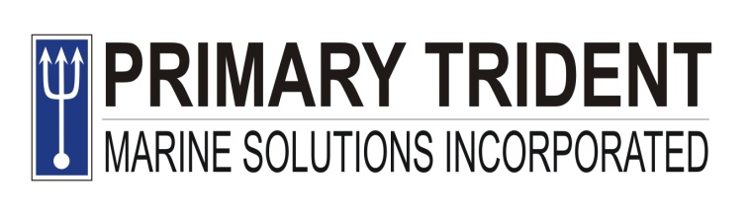
CSI Compound, Canduman,
Mandaue City, Cebu
Tel Nos: 344-8081, 422-1831
Telefax: 344-8081 local 116

CERTIFICATION

This is to certify that JAY-R ANDRIN EDANO has been employed by PRIMARY TRIDENT MARINE SOLUTIONS INCORPORATED as CHIEF OFFICER of LCT POSEIDON 40.

This certification is issued for the purpose of application of Ship Station License as per required by the National Telecommunication Commission.

Done this 28TH day of July 2025, at CSI Compound, Brgy. Canduman, Mandaue City, Cebu.

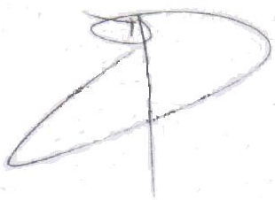

Engr. Alvin G. Basal
General Manager
Primary Trident Marine Solutions Incorporated

