MV TRISHA KERSTIN 3

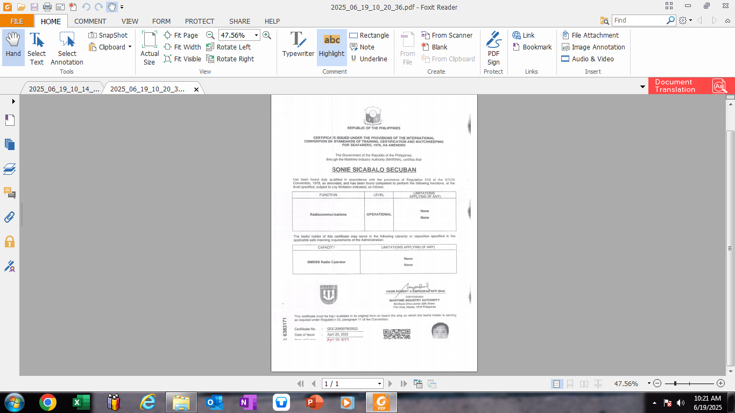CAPTAIN SECUBAN, SONIE