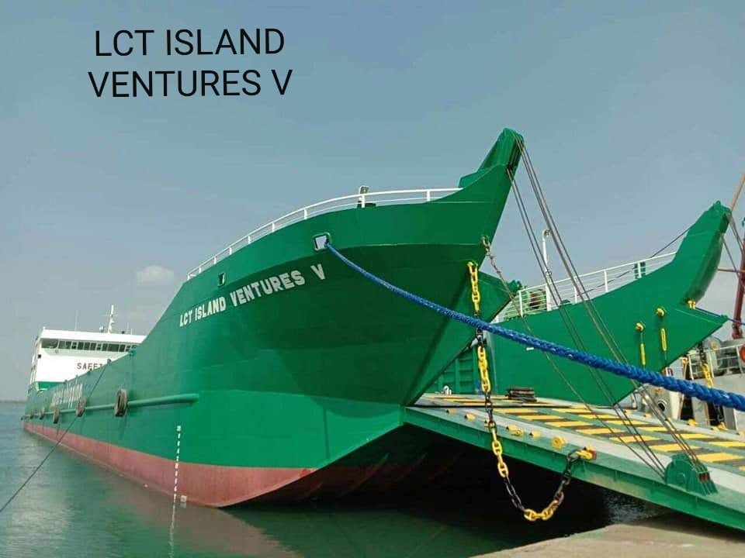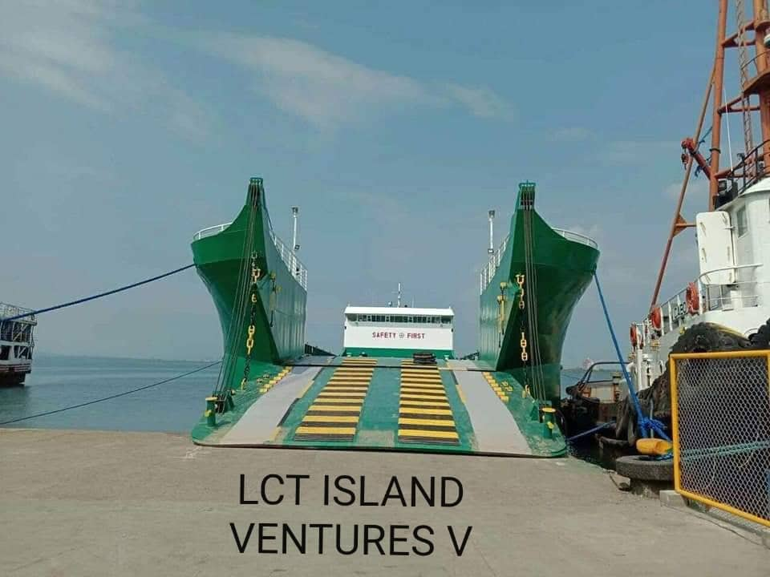

|  |  |  |  |  |  |  |  |  |  |  |  |  |  |  |  |  |
| --- | --- | --- | --- | --- | --- | --- | --- | --- | --- | --- | --- | --- | --- | --- | --- | --- |
| **LCT “ISLAND VENTURES-V”** | **Off. No.**  **07-0003354** | **Call Sign:**  **DUH-5152** | | | | | | **IMO NO.** | | | **Type of Ship:**  **PASS. SHIP/RO-RO PASS.** | | | | | |
| **Trading Area:**  **COASTWISE** | **Home Port:**  **CEBU** | | | | | **Builder:**  **ELITE FABRICATION YARD** | | | | | | | | **Year Built:**  **2019** | |
| **Vessel Former Name:**  **-** | | | | **Former Owner**  **-** | | | | | | | | | | **No. of Mast:**  **-2-** | |
| **Number of Deck:**  **-1-** | **Hull Material:**  **Steel** | | | | **Length (meter)**  **71.00 /** | | | | **Breadth (meter)**  **14.80** | | | | | | **Depth (meter)**  **3.00** |
| **Gross Tonnage**  **1122** | **Net Tonnage:**  **336** | | | | **Engine No/Model:**  **WIECHAI DUETZ** | | | | | | | **S.N. #:**  **S- 2216L000161**  **P- 2217A000001** | | | |
| **Kilo Watt:**  **941.09 kw P**  **941.09 kw S** | | | **No of Cylinder:**  **-8- P-8- S** | | | | | **Cycle:**  **-4- P-4- S** | | | **No of Aux./Model:**  **/WIECHAI** | | | | |
| **KVA:**  **125 x 2 / 1 x 75** | | **No. of Propeller:**  **2 x 4** | | | | | | **Pitch/Diameter:** | | | | |  | | |