August 4, 2025

CERTIFICATE OF EMPLOYMENT

To whom it may concern,

This is to certify that **Alreny Kahong** presently works with me as a manager handling works related to ship station.

This certificate is issued upon his request for whatever purpose it may serve.

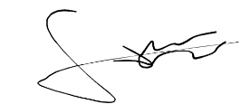

GARY T. BONSIL JR

Owner