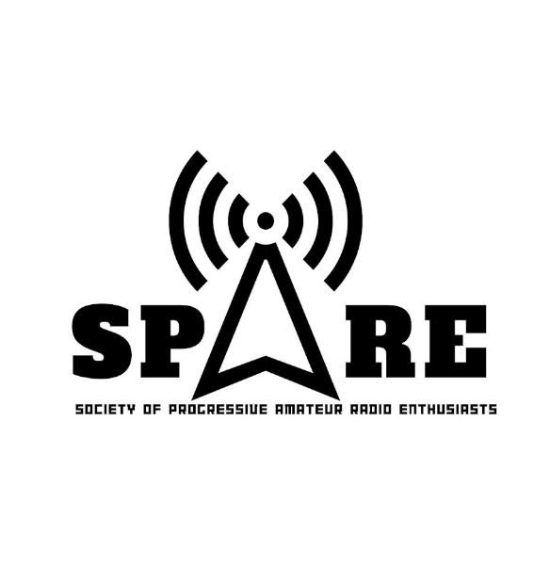

**SOCEITY OF PROGRESSIVE AMATEUR RADIO ENTHUSIASTS**

**DV7MAU**