# OVERVIEW:

# NPP PARAMETER UPDATE SYSTEM

NPCIL

ANKITA MANDAL

DEBLINA MANDAL

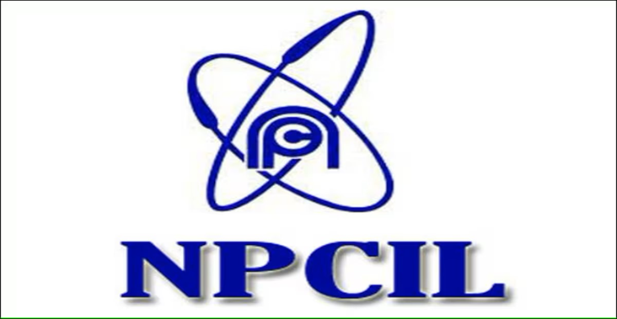

INTRODUCTION

The Nuclear Power Plant Update Parameter System (NPPUPS) is a groundbreaking initiative aimed at enhancing the safety, efficiency, and reliability of nuclear power generation worldwide. This system represents a comprehensive approach to managing the vast array of parameters that influence the operation and maintenance of nuclear reactors. By integrating advanced technologies, rigorous scientific methodologies, and collaborative international standards, NPPUPS seeks to address the complex challenges associated with nuclear energy production in the 21st century.

Historical Context and Need for Innovation:

Nuclear power has long been recognized as a significant source of electricity, offering high energy density and low greenhouse gas emissions compared to fossil fuels. However, the safe and efficient operation of nuclear power plants (NPPs) demands stringent regulation and constant vigilance against potential risks, including natural disasters, equipment failures, and terrorist threats. Over time, the complexity of NPP operations and the increasing sophistication of nuclear technologies have underscored the need for a more sophisticated and adaptable system for managing operational parameters.

Core Components and Objectives:

At the heart of NPPUPS is a centralized database that collects, analyzes, and disseminates real-time data on thousands of operational parameters. These parameters encompass everything from reactor pressure and temperature readings to radiation levels and chemical compositions of coolant fluids. By continuously monitoring these parameters, operators can detect anomalies early, prevent accidents, and optimize plant performance.

One of the key objectives of NPPUPS is to standardize operational parameters across different countries and reactor models. This standardization facilitates international collaboration, enables cross-comparison of safety records, and accelerates the adoption of best practices. Furthermore, NPP promotes the use of predictive analytics and machine learning algorithms to forecast potential issues before they occur, thereby enhancing preventive maintenance strategies.

Technological Innovations and Advancements:

The success of NPPUPS hinges on the integration of cutting-edge technologies, including Internet of Things (IoT) devices for remote monitoring, artificial intelligence (AI) for predictive analysis, and blockchain technology for secure data sharing. These innovations enable real-time data collection, automated anomaly detection, and verifiable record keeping, significantly improving the responsiveness and accuracy of operational management.

Moreover, NPPUPS incorporates virtual reality (VR) and augmented reality (AR) tools for training personnel, simulating emergency scenarios, and facilitating remote inspections. Such immersive technologies enhance operator proficiency and readiness, contributing to safer and more efficient operations.

International Collaboration and Regulatory Compliance:

NPPUPS emphasizes the importance of international cooperation in advancing nuclear safety and sustainability. By establishing a common framework for parameter management, the system facilitates knowledge exchange between countries, supports joint research initiatives, and harmonizes regulatory standards. This collaborative approach not only strengthens global nuclear safety but also fosters mutual trust and confidence in the peaceful use of nuclear energy.

Challenges and Future Directions:

While NPPUPS holds immense promise for the future of nuclear power, it also faces significant challenges, including cybersecurity concerns, the need for extensive infrastructure upgrades, and the requirement for highly skilled personnel. Addressing these challenges requires ongoing investment in research and development, as well as sustained international dialogue and support.

Looking ahead, the evolution of NPPUPS will likely involve further integration of emerging technologies, such as quantum computing for enhanced predictive modeling, and the development of decentralized architectures to improve resilience and flexibility. As nuclear energy continues to play a crucial role in the global energy mix, the continuous refinement of NPPUPS will be essential for meeting the dual goals of safety and sustainability.

Area of Importance:

The Nuclear Parameter Update System (NPUS) plays a crucial role in ensuring the safe, efficient, and reliable operation of nuclear power plants (NPPs). This system encompasses a wide range of parameters that directly affect the performance and safety of nuclear reactors. Understanding the areas of importance within NPUS is vital for maintaining high standards of nuclear energy production and minimizing the risk of accidents. Here are the key areas of importance in the NPUS:

1. Reactor Core Parameters

The core of a nuclear reactor is its heart, where nuclear fission occurs. Monitoring parameters related to the reactor core, such as fuel assembly temperatures, neutron flux densities, and control rod positions, is essential for maintaining optimal operating conditions and preventing overheating or meltdown scenarios.

2. Coolant and Moderator Systems

The coolant and moderator systems are critical for controlling the nuclear reaction and removing heat from the reactor core. Parameters related to these systems, including coolant temperatures, pressures, flow rates, and chemical compositions, must be closely monitored to ensure they operate within safe limits and efficiently transfer heat away from the reactor core.

3. Radiation Levels and Containment Integrity

Monitoring radiation levels inside and outside the reactor building is paramount for protecting workers and the surrounding community. Additionally, the integrity of containment structures, which are designed to withstand extreme conditions and contain radioactive materials in case of an accident, must be continuously assessed through parameters such as structural stress, leak rates, and containment pressure.

4. Power Generation and Reactivity Control

Parameters related to power generation, such as electrical output, voltage, and frequency, are important for assessing the reactor's performance and ensuring it meets the grid's demand. Reactivity control parameters, including the position of control rods and the concentration of boron in the coolant, are crucial for maintaining the balance between power generation and safety.

5. Waste Management and Decommissioning

Long-term considerations, such as waste management and decommissioning, are also part of the NPUS. Parameters related to spent fuel storage, waste disposal, and decontamination processes must be carefully managed to minimize environmental impact and comply with regulatory standards.

6. Operational Safety and Emergency Preparedness

Safety parameters extend beyond normal operations to include emergency preparedness and response capabilities. This includes the status of emergency cooling systems, the availability of backup power supplies, and the readiness of emergency response teams. Parameters related to these aspects ensure that NPPs are prepared to handle unexpected situations safely.

7. Regulatory Compliance and Reporting

Compliance with national and international regulations is another area of importance. The NPUS includes parameters related to licensing requirements, inspection schedules, and reporting obligations, ensuring that NPPs adhere to the highest standards of safety and performance.

Conclusion:

In conclusion, the Nuclear Power Plant Update Parameter System represents a landmark achievement in the quest for safer, cleaner, and more efficient nuclear power generation. By harnessing the power of technology and fostering global collaboration, NPPUPS sets a new standard for operational excellence in the nuclear sector. As we navigate the complexities of the 21st-century energy landscape, the principles and innovations embodied in NPPUPS offer a beacon of hope and progress for a sustainable future powered by nuclear energy.