 

**LIBRARY MANAGEMENT SYSTEM PROJECT**

**A PROJECT REPORT**

Submitted in partial fulfillment of the

Requirement of the award of the Degree of

**MASTER OF SCIENCE (DATA SCIENCE)**

**By**

**Devika**

**UID - O23MSD110162**



**INSTITUTE OF DISTANCE & ONLINE LEARNING**

**DEPARTMENT OF DATA SCIENCE**

**CHANDIGARH UNIVERSITY**

**MOHALI, PUNJAB(INDIA)**

**SUBMITED BY: SUBMITED TO:**

**NAME: Devika Program Coordinator: M.sc Data Science**

**UID: O23MSD110162 Institute of Distance & Online Learning**

**COURSE: M.Sc. Data Science Chandigarh University**

**BATCH: July 2023 Mohali, Punjab (India)**

**Abstract**

The Library Management System (LMS) is a comprehensive software application designed to streamline library operations and enhance user engagement. This project aims to address common challenges faced by libraries, such as inefficient tracking of books and users, and the complexity of managing library resources. The LMS features a user-friendly interface that includes a home page summarizing key statistics with pie charts, alongside dedicated pages for managing books and student records. Users can issue and return books seamlessly, view all transactions, and monitor overdue items through a defaulter list. Utilizing MySQL for database management, Java as the programming language, and the Swing framework for the user interface, the LMS promotes efficient library management, ultimately enriching the user experience.

**Table of Content**

1. Abstract 2
2. Background 4
3. Problem Statement OR Related Research OR Related Work 4
4. Research Questions 5
5. Aim and Objectives 5
6. Significance of the Study 6
7. Scope of the Study 7
8. Research Methodology 8. Requirements Resources 9
9. Research Plan 12
10. References 12
11. Source code 12
12. Screenshot of the app 13
13. **Background**

Libraries play a crucial role in promoting education and access to information in communities. With the rise of digital technology, many libraries are transitioning from traditional manual systems to automated solutions that enhance operational efficiency. Library Management Systems have become essential tools for managing a vast array of resources, including books, journals, and multimedia.

Historically, libraries have relied on manual cataloging and tracking methods, which are often time-consuming and prone to errors. As user demands grow, there is a pressing need for systems that not only manage resources efficiently but also improve user interactions. The integration of technology in library management has shown to enhance service delivery and user satisfaction, making it imperative for libraries to adopt modern systems.

Also, we have added **two step authentications** as security of the data is our priority and at the same time, we have added the **alert of login** so that user will be aware if anyone tried to login their account.

1. **Problem Statement OR Related Research OR Related Work**

Many libraries continue to operate with outdated systems that do not meet the demands of today’s users. Manual management of library operations can lead to several issues, including:

* **Inefficient Book Tracking:** Difficulty in locating books, tracking their availability, and managing due dates.
* **Poor User Management:** Challenges in maintaining accurate records of library members, their borrowing history, and fines.
* **Time-Consuming Processes:** Manual tasks such as book issuance, return, and inventory updates consume significant staff time.
* **Data Accuracy and Consistency:** Human error can lead to inaccuracies in records and inconsistencies in data.

Research shows that libraries that adopt automated management systems experience improvements in operational efficiency and user engagement. A study by Jones and Davis (2020) found that libraries that implemented automated systems experienced significant increases in user satisfaction due to faster checkout times, improved search capabilities, and enhanced access to resources. However, many current solutions still fall short in providing a holistic approach to library management, necessitating the development of a new, more effective system.

1. **Research Questions**

* How can a centralized Library Management System improve the operational efficiency of libraries
* What specific features are essential for enhancing user engagement in library management?
* In what ways can data visualization (e.g., pie charts) aid library staff in resource management and decision-making?

**4. Aim and Objectives**

**Aim**

To develop a comprehensive Library Management System (LMS) that automates and streamlines library operations, providing efficient and user-friendly services to both library staff and patrons.

**Objectives:**

1. **User Interface Development:**
   * Design and implement a user-friendly graphical user interface (GUI) for easy navigation and interaction.
   * Ensure the interface is intuitive and accessible to users of varying technical expertise.
2. **Book Management:**

* Develop functionalities to add, edit, delete, and search book records.
* Implement a system to track book availability and quantity.
* Maintain a comprehensive database of book details, including title, author, ISBN, publication year, and category.

1. **Student Management:**
   * Develop functionalities to add, edit, delete, and search student records.
   * Maintain a database of student information, including student ID, name, department, and contact details.
   * Implement a system to track student borrowing history and fines.
2. **Book Issuance and Return:**
   * Develop a system to issue books to students based on availability and due dates.
   * Implement a system to record book returns and update book availability.
   * Calculate and track fines for overdue books.
   * Generate receipts for book issuance and return transactions.
3. **Record Management:**
   * Maintain a comprehensive database of all library transactions, including book issuance, return, and renewal records.
   * Generate detailed reports on book circulation, popular books, and overdue items.
   * Provide tools for data analysis and decision-making.
4. **Defaulter Management:**
   * Identify and track students who have not returned books on time.
   * Generate defaulter lists and send reminders to overdue books.
   * Implement appropriate measures to recover overdue books.

By achieving these objectives, the LMS will significantly improve the efficiency of library operations, enhance user satisfaction, and optimize the utilization of library resources.

## **5. Significance of the Study**

The development of a robust and efficient Library Management System (LMS) is crucial for several reasons:

1. **Improved Efficiency:**
   * **Automation of Tasks:** Automates routine tasks such as book issuance, return, and renewal, reducing manual effort and increasing productivity.
   * **Reduced Human Error:** Minimizes human error in record-keeping, leading to accurate and reliable data.
   * **Faster Processing Times:** Streamlines processes, resulting in quicker book issuance and return times.
2. **Enhanced User Experience:**
   * **User-Friendly Interface:** Provides an intuitive interface that is easy to navigate, even for users with minimal technical knowledge.
   * **Efficient Search and Retrieval:** Enables users to quickly locate books and other resources.
   * **Real-time Information:** Offers up-to-date information on book availability, due dates, and fines.
3. **Better Resource Management:**
   * **Data-Driven Decision Making:** Provides valuable insights through data analysis and reporting, enabling informed decisions on resource allocation and procurement.
   * **Optimized Inventory Management:** Helps in maintaining optimal inventory levels by tracking book circulation and identifying popular titles.
   * **Effective Utilization of Resources:** Maximizes the utilization of library resources by reducing idle time and wastage.
4. **Cost Reduction:**
   * **Reduced Labor Costs:** Automates tasks, reducing the need for additional staff.
   * **Minimized Loss of Books:** Implements effective tracking and monitoring systems to prevent book loss and theft.
   * **Optimized Resource Allocation:** Enables efficient allocation of resources based on usage patterns.

By addressing these areas, the LMS can significantly contribute to the overall efficiency and effectiveness of libraries, benefiting both library staff and patrons.

**6. Scope of the Study**

This project aims to develop a Library Management System (LMS) that will automate and streamline various library operations. The system will specifically focus on the following areas:

**Core Functionalities:**

1. **Book Management:**
   * **Book Record Maintenance:** Adding, editing, and deleting book records, including details such as title, author, quantity and we can give a specific book Id as per the librarian choice.
   * **Book Availability Tracking:** Monitoring the availability of books and updating the system accordingly.
2. **Student Management:**

* **Student Record Maintenance:** Adding, editing, and deleting student records, including details such as student ID, name, department, and branch.
* **Student Borrowing History:** Tracking the borrowing history of each student.

1. **Book Issuance and Return:**
   * **Issuance Process:** Issuing books to students, recording the issue date, due date, and student ID.
   * **Return Process:** Recording the return of books, updating book availability, and calculating any fines.
2. **Record Keeping and Reporting:**
   * **Transaction History:** Maintaining a detailed record of all book issuance and return transactions.
   * **Overdue Book Tracking:** Identifying and tracking overdue books.
   * **Report Generation:** Generating reports on book circulation, student borrowing history, and other relevant statistics.
3. **User Interface:**
   * **Intuitive Design:** Developing a user-friendly interface that is easy to navigate and use.
   * **Clear and Concise Information:** Displaying information in a clear and concise manner.

**Limitations:**

While the LMS will provide a comprehensive solution for library management, it will be limited to the following:

* **Specific Library Operations:** The system will be tailored to the specific needs of the library and may not be suitable for all types of libraries.

**Future Considerations:**

Potential for mobile app development and integration with e-book lending services.

**7. Research Methodology**

The research methodology for the Library Management System (LMS) project is designed to systematically guide the development of the application, ensuring that it effectively meets the needs of library operations and enhances user experience. This methodology comprises several key phases: literature review, requirements gathering, system design, development, testing, and deployment. Each phase contributes to a comprehensive understanding of user requirements and the creation of a robust LMS.

**1. Literature Review**

**Objective:**  
To gain insights into existing library management systems, their functionalities, and the challenges they face, providing a foundation for developing a more effective LMS.

**Activities:**

* **Analysis of Existing Literature:** Review academic papers, articles, and case studies on library management systems to identify current trends and best practices.
* **Identification of Features:** Document essential features that successful systems incorporate, such as user management, inventory control, and reporting tools.
* **Gap Analysis:** Identify shortcomings in existing systems, such as limited user interfaces, inadequate reporting capabilities, and challenges in user engagement.

**2. Requirements Gathering**

**Objective:**  
To collect and define the specific functional and non-functional requirements of the LMS based on user needs.

**Activities:**

* **Stakeholder Interviews:** Conduct interviews with library staff and users (students) to understand their needs and expectations from the system.
* **Surveys and Questionnaires:** Distribute surveys to gather quantitative data on desired features and usability preferences.
* **Use Case Development:** Create use cases to illustrate how different users will interact with the system, focusing on managing books, students, issuing/returning books, and viewing records.

**3. System Design**

**Objective:**  
To create a detailed design blueprint that outlines the architecture and user interface of the LMS.

**Activities:**

* **User Interface Design:** Develop wireframes for key components, including:
  + **Home Page:** A dashboard leading to subsections with summaries visualized through pie charts.
  + **Manage Book Page:** Interface for adding, updating, and deleting book details (book ID, author details, quantity).
  + **Manage Student Page:** Interface for managing student information (student ID, name, branch, department).
  + **Issue Book and Return Book Pages:** Processes for issuing and returning books with relevant data displays.
  + **View All Records and View Issued Book Pages:** Interfaces for tracking transaction histories and due dates.
  + **Defaulter List Page:** Displaying overdue items and associated details.
* **System Architecture Design:** Outline the system's architecture, detailing interactions between the frontend, backend, and MySQL database.

**4. Development**

**Objective:**  
To implement the designed system using appropriate technologies, ensuring functionality and user experience.

**Activities:**

* **Technology Stack Implementation:** Utilize Java as the programming language and the Swing framework for the user interface. MySQL will be used for database management.
* **Feature Implementation:**
  + **Manage Book Functionality:** Code for adding, updating, and deleting book records.
  + **Manage Student Functionality:** Implement features for managing student details.
  + **Issuing and Returning Books:** Create processes for issuing books and updating records on returns.
  + **Record Viewing Functions:** Develop interfaces for viewing all records, issued books, and generating defaulter lists.
* **Database Design:** Create the MySQL database schema, including tables for books, students, and transactions to facilitate efficient data management.

**5. Testing**

**Objective:**  
To ensure that the LMS functions correctly and meets the established requirements.

**Activities:**

* **Unit Testing:** Test individual components for functionality, such as book management and student management features.
* **Integration Testing:** Verify that all system components work together seamlessly, particularly in transaction processing (issuing and returning books).
* **User Acceptance Testing (UAT):** Involve actual users in testing the system to gather feedback on usability and functionality, allowing for adjustments based on real-world interactions.
* **Bug Fixing:** Identify and rectify any issues discovered during testing to enhance system reliability.

## **8. Requirements Resources**

1. **Software Requirements:**

* Programming Language: Java
* Database Management: MySQL
* Development Framework: Swing

1. **Hardware Requirements:**
   * Standard server specifications for hosting the database and application.
   * Client machines for library staff with appropriate software installed.
2. **Human Resources:**
   * Development Team: Devika
   * Testing Team: Devika

## **9. Research Plan**

The research plan outlines the phases of development, including timelines and key deliverables:

1. **Phase 1: Literature Review and Requirements Gathering** 
   * Conduct a thorough analysis of existing systems and gather user requirements through surveys and interviews.
2. **Phase 2: System Design** 
   * Develop UI/UX designs and create an architectural plan detailing system component.
3. **Phase 3: Development** 
   * Implement core functionalities for book and student management, transaction processing, and record viewing.
4. **Phase 4: Testing and Refinement** 
   * Perform extensive testing and refine the system based on user feedback and performance metrics.

## **10. References**

* <https://www.edureka.co/blog/library-management-system-project-in-java>
* <https://github.com/OSSpk/Library-Management-System-JAVA>
* <https://www.javatpoint.com/library-management-system-in-java-swing>
* <https://projectgurukul.org/java-library-management-system/>
* <https://data-flair.training/blogs/java-library-management/>

**11. Source code link for reference**

<https://github.com/httpsdevika/Library-Management-System.git>

**Screenshot**

1. Login Page

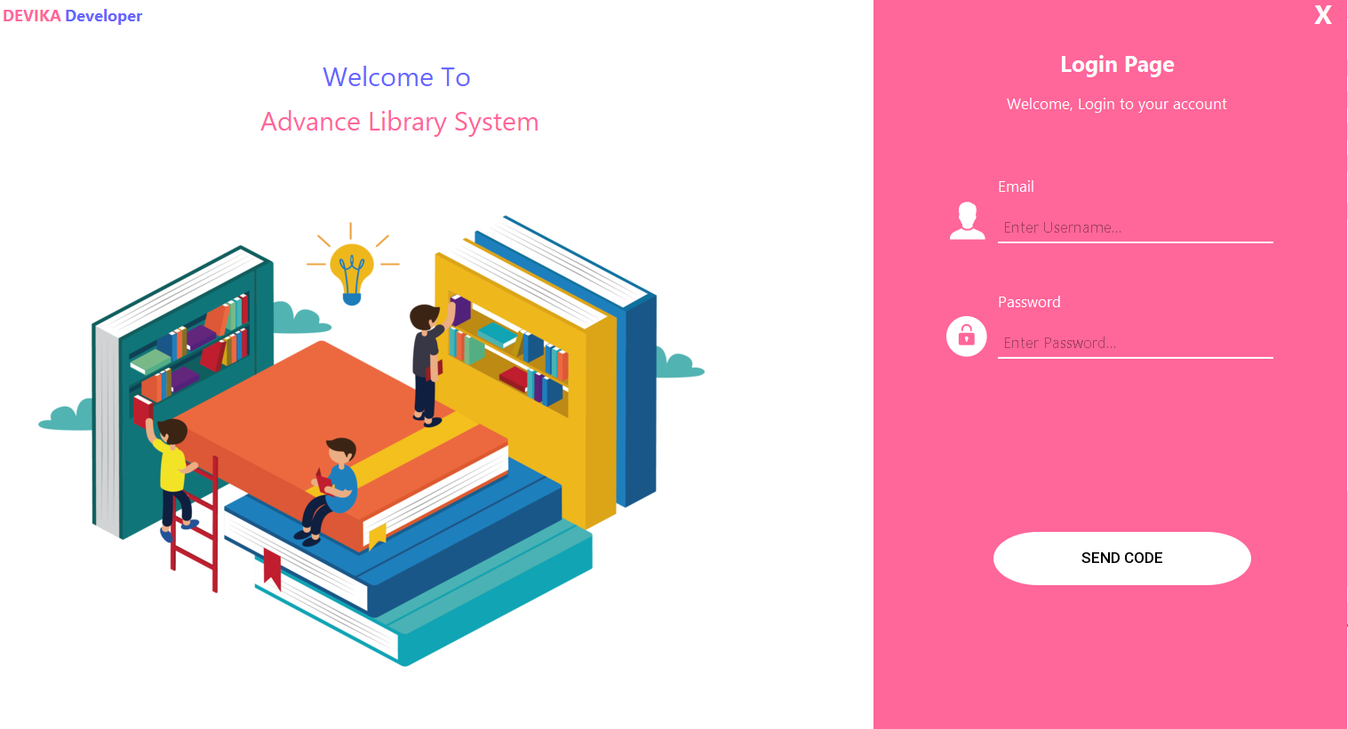

1. Registration Page

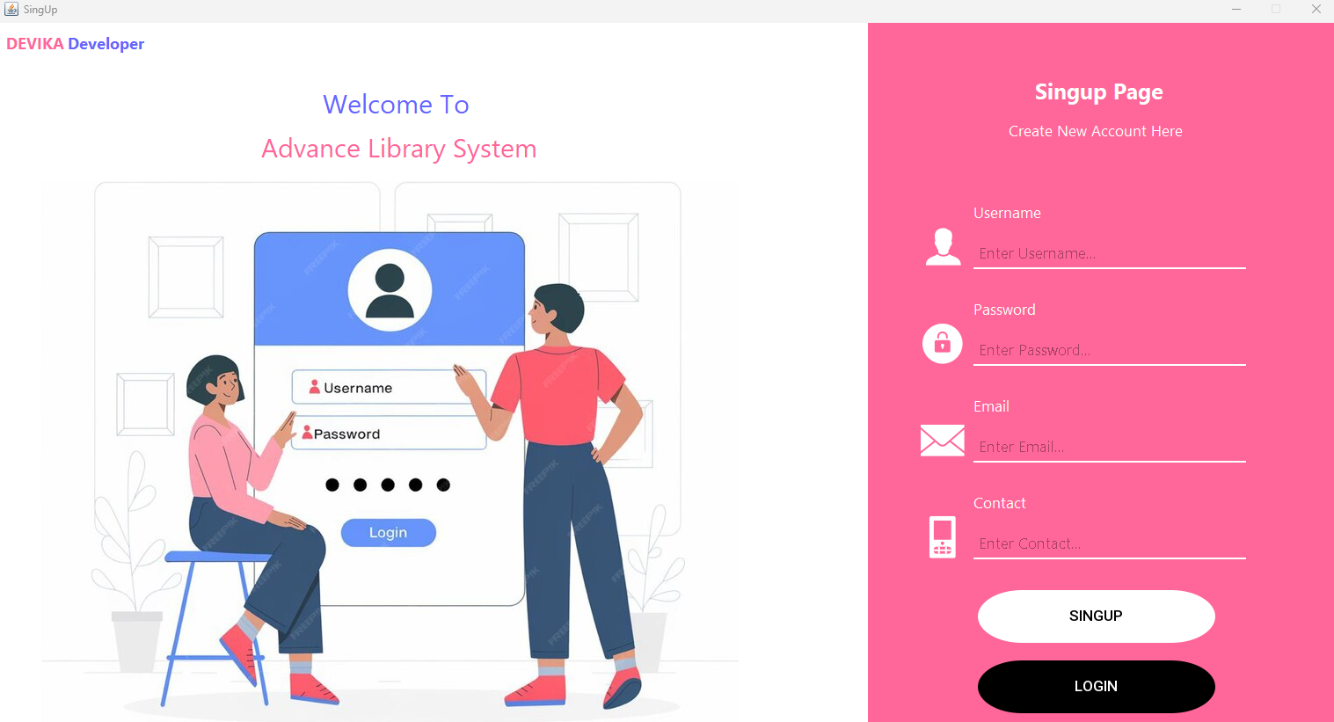

1. Home Page

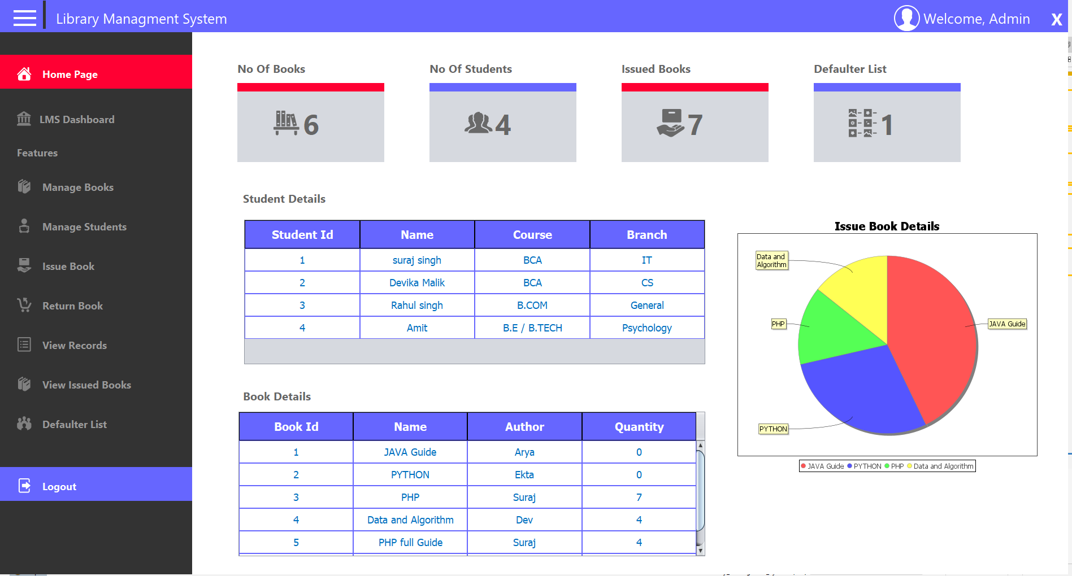

1. Manage Students

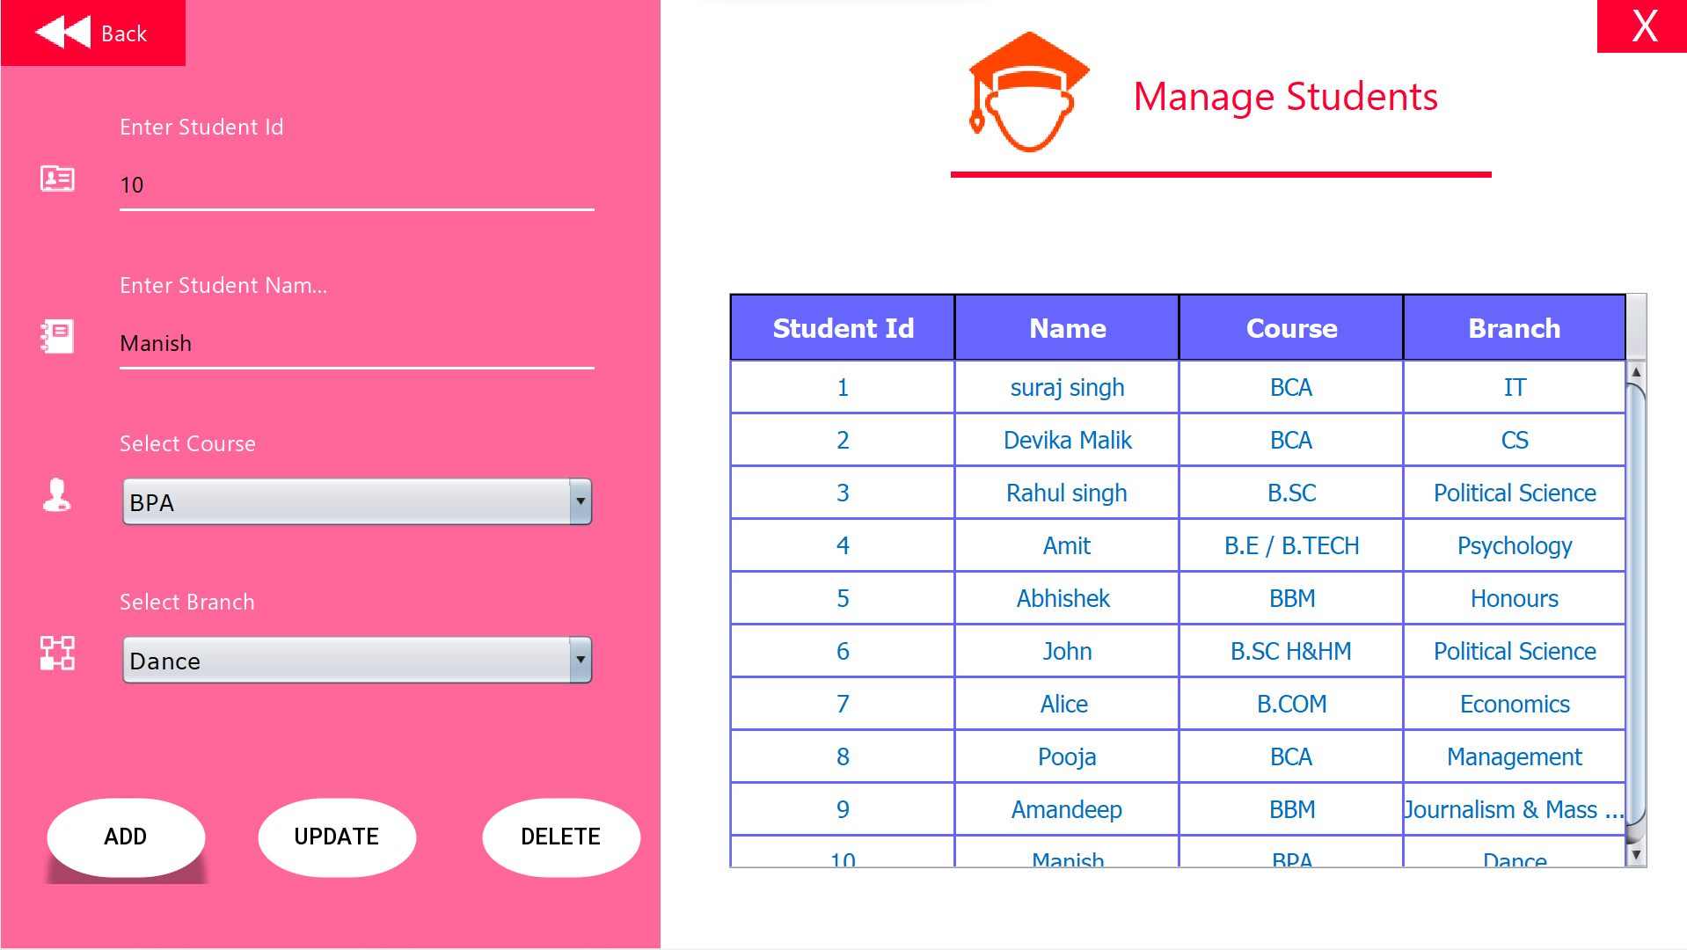

1. Manage Books

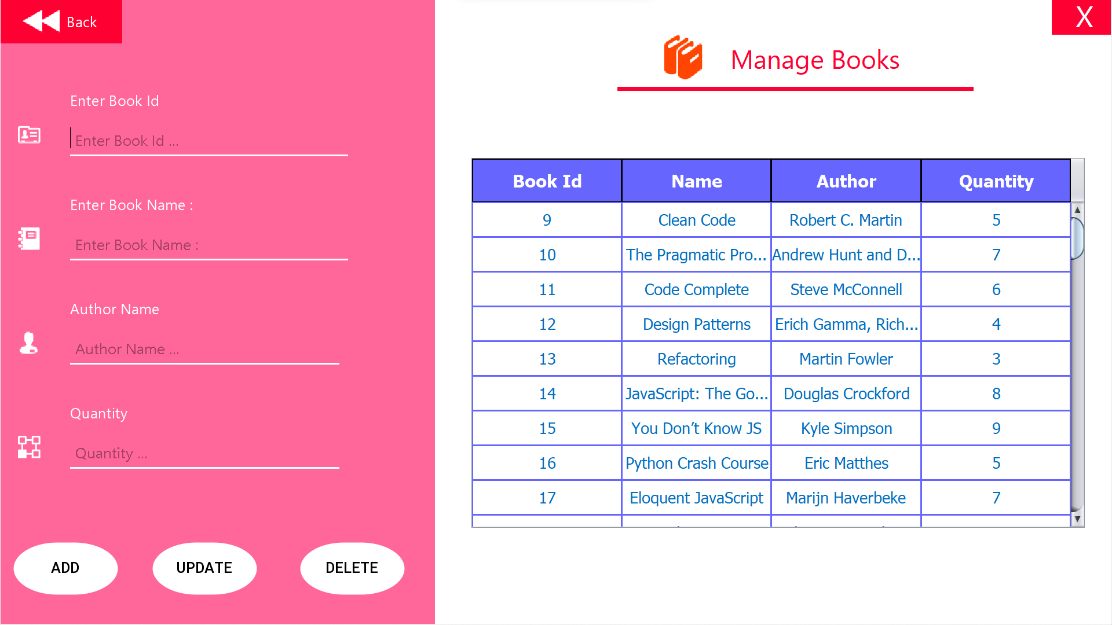

1. Issue Books

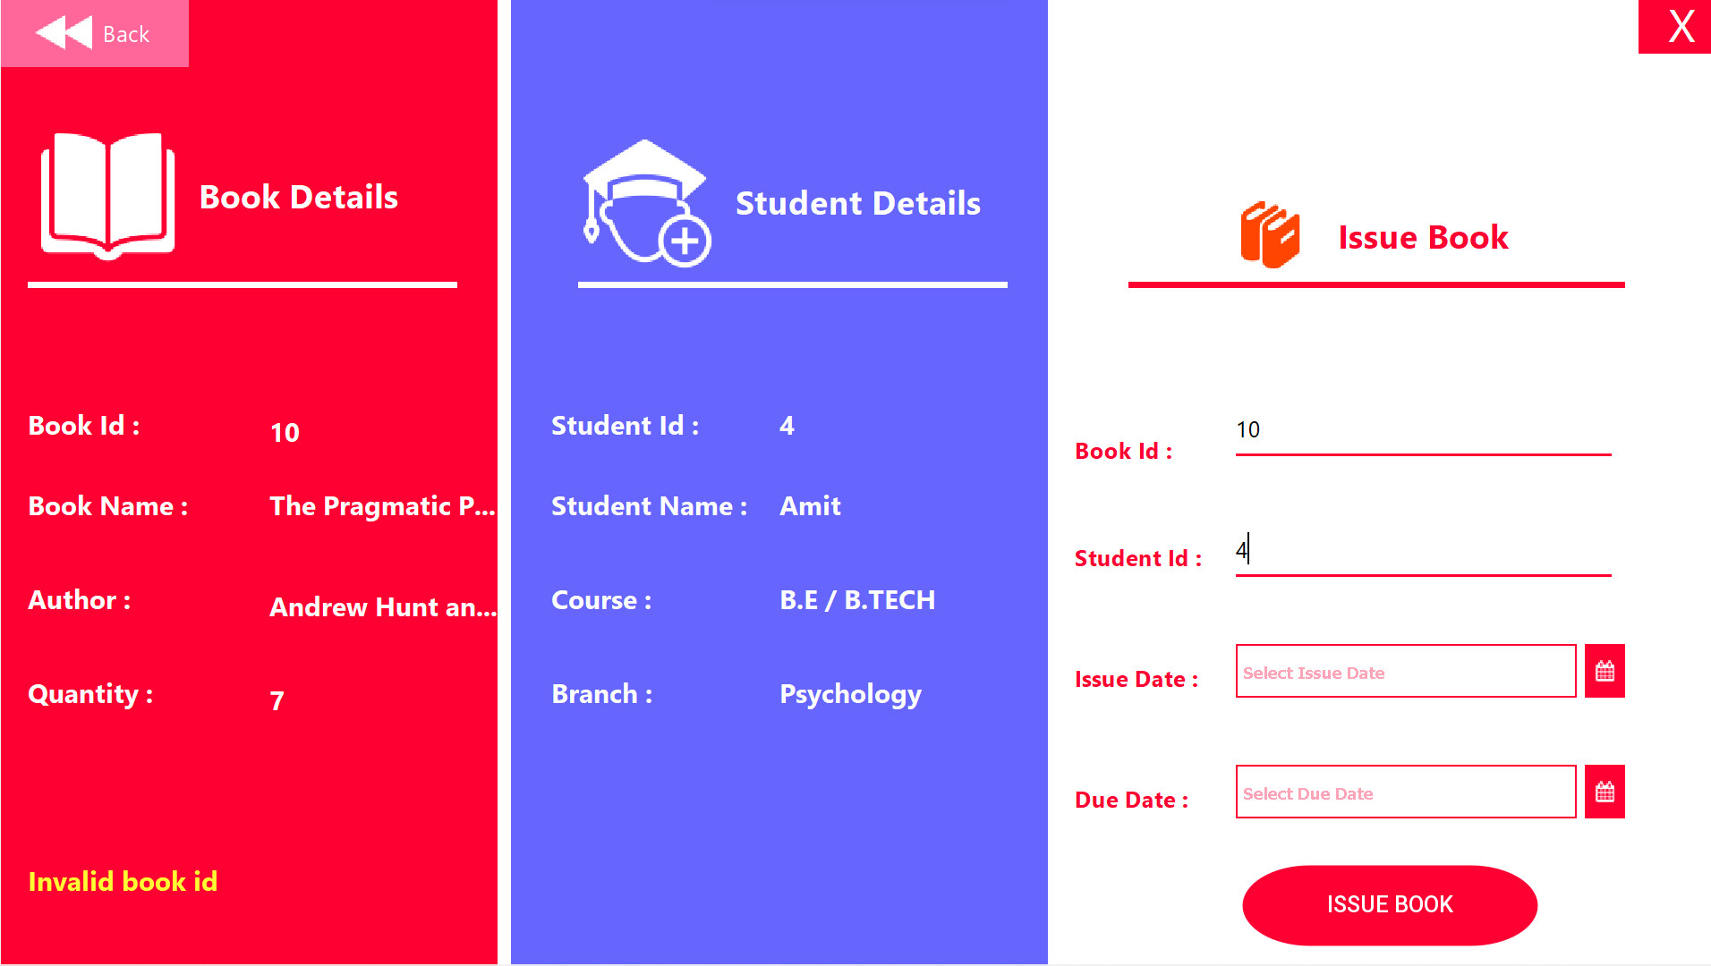

1. Return Books

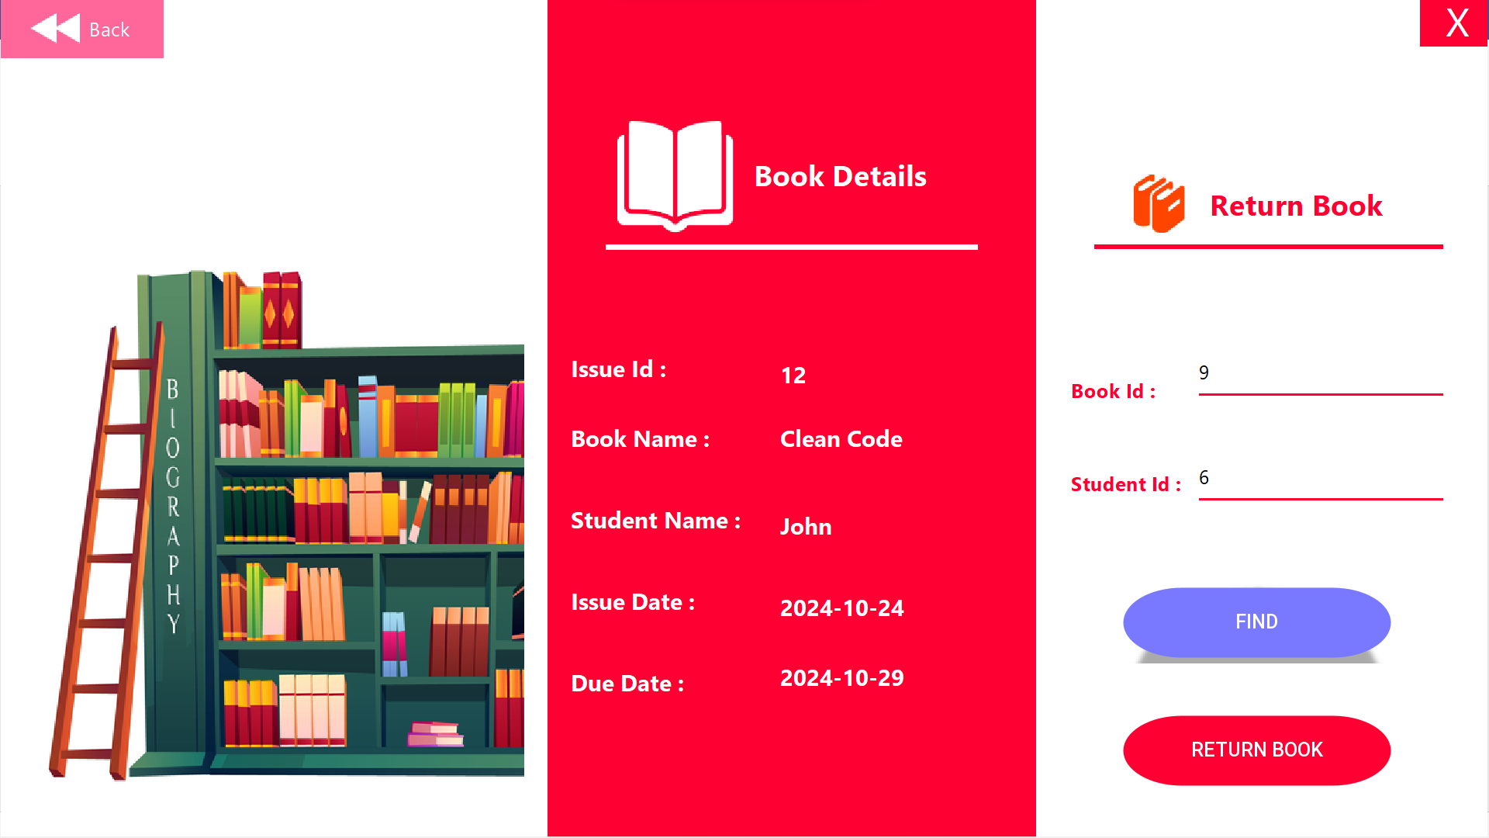

1. View all Records

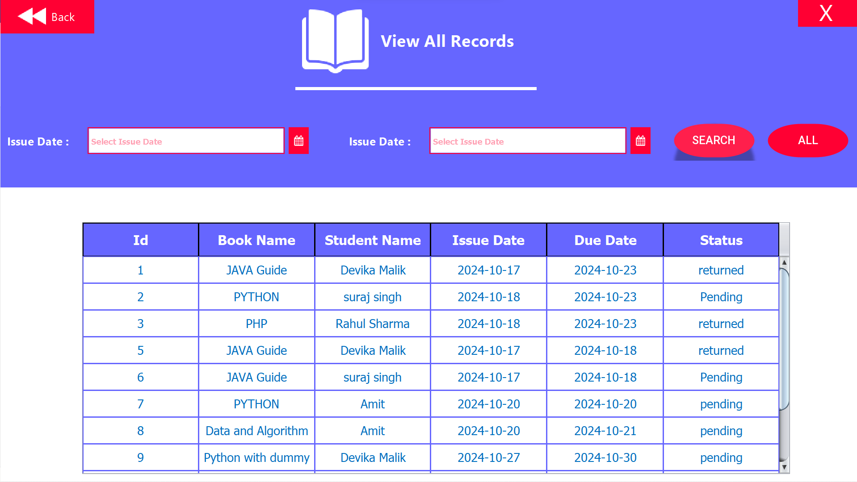

1. View issued Books

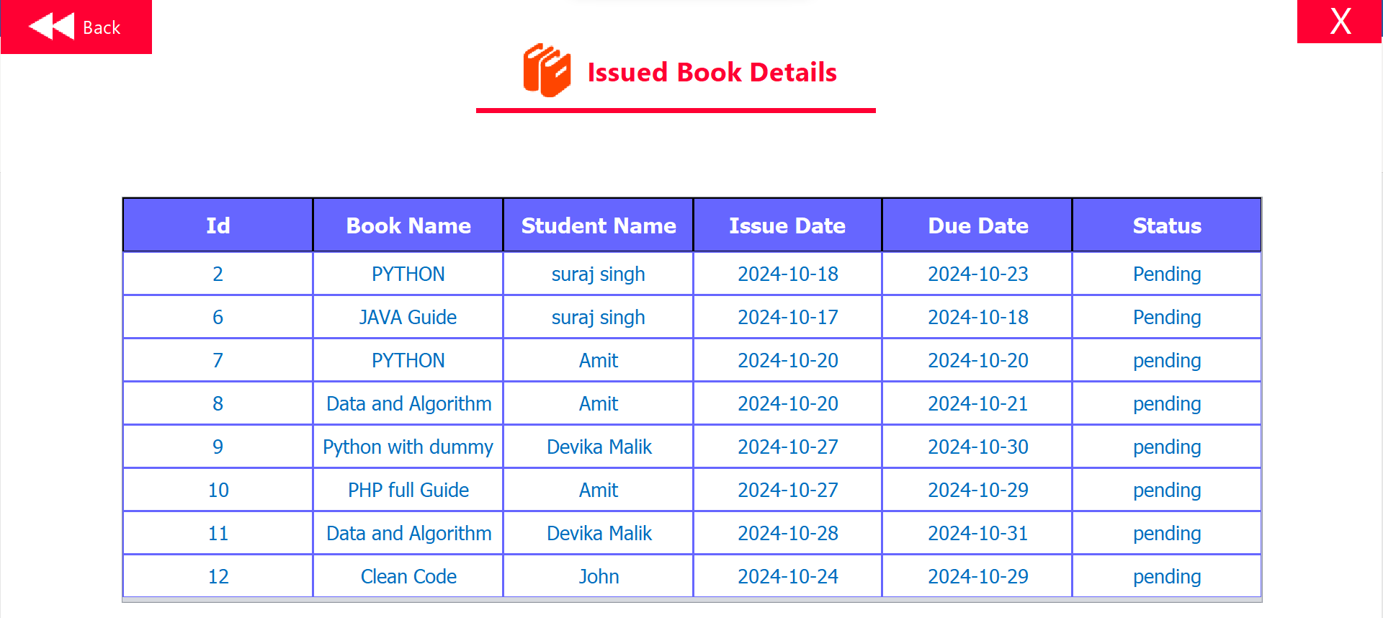

1. Defaulter list

