Lab 6 PS Functions

Student: Kashif Sharma

Student ID: 991857768

Domain: Kashif.powershell.com

Script: Get-RatingMessage.ps1

GitHub Link:

1. Introduction

The purpose of the lab was to create a PowerShell script that contains a function that validates the rating of a product and outputs a message. The function needed to be named Get-RatingMessage and accept string arguments (product name, rating label, comment) and integer arguments (score, max score).

The script also required to have necessary parameters, validation for the parameters, support for pipelines, and to be written in the script template provided in the course. The expected output should be as follows:

Laptop scored 8 points for Product. This product is doing Excellent.

I tested it in VS code and executed it on my Windows Server (192.168.1.20) via Enter-PSSession to a remote session.

2. What I Did
- Created a new file called Get-RatingMessage.ps1 in my Lab6 folder in VS Code.
- Copied the script template into the file and filled in the comment-based help (SYNOPSIS, DESCRIPTION, PARAMETER, EXAMPLE, NOTES and LINK).
- Wrote the Get-RatingMessage function under the #Functions section with [CmdletBinding()] and a param() block.
- Added mandatory parameters, validation attributes and pipeline support to the parameters.
- Added test calls under #Execution Code: a normal call, pipeline with strings, and pipeline with objects.
- Copied the script to the server in C:\Users\Administrator\Documents\lab6.
- Connected to the server from the VS Code terminal using Enter-PSSession and went to the lab6 folder.
- Ran the script, then dot-sourced it and tested the function with the pipeline and with an invalid score.
To connect to the server I used:
Enter-PSSession -ComputerName 192.168.1.20 -Credential
Kashif.powershell.com\Administrator
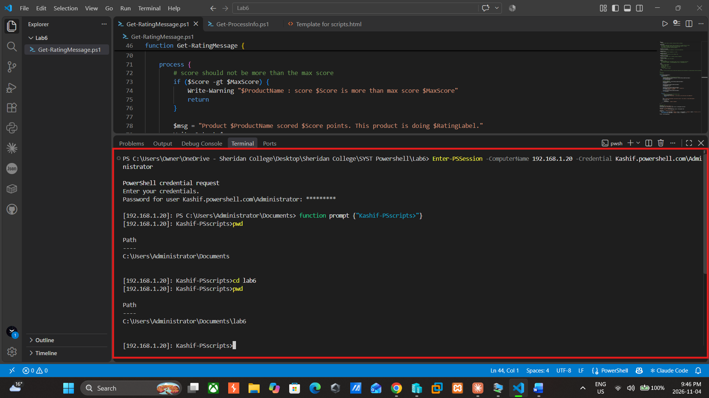
Figure 1: Connecting to the server with Enter-PSSession and moving to the lab6 folder
Running the script:
.\Get-RatingMessage.ps1

When I first tried to run the script, it did not execute because I was not in the correct folder, so I used the pwd command to check which folder I am and then using the cd command I move into the right folder where the script was saved and then ran it again.
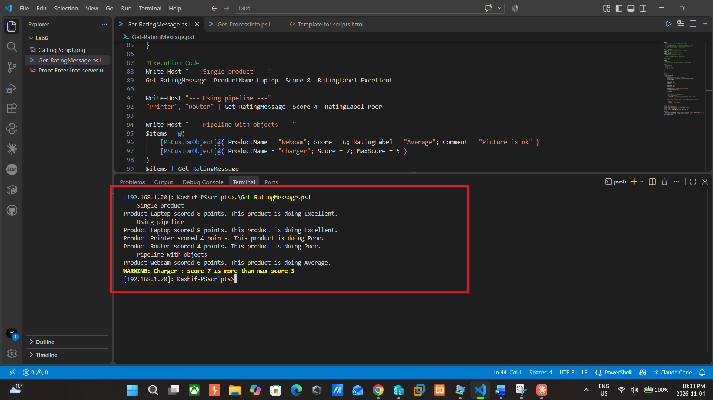
Figure 2: Running the script on the server, showing the single product, pipeline and object outputs
To use the function on its own in the terminal, I loaded it with dot-sourcing and then sent product names through the pipeline:
. .\Get-RatingMessage.ps1
"Laptop" | Get-RatingMessage -Score 8 -RatingLabel Excellent

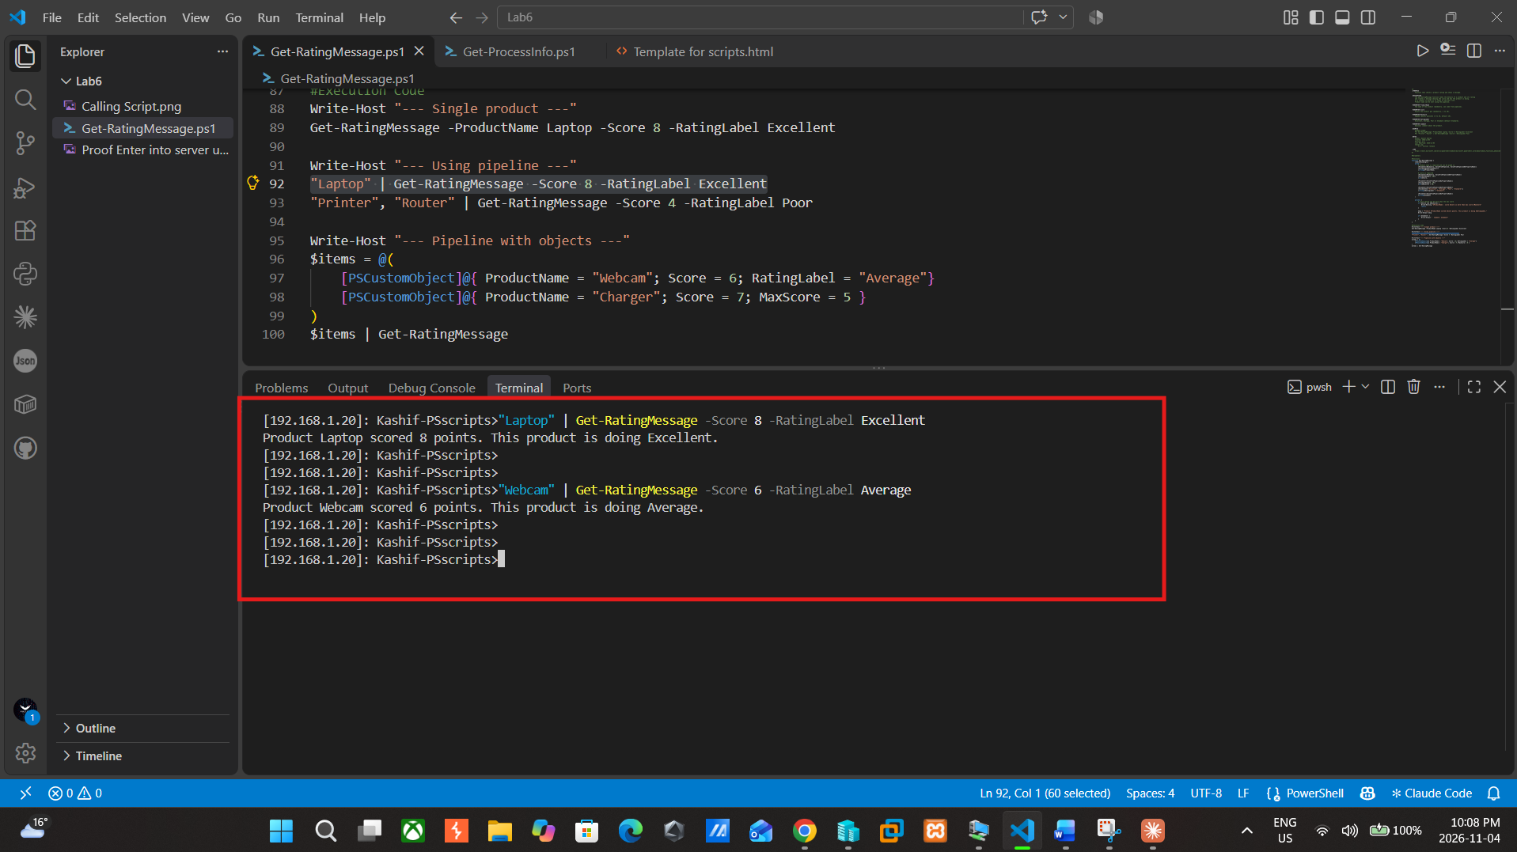
Figure 3: Sending product names to the function through the pipeline

I also tested the validation by giving a score of 15, which is outside the allowed range:
Get-RatingMessage -ProductName Laptop -Score 15 -RatingLabel Excellent
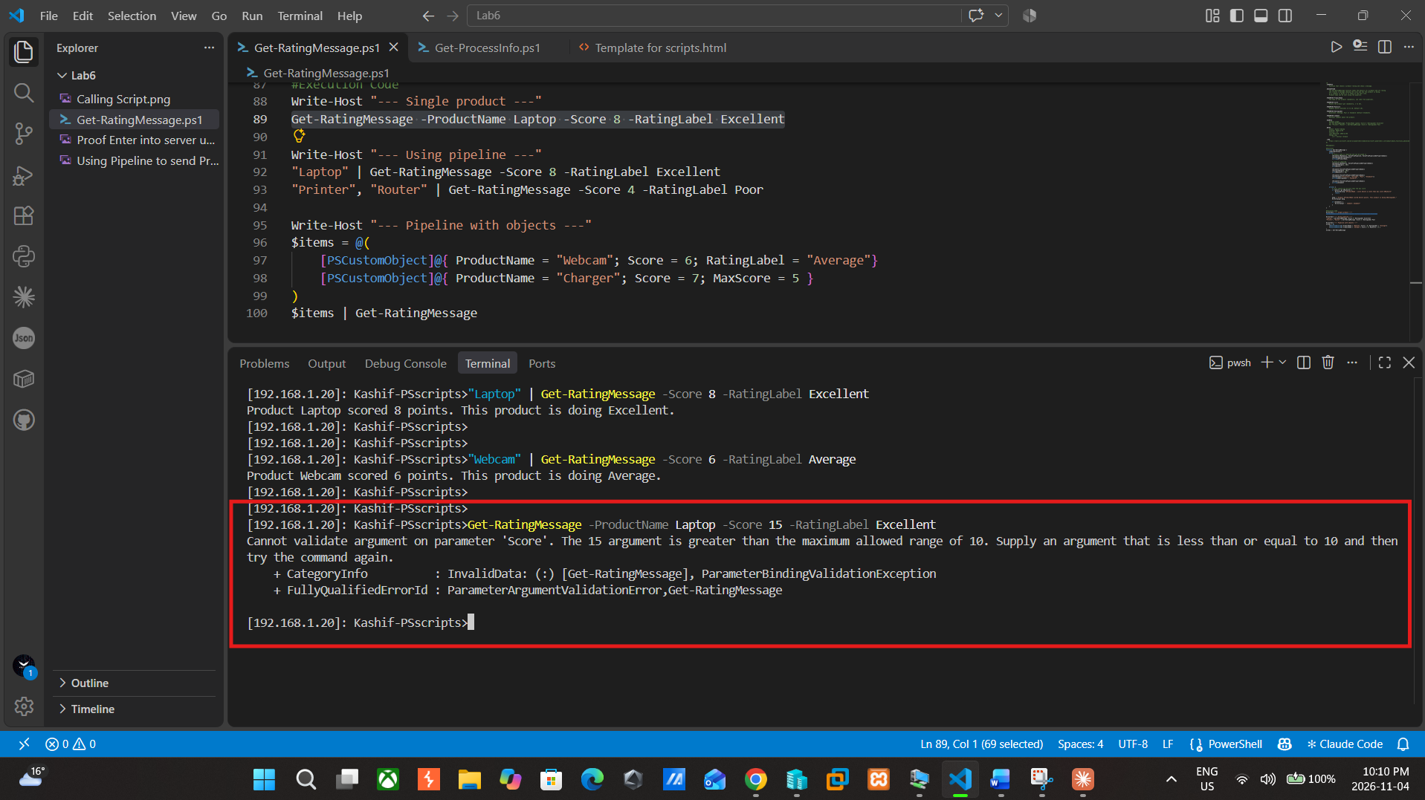
Figure 4: ValidateRange stops the command because 15 is greater than 10

3. How My Script Works
I used the script template from class, so the script starts with the help section at the top. After that come the #Parameters, #Functions and #Execution Code parts. I left #Parameters empty because the function has its own parameters.
The function is called Get-RatingMessage, and I added [CmdletBinding()] so it works like a normal cmdlet. It has 5 parameters. ProductName, RatingLabel and Comment are strings, and Score and MaxScore are integers.
ProductName and Score are mandatory, so if I don’t type them, PowerShell asks me for them. MaxScore is 10 by default and RatingLabel is Standard by default, so I don’t have to enter them every time.
For validation I used:
- ValidateNotNullOrEmpty, so the product name can’t be blank
- ValidateRange(1, 10) for Score, so a score like 15 gives an error (Figure 4)
- ValidateRange(5, 10) for MaxScore
- ValidateSet for RatingLabel, so only Excellent, Average, Poor or Standard can be used
I also added an if statement that checks whether the score is bigger than the max score. If it is, the function shows a warning and skips that product. You can see this with Charger in Figure 2.
For the pipeline, I added ValueFromPipeline to ProductName so I can pipe a product name straight in, like “Laptop” | Get-RatingMessage. I also added ValueFromPipelineByPropertyName, so I can pipe in objects that have the same property names as the parameters. I put the code inside a process block so it runs for every item in the pipeline, not just the first one.
Last, the function puts the message in $msg and shows it with Write-Output, which gives the output from the lab:
Product Laptop scored 8 points. This product is doing Excellent.
In the #Execution Code part I tested the function in different ways. Write-Host just prints a heading so the output is easier to read. First I called the function normally with -ProductName, -Score and -RatingLabel. Then I tested the pipeline by piping “Laptop” into the function, and then two products at once (“Printer”, “Router”), which gives one message for each. Last, I used $items = @() to make an array of two objects with [PSCustomObject] and piped them into the function. The Webcam object works normally. The Charger object has a score of 7 and a max score of 5, so it shows the warning instead of a message.

4. My Script
<#
.SYNOPSIS
Function that checks a product rating and shows a message.

.DESCRIPTION
The Get-RatingMessage function takes the details of a product and its rating
and creates a message showing the score and how the product is doing.
If a comment is given it is shown on the next line.
Product name can be sent using the pipeline.

.PARAMETER ProductName
The name of the product (mandatory, can come from pipeline).

.PARAMETER Score
Points the product got (mandatory, 1 to 10).

.PARAMETER MaxScore
Highest points possible (5 to 10, default 10).

.PARAMETER RatingLabel
Excellent, Average, Poor or Standard (default Standard).

.PARAMETER Comment
Optional comment about the product.

.EXAMPLE
Example usage:
PS> Get-RatingMessage -ProductName Laptop -Score 8 -RatingLabel Excellent
PS> "Printer","Router" | Get-RatingMessage -Score 4 -RatingLabel Poor

.NOTES
Author: Kashif Sharma
Created: 2026-11-04
Version: 1.0
Last Modified: 2026-11-04
Change Log:
1.0 - Initial release

.LINK
https://learn.microsoft.com/en-us/powershell/module/microsoft.powershell.core/about/about_functions_advanced_parameters
#>

#Parameters

#Functions
function Get-RatingMessage {
[CmdletBinding()]
param (
# product name is required and can be piped in
[Parameter(Mandatory, ValueFromPipeline, ValueFromPipelineByPropertyName)]
[ValidateNotNullOrEmpty()]
[string]$ProductName,

# score is required
[Parameter(Mandatory, ValueFromPipelineByPropertyName)]
[ValidateRange(1, 10)]
[int]$Score,

[Parameter(ValueFromPipelineByPropertyName)]
[ValidateRange(5, 10)]
[int]$MaxScore = 10,

[Parameter(ValueFromPipelineByPropertyName)]
[ValidateSet("Excellent", "Average", "Poor", "Standard")]
[string]$RatingLabel = "Standard",

[Parameter(ValueFromPipelineByPropertyName)]
[string]$Comment
)

process {
# score should not be more than the max score
if ($Score -gt $MaxScore) {
Write-Warning "$ProductName : score $Score is more than max score $MaxScore"
return
}

$msg = "Product $ProductName scored $Score points. This product is doing $RatingLabel."
Write-Output $msg

if ($Comment) {
Write-Output " Comment: $Comment"
}
}
}

#Execution Code
Write-Host "--- Single product ---"
Get-RatingMessage -ProductName Laptop -Score 8 -RatingLabel Excellent

Write-Host "--- Using pipeline ---"
"Laptop" | Get-RatingMessage -Score 8 -RatingLabel Excellent
"Printer", "Router" | Get-RatingMessage -Score 4 -RatingLabel Poor

Write-Host "--- Pipeline with objects ---" #$items= @() is used to create an array of objects.
$items = @(
[PSCustomObject]@{ ProductName = "Webcam"; Score = 6; RatingLabel = "Average"}
[PSCustomObject]@{ ProductName = "Charger"; Score = 7; MaxScore = 5 }
)
$items | Get-RatingMessage

5. Conclusion
I wrote the Get-RatingMessage function with the script template in this lab. It is a string and integer input, uses required parameters, validates the input using the validation attributes and supports the pipeline ByValue and ByPropertyName. Executed the script on the server using Enter-PSSession and the results matched the sample of the lab.
I found two things out while running it remotely. Once downloaded a script is blocked by the execution policy until it is unblocked. Running a script with .\ does not retain the function into the session afterwards, so I would have to dot-source the script before I could call Get-RatingMessage on the terminal.

