COMP1786 Logbook Upload Template
COMP1786 (2026-27) Mobile Application Design and Development - CW2 logbook, Exercise 1.
1. Basic Information
1.1 Student name | Htun Khaing Lynn  Student ID: [ADD STUDENT ID]
1.2 Who did you work with? | Name: Not applicable  Login id: Not applicable  This exercise was completed individually.
1.3 Which Exercise is this? | Exercise 1
1.4 How well did you complete the exercise? Tick as appropriate. | ☐ I tried but couldn't complete it  ☐ I did it but I feel I should have done better  ☑ I did everything that was asked  ☐ I did more than was asked for
1.5 Briefly explain your answer to question 1.4 | The Java BMI Calculator accepts weight in kilograms or pounds and height in centimetres or metres. It converts the selected units, calculates adult BMI, shows Underweight, Healthy weight, Overweight or Obese in words and colour, and rejects missing, non-numeric or out-of-range input. Labels, messages, category colours, styles and the result panel use Android resources. Pure Java tests cover conversion, category boundaries, validation ranges and comma decimals. The app therefore completes the requested calculation, controls, validation and presentation requirements.

2. Exercise answer
2.1 Screen shots demonstrating what you achieved
The following genuine Android screenshots show the completed exercise, valid unit conversions and input validation on a running device or emulator.
Screenshot 1 - Valid kilograms/centimetres result
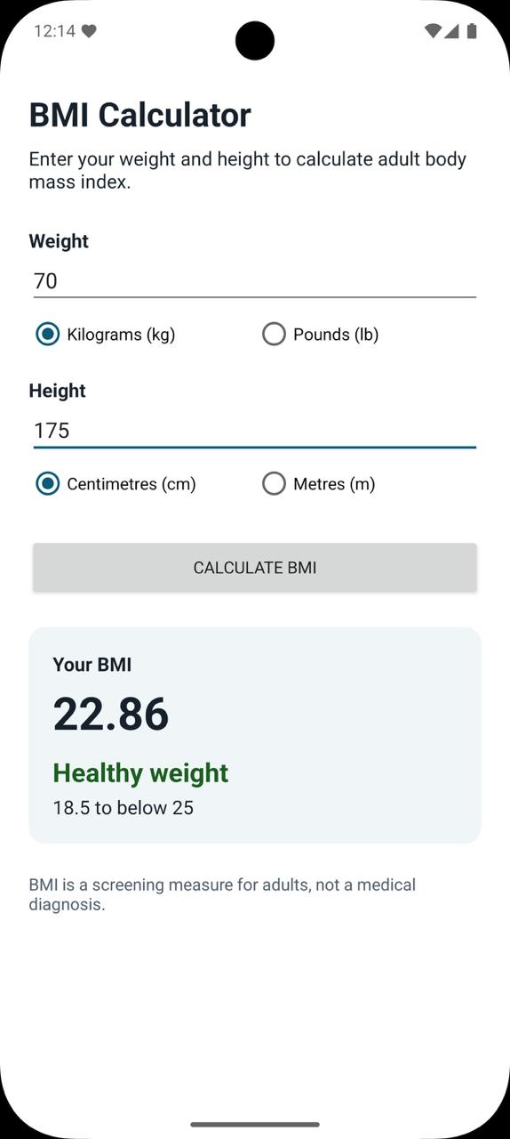
What this demonstrates: Valid calculation, BMI value, selected units and category feedback.

Screenshot 2 - Pounds conversion
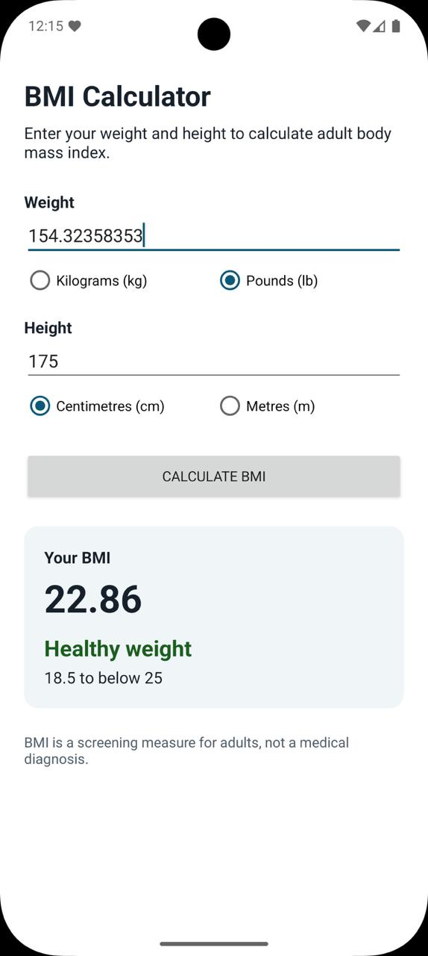
What this demonstrates: Weight conversion from pounds to kilograms.

Screenshot 3 - Metres conversion
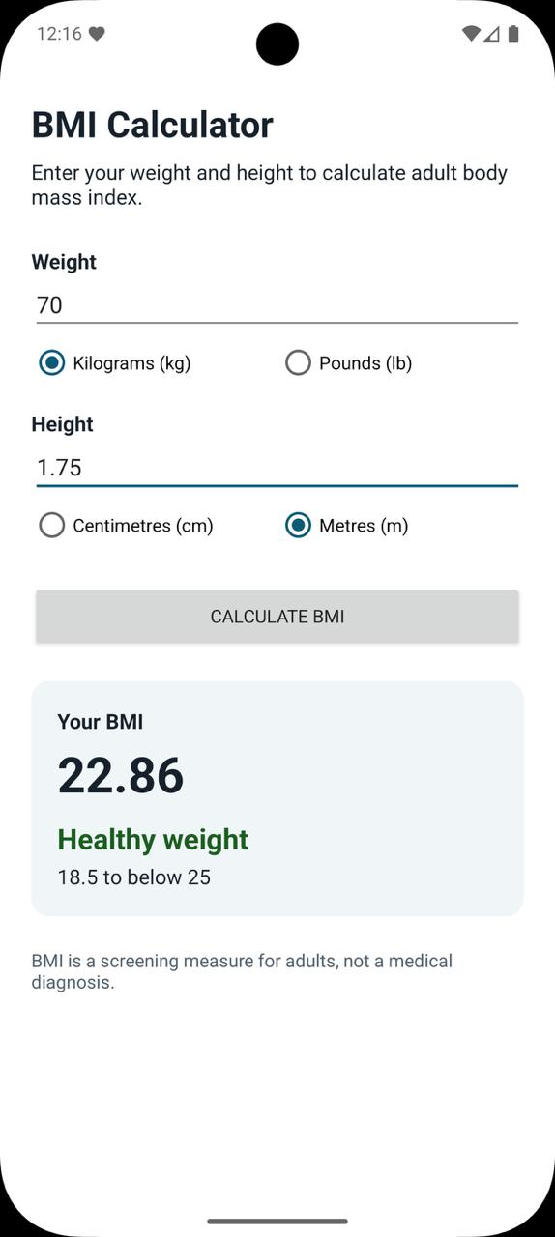
What this demonstrates: Height conversion from metres and consistent calculation.

Screenshot 4 - Missing weight validation
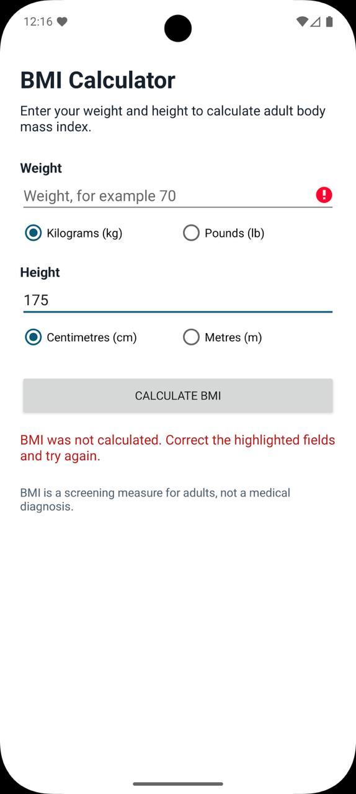
What this demonstrates: A required value is rejected and no stale BMI is shown.

Screenshot 5 - Range validation
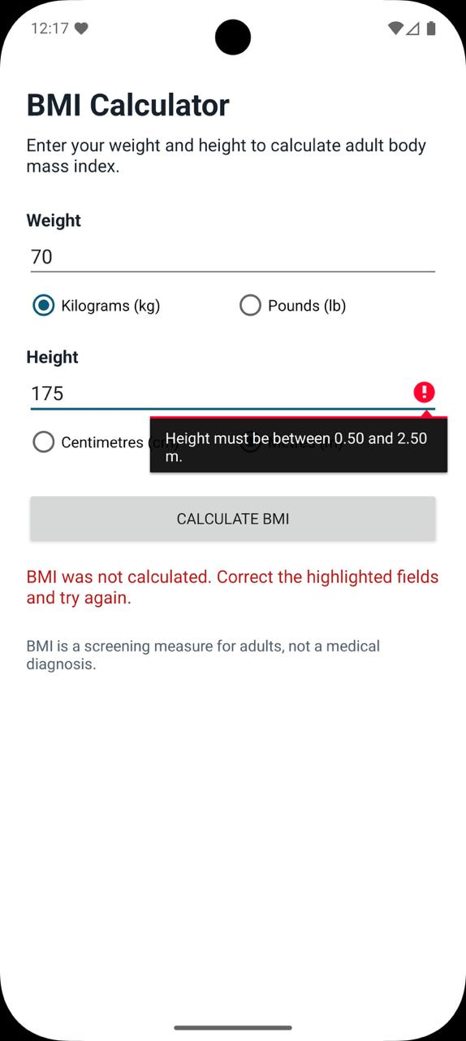
What this demonstrates: Numeric but unreasonable values are rejected for the selected unit.

2.2 Code that you wrote
The relevant source is copied below as editable text, not screenshots. No generated line numbers are added. Generated files and build output are excluded.
bmiapp/src/main/java/com/htunkhainglinn/bmicalculator/BmiCalculator.java
Pure Java logic validates measurements, converts units, calculates BMI and assigns the four adult categories. Keeping this outside the Activity makes it directly unit-testable.
package com.htunkhainglinn.bmicalculator;

/** Pure calculation and validation logic for adult BMI. */
public final class BmiCalculator {
private static final double KILOGRAMS_PER_POUND = 0.45359237;

public enum WeightUnit { KILOGRAMS, POUNDS }
public enum HeightUnit { CENTIMETRES, METRES }
public enum Category { UNDERWEIGHT, HEALTHY, OVERWEIGHT, OBESE }
public enum FieldError { NONE, MISSING, NOT_A_NUMBER, OUT_OF_RANGE }

public static final class Outcome {
public final double bmi;
public final Category category;
public final FieldError weightError;
public final FieldError heightError;

private Outcome(double bmi, Category category, FieldError weightError, FieldError heightError) {
this.bmi = bmi;
this.category = category;
this.weightError = weightError;
this.heightError = heightError;
}

public boolean isValid() {
return weightError == FieldError.NONE && heightError == FieldError.NONE;
}
}

private static final class Measurement {
final double value;
final FieldError error;

Measurement(double value, FieldError error) {
this.value = value;
this.error = error;
}
}

private BmiCalculator() { }

public static Outcome calculate(String weightText, WeightUnit weightUnit,
String heightText, HeightUnit heightUnit) {
if (weightUnit == null || heightUnit == null) {
throw new IllegalArgumentException("Units are required");
}
Measurement weight = readMeasurement(weightText,
weightUnit == WeightUnit.KILOGRAMS ? 20 : 44,
weightUnit == WeightUnit.KILOGRAMS ? 300 : 661);
Measurement height = readMeasurement(heightText,
heightUnit == HeightUnit.CENTIMETRES ? 50 : 0.5,
heightUnit == HeightUnit.CENTIMETRES ? 250 : 2.5);
if (weight.error != FieldError.NONE || height.error != FieldError.NONE) {
return new Outcome(Double.NaN, null, weight.error, height.error);
}

double kilograms = weightUnit == WeightUnit.KILOGRAMS
? weight.value : weight.value * KILOGRAMS_PER_POUND;
double metres = heightUnit == HeightUnit.METRES
? height.value : height.value / 100.0;
double bmi = kilograms / (metres * metres);
Category category = bmi < 18.5 ? Category.UNDERWEIGHT
: bmi < 25.0 ? Category.HEALTHY
: bmi < 30.0 ? Category.OVERWEIGHT : Category.OBESE;
return new Outcome(bmi, category, FieldError.NONE, FieldError.NONE);
}

private static Measurement readMeasurement(String raw, double minimum, double maximum) {
String text = raw == null ? "" : raw.trim();
if (text.isEmpty()) {
return new Measurement(Double.NaN, FieldError.MISSING);
}
// A pasted comma decimal is accepted, but signs, exponents and multiple separators are not.
if (!text.matches("[0-9]+([.,][0-9]+)?")) {
return new Measurement(Double.NaN, FieldError.NOT_A_NUMBER);
}
double value;
try {
value = Double.parseDouble(text.replace(',', '.'));
} catch (NumberFormatException exception) {
return new Measurement(Double.NaN, FieldError.NOT_A_NUMBER);
}
if (!Double.isFinite(value) || value < minimum || value > maximum) {
return new Measurement(Double.NaN, FieldError.OUT_OF_RANGE);
}
return new Measurement(value, FieldError.NONE);
}
}

bmiapp/src/main/java/com/htunkhainglinn/bmicalculator/BmiActivity.java
The Activity reads the selected radio-button units, displays field-specific resource messages and renders the valid BMI result without duplicating calculation rules.
package com.htunkhainglinn.bmicalculator;

import android.app.Activity;
import android.os.Bundle;
import android.text.Editable;
import android.text.TextWatcher;
import android.view.View;
import android.widget.Button;
import android.widget.EditText;
import android.widget.RadioGroup;
import android.widget.TextView;

import androidx.core.view.ViewCompat;
import androidx.core.view.WindowInsetsCompat;

import java.util.Locale;

public final class BmiActivity extends Activity {
private EditText weightInput;
private EditText heightInput;
private RadioGroup weightUnits;
private RadioGroup heightUnits;
private View resultPanel;
private TextView resultStatus;
private TextView bmiValue;
private TextView categoryValue;
private TextView categoryBand;

@Override
protected void onCreate(Bundle savedInstanceState) {
super.onCreate(savedInstanceState);
setContentView(R.layout.activity_bmi);

View root = findViewById(R.id.root);
ViewCompat.setOnApplyWindowInsetsListener(root, (view, insets) -> {
androidx.core.graphics.Insets bars = insets.getInsets(WindowInsetsCompat.Type.systemBars());
view.setPadding(bars.left, bars.top, bars.right, bars.bottom);
return insets;
});

weightInput = findViewById(R.id.weight_input);
heightInput = findViewById(R.id.height_input);
weightUnits = findViewById(R.id.weight_units);
heightUnits = findViewById(R.id.height_units);
resultPanel = findViewById(R.id.result_panel);
resultStatus = findViewById(R.id.result_status);
bmiValue = findViewById(R.id.bmi_value);
categoryValue = findViewById(R.id.category_value);
categoryBand = findViewById(R.id.category_band);
Button calculateButton = findViewById(R.id.calculate_button);

TextWatcher clearOnEdit = new TextWatcher() {
@Override public void beforeTextChanged(CharSequence text, int start, int count, int after) { }
@Override public void onTextChanged(CharSequence text, int start, int before, int count) {
clearResult();
}
@Override public void afterTextChanged(Editable text) { }
};
weightInput.addTextChangedListener(clearOnEdit);
heightInput.addTextChangedListener(clearOnEdit);
weightUnits.setOnCheckedChangeListener((group, checkedId) -> clearResult());
heightUnits.setOnCheckedChangeListener((group, checkedId) -> clearResult());
calculateButton.setOnClickListener(view -> calculate());
}

private void clearResult() {
resultPanel.setVisibility(View.GONE);
resultStatus.setVisibility(View.GONE);
weightInput.setError(null);
heightInput.setError(null);
}

private void calculate() {
BmiCalculator.WeightUnit weightUnit = weightUnits.getCheckedRadioButtonId() == R.id.unit_lb
? BmiCalculator.WeightUnit.POUNDS : BmiCalculator.WeightUnit.KILOGRAMS;
BmiCalculator.HeightUnit heightUnit = heightUnits.getCheckedRadioButtonId() == R.id.unit_m
? BmiCalculator.HeightUnit.METRES : BmiCalculator.HeightUnit.CENTIMETRES;
BmiCalculator.Outcome outcome = BmiCalculator.calculate(
weightInput.getText().toString(), weightUnit,
heightInput.getText().toString(), heightUnit);

if (!outcome.isValid()) {
resultPanel.setVisibility(View.GONE);
showFieldError(weightInput, outcome.weightError,
weightUnit == BmiCalculator.WeightUnit.KILOGRAMS
? R.string.weight_range_kg : R.string.weight_range_lb);
showFieldError(heightInput, outcome.heightError,
heightUnit == BmiCalculator.HeightUnit.CENTIMETRES
? R.string.height_range_cm : R.string.height_range_m);
resultStatus.setText(R.string.correct_inputs);
resultStatus.setVisibility(View.VISIBLE);
return;
}

weightInput.setError(null);
heightInput.setError(null);
resultStatus.setVisibility(View.GONE);
bmiValue.setText(String.format(Locale.getDefault(), "%.2f", outcome.bmi));
int label;
int band;
int color;
switch (outcome.category) {
case UNDERWEIGHT:
label = R.string.category_underweight;
band = R.string.band_underweight;
color = R.color.category_underweight;
break;
case HEALTHY:
label = R.string.category_healthy;
band = R.string.band_healthy;
color = R.color.category_healthy;
break;
case OVERWEIGHT:
label = R.string.category_overweight;
band = R.string.band_overweight;
color = R.color.category_overweight;
break;
default:
label = R.string.category_obese;
band = R.string.band_obese;
color = R.color.category_obese;
}
categoryValue.setText(label);
categoryValue.setTextColor(getColor(color));
categoryBand.setText(band);
resultPanel.setVisibility(View.VISIBLE);
}

private void showFieldError(EditText field, BmiCalculator.FieldError error, int rangeMessage) {
switch (error) {
case MISSING: field.setError(getString(R.string.required_field)); break;
case NOT_A_NUMBER: field.setError(getString(R.string.valid_number)); break;
case OUT_OF_RANGE: field.setError(getString(rangeMessage)); break;
default: field.setError(null);
}
}
}

bmiapp/src/main/res/layout/activity_bmi.xml
The scrollable layout provides labelled numeric inputs, selectable unit controls, a clear calculate action and an accessible text result panel.
<?xml version="1.0" encoding="utf-8"?>
<ScrollView xmlns:android="http://schemas.android.com/apk/res/android"
android:id="@+id/root"
android:layout_width="match_parent"
android:layout_height="match_parent"
android:fillViewport="true">

<LinearLayout
android:layout_width="match_parent"
android:layout_height="wrap_content"
android:orientation="vertical"
android:padding="24dp">

<TextView
android:layout_width="match_parent"
android:layout_height="wrap_content"
android:text="@string/screen_title"
android:textAppearance="@style/TextAppearance.Bmi.Title" />

<TextView
android:layout_width="match_parent"
android:layout_height="wrap_content"
android:layout_marginTop="8dp"
android:text="@string/screen_intro"
android:textAppearance="@style/TextAppearance.Bmi.Body" />

<TextView
android:layout_width="match_parent"
android:layout_height="wrap_content"
android:layout_marginTop="28dp"
android:text="@string/weight_label"
android:textAppearance="@style/TextAppearance.Bmi.FieldLabel" />

<EditText
android:id="@+id/weight_input"
android:layout_width="match_parent"
android:layout_height="wrap_content"
android:hint="@string/weight_hint"
android:importantForAutofill="no"
android:inputType="numberDecimal"
android:maxLines="1" />

<RadioGroup
android:id="@+id/weight_units"
android:layout_width="match_parent"
android:layout_height="wrap_content"
android:layout_marginTop="6dp"
android:orientation="horizontal">

<RadioButton
android:id="@+id/unit_kg"
android:layout_width="0dp"
android:layout_height="wrap_content"
android:layout_weight="1"
android:checked="true"
android:text="@string/unit_kg" />

<RadioButton
android:id="@+id/unit_lb"
android:layout_width="0dp"
android:layout_height="wrap_content"
android:layout_weight="1"
android:text="@string/unit_lb" />
</RadioGroup>

<TextView
android:layout_width="match_parent"
android:layout_height="wrap_content"
android:layout_marginTop="20dp"
android:text="@string/height_label"
android:textAppearance="@style/TextAppearance.Bmi.FieldLabel" />

<EditText
android:id="@+id/height_input"
android:layout_width="match_parent"
android:layout_height="wrap_content"
android:hint="@string/height_hint"
android:importantForAutofill="no"
android:inputType="numberDecimal"
android:maxLines="1" />

<RadioGroup
android:id="@+id/height_units"
android:layout_width="match_parent"
android:layout_height="wrap_content"
android:layout_marginTop="6dp"
android:orientation="horizontal">

<RadioButton
android:id="@+id/unit_cm"
android:layout_width="0dp"
android:layout_height="wrap_content"
android:layout_weight="1"
android:checked="true"
android:text="@string/unit_cm" />

<RadioButton
android:id="@+id/unit_m"
android:layout_width="0dp"
android:layout_height="wrap_content"
android:layout_weight="1"
android:text="@string/unit_m" />
</RadioGroup>

<Button
android:id="@+id/calculate_button"
android:layout_width="match_parent"
android:layout_height="wrap_content"
android:layout_marginTop="28dp"
android:minHeight="52dp"
android:text="@string/calculate_button" />

<TextView
android:id="@+id/result_status"
android:layout_width="match_parent"
android:layout_height="wrap_content"
android:layout_marginTop="16dp"
android:accessibilityLiveRegion="polite"
android:textAppearance="@style/TextAppearance.Bmi.Error"
android:visibility="gone" />

<LinearLayout
android:id="@+id/result_panel"
android:layout_width="match_parent"
android:layout_height="wrap_content"
android:layout_marginTop="24dp"
android:background="@drawable/result_background"
android:accessibilityLiveRegion="polite"
android:orientation="vertical"
android:padding="20dp"
android:visibility="gone">

<TextView
android:layout_width="match_parent"
android:layout_height="wrap_content"
android:text="@string/result_label"
android:textAppearance="@style/TextAppearance.Bmi.FieldLabel" />

<TextView
android:id="@+id/bmi_value"
android:layout_width="match_parent"
android:layout_height="wrap_content"
android:layout_marginTop="4dp"
android:textAppearance="@style/TextAppearance.Bmi.Result" />

<TextView
android:id="@+id/category_value"
android:layout_width="match_parent"
android:layout_height="wrap_content"
android:layout_marginTop="10dp"
android:textAppearance="@style/TextAppearance.Bmi.Category" />

<TextView
android:id="@+id/category_band"
android:layout_width="match_parent"
android:layout_height="wrap_content"
android:layout_marginTop="4dp"
android:textAppearance="@style/TextAppearance.Bmi.Body" />
</LinearLayout>

<TextView
android:layout_width="match_parent"
android:layout_height="wrap_content"
android:layout_marginTop="24dp"
android:text="@string/bmi_disclaimer"
android:textAppearance="@style/TextAppearance.Bmi.Note" />
</LinearLayout>
</ScrollView>

bmiapp/src/test/java/com/htunkhainglinn/bmicalculator/BmiCalculatorTest.java
The unit tests verify representative calculations, boundary categories, missing/invalid input, unit-specific ranges and decimal-comma support.
package com.htunkhainglinn.bmicalculator;

import static com.htunkhainglinn.bmicalculator.BmiCalculator.Category;
import static com.htunkhainglinn.bmicalculator.BmiCalculator.FieldError;
import static com.htunkhainglinn.bmicalculator.BmiCalculator.HeightUnit;
import static com.htunkhainglinn.bmicalculator.BmiCalculator.WeightUnit;
import static org.junit.Assert.assertEquals;
import static org.junit.Assert.assertFalse;
import static org.junit.Assert.assertTrue;

import org.junit.Test;

public class BmiCalculatorTest {
@Test public void kilogramsAndCentimetresCalculateHealthyBmi() {
BmiCalculator.Outcome result = BmiCalculator.calculate("70", WeightUnit.KILOGRAMS,
"175", HeightUnit.CENTIMETRES);
assertTrue(result.isValid());
assertEquals(22.86, result.bmi, 0.01);
assertEquals(Category.HEALTHY, result.category);
}

@Test public void poundsAndMetresConvertToSameBmi() {
BmiCalculator.Outcome result = BmiCalculator.calculate("154.32358353", WeightUnit.POUNDS,
"1.75", HeightUnit.METRES);
assertTrue(result.isValid());
assertEquals(22.86, result.bmi, 0.01);
}

@Test public void categoryBoundariesBelongToHigherBand() {
assertEquals(Category.UNDERWEIGHT, calculateAtTwoMetres("73.96").category);
assertEquals(Category.HEALTHY, calculateAtTwoMetres("74").category);
assertEquals(Category.OVERWEIGHT, calculateAtTwoMetres("100").category);
assertEquals(Category.OBESE, calculateAtTwoMetres("120").category);
}

@Test public void missingAndInvalidFieldsPreventCalculation() {
BmiCalculator.Outcome result = BmiCalculator.calculate("abc", WeightUnit.KILOGRAMS,
"", HeightUnit.CENTIMETRES);
assertFalse(result.isValid());
assertEquals(FieldError.NOT_A_NUMBER, result.weightError);
assertEquals(FieldError.MISSING, result.heightError);
assertTrue(Double.isNaN(result.bmi));
}

@Test public void selectedUnitRangesAreEnforced() {
BmiCalculator.Outcome result = BmiCalculator.calculate("70", WeightUnit.KILOGRAMS,
"175", HeightUnit.METRES);
assertFalse(result.isValid());
assertEquals(FieldError.OUT_OF_RANGE, result.heightError);
assertEquals(FieldError.NONE, result.weightError);
}

@Test public void commaDecimalIsAccepted() {
BmiCalculator.Outcome result = BmiCalculator.calculate("70,5", WeightUnit.KILOGRAMS,
"1,75", HeightUnit.METRES);
assertTrue(result.isValid());
assertEquals(23.02, result.bmi, 0.01);
}

private static BmiCalculator.Outcome calculateAtTwoMetres(String kilograms) {
return BmiCalculator.calculate(kilograms, WeightUnit.KILOGRAMS,
"2", HeightUnit.METRES);
}
}

