COMP 1682 PROJECT DOCUMENTATION
Aegis
API Security and Management System

Htun Khaing Lynn
Student ID: 001557481
BSc (Hons) Computing
Final Project Report - 2026

Abstract
Aegis is a self-hosted API security and management system that centralises authentication, authorisation, rate limiting, threat detection and audit visibility in front of protected services. It combines a Python/FastAPI Control Plane, a Go Reverse Proxy and a React dashboard with PostgreSQL and Redis. This report evaluates the implemented system against the Project Proposal, current source code, database migrations and verified local test verification.
The implementation issues cryptographically random API keys whose hashes alone are persisted; validates API keys and optional JWTs; binds exact HTTP method/path pairs to required resource:action scopes; applies fixed-window, sliding-window and token-bucket limits in Redis; distributes policy by REST bootstrap and authenticated gRPC streaming; detects configured request-target patterns; enforces manual and automatic IP blocks; and records sanitised analytics. The report explains how JSON payload structures are parsed and validated and how the Go proxy consumes the resulting policy without inferring semantics from scope names.
Verification includes 47 Control Plane tests at 77% application coverage, Go race/vet/format checks and 83.4% enforcement-core coverage, six dashboard tests, thirteen POC/tooling tests, focused request-schema and exact-scope tests, an observed live attack/defence flow and a completed isolated Docker E2E run. In line with the structural reference, detailed design, implementation, operation and testing material is presented inside the relevant chapters. Only the proposal pointer and project-plan figure remain as appendices.
Keywords: API security, reverse proxy, FastAPI, Go, JWT, rate limiting, Redis, DSDM.

Acknowledgements
I would like to thank the project supervisor, module tutors and COMP 1682 teaching team for their guidance on scope, academic writing, verification and project management. Their feedback led to a clearer distinction between implementation delivery timeboxes and the surrounding design, testing and evaluation activities.
The report also acknowledges the standards, research literature and open-source communities referenced in the bibliography. Hein Htet Aung's 2026 final report was used as the latest structural reference: its chapter-first treatment of implementation, testing and deployment, and its restrained appendix use, informed this revision. Its project-specific content was not reused as Aegis verification.

Table of Contents
Abstract 2
Acknowledgement 3
List of Figures 5
List of Tables 6
Chapter 1: Introduction 7
Chapter 2: Product Research 12
Chapter 3: Literature Review 15
Chapter 4: Legal, Social, Ethical and Professional Issues 17
Chapter 5: System Analysis 20
Chapter 6: System Design 29
Chapter 7: Project Timeline 35
Chapter 8: System Implementation 45
Chapter 9: Evaluation and Reflection 62
References 65
Appendices 67

List of Figures
Figure | Description
Figure 6.1 | Current architecture
Figure 6.2 | Persisted domain model
Figure 6.3 | Control Plane request validation
Figure 6.4 | Proxy enforcement sequence
Figure 6.5 | Policy distribution and fallback
Figure 6.6 | Rate-limit decision
Figure 6.7 | Event and analytics flow
Figure 7.1 | Date-based delivery schedule
Figure 8.1 | Dashboard login page
Figure 8.2 | Control Plane OpenAPI page
Figure 8.3 | Attack/defence console

List of Tables
Chapter group | Principal tables
1-5 | SWOT, product comparison, requirements, roles and MoSCoW priorities
6 | Component boundaries, data choices and exact route-to-scope examples
7 | DSDM allocation, MoSCoW plan and six simple task/date/deliverable timebox records
8 | Cross-component request contract and screenshot completion guide
9 | Objectives, strengths, limitations and future improvements

Chapter 1: Introduction

1.1 Background to API Security and Management
Modern web applications depend heavily on Application Programming Interfaces (APIs) to enable communication between clients, services, and third-party systems (Fielding, 2000; Newman, 2021). The widespread adoption of microservices and distributed architectures has increased the number of exposed APIs within a typical system, which in turn expands the attack surface and makes consistent security enforcement more difficult (Newman, 2021). APIs now represent one of the primary channels through which organisations expose business logic and data, making their protection a critical concern for modern software systems.
As the number and complexity of APIs grows, organisations increasingly require mechanisms that can validate requests, enforce access policies, and detect malicious activity in real time. Centralised API gateways and reverse proxies have emerged as a common architectural pattern for enforcing authentication, authorisation, and traffic control consistently across multiple services (Newman, 2021; Indrasiri and Kuruppu, 2020). Such centralisation reduces duplicated security logic across services and provides a single point from which policies can be defined, monitored, and updated.

1.2 Challenges in Existing API Security Systems
Despite the availability of commercial and open-source API security solutions, several challenges continue to affect organisations attempting to secure their APIs.
A key issue is the reliance on per-service security implementation, where each backend service independently implements its own authentication, rate limiting, and logging logic. This approach leads to duplicated development effort, inconsistent policy enforcement, and limited visibility across the system as a whole (OWASP Foundation, 2023). As the number of services increases, maintaining consistent security configuration across all of them becomes increasingly difficult and error-prone.
Organisations also face a range of specific threats that are difficult to defend against without centralised protection, including unauthorised access, brute-force and denial-of-service attacks, token hijacking, and large-scale data scraping (OWASP Foundation, 2023). Without a consistent enforcement layer, individual services may implement these protections inconsistently, or omit them entirely, leaving gaps that attackers can exploit.
A further challenge is the trade-off between security and operational simplicity. Fully featured commercial gateways provide extensive functionality but often introduce significant configuration complexity, licensing cost, and vendor lock-in. Conversely, minimal or self-built solutions may lack essential capabilities such as distributed rate limiting, structured threat detection, and real-time analytics, leaving services inadequately protected.
Visibility and monitoring also present ongoing difficulties. Without centralised logging and analytics, security teams often lack real-time insight into how APIs are being used or attacked, which delays the detection of anomalous behaviour and increases the time required to respond to incidents (OWASP Foundation, 2023). These limitations highlight the need for a system that consolidates security enforcement and monitoring into a single, manageable layer without requiring changes to existing backend services.

1.3 SWOT Analysis of Existing API Security Systems
A SWOT analysis was conducted to evaluate existing API security and gateway solutions.

Strengths
Established platforms offer mature, battle-tested feature sets, including authentication, rate limiting, and traffic management. Centralised gateways and reverse proxies are widely used and well understood, and enforce authentication, authorisation, and traffic control consistently across services (Newman, 2021; Indrasiri and Kuruppu, 2020), reducing the need for individual services to implement these concerns independently.

Weaknesses
Many existing solutions introduce considerable configuration complexity and, in the case of commercial products, ongoing licensing costs. Self-hosted alternatives frequently lack integrated, real-time threat detection and require significant engineering effort to extend or customise. Limited support for real-time configuration synchronisation across multiple proxy instances also reduces operational responsiveness in dynamic environments.

Opportunities
There is an opportunity to design a lightweight, self-hosted API security system that combines the core protections offered by commercial gateways with simpler deployment and configuration. Integrating distributed rate limiting, JWT validation, IP-based blocking, and real-time analytics within a single, cohesive system can improve both security posture and operational visibility while remaining accessible to smaller teams.

Threats
Established commercial platforms benefit from extensive documentation, community support, and enterprise adoption, creating strong competition for any new system. Additionally, the rapid evolution of API attack techniques, as catalogued in the OWASP API Security Top 10 (OWASP Foundation, 2023), means that any security system must be designed with extensibility in mind to remain effective against emerging threats.
This analysis reinforces the need for a solution that balances comprehensive security functionality with deployment simplicity and cost-effectiveness.

1.4 Key Characteristics of Effective API Security Systems
Effective API security systems share several key characteristics. Centralised enforcement ensures that authentication, rate limiting, and validation are applied consistently across all backend services, rather than being duplicated and potentially inconsistently implemented in each service (Newman, 2021).
Secure API key management, including cryptographically strong generation and hashed storage, is essential to prevent credential compromise. Robust token validation, particularly through standards such as JSON Web Tokens (JWT), ensures that only properly authenticated requests are permitted to reach backend services (Jones, Bradley and Sakimura, 2015).
Distributed rate limiting is also critical in environments with multiple proxy instances, as it ensures that traffic control policies are enforced consistently regardless of which instance handles a given request (Oliveira, 2022). In addition, real-time monitoring and analytics capabilities allow administrators to detect and respond to threats quickly, supporting proactive rather than reactive security management.
Finally, usability and deployability remain important, particularly for teams without dedicated security engineering resources. A system that can be deployed without requiring modification to existing backend services reduces adoption friction and integration risk.

1.5 Problem Statement and Research Gap
Existing API security solutions do not fully address the needs of organisations seeking centralised, comprehensive protection without the cost and complexity associated with enterprise-grade commercial platforms.
Commercial gateways provide extensive functionality but introduce licensing costs, vendor lock-in, and configuration overhead. Self-built or minimal solutions avoid these costs but typically lack integrated threat detection, distributed rate limiting, and real-time analytics, leaving services under-protected. This creates a gap between fully featured commercial platforms and lightweight, inadequately protected custom implementations.
Therefore, there is a need for a self-hosted, high-performance API security system that integrates essential protections — API key management, distributed rate limiting, JWT validation, IP-based blocking, and threat detection — within a single, centrally managed platform, while remaining straightforward to deploy alongside existing backend services. Addressing this gap is important for improving the security posture of API-driven systems without imposing unnecessary cost or complexity.

1.6 Aim and Objectives
The aim of this project is:
“To design and develop a production-ready API security and management system that provides centralised protection for backend services through intelligent request validation, rate limiting, and threat detection, while demonstrating proficiency in full-stack development using Python/FastAPI, Go, and React.”
The objectives are:
- Conduct research into existing API security solutions and best practices
- Analyse current systems to identify strengths, limitations, and gaps
- Investigate and justify suitable methodologies and technologies
- Define and prioritise functional and non-functional system requirements
- Design system architecture, database schema, and user interfaces
- Implement the system using an iterative, timeboxed approach
- Test the system for functionality, performance, and security
- Evaluate the system against its objectives and existing solutions

1.7 Proposed System Overview
The proposed system, Aegis, is a centralised API security and management platform designed to address the limitations identified in existing solutions.
Aegis places a secure, high-performance reverse proxy in front of existing backend services, validating incoming requests before they are forwarded onward. The system is composed of three main components: a Control Plane built with Python and FastAPI for centralised configuration and management, a Reverse Proxy built with Go for high-throughput request validation, and a Dashboard built with React for real-time monitoring and administration.
Key features include secure API key generation and management using bcrypt hashing, distributed rate limiting via Redis, JWT token validation, real-time threat detection through pattern matching, manual and automatic IP-based blocking, and real-time configuration synchronisation between components via gRPC. The system also provides a comprehensive analytics dashboard and request logging capabilities, enabling administrators to monitor API usage and security events without requiring any changes to existing backend services.

1.8 Scope of the System
The system focuses on the core functionalities required for effective API security and management. Included features are:
- secure API key generation and management
- distributed rate limiting
- JWT token validation
- real-time threat detection through pattern matching
- manual and automatic IP-based blocking
- real-time analytics and monitoring dashboard
Excluded features include support for non-HTTP protocols, offline or air-gapped deployment, and native mobile administration applications. These exclusions ensure that development remains feasible within the project timeframe while maintaining a focused and coherent feature set.

1.9 Summary
This chapter introduced the context and motivation for the Aegis system. It examined the challenges faced by organisations securing modern API-driven applications and identified a gap between costly, complex commercial gateways and inadequately protected self-built alternatives. A SWOT analysis was conducted to evaluate current solutions.
The aim, objectives, system overview, and scope of the project were then defined. These findings establish a clear link between the identified limitations of existing systems and the proposed solution, providing a foundation for the research, analysis, and design presented in the chapters that follow.

Chapter 2: Product Research

2.1 Overview
This chapter examines existing API security and management products currently available on the market. Rather than reviewing academic theory, which is addressed separately in Chapter 3, the purpose here is to evaluate practical, real-world tools that organisations use today, in order to identify functional gaps that Aegis is intended to address.
The products reviewed are grouped into two categories: commercial and cloud-managed gateways, and open-source, self-hosted gateways. This grouping reflects the two dominant deployment models currently used for API security (API7.ai, 2026).

2.2 Commercial and Cloud-Managed Gateways
Cloud-managed gateways such as AWS API Gateway, Azure API Management, and Google Apigee are fully managed services with deep integration into their respective cloud ecosystems. They offer strong reliability and minimal operational overhead, since infrastructure management is handled by the provider. However, this convenience comes with vendor lock-in, limited customisation, and, at scale, significant cost (API7.ai, 2026).
Cloudflare API Gateway takes a different approach, focusing on edge-based security such as bot mitigation and DDoS protection. While effective at the network edge, it is not a complete API lifecycle management platform, and its configuration, transformation, and backend orchestration capabilities are limited compared with dedicated gateways such as Apigee or Kong (Geekflare, 2026).
Google Apigee offers the most complete commercial feature set, including a developer portal, monetisation, and analytics, delivered either as a fully managed service or a hybrid model with a customer-operated Kubernetes runtime. This completeness comes at the cost of deployment complexity and unpredictable pricing, making it best suited to large enterprises rather than small or medium-scale projects (API7.ai, 2026).

2.3 Open-Source and Self-Hosted Gateways
Kong Gateway (Community Edition) is one of the most widely adopted open-source gateways, offering a mature plugin ecosystem and flexible deployment options. However, its free tier lacks distributed rate limiting and integrated threat detection without additional paid plugins, and operating it in production requires managing a Postgres or Cassandra data store (Moesif, 2025).
Apache APISIX is a fully open-source, cloud-native gateway built on NGINX and OpenResty, frequently cited as one of the fastest self-hosted options available, with dynamic configuration handled through etcd (Geekflare, 2026).
Tyk Community Edition provides a Go-based, open-source alternative with native GraphQL support. Notably, Tyk's AI Studio component became fully open source in early 2026, reflecting a broader industry trend toward open-sourcing previously commercial gateway features (ChatForest, 2026).
Across these open-source options, a common limitation is the absence of integrated, real-time threat detection and distributed rate limiting out of the box; both typically require additional configuration, external data stores such as Redis, or paid enterprise add-ons.

2.4 Comparative Analysis
Table 2.1 summarises the products reviewed against the core capabilities relevant to this project.
Product | Type | Rate Limiting | JWT Validation | Threat Detection | Deployment Complexity
Kong Gateway (CE) | Self-hosted, open-source | Plugin-based, basic | Yes (plugin) | Limited | Moderate
Apache APISIX | Self-hosted, open-source | Built-in | Yes | Limited | Moderate
Tyk (CE) | Self-hosted, open-source | Built-in | Yes | Limited | Moderate
AWS API Gateway | Cloud-managed | Built-in | Yes | Via AWS WAF add-on | Low (managed)
Cloudflare API Gateway | Cloud/edge-managed | Built-in | Partial | Strong (bot/DDoS) | Low (managed)
Google Apigee | Cloud/hybrid | Built-in | Yes | Limited | High
Aegis (Proposed) | Self-hosted | Distributed (Redis) | Yes | Real-time pattern matching | Low–Moderate
Table 2.1: Comparison of existing API gateway products against proposed Aegis features

2.5 Gaps Identified
The product research highlights a consistent gap between two categories of solution. Commercial and cloud-managed gateways provide strong feature completeness but introduce vendor lock-in, high cost at scale, and, in Cloudflare's case, incomplete API lifecycle coverage. Open-source, self-hosted gateways avoid these costs but generally lack integrated real-time threat detection and require additional engineering effort to achieve distributed rate limiting and analytics.
This gap supports the direction proposed for Aegis: a self-hosted system that bundles distributed rate limiting, JWT validation, and real-time threat detection into a single, centrally managed platform, positioned between the operational simplicity of commercial tools and the flexibility of open-source alternatives.

2.6 Summary
This chapter reviewed existing commercial and open-source API security products and compared their core capabilities against the features proposed for Aegis. The review confirmed that no single existing product combines low deployment complexity, distributed rate limiting, and integrated real-time threat detection in a self-hosted package, reinforcing the research gap identified in Chapter 1. The next chapter examines the academic and technical literature underpinning the design decisions for Aegis.

Chapter 3: Literature Review

3.1 Introduction
This chapter reviews the academic and technical literature relevant to Aegis, covering established standards, algorithms, and architectural patterns that inform its design. Where existing products are referenced, discussion is limited to Kong Gateway and Apache APISIX, as representative open-source implementations of the concepts discussed; the broader product landscape was already addressed in Chapter 2 and is not repeated here.

3.2 API Security Threats and Standards
The foundation of API-based architectures lies in Representational State Transfer (REST), a set of architectural constraints for building scalable, stateless network services (Fielding, 2000). While REST itself does not define security mechanisms, its widespread adoption has made API-specific threats a distinct area of study.
The OWASP API Security Top 10 provides the most widely referenced classification of API-specific vulnerabilities, including broken object-level authorisation, broken authentication, and unrestricted resource consumption (OWASP Foundation, 2023). This classification directly informs Aegis's threat model, particularly its focus on authentication enforcement and rate limiting as primary mitigations against the most common attack categories identified in the standard.

3.3 Authentication and Authorization Techniques
JSON Web Tokens (JWT) are defined in RFC 7519 as a compact, URL-safe means of representing claims to be transferred between two parties (Jones, Bradley and Sakimura, 2015). JWTs are widely used for stateless authentication because the signed token itself carries the information needed to verify a request, removing the need for the verifying service to query a central session store on every request.
This property is particularly relevant to Aegis's Data Plane design: because the Go reverse proxy must validate large volumes of requests with minimal latency, stateless JWT verification avoids the overhead of a database lookup per request, at the cost of requiring careful handling of token revocation, which Aegis addresses through short-lived tokens combined with a Redis-backed revocation list at the Control Plane level.

3.4 Rate Limiting Algorithms
Rate limiting is a core technique for protecting services against abuse and denial-of-service conditions. The literature identifies several established algorithms, including the Token Bucket, Leaky Bucket, and Sliding Window approaches, each offering different trade-offs between burst tolerance, memory usage, and implementation complexity (Oliveira, 2022).
The Token Bucket algorithm allows short bursts of traffic while enforcing a long-term average rate, making it well suited to typical API traffic patterns where legitimate clients may briefly exceed a steady rate. In distributed environments with multiple proxy instances, rate limiting state must be shared across instances to be effective; Redis is commonly used for this purpose because its atomic increment and expiry operations allow rate counters to be updated consistently without race conditions (Oliveira, 2022). This directly informs Aegis's choice of a Redis-backed distributed rate limiter in the Go reverse proxy.

3.5 Reverse Proxy and Gateway Architecture Patterns
Centralising cross-cutting concerns such as authentication, rate limiting, and logging behind a reverse proxy is a well-established pattern in microservices architecture, allowing individual backend services to remain simple while security and traffic policies are enforced consistently at a single layer (Newman, 2021).
Open-source implementations of this pattern illustrate two common architectural approaches. Kong Gateway is built as a plugin-based proxy on top of NGINX, where cross-cutting concerns are implemented as discrete, composable plugins attached to routes. Apache APISIX instead embeds routing and policy logic directly using the OpenResty/Lua runtime, with configuration state distributed through etcd rather than a plugin pipeline. Both approaches confirm the viability of separating a lightweight data-path proxy from a centralised configuration store, a separation that Aegis adopts directly through its Control Plane/Data Plane split, with gRPC used for configuration propagation instead of etcd or a plugin system (Indrasiri and Kuruppu, 2020).

3.6 Microservices Security Considerations
Distributed systems introduce security considerations beyond those of monolithic applications, including the need for consistent policy enforcement across many independently deployable services and the risk of inconsistent implementation when each service manages its own security logic (Newman, 2021). The literature generally recommends centralising authentication and access control at a shared boundary rather than duplicating it within each service, both to reduce implementation inconsistency and to simplify auditing of security behaviour across the system.

3.7 Summary and Research Gap Synthesis
This chapter reviewed the academic and technical foundations relevant to Aegis: REST and API-specific threat models (Fielding, 2000; OWASP Foundation, 2023), JWT-based stateless authentication (Jones, Bradley and Sakimura, 2015), distributed rate limiting algorithms (Oliveira, 2022), and reverse proxy architecture patterns as implemented in Kong Gateway and Apache APISIX (Newman, 2021; Indrasiri and Kuruppu, 2020).
Combined with the product-level gaps identified in Chapter 2, the literature confirms that the individual techniques required by Aegis, stateless JWT validation, distributed token-bucket rate limiting, and a decoupled control/data plane architecture, are well established, but no reviewed open-source product combines them into a single, low-complexity, self-hosted system. This synthesis of theoretical grounding and product-level gap directly justifies the design decisions carried forward into the following chapters.

Chapter 4: Legal, Social, Ethical and Professional (LSEP) Issues

4.1 Introduction
This chapter examines the legal, social, ethical, and professional issues relevant to the design, development, and operation of Aegis, expanding on the LSEP considerations first identified in the Project Proposal (Section 5). As a system that handles user credentials, API keys, and security-related data, Aegis raises considerations beyond purely technical correctness, and these are addressed systematically below, together with the mitigations adopted during development.

4.2 Legal Issues
Aegis stores and processes personal and security-sensitive data, including user account information, hashed passwords, API key metadata, and request logs. This raises data protection considerations broadly aligned with the principles underlying the General Data Protection Regulation (GDPR), even though the system is developed as an academic project rather than a commercial product subject to formal regulatory audit. In particular, storing only what is necessary, hashing sensitive credentials rather than storing them in plain text, and defining clear retention expectations for request logs are treated as baseline requirements rather than optional enhancements.
A further legal consideration concerns intellectual property. Aegis is built using a number of open-source libraries and frameworks, including FastAPI, SQLAlchemy, and various Go and React packages, distributed under permissive licences such as MIT and Apache 2.0. All third-party dependencies are used in accordance with their licence terms, and none are modified or redistributed in a way that would breach those terms. Care is also taken to ensure that all code, diagrams, and written content produced for this project are original work, with external sources properly attributed using Harvard referencing, to avoid any concerns around plagiarism or unauthorised use of third-party material.
Mitigation: sensitive fields (passwords, API keys, JWT signing material) are hashed or encrypted rather than stored in plain text; all third-party licences are reviewed before dependencies are introduced; and all external sources are documented and cited throughout this report.

4.3 Social Issues
Aegis is intended to be usable by a range of technical stakeholders, from developers integrating an API key into a client application to administrators configuring rate limiting policy through the dashboard. Accessibility is therefore a relevant concern, particularly for the React-based dashboard, which should follow established accessibility guidance such as the Web Content Accessibility Guidelines (WCAG 2.1) (W3C, 2018) — for example through semantic HTML, sufficient colour contrast, and keyboard-navigable interactive elements — so that the system does not unnecessarily exclude administrators who rely on assistive technology.
A related social consideration is the digital divide: not every organisation that might benefit from a system like Aegis has access to significant infrastructure or specialist security engineering staff. This is part of the motivation identified in Chapter 1 for a lightweight, self-hosted alternative to complex commercial gateways. Ensuring the system can run on modest hardware via Docker Compose, and that its documentation is written clearly enough for developers without a security background to deploy and configure it, both help to reduce this barrier.
Mitigation: accessibility best practices are followed in dashboard design where practical within the project's scope; deployment is containerised and documented to keep hardware and expertise requirements low, consistent with the accessibility goals set out in the Project Proposal (Section 5.3).

4.4 Ethical Issues
Because Aegis is a security-focused system, it necessarily handles data that could reveal sensitive information about how an organisation's APIs are used and attacked, including request logs and flagged security events. Handling this data responsibly is an ethical obligation as well as a legal one: logs should be used only for their stated security purpose, and any vulnerabilities discovered during development or testing should be handled through responsible disclosure rather than being publicised in a way that could enable misuse.
A further ethical consideration is fairness in automated enforcement. Rate limiting and IP blocking, if misconfigured, risk unfairly denying service to legitimate users rather than only to malicious actors. Aegis's design mitigates this by making rate limit rules and blocking decisions explicit and configurable by an administrator, rather than opaque, and by scoping rules narrowly (globally, per API key, or per route) so that overly broad blocking is a deliberate configuration choice rather than an accidental side effect of the system's default behaviour.
Mitigation: security event data is used only for its intended monitoring and protection purpose; rate limiting and blocking configuration is transparent and auditable rather than opaque; and any vulnerabilities identified during testing are handled and reported responsibly rather than disclosed publicly ahead of remediation.

4.5 Professional Issues
Professional practice is reflected throughout the development of Aegis in the coding standards, project management approach, and testing discipline applied. Code is developed following consistent formatting and linting standards, structured into clearly separated modules (Control Plane, Reverse Proxy, Dashboard), and documented so that the codebase remains maintainable rather than being optimised only for short-term progress.
Project management is conducted using the Agile DSDM approach and timeboxed structure described in Chapter 7, with realistic scope prioritisation (MoSCoW) used to manage the risk of overcommitment within a fixed academic deadline. This includes being transparent, in this report and in supervisor communication, about actual progress against the planned timeline rather than presenting an inaccurate picture of completion.
Testing and quality assurance are treated as a professional responsibility rather than an afterthought: features are accompanied by automated tests covering core functionality, ownership and authorisation enforcement, and key edge cases, consistent with the testing strategy defined in the Project Proposal (Section 3.6).
Mitigation: consistent code style and linting are enforced across modules; progress is reported honestly against the project timeline; and automated testing is treated as a required part of each feature rather than optional polish.

4.6 Summary of LSEP Issues and Mitigations
Category | Key Issue | Mitigation
Legal | Handling of personal data and sensitive credentials; third-party licence compliance | Hashing/encryption of sensitive fields; licence review for all dependencies; full citation of external sources
Social | Accessibility of the dashboard; digital divide for smaller organisations | WCAG-aligned design practices where practical; lightweight, low-hardware Docker Compose deployment
Ethical | Responsible handling of security event data; fairness of automated rate limiting and blocking | Data used only for its stated purpose; transparent, auditable, narrowly scoped rule configuration
Professional | Code quality, project management realism, and testing discipline | Consistent coding standards; honest progress reporting against the DSDM timeline; automated testing per feature
Table 4.1: Summary of LSEP issues and mitigations

4.7 Conclusion
This chapter has extended the LSEP considerations introduced in the Project Proposal into a fuller discussion of the legal, social, ethical, and professional issues relevant to Aegis. Addressing these issues alongside the technical requirements defined in earlier chapters supports the development of a system that is not only functionally secure, but also responsibly designed, fairly operated, and professionally delivered.

Chapter 5: System Analysis

5.1 Introduction
This chapter presents the system analysis of Aegis, translating the problem statement and system overview established in Chapter 1 into clearly defined system requirements for design and implementation. Aegis addresses challenges such as inconsistent per-service security enforcement, unauthorised access, and denial-of-service style abuse by centralising API key management, rate limiting, JWT validation, and threat detection into a single control layer.
The analysis is structured into user roles and system interactions, functional requirements, non-functional requirements, and MoSCoW prioritisation, in order to ensure that development effort within the timeboxed schedule described in Chapter 7 is directed toward the features that matter most.

5.2 User Roles and System Interactions
Aegis defines several actors, both human and system-level, that interact with it in distinct ways. Each is enforced through role-based access control at the Control Plane, and each corresponds to one or more of the use cases illustrated in Section 6.6.

5.2.1 New User
A New User is an unauthenticated individual who does not yet hold an Aegis account. Their only interaction with the system is registration: providing an email address, full name, and password to create an account.
This role represents the entry point into the system. Once registration is complete, the individual becomes an Authenticated User and gains access to the capabilities associated with their assigned role (API Consumer, Viewer, or Admin).

5.2.2 API Consumer
The API Consumer is a developer or service that integrates with backend APIs protected by Aegis. Their primary interaction is managing their own API keys: generating new keys, viewing existing key metadata, and revoking keys that are no longer needed or suspected of compromise.
API Consumers do not have access to configuration features such as rate limit rules or JWT settings. Once issued a key, they authenticate to proxied backend services directly using that key or an associated JWT, without further involvement from the Aegis dashboard.

5.2.3 Admin
The Admin is the primary user responsible for configuring and operating Aegis, with the highest level of control within the system. Admins define rate limiting rules, configure JWT signing parameters, manage threat detection patterns and IP blocking rules, and oversee user accounts.
Admins also monitor system-wide activity through the analytics dashboard, reviewing API usage, flagged security events, and overall system health. Because configuration changes made by an Admin affect enforcement across all proxied traffic, all write operations in this role are subject to strict authorisation checks at the API level.

5.2.4 Viewer
The Viewer role provides read-only access to the analytics dashboard, allowing stakeholders such as a supervisor, team member, or auditor to observe system activity without being able to modify configuration. This separation allows visibility to be shared without expanding the set of users who can change security-critical settings.

5.2.5 Reverse Proxy (System Actor)
The Reverse Proxy is modelled as a system actor rather than a human one, since it interacts with the Control Plane autonomously rather than through direct human input. It retrieves API key, rate limit, and JWT configuration in order to validate incoming requests, and forwards or rejects each request accordingly before it reaches a backend service.

5.2.6 Role-Based Access Control Overview
To enforce secure interactions, Aegis implements role-based access control at the Control Plane. Every write endpoint checks both the caller's role and, where applicable, resource ownership, before permitting an action. For example:
- Only Admins can create, update, or delete rate limit rules, JWT configuration, threat detection rules, and IP blocks
- API Consumers can only view or revoke API keys that they themselves own, never another user's keys
- Viewers can read analytics and configuration for visibility, but cannot perform any write operation
This layered model ensures controlled access while preventing unauthorised configuration changes, consistent with the threat model discussed in Chapter 4.

5.3 Functional Requirements
This section defines the core functional requirements of Aegis, organised into functional areas reflecting the system's modular design across the Control Plane and Data Plane.

5.3.1 Authentication and User Management
The system shall provide secure authentication to protect user accounts and administrative access.
The system shall:
- Support user registration with email, full name, and password, storing passwords using bcrypt hashing
- Implement stateless authentication using JSON Web Tokens, with short-lived access tokens and longer-lived refresh tokens
- Support logout by revoking the active access token in Redis, preventing further use of a stolen or leaked token
- Allow authenticated users to view, update, and delete their own account
- Allow Admins to list and manage all user accounts
These mechanisms ensure that access to both the API surface and the administrative dashboard is protected against common credential-based attacks.

5.3.2 API Key Management
The system shall provide secure lifecycle management for API keys used by consumers to authenticate to proxied services.
The system shall:
- Generate cryptographically random API keys, displaying the raw key to the user once at creation only
- Store only a bcrypt hash of each key, together with a non-sensitive prefix used for lookup and display
- Allow key owners to view metadata (name, status, creation date) without ever re-exposing the raw key or hash
- Allow key owners to revoke a key, which performs a soft revoke (status change) rather than a hard delete, preserving audit history
- Enforce ownership checks so that a user can only view or revoke their own keys, unless acting as an Admin

5.3.3 Rate Limit Configuration
The system shall allow Admins to define traffic control policy, which the Reverse Proxy subsequently enforces.
The system shall:
- Allow rate limit rules to be scoped globally, to a specific API key, or to a specific route
- Support configurable algorithms (token bucket, sliding window, or fixed window), request limits, and time windows
- Reject the creation of a second active rule with an identical scope, to avoid ambiguous enforcement
- Allow rules to be disabled without being permanently deleted, so proxy caches referencing a rule are not left dangling mid-sync
Rule definition and rule enforcement are deliberately separated: this section defines the configuration API only, while enforcement using Redis-backed distributed counters is implemented in the Reverse Proxy (Section 6.3.5).

5.3.4 JWT Configuration
The system shall allow Admins to manage the signing configuration used to issue and validate JWTs across the system.
The system shall:
- Support HS256, RS256, and ES256 signing algorithms
- Encrypt signing keys at rest, and never return raw key material in any API response after creation, returning a masked value instead
- Allow only one JWT configuration to be active at a time, with an explicit activation step that deactivates the previous configuration
- Restrict all JWT configuration endpoints, including read access, to Admins only, given the sensitivity of signing material

5.3.5 Request Validation and Enforcement (Reverse Proxy)
The system shall validate every request before it reaches a backend service, without requiring any modification to that service.
The Reverse Proxy shall:
- Validate the presence and correctness of an API key or JWT on each incoming request
- Enforce the applicable rate limit rule using a Redis-backed distributed counter shared across all proxy instances
- Forward valid requests to the configured backend service and return its response to the client unmodified
- Reject invalid, unauthenticated, or rate-limited requests with an appropriate error response, without forwarding them

5.3.6 Threat Detection and IP Blocking
The system shall provide protective controls against malicious or abusive traffic.
The system shall:
- Allow Admins to define threat detection patterns used to flag suspicious requests in real time
- Allow Admins to manually block specific IP addresses
- Support automatic blocking of IP addresses that repeatedly violate rate limit or threat detection rules
- Allow blocks to be reviewed and lifted by an Admin

5.3.7 Monitoring, Analytics and Logging
The system shall provide visibility into system usage and security events.
The system shall:
- Provide a dashboard showing API usage metrics, request volume, and flagged security events
- Record security-relevant events, including rejected requests and IP blocks, for audit purposes
- Allow Admins and Viewers to review this information without exposing it to API Consumers

5.3.8 System Administration
The system shall support platform-level administrative operations.
The system shall:
- Allow Admins to view system-wide statistics, such as total users and active API keys
- Allow Admins to manage user account status
- Provide consistent, structured error responses across all API endpoints to support debugging and integration

5.4 Non-Functional Requirements
Non-functional requirements define the quality attributes that influence how Aegis operates, particularly under concurrent traffic and in security-sensitive scenarios.

5.4.1 Security
Security is critical given the system's role in protecting backend services and handling authentication material.
The system shall:
- Store passwords and API keys using bcrypt hashing, never in plain text
- Encrypt JWT signing keys at rest, decryptable only by the Control Plane and, later, the Reverse Proxy
- Validate all critical operations, including key ownership and Admin-only actions, on the server side
- Never re-expose a raw API key or JWT signing key in any response after initial creation

5.4.2 Scalability and Concurrency
The system must support multiple concurrent Reverse Proxy instances operating against shared configuration and rate limiting state.
The system shall:
- Share rate limiting state across proxy instances via Redis, rather than relying on per-instance memory
- Support configuration synchronisation from the Control Plane to multiple proxy instances without conflicting state

5.4.3 Performance
Performance is essential, since the Reverse Proxy sits directly in the request path of every proxied API call.
The system shall:
- Add minimal latency overhead to proxied requests under normal conditions
- Perform API key and JWT validation efficiently, avoiding unnecessary database lookups on the hot path

5.4.4 Usability
Usability ensures the system remains approachable for administrators without deep security engineering expertise.
The system shall:
- Provide a dashboard with consistent interface design and clear feedback for configuration actions
- Mask sensitive values (keys, signing material) visually rather than hiding configuration entirely, so administrators can confirm what is configured
These requirements are informed by usability principles such as visibility of system status and error prevention (Nielsen, 1994), consistent with the usability considerations discussed in Chapter 1.

5.4.5 Reliability and Maintainability
The system shall:
- Continue enforcing cached configuration at the Reverse Proxy if the Control Plane is briefly unavailable
- Provide consistent error handling and structured logging across the Control Plane API
- Maintain a clear separation of concerns between the Control Plane (policy) and Data Plane (enforcement), so each can be maintained and tested independently

5.5 Requirement Prioritisation Using MoSCoW
To ensure effective delivery within the timeboxed schedule described in Chapter 7, requirements are prioritised using the MoSCoW method, balancing feature importance, implementation complexity, and dependency on other features.

5.5.1 Must Have Requirements
Must Have requirements represent the minimum functionality without which Aegis would fail to achieve its primary purpose.
- User authentication and API key management — all other functionality depends on being able to identify and authenticate a caller
- Rate limit rule configuration and enforcement — this is the most immediately visible and commonly required protection a gateway provides
- JWT validation at the Reverse Proxy — without this, request authenticity cannot be verified once past initial API key checks
- Role-based access control on all configuration endpoints — without this, any authenticated user could alter security-critical settings
These features are prioritised because they are interdependent and form the minimum viable system: a proxy that cannot authenticate or rate-limit requests does not meaningfully improve on having no security layer at all.

5.5.2 Should Have Requirements
Should Have requirements improve security coverage and operational visibility but are not strictly required for a functioning minimum system.
- Threat detection pattern matching — improves protection against malicious request targets, but the system remains functional (if less protected) without it
- Analytics dashboard — provides valuable visibility into usage and security events, but its absence does not prevent the proxy from enforcing policy correctly
These features are classified as Should Have because they provide high practical value but a lower dependency on core enforcement workflows.

5.5.3 Could Have Requirements
Could Have requirements provide additional enhancements that were deprioritised due to time constraints and implementation complexity.
- Automatic IP blocking based on repeated rule violations — manual blocking covers the core need; automation adds convenience at additional complexity
- gRPC-based real-time configuration sync — a REST-based polling approach can substitute in earlier timeboxes, with gRPC added once core enforcement logic is proven, as discussed in the project's development approach
These features are considered incremental improvements rather than critical system components.

5.5.4 Won't Have Requirements
Won't Have requirements are explicitly excluded to maintain project feasibility within the available timeframe, consistent with the Scope defined in Chapter 1.
- Support for non-HTTP protocols — this would significantly broaden the Reverse Proxy's scope beyond what is feasible within the project timeline
- Offline or air-gapped deployment — this would require additional synchronisation and conflict-resolution mechanisms not required for the system's primary use case
- Native mobile administration application — the web dashboard is sufficient for the intended administrator workflows within this project's scope
These features are excluded due to limited contribution to the project's core objectives relative to their implementation cost within the available timeframe.

5.5.5 Use Case Model
The use case model provides a high-level representation of system interactions from each actor's perspective. It identifies the main actors described in Section 6.2 and their interactions, illustrating overall system functionality without exposing implementation details.
Aegis includes five primary actors: New User, API Consumer, Admin, Viewer, and the Reverse Proxy, modelled as a system actor. These actors interact with key functionalities including account registration, authentication, API key management, security configuration, monitoring, and request enforcement.
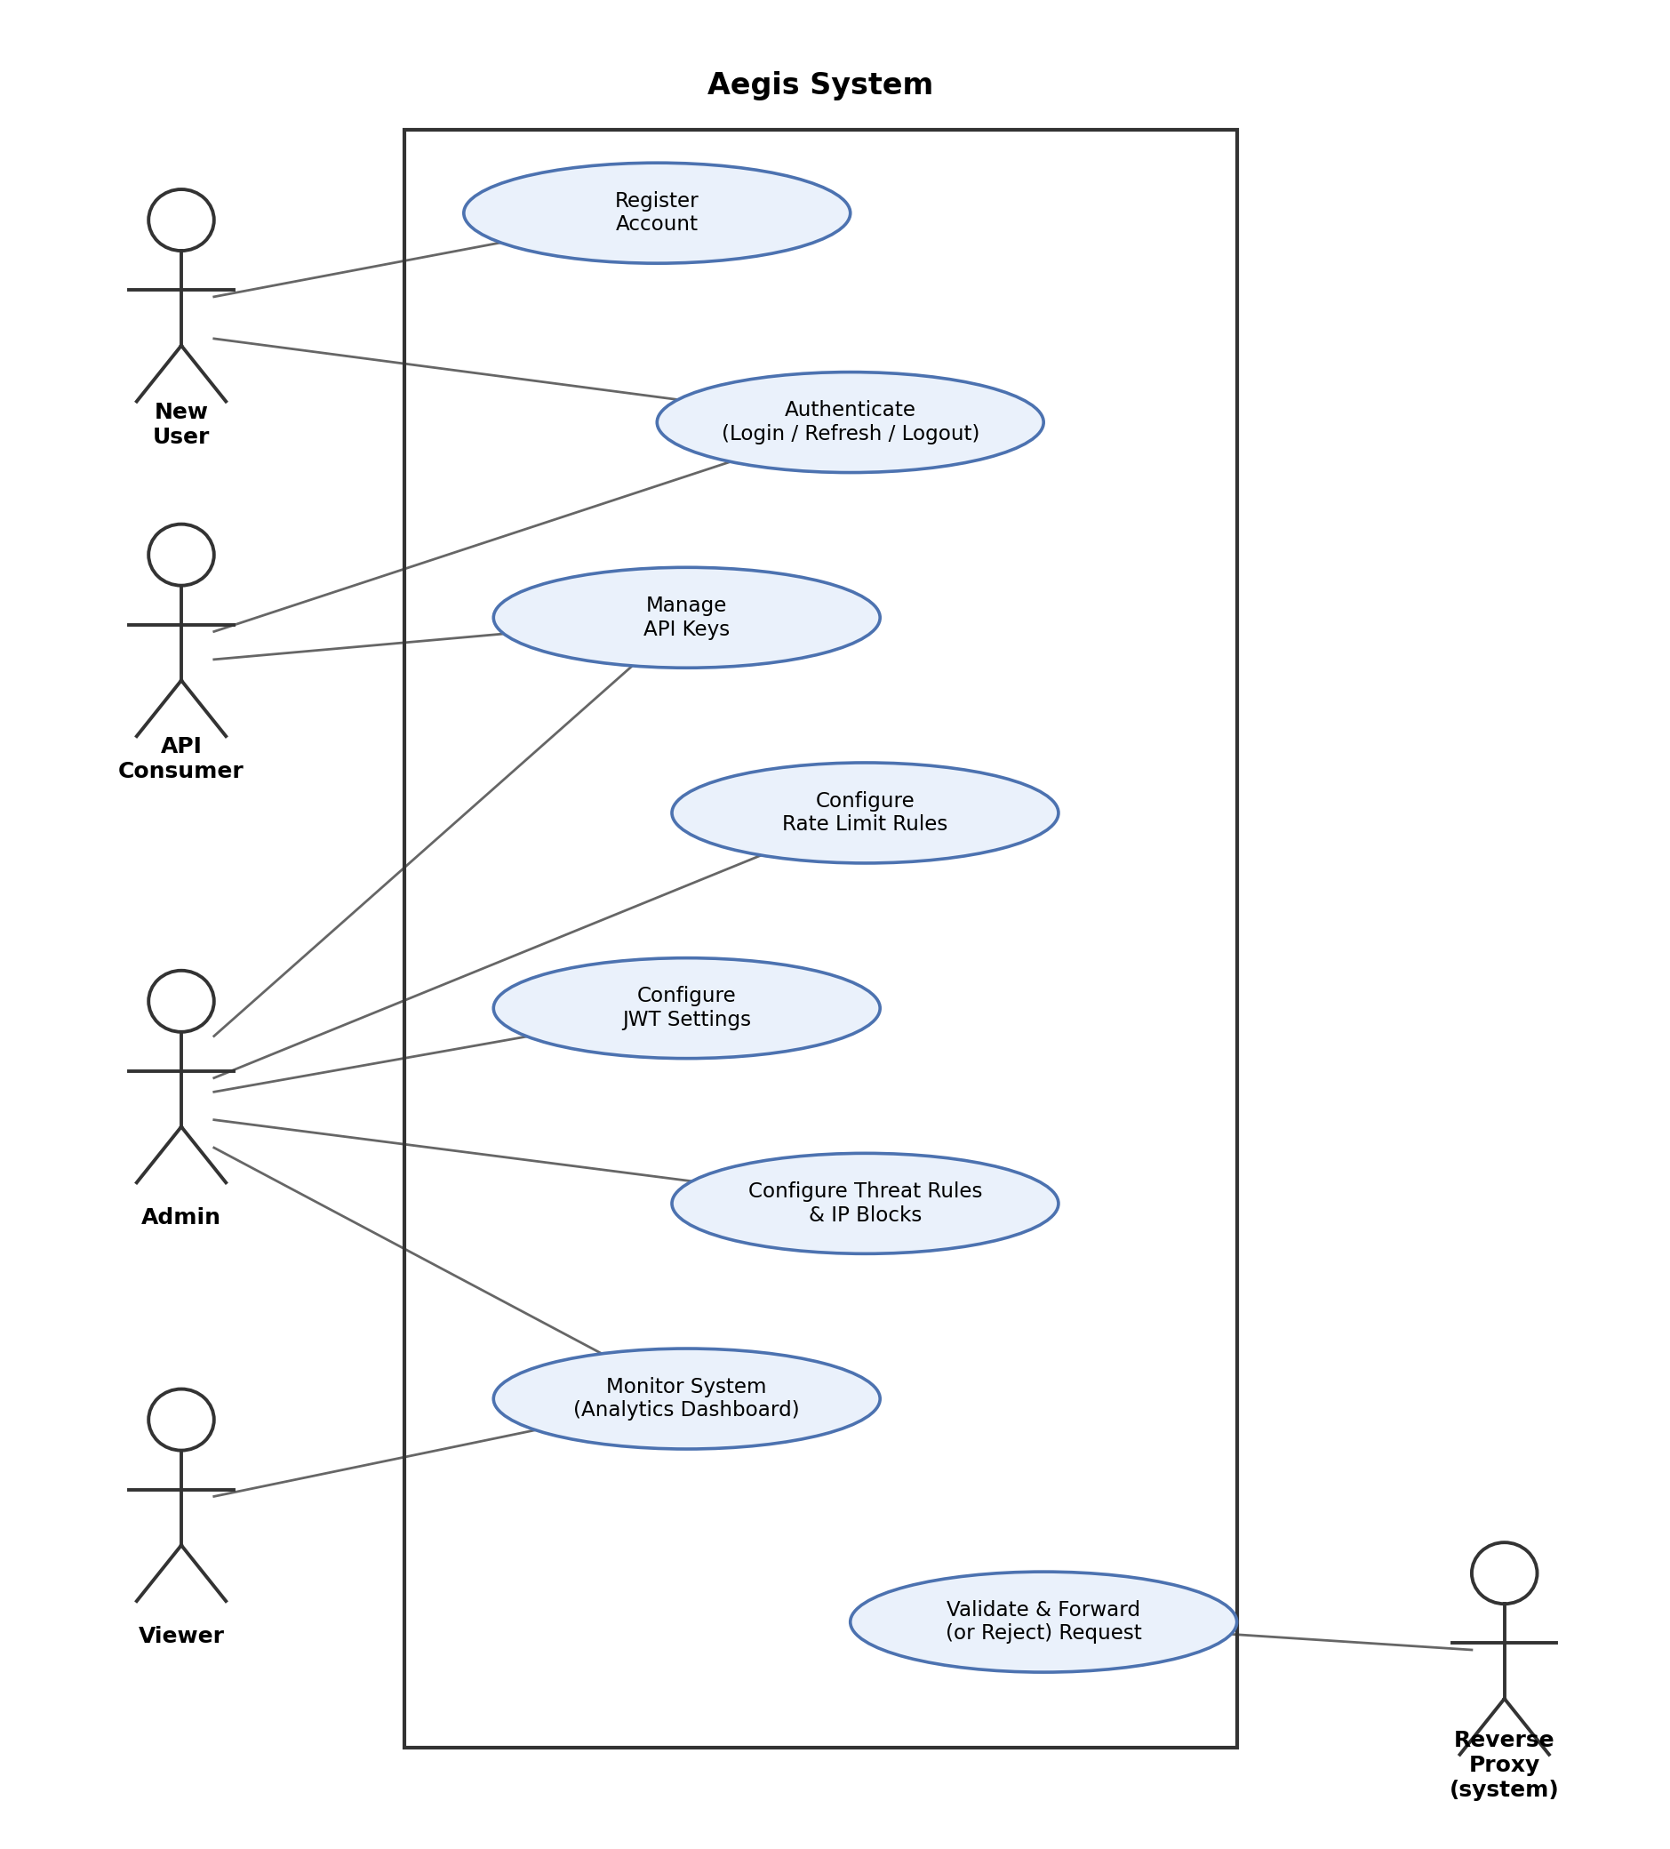
Figure 5.1: Use Case Diagram for Aegis

5.6 Conclusion
This chapter presented the system analysis for Aegis, including user roles, functional requirements grouped by system area, non-functional requirements, and MoSCoW prioritisation. The analysis reflects the system's core purpose of centralising API security enforcement while remaining lightweight and self-hosted, as motivated in Chapter 1.
The use of MoSCoW prioritisation ensures that essential features, authentication, API key management, rate limiting, and JWT validation, are delivered first within the project's timeboxed schedule, while less critical enhancements are implemented only as time permits. These requirements, together with the use case model in Section 6.5.5, provide the foundation for the system design discussed in the next chapter.

Chapter 6: System Design

6.1 Design Basis
The design in this chapter reflects the current repository, database migrations and proxy handler rather than a generic gateway template. Aegis separates configuration from enforcement: operators manage durable identity and policy through the Control Plane and dashboard, while the Go Reverse Proxy makes a bounded decision for each request before any protected upstream is reached. PostgreSQL stores users, keys, policy and events; Redis supplies shared runtime counters and revocation state.

6.2 Current Architecture
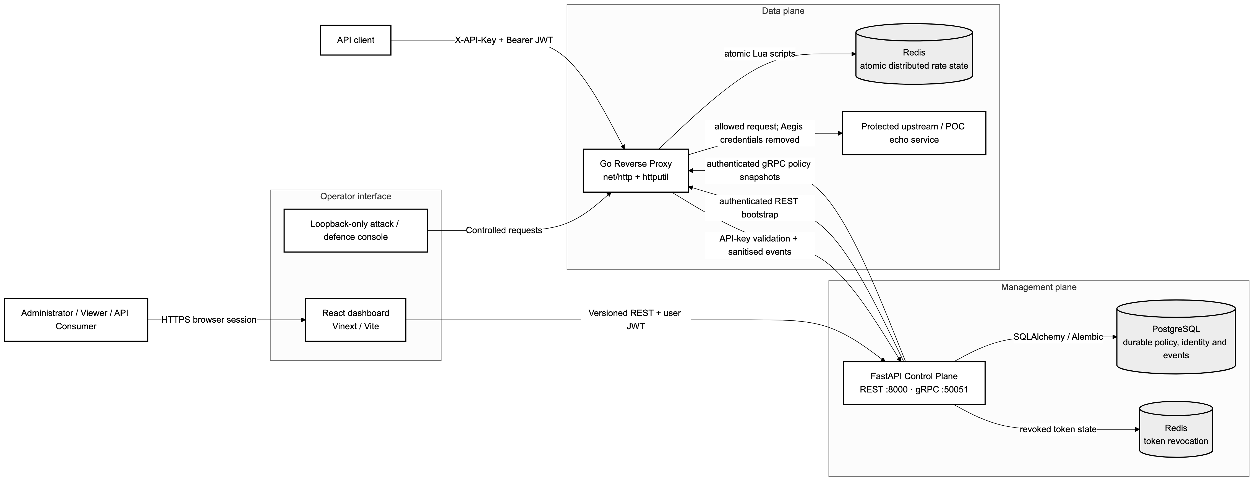
Figure 6.1: Current Aegis architecture and deployed component connections.
The dashboard calls versioned Control Plane REST endpoints. The Control Plane persists administration data in PostgreSQL and uses Redis for runtime state. The proxy first bootstraps policy by REST, then receives authenticated gRPC snapshots. Requests enter only through the proxy; an allowed request is stripped of Aegis credentials and forwarded to the configured upstream. Security outcomes are reported asynchronously so analytics work does not delay the enforcement decision.
Table 6.1: Responsibilities and boundaries in the implemented system.
Component | Primary responsibility | Trust boundary
Dashboard | Role-aware administration and analytics UI | Never stores raw issued keys or tokens persistently
Control Plane | Validation, RBAC, policy lifecycle and analytics | Authoritative administrative API
Reverse Proxy | Per-request authentication, authorisation and traffic controls | Only allowed path to protected upstreams
PostgreSQL | Durable users, key metadata, policies, blocks and events | Restricted to the Control Plane
Redis | Revocation state and atomic distributed rate counters | Internal runtime dependency

6.3 Domain and Persistence Design
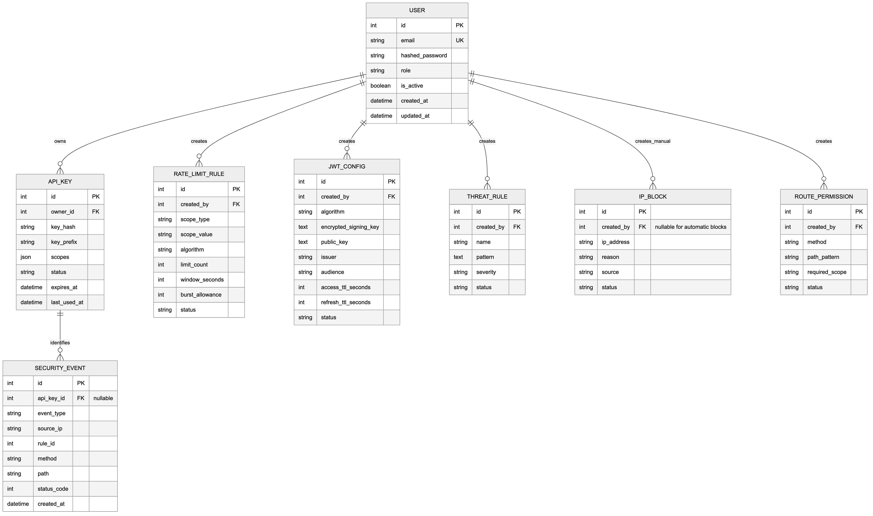
Figure 6.2: Persisted domain model derived from current SQLAlchemy models and migrations.
User owns APIKey records; the key stores a hash and lookup prefix rather than the raw secret. RateLimitRule may target one key, one route or the whole proxy. JWTConfig stores encrypted signing material and an active state. RoutePermission binds method and path to one exact required scope. ThreatRule and IPBlock represent early rejection policy. SecurityEvent stores sanitised request metadata and the final action for analytics and automatic-block calculations.
Table 6.2: Selected design choices in the persisted model.
Model | Important fields | Reason for the structure
APIKey | owner_id, key_hash, prefix, scopes, revoked_at | One-time disclosure, fast lookup and traceable revocation
RoutePermission | method, path_pattern, required_scope, is_active | Makes resource:action labels enforceable against real requests
RateLimitRule | scope_type, target, algorithm, limit, window | Supports specific-to-general rule precedence
SecurityEvent | request_id, action, reason, status, route, client_ip | Supports audit and analytics without storing credentials or bodies

6.4 Administrative Request Validation
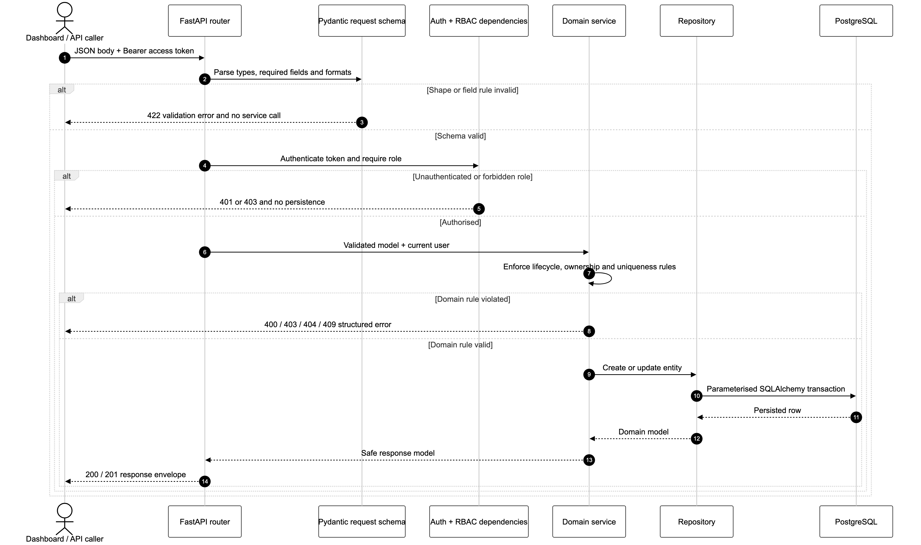
Figure 6.3: Control Plane validation from JSON decoding to persistence.
FastAPI decodes JSON and asks a typed Pydantic schema to validate required fields, enum values, address formats and numeric ranges. Authentication and RBAC dependencies run before the service. The service then checks rules that depend on existing data, such as ownership, duplicate active policy and referenced API keys. Only a valid command reaches the repository transaction. This division matters: field validation returns a controlled 422 response, authorisation failures return 401 or 403, and domain conflicts are handled without partial writes.
Example: a route-permission object binds the concrete GET request to echo:read.
{
"method": "GET",
"path_pattern": "/api/echo",
"required_scope": "echo:read",
"is_active": true
}

6.5 Proxy Enforcement Sequence
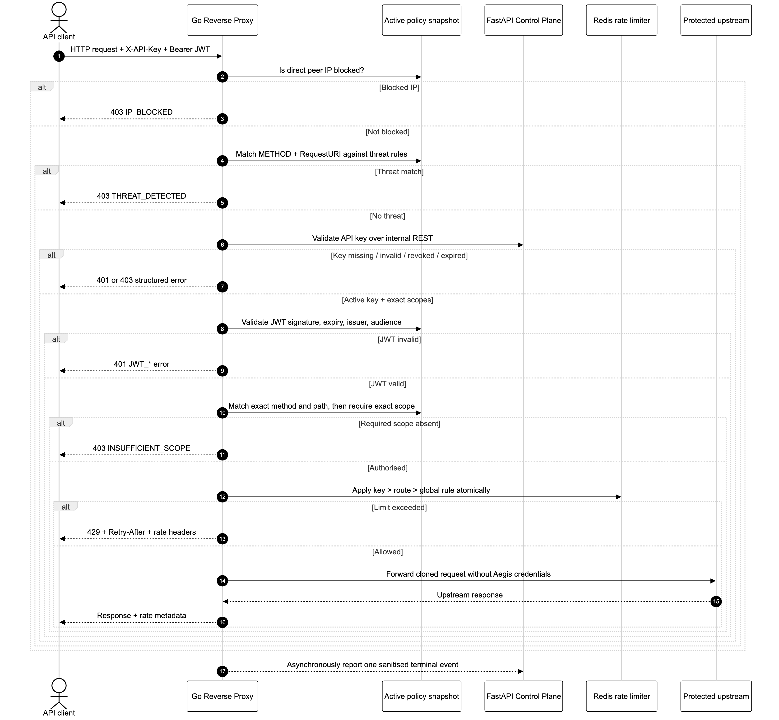
Figure 6.4: Core request-validation and enforcement sequence in the Go proxy.
The handler creates a request identifier and canonical client address, rejects an exact IP block or matching threat, validates the API key, validates JWT policy when active, resolves the matching route permission, compares the exact required scope and consumes the selected Redis limit. A rejection returns immediately; it does not call the upstream. An allowed request has Aegis credentials removed before ReverseProxy.ServeHTTP forwards it. The final action is sent to the asynchronous reporter.

6.6 Scope and Resource Mapping
A label such as echo:read consists of a resource name and action separated by a colon. It remains a string because keys may carry several independent permissions. The proxy does not infer what echo means. It finds the active RoutePermission whose method and path pattern match the incoming request, reads required_scope, and performs an exact membership check against the validated key scopes. Therefore ["echo:read"] is useful only when a route record explicitly maps a real request to echo:read.
Table 6.3: Exact route-to-scope examples.
Incoming request | Route permission | Key scopes | Decision
GET /api/echo | echo:read | [echo:read] | Allow
POST /api/echo | echo:write | [echo:read] | Deny: insufficient scope
POST /api/echo | echo:write | [echo:read, echo:write] | Allow
GET /api/orders | orders:read | [echo:read] | Deny: insufficient scope

6.7 Policy Distribution and Resilience
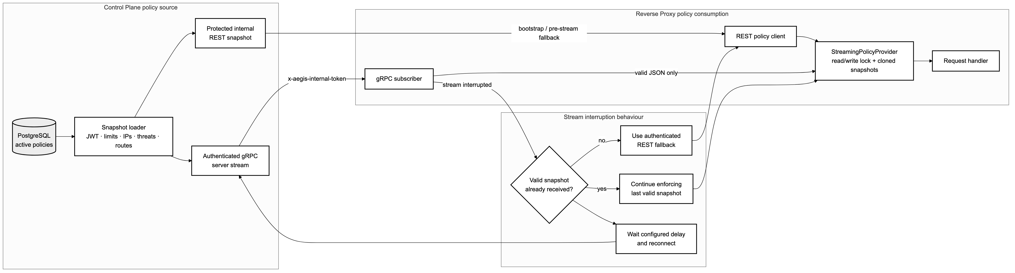
Figure 6.5: REST bootstrap, authenticated gRPC updates and last-valid snapshot behaviour.
At startup the proxy retrieves a complete policy snapshot through the internal REST contract. It then subscribes to gRPC updates authenticated with a separate internal token. A complete new snapshot replaces the previous in-memory value atomically. If the stream disconnects, reconnect logic runs with backoff while the last valid policy continues to protect traffic. The proxy fails closed when no initial policy is available.

6.8 Rate-Limit Decision
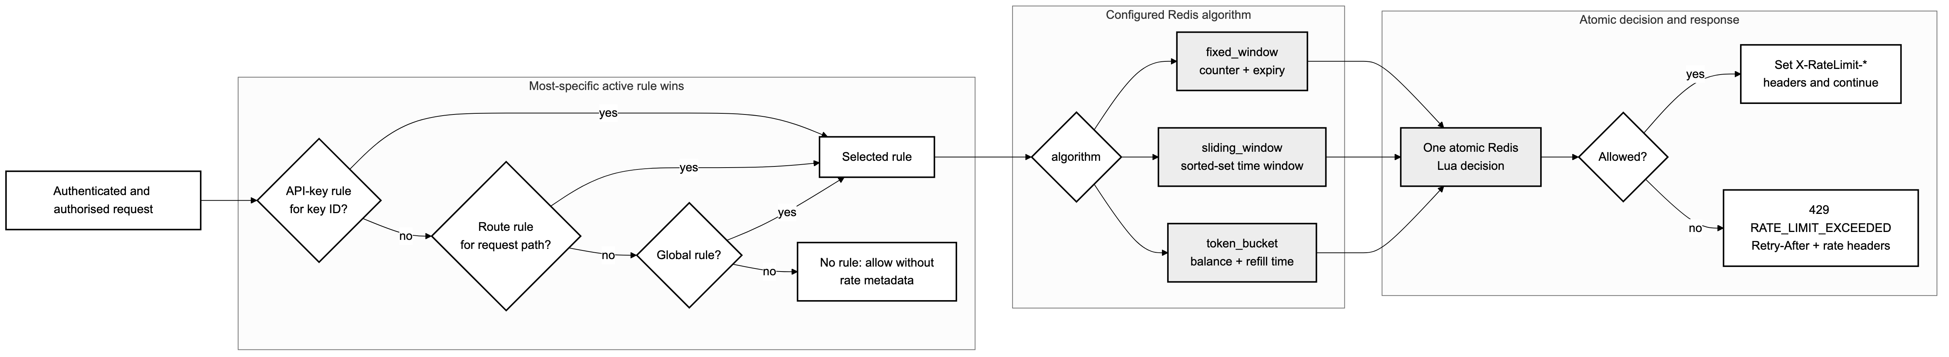
Figure 6.6: Rate-limit rule selection and Redis-backed decision flow.
The selector evaluates active rules from most specific to least specific. API-key rules isolate each consumer; route rules share capacity for the matching route; global rules share one bucket. Redis Lua scripts make reads and writes atomic across proxy instances. Fixed window is simple, sliding window smooths boundary bursts, and token bucket supports controlled bursts with refill. A denied request returns 429 and reset metadata.

6.9 Event and Analytics Flow
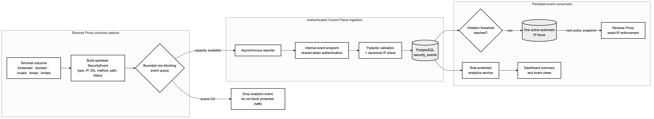
Figure 6.7: Sanitised event reporting, analytics aggregation and automatic IP blocking.
The proxy reports request identifier, route, method, client address, status, action, reason and timing, but excludes raw keys, JWTs and bodies. A bounded queue prevents reporting from blocking requests. The Control Plane persists the event, aggregates dashboard metrics and may create an automatic exact-IP block after repeated qualifying violations. This feedback path is deliberately separate from the immediate decision path.

6.10 Security Trade-offs and Summary
Aegis chooses exact routes, exact scopes and direct-peer IP values to avoid silently trusting ambiguous wildcard or forwarded-header input. These choices are safer for the current deployment but limit CIDR policy and operation behind trusted load balancers. Memory-only dashboard tokens reduce browser persistence but require login after reload. Last-valid policy improves availability, while authenticated distribution and fail-closed startup prevent an untrusted or empty snapshot from weakening enforcement. The result is a clear boundary: the Control Plane defines valid policy, and the proxy applies it consistently before upstream access.

Chapter 7: Project Timeline

7.1 Planning Basis
The Project Proposal fixes Design between 27 April and 29 May 2026, Implementation between 1 June and 11 September 2026, and the separate project Testing activity between 14 September and 9 October 2026 (Htun Khaing Lynn, 2026). Only Implementation is divided into timeboxes. Design remains an enabling activity before timeboxed delivery, while the formal Testing and Evaluation periods remain ordinary project activities after implementation. This avoids incorrectly calling every project phase a timebox.
The proposal specifies six implementation timeboxes and allocates seventy-five working days to Implementation. The schedule therefore retains six fixed timeboxes and distributes the complete implementation window across them. Each timebox is approximately two and a half weeks, within the usual DSDM range of two to four weeks. Weekends are excluded from the effort calculation, while the calendar start and finish dates remain fixed.

7.2 DSDM Structured Timebox Rules
Aegis uses the DSDM structured timebox rather than a Scrum phase breakdown. For readability, the report uses plain implementation labels for the five official DSDM control points: Implementation Setup corresponds to Kick-off, Feature Build to Investigation, Testing and Fixing to Refinement, Integration and Documentation to Consolidation, and Review and Sign-off to Close-out. The labels are simplified, but their sequence, review purpose and fixed-time behaviour remain unchanged (Agile Business Consortium, 2014).
Table 7.1: Day allocation for the 12-day and 13-day Aegis implementation timeboxes.
Timebox step | 12-day TB | 13-day TB | Aegis application
Implementation Setup | 0.5 day | 0.5 day | Confirm objective, availability, dependencies, MoSCoW scope and acceptance criteria.
Feature Build | 2 days | 2 days | Clarify detailed requirements and technical approach, then build the selected features.
Testing and Fixing | 7 days | 8 days | Test iteratively, correct defects and demonstrate the near-complete increment.
Integration and Documentation | 2 days | 2 days | Integrate the increment, complete regression and security checks, and update documentation.
Review and Sign-off | 0.5 day | 0.5 day | Accept the increment, record the outcome and agree actions for the next timebox.

A 12-day timebox totals 0.5 + 2 + 7 + 2 + 0.5 days, while a 13-day timebox totals 0.5 + 2 + 8 + 2 + 0.5 days. Testing remains integrated throughout the main delivery work and is followed by explicit integration, documentation and acceptance activity; it is not postponed until the separate project Testing period.

7.3 MoSCoW Capacity Rule
Time and quality are fixed; detailed scope is the variable. Each timebox reserves approximately 55% of effort for Must Haves, 25% for Should Haves and 20% for Could Haves. Won't Haves are excluded from capacity. This keeps Must Have effort below the DSDM recommendation of 60% and maintains a real 20% contingency. A Must Have is used only where the objective would fail without it; a Should Have remains important but has a workaround; a Could Have is the first scope removed when risk materialises.
Table 7.2: MoSCoW effort balance used for every implementation timebox.
Priority | Effort | Meaning in Aegis
Must Have | 55% | Essential to the usable security increment; without it the timebox objective is not met.
Should Have | 25% | Important and expected, but the increment remains usable with a documented workaround.
Could Have | 20% | Contingency pool delivered only after Must/Should quality remains protected.
Won't Have this time | Excluded | Explicitly deferred so it cannot silently consume the fixed timebox.

7.4 Implementation-Only Delivery Plan
Table 7.3: Six fixed timeboxes across the proposal's 75-working-day implementation window.
ID | Implementation increment | Fixed dates | Working days
TB1 | Control Plane Foundation and Identity | 1-17 Jun | 13
TB2 | API Keys and Administrative Policy | 18 Jun-3 Jul | 12
TB3 | Proxy Authentication and Authorisation | 6-22 Jul | 13
TB4 | Distributed Limits and Threat Enforcement | 23 Jul-7 Aug | 12
TB5 | Policy Distribution, Analytics and Dashboard | 10-26 Aug | 13
TB6 | Integration, POC and Hardening | 27 Aug-11 Sep | 12

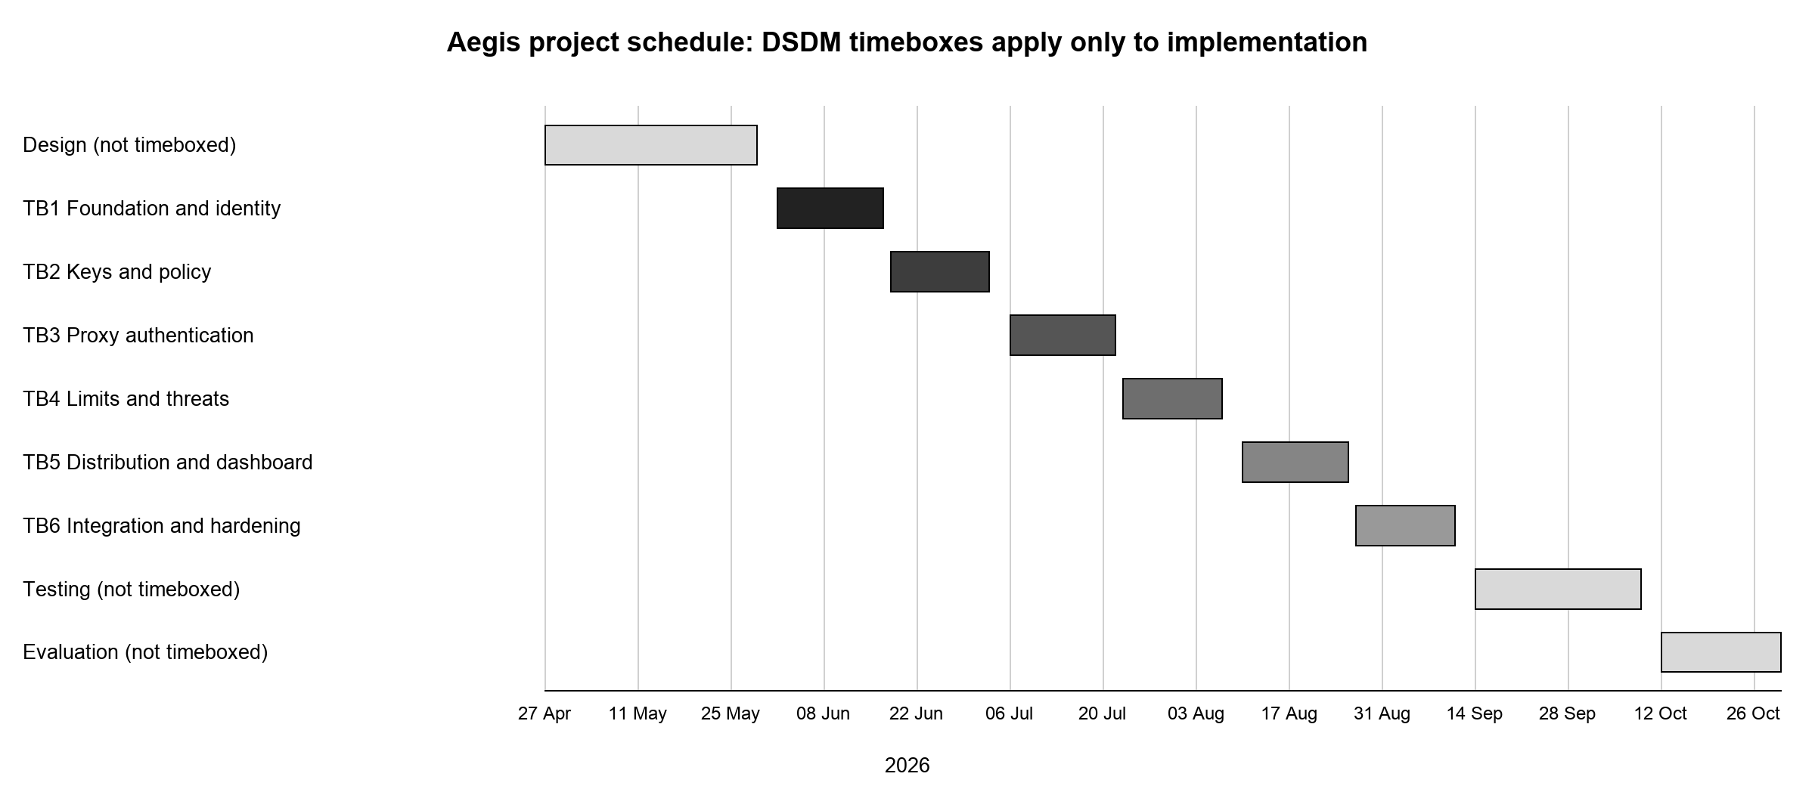
Figure 7.1: Design, six implementation timeboxes and the separate project-testing period.

7.5 TB1 - Control Plane Foundation and Identity
Timebox Detail | Value
Timebox Name | Control Plane Foundation and Identity Timebox
Start Date | 1 June 2026
End Date | 17 June 2026

Table 7.4: TB1 task and date schedule.
Task | Duration | Start Date | End Date
Implementation Setup | 0.5 day | 1 Jun 2026 | 1 Jun 2026
Feature Build | 2 days | 1 Jun 2026 | 3 Jun 2026
Testing and Fixing | 8 days | 3 Jun 2026 | 15 Jun 2026
Integration and Documentation | 2 days | 15 Jun 2026 | 17 Jun 2026
Review and Sign-off | 0.5 day | 17 Jun 2026 | 17 Jun 2026

Key Deliverables (Output)
Design
- User, role and session data design.
- Authentication flow and database migration plan.
Coding
- FastAPI registration, login, refresh and logout.
- Persisted RBAC, Admin user management and Redis token revocation.
Non-Functional Requirements
- Hashed passwords, typed request validation and server-side role enforcement.
Testing
- Migration, authentication, token lifecycle and RBAC tests.

7.6 TB2 - API Keys and Administrative Policy
Timebox Detail | Value
Timebox Name | API Keys and Administrative Policy Timebox
Start Date | 18 June 2026
End Date | 3 July 2026

Table 7.5: TB2 task and date schedule.
Task | Duration | Start Date | End Date
Implementation Setup | 0.5 day | 18 Jun 2026 | 18 Jun 2026
Feature Build | 2 days | 18 Jun 2026 | 22 Jun 2026
Testing and Fixing | 7 days | 22 Jun 2026 | 1 Jul 2026
Integration and Documentation | 2 days | 1 Jul 2026 | 3 Jul 2026
Review and Sign-off | 0.5 day | 3 Jul 2026 | 3 Jul 2026

Key Deliverables (Output)
Design
- API-key lifecycle and administrative policy structure.
- Exact method/path to resource:action scope mapping.
Coding
- One-time key issuance, bcrypt persistence, prefix lookup and soft revocation.
- CRUD for rate limits, JWT settings, threat rules, IP blocks and route permissions.
Non-Functional Requirements
- Secret non-disclosure, ownership checks and duplicate-active-policy protection.
Testing
- Key ownership, revocation, validation and policy-conflict tests.

7.7 TB3 - Reverse Proxy Authentication and Authorisation
Timebox Detail | Value
Timebox Name | Reverse Proxy Authentication and Authorisation Timebox
Start Date | 6 July 2026
End Date | 22 July 2026

Table 7.6: TB3 task and date schedule.
Task | Duration | Start Date | End Date
Implementation Setup | 0.5 day | 6 Jul 2026 | 6 Jul 2026
Feature Build | 2 days | 6 Jul 2026 | 8 Jul 2026
Testing and Fixing | 8 days | 8 Jul 2026 | 20 Jul 2026
Integration and Documentation | 2 days | 20 Jul 2026 | 22 Jul 2026
Review and Sign-off | 0.5 day | 22 Jul 2026 | 22 Jul 2026

Key Deliverables (Output)
Design
- Ordered proxy enforcement flow and Control Plane validation contract.
Coding
- Go reverse proxy, API-key cache, JWT validation and exact scope authorisation.
- Credential stripping and structured proxy error responses.
Non-Functional Requirements
- Bounded timeouts, last-valid policy caching and upstream isolation.
Testing
- Missing/revoked keys, invalid JWTs, denied scopes, forwarding and header-stripping tests.

7.8 TB4 - Distributed Limits and Threat Enforcement
Timebox Detail | Value
Timebox Name | Distributed Limits and Threat Enforcement Timebox
Start Date | 23 July 2026
End Date | 7 August 2026

Table 7.7: TB4 task and date schedule.
Task | Duration | Start Date | End Date
Implementation Setup | 0.5 day | 23 Jul 2026 | 23 Jul 2026
Feature Build | 2 days | 23 Jul 2026 | 27 Jul 2026
Testing and Fixing | 7 days | 27 Jul 2026 | 5 Aug 2026
Integration and Documentation | 2 days | 5 Aug 2026 | 7 Aug 2026
Review and Sign-off | 0.5 day | 7 Aug 2026 | 7 Aug 2026

Key Deliverables (Output)
Design
- Rate-rule precedence, direct-peer IP policy and RE2 threat-matching rules.
Coding
- Redis fixed-window, sliding-window and token-bucket enforcement.
- Exact IP blocking, threat detection and automatic blocking.
Non-Functional Requirements
- Atomic shared counters, fail-closed behaviour and race-safe enforcement.
Testing
- 429 limits, consumer isolation, threat, IP-block and Go race tests.

7.9 TB5 - Policy Distribution, Analytics and Dashboard
Timebox Detail | Value
Timebox Name | Policy Distribution, Analytics and Dashboard Timebox
Start Date | 10 August 2026
End Date | 26 August 2026

Table 7.8: TB5 task and date schedule.
Task | Duration | Start Date | End Date
Implementation Setup | 0.5 day | 10 Aug 2026 | 10 Aug 2026
Feature Build | 2 days | 10 Aug 2026 | 12 Aug 2026
Testing and Fixing | 8 days | 12 Aug 2026 | 24 Aug 2026
Integration and Documentation | 2 days | 24 Aug 2026 | 26 Aug 2026
Review and Sign-off | 0.5 day | 26 Aug 2026 | 26 Aug 2026

Key Deliverables (Output)
Design
- REST bootstrap, authenticated gRPC updates and sanitised analytics flow.
Coding
- Policy streaming, reconnect/backoff and bounded asynchronous event reporting.
- Analytics APIs and role-aware React dashboard pages.
Non-Functional Requirements
- Last-valid policy resilience, data minimisation and memory-only browser tokens.
Testing
- Internal authentication, stream fallback, event queue and dashboard route tests.

7.10 TB6 - Integration, POC and Implementation Hardening
Timebox Detail | Value
Timebox Name | Integration, POC and Implementation Hardening Timebox
Start Date | 27 August 2026
End Date | 11 September 2026

Table 7.9: TB6 task and date schedule.
Task | Duration | Start Date | End Date
Implementation Setup | 0.5 day | 27 Aug 2026 | 27 Aug 2026
Feature Build | 2 days | 27 Aug 2026 | 31 Aug 2026
Testing and Fixing | 7 days | 31 Aug 2026 | 9 Sep 2026
Integration and Documentation | 2 days | 9 Sep 2026 | 11 Sep 2026
Review and Sign-off | 0.5 day | 11 Sep 2026 | 11 Sep 2026

Key Deliverables (Output)
Design
- Full-stack Compose topology, release boundary and repeatable demo plan.
Coding
- Docker Compose wiring, generated secrets and idempotent bootstrap.
- Isolated end-to-end script and localhost attack/defence console.
Non-Functional Requirements
- Reproducible local deployment, safe secret handling and graceful shutdown.
Testing
- Complete quality gate, allow/deny/scope/rate POC and isolated Docker E2E.

7.11 Activities Outside the Timeboxes
Table 7.10: Separation between implementation timeboxes and non-timeboxed project activities.
Activity | Dates | Relationship to timeboxing
Design | 27 Apr-29 May 2026 | Enough Design Up Front: architecture, data, API and security foundations; not a timebox.
Implementation | 1 Jun-11 Sep 2026 | The only activity divided into six DSDM structured timeboxes.
Project Testing | 14 Sep-9 Oct 2026 | Independent consolidation of unit, integration, security, performance and UAT results; not a timebox.
Evaluation and conclusion | 12-30 Oct 2026 | Evaluation against objectives and reflection; not a timebox.

7.12 Chapter Summary
The plan keeps six implementation-only timeboxes. Each is presented with a simple name/date block, a task schedule with duration and a concise list of outputs. The five DSDM control points, MoSCoW contingency, integrated testing and fixed-date sign-off are retained without repeating detailed definition or acceptance-boundary text. This protects the 11 September implementation finish. Design remains an enabling activity, while separate project Testing continues to 9 October.

Chapter 8: System Implementation

8.1 Implementation Approach
Implementation followed six fixed-date increments. To make the chapter easier to review, every timebox uses the same four-part structure: Design states the decision made for the increment; Coding identifies how the repository realises it; Testing records the observed checks and outcomes; Retro states what changed in understanding or process. Examples and interface captures are placed beside the feature that they explain.

8.2 TB1 - Control Plane Foundation and Identity (1-17 June 2026)

8.2.1 Design
The first increment established the trusted administrative boundary. The User model stores a UUID, unique email, password hash, role, active state and timestamps. FastAPI request models validate typed input before a service applies registration and role rules. PostgreSQL is the durable source for identity, while Redis stores refresh-token revocation state. Public registration is restricted to API Consumer accounts; Admin and Viewer roles are assigned through protected administration routes.

8.2.2 Coding
The implementation separates routers, Pydantic schemas, services and repositories. Passwords are hashed before persistence; login returns short-lived access and refresh tokens; refresh checks revocation; logout records the refresh-token identifier. Dependencies resolve the current user and required role before protected operations run.
Example request: login data is typed and validated before authentication.
POST /api/v1/auth/login
{
"email": "admin@example.test",
"password": "<development-password>"
}
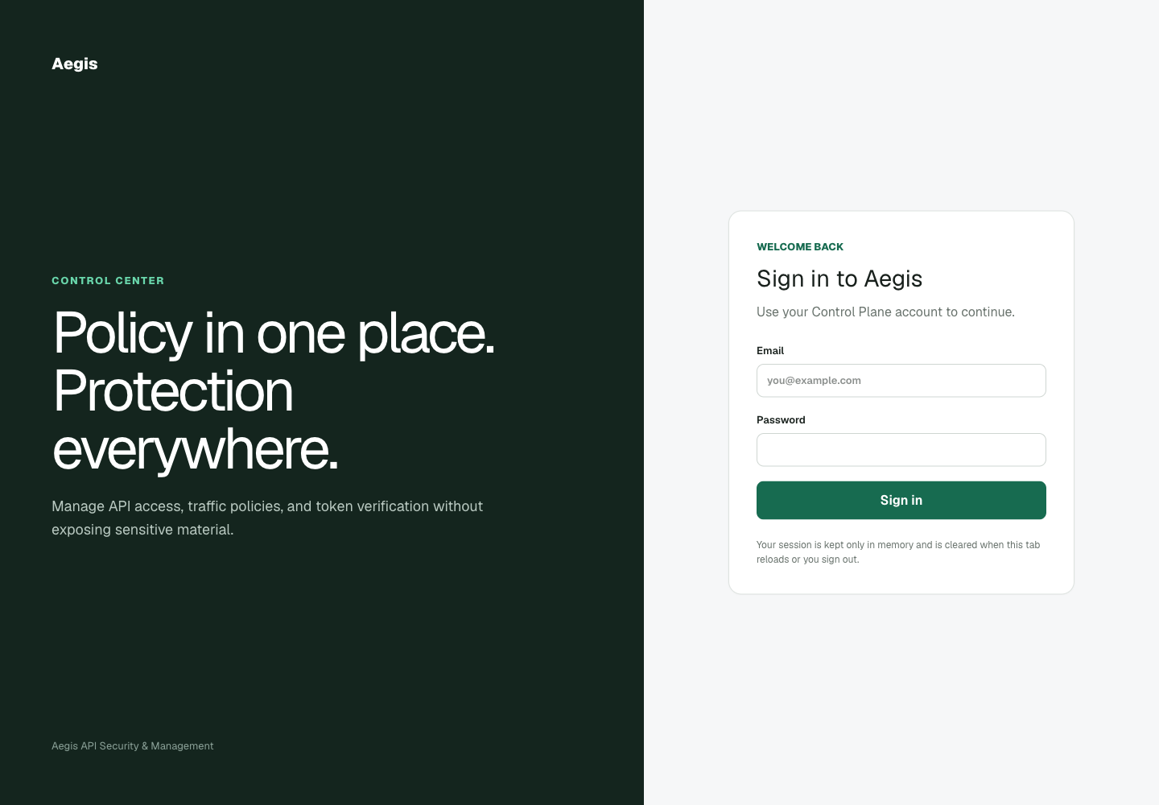
Figure 8.1: Aegis dashboard login page with memory-only session guidance.
SCREENSHOT TO ADD - 8-A: Admin user-management page

Capture instruction: Log in as Admin, open Users, show the role and active-state controls, and hide all real email addresses.

8.2.3 Testing
Focused authentication and RBAC tests covered registration, login, refresh, logout, bootstrap administration and Admin-only user management. The current quality run completed 47 Control Plane tests. Invalid credentials return a controlled 401 response, an unauthorised role returns 403, and public registration cannot create an Admin account.
The authentication checks were divided by boundary rather than by endpoint name. Schema cases confirmed that malformed email and missing password data stop before the service. Service cases checked password verification, disabled accounts and the refresh-token lifecycle. Route cases checked that a valid token is still insufficient when the caller lacks the required role. Database-backed cases confirmed that a role change or soft deactivation is reflected on the next protected request. This layered approach matters because a single successful login case cannot show that registration, token renewal, logout and administration fail safely. The focused scenario run also exercised the typed login response and the Admin-only user-management path independently from the broader suite.
Table 8.1: TB1 testing record.
Check | Trigger | Observed result | Interpretation
Registration role | Request Admin through public registration | Rejected; consumer role retained | Client JSON cannot escalate privilege
Invalid login | Wrong password for an existing user | 401 structured response | No session token is issued
Refresh lifecycle | Refresh, revoke, then reuse token | First succeeds; reused token fails | Revocation state is enforced
Admin boundary | Consumer calls user-management route | 403 response | Authentication does not imply administration
Valid Admin | Typed login followed by protected request | 200 response with current role | Identity and RBAC cooperate

The negative cases also distinguish caller mistakes from server faults. Missing fields and invalid formats are client-contract failures; wrong credentials are authentication failures; a valid identity with the wrong role is an authorisation failure. Keeping those outcomes separate gives the dashboard useful feedback without revealing whether a protected account exists. It also makes regression diagnosis faster: a change from 403 to 500 points to exception handling, while an unexpected 200 indicates a security boundary failure. The tests assert both status and response shape so later refactoring cannot silently replace structured errors with framework traces.

8.2.4 Retro
Separating input validation from business rules made failures easier to locate. The main lesson was that role values in JSON are untrusted input: the server, not the browser, must decide which roles a caller may create or assign.
The increment exposed two different meanings of validation. Pydantic can prove that a role string has an allowed shape, but it cannot prove that the current caller may assign that role. Moving privilege decisions into the service and dependency layer removed that ambiguity. The team also learned to test the negative lifecycle, not only token creation: logout is useful only when a previously valid refresh token is demonstrably unusable afterwards. These lessons established the pattern used in later timeboxes: validate shape first, authorise intent second and persist only after both checks succeed.
Table 8.2: TB1 retrospective actions.
Retrospective point | Recorded outcome
What worked | Router/service/repository separation made failed branches easy to isolate
What changed | Role assignment became an explicit server-side rule
Carry-forward | Every later administrative resource reused typed input plus RBAC dependencies

The carry-forward decision was to require the same three-level check for every new Control Plane resource: typed schema tests, service-level ownership or role tests, and route-level response tests. TB2 adopted this immediately for API-key ownership and policy administration. Session identifiers and user roles were also treated as security data in logs, so debugging output was kept descriptive but did not include token contents.

8.3 TB2 - API Keys and Administrative Policy (18 June-3 July 2026)

8.3.1 Design
An API key is represented by durable metadata plus a one-way hash. The raw secret is returned only after creation. Scope labels use resource:action strings, for example echo:read, but the label has no routing meaning by itself. A RoutePermission binds an HTTP method and path pattern to the required label. Administrative schemas also validate rate limits, JWT configurations, threat rules and exact IP blocks.

8.3.2 Coding
The service generates a cryptographically random key, stores its bcrypt hash and prefix, and returns the raw value once. List responses expose only masked metadata. Revocation soft-disables a key so historical events remain traceable. Policy services reject invalid algorithms, duplicate active route scopes and references to missing keys.
Example pair: create a least-privilege key, then bind a real route to its scope.
POST /api/v1/api-keys
{
"name": "Echo reader",
"scopes": ["echo:read"],
"expires_at": "2026-12-31T23:59:59Z"
}

POST /api/v1/route-permissions
{
"method": "GET",
"path_pattern": "/api/echo",
"required_scope": "echo:read",
"is_active": true
}
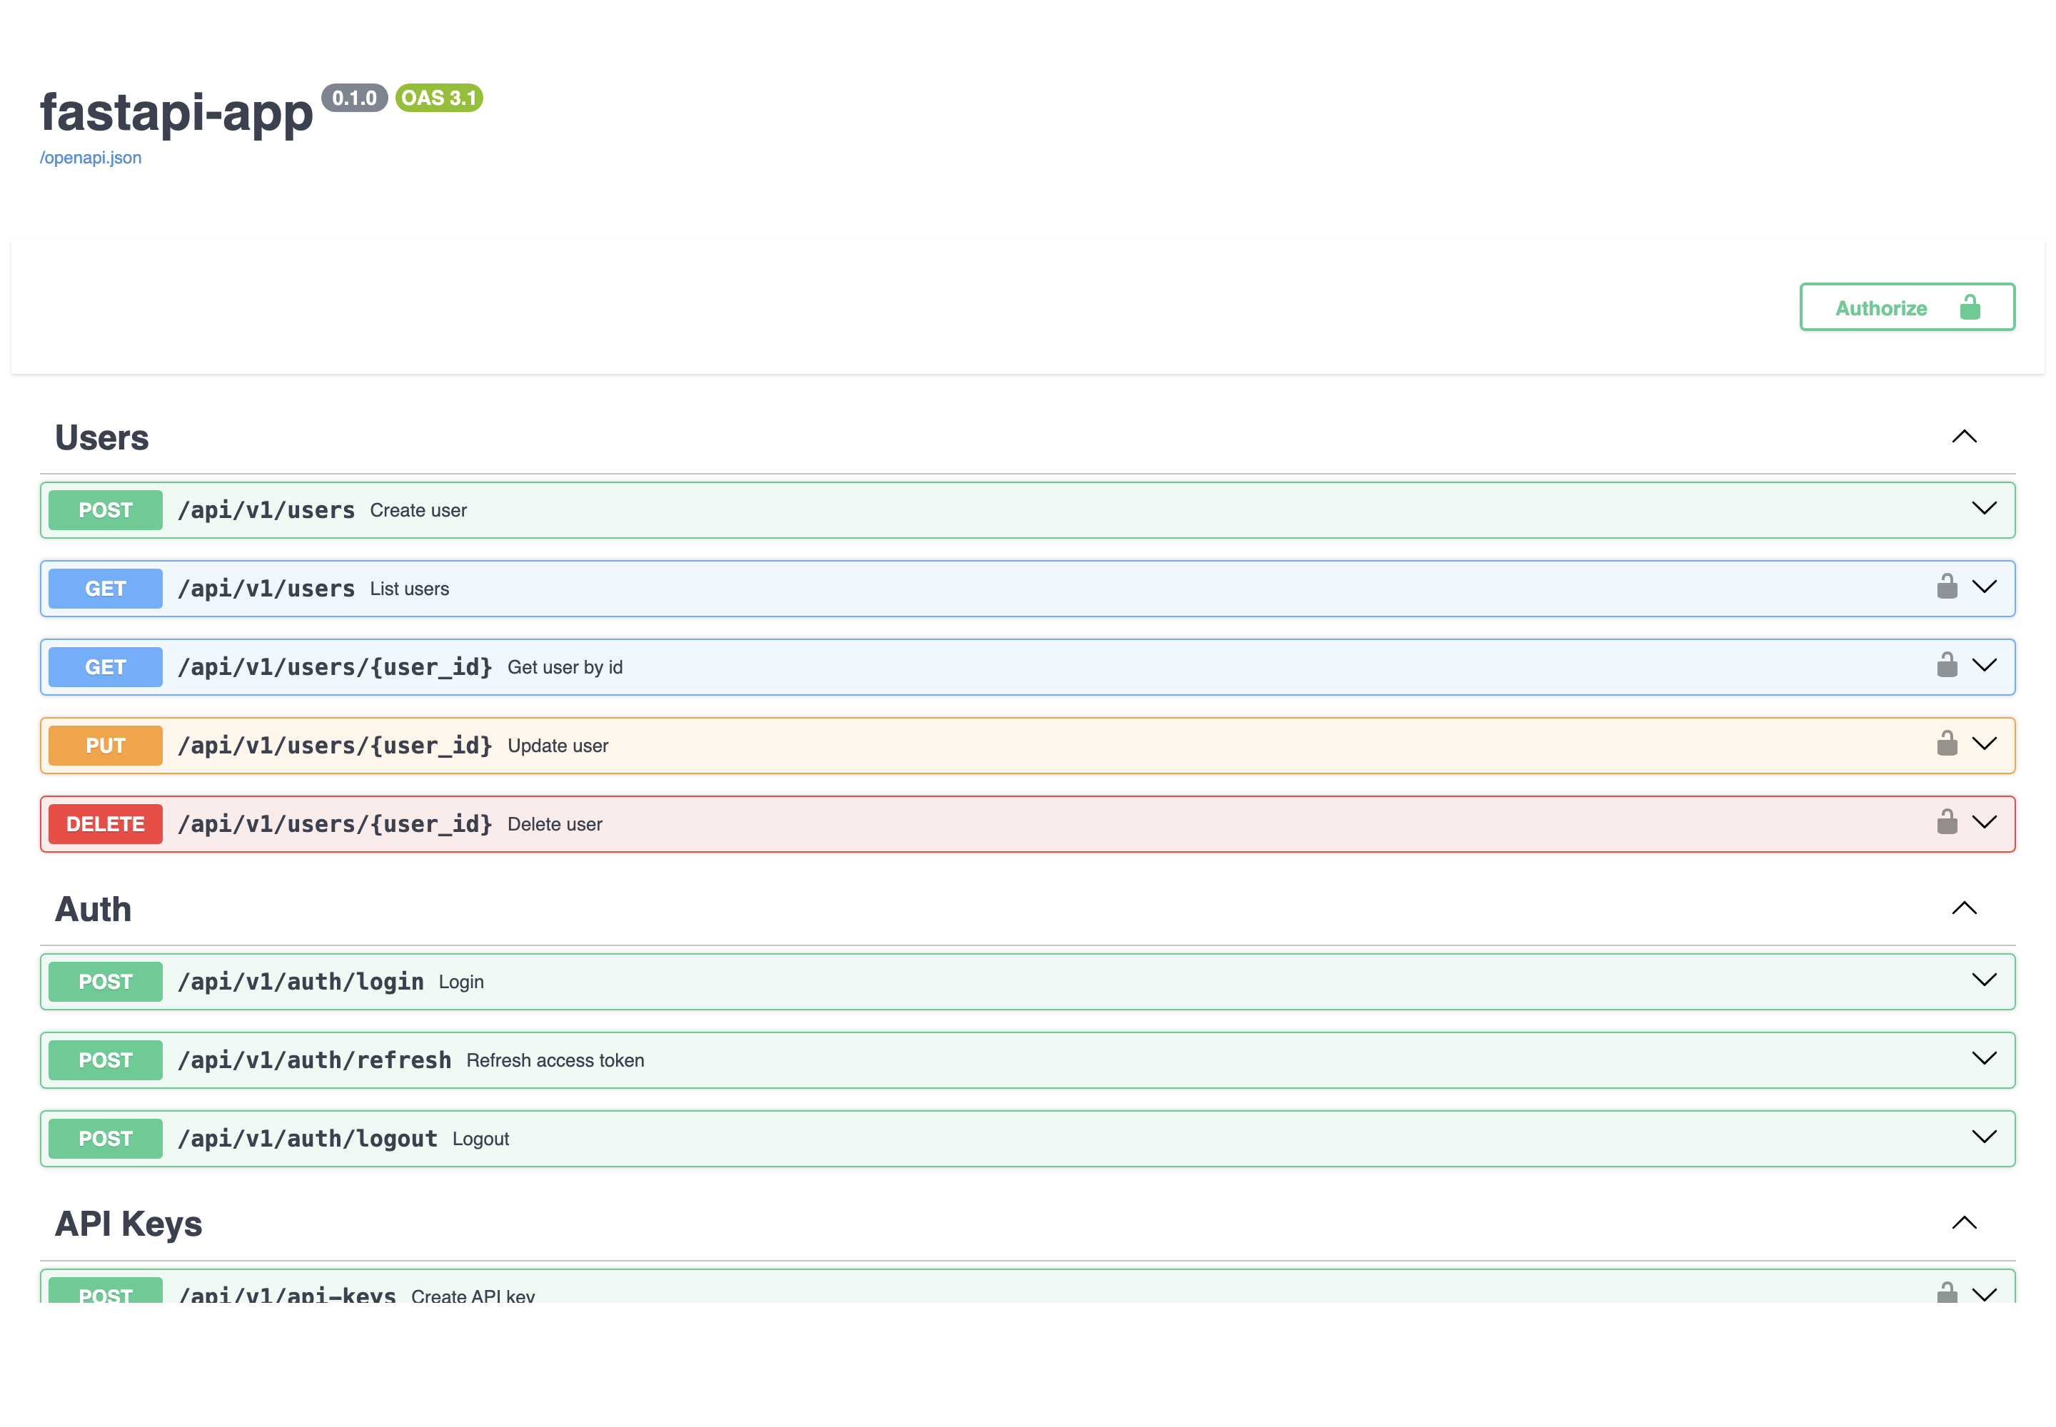
Figure 8.2: Generated Control Plane OpenAPI page showing protected and public operations.
SCREENSHOT TO ADD - 8-B: Dashboard API Keys page

Capture instruction: Create a demonstration key, copy the raw value off-screen, then capture the list showing only name, prefix, scopes, status and expiry.

8.3.3 Testing
Scenario tests confirmed one-time secret disclosure, owner and Admin access rules, soft revocation, duplicate-policy rejection and typed validation errors. Invalid combinations are rejected before database writes, while a revoked key remains identifiable but cannot authenticate proxy traffic.
API-key tests concentrated on disclosure, ownership and lifecycle. Creation had to return a usable raw value once while every later representation remained masked. Repository checks confirmed that only a bcrypt hash and non-sensitive prefix are persisted. Ownership scenarios compared an API Consumer managing its own key with attempts to read or revoke another consumer's key; Admin operations were checked separately. Policy tests exercised field ranges, algorithm enums, referenced key identifiers, duplicate active route permissions and soft-disable behaviour. A focused four-scenario run covered one-time key return and the route-permission validation that prevents two active records from claiming the same method, path and required scope.
Table 8.3: TB2 testing record.
Check | Trigger | Observed result | Interpretation
One-time secret | Create a new API key | 201 with raw key in create response | Caller receives the secret exactly once
Persistence | Read the stored key record | Hash and prefix only | Database disclosure does not reveal the raw key
Ownership | Consumer requests another owner's key | Controlled denial | Tenant boundary is applied in the service
Duplicate route | Create the same active method/path/scope | Validation or conflict response | Policy selection remains unambiguous
Revocation | Use a key after soft revocation | 403 API_KEY_REVOKED | History remains, authentication stops

A particularly important failure case is a successful database write followed by an unsafe response. The API-key tests therefore inspect output as well as storage: the create response may contain the raw key, but list, read and revoke responses must not. Policy validation follows the inverse concern: a rejected command must not leave a partial active record. Duplicate-route and invalid-reference cases are checked around the service transaction so the system cannot publish ambiguous policy after returning an error to the caller. These assertions protect confidentiality and configuration integrity at the same time.

8.3.4 Retro
The initial idea that a scope alone identifies a backend was too ambiguous. The corrected design treats the scope as a permission label and makes the route-permission record the explicit connection between a real request and that label.
The most important correction was separating permission vocabulary from request routing. Early examples made echo:read look as if the proxy could discover an echo service from the word echo. Testing showed that a label cannot safely define a route, because names can be reused and do not contain an HTTP method or path. RoutePermission therefore became the authoritative mapping, while the key merely carries labels. The timebox also confirmed that list and audit usability should never require redisplaying the raw secret; prefix, name, owner, status, scopes and timestamps are sufficient for administration.
Table 8.4: TB2 retrospective actions.
Retrospective point | Recorded outcome
What worked | One-way persistence and masked list responses reduced secret exposure
What changed | RoutePermission became the explicit request-to-scope binding
Carry-forward | Proxy tests used real method/path records rather than interpreting labels

The timebox closed with a clearer documentation rule: examples must always show the scope label beside its RoutePermission, never as an isolated string that appears to discover a backend automatically. TB3 then reused the same example pair in handler tests. Operator pages were designed around masked prefixes and lifecycle state, and any future import or bulk-create feature must preserve one-time disclosure rather than inventing a convenient way to reveal stored secrets.

8.4 TB3 - Reverse Proxy Authentication and Authorisation (6-22 July 2026)

8.4.1 Design
The Go handler enforces policy before the standard reverse proxy forwards a request. The ordered path is request context, direct-peer IP block, threat matching, API-key validation, optional JWT validation, exact route permission, Redis rate limit, credential stripping and upstream forwarding. Failures stop immediately and use stable JSON error codes.

8.4.2 Coding
Go interfaces isolate the Control Plane client, policy provider, limit store and event reporter, so handler branches can be tested without a full stack. The key cache stores successful and negative lookups for bounded periods. JWT validation pins the configured algorithm and checks expiry. Before forwarding, Aegis API-key and authorization headers are removed.
Example decision: the same consumer is allowed to read but not write.
# Key contains ["echo:read"]
GET /api/echo -> required echo:read -> 200
POST /api/echo -> required echo:write -> 403 INSUFFICIENT_SCOPE

8.4.3 Testing
Go tests verified missing, malformed, revoked and invalid keys; JWT expiry and algorithm substitution; exact-scope matching; denied write access; header stripping; and successful upstream forwarding. The focused scope run showed echo:read allows the configured GET route, whereas a missing echo:write denies POST and never calls the backend.
The proxy suite used both isolated collaborators and a real upstream integration. Table-driven cases supplied missing, malformed, expired and revoked credentials and asserted that the upstream counter remained unchanged. JWT cases pinned HS256 and rejected an algorithm-substitution attempt rather than trusting the token header. Scope cases compared exact read and write labels, including labels that resemble wildcards; no implicit permission was granted. The forwarding integration then supplied a valid key, active JWT policy and matching RoutePermission, confirmed a 200 upstream response and checked that Aegis credentials were absent from the request received by the backend. Race-enabled tests exercised the same handler code with concurrent requests.
Table 8.5: TB3 testing record.
Check | Trigger | Observed result | Interpretation
Missing key | Request has no X-API-Key | 401 API_KEY_MISSING | Request stops before upstream
Revoked key | Validated record has revoked state | 403 API_KEY_REVOKED | Cached metadata cannot bypass lifecycle
JWT algorithm | Token header substitutes another algorithm | 401 JWT error | Configured algorithm is pinned
Exact scope | GET requires echo:read and key has it | 200 forwarded | Route and key labels match exactly
Denied write | POST requires echo:write; key has read only | 403 INSUFFICIENT_SCOPE | Backend is not called
Header stripping | Valid request reaches echo upstream | Aegis credentials absent | Secrets do not cross the trust boundary

Handler tests treat an upstream call during a denied case as a test failure even when the client receives the expected status. This catches implementations that validate too late or write an error after forwarding has begun. The same principle applies to headers: a 200 response is insufficient if the upstream receives X-API-Key or Authorization. By checking side effects, the suite verifies the trust boundary rather than merely the response surface. Timeout and unavailable-Control-Plane cases further confirm that cache and policy behaviour fail in a controlled direction instead of allowing a request because validation could not complete.

8.4.4 Retro
Middleware order is part of the security design. Cheap deterministic rejections should occur early, but each denial must still produce a sanitised event. Exact matching is intentionally conservative; wildcard-looking scope labels do not grant implicit permissions.
This increment made ordering visible as a security property. Returning the right status is not enough if a denied request has already reached the backend, so tests observed the upstream call count and received headers. Interfaces around key validation, policy lookup, rate storage and reporting made these assertions possible without a full deployment. The team also learned that cache behaviour belongs in authorisation testing: positive entries need bounded lifetimes, negative entries reduce repeated invalid-key work, and revocation must be reflected quickly enough that convenience never becomes a bypass.
Table 8.6: TB3 retrospective actions.
Retrospective point | Recorded outcome
What worked | Interface-driven tests observed both response and upstream side effects
What changed | Exact method/path/scope matching replaced permissive interpretation
Carry-forward | Later controls preserved the same stop-before-upstream invariant

The retrospective converted the handler order into a review checklist used in TB4 and TB6. Every new control must identify its position, its cost, the status and code it returns, whether it reports an event, and whether the upstream remains untouched. The Go interfaces were kept narrow so new limit, threat and block cases could reuse the same observable call counters rather than require fragile network-only tests for every branch.

8.5 TB4 - Distributed Limits and Threat Enforcement (23 July-7 August 2026)

8.5.1 Design
Redis provides shared counters for fixed-window, sliding-window and token-bucket rules. Precedence chooses the most specific active rule: API-key, then route, then global. Exact direct-peer IP blocks and RE2-compatible request-target patterns run before credential validation. Repeated qualifying events can create an automatic block through the Control Plane.

8.5.2 Coding
Lua scripts perform atomic counter updates and return the decision plus reset information. The proxy emits 429 with a stable RATE_LIMIT_EXCEEDED code when capacity is exhausted. Threat patterns are compiled safely, exact IP values are canonicalised, and automatic blocks are persisted rather than remaining only in one proxy process.
Example rule and resulting request sequence.
POST /api/v1/rate-limit-rules
{
"name": "Echo demo limit",
"scope_type": "global",
"algorithm": "fixed_window",
"limit": 2,
"window_seconds": 60,
"is_active": true
}

# Observed proxy results
200, 200, 429 RATE_LIMIT_EXCEEDED
SCREENSHOT TO ADD - 8-C: Dashboard Rate Limits and Threat Rules pages

Capture instruction: Use development data only. Capture the active limit and one threat rule without exposing secrets or internal tokens.

8.5.3 Testing
Unit and integration tests covered counter sharing, key isolation, refill and expiry, invalid threat expressions, direct-peer IP handling and race safety. The isolated stack produced 200, 200, 429 for a two-request fixed window, returned 403 for a matching threat, returned 403 for an exact IP block, and confirmed that an automatic block persisted in Control Plane data.
Rate-limit verification covered algorithm correctness and distribution semantics. Fixed-window cases checked first use, exhaustion and reset. Sliding-window cases checked that timestamps outside the active interval stop contributing. Token-bucket cases checked burst capacity, refill and rejection when no token remains. Separate tests confirmed that API-key scope isolates consumers while route and global scopes deliberately share counters across proxy instances. Threat tests compiled valid RE2 expressions, rejected unsupported patterns and matched the request target rather than reading a body. IP tests canonicalised the direct peer and applied exact matches. The isolated stack combined these controls and produced the observed 200, 200, 429 sequence plus separate 403 threat and IP outcomes.
Table 8.7: TB4 testing record.
Check | Trigger | Observed result | Interpretation
Fixed window | Three requests under a two-request rule | 200, 200, 429 | Atomic counter enforces the configured limit
Key isolation | Second consumer requests after first is limited | Second consumer receives 200 | API-key buckets are independent
Shared route | Different keys use one route-scoped rule | Counter is shared | Scope semantics match the policy model
Threat match | Request target matches active RE2 rule | 403 THREAT_DETECTED | Credential work and upstream call are skipped
Exact IP | Direct peer equals an active block | 403 IP_BLOCKED | Canonical direct-peer policy is enforced
Automatic block | Repeated qualifying violations | Active block appears in Control Plane | Protection persists beyond one process

Rate-limit assertions include the sequence and the selected scope because 429 alone can hide an incorrect bucket. If consumer two is limited by consumer one's key-scoped traffic, the algorithm may be atomic but the key design is wrong. Conversely, route and global tests expect deliberate sharing. Threat and IP checks assert their early position by using requests with missing credentials: the expected result remains THREAT_DETECTED or IP_BLOCKED, proving that the request was rejected before key work. Invalid patterns and malformed addresses are administrative validation failures and must not reach the active snapshot.

8.5.4 Retro
A stale loopback block affected an early local run. The proxy was behaving correctly; the environment was not clean. The timebox therefore added explicit setup checks and disposable data to distinguish policy state from implementation defects.
The stale loopback block was a useful failure because it demonstrated that a correct security control can make a test appear broken. The response was not to weaken IP enforcement, but to make environment state explicit: disposable data, unique rule names, pre-run inspection and cleanup. Rate tests also clarified that the word distributed is incomplete without a sharing rule. The test plan now states whether a bucket belongs to one key, one route or the whole proxy, so an observed 429 can be interpreted against the intended scope rather than treated as a generic success.
Table 8.8: TB4 retrospective actions.
Retrospective point | Recorded outcome
What worked | Lua scripts made counter updates atomic across instances
What changed | Setup and cleanup became part of security-test repeatability
Carry-forward | Integrated runs record both policy scope and environment state

The timebox added an environment preflight to the integrated script: inspect active blocks and rules, create uniquely named demonstration records, use disposable ports and clean up after the run. Test descriptions now include algorithm, scope and window rather than saying only rate limit. A future CIDR feature will require a separate model and precedence design; it must not be simulated by loosening the exact-address matcher that current tests define.

8.6 TB5 - Policy Distribution, Analytics and Dashboard (10-26 August 2026)

8.6.1 Design
The proxy obtains a REST bootstrap snapshot, then subscribes to authenticated gRPC updates. A last-valid in-memory copy continues to protect traffic during a temporary Control Plane interruption. A bounded asynchronous reporter sends sanitised security events. The React dashboard is role-aware and keeps its access token only in memory.

8.6.2 Coding
The subscriber authenticates with an internal token, swaps complete snapshots atomically and reconnects with backoff. The reporter excludes raw API keys, JWTs and bodies. Control Plane analytics aggregate forwarded and blocked outcomes. Dashboard routes cover login, API keys, policies, IP blocks, threat rules and analytics according to the current role.
Example sanitised event: it contains a decision but no API key, JWT or body.
{
"request_id": "req-demo-001",
"method": "POST",
"route": "/api/echo",
"status_code": 403,
"action": "blocked",
"reason": "INSUFFICIENT_SCOPE"
}
SCREENSHOT TO ADD - 8-D: Dashboard Analytics page

Capture instruction: After running allow, deny and rate-limit cases, capture the summary cards and recent-event table with test addresses only.

8.6.3 Testing
Tests covered rejected internal tokens, bootstrap and stream updates, stale-policy fallback, asynchronous flush, dashboard route guards and live analytics data. The isolated run activated an HS256 policy, delivered it through authenticated gRPC, forwarded a 200 request, then showed forwarded, blocked, threat and rate-limit events in analytics.
Distribution tests covered the transition from no policy to a usable bootstrap snapshot and then to live gRPC updates. A wrong internal token was rejected. A valid subscriber received a complete snapshot and swapped it without exposing a partially updated policy to concurrent requests. Reconnect cases preserved the last valid snapshot during interruption, while a startup with no valid policy remained closed. Reporter tests filled, flushed and shut down the bounded queue and asserted that delivered events contained decisions but no raw credentials or bodies. Six dashboard tests checked server rendering, role-gated navigation, memory-only authentication state, Admin-only IP and threat pages, and analytics backed by live Control Plane data.
Table 8.9: TB5 testing record.
Check | Trigger | Observed result | Interpretation
Bootstrap | Proxy starts before first stream update | REST snapshot becomes active | Initial policy is available deterministically
Stream auth | Subscriber sends wrong internal token | Connection rejected | Administrative policy is not publicly distributable
Atomic update | Complete gRPC snapshot arrives | New policy replaces old snapshot | Readers never see a partial configuration
Interruption | Control Plane stream disconnects | Last valid snapshot remains active | Temporary outage does not remove protection
Sanitisation | Blocked request is reported | No key, JWT or body in event | Analytics does not become a secret store
Dashboard roles | Viewer and Consumer navigate protected pages | Routes follow permission matrix | Browser controls reflect server roles

Policy resilience tests cover both sides of the availability boundary. A subscriber that has already obtained a valid snapshot may keep using it during interruption, but a fresh proxy with no trusted snapshot must not invent empty policy and forward traffic. Event tests similarly distinguish dropping non-critical analytics under queue pressure from dropping the security decision itself: request enforcement completes first, while the bounded reporter handles delivery asynchronously. Dashboard tests remain supporting checks; server-side RBAC is still tested independently because hidden navigation is not an authorisation control.

8.6.4 Retro
The key learning was to move whole immutable snapshots rather than mutate shared policy structures field by field. For the browser, memory-only tokens reduce persistence risk but require a new login after a reload, which is an accepted usability trade-off.
The principal lesson was that resilience and freshness pull in opposite directions. Discarding policy on every disconnect would be fresh but unsafe for availability; keeping data forever would be available but potentially stale. The implemented compromise is authenticated complete snapshots, last-valid operation and reconnect with backoff, with operators able to observe the Control Plane state. On the frontend, memory-only tokens avoided persistent browser storage. That choice was retained even though it makes reloads less convenient, because the project prioritises administrative credential protection over uninterrupted browser sessions.
Table 8.10: TB5 retrospective actions.
Retrospective point | Recorded outcome
What worked | Whole-snapshot replacement simplified concurrency and rollback reasoning
What changed | Last-valid fallback gained explicit startup and interruption tests
Carry-forward | TB6 exercised policy delivery before every integrated allow/deny case

TB5 closed with explicit operational indicators for the final integrated run: service health, snapshot delivery, last update state, reporter completion and analytics visibility. The frontend retained memory-only authentication and documented the reload trade-off. Any future persistent session design will require a fresh threat review covering browser storage, cross-site scripting and logout invalidation rather than being treated as a cosmetic convenience.

8.7 TB6 - Integration, POC and Implementation Hardening (27 August-11 September 2026)

8.7.1 Design
The final implementation increment connected PostgreSQL, Redis, FastAPI, gRPC, the Go proxy, the dashboard and a local echo upstream through Docker Compose. Generated local credentials, health checks and deterministic setup scripts support repeatable demonstrations without storing secrets in the report.

8.7.2 Coding
Compose wiring defines component dependencies and local ports. The end-to-end script creates disposable data, logs in, creates policies and keys, exercises allow and deny paths, checks analytics and cleans up the isolated stack. The attack/defence console offers the same core scenarios through a safe localhost-only web interface.
Example release commands and the main integrated outcomes.
make check
./scripts/e2e.sh

# Integrated outcomes
health -> policy sync -> upstream 200
threat -> 403
rate sequence -> 200, 200, 429
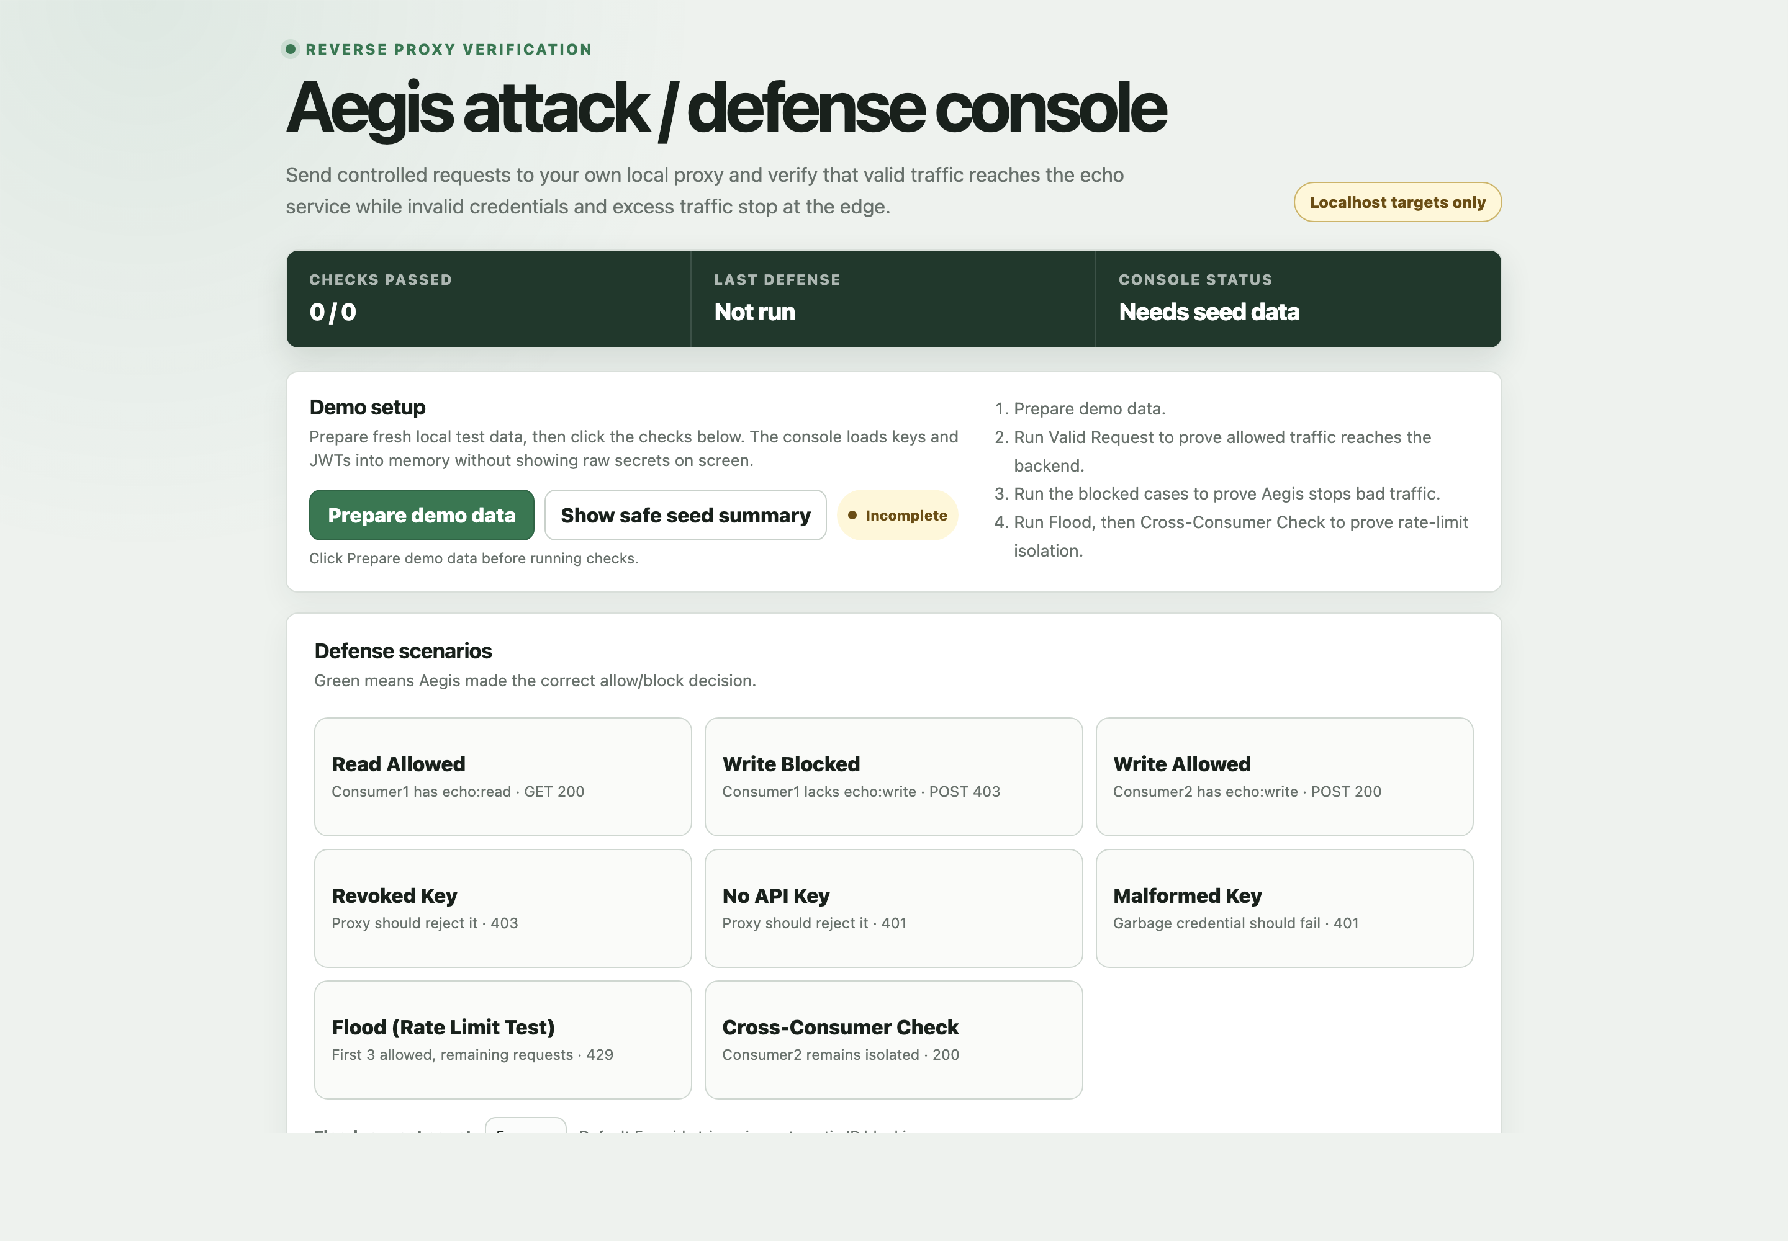
Figure 8.3: Localhost-only attack/defence console used to run controlled proxy scenarios.

8.7.3 Testing
The complete quality gate passed: 47 Control Plane tests, Go format/vet/race checks with 83.4% proxy-core coverage, six dashboard tests and thirteen POC/tooling tests. The isolated Docker run completed health, authenticated policy delivery, upstream forwarding, invalid and revoked credential rejection, manual and automatic IP blocking, threat matching, rate limiting and analytics.
The release check joined component and system-level results without treating one as a substitute for another. make check completed the Python suite with 47 passing tests and 77% application coverage, Go formatting, vet and race checks with 83.4% proxy-core coverage, six dashboard tests and thirteen POC/tooling tests. The disposable Docker scenario then verified live service health, dashboard readiness, Admin login, API-key creation and revocation, JWT and threat policy activation, authenticated gRPC delivery, a successful upstream request, invalid and revoked credentials, manual and automatic exact-IP blocking, the Redis limit sequence and analytics aggregation. Generated credentials were excluded from the retained output and the isolated stack was removed after completion.
Table 8.11: TB6 testing record.
Check | Trigger | Observed result | Interpretation
Quality gate | Run make check | All component suites and static checks pass | Repository is internally consistent
Service health | Start disposable Compose stack | Control Plane, PostgreSQL and Redis healthy | Dependencies are reachable
Policy path | Activate JWT and subscribe through gRPC | Valid request reaches upstream with 200 | Management-to-enforcement path works
Deny matrix | Invalid/revoked key, threat and manual block | Controlled 401 or 403 responses | Distinct controls stop requests
Rate path | Apply two-request fixed window | 200, 200, 429 | Redis policy works in the deployed stack
Analytics | Query after allow and deny scenarios | Forwarded and blocked outcomes aggregated | Reporter and persistence path works
Cleanup | Scenario completes | Disposable services and data removed | Run can be repeated safely

The integrated scenario intentionally repeats controls already covered by unit tests because configuration can invalidate otherwise correct code. It checks that the proxy uses the expected Control Plane address, gRPC token, Redis database, upstream target and generated policy identifiers. Each checkpoint narrows the fault domain: health precedes login, login precedes policy creation, policy delivery precedes the first 200, and denial cases precede analytics inspection. Cleanup is asserted as part of the scenario so a successful run cannot leave active blocks or counters that corrupt the next demonstration.

8.7.4 Retro
Cross-component tests found configuration and state problems that unit tests could not reveal. The final process now uses generated credentials, redacted output, disposable resources and explicit cleanup. Production load testing and an independent penetration review remain future work.
The integrated run changed the meaning of done. A component can pass its own tests while deployment wiring, internal authentication, policy propagation or stale state still prevents the product from working. TB6 therefore kept component checks for fast diagnosis and added a bounded end-to-end path for interaction risk. The console remained localhost-only and generated secrets stayed in memory or temporary environment state. Remaining work was recorded honestly: the run demonstrates functional integration, not production throughput, hostile-internet exposure or an independent penetration assessment.
Table 8.12: TB6 retrospective actions.
Retrospective point | Recorded outcome
What worked | Layered checks separated component defects from integration defects
What changed | Disposable credentials and cleanup became mandatory release controls
Carry-forward | Future work targets load, accessibility and independent security review

The final retrospective separated release confidence from production assurance. The completed checks support functional correctness in the local architecture, but do not claim capacity under sustained load, resistance to an independent attacker or usability across assistive technologies. Those items were placed in future work with measurable entry criteria: controlled hardware and traffic profiles, an external security review, browser accessibility testing and trusted-load-balancer address handling before any public deployment.

8.8 Cross-Component Request Example
Consider GET /api/echo with an active key carrying echo:read. The dashboard or API client first creates a RoutePermission that requires echo:read for that method and path. The Control Plane validates and persists it, the gRPC server publishes a complete snapshot, and the Go subscriber swaps the snapshot into memory. At request time the proxy validates the key and JWT policy, resolves the route, finds the exact scope, consumes the chosen limit, strips credentials and forwards. POST /api/echo follows the same path but requires echo:write and is denied when that label is absent.
Table 8.13: One request contract across the Aegis components.
Layer | Input | Successful output | Common failure
Pydantic | Administrative JSON | Typed command | 422 invalid field or enum
Service | Typed command + current user | Authorised domain change | 403 role or ownership denial
Repository | Validated domain change | Committed row | Controlled duplicate conflict
Policy stream | Complete database snapshot | Authenticated proxy update | Reconnect with last-valid snapshot
Proxy | HTTP request + in-memory policy | Sanitised forwarded request | 401, 403 or 429 without upstream call

8.9 Screenshot Completion Guide
The report already includes the login page, generated OpenAPI page and attack/defence console. Four marked slots remain for authenticated pages that require a live signed-in dashboard session. When adding them, use development-only data, crop browser chrome where appropriate, hide emails and addresses that identify real people, and never display a raw API key, bearer token, password or internal service token.
Table 8.14: Webpage captures still required from an authenticated session.
Slot | Report page | Page to capture | What must be visible
8-A | 46 | Users | Role and active-state controls with anonymised users
8-B | 49 | API Keys | Name, prefix, scopes, status and expiry; no raw key
8-C | 53 | Rate Limits / Threat Rules | One active demonstration rule in each view
8-D | 55 | Analytics | Summary cards and sanitised recent outcomes

8.10 Implementation Summary
The implementation now connects typed administrative JSON, durable policy, authenticated distribution and ordered Go enforcement. The repeated Design-Coding-Testing-Retro format shows how each increment progressed and what was learned. The practical examples explain why a key contains scope strings, how a route gives those strings meaning, how invalid input is rejected, and how distributed policy produces observable allow or deny outcomes without exposing secrets.

Chapter 9: Evaluation and Reflection

9.1 Evaluation Against the Aim
The Project Proposal aimed to design and develop a production-ready API security and management system that provides central protection through request validation, rate limiting and threat detection while demonstrating Python/FastAPI, Go and React skills (Htun Khaing Lynn, 2026). The current project achieves the central architectural and learning aim: policy is managed in the FastAPI Control Plane and enforced by the Go proxy before an upstream request is possible. The React dashboard and POC make that behaviour observable, and the completed isolated Compose run verifies the integrated local topology. The term production-ready should nevertheless be qualified because deployment-specific TLS, trusted-proxy handling, load benchmarking, operational rotation and long-running resilience testing remain future work.

9.2 Evaluation of Objectives
Table 9.1: Evaluation of the Project Proposal objectives against current verification.
Objective | Evaluation | Verification
Research existing solutions | Achieved | Commercial/open-source comparison and literature synthesis in Chapters 2-3.
Define requirements and roles | Achieved | MoSCoW analysis, RBAC and current persisted policies in Chapter 5.
Design architecture and workflows | Achieved | Current architecture, domain and sequence diagrams in Chapter 6.
Implement the full stack | Achieved | FastAPI, Go, React, PostgreSQL, Redis, gRPC and POC described in Chapter 8.
Test security behaviour | Achieved for the project scope | Passing component suites, focused scope tests, live enforcement and completed isolated Docker E2E.
Evaluate the result | Achieved with limitations | Comparison, strengths, limitations, reflection and future work in this chapter.

9.3 Comparison with Existing Products
Kong, APISIX, Tyk, AWS API Gateway and Cloudflare provide broader ecosystems, managed availability, extensive plugins and established operational tooling. Aegis does not replace those products. Its value is a focused, self-hosted and explainable implementation in which the student controls the policy model, request order, rate algorithms and audit shape. This makes security decisions easier to reverse-learn than in a platform where behaviour is distributed across plugins and vendor infrastructure.

9.4 Strengths
- Management-plane/data-plane separation prevents common policy decisions from depending on a per-request PostgreSQL query.
- The enforcement sequence applies inexpensive source/threat checks before credentials, authorisation and rate limiting.
- Exact RoutePermission records make scope semantics explicit and testable.
- Cryptographic key generation, one-time raw-key disclosure and hashed persistence reduce credential exposure.
- Atomic Redis algorithms support shared counters across proxy instances.
- Sanitised security events and credential stripping reduce unnecessary sensitive-data propagation.
- The POC demonstrates a real upstream outcome and per-consumer isolation rather than only mocked service calls.

9.5 Limitations
- Exact route matching does not yet support reviewed wildcard, parameter or deny-by-default policies.
- Threat detection is pattern matching over method and request URI, not request-body inspection or a complete web application firewall.
- Direct-peer IP handling is safe for the current topology but needs an explicit trusted-proxy configuration for load-balanced deployment.
- The current dashboard has automated route checks but limited formal usability and accessibility evaluation with end users.
- Performance has not been evaluated with controlled hardware, concurrent load profiles and percentile latency measurements.
- The completed Docker E2E proves the isolated local stack, but it does not replace production-like TLS, distributed deployment, failure-injection or throughput verification.

9.6 Reflection on Development and Learning
The most important technical learning was the difference between recognising a credential and authorising a resource operation. A key can validly contain ["echo:read"], but that string has no inherent knowledge of the echo service. The later route-permission model explicitly maps GET /api/echo to echo:read. This small data structure made the authorisation boundary clearer than embedding route names in handler conditions.
Go required a more explicit approach to dependencies and failure paths than the initial Python work. Handler interfaces made policy providers, key validation, JWT validation, rate limiting, event reporting and forwarding independently testable. Context timeouts and cloned headers exposed practical HTTP concerns that are easy to miss when learning reverse proxies conceptually. Python/FastAPI made schema validation and REST organisation productive, but also reinforced that validation rules must remain consistent with Go's accepted snapshot values.
The POC run also provided a process lesson. The unexpected loopback block was correct system behaviour caused by persistent environment state. Treating it as verification, finding the policy record and rerunning after a traceable soft-disable was more valuable than forcing a green screenshot. The isolated Docker run was then repeated to completion with disposable state and redacted checkpoint logging. These decisions reflect professional responsibility and improve confidence in the report.

9.7 Future Improvements
- Design parameterised/wildcard route permissions with conflict analysis and a staged deny-by-default option.
- Add trusted-load-balancer configuration and CIDR policy only after defining exactly which forwarded headers are authoritative.
- Extend the completed reproducible Docker E2E with repeatable load benchmarks, failure injection and documented hardware and latency percentiles.
- Add signing-key rotation, policy version history, audit diffing and operational alert integrations.
- Conduct dashboard accessibility auditing and task-based usability sessions with Admin, Viewer and API Consumer participants.
- Assess body-aware detection separately, including privacy, memory/latency cost, payload limits and false-positive handling.

9.8 Final Conclusion
Aegis demonstrates that a focused custom reverse proxy can centralise meaningful API security controls while remaining understandable from database record to HTTP result. The project does not claim the breadth or operational maturity of a commercial gateway. Its contribution is a coherent learning implementation whose main behaviours are inspectable, testable and connected to the original proposal. With the identified deployment hardening and verification gaps addressed, it provides a credible foundation for further production-oriented development.

References
Agile Business Consortium (2014) The DSDM Agile Project Framework. Tunbridge Wells: Agile Business Consortium.
Amazon Web Services (2026) Control access to HTTP APIs with JWT authorizers. Available at: https://docs.aws.amazon.com/apigateway/latest/developerguide/http-api-jwt-authorizer.html (Accessed: 2 August 2026).
Apache APISIX (2026) rate-limit and jwt-auth plugin documentation. Available at: https://apisix.apache.org/docs/apisix/plugins/ (Accessed: 2 August 2026).
Cloudflare (2026) API Gateway and rate limiting documentation. Available at: https://developers.cloudflare.com/api-shield/ (Accessed: 2 August 2026).
Docker Inc. (2026) Docker Compose documentation. Available at: https://docs.docker.com/compose/ (Accessed: 2 August 2026).
Fielding, R.T. (2000) Architectural Styles and the Design of Network-based Software Architectures. PhD thesis. University of California, Irvine.
Htun Khaing Lynn (2026) Aegis: API Security and Management System - Project Proposal. Unpublished project proposal.
Indrasiri, K. and Kuruppu, D. (2020) gRPC: Up and Running. Sebastopol: O'Reilly Media.
Jones, M., Bradley, J. and Sakimura, N. (2015) JSON Web Token (JWT). RFC 7519. Internet Engineering Task Force. Available at: https://www.rfc-editor.org/rfc/rfc7519 (Accessed: 2 August 2026).
Kong Inc. (2026) Rate limiting plugin documentation. Available at: https://developer.konghq.com/plugins/rate-limiting/ (Accessed: 2 August 2026).
Newman, S. (2021) Building Microservices: Designing Fine-grained Systems. 2nd edn. Sebastopol: O'Reilly Media.
Oliveira, G. (2022) Rate-limiting algorithm discussion cited in the Aegis Project Proposal.
OWASP Foundation (2023) OWASP API Security Top 10 2023. Available at: https://owasp.org/www-project-api-security/ (Accessed: 2 August 2026).
PostgreSQL Global Development Group (2026) PostgreSQL documentation. Available at: https://www.postgresql.org/docs/ (Accessed: 2 August 2026).
Redis Ltd. (2026) Redis command and scripting documentation. Available at: https://redis.io/docs/latest/ (Accessed: 2 August 2026).
The Go Authors (2026) Package net/http and httputil documentation. Available at: https://pkg.go.dev/net/http (Accessed: 2 August 2026).
Tyk Technologies (2026) Rate limiting documentation. Available at: https://tyk.io/docs/api-management/rate-limit/ (Accessed: 2 August 2026).
W3C (2018) Web Content Accessibility Guidelines (WCAG) 2.1. Available at: https://www.w3.org/TR/WCAG21/ (Accessed: 2 August 2026).
Agile Business Consortium (2014) The DSDM Agile Project Framework. Available at: https://www.agilebusiness.org/resource/the-dsdm-agile-project-framework/ (Accessed: 11 August 2026).
Agile Business Consortium (2026) What is MoSCoW Prioritization? Available at: https://www.agilebusiness.org/resource/what-is-moscow-prioritization/ (Accessed: 11 August 2026).
Agile Business Consortium (2026) What is Timeboxing? Available at: https://www.agilebusiness.org/resource/what-is-timeboxing/ (Accessed: 11 August 2026).
Nay Ye Htet Naing (2025) Restaurant Management System for Chef Restaurant: Project Documentation. Unpublished COMP 1682 reference report.
Hein Htet Aung (2026) An AI-Driven Retrieval-Augmented Generation (RAG) System for Enhancing Entrepreneurial Knowledge Acquisition among Young Adults: Final Report. Unpublished COMP 1682 final project report.

Appendices

Appendix A: Project Proposal
The approved Aegis Project Proposal is submitted as the accompanying source document. It defines the original problem, aim, objectives, scope, risk register and overall schedule. Chapters 1, 5, 7, 8 and 9 explicitly trace the implemented system back to that baseline and identify material adaptations rather than presenting them as if they were planned from the outset.
Table A.1: Proposal schedule interpretation used throughout the report.
Proposal baseline | How this report uses it
Design: 27 April-29 May 2026 | Treated as a project activity, not as a DSDM delivery timebox.
Implementation: 1 June-11 September 2026 | Divided into six fixed DSDM structured timeboxes.
Testing: 14 September-9 October 2026 | Retained as a separate scheduled activity, with its verification integrated into Chapter 8 beside the relevant implementation timeboxes.
Evaluation: 12-30 October 2026 | Used to assess delivery, limitations and learning against the original objectives.

Appendix B: Figures
Figure B.1 reproduces the consolidated project plan. Dark bars are the six implementation delivery timeboxes. Design, formal testing and evaluation remain visible as project activities but are deliberately labelled as not timeboxed, preserving the DSDM boundary required for this report.

Figure B.1: Aegis project plan with DSDM timeboxes applied only to implementation.

