COMP 1682 PROJECT DOCUMENTATION
Aegis
API Security and Management System

Htun Khaing Lynn
Student ID: 001557481
BSc (Hons) Computing
Final Project Report - 2026

Abstract
Aegis is a self-hosted API security and management system that centralises authentication, authorisation, rate limiting, threat detection and audit visibility in front of protected services. It combines a Python/FastAPI Control Plane, a Go Reverse Proxy and a React dashboard with PostgreSQL and Redis. This report evaluates the implemented system against the Project Proposal, current source code, database migrations and verified local test evidence.
The implementation issues cryptographically random API keys whose hashes alone are persisted; validates API keys and optional JWTs; binds exact HTTP method/path pairs to required resource:action scopes; applies fixed-window, sliding-window and token-bucket limits in Redis; distributes policy by REST bootstrap and authenticated gRPC streaming; detects configured request-target patterns; enforces manual and automatic IP blocks; and records sanitised analytics. The report explains how JSON payload structures are parsed and validated and how the Go proxy consumes the resulting policy without inferring semantics from scope names.
Verification includes 47 Control Plane tests at 77% application coverage, Go race/vet/format checks and approximately 83% enforcement-core coverage, six dashboard tests, thirteen POC/tooling tests and an observed live attack/defence flow. In line with the new structural reference, detailed design, implementation, operation and testing material is presented inside the relevant chapters. Only the proposal pointer and project-plan figure remain as appendices.
Keywords: API security, reverse proxy, FastAPI, Go, JWT, rate limiting, Redis, DSDM.

Acknowledgements
I would like to thank the project supervisor, module tutors and COMP 1682 teaching team for their guidance on scope, academic writing, evidence and project management. Their feedback led to a clearer distinction between implementation delivery timeboxes and the surrounding design, testing and evaluation activities.
The report also acknowledges the standards, research literature and open-source communities referenced in the bibliography. Hein Htet Aung's 2026 final report was used as the latest structural reference: its chapter-first treatment of implementation, testing and deployment, and its restrained appendix use, informed this revision. Its project-specific content was not reused as Aegis evidence.

Table of Contents
Abstract 2
Acknowledgements 3
List of Figures 7
List of Tables 8
Chapter 1: Introduction 9
1.1-1.9 Background, problem, aim, objectives and scope 9
Chapter 2: Product Research 14
2.1-2.6 Product comparison and research findings 14
Chapter 3: Literature Review 17
3.1-3.7 Security, identity, rate limiting and architecture 17
Chapter 4: Legal, Social, Ethical and Professional Issues 19
4.1-4.7 Legal, social, ethical and professional analysis 19

Table of Contents (continued)
Chapter 5: System Analysis 22
5.1-5.6 Users, requirements and MoSCoW priorities 22
Chapter 6: System Design 31
6.1-6.9 Architecture, domain model and enforcement design 31
6.10 Detailed domain data dictionary 38
6.11 Reverse proxy enforcement walkthrough 45
Chapter 7: Project Timeline 56
7.1-7.12 DSDM rules and six implementation-only timeboxes 56
Chapter 8: System Implementation 71
8.1-8.11 Design, coding and testing evidence for six timeboxes 71
8.12 DSDM review and sign-off records 86
8.13 Valid JSON payloads 91
8.14 Control Plane API operation catalogue 93
8.15 Operator and API consumer procedures 108
8.16 Deployment and operations 116
8.17 Reverse-learning Go and JSON 126

Table of Contents (continued)
8.18 Integrated verification evidence 133
8.19 Selected test case matrix 136
8.20 Evidence and reproducibility 137
8.21 Detailed testing and traceability 137
Chapter 9: Evaluation and Reflection 150
9.1-9.8 Objectives, limitations, reflection and conclusion 150
References 153
Appendices 155
Appendix A: Project Proposal 155
Appendix B: Figures 155

List of Figures
Figure | Description
Figure 5.1 | Aegis use-case model
Figure 6.1 | Current implemented system architecture
Figure 6.2 | Current persisted domain model
Figure 6.3 | Request validation and enforcement sequence
Figure 8.1 | TB1 identity and RBAC test evidence
Figure 8.2 | Actual dashboard login interface
Figure 8.3 | TB2 key and policy test evidence
Figure 8.4 | Generated FastAPI OpenAPI interface
Figure 8.5 | TB3 proxy authentication and authorisation tests
Figure 8.6 | TB4 limits, threat and IP-enforcement tests
Figure 8.7 | TB5 distribution, analytics and dashboard tests
Figure 8.8 | TB6 complete quality-gate evidence
Figure 8.9 | Actual attack/defence console
Figure 8.10 | Observed live POC output
Figure 8.11 | Completed automated quality-gate result
Figure 8.12 | Completed live POC enforcement result
Figure B.1 | Project plan showing implementation-only DSDM timeboxes

List of Tables
Chapter | Principal table groups
1-3 | SWOT, product comparison, algorithms and literature synthesis.
4-6 | LSEP mitigations, requirements, components, data definitions and enforcement design.
7 | DSDM rules, MoSCoW balance and dated From/To/Duration/Summary schedules.
8 | Timebox design, coding and testing evidence; payloads; operations; deployment and traceability.
9 | Objective evaluation, limitations, reflection and conclusion.

Chapter 1: Introduction

1.1 Background to API Security and Management
Modern web applications depend heavily on Application Programming Interfaces (APIs) to enable communication between clients, services, and third-party systems (Fielding, 2000; Newman, 2021). The widespread adoption of microservices and distributed architectures has increased the number of exposed APIs within a typical system, which in turn expands the attack surface and makes consistent security enforcement more difficult (Newman, 2021). APIs now represent one of the primary channels through which organisations expose business logic and data, making their protection a critical concern for modern software systems.
As the number and complexity of APIs grows, organisations increasingly require mechanisms that can validate requests, enforce access policies, and detect malicious activity in real time. Centralised API gateways and reverse proxies have emerged as a common architectural pattern for enforcing authentication, authorisation, and traffic control consistently across multiple services (Newman, 2021; Indrasiri and Kuruppu, 2020). Such centralisation reduces duplicated security logic across services and provides a single point from which policies can be defined, monitored, and updated.

1.2 Challenges in Existing API Security Systems
Despite the availability of commercial and open-source API security solutions, several challenges continue to affect organisations attempting to secure their APIs.
A key issue is the reliance on per-service security implementation, where each backend service independently implements its own authentication, rate limiting, and logging logic. This approach leads to duplicated development effort, inconsistent policy enforcement, and limited visibility across the system as a whole (OWASP Foundation, 2023). As the number of services increases, maintaining consistent security configuration across all of them becomes increasingly difficult and error-prone.
Organisations also face a range of specific threats that are difficult to defend against without centralised protection, including unauthorised access, brute-force and denial-of-service attacks, token hijacking, and large-scale data scraping (OWASP Foundation, 2023). Without a consistent enforcement layer, individual services may implement these protections inconsistently, or omit them entirely, leaving gaps that attackers can exploit.
A further challenge is the trade-off between security and operational simplicity. Fully featured commercial gateways provide extensive functionality but often introduce significant configuration complexity, licensing cost, and vendor lock-in. Conversely, minimal or self-built solutions may lack essential capabilities such as distributed rate limiting, structured threat detection, and real-time analytics, leaving services inadequately protected.
Visibility and monitoring also present ongoing difficulties. Without centralised logging and analytics, security teams often lack real-time insight into how APIs are being used or attacked, which delays the detection of anomalous behaviour and increases the time required to respond to incidents (OWASP Foundation, 2023). These limitations highlight the need for a system that consolidates security enforcement and monitoring into a single, manageable layer without requiring changes to existing backend services.

1.3 SWOT Analysis of Existing API Security Systems
A SWOT analysis was conducted to evaluate existing API security and gateway solutions.

Strengths
Established platforms offer mature, battle-tested feature sets, including authentication, rate limiting, and traffic management. Centralised gateways and reverse proxies are widely used and well understood, and enforce authentication, authorisation, and traffic control consistently across services (Newman, 2021; Indrasiri and Kuruppu, 2020), reducing the need for individual services to implement these concerns independently.

Weaknesses
Many existing solutions introduce considerable configuration complexity and, in the case of commercial products, ongoing licensing costs. Self-hosted alternatives frequently lack integrated, real-time threat detection and require significant engineering effort to extend or customise. Limited support for real-time configuration synchronisation across multiple proxy instances also reduces operational responsiveness in dynamic environments.

Opportunities
There is an opportunity to design a lightweight, self-hosted API security system that combines the core protections offered by commercial gateways with simpler deployment and configuration. Integrating distributed rate limiting, JWT validation, IP-based blocking, and real-time analytics within a single, cohesive system can improve both security posture and operational visibility while remaining accessible to smaller teams.

Threats
Established commercial platforms benefit from extensive documentation, community support, and enterprise adoption, creating strong competition for any new system. Additionally, the rapid evolution of API attack techniques, as catalogued in the OWASP API Security Top 10 (OWASP Foundation, 2023), means that any security system must be designed with extensibility in mind to remain effective against emerging threats.
This analysis reinforces the need for a solution that balances comprehensive security functionality with deployment simplicity and cost-effectiveness.

1.4 Key Characteristics of Effective API Security Systems
Effective API security systems share several key characteristics. Centralised enforcement ensures that authentication, rate limiting, and validation are applied consistently across all backend services, rather than being duplicated and potentially inconsistently implemented in each service (Newman, 2021).
Secure API key management, including cryptographically strong generation and hashed storage, is essential to prevent credential compromise. Robust token validation, particularly through standards such as JSON Web Tokens (JWT), ensures that only properly authenticated requests are permitted to reach backend services (Jones, Bradley and Sakimura, 2015).
Distributed rate limiting is also critical in environments with multiple proxy instances, as it ensures that traffic control policies are enforced consistently regardless of which instance handles a given request (Oliveira, 2022). In addition, real-time monitoring and analytics capabilities allow administrators to detect and respond to threats quickly, supporting proactive rather than reactive security management.
Finally, usability and deployability remain important, particularly for teams without dedicated security engineering resources. A system that can be deployed without requiring modification to existing backend services reduces adoption friction and integration risk.

1.5 Problem Statement and Research Gap
Existing API security solutions do not fully address the needs of organisations seeking centralised, comprehensive protection without the cost and complexity associated with enterprise-grade commercial platforms.
Commercial gateways provide extensive functionality but introduce licensing costs, vendor lock-in, and configuration overhead. Self-built or minimal solutions avoid these costs but typically lack integrated threat detection, distributed rate limiting, and real-time analytics, leaving services under-protected. This creates a gap between fully featured commercial platforms and lightweight, inadequately protected custom implementations.
Therefore, there is a need for a self-hosted, high-performance API security system that integrates essential protections — API key management, distributed rate limiting, JWT validation, IP-based blocking, and threat detection — within a single, centrally managed platform, while remaining straightforward to deploy alongside existing backend services. Addressing this gap is important for improving the security posture of API-driven systems without imposing unnecessary cost or complexity.

1.6 Aim and Objectives
The aim of this project is:
“To design and develop a production-ready API security and management system that provides centralised protection for backend services through intelligent request validation, rate limiting, and threat detection, while demonstrating proficiency in full-stack development using Python/FastAPI, Go, and React.”
The objectives are:
- Conduct research into existing API security solutions and best practices
- Analyse current systems to identify strengths, limitations, and gaps
- Investigate and justify suitable methodologies and technologies
- Define and prioritise functional and non-functional system requirements
- Design system architecture, database schema, and user interfaces
- Implement the system using an iterative, timeboxed approach
- Test the system for functionality, performance, and security
- Evaluate the system against its objectives and existing solutions

1.7 Proposed System Overview
The proposed system, Aegis, is a centralised API security and management platform designed to address the limitations identified in existing solutions.
Aegis places a secure, high-performance reverse proxy in front of existing backend services, validating incoming requests before they are forwarded onward. The system is composed of three main components: a Control Plane built with Python and FastAPI for centralised configuration and management, a Reverse Proxy built with Go for high-throughput request validation, and a Dashboard built with React for real-time monitoring and administration.
Key features include secure API key generation and management using bcrypt hashing, distributed rate limiting via Redis, JWT token validation, real-time threat detection through pattern matching, manual and automatic IP-based blocking, and real-time configuration synchronisation between components via gRPC. The system also provides a comprehensive analytics dashboard and request logging capabilities, enabling administrators to monitor API usage and security events without requiring any changes to existing backend services.

1.8 Scope of the System
The system focuses on the core functionalities required for effective API security and management. Included features are:
- secure API key generation and management
- distributed rate limiting
- JWT token validation
- real-time threat detection through pattern matching
- manual and automatic IP-based blocking
- real-time analytics and monitoring dashboard
Excluded features include support for non-HTTP protocols, offline or air-gapped deployment, and native mobile administration applications. These exclusions ensure that development remains feasible within the project timeframe while maintaining a focused and coherent feature set.

1.9 Summary
This chapter introduced the context and motivation for the Aegis system. It examined the challenges faced by organisations securing modern API-driven applications and identified a gap between costly, complex commercial gateways and inadequately protected self-built alternatives. A SWOT analysis was conducted to evaluate current solutions.
The aim, objectives, system overview, and scope of the project were then defined. These findings establish a clear link between the identified limitations of existing systems and the proposed solution, providing a foundation for the research, analysis, and design presented in the chapters that follow.

Chapter 2: Product Research

2.1 Overview
This chapter examines existing API security and management products currently available on the market. Rather than reviewing academic theory, which is addressed separately in Chapter 3, the purpose here is to evaluate practical, real-world tools that organisations use today, in order to identify functional gaps that Aegis is intended to address.
The products reviewed are grouped into two categories: commercial and cloud-managed gateways, and open-source, self-hosted gateways. This grouping reflects the two dominant deployment models currently used for API security (API7.ai, 2026).

2.2 Commercial and Cloud-Managed Gateways
Cloud-managed gateways such as AWS API Gateway, Azure API Management, and Google Apigee are fully managed services with deep integration into their respective cloud ecosystems. They offer strong reliability and minimal operational overhead, since infrastructure management is handled by the provider. However, this convenience comes with vendor lock-in, limited customisation, and, at scale, significant cost (API7.ai, 2026).
Cloudflare API Gateway takes a different approach, focusing on edge-based security such as bot mitigation and DDoS protection. While effective at the network edge, it is not a complete API lifecycle management platform, and its configuration, transformation, and backend orchestration capabilities are limited compared with dedicated gateways such as Apigee or Kong (Geekflare, 2026).
Google Apigee offers the most complete commercial feature set, including a developer portal, monetisation, and analytics, delivered either as a fully managed service or a hybrid model with a customer-operated Kubernetes runtime. This completeness comes at the cost of deployment complexity and unpredictable pricing, making it best suited to large enterprises rather than small or medium-scale projects (API7.ai, 2026).

2.3 Open-Source and Self-Hosted Gateways
Kong Gateway (Community Edition) is one of the most widely adopted open-source gateways, offering a mature plugin ecosystem and flexible deployment options. However, its free tier lacks distributed rate limiting and integrated threat detection without additional paid plugins, and operating it in production requires managing a Postgres or Cassandra data store (Moesif, 2025).
Apache APISIX is a fully open-source, cloud-native gateway built on NGINX and OpenResty, frequently cited as one of the fastest self-hosted options available, with dynamic configuration handled through etcd (Geekflare, 2026).
Tyk Community Edition provides a Go-based, open-source alternative with native GraphQL support. Notably, Tyk's AI Studio component became fully open source in early 2026, reflecting a broader industry trend toward open-sourcing previously commercial gateway features (ChatForest, 2026).
Across these open-source options, a common limitation is the absence of integrated, real-time threat detection and distributed rate limiting out of the box; both typically require additional configuration, external data stores such as Redis, or paid enterprise add-ons.

2.4 Comparative Analysis
Table 2.1 summarises the products reviewed against the core capabilities relevant to this project.
Product | Type | Rate Limiting | JWT Validation | Threat Detection | Deployment Complexity
Kong Gateway (CE) | Self-hosted, open-source | Plugin-based, basic | Yes (plugin) | Limited | Moderate
Apache APISIX | Self-hosted, open-source | Built-in | Yes | Limited | Moderate
Tyk (CE) | Self-hosted, open-source | Built-in | Yes | Limited | Moderate
AWS API Gateway | Cloud-managed | Built-in | Yes | Via AWS WAF add-on | Low (managed)
Cloudflare API Gateway | Cloud/edge-managed | Built-in | Partial | Strong (bot/DDoS) | Low (managed)
Google Apigee | Cloud/hybrid | Built-in | Yes | Limited | High
Aegis (Proposed) | Self-hosted | Distributed (Redis) | Yes | Real-time pattern matching | Low–Moderate
Table 2.1: Comparison of existing API gateway products against proposed Aegis features

2.5 Gaps Identified
The product research highlights a consistent gap between two categories of solution. Commercial and cloud-managed gateways provide strong feature completeness but introduce vendor lock-in, high cost at scale, and, in Cloudflare's case, incomplete API lifecycle coverage. Open-source, self-hosted gateways avoid these costs but generally lack integrated real-time threat detection and require additional engineering effort to achieve distributed rate limiting and analytics.
This gap supports the direction proposed for Aegis: a self-hosted system that bundles distributed rate limiting, JWT validation, and real-time threat detection into a single, centrally managed platform, positioned between the operational simplicity of commercial tools and the flexibility of open-source alternatives.

2.6 Summary
This chapter reviewed existing commercial and open-source API security products and compared their core capabilities against the features proposed for Aegis. The review confirmed that no single existing product combines low deployment complexity, distributed rate limiting, and integrated real-time threat detection in a self-hosted package, reinforcing the research gap identified in Chapter 1. The next chapter examines the academic and technical literature underpinning the design decisions for Aegis.

Chapter 3: Literature Review

3.1 Introduction
This chapter reviews the academic and technical literature relevant to Aegis, covering established standards, algorithms, and architectural patterns that inform its design. Where existing products are referenced, discussion is limited to Kong Gateway and Apache APISIX, as representative open-source implementations of the concepts discussed; the broader product landscape was already addressed in Chapter 2 and is not repeated here.

3.2 API Security Threats and Standards
The foundation of API-based architectures lies in Representational State Transfer (REST), a set of architectural constraints for building scalable, stateless network services (Fielding, 2000). While REST itself does not define security mechanisms, its widespread adoption has made API-specific threats a distinct area of study.
The OWASP API Security Top 10 provides the most widely referenced classification of API-specific vulnerabilities, including broken object-level authorisation, broken authentication, and unrestricted resource consumption (OWASP Foundation, 2023). This classification directly informs Aegis's threat model, particularly its focus on authentication enforcement and rate limiting as primary mitigations against the most common attack categories identified in the standard.

3.3 Authentication and Authorization Techniques
JSON Web Tokens (JWT) are defined in RFC 7519 as a compact, URL-safe means of representing claims to be transferred between two parties (Jones, Bradley and Sakimura, 2015). JWTs are widely used for stateless authentication because the signed token itself carries the information needed to verify a request, removing the need for the verifying service to query a central session store on every request.
This property is particularly relevant to Aegis's Data Plane design: because the Go reverse proxy must validate large volumes of requests with minimal latency, stateless JWT verification avoids the overhead of a database lookup per request, at the cost of requiring careful handling of token revocation, which Aegis addresses through short-lived tokens combined with a Redis-backed revocation list at the Control Plane level.

3.4 Rate Limiting Algorithms
Rate limiting is a core technique for protecting services against abuse and denial-of-service conditions. The literature identifies several established algorithms, including the Token Bucket, Leaky Bucket, and Sliding Window approaches, each offering different trade-offs between burst tolerance, memory usage, and implementation complexity (Oliveira, 2022).
The Token Bucket algorithm allows short bursts of traffic while enforcing a long-term average rate, making it well suited to typical API traffic patterns where legitimate clients may briefly exceed a steady rate. In distributed environments with multiple proxy instances, rate limiting state must be shared across instances to be effective; Redis is commonly used for this purpose because its atomic increment and expiry operations allow rate counters to be updated consistently without race conditions (Oliveira, 2022). This directly informs Aegis's choice of a Redis-backed distributed rate limiter in the Go reverse proxy.

3.5 Reverse Proxy and Gateway Architecture Patterns
Centralising cross-cutting concerns such as authentication, rate limiting, and logging behind a reverse proxy is a well-established pattern in microservices architecture, allowing individual backend services to remain simple while security and traffic policies are enforced consistently at a single layer (Newman, 2021).
Open-source implementations of this pattern illustrate two common architectural approaches. Kong Gateway is built as a plugin-based proxy on top of NGINX, where cross-cutting concerns are implemented as discrete, composable plugins attached to routes. Apache APISIX instead embeds routing and policy logic directly using the OpenResty/Lua runtime, with configuration state distributed through etcd rather than a plugin pipeline. Both approaches confirm the viability of separating a lightweight data-path proxy from a centralised configuration store, a separation that Aegis adopts directly through its Control Plane/Data Plane split, with gRPC used for configuration propagation instead of etcd or a plugin system (Indrasiri and Kuruppu, 2020).

3.6 Microservices Security Considerations
Distributed systems introduce security considerations beyond those of monolithic applications, including the need for consistent policy enforcement across many independently deployable services and the risk of inconsistent implementation when each service manages its own security logic (Newman, 2021). The literature generally recommends centralising authentication and access control at a shared boundary rather than duplicating it within each service, both to reduce implementation inconsistency and to simplify auditing of security behaviour across the system.

3.7 Summary and Research Gap Synthesis
This chapter reviewed the academic and technical foundations relevant to Aegis: REST and API-specific threat models (Fielding, 2000; OWASP Foundation, 2023), JWT-based stateless authentication (Jones, Bradley and Sakimura, 2015), distributed rate limiting algorithms (Oliveira, 2022), and reverse proxy architecture patterns as implemented in Kong Gateway and Apache APISIX (Newman, 2021; Indrasiri and Kuruppu, 2020).
Combined with the product-level gaps identified in Chapter 2, the literature confirms that the individual techniques required by Aegis, stateless JWT validation, distributed token-bucket rate limiting, and a decoupled control/data plane architecture, are well established, but no reviewed open-source product combines them into a single, low-complexity, self-hosted system. This synthesis of theoretical grounding and product-level gap directly justifies the design decisions carried forward into the following chapters.

Chapter 4: Legal, Social, Ethical and Professional (LSEP) Issues

4.1 Introduction
This chapter examines the legal, social, ethical, and professional issues relevant to the design, development, and operation of Aegis, expanding on the LSEP considerations first identified in the Project Proposal (Section 5). As a system that handles user credentials, API keys, and security-related data, Aegis raises considerations beyond purely technical correctness, and these are addressed systematically below, together with the mitigations adopted during development.

4.2 Legal Issues
Aegis stores and processes personal and security-sensitive data, including user account information, hashed passwords, API key metadata, and request logs. This raises data protection considerations broadly aligned with the principles underlying the General Data Protection Regulation (GDPR), even though the system is developed as an academic project rather than a commercial product subject to formal regulatory audit. In particular, storing only what is necessary, hashing sensitive credentials rather than storing them in plain text, and defining clear retention expectations for request logs are treated as baseline requirements rather than optional enhancements.
A further legal consideration concerns intellectual property. Aegis is built using a number of open-source libraries and frameworks, including FastAPI, SQLAlchemy, and various Go and React packages, distributed under permissive licences such as MIT and Apache 2.0. All third-party dependencies are used in accordance with their licence terms, and none are modified or redistributed in a way that would breach those terms. Care is also taken to ensure that all code, diagrams, and written content produced for this project are original work, with external sources properly attributed using Harvard referencing, to avoid any concerns around plagiarism or unauthorised use of third-party material.
Mitigation: sensitive fields (passwords, API keys, JWT signing material) are hashed or encrypted rather than stored in plain text; all third-party licences are reviewed before dependencies are introduced; and all external sources are documented and cited throughout this report.

4.3 Social Issues
Aegis is intended to be usable by a range of technical stakeholders, from developers integrating an API key into a client application to administrators configuring rate limiting policy through the dashboard. Accessibility is therefore a relevant concern, particularly for the React-based dashboard, which should follow established accessibility guidance such as the Web Content Accessibility Guidelines (WCAG 2.1) (W3C, 2018) — for example through semantic HTML, sufficient colour contrast, and keyboard-navigable interactive elements — so that the system does not unnecessarily exclude administrators who rely on assistive technology.
A related social consideration is the digital divide: not every organisation that might benefit from a system like Aegis has access to significant infrastructure or specialist security engineering staff. This is part of the motivation identified in Chapter 1 for a lightweight, self-hosted alternative to complex commercial gateways. Ensuring the system can run on modest hardware via Docker Compose, and that its documentation is written clearly enough for developers without a security background to deploy and configure it, both help to reduce this barrier.
Mitigation: accessibility best practices are followed in dashboard design where practical within the project's scope; deployment is containerised and documented to keep hardware and expertise requirements low, consistent with the accessibility goals set out in the Project Proposal (Section 5.3).

4.4 Ethical Issues
Because Aegis is a security-focused system, it necessarily handles data that could reveal sensitive information about how an organisation's APIs are used and attacked, including request logs and flagged security events. Handling this data responsibly is an ethical obligation as well as a legal one: logs should be used only for their stated security purpose, and any vulnerabilities discovered during development or testing should be handled through responsible disclosure rather than being publicised in a way that could enable misuse.
A further ethical consideration is fairness in automated enforcement. Rate limiting and IP blocking, if misconfigured, risk unfairly denying service to legitimate users rather than only to malicious actors. Aegis's design mitigates this by making rate limit rules and blocking decisions explicit and configurable by an administrator, rather than opaque, and by scoping rules narrowly (globally, per API key, or per route) so that overly broad blocking is a deliberate configuration choice rather than an accidental side effect of the system's default behaviour.
Mitigation: security event data is used only for its intended monitoring and protection purpose; rate limiting and blocking configuration is transparent and auditable rather than opaque; and any vulnerabilities identified during testing are handled and reported responsibly rather than disclosed publicly ahead of remediation.

4.5 Professional Issues
Professional practice is reflected throughout the development of Aegis in the coding standards, project management approach, and testing discipline applied. Code is developed following consistent formatting and linting standards, structured into clearly separated modules (Control Plane, Reverse Proxy, Dashboard), and documented so that the codebase remains maintainable rather than being optimised only for short-term progress.
Project management is conducted using the Agile DSDM approach and timeboxed structure described in Chapter 7, with realistic scope prioritisation (MoSCoW) used to manage the risk of overcommitment within a fixed academic deadline. This includes being transparent, in this report and in supervisor communication, about actual progress against the planned timeline rather than presenting an inaccurate picture of completion.
Testing and quality assurance are treated as a professional responsibility rather than an afterthought: features are accompanied by automated tests covering core functionality, ownership and authorisation enforcement, and key edge cases, consistent with the testing strategy defined in the Project Proposal (Section 3.6).
Mitigation: consistent code style and linting are enforced across modules; progress is reported honestly against the project timeline; and automated testing is treated as a required part of each feature rather than optional polish.

4.6 Summary of LSEP Issues and Mitigations
Category | Key Issue | Mitigation
Legal | Handling of personal data and sensitive credentials; third-party licence compliance | Hashing/encryption of sensitive fields; licence review for all dependencies; full citation of external sources
Social | Accessibility of the dashboard; digital divide for smaller organisations | WCAG-aligned design practices where practical; lightweight, low-hardware Docker Compose deployment
Ethical | Responsible handling of security event data; fairness of automated rate limiting and blocking | Data used only for its stated purpose; transparent, auditable, narrowly scoped rule configuration
Professional | Code quality, project management realism, and testing discipline | Consistent coding standards; honest progress reporting against the DSDM timeline; automated testing per feature
Table 4.1: Summary of LSEP issues and mitigations

4.7 Conclusion
This chapter has extended the LSEP considerations introduced in the Project Proposal into a fuller discussion of the legal, social, ethical, and professional issues relevant to Aegis. Addressing these issues alongside the technical requirements defined in earlier chapters supports the development of a system that is not only functionally secure, but also responsibly designed, fairly operated, and professionally delivered.

Chapter 5: System Analysis

5.1 Introduction
This chapter presents the system analysis of Aegis, translating the problem statement and system overview established in Chapter 1 into clearly defined system requirements for design and implementation. Aegis addresses challenges such as inconsistent per-service security enforcement, unauthorised access, and denial-of-service style abuse by centralising API key management, rate limiting, JWT validation, and threat detection into a single control layer.
The analysis is structured into user roles and system interactions, functional requirements, non-functional requirements, and MoSCoW prioritisation, in order to ensure that development effort within the timeboxed schedule described in Chapter 7 is directed toward the features that matter most.

5.2 User Roles and System Interactions
Aegis defines several actors, both human and system-level, that interact with it in distinct ways. Each is enforced through role-based access control at the Control Plane, and each corresponds to one or more of the use cases illustrated in Section 6.6.

5.2.1 New User
A New User is an unauthenticated individual who does not yet hold an Aegis account. Their only interaction with the system is registration: providing an email address, full name, and password to create an account.
This role represents the entry point into the system. Once registration is complete, the individual becomes an Authenticated User and gains access to the capabilities associated with their assigned role (API Consumer, Viewer, or Admin).

5.2.2 API Consumer
The API Consumer is a developer or service that integrates with backend APIs protected by Aegis. Their primary interaction is managing their own API keys: generating new keys, viewing existing key metadata, and revoking keys that are no longer needed or suspected of compromise.
API Consumers do not have access to configuration features such as rate limit rules or JWT settings. Once issued a key, they authenticate to proxied backend services directly using that key or an associated JWT, without further involvement from the Aegis dashboard.

5.2.3 Admin
The Admin is the primary user responsible for configuring and operating Aegis, with the highest level of control within the system. Admins define rate limiting rules, configure JWT signing parameters, manage threat detection patterns and IP blocking rules, and oversee user accounts.
Admins also monitor system-wide activity through the analytics dashboard, reviewing API usage, flagged security events, and overall system health. Because configuration changes made by an Admin affect enforcement across all proxied traffic, all write operations in this role are subject to strict authorisation checks at the API level.

5.2.4 Viewer
The Viewer role provides read-only access to the analytics dashboard, allowing stakeholders such as a supervisor, team member, or auditor to observe system activity without being able to modify configuration. This separation allows visibility to be shared without expanding the set of users who can change security-critical settings.

5.2.5 Reverse Proxy (System Actor)
The Reverse Proxy is modelled as a system actor rather than a human one, since it interacts with the Control Plane autonomously rather than through direct human input. It retrieves API key, rate limit, and JWT configuration in order to validate incoming requests, and forwards or rejects each request accordingly before it reaches a backend service.

5.2.6 Role-Based Access Control Overview
To enforce secure interactions, Aegis implements role-based access control at the Control Plane. Every write endpoint checks both the caller's role and, where applicable, resource ownership, before permitting an action. For example:
- Only Admins can create, update, or delete rate limit rules, JWT configuration, threat detection rules, and IP blocks
- API Consumers can only view or revoke API keys that they themselves own, never another user's keys
- Viewers can read analytics and configuration for visibility, but cannot perform any write operation
This layered model ensures controlled access while preventing unauthorised configuration changes, consistent with the threat model discussed in Chapter 4.

5.3 Functional Requirements
This section defines the core functional requirements of Aegis, organised into functional areas reflecting the system's modular design across the Control Plane and Data Plane.

5.3.1 Authentication and User Management
The system shall provide secure authentication to protect user accounts and administrative access.
The system shall:
- Support user registration with email, full name, and password, storing passwords using bcrypt hashing
- Implement stateless authentication using JSON Web Tokens, with short-lived access tokens and longer-lived refresh tokens
- Support logout by revoking the active access token in Redis, preventing further use of a stolen or leaked token
- Allow authenticated users to view, update, and delete their own account
- Allow Admins to list and manage all user accounts
These mechanisms ensure that access to both the API surface and the administrative dashboard is protected against common credential-based attacks.

5.3.2 API Key Management
The system shall provide secure lifecycle management for API keys used by consumers to authenticate to proxied services.
The system shall:
- Generate cryptographically random API keys, displaying the raw key to the user once at creation only
- Store only a bcrypt hash of each key, together with a non-sensitive prefix used for lookup and display
- Allow key owners to view metadata (name, status, creation date) without ever re-exposing the raw key or hash
- Allow key owners to revoke a key, which performs a soft revoke (status change) rather than a hard delete, preserving audit history
- Enforce ownership checks so that a user can only view or revoke their own keys, unless acting as an Admin

5.3.3 Rate Limit Configuration
The system shall allow Admins to define traffic control policy, which the Reverse Proxy subsequently enforces.
The system shall:
- Allow rate limit rules to be scoped globally, to a specific API key, or to a specific route
- Support configurable algorithms (token bucket, sliding window, or fixed window), request limits, and time windows
- Reject the creation of a second active rule with an identical scope, to avoid ambiguous enforcement
- Allow rules to be disabled without being permanently deleted, so proxy caches referencing a rule are not left dangling mid-sync
Rule definition and rule enforcement are deliberately separated: this section defines the configuration API only, while enforcement using Redis-backed distributed counters is implemented in the Reverse Proxy (Section 6.3.5).

5.3.4 JWT Configuration
The system shall allow Admins to manage the signing configuration used to issue and validate JWTs across the system.
The system shall:
- Support HS256, RS256, and ES256 signing algorithms
- Encrypt signing keys at rest, and never return raw key material in any API response after creation, returning a masked value instead
- Allow only one JWT configuration to be active at a time, with an explicit activation step that deactivates the previous configuration
- Restrict all JWT configuration endpoints, including read access, to Admins only, given the sensitivity of signing material

5.3.5 Request Validation and Enforcement (Reverse Proxy)
The system shall validate every request before it reaches a backend service, without requiring any modification to that service.
The Reverse Proxy shall:
- Validate the presence and correctness of an API key or JWT on each incoming request
- Enforce the applicable rate limit rule using a Redis-backed distributed counter shared across all proxy instances
- Forward valid requests to the configured backend service and return its response to the client unmodified
- Reject invalid, unauthenticated, or rate-limited requests with an appropriate error response, without forwarding them

5.3.6 Threat Detection and IP Blocking
The system shall provide protective controls against malicious or abusive traffic.
The system shall:
- Allow Admins to define threat detection patterns used to flag suspicious requests in real time
- Allow Admins to manually block specific IP addresses
- Support automatic blocking of IP addresses that repeatedly violate rate limit or threat detection rules
- Allow blocks to be reviewed and lifted by an Admin

5.3.7 Monitoring, Analytics and Logging
The system shall provide visibility into system usage and security events.
The system shall:
- Provide a dashboard showing API usage metrics, request volume, and flagged security events
- Record security-relevant events, including rejected requests and IP blocks, for audit purposes
- Allow Admins and Viewers to review this information without exposing it to API Consumers

5.3.8 System Administration
The system shall support platform-level administrative operations.
The system shall:
- Allow Admins to view system-wide statistics, such as total users and active API keys
- Allow Admins to manage user account status
- Provide consistent, structured error responses across all API endpoints to support debugging and integration

5.4 Non-Functional Requirements
Non-functional requirements define the quality attributes that influence how Aegis operates, particularly under concurrent traffic and in security-sensitive scenarios.

5.4.1 Security
Security is critical given the system's role in protecting backend services and handling authentication material.
The system shall:
- Store passwords and API keys using bcrypt hashing, never in plain text
- Encrypt JWT signing keys at rest, decryptable only by the Control Plane and, later, the Reverse Proxy
- Validate all critical operations, including key ownership and Admin-only actions, on the server side
- Never re-expose a raw API key or JWT signing key in any response after initial creation

5.4.2 Scalability and Concurrency
The system must support multiple concurrent Reverse Proxy instances operating against shared configuration and rate limiting state.
The system shall:
- Share rate limiting state across proxy instances via Redis, rather than relying on per-instance memory
- Support configuration synchronisation from the Control Plane to multiple proxy instances without conflicting state

5.4.3 Performance
Performance is essential, since the Reverse Proxy sits directly in the request path of every proxied API call.
The system shall:
- Add minimal latency overhead to proxied requests under normal conditions
- Perform API key and JWT validation efficiently, avoiding unnecessary database lookups on the hot path

5.4.4 Usability
Usability ensures the system remains approachable for administrators without deep security engineering expertise.
The system shall:
- Provide a dashboard with consistent interface design and clear feedback for configuration actions
- Mask sensitive values (keys, signing material) visually rather than hiding configuration entirely, so administrators can confirm what is configured
These requirements are informed by usability principles such as visibility of system status and error prevention (Nielsen, 1994), consistent with the usability considerations discussed in Chapter 1.

5.4.5 Reliability and Maintainability
The system shall:
- Continue enforcing cached configuration at the Reverse Proxy if the Control Plane is briefly unavailable
- Provide consistent error handling and structured logging across the Control Plane API
- Maintain a clear separation of concerns between the Control Plane (policy) and Data Plane (enforcement), so each can be maintained and tested independently

5.5 Requirement Prioritisation Using MoSCoW
To ensure effective delivery within the timeboxed schedule described in Chapter 7, requirements are prioritised using the MoSCoW method, balancing feature importance, implementation complexity, and dependency on other features.

5.5.1 Must Have Requirements
Must Have requirements represent the minimum functionality without which Aegis would fail to achieve its primary purpose.
- User authentication and API key management — all other functionality depends on being able to identify and authenticate a caller
- Rate limit rule configuration and enforcement — this is the most immediately visible and commonly required protection a gateway provides
- JWT validation at the Reverse Proxy — without this, request authenticity cannot be verified once past initial API key checks
- Role-based access control on all configuration endpoints — without this, any authenticated user could alter security-critical settings
These features are prioritised because they are interdependent and form the minimum viable system: a proxy that cannot authenticate or rate-limit requests does not meaningfully improve on having no security layer at all.

5.5.2 Should Have Requirements
Should Have requirements improve security coverage and operational visibility but are not strictly required for a functioning minimum system.
- Threat detection pattern matching — improves protection against malicious request targets, but the system remains functional (if less protected) without it
- Analytics dashboard — provides valuable visibility into usage and security events, but its absence does not prevent the proxy from enforcing policy correctly
These features are classified as Should Have because they provide high practical value but a lower dependency on core enforcement workflows.

5.5.3 Could Have Requirements
Could Have requirements provide additional enhancements that were deprioritised due to time constraints and implementation complexity.
- Automatic IP blocking based on repeated rule violations — manual blocking covers the core need; automation adds convenience at additional complexity
- gRPC-based real-time configuration sync — a REST-based polling approach can substitute in earlier timeboxes, with gRPC added once core enforcement logic is proven, as discussed in the project's development approach
These features are considered incremental improvements rather than critical system components.

5.5.4 Won't Have Requirements
Won't Have requirements are explicitly excluded to maintain project feasibility within the available timeframe, consistent with the Scope defined in Chapter 1.
- Support for non-HTTP protocols — this would significantly broaden the Reverse Proxy's scope beyond what is feasible within the project timeline
- Offline or air-gapped deployment — this would require additional synchronisation and conflict-resolution mechanisms not required for the system's primary use case
- Native mobile administration application — the web dashboard is sufficient for the intended administrator workflows within this project's scope
These features are excluded due to limited contribution to the project's core objectives relative to their implementation cost within the available timeframe.

5.5.5 Use Case Model
The use case model provides a high-level representation of system interactions from each actor's perspective. It identifies the main actors described in Section 6.2 and their interactions, illustrating overall system functionality without exposing implementation details.
Aegis includes five primary actors: New User, API Consumer, Admin, Viewer, and the Reverse Proxy, modelled as a system actor. These actors interact with key functionalities including account registration, authentication, API key management, security configuration, monitoring, and request enforcement.
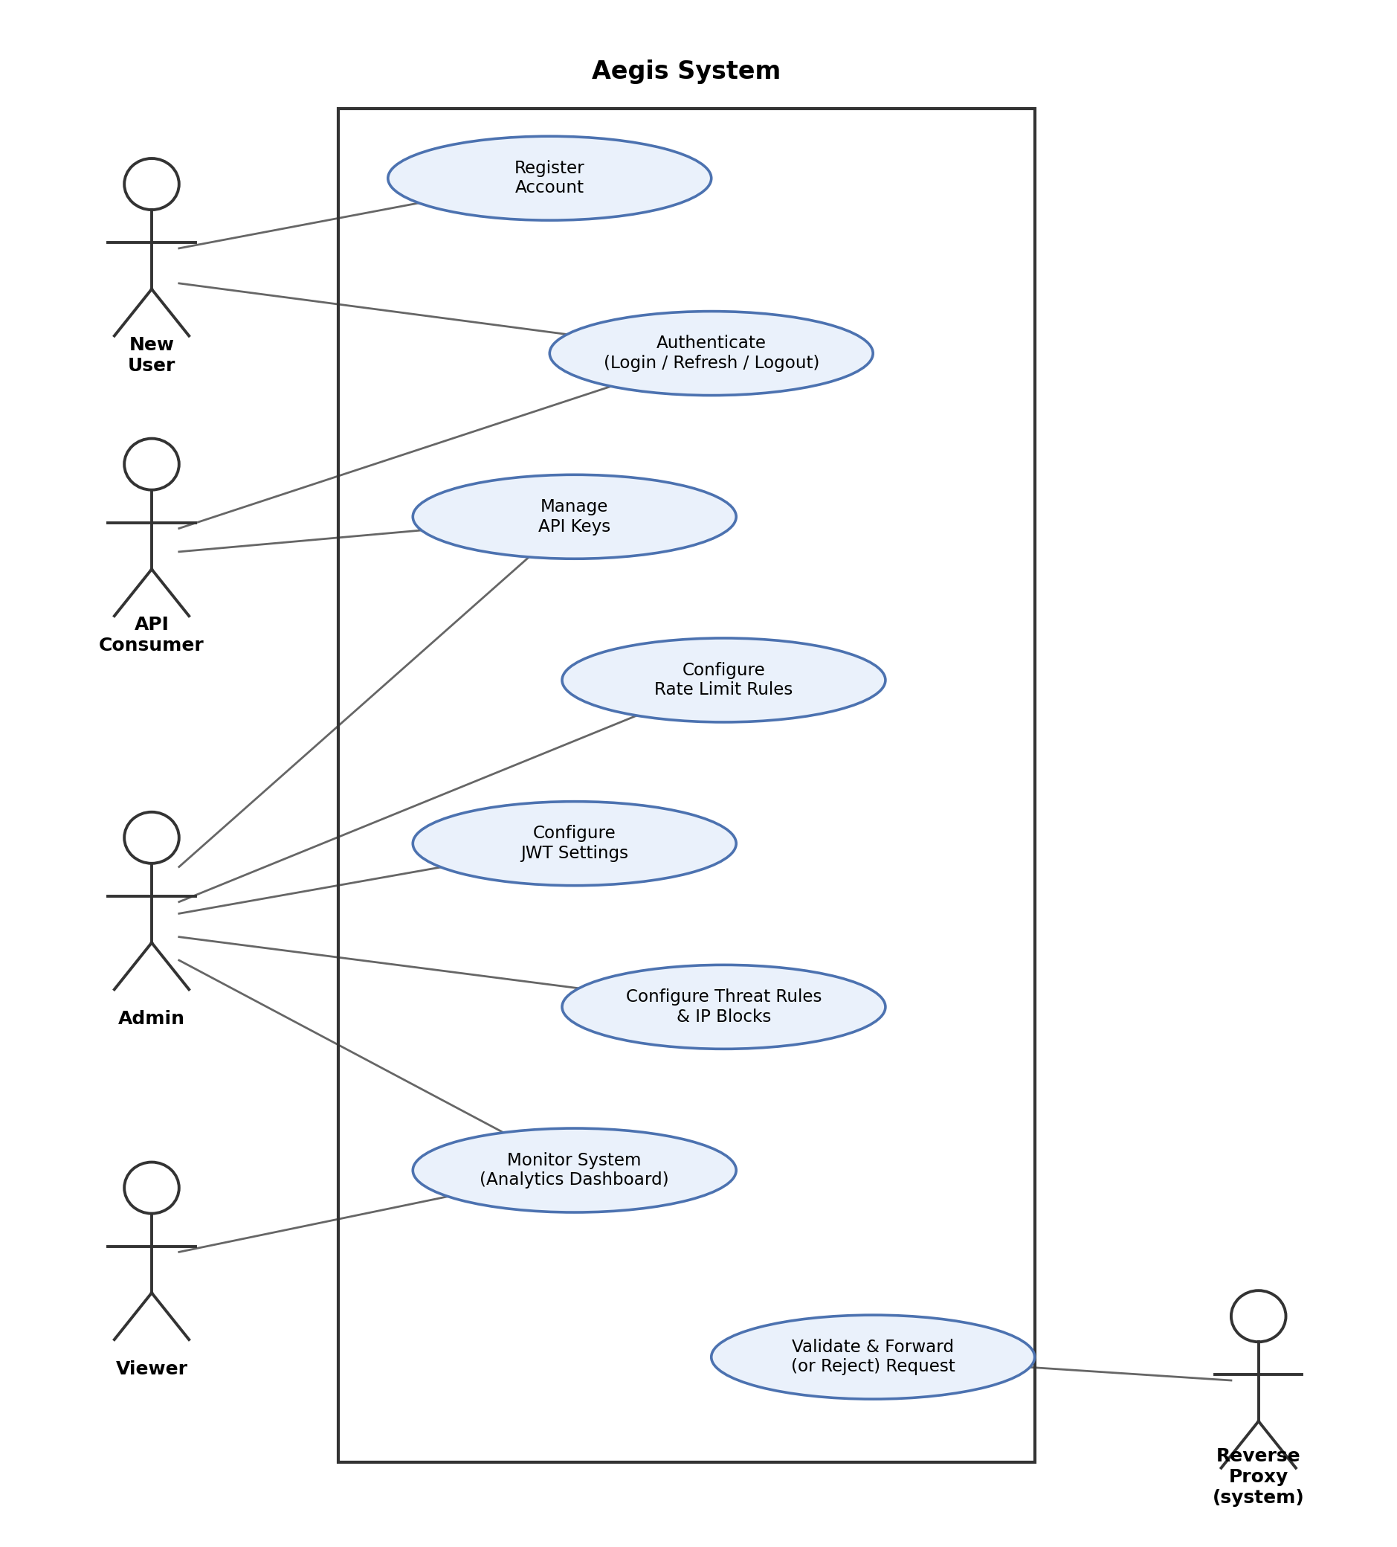
Figure 5.1: Use Case Diagram for Aegis

5.6 Conclusion
This chapter presented the system analysis for Aegis, including user roles, functional requirements grouped by system area, non-functional requirements, and MoSCoW prioritisation. The analysis reflects the system's core purpose of centralising API security enforcement while remaining lightweight and self-hosted, as motivated in Chapter 1.
The use of MoSCoW prioritisation ensures that essential features, authentication, API key management, rate limiting, and JWT validation, are delivered first within the project's timeboxed schedule, while less critical enhancements are implemented only as time permits. These requirements, together with the use case model in Section 6.5.5, provide the foundation for the system design discussed in the next chapter.

Chapter 6: System Design

6.1 Introduction
The Project Proposal defined three principal application components: a FastAPI Control Plane, a Go Reverse Proxy and a React dashboard. The implemented system retains that separation but adds concrete runtime dependencies and policy flows that were necessarily abstract in the proposal. This chapter therefore describes the system as built, using current Compose configuration, SQLAlchemy models, Alembic migrations, Go handler code and dashboard routes as the design authority.

6.2 High-Level Architecture
Aegis separates management-plane concerns from data-plane enforcement. Administrators and viewers use the dashboard, which calls versioned Control Plane REST endpoints. Durable policy and audit records are held in PostgreSQL. Redis stores token revocation state and rate-limit counters. The proxy bootstraps policy through a protected internal REST endpoint, subscribes to authenticated gRPC snapshots, validates each protected request and forwards only after all applicable checks succeed. The upstream service is not changed to understand Aegis credentials.

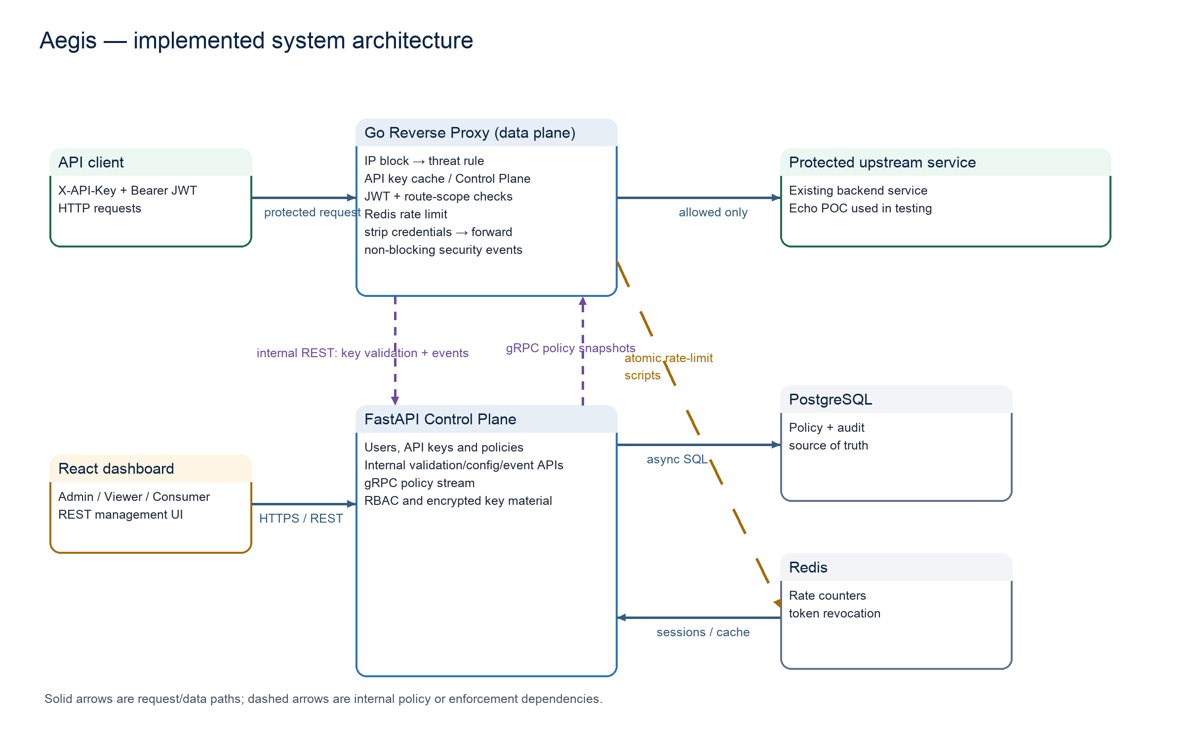
Figure 6.1: Current implemented Aegis architecture derived from the FastAPI, Go, React, PostgreSQL, Redis and POC code.

6.3 Component Responsibilities
Table 6.1: Responsibilities of the implemented Aegis components.
Component | Primary responsibility | Key interfaces and state
FastAPI Control Plane | User/RBAC management and the source of policy truth. | REST API, internal-token endpoints, gRPC policy stream, SQLAlchemy/Alembic.
Go Reverse Proxy | Latency-critical enforcement before upstream forwarding. | net/http, httputil.ReverseProxy, in-memory policy snapshot, Redis scripts, event queue.
React dashboard | Role-aware operator and API-consumer workflows. | Versioned REST calls; in-memory session token; no direct database/proxy configuration.
PostgreSQL | Durable identities, keys, rules, blocks and security events. | Normalised relational schema and indexed lookup fields.
Redis | Shared ephemeral enforcement state. | Atomic rate counters and revoked-token state.
Protected upstream | Existing business API behind Aegis. | Receives allowed requests after Aegis credentials are stripped.

6.4 Domain and Database Design
The current persisted domain contains User, APIKey, RateLimitRule, JWTConfig, ThreatRule, IPBlock, SecurityEvent and RoutePermission. Every entity inherits an integer identifier plus created_at and updated_at audit timestamps. Several resources are soft-disabled instead of deleted so that policy history remains explainable while snapshots propagate. API-key rows contain a hash and non-sensitive prefix rather than the raw key; JWT signing material is encrypted at rest and masked in administrative responses.

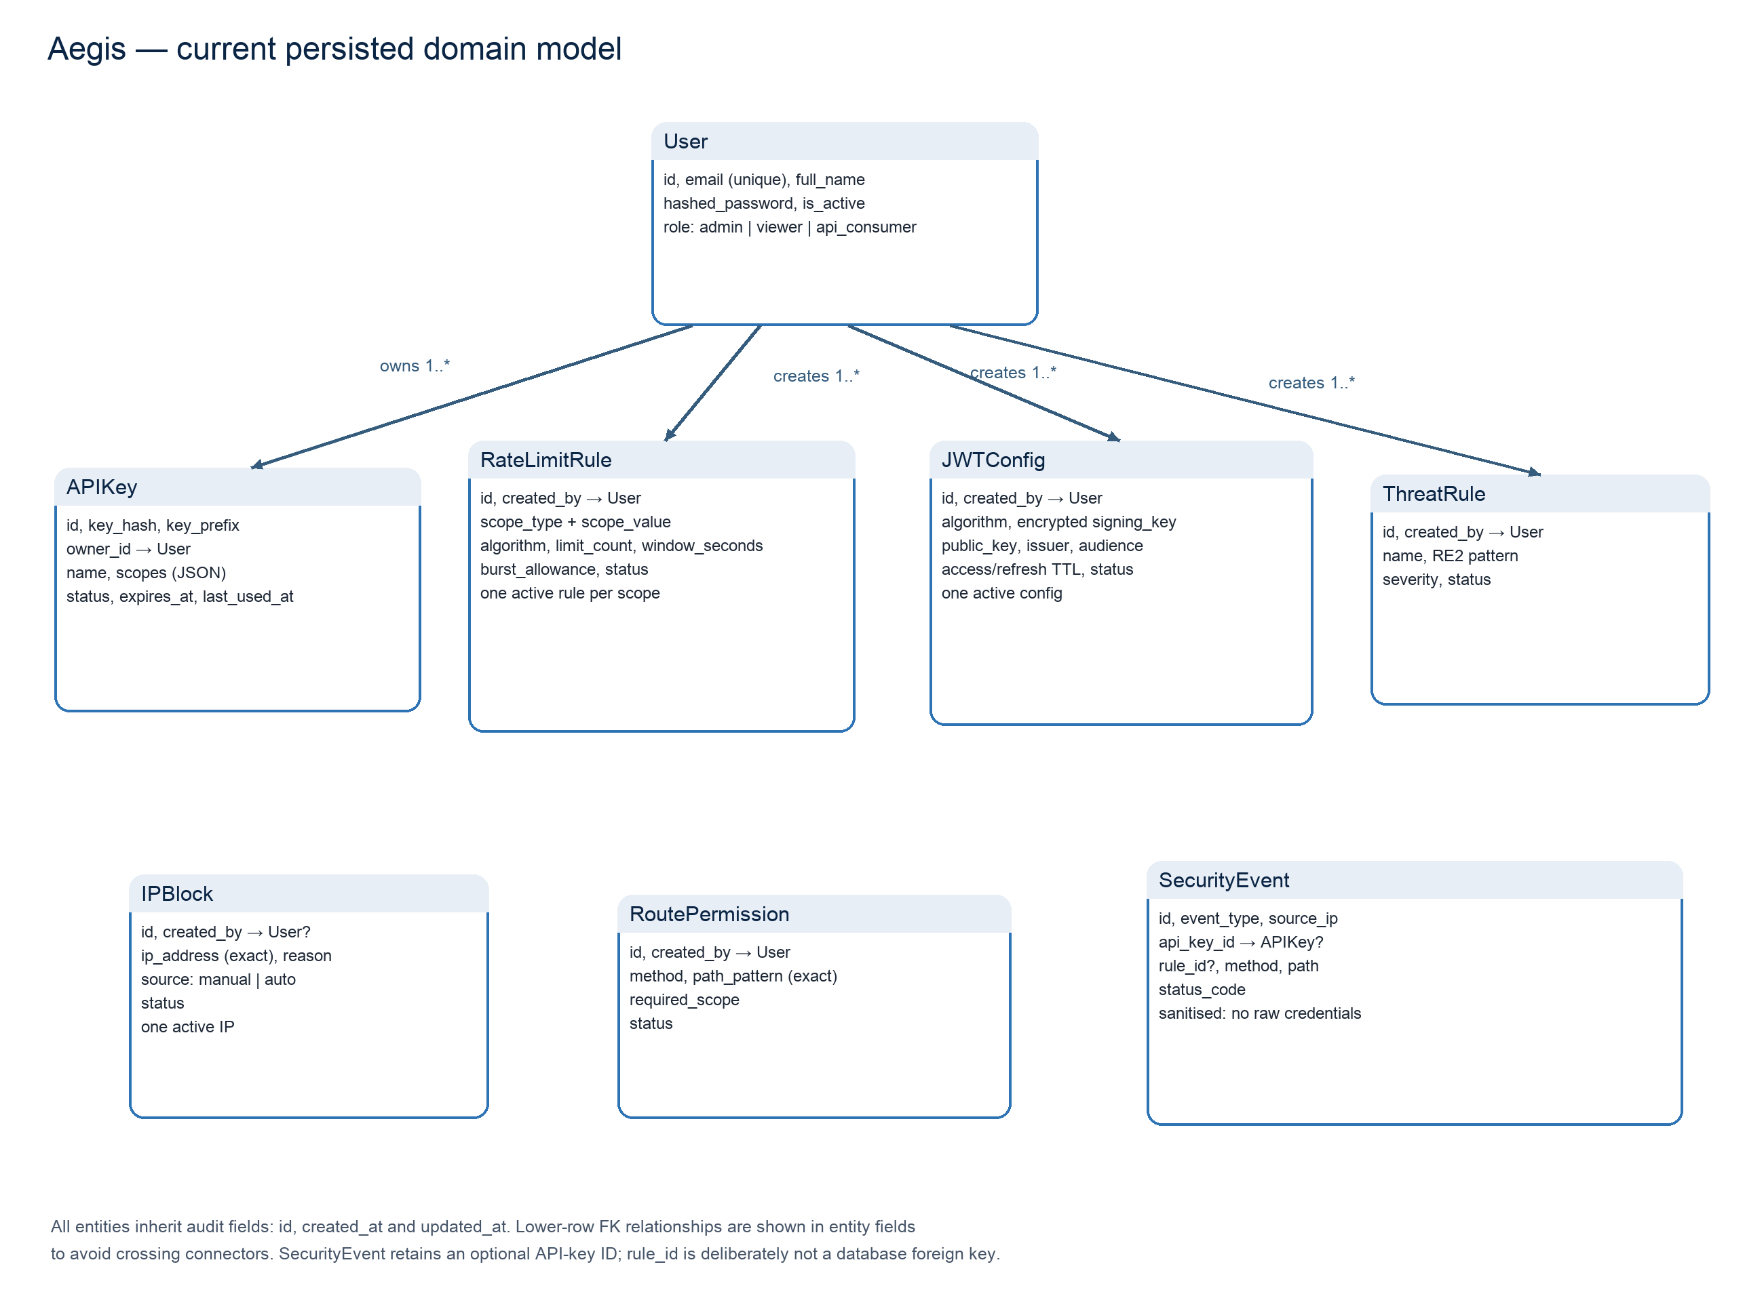
Figure 6.2: Current persisted domain model based on actual SQLAlchemy models and Alembic migrations.

Table 6.2: Important domain constraints and their design rationale.
Constraint | Reason
One active JWT configuration | Prevents ambiguous verification material and issuer/audience policy.
One active rate rule per scope | Makes API-key > route > global selection deterministic.
One active block per exact IP | Prevents duplicate active enforcement records while preserving history.
Exact route-permission path | Keeps authorisation explainable; wildcard and query syntax is rejected.
resource:action scope format | A scope such as echo:read becomes meaningful only when a route permission requires it.
Sanitised SecurityEvent | Supports analytics without persisting raw credentials or request bodies.

6.5 Request Validation and Enforcement
The validation order is a security and performance decision. Direct client-IP blocking and request-URI threat detection are evaluated before credential work. API-key validation returns status, expiry and scopes. JWT validation checks signature, expiry, issuer and audience against the active policy. Exact method/path authorisation then determines whether the key contains the required scope. The most specific active rate rule is applied before the proxy removes Aegis credentials and forwards. Every terminal path creates a sanitised security event through a bounded asynchronous reporter.

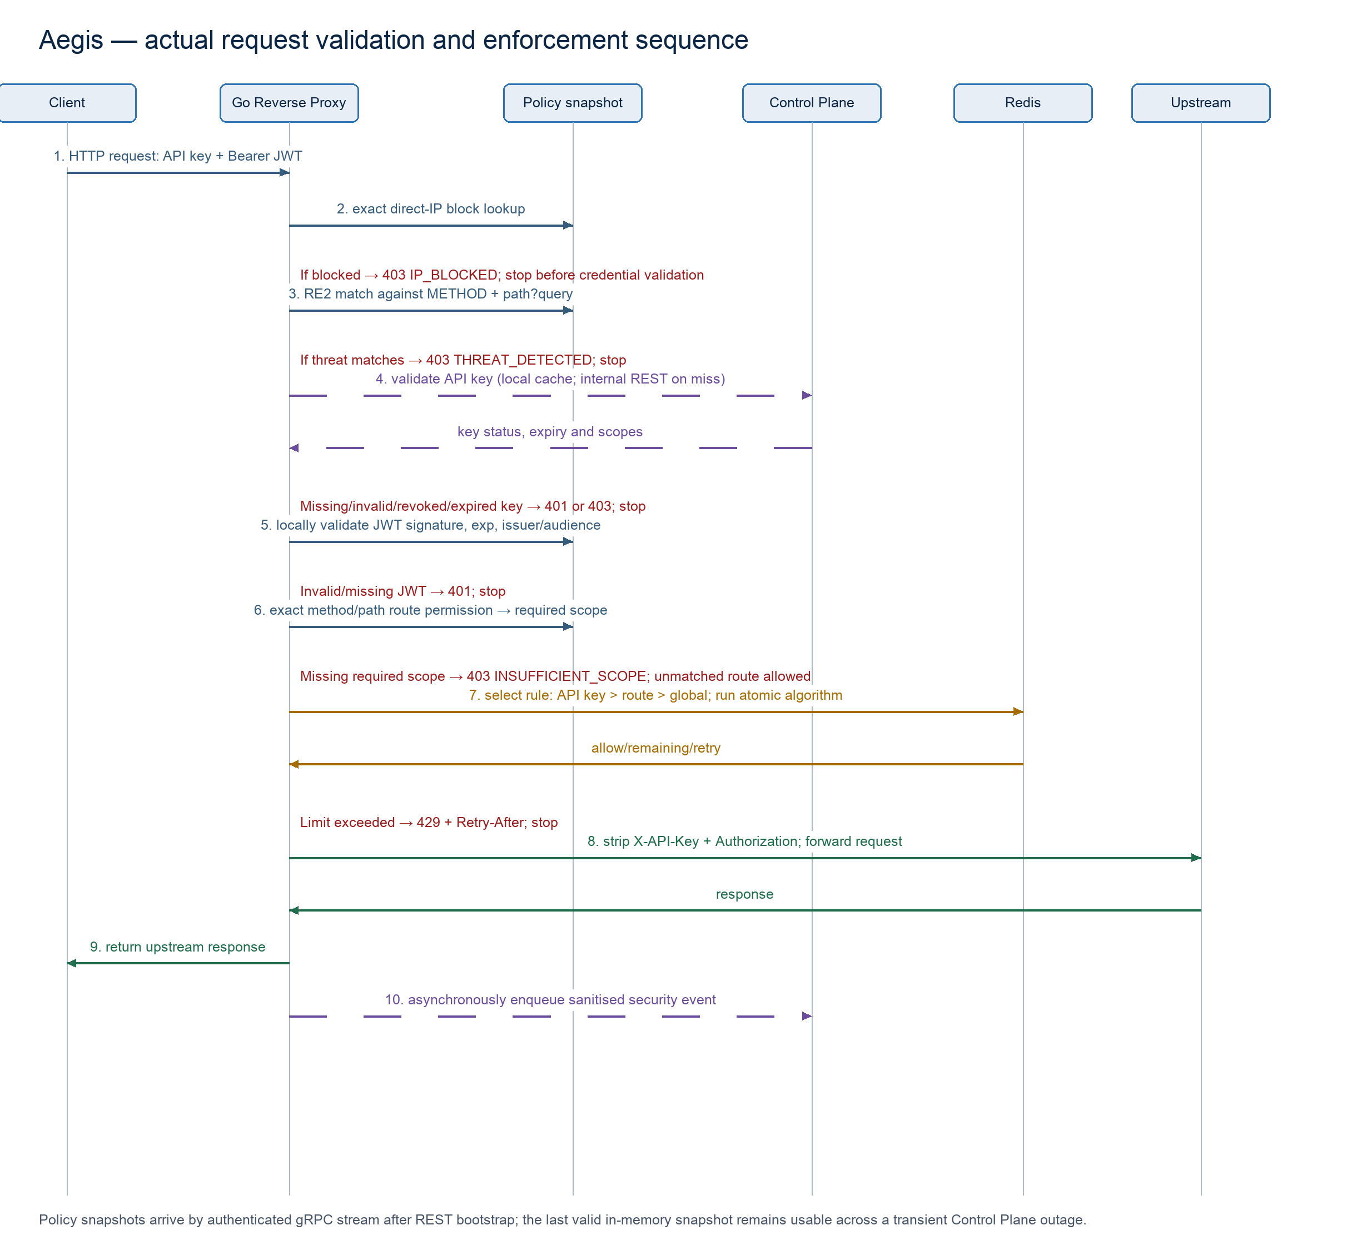
Figure 6.3: Actual request-validation and enforcement sequence implemented by the Go proxy handler.

6.6 Scope and Route-Permission Design
The proxy does not infer that the word echo in echo:read refers to a resource. The relationship is explicit data: a RoutePermission states that GET /api/echo requires echo:read and POST /api/echo requires echo:write. When a request matches a permission, the proxy performs an exact string membership test against the validated key's scopes. An unmatched route is currently allowed after authentication; a future deny-by-default mode would require a planned migration to avoid unexpectedly blocking existing services.
Extract 6.1: Current exact route-to-scope authorisation logic from reverse-proxy/internal/proxy/handler.go.
for _, permission := range snapshot.RoutePermissions {
if permission.Method != r.Method || permission.PathPattern != r.URL.Path {
continue
}
if hasScope(keyInfo.Scopes, permission.RequiredScope) {
return nil
}
writeError(w, 403, "INSUFFICIENT_SCOPE", "This API key does not have permission...")
return ErrKeyScopeForbidden
}
return nil

6.7 Policy Synchronisation and Resilience
The proposal called for real-time gRPC synchronisation. In the implemented design, gRPC is not the only source of configuration. The proxy obtains an authenticated REST snapshot during bootstrap and can fall back to REST before its first stream update. The gRPC subscriber then stores a cloned latest snapshot behind a read/write lock. If the stream temporarily fails after a valid snapshot has been received, the proxy continues enforcing that snapshot rather than allowing an outage to remove policy. Internal REST, gRPC and event-reporting endpoints use a separate internal token rather than a user access token.

6.8 Security Design Decisions and Trade-offs
- The direct peer address is used for IP policy; X-Forwarded-For is ignored until a trusted-proxy model is explicitly configured.
- RE2-compatible threat patterns avoid unsupported backtracking constructs and match METHOD plus RequestURI rather than collecting bodies.
- The proxy strips X-API-Key and Authorization before upstream forwarding, reducing accidental credential exposure.
- Rate limiting uses atomic Redis operations so multiple proxy instances share the same counter state.
- The dashboard improves usability but never becomes the security authority; every mutation remains protected by server-side RBAC.
- The bounded event queue prevents an unavailable analytics path from indefinitely blocking request handling, accepting a documented observability trade-off under saturation.

6.9 Core Design Summary
The implemented design fulfils the proposal's centralised policy and high-performance enforcement direction while making several important relationships explicit: scopes are connected to exact routes, policy is distributed as validated snapshots, and runtime rate state is separated from durable configuration. These decisions allow the behaviour shown in Chapter 8 to be traced to concrete design elements.

6.10 Detailed Domain Data Dictionary
This section is based on the actual SQLAlchemy models and Alembic migrations. It explains the persisted meaning that supports the class/domain diagram in Chapter 7.

6.10.1 User
Table 6.10.1: User data dictionary entry.
Aspect | Definition
Purpose | Identity and RBAC subject
Persisted fields | id; email; full_name; hashed_password; is_active; role; created_at; updated_at
Critical constraints | Unique email; role in admin/viewer/api_consumer; public registration cannot choose Admin.
Relationships/flow | One User owns many APIKey records and may create administrative policy records.

Why the structure matters
User separates durable policy or identity state from transient HTTP input. Identifiers and timestamps support auditability, while explicit status values support soft deletion so a proxy cache can finish using a previously valid snapshot without referencing a physically deleted row. Validation is split deliberately: Pydantic rejects malformed input early, the service applies business rules, and database constraints protect invariants during concurrent writes.

Security review questions
- Does the response schema expose only information required by its caller?
- Can a concurrent create violate the active uniqueness rule, and is the database the final protection?
- Will disabling the record produce a safe result in the next policy snapshot?
- Are secret, personal and analytics fields minimised and protected for their lifecycle?

6.10.2 APIKey
Table 6.10.2: APIKey data dictionary entry.
Aspect | Definition
Purpose | Credential metadata and ownership
Persisted fields | id; key_hash; key_prefix; owner_id; name; scopes JSON; status; expires_at; last_used_at; timestamps
Critical constraints | Raw key is not persisted; prefix indexed; status active/revoked; ownership required for consumer operations.
Relationships/flow | Belongs to User; may be referenced by key-scoped rate rules and security events.

Why the structure matters
APIKey separates durable policy or identity state from transient HTTP input. Identifiers and timestamps support auditability, while explicit status values support soft deletion so a proxy cache can finish using a previously valid snapshot without referencing a physically deleted row. Validation is split deliberately: Pydantic rejects malformed input early, the service applies business rules, and database constraints protect invariants during concurrent writes.

Security review questions
- Does the response schema expose only information required by its caller?
- Can a concurrent create violate the active uniqueness rule, and is the database the final protection?
- Will disabling the record produce a safe result in the next policy snapshot?
- Are secret, personal and analytics fields minimised and protected for their lifecycle?

6.10.3 RateLimitRule
Table 6.10.3: RateLimitRule data dictionary entry.
Aspect | Definition
Purpose | Distributed traffic policy
Persisted fields | id; scope_type; scope_value; algorithm; limit_count; window_seconds; burst_allowance; status; created_by
Critical constraints | scope_type in global/api_key/route; one active rule per logical scope; positive counts/windows.
Relationships/flow | Distributed to the proxy and interpreted through Redis scripts.

Why the structure matters
RateLimitRule separates durable policy or identity state from transient HTTP input. Identifiers and timestamps support auditability, while explicit status values support soft deletion so a proxy cache can finish using a previously valid snapshot without referencing a physically deleted row. Validation is split deliberately: Pydantic rejects malformed input early, the service applies business rules, and database constraints protect invariants during concurrent writes.

Security review questions
- Does the response schema expose only information required by its caller?
- Can a concurrent create violate the active uniqueness rule, and is the database the final protection?
- Will disabling the record produce a safe result in the next policy snapshot?
- Are secret, personal and analytics fields minimised and protected for their lifecycle?

6.10.4 JWTConfig
Table 6.10.4: JWTConfig data dictionary entry.
Aspect | Definition
Purpose | Proxy JWT validation policy
Persisted fields | id; algorithm; encrypted signing_key; public_key; issuer; audience; TTL values; status; created_by
Critical constraints | HS256/RS256/ES256 only; one active system-wide; asymmetric private key never distributed.
Relationships/flow | Active record becomes ProxyJWTValidationPolicy in the policy snapshot.

Why the structure matters
JWTConfig separates durable policy or identity state from transient HTTP input. Identifiers and timestamps support auditability, while explicit status values support soft deletion so a proxy cache can finish using a previously valid snapshot without referencing a physically deleted row. Validation is split deliberately: Pydantic rejects malformed input early, the service applies business rules, and database constraints protect invariants during concurrent writes.

Security review questions
- Does the response schema expose only information required by its caller?
- Can a concurrent create violate the active uniqueness rule, and is the database the final protection?
- Will disabling the record produce a safe result in the next policy snapshot?
- Are secret, personal and analytics fields minimised and protected for their lifecycle?

6.10.5 ThreatRule
Table 6.10.5: ThreatRule data dictionary entry.
Aspect | Definition
Purpose | Request-target detection policy
Persisted fields | id; name; pattern; severity; status; created_by; timestamps
Critical constraints | Pattern must compile under Go RE2 semantics; severity is low/medium/high/critical.
Relationships/flow | Active patterns are matched against METHOD plus path/query before credential validation.

Why the structure matters
ThreatRule separates durable policy or identity state from transient HTTP input. Identifiers and timestamps support auditability, while explicit status values support soft deletion so a proxy cache can finish using a previously valid snapshot without referencing a physically deleted row. Validation is split deliberately: Pydantic rejects malformed input early, the service applies business rules, and database constraints protect invariants during concurrent writes.

Security review questions
- Does the response schema expose only information required by its caller?
- Can a concurrent create violate the active uniqueness rule, and is the database the final protection?
- Will disabling the record produce a safe result in the next policy snapshot?
- Are secret, personal and analytics fields minimised and protected for their lifecycle?

6.10.6 IPBlock
Table 6.10.6: IPBlock data dictionary entry.
Aspect | Definition
Purpose | Manual or automatic exact-address block
Persisted fields | id; ip_address; reason; source; status; created_by; timestamps
Critical constraints | Canonical exact IPv4/IPv6; one active row per address; source manual/auto; soft disable.
Relationships/flow | Automatic records may have no human created_by; active addresses are distributed to the proxy.

Why the structure matters
IPBlock separates durable policy or identity state from transient HTTP input. Identifiers and timestamps support auditability, while explicit status values support soft deletion so a proxy cache can finish using a previously valid snapshot without referencing a physically deleted row. Validation is split deliberately: Pydantic rejects malformed input early, the service applies business rules, and database constraints protect invariants during concurrent writes.

Security review questions
- Does the response schema expose only information required by its caller?
- Can a concurrent create violate the active uniqueness rule, and is the database the final protection?
- Will disabling the record produce a safe result in the next policy snapshot?
- Are secret, personal and analytics fields minimised and protected for their lifecycle?

6.10.7 RoutePermission
Table 6.10.7: RoutePermission data dictionary entry.
Aspect | Definition
Purpose | Exact request authorisation mapping
Persisted fields | id; method; path_pattern; required_scope; status; created_by; timestamps
Critical constraints | Supported method; exact leading-slash path; resource:action scope; active duplicate protection.
Relationships/flow | Proxy matches method/path after JWT validation and requires exact membership in APIKey.scopes.

Why the structure matters
RoutePermission separates durable policy or identity state from transient HTTP input. Identifiers and timestamps support auditability, while explicit status values support soft deletion so a proxy cache can finish using a previously valid snapshot without referencing a physically deleted row. Validation is split deliberately: Pydantic rejects malformed input early, the service applies business rules, and database constraints protect invariants during concurrent writes.

Security review questions
- Does the response schema expose only information required by its caller?
- Can a concurrent create violate the active uniqueness rule, and is the database the final protection?
- Will disabling the record produce a safe result in the next policy snapshot?
- Are secret, personal and analytics fields minimised and protected for their lifecycle?

6.10.8 SecurityEvent
Table 6.10.8: SecurityEvent data dictionary entry.
Aspect | Definition
Purpose | Sanitised request outcome
Persisted fields | id; event_type; source_ip; api_key_id; rule_id; method; path; status_code; created_at
Critical constraints | No raw credentials, body or arbitrary headers; optional key/rule linkage.
Relationships/flow | Produced asynchronously by the proxy and aggregated by analytics services.

Why the structure matters
SecurityEvent separates durable policy or identity state from transient HTTP input. Identifiers and timestamps support auditability, while explicit status values support soft deletion so a proxy cache can finish using a previously valid snapshot without referencing a physically deleted row. Validation is split deliberately: Pydantic rejects malformed input early, the service applies business rules, and database constraints protect invariants during concurrent writes.

Security review questions
- Does the response schema expose only information required by its caller?
- Can a concurrent create violate the active uniqueness rule, and is the database the final protection?
- Will disabling the record produce a safe result in the next policy snapshot?
- Are secret, personal and analytics fields minimised and protected for their lifecycle?

6.11 Reverse Proxy Enforcement Walkthrough
This section reverse-learns the Go handler from incoming HTTP request to upstream response. Each step corresponds to code in reverse-proxy/internal/proxy and its collaborators.

6.11.1 Establish Request Context

Runtime behaviour
The handler derives a bounded context for policy and validation work. A request-scoped timeout prevents a slow internal dependency from holding the proxy indefinitely. The request is not forwarded at this stage.

Security rationale
Timeout handling must return a controlled gateway error and emit a sanitised outcome without leaking credential values.
Table 6.11.1: Review checklist for establish request context.
Question | Answer
Can the request reach upstream here? | Only H.9 invokes the upstream; every earlier rejection returns first.
Which state is trusted? | Validated request data plus the last valid policy/key metadata supplied by authenticated internal contracts.
What is logged? | A sanitised event with outcome metadata, never the raw API key, JWT, body or arbitrary headers.
How is it tested? | Focused unit tests use fake collaborators; integration/POC tests confirm the observable HTTP result.

6.11.2 Resolve the Direct Client Address

Runtime behaviour
The direct network peer is parsed and canonicalised. Aegis deliberately ignores X-Forwarded-For because no trusted upstream proxy boundary is configured in the baseline.

Security rationale
Using an untrusted forwarded header would allow a caller to spoof an address and bypass or frame an IP block decision.
Table 6.11.2: Review checklist for resolve the direct client address.
Question | Answer
Can the request reach upstream here? | Only H.9 invokes the upstream; every earlier rejection returns first.
Which state is trusted? | Validated request data plus the last valid policy/key metadata supplied by authenticated internal contracts.
What is logged? | A sanitised event with outcome metadata, never the raw API key, JWT, body or arbitrary headers.
How is it tested? | Focused unit tests use fake collaborators; integration/POC tests confirm the observable HTTP result.

6.11.3 Enforce Exact IP Blocks

Runtime behaviour
The active cached IP block list is checked before authentication. A match returns 403 IP_BLOCKED and no key/JWT work or upstream forwarding occurs.

Security rationale
Early rejection saves later work and ensures a blocked source cannot probe credential validity.
Table 6.11.3: Review checklist for enforce exact ip blocks.
Question | Answer
Can the request reach upstream here? | Only H.9 invokes the upstream; every earlier rejection returns first.
Which state is trusted? | Validated request data plus the last valid policy/key metadata supplied by authenticated internal contracts.
What is logged? | A sanitised event with outcome metadata, never the raw API key, JWT, body or arbitrary headers.
How is it tested? | Focused unit tests use fake collaborators; integration/POC tests confirm the observable HTTP result.

6.11.4 Evaluate Threat Patterns

Runtime behaviour
Active Go RE2 expressions inspect the string formed from the HTTP method and request path/query. A match returns 403 THREAT_DETECTED.

Security rationale
Bodies and arbitrary headers are excluded to protect streaming, latency and data minimisation. This is a narrow detector, not a full WAF.
Table 6.11.4: Review checklist for evaluate threat patterns.
Question | Answer
Can the request reach upstream here? | Only H.9 invokes the upstream; every earlier rejection returns first.
Which state is trusted? | Validated request data plus the last valid policy/key metadata supplied by authenticated internal contracts.
What is logged? | A sanitised event with outcome metadata, never the raw API key, JWT, body or arbitrary headers.
How is it tested? | Focused unit tests use fake collaborators; integration/POC tests confirm the observable HTTP result.

6.11.5 Extract and Validate the API Key

Runtime behaviour
The configured key header is required. The Control Plane validator or local cache resolves the raw key to non-secret enforcement metadata including ID, status, expiry and scopes.

Security rationale
Missing, malformed, revoked and expired keys map to distinct structured errors and never reach the upstream.
Table 6.11.5: Review checklist for extract and validate the api key.
Question | Answer
Can the request reach upstream here? | Only H.9 invokes the upstream; every earlier rejection returns first.
Which state is trusted? | Validated request data plus the last valid policy/key metadata supplied by authenticated internal contracts.
What is logged? | A sanitised event with outcome metadata, never the raw API key, JWT, body or arbitrary headers.
How is it tested? | Focused unit tests use fake collaborators; integration/POC tests confirm the observable HTTP result.

6.11.6 Validate JWT When Policy Requires It

Runtime behaviour
The bearer token is verified with pinned HS256, RS256 or ES256 policy. Expiration is required and issuer/audience checks are applied when configured.

Security rationale
Algorithm pinning prevents accepting a token under a different cryptographic method than the active policy.
Table 6.11.6: Review checklist for validate jwt when policy requires it.
Question | Answer
Can the request reach upstream here? | Only H.9 invokes the upstream; every earlier rejection returns first.
Which state is trusted? | Validated request data plus the last valid policy/key metadata supplied by authenticated internal contracts.
What is logged? | A sanitised event with outcome metadata, never the raw API key, JWT, body or arbitrary headers.
How is it tested? | Focused unit tests use fake collaborators; integration/POC tests confirm the observable HTTP result.

6.11.7 Apply Exact Route Scope

Runtime behaviour
The handler matches request method and exact path against RoutePermission. A matching policy requires exact string membership in the validated key's scopes.

Security rationale
The proxy never discovers that echo means /api/echo from the word itself; the database mapping supplies that meaning.
Table 6.11.7: Review checklist for apply exact route scope.
Question | Answer
Can the request reach upstream here? | Only H.9 invokes the upstream; every earlier rejection returns first.
Which state is trusted? | Validated request data plus the last valid policy/key metadata supplied by authenticated internal contracts.
What is logged? | A sanitised event with outcome metadata, never the raw API key, JWT, body or arbitrary headers.
How is it tested? | Focused unit tests use fake collaborators; integration/POC tests confirm the observable HTTP result.

6.11.8 Consume the Redis Rate Limit

Runtime behaviour
The most specific matching rule is selected: API key, route, then global. A single atomic Redis script updates state and returns allowed/remaining/reset information.

Security rationale
Atomic server-side execution prevents concurrent proxy instances from racing on a read-modify-write sequence.
Table 6.11.8: Review checklist for consume the redis rate limit.
Question | Answer
Can the request reach upstream here? | Only H.9 invokes the upstream; every earlier rejection returns first.
Which state is trusted? | Validated request data plus the last valid policy/key metadata supplied by authenticated internal contracts.
What is logged? | A sanitised event with outcome metadata, never the raw API key, JWT, body or arbitrary headers.
How is it tested? | Focused unit tests use fake collaborators; integration/POC tests confirm the observable HTTP result.

6.11.9 Strip Credentials and Forward

Runtime behaviour
Only after every applicable control passes does the handler clone the request and its headers, delete the API-key and Authorization headers, and call httputil.ReverseProxy.

Security rationale
The clone avoids surprising mutation of the incoming request and prevents Aegis credentials from becoming upstream application data.
Table 6.11.9: Review checklist for strip credentials and forward.
Question | Answer
Can the request reach upstream here? | Only H.9 invokes the upstream; every earlier rejection returns first.
Which state is trusted? | Validated request data plus the last valid policy/key metadata supplied by authenticated internal contracts.
What is logged? | A sanitised event with outcome metadata, never the raw API key, JWT, body or arbitrary headers.
How is it tested? | Focused unit tests use fake collaborators; integration/POC tests confirm the observable HTTP result.

6.11.10 Report the Sanitised Outcome

Runtime behaviour
The proxy enqueues method, path, direct source IP, optional key/rule IDs, event type and status. A worker posts events through an authenticated internal route.

Security rationale
The bounded queue is non-blocking; saturation drops analytics with a warning rather than delaying protected traffic.
Table 6.11.10: Review checklist for report the sanitised outcome.
Question | Answer
Can the request reach upstream here? | Only H.9 invokes the upstream; every earlier rejection returns first.
Which state is trusted? | Validated request data plus the last valid policy/key metadata supplied by authenticated internal contracts.
What is logged? | A sanitised event with outcome metadata, never the raw API key, JWT, body or arbitrary headers.
How is it tested? | Focused unit tests use fake collaborators; integration/POC tests confirm the observable HTTP result.

6.12 Chapter Summary
The design chapter contains the persisted data definitions and the complete enforcement walkthrough at the point where they are needed. Project Timeline follows this architecture chapter in direct response to tutor feedback.

Chapter 7: Project Timeline

7.1 Planning Basis
The Project Proposal fixes Design between 27 April and 29 May 2026, Implementation between 1 June and 11 September 2026, and the separate project Testing activity between 14 September and 9 October 2026 (Htun Khaing Lynn, 2026). In response to the current instruction, only Implementation is divided into timeboxes. Design remains an enabling activity before timeboxed delivery, while the formal Testing and Evaluation periods remain ordinary project activities after implementation. This avoids incorrectly calling every phase a timebox.
The proposal specifies six implementation timeboxes but also allocates seventy-five working days to Implementation. The schedule therefore retains six fixed timeboxes and distributes the full implementation window across them. Each timebox is approximately two and a half weeks, which falls within the DSDM guidance of a typical two-to-four-week delivery timebox. Weekends are excluded from effort calculations; calendar dates remain fixed.

7.2 DSDM Structured Timebox Rules
Aegis uses the DSDM structured timebox, not a Scrum phase breakdown. To make the schedule understandable to a project reader, the report uses plain implementation labels for the five official DSDM control points: Implementation Setup corresponds to Kick-off, Feature Build to Investigation, Testing and Fixing to Refinement, Integration and Documentation to Consolidation, and Review and Sign-off to Close-out. The labels are simplified, but their order, review purpose and fixed-time behaviour remain unchanged (Agile Business Consortium, 2014).
Table 7.1: Day allocation for every step in the 12-day and 13-day Aegis implementation timeboxes.
Timebox step | 12-day timebox | 13-day timebox | Aegis application
Implementation Setup | 0.5 day | 0.5 day | Confirm objective, availability, dependencies, MoSCoW scope and acceptance criteria.
Feature Build | 2 days | 2 days | Clarify the detailed requirements and technical approach, then build the selected features.
Testing and Fixing | 7 days | 8 days | Test iteratively, correct defects and demonstrate the nearly complete increment.
Integration and Documentation | 2 days | 2 days | Integrate the increment, complete regression and security checks, and update technical documentation.
Review and Sign-off | 0.5 day | 0.5 day | Accept the increment, record the review outcome and agree improvement actions for the next timebox.

The day allocations replace percentage-based step estimates. A 12-day timebox totals 0.5 + 2 + 7 + 2 + 0.5 days, while a 13-day timebox totals 0.5 + 2 + 8 + 2 + 0.5 days. Testing is integrated throughout the main delivery work and is followed by explicit integration, documentation and acceptance activity; it is not postponed until the separate project Testing period.

7.3 MoSCoW Capacity Rule
Time and quality are fixed; detailed scope is the variable. Each timebox reserves approximately 55% of available effort for Must Haves, 25% for Should Haves and 20% for Could Haves. Won't Haves are excluded from capacity. This keeps Must Have effort below the DSDM recommendation of 60% and maintains a real 20% Could Have contingency. A Must Have is used only where the timebox objective would fail without it; a Should Have remains important but has a workaround; a Could Have is desirable and is the first scope removed if risk materialises.
Table 7.2: MoSCoW effort balance used for each implementation timebox.
Priority | Effort | Meaning in Aegis
Must Have | 55% | Essential to the usable security increment; failure means the timebox objective is not met.
Should Have | 25% | Important and expected, but the increment remains usable with a documented workaround.
Could Have | 20% | Contingency pool delivered only after Must/Should quality remains protected.
Won't Have this time | Excluded | Explicitly deferred so it cannot silently consume the fixed timebox.

7.4 Implementation-Only Delivery Plan
Table 7.3: Six fixed implementation timeboxes across the proposal's 75-working-day implementation window.
ID | Implementation increment | Fixed dates | Working days
TB1 | Control Plane Foundation and Identity | 1-17 Jun | 13
TB2 | API Keys and Administrative Policy | 18 Jun-3 Jul | 12
TB3 | Proxy Authentication and Authorisation | 6-22 Jul | 13
TB4 | Distributed Limits and Threat Enforcement | 23 Jul-7 Aug | 12
TB5 | Policy Distribution, Analytics and Dashboard | 10-26 Aug | 13
TB6 | Integration, POC and Hardening | 27 Aug-11 Sep | 12

7.5 TB1 - Control Plane Foundation and Identity
Table 7.4: TB1 timebox definition and acceptance boundary.
Field | Committed value
Timebox | TB1: Control Plane Foundation and Identity
Fixed dates | 1 June 2026 - 17 June 2026
Objective | Deliver an executable FastAPI foundation with database migration, user identity, JWT session lifecycle and persisted RBAC.
Must Have (55%) | Application configuration; async database session; User model/migration; registration, login, refresh and logout; Admin/Viewer/API Consumer role checks; baseline tests.
Should Have (25%) | Admin user-list and profile maintenance; bootstrap Admin allowlist; Redis-backed token revocation.
Could Have (20%) | Operator-friendly validation messages and richer health metadata.
Won't Have this time | API gateway request enforcement and advanced analytics in this timebox.
Acceptance | Migrations apply to PostgreSQL; authentication tests pass; public registration cannot self-assign Admin; protected routes reject an unauthorised role.
Evidence source | app/models/user.py, auth/user routers and services, Alembic role migration, test_auth_and_user_rbac.py.

Structured control points
Table 7.5: TB1 structured control-point schedule.
From | To | Duration | Summary
1 Jun 09:00 | 1 Jun 13:00 | 0.5 day | Implementation Setup: Confirm FastAPI, PostgreSQL and Redis availability; agree the identity schema, migration order, RBAC roles and acceptance boundary.
1 Jun 13:00 | 3 Jun 13:00 | 2 days | Feature Build: Implement application configuration, async database sessions, user migration, registration, login, token refresh, logout and role checks.
3 Jun 13:00 | 15 Jun 13:00 | 8 days | Testing and Fixing: Test migrations, invalid credentials, refresh and revocation, bootstrap Admin restrictions and role enforcement; correct every failing branch.
15 Jun 13:00 | 17 Jun 13:00 | 2 days | Integration and Documentation: Connect identity routes, services and repositories to PostgreSQL and Redis; document configuration, migrations and the session lifecycle.
17 Jun 13:00 | 17 Jun 17:00 | 0.5 day | Review and Sign-off: Verify migrations and authentication tests pass, users cannot self-assign Admin, protected routes reject invalid roles, and record sign-off evidence.

7.6 TB2 - API Keys and Administrative Policy
Table 7.6: TB2 timebox definition and acceptance boundary.
Field | Committed value
Timebox | TB2: API Keys and Administrative Policy
Fixed dates | 18 June 2026 - 3 July 2026
Objective | Deliver one-time API-key issuance and the Control Plane resources required to describe enforceable policy.
Must Have (55%) | Cryptographic API-key creation; bcrypt persistence; prefix lookup; owner/Admin CRUD; soft revocation; rate-limit and JWT configuration validation.
Should Have (25%) | Threat-rule, exact IP-block and route-permission CRUD with active-duplicate protection.
Could Have (20%) | Improved list filters and additional masked operator metadata.
Won't Have this time | Proxy forwarding, distributed counters and gRPC streaming in this timebox.
Acceptance | Raw API key appears only in the create response; hashes never leave the service; invalid scope/rule/key combinations return 422 or controlled conflicts.
Evidence source | API-key/policy schemas, services, repositories, models, migrations and their pytest modules.

Structured control points
Table 7.7: TB2 structured control-point schedule.
From | To | Duration | Summary
18 Jun 09:00 | 18 Jun 13:00 | 0.5 day | Implementation Setup: Confirm the API-key lifecycle, ownership rules, policy vocabulary, persistence changes and dependencies on the completed identity increment.
18 Jun 13:00 | 22 Jun 13:00 | 2 days | Feature Build: Implement one-time key issuance, bcrypt hashing, prefix lookup, revocation and Admin CRUD for rate, JWT, threat, IP and route policies.
22 Jun 13:00 | 1 Jul 13:00 | 7 days | Testing and Fixing: Test secret non-disclosure, ownership and RBAC, duplicate protection, invalid policy combinations and soft-disable behaviour; fix discovered defects.
1 Jul 13:00 | 3 Jul 13:00 | 2 days | Integration and Documentation: Connect schemas, services, repositories and migrations; update OpenAPI and document valid JSON payloads for every administrative policy.
3 Jul 13:00 | 3 Jul 17:00 | 0.5 day | Review and Sign-off: Verify raw keys appear once, hashes never leave the service and invalid scope, rule or key combinations are rejected before sign-off.

7.7 TB3 - Reverse Proxy Authentication and Authorisation
Table 7.8: TB3 timebox definition and acceptance boundary.
Field | Committed value
Timebox | TB3: Reverse Proxy Authentication and Authorisation
Fixed dates | 6 July 2026 - 22 July 2026
Objective | Place the Go reverse proxy in front of a real upstream and enforce API-key, JWT and exact route-scope policy before forwarding.
Must Have (55%) | ReverseProxy forwarding; internal key validation; positive/negative cache; JWT algorithm pinning and expiry; exact route permissions; credential stripping; structured errors.
Should Have (25%) | Last-valid policy cache and explicit upstream error mapping.
Could Have (20%) | Additional response metadata and diagnostic logging.
Won't Have this time | Wildcard routes, body inspection and trusted-forwarded-header processing.
Acceptance | Invalid/revoked/missing keys never reach upstream; matching routes require the exact resource:action scope; allowed requests arrive without Aegis credentials.
Evidence source | internal/proxy/handler.go, jwt_validator.go, controlplane client/cache, handler and integration tests.

Structured control points
Table 7.9: TB3 structured control-point schedule.
From | To | Duration | Summary
6 Jul 09:00 | 6 Jul 13:00 | 0.5 day | Implementation Setup: Confirm the upstream boundary, Control Plane contract, API-key header, JWT requirements and exact route-permission mappings required by the proxy.
6 Jul 13:00 | 8 Jul 13:00 | 2 days | Feature Build: Implement forwarding, key validation and caching, JWT validation, exact method/path scope enforcement and credential removal before upstream delivery.
8 Jul 13:00 | 20 Jul 13:00 | 8 days | Testing and Fixing: Test missing, invalid, expired and revoked keys, invalid JWTs, insufficient scopes and upstream isolation; correct every enforcement failure.
20 Jul 13:00 | 22 Jul 13:00 | 2 days | Integration and Documentation: Connect the Go handler, Control Plane client, policy cache and reverse proxy; document the ordered request-enforcement flow and error codes.
22 Jul 13:00 | 22 Jul 17:00 | 0.5 day | Review and Sign-off: Verify rejected traffic never reaches upstream, allowed routes require the exact configured scope and forwarded requests contain no Aegis credentials.

7.8 TB4 - Distributed Limits and Threat Enforcement
Table 7.10: TB4 timebox definition and acceptance boundary.
Field | Committed value
Timebox | TB4: Distributed Limits and Threat Enforcement
Fixed dates | 23 July 2026 - 7 August 2026
Objective | Add shared traffic controls and early request rejection using Redis, threat patterns and canonical direct-peer IP policy.
Must Have (55%) | Atomic fixed-window, sliding-window and token-bucket scripts; scope precedence; 429 headers; exact IP blocking; RE2-compatible threat matching.
Should Have (25%) | Automatic blocking from qualifying security-event thresholds and operator-readable error codes.
Could Have (20%) | Additional rate-limit headers and tunable automatic-block thresholds.
Won't Have this time | CIDR blocking, payload inspection and machine-learning anomaly detection.
Acceptance | Counters are isolated for API-key scope and shared for route/global scope; blocked/threat requests are rejected before credential validation; race tests pass.
Evidence source | rate_limiter.go, ip_blocker.go, threat_detector.go, Redis Lua tests and POC flood sequence.

Structured control points
Table 7.11: TB4 structured control-point schedule.
From | To | Duration | Summary
23 Jul 09:00 | 23 Jul 13:00 | 0.5 day | Implementation Setup: Confirm Redis availability, rate-rule precedence, canonical client-IP handling, RE2 threat-pattern limits and automatic-block thresholds.
23 Jul 13:00 | 27 Jul 13:00 | 2 days | Feature Build: Implement atomic fixed-window, sliding-window and token-bucket limits, 429 headers, exact IP blocking, threat matching and automatic blocking.
27 Jul 13:00 | 5 Aug 13:00 | 7 days | Testing and Fixing: Test concurrent counters, consumer isolation, refill and expiry, blocked and threatening requests, invalid patterns and race safety; fix defects.
5 Aug 13:00 | 7 Aug 13:00 | 2 days | Integration and Documentation: Connect Redis scripts and threat/IP policy to the handler and security-event pipeline; document rule precedence and rejection order.
7 Aug 13:00 | 7 Aug 17:00 | 0.5 day | Review and Sign-off: Verify counter isolation, early block and threat rejection, RE2 compatibility and race-test results before approving the increment.

7.9 TB5 - Policy Distribution, Analytics and Dashboard
Table 7.12: TB5 timebox definition and acceptance boundary.
Field | Committed value
Timebox | TB5: Policy Distribution, Analytics and Dashboard
Fixed dates | 10 August 2026 - 26 August 2026
Objective | Make policy updates resilient and visible through authenticated streaming, sanitised events and role-aware dashboard pages.
Must Have (55%) | REST bootstrap; authenticated gRPC policy stream; immediate in-memory update; reconnect/backoff; bounded event queue; analytics summary/history; dashboard login and core policy pages.
Should Have (25%) | Automatic-block visibility, live traffic/security analytics and role-specific navigation.
Could Have (20%) | UI polish and additional filters.
Won't Have this time | External SIEM integration and persistent browser token storage.
Acceptance | Wrong internal tokens are rejected; the last valid snapshot remains active during interruption; security events exclude raw credentials and bodies; dashboard route tests pass.
Evidence source | grpc_server.py, grpc_policy_subscriber.go, event_reporter.go, analytics services/routes, React pages and tests.

Structured control points
Table 7.13: TB5 structured control-point schedule.
From | To | Duration | Summary
10 Aug 09:00 | 10 Aug 13:00 | 0.5 day | Implementation Setup: Confirm the REST bootstrap and gRPC contracts, internal authentication token, reconnect behaviour, analytics fields and dashboard role boundaries.
10 Aug 13:00 | 12 Aug 13:00 | 2 days | Feature Build: Implement policy bootstrap and streaming, reconnect and backoff, bounded event reporting, analytics APIs and the role-aware dashboard pages.
12 Aug 13:00 | 24 Aug 13:00 | 8 days | Testing and Fixing: Test invalid internal tokens, stream interruption, last-valid policy retention, event sanitisation, queue behaviour and dashboard routes; fix failures.
24 Aug 13:00 | 26 Aug 13:00 | 2 days | Integration and Documentation: Connect Control Plane, proxy, analytics storage and dashboard views; document policy propagation, security-event fields and operator workflows.
26 Aug 13:00 | 26 Aug 17:00 | 0.5 day | Review and Sign-off: Verify authenticated distribution, policy resilience, credential-free analytics and dashboard route tests, then record review and sign-off evidence.

7.10 TB6 - Integration, POC and Implementation Hardening
Table 7.14: TB6 timebox definition and acceptance boundary.
Field | Committed value
Timebox | TB6: Integration, POC and Implementation Hardening
Fixed dates | 27 August 2026 - 11 September 2026
Objective | Consolidate all components into a reproducible implementation increment and produce truthful evidence for the separate project testing phase.
Must Have (55%) | Docker Compose wiring; generated local secrets; idempotent bootstrap; complete component quality gate; live attack/defence POC; implementation documentation.
Should Have (25%) | Isolated end-to-end script, analytics verification and graceful event-queue shutdown.
Could Have (20%) | Additional demonstration scenarios and usability refinements.
Won't Have this time | Production cloud rollout, native mobile app and non-HTTP protocols.
Acceptance | make check passes; POC demonstrates allow/deny/scope/rate behaviour against a real upstream; any incomplete environment evidence is explicitly reported rather than claimed.
Evidence source | Makefile, compose.yaml, scripts/e2e.sh, poc/, docs/evidence and repository test output.

Structured control points
Table 7.15: TB6 structured control-point schedule.
From | To | Duration | Summary
27 Aug 09:00 | 27 Aug 13:00 | 0.5 day | Implementation Setup: Confirm the release boundary, component versions, environment variables, generated secrets, bootstrap order and evidence required for the final increment.
27 Aug 13:00 | 31 Aug 13:00 | 2 days | Feature Build: Complete Docker Compose wiring, local secret generation, idempotent bootstrap, quality-gate commands, the attack/defence POC and implementation documentation.
31 Aug 13:00 | 9 Sep 13:00 | 7 days | Testing and Fixing: Run component checks and live allow, deny, scope, rate and isolation scenarios; correct reproducible failures and record unresolved environment limits.
9 Sep 13:00 | 11 Sep 13:00 | 2 days | Integration and Documentation: Connect all deployable components, verify graceful event handling and consolidate setup, operation, testing and troubleshooting documentation.
11 Sep 13:00 | 11 Sep 17:00 | 0.5 day | Review and Sign-off: Confirm the quality gate and observed POC evidence, document any incomplete Docker result truthfully and approve the implementation for project testing.

7.11 Activities Outside the Timeboxes
Table 7.16: Clear separation between implementation timeboxes and non-timeboxed project activities.
Activity | Dates | Relationship to timeboxing
Design | 27 Apr-29 May 2026 | Enough Design Up Front: architecture, data, API and security foundations; not labelled a timebox.
Implementation | 1 Jun-11 Sep 2026 | The only activity divided into six DSDM structured timeboxes.
Project Testing | 14 Sep-9 Oct 2026 | Independent consolidation of unit, integration, security, performance and UAT evidence; not a timebox.
Evaluation and conclusion | 12-30 Oct 2026 | Evaluation against objectives and reflection; not a timebox.

7.12 Chapter Summary
The resulting plan follows the proposal's six-increment intention while resolving its twelve-week/seventy-five-day inconsistency transparently. Only Implementation is timeboxed. Every fixed timebox follows the five-step DSDM structure using explicit day allocations, integrates testing, creates MoSCoW contingency, ends with review and sign-off, and protects the final implementation date of 11 September. The separate Testing period continues to the proposal's 9 October end date.

Chapter 8: System Implementation

8.1 Introduction
This chapter explains how the implemented Aegis system evolved through the six DSDM timeboxes defined in the Project Timeline chapter. In response to tutor feedback, every timebox now presents its design evidence, representative implemented code and verified testing evidence together. The chapter uses the current repository and observed test runs rather than treating the Project Proposal as proof that every planned detail was built unchanged.
Additional screenshot markers are included inside each timebox to guide the collection of further primary evidence. Replace each [PHOTO] marker only after reproducing the stated scenario, insert the screenshot at that location, replace Figure 8.X with the next sequential figure number, update the List of Figures, and remove the capture instructions. Redact passwords, raw API keys, JWTs, signing keys, database credentials and private environment variables before submission.

8.2 TB1 - Control Plane Foundation and Identity
Deliver an executable FastAPI foundation with database migration, user identity, JWT session lifecycle and persisted RBAC.

Design Evidence
Confirm FastAPI, PostgreSQL and Redis availability; agree the identity schema, migration order, RBAC roles and acceptance boundary. The design fixed the boundaries below before coding continued.
Table 8.1: TB1 design evidence and authoritative sources.
Design artefact | Implemented decision
Identity boundary | FastAPI owns registration, login, refresh and logout; PostgreSQL stores users and roles.
Session boundary | JWT claims carry the current user role; Redis records token revocation state.
Design sources | User model and migration, auth schemas/router/service, RBAC dependencies and Figure 6.1.

Coding Evidence
Implement application configuration, async database sessions, user migration, registration, login, token refresh, logout and role checks. The following extract is taken from the implemented repository and represents the central code decision for this timebox.
Extract 8.1: The implemented login route validates a typed payload through the request-scoped authentication service.
@router.post("/login", response_model=ApiResponse[AuthTokenResponse])
async def login(payload: LoginRequest, auth_service: AuthService = Depends(get_auth_service)):
token_data = await auth_service.login(payload)
return success_response(message="Login successful.", data=token_data)

Testing Evidence
Test migrations, invalid credentials, refresh and revocation, bootstrap Admin restrictions and role enforcement; correct every failing branch. The focused suite covers safe public registration, bootstrap Admin behaviour, login and refresh claims, logout revocation, Admin-only user management, role assignment and soft deactivation.
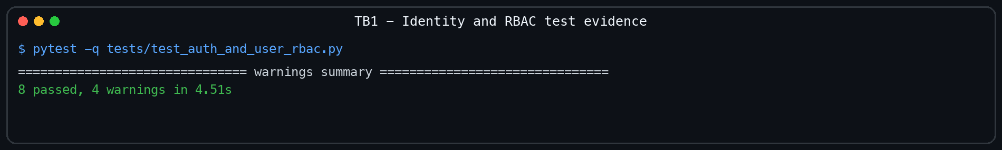
Figure 8.1: Verified TB1 identity and RBAC test run: eight tests passed on 15 August 2026.
Additional screenshot evidence to insert
[PHOTO — TB1 successful login request]
What to capture: Use the FastAPI OpenAPI page or Postman to show POST /api/v1/auth/login, the submitted test-user email, a 200 response and the token response with almost all token characters redacted.
Caption to use: Figure 8.X: Successful Control Plane login request demonstrating request-schema validation and access-token issuance.
[PHOTO — TB1 authentication or RBAC rejection]
What to capture: Show either an incorrect-password login returning 401 or a Viewer/API Consumer attempting an Admin-only user-management operation and receiving 403. Keep the request method, endpoint and response status visible.
Caption to use: Figure 8.X: Rejected authentication or role-protected request demonstrating fail-closed identity and RBAC enforcement.
Integration and review: Connect identity routes, services and repositories to PostgreSQL and Redis; document configuration, migrations and the session lifecycle. Verify migrations and authentication tests pass, users cannot self-assign Admin, protected routes reject invalid roles, and record sign-off evidence. The accepted boundary was: Migrations apply to PostgreSQL; authentication tests pass; public registration cannot self-assign Admin; protected routes reject an unauthorised role. Primary repository evidence: app/models/user.py, auth/user routers and services, Alembic role migration, test_auth_and_user_rbac.py.
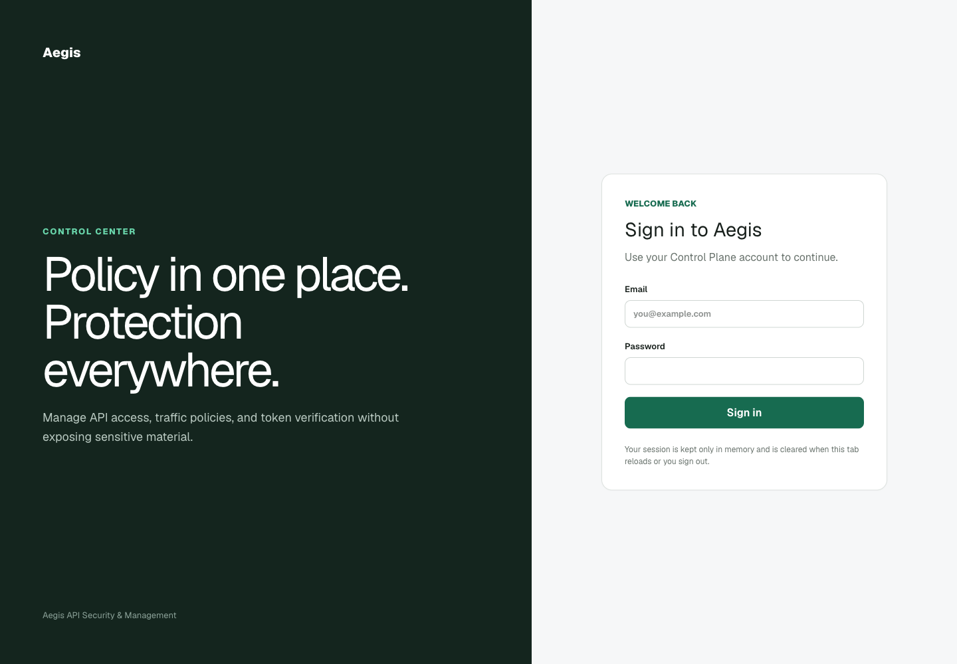
Figure 8.2: Actual Aegis login interface used by the implemented identity boundary.

8.3 TB2 - API Keys and Administrative Policy
Deliver one-time API-key issuance and the Control Plane resources required to describe enforceable policy.

Design Evidence
Confirm the API-key lifecycle, ownership rules, policy vocabulary, persistence changes and dependencies on the completed identity increment. The design fixed the boundaries below before coding continued.
Table 8.2: TB2 design evidence and authoritative sources.
Design artefact | Implemented decision
Secret lifecycle | The raw API key is returned once; only a bcrypt hash and non-sensitive prefix persist.
Policy model | Typed Control Plane resources describe keys, rate limits, JWTs, threats, exact IP blocks and route permissions.
Design sources | API-key/policy schemas, services, repositories, models, migrations and generated OpenAPI.

Coding Evidence
Implement one-time key issuance, bcrypt hashing, prefix lookup, revocation and Admin CRUD for rate, JWT, threat, IP and route policies. The following extract is taken from the implemented repository and represents the central code decision for this timebox.
Extract 8.2: API-key creation persists a hash and reveals the raw credential only in the create response.
raw_key = f"ak_{secrets.token_urlsafe(settings.api_key.TOKEN_BYTES)}"
key_prefix = raw_key[: settings.api_key.PREFIX_LENGTH]
api_key_in_db = APIKeyCreateInDB(
key_hash=hash_password(raw_key), key_prefix=key_prefix,
owner_id=actor_user.id, scopes=payload.scopes, status="active",
)
return APIKeyCreatedResponse(**metadata.model_dump(), api_key=raw_key)

Testing Evidence
Test secret non-disclosure, ownership and RBAC, duplicate protection, invalid policy combinations and soft-disable behaviour; fix discovered defects. The run covers key creation/listing/revocation/internal validation plus rate-limit, JWT, threat, IP-block and route-permission validation and RBAC.
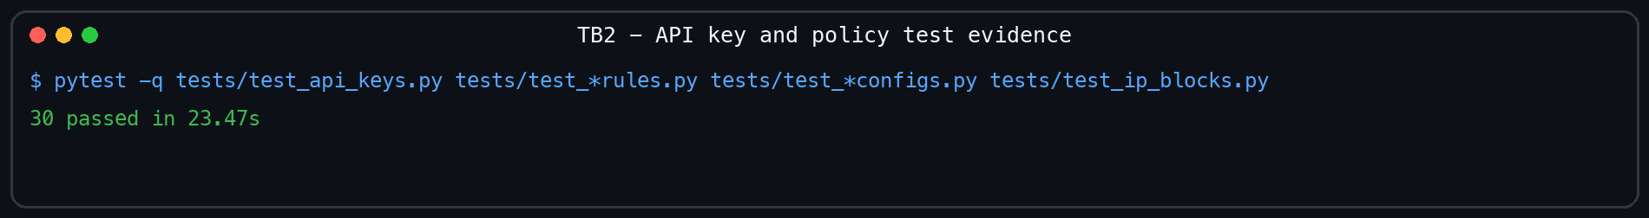
Figure 8.3: Verified TB2 API-key and administrative-policy test run: thirty tests passed on 15 August 2026.
Additional screenshot evidence to insert
[PHOTO — TB2 API-key creation with scope]
What to capture: Create a key through the dashboard, OpenAPI page or Postman and show its name, scopes such as ["echo:read"], the 201 response and only a masked fragment of the one-time raw key.
Caption to use: Figure 8.X: Successful API-key creation with an explicitly assigned echo:read scope and one-time secret disclosure.
[PHOTO — TB2 invalid policy JSON]
What to capture: Submit an invalid API-key, rate-limit or route-permission payload—for example a missing required field or unsupported value—and show the request JSON plus FastAPI's 422 validation response.
Caption to use: Figure 8.X: FastAPI schema validation rejecting an invalid administrative-policy JSON payload before persistence.
Integration and review: Connect schemas, services, repositories and migrations; update OpenAPI and document valid JSON payloads for every administrative policy. Verify raw keys appear once, hashes never leave the service and invalid scope, rule or key combinations are rejected before sign-off. The accepted boundary was: Raw API key appears only in the create response; hashes never leave the service; invalid scope/rule/key combinations return 422 or controlled conflicts. Primary repository evidence: API-key/policy schemas, services, repositories, models, migrations and their pytest modules.
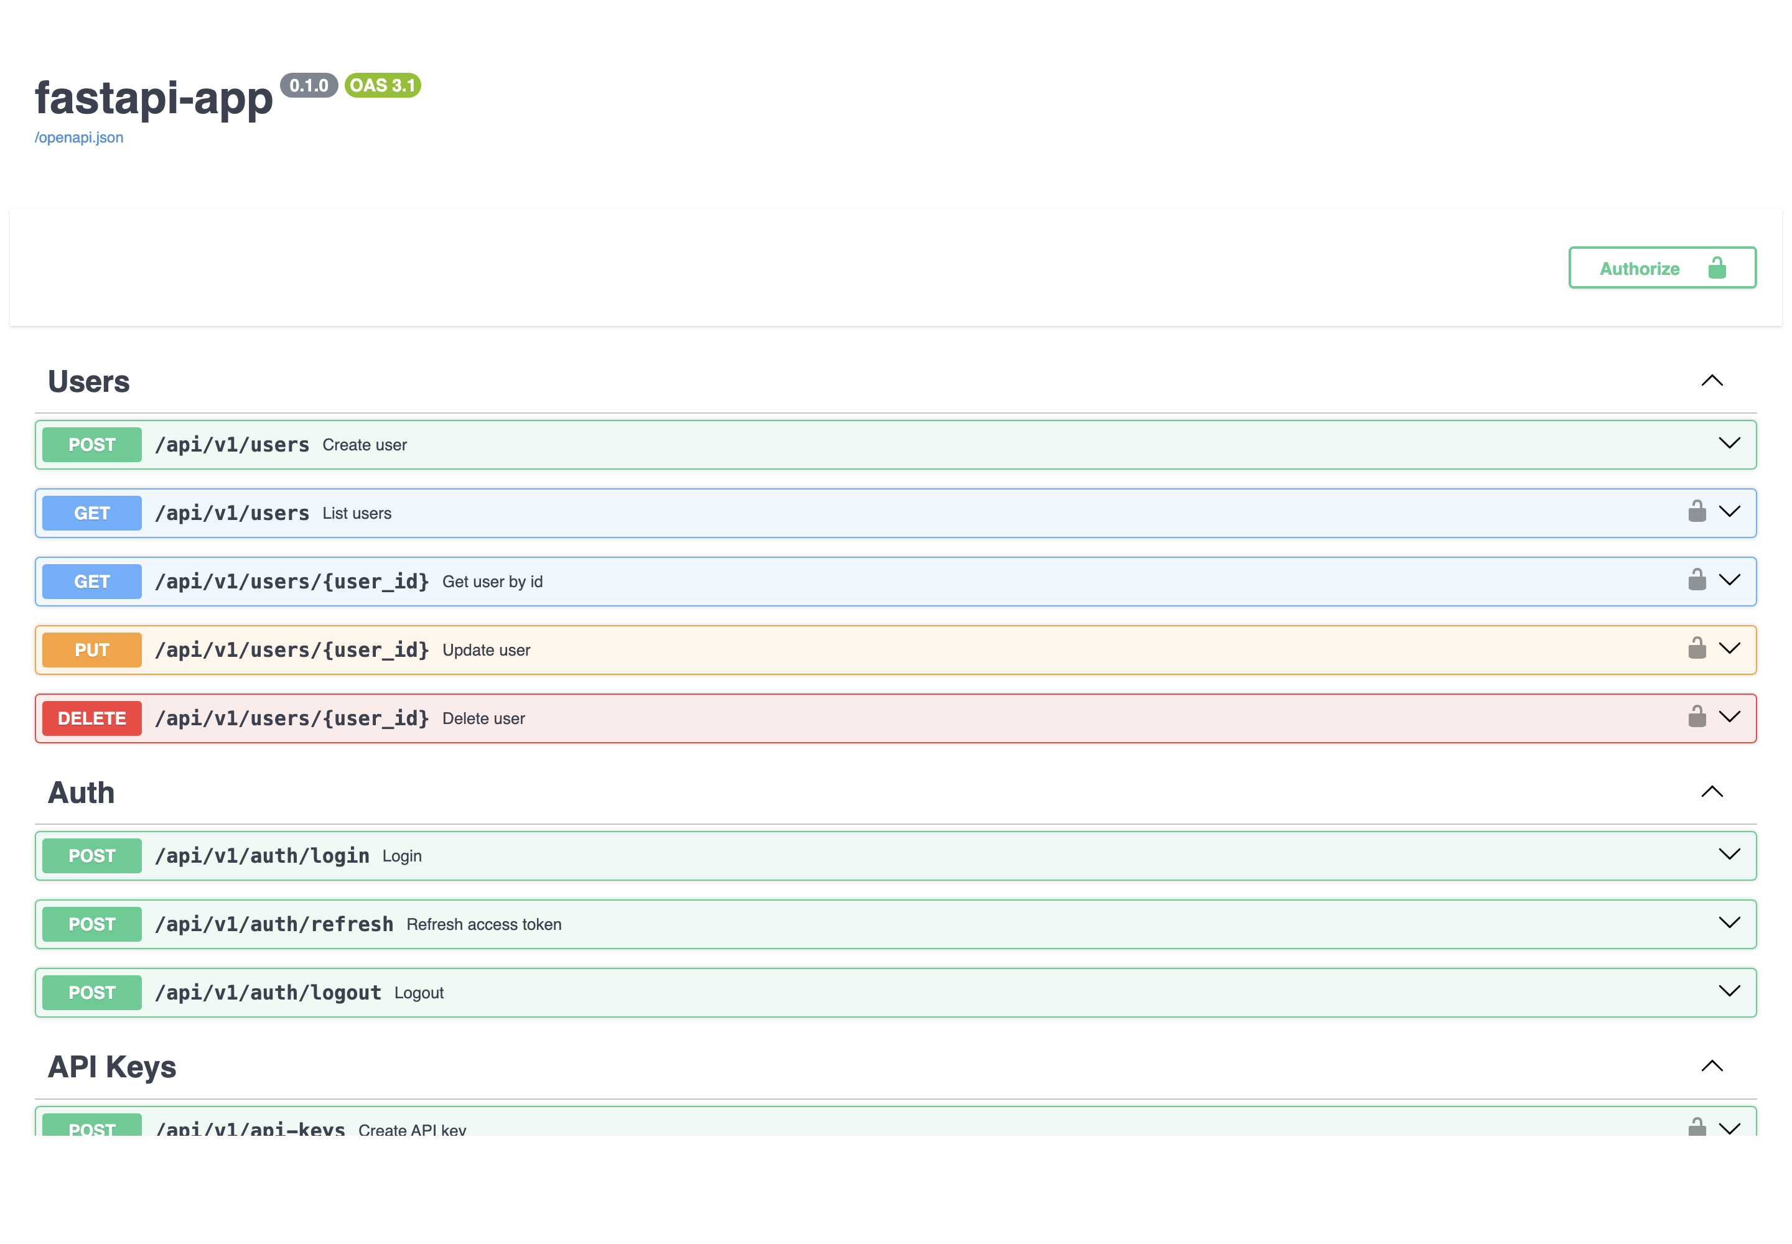
Figure 8.4: Generated Control Plane OpenAPI interface exposing the implemented key and policy operations.

8.4 TB3 - Reverse Proxy Authentication and Authorisation
Place the Go reverse proxy in front of a real upstream and enforce API-key, JWT and exact route-scope policy before forwarding.

Design Evidence
Confirm the upstream boundary, Control Plane contract, API-key header, JWT requirements and exact route-permission mappings required by the proxy. The design fixed the boundaries below before coding continued.
Table 8.3: TB3 design evidence and authoritative sources.
Design artefact | Implemented decision
Enforcement boundary | The proxy validates identity and policy before the upstream forwarder can run.
Authorisation contract | An exact method/path RoutePermission maps the request to one required resource:action scope.
Design sources | Figure 6.3 request sequence, policy snapshot DTOs and Go handler interfaces.

Coding Evidence
Implement forwarding, key validation and caching, JWT validation, exact method/path scope enforcement and credential removal before upstream delivery. The following extract is taken from the implemented repository and represents the central code decision for this timebox.
Extract 8.3: The Go handler performs exact method/path matching followed by exact scope membership.
for _, permission := range snapshot.RoutePermissions {
if permission.Method != r.Method || permission.PathPattern != r.URL.Path { continue }
if hasScope(keyInfo.Scopes, permission.RequiredScope) { return nil }
writeError(w, http.StatusForbidden, "INSUFFICIENT_SCOPE",
"This API key does not have permission to access this route.")
return ErrKeyScopeForbidden
}

Testing Evidence
Test missing, invalid, expired and revoked keys, invalid JWTs, insufficient scopes and upstream isolation; correct every enforcement failure. The selected tests exercise missing/revoked keys, JWT algorithms and expiry, exact scope matching, route permissions, validation timeouts and end-to-end forwarding isolation.
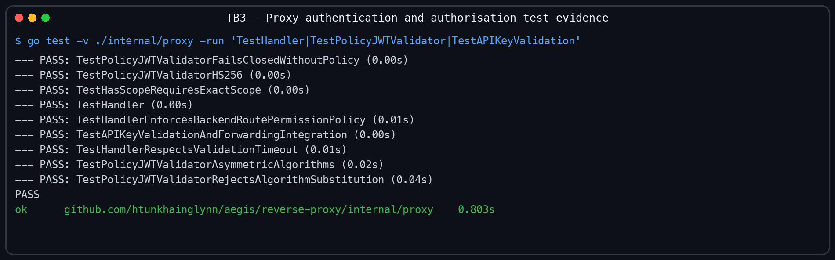
Figure 8.5: Verified TB3 proxy authentication and authorisation test run on 15 August 2026.
Additional screenshot evidence to insert
[PHOTO — TB3 allowed exact-scope request]
What to capture: Send GET /api/echo through the Reverse Proxy with an active key containing echo:read. Show the request target, credential header with its value masked, 200 status and returned upstream echo body.
Caption to use: Figure 8.X: Reverse Proxy allowing GET /api/echo because the API key contains the exact required echo:read scope.
[PHOTO — TB3 insufficient-scope rejection]
What to capture: Send a protected write request with a key containing only echo:read. Show the method/path and the 403 INSUFFICIENT_SCOPE response, while masking the key value.
Caption to use: Figure 8.X: Reverse Proxy denying a request because the presented API key does not contain the exact required write scope.
Integration and review: Connect the Go handler, Control Plane client, policy cache and reverse proxy; document the ordered request-enforcement flow and error codes. Verify rejected traffic never reaches upstream, allowed routes require the exact configured scope and forwarded requests contain no Aegis credentials. The accepted boundary was: Invalid/revoked/missing keys never reach upstream; matching routes require the exact resource:action scope; allowed requests arrive without Aegis credentials. Primary repository evidence: internal/proxy/handler.go, jwt_validator.go, controlplane client/cache, handler and integration tests.

8.5 TB4 - Distributed Limits and Threat Enforcement
Add shared traffic controls and early request rejection using Redis, threat patterns and canonical direct-peer IP policy.

Design Evidence
Confirm Redis availability, rate-rule precedence, canonical client-IP handling, RE2 threat-pattern limits and automatic-block thresholds. The design fixed the boundaries below before coding continued.
Table 8.4: TB4 design evidence and authoritative sources.
Design artefact | Implemented decision
Shared state | Redis Lua scripts make counter updates atomic across proxy instances.
Early rejection | Canonical peer IP and request-target threat checks run before credential-dependent forwarding.
Design sources | RateLimiter, PolicyThreatDetector, PolicyIPBlocker, Redis key design and Figure 6.3.

Coding Evidence
Implement atomic fixed-window, sliding-window and token-bucket limits, 429 headers, exact IP blocking, threat matching and automatic blocking. The following extract is taken from the implemented repository and represents the central code decision for this timebox.
Extract 8.4: The fixed-window Redis script atomically increments, expires and reports the shared counter.
local current = redis.call("INCR", KEYS[1])
if current == 1 then redis.call("PEXPIRE", KEYS[1], ARGV[2]) end
local allowed = 0
if current <= tonumber(ARGV[1]) then allowed = 1 end
local remaining = math.max(0, tonumber(ARGV[1]) - current)
return {allowed, remaining, math.max(0, redis.call("PTTL", KEYS[1]))}

Testing Evidence
Test concurrent counters, consumer isolation, refill and expiry, blocked and threatening requests, invalid patterns and race safety; fix defects. The run verifies all three rate algorithms, shared counters, recovery/refill, rule precedence, canonical IP decisions, threat matching and fail-closed policy handling.
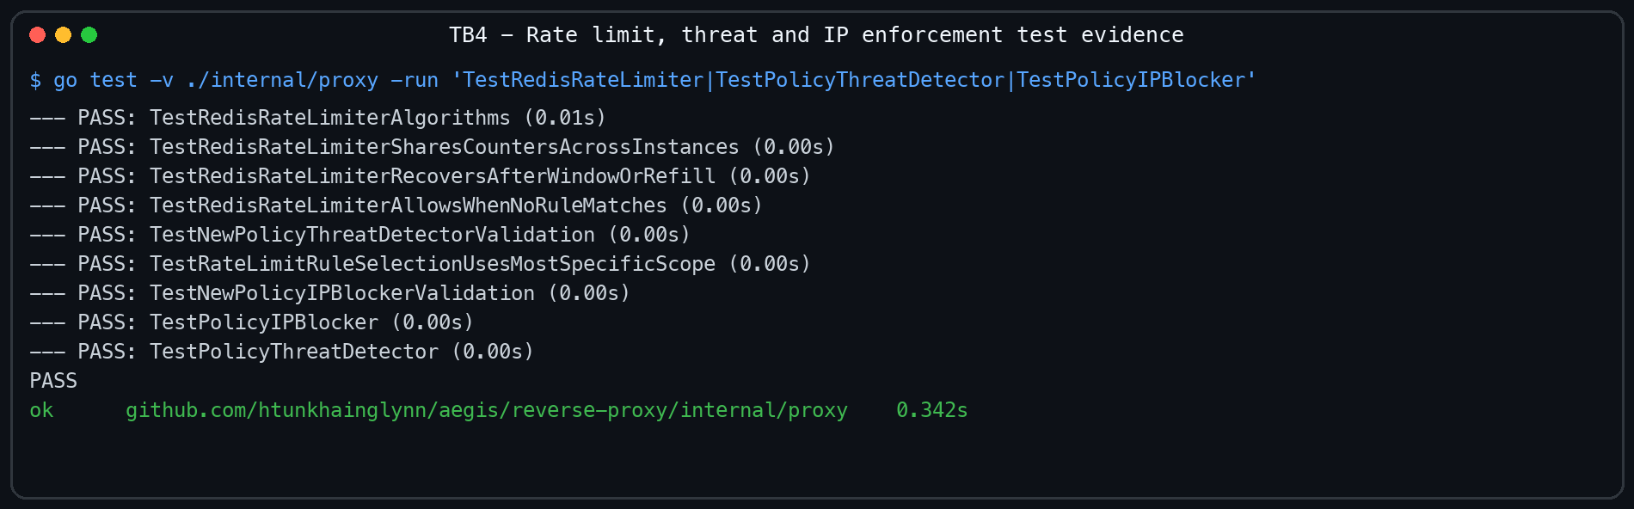
Figure 8.6: Verified TB4 rate-limit, threat and IP-enforcement test run on 15 August 2026.
Additional screenshot evidence to insert
[PHOTO — TB4 rate-limit sequence and headers]
What to capture: Run repeated requests against a small test limit and show the sequence of successful responses followed by 429 Too Many Requests. Include the limit, remaining and reset response headers where available.
Caption to use: Figure 8.X: Distributed rate-limit enforcement showing allowed requests followed by a controlled 429 response and rate metadata.
[PHOTO — TB4 threat or exact-IP rejection]
What to capture: Show one verified defensive scenario: either a request-target pattern rejected by an active threat rule or a request from an exact blocked address returning 403 IP_BLOCKED. Keep the active policy and response visible without exposing credentials.
Caption to use: Figure 8.X: Early threat or exact-IP enforcement blocking a prohibited request before authentication and upstream forwarding.
Integration and review: Connect Redis scripts and threat/IP policy to the handler and security-event pipeline; document rule precedence and rejection order. Verify counter isolation, early block and threat rejection, RE2 compatibility and race-test results before approving the increment. The accepted boundary was: Counters are isolated for API-key scope and shared for route/global scope; blocked/threat requests are rejected before credential validation; race tests pass. Primary repository evidence: rate_limiter.go, ip_blocker.go, threat_detector.go, Redis Lua tests and POC flood sequence.

8.6 TB5 - Policy Distribution, Analytics and Dashboard
Make policy updates resilient and visible through authenticated streaming, sanitised events and role-aware dashboard pages.

Design Evidence
Confirm the REST bootstrap and gRPC contracts, internal authentication token, reconnect behaviour, analytics fields and dashboard role boundaries. The design fixed the boundaries below before coding continued.
Table 8.5: TB5 design evidence and authoritative sources.
Design artefact | Implemented decision
Distribution path | REST supplies the first snapshot and authenticated gRPC streams subsequent policy versions.
Resilience and visibility | The last valid snapshot remains active; sanitised events feed analytics and role-aware dashboard views.
Design sources | Figure 6.1 architecture, gRPC contract/subscriber, event reporter, analytics API and React routes.

Coding Evidence
Implement policy bootstrap and streaming, reconnect and backoff, bounded event reporting, analytics APIs and the role-aware dashboard pages. The following extract is taken from the implemented repository and represents the central code decision for this timebox.
Extract 8.5: The authenticated gRPC subscriber decodes each valid snapshot and updates the streaming provider.
stream, err := policypb.NewPolicySyncClient(connection).Subscribe(
streamCtx, &policypb.SubscribeRequest{},
)
for {
message, receiveErr := stream.Recv()
if receiveErr != nil { return receiveErr }
var snapshot proxycore.PolicySnapshot
if json.Unmarshal(message.GetJsonPayload(), &snapshot) == nil { s.provider.Update(&snapshot) }
}

Testing Evidence
Test invalid internal tokens, stream interruption, last-valid policy retention, event sanitisation, queue behaviour and dashboard routes; fix failures. Six backend tests, the selected Go stream/cache/event tests, a successful dashboard production build and six rendered-dashboard checks all passed.
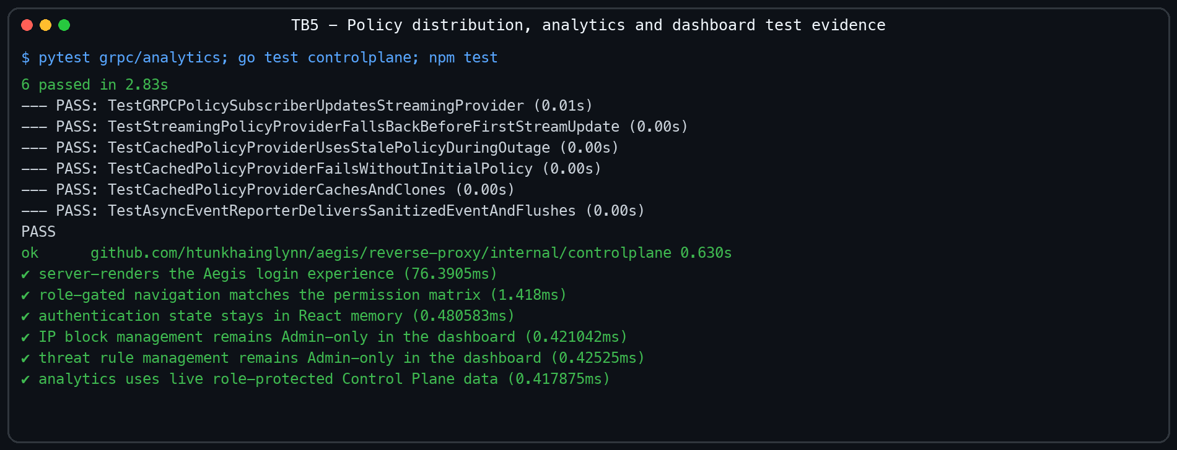
Figure 8.7: Verified TB5 distribution, analytics and dashboard test evidence on 15 August 2026.
Additional screenshot evidence to insert
[PHOTO — TB5 policy distribution to the proxy]
What to capture: Create or update a policy in the Control Plane, then show the corresponding Reverse Proxy log or test output confirming receipt of the new policy version through bootstrap or the authenticated gRPC stream.
Caption to use: Figure 8.X: Policy-distribution evidence showing a Control Plane policy update reaching the Reverse Proxy's active snapshot.
[PHOTO — TB5 analytics populated by real requests]
What to capture: After generating both allowed and denied traffic, open the analytics dashboard and show total requests, allowed/denied outcomes and status-code or event summaries. Use only sanitised demonstration data.
Caption to use: Figure 8.X: Dashboard analytics populated from real allowed and denied requests processed by the Reverse Proxy.
Integration and review: Connect Control Plane, proxy, analytics storage and dashboard views; document policy propagation, security-event fields and operator workflows. Verify authenticated distribution, policy resilience, credential-free analytics and dashboard route tests, then record review and sign-off evidence. The accepted boundary was: Wrong internal tokens are rejected; the last valid snapshot remains active during interruption; security events exclude raw credentials and bodies; dashboard route tests pass. Primary repository evidence: grpc_server.py, grpc_policy_subscriber.go, event_reporter.go, analytics services/routes, React pages and tests.

8.7 TB6 - Integration, POC and Implementation Hardening
Consolidate all components into a reproducible implementation increment and produce truthful evidence for the separate project testing phase.

Design Evidence
Confirm the release boundary, component versions, environment variables, generated secrets, bootstrap order and evidence required for the final increment. The design fixed the boundaries below before coding continued.
Table 8.6: TB6 design evidence and authoritative sources.
Design artefact | Implemented decision
Deployment topology | Compose connects PostgreSQL, Redis, Control Plane, proxy, dashboard and POC services with generated local secrets.
Release gate | One command runs backend, Go race/vet/format/coverage, dashboard lint/tests and POC/tooling tests.
Design sources | compose.yaml, root Makefile, environment generator, e2e.sh and the attack/defence console.

Coding Evidence
Complete Docker Compose wiring, local secret generation, idempotent bootstrap, quality-gate commands, the attack/defence POC and implementation documentation. The following extract is taken from the implemented repository and represents the central code decision for this timebox.
Extract 8.6: The root quality gate joins every implemented component and the POC/tooling tests.
check: backend-test proxy-test proxy-coverage frontend-lint frontend-test poc-test

proxy-test:
cd $(PROXY_DIR) && go test -race ./... && go vet ./... && test -z "$$(gofmt -l .)"

poc-test:
$(PYTHON) -m pytest -q scripts/tests poc/echo-service/tests poc/attack-console/tests

Testing Evidence
Run component checks and live allow, deny, scope, rate and isolation scenarios; correct reproducible failures and record unresolved environment limits. The observed run passed 47 Control Plane tests at 77% coverage, Go race/vet/format checks with 83.4% core coverage, six dashboard tests and thirteen POC/tooling tests.
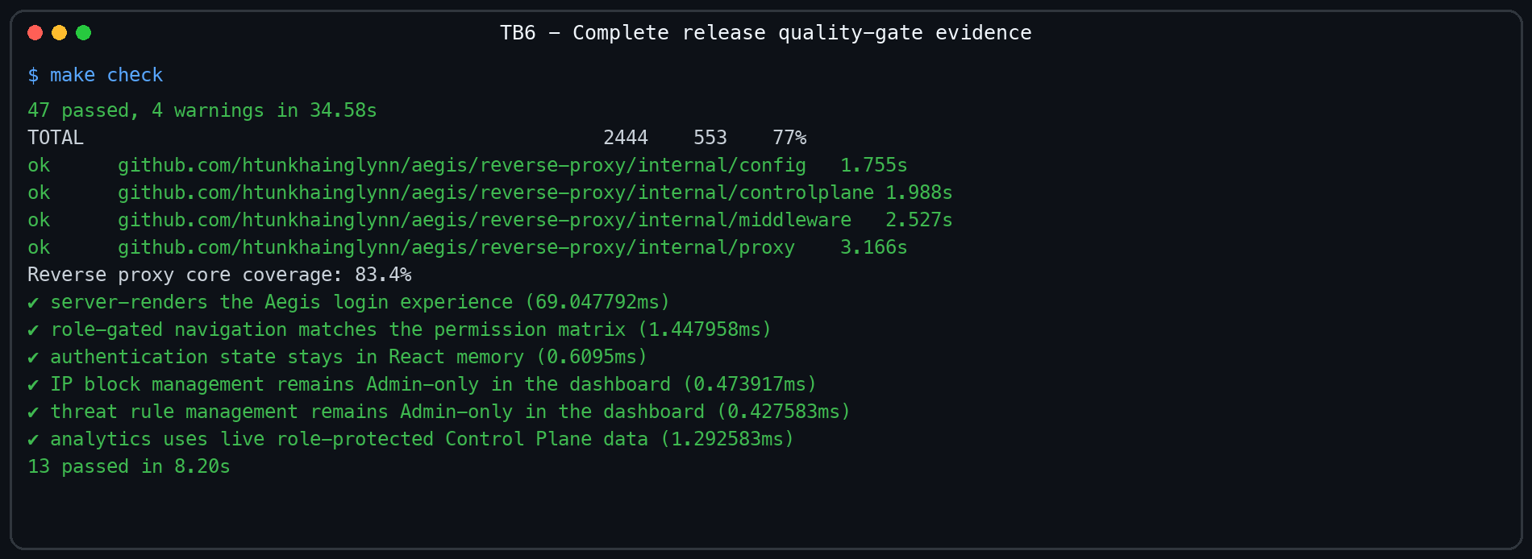
Figure 8.8: Verified TB6 complete release quality gate executed on 15 August 2026.
Additional screenshot evidence to insert
[PHOTO — TB6 integrated service health]
What to capture: Show the local service state or health endpoints for the Control Plane, Reverse Proxy, Dashboard, PostgreSQL and Redis. The screenshot must establish that the components used by the test were running together.
Caption to use: Figure 8.X: Local Aegis deployment showing the Control Plane, Reverse Proxy, Dashboard, PostgreSQL and Redis operating together.
[PHOTO — TB6 end-to-end allow and deny results]
What to capture: Capture a completed live run that includes one authorised request reaching the echo service and one denied request stopped by scope, rate, threat or IP policy. Show the request names, HTTP statuses and enforcement reason.
Caption to use: Figure 8.X: End-to-end Aegis verification showing an authorised upstream response and a policy-denied request in the same reproducible run.
Integration and review: Connect all deployable components, verify graceful event handling and consolidate setup, operation, testing and troubleshooting documentation. Confirm the quality gate and observed POC evidence, document any incomplete Docker result truthfully and approve the implementation for project testing. The accepted boundary was: make check passes; POC demonstrates allow/deny/scope/rate behaviour against a real upstream; any incomplete environment evidence is explicitly reported rather than claimed. Primary repository evidence: Makefile, compose.yaml, scripts/e2e.sh, poc/, docs/evidence and repository test output.
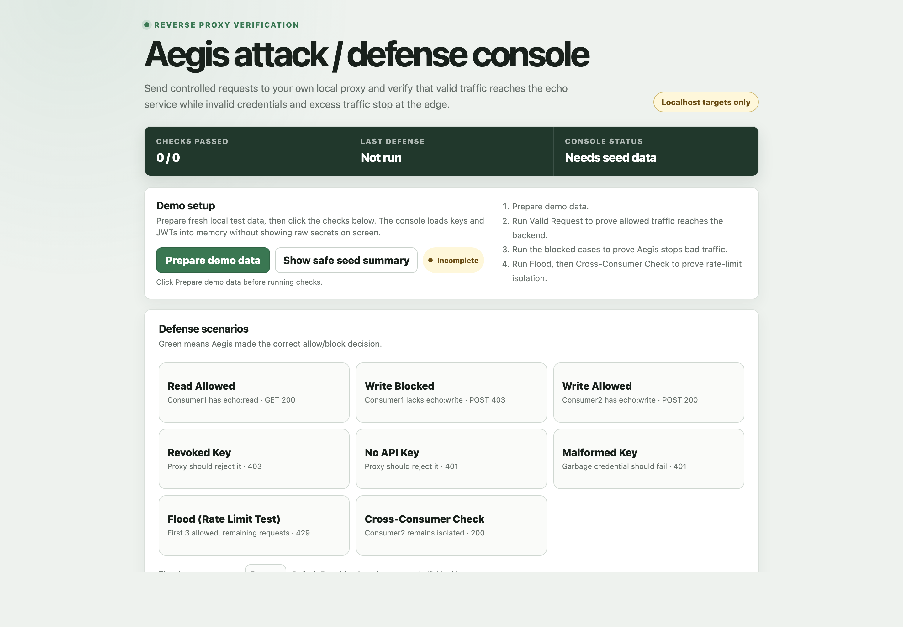
Figure 8.9: Actual Aegis attack/defence console used for TB6 implementation verification.
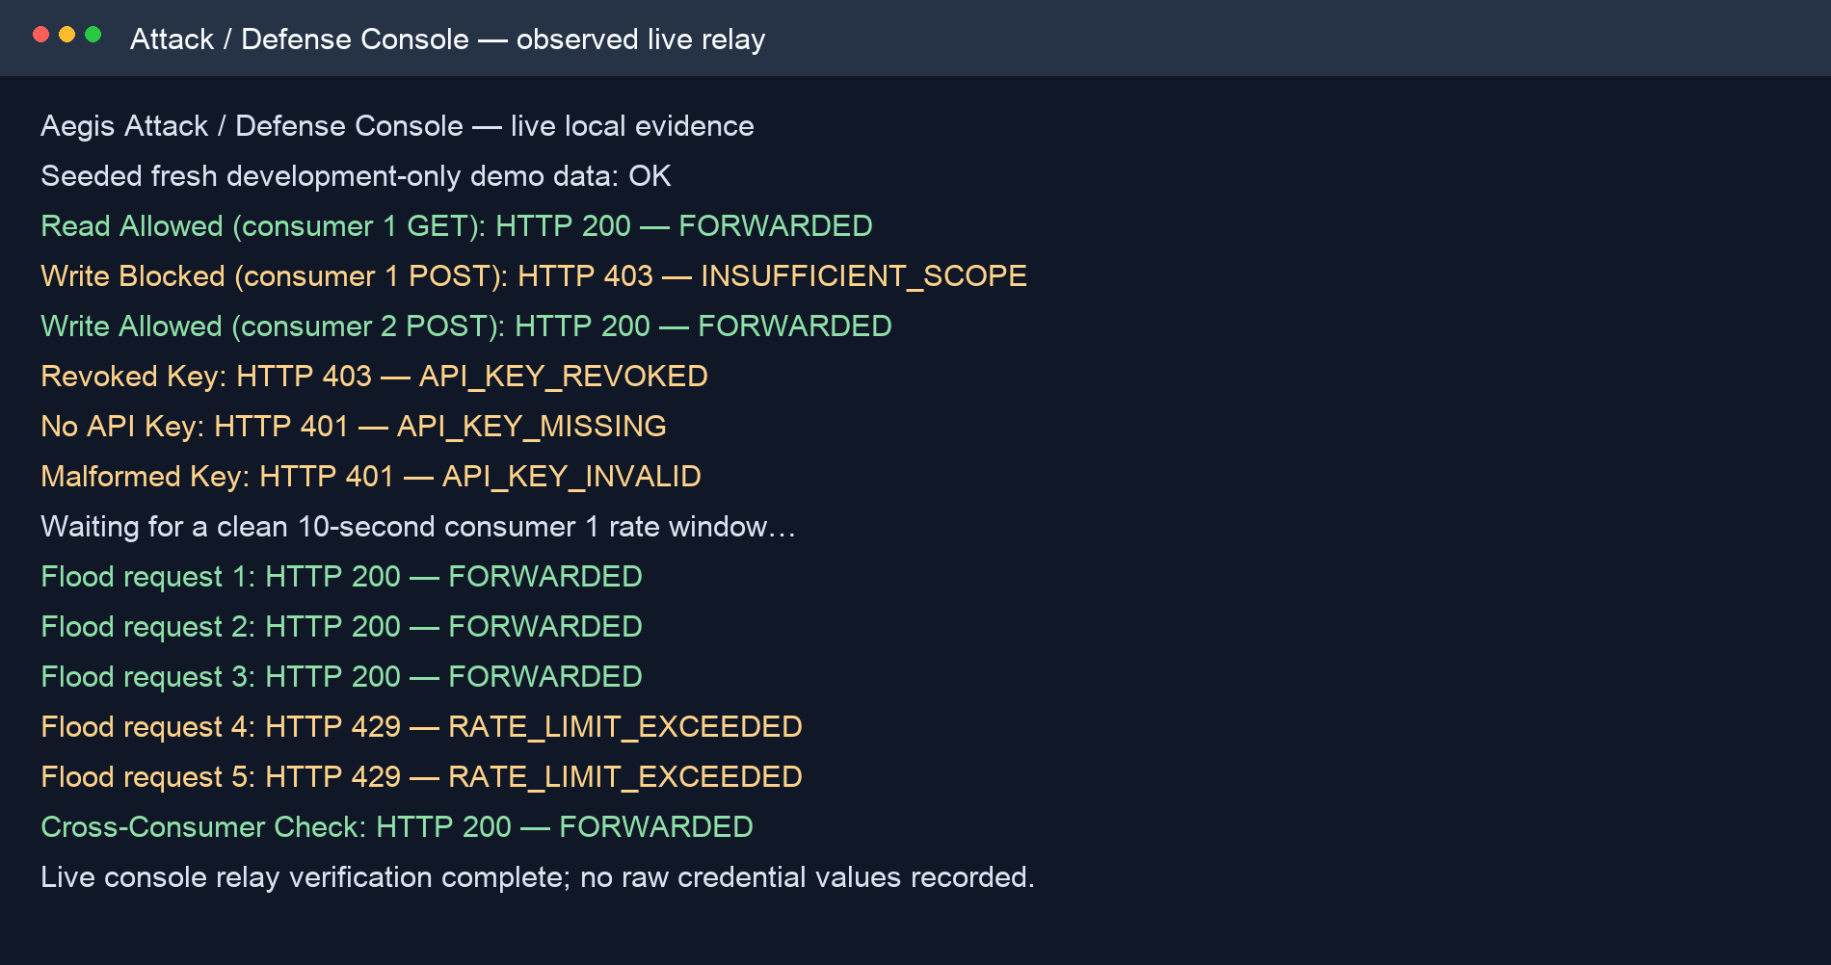
Figure 8.10: Observed live POC enforcement output retained as TB6 evidence.

8.8 Cross-Component Request Contract
A request can be forwarded only when the Go handler has enough trusted information to make every relevant decision. API-key validation returns an identifier, owner, status, scopes and expiry metadata; the policy snapshot carries JWT validation material, rate rules, exact IP blocks, threat patterns and route permissions. The proxy does not infer the meaning of echo:read from the string. A persisted RoutePermission explicitly maps GET /api/echo to that required scope, after which exact string membership becomes the authorisation check.
Extract 8.7: A valid route-permission payload binds a request target to a scope.
{
"method": "GET",
"path_pattern": "/api/echo",
"required_scope": "echo:read",
"status": "active"
}

8.9 Implementation Challenges and Decisions
- Policy values cross Python validation, PostgreSQL, JSON snapshots and Go structures; compatibility tests therefore protect enum and nullability meanings.
- Caching removes per-request database work but creates a first-snapshot and stale-policy question; REST bootstrap and indefinite last-valid-snapshot enforcement make that failure mode explicit.
- The direct network peer is used for blocking because trusting X-Forwarded-For without a configured trusted proxy would allow address spoofing.
- Threat matching is intentionally limited to METHOD plus path/query and Go RE2 syntax, protecting streaming bodies and eliminating regular-expression backtracking attacks.
- Security events use a bounded non-blocking queue. Availability of protected traffic is prioritised over guaranteed analytics ingestion when the queue is full.

8.10 Proposal-to-Implementation Traceability
Table 8.7: Traceability from proposed components to the current implementation.
Proposal component | Implemented result | Material adaptation
FastAPI Control Plane | Async routers, schemas, services, repositories, models, migrations and OpenAPI. | Expanded with persisted RBAC, internal event ingestion and gRPC streaming.
Go Reverse Proxy | Forwarding, key/JWT validation, scope enforcement, Redis limits, threat/IP controls. | Uses REST bootstrap plus authenticated gRPC updates and last-valid cache.
React Dashboard | Role-aware policy and analytics interface with tests. | Uses the existing React 19 Vinext/Vite structure rather than replacing it.
PostgreSQL | Durable users, keys, policies and sanitised events. | Actual migrations are authoritative for the schema.
Redis | Token revocation, distributed atomic rate state and runtime support. | Three rate algorithms and per-scope precedence are implemented.

8.11 Core Implementation Summary
The six implementation timeboxes delivered independently testable increments and converged on a full management-to-enforcement workflow. Design decisions, implemented code, focused test runs, interface screenshots, the full quality gate and live POC output are now retained beside the timebox that produced them. This integrated evidence structure removes the need for a separate Testing chapter while keeping broader traceability records within System Implementation.

8.12 DSDM Implementation Timebox Review Records
These records provide detailed retrospective implementation evidence while retaining the correct DSDM structured-timebox model. They are retrospective documentation of repository evidence, not a claim that non-implementation project activities were timeboxed.

8.12.1 TB1 Review and Sign-off Record
Table 8.12.1: TB1 review and sign-off record.
Review item | Recorded outcome
Objective | Deliver an executable FastAPI foundation with database migration, user identity, JWT session lifecycle and persisted RBAC.
Fixed dates | 1 June 2026 - 17 June 2026
Must Have evidence | Application configuration; async database session; User model/migration; registration, login, refresh and logout; Admin/Viewer/API Consumer role checks; baseline tests.
Should/Could handling | Admin user-list and profile maintenance; bootstrap Admin allowlist; Redis-backed token revocation. Operator-friendly validation messages and richer health metadata.
Acceptance result | Migrations apply to PostgreSQL; authentication tests pass; public registration cannot self-assign Admin; protected routes reject an unauthorised role.
Primary evidence | app/models/user.py, auth/user routers and services, Alembic role migration, test_auth_and_user_rbac.py.
Deferred boundary | API gateway request enforcement and advanced analytics in this timebox.

Retrospective learning
The timebox demonstrates the DSDM principle of delivering on time by protecting quality and negotiating lower-priority scope. Evidence is linked to completed artifacts and tests. Any dependency or limitation that remained was carried forward as an explicit backlog or risk item rather than silently extending the timebox.

8.12.2 TB2 Review and Sign-off Record
Table 8.12.2: TB2 review and sign-off record.
Review item | Recorded outcome
Objective | Deliver one-time API-key issuance and the Control Plane resources required to describe enforceable policy.
Fixed dates | 18 June 2026 - 3 July 2026
Must Have evidence | Cryptographic API-key creation; bcrypt persistence; prefix lookup; owner/Admin CRUD; soft revocation; rate-limit and JWT configuration validation.
Should/Could handling | Threat-rule, exact IP-block and route-permission CRUD with active-duplicate protection. Improved list filters and additional masked operator metadata.
Acceptance result | Raw API key appears only in the create response; hashes never leave the service; invalid scope/rule/key combinations return 422 or controlled conflicts.
Primary evidence | API-key/policy schemas, services, repositories, models, migrations and their pytest modules.
Deferred boundary | Proxy forwarding, distributed counters and gRPC streaming in this timebox.

Retrospective learning
The timebox demonstrates the DSDM principle of delivering on time by protecting quality and negotiating lower-priority scope. Evidence is linked to completed artifacts and tests. Any dependency or limitation that remained was carried forward as an explicit backlog or risk item rather than silently extending the timebox.

8.12.3 TB3 Review and Sign-off Record
Table 8.12.3: TB3 review and sign-off record.
Review item | Recorded outcome
Objective | Place the Go reverse proxy in front of a real upstream and enforce API-key, JWT and exact route-scope policy before forwarding.
Fixed dates | 6 July 2026 - 22 July 2026
Must Have evidence | ReverseProxy forwarding; internal key validation; positive/negative cache; JWT algorithm pinning and expiry; exact route permissions; credential stripping; structured errors.
Should/Could handling | Last-valid policy cache and explicit upstream error mapping. Additional response metadata and diagnostic logging.
Acceptance result | Invalid/revoked/missing keys never reach upstream; matching routes require the exact resource:action scope; allowed requests arrive without Aegis credentials.
Primary evidence | internal/proxy/handler.go, jwt_validator.go, controlplane client/cache, handler and integration tests.
Deferred boundary | Wildcard routes, body inspection and trusted-forwarded-header processing.

Retrospective learning
The timebox demonstrates the DSDM principle of delivering on time by protecting quality and negotiating lower-priority scope. Evidence is linked to completed artifacts and tests. Any dependency or limitation that remained was carried forward as an explicit backlog or risk item rather than silently extending the timebox.

8.12.4 TB4 Review and Sign-off Record
Table 8.12.4: TB4 review and sign-off record.
Review item | Recorded outcome
Objective | Add shared traffic controls and early request rejection using Redis, threat patterns and canonical direct-peer IP policy.
Fixed dates | 23 July 2026 - 7 August 2026
Must Have evidence | Atomic fixed-window, sliding-window and token-bucket scripts; scope precedence; 429 headers; exact IP blocking; RE2-compatible threat matching.
Should/Could handling | Automatic blocking from qualifying security-event thresholds and operator-readable error codes. Additional rate-limit headers and tunable automatic-block thresholds.
Acceptance result | Counters are isolated for API-key scope and shared for route/global scope; blocked/threat requests are rejected before credential validation; race tests pass.
Primary evidence | rate_limiter.go, ip_blocker.go, threat_detector.go, Redis Lua tests and POC flood sequence.
Deferred boundary | CIDR blocking, payload inspection and machine-learning anomaly detection.

Retrospective learning
The timebox demonstrates the DSDM principle of delivering on time by protecting quality and negotiating lower-priority scope. Evidence is linked to completed artifacts and tests. Any dependency or limitation that remained was carried forward as an explicit backlog or risk item rather than silently extending the timebox.

8.12.5 TB5 Review and Sign-off Record
Table 8.12.5: TB5 review and sign-off record.
Review item | Recorded outcome
Objective | Make policy updates resilient and visible through authenticated streaming, sanitised events and role-aware dashboard pages.
Fixed dates | 10 August 2026 - 26 August 2026
Must Have evidence | REST bootstrap; authenticated gRPC policy stream; immediate in-memory update; reconnect/backoff; bounded event queue; analytics summary/history; dashboard login and core policy pages.
Should/Could handling | Automatic-block visibility, live traffic/security analytics and role-specific navigation. UI polish and additional filters.
Acceptance result | Wrong internal tokens are rejected; the last valid snapshot remains active during interruption; security events exclude raw credentials and bodies; dashboard route tests pass.
Primary evidence | grpc_server.py, grpc_policy_subscriber.go, event_reporter.go, analytics services/routes, React pages and tests.
Deferred boundary | External SIEM integration and persistent browser token storage.

Retrospective learning
The timebox demonstrates the DSDM principle of delivering on time by protecting quality and negotiating lower-priority scope. Evidence is linked to completed artifacts and tests. Any dependency or limitation that remained was carried forward as an explicit backlog or risk item rather than silently extending the timebox.

8.12.6 TB6 Review and Sign-off Record
Table 8.12.6: TB6 review and sign-off record.
Review item | Recorded outcome
Objective | Consolidate all components into a reproducible implementation increment and produce truthful evidence for the separate project testing phase.
Fixed dates | 27 August 2026 - 11 September 2026
Must Have evidence | Docker Compose wiring; generated local secrets; idempotent bootstrap; complete component quality gate; live attack/defence POC; implementation documentation.
Should/Could handling | Isolated end-to-end script, analytics verification and graceful event-queue shutdown. Additional demonstration scenarios and usability refinements.
Acceptance result | make check passes; POC demonstrates allow/deny/scope/rate behaviour against a real upstream; any incomplete environment evidence is explicitly reported rather than claimed.
Primary evidence | Makefile, compose.yaml, scripts/e2e.sh, poc/, docs/evidence and repository test output.
Deferred boundary | Production cloud rollout, native mobile app and non-HTTP protocols.

Retrospective learning
The timebox demonstrates the DSDM principle of delivering on time by protecting quality and negotiating lower-priority scope. Evidence is linked to completed artifacts and tests. Any dependency or limitation that remained was carried forward as an explicit backlog or risk item rather than silently extending the timebox.

8.13 Valid Example JSON Payloads
These examples match the current Pydantic request schemas. Values are illustrative development data, not secrets copied from the test environment.

8.13.1 Create API key
{
"name": "echo-reader",
"scopes": [
"echo:read"
],
"expires_at": "2026-12-31T23:59:59Z"
}

8.13.2 Create key-scoped fixed-window rule
{
"name": "consumer-one-demo-limit",
"scope_type": "api_key",
"scope_value": "12",
"algorithm": "fixed_window",
"limit_count": 3,
"window_seconds": 10,
"burst_allowance": null,
"status": "active"
}

8.13.3 Create global sliding-window rule
{
"name": "global-baseline",
"scope_type": "global",
"scope_value": null,
"algorithm": "sliding_window",
"limit_count": 120,
"window_seconds": 60,
"burst_allowance": null,
"status": "active"
}

8.13.4 Create exact route permission
{
"method": "GET",
"path_pattern": "/api/echo",
"required_scope": "echo:read",
"status": "active"
}

8.13.5 Create threat rule
{
"name": "basic-sql-union",
"pattern": "(?i)(GET|POST)\\s+.*union(%20|\\+)select",
"severity": "high",
"status": "active"
}

8.13.6 Create manual IP block
{
"ip_address": "203.0.113.42",
"reason": "Repeated prohibited requests during controlled test",
"status": "active"
}

8.13.7 Create HS256 JWT configuration
{
"name": "development-jwt",
"algorithm": "HS256",
"signing_key": "replace-with-a-long-development-secret",
"public_key": null,
"issuer": "aegis-control-plane",
"audience": "aegis-proxy",
"access_token_ttl_seconds": 900,
"refresh_token_ttl_seconds": 604800
}
Why scopes look like ["echo:read"]: scopes is an array because one key may hold several permissions. Each value uses resource:action naming for readability. The string is not automatic discovery: RoutePermission records explicitly bind a method/path to the required string.

8.14 Control Plane API Operation Catalogue
The operation profiles below explain why each JSON shape exists, how FastAPI/Pydantic validates it and how the result affects later proxy enforcement. Payloads are illustrative and contain no real secret values.

8.14.1 Register API Consumer
Table 8.14.1: Register API Consumer operation profile.
Property | Value
Operation | POST /api/v1/users
Authentication | Public
Successful result | 201 with user metadata; public registration is forced to api_consumer unless the email is bootstrap-allowlisted.

Example request
{"email":"consumer@example.com","full_name":"Example Consumer","password":"ExamplePass123!"}

Validation and security meaning
Reject duplicate email, weak/invalid input and any attempt to self-assign an administrative role.
FastAPI first parses the JSON document, Pydantic validates required fields, types, enumerations and cross-field rules, and a protected router dependency establishes the caller role. The service then applies ownership, uniqueness or lifecycle rules before the repository writes a transaction. Validation errors stop before persistence; authorisation failures do not rely on hidden dashboard controls.

8.14.2 Login
Table 8.14.2: Login operation profile.
Property | Value
Operation | POST /api/v1/auth/login
Authentication | Public
Successful result | 200 with access_token, refresh_token, token_type and expiry metadata.

Example request
{"email":"consumer@example.com","password":"ExamplePass123!"}

Validation and security meaning
Passwords are verified against bcrypt; no hash is returned. Redis participates in the later session lifecycle.
FastAPI first parses the JSON document, Pydantic validates required fields, types, enumerations and cross-field rules, and a protected router dependency establishes the caller role. The service then applies ownership, uniqueness or lifecycle rules before the repository writes a transaction. Validation errors stop before persistence; authorisation failures do not rely on hidden dashboard controls.

8.14.3 Refresh Access Token
Table 8.14.3: Refresh Access Token operation profile.
Property | Value
Operation | POST /api/v1/auth/refresh
Authentication | Refresh token
Successful result | 200 with a new access token when the refresh token is valid and of the correct type.

Example request
{"refresh_token":"<refresh-token>"}

Validation and security meaning
Reject expired, malformed, revoked or access-token-shaped input.
FastAPI first parses the JSON document, Pydantic validates required fields, types, enumerations and cross-field rules, and a protected router dependency establishes the caller role. The service then applies ownership, uniqueness or lifecycle rules before the repository writes a transaction. Validation errors stop before persistence; authorisation failures do not rely on hidden dashboard controls.

8.14.4 Logout
Table 8.14.4: Logout operation profile.
Property | Value
Operation | POST /api/v1/auth/logout
Authentication | Bearer access token
Successful result | 200 after the access token identifier is revoked in Redis.

Example request
{"refresh_token":"<refresh-token>"}

Validation and security meaning
The server-side revocation check prevents continued access during the original token lifetime.
FastAPI first parses the JSON document, Pydantic validates required fields, types, enumerations and cross-field rules, and a protected router dependency establishes the caller role. The service then applies ownership, uniqueness or lifecycle rules before the repository writes a transaction. Validation errors stop before persistence; authorisation failures do not rely on hidden dashboard controls.

8.14.5 Create API Key
Table 8.14.5: Create API Key operation profile.
Property | Value
Operation | POST /api/v1/api-keys
Authentication | Admin or API Consumer
Successful result | 201 with raw_key once plus metadata.

Example request
{"name":"echo-reader","scopes":["echo:read"],"expires_at":"2026-12-31T23:59:59Z"}

Validation and security meaning
The raw key is generated cryptographically, only its bcrypt hash and non-sensitive prefix persist, and the response never exposes the hash.
FastAPI first parses the JSON document, Pydantic validates required fields, types, enumerations and cross-field rules, and a protected router dependency establishes the caller role. The service then applies ownership, uniqueness or lifecycle rules before the repository writes a transaction. Validation errors stop before persistence; authorisation failures do not rely on hidden dashboard controls.

8.14.6 List API Keys
Table 8.14.6: List API Keys operation profile.
Property | Value
Operation | GET /api/v1/api-keys
Authentication | Admin or API Consumer
Successful result | 200 list; Admin sees all keys while an API Consumer sees owned keys only.

Example request
No JSON body; optional pagination query parameters.

Validation and security meaning
The response is metadata-only and excludes raw keys and hashes.
FastAPI first parses the JSON document, Pydantic validates required fields, types, enumerations and cross-field rules, and a protected router dependency establishes the caller role. The service then applies ownership, uniqueness or lifecycle rules before the repository writes a transaction. Validation errors stop before persistence; authorisation failures do not rely on hidden dashboard controls.

8.14.7 Revoke API Key
Table 8.14.7: Revoke API Key operation profile.
Property | Value
Operation | DELETE /api/v1/api-keys/{id}
Authentication | Owner or Admin
Successful result | 200 with null data after status changes to revoked.

Example request
No JSON body.

Validation and security meaning
Soft revocation preserves audit/history and is observed by proxy validation after cache expiry.
FastAPI first parses the JSON document, Pydantic validates required fields, types, enumerations and cross-field rules, and a protected router dependency establishes the caller role. The service then applies ownership, uniqueness or lifecycle rules before the repository writes a transaction. Validation errors stop before persistence; authorisation failures do not rely on hidden dashboard controls.

8.14.8 Validate API Key Internally
Table 8.14.8: Validate API Key Internally operation profile.
Property | Value
Operation | POST /api/v1/api-keys/validate
Authentication | X-Aegis-Internal-Token
Successful result | 200 enforcement metadata for a valid active key.

Example request
{"api_key":"<raw-api-key>"}

Validation and security meaning
The prefix narrows candidate hashes; bcrypt verifies the secret. Public callers cannot use this internal contract.
FastAPI first parses the JSON document, Pydantic validates required fields, types, enumerations and cross-field rules, and a protected router dependency establishes the caller role. The service then applies ownership, uniqueness or lifecycle rules before the repository writes a transaction. Validation errors stop before persistence; authorisation failures do not rely on hidden dashboard controls.

8.14.9 Create Rate-Limit Rule
Table 8.14.9: Create Rate-Limit Rule operation profile.
Property | Value
Operation | POST /api/v1/rate-limit-rules
Authentication | Admin
Successful result | 201 with persisted rule metadata.

Example request
{"scope_type":"api_key","scope_value":"12","algorithm":"fixed_window","limit_count":3,"window_seconds":10,"status":"active"}

Validation and security meaning
scope_value is forbidden for global and required for api_key/route; only one active rule per scope is allowed.
FastAPI first parses the JSON document, Pydantic validates required fields, types, enumerations and cross-field rules, and a protected router dependency establishes the caller role. The service then applies ownership, uniqueness or lifecycle rules before the repository writes a transaction. Validation errors stop before persistence; authorisation failures do not rely on hidden dashboard controls.

8.14.10 Create JWT Configuration
Table 8.14.10: Create JWT Configuration operation profile.
Property | Value
Operation | POST /api/v1/jwt-configs
Authentication | Admin
Successful result | 201 inactive configuration with masked key material.

Example request
{"algorithm":"HS256","signing_key":"<long-secret>","issuer":"aegis-control-plane","audience":"aegis-proxy","access_token_ttl_seconds":900,"refresh_token_ttl_seconds":604800}

Validation and security meaning
Key shape must match the algorithm; the signing key is Fernet-encrypted at rest; activation is a separate operation.
FastAPI first parses the JSON document, Pydantic validates required fields, types, enumerations and cross-field rules, and a protected router dependency establishes the caller role. The service then applies ownership, uniqueness or lifecycle rules before the repository writes a transaction. Validation errors stop before persistence; authorisation failures do not rely on hidden dashboard controls.

8.14.11 Activate JWT Configuration
Table 8.14.11: Activate JWT Configuration operation profile.
Property | Value
Operation | POST /api/v1/jwt-configs/{id}/activate
Authentication | Admin
Successful result | 200 active configuration; the previous active configuration is disabled in the same transaction.

Example request
No JSON body.

Validation and security meaning
The single-active invariant prevents ambiguous proxy validation policy.
FastAPI first parses the JSON document, Pydantic validates required fields, types, enumerations and cross-field rules, and a protected router dependency establishes the caller role. The service then applies ownership, uniqueness or lifecycle rules before the repository writes a transaction. Validation errors stop before persistence; authorisation failures do not rely on hidden dashboard controls.

8.14.12 Create Threat Rule
Table 8.14.12: Create Threat Rule operation profile.
Property | Value
Operation | POST /api/v1/threat-rules
Authentication | Admin
Successful result | 201 with rule metadata.

Example request
{"name":"basic-sql-union","pattern":"(?i)(GET|POST)\s+.*union(%20|\+)select","severity":"high","status":"active"}

Validation and security meaning
Validation rejects regular-expression constructs that Go RE2 cannot compile, protecting policy distribution from incompatible rules.
FastAPI first parses the JSON document, Pydantic validates required fields, types, enumerations and cross-field rules, and a protected router dependency establishes the caller role. The service then applies ownership, uniqueness or lifecycle rules before the repository writes a transaction. Validation errors stop before persistence; authorisation failures do not rely on hidden dashboard controls.

8.14.13 Create Exact IP Block
Table 8.14.13: Create Exact IP Block operation profile.
Property | Value
Operation | POST /api/v1/ip-blocks
Authentication | Admin
Successful result | 201 with canonical address, source=manual and status.

Example request
{"ip_address":"203.0.113.42","reason":"Repeated prohibited requests","status":"active"}

Validation and security meaning
Only exact IPv4/IPv6 addresses are accepted; CIDR ranges are excluded to reduce accidental broad lockout.
FastAPI first parses the JSON document, Pydantic validates required fields, types, enumerations and cross-field rules, and a protected router dependency establishes the caller role. The service then applies ownership, uniqueness or lifecycle rules before the repository writes a transaction. Validation errors stop before persistence; authorisation failures do not rely on hidden dashboard controls.

8.14.14 Create Route Permission
Table 8.14.14: Create Route Permission operation profile.
Property | Value
Operation | POST /api/v1/route-permissions
Authentication | Admin
Successful result | 201 with exact method/path-to-scope policy.

Example request
{"method":"GET","path_pattern":"/api/echo","required_scope":"echo:read","status":"active"}

Validation and security meaning
Wildcards and query strings are rejected. This record, not the scope string alone, tells the proxy which resource requires echo:read.
FastAPI first parses the JSON document, Pydantic validates required fields, types, enumerations and cross-field rules, and a protected router dependency establishes the caller role. The service then applies ownership, uniqueness or lifecycle rules before the repository writes a transaction. Validation errors stop before persistence; authorisation failures do not rely on hidden dashboard controls.

8.14.15 Read Analytics Summary
Table 8.14.15: Read Analytics Summary operation profile.
Property | Value
Operation | GET /api/v1/analytics/summary?hours=24
Authentication | Admin or Viewer
Successful result | 200 totals and event-type counts for the requested window.

Example request
No JSON body.

Validation and security meaning
Stored events are sanitised and never contain raw API keys, JWTs, request bodies or arbitrary headers.
FastAPI first parses the JSON document, Pydantic validates required fields, types, enumerations and cross-field rules, and a protected router dependency establishes the caller role. The service then applies ownership, uniqueness or lifecycle rules before the repository writes a transaction. Validation errors stop before persistence; authorisation failures do not rely on hidden dashboard controls.

8.14.16 Fetch Proxy Policy Snapshot
Table 8.14.16: Fetch Proxy Policy Snapshot operation profile.
Property | Value
Operation | GET /api/v1/internal/proxy-config
Authentication | X-Aegis-Internal-Token
Successful result | 200 versioned active JWT, rate-limit, IP-block, threat and route-permission policy.

Example request
No JSON body.

Validation and security meaning
Only enforcement material is returned; asymmetric private keys and disabled policies are excluded.
FastAPI first parses the JSON document, Pydantic validates required fields, types, enumerations and cross-field rules, and a protected router dependency establishes the caller role. The service then applies ownership, uniqueness or lifecycle rules before the repository writes a transaction. Validation errors stop before persistence; authorisation failures do not rely on hidden dashboard controls.

8.15 Operator and API Consumer Procedures
The procedures use the implemented local interfaces and explain the expected security outcome. They complement, but do not replace, deployment-specific operating procedures.

8.15.1 Start the Local Stack
Purpose: Start the Local Stack using the current Aegis management and enforcement workflow.
Table 8.15.1: Procedure for start the local stack.
Step | Action
1 | Copy or generate the local environment values without committing secrets.
2 | Start PostgreSQL and Redis, apply migrations, then launch Control Plane, proxy, dashboard and POC in dependency order.
3 | Check /api/v1/health, the proxy health endpoint and dashboard availability before seeding demonstration data.
4 | Use disposable Compose project/volume names for isolated verification so normal developer data is not modified.

Expected outcome
A healthy stack is a prerequisite, not proof that enforcement works; complete the request scenarios in G.7 and G.8.

Safety checks
- Use only development/test credentials in screenshots and demonstrations.
- Confirm the caller role and target environment before changing an active policy.
- Prefer soft disable/revocation and preserve the reason for later audit.
- Verify both an allowed and a denied path so a configuration cannot appear correct merely because all traffic is blocked.

8.15.2 Register and Log In
Purpose: Register and Log In using the current Aegis management and enforcement workflow.
Table 8.15.2: Procedure for register and log in.
Step | Action
1 | Use public registration for an API Consumer; role input is not trusted from a public caller.
2 | Log in with email and password and retain the access/refresh tokens only for the current session.
3 | Present the access token as Authorization: Bearer <token> to protected Control Plane endpoints.
4 | Use refresh only with a refresh token and use logout to revoke the current access token in Redis.

Expected outcome
The React client keeps tokens in memory, so a page reload intentionally requires a new login.

Safety checks
- Use only development/test credentials in screenshots and demonstrations.
- Confirm the caller role and target environment before changing an active policy.
- Prefer soft disable/revocation and preserve the reason for later audit.
- Verify both an allowed and a denied path so a configuration cannot appear correct merely because all traffic is blocked.

8.15.3 Create and Store an API Key Safely
Purpose: Create and Store an API Key Safely using the current Aegis management and enforcement workflow.
Table 8.15.3: Procedure for create and store an api key safely.
Step | Action
1 | Choose a descriptive name and only the scopes required by the consumer.
2 | Copy the raw key from the successful create response immediately; it will not be shown again.
3 | Store it in a secret manager or local ignored environment file, never in source control or screenshots.
4 | Use the returned ID/prefix for later management and revoke the key when it is no longer needed.

Expected outcome
Creating ["echo:read"] grants a label to the key; a RoutePermission must bind a real request to that label.

Safety checks
- Use only development/test credentials in screenshots and demonstrations.
- Confirm the caller role and target environment before changing an active policy.
- Prefer soft disable/revocation and preserve the reason for later audit.
- Verify both an allowed and a denied path so a configuration cannot appear correct merely because all traffic is blocked.

8.15.4 Configure Route Permissions
Purpose: Configure Route Permissions using the current Aegis management and enforcement workflow.
Table 8.15.4: Procedure for configure route permissions.
Step | Action
1 | Identify the exact incoming method and path seen by the Aegis proxy.
2 | Choose a stable resource:action name such as echo:read or orders:write.
3 | Create one active RoutePermission for the method/path and required scope.
4 | Issue consumer keys with the appropriate scopes and verify allowed and denied combinations.

Expected outcome
Unmatched routes are currently allowed by default. Treat deny-by-default as a future controlled migration, not an undocumented assumption.

Safety checks
- Use only development/test credentials in screenshots and demonstrations.
- Confirm the caller role and target environment before changing an active policy.
- Prefer soft disable/revocation and preserve the reason for later audit.
- Verify both an allowed and a denied path so a configuration cannot appear correct merely because all traffic is blocked.

8.15.5 Configure Rate Limiting
Purpose: Configure Rate Limiting using the current Aegis management and enforcement workflow.
Table 8.15.5: Procedure for configure rate limiting.
Step | Action
1 | Select global, route or api_key scope based on whether callers should share a bucket.
2 | Choose fixed_window for simple quotas, sliding_window for smoother boundary behaviour, or token_bucket for controlled bursts.
3 | Set positive limit/window values and a burst allowance only where the algorithm supports it.
4 | Verify response headers and counter isolation using at least two API keys.

Expected outcome
When several rules match, Aegis chooses api_key, then exact route, then global.

Safety checks
- Use only development/test credentials in screenshots and demonstrations.
- Confirm the caller role and target environment before changing an active policy.
- Prefer soft disable/revocation and preserve the reason for later audit.
- Verify both an allowed and a denied path so a configuration cannot appear correct merely because all traffic is blocked.

8.15.6 Configure Threat and IP Policies
Purpose: Configure Threat and IP Policies using the current Aegis management and enforcement workflow.
Table 8.15.6: Procedure for configure threat and ip policies.
Step | Action
1 | Use RE2-compatible patterns over the combined HTTP method and path/query target.
2 | Test a pattern against expected benign and malicious examples before activation.
3 | Create manual IP blocks only for exact canonical addresses and provide an auditable reason.
4 | Disable policies softly so historical context remains available.

Expected outcome
The current baseline deliberately does not inspect request bodies and does not trust X-Forwarded-For.

Safety checks
- Use only development/test credentials in screenshots and demonstrations.
- Confirm the caller role and target environment before changing an active policy.
- Prefer soft disable/revocation and preserve the reason for later audit.
- Verify both an allowed and a denied path so a configuration cannot appear correct merely because all traffic is blocked.

8.15.7 Run the Attack/Defence Console
Purpose: Run the Attack/Defence Console using the current Aegis management and enforcement workflow.
Table 8.15.7: Procedure for run the attack/defence console.
Step | Action
1 | Seed fresh local demonstration users, keys and route policies through the restricted local helper.
2 | Run an allowed GET using echo:read and confirm a 200 upstream response.
3 | Run POST with echo:read and confirm 403 INSUFFICIENT_SCOPE, then repeat with echo:write and confirm 200.
4 | Run missing, malformed and revoked key scenarios and confirm they stop before the upstream.

Expected outcome
The relay is intentionally restricted to loopback, /api/echo and GET/POST so it cannot become an arbitrary proxy.

Safety checks
- Use only development/test credentials in screenshots and demonstrations.
- Confirm the caller role and target environment before changing an active policy.
- Prefer soft disable/revocation and preserve the reason for later audit.
- Verify both an allowed and a denied path so a configuration cannot appear correct merely because all traffic is blocked.

8.15.8 Verify Rate Isolation and Analytics
Purpose: Verify Rate Isolation and Analytics using the current Aegis management and enforcement workflow.
Table 8.15.8: Procedure for verify rate isolation and analytics.
Step | Action
1 | Configure an API-key-scoped limit of three requests per ten seconds.
2 | Send five rapid requests from consumer one and expect 200, 200, 200, 429, 429.
3 | Immediately send a request from consumer two and expect 200 because its key bucket is separate.
4 | Open analytics as Admin or Viewer and correlate forward, deny and rate-limit events without exposing secrets.

Expected outcome
A screenshot is evidence only when the underlying command or scenario completed and its environment state is recorded.

Safety checks
- Use only development/test credentials in screenshots and demonstrations.
- Confirm the caller role and target environment before changing an active policy.
- Prefer soft disable/revocation and preserve the reason for later audit.
- Verify both an allowed and a denied path so a configuration cannot appear correct merely because all traffic is blocked.

8.16 Deployment and Operations
These pages translate the development architecture into repeatable operational checks. They are deployment guidance for the current baseline, not a claim that a specific public production environment has been certified.

8.16.1 Configuration and Secret Baseline

Procedure
Create environment-specific database, Redis, JWT-encryption and internal-service secrets outside source control. Generate rather than reuse demonstration values. Validate required settings during startup and keep the ignored local environment file readable only by the developer account.

Security control
Never put the raw API keys issued to consumers, JWT signing secrets, Fernet encryption key or X-Aegis-Internal-Token in the repository, report screenshots or browser-visible configuration.
Table 8.16.1: Operational checkpoints for configuration and secret baseline.
Checkpoint | Required confirmation
Before | Target environment, owner, backup/recovery boundary and secret handling are known.
During | Commands and status are recorded; errors are handled without exposing credentials.
After | Health plus an allowed and denied behaviour are verified where relevant.
Rollback | The safe reversal or forward-correction path is explicit and preserves audit history.

8.16.2 Database Migration Procedure

Procedure
Back up the target database, review the forward Alembic revision and apply migrations before starting the new application build. Confirm expected tables, indexes, enum-compatible values and constraints. Do not edit an already-applied revision to change history; add a forward migration.

Security control
Models are convenient development representations, but the applied migration history is the authoritative record of how a real database reaches the current schema.
Table 8.16.2: Operational checkpoints for database migration procedure.
Checkpoint | Required confirmation
Before | Target environment, owner, backup/recovery boundary and secret handling are known.
During | Commands and status are recorded; errors are handled without exposing credentials.
After | Health plus an allowed and denied behaviour are verified where relevant.
Rollback | The safe reversal or forward-correction path is explicit and preserves audit history.

8.16.3 Control Plane Startup and Health

Procedure
Start PostgreSQL and Redis first, then launch FastAPI with validated configuration. Confirm the public health route, database connectivity, Redis connectivity, OpenAPI contract and bootstrap Admin behaviour. Bootstrap must create an absent account but never reset an existing password or role.

Security control
A green health endpoint proves dependencies are reachable; it does not prove RBAC, key lifecycle or proxy enforcement, which require behavioural tests.
Table 8.16.3: Operational checkpoints for control plane startup and health.
Checkpoint | Required confirmation
Before | Target environment, owner, backup/recovery boundary and secret handling are known.
During | Commands and status are recorded; errors are handled without exposing credentials.
After | Health plus an allowed and denied behaviour are verified where relevant.
Rollback | The safe reversal or forward-correction path is explicit and preserves audit history.

8.16.4 Reverse Proxy Startup

Procedure
Configure the upstream URL, key header, internal Control Plane address/token, Redis connection, policy refresh settings and request timeout. Start with REST policy bootstrap, then establish the authenticated gRPC stream. Confirm the proxy refuses unsafe startup states according to configuration validation.

Security control
After the first valid snapshot, a stream interruption must not clear policy. The proxy continues with the last valid snapshot and reconnects with backoff.
Table 8.16.4: Operational checkpoints for reverse proxy startup.
Checkpoint | Required confirmation
Before | Target environment, owner, backup/recovery boundary and secret handling are known.
During | Commands and status are recorded; errors are handled without exposing credentials.
After | Health plus an allowed and denied behaviour are verified where relevant.
Rollback | The safe reversal or forward-correction path is explicit and preserves audit history.

8.16.5 Dashboard Deployment

Procedure
Build the React application with the correct Control Plane base URL and serve the production bundle through an appropriate web server. Verify role-aware routes as Admin, Viewer and API Consumer. Keep access/refresh tokens out of persistent browser storage under the current design.

Security control
Hiding a navigation item is usability, not authorisation. Every protected write remains guarded by FastAPI dependencies and service-level checks.
Table 8.16.5: Operational checkpoints for dashboard deployment.
Checkpoint | Required confirmation
Before | Target environment, owner, backup/recovery boundary and secret handling are known.
During | Commands and status are recorded; errors are handled without exposing credentials.
After | Health plus an allowed and denied behaviour are verified where relevant.
Rollback | The safe reversal or forward-correction path is explicit and preserves audit history.

8.16.6 Policy Change Procedure

Procedure
Record the reason and affected consumers, create or update the policy through an Admin account, verify the persisted result and observe distribution to the proxy. Exercise one allowed and one denied request. If risk appears, soft-disable or restore the previous active policy without deleting history.

Security control
For route permissions and rate rules, check active-duplicate constraints before creating overlapping records. For JWT configuration, activate deliberately because only one record may be active.
Table 8.16.6: Operational checkpoints for policy change procedure.
Checkpoint | Required confirmation
Before | Target environment, owner, backup/recovery boundary and secret handling are known.
During | Commands and status are recorded; errors are handled without exposing credentials.
After | Health plus an allowed and denied behaviour are verified where relevant.
Rollback | The safe reversal or forward-correction path is explicit and preserves audit history.

8.16.7 API Key Rotation and Revocation

Procedure
Create a new least-privilege key, deliver it through a secure channel, update the consumer, verify successful traffic, then revoke the old key. Allow for positive validation-cache TTL when planning the cutover and confirm the revoked key is denied after the documented propagation boundary.

Security control
The Control Plane cannot recover an old raw key because only the hash was stored. Loss requires replacement, not retrieval.
Table 8.16.7: Operational checkpoints for api key rotation and revocation.
Checkpoint | Required confirmation
Before | Target environment, owner, backup/recovery boundary and secret handling are known.
During | Commands and status are recorded; errors are handled without exposing credentials.
After | Health plus an allowed and denied behaviour are verified where relevant.
Rollback | The safe reversal or forward-correction path is explicit and preserves audit history.

8.16.8 Incident Triage

Procedure
Use structured error codes and sanitised analytics to separate authentication, authorisation, threat, block, rate and upstream failures. Check recent policy changes, direct source address, key prefix/ID and rule ID without asking for raw secrets. Preserve timestamps and command output for reproducibility.

Security control
Do not disable broad security controls simply to make a request pass. Reproduce in an isolated environment, identify the exact policy or dependency and apply the narrowest reversible change.
Table 8.16.8: Operational checkpoints for incident triage.
Checkpoint | Required confirmation
Before | Target environment, owner, backup/recovery boundary and secret handling are known.
During | Commands and status are recorded; errors are handled without exposing credentials.
After | Health plus an allowed and denied behaviour are verified where relevant.
Rollback | The safe reversal or forward-correction path is explicit and preserves audit history.

8.16.9 Backup and Recovery

Procedure
Back up PostgreSQL with encryption and retention appropriate to user/policy/audit data. Redis rate counters and revocation state require an explicit recovery decision: restore where session continuity matters or accept controlled reset for ephemeral limits. Revalidate secrets separately from database restoration.

Security control
A backup containing encrypted JWT material still requires protection of the Fernet key. Test restoration; an untested backup is not recovery evidence.
Table 8.16.9: Operational checkpoints for backup and recovery.
Checkpoint | Required confirmation
Before | Target environment, owner, backup/recovery boundary and secret handling are known.
During | Commands and status are recorded; errors are handled without exposing credentials.
After | Health plus an allowed and denied behaviour are verified where relevant.
Rollback | The safe reversal or forward-correction path is explicit and preserves audit history.

8.16.10 Release Verification and Rollback

Procedure
Before release, run the complete quality gate, migration check and representative POC. Deploy Control Plane/schema changes before a proxy that requires new snapshot fields, or maintain backward compatibility. Monitor errors and policy-stream health, and retain the previous images/configuration for rollback.

Security control
Rollback must not reverse an irreversible database change without a tested migration strategy. Prefer additive compatibility and forward correction.
Table 8.16.10: Operational checkpoints for release verification and rollback.
Checkpoint | Required confirmation
Before | Target environment, owner, backup/recovery boundary and secret handling are known.
During | Commands and status are recorded; errors are handled without exposing credentials.
After | Health plus an allowed and denied behaviour are verified where relevant.
Rollback | The safe reversal or forward-correction path is explicit and preserves audit history.

8.17 Reverse-Learning Notes for Go and JSON
This section is written for a developer who is new to Go and reverse proxies. It connects payload structure, validation and enforcement to the exact Aegis architecture.

8.17.1 Why JSON Objects and Arrays Are Used
A JSON object groups named fields whose meaning differs: name identifies a key for people, scopes controls permissions and expires_at limits its lifetime. An array is used for scopes because one key may contain zero, one or many permission labels. Keeping the type stable avoids changing the contract when a second scope is added.

Concrete example
{"name":"orders-client","scopes":["orders:read","orders:write"],"expires_at":"2026-12-31T23:59:59Z"}

Questions to ask while reading the code
- Where is this value first accepted from an untrusted caller?
- Which layer validates its type, format, cross-field meaning and caller authority?
- How is it stored or distributed without exposing a secret?
- Which Go branch consumes it, what error is returned, and which test proves the boundary?

8.17.2 How Pydantic Validates a Request
FastAPI reads the HTTP body as JSON and asks the declared Pydantic model to construct a typed value. Missing required fields, wrong JSON types and invalid formats fail automatically. Field validators and model validators add business-shaped checks such as resource:action syntax, exact paths, algorithm/key compatibility and scope_type/scope_value relationships.

Concrete example
Request JSON -> parsing -> field types/enums -> cross-field validation -> router dependency -> service rules -> repository transaction

Questions to ask while reading the code
- Where is this value first accepted from an untrusted caller?
- Which layer validates its type, format, cross-field meaning and caller authority?
- How is it stored or distributed without exposing a secret?
- Which Go branch consumes it, what error is returned, and which test proves the boundary?

8.17.3 Why a Scope Is a String Such as echo:read
The resource:action convention is readable, compact and easy to compare exactly. It is a permission identifier, not executable code and not resource discovery. echo names the logical resource and read names the operation. A different project could use invoices:approve or users:write as long as its route policy uses the same stable vocabulary.

Concrete example
["echo:read"]

Questions to ask while reading the code
- Where is this value first accepted from an untrusted caller?
- Which layer validates its type, format, cross-field meaning and caller authority?
- How is it stored or distributed without exposing a secret?
- Which Go branch consumes it, what error is returned, and which test proves the boundary?

8.17.4 How the Proxy Knows What echo Means
It does not infer the resource from the scope text. The Control Plane stores a RoutePermission that maps an exact HTTP method and path to the required scope. That record is distributed in the policy snapshot. When GET /api/echo arrives, the Go handler finds the mapping and checks whether the validated key scopes contain echo:read.

Concrete example
{"method":"GET","path_pattern":"/api/echo","required_scope":"echo:read","status":"active"}

Questions to ask while reading the code
- Where is this value first accepted from an untrusted caller?
- Which layer validates its type, format, cross-field meaning and caller authority?
- How is it stored or distributed without exposing a secret?
- Which Go branch consumes it, what error is returned, and which test proves the boundary?

8.17.5 Go Structs and JSON Tags
A Go struct gives compile-time field names and types. JSON tags tell encoding/json which wire names to accept or produce. A slice such as []string naturally represents a JSON array of scopes. Validation is still required after decoding because correct types alone do not prove that a value is allowed or internally consistent.

Concrete example
type KeyInfo struct {
ID string `json:"id"`
Scopes []string `json:"scopes"`
Status string `json:"status"`
}

Questions to ask while reading the code
- Where is this value first accepted from an untrusted caller?
- Which layer validates its type, format, cross-field meaning and caller authority?
- How is it stored or distributed without exposing a secret?
- Which Go branch consumes it, what error is returned, and which test proves the boundary?

8.17.6 Interfaces Make the Handler Testable
The handler depends on behaviours such as key validation, policy lookup, JWT validation, rate limiting, event reporting and forwarding. Interfaces let tests supply small fake implementations that return a chosen result and record whether the next stage was called. A denial test can therefore prove that the forwarder was never invoked.

Concrete example
type Validator interface { Validate(ctx context.Context, rawKey string) (KeyInfo, error) }

Questions to ask while reading the code
- Where is this value first accepted from an untrusted caller?
- Which layer validates its type, format, cross-field meaning and caller authority?
- How is it stored or distributed without exposing a secret?
- Which Go branch consumes it, what error is returned, and which test proves the boundary?

8.17.7 Why Middleware Order Matters
Security checks form a short-circuiting pipeline. Direct IP and threat checks happen early; credential validation establishes identity; route scope establishes authorisation; the rate limiter consumes shared capacity; only then are credentials stripped and the request forwarded. Reordering can leak information, waste work or charge a limit bucket to traffic that should have been rejected earlier.

Concrete example
IP block -> threat -> API key -> JWT -> route scope -> rate limit -> strip credentials -> upstream

Questions to ask while reading the code
- Where is this value first accepted from an untrusted caller?
- Which layer validates its type, format, cross-field meaning and caller authority?
- How is it stored or distributed without exposing a secret?
- Which Go branch consumes it, what error is returned, and which test proves the boundary?

8.17.8 How to Reverse-Learn a Feature
Begin with an observed HTTP result, locate the handler branch that produced it, follow the interface to the provider, inspect the policy DTO, then trace that field back through the Control Plane response schema, service, repository, model and migration. Finally read the tests to see boundary cases. This path connects behaviour to data rather than reading files in arbitrary order.

Concrete example
HTTP status/error -> Go handler -> interface/provider -> snapshot JSON -> Pydantic schema -> service -> model/migration -> tests

Questions to ask while reading the code
- Where is this value first accepted from an untrusted caller?
- Which layer validates its type, format, cross-field meaning and caller authority?
- How is it stored or distributed without exposing a secret?
- Which Go branch consumes it, what error is returned, and which test proves the boundary?

8.18 Integrated Verification Evidence

8.18.1 Introduction
Testing validates the proposal's claim that Aegis can centralise request protection without relying on an unverified demonstration. The strategy combines component tests, static checks, race detection, coverage gates and a live local attack/defence flow. Results in this chapter were observed on 2 August 2026. Screenshots were created from the corresponding local outputs; raw API keys, passwords and JWT values were excluded.

8.18.2 Testing Strategy
- Control Plane: pytest tests for authentication, ownership, API keys, policy resources, analytics, internal snapshots and gRPC behaviour, with application coverage reporting.
- Reverse Proxy: Go unit/integration tests, the race detector, go vet, gofmt and an enforcement-core coverage threshold.
- Dashboard: lint/build checks plus rendered HTML tests for login, role navigation and key management/analytics views.
- POC/tooling: echo-service, console relay and development-helper tests.
- Live evidence: fresh seeded users/keys/JWT sent through the actual proxy to the actual echo upstream.

8.18.3 Automated Quality Suite
Table 8.8: Completed automated checks and observed results.
Check | Observed result | Coverage of behaviour
Control Plane pytest | 47 passed; 77% application coverage | RBAC, key lifecycle, rules, JWT, blocks, analytics, snapshots, gRPC and route permissions.
Go proxy | race/vet/gofmt pass; 83.4% core coverage | Concurrency, policy providers, handler outcomes, Redis algorithms and forwarding.
Dashboard | lint/build pass; 6 rendered HTML tests | Login, role-specific navigation and management views.
POC/tooling | 13 tests pass | Echo upstream, restricted relay and dev-only helper behaviour.

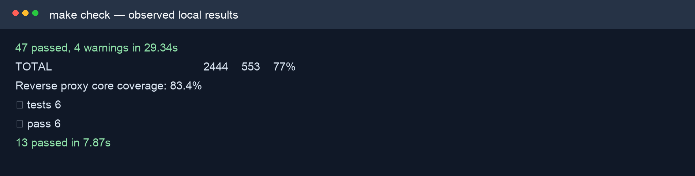
Figure 8.11: Extract of the actual local make check output showing passing suites and coverage results.

8.18.4 Live Attack/Defence POC
The live console was seeded with fresh development-only data and sent constrained /__aegis_probe requests through the running loopback proxy to /api/echo. Consumer 1 held echo:read; Consumer 2 held echo:read and echo:write. Exact RoutePermission records required echo:read for GET and echo:write for POST. This arrangement proves that the scope strings have enforceable meaning rather than merely appearing in JSON metadata.

Figure 8.12: Actual live POC relay evidence confirming forwarding, scope denial, credential failures, rate limiting and per-consumer isolation.
Table 8.9: Live POC scenarios and observed enforcement outcomes.
Scenario | Observed HTTP result | Interpretation
Consumer 1 GET | 200 FORWARDED | Key, JWT and echo:read satisfy the exact GET permission.
Consumer 1 POST | 403 INSUFFICIENT_SCOPE | The key lacks echo:write; the upstream is not called.
Consumer 2 POST | 200 FORWARDED | The required write scope is present.
Revoked key | 403 API_KEY_REVOKED | Lifecycle state is enforced after key lookup.
No/malformed key | 401 API_KEY_MISSING / API_KEY_INVALID | Credential errors terminate before forwarding.
Five-request flood | 200, 200, 200, 429, 429 | The key-scoped Redis rule permits three requests per ten seconds.
Cross-consumer check | 200 FORWARDED | Consumer 2 is isolated from Consumer 1's counter.

8.18.5 Defect and Environment Handling
The first live attempt returned IP_BLOCKED for every case. Investigation found an active manual block for 127.0.0.1 in the local Control Plane. The record was soft-disabled through the authenticated administrative endpoint and the evidence was rerun with fresh seeded data. This was not treated as a proxy defect: the proxy correctly enforced existing policy. Recording the condition protects the validity of the test and demonstrates why reproducible security testing includes environment-state checks.

8.18.6 End-to-End Docker Verification
The repository contains an isolated Docker Compose end-to-end script covering policy creation, gRPC propagation, proxy forwarding, IP blocks, threat detection, Redis limits and analytics. During this report run, the isolated Compose build remained in the build stage for nearly twenty minutes and did not produce a completion result. The process was stopped and its result is not asserted as passed. This limitation is reported explicitly because a historical or expected result is not current test evidence.
Evidence rule: Only completed observations are included in the result tables. The non-completed Docker build is described as a limitation, not converted into a pass or fail claim.

8.18.7 Limitations of Testing
- The completed evidence validates functional enforcement and component behaviour but is not a statistically rigorous throughput benchmark.
- The POC uses loopback services and fresh development credentials; production TLS termination, orchestration and remote network behaviour require deployment testing.
- Threat matching tests cover method/request-URI patterns rather than payload inspection, consistent with the current design boundary.
- Dashboard checks validate rendered routes and important interactions but do not constitute a full accessibility study with representative users.
- A complete isolated Docker E2E result should be captured after the local build issue is resolved.

8.18.8 Core Verification Summary
The completed test evidence supports the core Aegis claim: policy records are converted into observable allow and deny decisions before the upstream service. The quality suite covers each technology component, while the live POC connects scopes, credentials and Redis state to real HTTP outcomes. Remaining integration and performance evidence is stated transparently rather than inferred.

8.19 Selected Test Case Matrix
Table 8.19.1: Selected functional and security test cases derived from current automated and live checks.
ID | Feature | Input/condition | Expected result
TC-01 | Register user | Valid email/name/password | 201; password stored only as a hash
TC-02 | Login | Valid seeded user | 200; access and refresh tokens
TC-03 | RBAC mutation | Viewer creates rate rule | 403 forbidden
TC-04 | Create API key | name/scopes/expiry | Raw key returned once; metadata persists
TC-05 | List API keys | Existing key | Prefix/metadata only; no raw key/hash
TC-06 | Revoke API key | Active owned key | Status revoked; proxy later returns 403
TC-07 | JWT expiry | Expired Bearer token | 401 JWT_EXPIRED
TC-08 | Route scope | POST with echo:read | 403 INSUFFICIENT_SCOPE
TC-09 | Route scope | POST with echo:write | 200 forwarded
TC-10 | Missing API key | No X-API-Key header | 401 API_KEY_MISSING
TC-11 | Threat pattern | Matching method/request URI | 403 THREAT_DETECTED
TC-12 | Manual IP block | Blocked direct peer | 403 IP_BLOCKED
TC-13 | Fixed window | Five requests; limit three | 200, 200, 200, 429, 429
TC-14 | Counter isolation | Second consumer after first floods | 200; separate key scope
TC-15 | Credential stripping | Allowed request | Upstream receives neither Aegis credential
TC-16 | gRPC authentication | Wrong internal token | UNAUTHENTICATED
TC-17 | Policy resilience | Stream interruption after snapshot | Last valid snapshot remains available
TC-18 | Threat schema | Look-ahead/backreference regex | 422 RE2-incompatible pattern
TC-19 | Route schema | Wildcard/query path | 422 exact-path validation error
TC-20 | Analytics privacy | Proxy event | No raw API key, JWT or body stored

8.20 Evidence and Reproducibility
Table 8.20.1: Traceability from report claims to local evidence.
Evidence | Command/source | Result used in report
Automated quality gate | make check | 47 Python tests; 77% app coverage; Go race/vet/gofmt; 83.4% core; 6 dashboard; 13 POC.
Live POC relay | POST /__aegis_seed then /__aegis_probe | Allowed/denied scopes, credential errors, rate limit and key isolation.
Architecture diagram | Compose, app.main, proxy main/handler and dashboard routes | Figure 7.1.
Domain diagram | SQLAlchemy models plus Alembic migrations | Figure 7.2.
Sequence diagram | reverse-proxy/internal/proxy/handler.go | Figure 7.3.
Dashboard/OpenAPI/POC UI | Running localhost services | Figures 8.1-8.3.
Docker E2E | make e2e | Build did not complete; no pass claim.

8.21 Detailed Testing and Traceability Records
Only observed outcomes are recorded. The figures embedded in Chapter 9 are the original local evidence captured during the verified runs.

8.21.1 Control Plane Unit and Integration Suite
Table 8.21.1: Evidence record for control plane unit and integration suite.
Record field | Evidence
Procedure/condition | Run pytest through make check against the configured test environment.
Observed result | 47 tests completed with no skips; application coverage recorded at 77%.
Interpretation | Covers authentication/RBAC, keys, policies, analytics, proxy snapshot and gRPC synchronisation.
Evidence rule | A result is reported only when the command/scenario completed; incomplete runs remain limitations.

Traceability
This record traces a requirement or non-functional quality claim to an executable check and an observable result. Unit tests isolate policy branches, integration tests connect components, and live POC scenarios verify that the upstream is reached only after enforcement. Coverage percentages show exercised code, but they do not replace behavioural assertions or production performance evidence.

Repeatability checklist
- Record the repository revision, environment configuration and command used.
- Use fresh or explicitly inspected policy state before the scenario.
- Capture stdout/status codes without exposing secrets.
- Compare the actual result with the stated acceptance criterion and preserve limitations.

8.21.2 Go Race, Vet and Core Tests
Table 8.21.2: Evidence record for go race, vet and core tests.
Record field | Evidence
Procedure/condition | Run gofmt verification, go vet ./... and go test -race ./... through the quality gate.
Observed result | Checks completed; hand-written enforcement-core coverage recorded at approximately 83%.
Interpretation | Generated protobuf/process wiring is excluded from the core coverage gate by design.
Evidence rule | A result is reported only when the command/scenario completed; incomplete runs remain limitations.

Traceability
This record traces a requirement or non-functional quality claim to an executable check and an observable result. Unit tests isolate policy branches, integration tests connect components, and live POC scenarios verify that the upstream is reached only after enforcement. Coverage percentages show exercised code, but they do not replace behavioural assertions or production performance evidence.

Repeatability checklist
- Record the repository revision, environment configuration and command used.
- Use fresh or explicitly inspected policy state before the scenario.
- Capture stdout/status codes without exposing secrets.
- Compare the actual result with the stated acceptance criterion and preserve limitations.

8.21.3 Dashboard Quality Checks
Table 8.21.3: Evidence record for dashboard quality checks.
Record field | Evidence
Procedure/condition | Run lint, production build and Node rendered-route tests.
Observed result | Six dashboard tests completed with no skips alongside lint/build checks.
Interpretation | Validates important role-aware pages and build integrity, not a complete user accessibility study.
Evidence rule | A result is reported only when the command/scenario completed; incomplete runs remain limitations.

Traceability
This record traces a requirement or non-functional quality claim to an executable check and an observable result. Unit tests isolate policy branches, integration tests connect components, and live POC scenarios verify that the upstream is reached only after enforcement. Coverage percentages show exercised code, but they do not replace behavioural assertions or production performance evidence.

Repeatability checklist
- Record the repository revision, environment configuration and command used.
- Use fresh or explicitly inspected policy state before the scenario.
- Capture stdout/status codes without exposing secrets.
- Compare the actual result with the stated acceptance criterion and preserve limitations.

8.21.4 POC Tooling Tests
Table 8.21.4: Evidence record for poc tooling tests.
Record field | Evidence
Procedure/condition | Run the POC/tooling automated suite from make check.
Observed result | Thirteen tests completed.
Interpretation | Protects the bounded relay/seeding behaviour used to collect live evidence.
Evidence rule | A result is reported only when the command/scenario completed; incomplete runs remain limitations.

Traceability
This record traces a requirement or non-functional quality claim to an executable check and an observable result. Unit tests isolate policy branches, integration tests connect components, and live POC scenarios verify that the upstream is reached only after enforcement. Coverage percentages show exercised code, but they do not replace behavioural assertions or production performance evidence.

Repeatability checklist
- Record the repository revision, environment configuration and command used.
- Use fresh or explicitly inspected policy state before the scenario.
- Capture stdout/status codes without exposing secrets.
- Compare the actual result with the stated acceptance criterion and preserve limitations.

8.21.5 Allowed Read Scenario
Table 8.21.5: Evidence record for allowed read scenario.
Record field | Evidence
Procedure/condition | Consumer one key has echo:read; send GET /api/echo.
Observed result | 200 forwarded to the real echo upstream.
Interpretation | Demonstrates that a valid key and matching exact permission allow the request.
Evidence rule | A result is reported only when the command/scenario completed; incomplete runs remain limitations.

Traceability
This record traces a requirement or non-functional quality claim to an executable check and an observable result. Unit tests isolate policy branches, integration tests connect components, and live POC scenarios verify that the upstream is reached only after enforcement. Coverage percentages show exercised code, but they do not replace behavioural assertions or production performance evidence.

Repeatability checklist
- Record the repository revision, environment configuration and command used.
- Use fresh or explicitly inspected policy state before the scenario.
- Capture stdout/status codes without exposing secrets.
- Compare the actual result with the stated acceptance criterion and preserve limitations.

8.21.6 Denied Write Scenario
Table 8.21.6: Evidence record for denied write scenario.
Record field | Evidence
Procedure/condition | Consumer one key has echo:read; send POST /api/echo where echo:write is required.
Observed result | 403 INSUFFICIENT_SCOPE.
Interpretation | Shows authentication success does not imply authorisation.
Evidence rule | A result is reported only when the command/scenario completed; incomplete runs remain limitations.

Traceability
This record traces a requirement or non-functional quality claim to an executable check and an observable result. Unit tests isolate policy branches, integration tests connect components, and live POC scenarios verify that the upstream is reached only after enforcement. Coverage percentages show exercised code, but they do not replace behavioural assertions or production performance evidence.

Repeatability checklist
- Record the repository revision, environment configuration and command used.
- Use fresh or explicitly inspected policy state before the scenario.
- Capture stdout/status codes without exposing secrets.
- Compare the actual result with the stated acceptance criterion and preserve limitations.

8.21.7 Allowed Write Scenario
Table 8.21.7: Evidence record for allowed write scenario.
Record field | Evidence
Procedure/condition | Consumer two key has echo:write; send POST /api/echo.
Observed result | 200 forwarded.
Interpretation | Confirms the same route is allowed when the exact required scope is present.
Evidence rule | A result is reported only when the command/scenario completed; incomplete runs remain limitations.

Traceability
This record traces a requirement or non-functional quality claim to an executable check and an observable result. Unit tests isolate policy branches, integration tests connect components, and live POC scenarios verify that the upstream is reached only after enforcement. Coverage percentages show exercised code, but they do not replace behavioural assertions or production performance evidence.

Repeatability checklist
- Record the repository revision, environment configuration and command used.
- Use fresh or explicitly inspected policy state before the scenario.
- Capture stdout/status codes without exposing secrets.
- Compare the actual result with the stated acceptance criterion and preserve limitations.

8.21.8 Credential Failure Matrix
Table 8.21.8: Evidence record for credential failure matrix.
Record field | Evidence
Procedure/condition | Run revoked, missing and malformed API-key requests.
Observed result | Revoked returned 403; missing and malformed returned 401-class structured errors.
Interpretation | Each denial occurs before the upstream is invoked.
Evidence rule | A result is reported only when the command/scenario completed; incomplete runs remain limitations.

Traceability
This record traces a requirement or non-functional quality claim to an executable check and an observable result. Unit tests isolate policy branches, integration tests connect components, and live POC scenarios verify that the upstream is reached only after enforcement. Coverage percentages show exercised code, but they do not replace behavioural assertions or production performance evidence.

Repeatability checklist
- Record the repository revision, environment configuration and command used.
- Use fresh or explicitly inspected policy state before the scenario.
- Capture stdout/status codes without exposing secrets.
- Compare the actual result with the stated acceptance criterion and preserve limitations.

8.21.9 Distributed Rate Sequence
Table 8.21.9: Evidence record for distributed rate sequence.
Record field | Evidence
Procedure/condition | Five rapid requests with a three-per-ten-second API-key rule.
Observed result | 200, 200, 200, 429, 429.
Interpretation | Demonstrates fixed-window enforcement and controlled 429 behaviour.
Evidence rule | A result is reported only when the command/scenario completed; incomplete runs remain limitations.

Traceability
This record traces a requirement or non-functional quality claim to an executable check and an observable result. Unit tests isolate policy branches, integration tests connect components, and live POC scenarios verify that the upstream is reached only after enforcement. Coverage percentages show exercised code, but they do not replace behavioural assertions or production performance evidence.

Repeatability checklist
- Record the repository revision, environment configuration and command used.
- Use fresh or explicitly inspected policy state before the scenario.
- Capture stdout/status codes without exposing secrets.
- Compare the actual result with the stated acceptance criterion and preserve limitations.

8.21.10 Cross-Consumer Isolation
Table 8.21.10: Evidence record for cross-consumer isolation.
Record field | Evidence
Procedure/condition | Send consumer two immediately after consumer one exhausts its API-key bucket.
Observed result | Consumer two returned 200.
Interpretation | Confirms the Redis key includes key identity for api_key-scoped rules.
Evidence rule | A result is reported only when the command/scenario completed; incomplete runs remain limitations.

Traceability
This record traces a requirement or non-functional quality claim to an executable check and an observable result. Unit tests isolate policy branches, integration tests connect components, and live POC scenarios verify that the upstream is reached only after enforcement. Coverage percentages show exercised code, but they do not replace behavioural assertions or production performance evidence.

Repeatability checklist
- Record the repository revision, environment configuration and command used.
- Use fresh or explicitly inspected policy state before the scenario.
- Capture stdout/status codes without exposing secrets.
- Compare the actual result with the stated acceptance criterion and preserve limitations.

8.21.11 Environment-State Defect Handling
Table 8.21.11: Evidence record for environment-state defect handling.
Record field | Evidence
Procedure/condition | An old loopback IP block affected the first local POC attempt.
Observed result | The stale policy was identified, soft-disabled traceably and the scenario was rerun.
Interpretation | The report preserves the incident as evidence of environment control instead of hiding it.
Evidence rule | A result is reported only when the command/scenario completed; incomplete runs remain limitations.

Traceability
This record traces a requirement or non-functional quality claim to an executable check and an observable result. Unit tests isolate policy branches, integration tests connect components, and live POC scenarios verify that the upstream is reached only after enforcement. Coverage percentages show exercised code, but they do not replace behavioural assertions or production performance evidence.

Repeatability checklist
- Record the repository revision, environment configuration and command used.
- Use fresh or explicitly inspected policy state before the scenario.
- Capture stdout/status codes without exposing secrets.
- Compare the actual result with the stated acceptance criterion and preserve limitations.

8.21.12 Docker E2E Evidence Boundary
Table 8.21.12: Evidence record for docker e2e evidence boundary.
Record field | Evidence
Procedure/condition | The isolated Compose build was observed for approximately twenty minutes.
Observed result | The build did not complete in that observed session and no pass is claimed from it.
Interpretation | A historical expectation is not substituted for a completed run; rerun remains future evidence work.
Evidence rule | A result is reported only when the command/scenario completed; incomplete runs remain limitations.

Traceability
This record traces a requirement or non-functional quality claim to an executable check and an observable result. Unit tests isolate policy branches, integration tests connect components, and live POC scenarios verify that the upstream is reached only after enforcement. Coverage percentages show exercised code, but they do not replace behavioural assertions or production performance evidence.

Repeatability checklist
- Record the repository revision, environment configuration and command used.
- Use fresh or explicitly inspected policy state before the scenario.
- Capture stdout/status codes without exposing secrets.
- Compare the actual result with the stated acceptance criterion and preserve limitations.

8.22 Chapter Summary
System Implementation now combines timebox design decisions, representative code, focused and complete test runs, screenshots, live POC outcomes, traceability and acknowledged gaps. No failed or incomplete environment run is represented as a pass.

Chapter 9: Evaluation and Reflection

9.1 Evaluation Against the Aim
The Project Proposal aimed to design and develop a production-ready API security and management system that provides central protection through request validation, rate limiting and threat detection while demonstrating Python/FastAPI, Go and React skills (Htun Khaing Lynn, 2026). The current project achieves the central architectural and learning aim: policy is managed in the FastAPI Control Plane and enforced by the Go proxy before an upstream request is possible. The React dashboard and POC make that behaviour observable. The term production-ready should nevertheless be qualified because the project still requires deployment-specific TLS, trusted-proxy, benchmarking, operational rotation and completed isolated E2E evidence.

9.2 Evaluation of Objectives
Table 9.1: Evaluation of the Project Proposal objectives against current evidence.
Objective | Evaluation | Evidence
Research existing solutions | Achieved | Commercial/open-source comparison and literature synthesis in Chapters 2-3.
Define requirements and roles | Achieved | MoSCoW analysis, RBAC and current persisted policies in Chapter 5.
Design architecture and workflows | Achieved | Current architecture, domain and sequence diagrams in Chapter 6.
Implement the full stack | Achieved | FastAPI, Go, React, PostgreSQL, Redis, gRPC and POC described in Chapter 8.
Test security behaviour | Mostly achieved | Passing component suites and live enforcement; isolated Docker E2E did not complete.
Evaluate the result | Achieved with limitations | Comparison, strengths, limitations, reflection and future work in this chapter.

9.3 Comparison with Existing Products
Kong, APISIX, Tyk, AWS API Gateway and Cloudflare provide broader ecosystems, managed availability, extensive plugins and established operational tooling. Aegis does not replace those products. Its value is a focused, self-hosted and explainable implementation in which the student controls the policy model, request order, rate algorithms and audit shape. This makes security decisions easier to reverse-learn than in a platform where behaviour is distributed across plugins and vendor infrastructure.

9.4 Strengths
- Management-plane/data-plane separation prevents common policy decisions from depending on a per-request PostgreSQL query.
- The enforcement sequence applies inexpensive source/threat checks before credentials, authorisation and rate limiting.
- Exact RoutePermission records make scope semantics explicit and testable.
- Cryptographic key generation, one-time raw-key disclosure and hashed persistence reduce credential exposure.
- Atomic Redis algorithms support shared counters across proxy instances.
- Sanitised security events and credential stripping reduce unnecessary sensitive-data propagation.
- The POC demonstrates a real upstream outcome and per-consumer isolation rather than only mocked service calls.

9.5 Limitations
- Exact route matching does not yet support reviewed wildcard, parameter or deny-by-default policies.
- Threat detection is pattern matching over method and request URI, not request-body inspection or a complete web application firewall.
- Direct-peer IP handling is safe for the current topology but needs an explicit trusted-proxy configuration for load-balanced deployment.
- The current dashboard has automated route checks but limited formal usability and accessibility evaluation with end users.
- Performance has not been evaluated with controlled hardware, concurrent load profiles and percentile latency measurements.
- The Docker E2E script requires a fresh completed run before an isolated-stack pass can be claimed in this report.

9.6 Reflection on Development and Learning
The most important technical learning was the difference between recognising a credential and authorising a resource operation. A key can validly contain ["echo:read"], but that string has no inherent knowledge of the echo service. The later route-permission model explicitly maps GET /api/echo to echo:read. This small data structure made the authorisation boundary clearer than embedding route names in handler conditions.
Go required a more explicit approach to dependencies and failure paths than the initial Python work. Handler interfaces made policy providers, key validation, JWT validation, rate limiting, event reporting and forwarding independently testable. Context timeouts and cloned headers exposed practical HTTP concerns that are easy to miss when learning reverse proxies conceptually. Python/FastAPI made schema validation and REST organisation productive, but also reinforced that validation rules must remain consistent with Go's accepted snapshot values.
The POC run also provided a process lesson. The unexpected loopback block was correct system behaviour caused by persistent environment state. Treating it as evidence, finding the policy record and rerunning after a traceable soft-disable was more valuable than forcing a green screenshot. Likewise, the stalled Docker build was excluded from pass claims. These decisions reflect professional responsibility and improve confidence in the report.

9.7 Future Improvements
- Design parameterised/wildcard route permissions with conflict analysis and a staged deny-by-default option.
- Add trusted-load-balancer configuration and CIDR policy only after defining exactly which forwarded headers are authoritative.
- Complete reproducible Docker E2E evidence and add repeatable load benchmarks with documented hardware and latency percentiles.
- Add signing-key rotation, policy version history, audit diffing and operational alert integrations.
- Conduct dashboard accessibility auditing and task-based usability sessions with Admin, Viewer and API Consumer participants.
- Assess body-aware detection separately, including privacy, memory/latency cost, payload limits and false-positive handling.

9.8 Final Conclusion
Aegis demonstrates that a focused custom reverse proxy can centralise meaningful API security controls while remaining understandable from database record to HTTP result. The project does not claim the breadth or operational maturity of a commercial gateway. Its contribution is a coherent learning implementation whose main behaviours are inspectable, testable and connected to the original proposal. With the identified deployment hardening and evidence gaps addressed, it provides a credible foundation for further production-oriented development.

References
Agile Business Consortium (2014) The DSDM Agile Project Framework. Tunbridge Wells: Agile Business Consortium.
Amazon Web Services (2026) Control access to HTTP APIs with JWT authorizers. Available at: https://docs.aws.amazon.com/apigateway/latest/developerguide/http-api-jwt-authorizer.html (Accessed: 2 August 2026).
Apache APISIX (2026) rate-limit and jwt-auth plugin documentation. Available at: https://apisix.apache.org/docs/apisix/plugins/ (Accessed: 2 August 2026).
Cloudflare (2026) API Gateway and rate limiting documentation. Available at: https://developers.cloudflare.com/api-shield/ (Accessed: 2 August 2026).
Docker Inc. (2026) Docker Compose documentation. Available at: https://docs.docker.com/compose/ (Accessed: 2 August 2026).
Fielding, R.T. (2000) Architectural Styles and the Design of Network-based Software Architectures. PhD thesis. University of California, Irvine.
Htun Khaing Lynn (2026) Aegis: API Security and Management System - Project Proposal. Unpublished project proposal.
Indrasiri, K. and Kuruppu, D. (2020) gRPC: Up and Running. Sebastopol: O'Reilly Media.
Jones, M., Bradley, J. and Sakimura, N. (2015) JSON Web Token (JWT). RFC 7519. Internet Engineering Task Force. Available at: https://www.rfc-editor.org/rfc/rfc7519 (Accessed: 2 August 2026).
Kong Inc. (2026) Rate limiting plugin documentation. Available at: https://developer.konghq.com/plugins/rate-limiting/ (Accessed: 2 August 2026).
Newman, S. (2021) Building Microservices: Designing Fine-grained Systems. 2nd edn. Sebastopol: O'Reilly Media.
Oliveira, G. (2022) Rate-limiting algorithm discussion cited in the Aegis Project Proposal.
OWASP Foundation (2023) OWASP API Security Top 10 2023. Available at: https://owasp.org/www-project-api-security/ (Accessed: 2 August 2026).
PostgreSQL Global Development Group (2026) PostgreSQL documentation. Available at: https://www.postgresql.org/docs/ (Accessed: 2 August 2026).
Redis Ltd. (2026) Redis command and scripting documentation. Available at: https://redis.io/docs/latest/ (Accessed: 2 August 2026).
The Go Authors (2026) Package net/http and httputil documentation. Available at: https://pkg.go.dev/net/http (Accessed: 2 August 2026).
Tyk Technologies (2026) Rate limiting documentation. Available at: https://tyk.io/docs/api-management/rate-limit/ (Accessed: 2 August 2026).
W3C (2018) Web Content Accessibility Guidelines (WCAG) 2.1. Available at: https://www.w3.org/TR/WCAG21/ (Accessed: 2 August 2026).
Agile Business Consortium (2014) The DSDM Agile Project Framework. Available at: https://www.agilebusiness.org/resource/the-dsdm-agile-project-framework/ (Accessed: 11 August 2026).
Agile Business Consortium (2026) What is MoSCoW Prioritization? Available at: https://www.agilebusiness.org/resource/what-is-moscow-prioritization/ (Accessed: 11 August 2026).
Agile Business Consortium (2026) What is Timeboxing? Available at: https://www.agilebusiness.org/resource/what-is-timeboxing/ (Accessed: 11 August 2026).
Nay Ye Htet Naing (2025) Restaurant Management System for Chef Restaurant: Project Documentation. Unpublished COMP 1682 reference report.
Hein Htet Aung (2026) An AI-Driven Retrieval-Augmented Generation (RAG) System for Enhancing Entrepreneurial Knowledge Acquisition among Young Adults: Final Report. Unpublished COMP 1682 final project report.

Appendices

Appendix A: Project Proposal
The approved Aegis Project Proposal is submitted as the accompanying source document. It defines the original problem, aim, objectives, scope, risk register and overall schedule. Chapters 1, 5, 7, 8 and 9 explicitly trace the implemented system back to that baseline and identify material adaptations rather than presenting them as if they were planned from the outset.
Table A.1: Proposal schedule interpretation used throughout the report.
Proposal baseline | How this report uses it
Design: 27 April-29 May 2026 | Treated as a project activity, not as a DSDM delivery timebox.
Implementation: 1 June-11 September 2026 | Divided into six fixed DSDM structured timeboxes.
Testing: 14 September-9 October 2026 | Retained as a separate scheduled activity, with its evidence integrated into Chapter 8 beside the relevant implementation timeboxes.
Evaluation: 12-30 October 2026 | Used to assess delivery, limitations and learning against the original objectives.

Appendix B: Figures
Figure B.1 reproduces the consolidated project plan. Dark bars are the six implementation delivery timeboxes. Design, formal testing and evaluation remain visible as project activities but are deliberately labelled as not timeboxed, preserving the DSDM boundary required for this report.
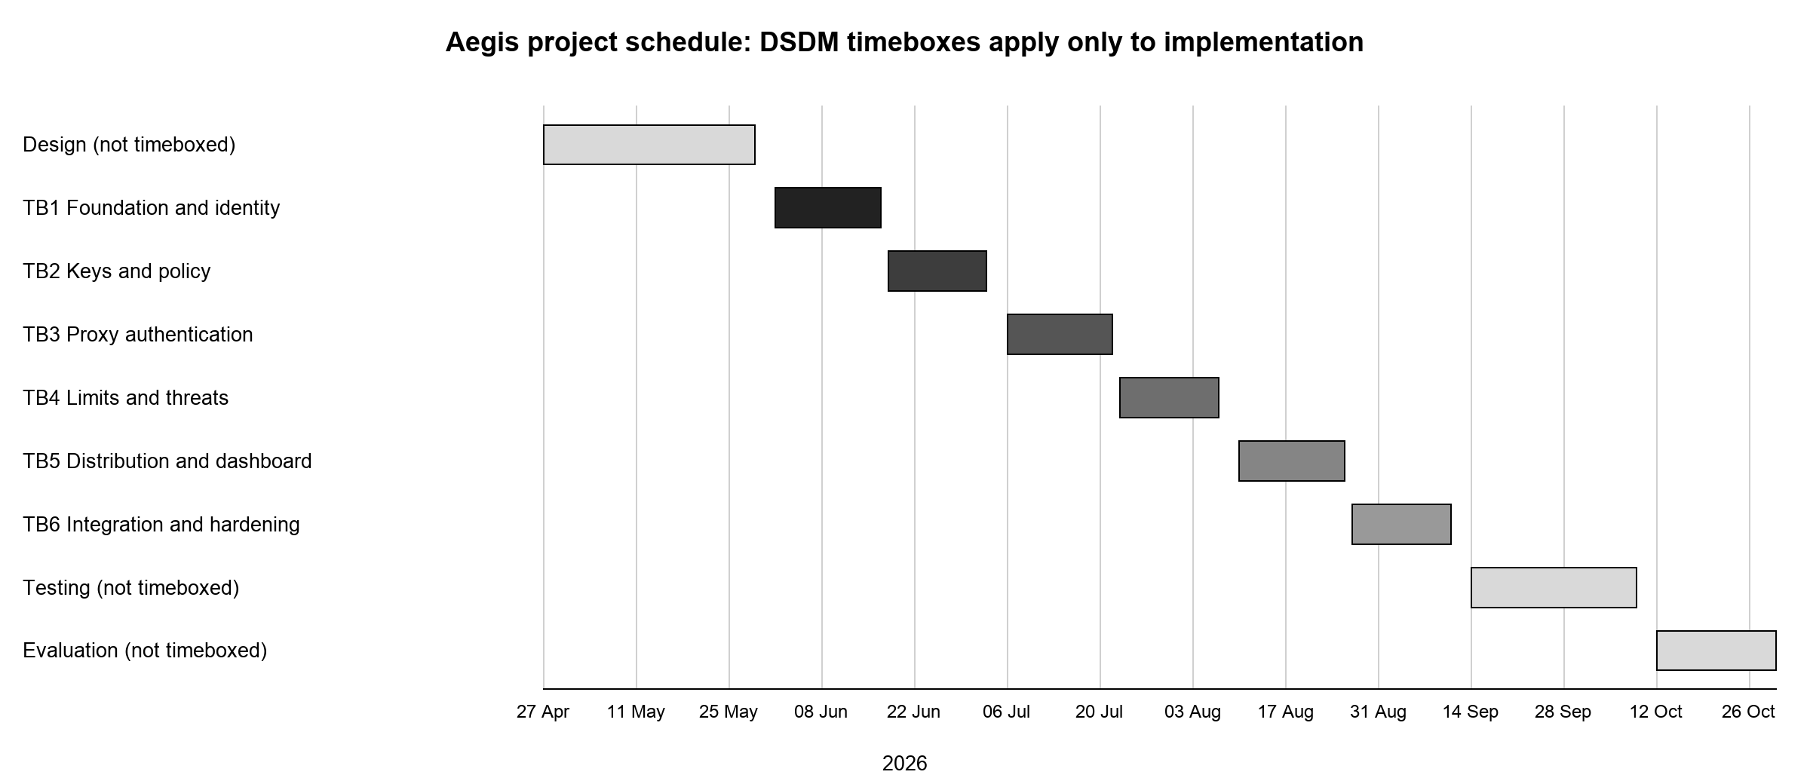
Figure B.1: Aegis project plan with DSDM timeboxes applied only to implementation.

