COMP 1682 PROJECT REPORT

Aegis
API Security and Management System

Htun Khaing Lynn
Student ID: 001557481
BSc (Hons) Computing

A code-grounded evaluation of a FastAPI Control Plane, Go Reverse Proxy, React dashboard, PostgreSQL and Redis
2026

Abstract
Modern applications depend on APIs, yet distributing authentication, authorisation, traffic control and audit logic across every backend creates inconsistent protection. The Project Proposal therefore defined Aegis as a central API security and management system built from a Python/FastAPI Control Plane, a Go Reverse Proxy and a React dashboard, with PostgreSQL and Redis supporting durable policy and runtime state. This report evaluates the implemented system rather than an idealised gateway template.
The current implementation provides role-based administration, cryptographically generated API keys stored as hashes, JWT validation, exact route-to-scope permissions, three Redis-backed rate-limit algorithms, RE2-compatible threat rules, manual and automatic IP blocking, analytics, REST bootstrap and authenticated gRPC policy streaming. The Go proxy applies controls in a deliberate order before stripping credentials and forwarding an allowed request. The architecture, domain and sequence diagrams are derived from current models, migrations and handler code.
Verification combined the repository quality gate, focused request-validation tests, a live local proof of concept and an isolated Docker Compose run. On 21 August 2026 the quality gate recorded 47 Control Plane tests at 77% application coverage, Go race/vet/format checks and 83.4% enforcement-core coverage, six dashboard tests, and thirteen POC/tooling tests. The isolated stack then verified health, authenticated gRPC policy distribution, upstream forwarding, credential rejection, threat and manual/automatic IP blocking, Redis rate limiting and analytics. The evaluation concludes that Aegis meets its learning and central enforcement aims while retaining limitations in wildcard routing, trusted-proxy address handling, body inspection and production benchmarking.
Keywords: API security, reverse proxy, API gateway, FastAPI, Go, JWT, rate limiting, Redis, DSDM.

Acknowledgement
I would like to thank the module tutors and project supervisor for their guidance on project scope, academic structure and the DSDM timeline. Their feedback led to a design-first, timebox-only plan and encouraged stronger traceability between the Project Proposal, implementation decisions and test evidence. I also acknowledge the authors and maintainers of the open standards, research literature and open-source technologies referenced throughout this report.

Table of Contents
Abstract 2
Acknowledgement 3
List of Figures and Tables 7
Chapter 1: Introduction 8
1.1 Background to API Security and Management 8
1.2 Challenges in Existing API Security Systems 8
1.3 SWOT Analysis of Existing API Security Systems 9
1.4 Key Characteristics of Effective API Security Systems 10
1.5 Problem Statement and Research Gap 10
1.6 Aim and Objectives 11
1.7 Proposed System Overview 11
1.8 Scope of the System 12
1.9 Summary 12
Chapter 2: Product Research 14
2.1 Overview 14
2.2 Commercial and Cloud-Managed Gateways 14
2.3 Open-Source and Self-Hosted Gateways 14
2.4 Comparative Analysis 15
2.5 Gaps Identified 15
2.6 Summary 16
Chapter 3: Literature Review 17
3.1 Introduction 17
3.2 API Security Threats and Standards 17
3.3 Authentication and Authorization Techniques 17
3.4 Rate Limiting Algorithms 18
3.5 Reverse Proxy and Gateway Architecture Patterns 18
3.6 Microservices Security Considerations 18
3.7 Summary and Research Gap Synthesis 19

Table of Contents (continued)
Chapter 4: Project Timeline 20
4.1 DSDM Delivery Approach 20
4.2 DSDM Timebox Schedule 20
4.3 Timebox Control Rules 20
4.4 Milestones and Dependencies 21
4.5 Chapter Summary 21
Chapter 5: LSEP Issues 22
5.1 Introduction 22
5.2 Legal Issues 22
5.3 Social Issues 23
5.4 Ethical Issues 23
5.5 Professional Issues 24
5.6 Summary of LSEP Issues and Mitigations 24
5.7 Conclusion 25
Chapter 6: System Analysis 26
6.1 Introduction 26
6.2 User Roles and System Interactions 26
6.3 Functional Requirements 28
6.4 Non-Functional Requirements 31
6.5 Requirement Prioritisation Using MoSCoW 32
6.6 Conclusion 35
Chapter 7: System Design 36
7.1 Introduction 36
7.2 High-Level Architecture 36
7.3 Component Responsibilities 38
7.4 Domain and Database Design 38
7.5 Request Validation and Enforcement 40
7.6 Scope and Route-Permission Design 42
7.7 Policy Synchronisation and Resilience 42
7.8 Security Design Decisions and Trade-offs 42
7.9 Chapter Summary 42

Table of Contents (continued)
Chapter 8: System Implementation 43
8.1 Introduction 43
8.2 Timebox 1 - Design Foundations 43
8.3 Timebox 2 - Control Plane Foundation 43
8.4 Timebox 3 - API Keys and Policy Resources 43
8.5 Timebox 4 - Reverse Proxy Enforcement 44
8.6 Timebox 5 - Rate Limiting, Threats and Policy Distribution 44
8.7 Timebox 6 - Dashboard, Documentation and POC 44
8.8 Proposal-to-Implementation Traceability 46
8.9 Implementation Challenges 46
8.10 Chapter Summary 46
Chapter 9: Testing 47
9.1 Introduction 47
9.2 Testing Strategy 47
9.3 Automated Quality Suite 47
9.4 Live Attack/Defence POC 47
9.5 Defect and Environment Handling 48
9.6 End-to-End Docker Verification 48
9.7 Limitations of Testing 49
9.8 Chapter Summary 49
Chapter 10: Evaluation and Reflection 50
10.1 Evaluation Against the Aim 50
10.2 Evaluation of Objectives 50
10.3 Comparison with Existing Products 50
10.4 Strengths 50
10.5 Limitations 50
10.6 Reflection on Development and Learning 51
10.7 Future Improvements 51
10.8 Final Conclusion 51
References 52
Appendix A: Valid Example JSON Payloads 53
Appendix B: Selected Test Case Matrix 55
Appendix C: Evidence and Reproducibility Index 56

List of Figures
Figure 6.1 Aegis use-case model
Figure 7.1 Current implemented system architecture
Figure 7.2 Current persisted domain model
Figure 7.3 Control Plane JSON validation and persistence sequence
Figure 7.4 Reverse Proxy request validation and enforcement sequence
Figure 7.5 Policy distribution and resilience flow
Figure 7.6 Rate-limit rule and algorithm decision flow
Figure 7.7 Security-event, analytics and automatic-block pipeline
Figure 8.1 Actual dashboard login interface
Figure 8.2 Actual FastAPI OpenAPI interface
Figure 8.3 Actual Attack/Defence Console interface
Figure 9.1 Actual automated quality-suite output
Figure 9.2 Actual live POC relay output
List of Tables
Table 2.1 Product capability comparison
Table 4.1 DSDM timebox schedule
Table 4.2 Timebox control rules
Table 5.1 LSEP risk and mitigation summary
Table 6.1 Role and permission summary
Table 7.1 Component responsibilities
Table 7.2 Domain constraints
Table 8.1 Proposal-to-implementation traceability
Table 9.1 Automated test results
Table 9.2 Live POC results
Table 10.1 Objective evaluation

Chapter 1: Introduction

1.1 Background to API Security and Management
Modern web applications depend heavily on Application Programming Interfaces (APIs) to enable communication between clients, services, and third-party systems (Fielding, 2000; Newman, 2021). The widespread adoption of microservices and distributed architectures has increased the number of exposed APIs within a typical system, which in turn expands the attack surface and makes consistent security enforcement more difficult (Newman, 2021). APIs now represent one of the primary channels through which organisations expose business logic and data, making their protection a critical concern for modern software systems.
As the number and complexity of APIs grows, organisations increasingly require mechanisms that can validate requests, enforce access policies, and detect malicious activity in real time. Centralised API gateways and reverse proxies have emerged as a common architectural pattern for enforcing authentication, authorisation, and traffic control consistently across multiple services (Newman, 2021; Indrasiri and Kuruppu, 2020). Such centralisation reduces duplicated security logic across services and provides a single point from which policies can be defined, monitored, and updated.

1.2 Challenges in Existing API Security Systems
Despite the availability of commercial and open-source API security solutions, several challenges continue to affect organisations attempting to secure their APIs.
A key issue is the reliance on per-service security implementation, where each backend service independently implements its own authentication, rate limiting, and logging logic. This approach leads to duplicated development effort, inconsistent policy enforcement, and limited visibility across the system as a whole (OWASP Foundation, 2023). As the number of services increases, maintaining consistent security configuration across all of them becomes increasingly difficult and error-prone.
Organisations also face a range of specific threats that are difficult to defend against without centralised protection, including unauthorised access, brute-force and denial-of-service attacks, token hijacking, and large-scale data scraping (OWASP Foundation, 2023). Without a consistent enforcement layer, individual services may implement these protections inconsistently, or omit them entirely, leaving gaps that attackers can exploit.
A further challenge is the trade-off between security and operational simplicity. Fully featured commercial gateways provide extensive functionality but often introduce significant configuration complexity, licensing cost, and vendor lock-in. Conversely, minimal or self-built solutions may lack essential capabilities such as distributed rate limiting, structured threat detection, and real-time analytics, leaving services inadequately protected.
Visibility and monitoring also present ongoing difficulties. Without centralised logging and analytics, security teams often lack real-time insight into how APIs are being used or attacked, which delays the detection of anomalous behaviour and increases the time required to respond to incidents (OWASP Foundation, 2023). These limitations highlight the need for a system that consolidates security enforcement and monitoring into a single, manageable layer without requiring changes to existing backend services.

1.3 SWOT Analysis of Existing API Security Systems
A SWOT analysis was conducted to evaluate existing API security and gateway solutions.

Strengths
Established platforms offer mature, battle-tested feature sets, including authentication, rate limiting, and traffic management. Centralised gateways and reverse proxies are widely used and well understood, and enforce authentication, authorisation, and traffic control consistently across services (Newman, 2021; Indrasiri and Kuruppu, 2020), reducing the need for individual services to implement these concerns independently.

Weaknesses
Many existing solutions introduce considerable configuration complexity and, in the case of commercial products, ongoing licensing costs. Self-hosted alternatives frequently lack integrated, real-time threat detection and require significant engineering effort to extend or customise. Limited support for real-time configuration synchronisation across multiple proxy instances also reduces operational responsiveness in dynamic environments.

Opportunities
There is an opportunity to design a lightweight, self-hosted API security system that combines the core protections offered by commercial gateways with simpler deployment and configuration. Integrating distributed rate limiting, JWT validation, IP-based blocking, and real-time analytics within a single, cohesive system can improve both security posture and operational visibility while remaining accessible to smaller teams.

Threats
Established commercial platforms benefit from extensive documentation, community support, and enterprise adoption, creating strong competition for any new system. Additionally, the rapid evolution of API attack techniques, as catalogued in the OWASP API Security Top 10 (OWASP Foundation, 2023), means that any security system must be designed with extensibility in mind to remain effective against emerging threats.
This analysis reinforces the need for a solution that balances comprehensive security functionality with deployment simplicity and cost-effectiveness.

1.4 Key Characteristics of Effective API Security Systems
Effective API security systems share several key characteristics. Centralised enforcement ensures that authentication, rate limiting, and validation are applied consistently across all backend services, rather than being duplicated and potentially inconsistently implemented in each service (Newman, 2021).
Secure API key management, including cryptographically strong generation and hashed storage, is essential to prevent credential compromise. Robust token validation, particularly through standards such as JSON Web Tokens (JWT), ensures that only properly authenticated requests are permitted to reach backend services (Jones, Bradley and Sakimura, 2015).
Distributed rate limiting is also critical in environments with multiple proxy instances, as it ensures that traffic control policies are enforced consistently regardless of which instance handles a given request (Oliveira, 2022). In addition, real-time monitoring and analytics capabilities allow administrators to detect and respond to threats quickly, supporting proactive rather than reactive security management.
Finally, usability and deployability remain important, particularly for teams without dedicated security engineering resources. A system that can be deployed without requiring modification to existing backend services reduces adoption friction and integration risk.

1.5 Problem Statement and Research Gap
Existing API security solutions do not fully address the needs of organisations seeking centralised, comprehensive protection without the cost and complexity associated with enterprise-grade commercial platforms.
Commercial gateways provide extensive functionality but introduce licensing costs, vendor lock-in, and configuration overhead. Self-built or minimal solutions avoid these costs but typically lack integrated threat detection, distributed rate limiting, and real-time analytics, leaving services under-protected. This creates a gap between fully featured commercial platforms and lightweight, inadequately protected custom implementations.
Therefore, there is a need for a self-hosted, high-performance API security system that integrates essential protections — API key management, distributed rate limiting, JWT validation, IP-based blocking, and threat detection — within a single, centrally managed platform, while remaining straightforward to deploy alongside existing backend services. Addressing this gap is important for improving the security posture of API-driven systems without imposing unnecessary cost or complexity.

1.6 Aim and Objectives
The aim of this project is:
“To design and develop a production-ready API security and management system that provides centralised protection for backend services through intelligent request validation, rate limiting, and threat detection, while demonstrating proficiency in full-stack development using Python/FastAPI, Go, and React.”
The objectives are:
- Conduct research into existing API security solutions and best practices
- Analyse current systems to identify strengths, limitations, and gaps
- Investigate and justify suitable methodologies and technologies
- Define and prioritise functional and non-functional system requirements
- Design system architecture, database schema, and user interfaces
- Implement the system using an iterative, timeboxed approach
- Test the system for functionality, performance, and security
- Evaluate the system against its objectives and existing solutions

1.7 Proposed System Overview
The proposed system, Aegis, is a centralised API security and management platform designed to address the limitations identified in existing solutions.
Aegis places a secure, high-performance reverse proxy in front of existing backend services, validating incoming requests before they are forwarded onward. The system is composed of three main components: a Control Plane built with Python and FastAPI for centralised configuration and management, a Reverse Proxy built with Go for high-throughput request validation, and a Dashboard built with React for real-time monitoring and administration.
Key features include secure API key generation and management using bcrypt hashing, distributed rate limiting via Redis, JWT token validation, real-time threat detection through pattern matching, manual and automatic IP-based blocking, and real-time configuration synchronisation between components via gRPC. The system also provides a comprehensive analytics dashboard and request logging capabilities, enabling administrators to monitor API usage and security events without requiring any changes to existing backend services.

1.8 Scope of the System
The system focuses on the core functionalities required for effective API security and management. Included features are:
- secure API key generation and management
- distributed rate limiting
- JWT token validation
- real-time threat detection through pattern matching
- manual and automatic IP-based blocking
- real-time analytics and monitoring dashboard
Excluded features include support for non-HTTP protocols, offline or air-gapped deployment, and native mobile administration applications. These exclusions ensure that development remains feasible within the project timeframe while maintaining a focused and coherent feature set.

1.9 Summary
This chapter introduced the context and motivation for the Aegis system. It examined the challenges faced by organisations securing modern API-driven applications and identified a gap between costly, complex commercial gateways and inadequately protected self-built alternatives. A SWOT analysis was conducted to evaluate current solutions.
The aim, objectives, system overview, and scope of the project were then defined. These findings establish a clear link between the identified limitations of existing systems and the proposed solution, providing a foundation for the research, analysis, and design presented in the chapters that follow.

Chapter 2: Product Research

2.1 Overview
This chapter examines existing API security and management products currently available on the market. Rather than reviewing academic theory, which is addressed separately in Chapter 3, the purpose here is to evaluate practical, real-world tools that organisations use today, in order to identify functional gaps that Aegis is intended to address.
The products reviewed are grouped into two categories: commercial and cloud-managed gateways, and open-source, self-hosted gateways. This grouping reflects the two dominant deployment models currently used for API security (API7.ai, 2026).

2.2 Commercial and Cloud-Managed Gateways
Cloud-managed gateways such as AWS API Gateway, Azure API Management, and Google Apigee are fully managed services with deep integration into their respective cloud ecosystems. They offer strong reliability and minimal operational overhead, since infrastructure management is handled by the provider. However, this convenience comes with vendor lock-in, limited customisation, and, at scale, significant cost (API7.ai, 2026).
Cloudflare API Gateway takes a different approach, focusing on edge-based security such as bot mitigation and DDoS protection. While effective at the network edge, it is not a complete API lifecycle management platform, and its configuration, transformation, and backend orchestration capabilities are limited compared with dedicated gateways such as Apigee or Kong (Geekflare, 2026).
Google Apigee offers the most complete commercial feature set, including a developer portal, monetisation, and analytics, delivered either as a fully managed service or a hybrid model with a customer-operated Kubernetes runtime. This completeness comes at the cost of deployment complexity and unpredictable pricing, making it best suited to large enterprises rather than small or medium-scale projects (API7.ai, 2026).

2.3 Open-Source and Self-Hosted Gateways
Kong Gateway (Community Edition) is one of the most widely adopted open-source gateways, offering a mature plugin ecosystem and flexible deployment options. However, its free tier lacks distributed rate limiting and integrated threat detection without additional paid plugins, and operating it in production requires managing a Postgres or Cassandra data store (Moesif, 2025).
Apache APISIX is a fully open-source, cloud-native gateway built on NGINX and OpenResty, frequently cited as one of the fastest self-hosted options available, with dynamic configuration handled through etcd (Geekflare, 2026).
Tyk Community Edition provides a Go-based, open-source alternative with native GraphQL support. Notably, Tyk's AI Studio component became fully open source in early 2026, reflecting a broader industry trend toward open-sourcing previously commercial gateway features (ChatForest, 2026).
Across these open-source options, a common limitation is the absence of integrated, real-time threat detection and distributed rate limiting out of the box; both typically require additional configuration, external data stores such as Redis, or paid enterprise add-ons.

2.4 Comparative Analysis
Table 2.1 summarises the products reviewed against the core capabilities relevant to this project.
Product | Type | Rate Limiting | JWT Validation | Threat Detection | Deployment Complexity
Kong Gateway (CE) | Self-hosted, open-source | Plugin-based, basic | Yes (plugin) | Limited | Moderate
Apache APISIX | Self-hosted, open-source | Built-in | Yes | Limited | Moderate
Tyk (CE) | Self-hosted, open-source | Built-in | Yes | Limited | Moderate
AWS API Gateway | Cloud-managed | Built-in | Yes | Via AWS WAF add-on | Low (managed)
Cloudflare API Gateway | Cloud/edge-managed | Built-in | Partial | Strong (bot/DDoS) | Low (managed)
Google Apigee | Cloud/hybrid | Built-in | Yes | Limited | High
Aegis (Proposed) | Self-hosted | Distributed (Redis) | Yes | Real-time pattern matching | Low–Moderate
Table 2.1: Comparison of existing API gateway products against proposed Aegis features

2.5 Gaps Identified
The product research highlights a consistent gap between two categories of solution. Commercial and cloud-managed gateways provide strong feature completeness but introduce vendor lock-in, high cost at scale, and, in Cloudflare's case, incomplete API lifecycle coverage. Open-source, self-hosted gateways avoid these costs but generally lack integrated real-time threat detection and require additional engineering effort to achieve distributed rate limiting and analytics.
This gap supports the direction proposed for Aegis: a self-hosted system that bundles distributed rate limiting, JWT validation, and real-time threat detection into a single, centrally managed platform, positioned between the operational simplicity of commercial tools and the flexibility of open-source alternatives.

2.6 Summary
This chapter reviewed existing commercial and open-source API security products and compared their core capabilities against the features proposed for Aegis. The review confirmed that no single existing product combines low deployment complexity, distributed rate limiting, and integrated real-time threat detection in a self-hosted package, reinforcing the research gap identified in Chapter 1. The next chapter examines the academic and technical literature underpinning the design decisions for Aegis.

Chapter 3: Literature Review

3.1 Introduction
This chapter reviews the academic and technical literature relevant to Aegis, covering established standards, algorithms, and architectural patterns that inform its design. Where existing products are referenced, discussion is limited to Kong Gateway and Apache APISIX, as representative open-source implementations of the concepts discussed; the broader product landscape was already addressed in Chapter 2 and is not repeated here.

3.2 API Security Threats and Standards
The foundation of API-based architectures lies in Representational State Transfer (REST), a set of architectural constraints for building scalable, stateless network services (Fielding, 2000). While REST itself does not define security mechanisms, its widespread adoption has made API-specific threats a distinct area of study.
The OWASP API Security Top 10 provides the most widely referenced classification of API-specific vulnerabilities, including broken object-level authorisation, broken authentication, and unrestricted resource consumption (OWASP Foundation, 2023). This classification directly informs Aegis's threat model, particularly its focus on authentication enforcement and rate limiting as primary mitigations against the most common attack categories identified in the standard.

3.3 Authentication and Authorization Techniques
JSON Web Tokens (JWT) are defined in RFC 7519 as a compact, URL-safe means of representing claims to be transferred between two parties (Jones, Bradley and Sakimura, 2015). JWTs are widely used for stateless authentication because the signed token itself carries the information needed to verify a request, removing the need for the verifying service to query a central session store on every request.
This property is particularly relevant to Aegis's Data Plane design: because the Go reverse proxy must validate large volumes of requests with minimal latency, stateless JWT verification avoids the overhead of a database lookup per request, at the cost of requiring careful handling of token revocation, which Aegis addresses through short-lived tokens combined with a Redis-backed revocation list at the Control Plane level.

3.4 Rate Limiting Algorithms
Rate limiting is a core technique for protecting services against abuse and denial-of-service conditions. The literature identifies several established algorithms, including the Token Bucket, Leaky Bucket, and Sliding Window approaches, each offering different trade-offs between burst tolerance, memory usage, and implementation complexity (Oliveira, 2022).
The Token Bucket algorithm allows short bursts of traffic while enforcing a long-term average rate, making it well suited to typical API traffic patterns where legitimate clients may briefly exceed a steady rate. In distributed environments with multiple proxy instances, rate limiting state must be shared across instances to be effective; Redis is commonly used for this purpose because its atomic increment and expiry operations allow rate counters to be updated consistently without race conditions (Oliveira, 2022). This directly informs Aegis's choice of a Redis-backed distributed rate limiter in the Go reverse proxy.

3.5 Reverse Proxy and Gateway Architecture Patterns
Centralising cross-cutting concerns such as authentication, rate limiting, and logging behind a reverse proxy is a well-established pattern in microservices architecture, allowing individual backend services to remain simple while security and traffic policies are enforced consistently at a single layer (Newman, 2021).
Open-source implementations of this pattern illustrate two common architectural approaches. Kong Gateway is built as a plugin-based proxy on top of NGINX, where cross-cutting concerns are implemented as discrete, composable plugins attached to routes. Apache APISIX instead embeds routing and policy logic directly using the OpenResty/Lua runtime, with configuration state distributed through etcd rather than a plugin pipeline. Both approaches confirm the viability of separating a lightweight data-path proxy from a centralised configuration store, a separation that Aegis adopts directly through its Control Plane/Data Plane split, with gRPC used for configuration propagation instead of etcd or a plugin system (Indrasiri and Kuruppu, 2020).

3.6 Microservices Security Considerations
Distributed systems introduce security considerations beyond those of monolithic applications, including the need for consistent policy enforcement across many independently deployable services and the risk of inconsistent implementation when each service manages its own security logic (Newman, 2021). The literature generally recommends centralising authentication and access control at a shared boundary rather than duplicating it within each service, both to reduce implementation inconsistency and to simplify auditing of security behaviour across the system.

3.7 Summary and Research Gap Synthesis
This chapter reviewed the academic and technical foundations relevant to Aegis: REST and API-specific threat models (Fielding, 2000; OWASP Foundation, 2023), JWT-based stateless authentication (Jones, Bradley and Sakimura, 2015), distributed rate limiting algorithms (Oliveira, 2022), and reverse proxy architecture patterns as implemented in Kong Gateway and Apache APISIX (Newman, 2021; Indrasiri and Kuruppu, 2020).
Combined with the product-level gaps identified in Chapter 2, the literature confirms that the individual techniques required by Aegis, stateless JWT validation, distributed token-bucket rate limiting, and a decoupled control/data plane architecture, are well established, but no reviewed open-source product combines them into a single, low-complexity, self-hosted system. This synthesis of theoretical grounding and product-level gap directly justifies the design decisions carried forward into the following chapters.

Chapter 4: Project Timeline

4.1 DSDM Delivery Approach
The Project Proposal selected the Dynamic Systems Development Method (DSDM) because the project combines a fixed submission window with incremental delivery and MoSCoW prioritisation (Agile Business Consortium, 2014; Htun Khaing Lynn, 2026). Tutor feedback requires the report timeline to begin with Design, remove standalone Research, Analysis and Planning phases, use activities longer than one day, and end Testing on 9 October. The schedule below therefore presents only DSDM development timeboxes. Research and analysis remain continuing inputs inside each timebox rather than separate timeline phases.
Each timebox follows the same internal rhythm: a short investigation and planning period, focused development, integrated testing, stakeholder review and retrospective. The timebox scope can be reprioritised, but the end date remains fixed. Must Have work is protected first; Should Have and Could Have work enters only when quality gates remain satisfied.

4.2 DSDM Timebox Schedule
Table 4.1: DSDM timebox schedule from mid-March to the proposal testing end date.
Timebox | Dates | Primary focus | Multi-day outputs
TB1 | 16 Mar-10 Apr | Design foundations | Architecture boundaries, schema, API contracts, threat model and validation sequence
TB2 | 13 Apr-8 May | Control Plane foundation | FastAPI structure, migrations, users, authentication, RBAC and API-key lifecycle
TB3 | 11 May-5 Jun | Proxy and traffic controls | Go forwarding, key/JWT validation, Redis rules and structured error contracts
TB4 | 8 Jun-3 Jul | Policy distribution | REST snapshot, authenticated gRPC stream, cached-policy resilience and route permissions
TB5 | 6-31 Jul | Security and observability | Threat rules, manual/automatic IP blocks, security events and analytics
TB6 | 3-28 Aug | Dashboard and integration | Role-aware React workflows, full-stack integration and POC console
TB7 | 31 Aug-25 Sep | Hardening | Cross-component tests, race/vet/lint gates, defect correction and documentation
TB8 | 28 Sep-9 Oct | Final testing | Regression, attack/defence evidence, evaluation inputs and submission-quality results

4.3 Timebox Control Rules
Table 4.2: Repeated control structure inside every DSDM timebox.
Internal activity | Minimum duration | Control
Investigation/planning | 2-4 days | Confirm acceptance criteria, dependencies and the exact Must Have slice.
Development | 6-12 days | Implement a vertically testable increment across the components required by the timebox.
Integrated testing | 2-5 days | Run unit/component checks continuously and a cross-component check before review.
Review | 2 days | Demonstrate working software and compare results with the timebox acceptance criteria.
Retrospective | 2 days | Record defects, design learning and changes to the next timebox backlog.

Critical delivery chain: Design foundations -> authenticated Control Plane -> proxy validation -> distributed policy -> security events -> dashboard/POC -> hardening -> final testing. A later feature cannot be accepted if it weakens an earlier enforcement invariant.

4.4 Milestones and Dependencies
- TB1 ends only when component boundaries, database entities and the request-enforcement order are reviewable.
- TB2 establishes users, RBAC and API-key metadata before the proxy depends on internal validation endpoints.
- TB3 creates a safe request path before advanced configuration streaming or analytics is introduced.
- TB4 keeps REST bootstrap and the last valid snapshot as resilience mechanisms around gRPC synchronisation.
- TB5 and TB6 add visible controls and evidence without moving authority from the server to the browser.
- TB7 protects the final timebox from unresolved defects; TB8 ends on 9 October as required by the Project Proposal and tutor feedback.

4.5 Chapter Summary
The corrected timeline is a DSDM timebox plan only. It starts with Design on 16 March, allocates multiple days to every activity, preserves an iterative review rhythm and ends final Testing on 9 October. This makes the report timeline consistent with tutor feedback while maintaining the proposal's methodology and technical dependencies.

Chapter 5: Legal, Social, Ethical and Professional (LSEP) Issues

5.1 Introduction
This chapter examines the legal, social, ethical, and professional issues relevant to the design, development, and operation of Aegis, expanding on the LSEP considerations first identified in the Project Proposal (Section 5). As a system that handles user credentials, API keys, and security-related data, Aegis raises considerations beyond purely technical correctness, and these are addressed systematically below, together with the mitigations adopted during development.

5.2 Legal Issues
Aegis stores and processes personal and security-sensitive data, including user account information, hashed passwords, API key metadata, and request logs. This raises data protection considerations broadly aligned with the principles underlying the General Data Protection Regulation (GDPR), even though the system is developed as an academic project rather than a commercial product subject to formal regulatory audit. In particular, storing only what is necessary, hashing sensitive credentials rather than storing them in plain text, and defining clear retention expectations for request logs are treated as baseline requirements rather than optional enhancements.
A further legal consideration concerns intellectual property. Aegis is built using a number of open-source libraries and frameworks, including FastAPI, SQLAlchemy, and various Go and React packages, distributed under permissive licences such as MIT and Apache 2.0. All third-party dependencies are used in accordance with their licence terms, and none are modified or redistributed in a way that would breach those terms. Care is also taken to ensure that all code, diagrams, and written content produced for this project are original work, with external sources properly attributed using Harvard referencing, to avoid any concerns around plagiarism or unauthorised use of third-party material.
Mitigation: sensitive fields (passwords, API keys, JWT signing material) are hashed or encrypted rather than stored in plain text; all third-party licences are reviewed before dependencies are introduced; and all external sources are documented and cited throughout this report.

5.3 Social Issues
Aegis is intended to be usable by a range of technical stakeholders, from developers integrating an API key into a client application to administrators configuring rate limiting policy through the dashboard. Accessibility is therefore a relevant concern, particularly for the React-based dashboard, which should follow established accessibility guidance such as the Web Content Accessibility Guidelines (WCAG 2.1) (W3C, 2018) — for example through semantic HTML, sufficient colour contrast, and keyboard-navigable interactive elements — so that the system does not unnecessarily exclude administrators who rely on assistive technology.
A related social consideration is the digital divide: not every organisation that might benefit from a system like Aegis has access to significant infrastructure or specialist security engineering staff. This is part of the motivation identified in Chapter 1 for a lightweight, self-hosted alternative to complex commercial gateways. Ensuring the system can run on modest hardware via Docker Compose, and that its documentation is written clearly enough for developers without a security background to deploy and configure it, both help to reduce this barrier.
Mitigation: accessibility best practices are followed in dashboard design where practical within the project's scope; deployment is containerised and documented to keep hardware and expertise requirements low, consistent with the accessibility goals set out in the Project Proposal (Section 5.3).

5.4 Ethical Issues
Because Aegis is a security-focused system, it necessarily handles data that could reveal sensitive information about how an organisation's APIs are used and attacked, including request logs and flagged security events. Handling this data responsibly is an ethical obligation as well as a legal one: logs should be used only for their stated security purpose, and any vulnerabilities discovered during development or testing should be handled through responsible disclosure rather than being publicised in a way that could enable misuse.
A further ethical consideration is fairness in automated enforcement. Rate limiting and IP blocking, if misconfigured, risk unfairly denying service to legitimate users rather than only to malicious actors. Aegis's design mitigates this by making rate limit rules and blocking decisions explicit and configurable by an administrator, rather than opaque, and by scoping rules narrowly (globally, per API key, or per route) so that overly broad blocking is a deliberate configuration choice rather than an accidental side effect of the system's default behaviour.
Mitigation: security event data is used only for its intended monitoring and protection purpose; rate limiting and blocking configuration is transparent and auditable rather than opaque; and any vulnerabilities identified during testing are handled and reported responsibly rather than disclosed publicly ahead of remediation.

5.5 Professional Issues
Professional practice is reflected throughout the development of Aegis in the coding standards, project management approach, and testing discipline applied. Code is developed following consistent formatting and linting standards, structured into clearly separated modules (Control Plane, Reverse Proxy, Dashboard), and documented so that the codebase remains maintainable rather than being optimised only for short-term progress.
Project management is conducted using the Agile DSDM approach and timeboxed structure described in Chapter 4, with realistic scope prioritisation (MoSCoW) used to manage the risk of overcommitment within a fixed academic deadline. This includes being transparent, in this report and in supervisor communication, about actual progress against the planned timeline rather than presenting an inaccurate picture of completion.
Testing and quality assurance are treated as a professional responsibility rather than an afterthought: features are accompanied by automated tests covering core functionality, ownership and authorisation enforcement, and key edge cases, consistent with the testing strategy defined in the Project Proposal (Section 3.6).
Mitigation: consistent code style and linting are enforced across modules; progress is reported honestly against the project timeline; and automated testing is treated as a required part of each feature rather than optional polish.

5.6 Summary of LSEP Issues and Mitigations
Category | Key Issue | Mitigation
Legal | Handling of personal data and sensitive credentials; third-party licence compliance | Hashing/encryption of sensitive fields; licence review for all dependencies; full citation of external sources
Social | Accessibility of the dashboard; digital divide for smaller organisations | WCAG-aligned design practices where practical; lightweight, low-hardware Docker Compose deployment
Ethical | Responsible handling of security event data; fairness of automated rate limiting and blocking | Data used only for its stated purpose; transparent, auditable, narrowly scoped rule configuration
Professional | Code quality, project management realism, and testing discipline | Consistent coding standards; honest progress reporting against the DSDM timeline; automated testing per feature
Table 5.1: Summary of LSEP issues and mitigations

5.7 Conclusion
This chapter has extended the LSEP considerations introduced in the Project Proposal into a fuller discussion of the legal, social, ethical, and professional issues relevant to Aegis. Addressing these issues alongside the technical requirements defined in earlier chapters supports the development of a system that is not only functionally secure, but also responsibly designed, fairly operated, and professionally delivered.

Chapter 6: System Analysis

6.1 Introduction
This chapter presents the system analysis of Aegis, translating the problem statement and system overview established in Chapter 1 into clearly defined system requirements for design and implementation. Aegis addresses challenges such as inconsistent per-service security enforcement, unauthorised access, and denial-of-service style abuse by centralising API key management, rate limiting, JWT validation, and threat detection into a single control layer.
The analysis is structured into user roles and system interactions, functional requirements, non-functional requirements, and MoSCoW prioritisation, in order to ensure that development effort within the timeboxed schedule described in Chapter 4 is directed toward the features that matter most.

6.2 User Roles and System Interactions
Aegis defines several actors, both human and system-level, that interact with it in distinct ways. Each is enforced through role-based access control at the Control Plane, and each corresponds to one or more of the use cases illustrated in Section 6.6.

6.2.1 New User
A New User is an unauthenticated individual who does not yet hold an Aegis account. Their only interaction with the system is registration: providing an email address, full name, and password to create an account.
This role represents the entry point into the system. Once registration is complete, the individual becomes an Authenticated User and gains access to the capabilities associated with their assigned role (API Consumer, Viewer, or Admin).

6.2.2 API Consumer
The API Consumer is a developer or service that integrates with backend APIs protected by Aegis. Their primary interaction is managing their own API keys: generating new keys, viewing existing key metadata, and revoking keys that are no longer needed or suspected of compromise.
API Consumers do not have access to configuration features such as rate limit rules or JWT settings. Once issued a key, they authenticate to proxied backend services directly using that key or an associated JWT, without further involvement from the Aegis dashboard.

6.2.3 Admin
The Admin is the primary user responsible for configuring and operating Aegis, with the highest level of control within the system. Admins define rate limiting rules, configure JWT signing parameters, manage threat detection patterns and IP blocking rules, and oversee user accounts.
Admins also monitor system-wide activity through the analytics dashboard, reviewing API usage, flagged security events, and overall system health. Because configuration changes made by an Admin affect enforcement across all proxied traffic, all write operations in this role are subject to strict authorisation checks at the API level.

6.2.4 Viewer
The Viewer role provides read-only access to the analytics dashboard, allowing stakeholders such as a supervisor, team member, or auditor to observe system activity without being able to modify configuration. This separation allows visibility to be shared without expanding the set of users who can change security-critical settings.

6.2.5 Reverse Proxy (System Actor)
The Reverse Proxy is modelled as a system actor rather than a human one, since it interacts with the Control Plane autonomously rather than through direct human input. It retrieves API key, rate limit, and JWT configuration in order to validate incoming requests, and forwards or rejects each request accordingly before it reaches a backend service.

6.2.6 Role-Based Access Control Overview
To enforce secure interactions, Aegis implements role-based access control at the Control Plane. Every write endpoint checks both the caller's role and, where applicable, resource ownership, before permitting an action. For example:
- Only Admins can create, update, or delete rate limit rules, JWT configuration, threat detection rules, and IP blocks
- API Consumers can only view or revoke API keys that they themselves own, never another user's keys
- Viewers can read analytics and configuration for visibility, but cannot perform any write operation
This layered model ensures controlled access while preventing unauthorised configuration changes, consistent with the threat model discussed in Chapter 5.

6.3 Functional Requirements
This section defines the core functional requirements of Aegis, organised into functional areas reflecting the system's modular design across the Control Plane and Data Plane.

6.3.1 Authentication and User Management
The system shall provide secure authentication to protect user accounts and administrative access.
The system shall:
- Support user registration with email, full name, and password, storing passwords using bcrypt hashing
- Implement stateless authentication using JSON Web Tokens, with short-lived access tokens and longer-lived refresh tokens
- Support logout by revoking the active access token in Redis, preventing further use of a stolen or leaked token
- Allow authenticated users to view, update, and delete their own account
- Allow Admins to list and manage all user accounts
These mechanisms ensure that access to both the API surface and the administrative dashboard is protected against common credential-based attacks.

6.3.2 API Key Management
The system shall provide secure lifecycle management for API keys used by consumers to authenticate to proxied services.
The system shall:
- Generate cryptographically random API keys, displaying the raw key to the user once at creation only
- Store only a bcrypt hash of each key, together with a non-sensitive prefix used for lookup and display
- Allow key owners to view metadata (name, status, creation date) without ever re-exposing the raw key or hash
- Allow key owners to revoke a key, which performs a soft revoke (status change) rather than a hard delete, preserving audit history
- Enforce ownership checks so that a user can only view or revoke their own keys, unless acting as an Admin

6.3.3 Rate Limit Configuration
The system shall allow Admins to define traffic control policy, which the Reverse Proxy subsequently enforces.
The system shall:
- Allow rate limit rules to be scoped globally, to a specific API key, or to a specific route
- Support configurable algorithms (token bucket, sliding window, or fixed window), request limits, and time windows
- Reject the creation of a second active rule with an identical scope, to avoid ambiguous enforcement
- Allow rules to be disabled without being permanently deleted, so proxy caches referencing a rule are not left dangling mid-sync
Rule definition and rule enforcement are deliberately separated: this section defines the configuration API only, while enforcement using Redis-backed distributed counters is implemented in the Reverse Proxy (Section 6.3.5).

6.3.4 JWT Configuration
The system shall allow Admins to manage the signing configuration used to issue and validate JWTs across the system.
The system shall:
- Support HS256, RS256, and ES256 signing algorithms
- Encrypt signing keys at rest, and never return raw key material in any API response after creation, returning a masked value instead
- Allow only one JWT configuration to be active at a time, with an explicit activation step that deactivates the previous configuration
- Restrict all JWT configuration endpoints, including read access, to Admins only, given the sensitivity of signing material

6.3.5 Request Validation and Enforcement (Reverse Proxy)
The system shall validate every request before it reaches a backend service, without requiring any modification to that service.
The Reverse Proxy shall:
- Validate the presence and correctness of an API key or JWT on each incoming request
- Enforce the applicable rate limit rule using a Redis-backed distributed counter shared across all proxy instances
- Forward valid requests to the configured backend service and return its response to the client unmodified
- Reject invalid, unauthenticated, or rate-limited requests with an appropriate error response, without forwarding them

6.3.6 Threat Detection and IP Blocking
The system shall provide protective controls against malicious or abusive traffic.
The system shall:
- Allow Admins to define threat detection patterns used to flag suspicious requests in real time
- Allow Admins to manually block specific IP addresses
- Support automatic blocking of IP addresses that repeatedly violate rate limit or threat detection rules
- Allow blocks to be reviewed and lifted by an Admin

6.3.7 Monitoring, Analytics and Logging
The system shall provide visibility into system usage and security events.
The system shall:
- Provide a dashboard showing API usage metrics, request volume, and flagged security events
- Record security-relevant events, including rejected requests and IP blocks, for audit purposes
- Allow Admins and Viewers to review this information without exposing it to API Consumers

6.3.8 System Administration
The system shall support platform-level administrative operations.
The system shall:
- Allow Admins to view system-wide statistics, such as total users and active API keys
- Allow Admins to manage user account status
- Provide consistent, structured error responses across all API endpoints to support debugging and integration

6.4 Non-Functional Requirements
Non-functional requirements define the quality attributes that influence how Aegis operates, particularly under concurrent traffic and in security-sensitive scenarios.

6.4.1 Security
Security is critical given the system's role in protecting backend services and handling authentication material.
The system shall:
- Store passwords and API keys using bcrypt hashing, never in plain text
- Encrypt JWT signing keys at rest, decryptable only by the Control Plane and, later, the Reverse Proxy
- Validate all critical operations, including key ownership and Admin-only actions, on the server side
- Never re-expose a raw API key or JWT signing key in any response after initial creation

6.4.2 Scalability and Concurrency
The system must support multiple concurrent Reverse Proxy instances operating against shared configuration and rate limiting state.
The system shall:
- Share rate limiting state across proxy instances via Redis, rather than relying on per-instance memory
- Support configuration synchronisation from the Control Plane to multiple proxy instances without conflicting state

6.4.3 Performance
Performance is essential, since the Reverse Proxy sits directly in the request path of every proxied API call.
The system shall:
- Add minimal latency overhead to proxied requests under normal conditions
- Perform API key and JWT validation efficiently, avoiding unnecessary database lookups on the hot path

6.4.4 Usability
Usability ensures the system remains approachable for administrators without deep security engineering expertise.
The system shall:
- Provide a dashboard with consistent interface design and clear feedback for configuration actions
- Mask sensitive values (keys, signing material) visually rather than hiding configuration entirely, so administrators can confirm what is configured
These requirements are informed by usability principles such as visibility of system status and error prevention (Nielsen, 1994), consistent with the usability considerations discussed in Chapter 1.

6.4.5 Reliability and Maintainability
The system shall:
- Continue enforcing cached configuration at the Reverse Proxy if the Control Plane is briefly unavailable
- Provide consistent error handling and structured logging across the Control Plane API
- Maintain a clear separation of concerns between the Control Plane (policy) and Data Plane (enforcement), so each can be maintained and tested independently

6.5 Requirement Prioritisation Using MoSCoW
To ensure effective delivery within the timeboxed schedule described in Chapter 4, requirements are prioritised using the MoSCoW method, balancing feature importance, implementation complexity, and dependency on other features.

6.5.1 Must Have Requirements
Must Have requirements represent the minimum functionality without which Aegis would fail to achieve its primary purpose.
- User authentication and API key management — all other functionality depends on being able to identify and authenticate a caller
- Rate limit rule configuration and enforcement — this is the most immediately visible and commonly required protection a gateway provides
- JWT validation at the Reverse Proxy — without this, request authenticity cannot be verified once past initial API key checks
- Role-based access control on all configuration endpoints — without this, any authenticated user could alter security-critical settings
These features are prioritised because they are interdependent and form the minimum viable system: a proxy that cannot authenticate or rate-limit requests does not meaningfully improve on having no security layer at all.

6.5.2 Should Have Requirements
Should Have requirements improve security coverage and operational visibility but are not strictly required for a functioning minimum system.
- Threat detection pattern matching — improves protection against malicious payloads, but the system remains functional (if less protected) without it
- Analytics dashboard — provides valuable visibility into usage and security events, but its absence does not prevent the proxy from enforcing policy correctly
These features are classified as Should Have because they provide high practical value but a lower dependency on core enforcement workflows.

6.5.3 Could Have Requirements
Could Have requirements provide additional enhancements that were deprioritised due to time constraints and implementation complexity.
- Automatic IP blocking based on repeated rule violations — manual blocking covers the core need; automation adds convenience at additional complexity
- gRPC-based real-time configuration sync — a REST-based polling approach can substitute in earlier timeboxes, with gRPC added once core enforcement logic is proven, as discussed in the project's development approach
These features are considered incremental improvements rather than critical system components.

6.5.4 Won't Have Requirements
Won't Have requirements are explicitly excluded to maintain project feasibility within the available timeframe, consistent with the Scope defined in Chapter 1.
- Support for non-HTTP protocols — this would significantly broaden the Reverse Proxy's scope beyond what is feasible within the project timeline
- Offline or air-gapped deployment — this would require additional synchronisation and conflict-resolution mechanisms not required for the system's primary use case
- Native mobile administration application — the web dashboard is sufficient for the intended administrator workflows within this project's scope
These features are excluded due to limited contribution to the project's core objectives relative to their implementation cost within the available timeframe.

6.5.5 Use Case Model
The use case model provides a high-level representation of system interactions from each actor's perspective. It identifies the main actors described in Section 6.2 and their interactions, illustrating overall system functionality without exposing implementation details.
Aegis includes five primary actors: New User, API Consumer, Admin, Viewer, and the Reverse Proxy, modelled as a system actor. These actors interact with key functionalities including account registration, authentication, API key management, security configuration, monitoring, and request enforcement.
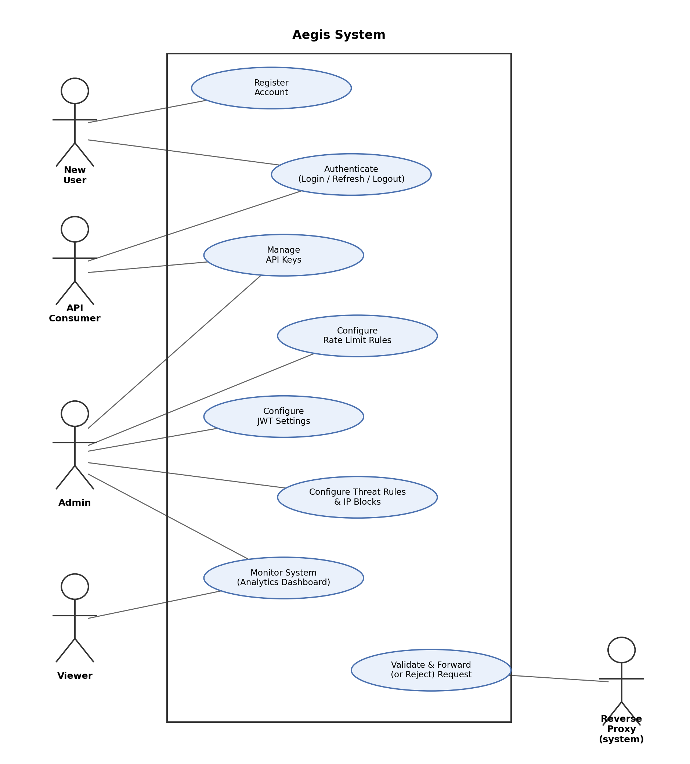
Figure 6.1: Use Case Diagram for Aegis

6.6 Conclusion
This chapter presented the system analysis for Aegis, including user roles, functional requirements grouped by system area, non-functional requirements, and MoSCoW prioritisation. The analysis reflects the system's core purpose of centralising API security enforcement while remaining lightweight and self-hosted, as motivated in Chapter 1.
The use of MoSCoW prioritisation ensures that essential features, authentication, API key management, rate limiting, and JWT validation, are delivered first within the project's timeboxed schedule, while less critical enhancements are implemented only as time permits. These requirements, together with the use case model in Section 6.5.5, provide the foundation for the system design discussed in the next chapter.

Chapter 7: System Design

7.1 Introduction
The Project Proposal defined three principal application components: a FastAPI Control Plane, a Go Reverse Proxy and a React dashboard. The implemented system retains that separation but adds concrete runtime dependencies and policy flows that were necessarily abstract in the proposal. This chapter therefore describes the system as built, using current Compose configuration, SQLAlchemy models, Alembic migrations, Go handler code and dashboard routes as the design authority.

7.2 High-Level Architecture
Aegis separates management-plane concerns from data-plane enforcement. Administrators and viewers use the dashboard, which calls versioned Control Plane REST endpoints. Durable policy and audit records are held in PostgreSQL. Redis stores token revocation state and rate-limit counters. The proxy bootstraps policy through a protected internal REST endpoint, subscribes to authenticated gRPC snapshots, validates each protected request and forwards only after all applicable checks succeed. The upstream service is not changed to understand Aegis credentials.

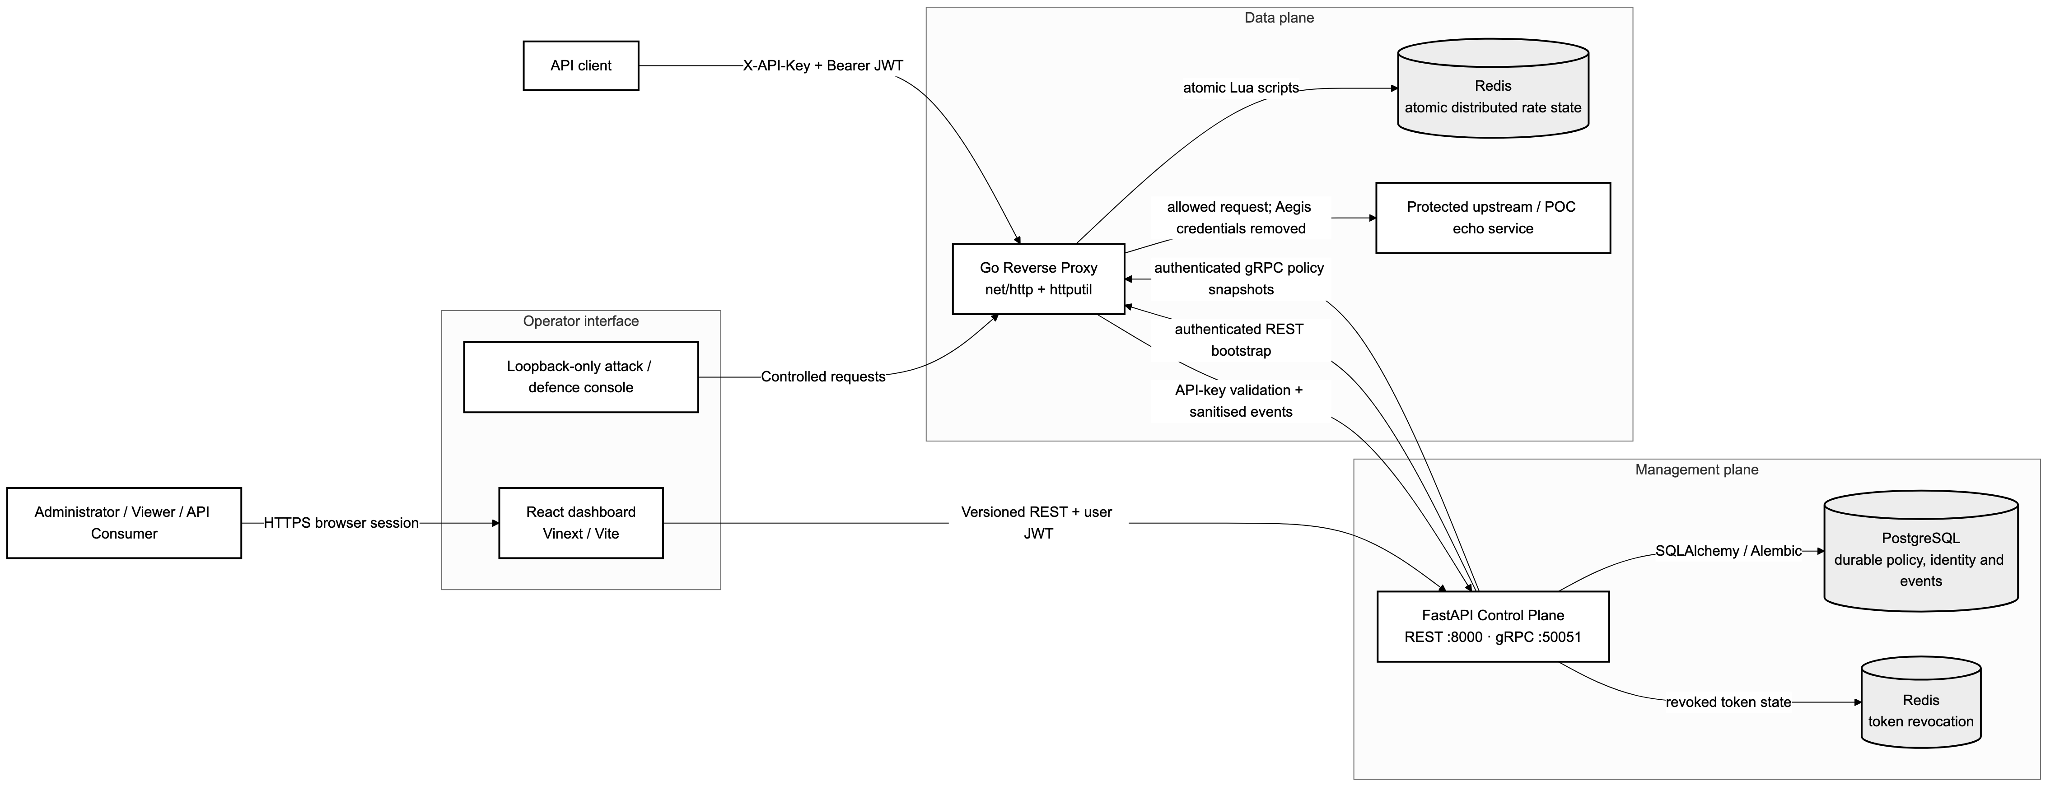
Figure 7.1: Mermaid architecture of the current implemented Aegis components and their real management-plane and data-plane connections.

7.3 Component Responsibilities
Table 7.1: Responsibilities of the implemented Aegis components.
Component | Primary responsibility | Key interfaces and state
FastAPI Control Plane | User/RBAC management and the source of policy truth. | REST API, internal-token endpoints, gRPC policy stream, SQLAlchemy/Alembic.
Go Reverse Proxy | Latency-critical enforcement before upstream forwarding. | net/http, httputil.ReverseProxy, in-memory policy snapshot, Redis scripts, event queue.
React dashboard | Role-aware operator and API-consumer workflows. | Versioned REST calls; in-memory session token; no direct database/proxy configuration.
PostgreSQL | Durable identities, keys, rules, blocks and security events. | Normalised relational schema and indexed lookup fields.
Redis | Shared ephemeral enforcement state. | Atomic rate counters and revoked-token state.
Protected upstream | Existing business API behind Aegis. | Receives allowed requests after Aegis credentials are stripped.

7.4 Domain and Database Design
The current persisted domain contains User, APIKey, RateLimitRule, JWTConfig, ThreatRule, IPBlock, SecurityEvent and RoutePermission. Every entity inherits an integer identifier plus created_at and updated_at audit timestamps. Several resources are soft-disabled instead of deleted so that policy history remains explainable while snapshots propagate. API-key rows contain a hash and non-sensitive prefix rather than the raw key; JWT signing material is encrypted at rest and masked in administrative responses.

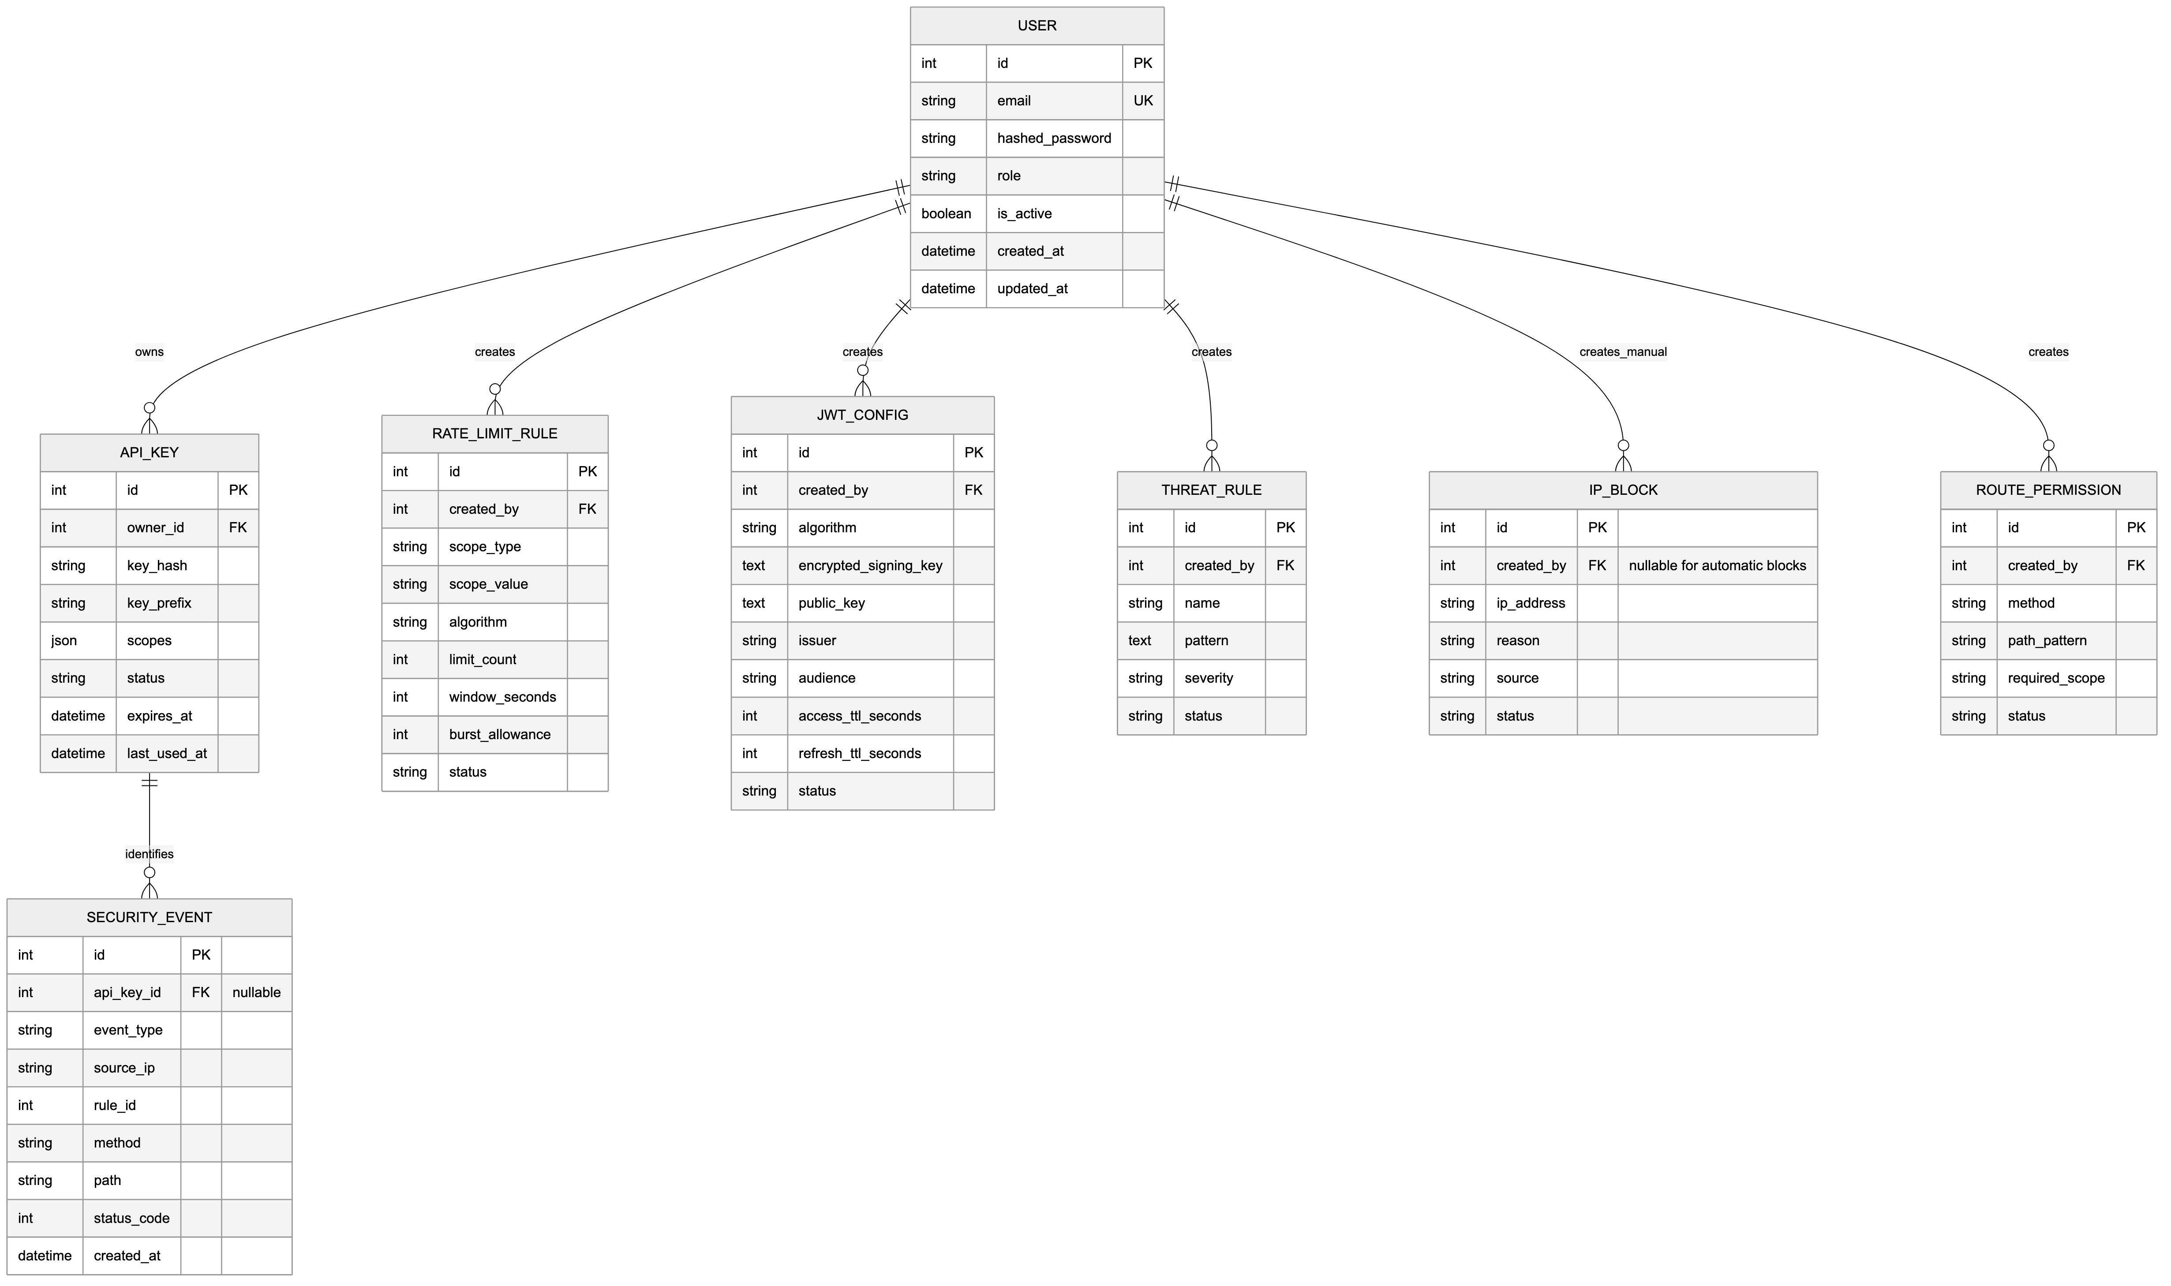
Figure 7.2: Mermaid entity-relationship diagram based on the current SQLAlchemy models and migration constraints.

Administrative JSON does not move directly into a database table. FastAPI first asks the declared Pydantic schema to parse types, required fields, enumerations and cross-field relationships. Authentication and reusable RBAC dependencies then establish who may call the operation. The service layer applies ownership, lifecycle and uniqueness rules before a repository opens the SQLAlchemy transaction. This separation explains why structurally invalid JSON returns 422 before persistence, while valid JSON can still be rejected by an authorisation or domain rule.

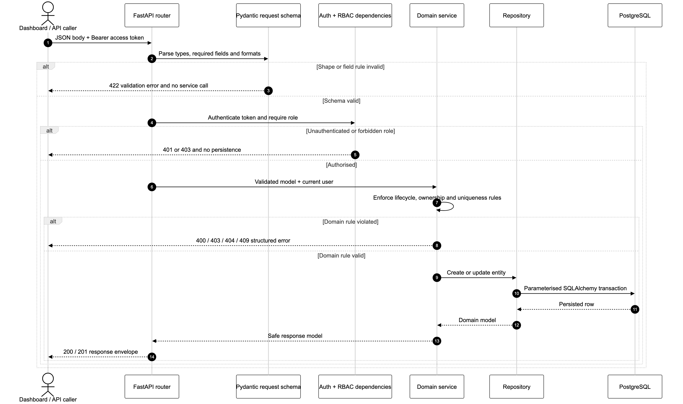
Figure 7.3: Mermaid sequence showing Control Plane JSON validation, RBAC, service rules and persistence boundaries.

Table 7.2: Important domain constraints and their design rationale.
Constraint | Reason
One active JWT configuration | Prevents ambiguous verification material and issuer/audience policy.
One active rate rule per scope | Makes API-key > route > global selection deterministic.
One active block per exact IP | Prevents duplicate active enforcement records while preserving history.
Exact route-permission path | Keeps authorisation explainable; wildcard and query syntax is rejected.
resource:action scope format | A scope such as echo:read becomes meaningful only when a route permission requires it.
Sanitised SecurityEvent | Supports analytics without persisting raw credentials or request bodies.

7.5 Request Validation and Enforcement
The validation order is a security and performance decision. Direct client-IP blocking and request-URI threat detection are evaluated before credential work. API-key validation returns status, expiry and scopes. JWT validation checks signature, expiry, issuer and audience against the active policy. Exact method/path authorisation then determines whether the key contains the required scope. The most specific active rate rule is applied before the proxy removes Aegis credentials and forwards. Every terminal path creates a sanitised security event through a bounded asynchronous reporter.

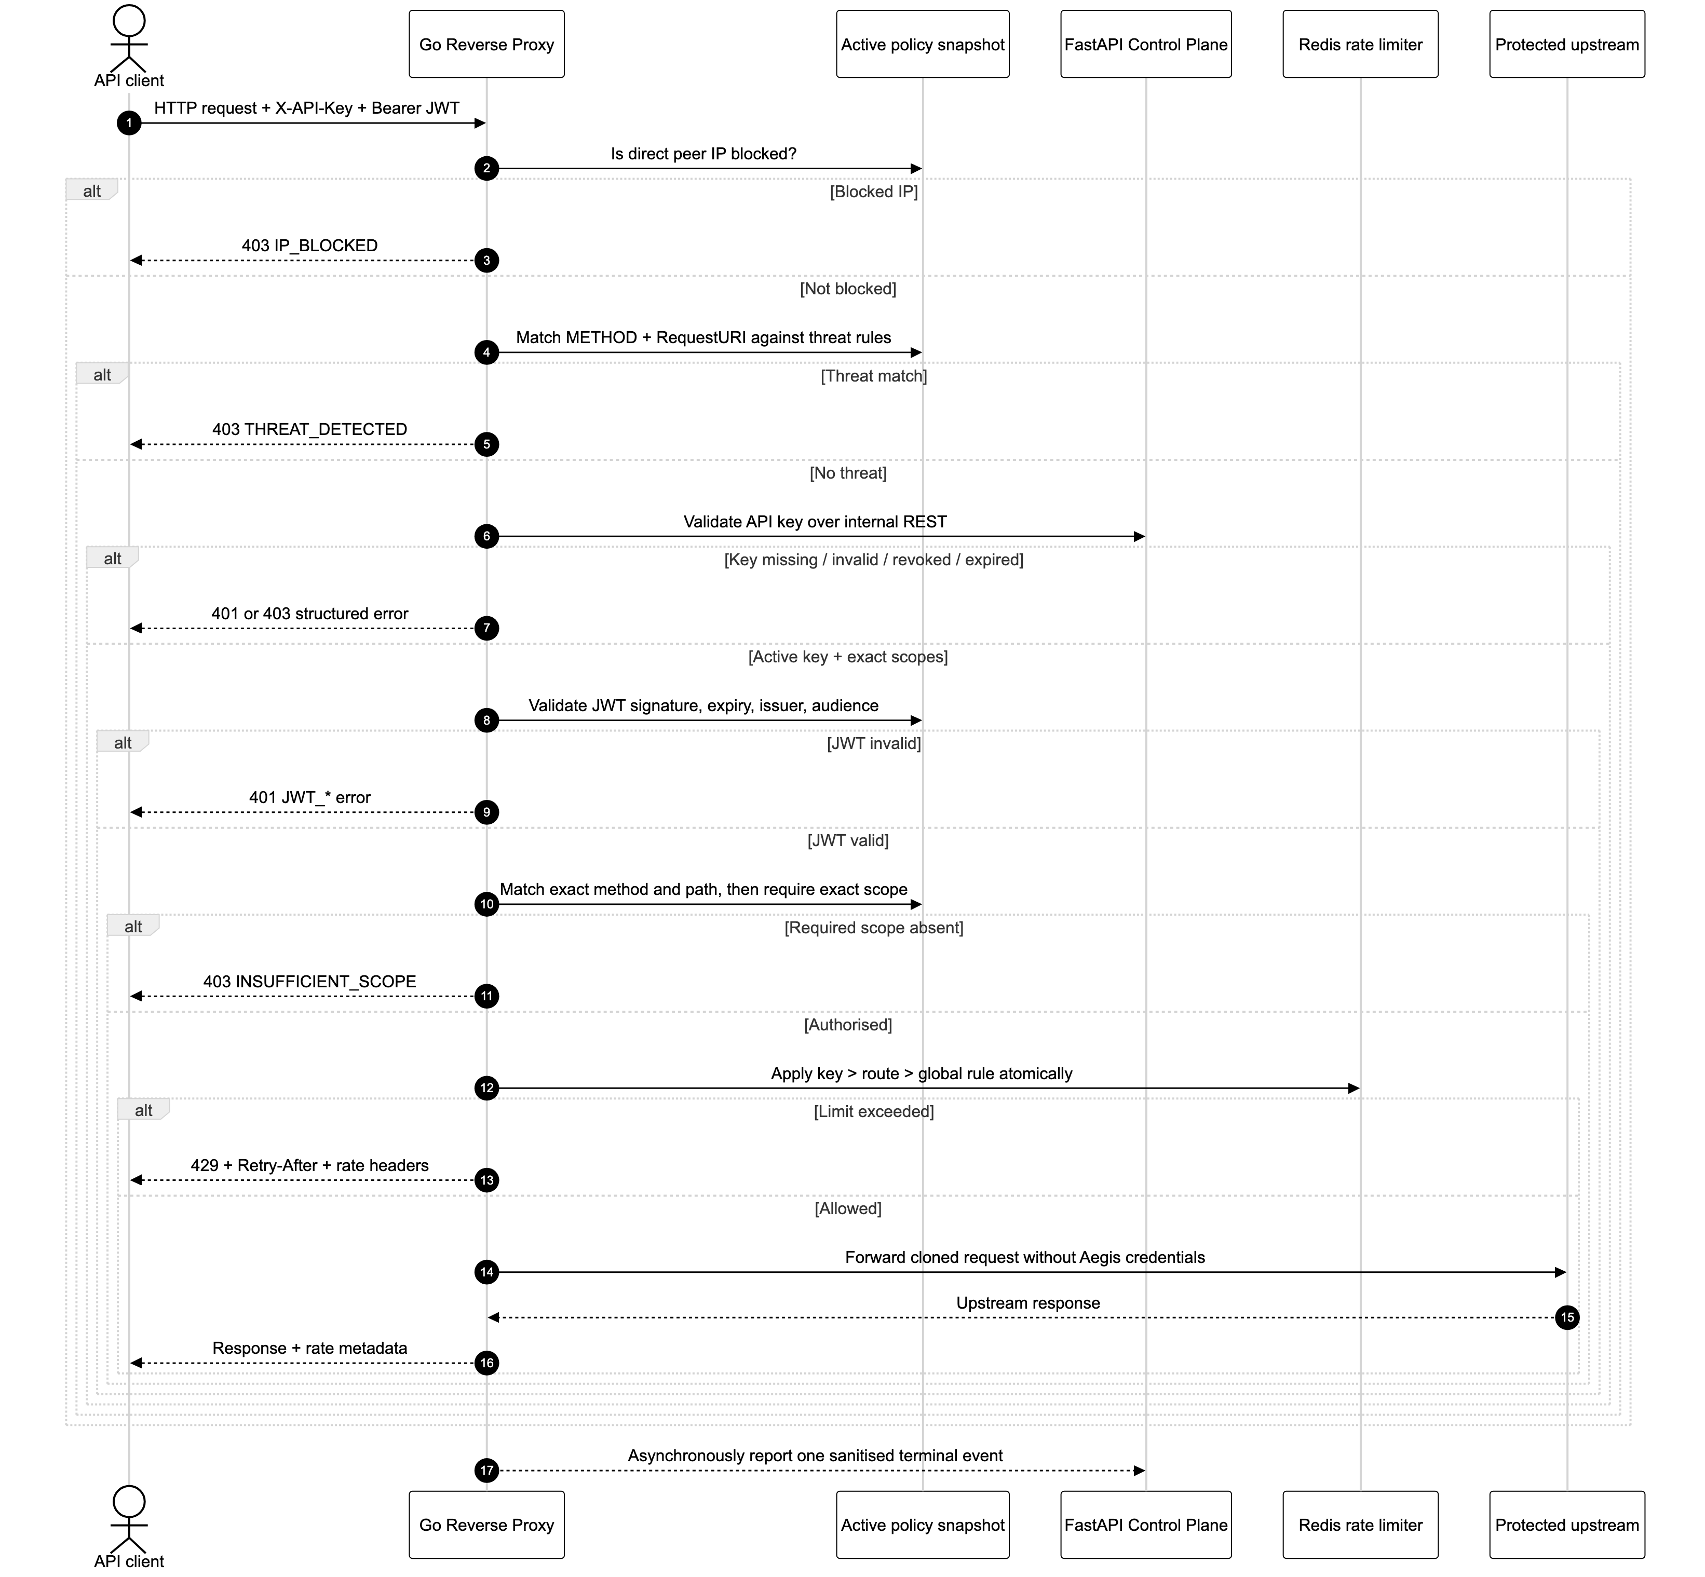
Figure 7.4: Mermaid sequence of the request-validation and enforcement order implemented by the Go proxy handler.

7.6 Scope and Route-Permission Design
The proxy does not infer that the word echo in echo:read refers to a resource. The relationship is explicit data: a RoutePermission states that GET /api/echo requires echo:read and POST /api/echo requires echo:write. When a request matches a permission, the proxy performs an exact string membership test against the validated key's scopes. An unmatched route is currently allowed after authentication; a future deny-by-default mode would require a planned migration to avoid unexpectedly blocking existing services.
Extract 7.1: Current exact route-to-scope authorisation logic from reverse-proxy/internal/proxy/handler.go.
for _, permission := range snapshot.RoutePermissions {
if permission.Method != r.Method || permission.PathPattern != r.URL.Path {
continue
}
if hasScope(keyInfo.Scopes, permission.RequiredScope) {
return nil
}
writeError(w, 403, "INSUFFICIENT_SCOPE", "This API key does not have permission...")
return ErrKeyScopeForbidden
}
return nil

7.7 Policy Synchronisation and Resilience
The proposal called for real-time gRPC synchronisation. In the implemented design, gRPC is not the only source of configuration. The proxy obtains an authenticated REST snapshot during bootstrap and can fall back to REST before its first stream update. The gRPC subscriber then stores a cloned latest snapshot behind a read/write lock. If the stream temporarily fails after a valid snapshot has been received, the proxy continues enforcing that snapshot rather than allowing an outage to remove policy. Internal REST, gRPC and event-reporting endpoints use a separate internal token rather than a user access token.

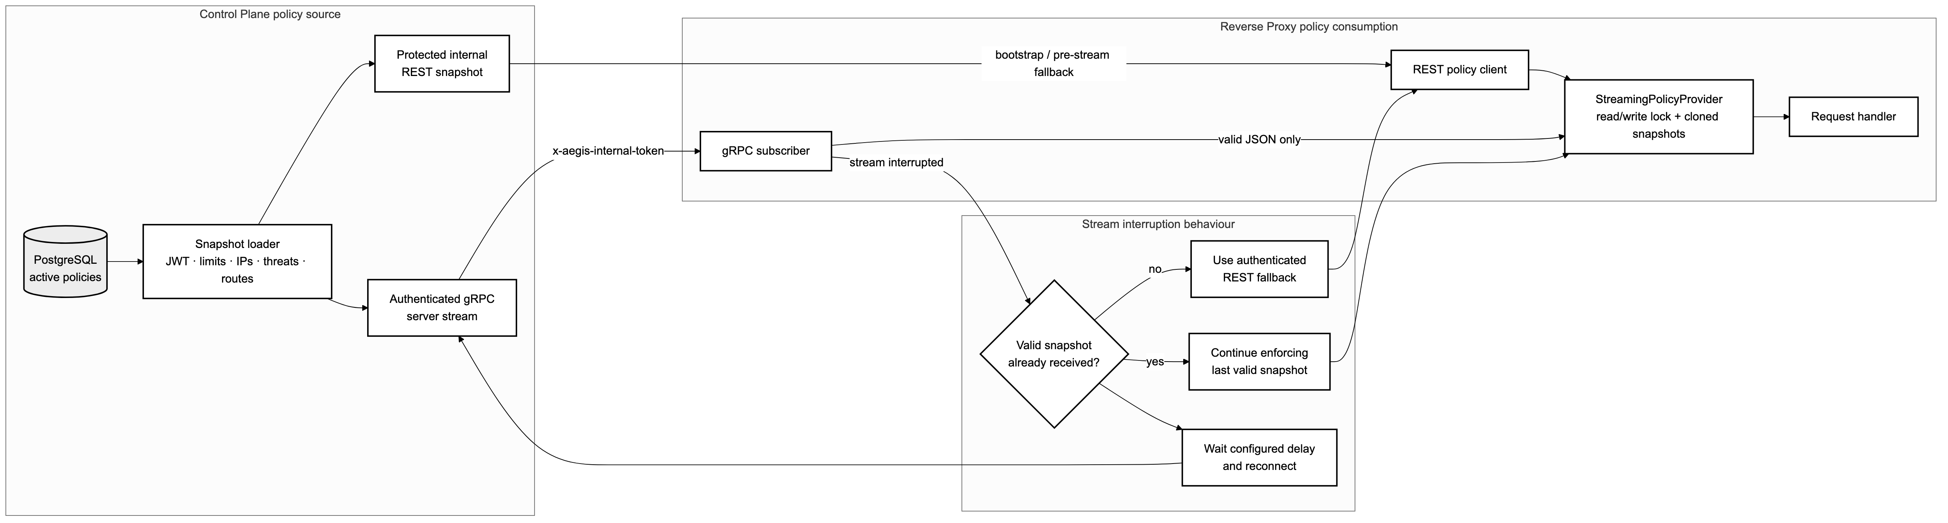
Figure 7.5: Mermaid policy-bootstrap, authenticated gRPC streaming and last-valid-snapshot resilience flow.

Rate-limit policy is deterministic even when several configured rules could apply. The handler selects an API-key-specific rule first, then an exact route rule and finally a global rule. The selected fixed-window, sliding-window or token-bucket algorithm executes as one atomic Redis Lua operation, so concurrent proxy instances share a decision rather than racing through separate reads and writes.

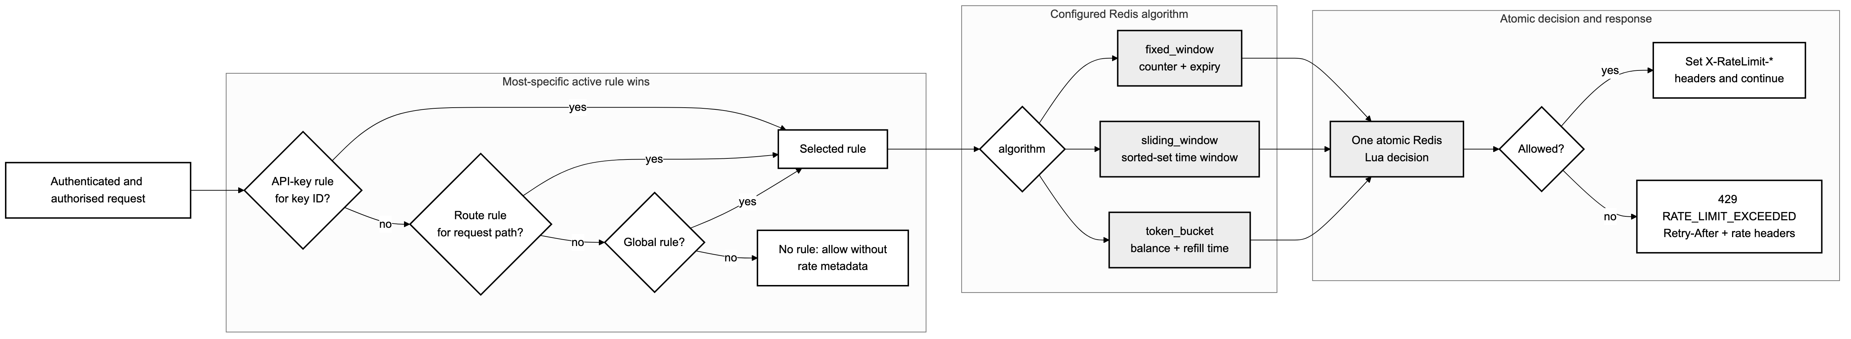
Figure 7.6: Mermaid decision flow for rule precedence, Redis algorithm selection and the 429 response boundary.

Every terminal handler path builds a sanitised event containing only the information needed for auditing and analytics. A bounded non-blocking queue separates reporting from request latency. The Control Plane validates and persists accepted events, aggregates them for authorised dashboard users and can create one active automatic IP block after repeated qualifying violations.

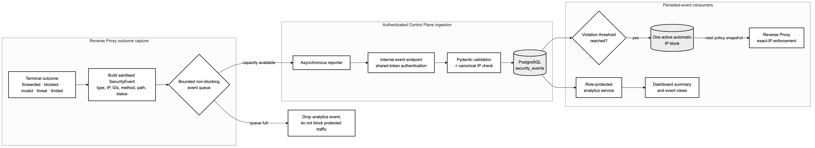
Figure 7.7: Mermaid security-event, analytics and automatic-IP-block pipeline.

7.8 Security Design Decisions and Trade-offs
- The direct peer address is used for IP policy; X-Forwarded-For is ignored until a trusted-proxy model is explicitly configured.
- RE2-compatible threat patterns avoid unsupported backtracking constructs and match METHOD plus RequestURI rather than collecting bodies.
- The proxy strips X-API-Key and Authorization before upstream forwarding, reducing accidental credential exposure.
- Rate limiting uses atomic Redis operations so multiple proxy instances share the same counter state.
- The dashboard improves usability but never becomes the security authority; every mutation remains protected by server-side RBAC.
- The bounded event queue prevents an unavailable analytics path from indefinitely blocking request handling, accepting a documented observability trade-off under saturation.

7.9 Chapter Summary
The implemented design fulfils the proposal's centralised policy and high-performance enforcement direction while making several important relationships explicit: scopes are connected to exact routes, policy is distributed as validated snapshots, and runtime rate state is separated from durable configuration. These decisions allow the behaviour shown in Chapter 9 to be traced to concrete design elements.

Chapter 8: System Implementation

8.1 Introduction
Implementation followed the Project Proposal's technology allocation while adapting to current library and deployment realities. FastAPI and SQLAlchemy implement the management plane, Go's net/http and httputil packages implement the proxy, the dashboard uses React 19 with Vinext/Vite, PostgreSQL stores durable records, and Redis supports shared runtime state. Work is described using the DSDM timeboxes established in Chapter 4, matching the structural approach used by the corrected reference report.

8.2 Timebox 1 - Design Foundations
The first increment established repository boundaries, configuration rules, normalised entities and the request-enforcement contract. Environment settings are validated at application startup, database evolution is captured in forward Alembic migrations, and API responses use a consistent status/message/data envelope. The resulting design kept the Control Plane authoritative without requiring the Go proxy to query PostgreSQL for every request.

8.3 Timebox 2 - Control Plane Foundation
The Control Plane is organised into routers, Pydantic schemas, services, repositories and SQLAlchemy models. Routers handle HTTP concerns and dependencies; services apply ownership, role and lifecycle rules; repositories isolate asynchronous persistence. Passwords are hashed, access and refresh tokens are differentiated, and logout places the access token identifier in Redis. Admin, Viewer and API Consumer permissions are enforced through reusable dependencies rather than through client-side navigation alone.
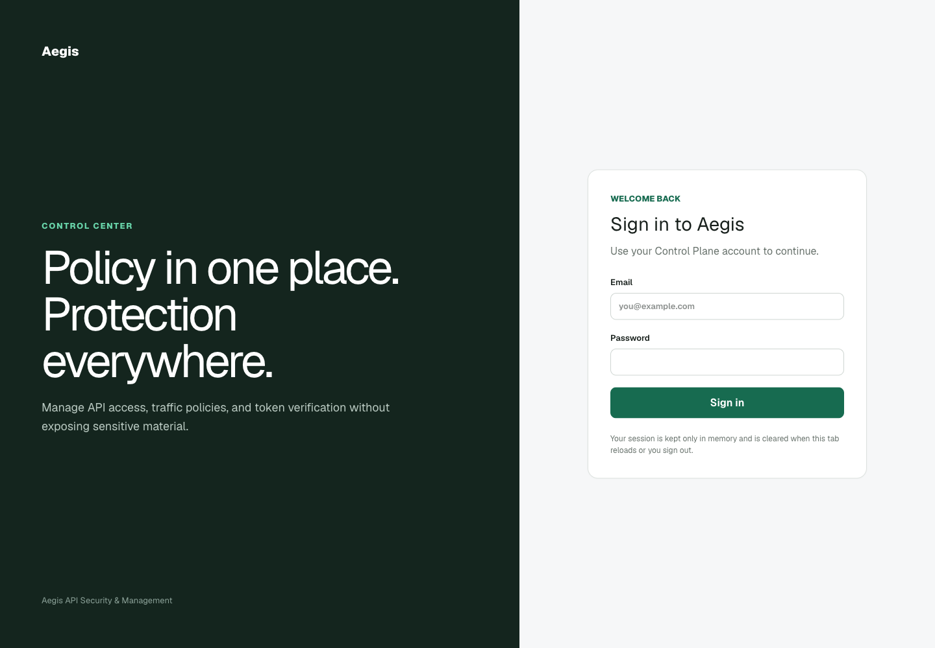
Figure 8.1: Actual Aegis dashboard login interface captured from the running local application.

8.4 Timebox 3 - API Keys and Policy Resources
API keys are generated from cryptographically secure random material. Only the digest and a short prefix are persisted; the raw key is returned once in the create response. API Consumers can view and revoke their own keys, while Admins can manage broader policy resources. Rate-limit rules validate the relationship between scope_type and scope_value. JWT configurations validate algorithm/key combinations and require access-token TTL to be shorter than refresh-token TTL. Threat rules reject constructs outside the Go RE2 subset, and exact route permissions validate resource:action scope syntax.
Extract 8.1: Example API-key create payload accepted by the current Pydantic schema.
{
"name": "echo-reader",
"scopes": ["echo:read"],
"expires_at": "2026-12-31T23:59:59Z"
}

8.5 Timebox 4 - Reverse Proxy Enforcement
The proxy uses a single Handler as the security boundary. A request-scoped timeout covers policy and validation work. Errors map to structured JSON codes such as API_KEY_MISSING, API_KEY_REVOKED, JWT_EXPIRED, INSUFFICIENT_SCOPE and RATE_LIMIT_EXCEEDED. Allowed responses expose standard rate-limit metadata; denied responses return before the upstream forwarder is invoked. Credentials are removed from a cloned header map so the original incoming request is not mutated unexpectedly.
Extract 8.2: Credential removal immediately before upstream forwarding.
forwardRequest := r.Clone(r.Context())
forwardRequest.Header = r.Header.Clone()
forwardRequest.Header.Del(h.apiKeyHeader)
forwardRequest.Header.Del("Authorization")
h.forwarder.ServeHTTP(capture, forwardRequest)

8.6 Timebox 5 - Rate Limiting, Threats and Policy Distribution
The Redis rate limiter implements fixed-window, sliding-window and token-bucket algorithms through atomic server-side scripts. Rule precedence is API-key scope, then route scope, then global scope. Threat detection compiles active RE2-compatible patterns and evaluates method plus request URI. Manual blocks are exact canonical IPv4/IPv6 values; automatic blocks are created from repeated qualifying security events when enabled. The gRPC service streams a JSON-encoded policy snapshot at a configured interval after constant-time internal-token authentication.
Extract 8.3: Authenticated Control Plane gRPC policy-stream pattern.
metadata = dict(context.invocation_metadata())
supplied_token = metadata.get("x-aegis-internal-token", "")
if not secrets.compare_digest(supplied_token, self.internal_token):
await context.abort(grpc.StatusCode.UNAUTHENTICATED, "internal authentication failed")

while not context.done():
snapshot = await self.snapshot_loader()
yield PolicySnapshot(json_payload=snapshot.model_dump_json().encode())

8.7 Timebox 6 - Dashboard, Documentation and POC
The dashboard presents role-aware navigation for system health, analytics, users, API keys, rate limits, IP blocks, threat rules and JWT configuration. Access and refresh tokens are kept in React memory rather than browser persistence, reducing exposure to long-lived client storage at the cost of requiring login after reload. The Control Plane also publishes generated OpenAPI documentation, making the request and response contracts directly inspectable during development.
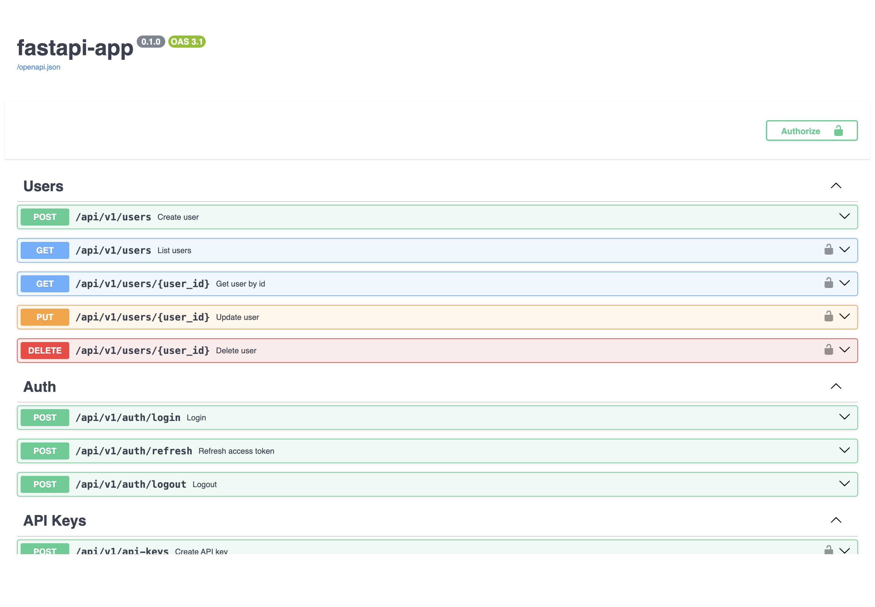
Figure 8.2: Actual FastAPI OpenAPI interface from the running Control Plane.
The POC consists of a deliberately simple echo upstream and a browser attack/defence console. The console relay is restricted to loopback, a fixed /api/echo target and GET/POST methods. Development helpers can seed fresh local-only credentials and load a sanitised summary. This bounded design demonstrates the security controls without turning the POC helper into an arbitrary HTTP proxy.
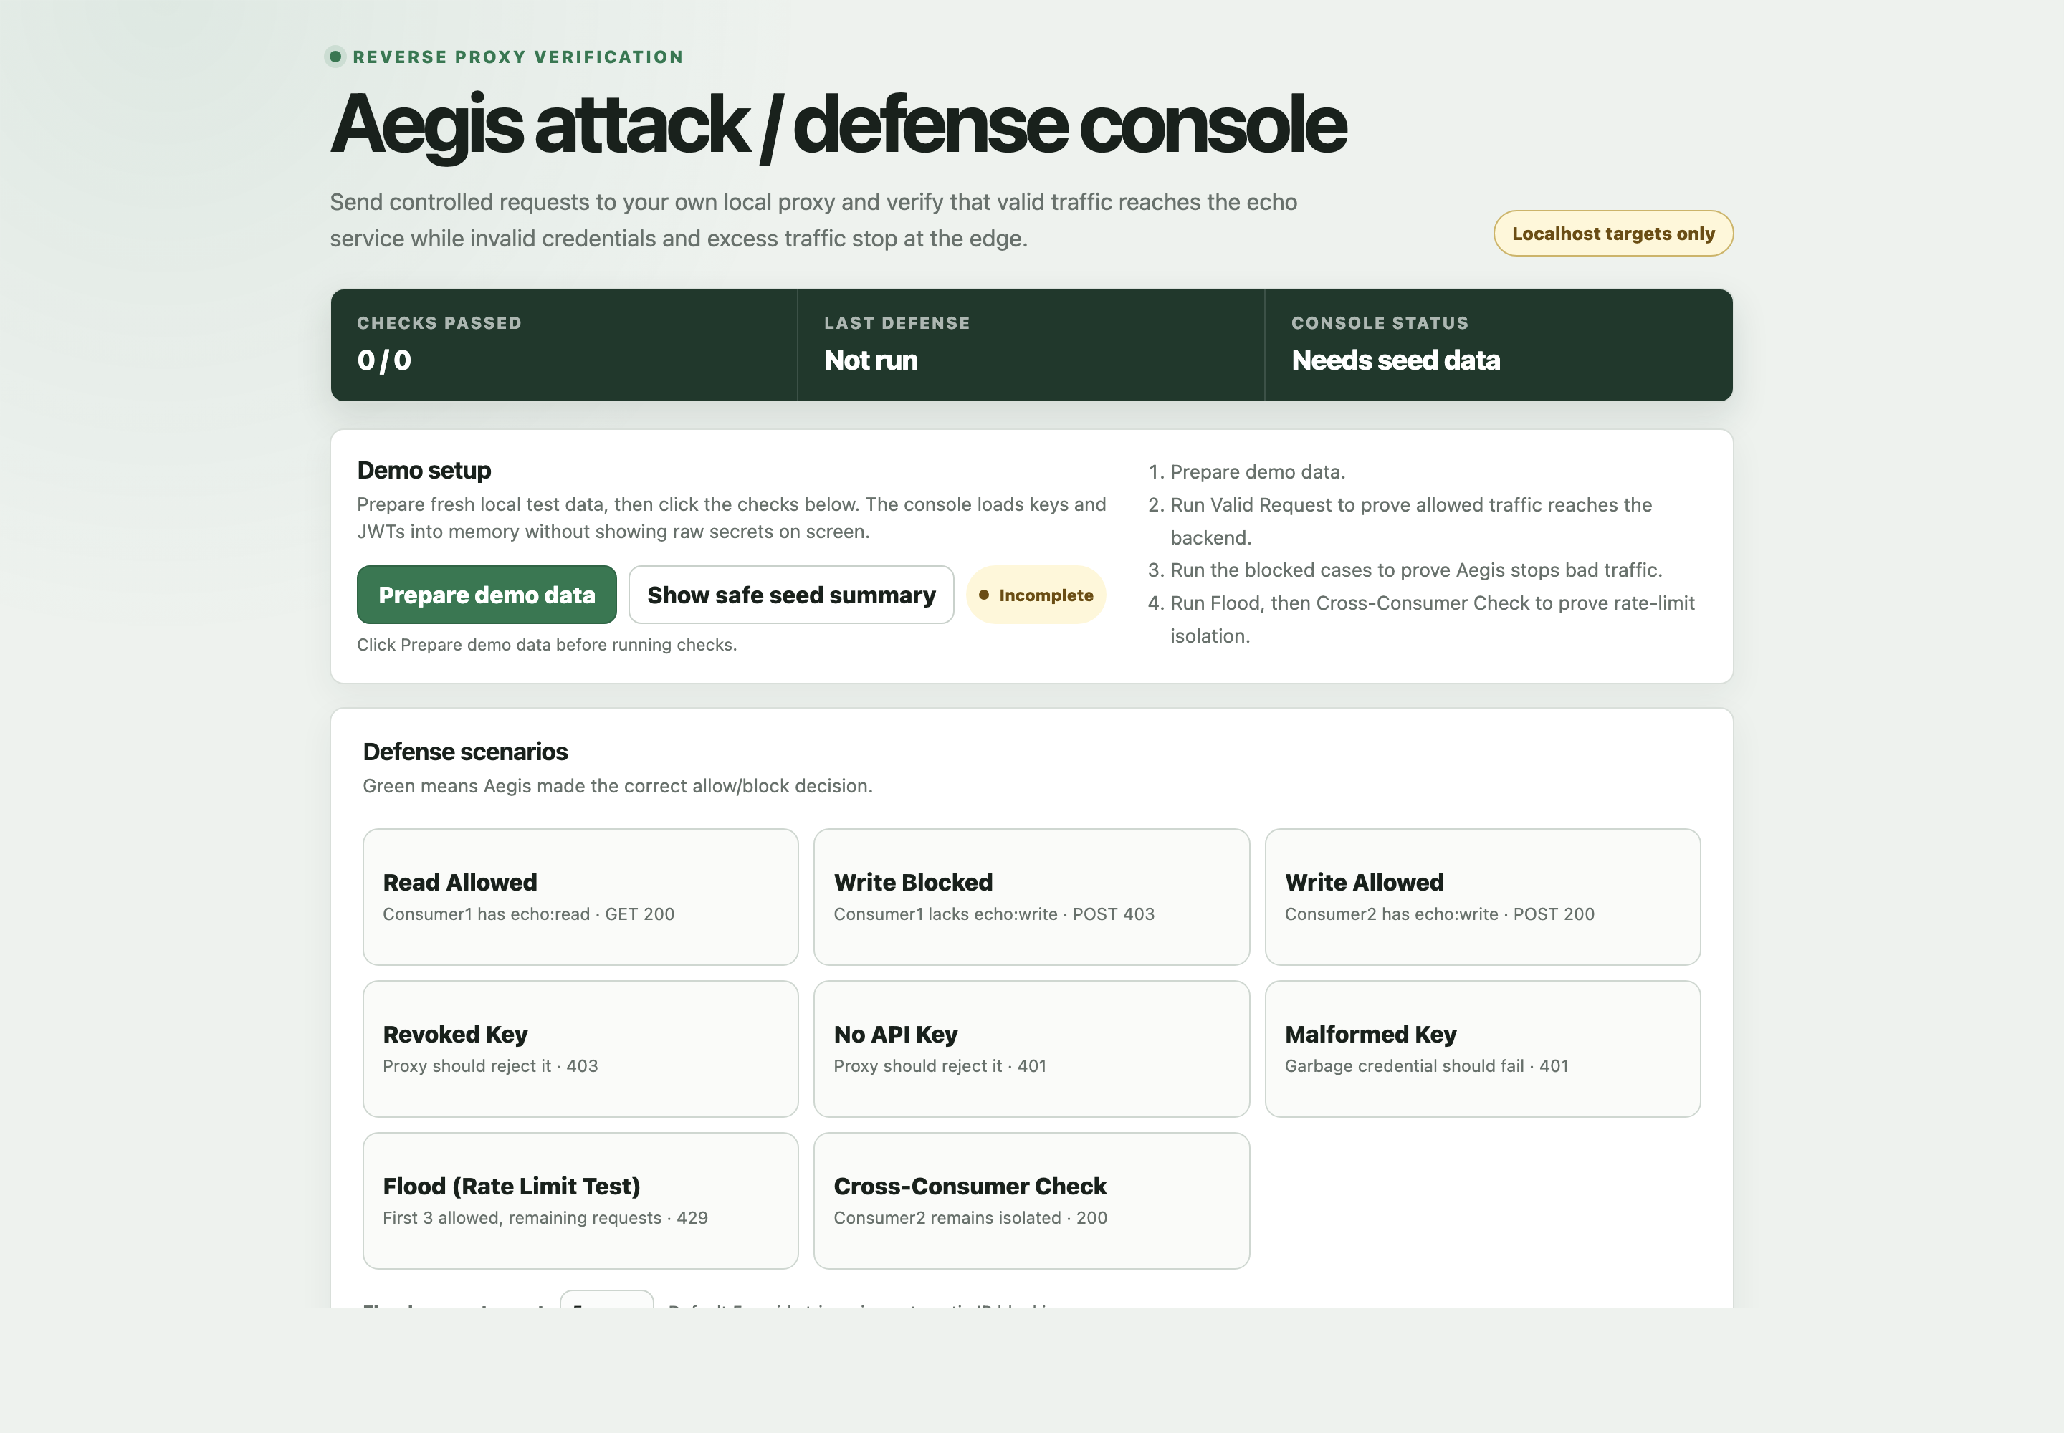
Figure 8.3: Actual Aegis Attack/Defence Console interface captured from the running local POC.

8.8 Proposal-to-Implementation Traceability
Table 8.1: Traceability from the Project Proposal to the current implementation.
Proposal commitment | Implemented evidence | Status
FastAPI Control Plane | Versioned REST, RBAC, repositories, migrations, internal endpoints and analytics. | Implemented
Go Reverse Proxy | Ordered request validation, httputil forwarding, credential stripping and event reporting. | Implemented
React dashboard | Role-aware management and monitoring routes. | Implemented
Distributed rate limiting | Three Redis-backed atomic algorithms with per-key/route/global precedence. | Implemented
JWT validation | HS256/RS256/ES256 configuration with issuer, audience and expiry checks. | Implemented
IP/threat protection | Exact blocks, automatic blocking option and RE2-compatible threat rules. | Implemented
Real-time configuration | REST bootstrap plus authenticated gRPC server stream and last-valid snapshot. | Implemented
Analytics dashboard | Sanitised events, summary views and role-protected UI. | Implemented

8.9 Implementation Challenges
- Maintaining one policy meaning across Python schemas, persisted values, gRPC JSON and Go structures required explicit validation and integration tests.
- Caching improved resilience but required clear behaviour before the first snapshot and during later stream interruptions.
- The meaning of a scope was initially easy to treat as self-explanatory; exact RoutePermission records were needed to bind resource:action names to real requests.
- Client IP policy required rejecting convenient forwarded headers until a trusted reverse-proxy boundary could be configured safely.
- A stale development IP block affected the first POC evidence run, demonstrating why test-environment state must be recorded and controlled.

8.10 Chapter Summary
The implementation converts the proposal's component diagram into a working management and enforcement path. The main achievement is traceability: user-facing configuration maps to persisted constraints, snapshot fields, Go checks, structured errors and observable tests. The next chapter evaluates those claims using completed local evidence.

Chapter 9: Testing

9.1 Introduction
Testing validates the proposal's claim that Aegis can centralise request protection without relying on an unverified demonstration. The strategy combines component tests, static checks, race detection, coverage gates and a live local attack/defence flow. Results in this chapter were observed on 2 August 2026. Screenshots were created from the corresponding local outputs; raw API keys, passwords and JWT values were excluded.

9.2 Testing Strategy
- Control Plane: pytest tests for authentication, ownership, API keys, policy resources, analytics, internal snapshots and gRPC behaviour, with application coverage reporting.
- Reverse Proxy: Go unit/integration tests, the race detector, go vet, gofmt and an enforcement-core coverage threshold.
- Dashboard: lint/build checks plus rendered HTML tests for login, role navigation and key management/analytics views.
- POC/tooling: echo-service, console relay and development-helper tests.
- Live evidence: fresh seeded users/keys/JWT sent through the actual proxy to the actual echo upstream.

9.3 Automated Quality Suite
Table 9.1: Completed automated checks and observed results.
Check | Observed result | Coverage of behaviour
Control Plane pytest | 47 passed; 77% application coverage | RBAC, key lifecycle, rules, JWT, blocks, analytics, snapshots, gRPC and route permissions.
Go proxy | race/vet/gofmt pass; 83.4% core coverage | Concurrency, policy providers, handler outcomes, Redis algorithms and forwarding.
Dashboard | lint/build pass; 6 rendered HTML tests | Login, role-specific navigation and management views.
POC/tooling | 13 tests pass | Echo upstream, restricted relay and dev-only helper behaviour.

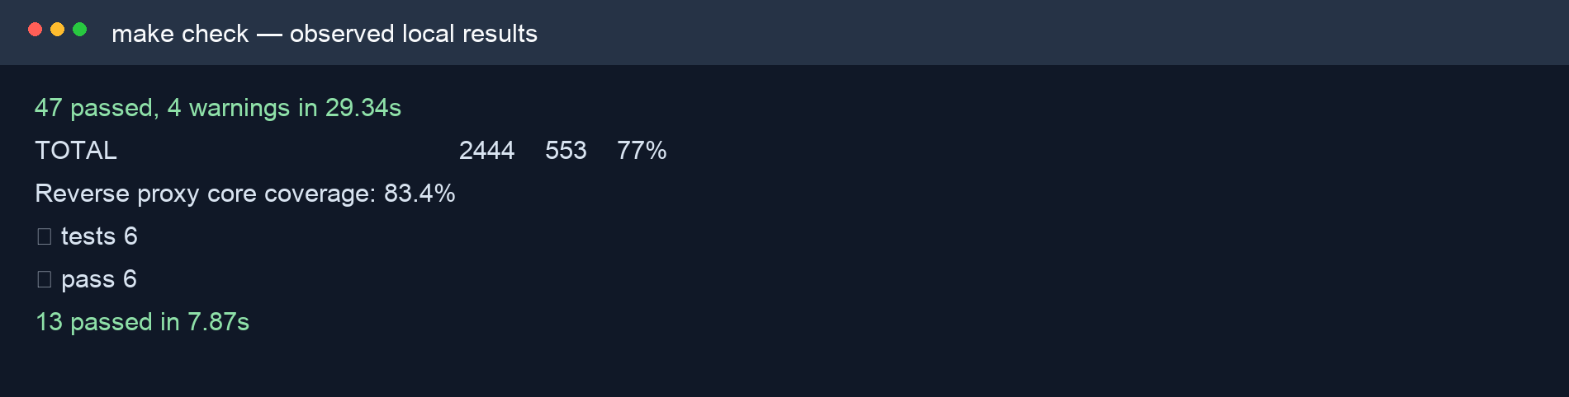
Figure 9.1: Extract of the actual local make check output showing passing suites and coverage results.

9.4 Live Attack/Defence POC
The live console was seeded with fresh development-only data and sent constrained /__aegis_probe requests through the running loopback proxy to /api/echo. Consumer 1 held echo:read; Consumer 2 held echo:read and echo:write. Exact RoutePermission records required echo:read for GET and echo:write for POST. This arrangement proves that the scope strings have enforceable meaning rather than merely appearing in JSON metadata.
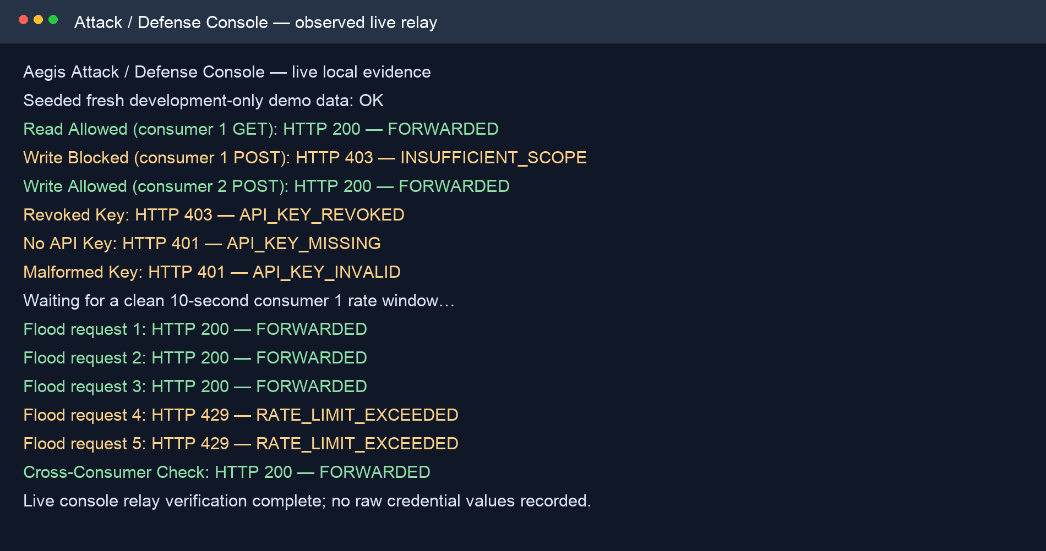
Figure 9.2: Actual live POC relay evidence confirming forwarding, scope denial, credential failures, rate limiting and per-consumer isolation.
Table 9.2: Live POC scenarios and observed enforcement outcomes.
Scenario | Observed HTTP result | Interpretation
Consumer 1 GET | 200 FORWARDED | Key, JWT and echo:read satisfy the exact GET permission.
Consumer 1 POST | 403 INSUFFICIENT_SCOPE | The key lacks echo:write; the upstream is not called.
Consumer 2 POST | 200 FORWARDED | The required write scope is present.
Revoked key | 403 API_KEY_REVOKED | Lifecycle state is enforced after key lookup.
No/malformed key | 401 API_KEY_MISSING / API_KEY_INVALID | Credential errors terminate before forwarding.
Five-request flood | 200, 200, 200, 429, 429 | The key-scoped Redis rule permits three requests per ten seconds.
Cross-consumer check | 200 FORWARDED | Consumer 2 is isolated from Consumer 1's counter.

9.5 Defect and Environment Handling
The first live attempt returned IP_BLOCKED for every case. Investigation found an active manual block for 127.0.0.1 in the local Control Plane. The record was soft-disabled through the authenticated administrative endpoint and the evidence was rerun with fresh seeded data. This was not treated as a proxy defect: the proxy correctly enforced existing policy. Recording the condition protects the validity of the test and demonstrates why reproducible security testing includes environment-state checks.

9.6 End-to-End Docker Verification
The isolated Docker Compose end-to-end script completed successfully on 21 August 2026 using disposable ports, volumes and generated credentials. It confirmed Control Plane, PostgreSQL and Redis health; dashboard readiness; login and policy creation; authenticated gRPC snapshot delivery; a successful proxy-to-upstream request; invalid and revoked credential rejection; manual and automatic exact-IP blocking; request-target threat detection; a 200, 200, 429 Redis rate sequence; and analytics aggregation. The script removed its isolated stack after completion, while a redacted checkpoint log was retained as primary evidence.
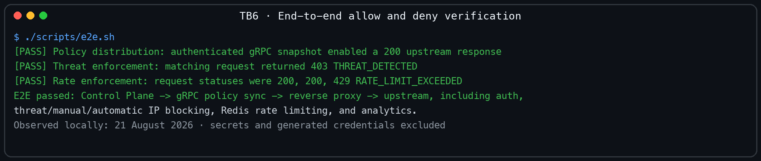
Figure 9.3: Redacted output from the completed isolated Docker end-to-end verification on 21 August 2026.
Evidence rule: Only completed observations are claimed. The embedded E2E evidence is generated from the current run log and excludes generated credentials and secrets.

9.7 Limitations of Testing
- The completed evidence validates functional enforcement and component behaviour but is not a statistically rigorous throughput benchmark.
- The POC uses loopback services and fresh development credentials; production TLS termination, orchestration and remote network behaviour require deployment testing.
- Threat matching tests cover method/request-URI patterns rather than payload inspection, consistent with the current design boundary.
- Dashboard checks validate rendered routes and important interactions but do not constitute a full accessibility study with representative users.
- The isolated Docker E2E validates one local Compose topology; remote TLS termination, orchestration, load, failure injection and long-running soak behaviour remain outside this evidence.

9.8 Chapter Summary
The completed test evidence supports the core Aegis claim: policy records are converted into observable allow and deny decisions before the upstream service. The quality suite covers each technology component, while the live POC connects scopes, credentials and Redis state to real HTTP outcomes. Remaining integration and performance evidence is stated transparently rather than inferred.

Chapter 10: Evaluation and Reflection

10.1 Evaluation Against the Aim
The Project Proposal aimed to design and develop a production-ready API security and management system that provides central protection through request validation, rate limiting and threat detection while demonstrating Python/FastAPI, Go and React skills (Htun Khaing Lynn, 2026). The current project achieves the central architectural and learning aim: policy is managed in the FastAPI Control Plane and enforced by the Go proxy before an upstream request is possible. The React dashboard and POC make that behaviour observable, and the completed isolated Compose run verifies the integrated local topology. The term production-ready should nevertheless be qualified because deployment-specific TLS, trusted-proxy handling, load benchmarking, operational rotation and long-running resilience testing remain future work.

10.2 Evaluation of Objectives
Table 10.1: Evaluation of the Project Proposal objectives against current evidence.
Objective | Evaluation | Evidence
Research existing solutions | Achieved | Commercial/open-source comparison and literature synthesis in Chapters 2-3.
Define requirements and roles | Achieved | MoSCoW analysis, RBAC and current persisted policies in Chapter 6.
Design architecture and workflows | Achieved | Current architecture, domain and sequence diagrams in Chapter 7.
Implement the full stack | Achieved | FastAPI, Go, React, PostgreSQL, Redis, gRPC and POC described in Chapter 8.
Test security behaviour | Achieved for the project scope | Passing component suites, focused scope tests, live enforcement and completed isolated Docker E2E.
Evaluate the result | Achieved with limitations | Comparison, strengths, limitations, reflection and future work in this chapter.

10.3 Comparison with Existing Products
Kong, APISIX, Tyk, AWS API Gateway and Cloudflare provide broader ecosystems, managed availability, extensive plugins and established operational tooling. Aegis does not replace those products. Its value is a focused, self-hosted and explainable implementation in which the student controls the policy model, request order, rate algorithms and audit shape. This makes security decisions easier to reverse-learn than in a platform where behaviour is distributed across plugins and vendor infrastructure.

10.4 Strengths
- Management-plane/data-plane separation prevents common policy decisions from depending on a per-request PostgreSQL query.
- The enforcement sequence applies inexpensive source/threat checks before credentials, authorisation and rate limiting.
- Exact RoutePermission records make scope semantics explicit and testable.
- Cryptographic key generation, one-time raw-key disclosure and hashed persistence reduce credential exposure.
- Atomic Redis algorithms support shared counters across proxy instances.
- Sanitised security events and credential stripping reduce unnecessary sensitive-data propagation.
- The POC demonstrates a real upstream outcome and per-consumer isolation rather than only mocked service calls.

10.5 Limitations
- Exact route matching does not yet support reviewed wildcard, parameter or deny-by-default policies.
- Threat detection is pattern matching over method and request URI, not request-body inspection or a complete web application firewall.
- Direct-peer IP handling is safe for the current topology but needs an explicit trusted-proxy configuration for load-balanced deployment.
- The current dashboard has automated route checks but limited formal usability and accessibility evaluation with end users.
- Performance has not been evaluated with controlled hardware, concurrent load profiles and percentile latency measurements.
- The completed Docker E2E proves the isolated local stack, but it does not replace production-like TLS, distributed deployment, failure-injection or throughput evidence.

10.6 Reflection on Development and Learning
The most important technical learning was the difference between recognising a credential and authorising a resource operation. A key can validly contain ["echo:read"], but that string has no inherent knowledge of the echo service. The later route-permission model explicitly maps GET /api/echo to echo:read. This small data structure made the authorisation boundary clearer than embedding route names in handler conditions.
Go required a more explicit approach to dependencies and failure paths than the initial Python work. Handler interfaces made policy providers, key validation, JWT validation, rate limiting, event reporting and forwarding independently testable. Context timeouts and cloned headers exposed practical HTTP concerns that are easy to miss when learning reverse proxies conceptually. Python/FastAPI made schema validation and REST organisation productive, but also reinforced that validation rules must remain consistent with Go's accepted snapshot values.
The POC run also provided a process lesson. The unexpected loopback block was correct system behaviour caused by persistent environment state. Treating it as evidence, finding the policy record and rerunning after a traceable soft-disable was more valuable than forcing a green screenshot. The isolated Docker run was then repeated to completion with disposable state and redacted checkpoint logging. These decisions reflect professional responsibility and improve confidence in the report.

10.7 Future Improvements
- Design parameterised/wildcard route permissions with conflict analysis and a staged deny-by-default option.
- Add trusted-load-balancer configuration and CIDR policy only after defining exactly which forwarded headers are authoritative.
- Extend the completed reproducible Docker E2E with repeatable load benchmarks, failure injection and documented hardware and latency percentiles.
- Add signing-key rotation, policy version history, audit diffing and operational alert integrations.
- Conduct dashboard accessibility auditing and task-based usability sessions with Admin, Viewer and API Consumer participants.
- Assess body-aware detection separately, including privacy, memory/latency cost, payload limits and false-positive handling.

10.8 Final Conclusion
Aegis demonstrates that a focused custom reverse proxy can centralise meaningful API security controls while remaining understandable from database record to HTTP result. The project does not claim the breadth or operational maturity of a commercial gateway. Its contribution is a coherent learning implementation whose main behaviours are inspectable, testable and connected to the original proposal. With the identified deployment hardening and evidence gaps addressed, it provides a credible foundation for further production-oriented development.

References
Agile Business Consortium (2014) The DSDM Agile Project Framework. Tunbridge Wells: Agile Business Consortium.
Amazon Web Services (2026) Control access to HTTP APIs with JWT authorizers. Available at: https://docs.aws.amazon.com/apigateway/latest/developerguide/http-api-jwt-authorizer.html (Accessed: 2 August 2026).
Apache APISIX (2026) rate-limit and jwt-auth plugin documentation. Available at: https://apisix.apache.org/docs/apisix/plugins/ (Accessed: 2 August 2026).
Cloudflare (2026) API Gateway and rate limiting documentation. Available at: https://developers.cloudflare.com/api-shield/ (Accessed: 2 August 2026).
Docker Inc. (2026) Docker Compose documentation. Available at: https://docs.docker.com/compose/ (Accessed: 2 August 2026).
Fielding, R.T. (2000) Architectural Styles and the Design of Network-based Software Architectures. PhD thesis. University of California, Irvine.
Htun Khaing Lynn (2026) Aegis: API Security and Management System - Project Proposal. Unpublished project proposal.
Indrasiri, K. and Kuruppu, D. (2020) gRPC: Up and Running. Sebastopol: O'Reilly Media.
Jones, M., Bradley, J. and Sakimura, N. (2015) JSON Web Token (JWT). RFC 7519. Internet Engineering Task Force. Available at: https://www.rfc-editor.org/rfc/rfc7519 (Accessed: 2 August 2026).
Kong Inc. (2026) Rate limiting plugin documentation. Available at: https://developer.konghq.com/plugins/rate-limiting/ (Accessed: 2 August 2026).
Newman, S. (2021) Building Microservices: Designing Fine-grained Systems. 2nd edn. Sebastopol: O'Reilly Media.
Oliveira, G. (2022) Rate-limiting algorithm discussion cited in the Aegis Project Proposal.
OWASP Foundation (2023) OWASP API Security Top 10 2023. Available at: https://owasp.org/www-project-api-security/ (Accessed: 2 August 2026).
PostgreSQL Global Development Group (2026) PostgreSQL documentation. Available at: https://www.postgresql.org/docs/ (Accessed: 2 August 2026).
Redis Ltd. (2026) Redis command and scripting documentation. Available at: https://redis.io/docs/latest/ (Accessed: 2 August 2026).
The Go Authors (2026) Package net/http and httputil documentation. Available at: https://pkg.go.dev/net/http (Accessed: 2 August 2026).
Tyk Technologies (2026) Rate limiting documentation. Available at: https://tyk.io/docs/api-management/rate-limit/ (Accessed: 2 August 2026).
W3C (2018) Web Content Accessibility Guidelines (WCAG) 2.1. Available at: https://www.w3.org/TR/WCAG21/ (Accessed: 2 August 2026).

Appendix A: Valid Example JSON Payloads
These examples match the current Pydantic request schemas. Values are illustrative development data, not secrets copied from the test environment.

A.1 Create API key
{
"name": "echo-reader",
"scopes": [
"echo:read"
],
"expires_at": "2026-12-31T23:59:59Z"
}

A.2 Create key-scoped fixed-window rule
{
"name": "consumer-one-demo-limit",
"scope_type": "api_key",
"scope_value": "12",
"algorithm": "fixed_window",
"limit_count": 3,
"window_seconds": 10,
"burst_allowance": null,
"status": "active"
}

A.3 Create global sliding-window rule
{
"name": "global-baseline",
"scope_type": "global",
"scope_value": null,
"algorithm": "sliding_window",
"limit_count": 120,
"window_seconds": 60,
"burst_allowance": null,
"status": "active"
}

A.4 Create exact route permission
{
"method": "GET",
"path_pattern": "/api/echo",
"required_scope": "echo:read",
"status": "active"
}

A.5 Create threat rule
{
"name": "basic-sql-union",
"pattern": "(?i)(GET|POST)\\s+.*union(%20|\\+)select",
"severity": "high",
"status": "active"
}

A.6 Create manual IP block
{
"ip_address": "203.0.113.42",
"reason": "Repeated prohibited requests during controlled test",
"status": "active"
}

A.7 Create HS256 JWT configuration
{
"name": "development-jwt",
"algorithm": "HS256",
"signing_key": "replace-with-a-long-development-secret",
"public_key": null,
"issuer": "aegis-control-plane",
"audience": "aegis-proxy",
"access_token_ttl_seconds": 900,
"refresh_token_ttl_seconds": 604800
}
Why scopes look like ["echo:read"]: scopes is an array because one key may hold several permissions. Each value uses resource:action naming for readability. The string is not automatic discovery: RoutePermission records explicitly bind a method/path to the required string.

Appendix B: Selected Test Case Matrix
Table B.1: Selected functional and security test cases derived from current automated and live checks.
ID | Feature | Input/condition | Expected result
TC-01 | Register user | Valid email/name/password | 201; password stored only as a hash
TC-02 | Login | Valid seeded user | 200; access and refresh tokens
TC-03 | RBAC mutation | Viewer creates rate rule | 403 forbidden
TC-04 | Create API key | name/scopes/expiry | Raw key returned once; metadata persists
TC-05 | List API keys | Existing key | Prefix/metadata only; no raw key/hash
TC-06 | Revoke API key | Active owned key | Status revoked; proxy later returns 403
TC-07 | JWT expiry | Expired Bearer token | 401 JWT_EXPIRED
TC-08 | Route scope | POST with echo:read | 403 INSUFFICIENT_SCOPE
TC-09 | Route scope | POST with echo:write | 200 forwarded
TC-10 | Missing API key | No X-API-Key header | 401 API_KEY_MISSING
TC-11 | Threat pattern | Matching method/request URI | 403 THREAT_DETECTED
TC-12 | Manual IP block | Blocked direct peer | 403 IP_BLOCKED
TC-13 | Fixed window | Five requests; limit three | 200, 200, 200, 429, 429
TC-14 | Counter isolation | Second consumer after first floods | 200; separate key scope
TC-15 | Credential stripping | Allowed request | Upstream receives neither Aegis credential
TC-16 | gRPC authentication | Wrong internal token | UNAUTHENTICATED
TC-17 | Policy resilience | Stream interruption after snapshot | Last valid snapshot remains available
TC-18 | Threat schema | Look-ahead/backreference regex | 422 RE2-incompatible pattern
TC-19 | Route schema | Wildcard/query path | 422 exact-path validation error
TC-20 | Analytics privacy | Proxy event | No raw API key, JWT or body stored

Appendix C: Evidence and Reproducibility Index
Table C.1: Traceability from report claims to local evidence.
Evidence | Command/source | Result used in report
Automated quality gate | make check | 47 Python tests; 77% app coverage; Go race/vet/gofmt; 83.4% core; 6 dashboard; 13 POC.
Live POC relay | POST /__aegis_seed then /__aegis_probe | Allowed/denied scopes, credential errors, rate limit and key isolation.
Architecture diagram | Compose, app.main, proxy main/handler and dashboard routes | Figure 7.1.
Domain diagram | SQLAlchemy models plus Alembic migrations | Figure 7.2.
Control Plane sequence | FastAPI routers, Pydantic schemas, RBAC dependencies, services and repositories | Figure 7.3.
Proxy sequence | reverse-proxy/internal/proxy/handler.go | Figure 7.4.
Policy/rate/event flows | gRPC subscriber, policy provider, Redis limiter and event reporter | Figures 7.5-7.7.
Dashboard/OpenAPI/POC UI | Running localhost services | Figures 8.1-8.3.
Docker E2E | make e2e | Completed on 21 August 2026; redacted checkpoints verify health, gRPC policy sync, proxy forwarding, denial controls, Redis limits and analytics.

