AEGIS PROJECT REPORT
Chapter 7
System Design
Htun Khaing Lynn | Student ID: 001557481
Aegis: API Security and Management System

7.1 Design Overview
The implemented design follows the proposal’s three-component direction but the details are now verified against the current codebase. FastAPI is the Control Plane and policy source of truth; Go is the data-plane enforcement layer; React is the dashboard. PostgreSQL stores durable policy/audit data and Redis is shared runtime state. The dashboard never directly configures the proxy, and the proxy does not query PostgreSQL on every request.

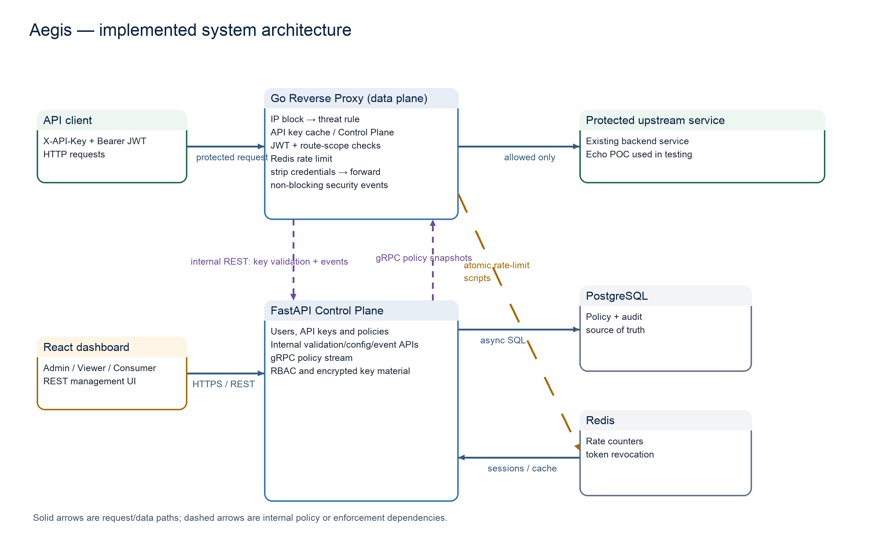
Figure 7.1: Actual Aegis system architecture, derived from the current FastAPI, Go, React, Docker Compose and POC code.

7.2 Component Responsibilities
Component | Responsibility | Important interface
Control Plane | Defines policy, ownership, RBAC, active configuration and analytics. | Versioned REST; internal token routes; gRPC PolicySync stream.
Reverse Proxy | Enforces IP/threat/credential/scope/rate decisions then forwards allowed traffic. | HTTP request path, policy snapshot, Redis scripts, async event post.
Dashboard | Role-aware operator and consumer experience. | REST calls to Control Plane only.
PostgreSQL | Durable users, keys, policies, blocks and events. | SQLAlchemy/Alembic source of truth.
Redis | Shared rate counters and auth revocation support. | Atomic Lua-style scripts through go-redis.

7.3 Database and Domain Design
The domain diagram reflects the actual SQLAlchemy models and forward migrations, which take precedence over earlier prose documentation. Every model inherits audit fields. Soft status changes preserve records which a cached proxy may still refer to while a new snapshot is being distributed.

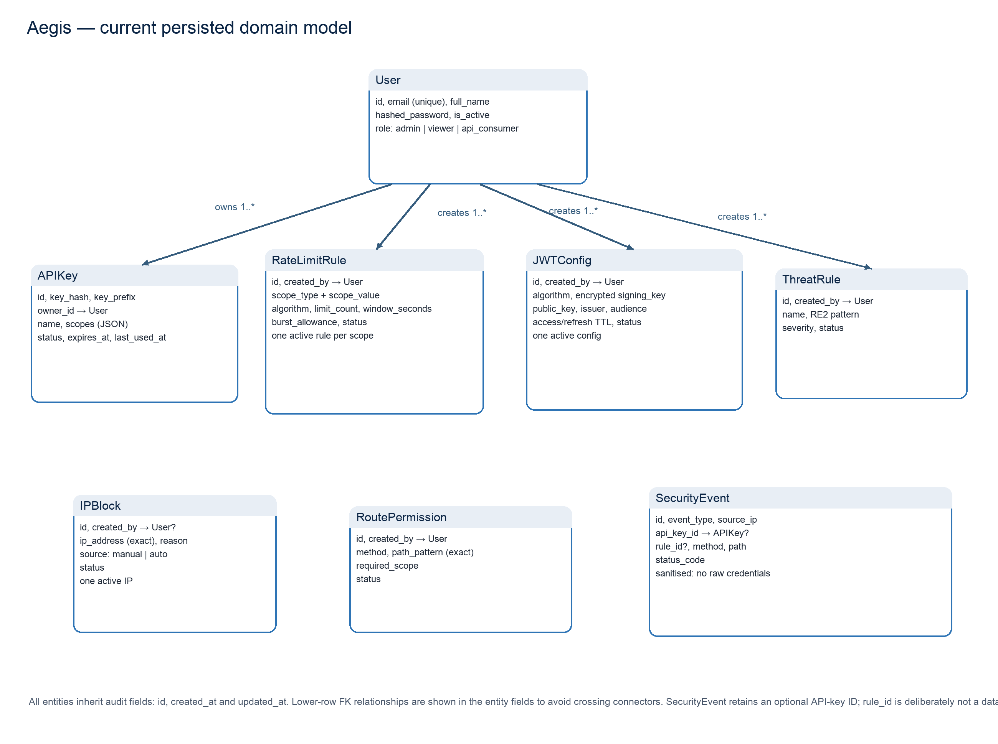
Figure 7.2: Current Aegis persisted domain model, based on actual SQLAlchemy models and Alembic migrations.

Constraint | Design rationale
One active JWT configuration | Avoids ambiguous verification policy; activation deactivates the previous policy.
One active rate rule per scope | Removes conflict when the proxy selects the applicable rule.
One active IP block per address | Retains history while preventing duplicate active records.
Exact route permission | Method and path are explicit; wildcard/query route rules are rejected in current scope.
One-time raw API key | A key hash cannot be re-exposed; prefix remains available for lookup/display.

7.4 Policy Synchronisation
The proxy first obtains a REST policy snapshot through the internal-token endpoint. After that it subscribes to authenticated server-streaming gRPC updates. The streaming provider holds a clone of the latest valid snapshot under a read/write lock. If the stream is unavailable after a snapshot was received, enforcement continues with that snapshot; before any stream update, the REST provider is the fallback. This deliberately prioritises safe continuity over a per-request Control Plane dependency.

7.5 Request-validation Design
Figure 7.3 records the order implemented by Handler.ServeHTTP. The order is consequential. A blocked IP or threat rule avoids expensive credential work. Scope authorization occurs only after both key and JWT validation. Rate limiting occurs before forwarding. Every termination path reports a sanitised event through the bounded event reporter, but event delivery is intentionally outside the latency-critical decision.

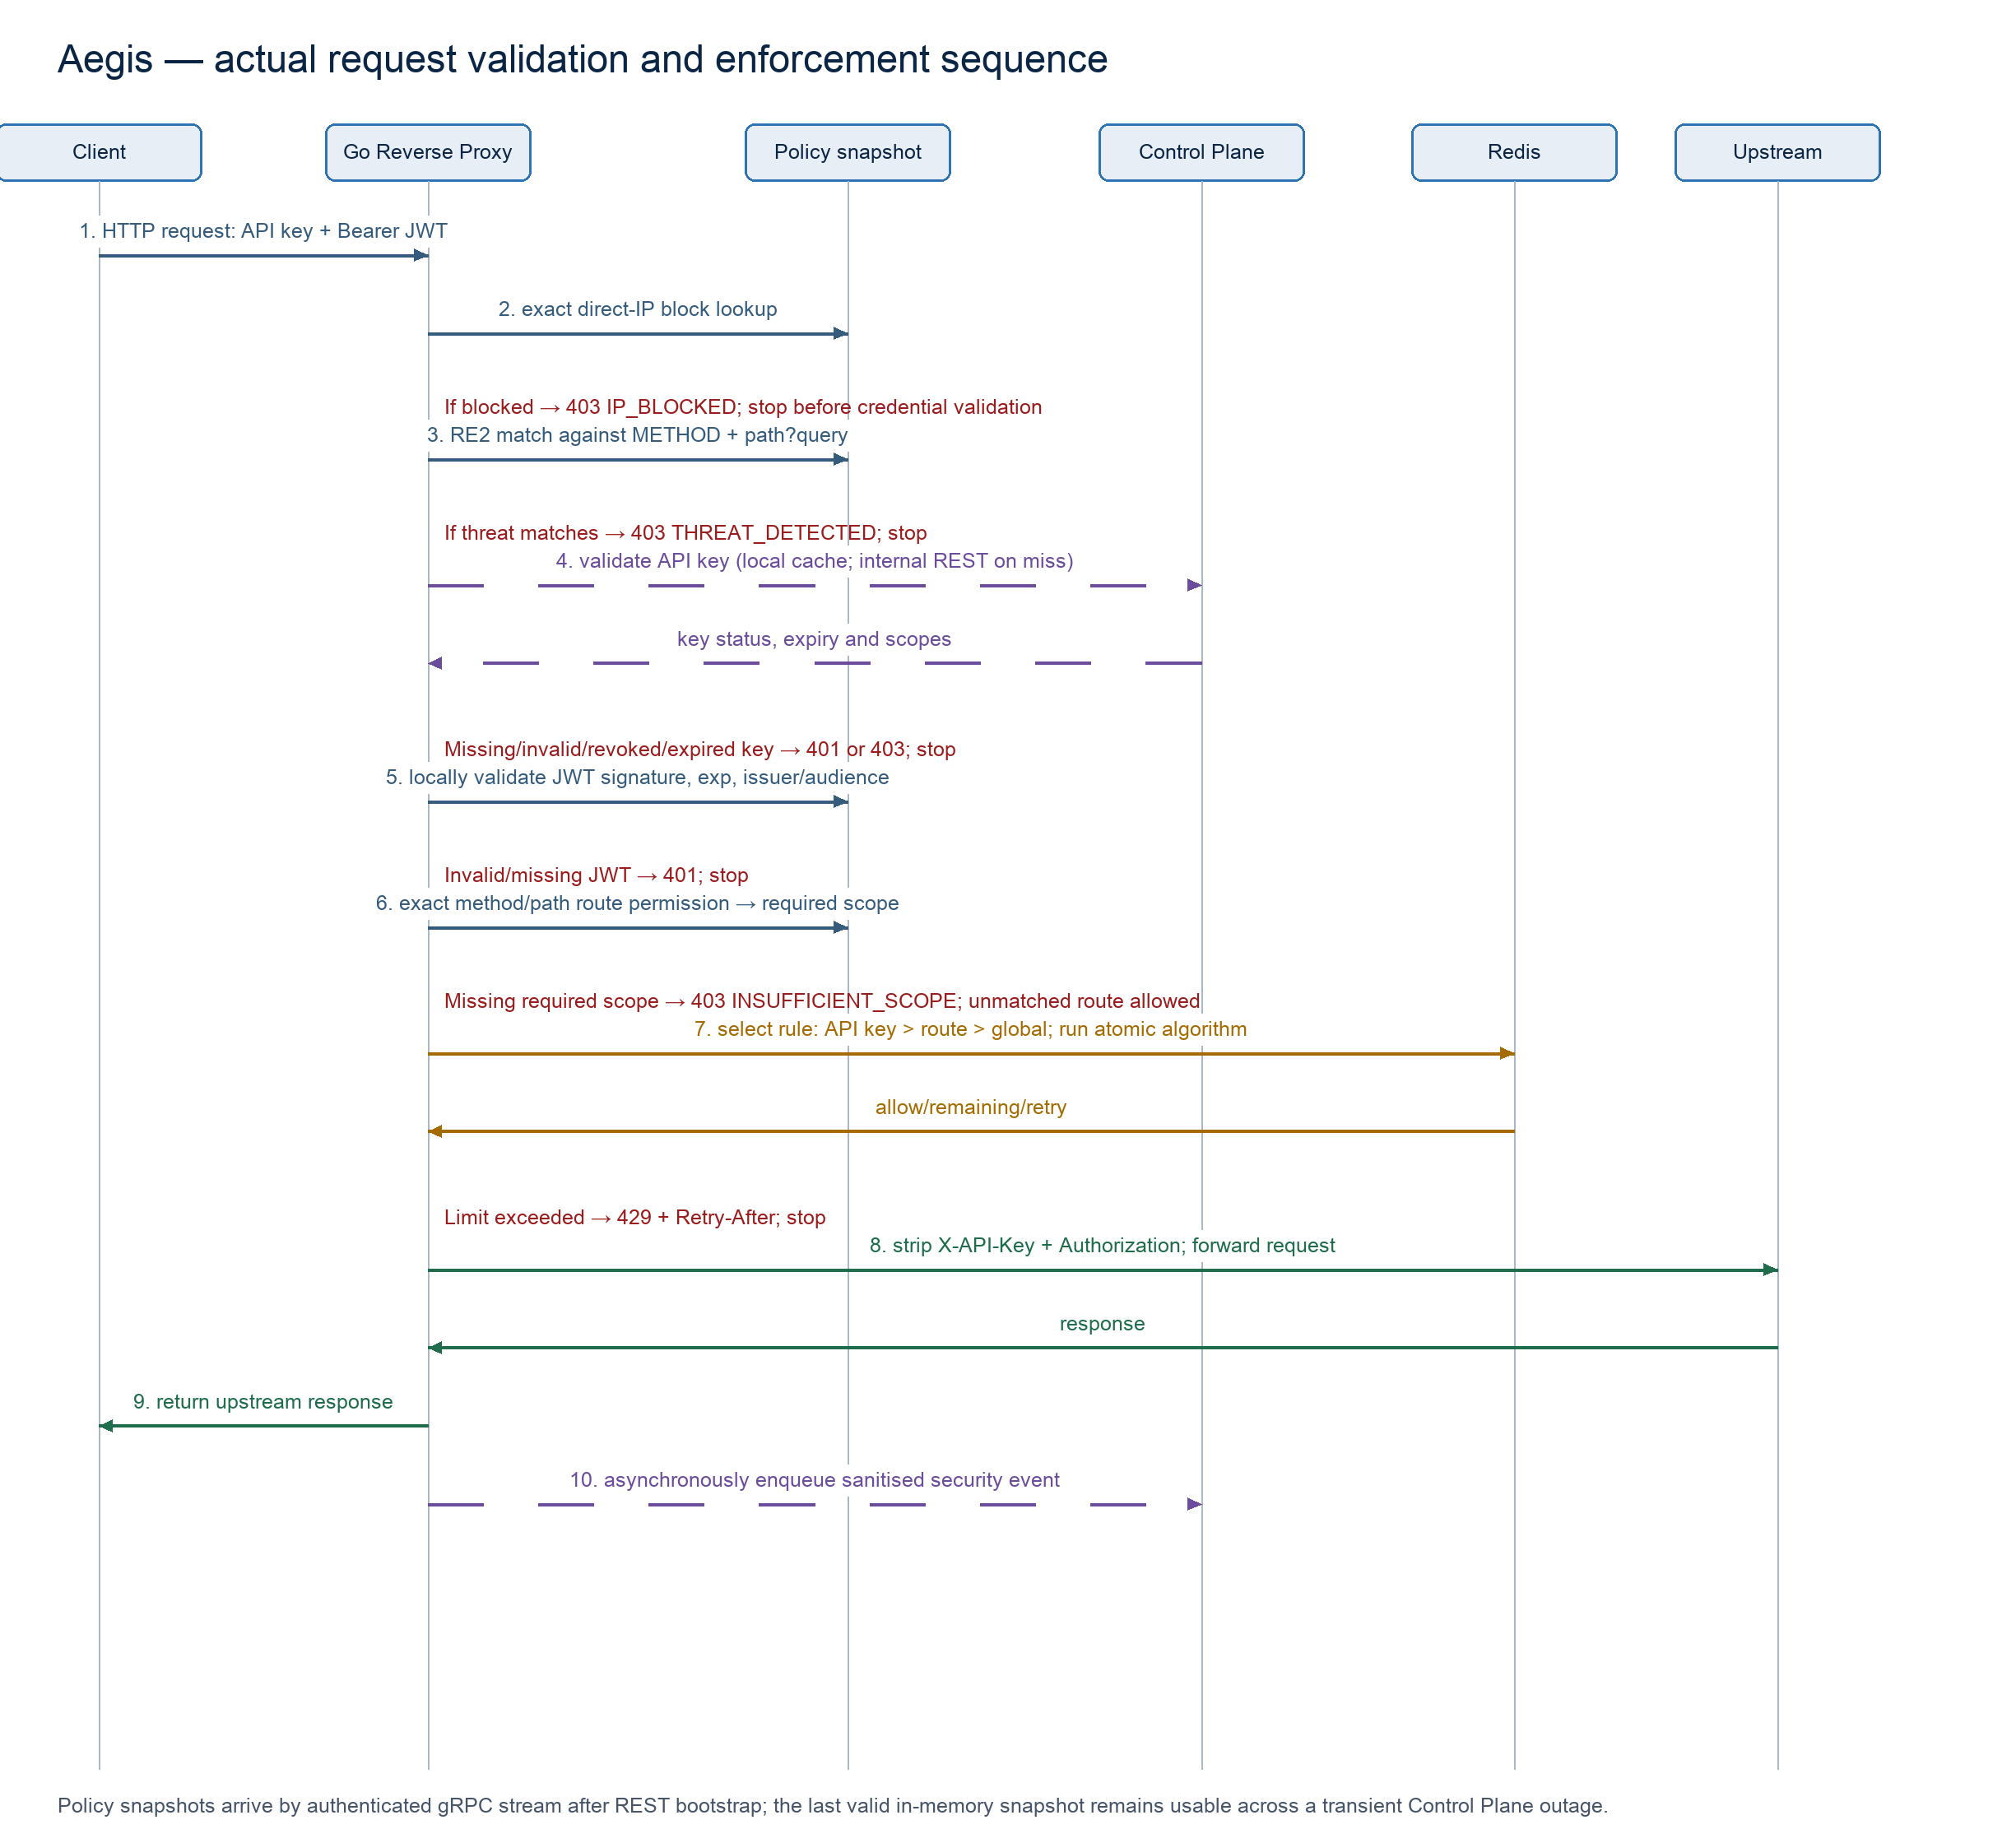
Figure 7.3: Actual core request-validation and enforcement sequence, based on the Go Reverse Proxy handler and its collaborators.

7.6 Security Design Decisions
- The proxy strips X-API-Key and Authorization before forwarding, so the upstream POC service demonstrates it receives no Aegis credentials.
- Threat patterns are constrained to RE2-compatible syntax and inspect only method plus request URI, avoiding body scanning and arbitrary content collection.
- The direct peer address is used for IP decisions; X-Forwarded-For is deliberately ignored unless a future trusted-proxy model is designed.
- Route scope is explicit. GET /api/echo and POST /api/echo can require different scopes even though they share the same path.

References
Agile Business Consortium (2014) The DSDM Agile Project Framework. Tunbridge Wells: Agile Business Consortium.
Fielding, R.T. (2000) Architectural Styles and the Design of Network-based Software Architectures. PhD thesis. University of California, Irvine.
Indrasiri, K. and Kuruppu, D. (2020) gRPC: Up and Running. Sebastopol: O’Reilly Media.
Jones, M., Bradley, J. and Sakimura, N. (2015) JSON Web Token (JWT). RFC 7519. Internet Engineering Task Force. Available at: https://www.rfc-editor.org/rfc/rfc7519 (Accessed: 2 August 2026).
Newman, S. (2021) Building Microservices: Designing Fine-grained Systems. 2nd edn. Sebastopol: O’Reilly Media.
OWASP Foundation (2023) OWASP API Security Top 10 2023. Available at: https://owasp.org/www-project-api-security/ (Accessed: 2 August 2026).
W3C (2018) Web Content Accessibility Guidelines (WCAG) 2.1. Available at: https://www.w3.org/TR/WCAG21/ (Accessed: 2 August 2026).

