AEGIS PROJECT REPORT
Chapter 9
Testing
Htun Khaing Lynn | Student ID: 001557481
Aegis: API Security and Management System

9.1 Testing Strategy
Testing combines automated component checks, cross-component coverage gates, an isolated end-to-end stack and a live local proof of concept. This follows the proposal’s intention to test Python, Go and React components as well as integrations. The results reported below are observed in the workspace on 2 August 2026; screenshots are terminal captures created from the corresponding local command output, with generated development credentials deliberately excluded.

9.2 Automated Quality Suite
Check | Observed result | What it covers
Control Plane pytest + coverage | 47 passed; 77% application coverage | RBAC, API keys, rate rules, JWT config, threats, IP blocks, analytics, policy snapshot, gRPC and route permissions.
Go proxy | go test -race, go vet and gofmt pass; 83.4% core coverage | Concurrency/race checks and hand-written proxy enforcement core.
Dashboard | Lint/build pass; 6 rendered HTML tests pass | Login UI, role navigation, in-memory auth state, IP/threat/analytics views.
POC/tooling | 13 tests pass | Echo service, console relay restrictions and development helpers.

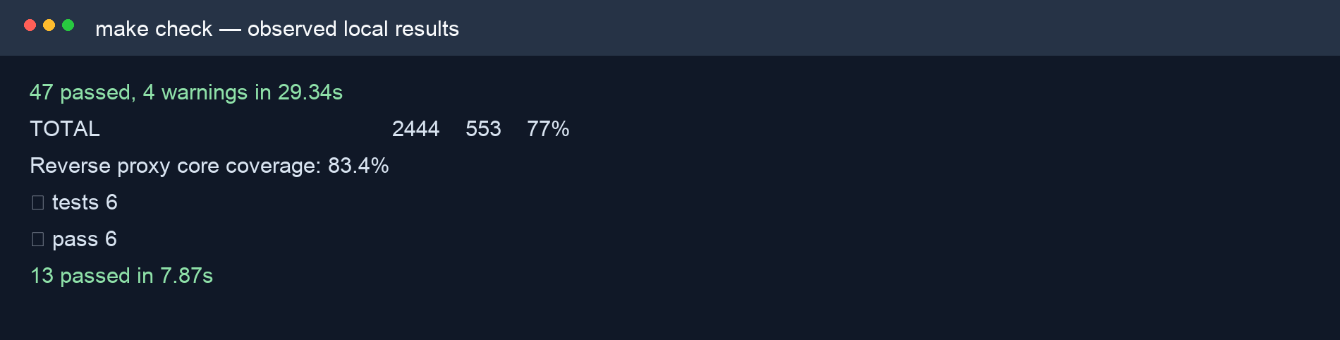
Figure 9.1: Extract of the actual local make check terminal output. It records passing component suites and coverage results.

9.3 Live Attack/Defense POC
The local console was seeded with fresh development-only data and used its constrained /__aegis_probe relay against the running loopback proxy. The relay permits only GET/POST probes to the local /api/echo endpoint. Consumer 1 has echo:read and Consumer 2 has echo:read plus echo:write. This makes the scope result meaningful rather than merely testing an error status.
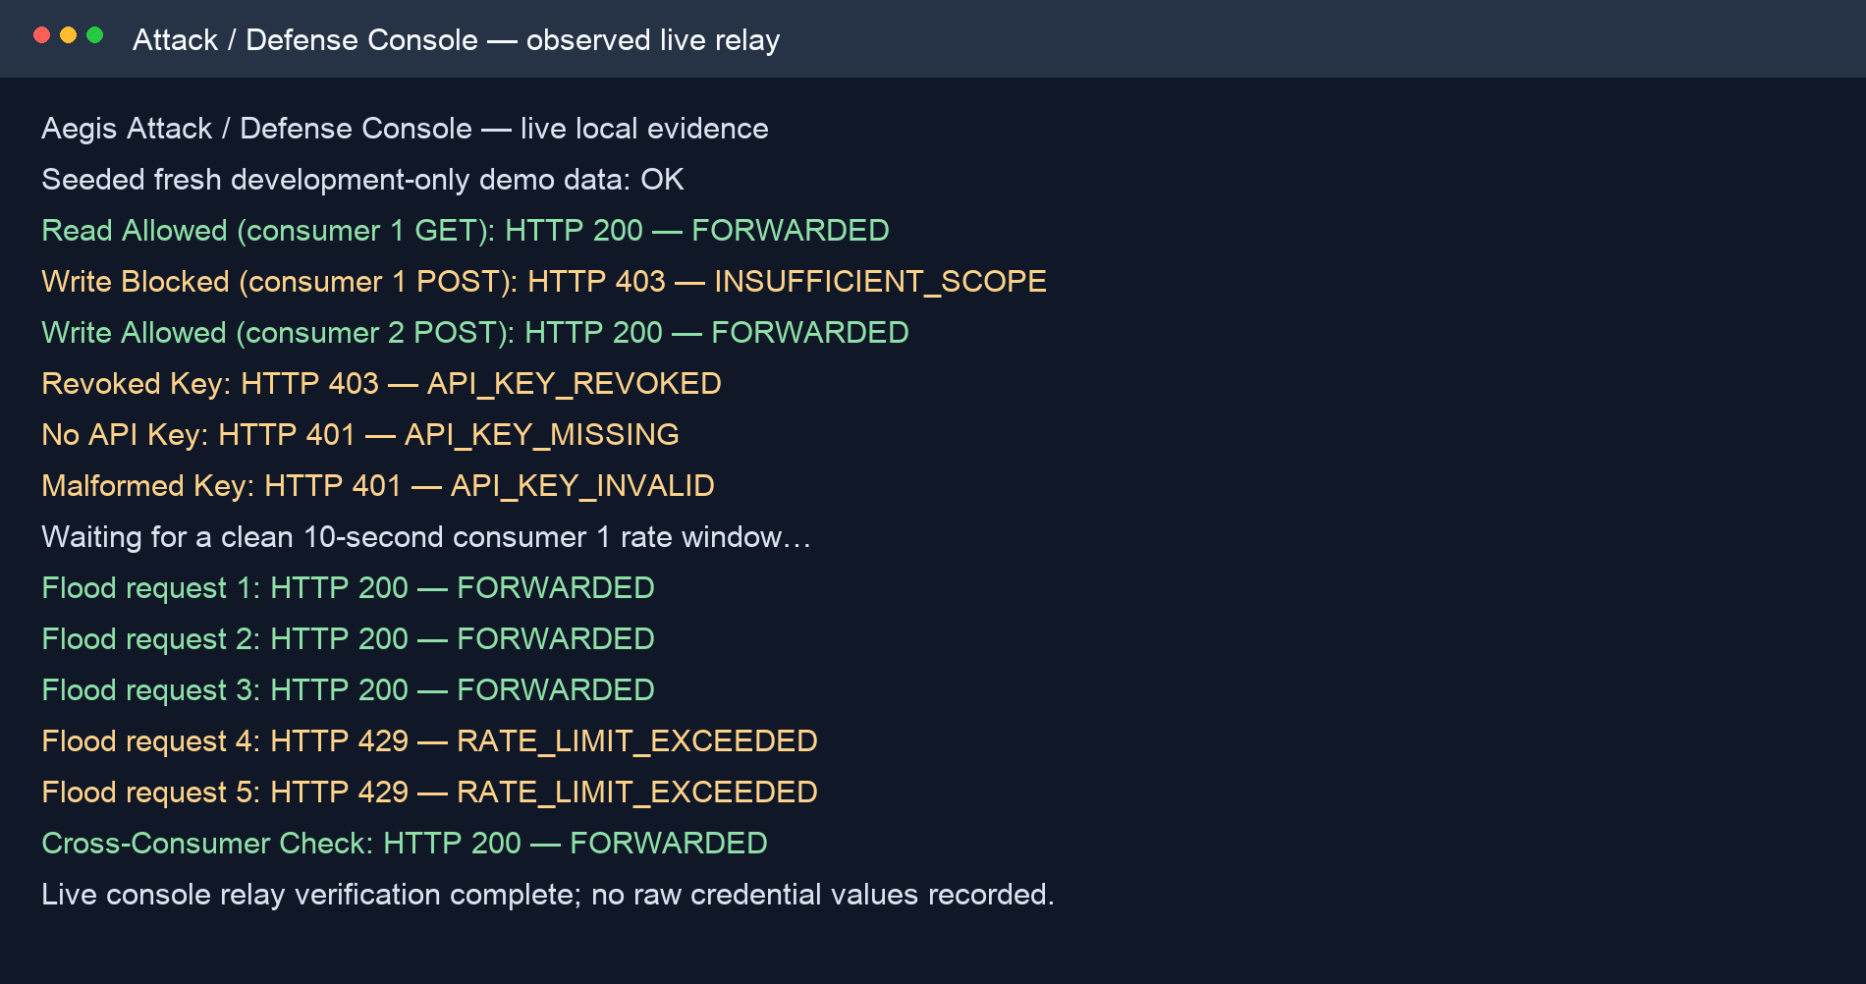
Figure 9.2: Actual local POC console relay evidence. The output confirms forwarding, scope denial, credential failures, rate limiting and per-consumer isolation.
Scenario | Expected/observed HTTP result | Evidence of behaviour
Consumer 1 read | 200 / forwarded | Valid key, JWT and echo:read scope reach upstream.
Consumer 1 write | 403 / INSUFFICIENT_SCOPE | Exact POST route policy blocks an absent echo:write scope.
Consumer 2 write | 200 / forwarded | Consumer 2 contains the required scope.
Revoked/missing/malformed key | 403 / 401 / 401 | The proxy rejects credentials before forwarding.
Five-request flood | 200, 200, 200, 429, 429 | Consumer 1’s 3 requests/10 seconds Redis rule is enforced.
Cross-consumer check | 200 / forwarded | Consumer 2 is not charged against Consumer 1’s key-scoped counter.

9.4 End-to-end Verification
The repository includes an isolated Docker Compose end-to-end script covering policy setup, gRPC propagation, proxy forwarding, blocks, threat detection, Redis limits and analytics. Its result is not asserted in this chapter until the script’s current run has completed; this protects the report from presenting an unverified integration claim as evidence.

9.5 Findings and Defect Handling
During the first live POC attempt, a pre-existing manual development block for 127.0.0.1 caused every scenario to return IP_BLOCKED. The record was verified through the local Control Plane, then soft-disabled as a development-only setup correction before the final evidence run. This was a useful integration finding: IP blocking correctly occurs before any credentials or scope check. It is recorded here rather than hidden because test environment state affects security evidence.

9.6 Test Limitations
The evidence demonstrates functional enforcement and cross-component behaviour, not a production load benchmark or independent penetration test. Future testing should add measured latency/throughput under controlled hardware, browser accessibility audits, trusted-load-balancer address handling, fuzzing of policy payloads and external security review. The automated coverage values are guardrails, not proof that every security issue has been eliminated.

References
Agile Business Consortium (2014) The DSDM Agile Project Framework. Tunbridge Wells: Agile Business Consortium.
Fielding, R.T. (2000) Architectural Styles and the Design of Network-based Software Architectures. PhD thesis. University of California, Irvine.
Indrasiri, K. and Kuruppu, D. (2020) gRPC: Up and Running. Sebastopol: O’Reilly Media.
Jones, M., Bradley, J. and Sakimura, N. (2015) JSON Web Token (JWT). RFC 7519. Internet Engineering Task Force. Available at: https://www.rfc-editor.org/rfc/rfc7519 (Accessed: 2 August 2026).
Newman, S. (2021) Building Microservices: Designing Fine-grained Systems. 2nd edn. Sebastopol: O’Reilly Media.
OWASP Foundation (2023) OWASP API Security Top 10 2023. Available at: https://owasp.org/www-project-api-security/ (Accessed: 2 August 2026).
W3C (2018) Web Content Accessibility Guidelines (WCAG) 2.1. Available at: https://www.w3.org/TR/WCAG21/ (Accessed: 2 August 2026).

