**Mind-wandering task**

@Haoting Wang

I have included all the information I can think of in this guide, for users who are not changing any special parameters. If you need to change the task parameters, I have commented the most of the things in the scripts. Of course, the first part of the document ‘script structure’ will still be helpful in this case.

The output file should be very self-explanatory.

If you want a completely clean version with all the initial setting, check here:

<https://github.com/htwangtw/MindWanderingTask>

**Script structure**

I have developed this framework of script, so we can easily replace/edit instructions without editing the scripts. By dividing different part of experiments into modules/functions, it would be easier for debugging. You don't always need to run the whole experiment while debugging. Testing single units save you time.

**[task name]_[verion]_[last update date]**

This is the name of the folder.

**Instruction:**

Containing instruction in .txt format. You just type in the instruction as how you want to present on the screen. '#' is a page breaker.

Do not change the file names, or the script won’t find the task.

**Stimuli:**

Stimulus files. Includes condition lists or pictures, audio files...

You can edit the content of the files.

Do not change the file names, or the script won’t find the task.

**baseDef.py**

The basic functions for the experiments. This file should all be the same in every task.

**[task name]_TrialDisplay.py**

This file includes the actual functions that shows the trials. I create functions for different screens/ different type of trials.

**Run_[task name].py**

This is just the frame of the experiment. You assemble the functions built in [task name]_TrialDisplay.py here. **Run this file when you run the experiment task.** In other words, this is where the action happens.

**[task name]_StimList.py**

For tasks with complicated condition order, I create a separate file to generate it, as it is easier to debug as a single module.

**[task name]_practice.py**

This is just the frame of the practice. You assemble the functions built in [task name]_TrialDisplay.py here. **Run this file when you run the practice task.**

**How to run the task**

(Of course, you can just run the compiled file. If you don’t understand the sentence above, just follow this guide.)

* + 1. Open PsychoPy, you should see the Coder GUI like this:   
       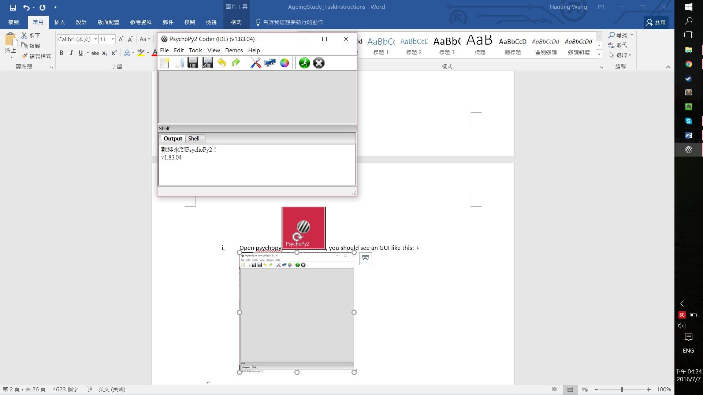   
       If you enter the Builder GUI, use *Ctrl + L* to switch to the coder GUI.
    2. Nevigate to the task folder 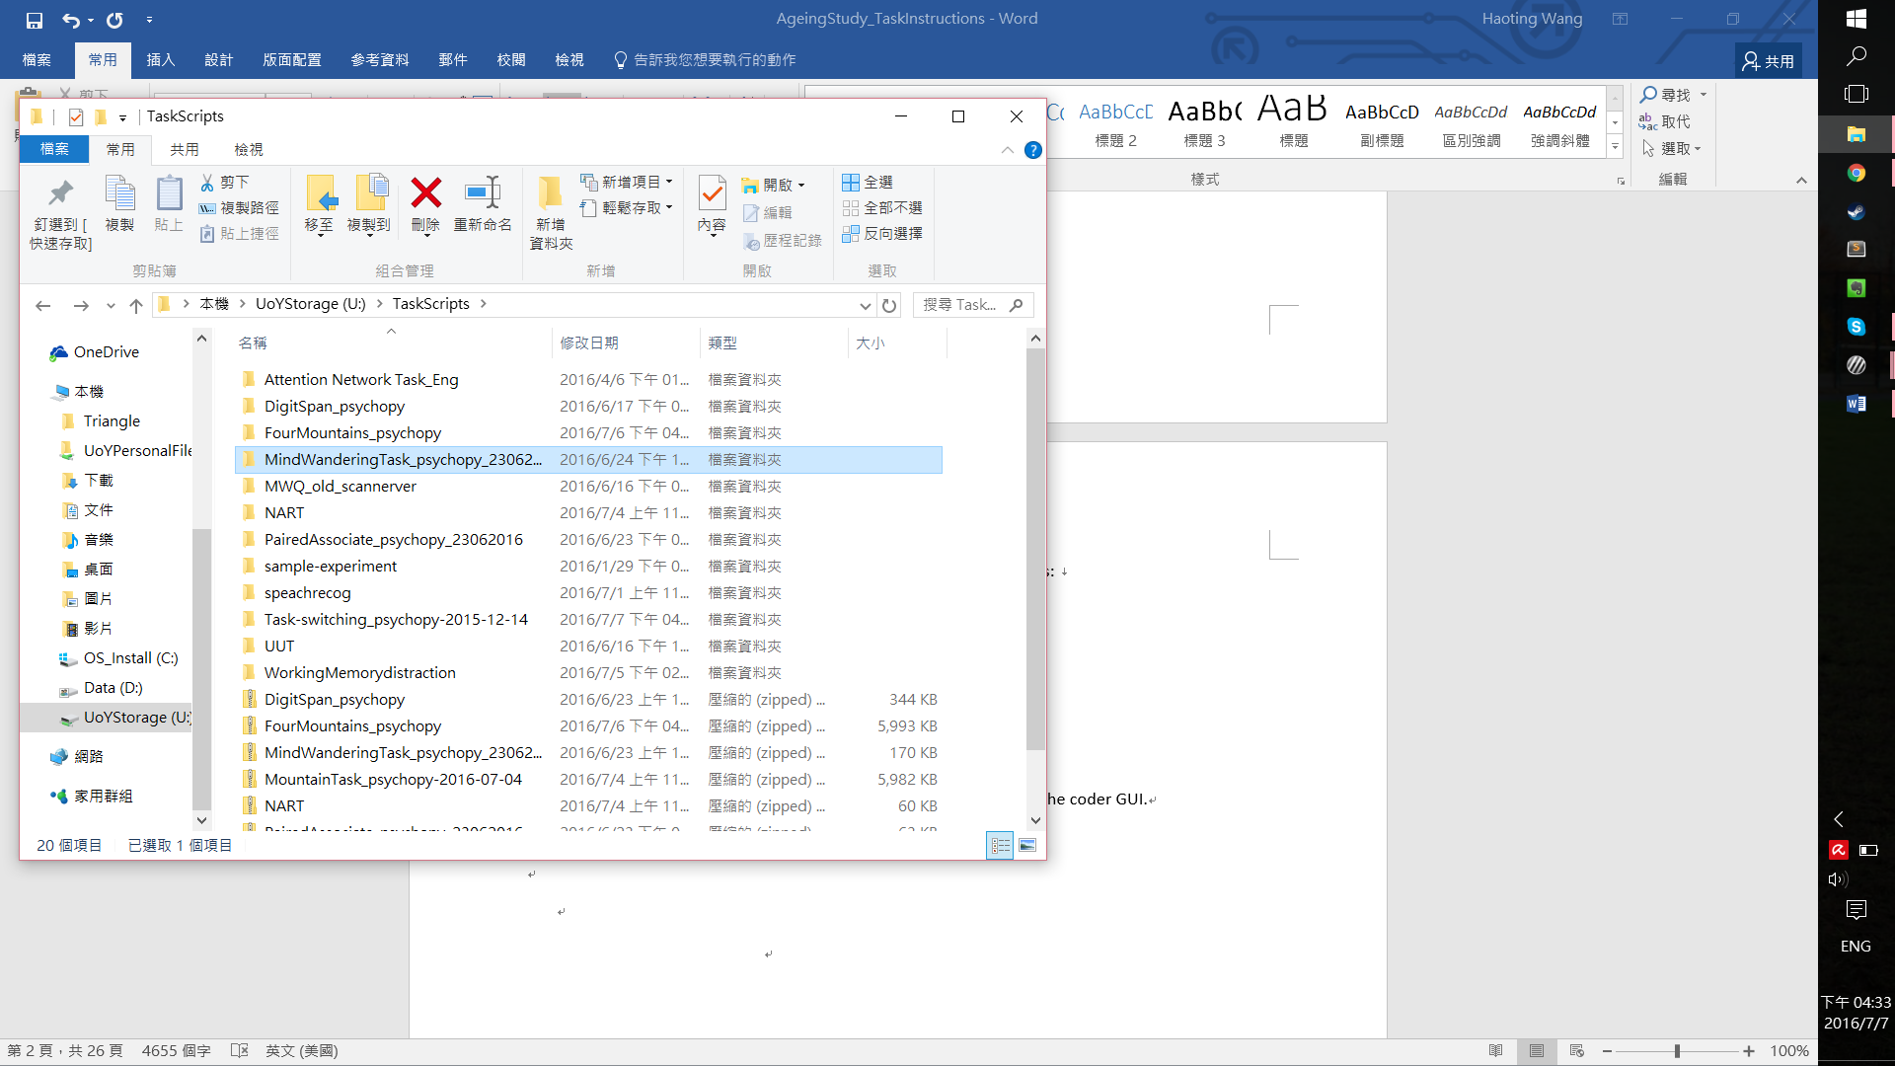 , and open the folder.
    3. Open the [*TaskName]_[version name or number].py* file in PsychoPy. Make sure it is the file you want to run.

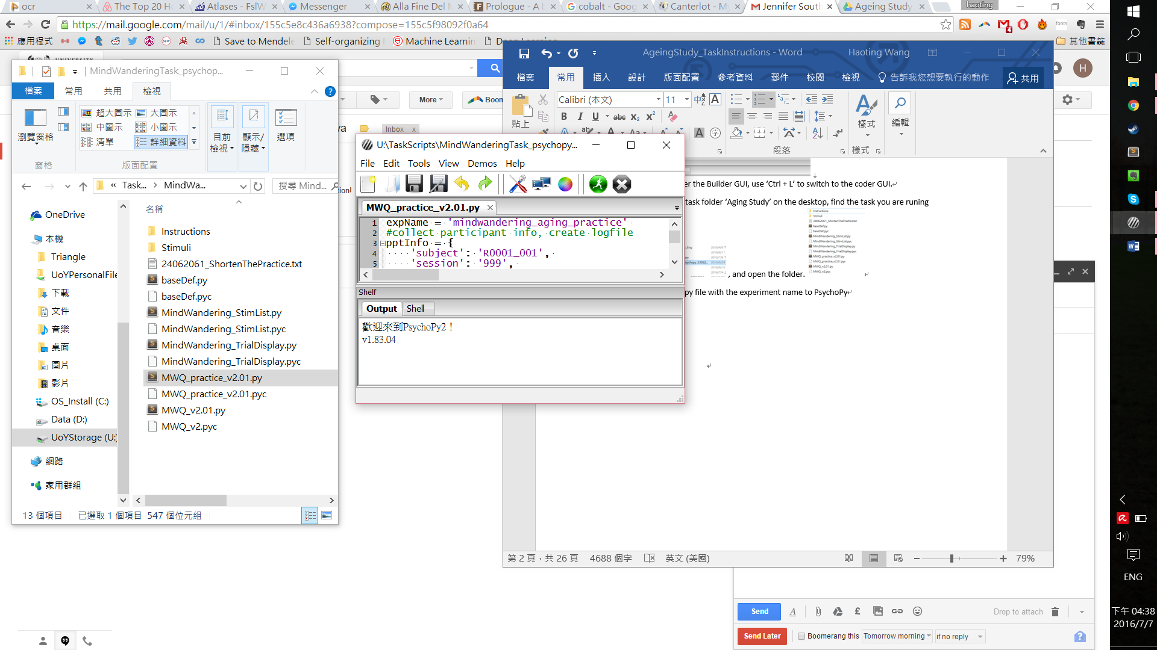

* + 1. Press ‘Ctrl’ and ‘R’, or click on the green button 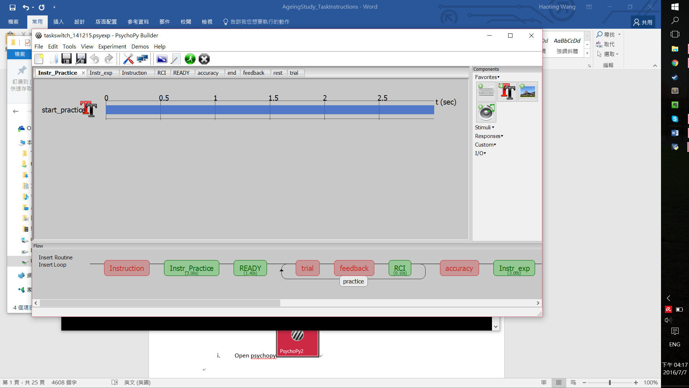to start the task.
    2. Enter participant information, session and select condition, if applied, in the dialog GUI. Click OK.   
       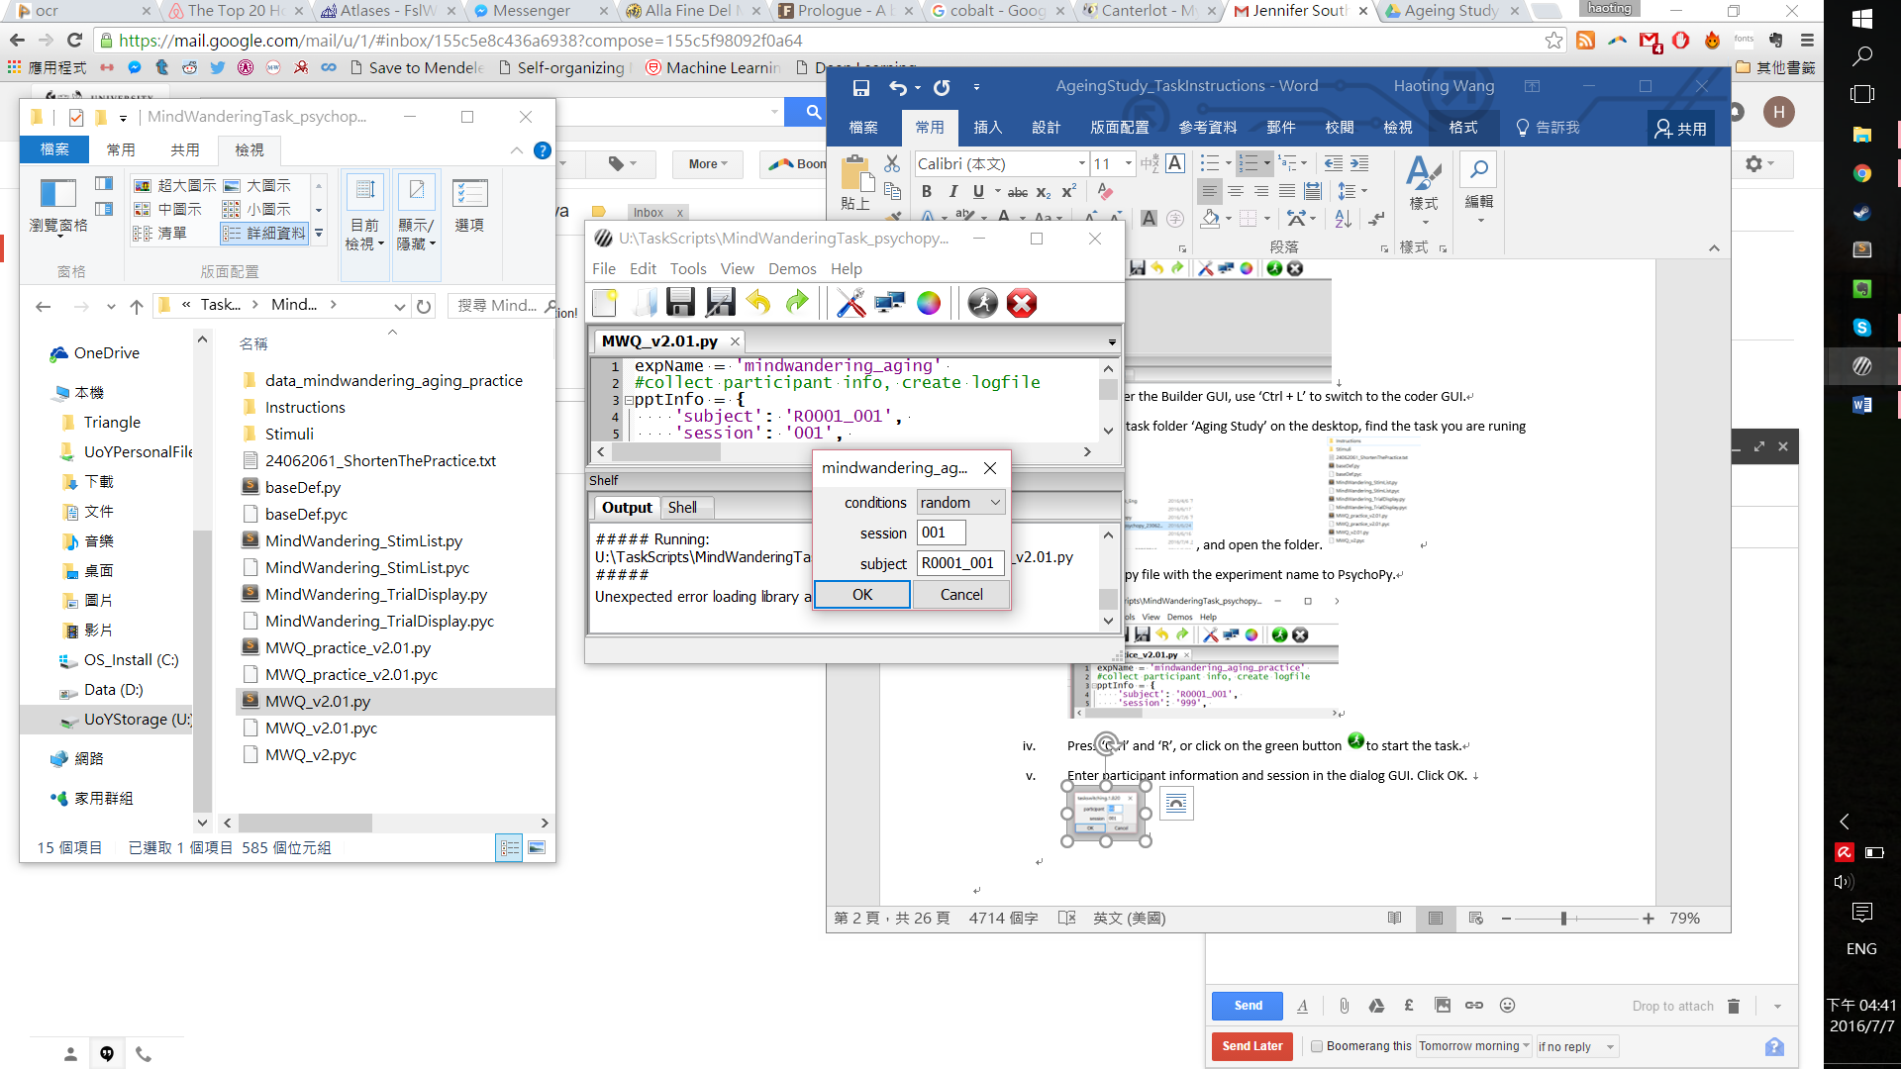

**Instruction for experimenters**

Please start the Practice task for the participant if this is the first time they encounter this task. Read through the instruction with them, and show them the graph (see last page of this document) to help them understand the task. They are using the left and right arrow keys for the task, and number 1 to 4 for the questionnaire.

See full instruction here:

In it you will be asked to attend to pairs of different shapes, divided by a coloured vertical line in the middle of the screen. The vertical line will always be BLUE or RED to indicate whether you are in the BLUE condition or RED condition.

On screens where shapes are coloured BLACK you will only be required to keep your eyes in the centre of the screen and attend to the shapes.

Depending on the condition when you are presented with a target you must indicate

In BLUE CONDITION which side the target shape is on CURRENTLY;  
In RED CONDITION which side the target shape was on PREVIOUSLY.

The left arrow button indicates LEFT, the right arrow button indicates RIGHT.

You should try to be as quick and accurate as possible.

Sometimes the task will randomly stop and you will be asked about your level of focus on the task and a series of questions about your thoughts. You will then have to specify on what your thoughts were focused on just before the task was interrupted. When answering these questions please remember there are no right answers, but please try to answer them as fast as possible. When prompted please try to describe the thoughts that you were having in EXACTLY the moments before you were interrupted.

Please use number '1' to '4' to indicate how much each description reflects your experience.

'1' indicates 'not at all'. '2' indicates 'slightly'.   
 '3' indicates 'moderately'. '4' indicates 'completely'.

Behavioural session

**Mind-wandering Task**

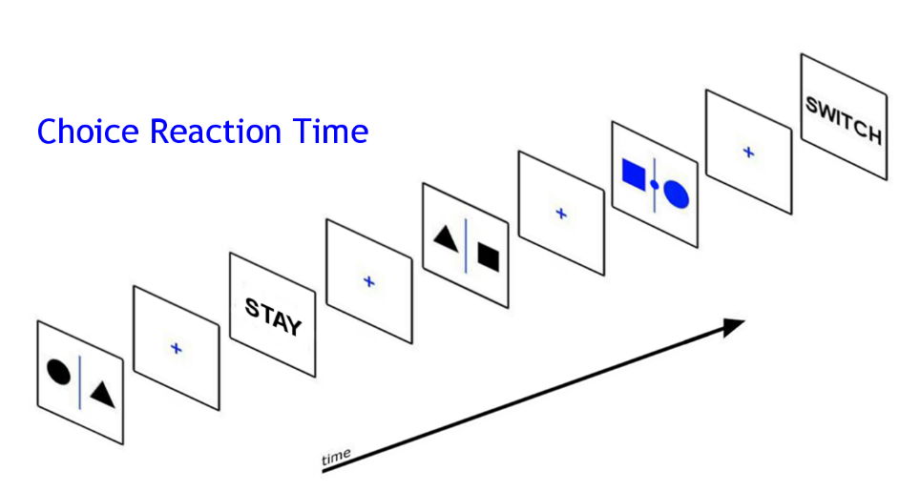

**Press RIGHT**

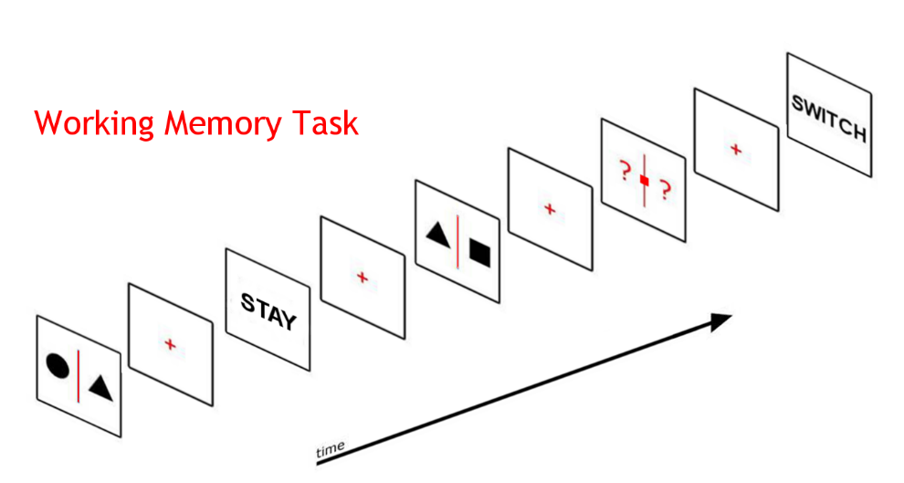

**Press RIGHT**