Dose-effect meta-analysis for psychopharmacologic interventions using randomized data - Appendix

Tasnim Hamza

5/7/2021

## Dose-effect meta-analysis

# Run dose-effect meta-analysis:   
# 1. one-study analysis (with linear and RCS)  
# 2. multi-studies analysis: 1stage and 2stage (with RCS)  
  
library(rms) # rcs()  
library(dosresmeta) # dosresmeta()  
library(meta) # metaprop()  
library(dplyr)  
source('fun to analyze EBMH.R') # include createORreference.fun()  
  
# ---------- load data and prepare ----------  
  
# load and exclude single arm studies  
mydata <- read.csv('DOSEmainanalysis.csv')  
antidep=mydata[mydata$exc==F,]  
  
# add OR  
antidep <- antidep%>%arrange(Study_No,hayasaka_ddd) # arrange doses per study  
antidep$studyid <- as.numeric(as.factor(antidep$Study_No))  
antidep$nonResponders <- antidep$No_randomised- antidep$Responders  
logORmat <- sapply(unique(antidep$studyid),function(i) createORreference.fun(antidep$Responders[antidep$studyid==i],antidep$No_randomised[antidep$studyid==i]),simplify = FALSE)  
logORmat <- do.call(rbind,logORmat)  
antidep$logOR <- c(logORmat[,1])  
antidep$selogOR <- c(logORmat[,2])  
  
# knots  
knots= quantile(antidep$hayasaka_ddd[antidep$hayasaka_ddd!=0],c(0.10,0.50,0.90))  
  
# ---------- 1.one-study analysis ----------  
study_87 <- antidep[antidep$Study_No=='87',]   
  
# linear  
lin_1study <- dosresmeta(formula=logOR~hayasaka_ddd,   
 id=Study_No,   
 type=type,  
 cases=Responders,  
 n=No_randomised,  
 se=selogOR,  
 data=study_87,  
 method = 'reml')  
  
# RCS  
rcs_1study <- dosresmeta(formula=logOR~rcs(hayasaka_ddd,knots),   
 id=Study_No,   
 type=type,  
 cases=Responders,  
 n=No_randomised,  
 se=selogOR,  
 data=study_87,  
 method = 'reml')  
  
# ---------- 1.multi-study analysis ----------  
# 1-stage  
rcs_pooled1 <- dosresmeta(formula=logOR~rcs(hayasaka_ddd,knots),   
 proc="1stage",  
 id=Study_No,   
 type=type,  
 cases=Responders,  
 n=No_randomised,  
 se=selogOR,  
 data=antidep,  
 method = 'reml')  
print(waldtest(b=coef(rcs_pooled1)[2],   
 Sigma=vcov(rcs_pooled1)[2,2],  
 Terms=1)) # wald test for spline coefficient

## Wald test:  
## ----------  
##   
## Chi-squared test:  
## X2 = 39.9, df = 1, P(> X2) = 2.7e-10

# 2-stage  
# include studies with at least 3 arms  
studies_2arm <- unique(antidep$Study_No)[table(antidep$Study_No)<3]  
antidep_2stage <- antidep[!antidep$Study_No%in%studies_2arm,]  
  
rcs_pooled2 <- dosresmeta(formula=logOR~rcs(hayasaka_ddd,knots),   
 proc="2stage",  
 id=Study_No,   
 type=type,  
 cases=Responders,  
 n=No_randomised,  
 se=selogOR,  
 data=antidep_2stage,  
 method = 'reml')  
  
# placebo effect - meta-analysis  
antidep_p <- antidep[antidep$Drug=='placebo',]  
antidep_p <- antidep_p[!(is.na(antidep_p$Responders)|is.na(antidep_p$No_randomised)),] # discard arms with NA  
  
meta_pl<-metaprop(event=Responders,   
 n=No_randomised,   
 data=antidep_p,   
 studlab=Study_No,  
 comb.fixed = FALSE)  
# back transformation: logit = log (p/(1-p)) -> probability p  
pl_eff <- exp(meta_pl$TE.random)/(1+exp(meta_pl$TE.random))

## Figures and tables

source('analyze EBMH.R')

## Wald test:  
## ----------  
##   
## Chi-squared test:  
## X2 = 4.6, df = 1, P(> X2) = 0.033

source('fun to plot EBMH.R')  
  
# Table 1 - data of Feighner et al study   
tab1()

## level dose response total OR lb ub logOR selogOR  
## 1 0 0 42 129 1.00 NA NA 0.00 NA  
## 2 1 10 61 131 1.81 1.09 2.99 0.59 0.26  
## 3 2 20 61 130 1.83 1.11 3.03 0.61 0.26  
## 4 3 40 80 131 3.25 1.95 5.41 1.18 0.26  
## 5 4 60 73 129 2.70 1.63 4.48 0.99 0.26

# Figure 1 - OR vs flux.dose - RCS and Linear (Feighner et al study)  
plotdata1s = plotdata.fun(drma = rcs_1study,  
 data = study_87,  
 knots=knots) # RCS  
plotdata2s = plotdata.fun(drma = lin_1study,  
 data = study_87,  
 knots=knots) # Linear  
  
doseres.plot(plotdata = plotdata1s,  
 data=study_87,  
 ymax = 4.6,  
 ymin=1,  
 y='OR',  
 ub='ubo',  
 lb='lbo',  
 add2=plotdata2s) # Linear and RCS

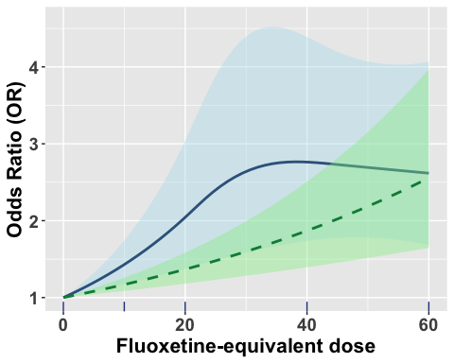

# Figure 2: OR vs flux.dose - RCS: 2stage & 1stage   
plotdata1 = plotdata.fun(drma = rcs_pooled2,  
 data = antidep,  
 knots=knots)  
  
plotdata2 = plotdata.fun(drma = rcs_pooled1,  
 data = antidep,  
 knots=knots,  
 p.eff=pl_eff)  
  
  
doseres.plot(plotdata =plotdata1,  
 data=antidep,  
 ymax = 2,  
 ymin=0.5,  
 y='OR',  
 ub='ubo',  
 lb='lbo',  
 add2=plotdata2,  
 add3=NULL) # RCS 1stage and 2stage

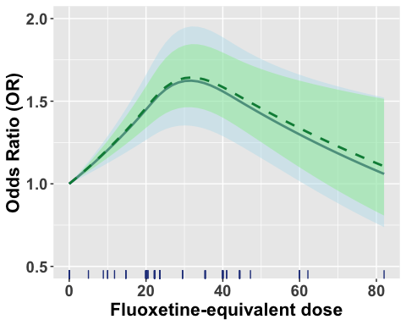

# Figure 3: prob vs flux.dose - RCS 1stage  
doseres.plot(plotdata =plotdata2,  
 data=antidep,  
 ymax = 0.55,  
 ymin=0.3,  
 y='prob',  
 ub='ubp',  
 lb='lbp',  
 labs = c('Predicted absolute effect','Fluoxetine-equivalent dose')) # RCS 1stage

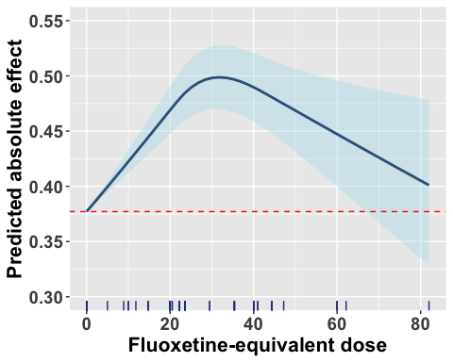

# Figure 4: VPC vs dose  
  
# VPC   
df <- antidep[!is.na(antidep$selogOR),]  
df$vpc <- vpc(rcs_pooled1)  
min(df$vpc[df$hayasaka_ddd==20])

## [1] 0.03776123

max(df$vpc[df$hayasaka_ddd==20])

## [1] 0.4027483

max(df$vpc)

## [1] 0.7556904

ggplot(df, aes(hayasaka_ddd,vpc)) +   
 annotate("rect", xmin = -Inf, xmax = Inf, ymin = -Inf, ymax = 0.3, fill= "darkseagreen2", alpha=0.3) +  
 theme_light()+  
 annotate("rect", xmin = -Inf, xmax = Inf, ymin = 0.3, ymax = 0.6 , fill= "lightgoldenrod2", alpha=0.3) +   
 theme_light()+  
 annotate("rect", xmin = -Inf, xmax = Inf, ymin = 0.6, ymax = Inf, fill= "lightcoral", alpha=0.3) +  
 theme_light()+  
 geom_point() +   
 geom_smooth(method = "loess",se=FALSE)+  
 coord_cartesian(clip="off", ylim=c(0,0.9))+  
 theme(axis.title=element_blank(),  
 plot.margin = unit(c(5,10,10,5), "mm"))

## `geom_smooth()` using formula 'y ~ x'

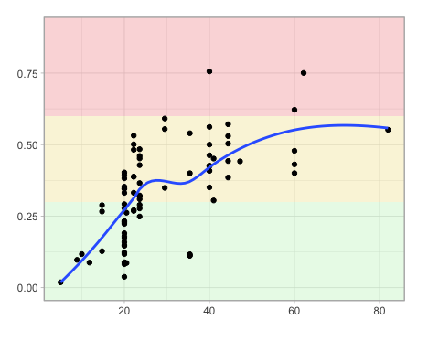

ggplot(df, aes(hayasaka_ddd,vpc)) +   
 coord_flip()+  
 geom_boxplot() +   
 geom_jitter(shape=16, position=position_jitter(0.2))+  
 coord_cartesian(clip="off", ylim=c(0,0.9))+  
 theme(axis.title=element_blank(),  
 plot.margin = unit(c(5,10,10,5), "mm"))

## Coordinate system already present. Adding new coordinate system, which will replace the existing one.

## Warning: Continuous x aesthetic -- did you forget aes(group=...)?

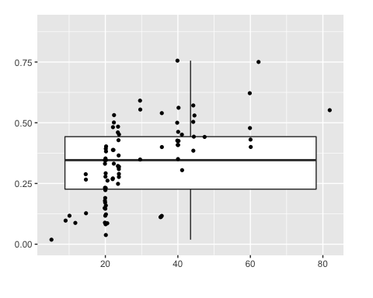

# Appendix figure 1  
dose_dist1()

## `stat_bindot()` using `bins = 30`. Pick better value with `binwidth`.

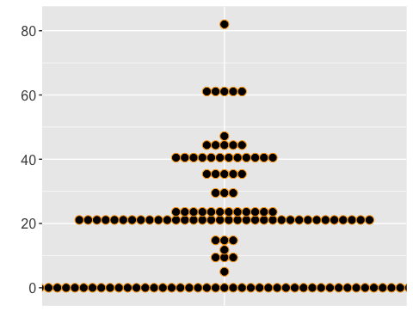

# Appendix figure 2  
dose_dist2()

## `stat_bindot()` using `bins = 30`. Pick better value with `binwidth`.

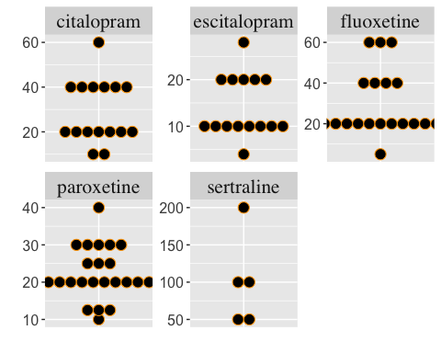

# Appendix table  
app.tab()

## # A tibble: 6 x 4  
## `Number of events` `Number of patient… `Number of studi… `Number of non-zero …  
## * <int> <int> <int> <int>  
## 1 1002 1928 9 16  
## 2 1089 2405 11 15  
## 3 901 2265 18 25  
## 4 1389 2669 19 25  
## 5 2183 5556 59 59  
## 6 134 351 3 5