Antidepressant Analysis: compare the dose-response meta-analysis models

The number of included studies is:

## 60

# Analysis for Risk ratio (RR): linear and splines

## Estimation

|  |  |  |  |  |  |
| --- | --- | --- | --- | --- | --- |
|  | bayesBin | bayesNor | Freq | rhatS | rhatS |
| dose.s | 0.01162 | 0.01443 | 0.01109 | 1.00149 | 1.00103 |
| dose.trans.s | -0.01575 | -0.02723 | -0.02013 | 1.00170 | 1.00108 |
| tau.s | 0.00413 | 0.01040 | NA | 1.00102 | 1.00102 |
| dose.l | 0.00933 | 0.00770 | 0.00620 | 1.00100 | 1.00100 |
| tau.l | 0.00350 | 0.01048 | NA | 1.00101 | 1.00102 |

## Including Plots

### Check autocorrelation

#### Spline

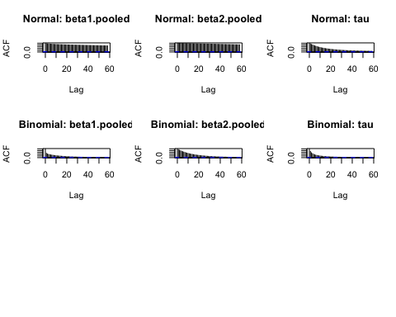 #### Linear 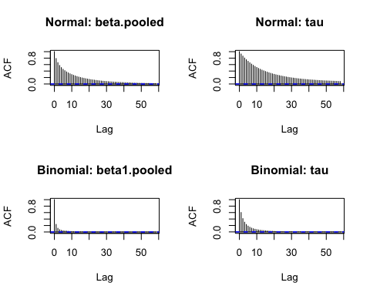 ### Trace plots

#### Spline

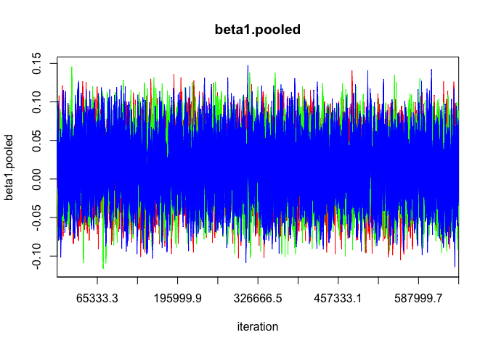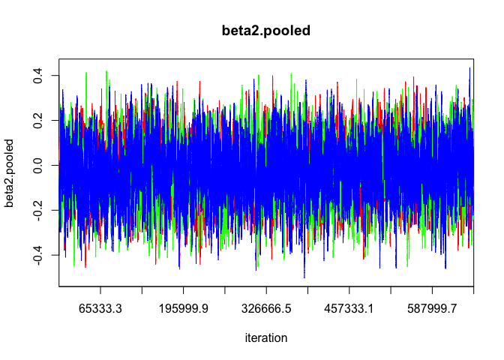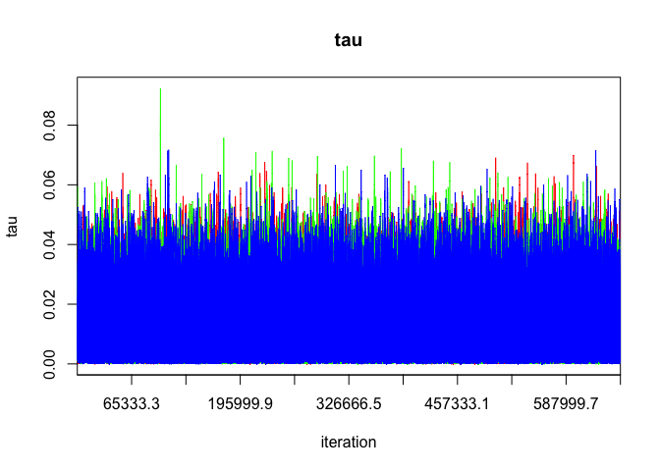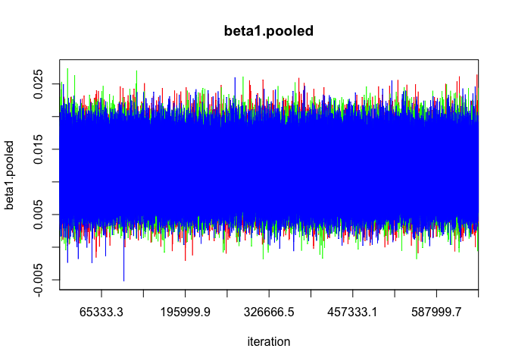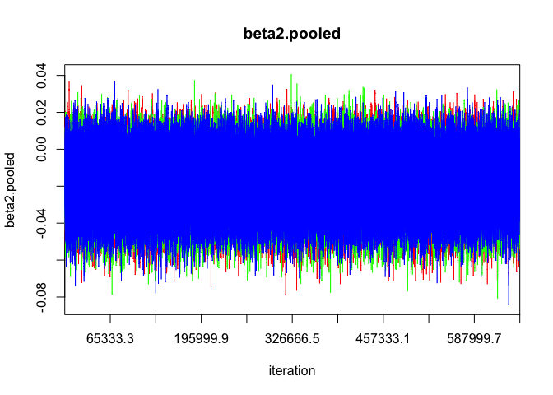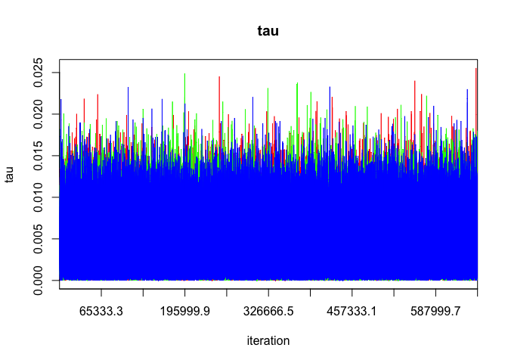 #### Linear 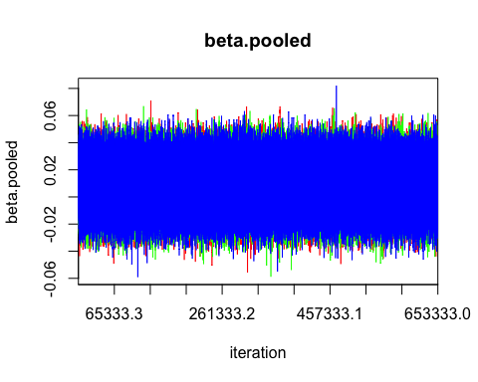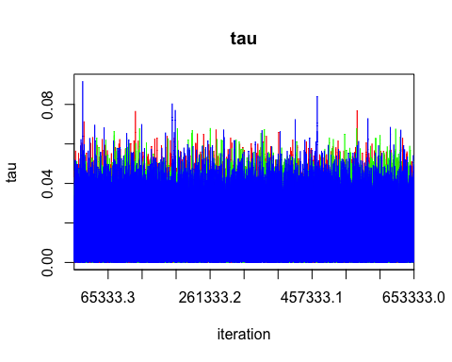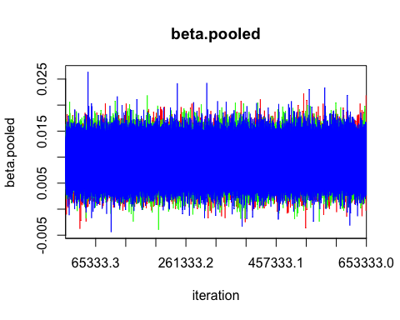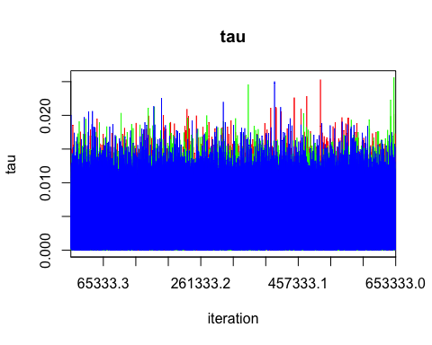

### Parameters distribution

#### Spline

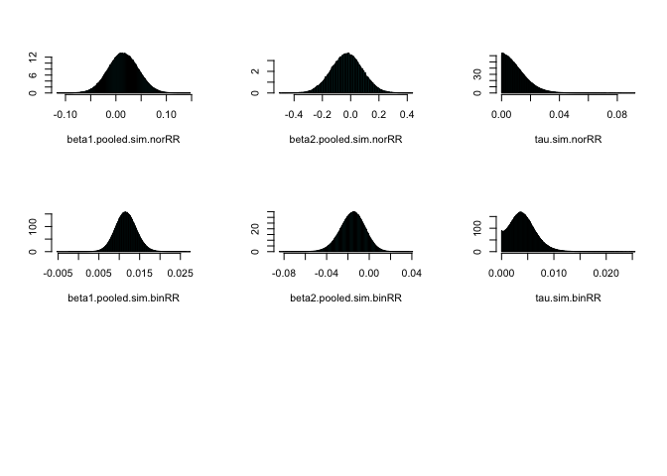

#### Linear

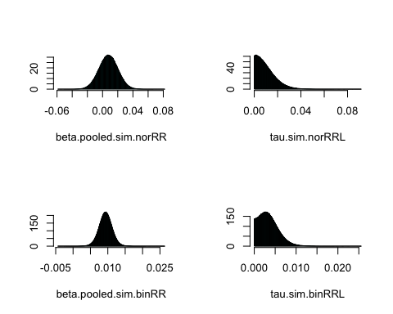

### Compare the three models

#### Spline

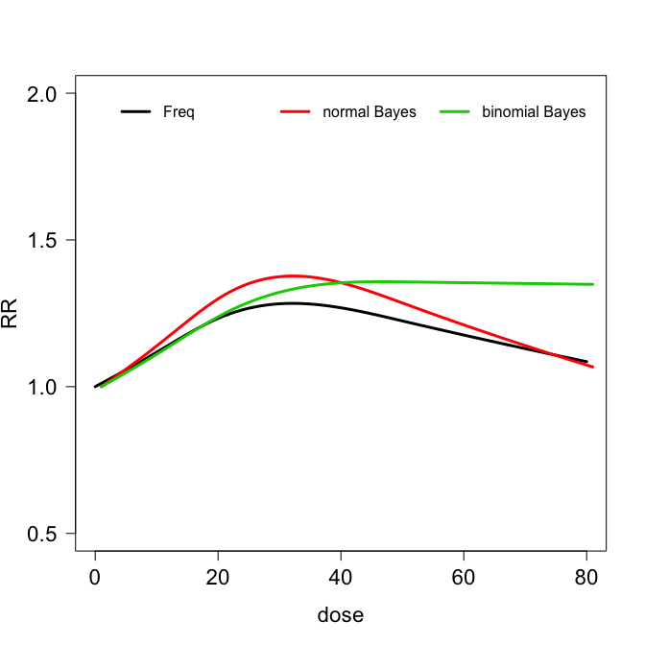

#### Linear

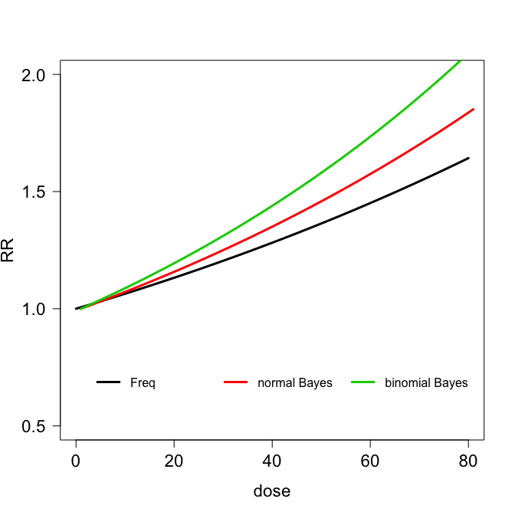

# Analysis for odds ratio (OR): linear and splines

## Estimation