CODA of dose-response MA model: antidepressant

**Density**

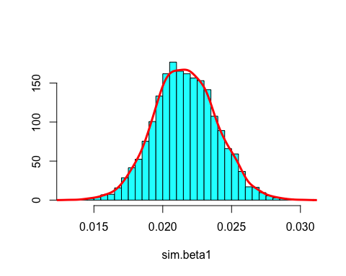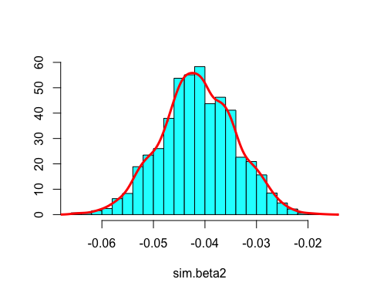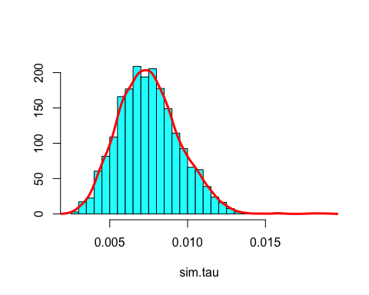

**Traceplots**

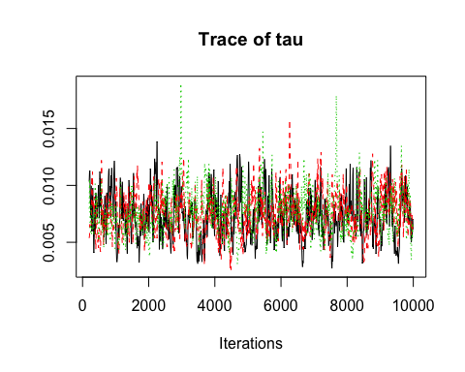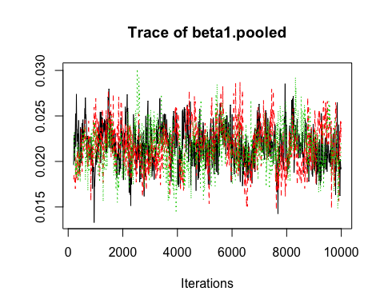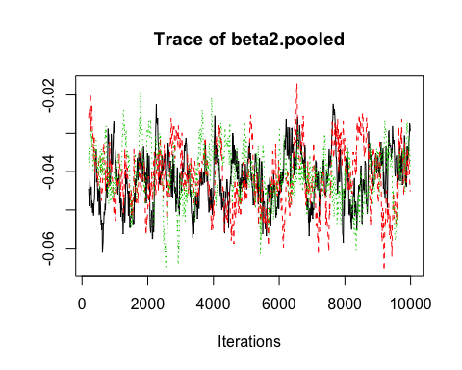

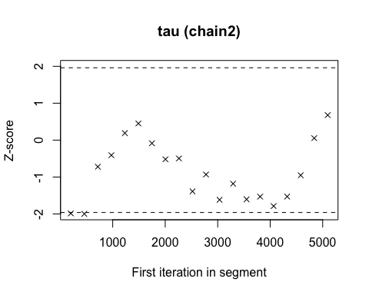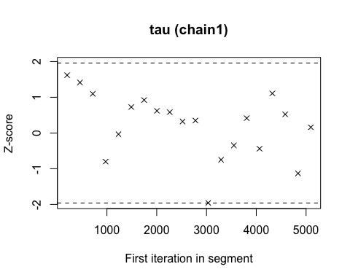

**Geweke plot**

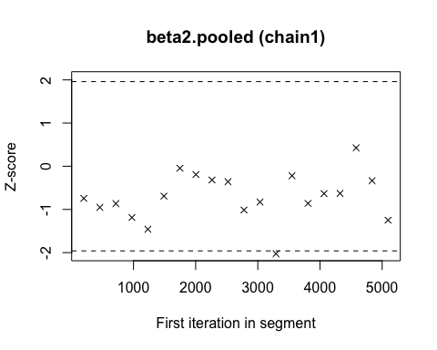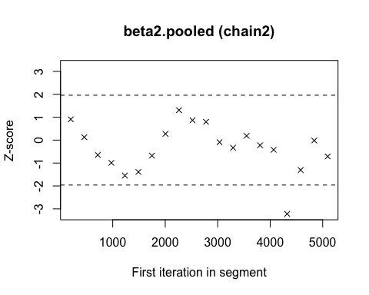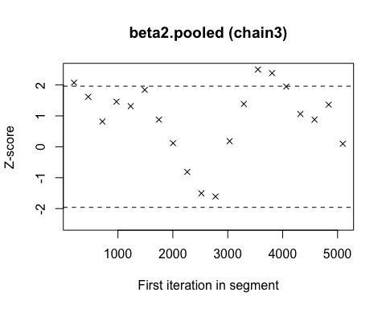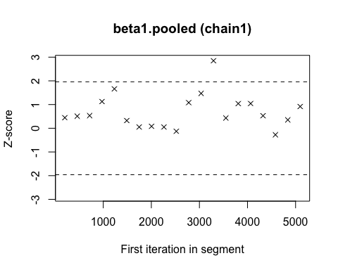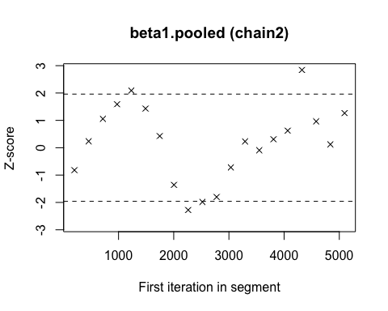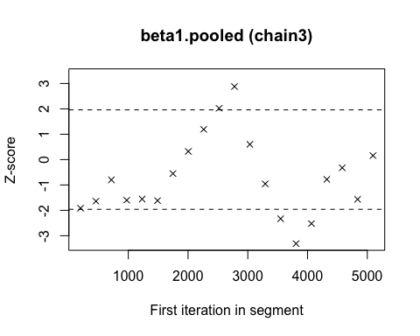

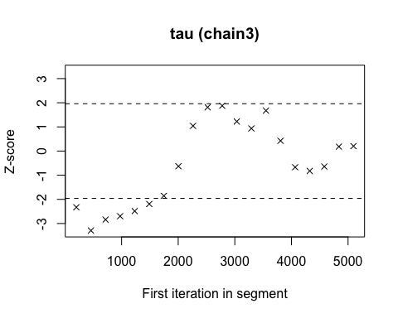

**Gelman plot**

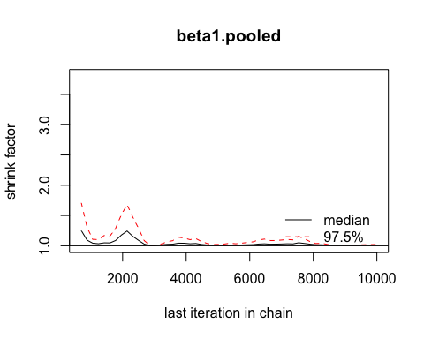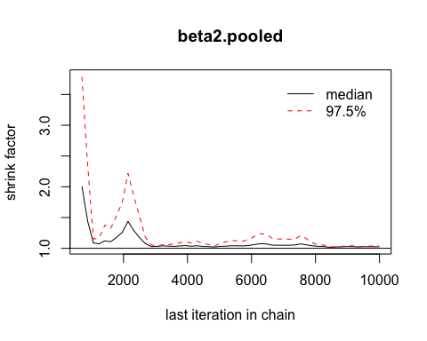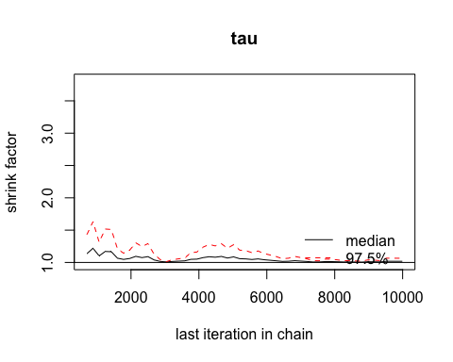

**Gelman diagnosis measure**

## Potential scale reduction factors:  
##   
## Point est. Upper C.I.  
## beta1.pooled 1.01 1.02

## Potential scale reduction factors:  
##   
## Point est. Upper C.I.  
## beta2.pooled 1.02 1.04

## Potential scale reduction factors:  
##   
## Point est. Upper C.I.  
## tau 1.02 1.06

**Effective sample size**

## beta1.pooled   
## 357.5735

## beta2.pooled   
## 170.4447

## tau   
## 404.4128

**Raftery diagnosis**

## [[1]]  
##   
## Quantile (q) = 0.025  
## Accuracy (r) = +/- 0.005  
## Probability (s) = 0.95   
##   
## You need a sample size of at least 3746 with these values of q, r and s  
##   
## [[2]]  
##   
## Quantile (q) = 0.025  
## Accuracy (r) = +/- 0.005  
## Probability (s) = 0.95   
##   
## You need a sample size of at least 3746 with these values of q, r and s  
##   
## [[3]]  
##   
## Quantile (q) = 0.025  
## Accuracy (r) = +/- 0.005  
## Probability (s) = 0.95   
##   
## You need a sample size of at least 3746 with these values of q, r and s

## [[1]]  
##   
## Quantile (q) = 0.025  
## Accuracy (r) = +/- 0.005  
## Probability (s) = 0.95   
##   
## You need a sample size of at least 3746 with these values of q, r and s  
##   
## [[2]]  
##   
## Quantile (q) = 0.025  
## Accuracy (r) = +/- 0.005  
## Probability (s) = 0.95   
##   
## You need a sample size of at least 3746 with these values of q, r and s  
##   
## [[3]]  
##   
## Quantile (q) = 0.025  
## Accuracy (r) = +/- 0.005  
## Probability (s) = 0.95   
##   
## You need a sample size of at least 3746 with these values of q, r and s

## [[1]]  
##   
## Quantile (q) = 0.025  
## Accuracy (r) = +/- 0.005  
## Probability (s) = 0.95   
##   
## You need a sample size of at least 3746 with these values of q, r and s  
##   
## [[2]]  
##   
## Quantile (q) = 0.025  
## Accuracy (r) = +/- 0.005  
## Probability (s) = 0.95   
##   
## You need a sample size of at least 3746 with these values of q, r and s  
##   
## [[3]]  
##   
## Quantile (q) = 0.025  
## Accuracy (r) = +/- 0.005  
## Probability (s) = 0.95   
##   
## You need a sample size of at least 3746 with these values of q, r and s

## [[1]]  
##   
## Stationarity start p-value  
## test iteration   
## beta1.pooled passed 1 0.121   
##   
## Halfwidth Mean Halfwidth  
## test   
## beta1.pooled passed 0.0217 0.000391   
##   
## [[2]]  
##   
## Stationarity start p-value  
## test iteration   
## beta1.pooled passed 1 0.964   
##   
## Halfwidth Mean Halfwidth  
## test   
## beta1.pooled passed 0.0217 0.000566   
##   
## [[3]]  
##   
## Stationarity start p-value  
## test iteration   
## beta1.pooled passed 1 0.217   
##   
## Halfwidth Mean Halfwidth  
## test   
## beta1.pooled passed 0.0215 0.00034

**Heidel diagnosis**

## [[1]]  
##   
## Stationarity start p-value  
## test iteration   
## beta2.pooled passed 1 0.154   
##   
## Halfwidth Mean Halfwidth  
## test   
## beta2.pooled passed -0.0419 0.00173   
##   
## [[2]]  
##   
## Stationarity start p-value  
## test iteration   
## beta2.pooled passed 1 0.907   
##   
## Halfwidth Mean Halfwidth  
## test   
## beta2.pooled passed -0.0416 0.00221   
##   
## [[3]]  
##   
## Stationarity start p-value  
## test iteration   
## beta2.pooled passed 1 0.17   
##   
## Halfwidth Mean Halfwidth  
## test   
## beta2.pooled passed -0.0407 0.00176

## [[1]]  
##   
## Stationarity start p-value  
## test iteration   
## tau passed 1 0.509   
##   
## Halfwidth Mean Halfwidth  
## test   
## tau passed 0.00735 0.000351   
##   
## [[2]]  
##   
## Stationarity start p-value  
## test iteration   
## tau passed 1 0.144   
##   
## Halfwidth Mean Halfwidth  
## test   
## tau passed 0.00753 0.000307   
##   
## [[3]]  
##   
## Stationarity start p-value  
## test iteration   
## tau passed 1 0.232   
##   
## Halfwidth Mean Halfwidth  
## test   
## tau passed 0.00768 0.00034