
毕业设计（论文）翻译资料

院（系） 计算机科学与技术学院
专 业 网络工程
原 文 标 题 Matrix Factorization Techniques For
Recommender Systems
译 文 标 题 推荐系统的矩阵分解技术
学 生 姓 名 胡鑫 学号 1425131003
指 导 教 师 王靖
顾 问 教 师 王靖
完 成 时 间 2018 年 3 月 2 日

原文：
Matrix factorization techniques for recommender systems
As the Netflix Prize competition has demonstrated, matrix factorization models are superior to classic nearest-neighbor techniques for producing product recommendations, allowing the incorporation of additional information such as implicit feedback, temporal effects, and confidence levels.
Modern consumers are inundated with choices. Electronic retailers and content providers offer a huge selection of products, with unprecedented opportunities to meet a variety of special needs and tastes. Matching consumers with the most appropriate products is key to enhancing user satisfaction and loyalty. Therefore, more retailers have become interested in recommender systems, which analyze patterns of user interest in products to provide personalized recommendations that suit a user’s taste. Because good personalized recommendations can add another dimension to the user experience, e-commerce leaders like Amazon.com and Netflix have made recommender systems a salient part of their websites.
Such systems are particularly useful for entertainment products such as movies, music, and TV shows. Many customers will view the same movie, and each customer is likely to view numerous different movies. Customers have proven willing to indicate their level of satisfaction with particular movies, so a huge volume of data is available about which movies appeal to which customers. Companies can analyze this data to recommend movies to particular customers.
Recommender system strategies
Broadly speaking, recommender systems are based on one of two strategies. The content filtering approach creates a profile for each user or product to characterize its nature. For example, a movie profile could include attributes regarding its genre, the participating actors, its box office popularity, and so forth. User profiles might include demographic information or answers provided on a suitable questionnaire. The profiles allow programs to associate users with matching products. Of course, content-based strategies require gathering external information that might not be available or easy to collect.
A known successful realization of content filtering is the Music Genome Project, which is used for the Internet radio service Pandora.com. A trained music analyst scores each song in the Music Genome Project based on hundreds of distinct musical characteristics. These attributes, or genes, capture not only a song’s musical identity but also many significant qualities that are relevant to understanding listeners’ musical preferences.
An alternative to content filtering relies only on past user behavior—for example, previous transactions or product ratings— without requiring the creation of explicit profiles. This approach is known as collaborative filtering, a term coined by the developers of Tapestry, the first recommender system.1 Collaborative filtering analyzes relationships between users and interdependencies among products to identify new user-item associations.
A major appeal of collaborative filtering is that it is domain free, yet it can address data aspects that are often elusive and difficult to profile using content filtering. While generally more accurate than content-based techniques, collaborative filtering suffers from what is called the cold start problem, due to its inability to address the system’s new products and users. In this aspect, content filtering is superior.
The two primary areas of collaborative filtering are the neighborhood methods and latent factor models. Neighborhood methods are centered on computing the relationships between items or, alternatively, between users. The itemoriented approach evaluates a user’s preference for an item based on ratings of “neighboring” items by the same user. A product’s neighbors are other products that tend to get similar ratings when rated by the same user. For example, consider the movie Saving Private Ryan. Its neighbors might include war movies, Spielberg movies, and Tom Hanks movies, among others. To predict a particular user’s rating for Saving Private Ryan, we would look for the movie’s nearest neighbors that this user actually rated. As Figure 1 illustrates, the user-oriented approach identifies like-minded users who can complement each other’s ratings.
Latent factor models are an alternative approach that tries to explain the ratings by characterizing both items and users on, say, 20 to 100 factors inferred from the ratings patterns. In a sense, such factors comprise a computerized alternative to the aforementioned humancreated song genes. For movies, the discovered factors might measure obvious dimensions such as comedy versus drama, amount of action, or orientation to children; less well-defined dimensions such as depth of character development or quirkiness; or completely uninterpretable dimensions. For users, each factor measures how much the user likes movies that score high on the corresponding movie factor.
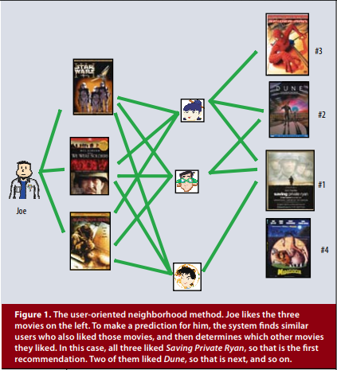
Figure 2 illustrates this idea for a simplified example in two dimensions. Consider two hypothetical dimensions characterized as female- versus male-oriented and serious versus escapist. The figure shows where several well-known movies and a few fictitious users might fall on these two dimensions. For this model, a user’s predicted rating for a movie, relative to the movie’s average rating, would equal the dot product of the movie’s and user’s locations on the graph. For example, we would expect Gus to love Dumb and Dumber, to hate The Color Purple, and to rate Braveheart about average. Note that some movies—for example, Ocean’s 11—and users—for example, Dave—would be characterized as fairly neutral on these two dimensions.
Matrix factorization methods
Some of the most successful realizations of latent factor models are based on matrix factorization. In its basic form, matrix factorization characterizes both items and users by vectors of factors inferred from item rating patterns. High correspondence between item and user factors leads to a recommendation. These methods have become popular in recent years by combining good scalability with predictive accuracy. In addition, they offer much flexibility for modeling various real-life situations.
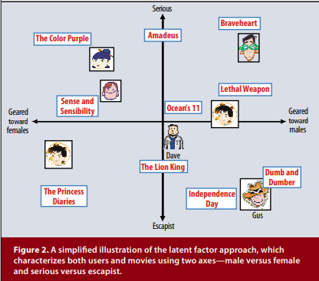
Recommender systems rely on different types of input data, which are often placed in a matrix with one dimension representing users and the other dimension representing items of interest. The most convenient data is high-quality explicit feedback, which includes explicit input by users regarding their interest in products. For example, Netflix collects star ratings for movies, and TiVo users indicate their preferences for TV shows by pressing thumbs-up and thumbs-down buttons. We refer to explicit user feedback as ratings. Usually, explicit feedback comprises a sparse matrix, since any single user is likely to have rated only a small percentage of possible items.
One strength of matrix factorization is that it allows incorporation of additional information. When explicit feedback is not available, recommender systems can infer user preferences using implicit feedback, which indirectly reflects opinion by observing user behavior including purchase history, browsing history, search patterns, or even mouse movements. Implicit feedback usually denotes the presence or absence of an event, so it is typically represented by a densely filled matrix.
A BASIC MATRIX FACTORIZATION MODEL
Matrix factorization models map both users and items to a joint latent factor space of dimensionality f, such that user-item interactions are modeled as inner products in that space. Accordingly, each item i is associated with a vector qi ∈  f , and each user u is associated with a vector pu ∈  f . For a given item i, the elements of qi measure the extent to which the item possesses those factors, positive or negative. For a given user u, the elements of pu measure the extent of interest the user has in items that are high on the corresponding factors, again, positive or negative. The resulting dot product, qi T pu, captures the interaction between user u and item i—the user’s overall interest in the item’s characteristics. This approximates user u’s rating of item i, which is denoted by rui, leading to the estimate.
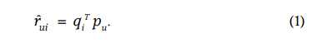
The major challenge is computing the mapping of each item and user to factor vectors qi , pu ∈  f . After the recommender system completes this mapping, it can easily estimate the rating a user will give to any item by using Equation 1.
Such a model is closely related to singular value decomposition (SVD), a well-established technique for identifying latent semantic factors in information retrieval. Applying SVD in the collaborative filtering domain requires factoring the user-item rating matrix. This often raises difficulties due to the high portion of missing values caused by sparseness in the user-item ratings matrix. Conventional SVD is undefined when knowledge about the matrix is incomplete. Moreover, carelessly addressing only the relatively few known entries is highly prone to overfitting.
Earlier systems relied on imputation to fill in missing ratings and make the rating matrix dense.2 However, imputation can be very expensive as it significantly increases the amount of data. In addition, inaccurate imputation might distort the data considerably. Hence, more recent works3-6 suggested modeling directly the observed ratings only, while avoiding overfitting through a regularized model. To learn the factor vectors (pu and qi ), the system minimizes the regularized squared error on the set of known ratings:
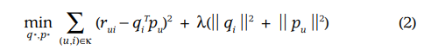
Here, κ is the set of the (u,i) pairs for which rui is known (the training set).
The system learns the model by fitting the previously observed ratings. However, the goal is to generalize those previous ratings in a way that predicts future, unknown ratings. Thus, the system should avoid overfitting the observed data by regularizing the learned parameters, whose magnitudes are penalized. The constant λ controls the extent of regularization and is usually determined by cross-validation. Ruslan Salakhutdinov and Andriy Mnih’s “Probabilistic Matrix Factorization”7 offers a probabilistic foundation for regularization.
LEARNING ALGORI
Two approaches to minimizing Equation 2 are stochastic gradient descent and alternating least squares (ALS).
- Stochastic gradient descent
Simon Funk popularized a stochastic gradient descent optimization of Equation 2 (http://sifter.org/~simon/ journal/20061211.html) wherein the algorithm loops through all ratings in the training set. For each given training case, the system predicts rui and computes the associated prediction error
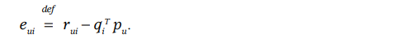
Then it modifies the parameters by a magnitude proportional to g in the opposite direction of the gradient, yielding:
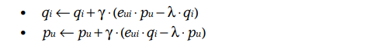
This popular approach4-6 combines implementation ease with a relatively fast running time. Yet, in some cases, it is beneficial to use ALS optimization.
- Alternating least squares
Because both qi and pu are unknowns, Equation 2 is not convex. However, if we fix one of the unknowns, the optimization problem becomes quadratic and can be solved optimally. Thus, ALS techniques rotate between fixing the qi ’s and fixing the pu ’s. When all pu ’s are fixed, the system recomputes the qi ’s by solving a least-squares problem, and vice versa. This ensures that each step decreases Equation 2 until convergence.
While in general stochastic gradient descent is easier and faster than ALS, ALS is favorable in at least two cases. The first is when the system can use parallelization. In ALS, the system computes each qi independently of the other item factors and computes each pu independently of the other user factors. This gives rise to potentially massive parallelization of the algorithm.9 The second case is for systems centered on implicit data. Because the training set cannot be considered sparse, looping over each single training case—as gradient descent does—would not be practical. ALS can efficiently handle such cases.
ADDING BIASES
One benefit of the matrix factorization approach to collaborative filtering is its flexibility in dealing with various data aspects and other application-specific requirements. This requires accommodations to Equation 1 while staying within the same learning framework. Equation 1 tries to capture the interactions between users and items that produce the different rating values. However, much of the observed variation in rating values is due to effects associated with either users or items, known as biases or intercepts, independent of any interactions. For example, typical collaborative filtering data exhibits large systematic tendencies for some users to give higher ratings than others, and for some items to receive higher ratings than others. After all, some products are widely perceived as better (or worse) than others.
Thus, it would be unwise to explain the full rating value by an interaction of the form qi T pu. Instead, the system tries to identify the portion of these values that individual user or item biases can explain, subjecting only the true interaction portion of the data to factor modeling. A first-order approximation of the bias involved in rating rui is as follows:
The bias involved in rating rui is denoted by bui and accounts for the user and item effects. The overall average rating is denoted by µ; the parameters bu and bi indicate the observed deviations of user u and item i, respectively, from the average. For example, suppose that you want a first-order estimate for user Joe’s rating of the movie Titanic. Now, say that the average rating over all movies, µ, is 3.7 stars. Furthermore, Titanic is better than an average movie, so it tends to be rated 0.5 stars above the average. On the other hand, Joe is a critical user, who tends to rate 0.3 stars lower than the average. Thus, the estimate for Titanic’s rating by Joe would be 3.9 stars (3.7 + 0.5 - 0.3). Biases extend Equation 1 as follows:
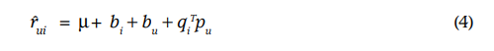
Here, the observed rating is broken down into its four components: global average, item bias, user bias, and useritem interaction. This allows each component to explain only the part of a signal relevant to it. The system learns by minimizing the squared error function:
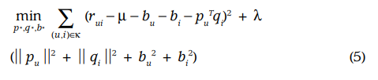
Since biases tend to capture much of the observed signal, their accurate modeling is vital. Hence, other works offer more elaborate bias models.
ADDITIONAL INPUT SOURCES
Often a system must deal with the cold start problem, wherein many users supply very few ratings, making it difficult to reach general conclusions on their taste. A way to relieve this problem is to incorporate additional sources of information about the users. Recommender systems can use implicit feedback to gain insight into user preferences. Indeed, they can gather behavioral information regardless of the user’s willingness to provide explicit ratings. A retailer can use its customers’ purchases or browsing history to learn their tendencies, in addition to the ratings those customers might supply.
For simplicity, consider a case with a Boolean implicit feedback. N(u) denotes the set of items for which user u expressed an implicit preference. This way, the system profiles users through the items they implicitly preferred. Here, a new set of item factors are necessary, where item i is associated with xi ∈  f . Accordingly, a user who showed a preference for items in N(u) is characterized by the vector.
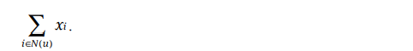
Normalizing the sum is often beneficial, for example, working with:
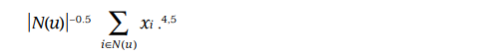
Another information source is known user attributes, for example, demographics. Again, for simplicity consider Boolean attributes where user u corresponds to the set of attributes A(u), which can describe gender, age group, Zip code, income level, and so on. A distinct factor vector ya ∈  f corresponds to each attribute to describe a user through the set of user-associated attributes:
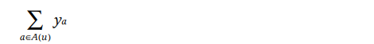
The matrix factorization model should integrate all signal sources, with enhanced user representation:
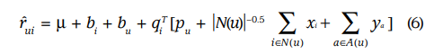
While the previous examples deal with enhancing user representation—where lack of data is more common— items can get a similar treatment when necessary.
TEMPORAL DYNAMICS
So far, the presented models have been static. In reality, product perception and popularity constantly change as new selections emerge. Similarly, customers’ inclinations evolve, leading them to redefine their taste. Thus, the system should account for the temporal effects reflecting the dynamic, time-drifting nature of user-item interactions.
The matrix factorization approach lends itself well to modeling temporal effects, which can significantly im-prove accuracy. Decomposing ratings into distinct terms allows the system to treat different temporal aspects separately. Specifically, the following terms vary over time: item biases, bi (t); user biases, bu(t); and user preferences, pu(t).
The first temporal effect addresses the fact that an item’s popularity might change over time. For example, movies can go in and out of popularity as triggered by external events such as an actor’s appearance in a new movie. Therefore, these models treat the item bias bi as a function of time. The second temporal effect allows users to change their baseline ratings over time. For example, a user who tended to rate an average movie “4 stars” might now rate such a movie “3 stars.” This might reflect several factors including a natural drift in a user’s rating scale, the fact that users assign ratings relative to other recent ratings, and the fact that the rater’s identity within a household can change over time. Hence, in these models, the parameter bu is a function of time.
Temporal dynamics go beyond this; they also affect user preferences and therefore the interaction between users and items. Users change their preferences over time. For example, a fan of the psychological thrillers genre might become a fan of crime dramas a year later. Similarly, humans change their perception of certain actors and directors. The model accounts for this effect by taking the user factors (the vector pu ) as a function of time. On the other hand, it specifies static item characteristics, qi , because, unlike humans, items are static in nature.
Exact parameterizations of time-varying parameters11 lead to replacing Equation 4 with the dynamic prediction rule for a rating at time t:
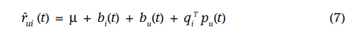
INPUTS WITH VARYING CONFIDENCE LEVELS
In several setups, not all observed ratings deserve the same weight or confidence. For example, massive advertising might influence votes for certain items, which do not aptly reflect longer-term characteristics. Similarly, a system might face adversarial users that try to tilt the ratings of certain items.
Another example is systems built around implicit feedback. In such systems, which interpret ongoing user behavior, a user’s exact preference level is hard to quantify. Thus, the system works with a cruder binary representation, stating either “probably likes the product” or “probably not interested in the product.” In such cases, it is valuable to attach confidence scores with the estimated preferences. Confidence can stem from available numerical values that describe the frequency of actions, for example, how much time the user watched a certain show or how frequently a user bought a certain item. These numerical values indicate the confidence in each observation. Various factors that have nothing to do with user preferences might cause a one-time event; however, a recurring event is more likely to reflect user opinion.
The matrix factorization model can readily accept varying confidence levels, which let it give less weight to less meaningful observations. If confidence in observing rui is denoted as cui, then the model enhances the cost function (Equation 5) to account for confidence as follows:
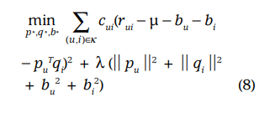
For information on a real-life application involving such schemes, refer to “Collaborative Filtering for Implicit Feedback Datasets.”
NETFLIX PRIZE COMPETITION
In 2006, the online DVD rental company Netflix announced a contest to improve the state of its recommender system.12 To enable this, the company released a training set of more than 100 million ratings spanning about 500,000 anonymous customers and their ratings on more than 17,000 movies, each movie being rated on a scale of 1 to 5 stars. Participating teams submit predicted ratings for a test set of approximately 3 million ratings, and Netflix calculates a root-mean-square error (RMSE) based on the held-out truth. The first team that can improve on the Netflix algorithm’s RMSE performance by 10 percent or more wins a $1 million prize. If no team reaches the 10 percent goal, Netflix gives a $50,000 Progress Prize to the team in first place after each year of the competition.
The contest created a buzz within the collaborative filtering field. Until this point, the only publicly available data for collaborative filtering research was orders of magnitude smaller. The release of this data and the competition’s allure spurred a burst of energy and activity. According to the contest website (www.netflixprize.com), more than 48,000 teams from 182 different countries have downloaded the data.
Our team’s entry, originally called BellKor, took over the top spot in the competition in the summer of 2007, and won the 2007 Progress Prize with the best score at the time: 8.43 percent better than Netflix. Later, we aligned with team Big Chaos to win the 2008 Progress Prize with a score of 9.46 percent. At the time of this writing, we are still in first place, inching toward the 10 percent landmark.
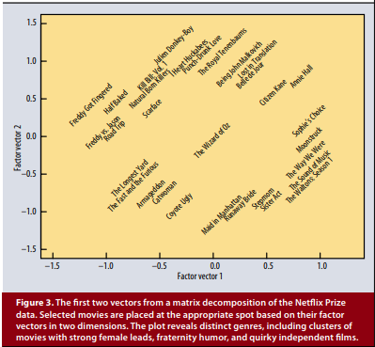
Our winning entries consist of more than 100 different predictor sets, the majority of which are factorization models using some variants of the methods described here. Our discussions with other top teams and postings on the public contest forum indicate that these are the most popular and successful methods for predicting ratings.
Factorizing the Netflix user-movie matrix allows us to discover the most descriptive dimensions for predicting movie preferences. We can identify the first few most important dimensions from a matrix decomposition and explore the movies’ location in this new space. Figure 3 shows the first two factors from the Netflix data matrix factorization. Movies are placed according to their factor vectors. Someone familiar with the movies shown can see clear meaning in the latent factors. The first factor vector (x-axis) has on one side lowbrow comedies and horror movies, aimed at a male or adolescent audience (Half Baked, Freddy vs. Jason), while the other side contains drama or comedy with serious undertones and strong female leads (Sophie’s Choice, Moonstruck). The second factorization axis (y-axis) has independent, critically acclaimed, quirky films (Punch-Drunk Love, I Heart Huckabees) on the top, and on the bottom, mainstream formulaic films (Armageddon, Runaway Bride). There are interesting intersections between these boundaries: On the top left corner, where indie meets lowbrow, are Kill Bill and Natural Born Killers, both arty movies that play off violent themes. On the bottom right, where the serious female-driven movies meet the mainstream crowd-pleasers, is The Sound of Music. And smack in the middle, appealing to all types, is The Wizard of Oz.
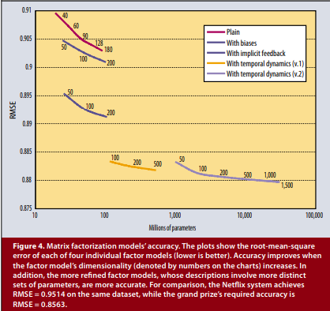
In this plot, some movies neighboring one another typically would not be put together. For example, Annie Hall and Citizen Kane are next to each other. Although they are stylistically very different, they have a lot in common as highly regarded classic movies by famous directors. Indeed, the third dimension in the factorization does end up separating these two.
We tried many different implementations and parameterizations for factorization. Figure 4 shows how different models and numbers of parameters affect the RMSE as well as the performance of the factorization’s evolving implementations—plain factorization, adding biases, enhancing user profile with implicit feedback, and two variants adding temporal components. The accuracy of each of the factor models improves by increasing the number of involved parameters, which is equivalent to increasing the factor model’s dimensionality, denoted by numbers on the charts.
The more complex factor models, whose descriptions involve more distinct sets of parameters, are more accurate. In fact, the temporal components are particularly important to model as there are significant temporal effects in the data.
Matrix factorization techniques have become a dominant methodology within collaborative filtering recommenders. Experience with datasets such as the Netflix Prize data has shown that they deliver accuracy superior to classical nearest-neighbor techniques. At the same time, they offer a compact memory-efficient model that systems can learn relatively easily. What makes these techniques even more convenient is that models can integrate naturally many crucial aspects of the data, such as multiple forms of feedback, temporal dynamics, and confidence levels.

译文：
推荐系统的矩阵分解技术
正如Netflix奖竞赛所表明的那样，矩阵分解模型优于经典的最近邻居产生产品推荐的技术，允许合并隐含的附加信息反馈，时间效应和信任水平。
现代消费者被淹没选择中。电子零售商和内容提供商提供了大量的产品选择，有着前所未有的机会满足消费者各种特殊需求和口味。使消费者与最合适的消费者相匹配产品是提高用户满意度和忠诚度的关键。因此，更多零售商已经对推荐系统感兴趣，分析用户的模式对产品兴趣提供个性化建议，适合用户的口味。 因为好的个性化建议可以向用户添加另一个维度的体验，电子商务领导者如亚马逊和Netflix已经使推荐系统成为网站的一个显着的部分。
这种系统对娱乐产品特别有用，如电影，音乐和电视节目。许多客户将观看相同的电影，并且每个客户都是可能会观看许多不同的电影。能够表明客户更喜欢哪些电影，所以可以获得大量关于哪些电影吸引哪些客户的数据。公司可以分析这些数据来推荐电影给特定的客户。
推荐系统策略
广义而言，推荐系统基于两个策略。内容过滤方法为每个用户或产品创建一个配置文件来表征其性质。例如，电影配置文件可能包含关于它的类型的属性，参与者，其参与者票房受欢迎程度等等。用户简档可能包括人口统计信息或提供的答案在适当的问卷上。配置文件允许程序将用户与匹配产品相关联。当然，基于内容的策略需要收集外部信息这可能不可用或不易收集。
已知的内容过滤的成功案例是用于互联网的音乐基因组计划无线电服务网站Pandora。经过训练的音乐分析师会对Music Genome Project中的每首歌曲基于数百种不同的音乐特点进行评分。这些属性或基因，不仅可以捕捉歌曲的音乐身份，并且也有很多重要的特质与理解听众的音乐有关优先选择权。
内容过滤的替代方案依赖于仅针对过去的用户行为。例如，以前的交易或产品评级，不需要创建明确的配置文件。 这种方法被称为协作过滤，这个术语由Tapestry的开发者创造，第一个推荐系统，协作过滤分析用户和用户之间的关系，产品之间的相互依存关系识别新的用户项目关联。
协作过滤的主要吸引力是它是免费的，但它可以解决常常难以捉摸的数据方面的问题和难以使用内容过滤进行配置的问题。虽然通常比基于内容的技术，协作过滤遭受所谓的感冒由于无法解决问题而引发问题系统的新产品和用户。在这方面，内容过滤是优越的。
协同过滤的两个主要领域是邻域方法和潜在因子模型。邻里方法的核心是计算关系项目之间或者用户之间。项目导向方法评估用户的偏好项目基于“邻近”项目的评分用户。产品的邻居是倾向的其他产品当被同一用户评价时获得相似的评价。对于例如，考虑电影Saving Private Ryan。它的邻居可能包括战争电影，斯皮尔伯格电影，和汤姆汉克斯电影等。预测一个特定的用户对Saving Ryan的评价，我们会看看为电影的最近的邻居，这个用户实际上评级。如图1所示，面向用户的方法确定可以补充每个用户的志趣相投的用户其他的评级。
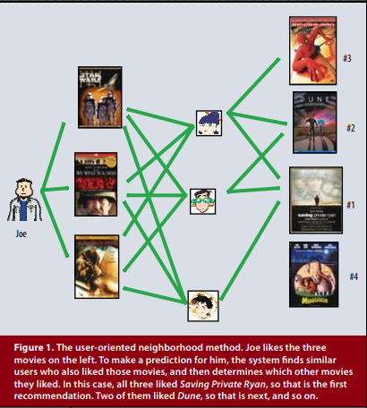
潜在因素模型是一种替代方法试图通过表征两者来解释收视率项目和用户，比如从20到100个因素推断出来收视模式。从某种意义上说，这些因素包括a电脑化替代上述人类创造的歌曲基因。对于电影，发现的因素可能会测量明显的尺寸，比如喜剧和对比戏剧，行动量或对儿童的定位; 不太明确的维度，如角色发展的深度或怪癖; 或完全不可解释尺寸。对于用户来说，每个因素都会测量多少用户喜欢相应的高分电影电影因素。
图2说明了这个简化例子的想法在两个维度。考虑两个假设维度其特征为女性与男性相对立严重与逃避现实。该图显示了几个着名的电影和一些虚构的用户可能会落在后面这两个维度。对于这个模型，用户的预测评级为一部电影，相对于电影的平均评分，将等于电影和用户位置的点积在图上。例如，我们期待Gus爱Dumb和Dumber，讨厌The Purple Purple和对Braveheart进行平均评分。请注意，一些电影 - 为例如，Ocean的11和用户 - 例如，戴夫 - 将被视为相当中性的这些两个维度。
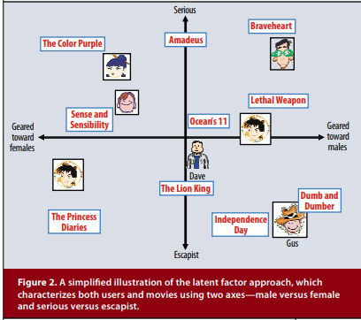
矩阵分解方法
一些最成功的潜在因素实现模型基于矩阵分解。在其基本形式中，矩阵分解表征了项目和用户从物品评分模式推断的因素向量。高项目和用户因素之间的对应关系导致推荐。这些方法已成为流行最近几年通过结合良好的可扩展性和预测性准确性。另外，它们为建模提供了很大的灵活性各种现实生活中的情况。
推荐系统依赖于不同的类型输入数据，这些数据通常放在一个矩阵中维度代表用户和其他维度代表感兴趣的项目。 最方便的数据是高质量的显式反馈，其中包括显式的用户对他们对产品的兴趣所输入的信息。 对于例如，Netflix收集电影和TiVo的星级评分用户通过按下来显示他们对电视节目的偏好竖起大拇指和拇指向下按钮。 我们提到明确的用户反馈作为评级。 通常，显式反馈包括一个稀疏矩阵，因为任何单个用户都可能只评定了一小部分可能的项目。
矩阵分解的一个优点是它允许并入其他信息。 明确时反馈不可用，推荐系统可以推断使用隐式反馈的用户偏好，这是间接的通过观察包括购买在内的用户行为反映意见历史记录，浏览历史记录，搜索模式甚至是鼠标移动。 隐式反馈通常表示一个事件的存在与否，所以它通常被表示出来由密集填充矩阵。
一个基本的矩阵分解模型
矩阵分解模型映射用户和项目到维度f的联合潜在因素空间，用户 - 项目交互被建模为内部产品那个空间。因此，每个项目i与矢量q_{i}∈R^{f}相关联，并且每个用户都是关联的具有向量p_{u}∈R^{f}。对于给定的项目我是气的元素衡量的程度该项目拥有这些因素，正面或负面。对于给定的用户你，p_{u}的元素衡量的程度用户对高价商品的兴趣在相应的因素，再次，积极或否定的。由此产生的点积，
q_{i}^{T}p_{u},，捕捉用户之间的交互你和项目我-用户的整体兴趣该项目的特点。这近似用户u对项目i的评分，表示为导致估计。
rˆ_{ui} = q_{i}^{T}p_{u}. (1)
主要的挑战是计算映射每个项目和用户的因素向量齐，p_{u}∈R^{f}。推荐系统之后完成这个映射，它可以很容易地估计用户对任何物品的评分通过使用等式1。
这种模型与奇异值分解密切相关（SVD），这是一种成熟的识别技术信息检索中潜在的语义因素。应用协同过滤领域的SVD需要分解用户项目评分矩阵。这往往会带来困难，由于稀疏造成的缺失值的很大一部分在用户项目评分矩阵中。 传统的SVD是当关于矩阵的知识不完整时未定义。而且，不小心只处理相对的问题很少有已知的条目很容易过度配合。
早期的系统依靠插补填补缺失评级并使评级矩阵密集。但是，插补可能非常昂贵，因为它显着增加数据量。另外，不准确的插补可能会大大扭曲数据。因此，更近期作品建议直接观察评级只有通过正规化避免过度配合模型。要学习因子矢量（p_{u}和q_{i}），系统使集合上的正则化平方误差最小化已知评级：
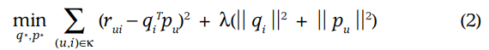
这里，κ是r_{ui}已知的（u，i）对的集合（训练集）。
系统通过先前拟合来学习模型观察评级。但是，我们的目标是推广这些以前的评级预测未来，未知收视率。因此，系统应该避免过度配合通过规律化学习参数观察数据，其量值受到惩罚。 常数λ控制正则化的程度，通常由确定交叉验证。Ruslan Salakhutdinov和Andriy Mnih的“概率矩阵分解”提供了一个概率正规化基础。
学习算法
两种最小化方程2的方法是随机的梯度下降和交替最小二乘（ALS）。
- 随机梯度下降
西蒙·芬克普及了随机梯度下降等式2的优化（http://sifter.org/~simon/期刊/ 20061211.html），其中算法循环通过训练集中的所有评分。 对于每个给定的培训案例，系统预测r_{ui}和计算相关的预测误差.
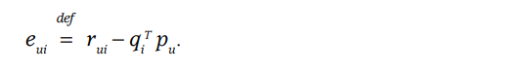
然后它通过一个幅度比例来修改参数在梯度的相反方向上，收益：
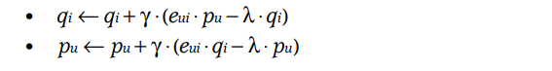
这种流行的方法4-6结合了实现以相对较快的运行时间缓解。 然而，在某些情况下，使用ALS优化是有益的。
- 交替最小二乘
因为都是q_{i}和p_{u}是未知数，等式2不是凸。但是，如果我们修复了其中一个未知数，那么优化问题变成二次的并且可以解决最佳。因此，ALS技术在固定之间旋转q_{i}并且修理p_{u}的。当所有p_{u}系统是固定的重新计算q_{i}通过解最小二乘问题，并且反之亦然。这确保了每一步都减少了公式2直到收敛。
一般来说，随机梯度下降更容易并且比ALS更快，ALS在至少两种情况下是有利的。首先是系统可以使用并行化的时间。在ALS中，系统计算每个q_{i}彼此独立项目因素并计算每个p_{u}独立的其他用户因素。这导致潜在的巨大并行化算法。第二种情况是以隐式数据为中心的系统。因为训练设置不能被认为是稀疏的，循环遍历每一个训练案例-如梯度下降-不会实际的。ALS可以有效地处理这种情况。
添加偏差
矩阵分解方法对协作的一个好处过滤是它在处理各种数据方面和其他应用程序特定要求时的灵活性。这需要在方程式1中保留住宿在同一个学习框架内。 公式1尝试捕获用户和产生的项目之间的交互不同的评价值。然而，大部分观察到的评级值的变化是由于与之相关的影响无论是用户还是项目，称为偏差或截取，都是独立的的任何互动。例如，典型的协作过滤数据显示出一些较大的系统趋势用户给予比其他人更高的评分，以及某些项目获得比其他人更高的评价。 毕竟，有些产品被普遍认为比其他人更好（或更差）。
因此，解释完整的评级值是不明智的通过形式气的相互作用q_{i}^{T}p_{u}。系统会尝试确定个人用户或者个人用户的这些价值的部分项目偏见可以解释，只受真正的互动部分数据进行因子建模。一阶近似参与评级r_{ui}的偏差如下：
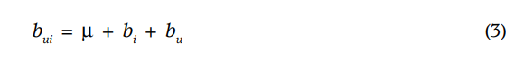
参与评级r_{ui}的偏差由b_{ui}和账户表示为用户和项目效果。整体平均水平等级由μ表示; 参数b_{u}和b_{i}表明观察到用户u和项目i的偏差，从平均水平来看。 例如，假设你想要用户Joe对该电影的评价的一阶估计泰坦尼克号。现在，假设所有电影的平均评分μ，是3.7颗星。此外，泰坦尼克号比平均水平要好电影，所以它往往被评为高于平均水平0.5星。另一方面，Joe是一个关键用户，他倾向于评价比平均值低0.3颗星。因此，估计泰坦尼克号对乔的评价是3.9星（3.7 + 0.5 - 0.3）。偏差如下扩展方程1：
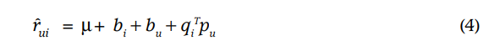
在这里，观察到的评级被分解为四个组件：全球平均值，项目偏差，用户偏好和用户项目相互作用。 这允许每个组件进行解释只有与它有关的信号部分。 系统学习通过最小化平方误差函数：
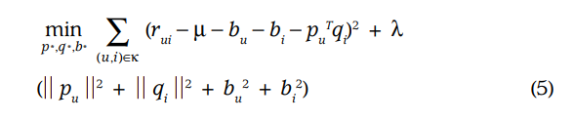
由于偏见倾向于捕捉大部分观察到的信号，它们的准确建模至关重要。 因此，其他作品提供更精细的偏见模型。
额外的输入源
通常系统必须处理冷启动问题，其中许多用户提供的评分很少，使得难以就他们的口味达成一般结论。 一种方式解决这个问题的方法是整合其他来源有关用户的信息。 推荐系统可以使用隐式反馈来深入了解用户偏好。事实上，他们无论如何都可以收集行为信息的用户愿意提供明确的评级。 零售商可以使用其客户的购买或浏览历史记录学习他们的倾向，除了收视率那些客户可能会提供。
为了简单起见，考虑一个布尔隐式的情况反馈。 N（u）表示用户u的项目集合表示了一种隐含的偏好。 这样，系统通过它们隐含地首选的项目对用户进行配置文件。在这里，一套新的项目因素是必要的，其中项目我与x_{i}∈R^{f}有关。相应地，用户谁显示了对N（u）中项目的偏好特征矢量。
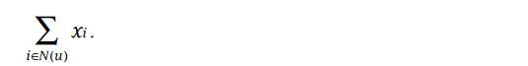
标准化总和通常是有益的，例如，与下面的式子合作：
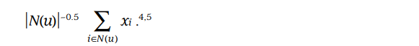
另一个信息来源是已知的用户属性，例如，人口统计。再次，为了简单考虑布尔属性，其中用户u对应于该集合属性A（u）可以描述性别，年龄组，邮政编码，收入水平等等。一个独特的因素向量y_{a} ∈ R^{f}对应于每个属性来描述用户通过一组用户关联的属性：
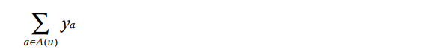
矩阵分解模型应该整合所有信号源，增强用户表示：
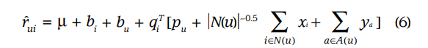
前面的例子涉及增强用户代表性 - 数据缺乏更常见 - 物品在必要时可以得到类似的待遇。
时间动态
到目前为止，所提出的模型一直是静态的。事实上，产品感知和知名度不断变化随着新的选择出现。同样，客户的倾向进化，引导他们重新定义自己的品味。从而，系统应考虑到反映的时间效应用户项目的动态的，时间漂移的特性互动。
矩阵分解法非常适合建模时间效应，这可以显着提高准确性。 将评分分解为不同的术语允许系统分别处理不同的时间方面。具体而言，以下条款随时间而变化：项目偏见,b_{i}（t）; 用户偏好，b_{u}（t)和用户偏好，p_{u}（t）。
第一个时间效应解决了一个事实项目的受欢迎程度可能会随着时间而改变 例如，电影可以进入和退出受欢迎的状态外部事件，例如演员在新角色中的表现电影。因此，这些模型处理项目偏差b_{i}作为一个时间的功能。第二个时间效应允许用户随着时间的推移改变他们的基准评分 例如，a倾向于评价平均电影“4星级”的用户可能现在评价这样的电影“三星级”。这可能反映了几个包括用户评分等级中的自然漂移的因素，用户相对于其他近期指定评分的事实评级以及评估者在家庭中的身份这一事实可以随时间变化。因此，在这些模型中，参数b_{u}是时间的函数。
时间动态超越了这个; 他们也影响用户偏好以及因此之间的相互作用用户和项目。用户随着时间改变他们的偏好。例如，心理惊悚片类型的粉丝可能会在一年后成为犯罪剧的粉丝。同样的，人类会改变他们对某些演员的看法和董事。 该模型考虑了这种影响用户因素（矢量p_{u}）作为时间的函数。上另一方面，它指定了静态项目特征q_{i}，因为与人类不同，物品本质上是静态的。
时变参数的精确参数化导致用动态预测代替方程4在时间t评分的规则：
具有可变信心水平的输入
在几个设置中，并非所有观察到的评级都值得相同的重量或信心。 例如，大量的广告可能会影响某些项目的投票，这会影响投票不恰当反映较长期的特点。 同样，a系统可能面临试图倾斜评级的敌对用户某些项目。
另一个例子是围绕隐式构建的系统反馈。在这个解释正在进行的系统中用户的行为，用户的确切偏好级别很难量化。因此，系统使用较粗略的二进制文件说“可能喜欢产品”或者“可能对该产品不感兴趣”。在这些情况下，将置信度分数添加到估计值很有价值优先。信心可能来自可用性描述工作频率的数值，例如，当用户观看某个时间显示用户购买特定产品的频率或频率。这些数值表示每个观察的置信度。与用户偏好无关的各种因素可能会导致一次性使用事件; 然而，一个反复发生的事件是这更可能反映用户的意见。
矩阵分解模型可以随时接受不同的信心水平，让它减轻重量意义不大的观察。如果有信心在观察r_{ui}表示为c_{ui},那么该模型会提高成本函数（等式5）来解释信心如下：
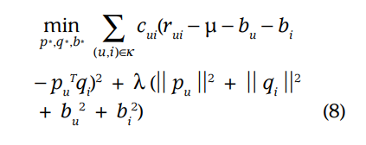
有关实际应用程序的信息涉及这样的计划，请参阅“协作过滤”隐式反馈数据集。
NETFLIX奖竞争
2006年在线DVD租赁Netflix公司宣布了一场比赛改善推荐系统的状态为此，该公司发布了一套更多的培训超过1亿个评级，跨越约50万匿名客户和他们的收视率超过17,000电影，每部电影的评分等级为1至5星。参与团队提交测试集的预测评级大约3百万个评级，并且Netflix计算基于保留的均方根误差（RMSE）真相。第一个可以改进Netflix算法的团队RMSE性能提高10％甚至更多100万美元的奖金。如果没有球队达到10％的目标，Netflix首先向团队提供50,000美元的进步奖在每年的比赛后放置。
比赛在协作过滤中引发了一阵热议领域。直到这一点，唯一公开的数据对于协作过滤的研究达到了数量级小。这些数据和竞赛的发布魅力激发了一阵能量和活动。根据比赛网站（www.netflixprize.com）等等来自182个不同国家的48,000个团队已经下载数据。
我们团队的入门，原名BellKor，接手在2007年夏季的比赛中名列第一，并在2007年获得了最佳成绩的2007年进步奖时间：比Netflix好8.43％。后来，我们一致与Big Chaos一起赢得2008年进步奖得分为9.46％。在撰写本文时，我们依然如此首先，朝着10％的地标迈进。
我们的获奖作品包括超过100种不同的作品预测集，其中大部分都是分解因子模型使用这里描述的方法的一些变体。我们与其他顶级团队的讨论和贴子上的帖子公开竞赛论坛表明这些是最受欢迎的并预测评级的成功方法。
分解Netflix用户电影矩阵可以让我们分享发现预测的最具描述性的维度电影喜好。我们可以识别出前几名矩阵分解的重要维度在这个新空间探索电影的位置。图3显示了Netflix数据矩阵的前两个因素因式分解。电影根据他们的因素放置向量。有人熟悉所示的电影可以看到明确潜在因素的意义。第一个因素矢量（x轴）有一面低俗的喜剧和恐怖电影，针对男性或青少年观众（半烤，弗雷迪与杰森），而另一方包含戏剧或喜剧有严肃的意味和强烈的女性主角（Sophie's Choice，Moonstruck）。第二个因素轴（y轴）具有独立性，广受好评，古怪电影（Punch-Drunk Love，I Heart Huckabees）在上面，并在底部，主流配方电影（大决战，失控的新娘）。有趣的交叉点在这些边界之间：在左上角，在哪里独立会见低调，杀死比尔和天生杀人狂，这两个艺术电影播放暴力主题。在底部右侧是严肃的女性驱动电影与主流人群讨论的地方，即音乐之声。而在中间sma，，吸引所有类型的是The绿野仙踪。
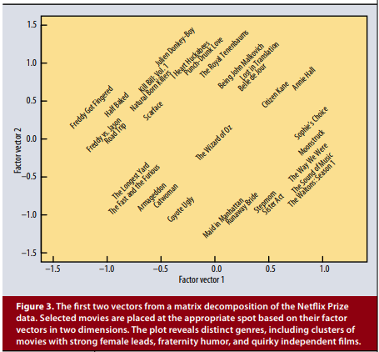
在这个情节中，一些电影通常彼此相邻不会放在一起。例如，Annie Hall和Citizen Kane相邻。尽管他们在风格上非常不同，他们有很多共同之处作为着名导演高度重视的经典电影。事实上，分解的第三个维度结束了将这两者分开。
我们尝试了许多不同的实现和参数化为分解。图4显示了如何不同的型号和数量的参数会影响到RMSE以及分解的表现不断演变的实现 - 明确的分解，增加偏见，通过隐式反馈增强用户信息，以及两个变体添加时间组件。准确性每个因素模型的改进都是通过增加涉及参数的数量，相当于增加因子模型的维数，记为数字在图表上。
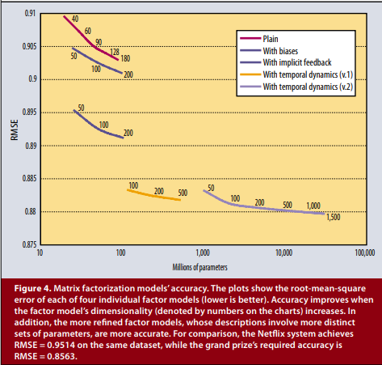
更复杂的因素模型，其描述涉及更多不同的参数组，更准确。事实上，时间成分尤其如此由于存在显着的时间效应，因此很重要在数据中。
矩阵分解技术已成为一个主导方法论中协作过滤推荐器。与经验数据集，如Netflix奖数据显示他们交付精度优于经典最近邻居技术。在同时，他们提供了一个紧凑的内存效率模型该系统可以相对地学习容易。是什么使这些技术更方便的是该模型可以自然地整合许多关键的方面数据，如多种形式反馈，时间动态，和置信水平。

