CONTENTS 目录
To the teacher and student
Learning a foreign language in the classroom
About this course
How to use this course
ix
致教师和学生 外语的课堂教学 关于本教材的说明
本教材使用说明
Lesson 1 | Excuse me!对不起! | 1
Lesson 2 | Is this your ...?这是你的……吗？ | 3
Lesson 3 | Sorry, sir.对不起，先生。 | 5
Lesson 4 | Is this your ...?这是你的 吗？ | 7
Lesson 5 | Nice to meet you.很高兴见到你。 | 9
Lesson 6 | What make is it?它是什么牌子的？ | 11
Lesson 7 | Are you a teacher?你是教师吗? | 13
Lesson 8 | What's your job?你是做什么工作的？ | 15
Lesson 9 | How are you today?你今天好吗？ | 17
Lesson 10' | Look at ...看 | 19
Lesson 11 | Is this your shirt?这是你的衬衫吗？ | 21
Lesson 12 | Whose is this ...? This is my/your/his/her ...这 是谁的？这是我的/你的/他的/她的•…  Whose is that ...? That is my/your/his/her ...那 是谁的？那是我的/你的/他的/她的… | ■- 23
Lesson 13 | A new dress 一件新连衣裙 | 25
Lesson 14 | What colour is your ...?你的 是什么颜色的？ | 27
Lesson 15 | Your passports, please.请出示你们的护照。 | 29
Lesson 16 | Are you ...?你是……吗？ | 31
Lesson 17 | How do you do?你好！ | 33
Lesson 18 | What are their jobs?他们是做什么工作的？ | 35
Lesson 19 | Tired and thirsty 又累又渴 | 37
Lesson 20 | Look at them!看看他/它们！ | 39
Lesson 21 | Which book?哪一本书? | 41
Lesson 22 | Give mc/him/her/us/them a …给我/他/她/我们/他们 、  Which one?哪一……？ | 43
Lesson 23 | Which glasses?哪几只杯子？ | 45
Lesson 24 | Give mc/him/her/us/them some ...给我/他/她/我们/他们 些  Which ones?哪些？ | 47
Lesson 25 | Mrs. Smith、kitchen史密斯太太的厨房 | 49
Lesson 26 | Where is it?它在哪里？ | 51
Lesson 27 | Mrs. Smith's living room史密斯太太的客厅 | 53
Lesson 28 | Where are they?它们在哪里？ | 55
Lesson 29 | Come in, Amy.进来，艾米。 | 57
Lesson 30 | What must I do?我应该做什么？ | 59

Lesson 31 | Where's Sally?萨莉在哪里？ | 61
Lesson 32 | What's he/she/it doing?他/她/它正在做什么？ | 63
Lesson 33 | A fine day 晴天 | 65
Lesson 34 | What arc they doing?他们在做什么? | 67
Lesson 35 | Our village我们的村庄 | 69
Lesson 36 | Where ...?……在哪里？ | 71
Lesson 37 | Making a bookcase 做书架 | 73
Lesson 38 | What are you going to do?你准备做什么?  What are you doing now?你现在正在做什么? | 75
Lesson 39 | Don't drop it!别摔了 ! | 77
Lesson 40 | What are you going to do?你准备做什么？ I m going to ...我准备 | 79
Lesson 41 | Penny's bag彭妮的提包 | 81
Lesson 42 | Is there a ... in/on that ...?在那个 中/上有 个 吗?  Is there any ... in/on that ...?在那个 中/上有 吗？ | 83
Lesson 43 | Hurry叩！快点! | 85
Lesson 44 | Are there any ...?有些 吗?  Is there any …？有些 吗？ | 87
Lesson 45 | The boss's letter 老板的信 | 89
Lesson 46 | Can you ...?你能……吗？ | 91
Lesson 47 | A cup of coffee 一杯咖啡 | 93
Lesson 48 | Do you like ...?你号欢 吗？  Do you want ...?你想要……吗？ | 95
Lesson 49 | At the butcher^ 在肉店 | 97
Lesson 50 | He likes ...他喜欢  But he doesn't like ...但是他不喜欢 | 99
Lesson 51 | A pleasant climate 宜人的气候 | 101
Lesson 52 | What nationality are they?他们是哪国人？ Where do they come from?他们来自哪个国家？ | 103
Lesson 53 | An interesting climate 有趣的气候 | 105
Lesson 54 | What nationality are they?他们是哪国人?  Where do they come from?他们来自哪个国家？ | 107
Lesson 55 | The Sawyer famjly 索耶一家人 | 109
Lesson 56 | What do they usually do?他们通常做什么？ | 111
Lesson 57 | An unusual day很不平常的一天 | 113
Lesson 58 | What's the time?几点铀？ | 115
Lesson 59 | Is that all?就这些吗？ | 117
Lesson 60 | What's the time?几点钟? | 119
Lesson 61 | A bad cold重感冒 ' | 121
Lesson 62 | What's the matter with them?他们怎么啦?  What must they do?他们该怎么办? | 123
Lesson 63 | Thank you, doctor.谢谢你，医生。 | 125
Lesson 64 | Don't…！不要……！  You mustn,t -...!你不应该 ! | 127
Lesson 65 | Not a baby不是一个孩子 | 129
Lesson 66 | What's the time?几点钟？ | 131
Lesson 67 | The weekend 周末 | 133
Lesson 68 What!s the time?几点钟？ 135
Lesson 69 The car race 汽车比赛 137
Lesson 70 When were they there?他们是什么时候在那里的？ 139
Lesson 71 He's awful !他讨厌透了 ！ 14}
Lesson 72 When did you ...?你什么时候 ? 143
Can you do this test?你能完成以下测试吗？ 145
Lesson 73 The way to King Street 到国王街的走法 149
Lesson 74 What did they do?他们干了什么？ 151
Lesson 75 Uncomfortable shoes 不舒适的鞋子 153
Lesson 76 When did you ...?你什么时候 ? 155
Lesson 77 Terrible toothache 要命的牙痛 157
Lesson 78 When did you ...?你什么时候 ? 159
Lesson 79 Caroli shopping list 卡罗尔的胸物单 161
Lesson 80 I must go to the ...我必须去 163
Lesson 81 Roast beef and potatoes 烤牛肉和 土反 165
Lesson 82 I had ...我吃（喝、从事）了 167
Lesson 83 Going on holiday 度假 169
Lesson 84 Have you had ...?你已经 了吗？ 171
Lesson 85 Paris in the spring 巴黎之春 173
Lesson 86 What have you done?你已经做了什么？ 175
Lesson 87 A car crash 车祸 177
Lesson 88 Have you ... yet?你已经 了吗？ 179
Lesson 89 For sale 待售 181
Lesson 90 Have you ... yet?你已经 了吗？ 183
Lesson 91 Poor Ian!可怜的伊恩！ 185
Lesson 92 When will ...?什么时候要 ? 187
Lesson 93 Our new neighbour 我们的新邻居 189
Lesson 94 When did you/will you go to ...?你过去/将在什么时候去 ? 191
Lesson 95 Tickets, please.请把车票拿出来。 193
Lesson 96 What's the exact time?确切的时间是几点? 195
Lesson 97 A small blue case 一只蓝色的小箱子 197
Lesson 98 Whose is it?它是谁的？ 199
Whose are they?它们是谁的？
Lesson 99 Ow !啊哟！ 201
Lesson 100 He says that ... She says that ... They say that …他/她/他们说 203
Lesson 101 A card from Jimmy 吉米的明信片 205
Lesson 102 He says he ... She says she ... They say they ...他/她/他们说他/她/他们 207
Lesson 103 The French test 法语考试 209
Lesson 104 Too, very, enough 太、非常、足够 211
Lesson 105 Pull of mistakes 错误百出 213
Lesson 106 I want you/him/her/them to ...我要你/他/她/他们 215
Tell him/her/them to ...告诉他/她/他们
Lesson 107 It's too small.太小了。 217
Lesson 108 How do they compare?它们的比较级和最高级是什么？ 219
Lesson 109 A good idea 好主意 221
Lesson 110 How do they compare?它们的比较级和最高级是什么？ 223
Lesson 111 The most expensive model 最昂贵的型号 225
Lesson 112 How do they compare?它们的比较级和最高级是什么？ 227
Lesson 113 Small changes 零钱 229
Lesson 114 Ive got none.我没有。 231
Lesson 115 Knock, knock!敲敲门！ 233
Lesson 116 Every, no, any and some 每一、无、若干和一些 235
Lesson 117 Tommy's breakfast 汤米的早餐 237
Lesson 118 What were you doing?你那时正在做什么? 239
Lesson 119 A true story 一个真实的故事 241
Lesson 120 It had already happened.它已经发生了 。 243
Lesson 121 The man in a hat 戴帽子的男士 245
Lesson 122 Who (whom) , which and that 关系代词 247
Lesson 123 A trip to Australia 澳大利亚之行 249
Lesson 124 (Who) / (whom) , (which) and (that)关系代词 251
Lesson 125 Tea for two 两个人一起喝茶 253
Lesson 126 Have to and do not need to 不得不和不必要 255
Lesson 127 A famous actress 著名的女演员 257

Lesson 128 He caift be ...他不可能，… 259
- He must be ...他肯定是
Lesson 129 Seventy miles an hour 时速 70 英里 261
Lesson 130 He can't have been ...他那时不可能 263
He must have been ...他那时肯定是
Lesson 131 Don't be so sure! 别那么肯定！ 265
Lesson 132 He may be ...他可能是 267
He may have been…他可能已经
I'm not sure.我不敢肯定。
Lesson 133 Sensational news!爆炸性新闻！ 269
Lesson 134 He said (that) he ...他曾说他 271
He told me (chat) he ...他曾告诉我说他
Lesson 135 The latest report 最新消息 273
Lesson 136 He said (that) he ...他(曾)说他 275
He told me (that) he ...他(曾)告诉我说他
Lesson 137 A pleasant dream 美好的梦 277
Lesson 138 If...如果 279
Lesson 139 Is that you, John?是你吗，约翰？ 281
Lesson 140 He wants to know if/why/what/when他想知道是否/为什么/什么/什么时候 283
Lesson 141 Sally's first train ride 萨莉第一次乘火车旅行 285
Lesson 142 Someone invited Sally to a party.有人邀请萨莉出席一个聚会。 287
Sally was invited to a party,萨莉应邀出席一个聚会。
Lesson 143 A walk through the woods 林中散步 289
Lesson 144 He hasn't been served yet.还没有人来侍候他。 291
He will be served soon.很快会有人来侍候他的。
Appendix 1: Personal names附录1 ：人名中英文对照表 293
Appendix 2: Gedgraphical names 附录 2 :地名中英文对照表 294
Appendix 3: Phonetic symbols 附录 3 :英语音标 295

Lesson 1 Excuse me!对不起!

Listen to the tape then answer this question. Whose handbag is it?
听录音，然后回答问题。这是谁的手袋？
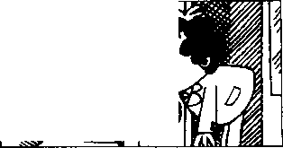
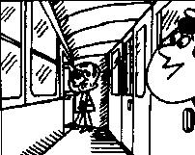
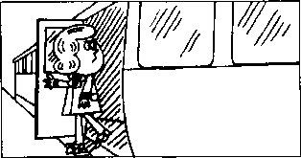
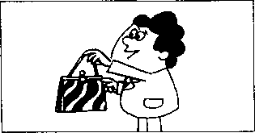
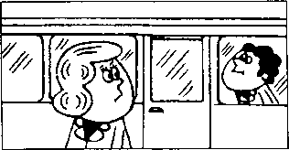
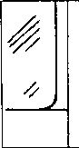
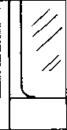
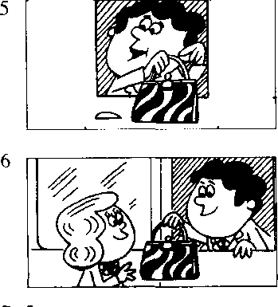
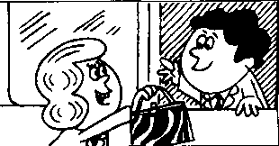
Excuse me!
Yes?
Is this your handbag?
Pardon?
Is this your handbag?
Yes, it is.
Thank you very much.
excuse /iks'kjuiz/ v.原谅 me /mi:/ pron. （宾格）
yes /jes/ adv.是的 is /iz/ v. be动词现在时第三人称单数 this /dis/ pron.这
your /jo:/ possessive adjective 你的，你们的
handbag /'haendbaeg/ n.（女用）手提包 pardon /'pa:dn/ int.原谅，请再说一遍 it /it/ pron.它
thank you /'Qaegk-ju:/ 感谢你（们） very much /'veri-mAtJ/ 非常地

Notes on the text 课文注释
这个短语常用于与陌生人搭话，打断别人的说话或从别人身边挤过。在课文中，男士为了吸引女 士的注意力而用了这个表示客套的短语。
- Pardon?
全句为I beg your pardon.意思是请求对方把刚才讲过的话重复一遍。 参考译文
对不起。
什么事，
这是您的手提包吗？
对不起，请再说一遍。
这是您的手提包吗？
\
是的，是我的。
非常感谢！

Lesson 2 Is this your・..？这是你的 吗？

Listen to the tape and do the exercises. 听录音并回答问题o
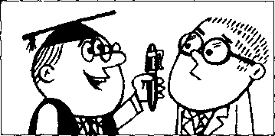
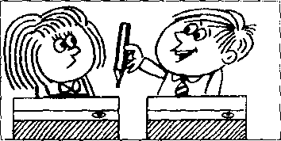

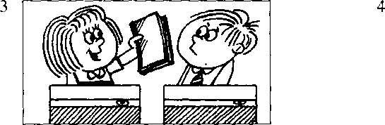
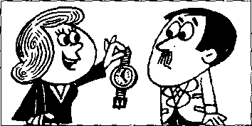
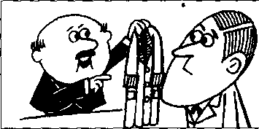
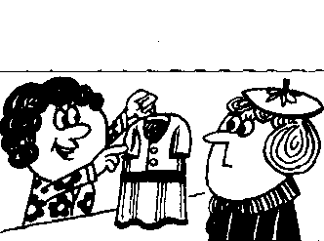
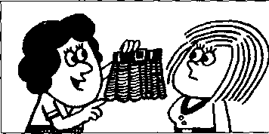
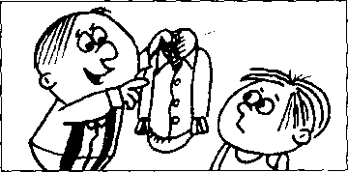
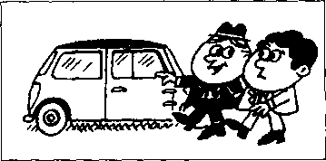
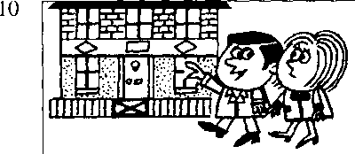
9
Lesson 2

New words and expressions 生词和短语
pen /pen/阳钢笔 pencil /'pens^l/ n.铅笔 book /bok/ n.书 watch /wotf/ 儿手表 coat /ksot/ 〃.上衣，外衣
dress /dres/ n.连衣裙 skirt /sk3：t/ n.裙子 shirt/f₃：Vn.衬衣 car /ka:/ n,小汽车 house /haus/ 儿房子

Written exercise 书面练习
Copy these sentences. 抄写以下句子_{Q}
me!
鶴7
tkU- kcuidbacf?
Pardon?
力 Hui W必,it认.
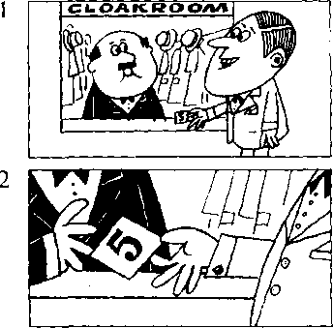
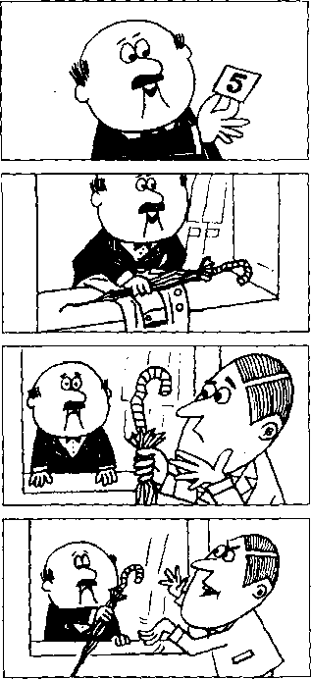
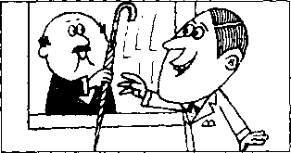

Lesson 3 Sorry, sir.对不起，先生。

Listen to the tape then answer this question. Does the man get his umbrella back?
听录音，然后回答问题。这位男士有没有要回他的雨伞?
My coat and my umbrella please.
Here is my ticket.
Thank you, sir.
Number five.
Here's your umbrella and your coat.
This is not my umbrella. Sorry, sir.
Is this your umbrella? No, it isn't.
Is this it?
Yes, it is.
Thank you very much.
umbrella /Am'brela/ n.伞
please /pli:z/ int.请
here /his/ adv.这里
my /mai/ possessive adjective 我的 ticket /'tikit/ n.票

Notes on the text 课文注释
number /'nAmba/ n.号码
five /faiv/ num.五
sorry /'snri/ adj.对不起的
sir /s3：/ n.先生
cloakroom /'kloukrum/ n.衣帽存放处
- Here's是Hereis的缩写形式，类似的例子有He's (Heis), Ifs(Itis)等。缩写形式和非缩写形式在英 语的书面用语和口语中均有，但非缩写形式常用于比较正式的场合。
- Sorry = Tm sorry,这是口语中的缩略形式，用于社交场合，向他人表示歉意。
- sir,先生，这是英美人对不相识的男子、年长者或上级的尊称。
- Is this it?
本句中it是指your umbrella o由于前面提到了，后面就用代词ii来代替，以免重复。

参考译文
请把我的大衣和伞拿给我。
这是我(寄存东西)的牌子。
谢谢，先生0
是5号。
这是您的伞和大衣0
这不是我的伞。
对不起，先生。
这把伞是您的吗？
不，不是！
$
这把是吗？
是，是这把。
非常感谢。

Lesson 4 Is this your... ?这是你的 吗？

Listen to the tape and answer the questions.
听录音并回答问题o

1
Is this your pencil?
Is this your book?
Is this your pen?
4
Is this your watch?
5
Is this your coat?
6
Is this your dress?
Is this your skirt?
Is this your shirt?
10
Is this your house?
11
Is this your suit?
Is this your school?
Is this your teacher?
14
Is this your son?
15
Is this your daughter?
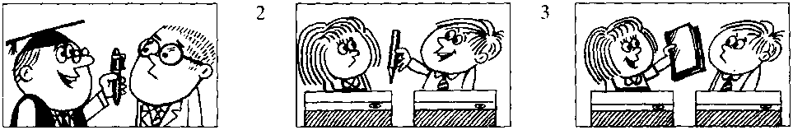
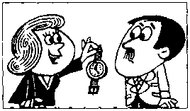
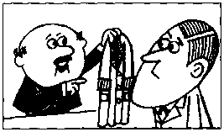
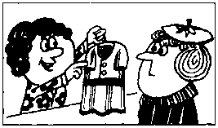
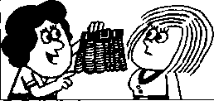
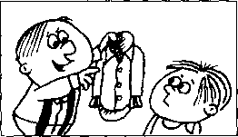
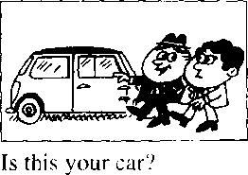
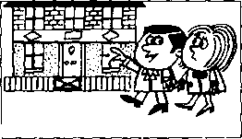
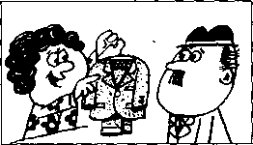
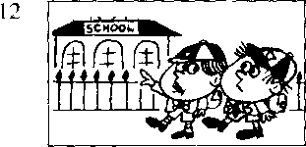
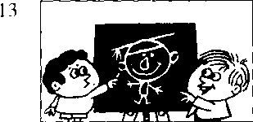
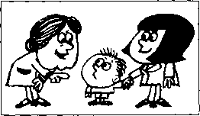
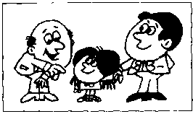

suit /su:t/ n. 套衣服 school /skuil/ 儿学校 teacher /'tirtfg/ n.老师 son /sad/儿儿子 daughter /'do:ta/ n.女儿

Written exercises 书面练习
A Copy these sentences. 抄写以下句子。
9九 u4nl^iMa2
Na-, it U4^t!
B Answer these questions.
模仿例句回答以下问题。
Example:
Is this your umbrella?
N®. * i^nl^ieUa.优&
- Is this your pen?
- Is this your pencil?
- Is this your book?
- Is this your watch?
- Is this your coat?
- Is this your dress?
- Is this your skirt?
- Is this your shirt?
- Is this your car?
- Is this your house?

Lesson 5 Nice to meet you.很高兴见到你。

fisa Listen to the tape then answer this question. Is Chang-woo Chinese?
H听录音，然后回答问题。昌宇是中国人吗？
MR. BLAKE : Good morning.
STUDENTS : Good morning, Mr. Blake.
MR. BLAKE : This is Miss Sophie Dupont.
Sophie is a new student.
She is French.
MR. BLAKE : Sophie, this is Hans.
He is German.
HANS : Nice to meet you.
MR. BLAKE : And this is Naoko.
She's Japanese.
NAOKO : Nice to meet you.
MR. BLAKE : And this is Chang-woo.
He's Korean.
CHANG-WOO : Nice to meet you.
MR. BLAKE : And this is Luming.
He's Chinese..
LUMING : Nice to meet you.
MR. BLAKE : And this is Xiaohui.
She's Chinese, too.
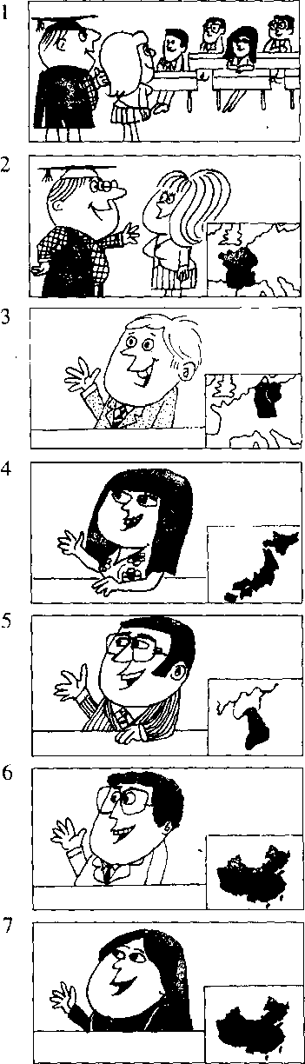
XIAOHUI : Nice to meet you.
Mr. /'mists/ 先生 good /god/ adj.好 morning /'mxnig/ n.早晨
Miss /mis/ 小姐 new /nju:/ adj.新的 student /'sljuidant/ 儿学生
French /frentj/ adj. & 儿法国人
German /'djaiman/ adj. & 几德国人 nice /nais/ adj.美好的 meet /milt/ v.遇见
Japanese ^aep'niiz/ adj. &几日 本人 Korean /ka'nan/ adj. & n.韩国人 Chinese /,tjai'ni:z/ adj, & n,中国人 too /tu:/ adv,也

Notes on the text 课文注释
- Good morning.
早上好0英语中常见的问候用语o
- This is Miss Sophie Dupont.
一般用于将某人介绍给他人的句式0 一般指未婚女子O
- Nice to meet you.
用于初次与同学，朋友见面等非正式场合0正式的场合常用How do you do?

参考译文
布莱克先生：早上好。
学 生：早上好，布莱克先生。
布莱克先生：这位是索菲娅•杜邦小姐O索菲娅是个新学生0她是法国人O
布莱克先生：索菲娅，这位是汉斯。他是德国人。.
汉 斯：很高兴见到你O
布莱克先生：这位是直子。她是日本人。
直 子：很高兴见到你。
布莱克先生：这位是昌宇。他是韩国人。 昌 宇：很高兴见到你0

布莱克先生
鲁 明
:这位是鲁明。他是中国人。
:很高兴见到你。
布莱克先生
晓 惠
:这位是晓惠。她也是中国人。
:很高兴见到你。

Lesson 6 What make is it?它是什么牌子的？

Listen to the tape and answer the questions.
听录音并回答问题o

8
Its a Volvo. (Swedish)
9
It's a Peugeot. (French)
10
It's a Mercedes. (German)
13
It's a Mini. (English)
14
It's a Ford. (American)
15
It's a Fiat. (Italian)
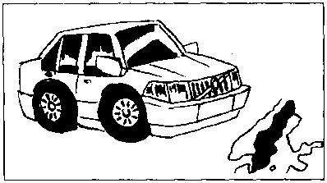
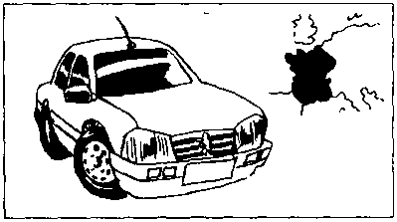
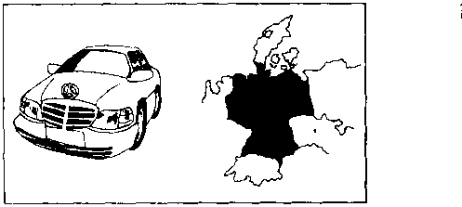
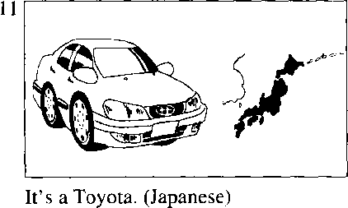
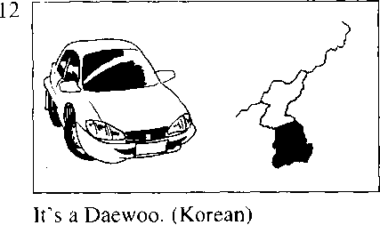
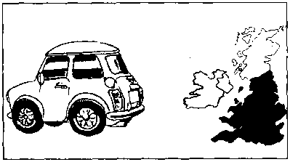
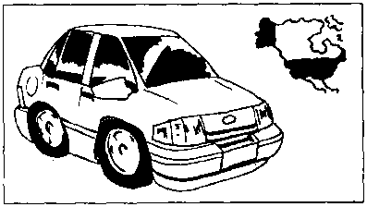
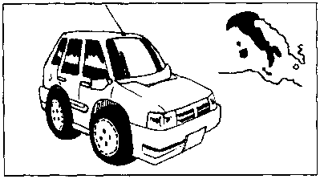

make /meik/儿（产品的）牌号 | Mercedes /ma'seidiiz/ n.梅赛德斯
Swedish /'swi:dij/ adj.瑞典的 | Toyota /'taujsuta/ 儿丰田
English /'iijgliJ/ adj.英国的 | Daewoo /'da:wu:/ 儿大宇
American /a'menkan/ adj. 美国的 | Mini /'mini/ n.迷你
Italian/I'tselian/ adj.意大利的 | Ford /ford/ n.福特
Volvo /'volvao/ n.沃尔沃 | Fiat /'fiiaet/ n.菲亚特
Peugeot/'p3：3au/ n.标致

Written exercises 书面练习
A Complete these sentences using He, She or It, 完成以下句子，用He, She或It琪空。
Examples:
Stella is a student isn't German is Spanish.
gteUa 场 q 幼e Un t 幼羽必
Alice is a student isn't German is French.
This is her car 1 is a French car.
Hans is a student isn't French is German.
This is his car is a German car.
B Write questions and answers using He She, It a or an.
模仿例句写出相应的疑问句，并回答。选用He, She, It, a或s等词。
Examples:
This is Miss Sophie Dupont. French/(Swedish)
9土 盘^ dii4>dent g a ga/eduk
She a g施2 a-
This is a Volvo. SwedishZ(French)
% it a ^u^eduk ca^i s a- oan7
9t e 勿&七2 caA. a ca^.

- This is Naoko. Japanese/(German)
- This is a Peugeot. FrenchZ(German)
- This is Hans. German/(Italian)
- This is Xiaohui. Chinese/(Italian)
- This is a Mini. English/(American)
- This is Chang-woo. Korean/(Japanese)
- This is a Fiat. ItalianZ(English)
- This is Luming. Chinese/(English)
- This is a Mercedes. German/(French)
- This is a Toyota. Japanese/(Chinese)
- This is a Ford. American/(English)
- This is a Daewoo. Korean/(Japanese)

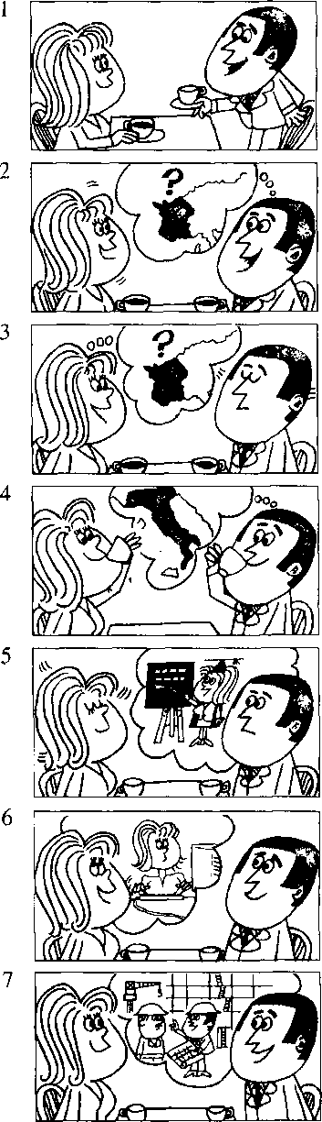

Lesson 7 Are you a teacher?你是教师吗？

Listen to the tape then answer this question. What is Roberta job?
听录音，然后回答问题。罗伯特是做什么工作的？
ROBERT : I am a new student.
My name's Robert. SOPHIE : Nice to meet you.
My name's Sophie.
ROBERT : Are you French?
SOPHIE : Yes, I am.
SOPHIE : Are you French, too?
ROBERT : No, I am not.
SOPHIE : What nationality are you?
ROBERT : I'm Italian.
ROBERT : Are you a teacher? SOPHIE : No, I'm not.
ROBERT : What's your job? SOPHIE : I'm a keyboard operator.
SOPHIE : Whafs your job? ROBERT : I'm an engineer.
- /ai/ pron.我
nationality /.naefs'naehti/ 几国籍 job /d3ob/ n.工作
keyboard /'ki:bo:d/ n.电脑键盘 operator /'opareita/ n.操作人员 engineer /endji'ma/ n.工程师
am /aem/ v. be动词现在时第一人称单数 are /a:/ v. be动词现在时复数
name /neim/ 几名字
what /wot/ adj. & pron.什么

Notes on the text 课文注释
- My name's = My name is.
- I'm /aim/ = I am.
口语中经常使用这种缩略形式。
- Whafs your job?你是做什么工作的？
Whafs = What is.
- What nationality are you?
用来询问对方国籍o也可以问Where are you from? 参考译文
罗伯持：我是个新学生，我的名字叫罗伯特。
索菲娅•.很高兴见到你。我的名字叫索菲娅。
罗伯特：你是法国人吗？
索菲娅：是的，我是法国人。
索菲娅：你也是法国人吗？
罗伯特：不，我不是。
索菲娅：你是哪国人？
罗伯特：我是意大利人。
罗伯特：你是教师吗？
索菲娅：不，我不是。
罗伯特：你是做什么工作的？
索菲娅：我是电脑录入员。
索菲娅：你是做什么工作的？ ’
罗伯特：我是工程师。

Lesson 8 Whafs your job?你是做什么工作的?


Listen to the tape then answer the questions.
听录音并回答问题o

I'm a policeman.
12
13
Fm a taxi driver.
I'm a policewoman*
15
I'm a postman.
16
I'm a nurse.
17
I'm a mechanic.
18
Pm a hairdresser.
20
I'm a milkman.
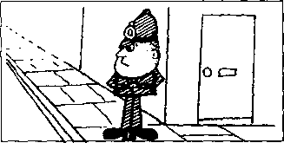
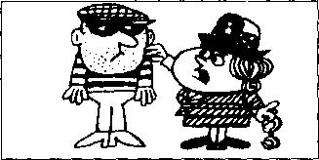
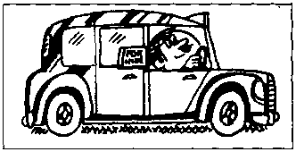
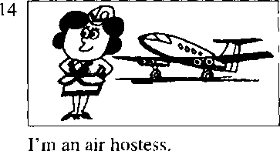
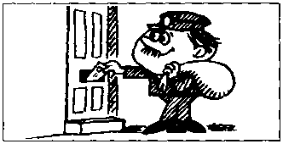
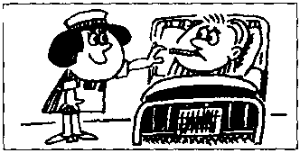
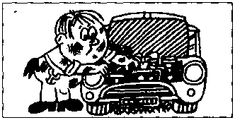
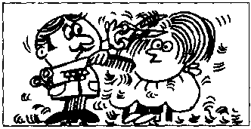
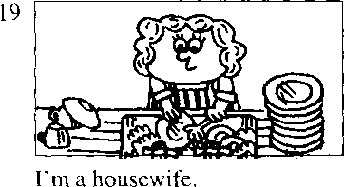
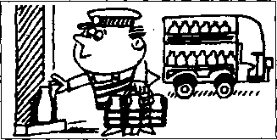

policeman /pa'lirsmon/ n.警察 policewoman /po'li:s₍wom9n/ n.女警察 taxi driver/'t<eksi-'draiva/ 出租汽车诃机 air hostess /'eo-'haostas/ 空中小姐 postman /'pgustmsn/ n.由K递员 nurse/n3：s/n.
mechanic /mi'kaemk/ n.机械师 hairdresser /'hea.cireso/ n.理发师 housewife /'hauswai^ n.家庭妇女 milkman /'milkman/ n.送牛奶的人

Written exercises 书面练习
A Complete these sentences using am or is. 完成以下句子，用am或is填空。
Example:
My name Xiaohui. I Chinese.
Mtf name,曷 !) OkUieie.
My name Robert. I a student. I
Sophie not Italian. She French.
Mr. Blake
Italian.
my teacher. He
not French.

Write questions and answers using his, her, he, she, a or an.
模仿例句写出相应的疑问句，并回答。选用his, her, he, she, a或qd等
Examples:
keyboard operator
WluitA. jok? h a 件必必47 密泌e 虹
engineer
层 t jab? 9% he cut e^UteeA?籟必.

policeman policewoman taxi driver
air hostess
postman
10
nurse mechanic hairdresser housewife milkman

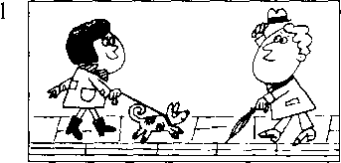
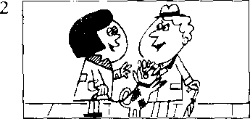
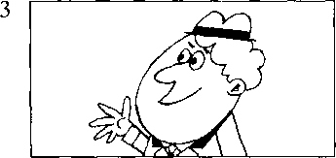
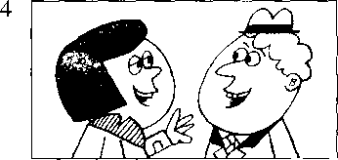
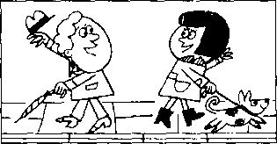

Lesson 9 How are you today?你今天好吗？

Listen to the tape then answer this question. How is Emma?
听录音，然后回答问题。埃玛身体好吗？
STEVEN : Hello, Helen.
HELEN : Hi, Steven.
STEVEN : How are you today? HELEN : I'm very well, thank you.
And you?
STEVEN : I,m fine, thanks.
STEVEN : How is Tony?
HELEN : He's fine, thanks.
How's Emma?
STEVEN : She's very well, loo, Helen.
STEVEN : Goodbye, Helen.
Nice to see you.
HELEN : Nice to see you, too, Steven.
Goodbye*
hello /hs'lao/ int.喂（表示问候） hi /ha[/ int.喂，嗨
how /hao/ adv.怎样
today /ta'dci/ adv.今天 fine /fain/ adj.美好的 thanks /Qaerjks/ int.谢谢 goodbye /'god'bai/ int.再见 see /si:/ v.见
well /wel/ adj.身体好

Notes on the text 课文注释
- How are you?
这是朋友或相识的人之间见面时问对方身体情况的寒暄话，一般回答是：Fine, thank you.
- And you?即 And how are you?的简略说法 _{o}
- Nice to see you.是 It*s nice to see you.的简略说法。
这一句也是见面时的客气话：一般回答是：Nice to see you, too.见到你，我也很高兴。也可说: Nice to meet you.很高兴遇到你。
参考译文
史蒂文：你好，海伦。 .
海伦：你好，史蒂文。
史蒂文：你今天好吗？
海伦：很好，谢谢你。你好吗？
史蒂文：很好，谢谢。
史蒂文：托尼好吗? '
海伦：他很好，谢谢。埃玛好吗？
史蒂文：她也很好，海伦。
史蒂文：再见，海伦。见到你真高兴。
海 伦：我见到你也很高兴，史蒂文。再见。

Lesson 10 Look at...看

Listen to the tape and answer the questions. 听录音并回答问题o
laEr]

12
(fat)
13
that policeman!
14
that woman!
(thin)
(tall)
that policewoman!
(short)
(dirty)
that nurse!
(hot)
18
(clean)
Emma!
(cold)
19
that milkman!
(young)
21
22
比at housewife!
(old)
that hairdresser!
(busy)
(lazy)
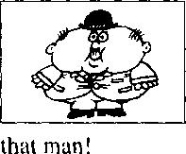
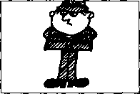
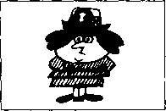
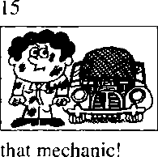
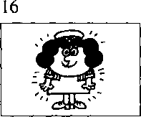
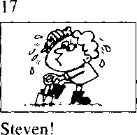
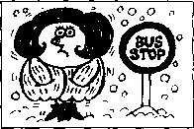
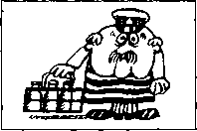
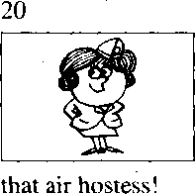
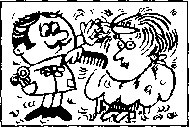
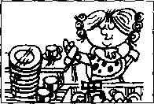

fat /fet/ adj.胖的 woman /'woman/ n.女丿、 thin /9in/ adj.瘦的 tall MF adj.高的 short l\Ml adj,矮的 dirty /'d3：ti/ adj.脏的 clean /kli:n/ adj.干净的
hot /hot/ adj.热的 cold /ksold/ adj.冷的 old /auld/ adj,老的 young /jAt)/ adj.年轻的 busy /'bizi/ <2# 忙的 lazy /'leizi/ adj.懒的

Written exercises 书面练习
A Complete these sentences using He's, She's or It's. 完成以下句子，用He's, She's或/Fs填空。
Example:
Robert isn't a teacher. an engineer.
U-i-t t a teacher.丿*2 砂 円絲初猝公
1 | Mr. Blake isn't a student. | a teacher.
2 | This isn't my umbrella. _ | your umbrella.
3 | Sophie isn't a teacher | a keyboard operator.
4 | Steven isn't cold | hot.
5 | Naoko isn't Chinese. 一 | _ Japanese.
6 | This isn't a German car. _ | a Swedish car.

B Write sentences using He or She. 模仿例句写出才目应的句子；
Example:
Helen/well
Jl&&k cd Me!", Ske "典瞥
1 mun/fat | 7 | Steven/hot
2 woman/thin | 8 | Emma/cold
3 policeman/tall | 9 | milkman/old
4 policewoman/short | 10 | air hostess/young
5 mcchanic/dirty | 11 | hairdresser/busy
6 nurse/clean | 12 | housewife/lazy

Lesson 11 Is this your shirt ?这是你的衬衫吗？


Listen to the tape then answer this question. Whose shirt is white?
听录音，然后回答问题。谁的衬衣是白色的？
TEACHER : Whose shirt is that?
TEACHER : Is this your shirt, Dave?
DAVE : No, sir.
It's not my shirt.
DAVE : This is my shirt.
My shirt's blue.
TEACHER : Is this shirt Tim's?
DAVE : Perhaps it is, sir.
Tim's shirt's white.
TEACHER : Tim!
TIM : Yes, sir?
TEACHER : Is this your shirt?
TIM : Yes, sir.
TEACHER : Here you are.
Catch!
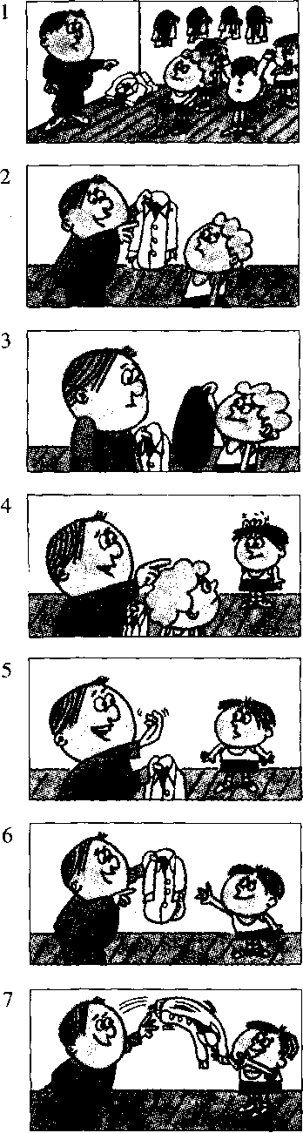
TIM : Thank you, sir.
whose /hu:z/ pr(m.谁的 white /wait/ adj.白色的
blue /blu:/ adj.蓝色的 catch /ksetf/ v.抓住
perhaps /pa'haeps/ adv.大概

Notes on the text 课文注释
- Whose shirt is that?
疑问代词Whose在本句中作定语，修饰shirt □
- Is this shirt Tim's?
Tim's是Tim的所有格形式，为避免重复，Tim's后面可以省去shirt ₀
例：It isn't my pen, it's Frank's.这不是我的钢笔，是弗兰克的。 ，
- Here you are.或 Here it is.
是给对方东西时的用语，句中的are和is应重读。
参考译文
老师：那是谁的衬衫？
老师：戴夫，这是你的衬衫吗？ .
戴夫：不，先生。这不是我的衬衫O
戴夫：这是我的衬衫0我的衬衫是蓝色的O
老师：这件衬衫是蒂姆的吗？
戴夫：也许是，先生。蒂姆的衬衫是白色的。
老师：蒂姆！
蒂姆：什么事，先生？
老师：这是你的衬衫吗？
蒂姆：是的，先生。
X
老师：给你。接着！
蒂姆：谢谢您，先生0

Lesson 12 Whose is this ... ? This is my/your/his/her...
这……是谁的？这是我的/你的/他的/她的••…

Whose is that ..，？ That is my/your/his/her .・.
那……是谁的？那是我的/你的/他的/她的•…

*


Listen to the tape and answer the questions.
听录音并回答问题。
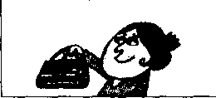
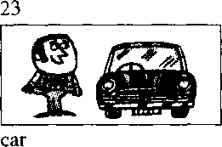
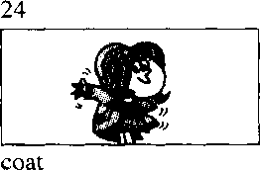
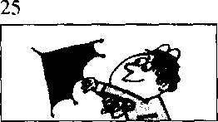
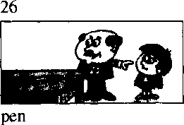
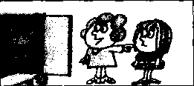
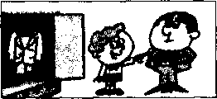
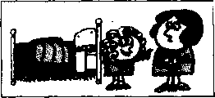
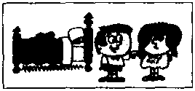
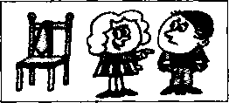
22
handbag
It's Stella's.
It's Paul's.
It's Sophie's.
umbrella
It's Steven's.
It's my son's.
27
dress
It's my daughter's.
28
suit
It's my father's.
29
skirt
It's my mother's.
30
blouse
It's my sister's.
31
tie
It's my brother's.
tie /tai/ n.领带
father /'faids/ n.父耒 mother/'mAda/ n.母亲 blouse /blauz/ n.女衬彳 sister /'sista/ n,姐，妹
brother /'brAdo/ 儿兄，弟 his /hiz/ possessive adjective 他的 her /h3：/ possessive adjective 她的

Written exercises 书面练习
A Complete these sentences using my, your, his or her. 完成以下句子厂用my, your, his或her填■空。
Example:
Hans is here. That is car.
弘 W 必 ku. ca/b.
- Stella is here. That is car.
- Excuse me, Steven. Is this umbrella?
- I am an air hostess name is Britt.
- Paul is here, too. That is coat.
B Write questions and answers using's, his and hers.
模仿例句提问并回答，选用名词所有格形式，s或代词所有格形式M或
hers o
Example;
shirt/Tim
- handbag/Stella
- car/Paul
- coat/Sophie
- umbrella/Steve
- car/Paul
- coat/Sophie
- umbrella/Steven
- pen/my daughter
- dress/my sori
7
8
9
10
11
12
suit/my father skirt/my mother blouse/my sister tie/my brother pen/Sophie pencil/Hans
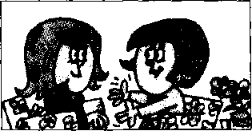
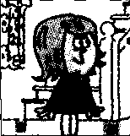
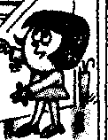
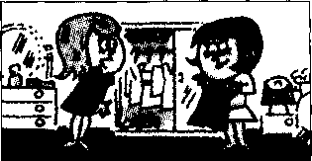
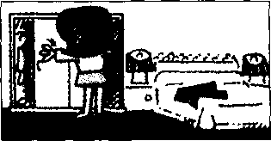
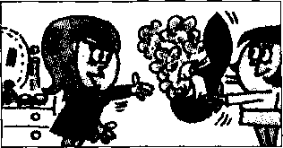
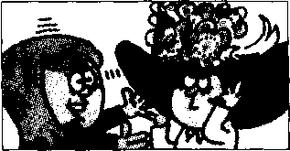
2

Lesson 13 A new dress 一件新连衣裙

Listen to the tape then answer this question. What colour is Anna's hat?
听录音，然后回答问题。安娜的帽子是什么颜色的？
LOUISE : What colour's your new dress? ANNA : It's green.
ANNA : Come upstairs and see it, LOUISE : Thank you.
ANNA: Look!
Here it is!
LOUISE : Thafs a nice dress.
It's very smart.
ANNA : My hat's new, too.
LOUISE : What colour is it?
ANNA : It's the same colour.
It's green, too.
LOUISE : That is a lovely hat!
s.mart /smart/ adj.时髦的*巧妙的 hat /haet/几帽子
colour Z'kAla/ n.颜色 green /griin/ adj.绿色 come /k,im/ v.来 upstairs /Ap'steaz/ ady.楼上
same /seim/相同的
lovely /'kvli/adj.可爱的，秀丽的

Notes on the text 课文注释
- What colour's = What colour is,
- Come upstairs and see it. '
句中and不当"和”讲，而是表示目的，例：Come and see me.来见我6在英文中不能用Come upstairs to see it.

参考译文
路易丝：你的新连衣裙是什么顔色的? 安娜：是绿色的。
安娜：到楼上来看看吧。
路易丝：谢谢。
安娜：瞧，就是这件。
路易丝：这件连衣裙真好，真漂壳。
安娜：我的帽子也是新的O
路易丝：是什么颜色的？
安娜：一样的颜色，也是绿的。
路易丝：真是一顶可爱的帽子,！

Lesson 14 What colours your...?你的 是什么颜色的？

Listen to the tape and answer the questions. 听录音并回答问题o
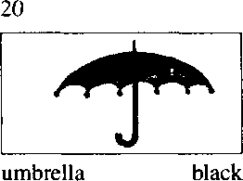
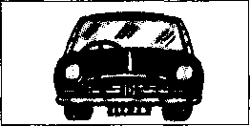
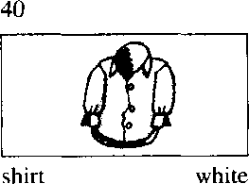
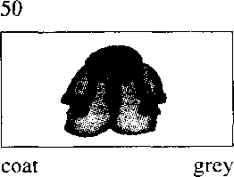
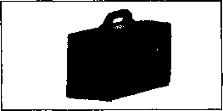
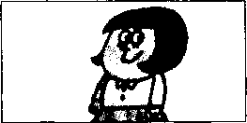
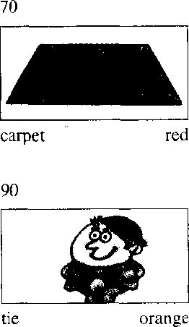
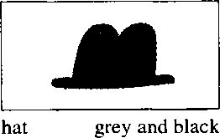
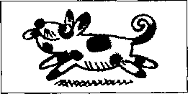
30
60
case brown
80
blouse
101
100
dog brown and white
case /keis/ n.箱子 carpet /*ka:pit/ n.地毯
dog /dog/ n.狗

Written exercises 书面练习
A Rewrite these sentences.
模仿例句将下列各组句子合二为一 0
Example:
This is Stella. This is her handbag.
- This is Paul. This is his car.
- This is Sophie. This is her coat.
- This is Helen. This is her dog.
- This is my father. This is his suit.
- This is my daughter. This is her dress.
B Write sentences using's, his or her.
模仿例句提问并回答，选用名词所有格形式怎或代词所有格形式*或物。
Example:
Steven/umbrella/black
Wkai 丿认 black-.
- Helen/dog/brown and white
1 Steven/car/blue
2 Tim/shirt/white
3 Sophie/coat/grey
- Hans/pen/green
- Luming/suit/grey
- Mrs. White/carpet/red
- Dave/tie/orange -
- Steven/hat/grey and black
- Stella/pencil/blue
- Xiaohui/handbag/brown
- Sophie/skirt/yellow

Lesson 15 Your passports, please.请出示你们的护照。

Listen to the tape then answer this question. Is there a problem with the Customs officer?
听录音，然后回答问题。海关官员有什么疑问吗？
CUSTOMS OFFICER : Are you Swedish?
GIRLS : No, we are not.
We are Danish.
CUSTOMS OFFICER : Are your friends Danish, too? GIRLS : No, they aren't.
They are Norwegian.
CUSTOMS OFFICER : Your passports, please.
GIRLS : Here they are.
1
2
3
CUSTOMS OFFICER : Are these your cases?
GIRLS : No, they aren't.
GIRLS : Our cases are brown.
Here they are.
CUSTOMS OFFICER : Are you tourists?
GIRLS :
Yes, we are.
CUSTOMS OFFICER : Are your friends tourists too? GIRLS : Yes, they are.
CUSTOMS OFFICER : Thafs fine.
GIRLS : Thank you very much.
4
5
6
7
8
2Q

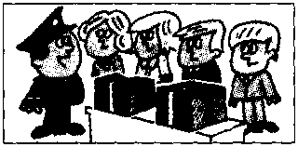
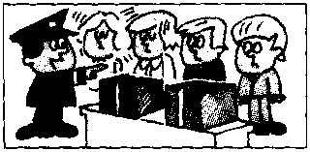
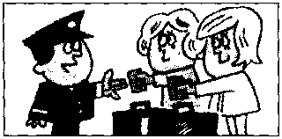
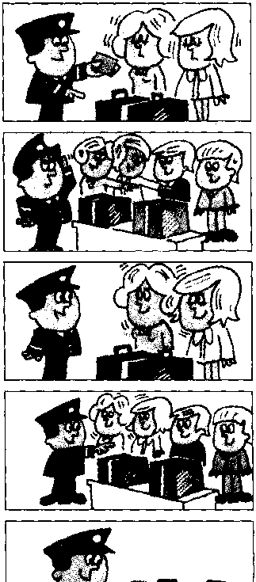

customs / 'kAstomz/ n."每关 officer /'ofisa/ n.官 员 girl /gsil/儿女孩' 姑娘
Norwegian /no:'wi:d3an/ adj. & n.挪威人
passport /'pa:spo:t/ n.护貝魚 brown /braon/ adj.棕色的 tourist /'toanst/ n.旅游者
Danish /'deinif/ adj. & n.丹麦人 friend /frend/ 打.朋友

Note on the text 课文注释
可数名词的复数形式一般是在单数名词后面加上-s,如课文中的friend — friends /frendz/; tourist — tourists /'toansts/; case ~~ cases /'keisiz/₀ 请注意-s 的不同发音 _{o}
参考译文
海关官员：你们是瑞典人吗？
姑娘4】：不，我们不是瑞典人。我们是丹麦人0
海关官员：你们的朋友也是丹麦人吗？
姑 娘们：不，他们不是丹麦人。他们是挪威人。
海关官员：请出示你们的护照0
姑娘〕：给您。
海关官员：这些是你们的箱子吗？
姑娘们：不，不是。
姑娘们：我们的箱子是棕色的。在这儿呢。
海关官员：你们是大旅游的吗？
姑娘们：是的.我们是来旅游的₀
海关官员：你们的朋友也是来旅游的吗？
姑娘们：是的.他们也是O
海关官员：好了 0
姑娘们：非常感谢°

Lesson 16 Are you・..？你是 吗？

Listen to the tape and answer the questions. 听录音并回答问题o
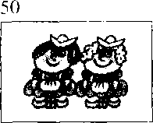
20
30
40
so
W KM
Dutch?
Russian?
English?
American?

Are these your... ? What colour are your …2 这些是你的 吗？你的 是 什么颜色？

red books
70
white shirts
grey coats
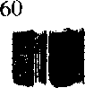
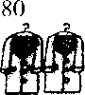


100
blue suits
101
a
black and grey hats
90
她
yellow tickets
102
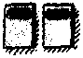

green passports
103
ff
black umbrellas
104
white handbags

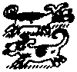
106
brown and white dogs
107
11
blue pens
105
35
orange ties
108 | 109  tl | 110
red cars | green dresses | yellow blouses

Russian / 'rApn/ adj. & n.俄罗斯人 Dutch /dAtj'/ adj. & /?.荷人 these /dirz/ pron.这些（this 的复数） red /red/ "勿.红色的
grey grei/ adj.灰色的 yellow /yelao/ adj.黄色的 black /btek/ adj.黑色的 orange /¹ nnnd3/ adj.橘黄色的

Notes on the text 课文注释
1如果名词是以-s结尾的.变成复数时要/JO -es. dress — dresses _{o}
2表示复数的-s或-es一般遵循以下发音规则：
- 如果名词词尾的发音是一个清辅音(/M/R单除外)■ -sS/s/的音，如 books/buks/-
suits /suits/;
- 如果名词词尾的发音是一个浊辅音(/z/,/₃/. /d₃/除外)或元音，-s发/z/的音，如 ties /taiz/,
dogs /dDgz/;
- 如果名词词尾的发音是/s/, /z/^'/J*/,③,噸或皿/，-s发/iz/的音，如
dresses /'dresiz/,
blouses /'blaoziz/。

Written exercises 书面练习
A Complete these sentences using a or an. 完成以下句子，用冠词a或w填空
Examples:
It is Swedish car.凡必 Sweduk g.
She is air hostess. &临 以次汕 /kmTW.
1 It is — | English car. | 3 It is | Italian car. | 5 It is — | American car.
2 It is一 | Japanese car. | 4. It is 一 | French car. | 6 Robert is not |  | teacher.

B Write questions and answers using our. ,模仿例句提问并用our来回答。
Example:
books/red
What OnA- aAe ned.
1 | shirts/white | 4 | suits/blue | 7 | umbrellas/black | 10 | dogs/brown and white
2 | coats/grey | 5 | hats/black and grey | 8 | handbags/white | 11 | pens/blue
3 | tickets/yellow | 6 | passports/green | 9 | ties/orange | 12 | cars/red

Lesson 17 How do you do?你好!
r=» Listen to the tape then answer this question.
What are Michael Baker and Jeremy Short's jobs?
听录音，然后回答问题D迈克尔•贝克和杰里米，肖特是做什么工作的？
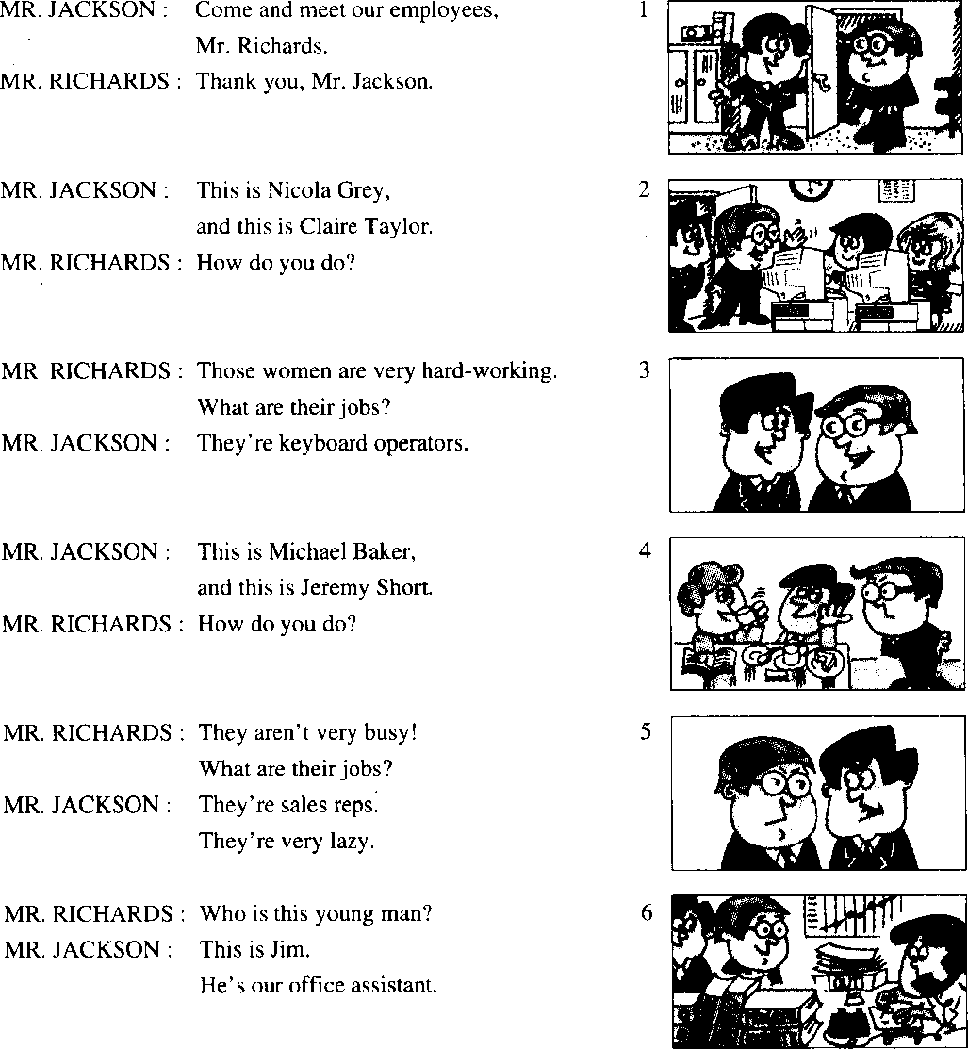

New words and expressions 生词和短。吾
employee /imphfi：/ h.应 员 hard-working , ,ha:d\v3：knj/ adj.勤奋的 sales reps /^cilz-'rcps/ 肖员
man masn/ n.男 人 office /'ofis/ n.办公室 assistant /^'sist^nt/ n.助『

Notes on the text 课文注释
- How do you do?您好（用于第一次见面时）。一般用同样的话来回答。见第5课课文注释3。
- sales reps 是 sales representatives 的缩写形式' 常用于口语 _{o}
- office assistant 指办公室干杂务的工作人员。
参考译文
杰克逊先牛：来见见我们的雇员，理查兹先生。
理査兹先生：谢谢，杰克逊先生。
杰克逊先牛：这位是尼古拉，格雷，这位是克莱尔•泰勒。
理査兹先牛：你们好！
理查兹先生：那些姑娘很勤快.她们是做什么工作的？ 杰克逊先生：她们是电脑输录入员。
杰克逊先牛：这位是近克尔•贝克,这位是杰里米•肖特。
理传兹先生：你们好！
理佐兹先生：他们不很忙吧！他们是做什么工作的？
杰克逊先牛：他们是推销员，他们非常懒。
理查兹先乍：这个年轻人是谁。
杰克逊先乍：他是吉姆•是我们办公室的勤杂人员。

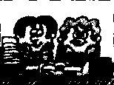
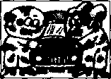
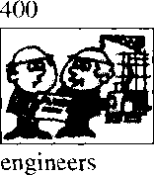
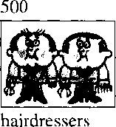
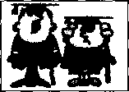
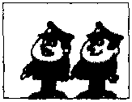
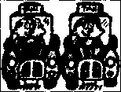
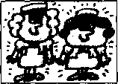
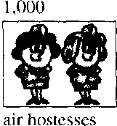
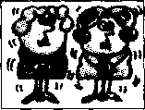
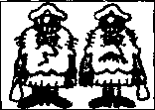
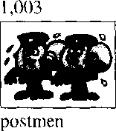
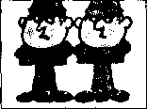
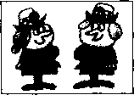
100
sales reps
300
mechanics
600
teachers
900
700
Customs officers
800
taxi drivers
nurses
1,001
housewives
1,002
milkmen
1,004
policemen
1.005
policewomen

Lesson 18 What are their jobs?他们是做什么工作的？

Listen to the tape and answer the questions.
听录音并回答问题o
200 keyboard operators

Notes on the text 课文注释
1如果名词是以-f或而结尾的，变成复数时.一般要把-f或-fe变成-v,再加-es,如 housewife — housewives _{c}
2英语中冇一此名词的复数形式是不规则的，如man, woman,以及由这两个词组成的复合名词:
man ——men; woman ——women;
milkman — milkmen;
policewoman — policewomen^

Written exercises 书 面练习
A Complete these sentences using He, She We or They.
完成以下句子，用He, Sho, W&或mep填空。，
Example:
Those men are lazy. are sales reps.
- That man is tall is a policeman.
- Those girls are busy are keyboard operators.
- Our names are Britt and Inge are Swedish.
- Look at our office assistant is very hard-working.
- Look at Nicola is very pretty.
- Michael Baker and Jeremy Short are employees. are sales reps.
B Write questions and answers.
模仿例句提问并回答。
Example:
(mechanics)/sales reps
Wkat tkein- .
Q脆 tke^ mechanic^ g
2 | (postmen)/policemen | 7 | (policewomen)/keyboard operators
3 | (policewomen)/nurses | 8 | (milkmen)/engineers
4 | (customs officers)/hairdressers | 9 | (policemen)Zmilkmen
5 | (hairdressers)/teachers | 10 | (nurses)/housewives
1 (keyboard operators)/air hostesses
6 (engineers)/taxi drivers

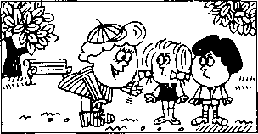
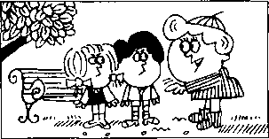
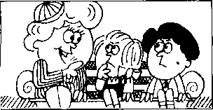
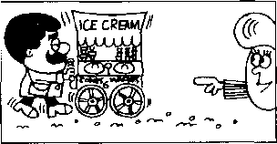
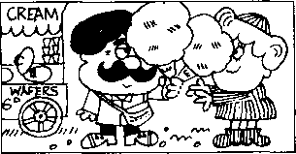
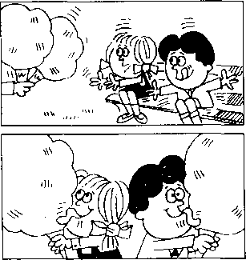
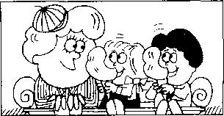
2
3
4
5
6
7
8

Lesson 19 Tired and thirsty 又累又渴

Listen to the tape then answer this question. Why do the children thank their mother?
听录音，然后回答问题。为什么孩子们向母亲致谢?
MOTHER : What's the matter, children?
GIRL : We're tired...
BOY : ….and thirsty, Mum.
MOTHER : Sit down here.
MOTHER : Are you all right now?
BOY : No, we aren't.
MOTHER: Look!
There's an ice cream man.
MOTHER : Two ice creams please.
MOTHER : Here you are, children.
CHILDREN : Thanks, Mum.
GIRL : These ice creams are nice.
MOTHER : Are you all right now? CHILDREN : Yes, we are, thank you!
matter /'maeto/ n.事情
Mum /m\m/ n.妈妈（儿语） sit down /'sit-daun/ 坐下 right/rait/adj,好，可以 ice cream /'ais-'kri:m/ 冰淇淋
children /'tjildran/ n.孩子们（child 的复数） tired /taiad⁷ adj.累.疲乏
boy /bdi/儿男孩
thirsty /'03：sti/ adj.渴

Notes on the text 课文注释
- What's the matter?二 Tell me what's wrong. 怎么啦？
- There^s = There is.

参考译文
母亲：怎么啦.孩子们
女孩：我们累了……
男孩：……口也渴，妁妈O
母亲：坐在这儿吧O
母亲：你们现在好些了吗？
男孩：不，还没有。
母亲：瞧！有个卖冰淇淋的0
母亲：请拿两份冰淇淋。
母亲：拿着，孩子们。
孩子们：谢谢，妈妈°
女孩：这些冰淇淋真好吃。
母亲：你们现在好了吗。
孩子们：是的，现在好了，谢谢您!

Lesson 20 Look at them!看看他/它们!

Listen to the tape and answer the questions.
CCD
听录音并回答问题o
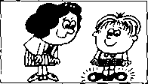
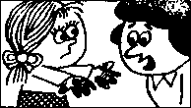
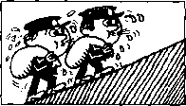
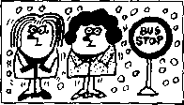
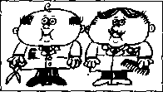
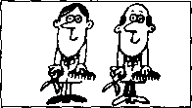
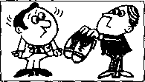
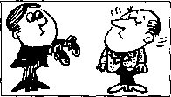
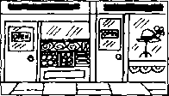
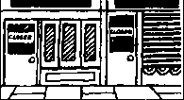
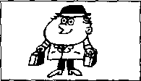
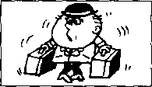
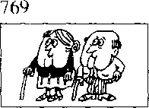
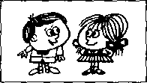
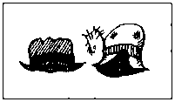
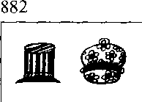
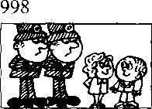
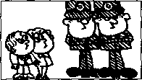
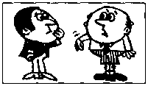
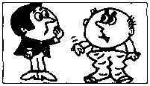
105
They're clean.
106
217
They⁵ re hot.
218
They're cold.
321
They're dirty.
322
They're fat.
They're thin.
433
They're big.
434
They're small.
545
546
They’re open.
They're shut.
657
They're light.
658
They're heavy.
They're old.
770
They're young.
881
They're old.
They're new.
They're short.
999
They're tall.
1,000
They're short.
1,001
They're long.
3Q
heavy /'hevi/ adj.重的
big 'b【q/ adj.大的
small adj.小的 open /'aopon/ adj.汁石口勺 shut /j'At/ adj. X；着的 light /lait/ adj.轻的
long /log/ adj.长的
shoe/Ju:/ n.鞋子
grandfather /'graend,fa:da/ 儿-祖父，外祖父 grandmother /'graen.mAds/ n.祖母，夕卜祖母

Written exercises 书面练习
A Complete these sentences using om, is or are. 扌少写以下句子，用am. is或are填空。
Example:
Those children thirsty.
- Those children tired.
- Their mother tired, too.
- That ice cream man very busy.
- His ice creams very nice.
- What's the matter, children? We thirsty.
- What's the matter, Tim? 1 tired.
B Write questions and answers.
模仿例句提问并回答。
Example:
his shoes/(dirty)/clean
kiA- 啊 clea^},
昵 tn&l cleM.
1 | the children/(tired)/thirsty | 6 | his cases/(heavy)/light
2 | the postmen/(cold)/hot | 7 | grandmother and grandfather/(young)/old
3 | the hairdressers/(thin)/fat | 8 | their hats/(old)/new
4 | the shoes/(small)/big | 9 | the policemen/(short)/tall
5 | the shops/(shut)/open | 10 | his trousers/(short)/long

Lesson 21 Which book?哪一本书?

Listen to the tape then answer this question. Which book does the man want?
rr-n|
听录音，然后回答问题。这位男士要哪本书？
MAN : Give me a book please, Jane.
WOMAN : Which book?
WOMAN : This one?
MAN : No, not that one. The red one.
WOMAN : This one?
MAN : Yes, please.
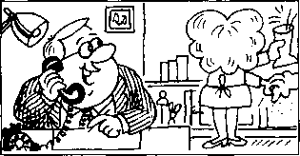
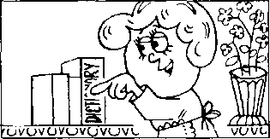
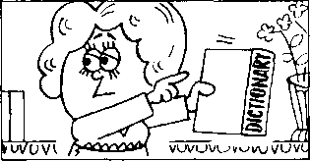
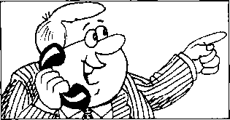
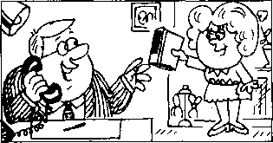
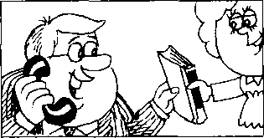
WOMAN : Here you are. MAN : Thank you.
1
2
3
4
5
6
give /giv/ v.给 which /witf/ question word 哪一个
one /wAn/ pron. 一个

Notes on the text 课文注释
- Give me a book, please. 这是祈使句，省略了主语you₀
- Which book?哪一本:,这是一种省略形式。
- This one?句中的one是不定代词，表示book。复数形式是ones₀
参考译文
丈夫：请拿本书给我，简O
妻子：哪一本？
妻子：是这本吗？
丈夫：不，不是那本。是那本红皮的。
妻子：这本吗？
丈夫：是的，请给我0
妻子：给你。 •
丈夫：谢谢O

Lesson 22 Give me/him/her/us/them a ...

Which one?
给我/他/她/我们/他们一…… 哪—……?


Listen to the tape and answer the questions.
听录音并回答问题。

1,001
(dirty)
1,004
(full)
1,005
(large)
1,006
(small)
1,009
(new)
1,010
(old)
1,011
(sharp)
1,012
(blunt)
1,013
(new)
1,014
(old)
1,016
(small)
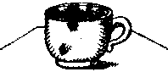
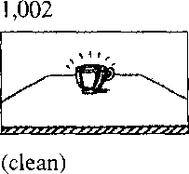
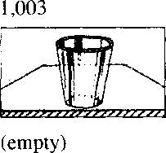
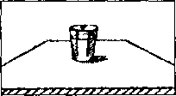
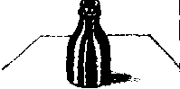
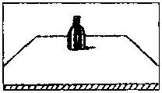
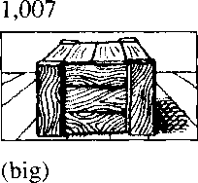
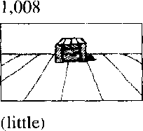
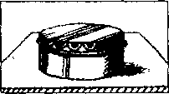
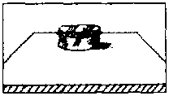
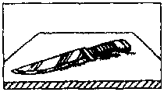
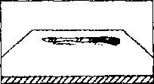
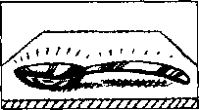
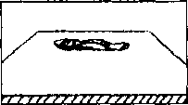
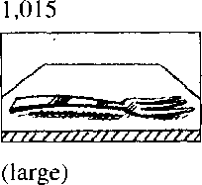
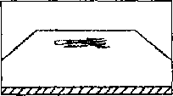

empty /'cmpti/ adj. ‘空口勺 full fuL"//'.满的 large adj. kn勺 little /"[itl, 小的 sharp /Jaip/ 尖的.锋利的 small /smo:l/ adj.小的 big /big/ adj.大的 blunt /bknt/ adj.钝的
box /boks/ n.盒子，箱子 glass /gla:s/ n.杯子 cup /kAp/几茶杯 bottle /'botl/ n.瓶子 tin /tin/ n.罐头 ” knife /naif?儿刀子 fork /fb:k/ 刀.叉子 spoon /spu:n/ n.勺子

Written exercises 书 面练习
A Complete these sentences using His, Hec Our or Their. 完成以下句子，用His, Her, Ou厂或Their填空。
Example:
Is this Tim's shirt? No, it's not shirt is white.
力 以如'弓旳丄4幼！Z? N&, il 4’用Z出认處ialute.
- Is this Nicola's coat? No. it's not coat is grey.
- Arc these your pens? No. they're not pens are blue.
- Is this Mr. Jackson's hat ? No, it's not. — hat is black.
- Are these the children's books? No, they're not books are red.
- Is this Helen's dog? No. it's not. dog is brown and white.
- Is this your father's tie? No. it s not tie is orange.
Write questions and answers. 模仿例句写出相应的对话0
Example:
book/(this blue)/that red
易么? me a haoJe. 以阳如.
Whidt Mie? "lluA- (due.(^ie?
N&, 必/ tku —kat o^te.

- cup/(this dirty)/that clean
- glass/(this empty)/that full
- bottle/(this large)/that small
- box/(this big)/that little
- tin/(this new)/that old
- knife/(this sharp)/that blunt
- spoon/(this new)/that old
- fork/(this Iarge)/that small

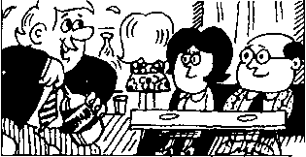
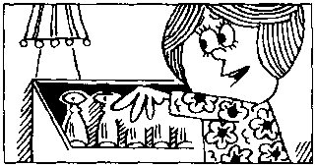
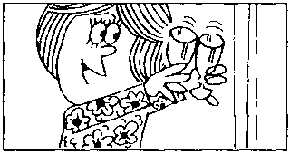
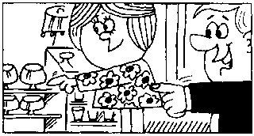
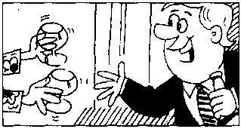
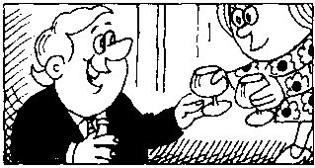
1
3
2
3
4
5
6

Lesson 23 Which glasses?哪几只杯子?

Listen to the tape then answer this question. Which glasses does the man want?
cEd|
听录音，然后回答问题。这位男一士要哪些杯子？
MAN : Give me some glasses please, Jane.
WOMAN : Which glasses?
WOMAN : These glasses?
MAN : No, not those.
The ones on the shelf.
WOMAN : These?
MAN : Yes, please.
WOMAN : Here you are.
MAN: Thanks.

New words and expressions 生词和短语
on /on/prep.在 之上 shelf /JelfZ/v.架子，搁板

Notes on the text 课文注 #
- /li Give me some glasses中，动词give后面有两个宾语■:即直接宾语some glasses和间接宾in me。 人称代词作宾语时要用人称代词的宾格.如：me （I的宾格）,us（we的宾格）,you （you的宾格）,him （he的宾格）.her （she的宾格）,them （they的宾格）和it （it的宾格）。
- No, not those.
句中 those 是指 those glasses。
- The ones on the shelf. ,
本句是省略句。句中的ones代表glasses_{o}
参考译文
丈夫：请拿给我几只玻璃杯，简。
妻子：哪几只？
妻子：是这几只吗？’
丈夫：不，不是那几只。是架子上的那几只。
妻子：这几只〉
丈夫：是的，请拿给我。
妻子：给你。
丈夫：谢谢。

Lesson 24 Give me/him/her/us/them some Which ones?
给我/他/她/我们/他们一些…… 哪些？


Listen to the tape and answer the questions.
听录音并回答问题_{o}，

pens/on the desk
spoons/on the table
plates on the cupboard
1,521
cigarettes/on the television
1,723
bottles/on the dressing table
magazines/on the bed
2,000
newspapers/on the stereo
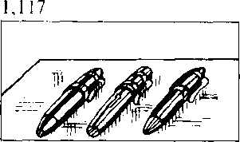
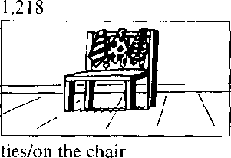
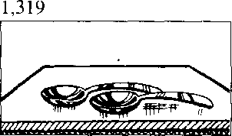
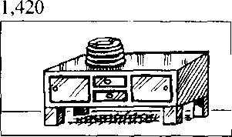
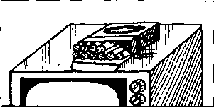
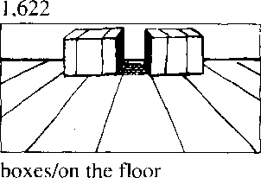
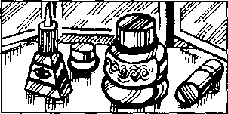
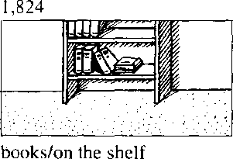
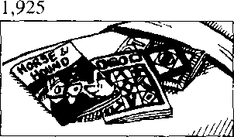
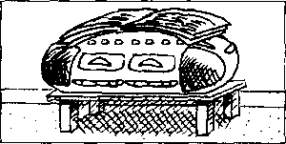

desk /desk/ n.课桌 table /'leibl/ n.桌 f' plate /pleit, n.鳳广 cupboard , 'kAbsd/ n.食橱 cigarette /, sig a'ret/ n.香烟 television /'tell, v^n/ n.电视机 floor /flo:/ 几地板
dressing table /'dresuj-'tcibl/ 梳妆台 magazine /msgo'zirn/ n.杂志 bed /bed/ 儿床
newspaper /'nju:speipa/ n.扌艮纟氏 stereo /'steriao/ n,立体声音响

Written exercises 书面练、习
A Complete these sentences using me_{z} him her, us or them. 完成以下句子，用me, him, her, us或them填空。
Example:
Give Tim this shirt. Give this one, too.
Wim tkiA.如诚.Qlue- him- tliU，(me,
- Give Jane this watch. Give this one, too.
- Give the children these ice creams. Give these, too.
- Give Tom this book. Give this one, too.
- That is my passport. Give my passport please.
- That is my coat. Give my coat please.
- Those are our umbrellas. Give our umbrellas please.
Write questions and answers. 模仿例句写出相应的对话0
Example:
glasses/on the shelf q观,me. gladded plea^ie.
Wkick-^IkeAe?
心t Ik&de. Wke one』伽 the

- pens/on the desk
- ties/on the chair
- spoons/on the table
- plates/on the cupboard
- cigarettes/on the television
- boxes/on the floor
- bottles/on the dressing table
- books/on the shelf
- magazines/on the bed
1() newspapers/on the stereo

Lesson 25 Mrs. Smith's kitchen 史密斯太太的厨房


Listen to the tape then answer this question. What colour is the electric cooker?
听录音，然后回答问题。电灶是什么颜色的？
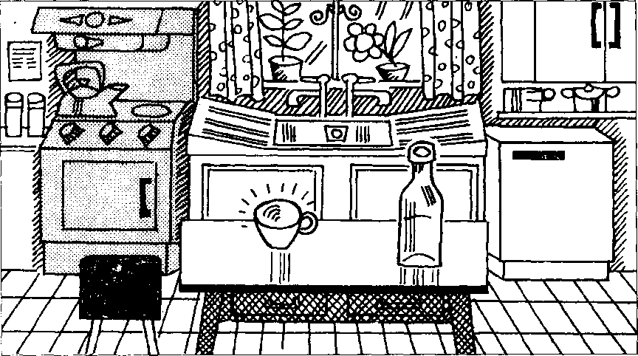

Mrs. Smith's kitchen is small.
There is a refrigerator in the kitchen. The refrigerator is white.
It is on the right.
There is an electric cooker in the kitchen.
The cooker is blue.
It is on the left.
There is a table in the middle of the room.
There is a bottle on the table.
The bottle is empty.
There is a cup on the table, too.
The cup is clean.
Mrs. /'misiz/ 夫人 kitchen /^{l} kit Jan/ 几厨房 refrigerator/n,frid39reita/n.电冰箱 right /rait/ n.右边 electric Zi'lektrik/W/.带电的，可通电的 left /left/ n.左边
cooker/'koka/rt.炉子，炊具 middle /'midi/ n.中间
of /av/ prep.（属于） 的
room /ru:m/ n.房间 cup /kAp/儿杯子

Notes on the text 课文注释
- There is的结构用来说明人或物的存在，荏汉语中可以译为“有”。这个结构要跟单数名词，句中往 往•要有一个介词短语来表示位置或地点。
- on the right （left）,在右边（左边），是介词短语，在本句中作表语。
3注意不要把cooker和cook混淆，cooker是炉子、锅等炊具，不是“炊事员”。炊事员在英语中是 cook 0
- in the middle of,在 之间。
5在课文的第2行和第3行的名词refrigerator前面用了两种不同的冠词：a （不定冠词）和the （定 冠词）。在第2行，“冰箱”是第一次提到，是指冰箱这类电器中的一个，因此要用不定冠词a o当 第2次提到冰箱时，就不是泛指任何一个冰箱，而是特指第2行中的那个冰箱了，因此要用定冠 in] the。
参考译文
史密斯夫人的厨房很小 厨房里冇个电冰箱° 冰箱的颜色是口的0 它位于房间右侧 厨¹房里有个电灶。
电灶的颜色是蓝的。 它位于房间左侧。 房间的中央有张桌子O 桌f上有个瓶子。
瓶了•是空的。
桌了-上还有一只杯子O 杯了很f■净0

Lesson 26 Where is it?它在哪里?


Listen to the tape and answer the questions.
听录音并回答问题o

3,000
There is a cup on the table.
4,000
There is a box on the floor.
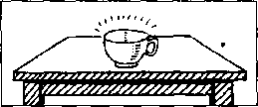
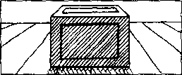

The box is large.
The cup is clean.

5,000
6,000
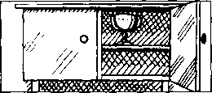
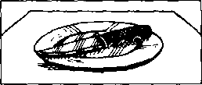

There is a glass in the cupboard. The glass is empty.
There is a knife on the plate. The knife is sharp.

7,000
There is a fork on the tin.
The fork is dirty.
10,000
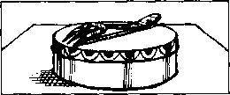
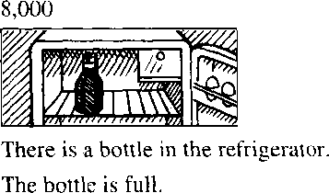
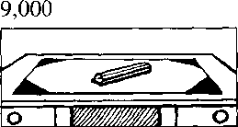
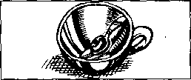

There is a pencil on the desk.
The pencil is blunt.
There is a spoon in the cup.
The spoon is small.

where /weo/ adv.在哪-11 in /in/ prep.在 里

Written exercises 书面练习
A Complete these sentences using a or the.
完成以下句子，用a或the填空。
Example:
Give me book. Which book? book on the table.
me a Wkick bo&k? 如 Ute
- Give me glass. Which glass? empty one.
- Give me some cups. Which cups? cups on the table.
- Is there book on table? Yes, there is. Is book red?
- Is there knife in that box? Yes, there is. Is knife sharp?
B Write sentences using these words. 模仿例句写出相应的句子。
Example:
refrigerator in the kitchen/white " <2- 讥 SsUcke^i..
习扇 时以斧位如■ U- 泓渔.
- cup on the table/clean
- fork on the tin/dirty
- bottle in the refrigerator/full
- pencil on the desk/blunt
- box on the floor/large
- glass in the cupboard/empty
- knife on the plate/sharp

Lesson 27 Mrs. Smith's living room 史密斯太太的客厅

Listen to the tape then answer this question. Where are the books?
OCT) wai
听录音，然后回答问题。书在哪里？
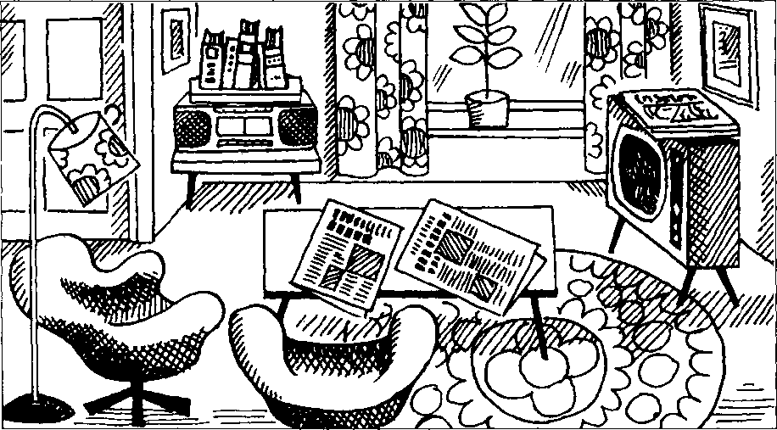

Mrs. Smith's living room is large.
There is a television in the room.
The television is near the window.
There are some magazines on the television.
There is a table in the room.
There are some newspapers on the table.
There are some armchairs in the room.
The armchairs are near the table.
There is a stereo in the room.
The stereo is near the door.
There are some books on the stereo.
There are some pictures in the room.
The pictures are on the wall.
living room /'livig-rum/ 客厅 near /ma/prep.靠近 window /'windau/ n.窗户 armchair/'a:mtjea/ n. 扶于 椅
door /do:/ n.门 picture /'piktfa/ n.图画 wall /wad/ n.墙

Notes on the text 课文注释
- There are的结构中要用复数名词。
- near the window (door),靠近窗(门)，为介词短语◎在本句中作表语₀
- on the wall,在墙上。介词短语作表语。
参考译文
史密斯夫人的客厅很大。 客厅里有台电视机。
电视机靠近窗子。
电视机上放着几本杂志。
客厅里有张桌子O
桌上放看几份报纸O 客厅里有几把扶手椅。
这四扶手椅靠近桌子。
客丿「里有台立体声音响。
音响靠近门O
首响上面有丿L本书_{o}
客厅里有几幅画。
画挂在墙上。

Lesson 28 Where are they?它们在哪里？


Listen to the tape and answer the questions.
听录音并回答问题。

1,120
There are some cigarettes on the dressing table. They are near that box.
2,230
There are some plates on the cooker. They are clean.
3,340
There are some trousers on the bed.
They are near that shirt.
There are some bottles in the refrigerator.
They are empty.
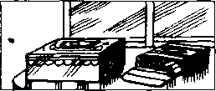
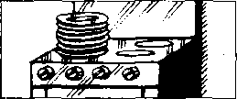
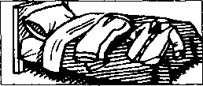
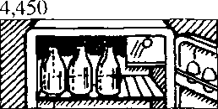

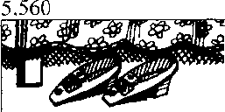
6,670


There are some shoes on the floor.
There are some knives on the table.
They're near the bed.
They're in that box.

7,780
There are some forks on the shelf.
They're near those spoons.
8,890
There are some bottles on the cupboard. They're near those tins.
9,999
There are some tickets on the shelf.
They're in that handbag.
10,001
There are some glasses on the television. They're near those bottles.
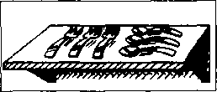
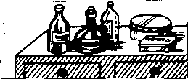
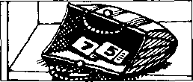
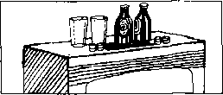

Lesson 28

lronscrs 'irao/oz/ 11. 敬J HiW

Written exercises S 面 练 习
A Look at these words.
注意单数名词和1效名词的区別
Examples:
book — 一 some books; a man - - some men: a housewife —— some housewives
Rewrite these sentences using There are. 模仿例句改用There ere的纟苫构。
Example:
There rs u bo(/k on the desk.
‘： < * lame a ", the 卷孩
- There is a pencil on the desk.
- Inhere is a knife near th;U tin.
- There /.v(i poheenum in the kitchen.
B Write sentences using these words. 模仿例句写出相应的对诂O
- There is a newspaper in the living room.
- There /v a keyboard operator in the office.

Exomple:
(books)/on the dressing lable/cigarettes/near thtit box
仏* 以旳 匾必 顷 ike 部汹我修 taUe?
fya, tl-ui'ie anient boahi如 the tai血.
，以必 伪 me （油衫加7么动，
Wkc^e- q 况
T•坎ne必s that庆见

- (books)/in lhe room/magazines/on the leicvision
- (ties)/on the tloor/shocs/near the bed
- (glasses)/on the cupboard/bottles/near those tins
- ( newspapers)^{z}on the shelf/tickcts/in that handbag
- (lorks)/on lhe ial)ic/knivcs/in that box
- (cups)/on the stereo/glasses/near those bottles
- (cups)/in the kilchen/plates/on the cooker
- (glasses)/in the kitchen/bottles/in the refrigerator
- (books)/in the room/pictures/on the wall
- (chairs)/in the room/armchairs/near the table

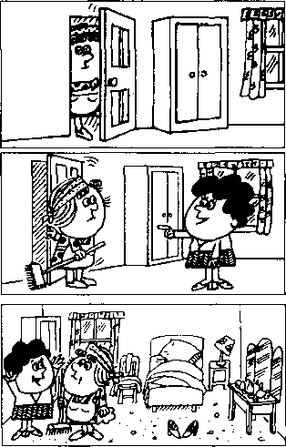
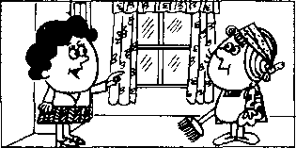
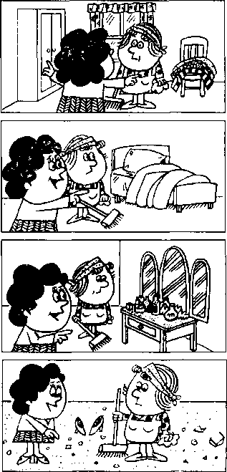
2
3
4
5
6
7
8

Lesson 29 Come in, Amy.进来，艾米。

Listen to the tape then answer this question. How must Amy clean the floor?
听录音，然后回答问题。艾米需要如何来清扫地面？
MRS. JONES : Come in, Amy.
MRS. JONES : Shut the door, please.
MRS. JONES : This bedroom's very untidy.
AMY : What must I do, Mrs. Jones?
MRS. JONES : Open the window and air the room.
MRS. JONES :, Then put these clothes in the wardrobe.
MRS. JONES : Then make the bed.
MRS. JONES : Dust the dressing table.
MRS. JONES : Then sweep the floor.
shut /jAt/ V.关 ]
bedroom /'bedrom/ n.臣卜室 untidy /An'taidi/ q# 乱，不整齐 must /mASt/ modal verb 必须, 应该 open /'sopsn/ v.扌丁丿F
air/ea/ v. ……通风，换换空气
put /put/ V.放置
clothes /kloudz/ n.衣服 wardrobe /'woidraob/ n.大衣柜 dust /dAst/ v.扌单掉灰尘 sweep /swi:p/ v.扫

Notes on the text 课文注释
1英文中需用祈使语气来表示直接的命令、建议、告诫、邀请等多种意图。祈使句一般省略主语you、 动词釆用动词的原形0如本课对话中的Come in, shut the door, open the window ...等均为祈使句_{o}
- What must I do?我应该做些什么呢？其中的must是情态动词，表示不可逃避的义务或不可推卸的 责任0
- make the bed,铺床 _{o} 参考译文
琼斯夫人：进来，艾米。
琼斯夫人：请把门关上。
琼斯夫人：这卧室太不整洁了 _{c}
艾 米：我应该做些什么呢，琼斯夫人?
琼斯夫人：打开窗子，给房间通通风。
琼斯夫人：然后把这些衣服放进衣橱里去c 琼斯夫人：再把床整理一卜。
琼斯夫人：押掉梳妆台上的灰尘。
琼斯夫人：然后扫扫地。

Lesson 30 What must I do?我应该做什么?

Listen to the tape and answer the questions.
NJ听录音并回答问题o

Open shut y°^{ur}
Sweep the
Clean the
Dust the
Empty the
Read this
Sharpen these
Put on
Take off ^{your}
Turn on .
Turn off ^{the}
區術.食
7
8
10
ii
16
12
13
14
15
17
18
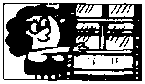
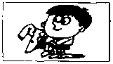
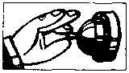
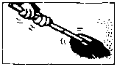
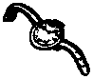

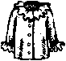
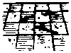
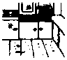
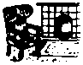
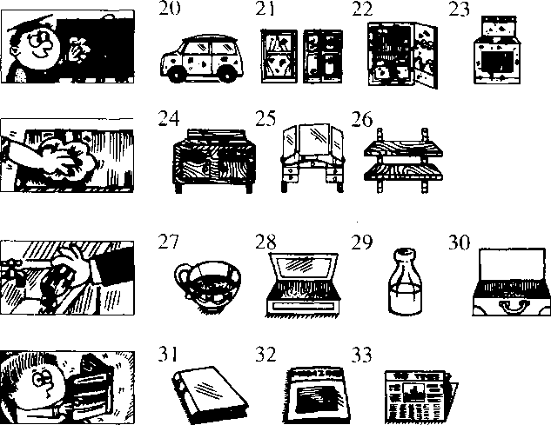
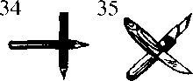

empty /'empti/站倒空，使 变空
take off /'teik-of?脱掉
turn on /'tam-on/ 开（电灯）
turn off /'t3：n-t>f7 关（电灯）
read /riid/ v.读
sharpen /'j\rpon/ v.削尖；使锋利 put on /'pot-du/ 穿上

Written exercises 书面练习
A Rewrite these sentences.
模仿例句写出相应的祈使句。
Example:
The cup isn't empty. 8地d!
- The window isn't clean.
- The door isn't shut.
- The wardrobe isn't open.
B Look at this table:

注意下表：
Shut the | stereo
Open the | tap
Put on your | blackboard
Take off your | cup
Turn on the | window
Turn off the | cupboard
Sweep the | magazine
Clean the | knives
Dust the | shirt
Empty the | door
Read this | floor
Sharpen these | shoes

Now write eleven sentences.
模仿下面的例句写出11句表示命令的句子。
Example:

6Q

Lesson 31 Whereas Sally?萨莉在哪里?


Listen to the tape then answer this question. Is the cat climbing the tree? 听录音，然后回答问题。猫正在爬树吗？

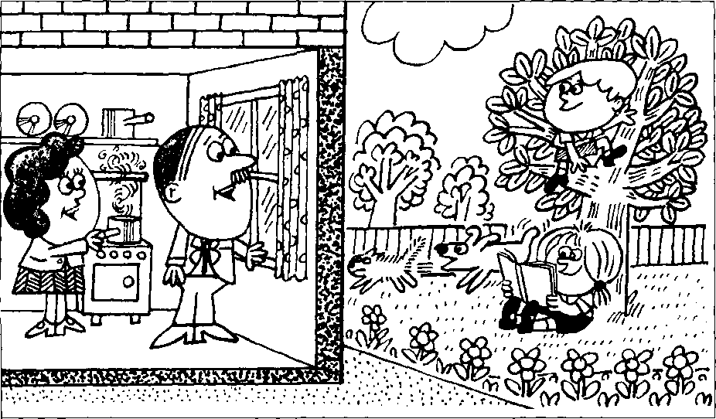

JEAN : Where⁷ s Sally, Jack?
JACK : She's in the garden, Jean.
JEAN : What's she doing?
JACK : She's sitting under the tree.
JEAN : Is Tim in the garden, too?
JACK : Yes, he is.
He's climbing the tree.
JEAN : I beg your pardon?
Who's climbing the tree?
JACK : Tim is.
JEAN : What about the dog?
JACK : The dog's in the garden, too.
It's running across the grass. It's running after a cat.

New words and expressions 生词 和短语
garden /'ga:dn/ 几 花园
under/'Anda/ prep. 之 卜 tree /tri:/ n.树
climb /klaim/ r.爬，攀登
who /hu:/ pron.谁
run /rAn/ 卩跑
grass /gra:s/ n.草，草地
after /'a:fta/ prep.在 之后
across /.s'kos/ prep. 横过，穿过 cat /kaet/ n.猫

Notes on the text 课文注释
1在英文中表示说话时正在进行的动作或事件，要用动词的现在进行时。现在进行时由be的现在 时加上现在分词组成、如课文中的“She's sitting under the tree.”和“He's climbing the tree.”等句子均 为现在进行时。对大多数动词来说，在动词后面直接加-ing即可组成现在分词，如doing, climbing。 对以-e结尾的动词，要去掉-e,再加-ing,如making0如果动词只有一个元音字母，而其后跟了 -个辅音字母时，则需将辅音字母双写，再加-ing,如running, sitting。
- What about the dog?那么狗呢？这句话的意思是 What is the dog doing in the garden?为 了避'免重复 原句中的主语和谓语动词，可以用What about这个结构，用来询问情况。
- run after,追逐。
例：Look, Sally is running after her Mum.瞧，萨莉正在追赶她的母亲。

参考译文
琼：杰克，萨莉在哪儿？
杰克：她在花园里，琼O
琼：她在干什么？
杰克：她正在树荫下坐着0
琼：蒂姆也在花园里吗？
杰克：是的，他也在花园里。他正在爬树。
琼：你说什么？谁在爬树？
杰克：蒂姆在爬树0
琼：那么狗呢？
杰克：狗也在花园里。它正在草地上跑，在追一只猫。

Lesson 32 Whafs he/she/it doing?他/她/它正在做什么？


Listen to the tape and answer the questions. 听录音并回答问题。

20,000
Nicola is typing a letter.
She is emptying
30,000
a basket.
40,000
Mr. Richards is opening the window.
50,000
My mother is making
the bed.
60,000
Sally is shutting the door.
70,000
It is eating a bone.
80,000
My sister is looking
at a picture.
90,000
Jack is reading a magazine.
100,000
He is cleaning his teeth.
200,000
She is dusting the dressing table.
300,000
Emma is cooking a meal.
400,000
The cat is drinking its milk.
800,000
600,000
Tim is sharpening a pencil.
700,000
He is turning on the light.
The girl is turning off the tap.
900,000
The boy is putting on his shirt.
1,000,000
Mrs. Jones is taking off her coat.
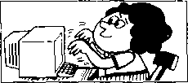
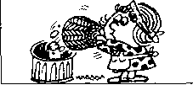
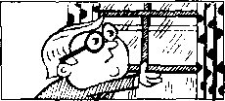
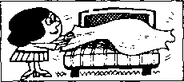
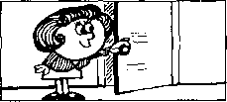
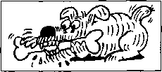
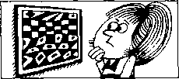
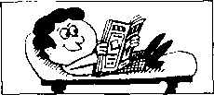
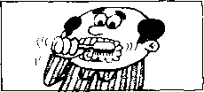
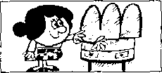
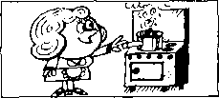
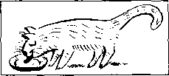
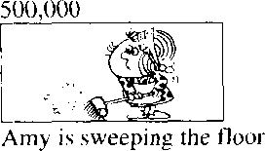
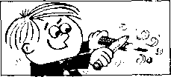
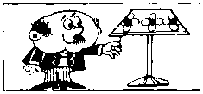
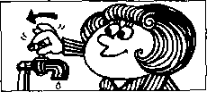
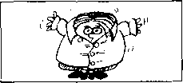
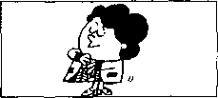

New words and expressions 生词和短语
tooth /tui6/ （teeth /ti:0/）儿牙爵 cook ^{z}kuV v.做（饭菜）
type /taip/ v.打字
letter / 'lets/ n.
basket /'ba:skit/ /?.篮子 eat /i:t.^{z} v.吃
bone /bson/ 几 骨头 clean /kli:n/ v.清洗
milk ,milk/ 儿牛奶
meal /mi:l/ n.饭，一顿饭
drink /dngk/ v.喝
tap /t£cp/ n.（水）龙头

Written exercises 书面练习
A Complete these sentences.
模仿例句把祈使句改写成现在进行时O
Example:
Sweep the floor! She 必 d.
- Open the window! He
- Sharpen this pencil! She
- Dust the cupboard! She
- Empty the basket! She
- Look at the picture! He
B Write questions and answers.
模仿例句提问并回答。
Example:
Nicola/emptying the basket/typing a letter
9七 dJne the hadhet?
如't the badJzet.
She % a. Utts,
- Mr. Richards/cleaning his teeth/opening the window
- My mother/shutting the door/making the bed
- The dog/drinking its milk/eating a bone
- My sister/reading a magazine/looking at a picture
- Emma/dusting the dressing table/cooking a meal
- Amy/making the bed/sweeping the floor
- Tim/reading a magazine/sharpening a pencil
- The girl/turning on the light/turning off the tap
- The boy/cleaning his teeth/putting on his shirt
- Miss Jones/putting on her coat/taking off her coat

ssa Listen to the tape then answer this question. Where is the Jones family? 听录音：然后回答问题。琼斯一家人在哪里?
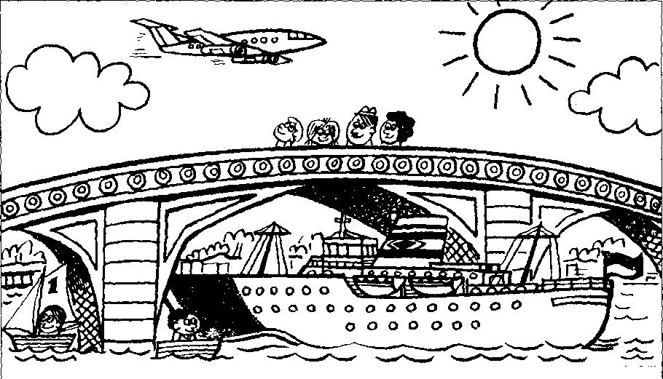

It is a fine day today.
There are some clouds in the sky, but the sun is shining,
Mr. Jones is with his family.
They are walking over the bridge.
There are some boats on the river.
Mr. Jones and his wife are looking at them.
Sally is looking at a big shi[i
The ship is going under the bridge.
Tim is looking at an aeroplane.
The aeroplane is flying over the river.

New words and expressions 生词和短语
day /dei/ n.日 p | over /'auvs/ prep.跨越, | 在……之上
cloud/klaod/ a.如 | bridge /bnd^/ n.桥 | 、
sky /skai/儿大空 | boat /baot/ n.船
sun /sar/ n.太阳 | river /'nva/ n. *可
shine /fain/ il 照耀 | ship /Jip/ n.轮船
with /wid/ prep.和 在一起 | aeroplane /'esrsplein/ n. | 飞机
family /'faemili/ n.家庭（成员） | fly /flai/ v.飞
walk /wo:k/ v.走路，步行

Notes on the text 课文注释
1. It is a fine day today.
旬中的il是指天气。
2 some clouds,几朵云。
some可以修饰可数名词，也能修饰不可数名词。

参考译文
今天大气好。
天空中飘着几朵云、但阳光灿烂。
琼斯先车同他的家人在一起_{o} 他们正在过桥0
河".有,几艘船。
琼斯先生和他的妻子正在看这些船。 莎莉正在观看一艘大船;
那船正从桥下驶过c
蒂姆正望着一架飞机。
飞机正从河上飞过


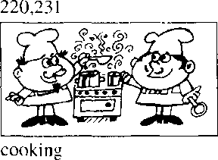
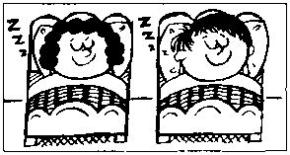
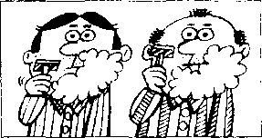
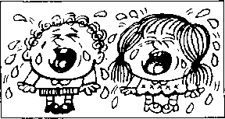
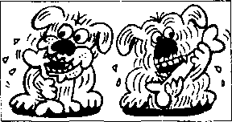
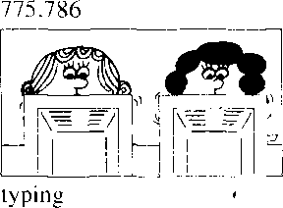
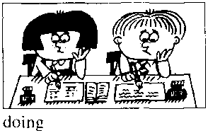
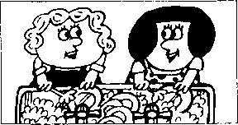
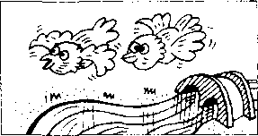
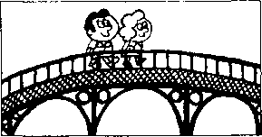
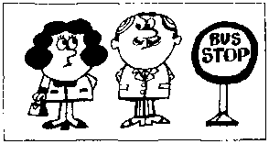
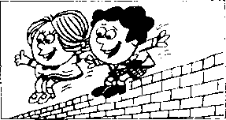
Listen to the tape and answer the questions. 听录音并回答问题。
331,342
sleeping
442,453
shaving
553,564
crying
664,675
eating
886,897
997,998
washing
1,000.001
flying
1,100,000
walking
1,500,00()
waiting
2,000.()()()
jumping

New words and expressions 生 词 和短语
sleep /sli:p/ 讥睡觉 | wash /woj/ v.洗
shave /Jeiv/ 卩.刮脸 | wait /weit/ v.等
cry /krai/ v.哭)喊 | jump /d3Amp/ v.跳

Written exercises书面纟东习
A Complete these sentences.
模仿例句用现在进行时完成以下句子。
Example:
take — taking
Take . . . He is 泓"his book.
注意以下例句：
如果动词是以-e结尾，变成现在分词时要去掉-e、然后再加
1 | Type … | She is | a letter.
2 | Make ... | She is | the bed.
3 | Come ... | He is
4 | Shine ... | The sun is
5 | Give ... | He is | me some magazines.

B Write questions and answers. 模仿例句提问并回答。
Example:
the children/looking at the boats on the river
Wkat cm
秘 cd tke AWi s tke，
- the children/doing their homework
- the men/cooking a meal
- they/sleeping
- the men/shaving
- the children/crying
- the dogs/eating bones
- the women/typing letters
- the women/washing dishes
- the birds/flying over the river
1() they/walking over the bridge
- the man and the woman/waiting for a bus
- the children/jumping off the wall

Listen to the tape then answer this question.

Are the children coming out of the park or going into it?

听录音，然后回答问题O孩子们是正从公园里出来还是正在往里走?
This is a photograph of our village.
Our village is in a valley.
It is between two hills.
The village is on a river.
Here is another photograph of the village. My wife and I are walking along the banks of the river.
We are on the left.
There is a boy in the water.
He is swimming across the river.
Here is another photograph.
This is the school building.
It is beside a park.
The park is on the right.
Some children are coming out of the building.
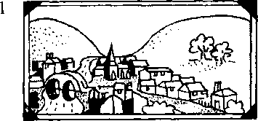
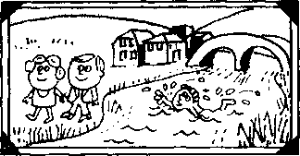
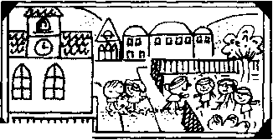
Some of them are going into the park.
3

New words and expressions 生词和短语
photograph/'faotggruif//?. | bank /beegk/ n.河岸
village 打 1 | water / 'wo:t9/ n.水
valley /'vgeli/ 儿山谷 | swim /swim/ v.游泳
between /bi twi:n/ prep.在 之间 | building /'bildii]/ n.大楼，建筑物
hill/hiLF.小山 | park /park/ n.公园
another/a'nAd^/ del.另,一个 | into /'mta/ prep.进入
wife /waif? n.妻 f
along/s'loij/pr^p.沿着

Notes on the text 课文注释
- The village is on a river.
这句话中的介词。n不表示“在……上”，而是“邻近”•“靠近”的意思.
- My wife and I ...
我和妻子……在英语中表达“我和……”时，要把I放在别人的后面。
- Some children are coming out of the building.
out of表示"从里向外”的动作。

参考译文
这是我们村庄的一张照片°
我｛I I的村庄坐落在一个山谷之中。
它位于两座小山之间_{c}
它靠近一条小河。
这是我们村庄的另一张照片。
我和妻子正沿河岸定着0
我倡在河的上伽。
河里血-仃个男孩O
他正橫渡小河3
这是另一张照片C,
这是学校大楼G 它位于公园的旁边。
公园在右面O
F孩子正从楼里出来。 *
他们中有几个正走进公园。

1

Listen to the tape and answer the questions.
听录音并回答问题。
one
going into
2
two 3
three
going out of
silting beside
four
walking across
running along
6 six
jumping off
7
seven
walking between
8
sitting near
9
nine
11
eleven
sittingon

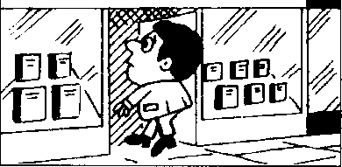
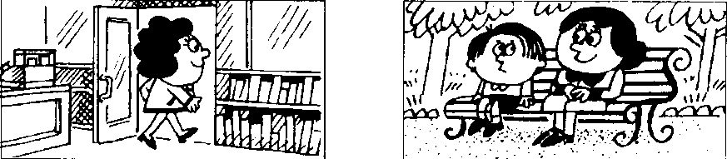
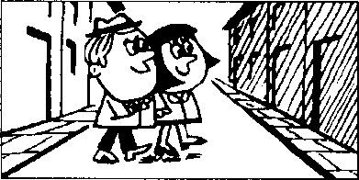
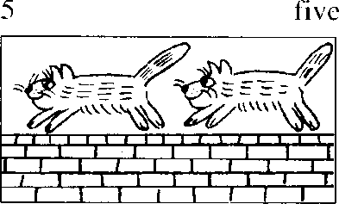
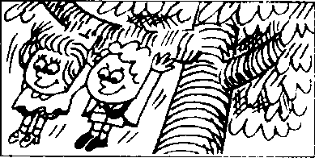
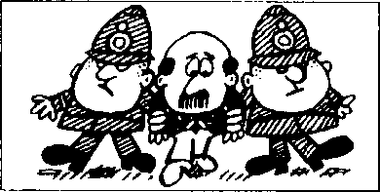
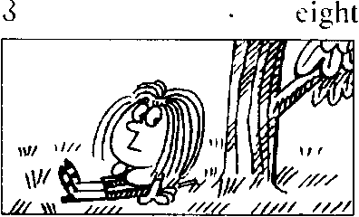
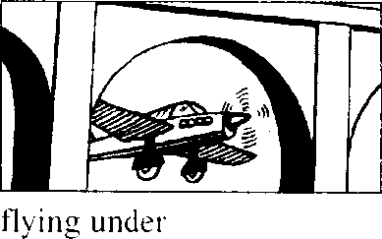
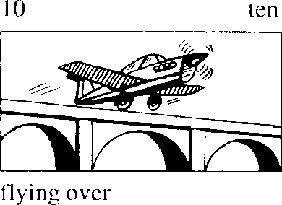
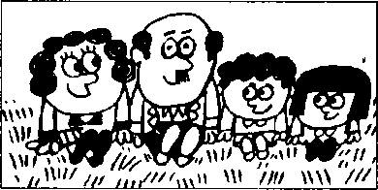
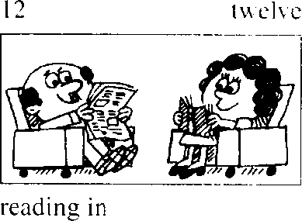

New words and expressions 生词 和 短十吾
beside /bi'said/ prep.在 旁
off /of? prep.离开

Written exercises 书面练习
A Complete these sentences.
模仿例句用现在进行时完成以下句子c
注意：如果单音节动词仅有一个元音字母而其后跟一个辅音字母时' 变成现在分词时要将此辅音字母 双与。
Example:
put — putting
put. . . He is on his coat.
- swim ... He is across the river.
- sit. . . She is on the grass.
- run . . . The cat is along the wall.
B Write sentences using these words.
模仿例句提问并回答。
Examples:
boy swimming/across the river
Wk&ie 圍 Ute cAe 2 Ute-
children going/into the park
Wkene- one. ckMne^-5%^ 栃Ute
- man standing/between two policemen
- man going/into the shop
- woman going/out of the shop
- he sitting/beside his mother
- they walking/across the street
- the cats running/along the wall
- the children jumping/off the branch
- she sitting/near the tree
- it flying/under the bridge
- the aeroplane flying/over the bridge
- they sitting/on the grass
- the man and the woman reading/in the living
room

Lesson 37 Making a bookcase 做书架
cezdI
IBMM

Listen to the tape then answer this question. What is Susan's favourite colour? 听录音，然后回答问题。苏珊最喜欢哪种颜色？
DAN : You're working hard, George.
What are you doing?
GEORGE : I'm making a bookcase.
GEORGE : Give me that hammer please, Dan.
DAN : Which hammer?
This one?
GEORGE : No, not that one.
The big one.
DAN : Here you are.
GEORGE : Thanks, Dan.
DAN : What are you going to do now, George?
GEORGE : rm going to paint it.
DAN : What colour are you going to paint it?
GEORGE : I'm going to paint it pink.
DAN: Pink!
GEORGE : This bookcase isn't for me.
Ifs for my daughter, Susan.
Pink's her favourite colour.
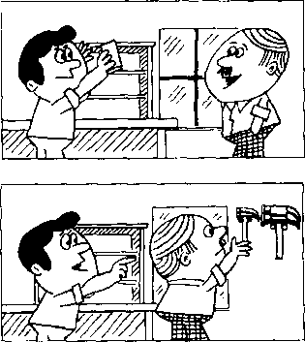
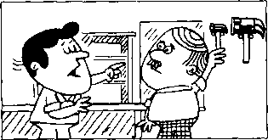
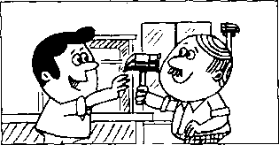
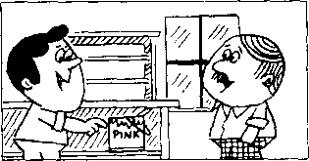
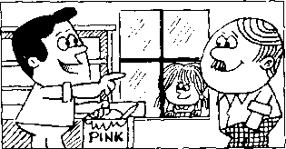
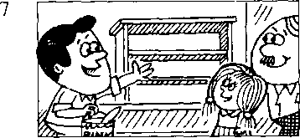

New words and expressions 生词和短语
work /w3ik/ 卩工作
hard /ha:d/ adv.努力地
make /mcik/ v.做
bookcase /'bok-keis/ 〃.书橱.书架 hammer /'hgema/ n.锤子 paint /pemt/ y.上漆，涂 pink /piqk/ n. & adj.粉红色 favourite /'feivsrit/ adj.最喜欢的

Notes on the text 课文注释
- You're working hard, George.在这句话中hard是一个副词，修饰动词work,有“努力地”、“费劲 地"的意思。hard还常常与表示动作、举止的动词连用，如work, listen, play, try等，用来加强动 作的强度：常译成“拼命地”。
- What are you going to do now, George? 你现在准备做什么.乔治？
be going to,是“打算L “准备”、“按计划”在最近做某事，表示将来。
- paint it pink,
it指bookcase,是宾语,pink是宾语补足语。

参考译文
丹：你干得真辛苦.乔治。你在干什么呢？
乔治：我正在做书架O
乔治：请把那把锤子拿给我，丹₀
丹：哪一把？是这把叫？
乔治：不：不是那把。是那把大的。
丹：给你。
乔治：谢谢、丹。
丹：你现在打算干什么，乔治？
乔治：我打算把它漆一卜₀
丹：你打算把它漆成什么颜色？
乔治：我想漆成粉红色C
丹：粉红色！
乔治：这个书架不是为我做的，是为我的女儿苏珊做的。粉红色是她最喜欢的颜色。

Lesson 38 What are you going to do?你准备做什么？

What are you doing now?你现在正在做什么？


Listen to the tape and answer the questions, 听录音并回答问题。

one
I am going to shave.
two
Now I am shaving.
three
I'm going to wait for a bus.
four
Now I'm waiting for a bus.
five
We're going to do our homework.
seven
I'm going to paint this bookcase.
eight
Now I'm painting this bookcase.
nine
JUT-KIT
We're going to listen to the stereo.
ten
Now we\e listening to the stereo.
eleven
I*in going to wash the dishes.
twelve
Now I'm washing the dishes.
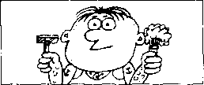
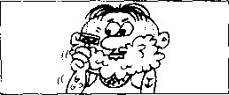
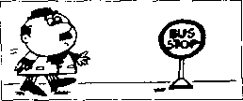
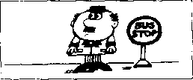
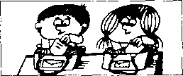
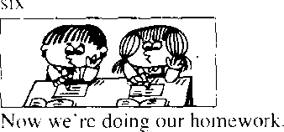
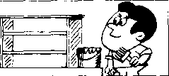
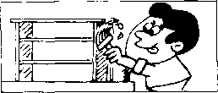
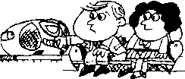
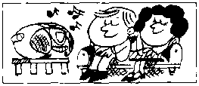
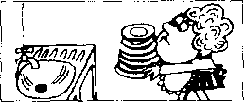
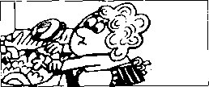

New words and expressions 生。司和短语
homework /'houm\v3：k/ 几作业 dish /dij/ n.盘子，碟子
listen /'lis^n/ v.听

Written exercises 书 面练习
A Complete these sentences using am, is or are. 完成以下句子，.用am, is或are填空。
Examples:
What you doing?
Wliat
Wc reading.
We g<u，
1 | What.— | __ you doing? We | reading.
2 | What — | they doing? They _ | doing their homework.
3 | What | he doing? He | —working hard.
4 | What — | you doing? I | _ washing the dishes.

B Write questions and answers.
模仿例句写出相应的对话。
Example:
painr this bookcase
Wkat.么? iji"斧"(h ?
(pmq, la UuA l^kca^e. What oAe ipu, d&inc^ j m *■必幼^ 场以 加以必妃
- sh；H^{r}e
- wait for a bus
- do my homework
- listen to the stereo
- wash the dishes

Lesson 39 Don't drop it!别摔了 !

Listen to the tape then answer this question. Where does Sam put the vase in the end?

听录音，然后回答问题。萨姆把花瓶放在什么地方？
SAM : What are you going to do with that vase, Penny?
PENNY : I'm going to put it
on this table, Sam.
SAM : Don't do that.
Give it to me.
PENNY : What are you going to do with it? SAM : I'm going to put it here,
in front of the window.
PENNY : Be careful!
Don't drop it!
PENNY : Don't put it there, Sam.
Put it here, on this shelf.
SAM : There we are!
It's a lovely vase.
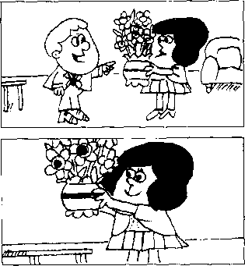
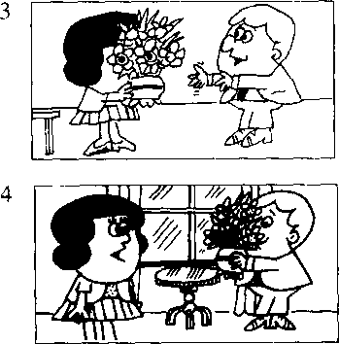
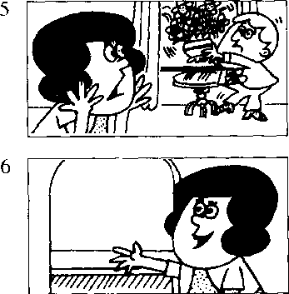
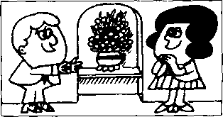
PENNY : Those flowers are lovely, too.

New words and expressions 生词和短语
vase /va:z/ 儿花瓶 drop /drop/ v.掉下 flower/'flaoa/ n.花
front /frAnt/ n.由j 而
in front of A： 之前
careful /'keaf^l/ adj. 的，仔细的

Notes on the text 课文注释
- do wi山指对某件事物或人的处理。
2在第29课中，我们讲到在英文中需用祈使语气来表示直接的命令、建议等多种意图。而祈使句 的否定形式则由don't加上动词原形组成，如课文中的''Don't do that”; "Don't drop it”等句子@
3在第21课有这样的句型“give me a book”，在本课文中又岀现了 "give it to irie,?的句型_{o}在劝词 give后面可以冇两个宾语：直接宾语（指物，如a book, it）和间接宾语（指人，如me）。如果直 接宾由置于动词give之后•间接宾语则变成有to的介词短语。
- Be careful!小心点！这个固定结构常用来提醒他人可能发生的事故或困难。
- There we are.就放在那里°参见第11课课文注释3。

参考译文
萨姆：你打算如何处理那花瓶？
彭妮：我打算把它放在这张桌子上.萨姆。
萨姆：不要放在那儿、把它给我0
彭妮：你打算怎么办？
萨姆：我准备把它放在这儿.放在窗前。
彭妮：小心点！别摔f!
彭妮：别放在那儿，萨姆。放在这儿，这个架子上°
萨姆：这是只漂亮的花瓶。
彭妮：那些花也很漂亮啊。

Lesson 40 What are you going to do?你准备做什么?

I'm going to .. ■我准备
Listen to the tape and answer the questions. 听录音并回答问题o
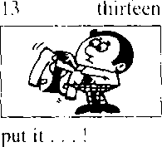
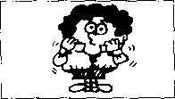
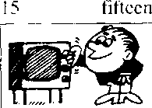
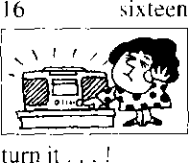
14 fourteen
take it... !
turn it... !

What are you going to do with that/those . -.?你准备把那个/那 些……？

I'm going to give/show/send/take .-.我准备给/展示/送/拿
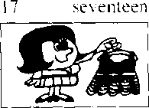
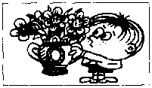
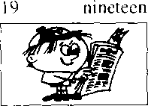
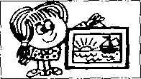
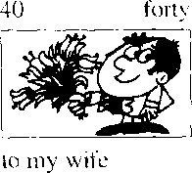
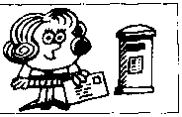
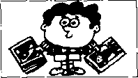
to my daughter
3() thirty
eighteen
18
to my father
20 twenty
to my mother
to the children
to my grandmother
50
fifty
to my grandfather
60 sixty
to my sister

New words and expressions 生词丰口短语
show Joo/「给 take /tcik. r.
send / send/「•送给

Written exercises 书面纬 1
A Rewrite these sentences.
模仿例句改写以下句子O
Example:
Give me that vase.
饥妃 that uaW M me.
- Send George that letter.
- Take her those flowers.
- Show me that picture.
- Give Mrs. Jones these books,
- Give the children these ice creams.
B Rewrite these sentences.
模仿例句改写以下句子。
Examples:
Put on your coat! 9彻 尹必^ A it"
Put on your shoes!
9 in to- put them 必.
- Put on your hat!
- Take off your shoes!
- Turn on the taps!
- Turn off the light!
- Put on your suit!
- Take off your hat!
- Turn on the lights!
J
- Turn off the television!
- Turn off the lights!
- Turn on the stereo!

Lesson 41 Penny's bag 彭妮的提包

Listen to the tape then answer this question. Who is the tin of tobacco for? M听录音，然后回答问题。那听烟丝是给谁买的？
SAM : Is that bag heavy, Penny?
PENNY : Not very.
SAM: Here!
Put it on this chair.
Whafsin it?
PENNY : A piece of cheese.
A loaf of bread.
A bar of soap.
A bar of chocolate.
A bottle of milk.
A pound of sugar.
Half a pound of coffee.
A quarter of a pound of tea.
And a tin of tobacco.
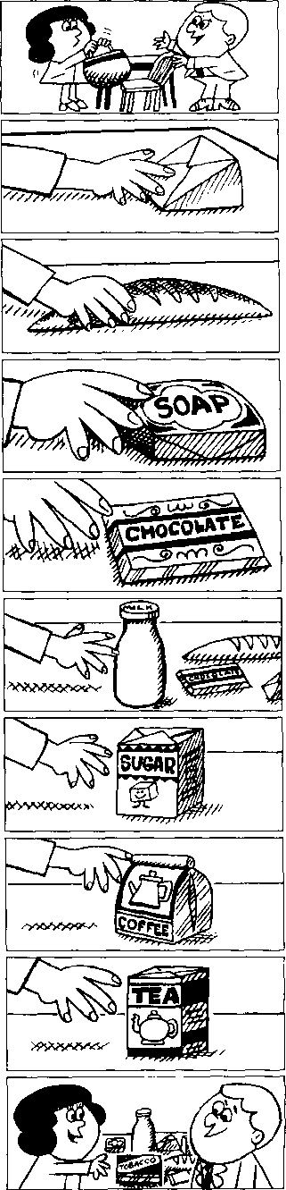
SAM : Is that tin of tobacco for me? PENNY :. Well, it's certainly not for me!
2
3
4
5
6
7
8
9
10

New words and expressions 生词 和短语
cheese n.扌L酪、干酪 bread /bred/ n.而包 soap /ssop n.肥 皀 chocolate /'tj'oklit/ n.巧克力
sugar/'Jogs/ n.糖
coffee /'kofi/ n.咖啡
tea /ti:/ n.茶
tobacco /ta'bfekao/ 儿烟草，烟丝

Notes on the text 课文注释
- Not very.是"It is not very heavy.¹¹的省略形式，常用于口语中。
- a piece of, 块，•张. 一片，用在不可数名词前，表示数量，又如：a piece of bread,一片面包 本课表小数量的短语还仃：
it loaf of, 一个：
a bar of, 一条；
a bottle of, 一瓶；
a pound of, 一磅； half a pound of,半磅；
a quarter of,四分之一（）.；
a tin of, 一听 _{o}

参考译文
阱姆：那个提包重吗，彭妮？
担妮：不太重。
萨姆：放这儿。把它放在这把椅子上。里面是什么东西。
彭妮：-块乳酪、一个面包、一块肥皂、一块巧克力、一瓶牛奶、一磅糖、半磅咖啡、%磅茶叶和 一听烟丝。
萨姆：那听烟丝是给我的吗？
彭妮：噢"当然不会是给我的！

Lesson 42 Is there a ■.. in/on that ...？

在那个……中/上有一个……吗？
Is there any ... in/on that... ?
在那个……中/上有……吗？
Listen to the tape and answer the questions. 听录音并回答问题。
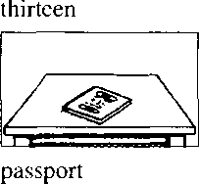
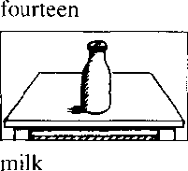
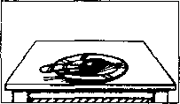
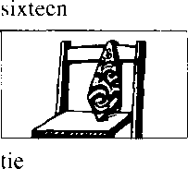
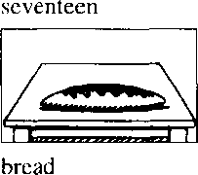
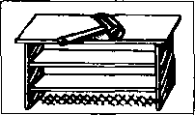
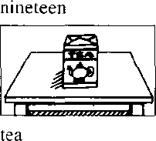
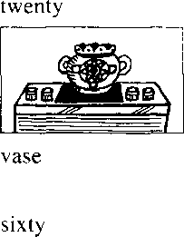
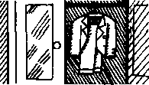
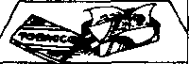
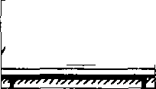
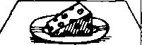
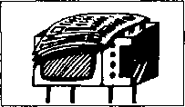
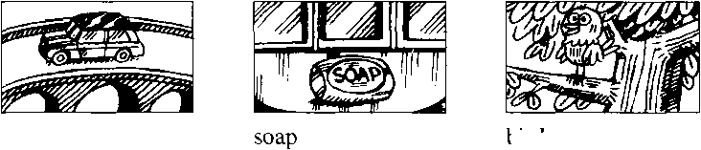
eighteen
fifteen
spoon
thirty
hammer
fifty
suit
tobacco
forty
cheese
70
seventy
newspaper
80
eighty
90
ninety
100
a hundred
bird
car

New words and expressions 生词木口短 i吾
bird , b3：c!/ h. "9 some /s.\m/ det. 一"§
any /'cni/ del.

Note on the text十果文注释
some和any是英文中表，K数量的限定词・它们一股不能精确地说明数量究竟有多大、在汉仍中疔往译 为“一项’some --般用于行建句中「my…般用于木施确定答案是胃定还是否定的統问旬和含"顷 或-n't的否定旬中 *

Written exercises 书 面练习
A Complete these sentences using a any or some.
完成以下句子，用o any或some填空c
Examples:
There's a photograph on the desk. Is there any milk in the bottle?
There isn't any milk in the bottle. There's sojne milk in that cup.
- Is there bread in the kitchen ?
- There's loaf on the Uiblc.
- There's coffee on the table, too.
- There isn't chocolate on the table.
- There's spoon on tha( dish.
- Is there soap on the dressing table⁹

Write questions and answers using these words. 模仿例句提问并回答。
Examples:
passport/on the table
方 the* a
id： Whene J- erne m the. talde-.
bread/on the table
tke^e 必.孚瘍的2 6.&me 伞 tke- taMe.

- spoon/on the plate
- tie/on the chair
- milk/on the table
- hammer/on the bookcase
- te<i/on the table
- vase/on the radio
- suit/in the wardrobe
- tobacco/in the tin
- chocolate/on the desk
- cheese/on the plate

Listen to the tape then answer this question.

How do you know Sam doesn't make the tea very。什en? 听录音，然后回答问题。你怎么知道萨姆不常沏茶？
PENNY : Can you make the tea, Sam?
SAM : Yes, of course I can, Penny.
SAM : Is there any water in this kettle?
PENNY : Yes, there is.
SAM : Where's the tea?
PENNY : It⁵s over there,
behind the teapot.
PENNY : Can you see it?
SAM : I can see the teapot,
but I can't see the tea.
PENNY : There it is!
It's in front of you!
SAM : Ah yes, I can see it now.
SAM : Where are the cups?
PENNY : There are some in the cupboard.
PENNY : Can you find them?
SAM : Yes. Here they are.
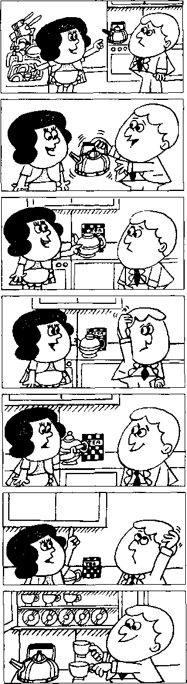
PENNY : Hurry up, Sam!
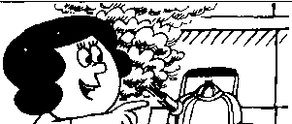
The kettle's boiling!

New words and expressions 生词 和短语
now /nao/ adv.现在，此刻 find /faind/ v.找到
boil /'boil/ v.沸腾，开
of course /ov-'ko:s/ 当 然
kettle /'ketl/ n.水壶
behind /bi'hamd/ prep.在 后面
teapot /'ti:pot/ n.茶廿臼

Notes on the text 课文注释
- make the tea,沏茶。
- over there是指 ''在那边”，指比较远的地方。
- 4 There are some in the cupboard 中，some 是代词，指 some cups _{o}
- hurry up,赶快.在祈使语气中用来催促他人₀

参考译文
彭妮：你会沏茶吗•萨姆，
萨姆：公的，我当然会，彭妮0 .
萨姆：这水壶里有水吗？
彭妮：有水。
阱姆：茶叶在哪儿？
形妮：就在那儿、茶壶后面。
彭妮：你看见了吗？
萨姆：茶壶我看见了，但茶叶没看到。
彭妮：那不是么！就在你眼前。
萨姆：噢、是啊.我现在看到了 ₀
萨姆：茶杯在哪儿呢？
彭妮：碗橱里有几只。
影妮：你找得到吗？
恠姆：找得到。就在这儿呢。
彭妮：快，萨姆。水幵了！

Lesson 44 Are there any ... ?有些 吗？
Is there any... ?有些 吗？


Listen to the tape and answer the questions.
听录音并回答问题o

seventy
bread on the table
eighty
ninety
milk in front of the door
soap on the cupboard
two hundred
newspapers behind that vase
three hundred
four hundred
five hundred
cups in front of that kettle
six hundred
tea in those cups
seven hundred
chocolate behind that book
nine hundred
teapots in the cupboard
eight hundred
cars in front of that building
coffee on the table
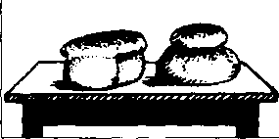
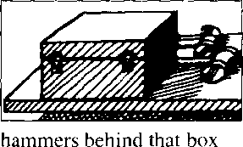
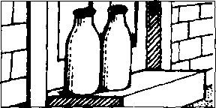
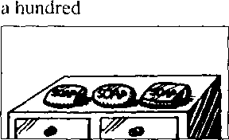
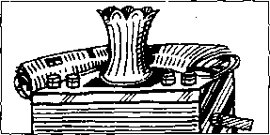
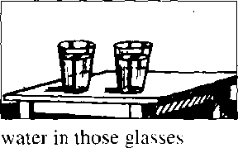
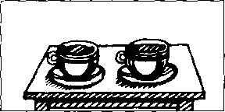
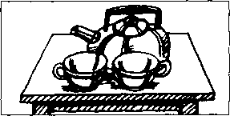
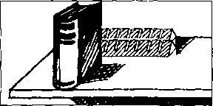
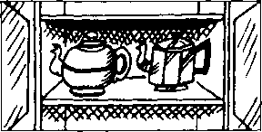
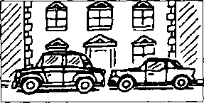
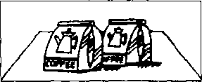

Written exercises 节 面纟东习
A Look at these:
注意名'词的单数和夏玫形式：
glass - glasses: book - books: housewife — housewives.
Rewrite these sentences, 改写以下句子，用名词的复教形式填空。
Example:
- can see some cups. 13nt I ciin'l see any (glass).
9 么％ 如他？ m%. kai 9 t
- I can see some spoons, but I can't sec an\ (knife).
- I can see some hammers, but I can't see any (box).
- I can see some cof fee, but I can't see any (loaf) of bread.
- I can see some cupboards, but I can't see any (shelf).
- I can see Mr. Jones and Mr. Brown, but I can't see their (wife).
- 1 can see some cups, but I caift see any (dish).
- I can see some cars, but I can't see any 一一一 (bus).
B Write questions and answers using these words. 模仿例句提问并回答o
Examples:
bread/on the table
% Uieu, a旳 Q玆/ k^u⁷-?
hammers/behind that box
Xfe tke^e he*
lje4, the/ie a/ie.二队演 cpie rw Ute. taklc‘.
- milk/in front of the door
- soap/on the cupboard
- newspapers/behind that vase
- water/in those glasses
- tea/in those cups
- cups/in front of that kettle
- chocolate/behind that book
- teapots/in that cupboard
- cars/in front of that building
- coffee/on the table

Lesson 45 The boss⁹s letter 老板的信

Listen to the tape then answer this question. Why can't Pamela type the letter?

听录音，然后回答问题。帕梅拉为什么无法打信?
THE BOSS : Can you come here a minute please, Bob?
BOB : Yes, sir?
THE BOSS : Whereas Pamela?
BOB : She's next door.
She's in her office, sir.
THE BOSS : Can she type
this letter for me?
Ask her please.
BOB : Yes, sir.
BOB : Can you type this letter
for the boss please, Pamela?
PAMELA : Yes, of course I can.
BOB : Here you are.
PAMELA : Thank you, Bob.
PAMELA : Bob!
BOB : Yes?
What⁵ s the matter?
PAMELA : I can't type this letter.
PAMELA : I can't read it!
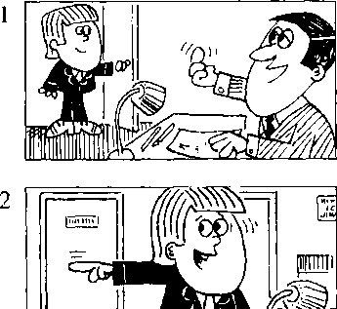
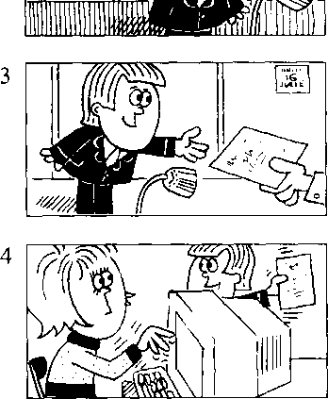
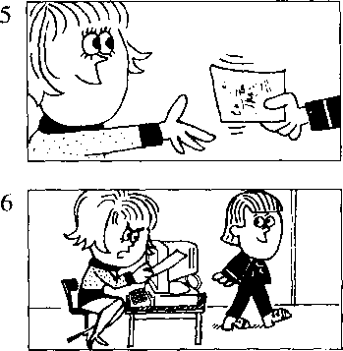
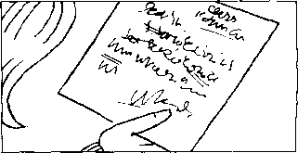
The boss's handwriting is terrible!

New words and expressions 生词 和短语
ask /a:sk/ v.请求,要求 handwriting /'haend^aitir）/ n.书写 terrible /'tenb^l/adj.糟糕的，可怕的
can /kaen/ modal verb 能够 boss /bos/几老板：上司 minute /'minit/ 几分 （钟）

Notes on the text 课文注释
- Can you come here a minute please, Bob?
句中的can是情态动词，表示“能力”。情态动词的否定式由情态动词加no［构成；疑问句中将情 态动词置于句首，后接句子的主语和主要谓语动词。
句中a minute作时间状语，当“一会儿”讲。
- next door.隔壁。
- boss's,老板的。这种所有格的形式已在第11课的课文注释中讲过。请注意它的发音是/'bosis/o

参考译文
老板：请你来一下好吗，鲍勃？
鲍勃：什么事，先生？
老板：帕梅拉在哪儿？
鲍勃：她在隔壁，在她的办公室里' 先生。
老 板：她能为我打一下这封信吗？请问问她。
鲍勃：好的，先生。
鲍 勃：请你把这封信给老板打一下可以吗，帕梅拉? 帕梅拉：可以，当然可以。
鲍勃：给你这信O
帕梅拉：谢谢你，鲍勃。
帕梅拉：鲍勃！
鲍勃：怎么了？怎么I叫算。
帕梅拉：我打不了这封信。
帕梅拉：我看不懂这封信，老板的书写太糟糕了！
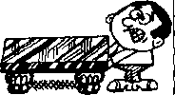
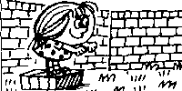
I can lift that chair,
but 1 can't lift this table.
three hundred and fifty thousand

Lesson 46 Can you ... ?你能 吗？

Listen to the tape and answer the questions. 竺^听录音，然后回答这个问题。
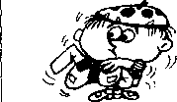
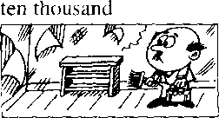
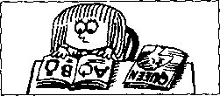
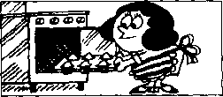
5,000
1,000
a thousand
I can put my hat on, bat I can't put my coat on.
〃
10,00()
I can paint this bookcase, but I can't paint this room.
210,000
two hundred and ten thousand
I can read this book,
but I can*t read that magazine.
500,000
five hundred thousand
I can make cakes, but I can't make biscuits.
five thousand
I can see that aeroplane, but I can't see a bird.
100,000
a hundred thousand
fl
350,000
，，e )
I can jump off this bo# but I can't jump off that wall.
1.000,000
a million
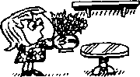

I can put the vase on this table, but I can't put it on that shelf.

lift /lift/ V.争起.搬，官狠祖
biscuit ^{z} biskit/ n.饼十

cake /kcik/ n. tJL ih 糕

Written exercises 书面稣 1
A Rewrite these sen'ences.
模仿例句改写以下句子：
Examples:
He is taking his book, u电 "J况」如八 IkkJz.
She is putting on her coat, gkcput 組如

1 They are typing these Idlers.
- She is making the bed.
- You are swimming across llic ri\er.
- We arc coming now.
- We are running across the park.
- He is sitting on the grass.
- I am giving him some chocolate.

B Write questions and answers using /, he, she, it, we or they.
模仿例句写出相应的对活，选用/,he. she. /t wq或they 代词。
Examples:
Can you put on your coat⁹
9 can.
What cun给以•膈? 顶ca^件诚硕mij以心/.
Can you and Sam listen to the radio?
hJhal can 必& g(utb 么，
We lute44-彭v nuJio-

- Can you type this letter?
- Can Penny wait for the bus',
- Can Pennv and Jane wash the dishes⁹
时
- C;)n George take these flowers〔()her ?
- Can the cat drink its milk?
- Can you and Sam paint this bookcase?
- Can you see that aeroplane?
- Can Jane read this book?

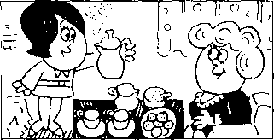
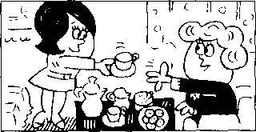
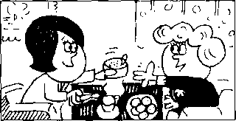
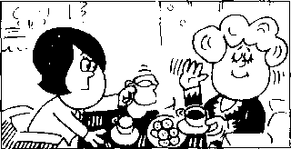
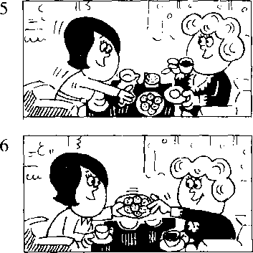
2
4

Lesson 47 A cup of coffee 一杯咖啡

Listen to the tape then answer this question. How does Ann like her coffee? 听录音，然后回答问题。安想要什么样的咖啡？
CHRISTINE : Do you like coffee, Ann?
ANN : Yes, I do.
CHRISTINE : Do you want a cup? ANN : Yes, please, Christine.
CHRISTINE : Do you want any sugar? ANN : Yes, please.
CHRISTINE : Do you want any milk?
ANN : No, thank you.
- don't like milk in my coffee. I like black coffee.
CHRISTINE : Do you like biscuits?
ANN : Yes, I do.
CHRISTINE : Do you want one?
ANN : Yes, please.

New words and expressions 生词和短语
like /laik/ v.喜欢，想要 want /wont/ v.想

Notes on the text 课文注释
- Do you want a cup?
旬中的a cup后面省略f of coffee。英语中的动词主要有及物动词和不及物动词两大类、及物动词 的后面要有名词或名词性短语做宾语o like和want都是及物动词。
- Yes, I do. -
是一种简略回答。完整的回答是：Yes, I like coffee.句中的do是助动词，用来替代动词，常用于简 略答语中。
- black coffee是指不加牛奶或咖啡伴侣的咖啡，加牛奶的咖啡叫white coffee。
- Do you want one?
句中不定代词one是指biscuit,以免重复。

参考译文
克里斯廷：你喜欢咖啡吗,安？
安：是的，我喜欢0
克里斯廷：你想要一杯吗？
安：好的，请来一杯，克里斯廷。
克里斯廷：你要放些糖吗？
安：好的，请放一些。
克里斯廷：要放些牛奶吗？
安：不了，谢谢。我不喜欢咖啡中放牛奶，我喜欢清咖啡。 克里斯廷：你喜欢饼干吗？
安：是的，我喜欢。
克里斯廷：你想要一块吗？
安：好的，请来一块。

Lesson 48 Do you like ・.・?你喜欢 吗?
Do you want…？你想要 吗？
ss Listen to the tape and answer the questions. 听录音并回答问题o
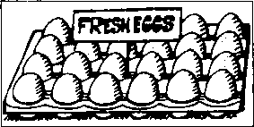
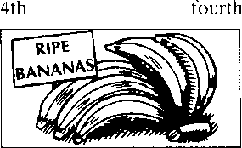
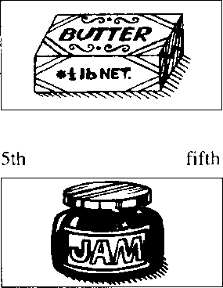
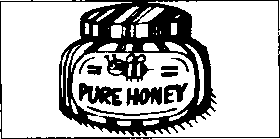
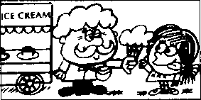
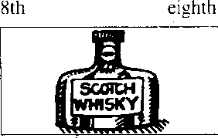
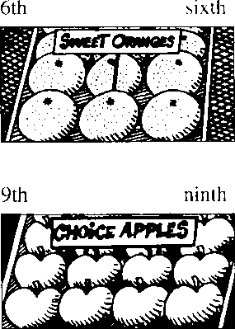
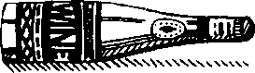
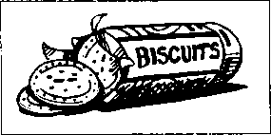
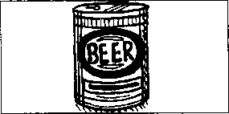
1st
first
seventh
2nd
second
third
3rd
7 th
tenth
twelfth
10th
11th eleventh
12th

New words and expressions 生词和短十吾
sweet /swi:t/ adj.甜的
fresh frej/ adj.新鲜的 egg /eg/' n. 乂鸟蛋 butter /'bAto/ n. 0T 油 pure /pjoo/ adj.纟电 净 G勺 honey /^{l}hAni/ n.蜂蜜 ripe /raip/ 血/'.成熟的 banana /bo'nams/ 〃.香蕉 jam 闭3缶m/ n.果酱
orange /'Drmd3/ n.橙
Scotch whisky /'skotj-'wiski/ 苏格、匕威七忌 choice /tfois/ adj.上等的，精选的 apple /'sepl/ n.苹果
wine /wain/儿酒，果酒
beer /bi9/ n.啤酒
blackboard /'blaekbord/ *.黑板

Written exercises书面纟东习
A Complete these sentences using oft over, between, along, in front of, behind under or across.
完成以 下 句子，用 off, over, between, along, in front of, behind, under across 等介词或介词短语填空。
- The aeroplane is flying the village.
- The ship is going the bridge.
- The children are swimming the river.
- Two cats are running the wall.
- The boy is jumping the branch.
- The girl is sitting her mother and her father.
- The teacher is standing the blackboard.
- The blackboard is the teacher.
B Answer these questions.
模仿例句回答问题，注意可数名词与不可数名词的区别。
Examples
Do you like butter?
Do you like eggs?
, 9 d.&.
9 like Imt 9 clem't
丿 da.
!) like- Imt H d(u^t Miud. (uu^.

2
3
4
5
Do you like honey?
Do you like bananas?
Do you like jam?
Do you like oranges?
Do you like ice cream?
6
7
8
9
10
Do you like whisky?
Do you like apples?
Do you like wine?
Do you like biscuits?
Do you like beer?

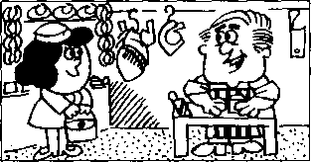
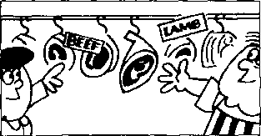
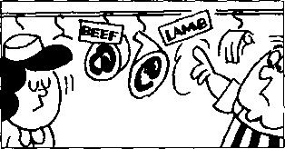
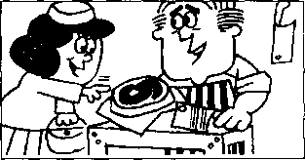
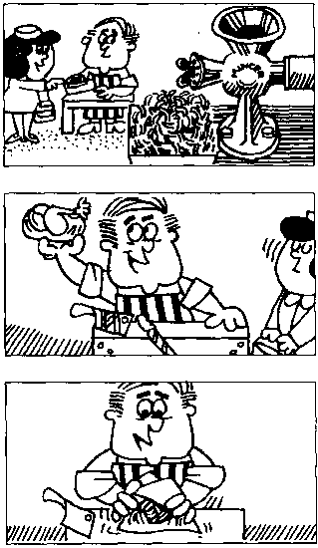
5
6
7

Lesson 49 At the butchefs 在肉店

f==)Listen to the tape then answer this question. What does Mr. Bird like? 筮听录音，然后回答问题。伯德先生喜欢什么？
BUTCHER : Do you want any meat today, Mrs. Bird?
MRS. BIRD : Yes, please.
BUTCHER : Do you want beef or lamb?
MRS. BIRD : Beef, please.
BUTCHER : This lamb's very good.
MRS. BIRD : I like lamb,
but my husband doesn't.
BUTCHER : What about some steak? This is a nice piece.
MRS. BIRD : Give me that piece, please.
MRS. BIRD : And a pound of mince, too.
BUTCHER : Do you want a chicken, Mrs. Bird? They're very nice.
MRS. BIRD : No, thank you.
MRS. BIRD : My husband likes steak,
but he doesn't like chicken,
BUTCHER : To tell you the truth, Mrs. Bird,
- don't like chicken either!

New words and expressions 生词 和短语
mince /mins/ n.肉馅，绞肉 chicken Z'tfikan/ n.鸡 tell /tel/ v.告诉
butcher /'botjo/ 〃.卖肉的 meat n.（食用）肉 beef /bi:f^{z} n.牛肉 lamb /laem/ n. 乍肉 husband 'hAzbsnd/ n.丈夫 steak /stcik/ n.牛排
truth /tru:0/ n.实情
either/'aids/ adv.也（用于否定句）

Notes on the text 课文注释
- Do you want beef or lamb?
是选择疑问句.本句有两项选择，第一选择beef念升调，lamb则读降调。
- I like lamb, but my husband doesn'L
句中的doesn,t后面省略了 like lamb _{o}用but连接的并列句，在后一分句中可以省略与前一分句 中相同的谓语动词和宾语。
- To tell you the truth (或 To tell the truth),意思是：“老实说”，"说实话"。
- I don't like chicken either.
either “也(不)”讲，用在否定句中。肯定句和疑问句中可用too,在第7课和第31课中已出现 这样的句了。

参考译文
肉 商：您今天要买点肉吗，伯德夫人？
伯德夫人：是的' 我买一点O
肉 商：您要牛肉还是要羔羊肉？
伯德夫人：请给我牛肉。 •
肉 商：这羔羊肉很好。
伯德夫人：我喜欢羔羊肉，可我丈夫不喜欢。
肉 商：大点牛排吗？这块很好。
伯德夫人：就请给我那块吧。
伯德夫人：再来一磅绞肉。
肉 商：您要买只鸡吗，伯德夫人？这些鸡很好。
伯德夫人：不要了，谢谢。
伯德夫人：我丈夫喜欢牛排，但他不喜欢鸡。
肉 商：说老实话，伯德夫人，我也不喜欢鸡O

Lesson 50 He likes ...他喜欢

But he doesn⁵t like .… 但是他不喜欢

i——I Listen to the tape and answer the questions. W」听录音并回答问题o
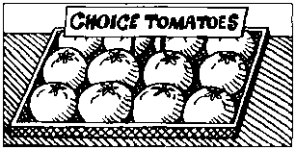
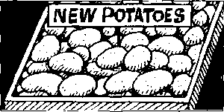
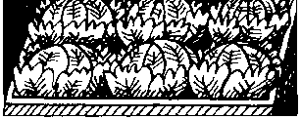
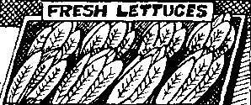
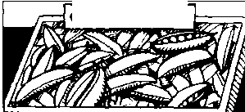
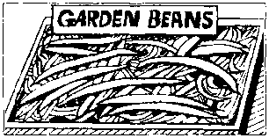
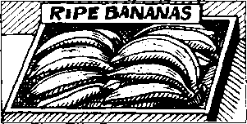
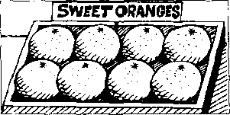
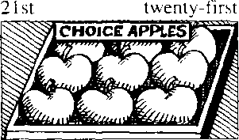
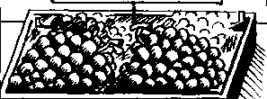
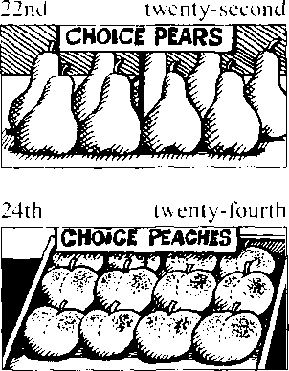
13th
thirteenth
fifteenth
14th fourteenth

15th
16th sixteenth

seventeenth
17th
18th
eighteenth
19th
nineteenth
20th twentieth
23rd
twenty-third
QQ
Lesson 50

New words and expressions 生词 和短语
tomaio /ta'mart^o/ n.西纟［柿 potato /ps'teitao/ n. t_^{r}<A cabbage /'kaebids/ n.卷兀' 莱 lettuce /'letis/ n.离苣 pea /pi:/ n.豌里'一
bean /biin/ n. S 角
pear /'peo/ n.梨 grape /greip/ 儿葡萄 peach /pi:tj/ n.桃

Written exercises 书面练习
A Complete these sentences using am not aren't isn't can't don7or doesn't. 完成以下句子，用 am not, aren't, isn't, can't, don't 或 doesn't 填空。
- He likes coffee, but I
- She likes tea, but he
- He is eating some bread, but she
- She can type very well, but he
- They are working hard, but we .
- He is reading a magazine, but I
B Answer these questions using L he or she.
模仿例句回答以下问题，选用/, E或she
Examples :
Does Penny like tomatoes?
M必.cl&ed-.
Do you like potatoes?
- Uke^ lud 7 don t w^d cuuf、
- Does Sam like cabbage?
- Does Sam like lettuce?
- Do you like peas?
- Does Mrs. White like beans?
- Do you like bananas?
- Does Mr. Jones like oranges?
- Does George like apples?
- Does Elizabeth like pears?
- Do you like grapes?
- Does Carol like peaches?
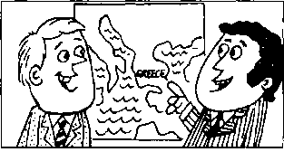
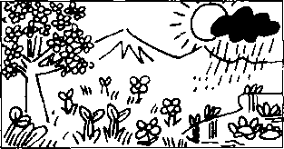
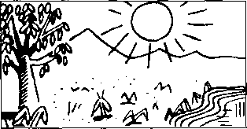
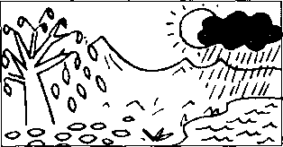
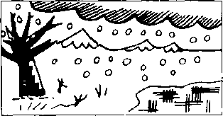

Lesson 51 A pleasant climate 宜人的气候

Listen to the tape then answer this question. Does it ever snow in Greece? w听录音，然后回答问题。希腊下过雪吗？
HANS : Where do you come from?
DIMITRI : I come from Greece.
HANS : What's the climate like
in your country?
DIMITRI : It's very pleasant.
HANS : What's the weather like in spring?
DIMITRI: It's often windy in March.
Ifs always warm in April and May,
but it rains sometimes.
HANS : What's it like in summer?
DIMITRI: It's always hot
in June, July and August.
The sun shines every day.
HANS : Is it cold or warm in autumn?
DIMITRI: It's always warm
in September and October.
It's often cold in November
and it rains sometimes.
HANS : Is it very cold in winter?
DIMITRI : Ifs often cold
in December, January and February.
It snows sometimes.

New words and expressions 生词和短语
Greece /gri:s/ n.希腊 climate 'klaimit/ n.气候 country /'kAntri/ n. HI 家 pleasant /'plezant/ adj.宜人白勺 weather /'weB。/ n.尺气 spring /sprii]/ 几春季 windy /'windi/ adj.有风的 warm /wo:m/ adj. 暖的 rain /rein/ v.卜雨 sometimes /'sAmtaimz/ adv.有日寸 summer /'sAms/ 儿夏天 autumn /'□itam/ n.秋天 winter /'winto/ n.冬天 snow /snou/ 机下雪 January /'d3aenju9ri/ 几 1 月
February /'februori/ 几 2 月 March /mcntj?几 3 月
April /'eipral/ 几 4 月
May /mei/ 几 5 月
June /d3um/ 几 6 月
July /d3o'lai/ n 7 月
August /'o:gost/ 儿 8 月 September /sep'temba/ n. 9 月 October /ok'touba/ n. 10 月 November /nau'vemba/ n. 11 月 December /di'sembs/ 几 12 月

Notes on the text 课文注释
- Where do you come from?
JI! POd对方是哪儿的人，在第7课中出现过一个类似的句子。
- What's the climate like in your country?
句中like是介词，不是动词，它的宾语是what □

参考译文
汉 斯"你是哪国人？ 迪米特里：我是希腊人O
汉 斯：你们国家的气候怎么样？ 迪米特里：气候非常宜人。
.
汉 斯：春季的天气怎么样？
迪米特里：3月里常常刮风。4月和5月的天气总是暖洋洋的，但有时下雨。
汉 斯：夏季的天气如何呢？
迪米特里：6月、7月和8月的天气总是炎热的，每天都出太阳。
汉 斯：秋季的天气是冷还是暖呢？ .
迪米特里：9月和10月总是很暖和，11月常常就冷了，而且有时下雨。
汉 斯：冬季的天气很冷吗？
迪米特里：12月、［月和2月常常很冷.有时还下雪。

Lesson 52 What nationality are they?他们是哪国人？

Where do they come from?他们来自哪个国家?


Listen to the tape and answer the questions. 听录音并回答问题。
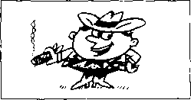
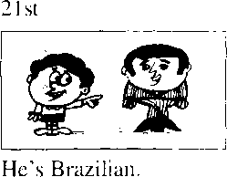
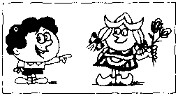
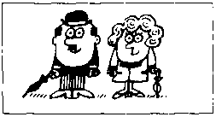
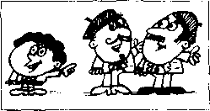
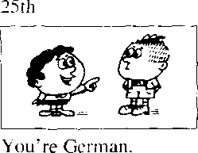
20th
I'm American.
He comes from Brazil.
22nd
She's Dutch.
She comes from Holland.
I come from the U.S.
23rd
We're English.
We come from England.
24th
They're French.
They come from France.
You come from Germany.
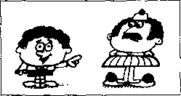
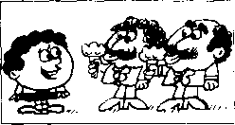
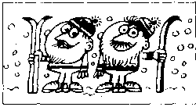
27th
26th
He's Greek.
You're Italian.
You come from Italy.
28th
We're Norwegian.
He comes from Greece.
We come from Norway.
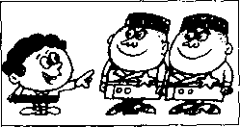
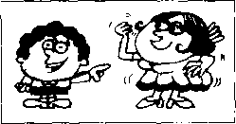
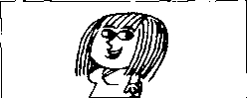
29th
30th
She's Spanish.
She comes from Spam.
31st
They're Russian. They come from Russia.
I'm Swedish.
I come from Sweden.

New words and expressions 生词 和短语
the U.S.美国 | Italy /'itali/ n.意大利
Brazil n.巴西 | Norway /'noiwei/ n.挪威
Holland /'holand/ 儿荷兰 | Russia /'E。/几俄罗斯
England /'iggland/ n.英国 | Spain /spein/ n.西班牙
France/'frarns/n.法国 | Sweden /'swi:dn/ n.瑞典
Germany /'d33：moni/ n.德国

Note on the text 课文注释
the U.S.与the U.S.A.是the United States of America的缩写，用的是两或三个首字母，即美利坚合众 国。

Written exercises 书 面练习
A Complete these sentences.

模仿例句完成以下句子O
Example :
I come from England, but Stella from Spain.
9 方ww bat Stella tww勿
- We come from Germany, but Dimitri from Greece.
- I like cold weather, but he warm weather.
- He comes from the U.S., but she from England.
- She doesn't like the winter, but she the summer.
- I come from Norway, but you from Spain.
- Stella comes from Spain, but Hans and Karl from Germany.
- We don't come from Spain. We from Brazil.
B Write questions and answers.

模仿例句提问并回答。
Example :
he/(Brazil)/the U.S.
5)辺 he c(Mte-
Ne* 提 t 顼0 Ute 勿 g
Wkat 必 k&?
1 | she/(England)/the U.S. | 5 | they/(Greece)/Italy | 9 she/(Norway)/France
2 | they/(France)/England | 6 | they/(Brazil)/Norway | 10 he/(the U.S.)/Brazil
3 | he/(France)/Germany | 7 | they/(N orw ay )/Greece
4 | he/(Italy)/Greece | 8 | she/(Italy)/Spain

Lesson 53 An interesting climate 有趣的气候

Listen to the tape then answer this question.

What is the favourite subject of conversation in England?

听录音，然后回答问题。在英国最受欢迎的话题是什么？
HANS : Where do you come from?
JIM : I come from England.
HANS : What's the climate like
in your country?
JIM : It's mild,
but it's not always pleasant.
JIM : The weather's often cold in the North and windy in the East.
It's often wet in the West
and sometimes warm in the South.
HANS : Which seasons do you like best? JIM : I like spring and summer.
The days are long and the nights are short.
The sun rises early and sets late.
JIM : I don't like autumn and winter.
The days are short and the nights are long.
The sun rises late and sets early.
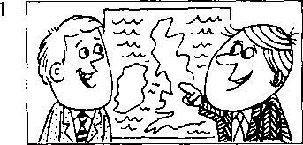
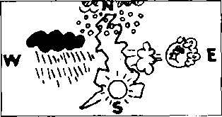
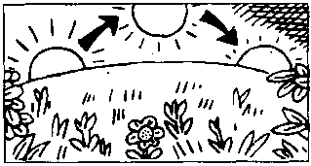
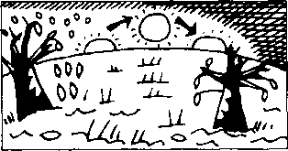
Our climate is not very good, but it's certainly interesting. It's our favourite subject of conversation.
3

New words and expressions 生词和短语
night /nait/ 儿夜晚
mild /maild/ adj.温和的,温暖的 always /'oilweiz/ adv.总是 north /no:0/ n.北方 east /i:st/ n.东方 wet /wet/ adj.潮湿的 west /west/ 几西方 south /sauO/ n.南方 season /'si:zan/ n.季节 best /best/ adv.最
rise /raiz/机升起
early /'3ili/ adv.早
set /set/ u.（太阳）落下去
late /leit/ adv.晚，迟
interesting /'mtristii]/adj.有趣的-有意思的 subject /'sAbdsikt/ n.话题
conversation /.konvs'seipn/ 阳谈话

Note on the text 课文注释
in the North = in the north of England
North的第一个字母大写，是因为它单独使用，特指英国的北部。

参考译文
汉斯：你是哪国人？
吉姆：我是英国人。
汉斯：你们国家的气候怎么样？
吉姆：气候温和，但也不总是宜人的。
吉姆：北部的天气常常寒冷，东部则常常刮风。
西部常下雨，南部有时则很暖和。
汉斯：你最喜欢哪些季节？
吉姆：我最喜欢春季和夏季。因为此时白天长而夜晚短，太阳升得早而落得晚。,
吉姆：我不喜欢秋季和冬季。因为此时白天短而夜晚长，太阳升得迟而落得早。
虽然我们国家的气候并不很好，但又确实很有意思O天气是我们最喜欢谈论的话题_{c}

Lesson 54 What nationality are they?他们是哪国人？

Where do they come from?他们来自哪个国家?


Listen to the tape and answer the questions. 听录音并回答问题。

20th
Pm Australian.
30th
He's Austrian.
40th
He's Canadian.
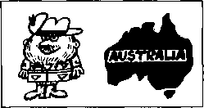
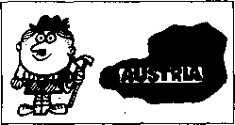
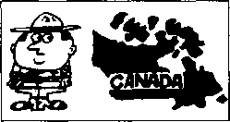

- come from Australia.
He comes from Austria.
He comes from Canada.

50th
WeTe Chinese.
60th
You're Finnish.
70th
She's Indian.
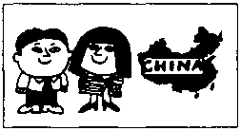
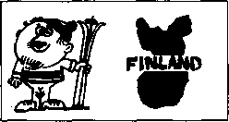
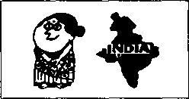

We come from China.
You come from Finland.
She comes from India.

80th
You're Japanese.
90th
I'm Korean.
100th
You come from Japan.
I come from Korea.
We're Nigerian. We come from Nigeria.
101st
They're Polish.
They come from Poland.
102nd
She comes from Thailand.
She comes from Turkey.
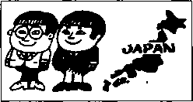
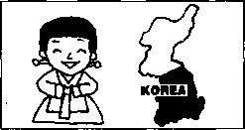
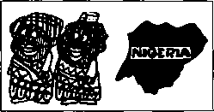
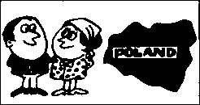
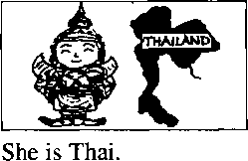
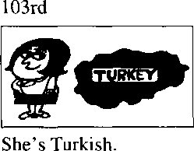

New words and expressions 生词 和短语
Australia /os'treilja/ n.澳大利亚 Australian /os'treiljsn/ n.澳大利亚人 Austria /'ostris/ n.奥地利
Austrian /'ostrian/ n.奥地利人 Canada / 'kaenado/ n.加拿大 Canadian /ka'neidisn/ n.加拿大人 China /'tfaina/ 儿中国
Finland /'finland/ n.芬兰 Finnish/'finif/n.芬兰人
India /'india/ 儿印度
Indian /'mdian/ n.印度人
Japan /djs'paen/ 儿日本
Nigeria /nai'dsiaria/ 儿尼日利亚 Nigerian /nai'dsiorion/ 几尼日利亚人 Turkey /'t3：ki/ 儿 土耳其
Turkish /'t3：kij/ n. 土耳其人
Korea /ko'no/ 儿韩国
Polish /'paolif/ n.波兰人
Poland /'poulond/ n.波兰
Thai /tai/ n.泰国人
Thailand /'tailand/ n.泰国

Written exercises 书面练习
A Write questions and answers.

模仿例句写出与下列句子相对应的疑问句和否定句O
Example :
The sun rises early. 偽 Me.
- Mrs. Jones wants a biscuit.
1 The sun sets late.
2 He likes ice cream.
- Jim comes from England.
B Write questions and answers using these words. 模仿例句提问并回答o
Example :
(
he/Brazil
必.丿危 山q carnet
1 | he/Australia | 6 | she/India
2 | he/Austria | 7 | they/Japan
3 | he/Canada | 8 | they/Nigeria
4 | they/China | 9 | she/Turkey
5 | he/Finland | 10 | she/Korea | f

Lesson 55 The Sawyer family 索耶一家人

Listen to the tape then answer this question. 1/"\1 When do the children do their homework?

听录音，然后回答问题。孩子们什么时候做功课?
The Sawyers live at 87 King Street.
In the morning, Mr. Sawyer goes to work and the children go to school.
Their father takes them to school every day.
Mrs. Sawyer stays at home every day.
-She does the housework.
She always eats her lunch at noon.
In the afternoon, she usually sees her friends. They often drink tea together.
In the evening,
the children come home from school.
They arrive home early.
Mr. Sawyer comes home from work.
He arrives home late.
At night,
the children always do their homework.
Then they go to bed.
Mr. Sawyer usually reads his newspaper, but sometimes he and his wife watch television.
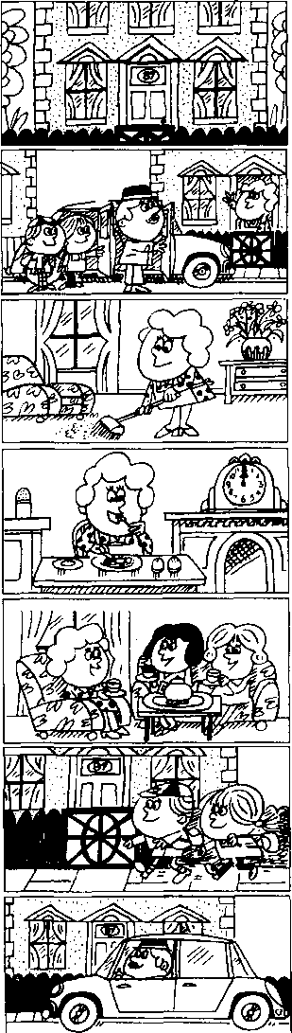
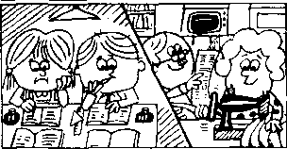
10Q
2
3
4
5
6
7
8

New words and expressions 生词 和短语
live /liv/ v.住，生活
usually /'ju：3O91i/ adv.通常 together /ta'geda/ adv. 一起 evening /'i:vmg/ n.晚上 arrive /a'raiv/ v,至U 达 night /nait/ n.夜间
stay /stei/卩.呆在，停留
home /haum/ n.家；adv.在家，到家 housework /^{l}haosw3：k/ n.家务
lunch /lAntJ/ n.午饭 afternoon /,a:fta'nu:n/ n,卜 午

Notes on the text 课文注释
- the Sawyers是指索耶一家。在英文中，姓氏后面加.s,前面加定冠词the,用来指一家人，特别是 丈夫和妻子O
- go to school,上学，请注意school前不带任何冠词。
- at noon指“正午”，也叫midday。请注意本课中表示时间的不同短语：in the moming/aftemoon/ evening, at noon/night ₀
- They arrive home early.
在本句中home和early都是副词，下文中的home和late也是副词□
- at night,在夜里。

参考译文
索耶一家住在国王街87号。
早上，索耶先生去上班，孩子们去上学。父亲每天送孩子们去上学。
索耶夫人每天呆在家里0她料理家务0
她总是在正午吃午饭O
下午’她总是会见她的朋友。她们经常在一起喝茶。
傍晚，孩子们放学回家。他们到家很早。
索耶先生下班回家。他到家很晚。
晚上，孩子们总是做作业，然后去睡觉。索耶先生总是读报纸，但有时和他的妻子一起看电视

Lesson 56 What do they usually do?他们通常做什么？

Listen to the tape and answer the questions. 听录音并回答问题。
every day | in the morning | at noon
 | in the afternoon | at night
 | in the evening

22nd
go
23rd
washes
24th
type
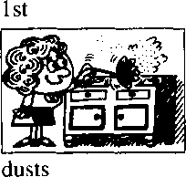
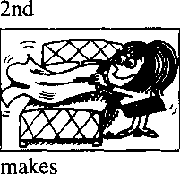
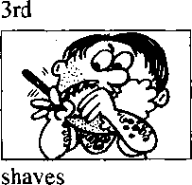
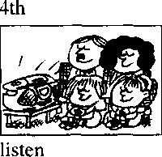
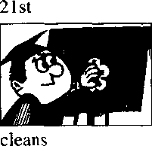
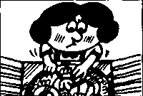
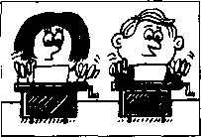
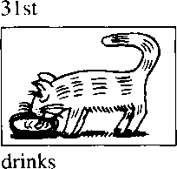
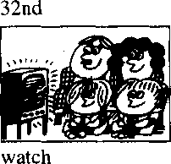
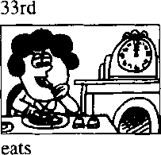
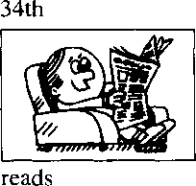

Written exercises 书面练习
A Complete these sentences using -s or -es.

完成以下句子，根据需要在动词后面加上-s或-es。
Example :
She wash the dishes every day.
gke th& doited- datf.
- The children go to school in the morning.
- Their father take them to school.
- Mrs. Sawyer stay at home.
- She do the housework.
- She always eat her lunch at noon.
B Write questions and answers.

,模仿例句提问并回答o
Example :
she/moming often/dust/the cupboard
讥 tke
1 | she/morning | always/make/the bed
2 | he/morning | always/shave
3 | they/evening | sometimes/listen to/the stereo
4 | he/every day | always/clean/the blackboard
5 | they/night | always/go/to bed early
6 | she/every day | usually/wash/the dishes
7 | they/afternoon | usually/type/some letters
8 | it/every day | usually/drink/some milk
9 | they/evening | sometimes/watch/television
10 | she/noon | always/eat/her lunch
11 | he/evening | often/read/his newspaper

Lesson 57 An unusual day 很不平常的一天

Listen to the tape then answer this question.

What is Mr. Sawyer doing tonight?

听录音，然后回答问题。索耶先生今晚正在做什么？
It is eight o'clock.
The children go to school by car every day, but today,
they are going to school on foot.
It is ten o'clock.
Mrs. Sawyer usually stays at home in the morning, but this morning, she is going to the shops.
It is four o'clock.
In the afternoon,
Mrs. Sawyer usually drinks tea in the living room.
But this afternoon, she is drinking tea in the garden.
It is six o'clock.
In the evening,
the children usually do their homework, but this evening,
they are not doing their homework.
At the moment, they are playing in the garden.
It is nine o'clock.
Mr. Sawyer usually reads his newspaper at night.
But he's not reading his newspaper tonight. At the moment,
he's reading an interesting book.

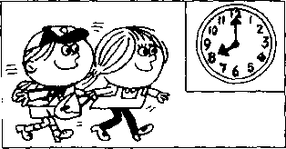
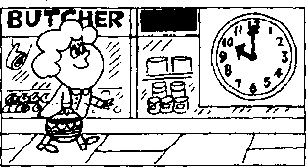
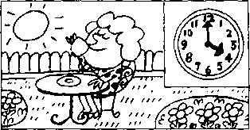
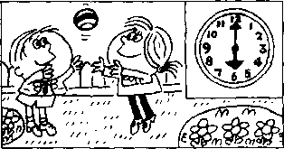
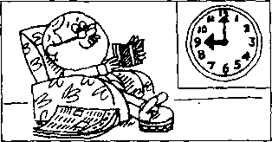

New words and expressions 生词 和短语
o'clock/SklDk/ adv.点钟 shop /fop/ n.商店
moment /'maomant/ n.片亥L 瞬间

Notes on the text 课文注释
- It is eight o'clock.现在是8点钟。在英语中常用it来指时间、天气、温度或距离。这种it被称作
- by car,乘汽车。on foot,步行_{o}这两个状语短语均用来表示方式。
- at the moment,指眼前，"此刻"。

参考译文
现在是8点钟
孩子们每天都乘小汽车去上学，而今天，他们正步行去上学
现在是10点钟
t：午，索耶夫人通常是呆在家里的，但今天上午，她正去商店买东西。
现在是4点钟
卜午，索耶夫人通常是在客厅里喝茶，但今天卜午，她正在花园里喝茶。
现在是6点钟
玩0
晚上，孩子们通常是做作业，而今天晚上，他们没做作业。此刻，他们正在花园里
现在是9点钟
8 O
索耶先生通常是在晚上看报，但今天晚上他没看报。此刻，他正在看一本有趣的

Lesson 58 Whafs the time?几点钟？


Listen to the tape and answer the questions. 听录音并回答问题。
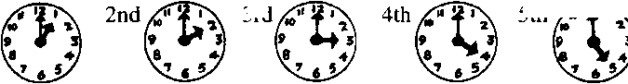
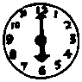
5 th /<!
1st
3rd
6th
^{7th}0 ^{8th}0 ^{9th}0 ^{loth}§}^{llth}0^{12th}®

They usually ... but today, they are.・・他们总是 ,但是今天他们正
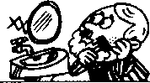

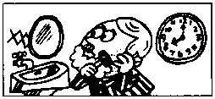
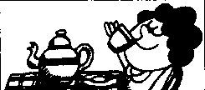
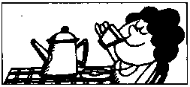
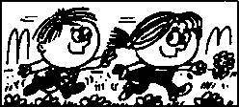
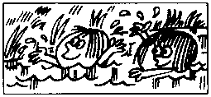
13th
He usually shaves at seven o'clock every day,
14th
but today, he ...
15 th
She usually drinks tea in the morning,
16th
but this morning, she
17th
They usually play in the garden in the afternoon,
18th
but this afternoon, they
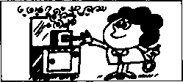
19th
I usually cook a meal in the evening,
20th
but this evening, I...
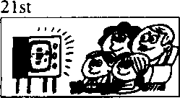
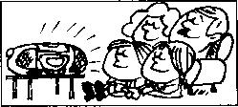
We usually watch television at night,
22nd
but tonight, we ...

Written exercises 书面纟东习
A Complete these sentences. 模仿例句完成以下句子o

Exomple
He usually shaves at 7.00 o'clock, but today, he at 8.00.
at 7.00 a clock,
奴/ tada^, ke 圍 at 8.00.
- She usually drinks tea in the morning, but this morning, she coffee.
- They usually play in the garden in the afternoon, but this afternoon, they in the park.
- He usually washes the dishes at night, but tonight he clothes.
B Write questions and answers following the pattern in the example,

模仿例句提问并回答。
Examples :
they/every day go/to school by car
IdJkat do- da
today go/to school on foot
- she/morning morning
- they/afternoon afternoon
- I/evening evening
- we/night tonight
drink/tea drink/coffee play/in the garden swim/in the river cook/a meal read/a book watch/television listen to/the stereo
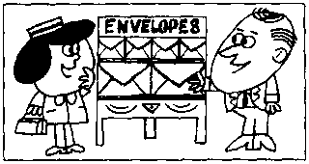
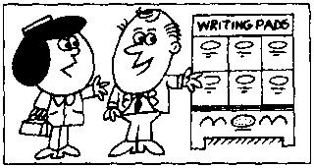
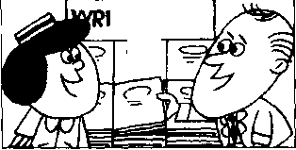
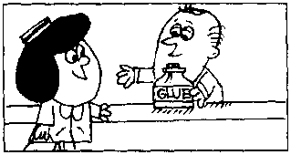
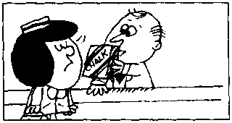
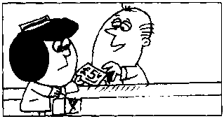
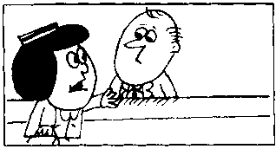
1
2
IHNGRADS
4
5

Lesson 59 Is that all?就这些吗？

Listen to the tape then answer this question. Does the lady buy any chalk? 听录音，然后回答问题。这位女士有没有买粉笔？
LADY : I want some envelopes, please.
SHOP ASSISTANT : Do you want
the large size or the small size?
LADY : The large size, please.
LADY : Do you have any writing paper?
SHOP ASSISTANT : Yes, we do.
SHOP ASSISTANT : I don't have any small pads. I only have large ones.
Do you want a pad?
LADY : Yes, please.
LADY : And I want some glue.
SHOP ASSISTANT : A bottle of glue.
LADY : And I want
a large box of chalk, too.
SHOP ASSISTANT : I only have small boxes.
Do you want one?
LADY : No, thank you.
SHOP ASSISTANT : Is that all?
LADY : That's all. thank you.
SHOP ASSISTANT : What else do you want? LADY : I want my change.

New words and expressions 生词和短语
envelope /'envsbop/ n.信封 writing paper /'raitirj-'peipa/ 信纸 shop assistant /'fop-a'sistant/ 侔货 员 size/saiz/儿尺寸.尺码.大小
pad /paed/儿信笺簿
glue /glu:/ n.胶水
chalk /tj*3：k/ n.粉笔 change /tfeinds/ n.零钱，找给的钱

Notes on the text 课文注释
Do you want the large size or the small size?
这句话是选择疑问句，逗号前的size读升调，后者读降调。
- I only have large ones. 句中的ones指pads _{o}
- What else do you want?您还要什么吗？其中的What else ...?可以看作是表示疑问的一个短语，意 思是：“还有什么吗?”

参考译文
女十：请给我拿几个信封0
售货员：您要大号的还是小号的？
女士 ：请拿大号的。
女上：您有信纸吗？
售货员：有°
售货员：我没有小本的信纸，只有大本的。您要一本吗？
女士 ：好，请拿一本。
女 上：我还要些胶水O
售货员：一瓶胶水.
女士：我还要一大盒粉笔0
售货员：我只有小盒的。您要一盒吗？
女上：不了、谢谢。
售货员：就要这些吗。
女 上：就这些，谢谢。
售货员：您还要什么吗？
女士：我要找的零钱。

Lesson 60 Whafs the time?几点钟?

Listen to the tape and answer the questions. 听录音并回答问题o

8th
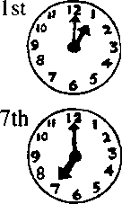
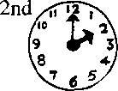
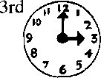
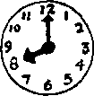
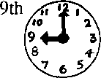
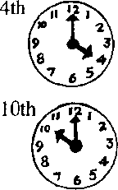
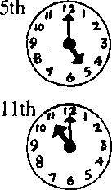
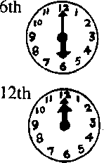

Do you have any...？你有 吗？

13th
15th
14th
16th
17th
18th
cheese
butter
jam
bread
eggs
19th
20th
21st
22nd
23rd
biscuits
& A
potatoes
tomatoes
peas
beans
24th
cabbages
25th
26th
27th
28th
29th
30th
lettuces
bananas
peaches
mince
steak
grapes
31st

I 柚 pan)
chicken
32nd
33rd 34th
&直11
beer wine
35th
tobacco
36th
soap
11Q
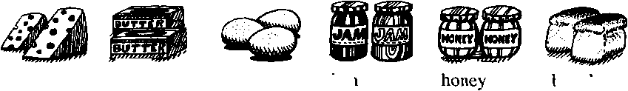
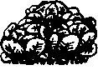
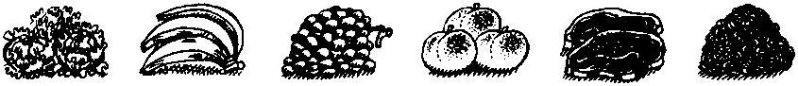

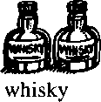
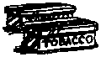
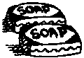

Written exercises书面纟东习
A Rewrite these sentences using -s or -es where necessary.

根据需要为以下句子中用斜体书写的名词加上-s或-es,或保持原形
Exomples :
- don't have any banana, but I have some peach.
9 t 么紹 O4i^r 底如泌 ImI 9 kaue d&tne 件以切.
- don't have any coffee, but I have some milk.
9 koi " kaae tndk.
- I don't have any grape, but I have some peach.
- I don't have any tomato, but I have some potato.
- I don't have any mince, but I have some steak.
- I don't have any glue , but I have some ink.
- I don't have any envelope, but I have some writing paper,
B Answer these questions beginning with L we or they.

模仿例句回答问题，选用/, we或they。
Example :
Do you have any butter? /cheese
J t kao■& <2/# 9 kaae 如加 cheed^.
- Do you have any honey? /jam
- Do you and Penny have any beans? /potatoes
- Do Penny and Sam have any wine? /beer
- Do you and Sam have any bread? /biscuits
- Do Sam and Penny have any grapes? /bananas
- Do you have any mince? /steak
- Do the children have any butter? /eggs
- Do you have any lettuces? /cabbages
- Do you and Penny have any beans? /peas
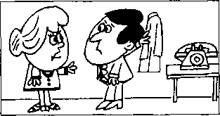
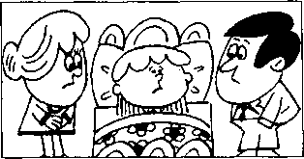
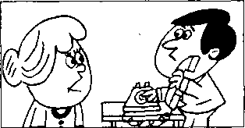
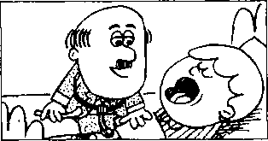
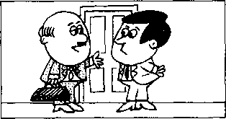
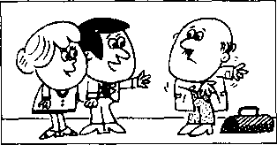

Lesson 61 A bad cold 重感冒

Listen to the tape then answer this question. What is good news for Jimmy? 听录音，然后回答问题。吉米有什么好消息？
cral
MR. WILLIAMS : Where's Jimmy?
MRS. WILLIAMS : He's in bed.
MR. WILLIAMS : What's the matter with him?
MRS. WILLIAMS : He feels ill.
MR. WILLIAMS : He looks ill.
MRS. WILLIAMS : We must call the doctor.
MR. WILLIAMS : Yes, we must.
MR. WILLIAMS : Can you remember
the doctor's telephone number? MRS. WILLIAMS : Yes.
If s 09754.
DOCTOR : Open your mouth, Jimmy.
Show me your tongue. Say, 'Ah'.
MR. WILLIAMS : Whats the matter with him, doctor?
DOCTOR : He has a bad cold,
Mr. Williams, so he must stay in bed for a week.
MRS. WILLIAMS : That's good news for Jimmy.
DOCTOR : Good news?
Why?
MR. WILLIAMS : Because he doesn't like school!

New words and expressions 生词 和短语
remember /rfmemba/ y.记得，记住 mouth /maoO/ n.嘴
feel v.感觉
look /lok/ v.看（起来） must /mASt/ modal verb 必须 call /ko:l/ v.叫，请 doctor/'dokta/ n.医生 telephone /'telifaon/ n.电话
tongue /tAi]/ 儿舌头
bad /baed/ adj.坏的，严重的 cold /ksold/zi,感冒 news /nju:z/ n.消息

Notes on the text 课文注释
- What's the matter with him?他怎么啦？
Whafsthe matter with...?常用来询问人或事物的状况，常作“是否有问题？” “是否有麻烦”讲。
- feel ill,觉得病了，f詞是系动词，ill是表语。注意feel ill和look ill在意思上的区别；前者指自我 感觉，后者指外表形象。
- It's09754.其中Ifs指“电话号码是”。
- have a bad cold,得了 重感冒。
- That's good news中的news是不可数名词，不是复数形式。
- Good news?是省略句，完整的句子应为Is it good news?

参考译文
威廉斯先生 威廉斯夫人 威廉斯先生 威廉斯夫人
威廉斯先生 威廉斯夫人 威廉斯先生
吉米在哪儿？ 他躺在床上。
他怎么啦？ 他觉得不舒服
他看上去是病了。 我们得去请医生O 是的，一定得请。
威廉斯先生：你还记得医生的电话号码吗? 威廉斯夫人：记得o是09754 O
医 生:把嘴张开，吉米。让我看看你的舌头。说“啊——”
威廉斯先生••他得了什么病，医生？
医 生：他得了重感冒，威廉斯先生，因此他必须卧床一周。
威廉斯夫人 医 生 威廉斯先生
对吉米来说，这可是个好消息。 好消息？为什么？
因为他不喜欢上学。

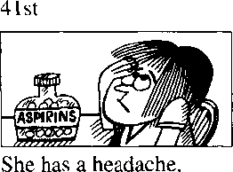
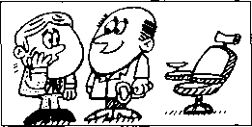
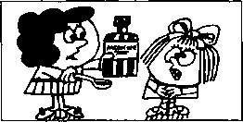
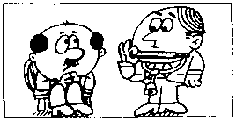
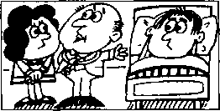
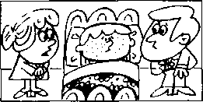
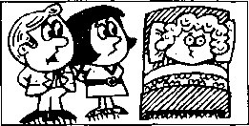
So she must take an aspirin.
63rd
He has a toothache.
74th
Jane has a stomach ache.
So he must see a dentist.
So she must take some medicine.
85th
Sam has a temperature.
So he must go to bed.
96th
Dave has flu.
So he must stay in bed.
107th
Jimmy has measles.
So we must call the doctor.
118th
Susan has mumps.
So we must call the doctor.

Lesson 62 Whafs the matter with them?他们怎么啦？ What must they do?他们该怎么办？


Listen to the tape and answer the questions. 听录音并回答问题。
52nd
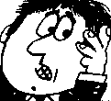
/；/
George has an earache.
So he must see a doctor.

New words and expressions 生词 和短语
headache /'hedeik/ n.头痛 aspirin / sesprm/ n.阿斯匹林 earache /'isreik/ n.耳痛 toothache /'tu:0eik/ 儿 牙痛 dentist /'dentist/ n.牙医 stomach ache /'stAmsk-eik/ 胃 痛 medicine /'medisin/ n.药 temperature /'temp^rotjs/ 几温度 flu /flu:/ n.流行性感冒 measles /'mi:z91z/ n.麻疹 mumps /mAmps/ n.腮腺炎

Notes on the text 课文注释
- take an aspirin 相当于 have an aspirin,服(吃)一片阿斯匹林 _{o}
- have a temperature,发烧 °

Written exercises 书面练习
A Rewrite these sentences using He, 改写下列句子，用He作主语o
Examples:
I have a headache. J/e a headache
I must stay at home. 赢 modi kame.

3 I am not well.
- I feel ill.
- I must see a doctor.
- I do not like doctors.
- I have a cold .
- I can^ go to work.
He

Write sentences like those in the example. 模仿例句完成以下句子O
Example :
Jimmy/(a stomach ache)/a headache/take an aspirin the
土必 如 龙站 a ache?
Nd he kaue a adt&. 丿e Im a keadaclte.
务 modi tak& 砂

- Elizabeth/(an earache)/a headache/take an aspirin
- George/(a headache)/an earache/see a doctor
- Jim/(a stomach ache)/a toothache/see a dentist
- Jane/(a toothache)/a stomach ache/take some medicine
- Sam/(a stomach ache)/a temperature/go to bed
- Dave/(a headache)/flu/stay in bed
- Jimmy/(a headache)/measles/we .…call the doctor
- Susan/(an earache)/mumps/we ... call the doctor

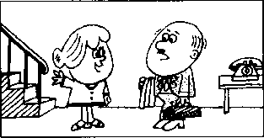
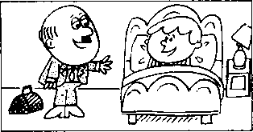
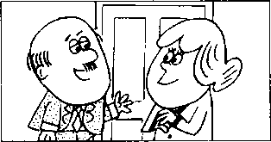
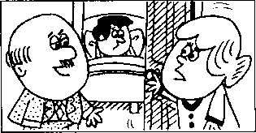
laatBi

Lesson 63 Thank you, doctor.谢谢你，医生。

Listen to the tape then answer this question. Who else is in bed today? Why? 听录音，然后回答问题。还有谁今天也卧床休息？为什么？
DOCTOR : How's Jimrpy today?
MRS. WILLIAMS : Better. Thank you, doctor.
DOCTOR : Can I see him please, Mrs. Williams?
MRS. WILLIAMS : Certainly, doctor.
Come upstairs.
DOCTOR : You look very well, Jimmy.
You are better now, but you mustn't get up yet.
You must stay in bed for another two days.
DOCTOR : . The boy mustn't
go to school yet, Mrs. Williams.
And he mustn't eat rich food.
MRS. WILLIAMS : Does he have a temperature, doctor?
DOCTOR : No, he doesn't.
MRS. WILLIAMS : Must he stay in bed?
DOCTOR: Yes.
He must remain in bed
for another two days.
He can get up
for about two hours each day, but you must keep the room warm.
DOCTOR : Where's Mr. Williams this evening?
MRS. WILLIAMS : He's in bed, doctor.
Can you see him please?
He has a bad cold, too!

New words and expressions 生词和短语
better /'bets/ adj.形容词well的比较级 | rich / ntj/ adj.油腻的
certainly /'s3：tnli/adv.当然 | food /fu:d/ n.食物
get up起床 | remain /n'mein/ v.保持，继续
yet /jet/ adv.还，仍

Notes on the text 课文注释
- He's better.
在英文中，如果将一个人或物等与另一个人或物等进行比较，就可以用比较级。在这句话中，威廉 斯夫人是把吉米今天的状况和前几天相比o形容词well的比较级形式不规则，意思是“健康状况有 所好转” 0
- come upstairs,上楼，此处 upstairs 是副词□
- ... you mustn't get up yet.
yet这个词一般用于否定句o get up表示起床，在英语中有不少动词常与介词或副词连用，组成 一个词组，称为动词短语，如g机叩就是一个动词短语。
- for another two days,
for引导的表示时间的短语往往可以译作“达”，“计”。本课中for about two hours each day可译为 “每天可达两小时”。each day是“每天”的意思。 ,
- keep the room warm,使房间保持暖和。

参考译文
医 生：吉米今天怎么样了？
威廉斯夫人：他好些了。谢谢您，医生。 医 生：我可以看看他吗，威廉斯夫人?
威廉斯夫人：当然可以，医生。上楼吧。
医 生：你看上去很好，吉米。你现在好些了，但你还不应该起床。你必须再卧床两天。
这孩子还不能去上学，威廉斯夫人，而且不能吃油腻的食物。
医 生 威廉斯夫人 医 生
威廉斯夫人 医 生
他还发烧吗，医生？ 不，他不发烧了 O 他还必须卧床吗？ 是的，他还必须卧床两天。他每天可以起来两个小时，但您必须保持房间温暖。
医 生：威廉斯先生今晚去哪儿了？
威廉斯夫人：他在床上呢，医生。您能看看他吗？他也得了重感冒!

Lesson 64 Don't …！不要 ！

You mustiYt...!你不应该


Listen to the tape and answer the questions. 听录音并回答问题。
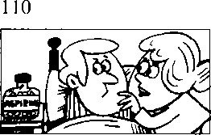
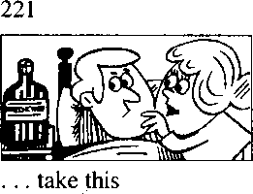
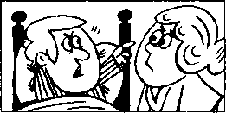
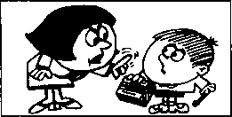
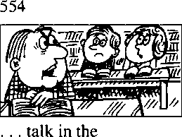
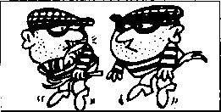
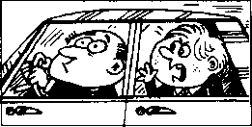
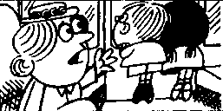
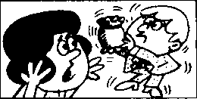
...take any
medicine!
332
..・ call the
aspirins!
doctor!
443
.…play with matches!
665
...make a noise!
776
…drive so quickly!
887
…lean out of the window!
998
...break that vase!

New words and expressions 生词 和短语
play /pier/ v.玩 match /maetj*/ 儿火柴 talk /t9：k/ v.谈话 library /'laibrsri/ n.图书馆 drive /draiv/ v.开车 so /s9u/ adv,如此地 quickly /'kwikli/ 贝m 快地 lean out of身体探出 break /breik/ v.打破 noise /noiz/ n.喧闹丿打

Notes on the text 课文注释
- play with matches,玩火柴 ₀
- make a noise指"弄出噪音”，“发出响声"。

Written exercises 书面练习
A Rewrite these sentences using Jimmy. 改写以下句子，用Jimmy作主语。
Example :
- mustn't take any aspirins.
take,
- I am better now but I mustn't get up yet.
- I have a cold and I must stay in bed.
- I can get up for two hours each day.
- I often read in bed.
- I listen to the stereo, too.
- I don't feel ill now.
Complete these sentences. 模仿例句完成以下句子o
Example :
eat rich food!
t eat

- take any aspirins!
- take this medicine!
- …call the doctor!
- play with matches!
- talk in the library!
- make a noise!
- drive so quickly!
- lean out of the window!
- break that vase!

OCX)

Listen to the tape then answer this question. Does Jill take the key to the front door?

听录音，然后回答问题。吉尔有没有拿到大门的钥匙?
FATHER : What are you going to do
this evening, Jill?
JILL : I'm going to meet some friends, Dad.
FATHER : You mustn't come home late.
You must be home at half past ten.
JILL : I can't get home so early, Dad!
JILL : Can I have the key
to the front door, please?
FATHER : No, you can't.
MOTHER : Jill's eighteen years old, Tom.
She's not a baby.
Give her the key.
She always comes home early.
FATHER : Oh, all right!
FATHER : Here you are.
But you mustn't come home after a quarter past eleven. Do you hear?
JILL : Yes, Dad.
JILL : Thanks, Mum.
MOTHER : Thafs all right.
Goodbye.
Enjoy yourself!
JILL : We always enjoy ourselves, Mum.
Bye-bye.
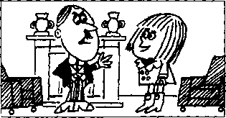
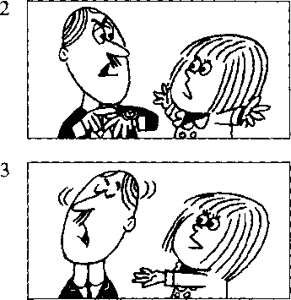
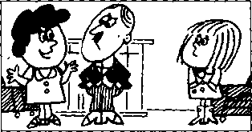
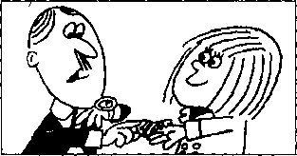
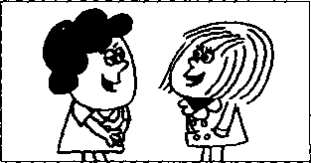

New words and expressions 生词 和短语
enjoy /in'd^oi/ v.玩得快活 yourself /jofself? pron.你自己 ourselves /.aoo'selvz/pron.我们 自已 mum /mAm/ n.妈妈
Dad /dsed/ n.爸（儿 语） key /ki:/ n.钥匙 baby /'beibi/ n.婴儿 hear /hia/ r.听见

Notes on the text 课文注释
- the key to the front door,
to the front door是介词短语，作定语，修饰key _{o}
- a quarter past eleven, 11 点 1 亥寸，past 是介词□
- Enjoy yourself!好好玩吧₀在enjoy这个动词后面往往有一个反身代词，如yourself, ourselves,
himself, herself 等 ₀

参考译文
父亲：今晚你打算干什么，吉尔？ 吉尔：我打算去看几个朋友，爸爸。
父亲：你不准回家太晚，你必须在10点，半到家。 吉尔：这么早我到不了家，爸爸！ 吉尔：我能带上前门的銅匙吗? 父亲：不行，你不能带0 母亲：吉尔都18岁了，汤姆。她不是小孩子了。把钥匙给她吧。她总是早早回家的。 父亲：那么，好吧！ 父亲：拿去。但你不能超过11点1刻回家。听见了吗? 吉尔：听见了，爸爸。
吉尔：谢谢，妈妈O 母亲：不用谢。再见。好好玩吧！
吉尔：我们总是玩得很开心的，妈妈。再见。

Lesson 66 What's the time?几点钟？


Listen to the tape and answer the questions. 听录音并回答问题o
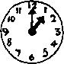
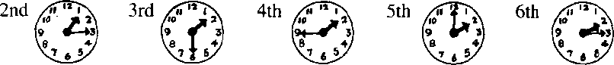
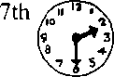
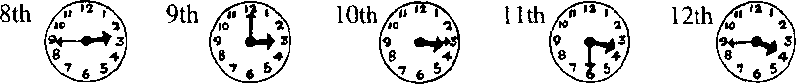
1st

When*s your birthday?你的生日是哪一天？

How old are you?你多大了？
, JULY
S |  | 7 | 14 | 21 | 28
M | 1 | 8 | 15 | 22 | 29
TU | 2 | 9 | 16 | 23 | 30
W | 3 | 10 | 17 | 24 | 31
TH | 4 | 11 | 18 | 25
F | 5 | 12 | 19 | 26
S | 6 | 13 | 20 | 27

Enjoy yourself!你好好玩吧!
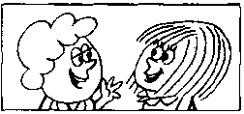
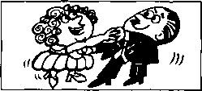
13th
Enjoy yourself!
14th
We're enjoying ourselves.
I always enjoy myself.
They're enjoying themselves.
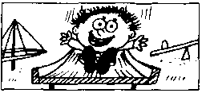
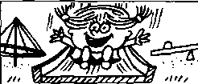
15th
He's enjoying himself.
16th
She's enjoying herself.

New words and expressions 生词和短语
myself /mafself? pron.我自己 themselves /dsm'selvz/ pron.他们自己
himself /him'self / pron.他自己 herself /hsfself? pron.她自己

Written exercises 书面练习
A Complete these sentences using ia at or from.
用in, at或from完成以下句子。
- I am going to see him ten o'clock.
- It often rains November.
- Where do you come ? I come France.
- I always go to work the morning.
- Whaf s the climate like your country?
- It's cold winter and hot summer.
B Answer these questions using l/you/he/she/we/they and ... o'clock, a quarter to . past …，half past...
模仿例句回答问题。
Example :
When must you come home? (1.00)
"ata dock.
- When must she go to the library? (1.15)
- When must you and Sam see the dentist? (3.45)
- When must you type this letter? (2.00)
- When must Sam and Penny see the boss? (1.30)
- When must George take his medicine? (3.15)
- When must Sophie arrive in London? (2.30)
- When must I catch the bus? (3.30)
- When must you arrive there? (3.00)
- When must they come home? (2.15)
- When must you meet Sam? (1.45)
- When must he telephone you? (2.45)


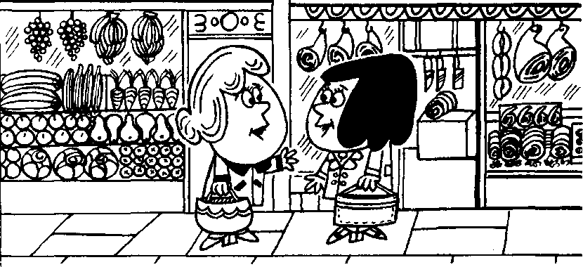
GREENGROCER
o BUTCHER。

Listen to the tape then answer this question.

What are the Johnsons going to do at the weekend? 听录音，然后回答问题。约翰逊夫妇周末准备做什么？

MRS. JOHNSON : Hello.
Were you at the butcher¹ s?
MRS. WILLIAMS : | Yes, I was.  Were you at the butcher's, too?
MRS. JOHNSON : | No, I wasn't.  I was at the greengrocer's.  How's Jimmy today?
MRS. WILLIAMS : | He's very well, thank you.

MRS. JOHNSON : Was he absent from school last week?
MRS. WILLIAMS : | Yes, he was.  He was absent on Monday, Tuesday.  Wednesday and Thursday.  How are you all keeping?
MRS. JOHNSON : | Very well, thank you.  We're going to spend three days in the country.  We're going to stay at my mother's for the weekend.
MRS. WILLIAMS : | Friday, Saturday and Sunday in the country!  Aren't you lucky!

New words and expressions 生词 和短语
greengrocer /'grim.gr^oso/ n.蔬菜水果零售商 absent /'<ebsnt/ adj.缺席的
spend /spend/ u.度过 weekend / wi:kend/ n.周末 Friday /'fraidi/ n.星期五 Saturday /'saetodi/ n.星期六 Sunday /'sAndi/ m.星期日 country /kAntri/ n.乡村 lucky /'kki/ adj.幸运的
Monday / mAndi/ n.星期一
Tuesday /'tju:zdi/ n.星鄭，二
Wednesday /'wenzdi/ n.星期三
Thursday /'03：zdi/n.星期四 keep /ki:p/ r （身体健康）处于（状况）

Notes on the text 课文注释
在英文表小某一种商店的短语中，往往可以把shop这个词省略，如课文中的the butcher's (shop)和 the greengrocer's (shop) ◎类似的例子还有 the hairdresser's (shop), the stationer's (shop), the doctor's (office), my mother's (house)等 ₀
在英文中，迂去发生的而现在已经结束的动作要用一般过去肘来表示。“是”(be)动词的过去式不 规则.第一、第三人称单数用was,其他情况用were _{o}
How are you all keeping?
这是一句问候对方身体如何的话。
for the weekend是指整个周末这几天的时间，而at the weekend是强调时间的某一点₀
Aren't you lucky! •
这句话是否定疑问句形式的感叹句，为的是加强语气。尽管形式上是否定的，但却表示强有力的肯 定O

参考译文
您好。刚才您在肉店里吗？
约翰逊夫人 威廉斯夫人 约翰逊夫人 威廉斯夫人 约翰逊夫人 威廉斯夫人 约翰逊夫人 威廉斯夫人
是的，我在肉店里。您也在肉店里吗？
不，我不是。我在蔬菜水果店里。吉米今天怎么样？
他很好，谢谢您。 ,
上星期他没上学吧？
是的，他没上学。他星期一、星期二、星期三和星期四没去上学。你们身体都好吗？ 很好，谢谢您。我们打算到乡下去三天，在我母亲家度周末。
星期五、星期六和星期日在乡下过！你们真幸运啊！

Lesson 68 Whafs the time?几点钟？

Listen to the tape and answer the questions. 听录音并回答问题。

3rd/tr^
4th
1st
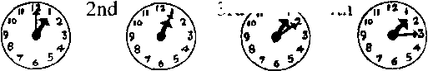
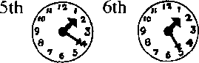
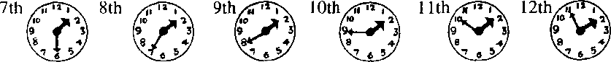

Where were you on ... ? 你在什么地方？

When were you at... ?你什么时候在 ？

church
Sunday, January 1st
school
Monday, February 2nd
the office
Tuesday, March 3rd
Wednesday, April 4th
the butcher's
Thursday, May 5th
the hairdresser's
Friday, June 6th
the baker's
Saturday, July 7th
the dairy
Sunday, August 8th
home
Monday, September 9th
the grocer's
Tuesday, October 10th
the greengrocer^
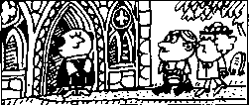
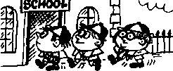
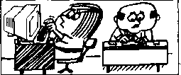
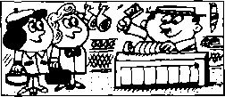
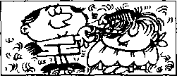
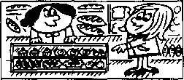
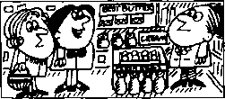
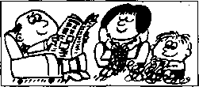
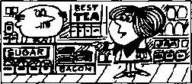
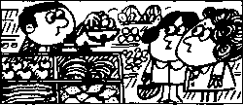

New words and expressions 生词和短语
church /tj3：tj/ n.教堂 baker /'beika/ n.面包师傅
dairy /'dc^ri/ n.乳品店 grocer/'graosa/ n.食品杂货商

Written exercises 书面纟东习
A Complete these sentences using the where necessary.
完成以下句子，必要时填上定冠词the o
- I was at church on Sunday.
- I was at office on Monday.
- My son was at school on Tuesday.
- My wife was at butcher's on Wednesday.
- She was at grocer's on Thursday.
- My daughter was in country on Friday.
- I was at home on Saturday.
B、Write questions and answers using he/she and at/on.
模仿例句提问并回答o
Example :
he/church/Sunday
ke> at cku^ch?
cMe ai dut^ick an
- Tom/the hairdresser' s/Thursday
- Mrs. Jones/the butcher,s/Wednesday
- he/home/Sunday
- Penny/the baker' s/Friday
- Mrs. Williams/the grocer's/Monday
- Nicola/the office/Tuesday

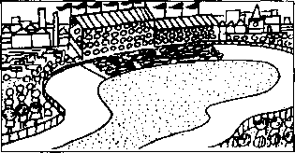
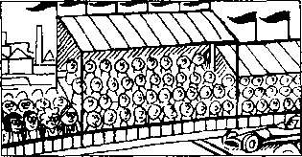
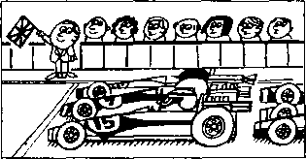
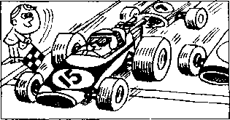
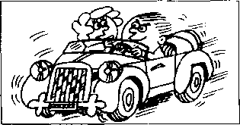

Listen to the tape then answer this question. Which car was the winner in 1995?

听录音，然后回答问题。哪辆车在1995年的比赛中获胜?
There is a car race
near our town every year.
In 1995,
there was a very big race.
There were hundreds of people there. My wife and I were at the race.
Our friends Julie and Jack were there, too.
You can see us in the crowd.
We are standing on the left.
There were twenty cars in the race.
There were English cars, French cars, German cars, Italian cars,
American cars and Japanese cars.
It was an exciting finish.
The winner was Billy Stewart.
He was in car number fifteen.
Five other cars were just behind him.
On the way home, my wife said to me, 'Don't drive so quickly! You're not Billy Stewart!*

New words and expressions 生词 和短语
year /jia/ n.年 race /reis/ n.比赛 town /taon/ n.城镇 crowd /kraod/ n.人群 stand /staend/ r.站立 exciting /ik'sartiij/ adj.使人激动的 just /d3ASt/ adv,正好，恰好
finish /'fimf/儿结尾，结束
winner /'wino/ n.获胜者
behind /bi'hamd/ prep.在 之后
way /wei/ n.路途

Notes on the text 课文注释
- hundreds of...,数以百计的……，用来表示不确定数量的复数形式。
- On the way home,在回家的途中□ on the way是指"在 的途中”。

参考译文
在我们镇子附近每年都有一场汽车比赛o 1995年举行了一次盛大的比赛0
许许多多人都去了赛场。我和我的妻子也去了 o我们的朋友朱莉和杰克也去了。你可以在人群中看 到我们。我们站在左面。
参加比奖的右2()辆汽车。有英国、法国、德国、意大利、美国和日本的汽车。
比赛的结尾是激动人心的。获胜者是比利，斯图尔特0他在第15号车里，其他5辆汽车紧跟在他后 面。
在冋家的途中.我妻子对我说：“别开得这样快！你可不是比利,斯图尔特！”

Lesson 70 When were they there?他们是什么时候在那里的？

rsasssi Listen to the tope and answer the questions. 听录音并回答问题o
ON
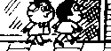
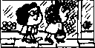
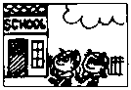
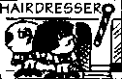
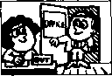
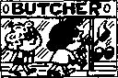
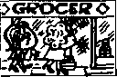
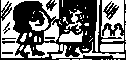
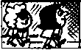
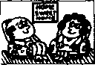
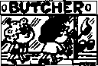
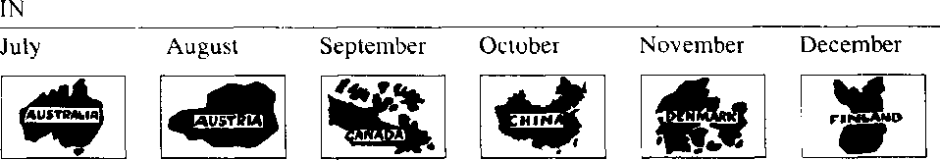
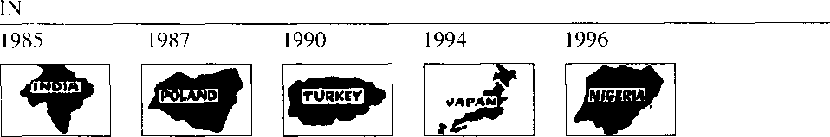
At:
At:
In:
In:
13Q
Monday
碍博緊性职J
Tuesday
Feb. 22nd
Wednesday
March 23rd
Thursday
Friday
Saturday
April 24th
I冋扣編成
May 25th
June 26th

New words and expressions 生词和短语
stationer /'steipns/n.文具商 Denmark /'denma:k/ n.丹麦

Written exercises 书 面练习
A Complete these sentences using at on or in. 完成以下句子，用适当的介词填空。
- We were the stationer's Monday.
- We were there four o'clock.
- They were Australia September.
- They were there spring.
- November 25th, they were Canada.
- They were there 1990.
B Write questions and answers using we/they and at/in/on,
模仿例句提问并回答，选用we或fh款作主语，介词可选用at in或on。
Examples:
Sam and Penny/the stationer^ /Monday
WUe^ie
5%^ 沁 at tke-以汝Z " Manda-i^.
you and Penny/Australia/July 妃le必以and他所件讥 We 炒se s 初方吻■.

- you and Susan/the office/March 23rd
- Sam and Penny/India/1986
- you and Penny/the baker's/Saturday
- Sam and Penny/Canada/1993
- you and Penny/Austria/August
- Sam and Penny/home/May 25th
- you and Penny/Finland/December
- you and Sam/school/February 22nd

Lesson 71 He⁵s awful!他讨厌透了!
IcezdI

Listen to the tape then answer this question.

How did Pauline answer the telephone at nine o'clock?

听录音，然后回答问题o波琳在9点接电话时是如何说的？
JANE : What's Ron Marston like, Pauline?
PAULINE : He's awful!
He telephoned me four times yesterday, and three times the day before yesterday.
PAULINE : He telephoned the office yesterday morning and yesterday afternoon.
My boss answered the telephone.
JANE : What did your boss say to him? PAULINE : He said, Tauline is typing letters.
She can't speak to you now!'
PAULINE : Then I arrived home
at six o* clock yesterday evening. He telephoned again.
But I didn't answer the phone!
JANE : Did he telephone again last night?
PAULINE : Yes, he did.
He telephoned at nine o'clock.
JANE : What did you say to him?
PAULINE : I said, 'This is Pauline's mother.
Please don't telephone my daughter again!⁷
JANE : Did he telephone again?
PAULINE : No, he didn't!
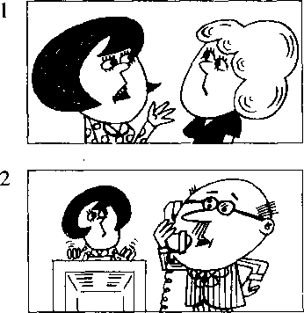
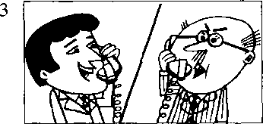
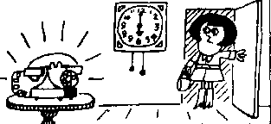
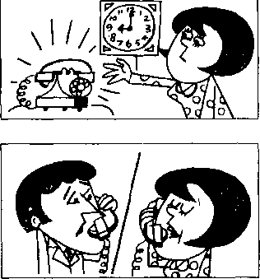
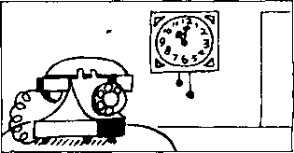

New words and expressions 生词和短语
awfuJ adj.让人讨厌的，坏的 telephone /'telifoon/ v. & 几打电话；电话 time /taim/ n.次(数)
last /la:st/ adj.最后的,前一次的 phone /fbon/ n.电话(=telephone) again /a'gen/ adv.又一次地 say /sei/ (said /sed/) v. 说
answer /'amsa/ v.接(电话)

Notes on the text 课文注释
- He telephoned me four times yesterday.他昨天给我打了 4次电话。“是"动词以外的动词在过去时中
•般*两种形式0规则动词一般是在动词后面加-ed,如answer/answered;以-e结尾的规则动词加
-d.如telephone/telephoned, arrive/airived。另〜部分动词的过去式拼写不规则，因此称为不规则动词, 如say/said, do/did ₀从本课开始，单词表中的不规则动词除列出原形外，还将在括弧中列岀过去式 他拼写和读音O
- -般过去时的句子中常常有表示过去某一时刻的时间状语，如本课中的yesterday （昨天），the day before yesterday （前天），yesterday morning （昨天上午），yesterday afternoon （昨天 T 午），yesterday c\cning （昨天晩上），lastnight （昨夜）。

参考译文
简：波琳、朗•马斯顿是怎样一个人？ 波琳：他讨厌透了！他昨天给我打了 4次电话。前天打了 3次0
波琳：他作天上午和卜午把电话打到了我的办公室，是我的老板接的。
简：你老板是怎么对他说的？
波琳：他说：“波琳正在打信，她现在不能同你讲话！”
波琳■-后来，我昨晩6点钟回到家里。他又打来电话，但我没接。
简：他昨天夜里又打电话了吗？
波琳：是的，打了。他在9点钟又打来了电话。
简：你对他怎么说的？ 波琳；我说：“我是波琳的母亲。请不要再给我女儿打电话了！ ”’
简：他又打了没有？ 波琳：没有！

Lesson 72 When did you ... ?你什么时候 ？

r——n Listen to the tape and answer the questions. 听录音并回答问题。
TODAY | YESTERDAY | THE DAY BEFORE YESTERDAY
this morning | yesterday morning | the day before yesterday
 |  | in the morning
this afternoon | yesterday afternoon | the day before yesterday
 |  | in the afternoon
this evening | yesterday evening | the day before yesterday
 |  | in the evening
tonight | last night | the night before last

1st
aired
2nd
cleaned
opened
4th
sharpened
6th
listened
9th
10th
stayed
11th
shaved
12th
climbed
13th
telephoned
14th
called
15th
emptied
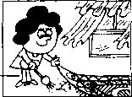
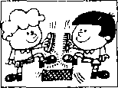
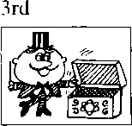
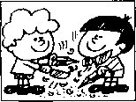
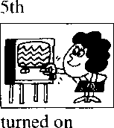
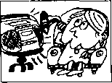
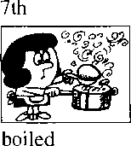
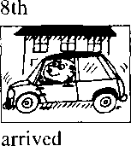
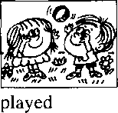
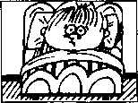
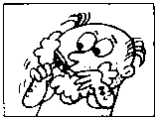
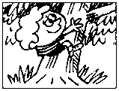
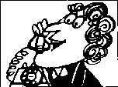
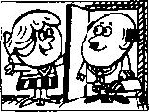
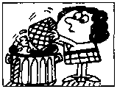

Written exercises 书面练习
A Complete these sentences.
模仿例句完成以下句子0
Example :
She is airing the room now. She it yesterday.
g辰.cu^ied it羿位以涝
- It is raining now. It yesterday.
- It is snowing now. It . yesterday.
- He is boiling some eggs. He some yesterday.
- We are enjoying our lunch. We it yesterday, too.
B Write questions and answers.
模仿例句提问并回答。
Example :
she/air the room/yesterday
Wkat did do-
Xfe(Une(L
- they/clean their shoes/yesterday
- he/open the box/last night
- they/sharpen their pencils/this morning
- she/turn on the television/this evening
- she/listen to the radio/last night
- she/boil an egg/yesterday morning
- they/p)ay a game/yesterday afternoon
- he/stay in bed/the day before yesterday/in the morning
- she/telephone her husband/yesterday evening
1() she/call the doctor/the night before last

Can you do this test? 你能完成以下测试吗？
- Dictation.

听写o
- Look at this:
阅读以下例句：
I am tired.
Write these again. Begin each sentence with He. 改写下面的句子.用He作句子的主语。
- I must call the doctor.
- I am going to telephone him.
- I can go with her.
- 1 have a new car.
- I come from America.
- I am American.
- I like ice cream.
- I want a newspaper.
- I was at school yesterday.
- I don't live here.
- Look ot this:
阅读以下例句：
There is a pencil on the desk.
Write these again. Begin each sentence with There are ... 改写下面的句子，将There are置于句首。
1 There is a watch on the table. | 6 | There is a peach on the desk.
2 There is a knife near that tin. | 7 | There is a passport on the shelf.
3 There is a policeman in the kitchen. | 8 | There is a fish in the cupboard.
4 There is a cup on the table. | 9 | There is a tree in the garden.
5 There is a letter on the shelf. | 10 | There is a boat on the river.
IV Put in a some or any: 用a, some或any填空：
1 | I have | __ new car. | 6 | I want | .loaf of bread, please.
2 | There are 一 | clouds in the sky. | 7 | Do you want | bread?
3 | There is | milk in the bottle. | 8 | No, I don't want bread.
4 | Is there | chocolate on the shelf? | 9 | I want | .tea
5 | There is | bar of chocolate on | 10 | I want | _ biscuits, too.
the table.

V Put in in at from or on:
用in, at, from或on填空:
- He is going to telephone five o'clock.
- My birthday is May 21st.
- It is always cold February.
- She isn't French, She comes Spain.
- My father was there 1942.
- Were you school yesterday?
- He doesn't live here. He lives England.
- They always do their homework the evening.
- Can you come Monday?
- She's not here. She’s the butcher's.
VI Put in across, over, between oft along, in, on into, out ot or under: 用 across, over, between, off, along, in, on, into, out of 或 under 填空：
- The aeroplane is flying the village.
- The ship is going the bridge.
- The boy is swimming the river.
- Two cats are running the wall.
- My books are the shelf.
- The bottle of milk is the refrigerator.
- The boy is jumping the branch.
- Mary is sitting her mother and her father.
- It is 9.0 o'clock. The children are going class.
- It is 4.0 o'clock. The children are coming class.
Do these in the same way:
模仿例句完成以下句子:
1 Make... | She is | the bed.
2 Swim ... | They are | acoss the river.
3 Shin© ... | The sun is | —
4 Shave ... | My father is | —
5 Run ... | They are | across the park.
6 Sit... | She is | in an armchair.
7 Type ... | We are | letters.
8 Put... | He is | on his coat.
9 Come ... | I am
10 Give ... | I am | _ it to him.

VII Look at this:
阅读以下例句：
Take...
He is takmcf his book.

VIII Look at this:
阅读以下例句:
He is sitting in an armchair.
QUESTION: | A ke ut an.
QUESTION: | Where 必 uttuuf?
NEGATIVE:

Do these in the same way:
模仿例句提问，并作出否定的回答：
1 He can come now.
Q：
Q: When
N:
- He wants a new car.
Q：
Q: What
N:
2 There is a newspaper on the desk.
Q：
Q: What
N:
- He is going to come now.
Q：
Q: When
N:
- They like ice cream.
Q：
Q: What
N: 一
- They must go home now.
Q：
Q: When :
N:
- He has a headache.
Q：
Q: What 一；
N:
- He comes from Germany.
Q：
Q: Where
N:
- He feels ill.
Q：
Q: How
N:
- He cleaned his shoes.
Q：
Q: When
N:

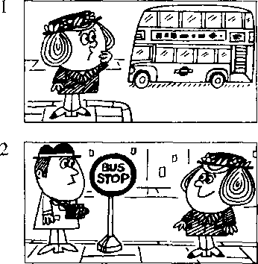
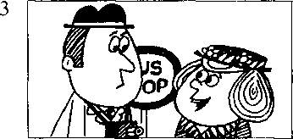
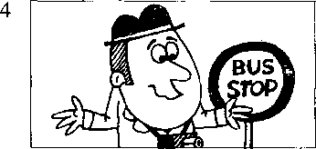
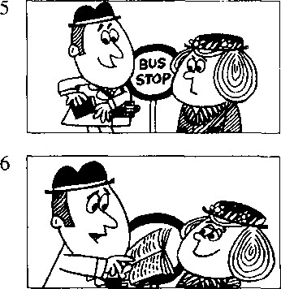

Lesson 73 The way to King Street 到国王街的走法

Listen to the tape then answer this question. Why did the man need a phrasebook?
|CC3)|

听录音，然后回答问题。为什么这位男士需要一本常用语手册?
Last week Mrs. Mills went to London.
She does not know London very well, and she lost her way.
Suddenly, she saw a man near a bus stop.
'I can ask him the way,'
♦
she said to herself.
'Excuse me/ she said.
'Can you tell me the way to King Street, please?'
The man smiled pleasantly.
He did not understand English!
He spoke German.
He was a tourist.
Then he put his hand into his pocket, and took out a phrasebook.
He opened the book and found a phrase.
He read the phrase slowly.
⁴I am sorry/ he said.
'I do not speak English/

New words and expressions 生词和短语
week /wi:k/ 几 周  London /'Lxndon/ 几伦敦 suddenly /'sAdnli/ adv.突然地 bus stop/^AS-stop/ 公共汽 4 4 ；古 smile /small/ v,微笑 pleasantly /'ples^ntli/ adv.愉快地 understand /^Ands'steend/ (understood /.Ands'stod/) m懂.明向 | speak /spi:k/ (spoke /spook/) v.  讲，说 '  hand /haend/ n.手  pocket /'pokit/ n.衣袋  phrasebook /'freizbok/ n.短语手册,常用语手册 phrase /'freiz/ n.短语■ slowly /'sboli/ adv.缓慢地

Notes on the text 课文注释
- . . . , and she lost her way. 因此她迷路了。
旬屮的and当“所以'、讲，表示结果。
- she said to herself,她心中暗想 ₀

参考译文
1一星期米尔斯夫人去了伦敦。她对伦敦不很熟悉，因此迷了路_{o}
突然，她在公共汽乍站附近看到一个男人。“我可以向他问路她想。
“对不起，您能告诉我到国王街怎么走吗？”她说。
这人友好地笑了笑_{o}他不懂英语！他讲德语.他是个旅游者。°
然后他把F伸进了衣袋，掏出了一本常用语手册_{o}
他翻开8找到了一条短语0他缓慢地读着短语0
「很抱歉L他说.“我不公讲英语

Lesson 74 What did they do?他们干了 什么？

Listen to the tape and answer the questions. 听录音并回答问题。

102
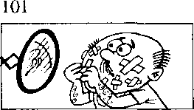
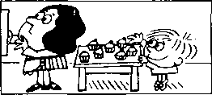

He took a cake and ate it quickly.
He shaved hurriedly this morning and cut himself badly.

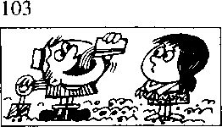

I gave him a glass of water and he drank it thirstily.
104
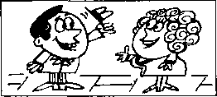
I met her in the street

the day before yesterday and she greeted me warmly.

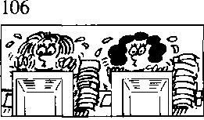
They worked very hard this morning.
105
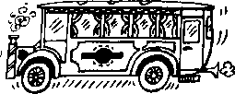

The bus went slowly yesterday afternoon and we arrived home late.

107
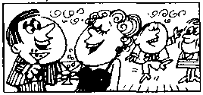
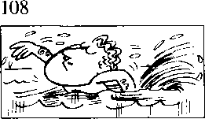

We enjoyed ourselves very much last night.
He swam very well this afternoon.

New words and expressions 生彳司 和短 i吾
hurriedly 'hAridli "dk.匆忙地
go /goo/ (went /went/) v.定 greet/grirt/r. P^{r}J候，打招呼
cut k.\t (cut) r.剧.伊 thirstily adv. \ 丨涡地

Written exercises 书 面练习
A Look at this.
注意下面的词
quick - quickly: thirsty 一 thirstily： careful 一 carefully
Example :
She smiled _________ . (pleasant)
Complete these sentences.
模仿例句完成以下句子_{c}.
1 He read the phrase _____ | . (slow) | 4 | He worked | . (careful)
2 He worked | —-(lazy) | 5 | The door opened | — .. (sudden)
3 He cut himself . (bad)

B Look at this table: 注意下表：
He | does not know read  smiled  went | a glass of water | very hard hurriedly slowly very well
She | shaved | the phrase | thirstily
We | drank | me | warmly
The bus | greeted | London | pleasantly
 | worked |  | very much
 | enjoyed ourselves

Now write eight sentences.
模仿下面的例句.从上面的表格中选出恰当的词和词组，写出8句话。
Example:
如/ the

Lesson 75 Uncomfortable shoes 不舒适的鞋子

Listen to the tape then answer this question.

What?s wrong with the fashionable shoes?

听录音，然后回彖问题。这些时髦的鞋有什么毛病？
LADY : Do you have any shoes like these?
SHOP ASSISTANT : What size?
LADY : Size five.
SHOP ASSISTANT : What colour?
LADY: Black.
SHOP ASSISTANT : I'm sorry.
We don't have any.
LADY : But my sister bought this pair
last month.
SHOP ASSISTANT : Did she buy them here?
LADY : No, she bought them
in the U.S.
SHOP ASSISTANT : We had some shoes like those
a month ago, but we don't have any now.
LADY : Can you get a pair for me, please?
SHOP ASSISTANT : I'm afraid that I can't.
They were in fashion last year and the year before last.
But they're not in fashion this year.
SHOP ASSISTANT : These shoes are in fashion now. LADY : They look very uncomfortable.
SHOP ASSISTANT : They are very uncomfortable.
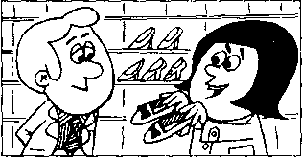
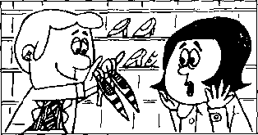
But women always wear uncomfortable shoes!
2

New words and expressions 生词和短语
fashion /'feepn； n.(服装的)流行式样 uncomfortable /An'kAmftob^l/ adj.不舒服的 wear /weo/ (wore /wo:/)认穿着
ago adw 以前
buy /bai/ (bought /b3：t/) v.买 pair /peg/ n.双，对

Notes on the text 课文注释
- like these是介词能语作定语，修饰shoes _{o}意思是"像这样的鞋子” °
- We don't have any.
any 后面省略了 black shoes _{o}
- ago放在表示时间长度的短语的后面，常与表示一般过去时的动词连用。如a month ago （一个月
之而匚 ^{r}
- in fashion.流行的，肘髦的。
- I'm afraid ...我恐怕 _{o}

参考译文
女 L ：像这样的鞋了你们有吗？
榜货忧：什么尺码的？ 女1: - 5号•的0 售货员：什么颜色？ 女士：黑的。
f号货员：对不起、我们没有。
女I: •.但是、我姐姐上个月买到了这样的一双。
售货员：她是住这儿买的叫？
女 土 ：不0她是住美国买的0
作货员：一个月前我们有这样的鞋，但是现在没有了。
女 上：您能为我找一双吗？
售货员：恐怕不行。这鞋在去年和前年时兴，而今年已不流行了。
告货员：现在流行的是这种鞋子。
女1::这种鞋子看上去很不舒适。
停货员：的确很不舒适。可是女人们总是穿不舒适的鞋子！

Lesson 76 When did you ... ?你什么时候 ?

Listen to the tape and answer the questions. 听录音并回答问题。
this week |  | last week | the week before last
this month |  | last month | the month before last
this year |  | last year | the year before last
a minute |  |  | two minutes
an hour |  |  | five hours
a day | AGO |  | three days AGO
a week |  |  | two weeks
a month |  |  | four months
a year |  |  | six years

109
looked
at a photograph
jumped off the wall
across the park
112
washed
113
worked
his hands
in an office
1 14
asked
those letters
television
117
talked
to the salesman
118
thanked
her father
a question
the cupboard
120
painted
at the bus stop
that bookcase
a car like that one
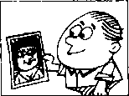
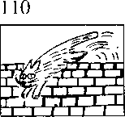
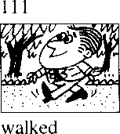
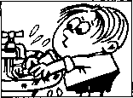
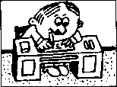
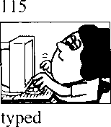
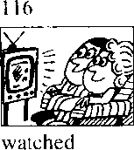
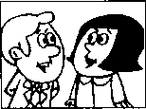
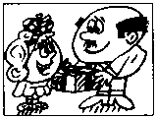
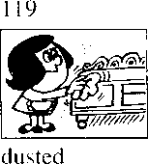
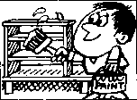
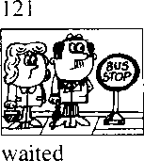
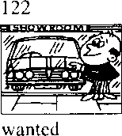
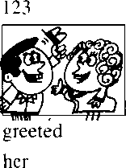

Lesson 76

Written exercises 书 面练习
A Rewrite these sentences.
模仿例句将以下句子改成过去时O
Exomple :
She goes to town every day. Wke la ham 弭我锡如a
1 She meets her friends every day.
- They drink some milk every day.
- He swims in the river every day.
- She lakes him to school every day.
- He aas himself every morning.
B Write questions and answers. 模仿例句捉问并回答。
Example :
look nt that phologr;iph/an hour ago
9 la炽日 uua.1 n奴"％m,计■ 爲标"紿g.

- walk across lhe park/last week
- wash v<Hir hands/a minute ago
- work in an office/the year before last
- ask a question/five minutes ago
- type those lettcrs/a month ago
- watch lelevision/every day this week
- talk to the shop assistant/last month
- thank your father/an hour ago
- dust the cupboard/three days ago
1() paint that bookcase/the year before last
I I want a car like that one/a year ago
12 greet her/a minute ago

Lesson 77 Terrible toothache 要命的牙痛

戸w珂 Listen to the tape then answer this question.

What time of day is it do you think? How do you know?

听录音，然后回答问题。你认为现在是几点钟？你怎么知道的？
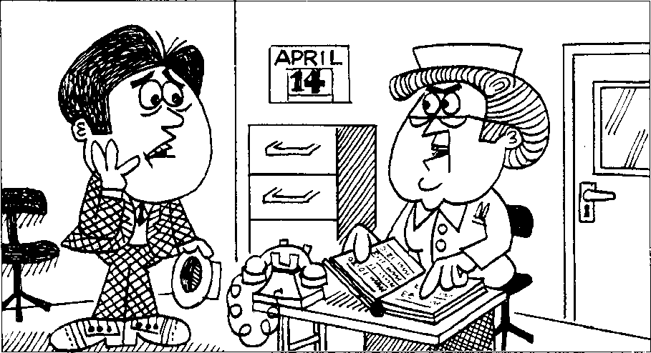

NURSE : Good morning, Mr. Croft.
MR. CROFT : Good morning, nurse.
- want to see the dentist, please.
NURSE : Do you have an appointment?
MR. CROFT : No J don't.
NURSE : Is it urgent?
MR. CROFT : Yes, it is.
It's very urgent.
- feel awful.
- have a terrible toothache.
NURSE : Can you come at 10 a.m.
on Monday, April 24th?
MR. CROFT : I must see the dentist now, nurse.
NURSE : The dentist is very busy
at the moment.
Can you come at 2 p.m.?
MR. CROFT : That's very late.
Can the dentist see me now?
NURSE : I'm afraid that he can't, Mr. Croft.
Can't you wait till this afternoon?
MR. CROFT : I can wait, but my toothache can't!

New words and expressions 生词 和短语
appointment /a^omtmant/ n.约会，预约 till /til/prep, IlSI 为止
urgent广3宙如t/ adj.紧急的，急迫的

Notes on the text 课文注释
- Can,t the dentist see me now?
这是情态动词的否定疑问句，表示请求。
- am, “上午”，p..m.是指“下午”。10a.m.,上午10点，2 p.m.,下午两点。

参考译文
早上好，克罗夫特先生。
护 士
克罗夫特先生 护 i:
克罗夫特先生 护 J：
克罗夫特先生 护 h 克罗夫特先生 护 ± 克罗夫特先生 护 ± 克罗夫特先生
早上好，护士。我想见牙科医生。 您约好了吗？
没有。
急叫?
是的，很急。我难受极了，牙痛得要命。
您在4月21日星期一上午10点钟来可以吗？
我必须现在就见牙科医生，护士。
牙科医生这会儿很忙O您下午两点钟来行吗？
那就太晚T O牙科医生现在就不能给我看一下吗？
恐怕不能：克罗夫特先生。您就不能等到今天下午了吗。 我倒是可以等O可是我的牙痛等不了啊！

Lesson 78 When did you・..?你什么时候 ？

Listen to the tape and answer the questions. 听录音并回答问题。
ccnl
AT:
o
0
o
伊4
：9 -^—3
商4
w
籲0
yj
俨p
iLf 6
2滞
4 JF
o
◎
©

ON. | Sunday | Monday | Tuesday | Wednesday | Thursday | Friday Saturday
IN: | January | February | March | April | May | June
 | July | August | September | October | November | December
IN: | 1988 | 1989 1990 | 1991 | 1992 1993 | 1994 | 1995 1996 1997
ON: | July 1st | Aug. 2nd | Sept. 3rd | 4th Oct. | 5th Nov. 6th Dec.

Written exercises 书 面练习
A Complete these sentences.
把下列句子改写成过去时o
Example :
She goes to town every day. She to town yesterday.
- She buys a new car every year. She a new car last year.
- She airs the room every day. She it this morning.
- He often loses his pen. He his pen this morning.
- She always listens to the news. She to the news yesterday.
- She empties this basket every day. She it yesterday.
B Answer these questions.
模仿例句回答以下问题，注意时间状语的变化。
Examples:
It's eight o'clock. When did you see him?
(half an hour ago)
9 kun at 仔it deaen.
It's Friday. When did she go to London?
(the day before yesterday)
Ske-
It's June. When did Mr Jones buy that car?
(last month)
cMe tkai ca/v 讥 Mcu^,.
- It's 1997. When did you paint this room?
(last year)
- It's 5th January. When did she meet him?
(two months ago)
- It's a quarter past eleven. When did they arrive?
(half an hour ago)
- It's Sunday. When did he lose his pen?
(yesterday)

Lesson 79 Carofs shopping list 卡罗尔的购物单

Listen to the tape then answer this question, What is Carol not going to buy? 听录音，然后回答问题。卡贾尔不准备买什么？
TOM : What are you doing, Carol? CAROL : I'm making a shopping list, Tom.
TOM : What do we need?
CAROL : We need a lot of things this week.
CAROL : I must go to the grocer's.
We haven't got much tea or coffee, and we haven't got any sugar or jam.
TOM : What about vegetables?
CAROL : I must go to the greengrocer^. We haven't got many tomatoes, but we've got a lot of potatoes.
CAROL : I must go to the butcher⁷ s, too.
We need some meat.
We haven't got any meat at all.
TOM : Have we got any beer and wine? CAROL : No, we haven't.
And I'm not going to get any!
TOM : I hope that you've got some money.
CAROL : I haven't got much.
TOM : Well, I haven't got much either!
5

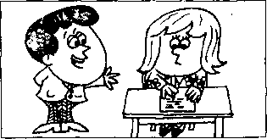
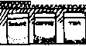

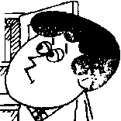
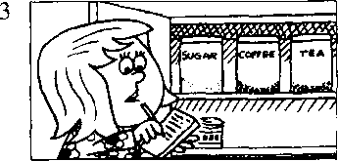
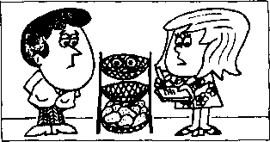
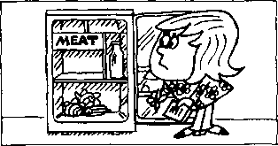
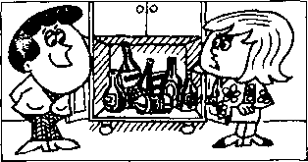
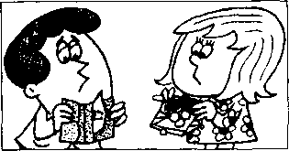

New words and expressions 生词和短语
shopping / Jopii]/ n.购物 | hope /hoop/ v.希望
list/list/- | thing /(hg/ n.事情
vegetable /'vcdjtab^l/ /?.蔬菜 | money /'mAni/ n.钱
need /niid/ v.需要

Notes on the text 课文注释
- make a shopping list,写一张采购物品的单子。
- a lot of "许多”讲，既可用在可数名词前、又能用在不可数名词前，一般用于肯定句。
- We haven't got any meat at all.我们一点肉也没有了。
a［汕这个词组用在否定句中，表示“丝毫”、"一•点”、“根本”的意思，有强调作用o have got have （"冇”）同义。
- many和much均可译成“许多”，但用法不同：many主要用于疑问句和否定句中，放在可数名词 之前.如many tomatoes; much用于疑问句和否定句中，放在不可数名词之前，如much tea, much money。

参考译文
汤姆：卡罗尔，你在干什么？
K罗尔：我在写购物单、汤姆。
汤姆：我们都需要什么？
K罗尔：这星期我们需要很多东西。
K罗尔：我得去一下食品店。我们的茶叶和咖啡不多了，糖和果酱也没有了。
汤姆：蔬菜呢？
K罗尔：我还得到蔬菜水果店去一下。我们的番茄不多了，但土豆还有不少。
k罗尔：我还要到肉店去--下。我们需要些肉。我们一点肉也没有了。
汤 姆：我们还有啤酒和葡萄酒吗？
尸罗尔：没有了'，不过，我不打算去买！
汤姆：我希望你还有钱O
卡罗尔：我的钱不多了 O
汤姆：唉，我也不多了！

Lesson 80 I must go to the.・・我必须去


Listen to the tape end answer the questions. 听录音并回容问题o

GROCER'S to get some GROCERIES:
120 121 . 122
123
cheese
eggs
butter
honey
125
231
23()
229
228
beans
bananas
peas
pears
oranges
GREENGROCER'S to get some FRUIT and VEGETABLES:
226 227
cabbages
336
335
334
333
chicken
beef
steak
lamb
mince
BUTCHER'S to get some MEAT:
332
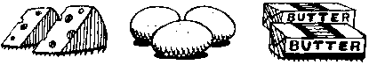
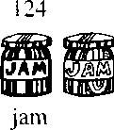
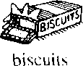
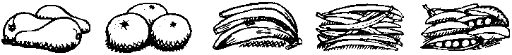
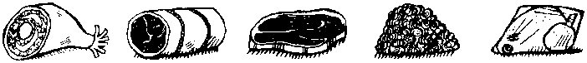

NEWSAGENT'S to get some STATIONERY:
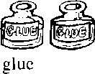


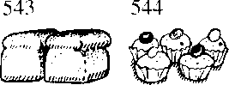
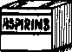
437 438
439
envelopes
440
441
newspapers magazines
writing paper
CHEMIST'S to get some:
BAKER'S to get some:
bread
cakes
545
aspirins
546
[medicine
medicine

New words and expressions 生词 和短语
groceries /'gro(JS^riz/ n.食品杂货 fruit /fru:t^{z} n. /K 果 stationery 'steijan^ri/ n.文 EE
newsagent /'nju:z_{i}eid3Jnt/ n.扌艮刊零侥人 chemist /'kemist/几药剂帅，化学家

Written exercises 书面练习
A Rewrite these sentences.
模仿例句改写以下句子o
Examples:

I don't have any eggs. 9 kau^it
- I don't have any butter.
- You don't have any envelopes.
- We don't have any milk.
- She doesn't have any biscuits.
- They don't have any stationery.
B Make two statements for each question, as in the examples. 模仿例句用两种方式回答以下每个问题。
Examples:
Have you got any cheese?
(grocer's)
/ need c?■血洛 ckee^e-. 9 kaae^ t cpi muck.
9 糸 la thek t&-(j^ei cheese.
Has he got any envelopes?
丿e neeJU e^^u&l^ped. c4e 't qot
(newsagent's)
1 Have they got any bread?
(baker's)
2 Has she got any eggs?
(grocer's)
3 Have they got any magazines?
(newsagent's)
- Have you got any beef?
- Has she got any butter?
- Have they got any bananas?
- Has he got any medicine?
(butcher's) (grocer's) (greengrocer's) (chemist's)

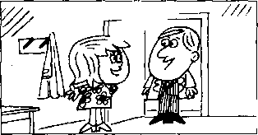
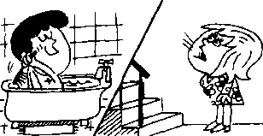
2

Lesson 81 Roast beef and potatoes 烤牛肉和土豆

Listen to the tape then answer this question. Why is Carol disappointed? 听录音，然后回答问题。为,什么卡罗尔感到失望？
SAM: Hi, Carol!
Where's Tom?
CAROL : He's upstairs.
He's having a bath.
CAROL: Tom!
TOM: Yes?
CAROL : Sam's here.
TOM : I'm nearly ready.

TOM : | Hello, Sam.  Have a cigarette. | 3
SAM : | No, thanks, Tom.
TOM : | Have a glass of whisky then.
SAM : | OK. Thanks.
 |  | 4
TOM : | Is dinner ready, Carol?
CAROL: | :It's nearly ready.
 | We can have dinner at seven o'clock.

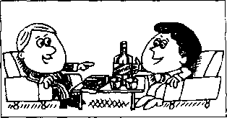
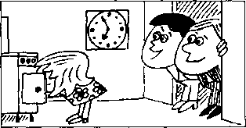

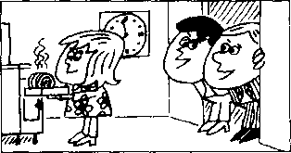
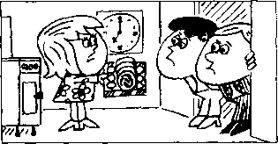
TOM : Sam and I had lunch together today. 5
We went to a restaurant.
CAROL : What did you have?
TOM : We had roast
beef and potatoes.
6
CAROL : Oh!
TOM : What's the matter, Carol?
CAROL : Well, you're going to have
roast beef and potatoes again tonight!

New words and expressions 生词和短r吾
bath /ba:0/ 〃.洗澡 | dinner /'dm。/ n.正餐，晚餐
nearly 止/t.几 T*-将近 | restaurant / restaront/ n.饭馆，餐馆
ready /redi/ adj.隹备好的.完好的 | roast /raost/ adj.烤的

Notes on the text 课文注释
1在第13课中我们见到了这样的句子：Come upstairs ...，其中的upstairs表示动作的方向。本课中的 He's upstairs.则表示他的方位，其中的 叩stairs可详为“在楼上”。
- He's having a bath.他正在洗澡。在本课中，动词have后面接名词或名词短语，有“进行""从事” 的意思、 如 have a bath, have a cigarette, have a glass of whisky, have dinner, have lunch 等。

参考译文
诉姆：你好、卡罗尔！汤姆在哪儿？
卡罗尔：他在楼上。他正在洗澡O •
"岁尔：汤姆！
汤姆：什么事，
卡罗尔：萨姆来了 O
汤姆：我马上就好。
汤姆：你好•萨姆。请抽烟。
萨姆：不，谢谢，汤姆0
汤姆：那么，来杯威士忌吧。
萨姆：好的，谢谢。•
汤姆：卡罗尔、饭好了吗？
K罗尔：4上就好。7点的我们可以吃饭。
汤姆：我和护姆今天一起吃的午饭。我们去了一家饭店。
K罗尔：你们吃什么？
汤姆：我们吃的是烤牛肉和土豆O
K罗尔：噢！
汤姆：怎么匚化罗尔？
K罗尔：唉，今晚你们又要吃烤牛肉和上豆了！

Lesson 82 I had ..我吃（喝、从事）了


Listen to the tape and answer the questions. 听录音并回答问题o
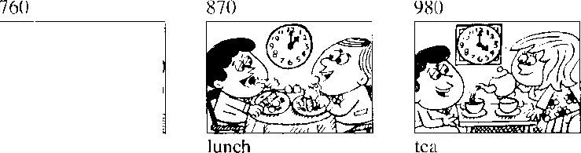
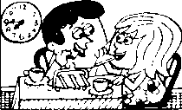
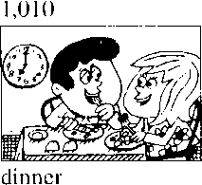
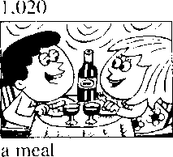
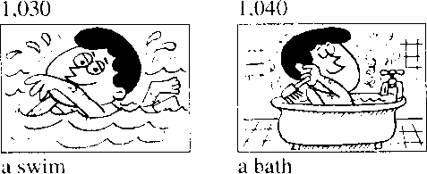
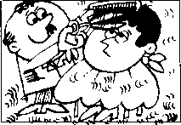
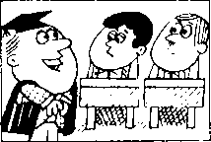
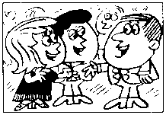
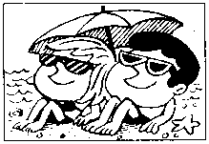
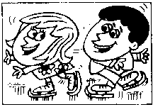
breakfast
L050
a haircut
1.060
a lesson
1,070
a party
1,080
a holiday
1,090
a good time

New words and expressions 生词和短语
breakfast /'brekfsst/ 几早饭 haircut /'heskAt/ n.理发
party /'pa:ti/ n.聚会 holiday /'holidi/ 几假日

Written exercises 书面练、习
A Rewrite these sentences using drank, enjoyed yourself, are eating, went for, ate or take. 模仿例句完成以下句子，选用 drank, enjoyed yourself, ere eating, went for, ate 或 take o
Example:
- had a cup of coffee. I 阮"a cup of coffee.
- They had a meal at a restaurant. They a meal at a restaurant.
- We had a holiday last month. We ： a holiday last month.
- Have a biscuit a biscuit.
- You had a good time. You
- They are having their lunch. They their lunch.
- I had a glass of milk. I a glass of milk.
B Answer these questions using going to have, having, must have or had. 模仿例句回答以下问题，选用恰当的动词和动词时态0
Example:
What is he goihg to do? (a glass of whisky)
1 | What are they going to do? | (breakfast)
2 | What are they doing? | .(lunch)
3 | What must he do? | (tea)
4 | What did they do? - | (dinner)
5 | What they do? | (a meal)
6 | What is he going to do? | (a swim)
7 | What is he doing? | (a bath)
8 | What did he do? | (a haircut)
9 | What are they doing? | (a lesson)
10 | What did they do? | (a party)
11 | What must they do? | (a holiday)
12 | What are they going to do? | (a good time)

Lesson 83 Going on holiday 度假

Osa Listen to the tape then answer this question. Where did Sam go for his holiday this year?
odd

听录音，然后回答问题。今年萨姆去了什么地方度假?
CAROL : Hello, Sam.
Come in.
TOM : Hi, Sam.
We're having lunch.
Do you want to have lunch with us?
SAM : No, thank you, Tom.
Fve already had lunch.
- had lunch at half past twelve.
CAROL : Have a cup of coffee then. SAM : I've just had a cup, thank you.
- had one after my lunch.
TOM : Lets go into the living room, Carol.
We can have our coffee ihere.
CAROL : Excuse the mess, Sam.
This room's very untidy.
We're packing our suitcases.
We're going to leave tomorrow.
Tom and I are going to have a holiday.
SAM : Aren't you lucky!
TOM : When are you going to
have a holiday, Sam?
SAM : I don't know.
Fve already had my holiday this year.
CAROL : Where did you go?
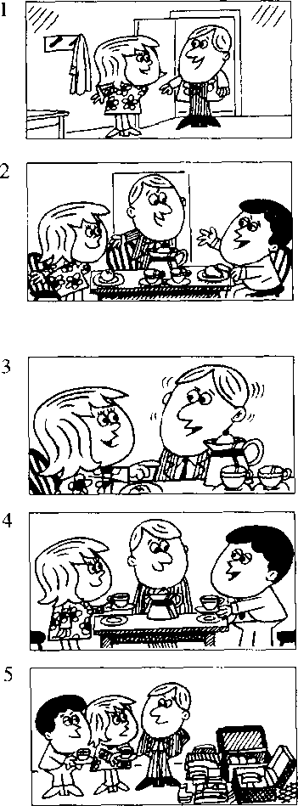
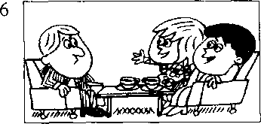
SAM : I stayed at home!

New words and expressions 生词 和短语
mess /mes/ n.杂乱.凌乱 leave /li:v/ （left /left/, left） v.离开
pack /pgeV v,包装，打包，装箱 already /o:l'redi/ adv.已经
suitcase /'su:tkeis/ n.手提箱

Notes on the text 课文注释
1在英语中，现在完成时主要用于以下两种情况：（1）表示在过去不确定的时间里发生的并与现 在有着某种联系的动作；（2）表示开始于过去并持续到现在的动作。本课中萨姆的3句话属于第 一种情况，正是因为他吃了饭、喝过了咖啡、也休过假，因此他谢绝了汤姆的邀请，并表示今年已 尤可能再次休假0现在完成时是由have的现在式加上过去分词组成0规则动词的过去分词与过去 式相同、而不规则动词的过去分词则无统一的规律可言。从本课起不规则动词还将列出过去分词的 拼写和读音_{o}
- Fve already had lunch.注意already的语序。在一般情况下，它跟在助动词后面。
- Excuse the mess.意思是："乱七八糟，请原谅。”
- have a holiday,度假 ₀
have在不同词组中，意思不同。如：have lunch,吃午饭：have a cup of coffee,喝杯咖啡。
- stay at home,呆在家里.注意名词home之前不加任何冠词₀在诸如go home, arrive home的短语中,
home是副词_{o} ,

参考译文 '
卡罗尔：你好，萨姆。进米吧。
汤 姆：你好，萨姆。我们正在吃午饭，你跟我们一起吃午饭好吗？
萨 姆：不，汤姆，谢谢。我已经吃过饭了。我在12点半吃的。
卡罗尔：那么喝杯咖啡吧。
萨 姆：我刚喝了…杯.谢谢。我是在饭后喝的。
汤 姆：我们到客厅里去吧，卡罗尔。我们可以在那里喝咖啡。
卡罗尔：屋子很乱.请原谅，萨姆。房间里乱七八糟。我们正在收拾手提箱。明天我们就要走 了匚我和汤姆准备去度假。
萨姆：你们真幸运！
汤 姆：萨姆，你准备什么时候去度假。
萨 姆：我不知道。今年我已度过假了 °
长罗尔：你去哪儿了？
萨姆：我呆在家里了！

Lesson 84 Have you had ・.・?你已经 了 口马?

Listen to the tape and answer the questions. 听录音并回答问题。

1,00()
fruit
2,000
bananas
4,000
5,000
apples
peaches
9,000
6,00()
vegetables
7,000
lettuce
8,000
cabbage
0次
10,000
beans
peas
1 1,00()
meat
12,000
beef
13,000
lamb
14,000
steak
15,000
chicken
16,000
milk
wine
19,000
20,000
beer
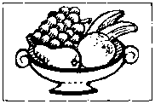
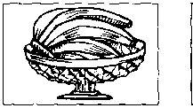
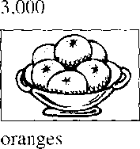
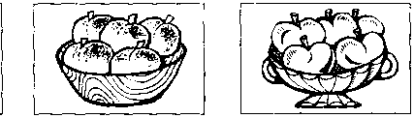
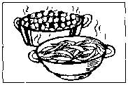
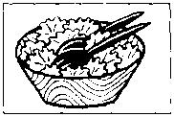
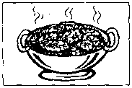
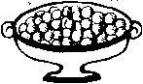
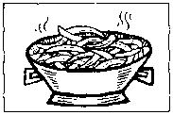
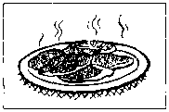
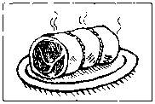
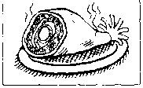
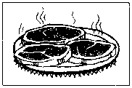
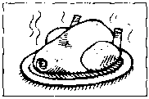
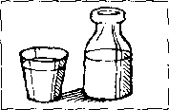
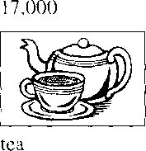
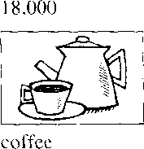
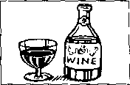
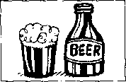

Written exercises 书面练习
A Write responses using some or one.
模仿例句写出对应的回答，选用some或one。
Examples:
Have some coffee. !)kad
Have a banana. 9呢 cdnea(Lf
- Have some beer.
- Have an apple.
- Have a peach.
- Have some milk.
- Have a glass of water.
- Have a biscuit.
- Have some cheese.
B Answer these questions.
模仿例句回答以下问题。
Example:
Have you had any vegetables or fruit? (I)
9 kauen. 't kcul
9 v■& 所〃 had dome ^uui.
- Has he had any beans or peas?
(He) (They) (I)
(I) (She) (He) (They) (She)
(I) (They)
- Have they had any tea or coffee?
- Have you had any apples or peaches?
- Have you had any cabbage or lettuce?
- Has she had any beer or wine?
- Has he had any lamb or beef?
- Have they had any tea or milk?
- Has she had any meat or vegetables?
- Have you had any chicken or steak?
- Have they had any bananas or oranges?

Lesson 85 Paris in the spring 巴黎之春

Listen to the tape then answer this question.

At what time of year did Ken vis什 Paris?

听录音，然后回答问瓶。肯是在什么季节访问巴黎的？
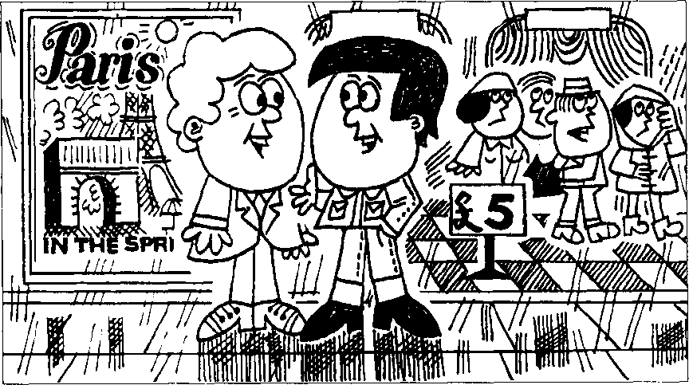

GEORGE : Hello, Ken.
KEN : Hi, George.
GEORGE : Have you just been to the cinema? KEN : Yes, I have.
GEORGE : Whafson?
KEN : Taris in the Spring'.
GEORGE : Oh, Fve already seen it.
- saw it
on television last year.
It's an old film, but it's very good.
KEN : Paris is a beautiful city.
GEORGE : Fve never been there.
Have you ever been there, Ken? KEN : Yes, I have.
I was there in April.
GEORGE : Paris in the spring, eh?
KEN : It was spring,
but the weather was awful.
It rained all the time.
GEORGE : Just like London!

New words and expressions 生词 和短语
Paris /'peens/ 〃.巴黎 cinema / sinim^/ n.电影院 film /film/ 几电影
city /'siti/ n.城市
never /'neva/ adv.从来?殳有 ever /'evs/ adv.在任何时候
beautiful /'bjuitif^l/ adj.漂亮的

Notes on the text 课文注释
- have been to ,到过 _{o} "到过那里’则说have been there□注意，在这里我们讲to the cinema,同 时也说to the park,但在第55课中，我们有to work, to school的短语。在名词school, work, church之 而不加定冠词the_{c}
- Whafson? t演什么电影？
- eh /ei/,感叹词.在此表示疑问。读升调。
- all the time, 一直，始终。
- Just like London!
这是省略句' 完整的句子为Paris was just like London。其中的just有“正好"“恰恰是"的意思c而在 第3行的Have you just been to ...中just是指时间，有"刚才"的意思。

参考译文
乔治：你好，肯。 骨：你好，乔治。
乔治：你刚去过龟影院吗？
肯：是的，我刚去过。
乔治：上映什么片子？
有：《巴黎之春》。
乔治：噢，我已看过了。我是去年在电视上看的。这是部老片子，但很好。 肯：巴黎是座美丽的城市₃
乔治：我从未去过。肯、你去过吗？
柠：是的' 我去过o 4月份我在那儿。
乔治：那是己黎之舂，是吗？
肯：是春天，但天气太糟了。一直在卜雨。
乔治：就像伦敦一样！

Lesson 86 What have you done?你已经做了什么？

Listen to the tape and answer the questions. 〔二听录音并回答问题o

aired
1st
2nd
cleaned
3rd
opened
sharpened
5th
turned on
6th
listened to
boiled
7th
8th
answered
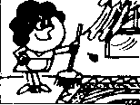
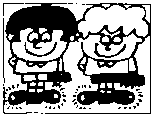
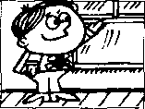
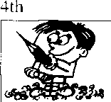
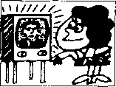
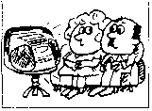
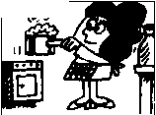
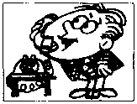
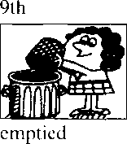


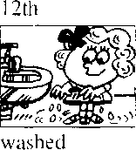
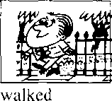
1 llh
typed
13th
10th 建 asked

14th
painted
15th
dusted
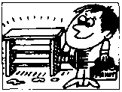
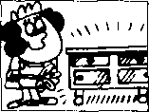

(this morning)
(last night) (an hour ago) (a minute ago) (ten minutes ago) (yesterday morning) (yesterday)
(two minutes ago) (this morning) (five minutes ago) (an hour ago) (a year ago) (this afternoon)

Written exercises 书面练 习
A Look ot these two sentences.
注意以下两个例句o
She has iilready aired lhe room.
She aired it this morning.
in which of these sentences can we put has?
在下面的句子中有一般过去时和现在完成时两种不同的时态。选出现在完成 时的句子，并填上has o
- She just boiled an egg,
- She boiled it a minute ago.
- She never been to China, but he was there in 1992.
- He already painted that bookcase.
- He painted it a week ago.
- She emptied the basket this morning.
- He just dusted the cupboard.
B Rewrite these sentences.
模仿例句改写以下祈使句O
Example:
Air the room!
9 ae Ike
9 Ike 所 UuA
- Cletin your shoes!
- Open the window!
- Sharpen your pencil!
4、Turn on the television!
- Boil the milk!
- Empty the basket!
- Ask a question!
- Type that letter!
- Wash your hands!
- Walk across the park!
- 1 Paint that bookcase!
12 Dust the cupboard：
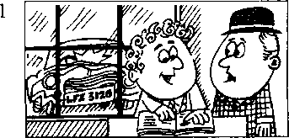
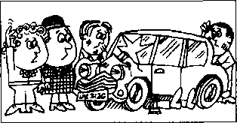

Lesson 87 A car crash 车祸

Listen to the tape then answer this question.

.7=^1 Can the mechanics repair Mr. Wood's car?

听录音，然后回答问题o修理工能否修复伍德先生的汽车?
MR. WOOD : Is my car ready yet? ATTENDANT : I don't know, sir.
What's the number
of your car?
MR. WOOD : It's LFZ 312 G.
ATTENDANT : When did you bring it to us?
MR. WOOD : I brought it here three days ago. ATTENDANT : Ah yes, I remember now.
MR. WOOD : Have your mechanics finished yet? ATTENDANT : No, they're still working on it.
Lefs go into the garage and have a look at it.
ATTENDANT : Isn^ that your car?
MR. WOOD : Well, it was my car.
ATTENDANT : Didn't you have a crash? MR. WOOD : That's right.
I drove it into a lamp-post. Can your mechanics repair it?
ATTENDANT : Well,
they're trying to repair it, sir. But to tell you the truth, you need a new car!

New words and expressions 生词和短语
attendant ^'tendont/ n.扌妾待员 lamp-post /'lasmp-poost/，灯木干
bring /brnj (brought /bro:t/, brought) t,带来：送来 repair /n'pea/ v.修理 garage /'gcera：3/ n. ^{z}f; i^{z}r--汽车修理厂 try /trai/ v.努力，设法
crash /kra?J/ n.点枝撞

Notes on the text 课文注释
i在英文中时以用一般疑问句的否定形式来表示期待、请求或希望得到肯定的答复，如课文中的
Isn?t that your car? 和 Didn't you have a crash?
- Well, it was my car.
心II是感叹词顼这里表示“哎、聊$用斜体，表示“过去是，现在不是了”。wc要重读。
- drive into是 ''撞倒……''的意思。
- they're trying to repair it.他们正在设法修理_{o} try后面常接to+动词不定义□

参考译文
伍德児乍：我的汽上修好了叫？
服务员：我不知道，先生。您的汽车牌号是多少？ 伍徳先乍：是LFZ312G。
服务员：您什么时候送来的，
伍德先％ ： 3天前。
服务员：啊，是的，我现在记起来了。 伍徳先牛：你们的机械师修好了吗？
服务员：没仃.他们还在修呢。我们到军库去看一下吧 服务员：这难道不是您的车吗？ 伍德先生：唔，这曾是我的车。
服务员：难道您核”出车祸吗？
伍徳先牛：是啊。我把汽车撞在电线杆上了 o你们的机械师能修好吗？
服务员：啊.他们伍设法修呢.先生。不过说实在的，您需要一辆新车了!
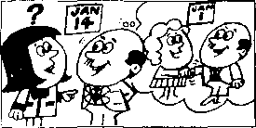
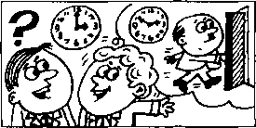
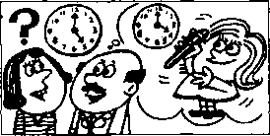
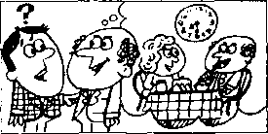
2
Has the boss left yet?
Yes, he has.
When did he leave?
He left ten minutes ago.
Has she found her pen yet?
Yes, she has.
When did she find it?
She found it an hour ago.
Have you had breakfast yet?

戸s』Listen to the tape and answer the questions. 听录音并回答问题。
Have you met Mrs. Jones yet?
Yes, I have.
When did you meet her?
\ met her two weeks ago.
Yes, we have.
When did you have it? We had it at half past seven.

Study these verbs.

记住以下不规则动词的过去式和过去分词。
buy | bought | bought | lose | lost | lost
find | found | found | make | made | made
gel | got | got | meet | met | met
have | had | had | send | sent | sent
hear | heard | heard | sweep | swept | swept
lea\ e | left | left | tell | told | told

17Q

Written exercises 书 面练习
A Write questions and answers.
襖仿例句就以下句子提问］并作出否定的回答
Example:
He bought a house last year.
QUESTION: he kMj, a k(^ie- Ic&U ijea/i?
NEGATIVE:顼e didn't a kad■班 LoaI 羿洗
- He found his pen a minute ago.
- He got a new television last week.
- We heard the news on the radio.
- They left this morning.
- He lost his umbrella yesterday.
- I swept the floor this morning.
B Write questions and answers.
模仿例句提问并回答。
Example:
they/bu)a new house/two weeks ago
al'Leadi.^ a new- haude-.
When did a hqm- li&uAe?
a.心如 k&idAe- tiA^ <v-ee聂 a<p-.
- he/meet Mrs. Jones/two weeks ago
- the boss/leave/ten minutes ago
- he/have breakfast/at half past seven
- she/find her pen/an hour ago
- he/get a television/two weeks ago
- she/hear the news/yesterday
- she/niake the bed/this morning
- he/send the letter/the day before yesterday
- she/sweep the Hoor/yesterday morning
1() she/tell him the truth/last night
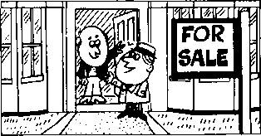
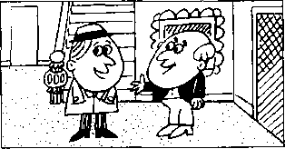

-——n Listen to the tape then answer this question. Why couldn't Nigel decide? ^{Iz} 听录音，然后回答问题。为什么奈杰尔作不了决定？
NIGEL : Good afternoon.
I believe that
this house is for sale.
IAN : That s right.
NIGEL : May I have a look at it, please?
IAN : Yes, of course.
Come in.
NIGEL : How long have you lived here? IAN : I've lived here for twenty years. NIGEL : Twenty years!
That's a long time.
IAN : Yes, Tve been here since 1976.
NIGEL : Then why do you want to sell it? IAN : Because I've just retired.
I want to buy
a small house in the country.
NIGEL : How much does this house cost?
IAN : £68,500.
NIGEL : Thafs a lot of money!
IAN : It's worth every penny of it.
NIGEL : Well, I like the house,
but I can't decide yet. My wife must see it first.
IAN : Women always have
the last word.

New words and expressions 生词 和短语
believe /bi'lirv/ v. 认为 | because /bi'koz/ conj.因为
may /mei/ modal verb （用于请求许可）可以 | retire /rftais/ v.退休
how long 多长 | cost /kost/ (cost, cost) v.花费
since /sins/ prep.自 从 | pound /paund/ n.英镑(£)
why /wai/ adv.为什么 | worth /w3：0/ prep.值 钱
sell /scl/(sold /s9old/, sold) v. AJ,出售 | penny /'peni/ n.彳更士

Notes on the text 课文注释
- for sale,供出包匚符售。
- Mayl ...?是-种比较正式的表示请求的句型。其中的may有“请求允许”的意思。
- It's worth every penny of it.
”独调的意思.后面的一个it是指刚才提到的那笔钱。全句的意思是：“你支付出的每一个便士都 是划算的L可以译成：“它确实值这么多钱
- leant decide yet.我还不能决定。句中的yet常用在否定句中，表示“迄今仍未"的意思。
- My wife must see it first.我的妻子必须先来看一看。其中的must当"必须”讲°
- have the last word,最后拍板 _{o}

参考译文
奈杰尔：卜午好。我想、这房子是要出售的吧！
伊恩：是的「
奈杰尔：我「"以看一看吗？
伊恩：可以，'七然可以3请进。
奈杰尔：您在这里住「多长时间？ 伊恩：我在这甲Li经住了 2（）年了 o 奈杰尔：以）年！这个时间可不短。
伊 恩：是啊，从1976年起我就住在这里。
奈杰尔：那么，您为什么要实掉它呢？
伊 恩：因为我刚退休。我想、在乡下买幢小房子。
奈杰尔：这座房『买多少钱？
伊恩；（）凯滨川英镑0
奈杰尔：那可真是一大笔钱呢！
伊恩：它确确实实值这么多钱O
奈杰尔：啊,我喜欢这房子，但我还不能决定0我妻子必须先来看一看O
伊恩：女人总是最后说了算的0

Lesson 90 Have you …yet?你已经 了吗?

Listen to the tape and answer the questions.

听录音并回答问题o
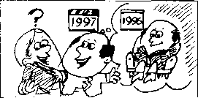
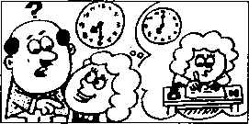
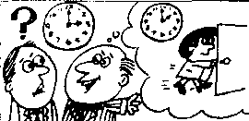
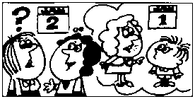
Have you read this book yet?
Yes, J have.
When did you read it?
I read it last year.
4
Has she spoken to him yet?
Yes, she has.
When did she speak to him? She spoke to him yesterday.
Have you done your homework yet?
Yes, I have.
When did you do it?
I did it half an hour ago.
Has he gone yet?
Yes, he has.
When did he go?
He went an hour ago.

Study these verbs.

记住以下不规则动词的过去式和过去分词O
cut | cut | cut | do | did | done | eat | ate | eaten
pul | put | put | come | came | come | g。 | went | gone
read | read | read | give | gave | given | rise | rose | risen
set | set | set | swim | swam | swum | see | saw | seen
shut | shut | shut | take | took | taken | speak | spoke | spoken

Written exercises 书 面练习
A Write questions and answers.
模仿例句就以下句子提问，并作出否定的回答。
Example:
He read this book last week.
QUESTION: 2况 ke nead UuA la^i laeek?
NEGATIVE： Uus week.
- The sun set at twenty past seven.
- He ate his lunch at one o'clock.
- They did their homework last night.
- He came by car this morning.
- The sun rose at'half past five.
- We swam across the river yesterday.
B Answer these questions. 模仿例句回答以下问题o
Examples:
Did you read this book last week?
Whai about Penny?
gke nead tku. Imk ijei.
- Did you do your homework last night?
What about Tom?
- Did Mrs. Jones go to the butcher's this morning?
What about Mrs. Williams?
- Did you speak to him yesterday?
What about Susan?
- Did George swim across the river an hour ago?
What about Sam?
- Did you see that film yesterday?
What about Sam and Penny?
- Did Tim take off his shoes a minute ago?
What about Frank?

Lesson 91 Poor Ian!可怜的伊恩!

Listen to the tape then answer this question. Who wanted to sell the house? 听录音，然后回答问题。谁想卖房？
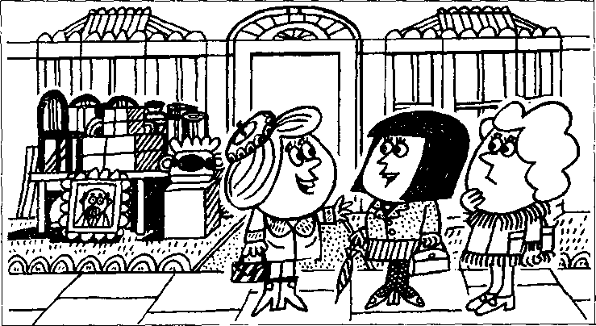

CATHERINE : Has Ian sold his house yet?
JENNY : Yes, he has.
He sold it last week.
CATHERINE : Has:he moved to his new house yet?
JENNY : | No, not yet.  He's still here.  He's going to move tomorrow.
CATHERINE : | When? Tomorrow morning?
JENNY : | No. Tomorrow afternoon.  ril miss him.  He has always been a good neighbour.
LINDA : | He's a very nice person.  WeUl all miss him.

CATHERINE : | When will the new people move into this house?
JENNY : | I think that they'll move in the day after tomorrow.
LINDA : | Will you see Ian today, Jenny?
JENNY : | Yes. 1 will.
LINDA : | Please give him my regards.
CATHERINE : Poor Ian!

JENNY : | He didn't want to leave this house.  No, he didn't want to leave,  but his wife did!

New words and expressions 生词和短语
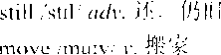
person /'p3：s^n/ n.人 people /'pi:p^l/ n. 人们 poor /poo/ adj.可怜的
miss /mis/ v.想念.思念
neighbour ^{z，}neiba/ n.邻居

Notes on the text 课文注释
- No. not yet. 4、.还没有。
j*是简略问答•’芫整的回答是 He hasn't moved to his new house yet.
- He's a very nice person.他是一个非常好的人° person是指人c当需要表示复数形式时，往彳主用people 这个词：,如"I 面的一句话 When will the new people move into this house?
- Please give him my regards.请代我问候他。
- No. he didn't want to leave ...是对上一句话的证实。由于上一句话中用了否定形式，因此.在证实时 句中的动词不可模仿而一句话的形式.而要根据事实来决定_{c}但在译成汉语时,No就要译成行 定的意思，如：,'是的.他不想离丿

参考译文
凯弦琳：伊恩已把他的房*卖掉了吗？
詹 尼：是的•卖掉了 ：他上星期卖掉的。
凯瑟琳：他□经迁逬新居了叫？
詹 尼：不"丿还没有’他仍在这里。他打算明天搬家。
凯瑟琳：什么时候？明大上午吗？
詹 尼：不，明天FT-.我会想念他的。他一直是个好邻居。
琳 达：他是个非常好的人，我们大家都会想念他的。
凯瑟琳：新住户什么时候搬进这所房子， 詹 尼：我想他们将在后天搬进来吧。
琳 认：隋尼.您今大公见到伊恩吗？
儈尼：是的.我会见到他。
琳达：请代我问候他：
凯瑟琳••可怜的伊恩！他本不想离开这幢房了 0 詹 尼：是啊.他是不想离丿R可是他妻子要离开。

Lesson 92 When will... ?什么时候要 ?
Listen to the tape and answer the questions.
MJ听录音并回答问题_{o}
TODAY | TOMORROW | THE DAY AFTER TOMORROW
this morning | tomorrow morning | the day after tomorrow in the morning
this afternoon | tomorrow afternoon | the day after tomorrow in the afternoon
this evening | tomorrow evening | the day after tomorrow in the evening
tonight | tomorrow night | the night after next

rain
3rd
leave
5th
arrive
6th
finish work
7 th
TRAWEfa
have a holiday
8th
drive home
9th
have a haircut
10th
telephone me
11th
have a shave
12th
pack his bags
13th
sweep the floor
14th
paint this room
16th
make an appointment
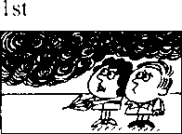
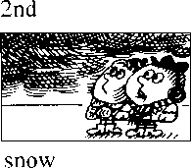
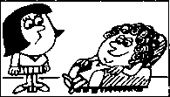
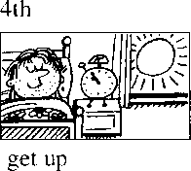
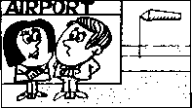
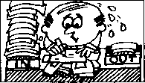
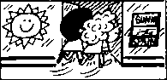
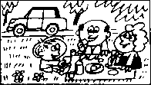
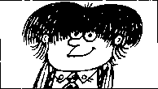
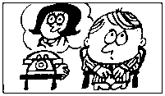
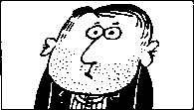
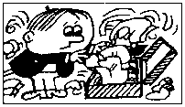
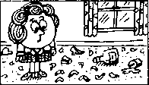
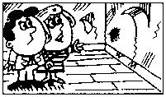
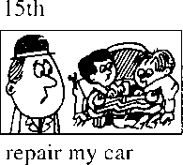
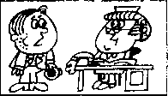

Written exercises 书面练、习
A Rewrite these sentences.
模仿例句改写以下句子o
Example:
It will rain tomorrow.
yt'U
He will arrive tomorrow morning. She will come this evening.
1
2
3
4
It will snow tonight.
He will not believe me.
Rewrite these sentences.
模仿例句确认以下的每一句话。
Example:
It rained yesterday.
Ifed., it uull n-aut 如,
It snowed yesterday.
1
2
3
4
5
6
7
8
He got up late yesterday.
He arrived late yesterday.
He finished work late yesterday. She drove to London yesterday. She telephoned him yesterday.
He had a shave yesterday.
She swept the floor yesterday.
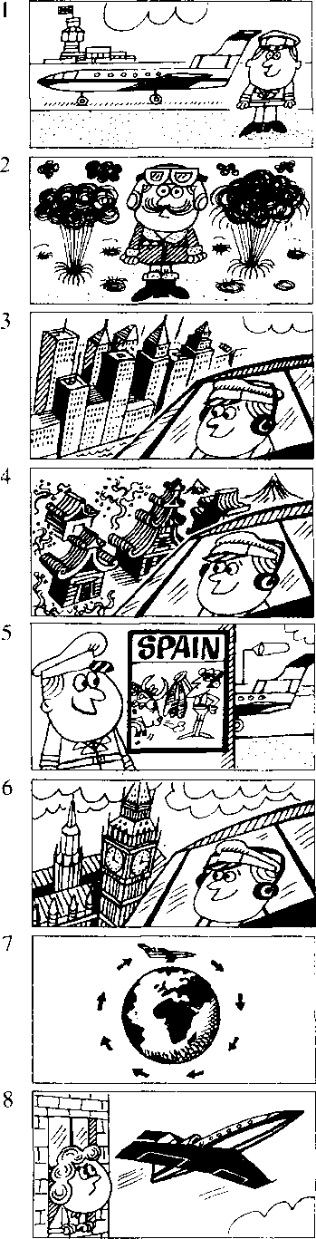

Lesson 93 Our new neighbour 我们的新邻居

Listen to the tope then answer this question. Why is Nigel a lucky man? 听录音，然后回答问题。为什么说奈杰尔很幸运？
Nigel is our new next-door neighbour. He's a pilot.
He was in the R.A.F.
He will fly to New York next month.
The month after next he'll fly to Tokyo.
Al the moment, he's in Madrid.
He flew to Spain a week ago.
He'll return to London the week after next.
He's only forty-one years old, and he has already been to nearly every country in the world.
Nigel is a very lucky man.
But his wife isn't very lucky.
She usually stays at home!

New words and expressions 生词和短语
pilot /'paiht fi. U r Gi reiurn v.返 l^{u}l New York -"nju:-pik; n.
Tokyo /'ookoo/ n.东京
Madrid/ma¹ dnd/^{l!}j德里
fly /flai/ (flew /flu:/, flown /floun/) v. K行

Notes on the text < 文注释
- next-door neighbour, 壁邻居。next-door 是一个复合词' 作定语。
- the R.A.F. = the Royal Air Force,英国皇家空4"
- He is only forty-one years old, and he has ...
本句中的and相、'彳f but （而……），起转折作用。

参考译文
奈杰尔是我们新搬來的隔壁邻居。他是个飞行员O
他曾/E皇家空军任职“
卜个丿J他将约,
再卜个月他将飞注东京0
现在他在马德里。他是一星期以前飞到西班牙的,
再卜个星期他将返问伦敦0
他只有41岁，但他却去过世界上几乎饪一个国家c
奈杰尔是个很幸运的人。但他的妻子运气不很好。她总是呆在家里!

Lesson 94 When did you/will you go to ・・.？
你过去/将在什么时候去……？

Listen to the tape and answer the questions. 听录音并回答问题。
last week | this week | next week | the week after next
last month | this month | next month | the month after next
last year | this year | next year | the year after next

Athens
Beijing
Bombay
6
London
7
Madrid
9
New York
12
Seoul
13
Stockholm
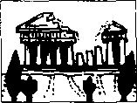
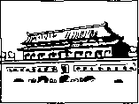
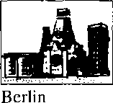
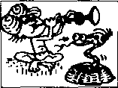
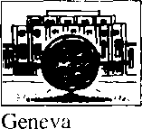
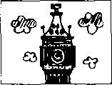
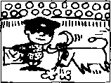
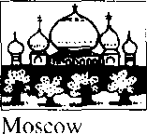
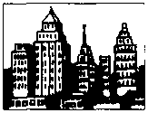
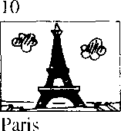
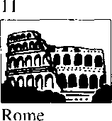
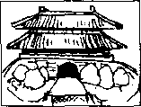
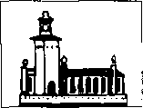
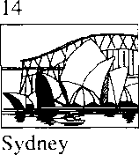
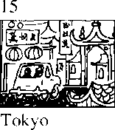

New words and expressions 生词 和短 i吾
Athens /'LeOinz/ n.雅典
Berlin /bsi'lin/ n. til林
Bombay bom'bei/ n. un：、关 Geneva /d^i'niivo； n.丨丨内 fL Moscow 'moskso/ n.史斯科
Rome /r^om/ n.罗
Seoul /saol/ n.汉城
Stockholm /'stokhaom/ n.斯德哥尔摩
Sydney /'sidni/ m.悉尼

Written exercises 书面练习
A Rewrite these sentences using will, 模仿例句改写、以下句子，用上will o
Example:
He went to Beijing last year. cMe uhU 尹 ta Reijuiq- 羿队.
1
2
3
4
5
He went to New York last week.
She went to Sydney last month.
I went to Paris the year before last.
We went to Stockholm last year.
They went to Geneva the week before last.
Answer these questions. 模仿例句回答以下问题o
Example:
Will you go to Athens next week?
(Beijing)
I
Will Helen return to Geneva next year?
Will you fly to London tomorrow?
Will you and Tom go to Madrid next year?
Will Tom arrive from Moscow next month?
Will Carol and Helen stay in New York next month?
(Bombay)
(Geneva) (London) (Madrid) (Moscow)

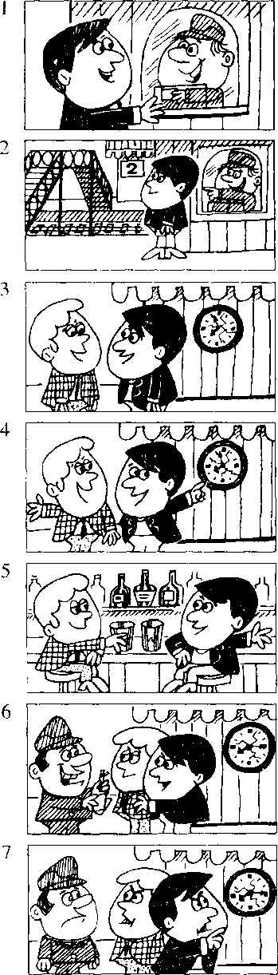
PORTER : | Tickets, please.
GEORGE: | We want to catch
 | the eight nineteen to London.
PORTER : | You've just missed it!
GEORGE: | What!
 | It's only eight fifteen.
PORTER : | Pm sorry, sir.
 | That clock's ten minutes slow
GEORGE: | When's the next train?
PORTER : | In five hours' time!

Lesson 95 Tickets, please,请把车票拿出来。

Listen to the tape then answer this question.

Why did George and Ken miss the train?

听录音，然后回答问题。为什么乔治和肯误了火车？
GEORGE : Two return tickets to London, please.
What time will the next train leave?
ATTENDANT : At nineteen minutes past eight.
GEORGE : Which platform?
ATTENDANT : Platform Two.
Over the bridge.
KEN : What time will the next train leave?
GEORGE : At eight nineteen.
KEN : We've got plenty of time.
GEORGE : H's only three minutes to eight.
KEN : Let's go and have a drink.
There's a bar 、
next door to the station.
GEORGE : We had better
go back to the station now, Ken.

New words and expressions 生词和短十吾
return ri t3in/ n. fF返 | bar /ba:/ n.酒吧
train /trein/11.火 4 | station /'steijan/ n. ^{z}|;-站、火车站’
pialtorni ^pl^ifoim/ //.站 台 | porter /'ports/ 几收票员
plenl) 'plcnti/ n.大 | catch /ksetj/ (caught /ko:t/, caught) v.赴上 miss /mis/ v.字昔过
Notes on the text 课文注释

- return ticket, fl：返票。
- next door to . . 相邻、在 隔壁。
- had bme’r相当「-情态动词、、'彳“最好'、讲，用于指现在和将要做的事情。各种人称后面的形式相 同.筒写作Pb国以：后面接动词原形0
- catch the eight nineteen to London.
eight nineteen是指8点19分的火车.to London是表示火车的行车方向_{o}
- in five hours' time, 5 小时之后
这里的介词in是“在……之后”的意思，复数名词hours后面用所有格，直接加表示所有格的 撇。就叮以，不必再加-喝

参考译文
乔 治：买两张到伦敦的往返票，下一班火车什么时候开？ 服务貝：8点19分。
乔治：在哪个站台？ 服务员：2号站台o过天桥
卩「卜一班火乍什么时候幵？
乔治：K点19分。
行：我们的时间还很宽裕。
乔治：现7点57分。
片：让我们去喝力、东西吧，车站旁有-个酒吧。
乔 治：肯、我们现在最好回到车站去.
收票员：请把个票拿出来。
乔治：我们要乘8点19分的车去伦敦。 收票员：你们刚好错过r那班车。
乔治：什么！现在只右8点15分_{c}
收票员：对不起、先'匚那个钟慢了 1()分钟G
乔治：卜-班车是什么时候？
收票员：5个小时以后！

Lesson 96 Whafs the exact time?确切的时间是几点?


Listen to the tape and answer the*questions. 听录音并回答问题a

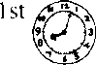
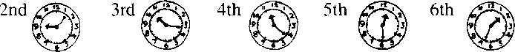

a minute/two minutes | a minute's/two minutes,
an hour/two hours | an hour,s/two hours'
a day/two days AGO | IN a day's/two days' TIME
a week/two weeks | a week⁵s/two weeks'
a month/two months | a month¹ s/two months'
a year/two years | a year⁵s/two years'

When did he/will he go to ...?他曾/将在什么时候去 T

Athens
Beijing
3
Berlin
Bombay
9
New York
11
Rome
12
Seoul
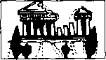
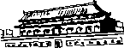
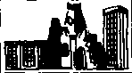
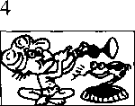
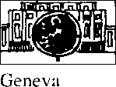
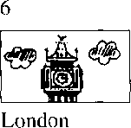
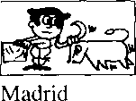

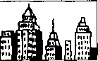
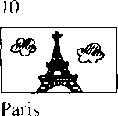
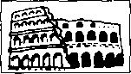
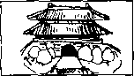
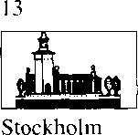
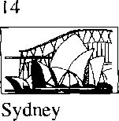
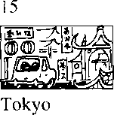

Written exercises 书 面练习
A Rewrite these sentences using had better. 用had better来改写以下句子：
Example:
We must go back to the station.
We kad batten 衫 hack t& tke
- 1 must stay here.
- We must wait for him.
- You must call a doctor.
- They must go home.
- She must hurry.
- You must be careful.
B Answer these questions using 'll. 模仿例句回答以下问题，用上7/。
Exomples:
- went to Beijing a year ago. What about you? a year's time
9 IL 密梱 必 a Ume.
Tom flew to Stockholm two weeks ago. What about Pamela?
two weeks* time
She 'll 版 to- 讥 Um&.
Dave and Alan returned to Tokyo two days ago. What about you and Jean? two days' time
We 'Ll 如 如s Ume.

Lesson 97 A small blue case 一只蓝色的小箱子

Listen to the tape then answer this question. Does Mr. Hall get his case back? M听录音，然后回答问题0霍尔先生有没有要回他的提箱？
MR. HALL : I left a suitcase
on the train to London the other day.
ATTENDANT : Can you describe it, sir?
MR. HALL : It's a small blue case
and it's got a zip.
There's a label on the handle with my name and address on it.
ATTENDANT : Is this case yours?
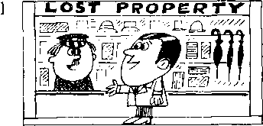
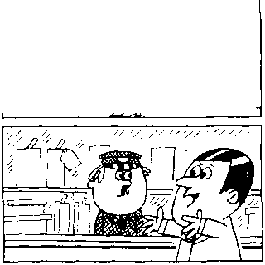
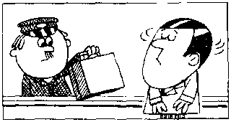
MR. HALL : No, that's not mine.
2
3
ATTENDANT : What about this one?
This one's got a label.
MR. HALL : Let me see it.
ATTENDANT : What's your name and address?
MR. HALL : David HalL
83, Bridge Street. ATTENDANT : That's right.
D. N. HalL
83, Bridge Street.
ATTENDANT : Three pounds fifty pence, please. MR. HALL : Here you are.
ATTENDANT : Thank you.
MR. HALL : Hey!
ATTENDANT : What\ the matter?
MR. HALL : This case doesn't belong to me!
You've given me the wrong case!
4
6
7
8
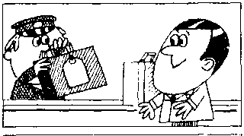
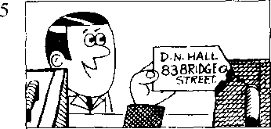
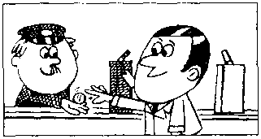
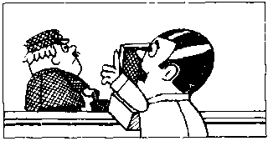
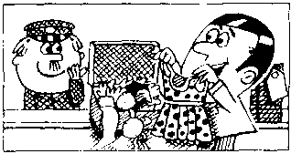

New words and expressions 生词 和短语
leave , ln\ ' (lefi /left/, left)「•遗帯 describe /di'skraib⁷ r.扌苻i丕 zip /zip n.拉鮭
label /'leib^l/ 几标签 handle /'haendl/ n.提手，把手 address /a'dres/ n.地址 pence 'pens/ n. penny 的复数形式 belong /bi'loij/ v.属于

Notes on the text 课文注释
the other day.几天前 It's got a zip.
句中的 it's = it has.不是 itiso
- Is this case yours^这箱子是您的吗？其中的yours是表示所有格的代词，所有格代词不能用于名词 之而、在旬中…般要重读。
- 83, Bridge Street,大桥街 83 号。
在英文中"弓地址时•要把门牌号放在街名的前面₀
- Hey!感叹诃丿II来表亦惊讶、疑问或用以引起注总。

参考译文
霍尔先牛.：几天前我把一只F提箱忘在幵往伦敦的火车上了 ₀
服 务员：先生•您能描述一下它是什么样子的吗？
霍尔先生：是只蓝色的小箱孔上面有拉链◎箱把上有一标签.上面与着我的姓名和住址。
服务员：这箱r•是您的叫？
霍尔光卞：不 ' 那不是我的0
服务员：这只是不是？这只箱r冇张标签。
雀尔先牛：：计.我看右
服务员：您的妳名和住址？
霍尔先4" 大卩•霍尔.大桥街83号。
服务员：那就向「o D N霍尔，大桥街83亏o
服弁员：请付3英镑初便丄L
霍尔先牛：：给您’
服务员：谢浏您…
霍尔先生：嗨！
服务员：怎么回事？
霍尔先生：这箱「不是我的！您给错了！

Lesson 98 Whose is it?它是谁的？

Whose are they?它们是谁的？

Listen to the tape and answer the questions. 听录音并回答问题o
Does this belong to me? | Is this mine?
Does this belong to you? | Is this yours?
Does this belong to him? | Is this his?
.  Does this belong to her? | Is this hers?
Do these belong to us? | Are these ours?
Do these belong to you? | Are these yours?
Do these belong to them? | Are these theirs?

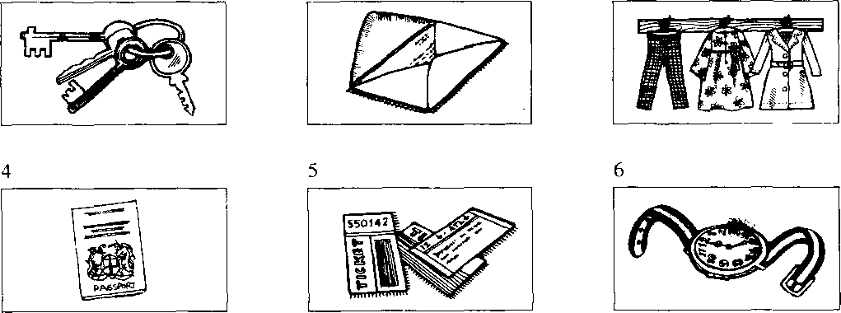

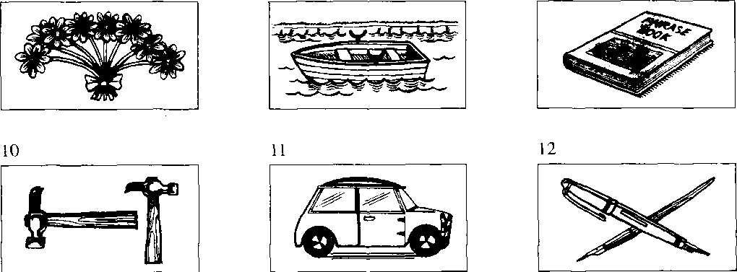

Written exercises 书 面练习
A Complete these sentences. 模仿例句完成以下句子，选用适当的所有格代词。
Example:
This dress belongs to my sister. It ke^.
- These things belong to my husband. They .
- This coat belongs to me. It
- These shoes belong to my wife. They .
- These books belong to my brother and me. They
- These pens belong to Tom and Jill. The pens .
- This suitcase belongs to you. It :
B Answer these questions. 模仿例句回答以下问题。
Examples:
Are these your keys?
'相 mme,.切終 me.
Is this John's letter?
坏力,#2切.切扁^ to- lum.
Are these my clothes?

- Is this Jane's passport?
- Are these their tickets?
- Is this your watch?
- Are these her flowers?
- Is this my boat?
- Is this Jim's phrasebook?
- Are these hammers Frank's and Gary's?
S Is this our car?
（） Are these the children's pens?

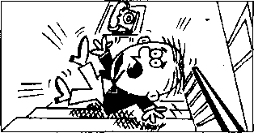
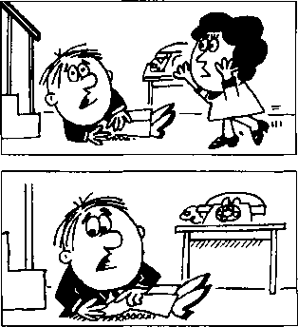
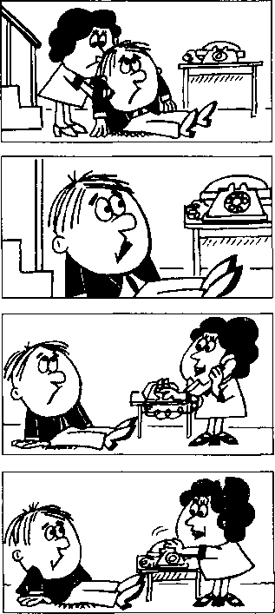


Listen to the tape then answer this question. Must Andy go to see the doctor?

听录音，然后回答问题。安迪需要去看医生吗？
ANDY : Ow!
LUCY : Whafs the matter, Andy? ANDY : I slipped and fell downstairs.
LUCY : Have you hurt yourself?
ANDY : Yes, I have.
- think that
I've hurt my back.
LUCY : Try and stand up.
Can you stand up? Here.
Let me help you.
ANDY : I'm sorry, Lucy.
I'm afraid that
I can't get up.
LUCY : I think that
the doctor had better see you. ril phone Dr. Carter.
LUCY : The doctor says that
he will come at once.
I'm sure that
you need an X-ray. Andy.

New words and expressions 生词 和短语
ow /ao/ bit.哎哟 | stand up /'stsend-'Ap/ 起立，站起来
slip/slip/V.滑倒，滑了一脚 | help /help/ u.帮助
fall /fo:l/ (fell /fcl/, fallen /Toilan/) v.落下，跌倒 | at once立艮卩
downstairs /_{t}daon'steaz/ adv.下楼 | sure /fo:/ adj. 一定的，确信的
hurt /h3：t/ (hurt, hurt) v.伤，伤害，疼痛 | X-ray /'eks-rei/ n. X 光透视
back /baek/ n.背

Notes on the text 课文注释
- fell downstairs,从楼梯上摔下来。
downstairs是副词，修饰fell ,作状语。
- Try and stand up.试着站起来。在英语中，常用and把两个动词连接在一起，如第13课的come upstairs and see it.这种句子往往用来鼓励某种动作。
- Here在这里是感叹词，意思是“来”或“喂”，引起别人注意。
- Let me help you.让我来帮你。其中let有“允许”的意思。注意在kt后面要加不带to的动词不 定式0
- The doctor says that he will come at once.
在英文中如果要把某人所说的话告诉另一个人，要用间接引语。间接引语不用引号，往往在引语 前加that等引导词。

参考译文
安迪：啊哟！
露西：怎么了，安迪？
安迪：我滑了一跤，从楼梯上摔下来了。
露西：你摔伤了没有？
安迪：是啊，摔伤了。我想我把背摔坏了。
露西：试试站起来。你能站起来吗？来，让我帮你。
安迪：对不起，露西，恐怕我站不起来。
露西：我想最好请医生来给你看一下0我去给卡特医生打电话O
露西：医生说他马上就来。安迪，我看你需要做一次X光透视。

Lesson 100 He says that .・・ She says that ・・・ They say that... 他/她/他们说……


Listen to the tape and answer the questions. 听录音并回答问题_{o}
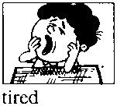
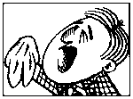
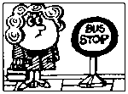
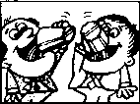
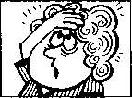
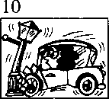
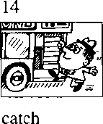
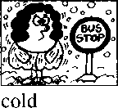
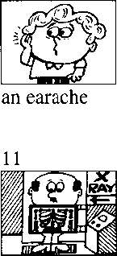
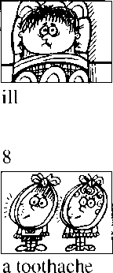
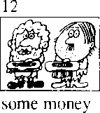
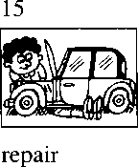
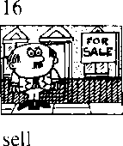
is/are
feel(s)
has/have
(got)
need(s) want(s)
can
must
will
 | says | is ...
 | thinks | feels ...
 | believes | has (got) ...
He | knows that he | needs ...
 | understands | wants ...
 | is afraid | can ...
 | is sorry | must...
 | is sure | will ...

2
1
5
a cold
a haircut
13
wait
thirsty
a headache
a licence
an X-ray

New words and expressions 生词和短十吾
licence /'lais^ns/ n.执冃W

Written exercises 书 面练习
A Rewrite these sentences.
模仿例句把下列句子改写成间接引语
Example:
He is drinking 'his milk. % 衣會 以成 必 办该切"如 mdk.
- She has found her pen.
- They must remain here.
- He remembers you.
- She doesn't speak English.
- They're washing the dishes.
B Answer these questions.
模仿例句用间接引语回答以下河题°
Examples:
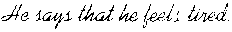
What's the matter with him? (fcel/tired)
What do they want?
(some/money)
that Ute^ dame
1 | What's the matter with him? | (feel/ill)
2 | What's the matter with her? | (have got/a headache)
3 | What does he want? | (a haircut)
4 | What's the matter with them? | (are/thirsty)
5 | What,s the matter with them? | (have/a toothache)
6 | What does she need? | (a licence)
7 | What does he want? | (an X-ray)
8 | What's the matter with her? | (is/cold)
9 | What's the matter with him? | (have got/a cold)
10 | What's the matter with him? | (have/an earache)

Lesson 101 A card from Jimmy 吉米的明信片

==l Listen to the tape then answer this question. Does Grandmother seem pleased to get a card from Jimmy? Why/Why not?

听录音，然后回答问题。收到吉米寄来的一张明信片，祖母是否显得高 兴？为什么/为什么不高兴？
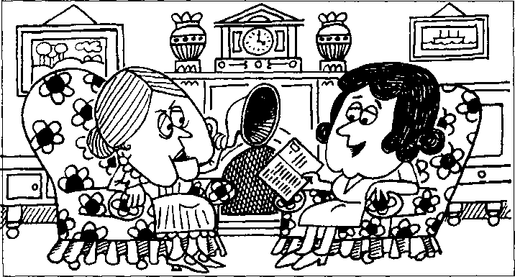

GRANDMOTHER : Read Jimmy's card to me please, Penny. PENNY : 'I have just arrived in Scotland
and I'm staying at a Youth Hostel.'
GRANDMOTHER : Eh?
PENNY : He says he's just arrived in Scotland.
He says he's staying at a Youth Hostel. You know he's a member of the Y.H.A.
GRANDMOTHER : The what?
PENNY: The Y.H.A., Mum.
The Youth Hostels Association.
GRANDMOTHER : What else does he say?
PENNY : Til write a letter soon.
I hope you are all well.'
GRANDMOTHER : What?
Speak up, Penny. I'm afraid I can't hear you.
PENNY : He says he'll write a letter soon.
He hopes we are all well.
'Love, Jimmy.'
GRANDMOTHER : Is that all?
He doesn't say very much, does he?
PENNY : He can't write very much
on a card, Mum.

New words and expressions 生词和短语
Scotland /'skotland/ n.苏格兰（英国） association /a.saosi'eipn/ n.协会
card /ka:d/ n.明信片 soon /suin/ adv.不久
youth /ju:O/ n.青年 write /rait/ （wrote /root/, written /Titn/） v.写
hostel /'hostl/ n.招待所，旅馆

Notes on the text 课文注释
- "I have just arrived in Scotland ... a Youth Hostel.
这是一个直接引语的例子o直接引语是英文中用书面语的形式来表示口语的方式，实际讲的话要 放在引号之间，句尾的标点符号也要放在引号之内。
- the Y.H.A. = the Youth Hostels Association
青年招待所协会。简称“青招协”。a Youth Hostel是一种为参加野外探险度假活动的青年人提供廉 价住宿的招待所.这种青年招待所实行会员制，首先要加入“青招协”才有资格享受这种待遇，
- speak up,大声地说。
- Love, Jimmy.爱你的吉米_{o}
Yours, Jimmy （你的，吉米）。这是朋友间通信时常用的结束语。
- He doesn't say very much, does he?
这是英文中的反意疑问句，它是由两部分组成的，前面是一个陈述句，逗号之后是一个简略问句。 反意疑问句可以用来确认自己的判断，获取真实的信息，还可以用来表示惊讶、愤怒等感情。如果 前一部分陈述句是肯定形式，简略问句就要用否定形式；如果前一部分是否定形式，后一部分则用 肯定形式。

参考译文
祖母：请把吉米的明信片念给我听听，彭妮。
彭妮•.“我刚到苏格兰，我现住在一家青年招待所0 ”
祖母：什么？
彭妮：他说他刚到苏格兰o他说他现住在一家青年招待所。您知道，他是“青招协”的一个成员， 祖母：什么？
彭妮：“青招协”，妈妈。青年招待所协会。
祖母：他还说了些什么？ ’
彭妮：“我很快会写信的O祝你们大家身体都好0 ”
祖母：什么？彭妮，大声一点。我可听不见你念的。
彭妮：他说他很快会写信的。他祝我们大家身体好。“谨此问候，吉米
祖母：就这些吗？他没写许多，是吗？
彭妮：在明信片上他写不了很多，妈妈。

Lesson 102 He says he ... She says she ・・・ They say they ・・. 他/她/他们说他/她/他们……


Listen to the tape and answer the questions. 听录音并回答问题O
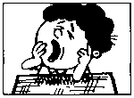
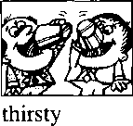
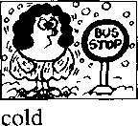
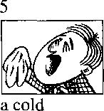
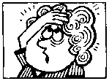
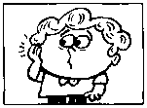
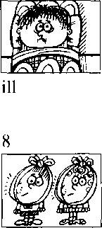
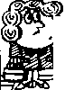
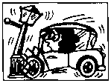
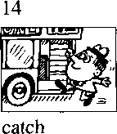
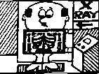
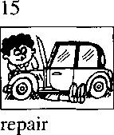
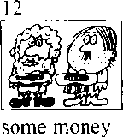
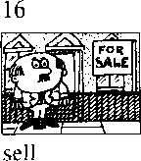
is/are
feel(s)
1
tired
has/have
(got)
6
a headache
7
an earache
a toothache
need(s) want(s)
can
must
will
a haircut
13
ffl
wait
10
a licence
11
an X-ray
says | is ...
thinks | feels ...
believes | has (got) ...
He knows he | needs …
hopes | wants ...
is afraid | can…
is sorry | must...
is sure | will...

Written exercises 书面纟东习
A Rewrite these sentences.
模仿例句把下列句子改写成间接引语。
Example:
He is drinking his milk.
ke ka^ milk.
1
2
3
4
5
She is shutting the door.
He is putting on his coat. He is reading this magazine. They are speaking to the boss. The sun is rising.
Look at this table. 注意以下表格o
He says he
cold
a bus
a haircut
has got | tired
feels | a cold
will sell | thirsty
needs | an X-ray
must wait for | an earache
 | his house
 | ill

Now write nine sentences.
利用上表中的短语，模仿例句写出9句话。
Example:
cMe. ke- ill.

Lesson 103 The French test 法语考试

Listen to the tape then answer this question. How long did the exam last? 听录音，然后回答问题。考试持续了多长时间？
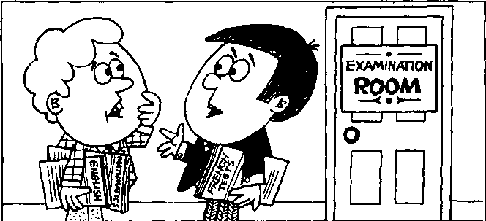
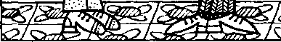
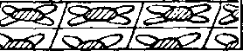

GARY: | How was the exam, Richard?
RICHARD : | Not too bad.  I think I passed in  English and Mathematics.  The questions were very easy. How about you, Gary?
GARY: | The English and Maths papers weren't easy enough for me.  1 hope I haven't failed.
RICHARD : | I think I failed the French paper.  I could answer sixteen of the questions.  They were very easy.  But I couldn't answer the rest.  They were too difficult for me.
GARY : | French tests are awful, aren't they?
RICHARD : | I hate them.  Pm sure I've got a low mark.
GARY : | Oh, cheer up!  Perhaps we didn't do too badly.  The guy next to me  wrote his name  at the top of the paper.
RICHARD :  GARY: | Yes?  Then he sat there  and looked at it for three hours!
209 | He didn't write a word!

New words and expressions 生词和短语
exam /ig'zaem/ n. 考 pass /pars/ il 及格，通过 mathematics "m&OSmaetiks/ （maths /mseGs/ 是缩写）
n.数学
question /'kwestjan/ n.问题 easy /'iizi/ adj.容易的 enough /i'nAi7 adv.足够地 paper /'peipa/ 几 考卷 fail /fell/ v.未及格，失败
answer / a:nsa/ v.回答 mark /maik/ n.分数 rest /rest/ n.其他的东西 difficult adj.困难的
hate /heit/ v.讨厌 low /bu/ adj.低的 cheer /tjia/ v.振作、振奋 guy /gar/ n.家伙，人 top /top/几上方，顶部

Notes on the text 课文注释
- I think I passed in English and Mathematics.我想我的英语和数学及格了。如果说通过某一个考试，直 接用动词pass；如果说通过某一科目，则用pass in ₀
- the English and Maths papers,英文和数学卷子□
paper这个词当“试卷”讲时，是可数名词。
- How about.. .? 怎么样？
用于征求他人意见或询问情况O
- easy enough for me,是指对我来说不难，我可以完成和通过◎而too difficult for me是指妇我來说太 难了.无法完成和通过。
- cheer up,振作起来。

参考译文
加里：考试考得怎样，理查德？
理查德：不算太坏，我想我的英语和数学及格了。题目很容易。加里，你怎么样？
加 里：英语和数学试题对我来说不很容易。我希望别不及格。
理查德:我想我的法语及不了格，我能回答其中的16道题。这些题很容易。
但我回答不出其余的题。那些题对我来说太难了。
加 里：法语太可怕了，你说呢？
理查德：我讨厌法语。我的法语成绩肯定很低。
加 里：啊，别灰心！或许我们考得还不太糟。坐在我旁边的那个人只在试卷顶端写了自己的名字。 理查德：是吗？ -
加 里：然后他就坐在那里，对着考卷看了 3个小时，一个字也没写！

Lesson 104 Too, very, enough 太、非常、足够

==Listen to the tape and answer the questions. 听录音并回答问题o
- could answer the questions.
They were very easy.
I couldn't answer the questions.
They were too difficult.
The questions were easy enough for me to answer.
The questions were too difficult for me to answer.

difficult
easy
C
clever
answer all the questions stupid H .
E
F
G
eat the cakes
buy the car
fresh
stale
L
climb the wall
soft
hard
low
sweet
high
eat the orange
sour
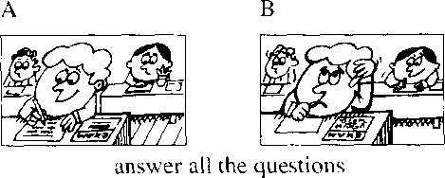
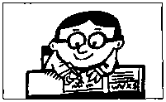
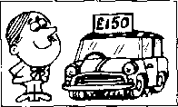
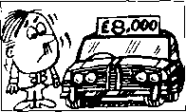
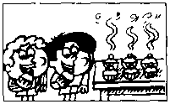
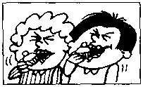
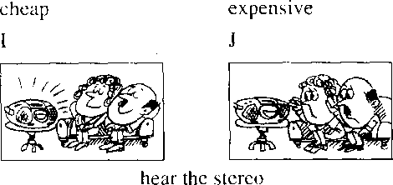
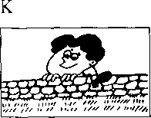
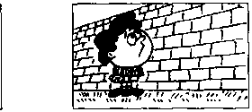
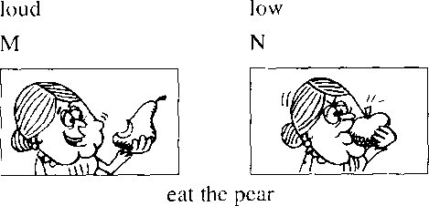
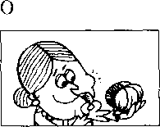
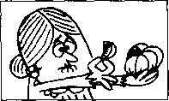

New words and expressions 生词和短语
clever/'kicvs/ adj.聪明的 | loud /laod/ adj.大声的
stupid /'stjurpid/ adj.笨的 | high /hai/ adj.高的
cheap /tji:p/ adj.便宜的 | hard /ha:d/ adj.硬的
expensive /ik'spensiv/ adj.贵白勺 | sweet /swi:t/ adj.甜的
fresh /frej/ “山.新鲜的 | soft /soft/ adj.软的
stale /stcil/ adj.变馒的 | sour /saoa/ adj.酸的
low /ho/ adj.低的，矮的

Written exercises 书面纟东习
A Complete these sentences using too, very or enough. 完成以下句子，用too, very或enough填空。
- I couldn't speak to the boss. He was busy.
- I couldn't go out. It was cold for me to go out.
- I could answer all the questions. They were easy.
- Is that suitcase light for you to carry?
- Is your brother old to be a member of our association?
- They couldn't see that film. They were young.
B Answer these questions.
模仿例句回答以下问题。
Examples:
Could he answer all the questions? (Yes/easy)
务辰 ccndd. 以以 钥&件4 脣 kim 处(^必边
Could he answer all the questions? (No/difficult)
1 | Could he buy the car? | (Yes/cheap)
2 | Could he buy the car? | (No/expensive)
3 | Could they eat the cakes? | (Yes/fresh)
4 | Could they eat the cakes? | (No/stale)
5 | Could they hear the stereo? | (Yes/loud)
6 | Could they hear the stereo? | (No/low)
7 | Could he climb the wall? | (Yes/low)
8 | Could he climb the wall? | (No/high)
9 | Could she eat the pear? | (Yes/soft)
10 | Could she eat the pear? | (No/hard)
1 1 | Could she eat the orange? | (Yes/sweet)
12 | Could she eat the orange? | (No/sour)

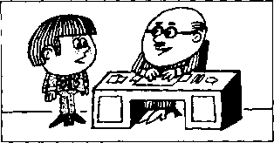
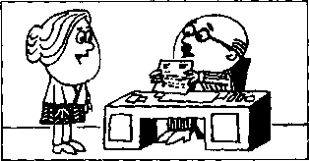
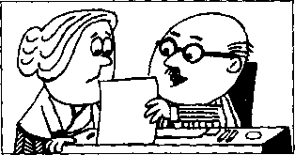
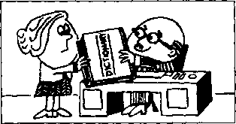

Lesson 105 Full of mistakes 错误百出

Listen to the tape then answer this question. What was Sandra's present? 听录音，然后回答问题。给桑德拉的礼物是什么？
THE BOSS : Where's Sandra, Bob?
I want her.
BOB : Do you want to speak to her?
THE BOSS : Yes, I do.
I want her to come to my office.
Tell her to come at once.
SANDRA : Did you want to see me?
THE BOSS : Ah, yes, Sandra.
How do you spell intelligent¹? Can you tell me?
SANDRA: I-N-T-E-L-L-LG-E-N-T.
THE BOSS : Thafs right.
You've typed it with only one 'L'.
This letter⁵s full of mistakes.
I want you to type it again.
SANDRA : Yes, 111 do that.
I'm sorry about that.
THE BOSS : And here's a little present for you. SANDRA : What is it?
THE BOSS : K's a dictionary.
I hope it'll help you.

New words and expressions 生词和短语
spell /spel/ (spelt /spelt/, spelt) v.拼写 present /'prez^nt/ n.礼物
intelligent /in'telid3^nt/ adj.聪明的，有智慧的 dictionary /'dikfonari/ n.词典 mistake /mi'steik/ n.车昔误

Notes on the text 课文注 #
- Do you want to speak to her?
在这句话中，to speak是动词want的宾语，而这个结构 动词原形前加to 在英文中被不尔
为动词不定式。本课用动词不定式作宾语的例句还有：
I want her to come to my office;
Tell her to come at once;
Did you want to see me;
I want you to type it again 等 _{o} 、
- full of ..充满了 。
- And here's. .. _{o}
这里and表示承上启R使上下文紧密联系，当“于是”，“因此''讲。

参考译文
老 板：鲍勃：桑德拉在哪儿？我要找她。
鲍勃：您要同她谈话吗？
老板：是的，我要她到我的办公室来。叫她马上就来。
桑德拉:您找我吗？
老 板：啊，是的，桑德拉。“intelligent”怎样拼写？你能告诉我吗？
桑徳拉：I — X — T — E — L — L — I — G — E — X — T ₀
老 板：对的。但你只打了 1个“L”。这封信里错误百出。我要你重打一遍。 桑德拉：是，我重打。对此我感到很抱歉。
老板：这里有一件小礼物送你O
桑德拉：是什么？
老 板：是本词典O我希望它能对你有所帮助。

Lesson 106 I want you/him/her/them to...
我要你/他/她/他们……

Tell him/her/them to ...
告诉他/她/他们……
Listen to the tape and answer the questions. 听录音并回答问题。
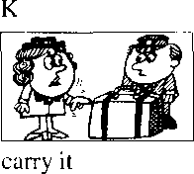
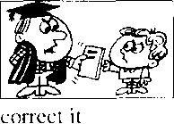
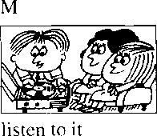
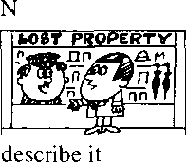
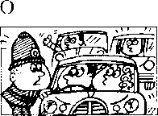
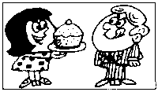
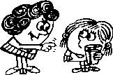
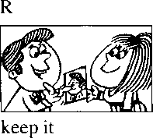
P
Q
move it
try it
finish it

I don't want you/him/her/them to … 我不要你/他/她/他们 Tell him/her/them not to .--告诉他/她/他们不要……
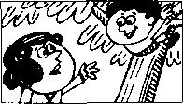
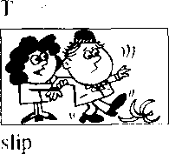
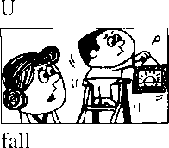
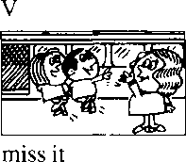
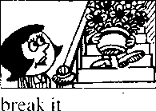
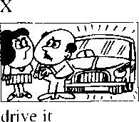
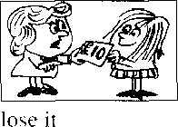
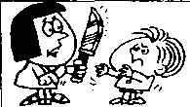
hurt yourself
W
cut yourself

New words and expressions 生词和短语
correct /ko'rekt/ y. SliE,纟lE keep /ki:p/ v.保存，保乾

Written exercises 书 面练习
A Rewrite these sentences.
模仿例句将以下祈使句改写成带有动词不定式的陈述句：
Example:
Please repair it. 9 如初Z 纾林 紿久沥 it.
Please spell it.
Please telephone him.
- Please wear it.
- Please ask her.
Please tell them.
Please help us.

Write questions ond answers. 模仿例句改写以下句子o
Example:
Type it again!
What me da? 9 外所 加 初诺 d
Carry it!
Correct it!
- Listen to it!
- Describe it!
- Move it!
- Try it!
- Finishit!
- Keep it!

Rewrite these sentences.
模仿例句改写以下句子，注意不定式的否定形式O
Example:
Don't type it again! (He/her)
必毎幼％ ke^ tnai to-初圮 ii attain. cM-e to-初跄沈吵湖.
Don't hurt yourself! (She/him) 3
Don't slip! (She/him)
Don't fall! (She/him)
Don't miss it! (She/them)
Don't break it! (She/him)
Don't drive it! (He/her)
Answer these questions. 模仿例句回答以下问题。
Example:

Why is he speaking to her? (type it again)
/leccudSe he，'t k&v to-切必 it aqam.

- Why is she speaking to him? (hurt himself)
- Why is she speaking to him? (slip)
- Why is she speaking to him? (fall)
- Why is she speaking to them? (miss it)
- Why is she speaking to him? (break it)
- Why is he speaking to her? (drive it)

Lesson 107 Its too small.太小了。
rr~n|
IBMBM

Listen to the tape then answer this question.

What kind of dress does the lady want?

听录音，然后回答问题。这位女士想要什么样的服装?
ASSISTANT : Do you like this dress, madam? LADY : I like the colour very much.
It's a lovely dress,
but it's too small for me.
ASSISTANT : What about this one?
It's a lovely dress.
It's very smart.
Short skirts are in fashion now.
Would you like to try it?
LADY : All right.
LADY : I'm afraid this green dress
is too small for me as well.
It's smaller than the blue one.
LADY : I don't like the colour either.
It doesn't suit me at all.
I think the blue dress is prettier.
LADY : Could you show me
another blue dress?
I want a dress like that one, but it must be my size.
ASSISTANT : I'm afraid I haven't got a larger dress. This is the largest dress in the shop.
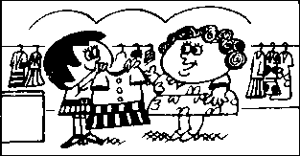
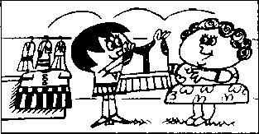
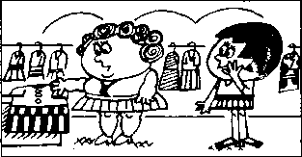
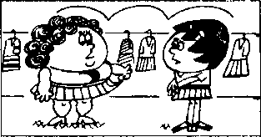
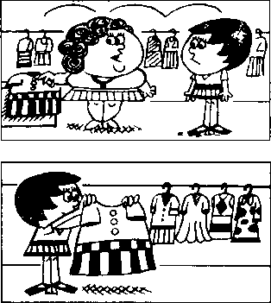

New words and expressions 生词 和短语
as well /gz-'wel/ 同样
madam /'maedom/ n.夫人，女士（对妇女的尊称） suit /su:t/ v.适于 smari ^{z}sma:t/ adj.漂見的 pretty /'pnti/ adj.漂亮的

Notes on the text 课文注释
- madam,是对妇女的一种尊称，服务行业的人员常用此称呼；同时，对于不知姓名的女士也可以用此 来表示尊重。这个单词也可拼作ma'am
- Would you like . . . ?你愿意……吗？用来表示委婉的请求或提议。
- It's smaller than the blue one.它比那套蓝色的小一些。
在英文中，为我们把一个人或物与另一个人或物进行比较时，就要用形容词的比较级。大多数单音 节的形容词的比较级是在原级后面加上-er,如small 一 smaller, large 一 larger^有些以-y结尾 的双音节形容词，如果-y前面是一个辅音字母，变比较级时就要把-y先变为—然后再加-er, pretty — prettier。
如果在句子中提到了对比的双方，就必须在比较级后面加上than,如It*s smaller than the blue one. 如果形容词比较级所指很清楚，比较级也可以独立存在，如I haven，E goi a larger dress.
- Could you ... ?
用在表示请求，比Can you ... ?更婉转客气。
例：Could you tel] me the way to the post office?
请你告诉我去邮局怎么走好吗？
- This is the largest dress in the shop.这是店里最大的一件衣服 ₀
句中使用了形容词的最高级，它是在形容词原级后面加上-est,在最高级形容词之前要加定冠词 the _{o}最高级用在将一个人或物与其他一个以上的人或物作比较时_{o}

参考译文
店员：夫人，您喜欢这件衣服吗？
女士：我很喜欢这颜色。这是件漂亮的衣服，可是对我来说太小了。
店员：这件怎么样？这是件漂亮的衣服，它很时髦。短裙现在很流行。您要试一试吗？ 女士 ：好吧。
女士 ：恐怕这件绿色的我穿着也太小了。它比那件蓝色的还要小。
女士：我也不喜欢这种颜色。这颜色我穿根本不合适。我认为那件蓝色的更漂亮些。
女士：您能再给我看一件蓝色的吗？我想要一件和那件一样的，但必须是我的尺寸。
店员：恐怕没有更大的了。这是店里最大的一件。

Lesson 108 How do they compare?它们的比较级和最高级是什么?

Listen to the tape and answer the questions. 听录音并回答问题
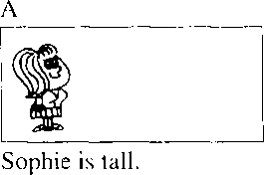
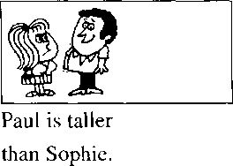
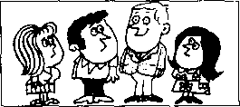
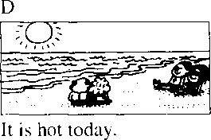
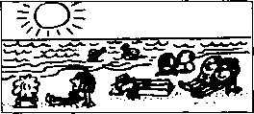
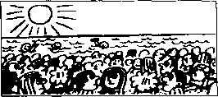
C
Hans is the tallest
student in our class.
It was hotter
The day before yesterday
yesterday.
was the hottest day in the year.
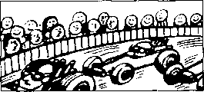
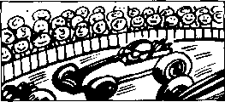
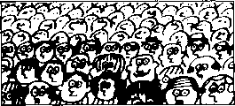
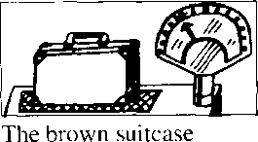
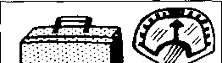
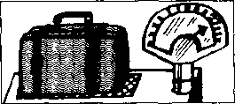
G
There was a large crowd at the race last year.
H
This year the crowd is larger.
It is the largest
crowd I have ever seen.
is heavy.
L
The green suitcase is
The blue suitcase is heavier than the brown one.
the heaviest of them all.

Written exercises 书 面练习
A Look at these words.
注意这些形容词的比较级形式O
cold 一 colder; nice — nicer; hot — hotter: heavy 一 heavier
Now complete these sentences. 模仿例句完成以下句子o
Example:
It is warm today, but it was yesterday.
Hi 必 么kut it 必0 uM/bmeA,好■以痍
It is cool today, but it was
1
2
3
4
5
.yesterday, yesterday.
yesterday.

It is wet today, but it was
He's late again today, but he was
This test is easy, but that one is This bookcase is large, but that one is
Write new sentences. 模仿例句改写以下句子。
Example:
I am very young.
- am. tkcui
9 am the 舛绍仔眾 M the clcM.
I am very old.
I am very tall.
- I am very lazy.
- I am very heavy.
- I am very lucky.
- I am very fat.
- I am very thin.
- I am very big.

Write new sentences. 模仿例句改写以下句子O
Example:,
This policeman is tall.
出e 處 talledi policeman- 9 haue eueA.

1 This street is clean.
3 This river is long.
2 This man is old.
4 This woman is short.
- This knife is blunt.
- This car is cheap.

Listen to the tape then answer this question.

What does Jane hove with her coffee?

听录音，然后回答问题。喝咖啡时简吃了什么？
CHARLOTTE : Shall I make some coffee, Jane?
JANE : That's a good idea, Charlotte.
CHARLOTTE : Ifs ready.
Do you want any milk?
JANE : Just a little, please.
CHARLOTTE : What about some sugar?
Two teaspoonfuls?
JANE : No, less than that.
One and a half teaspoonfuls, please. That's enough for me.
JANE : That was very nice.
CHARLOTTE : Would you like some more?
JANE : Yes, please.
JANE : I'd like a cigarette, too.
May 1 have one?
CHARLOTTE : Of course.
I think there are a few in that box.
JANE : I'm afraid it's empty.
CHARLOTTE : What a pity!
JANE : It doesn't matter.
CHARLOTTE : Have a biscuit instead.
Eat more and smoke less!
JANE : That's very good advice!

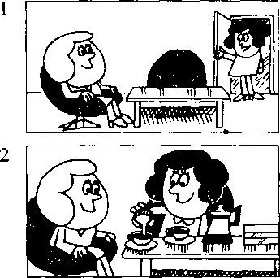
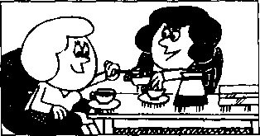
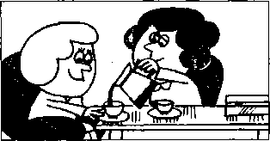
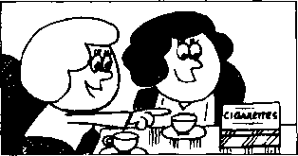
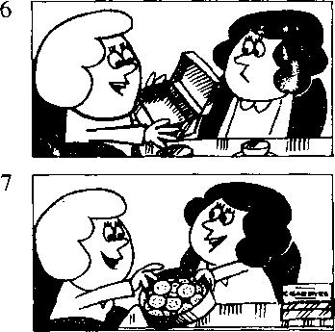

New words and expressions 生词和短语
idea /ai'dis/ n.主意
a lit氏少许（用于不可数名词之前） teaspoonful /'ti:spu:nful/ n. 一满茶匙 a few /a-'fju:/几个（用于可数名词之前） pity /'piti/ n.遗憾
instead /m'sted/ adv.代替
less/les/（7 J/', （little的比较级）较少的，更小的 advice /ad'vais/ n.建议，忠告

Notes on the text 课文注释
- less than that,意思是"比那稍微少一些"，其中的that指上文中的two teaspoonfuls ₀
- I'd = I would; I'd like .…，我想要 。
- What a pity!真遗憾。英语中常用“What a +可数名词”和“What +不可数名词”的结构来表示
感叹o k
参考译文
夏洛特：我来煮点咖啡好吗，简？
简：这是个好主意，夏洛特。
夏洛特：咖啡好了，你要放点奶吗？
简：请稍加一点0
夏洛特：加些糖怎么样？两茶匙行吗？
简：不，再少一些。请放一勺儿半。那对我已足够了。 简：太好了。
夏洛特：你再来点吗？
简：好的，请再来一点O
简：我还想抽枝烟。可以给我f枝吗？
夏洛特：当然可以。我想那个盒子里有一些。
简：恐怕盒子是空的O
夏洛特：真遗憾！
简：没关系。
夏洛特：那就吃块饼干吧。多吃点，少抽点！
简：这是极好的忠告啊！

Lesson 110 How do they compare?它们的比较级和最高级是什么？


Listen to the tape and answer the questions. 听录音并回答问题o
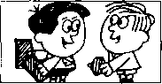
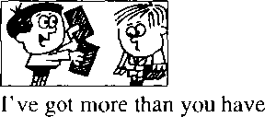
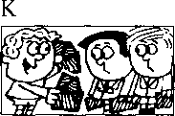
Have you got any chocolate?
I've got the most.
- haven't got much.
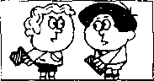
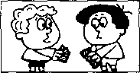
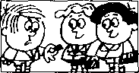
Have you got any chocolate?
M
I've got less than you have.
N
I've got the least.
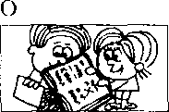
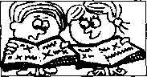
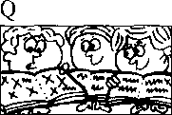
fve got very little.
I've made more than you have.
I've made the most.
Have you made any mistakes?
- haven't made many.
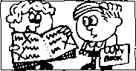
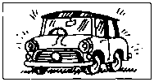
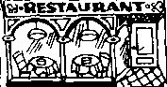
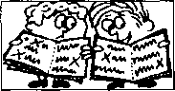
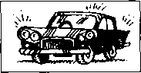
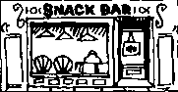
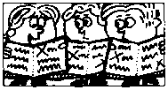
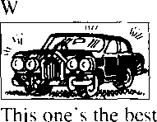
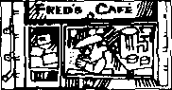
Have you made any mistakes? I've made very few.
U
You must see my new car.
It's very good.
X
You mustn't go to that restaurant.
It's very bad.
S
Fve made fewer than you
have.
V
This one's better.
Y
This one's worse.
T
I've made the fewest.
I've ever seen.
Z
This one's the worst
I've ever seen.

New words and expressions 生词和短语
most /moost/ adj. （ many, much 的最高级）最多的 worse /w3：s/ adj. （bad 的比较级）更坏的 least /liist adj. （little的最高级）最小的，最少的 worst /w3：st/adj. （bad的最高级）最坏的 best /best.' adj. ! good的最高级）最好的

Written exercises 书 面练习
A Complete these sentences using much, many, less or fewer. 完成以下句子，用much, many, less或fewer填空。
- I haven't got any pens. I haven't got either.
- I've got some money. Tve got than you have.
- 1 haven't got any money. I haven't got either.
- I've got some books. I've got than you have.
B Answer these questions.
模仿例句回答以下问题。
Examples:
Have you got any coffee? — 9 't <pi frntck Hue q&t UttU.
Have you got any biscuits?——9t丿绍衫^如終聞必.
- Have you got any jam?
- Have you got any potatoes?
- Have you got any oranges?
- Have you got any vegetables?
- Have you got any meat?
- Have you got any money?

C Write new sentences.
模仿例句、将以下句子改成比较级。
Example:
I've got some coffee.
9 必 epi m&ne tkem 好妃 kaue.
- Fve got some soap.
- I've got some fruit.
- I've got some books.
- fve got some eggs.
- I've got some presents.
6 I've got some stationery.
D Write new sentences. 模仿例句改写以下句子。
Examples:
I've got some coffee.—"槌 舛^金以力吆宠以初 姐必 9'g 钥 tke
fve got some biscuits. 一项膈 疝血物以叼好以 如頌.丿据疝 卷血切.
- I've got some jam.
- I'\e got some potatoes.
- Fve got some vegetables.
- I've got some oranges.
- I've got some meat.
- fve got some money.

Lesson 111 The most expensive model 最品贵的型号

Listen to the tape then answer this question.

Can Mr. Frith buy the television on instalments? How does it work?

听录音，然后回答问题。弗里斯先生可以用分期付款的方式购买电视机

吗？如何操作呢?
MR. FRITH : I like this television very much.
How much does it cost?
ASSISTANT : It's the most expensive model
in the shop.
It costs five hundred pounds.
MRS. FRITH : That's too expensive for us.
We can't afford all that money.
ASSISTANT : This modeFs less expensive
than that one.
It's only three hundred pounds.
But, of course, it's not as good as the expensive one.
MR. FRITH : I don't like this model.
The other model's more expensive, but it's worth the money.
MR. FRITH : Can we buy it on instalments? ASSISTANT : Of course.
You can pay a deposit of thirty pounds, and then fourteen pounds a month for three years.
MR. FRITH : Do you like it, dear? MRS. FRITH : I certainly do,
but I don't like the price.
You always want the best, but we can't afford it.
Sometimes you think you're a millionaire!
MR. FRITH : Millionaires don't buy things
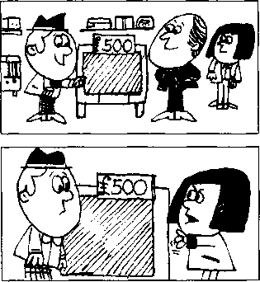
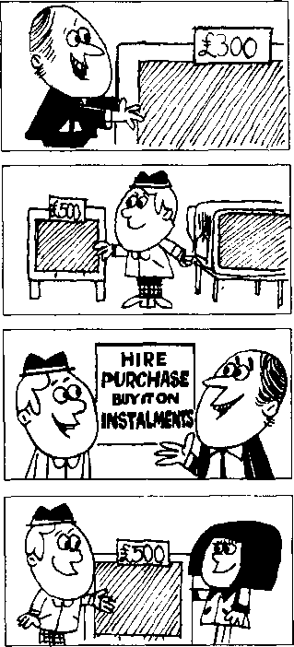
on instalments!

New words and expressions 生词和短语
instalment /in'stozlmant/ n.分期付款 price /prais/ n.价格 millionaire /.milja'nea/ n.百万富翁
model /'modi/ n.型号\ 式样 afford Z^'foid/ v.付得起（钱） deposit /di'pozit/ 〃.预付定金

Notes on the text 课文注释
1大多数两个以上音节的形容词可与more/less连用构成其比较级形式，与most/least连用构成其最 高级形式，如本课中的几个例子：This model's less expensive than that one; The other model's more expensive; It's the most expensive model in the shop.
- it's not as good as the expensive one,它不如那种价格高的好。not as ... as ...可以用来进行比较， 意思是，放在前面的人或物在程度上低于后面的人或物。
- buy . . . on instalments,以分期付款的方式购买。

参考译文
弗里斯先生：我非常喜欢这台电视机。请问它多少钱？
店 员：这是店里最贵的型号o它的售价是500英镑_{o}
弗里斯夫人：这对我们来说是太贵了。我们花不起那么多钱。
店 员：这种型号的比那种要便宜些。它只要300英镑。但是，它当然没有价钱高的那种好
弗里斯先生：我不喜欢这种型号。那一种型号价格是贵一些，但它值这么多钱。
弗里斯先生：我们可以用分期付款的方式购买吗？
店 员：当然可以。您可以先付30英镑定金，然后每月14镑，3年付清。
弗里斯先生：你喜欢吗，亲爱的？
弗里斯夫人：我当然喜欢，但是我不喜欢这个价钱。你总是要买最好的，可我们买不起°有时候 你认为自己是个百万富翁！
弗里斯先生：百万富翁是不会分期付款买东西的！

Lesson 112 How do they compare?它们的比较级和最高级是什么？

Listen to the tape and answer the questions. :听录音并回答问题。

As ... as 像 一样
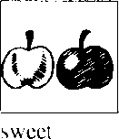
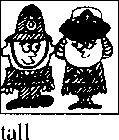
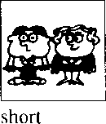
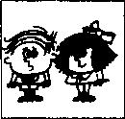
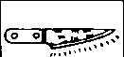
d
old
f
blunt
sharp

Not as ... as 不像 一样

g
clean
smart
light
new
expensive
m
This test is difficult.
n
T£^r NO 2.
U2.N1QX
口
This test is
more difficult.
任 St 23
This is the most difficult test I have ever done!
P
This book is
q
This book is less interesting.
r
This is the least interesting book I have ever read!
interesting.
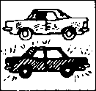
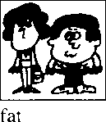
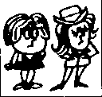
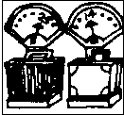
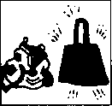
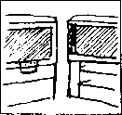
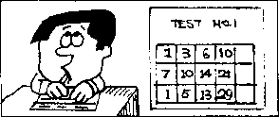
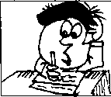
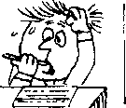
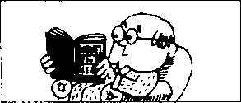
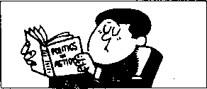
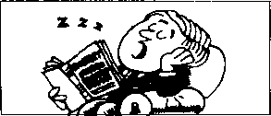

Written exercises 书 面练习
A Complete these sentences. 模仿例句完成以下句子c
Examples:
This dress is long, but that one is 必 Jam 處 *W tkat(u^e.场
Tom is intelligent, but Bill is .
處 kut QM 功 mane utielUf^d.
- This book is cheap, but that one is
This book-is expensive, but that one is
This question is easy, but that one is
This question is difficult, but that one is
Write questions and answers. 模仿例句提问并回答c
Example:
green apple/sweet/red apple
电 ad- ^Uaeet 力 t/ie ^ied
A/a, d 眾 t. <yiee^i apple 't ad 以 tkec&prde.
policeman/tall/policewoman
man/short/woman
- boy/old/girl
- red pencil/blunt/green pencil
- blue car/clean/red car
- woman/fat/man

Write new sentences. 模仿例句改写以下句子。
Examples:
This test is less difficult, (ever done)
N&,沈必〃 t. 如泌 旳您WZ
少‘4 tk& modi 吻齐法 9 必次datne.
My book is more interesting than yours, (ever read)
N®, d必"'t. 9金以 必如必払久
9" the k&ak 9 绍 &^ead.
- My radio is less expensive than yours, (ever seen)
- Tom is less intelligent than Bill, (person/ever met)
- My book is less interesting than yours, (ever read)
- This test is more difficult, (ever done)
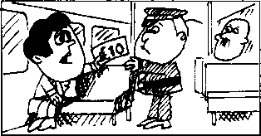
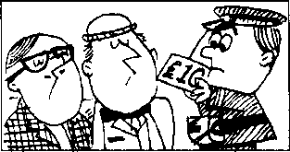
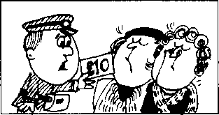
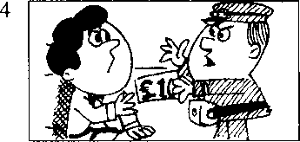
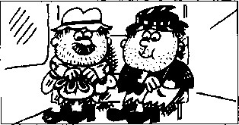
TWO TRAMPS :
1st TRAMP :
2nd TRAMP :

Lesson 113 Small change 零钱

Listen to the tape then answer this question. Who has got some small change?

听录音，然后回答问题。谁有零钱?
CONDUCTOR : Fares, please!
MAN : Trafalgar Square, please.
CONDUCTOR : Fm sorry, sir.
- can't change a ten-pound note. Haven't you got any small change?
MAN : Fve got no small change,
I'm afraid.
CONDUCTOR : ril ask some of the passengers.
CONDUCTOR : Have you any small change, sir? 1st PASSENGER : Fm sorry.
Fve got none.
2nd PASSENGER : I haven't got any either.
CONDUCTOR : Can you change
this ten-pound note, madam?
3rd PASSENGER : I'm afraid I can't.
4th PASSENGER : Neither can I.
CONDUCTOR : I'm very sorry, sir.
You must get off the bus. None of our passengers can change this note. They're all millionaires!
Except us.
I've got some small change.
So have I.

New words and expressions 生词 和短语
conductor /kan'dAkto/ n.售票员 | none /nxn/pron.没有任何东西
fare /fca/ n. -费、车票 | neither /'nards/ adv.也不
change /tfeind3/ v.兑换（钱） | get off下车
note /noot/ n.纸币 | tramp /trsemp/ n.流浪汉
passenger /'paesind3o/ n.乘客 | except /ik sept/ prep.除 夕卜

Notes on the text 课文注释
- Fares, please!请买票！这是公共车辆售票员用语。
- Trafalgar Square,特拉法加广场，位于伦敦市区。
- I've got no small change,我没有一点零钱。no +名词表示所指的东西全然没有，以上这句话比“I haven't got any small change.,,更强调没有任何一点零钱□
- Fve got none.这里是指零钱（不可数名词）。none也可与可数名词连用⁵如none of our passengers
can change this note. -
- Neither can I.
当有人说了一句否定意义的话，其否定的内容也适于你或另外的人或事物时，可以釆用这种简略的 句式。注意这种简略句式中主语和动词（包括be）的顺序。
- get off the bus, 2、车。
- So have I.
当有人说了一句肯定意义的话，其肯定的内容也适于你或另外的人或事物时，可以采用这种简略的 句式。注意这种简略句式中主语和动词（包括be）的顺序°

参考译文
售票员：请买票！
男 子：请买一张到特拉法加广场的票。
售票员：对不起，我找不开10英镑的钞票。您没有零钱吗？
男 子：恐怕我没有零钱。
售票员：我来问问其他乘客O
售票员：先生，您有零钱吗，
乘客1 ：对不起，我没有。
乘客2 ：我也没有
售票员：夫人，您能把这顶英镑的钞票换开吗？
乘客3 ：恐怕不能₀
乘客4 ：我也不能o
售票员：非常抱歉，先生。您必须下车。我们的乘客中没人能换开这张钞票。他们都是百万富翁！
二流浪以：我们俩除外O
流浪汉1 :我有零钱。
流浪汉2 ：我也有。


Listen to the tape and answer the questions. 听录音并回答问题o

Have you got any chocolate?
I haven't got any. I've got no chocolate, fve got none.
q
I haven't any either.
Neither have I.
Have you got any
envelopes?
I haven't got any.
t
I haven't any either.
Neither have I.
Eve got no envelopes.
fve got none.
cake?
w
So have I.
biscuits?
fve got some.
So have I.
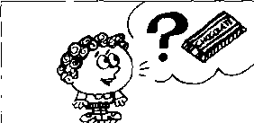
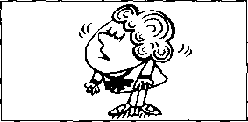
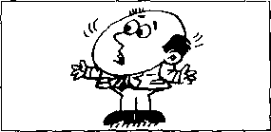
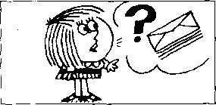
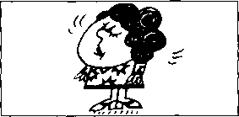
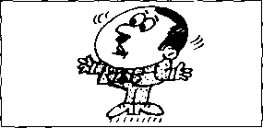
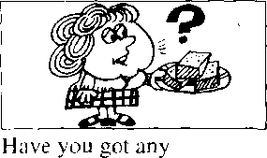
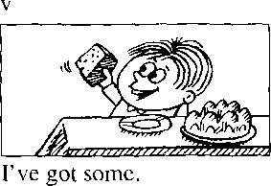
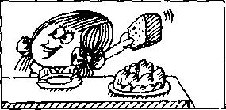
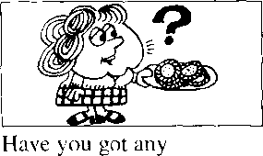
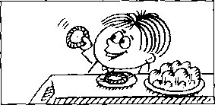
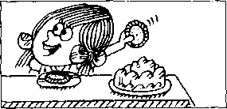

Written exercises 书 面练习
A Rewrite these sentences.
模仿例句改写以下句子，用m来表示否定:
Example:
There isn't any milk in that bottle,孚么好切必 mdk s that bMU.

- There aren't any books on that shelf.
- I havengot any money.
B Answer these questions.
模仿例句回答以下问题o

- There isn't any coffee in this tin.
- I didn't see any cars in the street.

Example:
Have you got any beer?
N@, 9 龙*以 <pt 04^ 匾4.
9 (pt g been,. 9'u^ (jot 织

- Have you got any milk?
- Have you got any envelopes?
C Write new sentences.
模仿例句完成以下句子o
Example;
I'm not tired.
9. 9 m not

- Have you got any magazines?
- Have you got any bread?

- wasn't at church yesterday.
I'm not hungry.
I didn't meet him.
I can't swim.
I'm not a doctor.
I don't like ice cream.
Write new sentences. 模仿例句完成以下句子
Example:
I'm tired.
务 % tiAed,如.

- I'm hungry.
- I met him.
I was at church yesterday.
I like ice cream.
I can swim.
I'm a doctor.

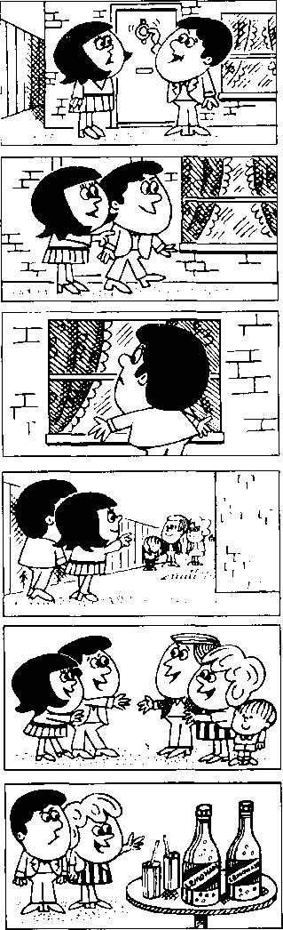
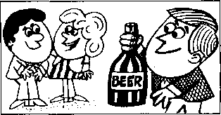
2
3
4
5
6

Lesspn 115 Knock, knock!敲敲门!


Listen to the tape then answer this question. What does Jim have to drink? 听录音，然后回答问题。吉姆只能喝什么饮料？
HELEN : Isn't there anyone at home?
JIM : ril knock again, Helen.
Everything's very quiet.
I'm sure there's no one at home.
HELEN : But that's impossible.
Carol and Tom invited us to lunch. Look through the window.
HELEN : Can you see anything?
JIM : Nothing at all.
HELEN : Let's try the back door.
JIM : Look! Everyone's in the garden.
CAROL : Hello, Helen. Hello, Jim.
TOM : Everybody wants to have lunch in the garden.
It's nice and warm out here.
CAROL : Come and have something to drink. JIM : Thanks, Carol.
May I have a glass of beer please?
CAROL : Beer?
There's none left.
You can have some lemonade.
JIM: Lemonade!
TOM : Don't believe her, Jim.
She's only joking.
Have some beer!

New words and expressions 生词 和短语
anyone /'eniwAn/pron.（用于疑问句，否定式） 任何人
invite /in'vait/v.邀请
anything /'eniOrrj/pron.任何东西 nothing /'nA0ig/ pron.什么也没有 lemonade /Jema'neid/ n.柠檬水 joke /d3ouk/ v.开玩笑
knock /rrnk/ 卩.敲，扌丁
everything /'evriOiq/ pron. 一切事物 quiet /'kwaist/ adj.宁静的，安静的 impossible /im'pnsib^l/ adj.不可能的

Notes on the text 课文注释
- Isn't there anyone at home?家里没人吗？在英语中，由 some, any, no, every 与-one,-thing 组成的 复合词，起代词作用，常被称为不定代词，这是因为我们常常不清楚其所指的是谁或什么。
- nice and ...
用于形容词或副词前以加强语气。一般表示褒义，但有时也用于贬义。
- There's none left. 一点儿都没剩下。
句中的left是个过去分词，用来修饰none_{o}

参考译文
诲伦：家里没有人吗？
吉 姆：海伦，我再敲一次。毫无动静，肯定家里没有人。
海 伦：但这是不可能的。卡罗尔和汤姆请我们来吃午饭。从窗子往里看看」
海伦：你能看见什么吗？
吉姆.•什么也看不见0
海伦：让我们到后门去试试。
吉姆：瞧！大家都在花园里。
卡罗尔：你好，海伦。你好，吉姆。
汤 姆：大家都想在花园里吃午饭。这外面挺暖和。
*
卡罗尔：来喝点什么0
吉 姆：谢谢，卡罗尔。给我一杯啤酒好吗？
卡罗尔：啤酒？ 一点都不剩了。你可以喝点柠檬水。
吉姆：柠檬水！
汤 姆：吉姆、别信她的。她只是在开玩笑。喝点啤酒吧！

Lesson 116 Every, no_{s} any and some 每一、无、若干和一些


Listen to the tape and answer the questions. 听录音并回答问题o
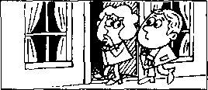
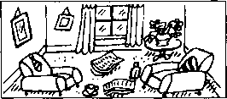
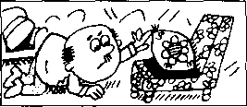
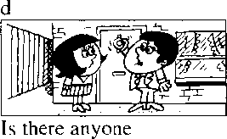
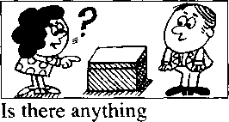
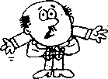
Everyone is asleep.
everything is untidy.
I looked for my pen
everywhere.
Everybody is asleep.
at home?
in that box?
f
I)
I couldn't find my pen anywhere.
Every | None | Any | Some
Everyone | No one | Anyone | Someone
Everybody | Nobody | Anybody | Somebody
Everything | Nothing | Anything | Something
Everywhere | Nowhere | Anywhere | Somewhere

Is there anybody at home?
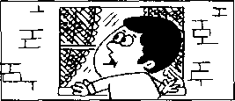
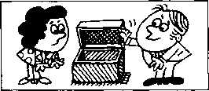
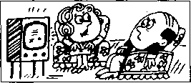
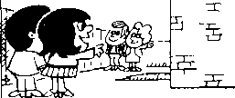
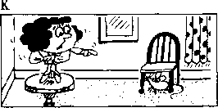
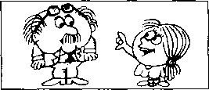
g
There's no one
at home.
There's nothing in this box.
Where did you go yesterday?
Nowhere. I stayed at home.
There's nobody at home.
There's someone in the garden.
There's somebody in the garden.
235
There's something under that chair!
My glasses must be somewhere!
You're wearing them!
Lesson 116

New words and expressions 生词 和短语
asleep/a'sliip/adj.睡觉，睡着（用作表语）
glasses / gla:siz/ n.眼镜

Written exercises 书面练、习
A Rewrite these sentences.
模仿例句改写以下句子：
Example:
- didn't buy anything.少如弘/徊以山％
- I didn't do ariything. 2 I didn't see anyone.
3 I didn't go anywhere. 4 I didn^ meet anybody.
B Answer these questions using any/no with -one. -body, -thing, -where. .模仿例句回答以下问题。
Example:
Did you see anyone?
Ns 9 cuupHe. 9 化么
- Did you hear anything?
- Did you speak to anyone?
- Did you go anywhere?
- Did you buy anything?
- Did you write to anybody?
- Did you meet anyone?
C Rewrite these sentences. 模仿例句改写以下句子
Example:
They're all watching television.
- They're all eating.
- They're all drinking lemonade.

- They're all looking out of the window.
- They're all hurrying to work.
Answer these questions. 模仿例句回答以下问题。
Example:
Have you got anything to wear? 一N®, 9 (pl cuufiki^ ta 丁呢神 M
What about Penny ? — Ske k 祕
- Have you got anything to eat? What about Sam?
- Have you got anything to do? What about the children?
- Have you got anything to drink? What about Jane?
- Have you got anything to read? What about Alan?

Lesson 117 Tommy's breakfast 汤米的早餐

Listen to the tape then answer this question.

What does she mean by change⁵ in the last sentence?

听录音，然后回答问题。最后一句话中的^change是什么意思?
When my husband was going into the dining room this morning, he dropped some coins on the floor.
There were coins everywhere.
We looked for them, but we could not find them all.
While we were having breakfast, our little boy, Tommy, found two small coins on the floor.
He put them both into his mouth. We both tried to get the coins, but it was too late.
Tommy had already swallowed them!
Later that morning,
when I was doing the housework, my husband phoned me from the office.
How's Tommy?' he asked.
'I don't know/ I answered, ‘Tommy's been to the toilet three times this morning, but I haven't had any change yet!'

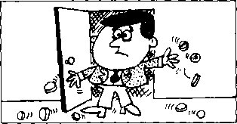
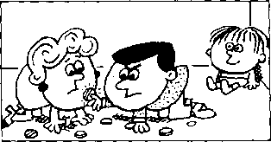
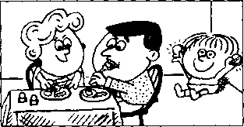
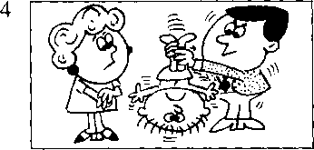
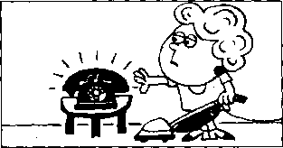
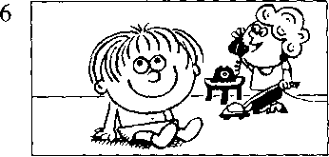

New words and expressions 生词和短语
swallow /'swolao/ v.吞下 later /'leito/ adv.后来 toilet /'toiiit/ n.厕所，盥洗室
dining room 饭厅 coin /koin/ .硬币 mouth /mao0/ n.嘴

Notes on the text 课文注释
i在英文中表示过去某时正在进行的动作，要用过去进行时。与现在进行时相比，过去进行时的区别
就在于要用be的过去式0过去进行时的例子有：When my husband was going into the dining room
this morning . . . ； While we were having breakfast...等。
- .them all, all用来强调每一个硬币_{o}从语法上来讲，all是them的同位语₀紧跟在一个名词或代词 后，进一步说明前面名词或代词是谁或什么东西的名词或代词，叫同位语。
- our little boy, Tommy,
Tommy是boy的同位语_{o}
- put them both
both是them的同位语_{o}
- we both
both是we的同位语o
- Tommy had already swallowed them!
句中用了过去完成时。过去完成时用来表示两个动作中，发生在前的那个动作。显然，句中“咽 卜硬币”的动作发生在夫妇俩能够把硬币从汤米手中抢过来之前。
- later that morning,那天上午的晚些时候_{o}
later是副词late的比较级。
- any change,
change是个多义词，既有“零钱”的意思，也有“变化”的意思。此处既可指“硬币”，亦可指“情 ,况的变化”。这是“双关”修辞法。

参考译文
今天早晨我丈夫走进饭厅时，把一些硬币掉在地上了。
到处都是硬币。我们虽然找了，但没能把它们全部找到。
正当我们吃早饭时，我们的小男孩汤米在地上找到了两枚小硬币O
他把这两枚硬币全都放进了嘴里。我们俩都试图把这两枚硬币拿出来，但太迟了。汤米已经把硬币 咽了卜去！
那天上午的晚些时候，当我正做家务时.我丈夫从办公室打来电话。
“汤米怎么样？”他问L我不知道,”我回答说，“今天上午汤米去了 3次厕所了，但我还没看到硬币！”

Lesson 118 What were you doing?你那时正在做什么？


Listen to the tape and answer the questions. 听录音并回答问题。

when I was having breakfast.
When I was leaving the house,
Just as I was opening the front door, the telephone rang.
the postman arrived.
while she was getting off the bus.
while he was shaving.
My wife was cooking the dinner while I was working in the garden.
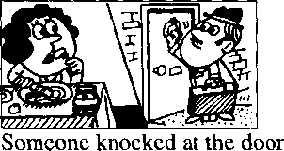
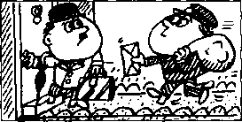
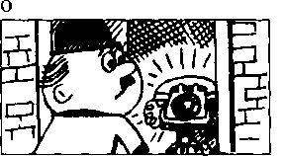
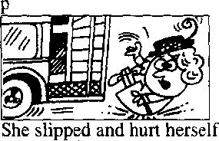
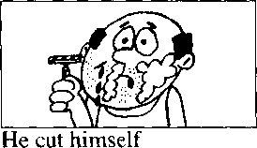
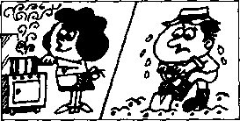

New words and expressions 生词和短语
ring /ng/ (rang /rxg/, rung /rAg/) v.响

Written exercises 书面练习
A Rewrite these sentences using when.
,模仿例句用when把两个句子合并成一句。
Example:
He arrived. I had a bath.丿。cm施/ 以次 9 必録 龙必"a balk.
- He knocked at the door. I answered the phone.
- The boss arrived. She typed a letter.
- The train left. I bought the tickets.
- It rained heavily. I drove to London.
- He came downstairs. I had breakfast.
- The phone rang. I washed the dishes.
B Answer these questions, 模仿例句回答以下问题。
Example：
What were you doing when he arrived? (have a bath)
Wken ke 以沥以 9 妣谖 a baik.
- What were you doing when he arrived? (cook a meal)
- What were you doing when he arrived? (wash the dishes)
- What were you doing when he arrived? (work in the garden)
- What were you doing when he arrived? (type letters)
- What were you doing when he arrived? (shave)
- What were you doing when he arrived? (boil the milk)
- What were you doing when he arrived? (phone my sister)
- What were you doing when he arrived? (dust the bedroom)
C Answer these questions. 模仿例句回答以下问题0
Example:
What was he doing while you were cooking the dinner?
(work in the garden)
- toad. 讥 ik& <jande^b.
- What was he doing while you were cooking the dinner? (have a wash)
- What was he doing while you were cooking the dinner? (watch television)
- What was he doing while you were cooking the dinner? (clean his shoes)
- What was he doing while you were cooking the dinner? (listen to the radio)
- What was he doing while you were cooking the dinner? (change his suit)
- What was he doing while you were cooking the dinner? (sit in the dining room)
- What was he doing while you were cooking the dinner? (read the paper)
- What was he doing while you were cooking the dinner? (drive home from work)

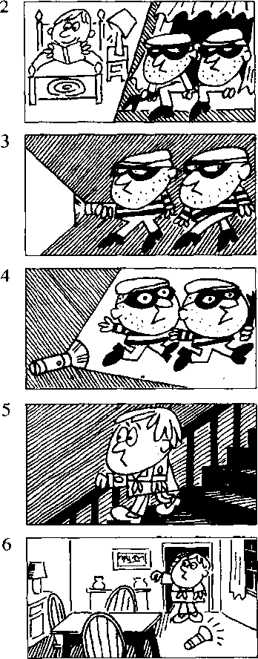
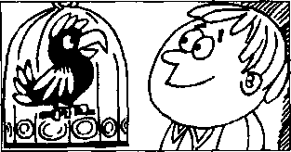

Lesson 119 A true story —个真实的故事

Listen to the tape then answer this question. Who called out to the thieves in the dark?

听录音，然后茴答问题。谁在暗处对窃贼喊了一声？
Do you like stories?
- want to tell you a true story.
It happened to a friend of mine a year ago.
While my friend, George, was reading in bed, two thieves climbed into his kitchen.
After they had entered the house, they went into the dining room.
It was very dark,
so they turned on a torch.
Suddenly, they heard a voice behind them. 'What's up? What's up?* someone called. The thieves dropped the torch and ran away as quickly as they could.
George heard the noise and came downstairs quickly.
He turned on the light, but he couldn't see anyone.
The thieves had already gone.
But George's parrot, Henry, was still there. 'What’s up, George?, he called.
'Nothing, Henry/ George said and smiled. 'Go back to sleep/

New words and expressions 生词和短语
story /'storri/ n.故事 | dark /dark/ adj.黑暗的
happen /'hspon/ v,发生 | torch /tetJV n.手电筒
thief Z9i:f7（复数 thieves /9i:vz/） n.贼 | voice /vois/ n.（说话的）声音
enter /^{l}enta/ v.进入 | parrot /'pasrat/ n.鹦鹉

Notes on the text 课文注释
- as quickly as they could是状语，修饰ran away ₀第1个as是副词，第2个as是连词.引导比较
・ 状语从句o could后省略了 run,是“能跑多快就跑多快、’的意思。
- What^sup? f什么？有什么事？
- he called,
he指parrot ₀英语中，动物有时用he或she代替，是“拟人”的写法。
- go back to sleep,继续睡觉 ₀

参考译文
你喜欢听故事吗？我要告诉你一个真实的故事。这是一年前发生在我的一个朋友身上的故事0
当我的朋友乔治在床上看书时，两个小偷爬进了他的厨房。
他们进到屋里后，走进了饭厅。饭厅里很暗，于是他们打幵了手电筒。
突然他们听到身后有声音。“什么事？什么事？”有人叫着。小偷扔下了手电筒，飞快地逃走了。
乔治听到了响声.迅速地下了楼。
他开了灯，但不见一个人。小偷逃走了。
但是乔治的鹦鹉亨利仍在那里。“什么事，乔治？”它叫着。“没事，亨利乔治笑着说，“接着睡 觉吧

Lesson 120 It had already happened.它已经发生了。


Listen to the tape and answer the questions. 听录音并回答问题o
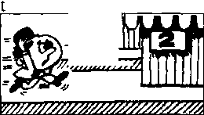

I ran to the platform quickly,
I asked the price of the car, but they had already sold it.
but the train had already left.
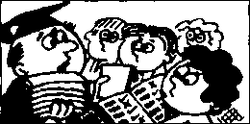
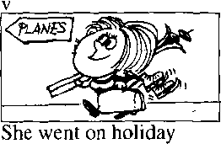
He gave us our exercise books after he had corrected them.
after she had taken the examination.
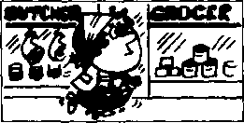
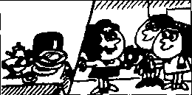
She had finished the housework
before she went out.
We had had dinner before they arrived.

New words and expressions 生词和短语
exercise book /'eksasaiz-bok/ n.练习本

Written exercises 书面练习

A Rewrite these sentences using after.

用after把两个句子合并为一。

Example:
She went home. She typed the letter.
gke laeni Zwwe dke. kad tke-
- He dropped the vase. He took it into the living room.
- He bought another car. He sold his old one.
- He swept the floor. He dusted everything.
- She drank the milk. She boiled it.
- He turned off the television. He saw the programme.
- He went to bed. He did his homework.
B Answer these questions.
模仿例句回答以下问题
Example:
Have you met him?
绥4, 9 夕眾 met 危初.9 had 夜met 如么
- Have you seen it?
- Have you read it?
- Have you tried it?
C Answer these questions.
模仿例句回答以下问题o
- Have you been there?
- Have you written a letter in English?
- Have you watched this programme?

Example:
Why didn't you sweep the floor? (She) 力 taa late. She had 朝毕^ it.
1 Why didn't you paint the bookcase? (He)
- Why didn't you correct it? (You)*
Why didn't you dust the dressing table? (She)
Why didn't you shut the door? (They)
Why didn't you make the bed? (She)
Why didn't you telephone him? (You)
D Write new sentences using after. 模仿例句，使用ofte「改写以下句子
Example:
Did you read the book? Yes, but I saw the film first.
- ^ead. the，弘払 洛奴 9 kad the
- Did you go to the doctor? Yes, but I made an appointment first.
- Did the boss leave the office? Yes, but he finished work first.
- Did your wife go out? Yes, but she finished the housework first.
- Did your teacher give you your exercise book? Yes, but he corrected it first.
- Did your sister go on holiday? Yes, but she took the examination first.
- Did you buy a new car? Yes, but I sold my old one first.

Lesson 121 The man in a hat 戴帽子的男士

Listen to the tape then answer this question.
czEd]

Why didn't Caroline recognize the customer straight away?

听录音，然后回答问题。为什么卡罗琳没有马上认出那位顾客?
CUSTOMER : I bought
two expensive dictionaries here half an hour ago,
but I forgot
to take them with me.
MANAGER : Who served you, sir? CUSTOMER : The lady who is standing behind the counter.
MANAGER : Which books did you buy?
CUSTOMER : The books
which are on the counter.
MANAGER : Did you serve this gentleman half an hour ago, Caroline? He says he's the man who bought these books.
CAROLINE : I can't remember.
The man who I served was wearing a hat.
MANAGER : Have you got a hat, sir?
CUSTOMER : Yes,l have.
MANAGER : Would you put it on, please? CUSTOMER : All right.
MANAGER : Is this the man
that you served, Caroline?
CAROLINE : Yes.
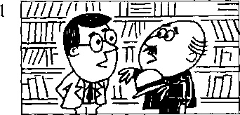
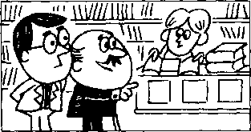
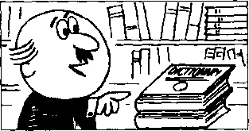
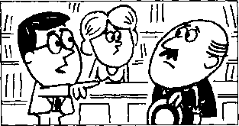
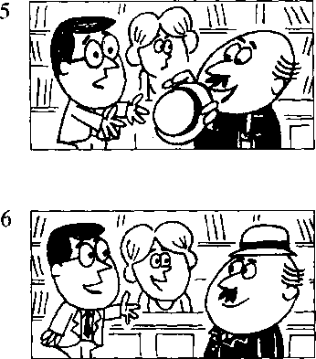
I recognize him now.
4

New words and expressions 生词和短语
customer /'kAstsms/ n.顾客
serve /s3：v/卩.照应，服务，接待 counter /'kaonts/ 儿柜台 recognize /'reksgnaiz/ v. 认出
forget /fa*get/ (forgot /fb'got/, forgotten /fo'gotn/) 认忘id
manager 'ni£enid3a/ n.纟仝壬里

Notes on the text 课文注释
- to take them with me 把它们带上 ₀
them指“两本词典"。
- The lady who is standing behind the counter.
这是一个省略句，完整的句子是 ^{4t}The lady who is standing behind the counter served me?其中 who is standing behind the counter是一个以关系代词who引导的定语从句，用来修饰前面的名词the lady。 本课带有定语从句的复合句还有：The books which are on the counter; He says he's the man who bought these books; The man who I served was wearing a hat; Is this the man that you served 等' 其中 which, who, whom, that均为关系代词◎
- The man who I served was wearing a hat.
这是另一个定语从句的例子o由于被修饰的名词the man在定语从句中是动词served的宾语，因 此，关系代词应该用宾格whom,但在口语中往往用主格who 0

参考译文
顾客：半小时以前我在这里买了两本很贵的辞典，但是我忘了拿走。
经理：是谁接待您的.先生？
顾客：站在柜台后面的那位女士 °
经理：您买的是两本什么书？
顾客：就是柜台上的那两本0
经 理：卡罗琳，半小时前你接待过这位先生吗？他说他就是买这两本书的人 K罗琳：我记不起来了。我接待的那个人戴着一顶帽子。
经.理：先生、您有帽予吗？
顾客：冇的.我有帽子0
经 理：请您把帽子戴上好吗？ 顾客•-好吧.
经 理：R罗琳，这就是你接待过的那个人吗? 长罗琳：是他。我现在认岀他来了。

Lesson 122 Who (whom), which and that 关系代词


Listen to the tape and answer the questions. 听录音并回答问题o
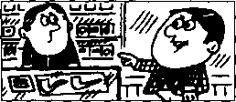
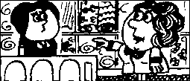
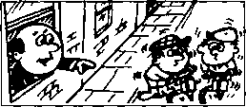
Who served you?
The man who/that is standing behind the counter.
Who served you?
The woman who/that is standing behind the counter.
3
Who is making all that noise?
The men who/that are repairing the road.
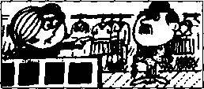
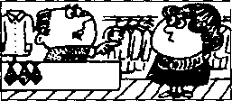
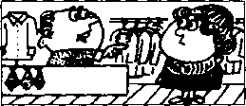
4
I served him yesterday.
He is the man who(m)/ that I served yesterday.
I served her
6
I saw them yesterday.
yesterday.
She is the woman who(m)/that I served yesterday.
They are the men who(m)/that I saw yesterday.
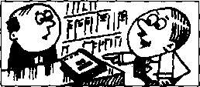
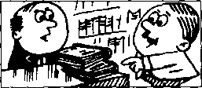
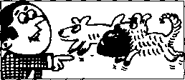
Which book did you buy?
The book which/that is on the counter.
Which books did
you buy?
The books which/that are on the counter.
9
Which dog is yours? The dog which/that is carrying that basket.

New words and expressions 生词和短语
road /rsod/ 儿 路

Written exercises 书 面练习
A Rewrite these sentences using who, whom or which.
用who, whom或which把以下每对句子改写成一句话
Examples:
She is the girl. She met me yesterday.
She.必 the qi/tl met tne，i^e6ieAxla4j-.
This is the book. I bought it yesterday. 该 tlie. 温 9 扇林伊々

She is the girl. I met her yesterday.
gke 该 Hie. 似處 （g 诚洌〃 !）met 户必以砂
This is the car. The mechanic repaired it yesterday.
He is the man. I invited him to the party. These are the things. I bought them yesterday.
He is the man. He came here last week.
5
6
7
8
He is the policeman. He caught the thieves.
She is the nurse. She looked after me.
She is the woman. I met her at the party.
- am the person. I wrote to you.
Write questions and answers. 模仿例句提问并回答o
Example:
He served me.
Wlta ipu?
M必,he 4 tk& man me.
She met him.
He sat there.
- She made it.
- He read it.
He shut it.
She took it.
He told me.
She saw me.

Write questions and answers. 模仿例句提问并回答o
Example:
- met him yesterday.
did tneel —kat mcut?
l/e^, he 4 tke> 纽"以iw 9 met 弭海以％.

- I saw him. 3 I invited him.
- I telephoned her. 4 I took him to the cinema.
I found him in the garden.
I drove her to London.
- I heard her.
8
I remembered him.

Lesson 123 A trip to Australia 澳大利亚之行
CCD

Listen to the tape then answer this question.

Who is the man with the beard?

听录音，然后回答问题。那个长着络腮胡孑的人是谁?
MIKE:
SCOTT:
Look, Scott.
This is a photograph I took during my trip to Australia. Let me see it, Mike.
SCOTT : This is a good photograph. 2
Who are these people?
MIKE : They're people I met during the trip.
MIKE :
That's the ship
we travelled on.
SCOTT : What a beautiful ship!
SCOTT : Who's this?
MIKE : That's the man 1 told you about.
Remember?
SCOTT : Ah yes.
The one who offered you a job in Australia.
MIKE: Thafs right.
SCOTT : Who's this?
MIKE: Guess!
SCOTT : It's not you, is it?
MIKE : That's right.
MIKE : I grew a beard during the trip, but I shaved it off when I came home.
SCOTT : Why did you shave it off?
MIKE : My wife didn't like it!
1
3
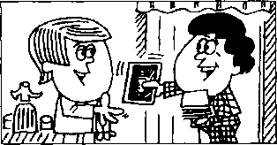
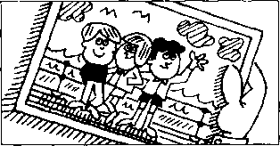
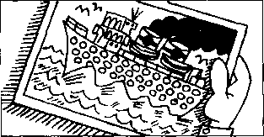
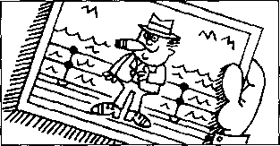
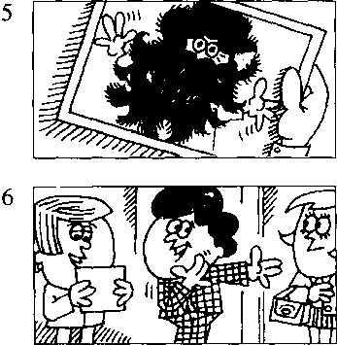

New words and expressions 生词和短语
during /'djosng/prep.在 期间
trip /trip/ n.旅行 travel /'trsev^l/ v.旅行 offer /'ofb/ v.提供
guess /ges/ v.猜
grow /grao/ (grew /gru:/, grown /graun/) v.长,
IE……生长
beard /bisd/ n.（下巴上的）胡子，络腮胡子
job /djob/ .工作

Notes on the text 课文注释
1 This is a photograph I took …
这句话中的I took during my trip to Australia是一个定语从句，用来修饰a photograph ；由于所修 饰的名词在从句中作动词took的宾语，因此，引导从句的关系代词that往往省略。
- They're people I met during the trip.
与注1的情况相同，关系代词whom往往省略。

参考译文
迈克：看，这是我到澳大利亚旅行时拍的一张照片。
斯科特：让我看看，迈克0
斯科特：这是一张很好的照片。这些人是谁？
迈 克：他们是我旅行时认识的人O
迈克：这是我们所乘的那条船。
斯科特：多漂亮的船啊！
斯科特：这是谁？
迈 克：这就是我跟你说过的那个人。还记得吗？
斯科特：啊，记得。就是在澳大利亚给你工作做的那个人O 迈克：对C
斯科特：这是谁？
迈克：你猜！
斯科特：这不是你，对吗？
迈克：不，是我。
迈克：我在旅行时留了胡子，但我回到家时就把它刮了。
斯科特：你为什么把它刮了？
迈克：我妻子不喜欢！

Lesson 124 (Who) / (whom), (which) and (that)

Listen to the tape and answer the questions. 听录音并回答问题。
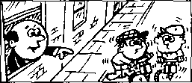
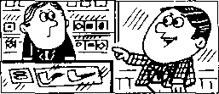
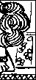
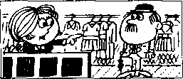
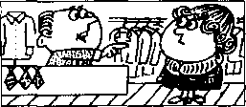
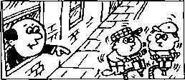

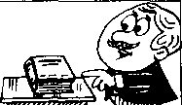
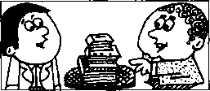
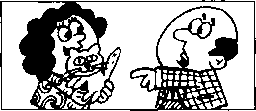
Who served you? The woman standing behind the counter.
关系代词
3
Who is making all that noise?
The men repairing the road.
Who served you? The man standing behind the counter.
I served him
yesterday.
He is the man
I served yesterday.
I served her yesterday.
She is the woman
6
I saw them yesterday.
They are the men
I saw yesterday.
I served yesterday.
7
What are these?
These are the books
9
What's this?
This is the kitten
I found in the garden.
Whafsthis?
This is the book
I bought yesterday.
I bought yesterday.

New words and expressions 生。司和短七吾
kitten /'kitn/ n.小猫

Written exercises 书面练习
A Rewrite these sentences.
模仿例句把以下每对句子改写成一句话:
Examples:
She is the girl. I met her yesterday. n 力斧以9 met 斧我MZ%.
This is the ship. I travelled on it. 切必圍 the 互绍 9 Inauelled on.
This is the book. I bought it yesterday.

- She is the woman. I drove her to London.
- That's the film. I saw it.
- That's the man. I spoke to him.
- They are the thieves. The police caught them.
- These are the letters. I typed them.
- These are the people. You asked me about them.

Write questions and answers. 模仿例句提问并回答。
Example:
I met that man yesterday.
Which man? That man?
宛t, the. man 9 met 弭如N%
- I saw that man yesterday.
- I repaired that car yesterday.
- I drove that woman to London yesterday.
- I bought that umbrella yesterday.
- I took that medicine yesterday.
- I invited that man to my house yesterday.

C Write new sentences.
模仿例句改写以下句子。
Example:
This is the film. I told you about it.
切标必Z "74^4-以the洪所 及玖told me. ah^d-.

- This is the village. I wrote to you about it.
- He is the person. I have heard about him.
- This is the test. I spoke to you about it.
- She is the woman. I read about her.
- This is something new. I haven't thought about it.
- This is something. I must decide about it.

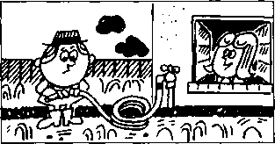
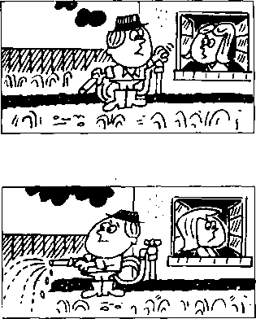
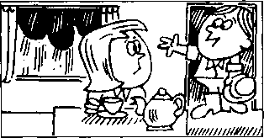
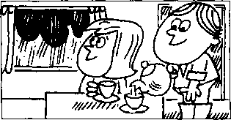

Lesson 125 Tea for two 两个人一起喝茶

Listen to the tape then answer this question. Does Susan have tea by herself?
rr—n|

听录音，然后回答问题。苏珊是一个人喝茶吗？
SUSAN : Can't you come in
and have tea now, Peter?*
PETER : Not yet.
- must water the garden first.
SUSAN : Do you have to water it now?
PETER : Pm afraid I must.
Look at it!
It's terribly dry.
SUSAN : What a nuisance!
PETER : Last summer it was very dry, too. Don't you remember?
I had to water it every day. * SUSAN : Well, Til have tea by myself.
SUSAN : That was quick!
Have you finished already?
PETER : Yes.
Look out of the window.
SUSAN : It,s raining!
That means
you don't need to water the garden.
PETER : That was a pleasant surprise.
It means I can have tea, instead.

New words and expressions 生词和短语
nuisance /⁽nju:s^ns/几讨厌的东西或人
water /'worts/ v,浇水 terribly /'tenbli/ adv.非常 dry /drai/ adj.干燥的，干的
mean /mi:n/ (meant /ment/, meant) v.意味着，意思是 surprise /sa'praiz/ n.惊奇，意外的事

Notes on the text 课文注释
- have to (过去式had to),不得不，必须。
, have to强调客观需要多一些o must则着重说明主观看法。
- What a nuisance!真讨厌！
- by myself,我自己，独自。同样，我们可以说 by yourself, by himself, by herseif, by itself, by ourselves, by yourselves, by themselves, by oneselfo

参考译文
苏珊：彼得，你现在能进来喝茶吗？ 彼得：还不能。我得先给花园浇水。
苏珊：你一定得现在浇吗？
彼得：恐怕我得现在浇。你看看，干得厉害。
苏珊：真讨厌！
彼得：去年夏天也是干得很。你不记得了吗？我不得不每天浇水。 苏珊：好吧，我一个人喝茶了。
苏珊:好快啊！你已经浇完了？
彼得：是的。你看看窗外0
苏珊：下雨了！这就是说，你不必给花园浇水了。
彼得：这是意想不到的好事。这意味着我反倒可以喝茶了。

Lesson 126 Have to and do not need to 不得不和不必要

Listen to the tape and answer the questions. 听录音并回答问题o

Do you have to go now?
Yes, I have to leave immediately.
Do you have to get up early tomorrow morning?
Yes, Uli have to get up at six o'clock.
I'm afraid I had to.
I couldn't get a bus.
Hasn't your friend arrived yet?
How long have you had to wait?
I've had to wait for two hours!
6
Do we have to walk to the station?
Do you have to water the garden?
No, I don't need to water it now.
It's going to rain.
No, we don't need to.
We can catch a bus.
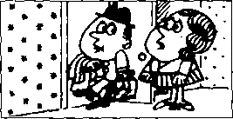
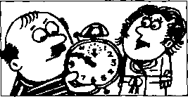
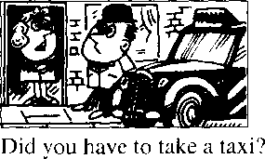
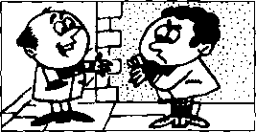
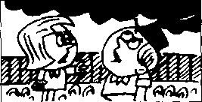
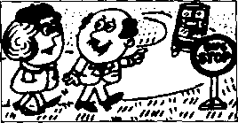

New words and expressions 生词和短语
immediately /fmizdiotli/(7^/v,立即地

Written exercises 书面练习
A Write questions and answers.
抄写以下句子，然后提问并写出相应的否定句
Examples:
You have to leave early.
to- leaue
d(m-1 hau■& h- leaue ea/d^.
She must leave early. leau& ea^l^?
Ske 't Leauc ea/dif,.
- She has to decide immediately.
- She must decide immediately.
B Answer these questions.
用have to或has f。回答问题°
- We have to take a taxi.
- We must take a taxi.
Example:
I must go now. What about you?
9 Uaue h-咎,血i.
- I must telephone him. What about you?
- I must wait for him. What about Mary?
- I must meet her. What about Jim?
- I must travel by ship. What about Tom and Mary?
C Write questions.
模仿例句改写提问。
Example:
I must go now.
2)& neallif to-舛
- I must telephone him.
- Mary must wait for him.
- Jim must meet her.
- Tom and Mary must travel by ship.

Lesson 127 A famous actress 著名的女演员

Listen to the tape then answer this question. Who is only twenty-nine, and why is it so unclear?
COD

听录音，然后回答问题。谁只有29岁？为什么这件事如此含糊不清?
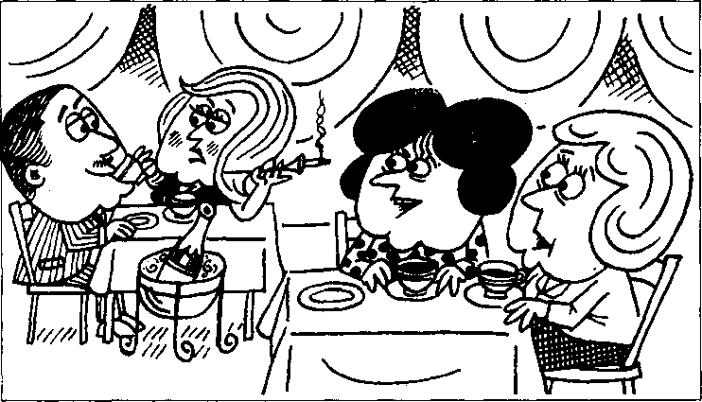

KATE : Can you recognize that woman, Liz? LIZ : I think I can. Kate.
It must be Karen Marsh, the actress. KATE : I thought so.
Who's that beside her?
LIZ : That must be Conrad Reeves.
KATE : Conrad Reeves, the actor?
It can't be.
Let me have another look.
- think you're right!
Isn't he her third husband?
LIZ : No. He must be her fourth or fifth.
KATE : Doesn't Karen Marsh look old!
LIZ : She does, doesn't she!
- read she's twenty-nine, but she must be at least forty.
KATE : I'm sure she is.
LIZ : She was a famous actress
when I was still at school.
KATE : That was a long time ago, wasn't it? LIZ : Not that long ago!
I'm not more than twenty-nine myself.

New words and expressions 生词和短语
famous / feimas/ adj.著名的 actress /'sektris/ n. 女演员 at least 令少
actor/'eekta/n.男演员
read /ri:d/ (read /red/, read) v.通过阅读得知

Notes on the text 课文注释
1在It must be Karen Marsh…这一•句中，mustbe是英文中用来表示根据事实所作的推论，往往译为 "一定”。must be 的否定式是can't be,如 Kate 的话“Itcan'tbe.” 是对Liz 的推论（"That must be Conrad Reeves/'）的否定。同时，请注意这里的can,t be （表示不可能）和第45课中I can't type this letter. （表示能力）的区别。
- Who,s that beside her?
本句中that指人o
- her fourth or fifth 后面省略了 husband □
- Not that long ago!
句中的that是副词、指像Kate所说的“那么”遥远，可译作“那样”，“那么L课文中用斜体印 刷表示一种强调，显然Liz对Kate的判断和对她本人年龄的估算很不满意。

参考译文
凯特：莉兹，你能认出那个女人吗？
莉兹：我想我快得出来，凯特。那一定是女演员卡伦•马什。
凯特：我也这样想c她旁边的那个人是谁。
莉兹：一定是康拉德•里弗斯。
凯特：’康拉德，里弗斯，那个男演员吗？不可能是。让我再看一看。我想你是对的。他不是她的第
3个丈夫吗？
莉兹：不，他一定是她的第4个或第5个丈夫。
凯特：R伦看上去不显老嘛！
莉兹：是的，谁说不是呢！我从报上看到她是29岁，但她一定至少有40岁了。
凯特:我肯定她有如岁了 O
莉兹：*我还是学生时，她就是个著名的演员了。
凯特：那是好久以前的事了，是吗？
莉兹：不.没有那么久。我自己现在还没29岁呢。

Lesson 128 He can't be ...他不可能

He must be...他肯定是


Listen to the tape and answer the questions. 听录音并回答问题。
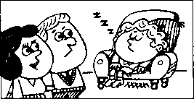
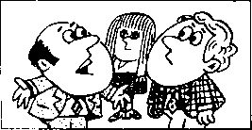
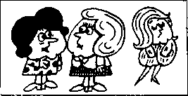
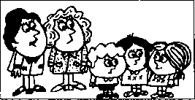
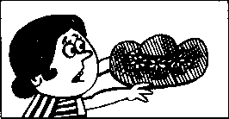
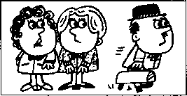
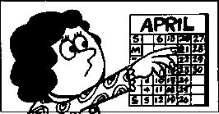
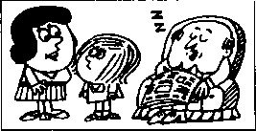
He can't be ill.
He must be tired.
She can't be Danish.
She must be Swedish.
She can't be forty.
She must be fifty.
7
He can't be the youngest.
He must be the oldest.
It can't be my new hat. It must be my old one.
He can't be a dentist.
He must be a doctor.
It can't be the 20th.
It must be the 21st.
He can't be reading. He must be sleeping.

Written exercises 书面练习
A Rewrite these sentences, using either has to or / think he is probably,.. 模仿例句，使用has to或丨think he is probably…改写以下句子。
Examples:
He must be home before six o'clock.
cAe " kame, 必
He must be tired.
- He must be here at six o'clock.
- He must be busy.
- He must be at the office early tomonow.
- He must be sleeping.
- He must be French.
- He must be in France next week.
- He must be an engineer.
B Write new sentences.
模仿例句改写下列句子o
Example:
- think she's Danish. (Swedish)
9 dant Uunk, da. ca^vt he团i.
She mudi be
- I think she's Italian. (Greek)
- I think he's English. (American)
- I think they're Canadian. (Australian)
- I think he's a mechanic, (engineer)
- I think he's a bus conductor, (bus driver)
- I think he's a sales rep. (the boss)
- I think he's twenty-four, (thirty)
- I think they're five, (seven)
- I think he's seventy-six. (over eighty)
- I think she's fifty-five, (under fifty)
- I think it's the 21st today. (20th)
- 1 think it's Tuesday today. (Wednesday)
- I think it's the 2nd today. (3rd)
- I think it's cheap, (expensive)
- I think it's easy, (difficult)
- 1 think she's old. (young)
- I think they're early, (late)
- I think he's reading, (sleeping)
- I think they're listening to the radio, (watching television)
- I think she's retiring, (looking for a-new job)

Lesson 129 Seventy miles an hour 时速 70 英里


Listen to the tape then answer this question. What does Ann advise her husband to do next time?

听录音，然后回答问题。安建议她的丈夫下次做什么？
ANN : Look, Gary!
That policeman's waving to you.
He wants you to stop.
POLICEMAN : Where do you think you are?
On a race track?
,You must have been driving
at seventy miles an hour.
GARY : I can't have been.
POLICEMAN : I was doing eighty
when I overtook you.
POLICEMAN : Didn't you see the speed limit?
GARY : I'm afraid I didn't, officer,
I must have been dreaming.
ANN : He wasn't dreaming, officer.
I was telling him to drive slowly.
GARY : That's why I didn't see the sign.
POLICEMAN : Let me see your driving licence.
POLICEMAN : I won't charge you this time.
But you'd better not do it again!
GARY : Thank you.
PH certainly be more careful.
ANN : I told you to drive slowly, Gary.
GARY : You always tell me
to drive slowly, darling.
ANN : Well, next time
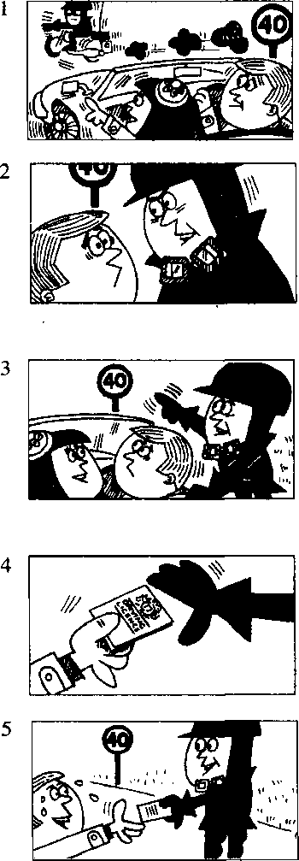
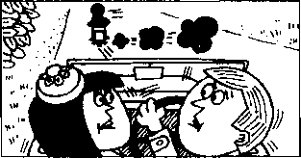
you'd better take my advice!
New words and expressions 生词 和短语
 | speed limit /'spi:d 限速
wave /weiv/ v.招手 | dream /dri:m/ v.做梦，思想不集中
track /trsk/ n.跑道 | sign /sain/ n.标记，牌子
mile /mail/ n.英里 | driving licence 驾驶执照
overtake / .sovs'tcik/ (overtook, overtaken) v. | charge /tjardj/ 机罚款
从后血超越.超小 | darling /'da:lig/ n.亲爱的（用作表示称呼）

Notes on the text 课文注释
- Where do you think you are?
do you think是用在特殊疑问句中的插入语，用来征询见解或表达看法。
- must have been driving,
这种结构用来表示对过去正进行的事情的推测_{o}可译为“一定”或“准是”。
- at seventy miles an hour,每小时 70 英里的速度。
- I was doing eighty when I overtook you.
其中的动词do表示“以……速度行进”。
- But you'd better not do it again!
you'd better = you had better,后面加动词原形。
had better用于建议在将来某一具体场合采取动作，而不用于一般情况，比should语气更为强烈, 常有威胁、告诚或催促的意味。
- you'd better take my advice!你最好还是听从我的劝告’ take one's advice是“听从劝告”的意思。

参考译文
安：瞧，加里！那个警察正朝你挥手呢。他要你停下来。
警察：你认为你现在是在哪儿？在赛车道上吗？你刚才一定是以每小时70英里的速度开车。
加里：我不会开得那样快的0
警察：我是以每小时80英里的速度赶上你的₀
警察：难道你没看见限速牌吗？
加里：恐怕我没有看见，警官。我一定是思想开小差了。
安：警官，他思想没有开小差o我刚才正告诉他开慢点O
加里：所以我才没看见那牌于O
警察：让我看一看你的驾驶执照。
警察■-这次我就不罚你款了。但你最好不要再开得这样快。 加里：谢谢您。我以后一定会多加注意。
安-加里，我刚才叫你开慢点吧。
加里：你总是叫我开慢点，亲爱的。
安：好啦，下次你最好还是听从我的劝告吧!

Lesson 130 He can^ have been ...他那时不可能

He must have been.・・他那时肯定是

Listen to the tape and answer the questions. 听录音并回答问题。
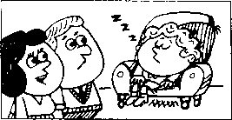
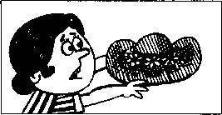
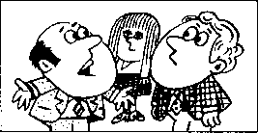
It must have been my old one.
He can't have been ill.
He must have been tired.
It can't have been my new hat.
3
She can't have been Dani-sh.
She must have been Swedish.
4
He can't have been a dentist.
He must have been a doctor.
5
She can't have been forty.
She must have been fifty.
6
It can't have been the 20th.
It must have been the 21st.
7
He can't have been the youngest.
He must have been the oldest.
8
He can't have been reading.
He must have been sleeping.

Written exercises 书 面练习
A Complete these sentences using had to or must have been. 完成以下句子，用had to或must have been填空。
Example:
He is very tired because he had to get up early this morning. cMe dldn't 穿 kaue-
- He didn't come to work yesterday. He ill.
- He didn't come to the office this morning. He stay at home.
- I don't think she was Austrian. She German.
- I lost my pen so I buy a new one.
- He forgot his case so he return home.
- She didn't hear the phone. She sleeping.
B Write new sentences.
模仿例句改写以下句子。
Example:
I think she was Danish. (Swedish)
9 Ske- cat^t kau&
She auidi
- I think it was Tuesday yesterday. (Wednesday)
- I think they were Canadian. (Australian)
- I think she was Finnish. (Russian)
- I think they were Japanese. (Chinese)
- I think they were butchers, (bakers)
- I think she was a dentist, (doctor)
- I think he was a sales rep. (the boss)
- I think she was seventeen, (twenty-one)
- I think they were five, (seven)
- I think he was seventy-six. (over eighty)
- I think she was fifty-five, (under fifty)
- I think it was the 17th yesterday. (16th)
- I think it was the 19出 yesterday. (20th)
- I think it was cheap, (expensive)
- I think it was easy, (difficult)
- I think she was old. (young)
- I think he was ill. (tired)
- I think they were listening to the radio, (watching television)
- I think she was retiring. (looking for a new job)
- I think they were sitting, (standing)

Lesson 131 Don¹! be so sure!另!l那么肯定!

Listen to the tape then answer this question.

What's the problem about deciding on a holiday?

听录音，然后回答问题。决定如何度假有什么为唯的地方?

MARTIN : Where are you going to
spend your holidays this year, Gary? GARY : We may go abroad.
I'm not sure.
My wife wants to go to Egypt.
rd like to go there, too.
We can't make up our minds. MARTIN : Will you travel by sea or by air? GARY : We may travel by sea. MARTIN : It's cheaper, isn't it?
GARY : It may be cheaper,
but it takes a long time.
MARTIN : I'm sure youUl enjoy yourselves. GARY : Don't be so sure.
We might not go anywhere.
My wife always worries too much.
Who's going to look after the dog?
Who's going to look after the house?
Who's going to l<)ok after the garden? We have this problem every year.
In the end, we stay at home and look after everything!

New words and expressions 生词和短语
Egypt /'izd^ipt/ n.埃及 worry /'wAri/ 卩担忧
abroad /a'bro:d/ adv.国夕卜

Notes on the text 课文注释
- We may go abroad.我们可能去国外。
在英文中用may来表示可能发生的事情，在may后面加动词原形_{o}请注意may表示的是一种可 能性，这与第127课所讲的表示有根据的推论是有区别的₀
- make up our minds,打定主意。
- Don't be so sure.别那么肯定 ₀
在祈使句中，be动词的否定形式要用don't be,这种结构常常用于劝告。
- We might not go anywhere.我们可能哪里也去不成。
might可以用来表示一种可能性，但它表示的"肯定”程度还不如may。和may 一样，might所表 示的是现在或将来的一种可能性。
- look after,照看。
- in the end,最后 ₀

参考译文
乌丁：加里，今年你们打算去哪里度假？
加里：我们可能到国外去，但我不敢肯定。我妻子想到埃及去，我也想去那儿。我们还拿不定主意。 马丁：你们乘船去，还是乘飞机去？
加里：我们可能乘船去0
马丁 ：这更便宜些，是吗？
加里：可能是便宜些，但花的时间长。
马丁：我肯定你们一定会玩得很痛快。
加里：别那么肯定。我们可能哪里也去不成。我妻子总是担心这担心那的。谁来照看狗啦，谁来看管 房子啦，谁来照料花园啦，我们每年都碰到这类问题。末了，我们呆在家里来照看一切。

Lesson 132 He may be...他可能是
i r

He may have been.・.他可能已经 I'm not sure.我不敢肯定。

Listen to the tape and answer the questions. 听录音并回答问题o

Where's Harry?
He may be in his room.
I'm not sure.
2
Where w山 he go?
He may go to the cinema.
I'm not sure.
Why is he late? He may be busy. I'm not sure.
4
What is he doing? He may be reading. I'm not sure.
Why was he late?
He may have been busy.
5
What was he doing? He may have been reading.

fm not sure.
I'm not sure.

Written exercises 书面练习
A Read the conversation in Lesson 131 again. Then answer these questions. 重读第131课的对话：然后回答以下问题：
- Is Martin talking to Gary?
- Where may Gary and his wife go this year?
- Who wants to go to Egypt?
- How will they travel?
- Isn't it cheaper to travel by sea?
- Doesn't it take a long time?
- Why might Gary and his wife not go anywhere?
B Answer these questions.
模仿例句回答以下问题。
Examples:
Do you think she is Danish? (Swedish)
Do you think she was Danish? (Swedish)
9'例 not
- Do you think they are Canadian? (Australian)
,2 Do you think she is Finnish? (Russian)
- Do you think they are Japanese? (Chinese)
- Do you think they were butchers? (bakers)
- Do you think she was a dentist? (doctor)
- Do you think he is a sales rep? (the boss)
- Do you think she is seventeen? (twenty-one)
- Do you think they were five? (seven)
- Do you think he was seventy-six? (over eighty)
- Do you think she was fifty-five? (under fifty)
- Do you think it is the 17th today? (16th)
- . Do you think it was Tuesday yesterday? (Wednesday)
- Do you think it is the 19th today? (20th)
- Do you think it is cheap? (expensive)
- Do you think it was easy? (difficult)
- Do you think she was old? (young)
- Do you think he was ill? (tired)
- Do you think they are listening to the radio? (watching television)
- Do you think she was retiring? (looking for a new job)
- Do you think they are sitting? (standing)

Lesson 133 Sensational news!爆炸性新闻!

Listen to the tape then answer this question. What reasons did Karen Marsh give for wanting to retire?

听录音，然后回答问题O卡伦•马什说她为什么想要退休?
REPORTER : Have you just made
a new film, Miss Marsh?
MISS MARSH : Yes, I have.
REPORTER : Are you going to make another?
MISS MARSH : No, I'm not.
I'm going to retire.
- feel very tired.
- don't want to make another film for a long time.
KATE : Let's buy a newspaper, Liz.
Listen to this!
'Karen Marsh: Sensational News! By our reporter, Alan Jones.
Karen Marsh arrived at London Airport today.
She was wearing a blue dress
and a mink coat.
She told me
she had just made a new film.
She said
she was not going to make another. She said she was going to retire.
She told reporters she felt very tired and didn't want to make another film for a long time/
LIZ : I wonder why!

New words and expressions 生词和短语
reporter /n'poits/ n.记者 mink coat /'migk-ksot/ 貂皮大衣
sensational /sen'seipnsl/ adj.爆炸性的，耸人听闻的

Notes on the text 课文注释
- Lefs = Letus,常用于第一人称的祈使句中，用来表示请求、建议、命令。
- She told me she had just made a new film.她告诉我她刚拍完一部新片子。
这是间接引语的又一个例子，这句话中含有一个用过去时引述动词的结构0如果我们对比一下Marsh 小姐对记者说的话（直接引语）和报上刊载的记者的复述（间接引语），就不难发现，间 接引语的动词时态往往要倒移。而这种倒移的普遍规则是：现在时变成过去时，现在完成时变成 过去完成时。
- 1 wonder why!我很想知道为什么□

参考译文
记 者：您刚拍完一部新电影吗，马什小姐'
马什小姐：是的，我刚拍完O
记 者：您准备再拍一部吗？
马什小姐：不，我不准备拍了。我准备退休了。我感觉累得很。我早就不想再拍片子了。
凯 特：我们买份报纸吧，莉兹。你听这段：“卡伦,马什：爆炸性新闻！由本报记者艾伦•琼斯报 导0卡伦•马什今天到达伦敦机场O她穿着一身蓝色的套装和一件貂皮大衣O她告诉我她刚 拍完一部新片子0她说她不准备再拍电影了 O她说她准备退休0她告诉记者她感到很疲 劳，早就不想再拍电影了
莉 兹：我很想知道为什么O

Lesson 134 He said (that) he ...他曾说他

He told me (that) he...他曾告诉我说他

Listen to the tape and answer the questions. 听录音并回答问题。
What did he tell you?
3
He said (that) he was tired.
He told me (that) he was
tired.

4
I'm reading.
5
What did she say?
What did she tell you?
She said (that) she was reading.
She told me (that) she was reading.
We want our dinner.
8
What did they say?
What did they tell you?
They said (that) they wanted their dinner.
They told me (that) they wanted their dinner.

10
I've finished my homework.
11
What did he say?
What did he tell you?
12
He said (that) he had finished his homework.
He told me (that) he had finished his homework.

Written exercises 书面练习
Read the conversation in Lesson 133 again. Then answer these questions. 重读第133课的对话，然后回答以下问题。
- Has Miss Marsh just made a new film?
- Who bought a newspaper?
- Where did Miss Marsh arrive?
- What was Miss Marsh wearing?
- Who was asking her questions?
- What is Miss Marsh going to do?
- Why doesn't Miss Marsh want to make another film?
B Answer these questions.
模仿例句回答以下问题。
Example:
I'm tired. — What did he say?
- I'm busy. — What did he say?
- The book's interesting. — What did she say?
- They*re hungry. — What did he say?
- She's cold. — What did he say?
C Answer these questions.
模仿例句回答以下问题o
Example:
I'm reading. — What did he tell you?

- I'm working. — What did he tell you?
- She's leaving. — What did they tell you?
D Answer these questions. 模仿例句回答以下问题。

- They're joking. — What did she tell you?
- Tom's waiting. — What did he tell you?

Example:
I've finished. — What did he tell you? t&ld me ke had liimdhed.
- Fve met him.——What did he tell you?
- It has stopped. — What did she tell you?
- She has arrived. — What did they tell you?
- I've lost it. — What did he tell you?

Lesson 135 The latest report 最新消息

Listen to the tape then answer this question. Is Karen Marsh going to retire_{z} do you think?
rr-nl

听录音，然后回答问题。你认为卡伦•马什会退休吗？
REPORTER : Are you really
going to retire, Miss Marsh?
MISS MARSH : I may.
I can't make up my mind.
I will have to ask my future husband.
He won't let me make another film.
REPORTER : Your future husband, Miss Marsh? MISS MARSH : Yes. Let me introduce him to you.
His name is Carlos.
We're going to get married next week.
KATE: Look, Liz!
Here's another report about
Karen Marsh.
Listen: 'Karen Marsh: The latest.
At her London Hotel today
Miss Marsh told reporters she might retire.
She said she couldn't make up her mind.
She said she would have to ask her future husband.
She said her future husband would not let her make another film.
Then she introduced us to Carlos and told us they would get married next week/
LIZ : That's sensational news, isn't it,
Kate?
KATE : It certainly is.
He'll be her sixth husband!

New words and expressions 生词和短语
latest /'leitist/ adj.最新的 introduce /jntra'djuis/ v.介绍
future /'iju:tjo/ n.未*的 get married 纟占婚
hotel /hao'tel/ n.饭店

Notes on the text 课文注释
1淸注意在直接引语变成间接引语的动词时态倒移过程中，情态助动词的变化：may-might, can 一 could, will 一 would 等，won't 一 wouldn't, going to 一 would, can't — couldn't 等□
- get married,结婚 ₀
- the latest,这里是指最新消息□

参考译文
记 者：与什小姐，您真的准备退休吗？
马什小姐：有可能退0我还拿不定主意。我得问一卜我的未婚夫。他不会再让我拍电影了 O
记 者：您的末婚夫，鸟什小姐？
鸟什小姐：是的' 让我把他给你们介绍一卜。他叫卡洛斯。下星期我们就要结婚了。
凯 特：看啊，莉兹！这又有一篇关于长伦•鸟什的报道。你听，“卡伦•马什：最新消息。今天 在伦敦旅馆，马什小姐告诉记者她可能要退休。她说她还拿不定主意。她说她得问问 她的未婚夫o她说她的未婚夫不会再让她拍电影，然后她把我们介绍给卡洛斯,并告 诉我们说他们下星期结婚o ”
莉 兹：凯特，这真是条轰动的消息，是不是？
凯 特：当然啦。他将是她的第6个丈夫！

He said (that) he ...他(曾)说他 He told me (that) he ...他(曾)
告诉我说他

Listen to the tape and answer the questions. 听录音并回答问题。
ril leave
2
What did he say?
He said (that) he would leave tomonow.
He told me (that) he would leave tomorrow.
tomorrow.
What did he tell you?
I can't do this
4
Maths problem.
7
I may return at
six o'clock.
5
What did he say?
What did he tell you?
What did she say?
What did she tell you?
He said (that) he couldn't do this Maths problem. He told me (that) he couldn't do this Maths problem.
She said (that) she might return at six o'clock.
She told me (that) she might return at six o'clock.

Written exercises 书面练习
A Read the conversation in Lesson 135 again. Then answer these questions. 重读第135课的对话，然后回答以下问题。
- Is Karen Marsh really going to retire, or is she still not sure?
- She can't make up her mind, can she?
- What is the name of her future husband?
- When will they get married?
- Where is Karen Marsh staying?
- Does Karen Marsh introduce Carlos to the reporters?
- How does Liz describe the news?
B Answer these questions.
模仿例句回答以下问题o
Example:
I will leave tomorrow. — What did he say?
daid he- leaue
- Penny will open the window. — What did he say?
- I will change some money. 一 What did she say?
- It will rain tomorrow. 一 What did he say?
C Answer these questions.
模仿例句回答以下问题o
Example:
I can do this Maths problem. What did he tell you? cMe t(M me. he oatdd da Hud,
- I can understand English. — What did he tell you?
- I can recognize him. 一 What did she tell you?
- They can afford it. — What did they tell you?
D Answer these questions.
模仿例句回答以下问题。
Example:
I may go to the cinema. — What did he say? 丿e daid wUqkt 舛 ta the-
- They may arrive tomorrow. — What did they say?
- I may retire. — What did he te卩 you?
- I may telephone him. — What did she say?
- They will arrive later. — What did he say?
- He will repair it. — What did she say?
- I will write to him. — What did he say?
- I can remember him. 一 What did she tell you?
- I can change it. — What did he tell you?
- I can finish it. — What did he tell you?
- I may sell it. — What did he tell you?
- She may recognize you. 一 What did he say?
- I may finish it. — What did she tell you?

Lesson 137 A pleasant dream 美好的梦
cr~n|

Listen to the tape then answer this question.

What would Julie like to do, if she had the money?

听录音，然后回答问题。如果朱莉有那笔钱，她想做什么呢?
JULIE : Are you doing the football pools, Brian? BRIAN : Yes, I've nearly finished, Julie.
I'm sure we'll win something this week. JULIE : You always say that,
but we never win anything!
What will you do if you win a lot of money?
BRIAN : If I win a lot of money ril buy you a mink coat.
JULIE : I don't want a mink coat!
- want to see the world.
BRIAN : All right.
If we win a lot of money we'll travel round the world and we'll stay at the best hotels. Then we'll return home and buy a big house in the country. We'll have a beautiful garden and
JULIE : But if we spend all that money
we'll be poor again.
What'll we do then?
BRIAN : If we spend all the money we'll try and win the football pools again.
JULIE : It's a pleasant dream
but everything depends on 'if!

New words and expressions 生词和短。吾

football /'fotbxl/ n.足球
pool /pu:l/ n.赌注
win /win/ (won /wAn/, won) v.赢 world /w3：ld/ n.世界 poor /poo/ adj.贫穷的 depend /di'pend/ v.依靠(on)

Notes on the text 课文注释
- football pools,英国流行的一种賭博方式，靠在足球比赛结果上的赌注来决定输赢。
- if you win a lot of money,如果你赢了许多钱。
这是一个表示条件的状语从句。在英文中，条件是指某一事情实现之后（状语从句中的动作）其他 事情（主句中的动作）才能发生，通常译作“假如”。如果条件状语从句用于询问或谈论十分 可能发生的事情，那么条件状语从句中常用一般现在时，而主句中则用一般将来时。a lot of既可与 可数名词也可与不可数名词相连。 *
- depend on,取决于，依靠。

参考译文
朱 莉：布赖恩，你正在下足球赛的赌注吗？
布赖恩：是的。我这就做完了，朱莉。我敢肯定这星期我们会赢一点的。
朱莉：你老是那样说，但是我们从来没赢过！要是你赢了许多钱，你打算做什么呢？
布赖恩：要是我赢了许多钱，我给你买件貂皮大衣。
朱 莉：我不要貂皮大衣。我要去见见世面。
布赖恩：好吧。要是我们赢了很多钱，我们就去周游世界，并且住最好的旅馆。然后我们返回家园, 在乡卜买幢大房子。我们将有一个漂亮的花园和……
朱 莉：但是如果我们把所有钱都花光了，我们又•会变穷的。那时我们怎么办呢？
由赖恩：如果我们花光了所有钱，我们设法在足球赛赌注上再赢一次。
朱 莉：这是个美好的梦，但一切都取决于“如果”！

戸H Listen to the tape and answer the questions. 听录音并回答问题o

If you break this window,
you'll have to pay for it!
If you don't hurry, we'll miss the train.
If he falls,
he'll hurt himself.
If it rains tomorrow, we won't go to the seaside.

If you feel better, you can get up.
If he sells that car, he can buy a new one.

Written exercises 书面练习
A Read the conversation in Lesson 137 again. Then answer these questions: 重读第137课的对话，然后回答以下问题：
- What is Brian doing?
- Has Brian ever won anything on the football pools?
- What will Brian buy his wife if he wins a lot of money?
- She doesn't want a mink coat, does she?
- What does Julie want instead of a mink coat?
- What will Brian do if he spends all the money?
- It's only a dream, isn't it?
- What does it all depend on?
B Answer these questions.
模仿例句回答以下问题o
Example:
What will you do if you win a lot of money? Stay at the best hotels.
莎 9 a led 洛 9'IL at h^ieU^.
- What will he do if he misses the bus?
Take a taxi.
- What will he do if he doesn't sell his old car?
He won't buy a new one.
- What will you do if they offer you more money? Work less.
- What will he do if she doesn't type the letter? Type it himself.
- What will the children do if they come home early? Play in the garden.
- What will you do if you are ill tomorrow?
- won't go to work.
- What will you do if you go to the party?
Enjoy myself.
- What will you do if he asks you?
Tell him the truth.
- What will they do if it rains tomorrow?
Stay at home.
C、Write sentences using these words. 模仿例句改写以下句子o
Example:
Stay at the best hotels. (He)
can at ike如疚 班&力 洛賜以 玆拔.

- Live abroad. (She)
- Travel round the world. (He)
- Buy a new house. (He)
- Have a long holiday. (They)
- Enjoy myself. (I)
- Offer your boss a job. (You)
- Fly to Tokyo. (He)
- Work less. (She)

280

Lesson 139 Is that you, John?是你吗，约翰?

Listen to the tape then answer this question.
crT>|

Which John Smith does Graham Turner think he is talking to?

听录音，然后回答问题。格雷厄姆•特纳以为他在和哪一个约翰•史密斯

通话?
GRAHAM TURNER : Is that you, John?
JOHN SMITH : Yes, speaking.
GRAHAM TURNER : Tell Mary well be late for dinner this evening.
JOHN SMITH : I'm afraid I don't understand.
GRAHAM TURNER : Hasn't Mary told you?
She invited Charlotte and me to dinner this evening.
I said I would be
at your house at six o'clock, but the boss wants me to do some extra work.
ril have to stay at the office.
I don't know when I'll finish.
Oh, and by the way, my wife wants to know if Mary needs any help.
JOHN SMITH : I don't know what you⁵re talking about.
GRAHAM TURNER : That is John Smith, isn't it?
JOHN SMITH : Yes, Fm John Smith.
GRAHAM TURNER : You are John Smith, the engineer, aren't you? JOHN SMITH : Thafs right.
GRAHAM TURNER : You work
for the Overseas Engineering Company, don't you? JOHN SMITH : No, I don't.
I'm John Smith the telephone engineer and I'm repairing your telephone line.

New words and expressions 生词和短语
extra /'ekstro/ adj.额外的 | company /'kAinp^ni/ n.公司
overseas /'aovasirz/adj.海外的，国外的 | line /lain/ 儿线路
engineering /_{l}end3i'ni9ni]/ n.工程

Notes on the text 课文注释
- Is that you, John?
Yes, speaking.
这两句话是朋友间打电话时的常用语。speaking可译作“请讲”。
- Tell Mary we'll be late ...
句中we will be late ...是一个宾语从句，作动词tell的宾语。这个宾语从句省略了引导词that _{o}
- She invited Charlotte and me to dinner this evening.她邀请我和夏洛特今晚去吃饭。在英语中，为了 表示客气常常把其他人的姓名放在“我”之前、请注意中英文不同鬲语序。
- I don,t know when I'll finish.
本句中也有一个宾语从句，从句中的引导词when不能省略0类似的例子还有：My wife wants to
know if Mary needs any help ; I don't know what you're talking about 等 _{o}
- by the way,顺便（问，说）c

参考译文
格雷厄姆•特纳：是你吗，约翰？
约翰•史密斯；是我，请讲。
格雷厄姆,特纳：你告诉玛丽，今晚吃饭我们将晚到一会儿。 约翰•史密斯：恐怕我还不明白您的意思。
格雷厄姆•特纳
:玛丽没有告诉你吗？她邀请我和夏洛特今晚去吃饭。我说过我6点到你家，但老板 要我加班。我不得不留在办公室，不知道什么时候才能结束。喔，顺便问一句，我妻 子想知道玛丽是否需要帮忙 我不知道您在说些什么。
约翰,史密斯： 格雷厄姆•特纳： 约翰•史密斯： 格雷厄姆•特纳： 约翰•史密斯： 格雷厄姆•特纳： 约翰•史密斯：
你是约翰-史密斯，对吗？ 是的，我是约翰•史密斯。
你是工程师约翰 '史密斯，对吗？ 对O
你在海外工程公司上班，是吗？ 不，不是o我是电话工程师约翰•史密斯，我正在修理您的电话线O

Le^s.on 140 He wants to know if/why/what/when
他想知道是否/为什么/什么/什么时候

,「仰士 2 tbie tape and answer the questions, j "「可竺问题
2
What does he want
to know?
What does he want to know?
3
He wants to know if you are tired.
He wants to know why you are tired.
6
5
What does he want
to know?
What does he want to know?
He wants to know if you are reading. He wants to know
what you are reading.
9
\\ 七e Tm d。his
8
What does he want
to know?
What does he want to know?
He wants to know if Tom always does his homework.
He wants to know when Tom does his homework.
_esson "0

Written exercises 书面练习
A Read the conversation in Lesson 139 again. Then answer these questions. , 重读第139课的对话，然后回答以下问题。
- Isn't Graham Turner speaking to John Smith?
- Who invited Mr. and Mrs. Turner to dinner?
- What time did Graham Turner say he would be there?
- Why can't he be there at six o'clock?
- Graham Turner doesn't know when he will finish work, does he?
- What does Mr. Turner's wife want to know?
B Write new sentences.
模仿例句，改写以下句子。
Example:
Are you tired? Why?
one lined. a/ve-
lined.
- ipu- cm lined. Well (2A& ti/ied.
1 Are you late? Why? 2 Are you dirty? Why? 3 Are you lazy? Why? 4 Are you busy? Wh> ?
C Write new sentences. 模仿例句改写以下句子。
Example:
Are you reading? What?
- 4 a/be，^ell me- * ifMi one
9 uj~ant 奴叱 舛^ aAe 础以财 Well me- udtat 舛^ one 姒以

- Are you painting? What?
- Are you playing? What?

D Write new sentences.
模仿例句改写以下句子o
Example:
Did Tom go to bed early? When?
9 弘必 么窈如“《為伽 to- ked，ea/di^. ^7eU me * W" tAj^d to- ke(L 纹吻.
9 uta/d ta 如以i(vJ^en 為^ ta <W. %// 婭 以必 atent ia hed.
- Did Tom gel up early? When?
- Did Tom arrive late? When?

Lesson 141 Sally's first train ride 萨莉第一次乘火车旅行

Ksa Listen to the tape then answer this question, Why was the mother embarrassed?

听录音，然后回答问题。为什么母亲感到很尴尬?

Last week, my four-year-old daughter, Sally, was invited to a children's party.
- decided to take her by train.
Sally was very excited
because she had never travelled
on a train before.
She sat near the window
and asked questions about everything she saw.
Suddenly, a middle-aged lady
got on the train , and sat opposite Sally. "Hello, little girl/ she said.
Sally did not answer,
but looked at her curiously.
The lady was dressed in a blue coat
and a large, funny hat.
After the train had left the station,
the lady opened her handbag and took out her powder compact. She then began to make up her face.
'Why are you doing that?¹ Sally asked.
'To make myself beautiful/ the lady answered.
She put away her compact and smiled kindly.
'But you are still ugly,¹ Sally said.
Sally was amused,
but I was very embarrassed!

New words and expressions 生词和短语
compact /'kompaekt/ n.带镜的化妆盒 kindly /'kaindli/ adv.和蔼地 ugly /'Agli/ adj.丑陋的 amused /o'mjuizd/ adj.有趣的 smile /small/ v.微笑 embarrassed /im'baerost/ adj.尴尬的，窘迫的
excited /ik'saitid/ adj.兴奋的
get on登■上
middle-aged /.midl-'e^d/ adj.中年的 opposite /'opazit/ prep.在 对面
curiously /'kjoariosli/ adv.好奇地 funny /'fAni/adj.可笑的，滑稽的 powder /'pauds/ n.香粉

Notes on the text 课文注释
- my four-year-old daughter,我那 4 岁的女儿。
four-year-old是名词daughter的定语，常常用连字符连在一起，组成一个复合形容词。注意在这个复 合词中仅用year,而不用复数。
Sally was invited to a children's party.
这是一个被动语态的例子。在英文中，如果想避免用含混不清的词（如someone等）作主语，常常 可使用被动语态0被动语态由相应的be动词加上过去分词组成o
she had never travelled on a train before,
副词before通常用于完成时（现在完成时或过去完成时）的句子里，ago用在过去时的句子里。
- be dressed in ..穿戴着 ₀
- make up her face,往她的脸上施脂粉。
- make myself beautiful,把自己打扮漂亮。

参考译文
上周，我4岁的女儿萨莉被邀请去参加一个儿童聚会。我决定带她乘火车去。萨莉非常激动，因 为她从未乘过火车。她靠车窗坐着，对她所看到的一切都要问个明白。突然，一个中年妇女上了火车， 坐在萨莉的对面。“你好，小姑娘，”她说。萨莉没回答，却好奇地看着她。那位妇女穿着一 件蓝色的大衣，戴着一顶大而滑稽的帽子。火车开出车站后，那位妇女打开了手提包，拿出了粉 盒。然后她开始打扮起来o “你为什么要那样做呢？”萨莉问。“为了把自己打扮漂亮啊，”那位 妇女答道。她放好了粉盒，慈祥地微笑着。“可是你仍然难看呀，”萨莉说。萨莉感到很有趣， 而我却很尴尬。

Les -n i -42 Someone invited Sally to a party.
有■人邀请萨莉出席一个聚会。

Sally was invited to a party.萨莉应邀出席一个聚会。

」「丿 the tape and answer the questions, j w厂矛闽多问题
They are worried.
Someone repairs it regularly.
It is repaired regularly.
Someone corrects them regularly.
They are corrected regularly.

8
Someone met him at the station
this morning.
He was met at the station this morning.
, cn I 42

New words and expressions 生词和短。吾
worried /'wArid/ adj.担心，担忧 regularly/TegjolMi/弟如纟伟F地；"

Written exercises 书面练习
A Read the story in Lesson 141 again. Then answer these questions. 重读第141课的故事，然后回答以下问题。
- How old is Sally?
- Why did Sally's mother decide to take her by train?
- Where did Sally sit?
- Who got on the train?
- How was the lady dressed ?
- What did the lady do?
- Why did the lady make up her tac. ^{J}
- Did Sally think the lady wa.s bcauiJi；

- Does anyone ever water these ll（）v\ci?,'
- Does anyone ever repair this car ?
- Does anyone ever dust this cuphui! 3 '
- Does anyone ever corrccl i，‘，；、
10 Does anyone ever shut this window '
- Did anyone buy these models'?
- Did anyone sweep this flour?
- Did anyone take them to school?
- Did anyone meet them at ihc sun 10 Did anyone tell them?
B Answer these questions.
用主动语态和被动语态两种形式来回答以下问题O
Examples: •
Does anyone ever open this window? d 91 功 opened
Does anyone ever open these windows? 必 tketn oaa w俨丄臨成咛
- Does anyone ever air this room?
- Does anyone ever clean these rooms?
- Does anyone ever empty this basket?
- Does anyone ever sharpen this knife?
- Does anyone ever turn on these taps?
C Answer these questions.
模仿例句回答以下问题o
Examples:
Did anyone open this window? apetted it. 91 opened
Did anyone open these windows?
- Did anyone water these flowers?
- Did anyone repair this car?
- Did anyone dust this cupboard?
- Did anyone correct these exercise books?
- Did anyone shut this window?

Lesson 143 A walk through the woods 林中散步

==Listen to the tape then answer this question.

What was so funny about the words on the sign?

听录音，然后回答问题。牌子上的字有什么可笑的地方?

- live in a very old town
which is surrounded by beautiful woods.
It is a famous beauty spot.
On Sundays, hundreds of people
come from the city
to see our town
and to walk through the woods. '
Visitors have been asked
to keep the woods clean and tidy.
Litter baskets have been placed under the trees, but people still throw their rubbish everywhere. Last Wednesday, I went for a walk in the woods. What I saw
made me very sad.
I counted seven old cars and three old refrigerators.
The litter baskets were empty and the ground was covered with pieces of paper, cigarette ends, old tyres, empty bottles and rusty tins.
Among the rubbish,
I found a sign which said,
'Anyone who leaves litter in these woods will be prosecuted !'

New words and expressions 生词和短语
place /pleis/ v.放
surround /s^'raond/ v,包围 wood /wod/几树林 beauty spot /'bju:ti-spot/ 风景点 hundred /'hAndnd/11.门 city /^{l}siti/ n.城市 through /Orur/ prep.穿过 visitor / vizita/ n.参观者，游客，來访者 tidy /'taidi/ adj.整齐的 litter / n.杂乱的东西 litter basket 废物筐
throw /Ono/ (threw /Oru:/. thrown /Oroon/) v.扔.抛 rubbish / 'rAbif/ n.垃圾 count /kaont/ 讥数，点
cover /:kAvo/ v,覆盖 piece /pi:s/ n, E卒片 tyre /taio/ n.轮胎 rusty /'rAsti/ adj.生锈的 among /Siyiaij/ prep.在 之间
prosecute /'prnsikjuit/ v.依法处置

Notes on the text 课文注释
was covered with ...,覆盖着 What I saw made me very sad.
旬中的主语what I saw是一个以what引导的名词性从句_{Q}
3 I found a sign which said ...
'这里用said木*“说”讲，而是“写着……、

参考译文
我住在一个山关册的树林环绕的古老小镇上。这是一个著名的风景胜地。每逢星期天、石许许多 多人从城里大观赏我们的小镇，并在树林中散步。游客已被告知要保持树林的整洁。树下都已设置 了废物筐，但是人们仍到处扔垃圾0上星期三我到树林里去散步。我所见到的一切使我非常难过。 我数了一 R冇7辆旧汽车皿3个旧冰箱。废物筐是空的、而满地都是纸片、烟头、旧轮胎、空瓶子 和牛锈的空罐头盒。在垃圾竦中我发现了一块牌子，上面写着：“凡在此树林里丢弃垃圾者，将依 法处置o

Lesson 144 He hasn't been served yet.还没有人来侍候他。 He will be served soon.很快会有人来侍候他的。

Listen to the tape and answer the questions.

T 听录音并回答问题。
Hasn't anyone repaired this car yet?
It has already been repaired!
Hasn't anyone corrected
They have already been corrected!
these exercise books yet?
anyone caught the thief yet?
6
He hasn't been caught yet.
He will be caught soon!
Hasif l anyone caught the thieves yet⁹
They haven't been caught yet.
They will be caught soon!

Written exercises 书 面练习
A Reod the piece in Lesson 143 ogain. Then answer these questions. 重读第143课课文，然后回答以下问题；’

- Where does the writer live?
- Why do visitors often come from the city?
- What have visitors been asked to do?
- Where have litter baskets been placed?
B Answer these questions. 模仿例句回答以下问题o
Examples:

- Where did the writer go last 也:’、，
- He saw a lot of rubbish, didn’i '
- What did he see among the
- What did the sign say'?
Hasn't anyone opened the window yet?
Hasn't anyone opened the windows yet?

opened them, kaue abteaJL^ opened.
- Hasn't anyone aired this room yet?
- Hasn't anyone cleaned these rooms yet?
- Hasn't anyone emptied this basket yet?
- Hasn't anyone sharpened this knife yet?
- Hasn't anyone turned on the taps yet?
C Answer these questions. 模仿例句回答以下问题o
- Hasn't anyone bought these Hiuvic；
- Hasn,t anyone swept the floor vl「
- Hasn't anyone taken then) io srh.n
- Hasn't anyone invited them xcl ?
- Hasn't anyone told them yef

Examples:
Hasn't anyone opened the window yet?
Hasn't anyone opened the windows yet?

- Hasn't anyone watered these Ihd j
- Hasn't anyone repaired 山i、car)i ；
- Hasn't anyone dusted the cupb()；；i J yer
- Hasn't anyone corrected these ext"； M
- Hasn't anyone shut the window :顷’

英文（课） | 译文 | John (139) | 约翰
Amy (29) | 皿 J*  义术 | Johnson (67) | 约翰逊（姓）
Andy (99) | 安迪 | Jones (29) | 琼斯（姓）
Ann (47) | 安 | Julie (137) | 朱莉
Anna (13) | 安娜 | Karen Marsh (127) | 卡伦•马什
Billy Steward (69) | 比利•斯图尔特 | Kate (127) | 凯特
Bird (49) | 伯德（姓） | Ken (85) | 肯
Blake (5) | 布莱克（姓） | Liz (127) | 莉兹
Bob (45) | 鲍勃 | Louis (13) | 路易丝
Brian (137) | 布赖恩 | Lucy (99) | 露西
Carlos (135) | 卡洛斯 | Martin (131) | 马丁
Carol (79) | 卡罗尔 | Mary (139) | 玛丽
Carter (99) | 卡特（姓） | Michael Baker (17) | 迈克尔•贝克
Catherine (91) | 凯瑟琳 | Mike (123) | 迈克
Chang-woo (5) | 昌宇 | Mills (73) | 米尔斯（姓）
Charlotte (109) | 夏洛特 | Naoko (5) | 直子
Christine (47) | 克里斯廷 | Nicola Grey (17) | 尼古拉-格雷
Claire Taylor (17) | 克莱尔•泰勒 | Nigel (89) | 奈杰尔
Conrad Reeves (127) | 康拉德•里弗斯 | Pamela (45) | 帕梅拉
Croft (77) | 克罗夫特（姓） | Pauline (71) | 波琳
Dan (37) | 丹 | Penny (39) | 彭妮
Dave (11) | 戴天 | Peter (125) | 彼得
David Hall (97) | 大卫•霍尔 | Richard (103) | 理查德
Dimitri (51) | 迪米特里 | Richards (17) | 理查兹（姓）
Emma (9) | 埃玛 | Robert (7) | 罗伯特
Frith (111) | 弗里斯（姓） | Ron Marston (71) | 朗•马斯顿
Gary (1()3) | 加里 | Sally (31) | 萨莉
George {37) | 乔治 | Sam (39) | 萨姆
Graham Turner (139) | 格雷厄姆，特纳 | Sandra (105) | 桑德拉
Hans (5) | 汉斯 | Sawyer (55) | 索耶（姓）
Helen (9) | 海伦 | Scott (123) | 斯科特
Henry (119) | 亨利 | Smith (25) | 史密斯（姓）
Ian (89) | 伊恩 | Sophie Dupont (5) | 索菲娅•杜邦
Jack (31) | 杰克 | Steven (9) | 史帝文
Jackson (17) | 杰克逊（姓） | Susan (37) | 苏珊
Jane (71) | 简 | Tim (11) | 蒂姆
Jean (31) | 琼 . | Tom (79) .Tommy | （117）汤姆，汤米
Jenny (91) | 詹尼 | Tony (9) | 托尼
Jeremy Short (17) | 杰里米•肖特 | Turner (139) | 特纳（姓）
Jill (651 | 吉尔 | Williams (61) | 威廉斯（姓）
Jim (115) Jimmy (61) | 吉姆，吉米 | Wood (87) | 伍德（姓）

Append ix 2 : Geographical names附录2 :地名中英文对照表
英文（课） | 译文 | 英文（课） | 译文
Athens (94) | 雅典 | Madrid (93) | 马德里
Australia (54) | 澳大利亚 | Moscow (94) | 莫斯科
Austria (54) | 奥地利 | New York (93) | 纽约
Berlin (94) | 柏林 | Nigeria (54) | 尼日利亚
Bombay (94) | 孟买 | Norway (52) | ' 挪威
Brazil (52) | 巴西 | Paris (85) | 巴黎
Canada (54) | '加拿大 | Poland (54) | 、 波兰
China (54) | 中国 | Rome (94) | 罗马
Denmark (70) | 丹麦 | Russia (52) | 俄罗斯
Egypt (131) | 埃及 | Scotland (101) | 苏格兰
England (52) | 英国 | Seoul (94) | 汉城
Finland (54) | 分三 | Spain (52) | 西班牙
France(52) | 法国 | Stockholm (94) | 斯德哥尔摩
Geneva (94) | 日内瓦 | Sweden (52) | 瑞典
Germany (52) | 德国 | Sydney(94) | 悉尼
Greece (51) | 希腊 | Thailand (54) | 泰国
Holland (52) | 何三 | Tokyo (93) | 东京
India (54) | 印度 | Turkey (54) | 土耳其
Italy (52) | 意大利 | [J. S., the (52) | 美国
Jcipan (54) | 日本

.\pfH-ndix 3 : Phonetic symbols 附录 3 ：英语音标

单元音和双元音
 | 皆标 | 例词 | 音标 | 例词 | 音标 | 例词
 | i: | beat | u | actuality | ei | ma^{b}e
 | I | bit | a: | car | ai | buy
 | e | let | 01 | born | 01 | boy
 | se | cat | UI | moon | 90 | go
 | 0 | hot | 3： | bird | ao | now
 | A | but | o | put | 10 | real
 | 3 | about |  |  | e? | pair
 | i | happy |  |  | 09 | sure
 |  |  |  |  | io | peculiar

辅音
苫标 | 例词 | 音标 | 例词 | 音标 | 例词
P | pen | f | five | h | how
b | bed | V | view | m | man
t | tea | 0 | thin | n | no
d | day | d | then | D | sung
k | key | s | so | 1 | let
9 | get | z | zoo | r | red
tj | chair | J | ship | j | yet
<13 | jump | 3 | measure | w | wet

1 I went to Sydney a month ago. What about you?
a month's time
2 A train left for Geneva an hour ago. What about the next one? an hour's time
3 Carol flew to Beijing two days ago. What about you? two days¹ ² ³ ⁴ time
4 Tom and Mary went to London an hour ago. What about you and Jean? an hour's time

Are you writing? What?
Are you cooking? What?
Did Tom do his homework yesterday? When ?
Did Tom have a bath yesterday? When'?
Hasn't anyone aired this room yet?
Hasn't anyone cleaned these rooms yet?
Hasn't anyone emptied this basket yet?
Hasn't anyone sharpened this knife yet?
Hasn't anyone turned on the taps yet?

