public class BankAccountTest

{

public static void main( String [] args )

{

// Create a BankAccount object using the default constructor

BankAccount account1 = new BankAccount();

// print the current balance

System.out.println( "The initial balance of account1 is " + account1.getBalance() );

// deposit 1000 dollars into account1

account1.deposit( 1000.0 );

// Print the current balance of account1

System.out.println( "After depositing $1000,the current balance of account1 is " + account1.getBalance() );

// Withdraw 250 dollars from account1

account1.withdraw(250.0);

// print the new balance

System.out.println( "After withdraing $250, the balance of account1 is " + account1.getBalance() );

// Create the second BankAccount object:

BankAccount account2 = new BankAccount( 500.0 );

// print current balance of account2

System.out.println( "The initial balance of account2 is " + account2.getBalance());

// Try withdrawing 550 dollars from account2

//account2.withdraw(550.0);

// line 33 would throw IllegalArgumentException error,

//becaue current balance is smaller than entered value.

// correct the line 33:

account2.withdraw(100.0);

// assign account1 to account2

account2 = account1;

// Deposit 50 dollars into account1.

account1.deposit(50.0);

// Print the current balance of both account1 and account2

System.out.println( "The current balance of account1 is " + account2.getBalance()

+ " and the current balance of account2 is " + account1.getBalance());

}

}

**\*\* output\*\***

**run:**

The initial balance of account1 is 0.0

After depositing $1000,the current balance of account1 is 1000.0

After withdraing $250, the balance of account1 is 750.0

The initial balance of account2 is 500.0

The current balance of account1 is 800.0 and the current balance of account2 is 800.0

1. Try to run BankAccount class by right-clicking inside the class and “run file”. Check **if you can run the program, why or why not?**

No, because this class doesn’t have a main method.

6i. Try withdrawing 550 dollars from account2, run the program and notice what happens. Explain the reason as to why the error occurred.

This would throw IllegalArgumentException error, because current balance is smaller than entered value.

6l. Deposit 50 dollars into account1.

Print the current balance of both account1 and account2 on the output window.  
***What are the balance values for the objects that are referred by both object references in step I? Explain your answer, why the balance values are same or different?***

Both balance values are 800.0. That is because variable account1 was assigned to account2. So they are referencing the same object now.

6m. Which of the following is a client program: BankAccount.java or BankAccountTest.java? Explain your answer.

BankAccountTest.java is the client program. Because it executes the code in BankAccount.java.

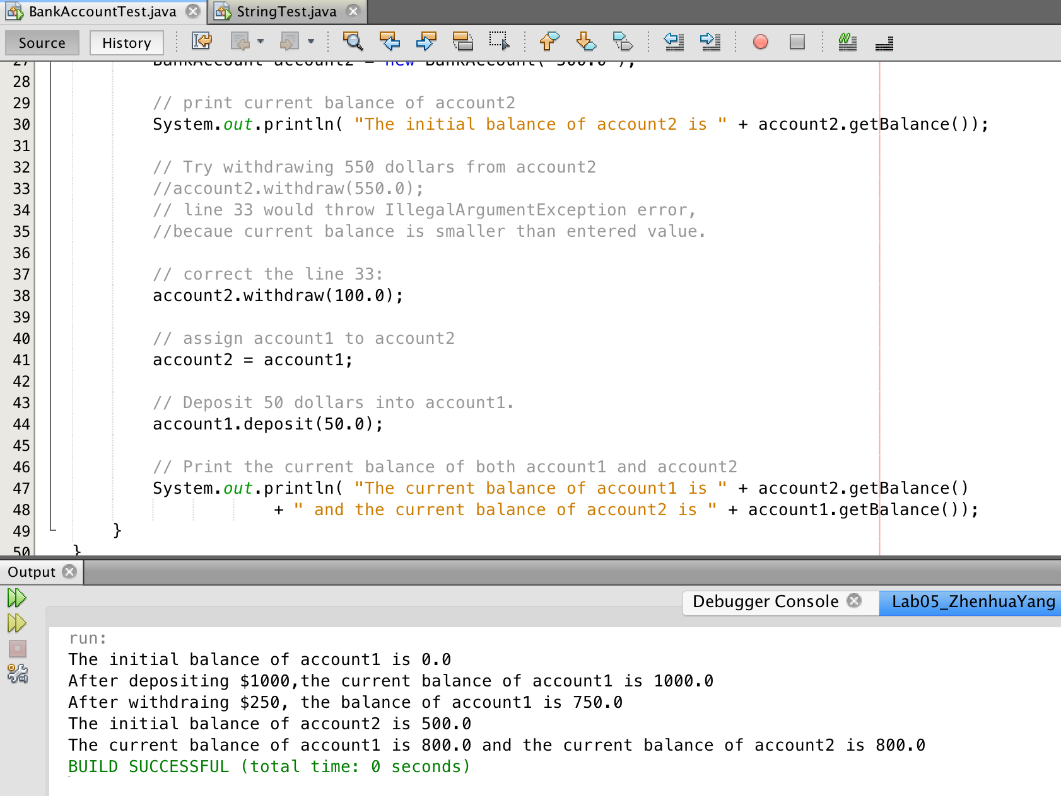

public class StringTest

{

public static void main( String [] args )

{

// create two string variables

String str1 = "Hi";

String str2 = "Hello World";

// print the lengths of two strings

System.out.println( "the lengthes of the two strings are: " + str1.length()

+ " and " + str2.length() );

// print the index of first occurrence of character ‘o’ in two strings

System.out.println( "Index of the first occurrence of character ‘o’ in two strings: "

+ str1.indexOf('o') + " and " + str2.indexOf('o') );

// print the index of the last occurrence of character ‘o’ in both the strings

System.out.println( "Index of the first occurrence of character ‘o’ in two strings: "

+ str1.lastIndexOf('o') + " and " + str2.lastIndexOf('o') );

// the subString of str2 begins after the white space

String subString = str2.substring(6);

System.out.println(subString);

// print the concatenated string

String concatenated = str1 + " " + subString;

System.out.println( "The concatenated string is " + concatenated );

// print the lower case of the string

System.out.println( "Lower case: " + concatenated.toLowerCase() );

// print the upper case of the string

System.out.println( "Upper case: " + concatenated.toUpperCase() );

}

}

