import java.util.Scanner;

import java.text.DecimalFormat;

public class Payroll

{

public static void main ( String [] args )

{

// create primary varialbles for this application

String employee;

int hoursWorked;

double hourlyPay;

double federalTaxRate;

double stateTaxRate;

// instantiate a Scanner object

Scanner scan = new Scanner( System.in );

// collecting user's input from keyboard

System.out.print( "Emoyee's name > ");

employee = scan.next();

System.out.print( "Number of hours worked in a week >");

hoursWorked = scan.nextInt();

System.out.print( "Hourly Rate > " );

hourlyPay = scan.nextDouble();

System.out.print( "Federal tax withholding rate >");

federalTaxRate = scan.nextDouble();

System.out.print( "State tax withholding rate > " );

stateTaxRate = scan.nextDouble();

// based on the data entered, calculate gross pay, federal tax, state tax and net income

double grossPay = hoursWorked \* hourlyPay;

double federalTax = grossPay \* federalTaxRate;

double stateTax = grossPay \* stateTaxRate;

double netIncome = grossPay - federalTax - stateTax;

// instantiate a DecimalFormat object specifying a pattern for currency

DecimalFormat rateFormat = new DecimalFormat( "$#0.00" );

// instantiate a DecimalFormat object specifying a pattern for percentage

DecimalFormat percFormat = new DecimalFormat( "#0%" );

// print the payroll statement

System.out.println( "\n\n==============Payroll=================\n" +

"\n-Employee's Name: " + employee +

"\n-Number of hours worked in a week: " + hoursWorked +

"\n-Hourly Pay: " + rateFormat.format(hourlyPay) +

"\n-Federal tax withholding rate: " + percFormat.format(federalTaxRate) +

"\n-State tax withholding rate: " + percFormat.format(stateTaxRate) +

"\n-Gross Pay: " + rateFormat.format(grossPay) +

"\n-Federal tax withholding: " + rateFormat.format(federalTax) +

"\n-State tax withholding: " + rateFormat.format(stateTax) +

"\n-Net Income: " + rateFormat.format(netIncome) + "\n");

}

}

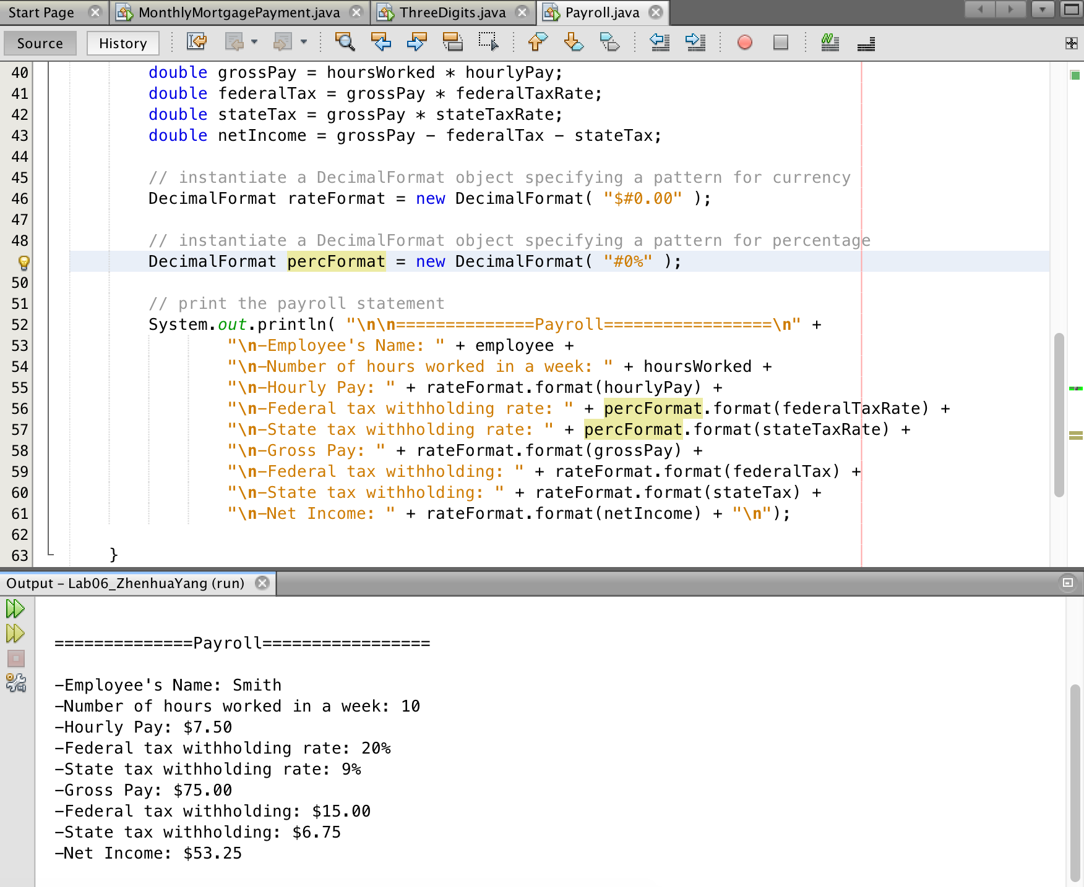

import java.util.Scanner;

import java.text.NumberFormat;

public class MonthlyMortgagePayment

{

public static void main( String [] args )

{

// Create three primary variables

double yIR;

int nOY;

double m;

// Instantiate a Scanner object

Scanner scan = new Scanner( System.in );

// Collect data input from keyboard

System.out.print( "Annual Interest tate: " );

yIR = scan.nextDouble();

System.out.print( "Number of years of mortgage: " );

nOY = scan.nextInt();

System.out.print( "Mortgae amount: ");

m = scan.nextDouble();

// Calculate the monthly rate, monthly payment, total payment, over payment,

// and the percentage of the over payment.

double mIR = yIR / 12;

double mPay = ( mIR \* m )/( 1 - ( 1 / Math.pow(( 1 + mIR), (12\*nOY)) ) );

double yPay = mPay \* 12 \* nOY;

double oPay = yPay - m;

double oPayP = oPay / m;

// instantiate a NumberFormat object specifying a pattern for percentage

NumberFormat percentFormat = NumberFormat.getPercentInstance();

// instantiate a NumberFormat object specifying a pattern for currency

NumberFormat dollarFormat = NumberFormat.getCurrencyInstance();

// Print the mortgage summary

System.out.println( "\n\n=============Mortgage Summary==============\n" +

"\n-Annual interest rate: " + percentFormat.format(yIR) +

"\n-Mortgage amount: " + dollarFormat.format(m) +

"\n-Monthly payment: " + dollarFormat.format(mPay) +

"\n-Total payment over the years: " + dollarFormat.format(yPay) +

"\n-Over payment: " + dollarFormat.format(oPay) +

"\n-Over payment in a percentage: " + percentFormat.format(oPayP) + "\n");

}

}

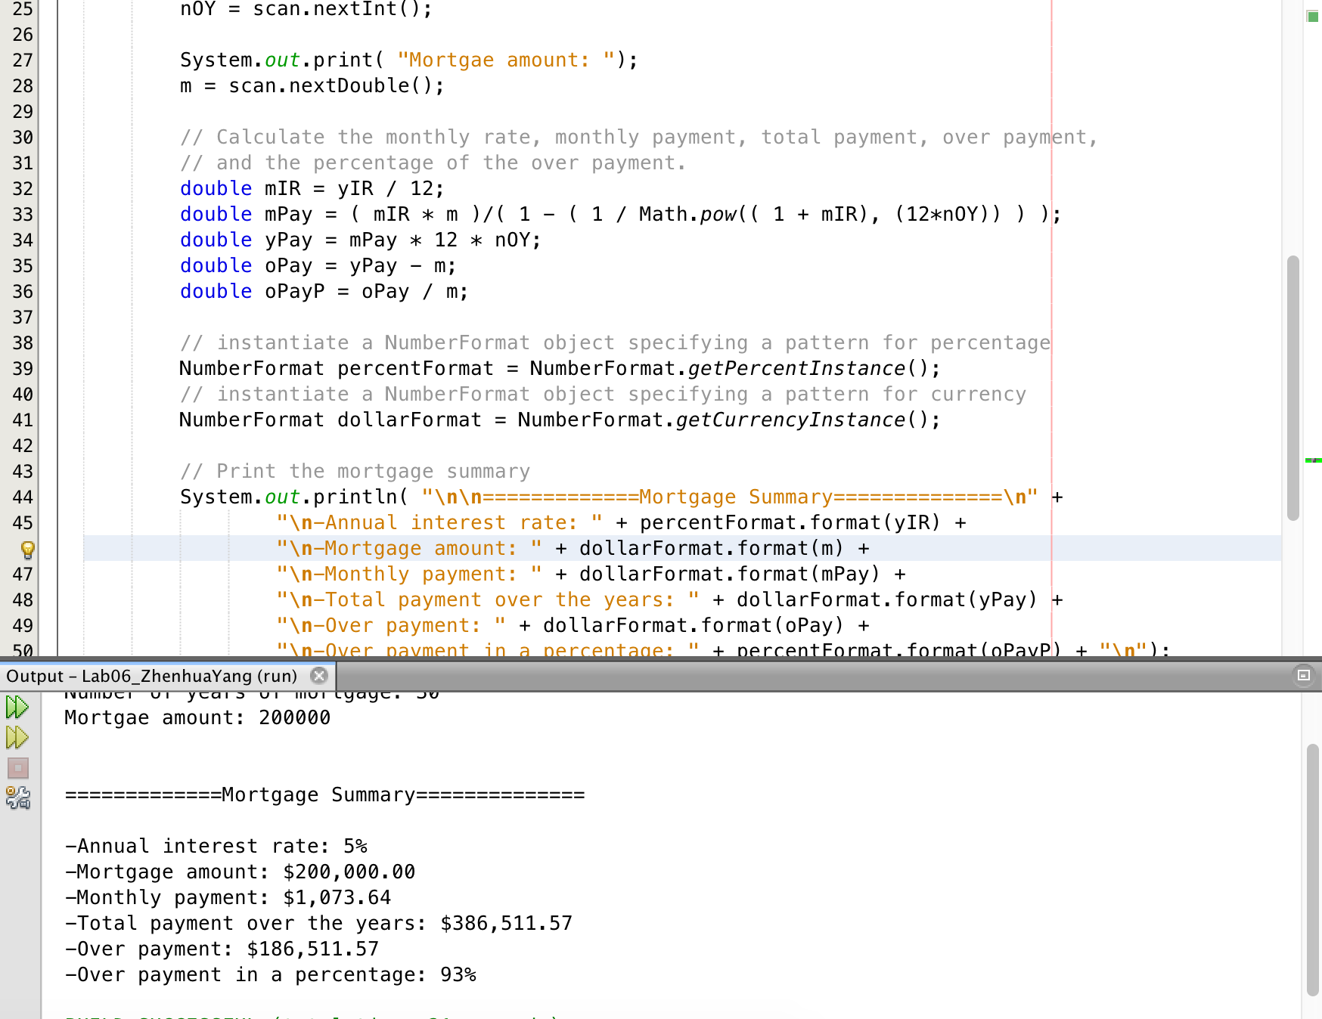

import java.util.Scanner;

public class ThreeDigits

{

public static void main( String [] args )

{

// create primary varialbles for this application

int numEntered = 932;

int digit1;

int digit2;

int digit3;

// instantiate a Scanner object

Scanner input = new Scanner( System.in );

// collet user's input from keyboard

System.out.print( "Please enter a three-digit integer between 100 and 999 > ");

numEntered = input.nextInt();

// initialize each of the digits from the entered number

digit1 = numEntered / 100;

digit2 = ( numEntered - ( digit1 \* 100 ) )/ 10;

digit3 = numEntered % 10;

// calculate the sum of three digits

int sum = digit1 + digit2 + digit3;

// print out the result

System.out.println( "\nthe sum is: " + sum );

}

}

